Jihad Report
May 06, 2017 -
May 12, 2017
Attacks | 33
Killed | 202
Injured | 172
Suicide Blasts | 7
Countries | 14
BSA is Destroyed by Terroristic Litigation
The Boy Scouts of America (BSA) was inspired by and modeled on the Boy Scout Association, established by Baden-Powell in Britain in 1908. In the early 1900s, several youth organizations were active, and many became part of the BSA (see Scouting in the United States).
The BSA grew rapidly and became the largest youth organization in the United States. Early issues involved race, the "younger boy problem," and the "older boy problem." Troops initially followed local community policy on race. For younger boys, the Cubbing program arose and for older boys, Rovering and Exploring programs were developed. Additional programs and changes have occurred over the years to adapt the program to the youth of the day.
W. D. Boyce was an American newspaper man and entrepreneur. According to legend, he was lost on a foggy street in London when an unknown Scout came to his aid, guiding him back to his destination.^{[1]} The boy then refused Boyce's tip, explaining that he was merely doing his duty as a Boy Scout. Immediately afterwards, Boyce met with General Robert Baden-Powell, who was the head of the Boy Scout Association at that time. Boyce returned to America, and, four months later, founded the Boy Scouts of America. This version of the legend has been printed in numerous BSA handbooks and magazines. There are several variations of this legend, such as one that claims he knew about Scouting ahead of time.
In actuality, Boyce stopped in London en route to a safari in British East Africa. It is true that an unknown Scout helped him and refused a tip. But this Scout only helped him cross a street to a hotel, did not take him to the Scout headquarters, and Boyce never met Baden-Powell. Upon Boyce's request, the unknown Scout did give him the address of the Scout headquarters, where Boyce went on his own and picked up information about the group.^{[2]} Weather reports show that London had no fog that day. Boyce returned to London after his safari and visited the Scout headquarters again and gained the use of Scouting for Boys in the development of a US Scouting program. This and other elements of the legend were promoted by James E. West in 1915 to help build up Boyce as the true founder of the BSA in order to defuse an escalating conflict between Daniel Carter Beard and Ernest Thompson Seton over who should be considered the founder of the BSA.^{[3][4]} Elements of this story, including the fog, may have been borrowed from a story concerning the Rhode Island Boy Scouts.
Boyce returned to the United States and with Edward S. Stewart and Stanley D. Willis he incorporated the Boy Scouts of America on February 8, 1910 and applied for a congressional charter. The bill was tied up with a charter for the Rockefeller Foundation and Boyce withdrew it after many delays. Around this time, William Randolph Hearst, a rival newspaperman, formed the American Boy Scouts (ABS), a group that lasted through 1918. Between business and travel, Boyce did not spend much time on the new organization. Edgar M. Robinson, a senior administrator of the YMCA in New York City, learned of the new Boy Scout program and traveled to Chicago where he agreed to help Boyce organize the Boy Scouts as a national organization. Boyce pledged $1000 a month for a year to support the program– but reports indicate only three or four payments were actually made. Robinson returned to New York to begin the search for members. After a series of meetings in early 1910, the Woodcraft Indians led by Ernest Thompson Seton, the Boy Scouts of the United States headed by Colonel Peter Bomus and the National Scouts of America headed by Colonel William Verbeck were absorbed into the BSA.^{[6]} The National Highway Patrol Association Scouts headed by Colonel E. S. Cornell and the Boy Pioneers (formerly known as the Sons of Daniel Boone) headed by Daniel Carter Beard were folded. The BSA National Office opened in the 28th Street YMCA in New York City on June 1, 1910. The first managing secretary (the precursor to the Chief Scout Executive) was John Alexander, a YMCA administrator from Philadelphia, Pennsylvania. By autumn BSA had 2,500 leader applications from 44 states and 150,900 youth inquiries.^{[7]}
The National Council was formed in the fall of 1910 with Colin H. Livingstone as the national president, Robinson becoming the managing secretary (on a temporary leave from the YMCA) and Seton as Chief Scout. Beard, Bomus and Verbeck became the national Scout commissioners. Seton wrote A Handbook of Woodcraft, Scouting, and Life-craft, the original edition of what is now the Boy Scout Handbook. It was hastily published and shipped to potential leaders for review. Robinson wanted to return to his full-time position at the YMCA, so Livingstone put out inquiries for a replacement. They hired James E. West, an enterprising young lawyer known as an advocate of children's rights. West was hired on a six-month temporary basis that lasted 35 years.
I spoke in a BSA Banquet about 20 years ago and said something that turned out to be prophetic. I said that our nation was in dire need of men of integrity in leadership. I said the best place to find a man of integrity is in a boy of integrity. And the best place to build a boy of integrity is the BSA. 11 of the 12 sets of footsteps on the Moon are from eagle scouts.
They are trustworthy, loyal, helpful, friendly, courteous, kind, obedient, cheerful, thrifty, brave, clean and reverent. On their honor they are morally straight.
Well, after more than 2 decades of terroristic litigation, the LBGT agenda finally broke the BSA. Scouting was a safe place for boys. But, the LGBT activists filed thousands of lawsuits to force the oldest and largest boy’s club the world has ever known to allow gay men to go camping in the woods with young boys. Almost immediately, the Mormon Church adopted the BSA program as the best platform for building men of integrity. This month, they succeeded in winning the landmark case that finally destroyed the organization. After thousands of boys have been molested by predatory adults, directly attributed to decades of court orders allowing openly gay men access to innocent young boys in unsupervised settings, the two churches that provide more than 85% of the financial support for the BSA are withdrawing from the club. Young teenagers are allowed to camp overnight, and they will be pulled from the Boy Scouts of America (BSA), the Mormon church announced Thursday. Younger boys are not allowed to camp overnight, except one night per year provided their father goes with them.
The announcement from the Church of Jesus Christ of Latter-day Saints means an estimated 130,000-180,000 teenagers ages 14-18 will no longer participate in Boy Scouts starting next year. The Mormon church is the largest sponsor of Boy Scouts troops in the United States.
The Boy Scouts' "Varsity" and "Venturing" programs for older teens had become difficult to implement within the religion, Mormon officials said in a news release. This is a polite way of saying that the BSA has been destroyed by the LGBT agenda and is no longer suitable and a safe place for young boys. Gay boys are allowed into the BSA program, but gay leaders were not allowed to have access to boys in a camping situation.
"Instead, Young Men activities will focus on spiritual, social, physical and intellectual outlined by the Church," officials said. "These activities are designed to be fun and meaningful and provide opportunities for personal growth and development."
The change applies just to the United States and Canada, where the "Varsity" and "Venturing" programs have been implemented, according to Mormon officials. Some 280,000 younger boys ages 8-13 will be kept Scouts while the church continues to develop a global scouting-type program.
The loss is only a fraction of the 2.3 million youth in Boy Scouts, which has had a close bond with the Utah-based religion for more than 100 years, but it has long been a contingency plan if gay men were allowed access by the courts.
The faith said the decision wasn't triggered by Boy Scouts policy change in 2015 to allow gay troop leaders since Mormon troops were allowed to run their groups to adhere to church teachings.
The Mormon church opposes gay marriage and teaches its members that being in a homosexual relationship is a sin.
The church has been working on an overarching global program for years.
"No, this is not the global program, but an important step that addresses an immediate need," the church said on its website. "Varsity and Venturing programs have been difficult to run effectively on a local level. The Church continues to work toward developing a program for young men and young women globally."
The church did not provide a timeline for rollout of the program that will be for all age groups.
Mormons who want to work toward an Eagle Scout award can continue to do so.
"In every discussion with the Boy Scouts of America, they have expressed a shared desire to do what is best for young men," Mormon officials said. "We are grateful for their continued support with this new change and look forward to continuing our strong relationship in the Cub Scout and Boy Scout programs."
BSA spokeswoman Effie Delimarkos said the organization is saddened about the decision but understands the need for the religion to customize its programming.
"Although thousands of youth and leaders who participate in Venturing crews nationwide embrace and support the program, we recognize that not all programs are a perfect fit for all partners," BSA said in a statement.
"We anticipate that many youth from the LDS Church will continue to participate in Scouting beyond the age of 14 as young men work to earn the Eagle Scout rank."
"The BSA values our ongoing partnership with the LDS Church in Cub Scouts and Boy Scouts programming and look forward to our continued efforts to extend the benefits of Scouting to as many youth and families as possible," the statement continued.
Trump Commencement Address

President Donald Trump gave his first commencement speech at Liberty University on Saturday, encouraging “dreamers” to ignore critics, take risks, never quit, and remember that “in America we don’t worship government, we worship God.”
President Trump told the graduates that they are “graduating to a totally brilliant future.”
“Each of you should take immense pride in what you have achieved,” he told them.
Trump specifically recognized graduates who have served in the military, “It is truly a testament to this university and to the values that you embrace, that your graduating class includes so many patriots who have served our country in uniform.”
He also thanked Liberty University President Jerry Falwell Jr. and members of the Falwell family.
“You are about to begin the greatest adventure of your life,” said Trump who remarked how blessed the graduates are.
Ask yourself, with all of those blessings and all of the blessings that you have been given, what will you give back to this country and indeed to the world, what imprint will you leave in the sands of history? What will future Americans say we did in our brief time right here on earth. Did we take risks? Did we dare to defy expectations? Did we challenge accepted wisdom and take on established systems? I think I did, but we all did and we’re all doing it. Or did we just go along with convention, swim downstream, so easily with the current and just give in because it was the easy way, it was the traditional way or it was the accepted way? Remember this: nothing worth doing ever, ever, ever came easy. Following your convictions means you must be willing to face criticism from those that lack the same courage to do what is right and they know what is right but they don’t have the same courage or guts or stamina to take it and to do it. It’s called the road less traveled.
Trump said that he knows each graduate will be “a warrior for the truth”, “a warrior for our country and for your family.” He encouraged them that they will do what is right even when it isn’t easy, “You will be true to yourself, your family, your beliefs.”
The President then referred to what he has seen so far in his short time serving in Washington, D.C.:
I’ve seen firsthand how the system is broken. A small group of failed voices who think they know everything and understand everyone want to tell everybody else how to live and what to do and how to think, but you aren’t going to let other people tell you what you believe, especially when you know that you’re right.
Trump remarked that those graduating have given half a million hours of charity in just the past year.
“We don’t need a lecture from Washington on how to lead our lives,” he followed.
He said he was standing in front of leaders, one or two future U.S. presidents could be in the crowd.
“America has always been a land of dreams because America is a nation of true believers,” said Trump who then referred to the pilgrims landing at Plymouth. He remarked that the pilgrims prayed and, later, America’s Founding Fathers invoked Creator God four times in the Declaration of Independence.
“Because in America we don’t worship government, we worship God,” he said.
He recognized that United States currency bears the phrase, “In God We Trust” and referenced “One nation under God” in the Pledge of Allegiance.
“The story of America is the story of an adventure that began with deep faith, big dreams, and humble beginnings,” said Trump who said Liberty University began in the same way.
Trump remarked that many likely told Liberty University founder Jerry Falwell Sr. that his vision of such a Christian university wasn’t possible. He recognized Christian evangelical voters and their effect on the 2016 Presidential election, thanking them for voting.
“No one has ever achieved anything significant without a chorus of critics standing on the sidelines explaining why it can’t be done. Nothing is easier or more pathetic than being a critic because they’re people that can’t get the job done,” said Trump.
“The future belongs to the dreamers and not to the critics,” he added.
He spoke of the university’s initiative to have a “world class” sports program and football team. “From the most humble roots you’ve become a powerhouse in both academics and sports,” said Trump.
President Trump went on to urge the class of 2017, “Never, ever give up, there will be times in life you’ll want to quit, you’ll want to go home…Just never quit.”
He said he has seen brilliant, top of their class people who gave up as well as those who didn’t have the same talent or ability, but are among the most successful people in the world now because they never gave up.
“Carry yourself with dignity and pride, demand the best from yourself and be totally unafraid to challenge entrenched interests and failed power structures,” he said, adding a parallel to his own path with the words, “does that sound familiar by the way?”
“The more people tell you it’s not possible, that it can’t be done, the more you should be absolutely determined to prove them wrong. Treat the word impossible as nothing more than motivation. Relish the opportunity to be an outsider,” said Trump.
“It’s the outsiders who change the world,” he declared. “The more a broken system tells you that you’re wrong the more certain you should be that you must keep pushing ahead, you must keep pushing forward.”
“Most importantly, you have to do what you love,” he counseled the graduates.
Trump recognized football Hall of Famer Jim Kelly as an inspiration to the commencement crowd. “He beat cancer not once, but twice,” said Trump. He recalled seeing Kelly and his wife Jill at a very low moment, but that they fought and Kelly pulled through. Kelly’s daughter Erin was also recognized as she graduates from Liberty University the same day.
“You are a living witness of the gospel message, of faith hope and love,” Trump told the graduates. “America is better when they put their faith into action. As long as I am your president no one is going to keep you from practicing your faith or from preaching what’s in your heart.”
“Pray to God and follow his teachings,” encouraged Trump.
Trump also recognized 98-year-old WWII veteran George Rogers. Once a POW and survivor of the Bataan Death March, he was just 85 pounds when he was recovered. Rogers formerly served as Liberty University CFO and Vice President.
“If anyone ever had reason to quit, to give into the bitterness and anger that we all face at some point, to lose hope in God’s vision for his life, it was indeed George Rogers, but that’s not what he did,” said Trump. “He defended civilization against a tide of barbarity, the kind of barbarity we are seeing today and we’ve been witnessing over the past number of years.”
Trump said America is countering this barbarity today very well and that America’s generals would have something to announce in the coming week regarding U.S. efforts.
He described Rogers’ faith in God, return home to America, and investment in Liberty University.
Trump encouraged the graduates in their futures as leaders in all aspects of life. He added, “You will have the faith to replace a broken establishment with a government that serves and protects the people.”
“We must always remember that we share one home and one glorious destiny,” said Trump.
Whether we are brown, black, or white, we all bleed the same red of patriots, we all salute the same great American flag and we are all made by the same almighty God. As long as you remember what you have learned here at Liberty, as long as you have pride in your beliefs, courage in your convictions, and faith in your God, then you will not fail. And as long as America remains true to its values, loyal to its citizens, and devoted to its Creator then our best days are yet to come, I can promise you that.
Ransom Ware WannaCry
24 hours after it first emerged, it has been called the first global, coordinated ransomware attack using hacking tools developed by the NSA, crippling over a dozen hospitals across the UK, mass transit around Europe, car factories in France and the UK, universities in China, corporations in the US, banks in Russia and countless other mission-critical businesses and infrastructure.
According to experts, "this could be one of the worst-ever recorded attacks of its kind." The security researcher who tweets and blogs as MalwareTech told The Intercept, “I’ve never seen anything like this with ransomware,” and “the last worm of this degree I can remember is Conficker.” Conficker was a notorious Windows worm first spotted in 2008; it went on to infect over 9 million computers in nearly 200 countries.
The fallout, according to cyber-specialists, has been "unprecedented": it has left unprepared governments, companies and security experts from China to the United Kingdom on Saturday reeling, and racing to contain the damage from the audacious cyberattack that spread quickly across the globe, raising fears that people would not be able to meet ransom demands before their data are destroyed.
As reported yesterday, the global efforts come less than a day after malicious software, transmitted via email and stolen from the National Security Agency, exposed vulnerabilities in computer systems in almost 100 countries in one of the largest “ransomware” attacks on record. The cyberattackers took over the computers, encrypted the information on them and then demanded payment of $300 or more from users in the form of bitcoin to unlock the devices.
The ransomware was subsequently identified as a new variant of "WannaCry" that had the ability to automatically spread across large networks by exploiting a known bug in Microsoft's Windows operating system.
The ransomware has been identifed as WannaCry
The hackers, who have not come forward to claim responsibility or otherwise been identified, likely made it a "worm", or self spreading malware, by exploiting a piece of NSA code known as "Eternal Blue" that was released last month by a group known as the Shadow Brokers (see "Hacker Group Releases Password To NSA's "Top Secret Arsenal" In Protest Of Trump Betrayal") , researchers with several private cyber security firms said.
"This is one of the largest global ransomware attacks the cyber community has ever seen," said Rich Barger, director of threat research with Splunk. The extremely well coordinated attack first emerged in the United Kingdom around noon on Friday and spread like wildefire around the globe. According to the Times "it has set off fears that the effects of the continuing threat will be felt for months, if not years" and raised questions about the intentions of the hackers: Did they carry out the attack for mere financial gain or for other unknown reasons?
The animated map below shows the speed and scale of the global infestation which took just a few hours to cover the globe:
Meanwhile, some of the world’s largest institutions and government agencies have been affected, including the Russian Interior Ministry, FedEx in the United States and Britain’s National Health Service. As people fretted over whether to pay the digital ransom or lose data from their computers, experts said the attackers might pocket more than $1 billion worldwide before the deadline ran out to unlock the machines.
Across Asia, several universities and organizations said they had been affected. In China, the virus hit the computer networks of both companies and universities, according to the state-run news media. News about the attack began trending on Chinese social media on Saturday, though most attention was focused on university networks, where there were concerns about students losing access to their academic work. The attack, however, focused on the UK and Europe where in addition to the British healthcare system, companies like Deutsche Bahn, the German transport giant; Telefónica, a Spanish telecommunications firm; and Renault, the French automaker, said some of their systems had been affected.
"Seeing a large telco like Telefonica get hit is going to get everybody worried," said Chris Wysopal, chief technology officer with cyber security firm Veracode.
The British National Health Service said that 45 of its hospitals, doctors’ offices and ambulance companies had been crippled — making it perhaps one of the largest institutions affected worldwide. Surgical procedures were canceled and some hospital operations shut down as government officials struggled to respond to the attack.
“We are not able to tell you who is behind that attack,” Amber Rudd, Britain’s home secretary, told the British Broadcasting Corporation on Saturday. “That work is still ongoing.”
Things only got worse on Saturday as auto production facilities across Europe have been shuttered, including car plants in the UK and France, in the aftermath of the cyberattack.
A cyber attack using NSA exploits, began in Europe Friday morning, with entities in the UK, Spain, and Portugal being hit first. Computers in hospitals, certain government offices and a huge number of corporations suddenly locked-up making them un-usable, and told their users that a certain amount of ransom had to be paid within a certain time period, or all the data on the computers would be forever destroyed. Once the ransom is paid, the user is given a password to decrypt their files and regain control of their computer system.
This particular computer attack uses exploits found by the US National Security Agency (NSA), to gain access to computers. The exploit was stolen from the NSA last year when hackers got into the servers of an NSA Contractor and downloaded the government's hacking tools along with classified information on how government gets into computers.
Initially, a hacker group calling itself "Shadow Brokers" announced they had the NSA tools and offered them to the highest bidder . . . . but apparently there were no takers. So a few months ago, Shadow Brokers uploaded all the NSA hacking materials to public Internet servers and released them to the general public for FREE!
Hundreds of thousands of copies of the NSA's secret government spy tools were downloaded worldwide within minutes, with there being no way to ever retrieve all the copied files.
Over the course of the past few months, someone . . . . no one knows who (yet) . . . . linked "Ransom-ware" with the NSA hacking exploits released by Shadow Brokers.
Ransom-ware is malicious computer code which seizes control of a computer, encrypts all the data on the computer, and holds it "hostage" unless money is sent to the hacker via anonymous Bitcoin or via anonymous Western Union money transfer.
Linking Ransom-ware with the NSA tools allowed computers to be hacked-into using the NSA exploits, and then infected with the Ransom-ware which locks up all the computer files, encrypts them with an unbreakable code, and tells the computer owner they must pay a certain "ransom" in order to get the password to release the files.
Any computer infected is also programmed to permanently DESTROY all the files if the ransom is not paid within a certain time period!
As of 10:00 PM eastern US time on Friday, May 12, 2017, 57,000 entities in 74 different countries around the world have confirmed their systems are compromised by this cyber attack!
Victims include individual computer owners, companies and corporations of all sizes, hospitals, and even certain government agencies. In the UK on Friday, several large hospitals could not render care to patients because their computer systems could not be accessed to release drugs or to review patient information.
Portugal Telecom was also hit, with tens of thousands locked out of computers that provided telephone service to much of the country! The cyber attack was so bad, that even technicians in Portugal Telecom could not communicate with each other to try to fix the problem! Phone outages remain and are growing throughout that country.
In Spain, hospitals, colleges, universities, local government agencies and many other entities, found themselves locked out of their systems and unable to work.

ONCE THE BANKS GET HIT: "ARMAGEDDON"
For years, many who are derided as "Conspiracy Theorists" have warned that a Global Financial Collapse is imminent because debt loads are overwhelming. Bankruptcies at the personal, corporate and even Sovereign Debt level (Greece, Puerto Rico, Detroit to name just a few) have skyrocketed in the past two years, and things are getting worse. The shear volume of debt is crippling more and more people and businesses.
The stock markets have only risen because central banks have been buying stocks with money they print out of thin air via computer account entries. The true value of stocks, based upon earnings, is long gone from reality.
Commodities markets have been widely manipulated - presumably by those same central banks -- to manipulate the value of actual goods, to the advantage of the fiat cash money system. They kept the price of Gold and Silver artificially low so as to make people think their paper money system was still sound. It isn't.
Even worse, the financial "gurus" conned people into buying Gold and Silver "on paper" while the Gurus would "hold" the physical metal for such customers . . . so it was "safe."
That turned out to be a complete lie when public records showed those Gurus has sold the same ounce of gold or silver, to more than 500 different people !!!! The gurus figured that there was no way all of these "paper" owners would demand delivery of the gold, so they kept selling the same ounces over and over again, collecting fees on those transactions, but lacking the physical metal to fulfill orders. Believe it or not, this is actually LEGAL under international banking laws!
As the "Conspiracy Theorists" publicized these facts, they were slammed as "tinfoil hat" nut jobs. They were smeared as being "paranoid."
In March of 2013, an insider revealed that a "cyber attack on a Friday would be the 72 hour warning of Martial Law." The "insider" claimed that a cyber attack would be blamed for making banking impossible, and the public would be told the banks would not re-open the following Monday, while being assured the problems would be resolved and everything would be back to normal quickly. (That original video warning appears at the end of this article!)
The insider then claimed that during the weekend, TROOPS WOULD BE DEPLOYED NATIONWIDE to quell civil disturbances when the public found itself without money, unable to get cash from ATM or the banks, and unable to use credit/debit cards because bank computers were all affected. It would leave people without any way to buy food or fuel.
The insider then said, as the days go on, and the "computer troubles" are not resolved, people would find themselves running out of food, medicine and other essentials. Companies could not do business and governments would be unable to help because, they too, would have no access to money. Panic and anger would send people by the hundreds-of-thousands into the streets.

HERE IT IS ! ? ! ?
Well, this "cyber attack" began on a Friday. Like magic, a massive "cyber attack" is making computers unavailable to tens of thousands of companies, hospitals and government agencies. Has it hit the banks yet -- and we haven't been told?
Will we be told over this weekend that the banks will not be able to open on Monday because of computer trouble?
What if things open as usual on Monday, and as the work week goes on, this cyber attack continues to spread . . . . and finally gets to the banks?
Will Next weekend be the weekend everything goes to hell financially?
A global financial collapse caused by a cyber attack???? Followed by Martial Law? Followed by hunger and food riots? Breakdown of civil authority? Chaos?

Time will tell.

GET CASH OR GET EXTRA FOOD THIS WEEKEND
if you have money in the bank, Friday and Saturday may be your only hope to get __any__ of it out. Get to an ATM right now . . . . right this minute . . . . don't wait. Take out the maximum you're allowed from the ATM. Go back to the bank Saturday morning when it opens to get more cash out.
Next, gas-up your car(s) while credit and debit still work. Tank-up!
When the banks open first thing Saturday morning, calmly go there and get a few thousand out to tie you over.
You need to have enough cash on-hand to buy food and fuel for a month or two.
If this article is wrong, and the cyber attack is defeated, you can put the money back in the bank next week if you want. No harm, no foul.

If you cannot get cash, do you have enough food on-hand to feed yourself and your family for a month or two?
What will you do if supermarkets get hit and can't sell food. What if Banks close and supermarkets can only take cash because they cannot process credit or debit cards?
Forget paying your bills. This is survival. Those with cash will survive. Those without, will riot, steal and kill for food.

- Bug Out While You Still Can! Learn More...

This could very well be exactly what the "insider" warned us about 4 years ago. Those of us who listened will be OK. Those of you who did not . . . . oh well . . . . we told ya so.

WHY NOW?
First, the global elite lost the November election. Their candidate, Hillary Clinton, blew it.
They've tried for months to disrupt Trump with paid (and violent) protesters nationwide. It failed.
They tried for months to discredit Trump with their phony "Russian Election Interference" nonsense. Not only did former Director of National Intelligence, James Clapper, testify under oath to Congress this week that "there is no evidence of collusion between Trump and Russia" but even Senator Diane Feinstein admitted it on CNN.
When asked by Wolf Blitzer if Feinstein or her Senate Committee had any evidence of collusion between Russia and Trump, she replied "Not at this time."
If that wasn't devastating enough for the elites, Trump fired their "ace in the hole"--- FBI Director James Comey.
Now, they're out of luck in getting a corrupted FBI to do their bidding.
Yesterday, for the first time, US military forces conducted air strikes IN SUPPORT OF the Syrian Arab Army of Bashar Assad! We bombed ISIS and anti-Assad "Rebels." Basically, the US switched sides!
Then, Trump met with Russian Foreign Minister Lavrov at the White House to begin patching things up between the US and Russia (as has long been needed.)
This means the elite’s plans are being shattered right before their eyes! Think about it: Protests failed. The Russian election interference nonsense failed. Comey is fired. Trump is now helping the Syrian President whom the elites wanted out, and Trump is patching things up with Russia.
Every plan the elites had for global domination through war and chaos has failed. The only tool they have left is to take down the global financial system to cause Civil Chaos. Lo and Behold, that is precisely what seems to be in the works with this sudden Cyber-Attack which spreads like wildfire.
Below is the video from four years ago warning us that Martial Law would be implemented due to a virus affecting banks. Here now, the video UPDATES TO THIS ARTICLE APPEAR BELOW THE VIDEO:

2013 Video "72 Hour "Red-Flag" for Martial Law" Due to Cyber Attack affecting Banks:

UPDATE 12:35 AM EDT, SATURDAY MAY 13 --
SuperStation95 has received information that ATM customers using BB&T Bank and First Citizens Bank ATM's in South Carolina were unable to get cash earlier today. The woman reports she both machines were up and running, accepted her card and asked for her PIN, but when she sought cash, both machines reported "That Operation cannot be performed at this time."
Whether it was related to the cyber attack is unknown.
As of 12:30 AM EDT this cyber attack has now been confirmed to affect 75,000 entities in 99 countries. It is still spreading fast.
FBI Tried to Falsify the Attack on Clinton
As The Washington Times reports, Yevgeny Nikulin, the alleged hacker, laid the claim to Russian media Thursday in a letter sent from a Czech Republic prison cell amid an international extradition battle currently underway between Washington and Moscow. FBI agents promised Mr. Nikulin money, American citizenship and a free apartment for taking the fall over hacking Mrs. Clinton’s campaign, he alleged in a letter published Thursday by Nastoyashchoe Vremya, a Russian-language website.
“[They told me:] you will have to confess to breaking into Clinton’s inbox for [President Trump] on behalf of [Russian President Vladimir Putin],” Mr. Nikulin wrote, as translated by The Moscow Times.
"Later I received an offer from an agent: "You will have to declare that you broke Hillary Clinton mailbox for J. Trump on Putin's orders, you must agree to the extradition to the US, then we will remove all charges give you apartment and money, US citizenship "- I gave up shortly" questioning "was over, the agent said that they had come"
According to Nikulin, the proposal was made during conversations 14-15 November. The following conversation then took place on February 7 (translation via Currenttime.tv)
"You have to say that it is you broke-mail Clinton, that you prepared and entered into a democratic network and polling stations on Putin's orders, you call the names of accomplices, agree to extradition, and in America we will resolve all the issues will be living in an apartment and we will provide you all."
“He was offered to falsely testify that he was cooperating in the attack on the Democratic Party,” defense attorney Martin Sadilek said Thursday, the Associated Press reported.
FBI agents interviewed Mr. Nikulin twice since his arrest, he wrote, and each time asked him to confess to hacking American political targets. Mr. Nikulin said he refused their initial request last November, then received a second offer three months later.
FBI agents asked Mr. Nikulin to admit hacking Mrs. Clinton’s presidential campaign, Democratic Party computers and American polling stations “on Putin’s orders,” he wrote.

In exchange, he alleges, the FBI said he’d be extradited to the U.S. but ultimately given money, citizenship and a free apartment.
The FBI declined to comment.
The Justice Department has charged Mr. Nikulin with hacking LinkedIn, Dropbox and Formspring, but not for cyberattacks on the political targets compromised during the run up to last year’s election. The U.S. government has largely attributed those cyberattacks to a division of Russia’s military intelligence agency, GRU, referred to by names including APT 28, Pawn Storm and Fancy Bear.
An extradition hearing concerning Mr. Nikulin had scheduled for Thursday, May 11, in Prague, but proceedings were abruptly postponed until May 30 due to formal objections raised by defense attorneys involving language barriers and other issues, the Associated Press reported.
Additionally, as The Moscow Times reports, the case has drawn some attention in Russia, where reporters have unearthed photos of the self-described “used car salesman” driving lavish cars and taking photos with the Russian elite. Nikulin's social media pages had included snaps with both the daughter of Defense Minister Sergei Shoigu, and Kremlin press secretary President Dmitry Peskov.

UPDATE 12:50 AM EDT-
FedEx employees in Memphis received a text notification: “Virus spreading through FedEx with ransomware threat. Could be US wide. Recommend you turn off your computer if it’s windows just in case.”"
Also..
"...Some employees were told company systems globally were affected and that non-critical systems and PCs were to remain turned off until further notice from management..."

UPDATE 1:15 AM EDT --
SuperStation95 can now confirm the cyber virus is in the global Banking System. Santander Bank has confirmed it is affected by this cyber attack.
ALL BANKS on planet earth utilize the SWIFT communications system to conduct "secure" banking. That system is so outdated, it requires Windows VISTA to operate!
Microsoft halted updates to VISTA years ago, meaning the banks are sitting ducks.
The fact that Santander Bank is affected, likely means the global banking system is now infected.
If YOUR bank becomes infected, how will they provide CASH OR CREDIT services if all their files are encrypted? See how this could mean no cash from ATM's and no credit or debit cards working?
We urgently suggest you take the steps outlined earlier in this article to try to protect yourself in case everything shuts down.

UPDATE 2:30 AM EDT --
Ross Feingold, a Taiwan-based political analyst who advises on Taiwan and Hong Kong political affairs, warned that full picture may not be known until Monday morning when officials returned to work.
“As the attack commenced on Friday night Taiwan time, many organizations, whether government or private sector, will only know the true impact on Monday morning when personnel return to work, turn on their computers, and possibly click on malware and/or otherwise discover that the organization is the victim of ransomware,” he said.

UPDATE 4:00 AM EDT - INFRA-STRUCTURE BEING CRIPPLED
The cyber attack has now begun to cripple main infrastructure systems in Europe. German railroads are now grinding to a halt becuase the computers which run those railroads are being locked by the cyber attack.
Below is a photo from a German Railway station this morning. It shows the Ransom-ware Notice in the Red Box, proving the computer for the railroad has been taken-over by the cyber attack.

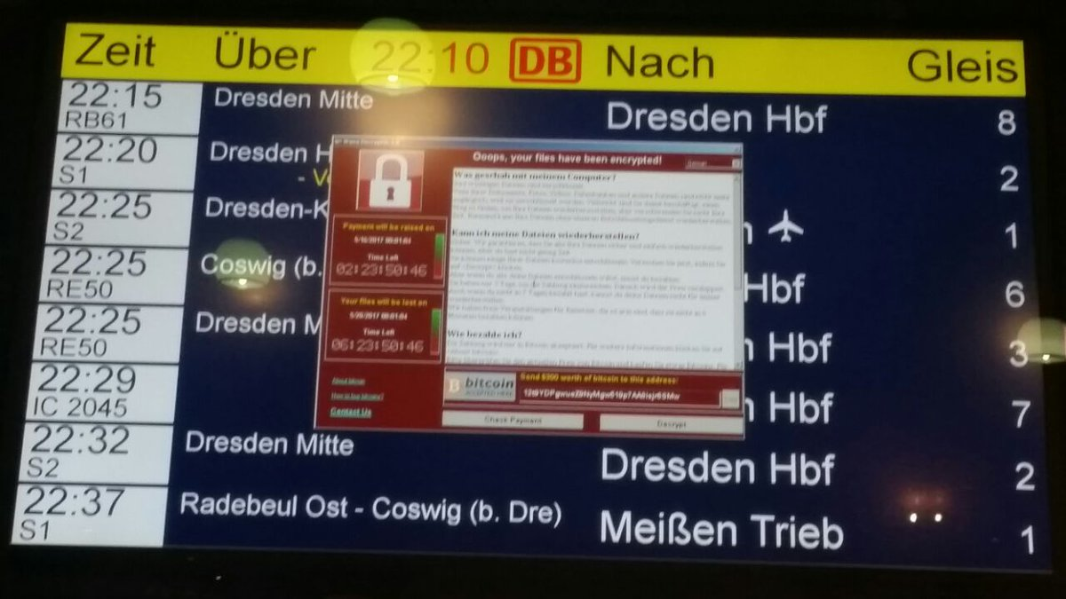

Here's a full size version of the Ransom Note which appears on infected computers:

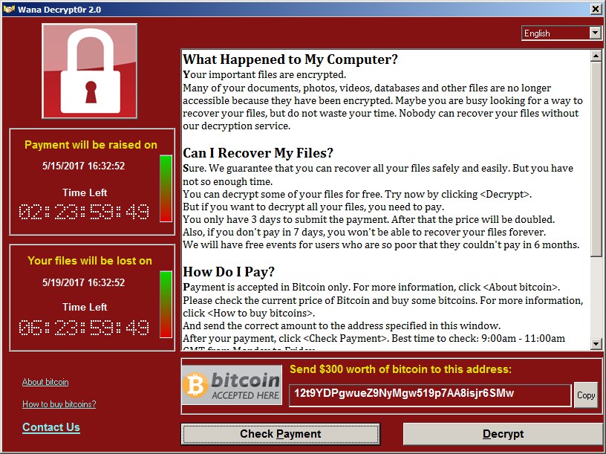

As more and more infrastructure is affected, water and electric power grids may also go down. Do you have emergency water stored so you and your family can survive for a month or two? Better store-up some emergency water right now. Don't wait.

UPDATE 8:34 AM EDT --
Some anti-Virus software has been able to detect the infecting file and quarantine it, but does so TOO LATE! Once the cyber attack virus grabs a computer, it sets-up a self-defense against your anti-virus software. If your anti-virus software interferes with the cyber-attack, you then get this message below:

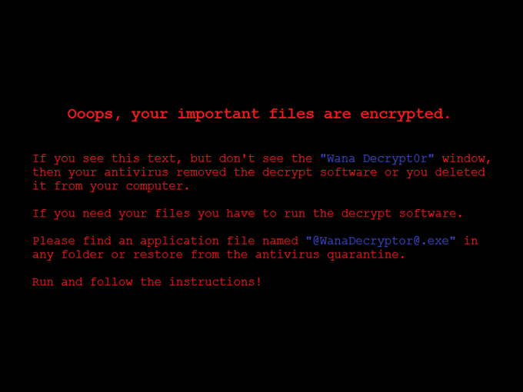

UPDATE 8:50 AM EDT --
The number of infections has jumped to 141,000+ in a matter of hours. The map below shows the most-prominent countries of infection:

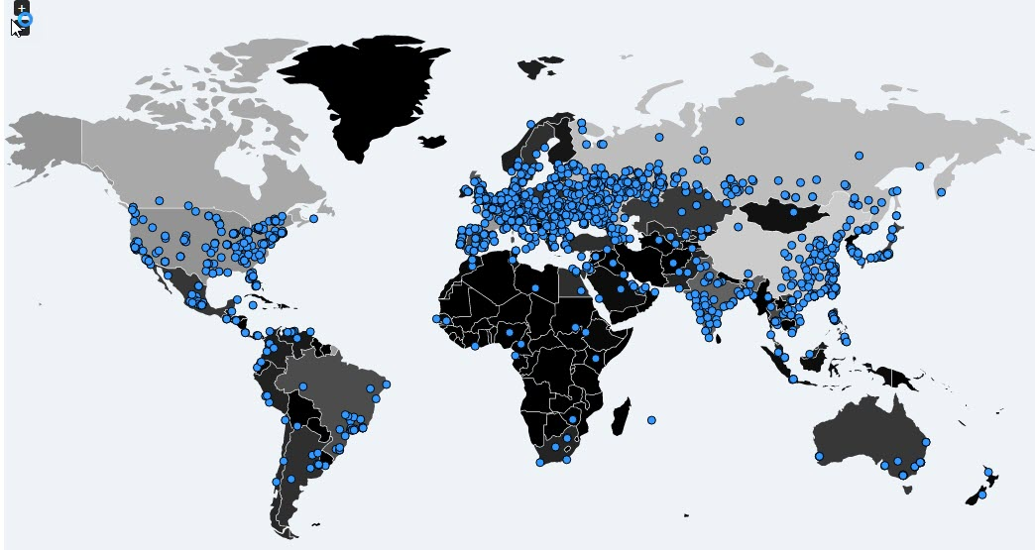

UPDATE 9:30 AM EDT --
According to MalwareTech.com, confirmed infections by this Cyber Attack have risen to 148,732 systems with 137,406 taken offline and made non-functional. The spread of this attack is continuing. It is important to note that of the 148,742 infected systems, that means "systems" not "computers."
Within a system can be one computer, or a thousand, depending upon the entity affected. For instance, the "banking SYSTEM" may count as one system, but obviously it could apply to tens-of-thousands of individual banks. So the magnitude of this cyber attack is staggering . . . and the spread continues.

UPDATE 11:25 AM EDT --
MalwareTech confirms the cyber attack has now seized 161,474 systems, of which 151,684 are OFFLINE and unable to operate. This attack is continuing despite reports that a young blogger in the UK found a "kill switch." According to various media reports, a young guy in Britain analysed the virus and found that it was setup to inquire on the Internet to a particular, and very strange Internet domain name. If it came across the name, that meant the virus should STOP instead of spreading. So the young guy spent $15 to register the domain name and bring it online!
Now, the problem seems to be that the initial cyber attacker has RE-programmed his virus to look for another domain name and the whole process is starting all over or rather CONTINUING. So whoever did this, is actively monitoring the effects of his malicious work and making adjustments to continue the trouble!
The Lease Car Bubble
The percentage of new car 'sales' moving off dealer lots via leases has nearly tripled since late 2009 when they hit a low of just over 10%. Over the past 6 years, new leases, as a percent of overall car sales, has soared courtesy of, among other things, low interest rates, stable/rising used car prices and a nation of rental-crazed citizens for whom monthly payment is the only metric used to evaluate a "good deal"...even though leasing a new vehicle is pretty much the worst 'deal' you can possibly find for a rapidly depreciating brand new asset like a car...but we digress.
Of course, what goes up must eventually come down. And all those leases signed on millions of brand new cars over the past several years are about to come off lease and flood the market with cheap, low-mileage used inventory. As Reuters noted, the flood of used vehicles is already starting to impact used car dealers:
Recently, though, a computer search for available used vehicles within 150 miles of Reel revealed an eye-popping figure: 668 Escapes. That's enough to put more than 40 percent of the inhabitants of this small northeastern Ohio town, population 1,600, into the popular crossover.
A search for the Chevrolet Equinox, a comparable crossover, showed 461 available.
"The automakers have flooded the market," said Reel, owner of Reel’s Auto in Orwell, Ohio, about 40 miles east of Cleveland.
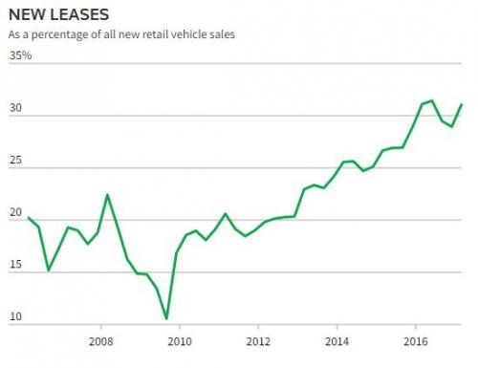

By the end of 2019, an estimated 12 million low-mileage vehicles are coming off leases inked during a 2014-2016 spurt in new auto sales, according to estimates by Atlanta-based auto auction firm Manheim and Reuters.
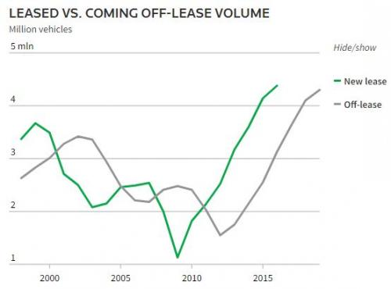

And, of course, that kind of supply is already starting to take it's toll on used car prices...
Chief Executive Mike Jackson said rising off-lease car numbers means "a higher supply of pre-owned vehicles at a more attractive price.”
Consumers seeking great deals are in luck. Used-vehicle prices at auction fell about 3 percent last year, according to Carmel, Indiana-based KAR Auction Services Inc (KAR.N), which facilitated the sale of 5.1 million used and salvaged vehicles in 2016. Used prices should drop around 3 percent annually for the next couple of years, according to KAR's chief economist Tom Kontos.
General Motors Co (GM.N) and Ford Motor Co (F.N) say prices for its used vehicles, which consist largely of nearly-new ones coming off lease to consumers, fell 7 percent in the first quarter versus the same period in 2016. GM says it expects a 7 percent decline for 2017 compared to last year.
...and, as Morgan Stanley recently pointed out, we're just getting started as they see used car prices dropping by up to 50% over the next 5 years.
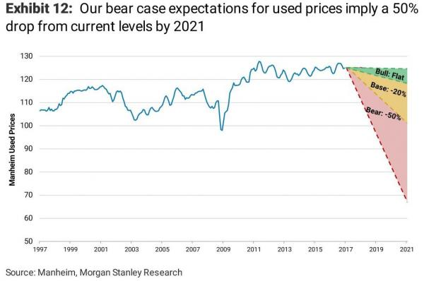

So what happens next? Unstable used car prices will almost certainly reduce OEM reliance on leases as the implied 3-year depreciation (or residual values, if you prefer) will make them all but completely uneconomical...remember, Americans only care about that monthly payment. Meanwhile, the relative value between used and new cars will tilt heavily in favor of the used market. Thankfully Americans will still be able to buy that Mercedes they require to get back and forth from their minimum wage jobs, while maintaining a monthly payment of $500 or less, but it will just have to have 30,000 miles on it.
Of course, the OEMs of the world won't admit that their game is over until it's way too late. So, they'll keep right on producing new cars to cover a 17-18mm SAAR environment up until the point they face an outright revolt from their dealer networks. At that point, however, dealer inventories will be so high that Detroit will be forced to shutdown for months on end while new car prices are slashed to reduce the massive inventory glut. Tanking new car prices will put even more pressure on used car prices which will mark the beginning of the death spiral that will result in a new round of inevitable auto bankruptcies...but that's just a hunch

The Deepest State

Sen. Rand Paul (R-KY) earlier this week revealed that another senator had told him that he was surveilled by the Obama administration.
“I know one other senator who’s already confided to me that he was surveilled by the Obama administration, including his phone calls,” he told Fox News on Wednesday.
“So when this all comes out, if there are political figures from the opposition party, it’s a story bigger than any of the allegations with regard to Russian collusion,” he said.
Earlier this month, Paul announced that sources have told him that he has been surveilled by the Obama administration, and that he has requested information from the White House and the congressional intelligence committees on whether he has ever been surveilled, unmasked, or searched for in intelligence reports.
“It’s about your own government spying on the opposition party, that would be enormous if true,” he said. “I don’t know the truth. We’ve asked the intel committees, House and Senate, and I’ve also asked the White House, because there is this whole discussion of Susan Rice unmasking people,” he said.
Former National Security Adviser Michael Flynn was fired in February, after a phone call he had with Russian Ambassador Sergei Kislyak was leaked to the Washington Post.
Listening in on an American’s phone calls is illegal without a warrant, but it can happen legally during surveillance of a foreign target. If Americans are caught up in surveillance of a foreign target, their identities are supposed to be “masked,” or concealed.
However, U.S. officials can request to have their names unmasked if it is necessary to understanding the context of the communications, with the approval of the agency conducting the surveillance.
Former Director of National Intelligence James Clapper revealed that last year, 1,934 Americans’ names were unmasked.
Last month it was reported that Susan Rice had unmasked Trump campaign officials — which she has not denied, but only claimed that it was not illegal.
“There was no reason for her to unmask people. Hers was not a position of investigation. Hers was a political position. And for her to get involved with unmasking Trump officials is alarming. If it happened to other people, it’s even more alarming,” he said.
“But we’re going to try to get to the bottom of this. And it’s a very secret world. You have to realize that it’s a world so secret most members of Congress are never allowed.”

Corrine Brown Follows Clinton Retirement Plan
After a historic, nearly 25-year career representing Florida in Congress, former U.S. Rep. Corrine Brown decided to follow the Clinton Retirement Plan. She set up a heart-wrenching charity and solicited funds from everyone who would warm a chair long enough to listen to her pitch. Of course, she did not have a devastating earthquake in a poor country to use as an ATM, like the Clintons, but it worked just the same. Nearly a million dollars was collected in a very short amount of time. She made one error though. She forgot to read the entire Clinton Retirement Plan that requires the charity to send the money to another charity in another country, before buying cars, clothes, lavish parties and exotic trips with her friends. She was finally caught, and found guilty Thursday of taking money from a charity that was purported to be giving scholarships to poor students. The charity actual gave $1,200 to one unnamed student. The rest of the money paid for a very sweet lifestyle for Corrine Brown.
The verdict came after prosecutors outlined a clear pattern of fraud by Brown, 70, and her top aide that included using hundreds of thousands of dollars from the One Door for Education Foundation for lavish parties, trips and shopping excursions. She was convicted of 18 of the 22 charges against her, including lying on her taxes and on her congressional financial-disclosure forms.
Brown watched the judge read each verdict in a silent courtroom with no visible reaction. Like any liberal Democrat caught of making money through fraud, bribes, or selling influence, she actually believes the charges don’t apply to her. She later left the courthouse holding onto the arm of a companion, surrounded by dozens of reporters. A few supporters shouted, “We love you, Corrine!” and “Keep the faith!” as she silently made her way to a waiting car.
“Former Congresswoman Corrine Brown violated the public trust, the honor of her position, and the integrity of the American system of government when she abused one of the most powerful positions in the nation for her own personal gain,” Acting Assistant Attorney General Kenneth Blanco said in a statement issued after the ruling.
Brown’s attorney, James Smith, told reporters outside the Jacksonville courtroom that Brown would ask for a new trial, though Smith declined to say on what grounds.
“She’s strong and fighting for her innocence,” Smith said outside the courthouse. “And she will continue to do that.”
Brown was one of the first three African-Americans elected to Congress from Florida since Reconstruction when she was elected in 1992.
Her district, specially created by creative gerrymandering to increase African-American representation in Congress, stretched from her hometown of Jacksonville to areas of western Orlando and Orange County, including Eatonville and the Pine Hills neighborhood.
Brown helped steer millions of dollars in federal money and projects to her district, putting in $377 million worth of earmark requests in 2010 and — when the practice of putting dollar figures on requests ended the next year — later ranking second in the state in the total number of requests for pet projects. It as this sort of open corruption that ruined the long-standing practice of accountability for the spending of public money.
She also served alongside former Republican U.S. Rep. John Mica as the top Democrat on the congressional railroads subcommittee, helping bring transportation funds to the area. Transportation has been notoriously corrupt for decades with an even longer history of cost overruns and lack of prosecution for that corruption.
Brown served in Congress for 24 years until a court-ordered redistricting in 2016 dismantled her specially manipulated district from Orlando to Tallahassee. Despite her lawsuits, and her statements comparing the move to “slavery” by diluting African-American voting power, the redistricting stood because it was based upon geography rather than the color of the skin of the people living in those neighborhoods, and she lost to state Sen. Al Lawson of Tallahassee in the Democratic primary.
By then, she had already been indicted on corruption charges following an ethics investigation in the House of Representatives.
Since her indictment last summer, she had been publicly defiant of the government’s charges, saying in a statement she was among black elected officials who have been “persecuted simply because she was black.” She had pleaded not guilty to all of the charges, but lost re-election last fall after her indictment. The crime of stealing money from a charity designed to help kids go to college was a violation of the trust her constituency had in her for 12 terms in Congress.
Key to the government’s conviction was the testimony of Brown’s former chief of staff, Elias “Ronnie” Simmons, and the charity’s president, Carla Wiley. Both pleaded guilty after their federal indictments for misusing the charity’s funds and testified against Brown.
Federal prosecutors said Brown and her associates used One Door to bring in more than $800,000 between 2012 and 2016, including a high-profile golf tournament at TPC Sawgrass. Brown’s indictment said the Virginia-based One Door only gave out one scholarship for $1,200 to an unidentified person in Florida.
Simmons said Brown ordered him to take cash and checks from One Door’s account. On dozens of occasions, Simmons said he was told to take out of One Door’s account the maximum $800 from an ATM near his house and deposit hundreds of it in Brown’s personal account. Sometimes he kept some for himself. The similarity between this practice and Obama withdrawing $1.3 billion in cash and sending it via charter jet to Iran is stunning. Of course, we will never know how much he and Valerie Jarrett skimmed off the top of those pallets of cash.
Brown testified in her own defense, saying she was left in the dark about the goings-on with One Door’s money, and blamed the theft on Simmons, in spite of hundreds of cash deposits in her personal account and the phone records on the dates of the ATM withdrawals and the deposits supporting Simmons’ claim that she called him with the orders.
Brown said she left those details to Simmons and other hired staffers, and said she should have paid more attention to her personal and professional finances. Yeah. There’s nothing suspicious about a bottomless credit card you never have to make payments on, is there?
U.S. District Judge Timothy J. Corrigan did not set a date for Brown’s sentencing. She faces up to 20 years for each of the 18 fraud or conspiracy convictions. Corrine Brown will die in prison. Hopefully, the DOJ now has the courage to go after the mack daddy of all charity frauds. We shall see.
Fake Bank
Wells Fargo may have opened as many as 3.5 million bogus bank accounts without its customers’ permission, attorneys for customers suing the bank have alleged in a court filing, suggesting the bank may have created far more fake accounts than previously indicated.
The plaintiffs’ new estimate of bogus bank accounts is about 1.4 million, or 67 percent, higher than the original estimate — disclosed last year as part of a settlement with regulators — that up to 2.1 million accounts were opened without customers’ permission.
In estimating the higher number of fake accounts, the plaintiffs’ attorneys examined a much longer time period than regulators and the bank had previously addressed, they said in court documents. The attorneys covered a period from 2002 to 2017, rather than the previously scrutinized five-year stretch from 2011 to some time in 2016 in which the bank acknowledged setting up unauthorized accounts. Scrutiny of bank employees’ activity during that five-year period led to the settlement last September, which required the bank to pay $185 million in fines.
The plaintiffs’ attorneys described how they developed the new, higher estimate of the bank’s number of bogus accounts: “Public information, negotiations and confirmatory discovery” were the primary sources used to arrive at the new estimate, the court documents stated.
“It’s important to note that these are estimates from the attorneys for the plaintiffs,” said Ruben Pulido, a spokesman for San Francisco-based Wells Fargo.
The 3.5 million figure is based on a “hypothetical scenario” and remains unverified, Pulido stated.
“The number of unauthorized accounts estimated in the filing do not reflect actual unauthorized accounts,” Pulido said. “The number is the plaintiffs’ estimate — and only an estimate.”
The plaintiffs also acknowledged the estimate of 3.5 million accounts could turn out to be greater than the actual number of bogus accounts created, saying in court records, “This number may well be over-inclusive.”
Wells Fargo’s Chief Executive Officer Timothy Sloan told investors during a meeting Thursday in San Francisco that 2016, the year when the bogus-accounts scandal surfaced, was challenging for the bank.
“There is no question that 2016 was among the toughest in our 165-year history,” he said.
Sloan acknowledged that the bank had lost its way.
“It’s clear that we had an incentive program and a high-pressure sales culture within our community bank that drove behavior that many times was inappropriate and inconsistent with our values,” Sloan told the investors.
Wells Fargo terminated 5,300 employees due to their connection with the opening of unauthorized checking or credit accounts. John Stumpf, the former Wells Fargo CEO who presided over the high-pressure culture at the bank, resigned. Carrie Tolstedt, who led the community bank at the height of the accounts fiasco, also left the bank.
Eventually, Wells Fargo rescinded $69 million in pay for Stumpf and $66.3 million in pay for Tolstedt as punishment for their roles in the scandal, according to the most recent court filings.
Wells Fargo shares dropped 1.3 percent Friday and closed at $53.02. So far in 2017, its shares have fallen 3.8 percent. The S&P Bank Index is down 3 percent over the same period.
The new administration of President Donald Trump could scrutinize Wells Fargo with fresh eyes, which could extend the process of resolving the scandal and its fallout, said Ken Thomas, a Miami-based independent banking analyst.
“It’s not over by a long shot for Wells Fargo,” Thomas said.
The Clinton Crime Syndicate Investigation
While Democrats and the mainstream media claim President Donald Trump terminated FBI Director James Comey because of what he might have found in an Russia meddling probe, the fact there will be a new leader at the bureau may have unintended consequences for scandal-plagued and twice-failed candidate Hillary Clinton.
The investigation into her emails and the immunity deals granted to Clinton and her aides may be revisited, Brian Weidner, a veteran former FBI agent warns.
“I would be surprised if they did not review all the investigations regarding HRC and come up with [a] conclusion regarding prosecution. The statute of limitations hasn’t come into play yet,” Weidner said in an email to Fox News.
Amid the 2016 presidential race last summer, the FBI ended a massive investigation of Hillary Clinton’s email server without charging a single person, even though Comey said then she’d been extremely careless with national security.
After outlining the alleged crimes committed by the Democrat nominee for president, the FBI director said he couldn’t find any evidence that Clinton meant to do what she did – there was no “intent,” and therefore “no reasonable prosecutor” would charge her.
Trust the government? Maybe you shouldn’t. Read the details in “Lies the Government Told You,” by Judge Andrew Napolitano.
While Comey testified on Capitol Hill that the decision not to pursue criminal charges against Clinton and her team for mishandling classified information was unanimous among the FBI agents on the case, he was criticized for going outside of his investigative lane, putting on his prosecutor’s hat and making that recommendation against criminal charges.
In a rare admission, the acting FBI director Andrew McCabe on Thursday testified that morale within the bureau took a huge hit after Comey cleared Clinton.
“There were folks within our agency who were frustrated with the outcome of the Hillary Clinton case and some of those folks were very vocal about those concerns,” McCabe said.
Critics claim McCabe is partisan because his wife took $700,000 for a 2015 state senate race in Virginia from Democrats, including long time Clinton aide, Virginia Gov. Terry McAuliffe.
And former State Department Inspector General Howard Krongard, who served as the State Department’s inspector general from 2005 to 2008, is suspicious of how Comey led the email investigation.
The FBI’s allocation of immunity deals to government officials – like key Clinton aides Huma Abedin, Bryan Pagliano, Cheryl Mills, John Bentel and Heather Samuelson – is “normally done in return for a proffer of evidence or testimony which will build a bridge from one level to a higher level,” Krongard told Fox News. “In this case, the immunity grants built a moat around the higher level, not a bridge.”
He said in this case, it appears there was “virtually nothing in return.”
What do YOU think? How much do you care about Comey firing? Sound off in today’s WND poll.
In light of the dissatisfaction within the bureau following Comey’s decision to let Clinton and her team walk away free, a new FBI director will likely be inclined to re-evaluate all aspects of the case against Clinton and invalidate offers of immunity that were previously granted to the former Democratic nominee and her associates, Weidner explained.
“A new AG and new director may take a good look at the entire case, and if anyone who received immunity did not live up to their agreement, like Huma [Abedin] with the classified documents on her computer, the deal is off and they are potential targets again,” the former agent said.
Democrats allege Trump fired Comey because of his plans to investigate Russian interference in the 2016 campaign and potential ties to Trump associates. Yet, a detailed memo from Deputy Attorney General Rod Rosenstein recommending Comey be terminated cited his conspicuous handling of the Clinton email probe last year.
President Trump has repeatedly slammed Comey for the manner in which he handled the bureau’s investigation into Clinton’s email server, and characterized Comey as a “showboat and grandstander.”
Metal Savings
Gold and silver have been sold down pretty hard since April 18th. But the structure of the weekly Commitment of Traders report, which shows the long and short positions of the various trader classifications (banks, hedgers, hedge funds, other large investment funds, retail) had been flashing a short term sell signal for the last few weeks. The net short position of the Comex banks and the net long position of the hedge funds had reached relatively high levels. Except Thursday (May 4th), almost all of the price decline action was occurring after the London p.m. gold fix and during the Comex floor trading hours, exclusively. This tells us all we need to know about the nature of the selling, especially given the enormous amount of physical gold currently being accumulated by the usual eastern hemisphere countries.
Some precious metals investors have become frustrated or complacent due to the low silver price. This is understandable because some may have purchased silver at a higher price and feel as if they made the wrong investment decision. However, acquiring physical silver should be done over a period of time and be held as a SAFE HAVEN for the future…. just like any other retirement plan.
The BIG difference between owning physical silver and most paper retirement plans, is that the value of most retirement assets will likely plunge in value in the future while the price of silver will likely be much higher. Unfortunately, most investors are either too impatient, fickle or lack the ability to understand this LONG-TERM fundamental setup.
Lastly, if Americans who are mainly invested in STOCKS, BONDS and REAL ESTATE, diversified into a small 2-5% allocation of physical gold and silver, it would totally overwhelm the market…. forget about the rest of the 7 billion people in the world.
Which is precisely why the MANIPULATION of gold and silver has been done mainly through psychology, rather than price. Why? Because the current algorithm pricing mechanism for gold and silver is based on their cost of production. So, to see a current $18 silver price and $1,275 is not that ridiculous if it is based upon what it cost to produce them.
But, gold and silver behave much differently than most commodities, energy, good and services. While most commodities and energy are consumed, a lot of gold and silver are saved. So, gold and silver must be valued differently. If individuals realized the dire energy predicament we are facing in the future, they would realize it would be prudent to own some physical gold and silver. However, they are being mislead by the Mainstream media, so they cannot really be blamed.
When the markets finally crack…. the Fed and Central Banks may have one last RABBIT to pull out of the hat, and that would be a HYPERINFLATIONARY event. Unfortunately, this will not last long and will end quite badly.
Thus, when we reach this point… there is NO GOING BACK. The United States and world will look like a much different place and at that point, it will be too late to sell paper and buy gold and silver.
WannaCry: Is it a Trigger?
A cyber attack using NSA exploits, began in Europe Friday morning, with entities in the UK, Spain, and Portugal being hit first. Computers in hospitals, certain government offices and a huge number of corporations suddenly locked-up making them un-usable, and told their users that a certain amount of ransom had to be paid within a certain time period, or all the data on the computers would be forever destroyed. Once the ransom is paid, the user is given a password to decrypt their files and regain control of their computer system.
This particular computer attack uses exploits found by the US National Security Agency (NSA), to gain access to computers. The exploit was stolen from the NSA last year when hackers got into the servers of an NSA Contractor and downloaded the government's hacking tools along with classified information on how government gets into computers.
Initially, a hacker group calling itself "Shadow Brokers" announced they had the NSA tools and offered them to the highest bidder . . . . but apparently there were no takers. So a few months ago, Shadow Brokers uploaded all the NSA hacking materials to public Internet servers and released them to the general public for FREE!
Hundreds of thousands of copies of the NSA's secret government spy tools were downloaded worldwide within minutes, with there being no way to ever retrieve all the copied files.
Over the course of the past few months, someone . . . . no one knows who (yet) . . . . linked "Ransom-ware" with the NSA hacking exploits released by Shadow Brokers.
Ransom-ware is malicious computer code which seizes control of a computer, encrypts all the data on the computer, and holds it "hostage" unless money is sent to the hacker via anonymous Bitcoin or via anonymous Western Union money transfer.
Linking Ransom-ware with the NSA tools allowed computers to be hacked-into using the NSA exploits, and then infected with the Ransom-ware which locks up all the computer files, encrypts them with an unbreakable code, and tells the computer owner they must pay a certain "ransom" in order to get the password to release the files.
Any computer infected is also programmed to permanently DESTROY all the files if the ransom is not paid within a certain time period!
As of 10:00 PM eastern US time on Friday, May 12, 2017, 57,000 entities in 74 different countries around the world have confirmed their systems are compromised by this cyber attack!
Victims include individual computer owners, companies and corporations of all sizes, hospitals, and even certain government agencies. In the UK on Friday, several large hospitals could not render care to patients because their computer systems could not be accessed to release drugs or to review patient information.
Portugal Telecom was also hit, with tens of thousands locked out of computers that provided telephone service to much of the country! The cyber attack was so bad, that even technicians in Portugal Telecom could not communicate with each other to try to fix the problem! Phone outages remain and are growing throughout that country.
In Spain, hospitals, colleges, universities, local government agencies and many other entities, found themselves locked out of their systems and unable to work.

ONCE THE BANKS GET HIT: "ARMAGEDDON"
For years, many who are derided as "Conspiracy Theorists" have warned that a Global Financial Collapse is imminent because debt loads are overwhelming. Bankruptcies at the personal, corporate and even Sovereign Debt level (Greece, Puerto Rico, Detroit to name just a few) have skyrocketed in the past two years, and things are getting worse. The shear volume of debt is crippling more and more people and businesses.
The stock markets have only risen because central banks have been buying stocks with money they print out of thin air via computer account entries. The true value of stocks, based upon earnings, is long gone from reality.
Commodities markets have been widely manipulated - presumably by those same central banks -- to manipulate the value of actual goods, to the advantage of the fiat cash money system. They kept the price of Gold and Silver artificially low so as to make people think their paper money system was still sound. It isn't.
Even worse, the financial "gurus" conned people into buying Gold and Silver "on paper" while the Gurus would "hold" the physical metal for such customers . . . so it was "safe."
That turned out to be a complete lie when public records showed those Gurus has sold the same ounce of gold or silver, to more than 500 different people !!!! The gurus figured that there was no way all of these "paper" owners would demand delivery of the gold, so they kept selling the same ounces over and over again, collecting fees on those transactions, but lacking the physical metal to fulfill orders. Believe it or not, this is actually LEGAL under international banking laws!
As the "Conspiracy Theorists" publicized these facts, they were slammed as "tinfoil hat" nut jobs. They were smeared as being "paranoid."
In March of 2013, an insider revealed that a "cyber attack on a Friday would be the 72 hour warning of Martial Law." The "insider" claimed that a cyber attack would be blamed for making banking impossible, and the public would be told the banks would not re-open the following Monday, while being assured the problems would be resolved and everything would be back to normal quickly. (That original video warning appears at the end of this article!)
The insider then claimed that during the weekend, TROOPS WOULD BE DEPLOYED NATIONWIDE to quell civil disturbances when the public found itself without money, unable to get cash from ATM or the banks, and unable to use credit/debit cards because bank computers were all affected. It would leave people without any way to buy food or fuel.
The insider then said, as the days go on, and the "computer troubles" are not resolved, people would find themselves running out of food, medicine and other essentials. Companies could not do business and governments would be unable to help because, they too, would have no access to money. Panic and anger would send people by the hundreds-of-thousands into the streets.

HERE IT IS ! ? ! ?
Well, this "cyber attack" began on a Friday. Like magic, a massive "cyber attack" is making computers unavailable to tens of thousands of companies, hospitals and government agencies. Has it hit the banks yet -- and we haven't been told?
Will we be told over this weekend that the banks will not be able to open on Monday because of computer trouble?
What if things open as usual on Monday, and as the work week goes on, this cyber attack continues to spread . . . . and finally gets to the banks?
Will Next weekend be the weekend everything goes to hell financially?
A global financial collapse caused by a cyber attack???? Followed by Martial Law? Followed by hunger and food riots? Breakdown of civil authority? Chaos?
Time will tell.
ALL BANKS on planet earth utilize the SWIFT communications system to conduct "secure" banking. That system is so outdated, it requires Windows VISTA to operate!
Microsoft halted updates to VISTA years ago, meaning the banks are sitting ducks.
The fact that Santander Bank is affected, likely means the global banking system is now infected.
If YOUR bank becomes infected, how will they provide CASH OR CREDIT services if all their files are encrypted? See how this could mean no cash from ATM's and no credit or debit cards working?

GET CASH OR GET EXTRA FOOD THIS WEEKEND
if you have money in the bank, Friday and Saturday may be your only hope to get __any__ of it out. Get to an ATM right now . . . . right this minute . . . . don't wait. Take out the maximum you're allowed from the ATM. Go back to the bank Saturday morning when it opens to get more cash out.
Next, gas-up your car(s) while credit and debit still work. Tank-up!
When the banks open first thing Saturday morning, calmly go there and get a few thousand out to tie you over.
You need to have enough cash on-hand to buy food and fuel for a month or two.
If this article is wrong, and the cyber attack is defeated, you can put the money back in the bank next week if you want. No harm, no foul.
If you cannot get cash, do you have enough food on-hand to feed yourself and your family for a month or two?
What will you do if supermarkets get hit and can't sell food. What if Banks close and supermarkets can only take cash because they cannot process credit or debit cards?
This could very well be exactly what the "insider" warned us about 4 years ago. Those of us who listened will be OK. Those of you who did not . . . . oh well . . . . we told ya so.

WHY NOW?
First, the global elite lost the November election. Their candidate, Hillary Clinton, blew it.
They've tried for months to disrupt Trump with paid (and violent) protesters nationwide. It failed.
They tried for months to discredit Trump with their phony "Russian Election Interference" nonsense. Not only did former Director of National Intelligence, James Clapper, testify under oath to Congress this week that "there is no evidence of collusion between Trump and Russia" but even Senator Diane Feinstein admitted it on CNN.
When asked by Wolf Blitzer if Feinstein or her Senate Committee had any evidence of collusion between Russia and Trump, she replied "Not at this time."
If that wasn't devastating enough for the elites, Trump fired their "ace in the hole"--- FBI Director James Comey.
Now, they're out of luck in getting a corrupted FBI to do their bidding.
Yesterday, for the first time, US military forces conducted air strikes IN SUPPORT OF the Syrian Arab Army of Bashar Assad! We bombed ISIS and anti-Assad "Rebels." Basically, the US switched sides!
Then, Trump met with Russian Foreign Minister Lavrov at the White House to begin patching things up between the US and Russia (as has long been needed.)
This means the elites plans are being shattered right before their eyes! Think about it: Protests failed. The Russian election interference nonsense failed. Comey is fired. Trump is now helping the Syrian President whom the elites wanted out, and Trump is patching things up with Russia.
Every plan the elites had for global domination through war and chaos has failed. The only tool they have left is to take down the global financial system to cause Civil Chaos. Lo and Behold, that is precisely what seems to be in the works with this sudden Cyber-Attack which spreads like wildfire.
The Truth Behind the Refugee Correlation with Crime
The globalists who run the governments and the media outlets in Europe will never admit the truth about the refugee crisis. They’ll never admit that there is a direct link between opening their nation’s borders to people from chaotic war-torn nations, and horrific terrorist attacks. They’re constantly reassuring their citizens that they have nothing to worry about from refugees who come from terror prone regions, and to suggest otherwise is racist and Islamophobic.
In fact, rather than admitting that the refugee community is riddled with terrorist sympathizers, and that this is a problem that needs to be addressed, the globalist try to normalize terrorism.
In Sweden, the government tries to rehabilitate and reintegrate ISIS fighters who have returned to their country. They give them free “housing, employment, education and financial support” rather than throwing them in jail. And in the UK, London mayor Sadiq Kahn has tried to convince everyone that terror attacks are “part and parcel of living in a big city.”
In reality, terrorism isn’t a normal part of living in a big city, or anywhere else for that matter, and it certainly shouldn’t be normalized. Instead, the source of these attacks should be addressed. And the main source of terrorism in the Western world is clearly the millions of unvetted migrants who have arrived here. The proof of this fact is in the form of map that you will never see in any mainstream news channel or publication.
The nations that have become the hottest destinations for refugees, are also the nations with the most terrorist attacks. France, Germany, Sweden, and the UK are brimming with terror incidents. Meanwhile, countries that didn’t take in so many refugees, like Poland, Slovakia, and the Baltic states, have very few terrorist attacks or none at all.
If you click on the link provided above the image, and scroll around the map, you’ll find that there are only few European countries that have faced numerous terror related incidents, despite not admitting very many refugees. There’s Ireland, where most of those red and orange dots appear to be foiled bomb plots; most likely related to Irish dissidents. In the Czech Republic, the handful of attempted attacks were caused by leftist radicals. And in Ukraine, most of the attacks are related to that nation’s internal struggle with Russian separatists.
Obviously there’s a link between admitting countless refugees from the Middle East, and domestic terrorist attacks. Our government knows this as well. For instance, a few days before FBI director James Comey was ousted by Trump, he stood before a Senate committee and admitted that 15% of his agency’s terror related investigations involved refugees. That’s a shocking number when you consider that the US admitted 85,000 refugees last year, and the percentage of the population that would consider themselves to be refugees is probably less than 1%.
The solution to this problem is obvious, and it has been implemented by president Trump for the USA. Every aspect of a refugee and a visa applicant is checked, including Twitter, Facebook, and a series of questions about the belief in Sharia law. Regardless of lawsuits, pressure by the major media moguls, and various global activist groups using violence and threats against the government, these people are being vetted. They are also being tracked. If you over-stay a visa, you will be rounded up within days and deported with your ability to return being permanently revoked.

