Jihad Report
Apr 29, 2017 -
May 05, 2017
Attacks | 42
Killed | 230
Injured | 207
Suicide Blasts | 9
Countries | 13

The Oreo Addiction

The origin of the name Oreo is unknown, but there are many theories, including derivations from the French word 'Or', meaning gold (as early packaging was gold), or the Greek word 'Oreo', meaning beautiful, nice or well done.

The New York Post featured a column last week by Lauren Tousignant about a worrying trend for Oreo aficionados. It seems increasing numbers of Americans are finding their favorite sandwich cookies have changed, now tasting “chalky,” “cheap,” or “weird.”
Tousignant’s article is titled “Did Nabisco Ruin America’s Favorite Cookie?” But that headline is a bit misleading. Oreo and Nabisco are now both brands of Mondelez International. Most people have trouble pronouncing Mondelez’ name, let alone keeping track of their many brands. Oreo is a huge business for Mondelez; they made $2 billion dollars in 2016 producing more than 40 billion cookies. Would they really mess with success?
The company says no. In a statement, Mondelez International said, “Oreo cookies which are made for sale in the US have the same recipe and taste profile, regardless of which manufacturing plant they are made at within our supply chain network. In addition, all of our manufacturing sites are held to the same high standards for safety and quality.”
Writing in the Post, Tousignant did a good job of documenting the problem. She gathered anecdotal evidence from family and friends, and also studied consumer complaint forums, which there is no shortage of on the Internet. She found a “significant increase” in complaints starting in November of 2016. Is this a Mandela effect? Are there actually people who have bought a sealed package of Oreo’s in Mexico City and then flown home to Tulsa, and sat down with a clean pallet and a single glass of cold milk and tried to tell a difference? Or are most people like me? Are they a recovering Oreo addict? I don’t think there is a subliminal message in the package or the commercials to carefully pinch two Oreos from the package and then reseal the flap. Go to the TV and sit down with a tumbler of cold milk. Dip half the cookie in the milk for a few seconds, and then softly, lovingly bite the softened portion off the cookie and savor the moment. That was fine for the first few years of my memory. Then, something strange happened.
I built up a tolerance for the perfect combination of chocolaty goodness and gritty cream center. But it didn’t go to three cookies or four. No. I began eating an entire row, pushing myself to the edge of nausea before I was satisfied. What was it that saved me from quitting my job, waving off my ever-expanding beltline and plotting for food stamps to make sure I had an ample supply of this vital food group? I’m not sure exactly. But at some point, I was able to walk down the grocery aisle and not put a package in my cart.
Could something have changed in the recipe that allowed me to look up from the strange antenna logo over the elliptical “O” in the center of that cookie? Well, Tousignant effectively laid out some of the reasons why food products may experience changes in flavor, both intentional and unintentional. These include the recipe change which Mondelez denied during the interview. As Tousignant points out in her article, even a change in equipment used between old and new production plants can play a huge role in the flavor of the food they produce. She’s right. This happens all the time in manufacturing. Sometimes, just moving the equipment from one side of the plant to the other, rearranging the assembly line, or expanding the capacity can change the product. Chemically, it is the same. But the texture, the timing, the pressure, the speed with which it is stirred, or even the ambient temperature can change the outcome. But how can you tell? Who is the expert that says, “Hey guys. Something is different.”
Readers that have kept up on the flow of American jobs to Mexico will note the fact that Mondelez moved a portion of their Oreo production from Chicago to Mexico. Oreos were made in Chicago for 60 years. Would the move from that old of a production plant to a new Mexican facility be the exact type of equipment change Tousignant describes? My experience in manufacturing says, absolutely. Some customers boycotted Oreos over the Mexico move, but that was primarily over the lost jobs. Who knew that a few short years later Mondelez might be in a position to lose customers due to a change in the product quality? We experts in the manufacturing business call this a Key Product Characteristic. The hard part is getting 100 addicts, I mean customers, to tell you what those characteristics are. Is it the creamy center? Is it the chocolate wafer, baked to perfection? Is it the way it consistently absorbs milk when dunked? Is it the rush or endorphins that flood your very soul when you eat the first one?
Mondelez, like many companies that produce products in Mexico, is quick to say the quality is the same. Same tanks. Same mixers. Same instructions. Their statement even says they have the same “taste profile.” Wait. What’s a taste profile? How do you quantify a taste profile? Usually, it is done with a side-by-side comparison. Like, here is Starbucks, and here is Amelie’s coffee. Do you taste a difference? Uh, yeah. Like this one tastes like warm dishwater, and this one tastes like coffee. Amelies French Bakery has the best coffee on earth. But, so discriminating are the cities that are privileged to have an Amelies French Bakery, that the owners now throw out beans unless they are ground and brewed within 3 days of roasting. Think about that next time to you walk down the grocery aisle and see Starbucks beans sitting on the shelf for, how long? Weeks? Months?
But for many Americans, experience and common sense dictate that the claim for identical taste profile by Modelez just ain’t so. Some companies are even willing to admit there is a difference in product quality, and they have to adapt to the customer’s perception of that quality. Fender offers Stratocaster guitars made in Mexico at a much lower price than their made in America product line — recognizing a difference in quality and materials. Whether we are talking cars, guitars or cookies, sending production south of the border is bound to affect the product in some way no matter how good the company’s Mexican facility is.
Some psychologists quoted in the article take another angle, suggesting differences between people’s taste buds result in Oreos tasting differently. That’s impossible. Unless there is some kind of Mandela Effect on my tongue. Like, I hated raw tomatoes as a kid, and guess what? I still hate them. I hated pickles, and guess what? Still hate them. A change in taste buds explanation doesn’t hold water, or milk if you’re an Oreo dunker like me. When I don’t have milk, I have dunked them in coffee, although you have to get it into the mouth much quicker. It’s like telling someone “no, no, no. You’re tasting it wrong,” in a food equivalent to Apple CEO Steve Jobs infamously replying to a customer with iPhone reception problems “you’re holding it wrong.” Yeah right. I mean, when is the last time you actually put a cell phone to your ear? That is so 1990’s. It’s like the difference between The Matrix and Minority Report. Gosh, sometimes CEO’s say to the most out of date things.
There is another possible reason for quality variations that isn’t included in Tousignant’s article. As companies rapidly expand their product lines to suit the short attention spans of their customers, they sometimes stray from the core competencies that turned their brands into billion-dollar powerhouses. Just as an example, do you know the last great candy revolution? Do you? Sweet Tarts. Go figure. There have been gazillions of iterations of this, but that was a long time ago. In the case of Oreos, I grew up with only regular Oreos and “Double Stuf” Oreos. The Double Stuf Oreos were so forbidden in my parent’s household that I still haven’t had one more than 20 years after I moved away from home. Too sweet for me. Chocolate, Christmas red, and even Halloween orange stuffed Oreos are the same. No addictive quality. Next thing you know, they will have ginger stuffed Oreos. The shame.
So gone is the addictive nature of this amazing recipe, that Mondelez currently has 59 varieties of Oreos available; including different flavors of Oreos, minis, thin crisps, thins, and fudge covered thins. The variety is almost endless! They have even succumbed to the national trend of having a limited edition pumpkin spice flavored Oreo. Sorry if you consider that link a tease, since Amazon doesn’t have them available, but I didn’t want to be accused of fake sandwich cookie news. Personally, I’m holding out for zero calorie Oreo sandwich cookies.
That sort of variety, including different fillings and cookies, can result in a tremendously complex inventory and production management puzzle. Maybe Oreos are suffering because the company is trying to make every combination available instead of doing what they do best — making regular Oreos.
Mondelez International may state that they haven’t changed Oreos, but something is going on here. Whether it is because of their production move to Mexico, or a mix of multiple factors, customers are noticing a change in Oreos. Like many companies have in the past, they may not take action to rectify consumer perceptions until they’ve taken a revenue hit. There are after all many Oreo replacement options available, from house brands like the Joe-Joes that my kids prefer, to the Newman-O’s that Tousignant prefers.
Another option that many people aren’t aware of is the return of Hydrox, which bills itself as “the original creme-filled chocolate sandwich cookie.” Hydrox disappeared from the market in 1999, but has been brought back by a company called Leaf Brands. Leaf Brands cleverly uses retro packaging to appeal to customer’s nostalgia, but also has made some smart marketing decisions for today’s customers. According to their website, Hydrox are made with cane sugar instead of corn syrup, and do not use hydrogenated oils. If you need a cookie fix and your Oreos “taste like dirt” as some told the Post, it may be time to try Hydrox. I warn you, though. They don’t dunk the same, and they are not addicting. The endorphin levels are mild at best.
Of course, some people who don’t like Oreos are gleefully enjoying the pain of Oreo-lovers finding their milk-dunked treat isn’t the same anymore. They shouldn’t be quick to judge — they should instead remember that Mondelez owns a dizzying array from brands ranging from Hall’s cough drops to Fig Newtons. Everyone in America eats something that Mondelez produces — except for a few diet freaks I know — so don’t be quick to mock the Oreos fans.

Hunting the American Author: Bloodsport of Democrats.
On April 20, when my book Big Agenda: President Trump’s Plan to Save America, was entering its 10th consecutive week on the New York Times best-seller list, I received an email from Robert O’Harrow, an investigative reporter for The Washington Post. He was asking for an interview, and even offered to fly to California to facilitate it. O’Harrow’s interest wasn’t in my book of course. For many years now, the Post and other leftwing media like The New York Times have only imposed a blackout on my books and what they regard as my dangerous conservative views. O’Harrow’s interest, as he explained, was in the David Horowitz Freedom Center, the organization I founded a quarter century ago, and “its work over the years and the impact of its groups and their political allies on the recent election…. We’re very interested in the state of play for (c)3s and their political activity.”
This was not a prescription for an objective piece of journalism. A quick Google check showed that O’Harrow’s last eight “investigative” articles were exclusively devoted to attacks on Steve Bannon and Donald Trump. But I didn’t even need that information to see he was gunning for me. The David Horowitz Freedom Center is a 501(c)3 tax-exempt organization, which is forbidden under IRS rules from engaging in political activities. So his “interest” in our “political allies” and even worse, our alleged “impact … on the recent election,” along with his request for “a copy of your original 1023 form seeking tax exempt status,” set off alarm bells I could hardly ignore.
There was also a half-hearted blandishment: “We’d like to discuss Shadow Party [a book I wrote in 2011 describing George Soros’ takeover of the Democratic party] and your assertion that many Democratic nonprofits are essentially political organizations…” Of course, O’Harrow had no intention of examining the political activities of Democrat tax-exempt 501(c)3’s such as Black Lives Matter; the ACLU (instigator of the Sanctuary Cities movement); the Southern Poverty Law Center, slander-central of the far left; or Soros’ own Open Society Institute (currently under investigation for taking US AID funds and using them in an attempt to overthrow the duly elected government of Macedonia). O’Harrow had one target in his crosshairs: the David Horowitz Freedom Center.
I sent him this reply: “Exactly which left-wing, liberal and progressive (c)3s are you investigating for your story? Please be specific.” I also said that while the Freedom Center is part of a shadow political universe dominated by left-wing (c)3’s, it does not engage in political activities in the narrow sense used in the I.R.S. code.”
Instead of answering my question, O’Harrow responded with a reprise of his clumsy attempt at seduction:
Right now [as if there was going to be some other occasion] we are focusing on you and some of your colleagues and affiliated and/or allied groups. We can travel to you. We are happy to discuss at length what we are looking at. Thanks, Robert.
I replied:
Why should I talk to you? If you are conducting a vendetta against one conservative organization under the guise of doing a fair-minded investigation of the IRS code? [Jesse Jackson’s] Rainbow Push, [Al Sharpton’s] National Action Network, Southern Poverty Law Center, Planned Parenthood would be four examples of c3 organizations much bigger than ours that would merit your attention if you were being honest about your agendas. The fact that you don’t mention even one leftwing organization that is a concern to you is a pretty good indicator that you are not honest and not approaching me in good faith. So why should I want to ‘chat’ with you? Would you chat with someone conducting his business as unethically as you apparently do?
The ball immediately reappeared in my court:
Dear Mr. Horowitz. We will reflect your views about the abuses of the charity rules in general and for our part will point out — as we have done in the past — the abuses that occur across the political spectrum. You have already noted for us, as pointedly as anyone involved in charities, how widespread such abuses are. That said, we are focusing on the Freedom Center and related charities, operations and people because that happens to be the direction of this story.
We would like to chat to tell you, in as much detail as you desire, the direction of our story and to solicit more of your thoughts about the Freedom Center, Jihad Watch, Restoration Weekend (and similar events) and your personal and financial ties to people who share your political views, including Stephen Miller, Stephen Bannon and a host of foundations that donate to the Freedom Center. [Author’s note: Actually the Center has 200,000 individual donors and only a handful, not a host, of foundations that donate to it.]
We also want to hear more about your thoughts about the need to reform the charitable system to prevent abuses on both the left and right of the political spectrum….If it helps reassure you, we are pursuing this as any other story, vigorously and in a balanced, fact-driven way.
My reply:
C’mon Robert. If you focus on us exclusively then your readers will regard us as the problem,… If you had any integrity – or respect for my intelligence – you would not be trying to pull the wool over my eyes and get me to cooperate in a hatchet job directed at me. Instead, you’d be singing my praises for raising the shadow political universe in the first place and you would focus on actual criminals like Jackson and Sharpton and Soros. Like your paper, you are a disgrace to what’s left of the journalistic profession in this country. And you’re not very bright to let me know that your real targets are Bannon and Miller, and the president, though I had already guessed that.
I thought this pretty much ended the conversation. But there was another tone deaf and somewhat robotic overture: “Hi, Mr. Horowitz. We are moving ahead with our reporting. We would like to continue our discussion with you, including the charities, its affiliates and allies and your views on political activism and ‘political warfare,’ as you have described it. We also want to focus in on the pay you have received over the years as head of the Freedom Center and its predecessor organization…. Please get back to us about setting up an interview. In the meantime, can you send us a copy of your group’s IRS form 1023, a public document that describes the tax-exempt purpose of a charity? Thank you, Robert.
I didn’t reply to this email or his next one, reiterating the same disingenuous claim to be pursuing a story rather than arranging for my public burning.
This is the scummy bottom where the “liberal” media now feed, a savage parody of investigative journalism that must have Ben Bradlee and Katherine Graham averting their eyes in shame.
In my book Big Agenda, I describe the Democrats – and progressives generally – as a “party of hate.” Rather than being interested in the other side, if only as a debating partner, they openly regard conservatives as “racists, sexists, homophobes, Islamophobes and xenophobes,” –irredeemable and deplorable, in Hillary’s revealing phrase. Such individuals are not worthy of fair treatment; they are beyond the pale and therefore legitimate targets of illegitimate attacks. If they are in any way effective, whether as members of a conservative presidential administration or as the author of a favorable book on that administration, they are prime targets for destruction.
Obama’s Gravy Train
Former president Barack Obama's upcoming speech to investment bank Cantor Fitzgerald has caught the eye of US lawmakers — particularly for the six-figure payment Obama is receiving for the appearance.
At least one lawmaker suggested Congress may evaluate Obama's presidential pension because of it.
House Oversight and Government Reform chair Jason Chaffetz commented in a USA Today story published Wednesday that said lawmakers may reintroduce a bill that would target presidential pensions if a former commander-in-chief earns outside income of at least $400,000.
While in office, Obama vetoed the Presidential Allowance Modernization Act — a bill sponsored by Chaffetz that would have capped a president's pension at $200,000 a year and phased out pensions if they earned $400,000 or more from other sources.
USA Today's tweet Wednesday night read: "Obama's $400,000 speech could prompt Congress to go after his pension."
Chaffetz responded: "Yes, it will."
"The Obama hypocrisy on this issue is revealing," Chaffetz added. "His veto was very self-serving."
"The basic premise here is, if they want to go fishing in Utah for the rest of their lives, they can do that. They will be well compensated for the rest of their lives," Chaffetz said. "If they're going to make millions of dollars, the taxpayers shouldn't have to subsidize them."
Obama reasoned that his veto was based upon "unintended consequences" that would have affected his predecessors
The Comey Conspiracy

President Tom Fitton discussed FBI Director James Comey’s testimony to Congress with SiriusXM host Alex Marlow on Thursday’s Breitbart News Daily.
Hillary Clinton has blamed Comey for her 2016 election loss, but Marlow argued that if Comey had concealed the FBI’s discovery that Clinton was handling classified material irresponsibly – in the most spectacular instance, allowing it to be forwarded to disgraced former congressman Anthony Weiner – it would have been “the end of the FBI as we know it.”
“You put your finger on it – the end of the FBI as we know it,” Fitton agreed. “Comey is very interested in protecting his own reputation and why he should have done X or why he should have done Y.”
“In the final analysis, what happened was that Comey has repeatedly and improperly protected Hillary Clinton and her top people from the consequences of their criminal behavior by coloring the law, misstating the law, and focusing on everything but the elephant in the living room: why didn’t he prosecute her? Why didn’t he recommend a prosecution? Why was immunity granted to all of these individuals? Why is it he said that he needed to prove intent, when in fact all they really needed was gross negligence, which was proven beyond the shadow of a reasonable doubt, and he probably had the intent there anyway?” he asked.
“Looking at the testimony generally yesterday, Alex, I just was reassured that Judicial Watch and all the critics of the way the Justice Department and the FBI handled this during the Obama administration are right, that the investigation into Hillary Clinton needs to be opened. He keeps on telling us other reasons why it needs to be opened, by disclosing additional crimes that his FBI has been covering up for eight months now. For instance, Huma Abedin mishandled classified information in sending it along to someone unauthorized to see, review it, or have it – Anthony Weiner, her husband,” said Fitton.
Marlow recalled the “surreal reversal” of Comey’s famous press conference, in which he laid out a compelling case for indicting Clinton – and then said he would not indict her.
“But the media has set the narrative, Tom, which is that he should actually be apologizing for saying anything negative about Her Highness Hillary Clinton, and not the way you and I are seeing it, which is that still we don’t know why she isn’t indicted, given all that we’ve learned,” he said.
“That’s right,” Fitton agreed. “I can understand why that letter was concerning to those people who were in the middle of a campaign. Mrs. Clinton’s conduct was requiring an FBI investigation, but the scandal is the FBI investigation was half-baked.”
He said Judicial Watch litigation has revealed that “the FBI was using Judicial Watch documents that we’ve gotten through the Freedom of Information Act to question some of the witnesses in the Clinton investigation.”
“Why haven’t they gotten them on their own, through grand juries or subpoenas or other law enforcement action?” he asked. “They seem to be following our lead here. I don’t think Comey’s heart was in it. He was always concerned, and he reaffirmed that yesterday, about getting involved in politics. If he was nervous about a letter getting involved in politics, can you imagine what he would have been nervous about if an indictment was in the offing, something that he wanted to pursue in the face of what he confirmed to be Justice Department interference and lack of good faith?”
“He’s just highlighting the fact that A) he shouldn’t be FBI Director, and B) the Justice Department was so thoroughly corrupt that he couldn’t even trust them to tell you what the time of day was, and C) that the investigation into Hillary Clinton needs to be reopened by someone independent and serious, and Comey should have nothing to do with it,” Fitton contended.
“There is precedent for this. I recall at the beginning of the Obama administration – you may remember this – remember the investigation into the four CIA saps who were charged with using enhanced interrogation techniques? They had been exonerated by the Bush administration. The Obama administration came in and re-initiated a special prosecution, an investigation of them. This is what should be done with Hillary Clinton,” he advised.
Marlow asked about the new standard of “criminal intent” as a requirement for indictment, which seems to apply only to “rich and powerful” individuals like Hillary Clinton.
“I don’t know why Mr. Comey is falsely stating what the law is under oath again before Congress,” Fitton replied. “There is no intent needed to prosecute someone for the mishandling of classified information. Just imagine, if someone is so careless about classified information that they leave it on the Internet equivalent of a park bench or a restaurant table, of course they’re going to get prosecuted, and they should. That’s precisely what Hillary Clinton did.”
“Not only that, but let’s say they said, ‘Let’s be sure because it’s going to be tough to prosecute her, let’s be sure that we have more than just the gross negligence standard that the law requires. Let’s say that we need the intent standard,’” he continued. “Well, Mrs. Clinton was warned repeatedly – again, uncovered by Judicial Watch documents the FBI had – not to use a system separate from the State Department system because of the security concerns. She acknowledged those warnings and did it anyway. No matter how you slice it, they had the case.”
Another Judicial Watch revelation noted by Marlow was the discovery of emails from Abedin that show “the Clinton Foundation and State Department were linked together on Haiti,” a relationship earlier revealed by Breitbart News Editor-at-Large Peter Schweizer’s book Clinton Cash.
“There were some emails showing that after the terrible Haitian earthquake in 2010, there was an almost immediate conference call involving the Clinton Foundation,” Fitton explained.
“Now, Mrs. Clinton promised that sort of thing wouldn’t happen – that the Clinton Foundation and the State Department, there would be a bright line demarcating, and the two wouldn’t meet. But instead they did meet, and obviously we later found out that Bill Clinton and his foundation effectively ran U.S. government operations down there, despite Mrs. Clinton’s promises that they’d have nothing to do with government when she was in the Secretary of State position, because that’s what she had to do in order to get the position of Secretary of State – promising a bright line between the Clinton Foundation and her Secretary of State office, because both Republicans and Democrats and even the White House, Barack Obama’s White House, had concerns about it,” he said.
“And by the way, the documents we have this week also show more classified information being shared with Huma Abedin and others that Hillary Clinton was sending and receiving on her system. Unbelievable, unbelievable,” Fitton exclaimed.
Marlow criticized President Trump’s announcement that Clinton would not be investigated further, and asked how such a determination could be made when relevant facts of the case are still being uncovered to this day.
“The charitable interpretation of that is that it was a reactive comment, and he doesn’t really believe it,” Fitton said of Trump’s statement on the matter. “I really don’t think he thinks that’s the case. Technically speaking, he can’t prosecute Hillary Clinton. The operational question is, is the Justice Department going to be staffed now by people in the Trump administration who understand what their roles and duties are, and their obligations are, to the American people and do their jobs?”
“All I’m asking is for is the thumb of politicians to be taken off the scales of justice, and allow a prosecution, a regular one, to proceed against Hillary Clinton,” he declared. “Certainly an investigation or a grand jury, a serious one. That doesn’t necessarily mean that she’ll be prosecuted, but the American people will be reassured that the rigged game that went on last year isn’t going to happen again, and there’s going to be finally a full vetting of what went on.”
Breeding Schrodinger’s Cats
CIFAR Quantum Information Science Fellow Alexander Lvovsky led the team of Russian Quantum Center and University of Calgary scientists who tested a method that could potentially amplify superpositions of classical states of light beyond microscopic limits and help determine the boundaries between the quantum and classical worlds.
The study was published in Nature Photonics.
In 1935, German physicist Erwin Schrödinger proposed a thought experiment where a cat, hidden from the observer, is in a superposition of two states: it was both alive and dead. Schrödinger's cat was intended to show how radically different the macroscopic world we see is from the microscopic world governed by the laws of quantum physics.
However, the development of quantum technologies makes it possible to create increasingly complex quantum states, and Schrödinger's thought experiment no longer seems too far out of reach.
"One of the fundamental questions of physics is the boundary between the quantum and classical worlds. Can quantum phenomena, provided ideal conditions, be observed in macroscopic objects? Theory gives no answer to this question -- maybe there is no such boundary. What we need is a tool that will probe it," says Lvovsky, who is a professor at the University of Calgary and head of the Quantum Optics Laboratory of the Russian Quantum Center, where the experiment was set up.
Exactly such a tool is provided by the physical analogue of the Schrödinger cat -- an object in a quantum superposition of two states with opposite properties. In optics, this is a superposition of two coherent light waves where the fields of the electromagnetic waves point in two opposite directions at once. Until now, experiments could only obtain such superpositions at small amplitudes that limit their use. The Lvovsky group carried out the procedure of "breeding" such states, which makes it possible to obtain optical "cats" of higher amplitudes with greater success.
Co-author and University of Calgary graduate student Anastasia Pushkina explains: "The idea of the experiment was proposed in 2003 by the group of Professor Timothy Ralph of the University of Queensland, Australia. In essence, we cause interference of two "cats" on a beam splitter. This leads to an entangled state in the two output channels of that beam splitter. In one of these channels, a special detector is placed. In the event this detector shows a certain result, a "cat" is born in the second output whose energy is more than twice that of the initial one."
The Lvovsky group tested this method in the lab. In the experiment, they successfully converted a pair of negative squeezed "Schrodinger cats" of amplitude 1.15 to a single positive "cat" of amplitude 1.85. They generated several thousand such enlarged "cats" in their experiment.
"It is important that the procedure can be repeated: new 'cats' can, in turn, be overlapped on a beam splitter, producing one with even higher energy, and so on. Thus, it is possible to push the boundaries of the quantum world step by step, and eventually to understand whether it has a limit," says the first author of the study, a graduate student from the Russian Quantum Center and the Moscow State Pedagogical University, Demid Sychev.
Such macroscopic "Schrodinger cats" would have applications in quantum communication, teleportation and cryptography.
The Government Prepares to Ban Encryption

A leaked document reveals the UK government has drawn up yet further, disturbingly dystopian draft bulk surveillance powers, which would give authorities carte blanche to monitor citizens' live communications, and effectively illegalize encryption. A cybersecurity expert told Sputnik this has terrifying implications not merely for internet privacy.
The draft, produced by private consultation, was leaked to the Open Rights Group. It details rules that would fall under Section 267(3)(i) of the Investigatory Powers Act.
​The rules would compel all communications companies — including phone networks and ISPs — to provide real-time access to any named individual's full content within a single working day, as well as any "secondary data" related to that individual, including encrypted content.
CC0 / Pixabay /
UN Team Investigates UK Human Rights Record, Mass Surveillance, Racial Profiling
This means UK organizations will be precluded from introducing true end-to-end encryption of user data, and legally required to introduce backdoors to their systems, so authorities can monitor any and all communications. Such ease of access was demanded by Home Secretary Amber Rudd in the wake of the March 22 Westminster terrorist attack.
In addition, communication firms would be required to facilitate bulk surveillance by introducing systems capable of providing real-time interception of 1 in 10,000 customers — in essence, the government would be capable of spying on 6,500 individuals simultaneously.
"[Communications companies must] provide and maintain the capability to disclose, where practicable, the content of communications or secondary data in an intelligible form and to remove electronic protection applied by or on behalf of the telecommunications operator to the communications or data," the document states.
​There are mild safeguards in the proposals, which would theoretically prevent unchecked use and abuse of the powers. Live surveillance would require authorization from the Home and Justice Secretaries, and a judge appointed by the Prime Minister.
While still at draft level, the technical capability notices paper has already been circulated to communications firms as part of a four-week consultation process, and passed through the UK's Technical Advisory Board, comprised of six telecom company representatives (O2, BT, BSkyB, Cable and Wireless, Vodafone and Virgin Media), six representatives of the UK's intercepting agencies, and a board chair.
This means the contents have already been largely agreed to by the bulk of the organizations included in the private consultation, which ends May 19. It remains uncertain whether the Home Office will open up the consultation to the public, or simply forward the document to parliament for formal rubber stamping without external review. Concerned readers may wish to email the UK government directly.
​Alex Walker, chief technology officer at UK cybersecurity firm Hook.ee, notes a particularly horrifying portion of the paper, covering requirements for postal operators, would allow the government to "open, copy and reseal any postal item."
"It makes me feel sick. The utter ignorance of the people making the decisions is abhorrent. Such measures move beyond the web to encompass the masses — this is blatant Stasi levels of spying. It isn't about the web anymore, this is 100 percent mass surveillance," Mr. Walker told Sputnik.
Despite his nausea, Mr. Walker finds the government's attempts to illegalize encryption somewhat mirthful. He notes that until the 1970s, information was often encrypted by hand — written down according to a set of rules, designed to make information unreadable to anyone who did not possess the necessary "key." Such ciphers were genuinely unbreakable.
"Are the government going to stop people doing encryption by hand now? Encryption is indistinguishable from random gibberish — and there's no way of proving if a code is one or the other. It's impossible to uphold such stupidity. The obvious result of banning encryption would be to shift more and more communications over to the dark web, anyway," he concluded.
Tony the Tiger Cries in His Wheaties

Troubled cereal giant Kellogg’s is continuing its reductions by shedding almost 300 more jobs, this time at facilities in New York.
A new round of layoffs was announced this week for New York, revealing that 278 employees will be losing their jobs at facilities in Batavia, North Syracuse, Johnson City, Binghamton, and Schenectady, the Democrat & Chronicle reported.
The layoffs at the Batavia trucking station is part of the mass layoffs announced this year in a move meant to staunch the financial bleeding the company has experienced the last few years.
The re-tooling plan resulted in the $53 million fourth-quarter loss reported by the cereal maker and is expected to include the closure of 39 distribution centers affecting roughly 1,100 workers across the country.
Kellogg’s is also reportedly targeting 57 layoffs in Rockland and Suffolk Counties in Long Island, as well as 255 more in Syracuse.
It has been more trouble for a company that has been struggling to stay afloat during the last few years. With its brand name falling in the eyes of consumers and mass layoffs, Kellogg’s has initiated a massive effort to scale back its expenses.
The moves come after Kellogg’s decided to cut its advertising with Breitbart News at the end of 2016, directly snubbing Breitbart’s 45,000,000 readers.
In November, Kellogg’s said Breitbart News’s conservative readers are not “aligned with our values as a company.”
While the decision by Kellogg’s to cease advertising made virtually no revenue impact on Breitbart.com., it did represent an escalation in the war by companies like Target and Allstate against conservative customers whose values propelled President Donald Trump into the White House.
Brick and Mortar Retail a Dying Breed
There is a slow creep in delinquent credit that is starting to get noticed. The special-servicing and delinquency rates for securitized commercial mortgages rose again last month, Commercial Mortgage Alert first reported. While the rise was reasonably contained, it is the trend of commercial underperformance that is causing a mild degree of concern. The data on Commercial Real Estate comes as investors are closely watching the prospects for retail malls across the country.
The percentage of commercial mortgage-backed security (MBS) loans in special servicing hit 6.6% to close April, Commercial Mortgage Alert reported, citing Trepp data. The five basis point move higher from March came as the past-due rate on Fitch-rated commercial mortgage-backed securities (CMBS) climbed by nine basis points to end April at to 3.5%.
Both MBS and CMBS rates hit their highest levels since 2015.
“The shrinking CMBS universe, which has long contributed to a steady rise in both rates, had a far more substantial impact on Trepp’s tally,” the Commercial Mortgage Alert analysis pointed out.

Special services loan volume dropped by $438.4 million, to $27.2 billion, a drop that was “overshadowed by a $9.5 billion plunge in the aggregate balance of outstanding CMBS.” This plunge, as a result, reduced the denominator in Trepp’s calculation to $411.9 billion as of April 30.

Big office property delinquencies in the Southwest also drive the numbers
Driving that data was a number of idiosyncratic situations.
The biggest mortgage added to the CMBS reporting involved office properties in the Southwest. The $198.5 million fixed-rate loan to Crystal River Capital of New York was noted on three properties in Arizona and Texas: a 724,000-square-foot office building and an adjacent 1,905-space garage in Phoenix and a 429,000-sf office building in Houston.
The 10-year loan was transferred to special servicer C-III Asset Management on March 16, Commercial Mortgage Alert noted, following the warning it would default at maturity on April 1. The debt is now classified as nonperforming beyond maturity and was originated by Deutsche Bank and offered as a $4 billion pool offering.
Fully $819 million of mortgages were added to Fitch’s past-due roll last month. That number was notably greater than the $544 million of loans that moved off the list after being sold, modified or otherwise resolved. When paydowns are considered, Fitch’s tally of 60-day late loans payments or deals in foreclosure or maturity default rose to $12.4 billion, higher by $283 million during April.
Student Loan Bubble is About to Burst
The system used by the Dept. of Education to collect on defaulted student loans came to a standstill in the last month, leaving an estimated 91,000 accounts in limbo, when the agency ordered debt collectors under contract to stop making collections on accounts. As Consumerist's Ashlee Kieler reports, consumers who expected their student loan payments to be deducted from their bank accounts this month have reportedly found the funds untouched, and their calls to the companies unanswered thanks to a Department of Education’s order prohibiting the debt collection companies from working on default accounts in response to two lawsuits against the agency.
The strange turn of events began with a lawsuit filed by two debt collection companies, who claim they were unfairly were fired by the Obama-era Education Department for poor performance. On March 29, the judge issued a temporary restraining order that prevented any new defaulted borrowers from being assigned to debt collectors and put into rehabilitation programs. Instead, the borrowers have piled up inside the department's system, waiting.
On April 21, the government ordered the debt collectors involved in the suit to stop work altogether on defaulted accounts: no phone calls, no withdrawals from student accounts, nothing.
The Education Department and the Justice Department are partly to blame for "unnecessarily" throwing a wrench into the entire defaulted loan system, one attorney with knowledge of the case told BuzzFeed News, because they've been unable to come to a resolution that allows the loan system to kick back into gear. "There's no fix in sight."
Judge Susan Braden has extended the emergency order [PDF] several times since then, noting that it was made to “preserve the status quo to protect the interests of all parties and to afford the government an opportunity to reach a global solution” to two lawsuits against the Dept. of Education.
The cases, filed separately by several debt collection firms, claim that the Dept. of Education unfairly terminated their contracts with the companies.
More recently, the Dept. of Education ordered servicers to stop work on defaulted accounts. The actions, the companies argued in court filings [PDF], “fundamentally alter the status quo and are not fiscally responsible to the borrowers or to the federal taxpayers.”
“Thus, the well-documented student loan crisis will become a pandemic not because this Court ordered that result, but because [Dept. of Education] thinks that is what this Court expects,” the companies argue.
This week, the Dept. of Education submitted a court filing detailing how the Judge’s order and its subsequent suspension of collection activities has affected consumers, Career Education Review reports.
The Dept. claims that the action “has effectively shut down the Government’s defaulted student loan collection program,” with an estimated 91,000 borrowers now stuck in limbo because their accounts weren’t assigned to a debt collector in April.
Additionally, the Dept. argues that by not assigning borrowers to collectors “tens of thousand of borrowers have been prevented from gaining access to rehabilitation programs” and other benefits.
BuzzFeed News reports that debt collection agencies say that since the Department ordered a stop to collection activities they have been inundated with calls from borrowers.
However, the companies can’t help the customers. This, they claim, has resulted in thousands of messages and complaints from borrowers.
The collectors, BuzzFeed reports, claim that because of this borrowers will re-default and those enrolled in repayment programs could lose their eligibility.
Suzanne Martingale, policy staff attorney for our colleagues at Consumers Union, tells Consumerist that the stop in collections and payments could do “untold damage to borrowers.”
“Meanwhile, they’re going to rack up a ton of charges as more interest accrues on their loans,” she adds.
As the work stoppage drags on, consumer protection advocates are confused about where borrowers stand, especially given a tangle of other lawsuits involving the loan companies and the government. "The whole process has been completely mind-boggling," said Persis Yu, the director of the Student Loan Borrower Assistance Project at the National Consumer Law Center, who called the standstill "mystifying from a consumer protection standpoint." When there is too much debt to collect from those who don't have the money, just shut down the collection. Problem solved.
America’s Pulse: The Auto Industry
One sector of the economy that is acting as if we were already in the middle of a horrible recession is the auto industry. We just got sales figures for the month of April, and every single major U.S. auto manufacturer missed their sales projections. And compared to one year ago, sales were way down across the entire industry. When you add this latest news to all of the other signals that the U.S. economy is slowly down substantially, a very disturbing picture begins to emerge. Either the U.S. economy is steamrolling toward a major slowdown, or this is one heck of a head fake.
One analyst that has been waiting for auto sales to start declining is Graham Summers. According to Summers, the boom in auto sales that we witnessed in previous years was largely fueled by subprime lending, and now that subprime auto loan bubble is starting to burst…
Auto-loan generation has gone absolutely vertical since 2009, rising an incredible 56% in seven years. Even more incredibly roughly 1/3 of this ~$450 billion in new loans are subprime AKA garbage.
In the simplest of terms, this is Subprime 2.0… the tip of the $199 TRILLION debt iceberg, just as subprime mortgages were for the Housing Bubble.
I’ve been watching this industry for months now, waiting for the signal that it’s ready to explode.
That signal just hit.
The signal that Summers is referring to is a persistent decline in U.S. auto sales. It would be easy to dismiss one bad month, but U.S. auto sales have been falling for a number of months now, and the sales figures for April were absolutely dismal. Just check out how much sales declined in April compared to one year ago for the biggest auto manufacturers…
General Motors: -5.8 percent
Ford: -7.1 percent
Fiat Chrysler: -7.0 percent
Toyota: -4.4 percent
Honda: -7.0 percent
For auto manufacturers, those are truly frightening numbers, and nobody is really projecting that they will get better any time soon.
At the same time, unsold vehicles continue to pile up on dealer lots at a staggering pace…
Meanwhile, inventory days are still trending higher as OEMs continue to push product on to dealer lots even though sale through to end customers has seemingly stalled.
GM, one of the few OEMs to actually disclose dealer inventories in monthly sales releases, reported that April inventories increased to 100 days (935,758 vehicles) from 98 days at the end of March and just 71 days (681,402 vehicles) in April 2016.
So why is this happening?
Of course there are a lot of factors, but one of the main reasons for this crisis is the fact that U.S. consumers are already drowning in debt and are simply tapped out…
Now, a new survey from Northwestern Mutual helps to shed some light on why Americans are completely incapable of saving money.
First, roughly 50% of Americans have debt balances, excluding mortgages mind you, of over $25,000, with the average person owing over $37,000, versus a median personal income of just over $30,000.
Therefore, it’s not difficult to believe, as Northwestern Mutual points out, that 45% of Americans spend up to half of their monthly take home pay on debt service alone.…which, again, excludes mortgage debt.
When you are already up to your eyeballs in debt, it is hard just to make payments on that debt. So for many American families a new car is simply out of the question.
And it isn’t just the U.S. auto industry that is in trouble. The credit card industry is also starting to show signs of distress…
Synchrony Financial – GE’s spin-off that issues credit cards for Walmart and Amazon – disclosed on Friday that, despite assurances to the contrary just three months ago, net charge-off would rise to at least 5% this year. Its shares plunged 16% and are down 27% year-to-date.
Credit-card specialist Capital One disclosed in its Q1 earnings report last week that provisions for credit losses rose to $2 billion, with net charge-offs jumping 28% year-over-year to $1.5 billion.
If you didn’t understand all of that, what is essentially being said is that credit card companies are starting to have to set aside more money for bad credit card debts.
Previously I have reported that consumer bankruptcies and commercial bankruptcies are both rising at the fastest rate that we have seen since the last recession. This trend is starting to spook lenders, and so many of them are starting to pull back on various forms of lending. For example, Bloomberg is reporting that lending by regional U.S. banks was down significantly during the first quarter of 2017…
Total loans at the 15 largest U.S. regional banks declined by about $10 billion to $1.73 trillion in the first quarter, compared with the previous three-month period, the first such drop in four years, according to data compiled by Bloomberg. All but two of those banks missed analysts’ estimates for total loans, as a slump in commercial and industrial lending sapped growth.
This is how a credit crunch begins. When the flow of credit starts restricting, that slows down economic activity, and in turn that usually results in even more credit defaults. Of course that just causes lending to get even tighter, and pretty soon you have a spiral that is hard to stop.
Just about everywhere you look, there are early warning signs of a new economic downturn. And just like we saw prior to the great crash of 2008, those that are wise are getting prepared for what is coming ahead of time. Unfortunately, most people usually end up getting blindsided by economic downturns because they believe the mainstream media when they insist that everything is going to be just fine.
Thankfully, there are at least a few people that are telling the truth, and one of them is Marc Faber. Just a few days ago, he told CNBC that the U.S. economy is “terminally ill”…
“Dr. Doom” Marc Faber says the U.S. economy is “terminally ill,” and the current outlook doesn’t seem to be improving.
“The U.S. has run a deficit for [so long],” he said Tuesday on CNBC’s “Futures Now.” “The conditions today are more fragile than they were ever before, and unless somebody comes and introduces minus 5 percent interest rates, I think the economy is really not in such a great shape.”
“I’m actually amazed that people are so optimistic,” the editor and publisher of the “Gloom, Boom & Doom Report” added.
Global Temperatures Plunging faster than Expected
The real data is alarming. The plunge in temperatures is happening faster than expected. Not sure if this is a taste of what is to come. Hope the poles don’t flip for we are overdue for that event as well. (See special report on the Maya).
The only way to get honest data is end taxing for global warming. Keep the regulation to prevent spewing out pollution. Let’s be honest. It was the regulations that cleaned the air – not the recent taxes for global warming. The government has a vested interest in such propaganda and cannot admit the research is bogus without then having to drop the taxes. So it is a one way street. Global warming/climate change = taxes revenue.
Even in economics, government needs a study for every bill they pass like Obamacare. They tell you what the conclusion must be and then hand you millions to support the bill with a predetermined conclusion for a study. You do as they command and you make millions for writing fictional novels regardless of the subject.
The whole system is skewed to corruption. That is why whenever we provide ANY help to governments, WE REFUSE to accept any payment whatsoever. Take 50 cents from government and you quickly find there is a string attached. We have ALWAYS donated our time to all governments and have never taken one cent in return or favors. Governments around the globe come to us all the time when they want to know what is really happening. The “economists” they pay for fake studies they also do not listen to because they know the reality of their forecasts. It’s all just a game. Even when I testified before Congress, the House Way & Means Committee apologized for having to create a panel with these bought economists and put me on last because they had no other “real” people to testify.

Global land temperatures have plummeted by one degree Celsius since the middle of this year – the biggest and steepest fall on record.
But the news has been greeted with an eerie silence by the world’s alarmist community. You’d almost imagine that when temperatures shoot up it’s catastrophic climate change which requires dramatic headlines across the mainstream media and demands for urgent action. But that when they fall even more precipitously it’s just a case of “nothing to see here”.
The cause of the fall is a La Nina event following in the wake of an unusual strong El Nino.
As David Rose reports:
Big El Ninos always have an immense impact on world weather, triggering higher than normal temperatures over huge swathes of the world. The 2015-16 El Nino was probably the strongest since accurate measurements began, with the water up to 3C warmer than usual.
It has now been replaced by a La Nina event – when the water in the same Pacific region turns colder than normal.
This also has worldwide impacts, driving temperatures down rather than up.
The satellite measurements over land respond quickly to El Nino and La Nina. Temperatures over the sea are also falling, but not as fast, because the sea retains heat for longer.
This means it is possible that by some yardsticks, 2016 will be declared as hot as 2015 or even slightly hotter – because El Nino did not vanish until the middle of the year.
But it is almost certain that next year, large falls will also be measured over the oceans, and by weather station thermometers on the surface of the planet – exactly as happened after the end of the last very strong El Nino in 1998. If so, some experts will be forced to eat their words.
Yes indeed. I recommend this sober assessment of the situation written earlier this month by Dr. David Whitehouse, science editor of the Global Warming Policy Foundation.
With 2016 being predicted as a record warm year it is interesting to speculate on what the El Nino’s contribution will be, which is, in a word, everything. It can be argued that without the El Nino (and the so-called “Pacific Blob”) 2014-2016 would not have been record warm years.
He calls the cooling a “reality check”, noting:
Many think that 2017 will be cooler than previous years. Myles Allen of Oxford University says that by the time of the next big United Nations climate conference global temperatures are likely to be no warmer than the Paris COP in 2015. This would be a strange thing to happen if, as some climate scientists have claimed, recent years would have been a record even without the El Nino.
The last three years may eventually come to be seen as the final death rattle of the global warming scare. Thanks what’s now recognised as an unusually strong El Nino, global temperatures were driven to sufficiently high levels to revive the alarmist narrative – after an unhelpful pause period of nearly 20 years – that the world had got hotter than ever before.
It resulted in a slew of “Hottest Year Evah” stories from the usual suspects. As I patiently explained at the time – here, here, and here – this wasn’t science but propaganda. If you’re a reader of Breitbart or one of the sceptical websites this will hardly have come as news to you. But, of course, across much of the mainstream media – and, of course, on all the left-leaning websites – these “Hottest Year Evah” stories were relayed as fact. And, inevitably, were often cited by a host of experts on Twitter as proof that evil deniers are, like, anti-science and totally evil and really should be thrown in prison for sacrificing the future of the world’s children by promoting Big-Oil-funded denialism.
This is why there is such an ideological divide regarding climate change between those on the left and those on the right. The lefties get their climate information from unreliable fake news sites like Buzzfeed.
Burn the Rice
The White House said Friday that it’s “a question for Congress” on whether former National Security Adviser Susan Rice should be subpoenaed to testify on the unmasking of U.S. citizens but that “it’s sad” that Rice chose “not to be transparent” and “not to cooperate in this process.”
“I think that that’s a question for Congress, but I do think that it’s sad that she has chosen not to be transparent in this process, and frankly, not to cooperate in this process,” White House Principal Deputy Press Secretary Sarah Huckabee Sanders said when CNSNews.com asked whether the president thinks Rice should be subpoaenaed.

“We feel very confident that as all of this plays out, it will land on the right side of where we are, but I think it’s unfortunate for her and has really no bearing for us,” she said.
Trump tweeted Thursday morning that it was “not good” that Rice chose not to testify on her own.
“Susan Rice, the former National Security Adviser to President Obama, is refusing to testify before a Senate subcommittee next week on allegations of unmasking Trump transition officials. Not good!” the president tweeted.
Rice’s attorney told Sen. Lindsey Graham (R-S.C.), chairman of the Senate Judiciary Subcommittee on on Crime and Terrorism, that she would help with the congressional investigation into Russian election meddling “because of the important national interests at stake, provided they are conducted in a bipartisan manner, and as appropriate, in classified session."
She refused to testify, according to her lawyer, because she had not received a bipartisan invitation. Her attorney said that Sen. Sheldon Whitehouse, the top Democrat on the subcommittee, did not agree to Rice’s invitation to testify.
Meanwhile, Rep. Trey Gowdy (R-S.C.) told Fox News that he would subpoena Rice to testify if necessary.
"There are things called subpoenas. You shouldn't have to use it with a former national security adviser, but if you do, you do," Gowdy said, adding that Rice is an important witness to the investigation.
"Members of Congress don't pick the witnesses. Lawyers don't pick witnesses. The facts pick the witnesses," Gowdy said. "And whether Ambassador Rice likes it or not, she's a really important fact witness."

North Carolina Nuked in 1961
Disaster struck early in the morning of January 24, 1961, as eight servicemen in a nuclear bomber were patrolling the skies near Goldsboro, North Carolina.
They were an insurance policy against a surprise nuclear attack by Russia on the United States — a sobering threat at the time. The on-alert crew might survive the initial attack, the thinking went, to respond with two large nuclear weapons tucked into the belly of their B-52G Stratofortress jet.
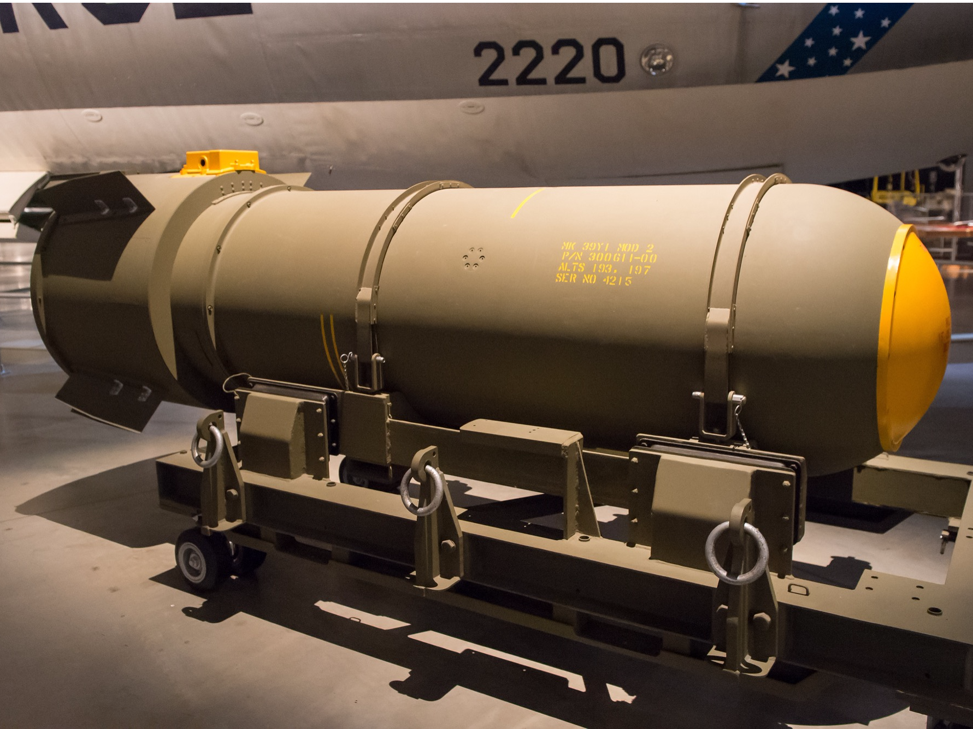A model of a Mark 39 (MK 39) hydrogen bomb on display at the National Museum of the USAF. Mark Mauno/Flickr (CC BY 2.0)
Each Mark 39 thermonuclear bomb was about 12 feet long, weighed more than 6,200 pounds, and could detonate with the energy of 3.8 million tons of TNT. Such a blast could kill everyone and everything within a diameter of about 17 miles — roughly the area inside the Washington, DC, beltway.
But the jet airplane and three of its crew members never returned to base, and neither did a nuclear core from one of the bombs.
The plane broke up about 2,000 above the ground, nearly detonating one of the bombs in the process.
Had the weapon exploded, the blast would have packed about 250 times the explosive power of the bomb dropped on Hiroshima.

Broken arrow over North Carolina
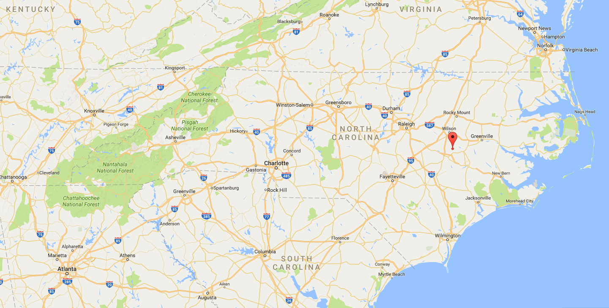The bombs fell onto (and into) a Faro, North Carolina farm. Google Maps
A major accident involving a nuclear weapon is called a "broken arrow," and the US military has officially recognized 32 of them since 1950.
A mysterious fuel leak, which the crew found out as a refueling plane approached, led to the broken arrow incident over North Carolina in 1961.
The leak quickly worsened, and the jet bomber "lost its tail, spun out of control, and, perhaps most important, lost control of its bomb bay doors before it lost two megaton nuclear bombs," according to a two-part series about the accident by The Orange County Register newspaper. "The plane crashed nose-first into a tobacco field a few paces away from Big Daddy Road just outside [Goldsboro], N.C., about 60 miles east of Raleigh."
One of two 3.8-megaton Mark 39 thermonuclear bombs recovered after the Goldsboro incident of 1961. USAF
One bomb safely parachuted toward the ground and snagged on a tree. Crews quickly found it, inspected it, and moved it onto a truck.
However, the parachute of the other bomb failed, causing it to slam into a swampy, muddy field and break into pieces. It took crews about a week of digging to find the crumpled bomb and most of its parts.
The military studied the bombs and learned that six out of seven steps to blow up one of them had engaged, according to the Register. Only one trigger stopped a blast — and that switch was set to "ARM," yet somehow failed to detonate the bomb.
It was only "by the slightest margin of chance, literally the failure of two wires to cross, a nuclear explosion was averted," said Robert McNamara, the US secretary of defense at the time, according to a declassified 1963 memo.
"Had the device detonated, lethal fallout could have been deposited over Washington, Baltimore, Philadelphia and as far north as New York City — putting millions of lives at risk," according to a 2013 story by Ed Pilkington in the Guardian.
Here's a Nukemap simulation of what might have been the blast radius and fallout zone of the Goldsboro incident:
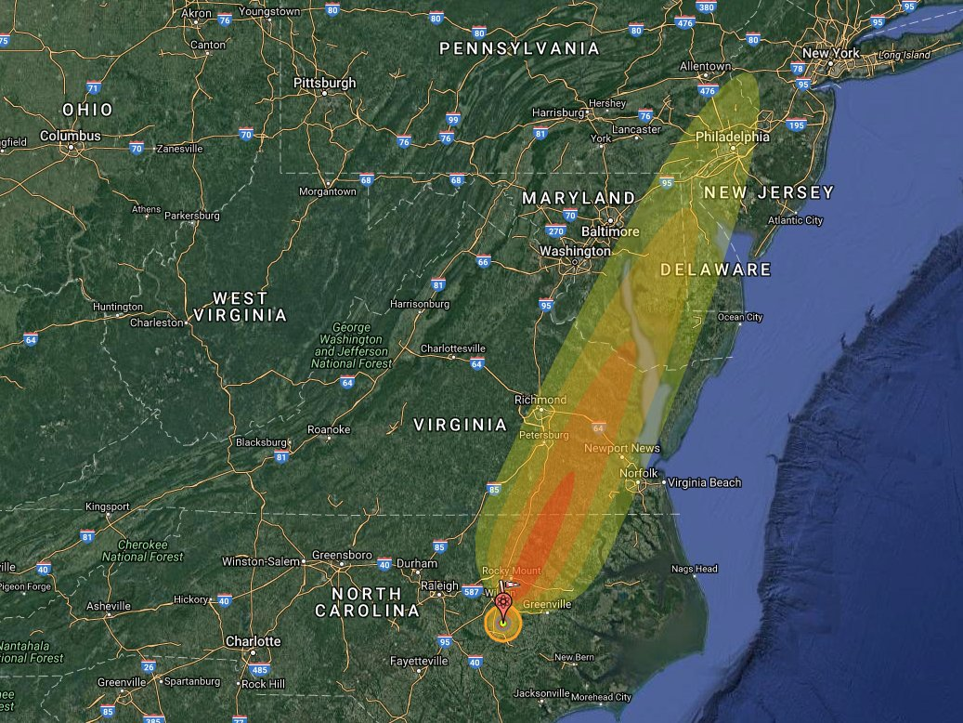The simulated blast radius (small circle) and fallout zone (wider bands) of a 3.8-megaton detonation in Faro, North Carolina. Nukemap; Google Maps

The thermonuclear core no one recovered
Both bombs were a thermonuclear design. So instead of just one nuclear core, these weapons — the most powerful type on Earth — had two nuclear cores.
In the fleeting moments after the first core (called a primary) explodes, it releases a torrent of X-ray and other radiation. This radiation reflects off the inside of the bomb casing, which acts like a mirror to focus it on and set off the secondary core. The one-two punch compounds the efficiency and explosive power of a nuclear blast.
While the US military recovered the entire Goldsboro bomb that hung from a tree, the second bomb wasn't fully recovered: Its secondary core was lost in the muck and the mire.
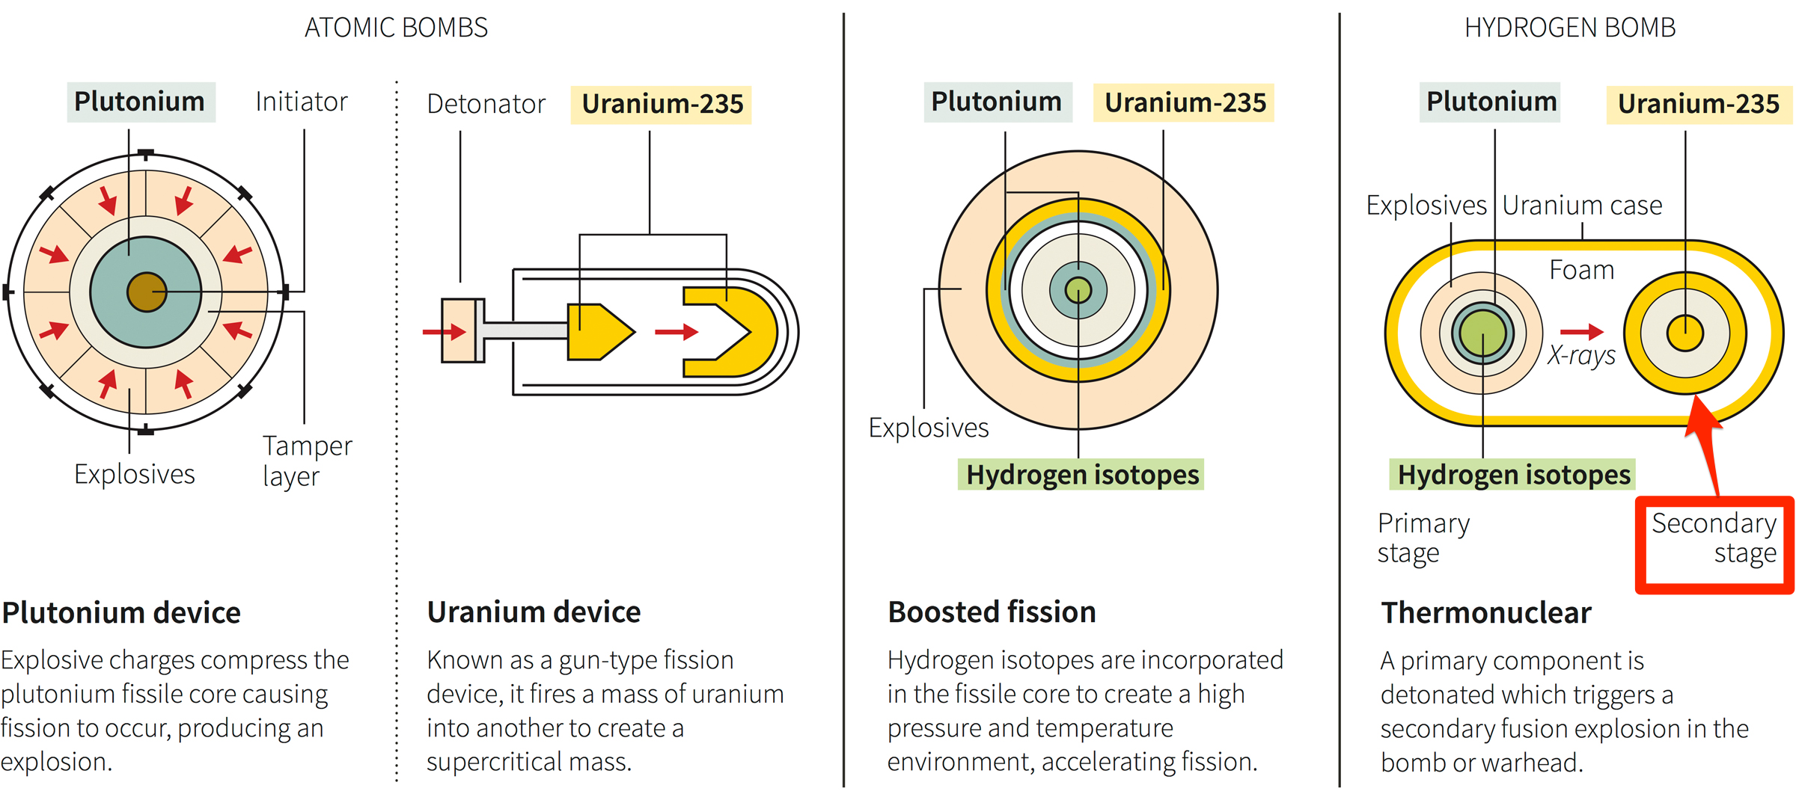The four basic types of nuclear weapons. The 1961 Goldsboro incident lost a secondary core to a hydrogen bomb. Reuters
Reports suggest the secondary core burrowed more than 100 feet into the ground at the crash site — possibly up to 200 feet down.
The missing secondary is thought to be made mostly of uranium-238, which is common and not weapons-grade material (but can still be deadly inside a thermonuclear weapon), plus some highly enriched uranium-235 (HEU), which is a weapons-grade material and a key ingredient in traditional atomic bombs.
Business Insider contacted the Department of Defense (DoD) to learn about the current status of the site and the missing secondary, and a representative said neither the DoD, Department of Energy, or USAF has "any ongoing projects or activities with this site."
The DoD representative would not say whether or not the secondary was still there. However, the representative forwarded some responses by Joel Dobson, a local author who penned the book "The Goldsboro Broken Arrow".
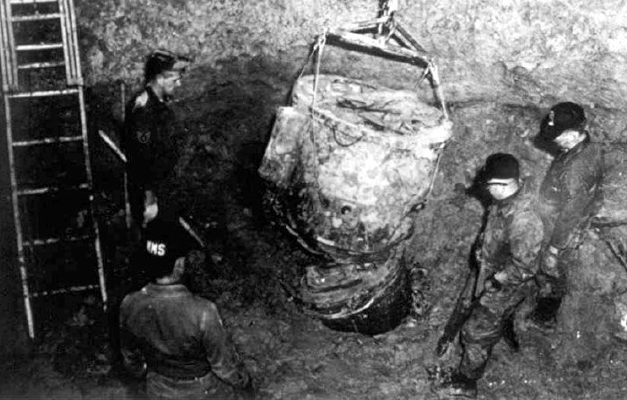One of two 3.8-megaton Mark 39 thermonuclear bombs recovered after the Goldsboro incident of 1961. USAF
"Nothing has changed [since 1961]," Dobson said, according to the DoD email. (Dobson did not return calls or emails from Business Insider.) "The area is not marked or fenced. It is being farmed. The DOD has been granted a 400 foot in diameter easement which, doesn't allow building of any kind but farming is ok."
When asked about the still-missing secondary, Michael O'Hanlon, a US defense strategy specialist with the Brookings Institution, said there should be little to worry about.
"Clearly, having a large part of a nuclear weapon on private land ... is a bit unsettling. That said, I'm not suggesting anyone lose sleep over this," O'Hanlon told Business Insider in an email.
"It would take a serious operation to get at it, requiring tunneling equipment and a fairly obvious and visible approach to the site by some kind of road convoy, presumably," O'Hanlon added. "Moreover, a secondary does NOT have a lot of HEU or plutonium ... which makes it less dangerous because you can't make a nuclear weapon out of it from scratch."
But O'Hanlon at least hopes the DoD and others have thought through "the possibility of someone trying to steal it."
"After all, digging and tunneling equipment has continued to improve over the years — and there is apparently no secret about where this weapon is located," O'Hanlon said. "On balance, I'd rather it not be there — but don't consider it a major national security risk, either."
Russian Checkmate in the Arctic
The commandant of the U.S. Coast Guard issued a stark warning on Wednesday that Russia was leagues ahead of Washington in the Arctic. And while the warming Arctic opens up, the United States could be caught flat-footed while other geopolitical rivals swiftly step in.
Adm. Paul Zukunft, commandant of the U.S. Coast Guard, warned that Russia is building up a huge military and industrial presence in the region while the United States dawdled. Russia is showing “I’m here first, and everyone else, you’re going to be playing catch-up for a generation to catch up to me first,” said Zukunft in remarks before the Center for Strategic and International Studies. “They’ve made a strategic statement,” he said.
Take icebreakers, specialized ships that can punch through thick Arctic ice and ensure access to sea lanes for both commercial and military ships. Russia has 40, while the United States has only two in service today, and only one really available for the Arctic.
As Arctic ice recedes, it’s opening access to a rich bed of natural resources other countries like Russia and China are hungrily eyeing: An estimated 30 percent of the world’s untapped gas reserves, 13 percent of the oil reserves, and $1 trillion in minerals. The United States will struggle to keep other geopolitical rivals from filling the void without a proper Arctic footprint, Zukunft warned.
The Polar Star, the last remaining U.S. heavy icebreaker built in the 1970s, is well past its prime. “Having only one heavy icebreaker … it is the one aspect I lose sleep over,” he said. Zukunft is pushing for funding from Congress to build six new icebreakers by 2023, high aims given the Coast Guard’s rocky start in the federal budget process.
He even said a new icebreaker fleet could need “offensive and defense armed capability” to hedge against any sort of showdown with Russia. But that’s all in the distant future, and if the Polar Star breaks down there’s little left in the U.S. inventory to take its place.
All the while, Russia is slated to launch two ice-breaking corvette ships armed with cruise missiles in the next several years. “We’re not building anything in the Navy surface fleet to counteract that,” Zukunft said.
That doesn’t mean Russia’s buildup is directed at U.S. Arctic territory around Alaska; most of its chess pieces are with its Northern fleet in the west, pointed toward Europe and the Atlantic. “Russia’s Pacific fleet is rather under-resourced compared to the Northern fleet,” said Magnus Nordenman, director of the Atlantic Council’s Transatlantic Security Initiative.
And Russia isn’t only bulking up its Arctic footprint for nefarious geopolitical gains against its former Cold War rival. “Their buildup makes economic sense. It’s a key region for Russia’s economy; 20 percent of its GDP comes out of the Arctic,” Nordenman told Foreign Policy.
Still, Zukunft is worried if things go south in the high north, Russia will have a big leg up on the United States.
“They’ve got all their chess pieces on the board right now, and right now we’ve got a pawn and maybe a rook,” he said. “If you look at this Arctic game of chess, they’ve got us at checkmate right at the very beginning.”
Jobs Jobs Jobs: Really?
For millions of Americans, there’s nothing more frightening than waking up one day and discovering you’re redundant. You’ve suddenly become replaceable, and the world has moved on without you. What are you supposed to do? In all likelihood, you’ve invested many years in a specific career path. You’ve sunk tens of thousands into degrees and certificates. Perhaps you’ve even given up more lucrative jobs to chase a passion.
Then, in one fell swoop, the rug has been pulled out from under you. It’s a scary thought. But for more and more people, it’s becoming a reality. The jobs of today are not the jobs of tomorrow. And the job skills you needed yesterday are not the job skills you need today — or tomorrow.

Jobs and skills
Unfortunately, there’s no easy way to tell which way the economic winds will shift. We have an idea, though. Truck drivers are probably going to be out of work in the near future, for example. And most factory work is being automated. This means a lot of people need to take stock of their experience, skills, and abilities to keep pace.
The first step is to take a look at your resume and purge all of the unnecessary or redundant information. That starts with job skills that no longer apply. If you want the jobs of today or tomorrow, you need to frame yourself as an employee who’s ready for those jobs. There are many ways in which you’ll want to take special care in preparing your resume, but a good place to start is by focusing on the key skills that will get you the job.
Regarding the following skills, unless an employer is specifically looking for them, it’s probably best to leave them off of your CV. Here are 13 job skills employers aren’t looking for anymore.
At this point, Microsoft Office is so ubiquitous that it’s pretty much an expectation you’ll know the basics. At least some familiarity with Word and Excel are going to be expected by most employers. Depending on the job or industry, possibly other programs, such as Powerpoint or OneNote, will be expected, too. If you know these programs, that’s great. But leave it off your CV unless the posting specifically lists them.
This is going to be industry and job-specific, but you’re going to want to purge any outdated programming languages you know. Obviously, this is going to apply to people who work in the tech industry or developers and designers. Most job listings will specify what languages and skills an employer is looking for. List those that you know on your CV, and avoid antiquated ones that might cause an HR manager to raise an eyebrow.
The ability to administer isn’t bad — in fact, it’s a good thing. But it’s not necessarily a skill you’ll want to, or even need to, include on your resume. An employer should be able to tell administration is in your wheelhouse by looking at your experience and background. If leadership is in your bones, your resume should speak for itself.
Again, this isn’t a skill that’s bad to have or that’s even outdated. It’s just something you shouldn’t have to put on your CV. If you’ve worked in customer service positions, your resume will relay that. And if you were bad at it your resume will probably relay that, as well. But if you’re good at customer service, your past job experience will likely speak for itself.
Some of the items on our list so far have basically translated to “I can use a computer.” That’s essentially what you’re saying if you put down “phone” or “fax” — the latter of which you should probably forget all about unless an employer has made it very clear it needs someone who can use a fax machine. It’s assumed you can use a phone, make calls, and do it professionally.
There are jobs in the social media space for which you’ll want to talk about your social media skills. But if you don’t work in a communications role of some kind, it’s best to leave social media off of your skills list. In fact, in most cases, including social media is going to be more of a liability than anything. Make sure your profiles are set to private and that you don’t have any incriminating posts out there that could cost you a job.
Keeping a business’ records intact is important. But it’s yet another role that is becoming increasingly automated. Given the high possibility for human error, more companies are looking to offload bookkeeping tasks to computers. That doesn’t mean we still don’t need bookkeepers. It’s just that you might not want to march into a job or career field that is rapidly evolving.
There’s academic research, and there’s regular run-of-the-mill online research. The latter requires the ability to type something into Google. The former requires much more. And unless you’re applying for an academic position in which you’re doing real, hardcore research, you’re better off leaving “research” or “online research” off your resume. Like many other skills on our list, this is something that’s expected of you.

