Jihad Report
Jun 17, 2017 -
Jun 23, 2017
Attacks | 39
Killed | 317
Injured | 556
Suicide Blasts | 12
Countries | 15
Democrats Block Certain Witnesses from Testifying Before Committee
But Democrats on the committee blocked the testimony, asserting they needed more time to prepare.
"He's the guy that many Democrats have been pointing to as the supposed mastermind and you would think they were interested hearing his story," said one Capitol Hill official.
Rep. Adam Schiff (Calif.), the committee's Democratic leader, did not respond to emails seeking comment on the blocked testimony.
Schiff has asserted in the past that evidence of collusion between Russia and the Trump campaign is "more than circumstantial," contrary to other intelligence and congressional oversight members who have said there is no evidence.
On Sunday, Schiff appeared to back off his earlier comments somewhat. Pressed on ABC News to explain the nature of the evidence of collusion, the lawmaker said: "Well, I think there is evidence. I can't go into the particulars of our closed investigation. But I also think there is also evidence of obstruction. But in both cases, I would say, whether there is some evidence doesn't mean there is proof beyond a reasonable doubt."
Schiff was referring to obstruction of justice charges against President Trump. His mention highlights a new tactic adopted by Democratic critics of the president regarding the Russian investigation: playing down charges of alleged collusion while playing up claims of a cover up.
"The same people that say that there's no evidence of collusion say there's no evidence of obstruction," Schiff said Sunday, noting claims presidents cannot be charged with that crime. "I don't buy that," he said.
Schiff told ABC that the allegations of collusion are focused on Russian hacking of private emails and making them public, and that Russians were working with Trump campaign staff and coordinated the influence operation. "But I'm not prepared to say that there's proof you could take to a jury," he said. "But I can say that there is enough that we ought to be investigating."
Schiff was not asked about why witnesses have not appeared before the panel but said the committee is "far closer to the beginning of the investigation than we are to the end"—suggesting Democrats plan to draw out the probe for many months.
The FBI has been investigating charges of Russia-Trump campaign collusion since July, based in part on a controversial private intelligence dossier produced by former British intelligence officer Christopher Steele.
Many of the dossier's claims, including charges that Page met with Russian intelligence figures, have been debunked.
In addition to Page, the House wants to hear from several current and former intelligence and law enforcement officials, including fired FBI Director James Comey and Adm. Mike Rogers, director of the National Security Agency.
Paul Manafort, who served for a time as Trump's campaign manager, also has said he is willing to testify before the House panel. Another figure in the controversy, former Trump adviser Roger Stone, also expressed an interest in testifying in a public hearing in March.
Page, however, was the only witness who had been scheduled to appear before Democrats blocked the testimony.
The House committee is also investigating whether the Obama administration improperly requested the unmasking of Americans' identities that were kept secret in classified transcripts of communications intercepts.
On May 31, the committee subpoenaed records from the FBI, CIA, and NSA related to requests for the identities of Americans caught up in foreign intelligence surveillance. The request is related to unmasking requests made by White House National Security Adviser Susan Rice, former CIA Director John Brennan, and former U.S. Ambassador to the United Nations Samantha Power.
Some records have been supplied to House investigators, but more information is being sought by the panel.
Additionally, the House panel announced it has issued subpoenas to Trump's former White House National Security Adviser, Michael Flynn, and Trump's personal lawyer, Michael Cohen.
The Senate intelligence oversight committee has heard testimony from former FBI Director James Comey and Attorney General Jeff Sessions.
Page, head of the firm Global Energy Capital, told the Washington Free Beacon he was disappointed by the failure to permit him to testify.
"This has been like remaining defenseless in a battle against kamikaze special attack squadrons with dozens of bombers," he said. "In blocking my open testimony, they seem committed to covering up the extreme disgrace of the Obama administration's secret FISA warrants and influential propaganda tactics which unsuccessfully tried to rig the 2016 election."
Page outlined what he plans to tell Congress in testimony in four letters sent to the House and Senate intelligence oversight panels between May 22 and June 8.
The letters reveal Page was set to appear before the committee on June 6 and urged that some of his testimony be public.
"In support of that forthcoming appearance, I have recently been in contact with Deputy Attorney General Rod Rosenstein, Special Counsel Robert Mueller, and other Justice Department officials regarding the multiple outstanding requests for immediate release of the illegitimate FISA warrants that were allegedly filed by the Obama Administration against me in 2016," Page said in the May 22 letter. He was referring to Foreign Intelligence Surveillance Court warrants reportedly issued.
Page denied any improper interaction between himself and Russian business or government officials.
Instead, he is charging that the Obama administration engaged in a political intelligence-gathering operation targeting Trump and his associates.
Page stated that he had no role in any government active-measures operations involving the election, but that he discussed the release of hacked documents with two officials of the state-run Russian RT television network.
"The only discussion I can recall where WikiLeaks even tangentially came up with any Russian occurred on the afternoon of Monday, October 24, 2016," he stated.
"In the moments before recording a TV interview at RT's studios in London where I was visiting for a few days on my way to Johannesburg, the host and staff mentioned in passing that the news they saw about WikiLeaks in the U.K. papers seemed like it might potentially be interesting. However, they anecdotally noted in passing that it was unfortunate that there was no way to efficiently sort through the high number of documents which had been released. Based on this limited verbal interaction, it seems unlikely that Russian entities such as this television network were in any way directly involved in the WikiLeaks cyber activity," Page said.
Noting he has had extensive business contacts with Russians since 1991, Page said he "personally saw no active measures by the Russian government or other foreign entities to interfere in any political campaigns whatsoever—neither last year nor at any point throughout my life."
A U.S. intelligence assessment made public in January charged that Russia had engaged in a cyber-enabled influence operation during the 2016 campaign targeting the U.S. democratic system and aimed at denigrating Democratic nominee Hillary Clinton.
The FBI, CIA, and NSA were divided on the level of confidence their analysts had regarding whether the Russians conducted the operation with a clear preference for Trump. FBI and CIA had high confidence, while NSA voiced moderate confidence.

Maxine Waters is Functionally Illiterate Along with 63% of her Voters
More than six in 10 Hispanic immigrants and 41 percent of all immigrants are functionally illiterate with the English language, according to a study by the Center for Immigration Studies (CIS). Further, 43 percent of immigrants who have been in the U.S. for 15 years or more also are functionally illiterate.

Other results from the CIS research:
•63 percent of Hispanic immigrants are illiterate in English.
•44 percent of Hispanic immigrants who self-report speaking English "well" or "very well" are actually illiterate in English.
•22 percent of children of Hispanic immigrants are below basic levels in English.
•Just 5 percent of second-generation Hispanic immigrants have elite literacy skills.

CIS also found that 67 percent of Hispanic immigrants who have been in the U.S. for 15 years or more are illiterate in English. That result "reveals an important observation: Immigrants who had poor English skills upon arrival still have poor English skills more than 15 years later," CIS reported.

The study surveyed 8,000 Americans between the ages of 16 and 74. The literacy test measures the English ability of a representative sample of adults living in U.S. households between 2012 and 2014. The test is strictly in English, meaning people whose English is weak will perform poorly, even if they are literate in another language.

Rep. Maxine Waters (D-Calif.) says she is putting her “career on the line” to speak out against President Trump.

At a gala hosted by EMILY’s list, a PAC that aims to elect female Democrats who support abortion rights, Waters said she has seen a boost in support from younger voters because of her “resistance to Trump,” the Washington Examiner reported.

She also noted a surge in social media following — she said she recently went from 46,000 followers to more than 300,000 on Twitter.

ADVERTISEMENT
The California Democrat said that although she enjoys wide support in the district she represents, “there are many who do not like what I’m doing.”
“But I've decided that no matter those who do dislike what I'm doing, no matter those who disagree with me, I feel absolutely certain that this country deserves better than Donald Trump

," she said, according to the Examiner.

She also lashed out at the president during her address at the event, calling him a “disgusting, poor excuse of a man” and pushing for his impeachment.

“We must take our anger, our pain, our collective strength to right this wrong, to resist this tyranny and to save our democracy from a man whose immoral character and distorted thinking are an imminent threat to our nation,” she said.

MSNBC anchor Peter Alexander took Rep. Maxine Waters (D-Ca.) to task over her past statement about FBI Director James Comey and how they didn’t quite fit with her current stance of outrage after his firing at the hands of President Trump. The interview was conducted Wednesday.
“You obviously have been very critical of James Comey in the past,” Alexander asked, “you said that he had ‘no credibility,’ I assume you support the president’s decision then, to fire his FBI director.”
Comey Chameleon and FBI Now Sued for Obstruction

Robert Mueller’s anti-Trump army has just been dealt a death blow. A former contractor for several federal agencies and his attorney, who both sued former FBI Director James Comey claiming he obstructed justice by burying an investigation into the mass surveillance of Americans, are asking a federal court for a protection order preventing the destruction of evidence in the case.
The plaintiffs are Dennis Montgomery – a whistleblower who worked as a contractor for the National Security Agency, the Central Intelligence Agency and the director of national intelligence – and his lawyer, Larry Klayman of Freedom Watch.
They have filed in U.S. District Court in Washington a motion for a temporary restraining order and a preliminary injunction.
They are asking the court to prevent the defendants, including Comey, the FBI and other federal officials mostly under the Obama administration, from continuing “illegally and unconstitutionally spying on and surveilling millions of Americans, including plaintiffs, without probable cause or a warrant.”
Secondly, they are asking the court to prevent the defendants from “destroying evidence of illegal and unconstitutional spying” that Montgomery turned over the Comey based on the promise it was going to be investigated. Justice has definitely been obstructed, but if this evidence is destroyed, then the finger will point at Trump and not at the agents who actually stopped justice from being served.
These objectives can be reached with a temporary restraining order and a preliminary injunction, they explain. Usually, time is of the essence in these cases, because secrecy and industrial shredding is crucial to pulling this off. Susan Rice was able to get hundreds of thousands of pages of incriminating evidence trucked out of the National Security Agency, where she was the director under Obama, and straight over to the Obama Library where it cannot be reached by Freedom of Information Act lawsuits. Unless the President acts soon, the evidence will be lost, and the entire Clinton Crime Syndicate will have gotten away with murder, once again!
The promised “investigation” was buried personally by Comey, and the evidence now is in danger of being destroyed forever, they allege.
Defendants in the case include Comey, who famously took with him government records when he was fired recently by President Trump, then turned them over to a friend with instructions to leak them to the media to instigate interest in a special prosecutor over claims of links between the Trump campaign and Russia – an investigation that to date has yielded no evidence.
Other defendants are the FBI, Michael Rogers, the NSA, John Brennan, Mike Pompeo, the CIA, James Clapper, Dan Coats and Obama. It remains to be seen if the injunction will be granted by the Court.
They were accused in the original lawsuit, filed only a few weeks ago, of “illegally and unconstitutionally spying on and surveilling millions of Americans, including plaintiffs, without probable cause or a warrant, and … destroying evidence of illegal and unconstitutional spying turned over to defendant Comey and the FBI by plaintiff Montgomery.” There were no warrants, FISA or otherwise, and the unmasking of American names and then sharing those names with the press is a felony punishable by 10 years in prison.
The defendants, the motion explains, “have engaged in an ongoing conspiracy to illegally and unconstitutionally spy on millions of Americans, including plaintiffs, without probable cause or a warrant.”
The motion alleges the illegal spying continues. The seriousness of these crimes is so severe, that it has become clear that the defendants will kill rather than be indicted. That brings up another colossal blunder by the Dept of Justice. WHY in God’s name have they not impaneled a Grand Jury? Why is there not a Grand Jury hearing this evidence?
Klayman, in the motion, points out that the same Washington court, in an earlier case, issued two preliminary injunctions, including one that “bars the government from collecting … any telephone metadata associated with these plaintiffs’ Verizon Business Network Services accounts.”
The new lawsuit alleges misbehavior by Comey and others when Montgomery “was induced by Defendants Comey and the FBI and made to turn over 47 hard drives of evidence of the aforementioned illegal, unconstitutional activity, which hard drives alone are valued in excess of $50,000.
“Indeed, counsel for Montgomery, plaintiff Klayman, was told and assured by the former general counsel of the FBI, James Baker, that defendant Comey was taking ‘hands on’ supervision and conducting the FBI’s Montgomery investigation, given its importance.”
Much of the information was classified and Klayman never saw it, “which is why the information was given to defendant Comey and the FBI to begin with,” he explained.
“As a result, on or about December 21, 2015, plaintiff Montgomery interviewed under oath at the FBI field office in the District of Columbia. There, over the course of an over three-hour interview, recorded on video, with special agents Walter Giardina and William Barnett, plaintiff Montgomery meticulously laid out the NSA, CIA, DNI’s, and the other defendants’ – particularly defendants Clapper and Brennan’s – pattern and practice – of conducting illegal, unconstitutional surveillance against millions of Americans, including prominent Americans such as the chief justice of the U.S. Supreme Court, other justices, 156 judges, prominent businessmen, and others such as Donald J. Trump …”
Klayman explained it is alleged that Comey, “in concert with the other defendants,” buried an FBI investigation into Montgomery’s whistleblower claims, essentially obstructing justice.
“Having asked the intelligence and judiciary committees in Congress to investigate the alleged obstruction of justice, and their having not taken action to date, Mr. Montgomery and I, on behalf of ourselves, had to take matters into our own legal hands. This mass surveillance, which threatens the privacy of all innocent Americans, must be ordered to cease forthwith, as it endangers our democracy and our republic,” Klayman said.
The latest move comes after Circa News reported, according to Klayman, that the FBI “has illegally shared raw intelligence about Americans with unauthorized third parties and violated other constitutional privacy protections, according to newly declassified government documents that undercut the bureau’s public assurances about how carefully it handles warrantless spy data to avoid abuses or leaks.”
“Once-top secret U.S. intelligence memos reviewed by Circa tell a different story, citing instances of ‘disregard’ for rules, inadequate training and ‘deficient’ oversight and even one case of deliberately sharing spy data with a forbidden part.”
The new motion explains that Montgomery’s testimony and evidence documented how the rogue federal officials conducted surveillance and then covered it up.
The filing argues the plaintiffs are entitled to the court’s protection, since courts previously have found that even a minimal deprivation of constitutional rights is a major injury.
The Democrat Espionage Team
A secretive Washington firm that commissioned the dubious intelligence dossier on Donald Trump is stonewalling congressional investigators trying to learn more about its connections to the Democratic Party.
The Senate Judiciary Committee earlier this month threatened to subpoena the firm, Fusion GPS, after it refused to answer questions and provide records to the panel identifying who financed the error-ridden dossier, which was circulated during the election and has sparked much of the Russia scandal now engulfing the White House.

SEE ALSO

Intel chiefs told Trump that Russia has dirt on him

What is the company hiding? Fusion GPS describes itself as a “research and strategic intelligence firm” founded by “three former Wall Street Journal investigative reporters.” But congressional sources say it’s actually an opposition-research group for Democrats, and the founders, who are more political activists than journalists, have a pro-Hillary, anti-Trump agenda.
“These weren’t mercenaries or hired guns,” a congressional source familiar with the dossier probe said. “These guys had a vested personal and ideological interest in smearing Trump and boosting Hillary’s chances of winning the White House.”
Fusion GPS was on the payroll of an unidentified Democratic ally of Clinton when it hired a long-retired British spy to dig up dirt on Trump. In 2012, Democrats hired Fusion GPS to uncover dirt on GOP presidential nominee Mitt Romney. And in 2015, Democrat ally Planned Parenthood retained Fusion GPS to investigate pro-life activists protesting the abortion group.
More, federal records show a key co-founder and partner in the firm was a Hillary Clinton donor and supporter of her presidential campaign.
In September 2016, while Fusion GPS was quietly shopping the dirty dossier on Trump around Washington, its co-founder and partner Peter R. Fritsch contributed at least $1,000 to the Hillary Victory Fund and the Hillary For America campaign, Federal Election Commission data show. His wife also donated money to Hillary’s campaign.
Property records show that in June 2016, as Clinton allies bankrolled Fusion GPS, Fritsch bought a six-bedroom, five-bathroom home in Bethesda, Md., for $2.3 million.
Fritsch did not respond to requests for comment. A lawyer for Fusion GPS said the firm’s work is confidential.
Sources say Fusion GPS had its own interest, beyond those of its clients, in promulgating negative gossip about Trump.

More On:

2016 presidential election

Russia recalls ambassador at center of collusion allegations against Trump campaign: report

Trump blasts Russia probes, says Clinton 'colluded' with Dems to bury Sanders

Trump doesn't have tapes of conversations with Comey

Intel officials say Trump wanted them to deny Russia collusion claims
Fritsch, who served as the Journal’s bureau chief in Mexico City and has lectured at the liberal Wilson Center’s Mexico Institute, married into a family with Mexican business interests. His wife, Beatriz Garcia, formerly worked as an executive at Grupo Dina, a manufacturer of trucks and buses in Mexico City that benefits from NAFTA, which Trump opposes.
Fritsch’s Fusion GPS partner Thomas Catan, who grew up in Britain, once edited a business magazine in Mexico, moreover. A third founding partner, Glenn Simpson, is reported to have shared dark views of both Russian President Vladimir Putin and Trump. Before joining Fusion GPS, Simpson did opposition research for a former Clinton White House operative.
The Senate Judiciary Committee is also investigating whether the FBI has wrongly relied on the anti-Trump dossier and its author, Christopher Steele — the old spy who was hired by Fusion GPS to build a Russia file on Trump — to aid its ongoing espionage investigation into the Trump campaign and its possible ties to Moscow.
The FBI received a copy of the Democrat-funded dossier in August, during the heat of the campaign, and is said to have contracted in October to pay Steele $50,000 to help corroborate the dirt on Trump — a relationship that “raises substantial questions about the independence” of the bureau in investigating Trump, warned Senate Judiciary Chairman Chuck Grassley, R-Iowa.
Senate investigators are demanding to see records of communications between Fusion GPS and the FBI and the Justice Department, including any contacts with former Attorney General Loretta Lynch, now under congressional investigation for possibly obstructing the Hillary Clinton email probe, and deputy FBI director Andrew McCabe, who is under investigation by the Senate and the Justice inspector general for failing to recuse himself despite financial and political connections to the Clinton campaign through his Democrat activist wife. Senate investigators have singled out McCabe as the FBI official who negotiated with Steele.
Like Fusion GPS, the FBI has failed to cooperate with congressional investigators seeking documents.
Steele contracted with Fusion GPS to investigate Trump’s ties to Russia starting in June 2016, whereupon he outlandishly claimed that Hillary campaign hackers were “paid by both Trump’s team and the Kremlin” and that the operation was run out of Putin’s office. He also fed Fusion GPS and its Hillary-allied clients incredulous gossip about Trump hating the Obamas so much that he hired hookers to urinate on a bed they slept in at the Moscow Ritz-Carlton, and that Russian intelligence recorded the pee party in case they needed to blackmail Trump.
Modal TriggerAP
Never mind that none of the rumors were backed by evidence or even credible sourcing (don’t bother trying to confirm his bed-wetting yarn, Steele advised, as “all direct witnesses have been silenced”). Steele reinforced his paying customers’ worst fears about Trump, and they rewarded him for it with a whopping $250,000 in payments.
But it’s now clear his “intelligence reports,” which together run more than 35-pages long, were for the most part worthless. And the clients who paid Fusion GPS (which claims to go “beyond standard due diligence”) for them got taken to the cleaners.
Steele’s most sensational allegations remain unconfirmed. For instance, his claim that Trump lawyer Michael Cohen held a “clandestine meeting” on the alleged hacking scheme in Prague with “Kremlin officials” in August 2016 unraveled when Cohen denied ever visiting Prague, his passport showed no stamps showing he left or entered the US at the time, witnesses accounted for his presence here, and Czech authorities found no evidence Cohen went to Prague.
Steele hadn’t worked in Moscow since the 1990s and didn’t actually travel there to gather intelligence on Trump firsthand. He relied on third-hand “friend of friend” sourcing. In fact, most of his claimed Russian sources spoke not directly to him but “in confidence to a trusted compatriot” who, in turn, spoke to Steele — and always anonymously.
But his main source may have been Google. Most of the information branded as “intelligence” was merely rehashed from news headlines or cut and pasted — replete with errors — from Wikipedia.
In fact, much of the seemingly cloak-and-dagger information connecting Trump and his campaign advisers to Russia had already been reported in the media at the time Steele wrote his monthly reports.
In the same August report, for example, Steele connected a Moscow trip taken by then-Trump campaign adviser Michael Flynn to “the Russian operation” to hack the election. But there was nothing secret about the trip, which had taken place months earlier and had been widely reported.
And there was nothing untoward about it. It was a dinner celebrating the 10th birthday of Russian TV network RT, and Flynn sat at the same table with Putin as US Green Party presidential candidate Jill Stein.
The real question is why anyone would take anything in the sketchy report seriously.
But even the CIA gave it credence. The dossier ended up attached to a Top Secret intelligence briefing on Russia for President Obama, even though his intelligence czar last month testified “We couldn’t corroborate the sourcing.” The FBI, moreover, has been using it for investigative leads on Trump associates like Carter Page, even though former FBI Director James Comey this month described the dossier as “salacious and unverified.”
And of course, Democratic leaders in Congress keep referring to it to cook up more charges against Trump, while liberal media continue to use it as a road map to find “scoops” on Trump in the “Russiagate” conspiracy they’re peddling — still hoping against hope that the central thrust of the report — that Trump entered into an unholy alliance with the Russian government during the election — will one day prove true and bring about the downfall of his presidency.

The Religion of Peace

Islamic extremists killed more than 1,620 people during this year’s holiest month for Muslims, marking one of the deadliest Ramadans in modern history, reveals a Breitbart News tally.
The large majority of Ramadan violence victims are Muslims.
At the end of Ramadan on Saturday, the total number of casualties across the world for the entire holy month had reached 3,451 (1,627 murders and 1,824 injuries), more than tripling the 1,150 (421 deaths and 729 injuries) that took place in 2016, considered the deadliest holy month in recent memory.
The 1,627 fatalities this year nearly quadrupled the estimated 421 deaths last year. There were an estimated 160 terror incidents in nearly thirty predominantly Muslim countries during Ramadan 2017.
On the annual Muslim festival of Eid ul Fitr that marked the end of Ramadan Saturday, jihadists attempted to attack Islam’s most sacred Grand Mosque in Mecca, Saudi Arabia, which surrounds the holiest place for Muslims — the Kabaa.
Saudi security troops thwarted the attack, but one of the suspects in the planned assault blew himself up, injuring six foreigners and five of the Sunni kingdom’s forces.
Between Friday and Saturday, Islamic extremists killed 141 people and injured 387 others. The majority the casualties (84 deaths and 282 injuries) took place in Pakistan, which the Pentagon has labeled a jihadi sanctuary.

The Islamic State (ISIS/ISIL) issued multiple messages urging its sympathizers and followers to carry out deadly attacks during Ramadan, namely in the United States, Europe, Russia, Australia, Iraq, Syria, Iran, and the Philippines.
Except for Russia, jihadists carried out attacks in all of the listed locations during the holy month.
Consistent with the years since the group surfaced in 2014, ISIS, including its Boko Haram affiliate, takes the grim title of the world’s most prolific terrorist group during Ramadan 2017, carrying out more attacks than any other jihadist organization.
ISIS-linked jihadists were behind an estimated 60 of the 160 terror incidents (about 40 percent) during Ramadan.
The Taliban, as well as al-Qaeda and its offshoots, has also been involved in the killing and murder of mainly fellow Muslims.
During Ramadan, the majority of Muslims follow the tradition of abstaining from eating, drinking, smoking, having sex, and other physical needs each day, starting from before the break of dawn until sunset.
However, extremists perceive Ramadan as a time when martyrdom and jihad are especially rewarded in paradise, prompting a spike in the terrorist attacks during the period every year.
Islamic extremist groups encourage martyrdom among their sympathizers and followers, promoting the belief that they will be doubly rewarded if they fatally castigate infidels during Ramadan.
In previous years, the fatalities have included women, children, and members of the Christian minority. This year is no exception.
Although Muslims of all sects make up the majority, there are members of a wide variety of ethnic and religious groups among the victims: Westerners of all ethnicities, Christians, Asians, Sunnis, Shiites, and Arabs, among others.
The West, including the United States, has not been immune to the Ramadan carnage this year.
Breitbart News’ count, gleaned from the Religion of Peace website in coordination with news reports, excludes casualties directly linked to battles between U.S.-led coalition and Iranian- and Russian-backed troops loyal to dictator Bashar al-Assad.
Except for some attacks outside battle zones involving civilian casualties, most deaths and injuries in Syria were excluded from Breitbart News’ count. The total number of Ramadan deaths and injuries could be higher.

DNC Killing Off Witnesses in Seth Rich Murder Investigation

Lawyers and plaintiffs suing the Democratic National Committee for rigging the 2016 presidential election say they’re being harassed with threatening messages and “freaky” encounters and they fear for their safety – particularly in the wake of the mysterious and unsolved murder of DNC staffer Seth Rich – but a federal court has denied their request for protection.
“We filed the motion because we do feel that not only us, but our staff and the plaintiffs, are deserving of a motion,” attorney Elizabeth Beck, who is litigating the case, told WND. “But our court system does not have the resources to do so.”
She continued: “The court, in denying our motion for protection, stated in its order that the federal Marshals Service doesn’t have enough resources to devote that amount of protection.”
A trove of DNC emails made public by WikiLeaks throughout the 2016 presidential election revealed top DNC officials privately conspiring to undermine candidate Bernie Sanders’ campaign, ultimately resulting in Rep. Debbie Wasserman-Schultz resigning from her post as DNC chairwoman in July 2016.
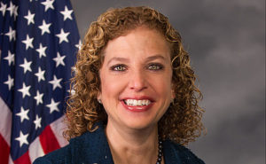
Debbie Wasserman Schultz
Jared Beck and Elizabeth Lee Beck filed a class-action lawsuit against Wasserman-Schulz and the Democratic National Committee last summer, charging that the DNC committed “fraud” in favoring Clinton over Sanders during the Democratic Party primaries. The Becks are seeking damages for Democratic Party donors and voters. They’re demanding the party repay individuals and Sanders supporters who were duped by the party’s 2016 primary and alleging misappropriation of funds.
‘2 potential witnesses in my case … both died’
On June 13, the Becks filed the motion for order of protection in the U.S. District Court in Florida. They asked Judge Zloch to provide court protection to the plaintiffs, their counsel and their families, as well as all of the witnesses in the DNC fraud lawsuit.
In support of the motion, they cited the unusual deaths of Seth Rich, DNC lawsuit process server Shawn Lucas and and the late Miami federal prosecutor Beranton Whisenant. (It’s unclear what roles, if any at all, Rich or Whisenant have played in the DNC case.) Beck also cited threats and bizarre phone calls the plaintiffs and counsel say they’ve received.
Rich, 27, was a DNC voter expansion data director for two years and had accepted a position with Hillary Clinton’s campaign. He was murdered in Washington, D.C., on July 10, 2016, near his apartment in an affluent neighborhood. Rich was shot twice in the back, and his wallet, credit cards, watch and phone were left in his possession. The Metropolitan Police Department has described it as a “botched robbery.”
Private investigators, however, have claimed there is evidence Rich was the source WikiLeaks used to obtain thousands of DNC emails released on the eve of the party’s presidential nominating convention last July. The emails, indicating the party was manipulating the primary race in favor of Clinton, led to Wasserman Schultz’s resignation.
“We believe Mr. Rich might have been a potential witness in this case,” Jared Beck said in a video announcing the protection request.
Jared Beck also tweeted on May 29: “If #DNCFraudLawsuit proceeds, DNC employee Seth Rich would’ve been potential witness. One reason why I’m so concerned what happened to him.”
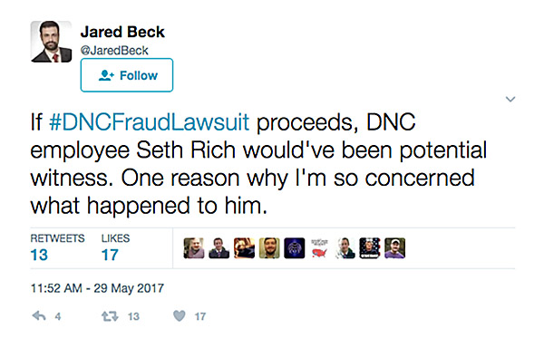
Less than a month after Rich was murdered, attorney Shawn Lucas, 38, was found dead in his bathroom. Lucas served the DNC with the lawsuit in early July 2016. According to Heavy, the Office of Chief Medical Examiner of Washington, D.C., said in November 2016 that Lucas’ Aug. 2 death was accidental and was caused by the “combined adverse effects of fentanyl [a synthetic opioid pain medication], cyclobenzaprine [a muscle relaxant], and mitragynine [better known as kraton].”

Rich and Lucas are both on WND’s list of 33 people associated with the Clintons who have died mysterious and often violent deaths.
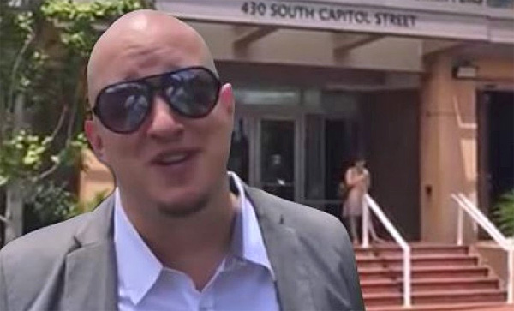
Attorney Shawn Lucas (Photo: Screenshot)
Beranton Whisenant Jr., 38, was a federal prosecutor who handled mostly immigration-related cases. He was found dead last month in Hollywood, Florida, which is in Debbie Wasserman Schultz’s district. Police say he might have died as a result of a possible gunshot wound to the head or other type of trauma.
Beck refused to speculate on whether any of the deaths might have been politically motivated murders, but she said the timing is suspicious.
“Rich [was] a potential witness in my case,” she said. “All I’m saying is, two potential witnesses in my case – Shawn Lucas was my process server – they both died. Why they died, how they died, I don’t know. Mr. Lucas was about to provide evidence to the court in this case, on service of process, when he very, very suddenly passed away.
“Seth Rich, he was an employee of the DNC, and he was murdered. Nothing was taken from him. They first said it was a botched robbery, but nothing was taken from him. You can ask anybody that grew up in a large urban area – I’ve gotten robbed – they usually take something.”
WND has launched a GoFundMe campaign to get to the bottom of the Seth Rich murder. You can personally help us get to the truth of what really happened.
‘Freaky’ calls, harassment and tampering
Meanwhile, Beck and her employees have been receiving “freaky” calls, she told WND.
“My co-counsel, Collin O’Brian – all the time he’s been getting emails and phone calls from anonymous people causing a lot of stress on him and his family,” she said. “Anonymous people are calling up Collin, talking about Mr. Whisenant. It’s not a call for information, it’s very freaky. These callers sound angry, ranting, talking about how they don’t like lawyers, and they mention Beranton Whisenant.”
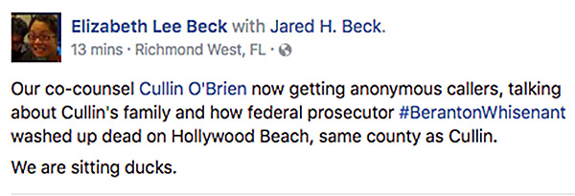
Facebook post by Elizabeth Beck
One of the plaintiffs, Angela Monson, claims in an affidavit to have awakened to her porch door open and both of her computers had been moved and showed evidence of tampering.
Beck said one of her staffers received a strange visit from an individual who asked for her by name. The person left some Democratic Party campaign literature for her, despite the fact that she is not a Democrat and there are no elections currently taking place in Florida.
“Because of those instances, we felt it was incumbent on us to bring this to the court’s attention,” Beck said.
How many people do YOU know who have died mysteriously? Not as many as the Clintons! Check out WND’s explosive report, “‘Clinton death list’: 33 spine-tingling cases.”
On June 1, the Becks filed a motion in court claiming they received a voice-modulated phone call from a number matching Debbie Wasserman Schultz’ office.
“We get this call about two weeks ago. I don’t know who it was; they were using a voice changing technology,” Beck told WND. “The person who answered the call couldn’t even tell if the person was a man or a woman. They were trying to find out information about the lawsuit.
“This number came up. I took a screenshot of it. I filed it in court. If you Google the number, the number is to defendant Congresswoman Debbie Wasserman Schultz’s local Aventura office.”
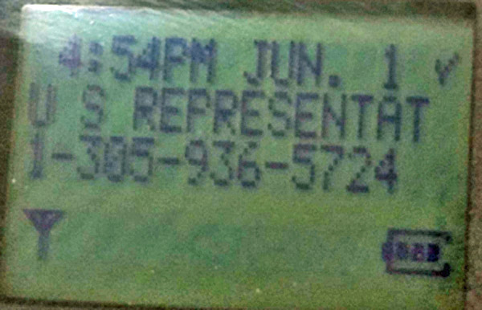
Elizabeth Beck told WND someone called her office using a voice-changing device and inquiring about the DNC lawsuit. She said this phone number, belonging to Rep. Debbie Wasserman Schultz’s Aventura, Florida, office, popped up on the phone’s caller ID (Photo: Beck)
Wasserman Schultz and the DNC’s defense counsel filed a response to the Becks’ submission stating that the congresswoman and her staff had no knowledge of any such call being made, nor was any such call authorized. The document also states that the office in question had been undergoing repairs for several months.

DNC lawsuit: ‘If you lie to somebody, steal from them, that’s a crime’
Current DNC Chairman and former Secretary of Labor Tom Perez, while campaigning to become DNC chairman, admitted in February that the Democratic Party primaries were rigged in favor of Democratic Party nominee Hillary Clinton. He later claimed he “misspoke.”
“The lawsuit is on behalf of three groups of people. One of the groups is folks that donated to the campaign of Bernie Sanders. The second group are people that donated funds to the DNC. The third group is the group of registered Democrats,” Beck explained.
Defending the tactics the party used last year during an April 25 hearing, DNC lawyers explained before Judge William J. Zloch that the party has a right to select candidates through “back-room” deals.
“We could have voluntarily decided that, ‘Look, we’re gonna go into back rooms like they used to and smoke cigars and pick the candidate that way,'” DNC attorney Bruce Spiva argued during the hearing. “That’s not the way it was done. But they could have. And that would have also been their right, and it would drag the court well into party politics, internal party politics to answer those questions.”
Article 4, Section 5 of the DNC charter states: “The chairperson shall exercise impartiality and evenhandedness between the presidential candidates and campaigns. The chairperson shall be responsible for ensuring that the national officers and staff of the Democratic National Committee maintain impartiality and evenhandedness during the Democratic Party presidential nominating process.”
Misleading constituents and donors is “fraud,” Beck charged.
“This was a revelation to the voters – to have that said openly – the Democratic National Committee’s own charter said that it will run the races in a fair and even-handed manner,” she said. “Chairwoman Wasserman Schulz said on national T.V. that they are not biased. So you have it straight from the horse’s mouth. You have it in black and white on a piece of paper. I guess none of that means anything. The Democratic Party made a statement, in absolute terms, that they were running a fair primary, and it looks like that hadn’t been the case. They would probably disagree that choosing a candidate in a backroom deal is the equivalent to rigging. I am sure there are many voters that would disagree.”
Beck continued: “The lawsuit is based on [DNC] fraud. The concept of fraud is very, very old. It’s older than our Constitution. It goes back centuries, and it basically says if you lie to somebody and you steal from them, that’s a crime. At least you can sue them for it.”
While Beck has been inundated with thousands of phone calls from Americans inquiring about the case since her firm filed suit, the mainstream media have not reported on the case at all.
The media are deliberately ignoring the suit, Beck argued, because news organizations like CNN and the New York Times are unabashedly an “apparatus” of the Democratic Party and the Clintons.
“They are not covering this story because they were really quite possibly a part of the apparatus that tried to propel Secretary Clinton into office. … Instead of just reporting, they seem to have been really invested in the outcome – really invested,” she said.
“How do I know that they are invested?” Beck continued. “Because the New York Times interviewed me over a lawsuit in which President Trump was the adverse party, and they were all over that story. And then when I started contacting the reporter, Michael Barboro – my contact at the New York Times – to cover the lawsuit against the DNC, he basically lost his head and blocked me on Twitter.
“Fragile New York Times temperaments. They can’t handle it. Obviously it’s a topic that they really don’t want to touch with a 10-foot pole.”
WND has launched a GoFundMe campaign to get to the bottom of the Seth Rich murder. You can personally help us get to the truth of what really happened.

SCOTUS About to Change Forever

The Supreme Court enters its final week of work before a long summer hiatus with action expected on the Trump administration's travel ban and a decision due in a separation of church and state case that arises from a Missouri church playground.
The biggest news of all, though, would be if Justice Anthony Kennedy were to use the court's last public session on Monday to announce his retirement.
To be sure, Kennedy has given no public sign that he will retire this year and give President Donald Trump his second high court pick in the first months of his administration. Kennedy's departure would allow conservatives to take firm control of the court.
But Kennedy turns 81 next month and has been on the court for nearly 30 years. Several of his former law clerks have said they think he is contemplating stepping down in the next year or so. Kennedy and his clerks were gathering over the weekend for a reunion that was pushed up a year and helped spark talk he might be leaving the court.
"Soon we'll know if rumors of Kennedy's retirement are accurate," one former Kennedy clerk, George Washington University law professor Orin Kerr, said on Twitter Friday.
When the justices take the bench Monday, they are expected to decide the case of Trinity Lutheran Church of Columbia, Missouri, which was excluded from a state grant program to pay for soft surfaces on playgrounds run by not-for-profit groups. The case is being closely watched by advocates of school vouchers, who hope the court will make it easier to use state money to pay for private, religious schooling in states that now prohibit it.
Missouri has since changed its policy under Republican Gov. Eric Greitens so that churches may now apply for the money.
Also expected in the next few days, though there's no deadline by which the court must decide, is a ruling on whether to allow the administration to immediately enforce a 90-day ban on visitors from six mostly Muslim countries.
Justice Neil Gorsuch, Trump's first Supreme Court nominee, could play a pivotal role in both the travel ban and church playground cases.
In all, six cases that were argued between November and April remain undecided. Three of those, all involving immigrants or foreigners, were heard by an eight-justice court, before Gorsuch joined the bench in April.
If the eight justices are evenly divided, those cases could be argued a second time in the fall, with Gorsuch available to provide the tie-breaking vote.
Space X: Space Goes Commercial

One day after putting Bulgaria's first communications satellite into orbit, SpaceX is preparing for a Falcon 9 launch from Vandenberg Air Force Base in California tomorrow (June 25). The rocket will deliver a second batch of next-generation spacecraft for the company Iridium Communications.
Liftoff of SpaceX's ninth mission this year is scheduled for 1:25 p.m. PDT (4:25 EDT/2025 GMT). After sending 10 Iridium satellites on their way to orbit, the rocket's first stage will turn around and attempt to land itself on a drone barge floating in the Pacific Ocean.
The flight is the second of eight missions SpaceX plans for Iridium, which is in the midst of a $3 billion upgrade of its satellite constellation, which provides global, mobile communications services. [SpaceX's Falcon 9: Rocket for the Dragon]
The booster used to deliver the first batch of next-generation Iridium satellites in January flew for a second time yesterday (June 23) to put BulgariaSat-1 into orbit. The satellite was commissioned by Bulgaria Sat, the country's only satellite provider, according the company website.
"We really think this is the way of the future," Bulgaria Sat CEO Max Zayakov told Space.com.
Bulgaria Sat was the second company to take advantage of an earlier launch opportunity and an undisclosed discount SpaceX offered for flying on a pre-flown Falcon.
Iridium CEO Matt Desch said he is open to the idea of using a pre-flown booster, but that he'd prefer to wait a bit to let SpaceX build some flight history with the boosters.
"I believe previously flown boosters are fantastic. I think it's revolutionizing the industry," Desch said during a conference call with reporters before launch. "Our using them or not using them is not a statement [about] the quality or capability of those boosters."
With seven Falcon 9 launches pending in the next 12 months, Iridium is more interested in schedule and reliability than in any financial discounts for using pre-flown boosters, Desch said. He characterized the current discounts as "minor."
"I believe the risk [of using pre-flown rockets] is pretty low right now, but it's not zero, because it's a new thing," he said.
"I'm open to previously flown [rockets], particularly for the second half of our launch schedule, maybe in 2018," Desch added. "Over the coming months … if there are additional launches [of previously flown rockets], I'll reconsider that."
Iridium is replacing its 20-year-old satellite network with next-generation satellites, 75 of which will be launched by SpaceX. The constellation consists of 66 operational spacecraft, nine spares in orbit and five spares to be stored on the ground.
The new spacecraft are faster and more powerful, and, for the first time, will allow worldwide tracking of aircraft in addition to mobile voice and data services.
With a successful launch on Sunday, SpaceX will have surpassed its annual flight record with half the year still to come.
SpaceX has a backlog of more than 70 missions, worth more than $10 billion, company representatives have said. About a dozen more launches are still pending for 2017, including the debut flight of the Falcon Heavy, a 27-engine version of the Falcon 9 (which uses 9 engines).

Star Wars Gets New Direction

- MORE

Credit: Disney/Lucasfilm
Lucasfilm has officially announced Ron Howard is taking over as director of 2018's standalone Han Solo film. Here is their official statement:
***
Lucasfilm is pleased to announce that Academy Award-winning filmmaker Ron Howard has been named director of the untitled Han Solo film.
"At Lucasfilm, we believe the highest goal of each film is to delight, carrying forward the spirit of the saga that George Lucas began forty years ago," said Kathleen Kennedy, president of Lucasfilm. "With that in mind, we're thrilled to announce that Ron Howard will step in to direct the untitled Han Solo film. We have a wonderful script, an incredible cast and crew, and the absolute commitment to make a great movie. Filming will resume the 10th of July."
Howard has made some of the biggest hits and most critically-acclaimed movies of the modern era. Among his many films are Lucasfilm's Willow, Apollo 13, A Beautiful Mind (winner of four Academy Awards, including Best Picture and Best Director), The Da Vinci Code, Frost/Nixon, and Rush. He also narrated and produced the beloved comedy series Arrested Development, starred in George Lucas' American Graffiti, and remains a TV icon for his roles in The Andy Griffith Show and Happy Days.
The untitled Han Solo film is slated for a May 25, 2018, release.
***
Howard replaces the previous team of Phil Lord and Christopher Miller, who were unexpectedly let go from the project earlier this week after several months of filming.
Production officially began on the still-officially untitled film February 20 at Pinewood Studios in London. The film stars Alden Ehrenreich as Han Solo, Donald Glover as Lando Calrissian, along with Woody Harrelson as Beckett, Emilia Clarke, Thandie Newton, Michael K. Williams, Phoebe Waller-Bridge, and Joonas Suotamod as Chewbacca.
Trump: Bringing Back the Gold Standard
Inside President Trump’s otherwise “standard Trump stump speech” at CPAC was nestled what might be a most intriguing observation:
Global cooperation, dealing with other countries, getting along with other countries is good, it’s very important. But there is no such thing as a global anthem, a global currency or a global flag. This is the United States of America that I’m representing.
There's a keen insight in there that could, just maybe, transform our lives, America, and the world. No "global currency?" Was this, with the poetic observation that “there is no such thing as a global anthem…or a global flag,” just a trope? Or could it contain a political portent with potential high impact on world financial markets? Let’s drill down.
As it happens, there is a global currency.
It’s called the "U.S. dollar.”
Most international trade is priced in dollars. The Bretton Woods international monetary system invested the dollar, which then was defined as and (internationally) was legally convertible to gold at $35/oz, with global currency status. France’s then-finance minister, later its president, Valéry Giscard d'Estaing, called the “reserve currency” status of the dollar -- its status, along with gold, as global currency -- an “exorbitant privilege.”
By this d'Estaing was alluding to the fact, as summarized at Wikipedia, that "As American economist Barry Eichengreen summarized: 'It costs only a few cents for the Bureau of Engraving and Printing to produce a $100 bill, but other countries had to pony up $100 of actual goods in order to obtain one.'" That privilege, which made great sense during the period immediately after World War II, became a curse.
In 1971 President Nixon, under the influence of his Svengali-like Treasury Secretary John Connally, "suspend[ed] temporarily the convertibility of the dollar into gold." That closure proved durable instead of temporary. The dollar became, and remains, the world's global currency.
What had been an “exorbitant privilege” devolved into an exorbitant liability. As my former professional colleague John D. Mueller, of the Ethics and Public Policy Center, formerly Rep. Jack Kemp's chief economist, writing in the Wall Street Journal in Trump's Real Trade Problem Is Money recently and astutely observed:

a monetary system based on a reserve currency is unsustainable, since foreign official dollar reserves (for example) are acquired and must be repaid in goods. In other words, the increase in official dollar reserves equals the net exports of the rest of the world, which means it must also equal U.S. international payments deficits—an unsustainable situation.
In other words, if President Trump wishes to address America’s merchandise trade deficit (balanced to perfection, of course, by a capital accounts surplus) he will find that allowing the dollar to be used as the global currency is the real snake in the economic woodpile. The dollar’s burden as the international reserve currency, not currency manipulation by our trading partners or bad treaties, is the true villain in the ongoing melodrama of crummy job creation.

Mueller’s Wall Street Journal column enumerates the three options open to President Trump:
First, muddle along under the current “dollar standard,” a position supported by resigned foreigners and some nostalgic Americans—among them Bryan Riley and William Wilson at the Heritage Foundation, and James Pethokoukis at the American Enterprise Institute.

Second, turn the International Monetary Fund into a world central bank issuing paper (e.g., special drawing rights) reserves—as proposed in 1943 by Keynes, since the 1960s by Robert A. Mundell, and in 2009 by Zhou Xiaochuan, governor of the People’s Bank of China. Drawbacks: This kind of standard is highly political and the allocation of special drawing rights essentially arbitrary, since the IMF produces no goods.
Third, adopt a modernized international gold standard, as proposed in the 1960s by Rueff and in 1984 by his protégé Lewis E. Lehrman …and then-Rep. Jack Kemp.

To “muddle along” would, of course, be entirely antithetical to Trump’s promise to Make America Great Again. It would destroy his crucial commitment to get the economy growing at 3%+ -- vastly faster than it has for the past 17 years -- which also happens to be the recipe for robust job creation and upward income mobility for workers. It also is the essential ingredient for balancing the federal budget while rebuilding our infrastructure and military.

To turn the IMF into a world central bank would, of course, be anathema to Trump’s economic nationalism. To subordinate the dollar to the IMF’s SDR would be equivalent to lowering Old Glory and replacing the American flag with the flag of the United Nations on every flagpole in America. Unthinkable under a Trump administration.
That leaves the third option, to “adopt a modernized international gold standard, as proposed in the 1960s by Rueff and in 1984 by his protégé Lewis E. Lehrman … and then-Rep. Jack Kemp” (whose eponymous foundation I advise). To this one should add, as Forbes.com contributor Nathan Lewis has shrewdly observed, the removal of tax and regulatory barriers to the use of gold as currency.
As I have repeatedly observed Donald Trump shows a strong affinity for gold. He has also shown a keen intuitive grasp of how the gold standard was crucial to having made America great:
Donald Trump: “We used to have a very, very solid country because it was based on a gold standard,” he told WMUR television in New Hampshire in March last year. But he said it would be tough to bring it back because “we don’t have the gold. Other places have the gold.”

Trump’s comment to GQ: "Bringing back the gold standard would be very hard to do, but boy, would it be wonderful. We’d have a standard on which to base our money."
Trump has been misled to believe that “we don’t have the gold. Other places have the gold.” In fact, the United States, Germany, and the IMF together have about as much gold as the rest of the world combined and America has well more than Germany and the IMF combined. [Note: This column has been updated to clarify that the United States has well more gold than Germany and the IMF combined but not, as originally stated, more than twice as much.]

We have the gold. Bringing back the gold standard would not be very hard to do.
Trump's politically unique intuition that “We used to have a very, very solid country because it was based on a gold standard” is no trivial matter. It is true. And as I have written elsewhere:
Marc Levinson writing recently in The Wall Street Journal provides a very pessimistic view for the American Dream, “Why the Economy Doesn’t Roar Anymore: The long boom after World War II left Americans with unrealistic expectations, but there’s no going back to that unusual Golden Age"
[He wrote:]
"People who had thought themselves condemned to be sharecroppers in the Alabama Cotton Belt or day laborers in the boot heel of Italy found opportunities they could never have imagined. The French called this period les trente glorieuses, the 30 glorious years. Germans spoke of the Wirtschaftswunder, the economic miracle, while the Japanese, more modestly, referred to “the era of high economic growth.” In the English-speaking countries, it has more commonly been called the Golden Age.
[…]
"The Golden Age was the first sustained period of economic growth in most countries since the 1920s. But it was built on far more than just pent-up demand and the stimulus of the postwar baby boom. Unprecedented productivity growth around the world made the Golden Age possible. In the 25 years that ended in 1973, the amount produced in an hour of work roughly doubled in the U.S. and Canada, tripled in Europe and quintupled in Japan.
[…]
"Ever since the Golden Age vanished amid the gasoline lines of 1973, political leaders in every wealthy country have insisted that the right policies will bring back those heady days. Voters who have been trained to expect that their leaders can deliver something more than ordinary are likely to find reality disappointing."
Levinson, whose column uses “Golden Age” as its leitmotif, strangely fails to make the connection between, or even explore, the fact that the era he calls the Golden Age correlated precisely with America (and the world) being on a form of gold standard, particularly the modified gold standard known as the Bretton Woods System. (Bretton Woods had the inherent flaw of using the dollar as an international reserve asset but, until that flaw undermined it, it served equitable prosperity.)

What would be the outcome of Trump's following his instincts and going for the gold?
Prosperity, that's what.
Former Fed Chairman Alan Greenspan just provided a barely noticed Big Reveal. In an interview with the World Gold Council’s Gold Investor Chairman Greenspan, stating “I view gold as the primary global currency,” went on to explicitly reveal, for the first time to my knowledge, that “When I was Chair of the Federal Reserve I used to testify before US Congressman Ron Paul, who was a very strong advocate of gold. We had some interesting discussions. I told him that US monetary policy tried to follow signals that a gold standard would have created. [Emphasis supplied.]

The period of "following signals that a gold standard would have created," called the Great Moderation under President Clinton, was one of the most equitably prosperous in modern American history. That era saw the creation of over 20 million jobs. Robust growth converted the federal deficit into a surplus. It was, if only virtually rather than institutionally, a golden age.
After the Fed abandoned its Great Moderation America experienced almost no net job creation under President George W. Bush and very mediocre job creation under President Obama. Sad!

I want the American Dream back. We all do, very much including President Trump.
How might President Trump go about turning this around? He has a unique opening to forcefully pivot America toward epic prosperity.
As Paul-Martin Foss of the Menger Center astutely points out the Federal Reserve Board currently has three vacancies. If Trump were to fill those vacancies with three sophisticated gold standard advocates from the short list of Lewis E. Lehrman (whose eponymous Institute I formerly served), Dr. Judy Shelton (who served as an advisor on his presidential economic transition team), former presidential candidate Steve Forbes, and John Allison, former CEO of BB&T (preferably as vice chairman for regulation) the president would create a super “beachhead team” at the Fed to seriously restore equitable prosperity.

These appointments would be the safe and sure first steps out of economic stagnation for America. Couple these with a White House “Team B” to plan the enactment of the Jack Kemp Gold Standard Act and removal of the regulatory and tax barriers to using gold as currency. Then watch an American economic miracle take place.
Mr. President: “No such thing as a global currency?” The dollar is the global currency. Want prosperity? Heed Chairman Greenspan and do not just view but restore "gold as the primary global currency.” President Trump: replace the dollar with gold as the global currency to make America great again. We have the gold.

Tyler Durden Says Happy Valentine’s Day

While most asset managers have been growing increasingly skeptical and gloomy in recent weeks (despite a few ideological contrarian holdouts), joining the rising chorus of bank analysts including those of Citi, JPM, BofA and Goldman all urging clients to "go to cash", none have dared to commit the cardinal sin of actually predicting when the next crash will take place.

On Sunday a prominent hedge fund manager, One River Asset Management's CIO Eric Peters broke with that tradition and dared to "pin a tail on the donkey" of when the next market crash - one which he agrees with us will be driven by a collapse in the global credit impulse - will take place. His prediction: Valentine's Day 2018.

Here is what Peters believes will happen over the next 8 months, a period which will begin with an increasingly tighter Fed and conclude with a market avalanche:

“The Fed hikes rates to lean against inflation,” said the CIO. “And they’ll reduce the balance sheet to dampen growing financial instability,” he continued. “They’ll signal less about rates and focus on balance sheet reduction in Sep.”

Inflation is softening as the gap between the real economy and financial asset prices is widening. “If they break the economy with rate hikes, everyone will blame the Fed.” They can’t afford that political risk.

“But no one understands the balance sheet, so if something breaks because they reduce it, they’ll get a free pass.”

“The Fed has convinced itself that forward guidance was far more powerful than QE,” continued the same CIO.

“This allows them to argue that reversing QE without reversing forward guidance should be uneventful.” Like watching paint dry. “Balance sheet reduction will start slowly. And proceed for a few months without a noticeable impact,” he said. “The Fed will feel validated.” Like they’ve been right all along.

“But when the global credit impulse reverses, it’ll be a cascade, an avalanche. And I pin the tail on that donkey to be Valentine’s Day 2018.”

The Auto Industry Is Hitting the Wall

To better understand why the automotive industry is in the middle of a perfect storm, first go back and consider the also perfect set of events that led to a robust recovery and a record setting 2016 sales year.

Our Last Recession
In 2009, the automotive industry faced a great challenge. New light vehicle sales dropped to 10.4 million, GM and Chrysler went through bankruptcy reorganizations, retail dealers closed and many folks lost their jobs. The US government felt the need to act in order to support the very vital automotive industry (3% of GDP & 10% of manufacturing). The Fed also stepped in to help stimulate the overall economy by reducing interest rates.

Consumer Purchasing Power
For the purpose of this piece, the central focus will be placed on the purchasing power of the consumer. With no bottom in sight for falling new vehicle sales, our government attempted to stimulate demand by approving the 3 billion dollar Cash for Clunkers program beginning on July 1, 2009. Consumers received as much as $4,500 for trade vehicles that qualified for “clunker” status. The trade value of $4,500 represented a $75-$90 reduction in monthly payment on a 60 month loan assuming good credit. The program would run until a specific end date or until the total approved funds ran out. Consumers responded very well to the stimulus and sales spiked sharp for a brief period till the program ended on August 24, 2009. This program also had an impact on the supply of used vehicles since all qualifying trades were destroyed as part of the transaction.
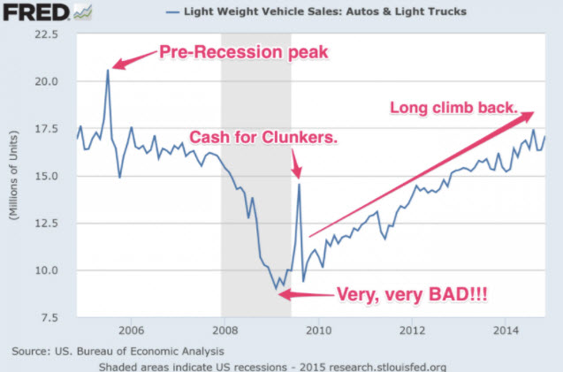
In December of 2008, the Fed also stepped in to stimulate the overall economy by lowering interest rates to a historic low between 0-.25%. In the following years, the 0% auto loan became the norm. Zero percent loans significantly boost consumer purchasing power by providing monthly payments of only $16.66 and $13.88 per thousand financed for 60 and 72 months respectively. These two forms of stimulus also had residual effects that further boosted sales volume and auto price inflation.
After the recession ended and demand returned, used vehicle values made strong and steady gains from 2009 till 2011 and peaked in 2014 due to a supply shortage, lower interest rates and increased demand from subprime borrowers after many folks damaged their personal credit by defaulting on a variety of loans.
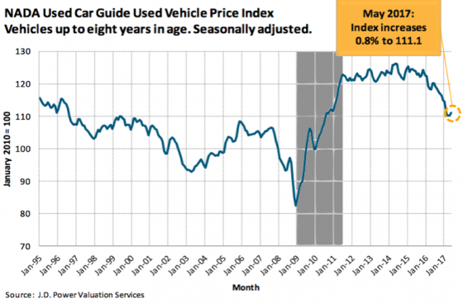
This period of strong used vehicle value performance resulted in very short trade cycles, which significantly boosted new vehicle sales velocity. To illustrate this, consider this chart of a 60-month loan on a Toyota Camry. The black line represents the principal balance owed. An optimal trade cycle occurs when the principal balance owed on a loan intersects with the market value of the vehicle. The black dotted line is representation of peak used passenger vehicle values. Note how quickly the value line crosses the principal balance line. Those who kept their vehicles slightly longer, found themselves with equity in their trades which further boosted their purchasing power.
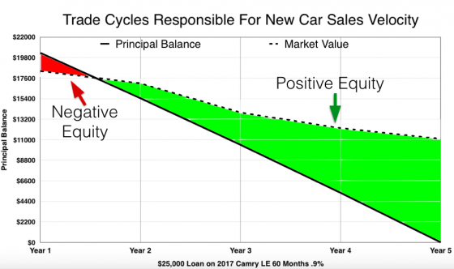
However, nothing gave consumers more purchasing power than leasing during this time period. Higher used vehicle values led to higher residual values. The most impactful portion of a lease is the gap between the sale price of a vehicle and the residual value. I’ve personally witnessed leases that boosted consumer buying by producing monthly payments that required as little as $10.00 per thousand of a vehicle’s MSRP. As a result, leasing became more and more popular with 2016 setting a lease penetration record.
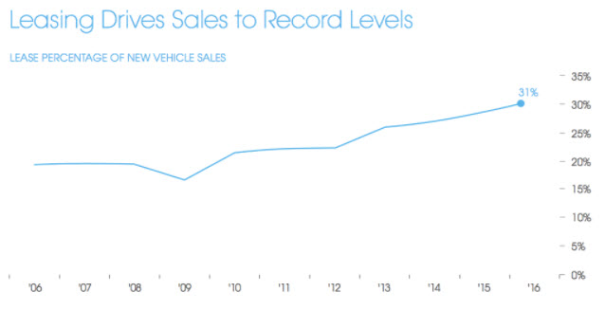

Asset Price Inflation
The stimulating effects of all the items listed above have created significant auto price inflation. The average new vehicle transaction price in 2008 was $28,350 and has increased to $35,309 in 2017 (24.5% inflation) while the median household income has increased by only 12.3% as of 2015. (Data for 2016 will be available in September of this year.) Some segments have inflated even more as shown below:
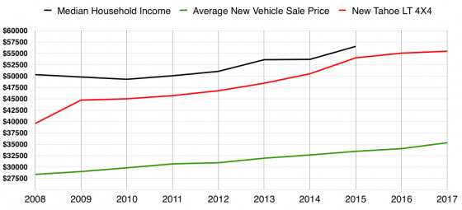
The price of a new Chevrolet Tahoe LT 4WD was $39,560 in 2008. Today, the price of that vehicle has inflated by 40.1% to $55,455. The highest trim level has inflated by an astounding 64.6%.
However, the 0% loans could only take us so far. The effect of ultra low lease payments due to abnormally high residual values helped to further inflate the value of new vehicle prices above and beyond what 0% loans could achieve. Here’s a look at the vehicle most often leased from the manufacturer with the highest lease penetration ratio. The Infiniti G37, now known as the Q60, has inflated in price by 43.8% since 2008.
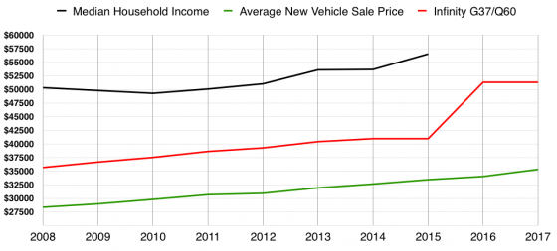
Once the price of a new vehicle gets so high that even 0% loan for 72 months no longer makes it affordable, the customer can simply be converted to a lease to keep the sales moving. This is very evident today as manufacturers have become more and more dependent on leasing.
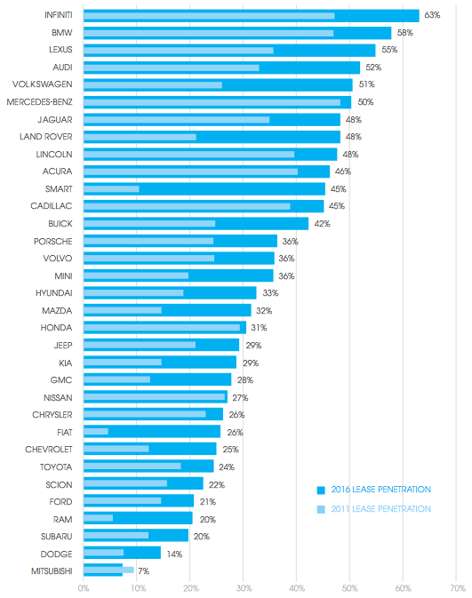

Why The Perfect Storm
The automotive industry needed every single ingredient listed above to reach last year’s record setting sales number. However, something has changed.
Well, in reality, everything has changed. The set of ingredients that perfectly fueled the recovery have all reversed and now power the perfect storm:
- Interest rates are rising. It’s getting harder and more expensive for manufacturers to subvent (buy down as a form of incentive) interest rates.
- Used vehicle prices are falling and will continue to fall. Falling used vehicle values prolong the negative equity period (elongated trade cycles) limiting the buying power of the consumer slowing the velocity of new vehicle sales.
- The last is the most dangerous of all. Residuals values, which lag used vehicle values, are adjusting and will continue to adjust lower.
What will happen when the new vehicle prices that have inflated beyond the affordability of 0% loans are no longer supported with the buying power that leasing provides? What will happen to the sales volume of the above manufacturers that rely on leases for more than 50% of their total sales?
Allow me to answer… Inventory at dealers will begin to backup. We will start witnessing big discounts from manufacturers that keep rising in effort to control a rising day supply problem because new vehicles will no longer be affordable. Incentives will stop working because as the price of the new vehicle is reduced, it will simultaneously put downward pressure on the trade value of the 1-3 year-old version of the vehicle. Production might slow or stop for a period of time, but it won’t change the fact that new vehicle prices will have inflated beyond the buying power of the consumer.
Utilize the same Chevrolet Tahoe from the chart above to illustrate:
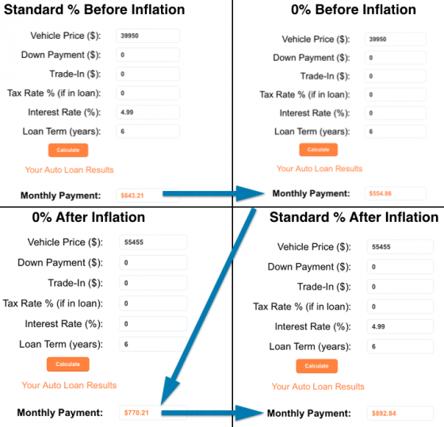
Note how the 0% loan today after price inflation is 19% higher than the standard rate loan before inflation ($643 vs $770) and 28% higher than the 0% loan ($554 vs $770). Interest rates are currently rising. If the same standard rate with today’s price is used, the monthly payment will be 38.7% higher ($643 vs $892) than where it started before the stimulus.

Did Manufacturers Fail to Sufficiently Advance Technology?
Nothing can be more disruptive to an industry than newer and better technology offered at a lower price. New technology goes through a process of consumer behavior and price changes. To date, consumers have welcomed the technology from Tesla, leaving price as the next barrier or chasm to mass-market adoption. We are only months away from what I believe will be the introduction of a mass-market electric vehicle. The chart below illustrates the progression of Tesla as a car company through the process of Rogers’ Diffusion of Innovation.
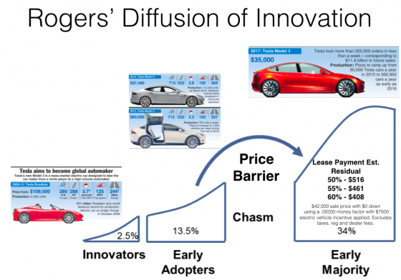
It’s important to note that the $7,500 electric vehicle rebate is included in the estimated payments above and will be a significant factor in the demand for the Model 3. The rebate equates to $193 in monthly payments on the scenarios listed above. If the rebate remains, I challenge you to consider the timing of this new model’s introduction. Over the next year, new vehicles will become more expensive (in regards to monthly payments) due to rising interest rates and falling residual values. The model 3 will then be offered to the public at this time and will represent the newest technology at a lower price (again, payments). The timing of these events might force new vehicle manufacturers to compete in the electric vehicle market sooner than expected, but I believe that Tesla has a commanding technological lead in this segment.

Will The Auto Industry Ever Be The Same?
I believe that we will witness significant changes in the way that we purchase our vehicles after the downturn that I expect in the auto industry. Profits for manufacturers and retail dealers will fall significantly in the coming years. As I write this, dealer groups are investing in more and more retail storefronts. Falling new vehicles sales will mean more dealers competing for fewer customers. This sales environment will lead to massive margin compression and newer entries may not survive. Both manufacturers and retail dealers will be forced to reconsider the cost structure of their business to better compete with companies like Tesla which have a much lower cost of distribution.
Something that’s very different today than it was during our last recession is the ability for companies to replace or reduce the size of their workforce with technological alternatives. I believe that when the smoke clears, manufacturers and dealers will adopt a much more cost-effective way of retailing new vehicles to the public. This will have a negative impact on both the quantity of jobs and wage growth in the automotive sector.

Does the Universe Remember Forever?

Researchers have found a way around what was considered a fundamental limitation of physics for over 100 years. They were able to conceive resonant systems that can store electromagnetic waves over a long period of time while maintaining a broad bandwidth. Their study opens up a number of doors, particularly in telecommunications.
Share:
FULL STORY

This is a wave-interference and resonant energy transfer from one source to another distant source or object, pertaining to the fundamental concept of resonances.
Credit: EPFL - Bionanophotonic Systems Laboratory
At EPFL, researchers challenge a fundamental law and discover that more electromagnetic energy can be stored in wave-guiding systems than previously thought. The discovery has implications in telecommunications. Working around the fundamental law, they conceived resonant and wave-guiding systems capable of storing energy over a prolonged period while keeping a broad bandwidth. Their trick was to create asymmetric resonant or wave-guiding systems using magnetic fields.
The study, which has just been published in Science, was led by Kosmas Tsakmakidis, first at the University of Ottawa and then at EPFL's Bionanophotonic Systems Laboratory run by Hatice Altug, where the researcher is now doing post-doctoral research.
This breakthrough could have a major impact on many fields in engineering and physics. The number of potential applications is close to infinite, with telecommunications, optical detection systems and broadband energy harvesting representing just a few examples.
Casting aside reciprocity
Resonant and wave-guiding systems are present in the vast majority of optical and electronic systems. Their role is to temporarily store energy in the form of electromagnetic waves and then release them. For more than 100 hundred years, these systems were held back by a limitation that was considered to be fundamental: the length of time a wave could be stored was inversely proportional to its bandwidth. This relationship was interpreted to mean that it was impossible to store large amounts of data in resonant or wave-guiding systems over a long period of time because increasing the bandwidth meant decreasing the storage time and quality of storage.
This law was first formulated by K. S. Johnson in 1914, at Western Electric Company (the forerunner of Bell Telephone Laboratories). He introduced the concept of the Q factor, according to which a resonator can either store energy for a long time or have a broad bandwidth, but not both at the same time. Increasing the storage time meant decreasing the bandwidth, and vice versa. A small bandwidth means a limited range of frequencies (or 'colors') and therefore a limited amount of data.
Until now, this concept had never been challenged. Physicists and engineers had always built resonant systems -- like those to produce lasers, make electronic circuits and conduct medical diagnoses -- with this constraint in mind.
But that limitation is now a thing of the past. The researchers came up with a hybrid resonant / wave-guiding system made of a magneto-optic material that, when a magnetic field is applied, is able to stop the wave and store it for a prolonged period, thereby accumulating large amounts of energy. Then when the magnetic field is switched off, the trapped pulse is released.
With such asymmetric and non-reciprocal systems, it was possible to store a wave for a very long period of time while also maintaining a large bandwidth. The conventional time-bandwidth limit was even beaten by a factor of 1,000. The scientists further showed that, theoretically, there is no upper ceiling to this limit at all in these asymmetric (non-reciprocal) systems.
"It was a moment of revelation when we discovered that these new structures did not feature any time-bandwidth restriction at all. These systems are unlike what we have all been accustomed to for decades, and possibly hundreds of years," says Tsakmakidis, the study's lead author. "Their superior wave-storage capacity performance could really be an enabler for a range of exciting applications in diverse contemporary and more traditional fields of research." Hatice Altug adds.
Medicine, the environment and telecommunications
One possible application is in the design of extremely quick and efficient all-optical buffers in telecommunication networks. The role of the buffers is to temporarily store data arriving in the form of light through optical fibers. By slowing the mass of data, it is easier to process. Up to now, the storage quality had been limited.+
With this new technique, it should be possible to improve the process and store large bandwidths of data for prolonged times. Other potential applications include on-chip spectroscopy, broadband light harvesting and energy storage, and broadband optical camouflaging ("invisibility cloaking"). "The reported breakthrough is completely fundamental -- we're giving researchers a new tool. And the number of applications is limited only by one's imagination," sums up Tsakmakidis.

