The FBI Coup Against Trump
Comey responds to Podesta and Hillary, joining DNC efforts to create a “cover story” for both the recent DNC server and email breaches and Hillary’s Russian Uranium One dealings. Mueller carried yellow cake Uranium Samples to Russia for Hillary before the Russians would agree to buy Uranium One through Rosatom. The FBI has been investigating and prosecuting for over a year relative to these deals, but the US Oversight Agencies which allowed the Uranium sale were not informed by the FBI.
The DNC, with the help of Alexandra Chalupa's [real name!] friend from the Atlantic Council, Dimitri Alperovitch, embeds Russian hacking footprints in the DNC server to frame the Russian Bogeymen. Simple analysis shows these tracks were forged.
Alexandra Chalupa returns to Ukraine creates a “ledger” to prove Paul Manafort took $27 million in illegal payments for work he did in Ukraine for Viktor Yanukovych when Manafort worked for him as a lobbyist. At this time, numerous operators have not filed any FARA paperwork related to these lobbying efforts. FBI-Friendly John Podesta will later file his FARA paperwork retroactively as the special counsel is being formed.
DNC buys the Russian Dossier Plan (Page Dossier) & Comey helps sell it, utilizing & using his undercover employee, Carter Page. According to the Page Dossier, Page will get paid money from a Russian oil company and Trump will be paid through Alpha Bank in Russia by Putin-friendly oligarchs who will also be implicated in election “meddling” that supports Trump and harms Hillary. At this time, this is only a secondary plan – their front line efforts are still to use the DNC to secure the party nomination for Hillary irregardless that Bernie Sanders is the popular candidate.
Comey targets Manafort in the Page Dossier because Comey knows that Manafort has been under investigation by the FBI, CIA, ODNI and US Treasury OIA since 2005, and it will be easy to use FBI resources to “surveil” Trump through the already existing warrants being used to monitor Paul Manafort 24/7.
3/2016 Comey gets Title-I FISA warrant on - claiming Carter Page is a known Russian spy. This gives Susan Rice/Committees complete surveillance of Trump team. The Podesta group will collapse under Mueller’s investigation because Tony Podesta was found to be as guilty as Manafort and Gates. [See retroactive FARA Registration] At this time Trump Tower is being actively tapped.
Comey opens FBI investigation into Donald Trump and his father. This report was posted on the FBI site for a short time and it stated there was no dirt found on the Trump family.

Comey enlists former associate Felix Sater, [Феликс Михайлович Шеферовский;] a criminal Russian associated with the FBI after Felix nearly killed a person in a NYC bar-room fight. Sater has been convicted multiple times since beginning work for the FBI. Felix penetrated the Trump camp when Mueller first heard Trump might run in 2000 when Roger Stone and others encouraged him to do so. Felix brought Trump Russian investors for the Trump Soho Towers and Felix has been foisting himself upon Trump ever since. Felix has been used repeatedly by Comey/Mueller over the years though it doesn’t seem to reach the news nor has Felix been questioned by the Mueller Investigation to Impeach Team. Felix Sater is the definition of Russian Meddling in the Election.
Comey had Felix Sater on June 9, 2016, set up the “fake opposition research” meeting with Natalia Veselnitskaya, Rinat Akhmetshin, Rob Goldstone, Ike Kaveladze, and the Trump Team including Manafort through whose phone they surveilled the meeting. Comey worked with the State Department to acquire movement Visas – because Natalia, Rob, and Rinat did not have movement into the US under normal law. The Russian Lawyer, Natalia Veselnitskaya, met with Fusion GPS founder Glenn Simpson before and after the meeting.
Comey had Felix Sater continue to involve the Trump team with anything Russian, including a trip to Moscow with two members of the Trump team to consider building a Trump Towers in Moscow, Georgia, and the Crimea. Nothing came of it
Comey approached and paid Franklin Foer, from Slate news agency, to supposedly “discover by accident” a direct line of communication between the “Trump Towers and Alpha Bank in Russia” that was supposedly sending money to Trump from three friends of Putin. Foer ran two articles as “October Surprises”. The DNS records for these deceptions were forged by a "Think Tank" tied to the DNC and probably "April Lorenzen". The DNS forgeries are obvious and clumsy.
On October 21, 2016 the Page Dossier is processed by the FBI without any evaluation of truth. Strzok and Page text "last resort to take Trump down and get Hillary elected." Comey lies under oath about Trump Tower Surveillance, which is completely hooked up supposedly to spy on specific people in Trump's team, but which is now surveilling the entire facility. Comey had to distance himself from the Trump Towers server because that part of his Page Dossier got proven to be a fraud. [A researched identified as April Lorenzon had forged DNS records to fraudulently show that some Trump Brand related marketing servers were connecting to Russian servers. This has been debunked, but it was used in part to justify spying of Trump Tower & the Campaign]

The Page Dossier was never supposed to be published and that is why Comey worked through the number one propaganda group, Fusion GPS, a criminal cabal of x-journalists used by the most corrupt people in the world. Comey had Glen Simpson, one of the owners of Fusion, to work with Christopher Steele, the “Foreign Agent” x-British spy who compiled the Page Dossier from numerous sources and came to America to “brief” CNN, Washington Post, New York Times, Mother Jones, and Yahoo News (all complicit in the conspiracy) on the fake contents of the Dossier so they could run fake news stories. Steele testified in one on his four law suits concerning the Dossier that it was only meant for the eyes of his clients.
His client was John Podesta’s DNC and Hillary’s Victory Campaign through Perkins Coie and Marc Elias (all complicit in the conspiracy). The “clients” of Steele’s Page Dossier at first claimed they knew nothing of the $12 million Page Dossier (which should be called the DNC Dossier) or who paid for it – they perjured themselves in their testimony. When Buzzfeed, who was probably given a copy by John McCain, printed the Page Dossier, all hell broke loose and Comey lost control of all of his many fronts that were attacking Trump. Thus, Comey’s conspiracy turned into a mess. All of the plans were poorly thought out and pathetically executed and were considered just a “back up plan” because they were all quite certain that Hillary would win.
Comey made sure the Sidney Blumenthal inspired and Cody Shearer created dossier (“Shearer Dossier”) got included into the Christopher Steele Page Dossier. This Shearer Dossier, combined what Burce Ohr (DoJ direct contact with Steele) got from his wife Nellie Ohr’s Fusion GPS “opposition research” into a “Fusion GPS Dossier” of its own. Comey made sure Bruce Ohr gave Steele a copy of the Fusion GPS Dossier as well as the previous DNC opposition research they had done on Trump before December 2015 – called the “DNC Server’s Trump Oppositional Research Folder”, which was released by Wikileaks. There was also the FBI research done on Trump in January, 2016, which we have mentioned above. That FBI file and another file from John Brennen, the person who admits to first receiving “intel” about Trump and Putin. Some claim Brennen spent $100,000.00 as an initial payment of $1 million for Trump opposition research which included an alleged video of Trump in a hotel room with prostitutes. No such tape ever surfaced.
Comey helped the DNC, Hillary, and Christopher Steele to create the Page Dossier and set the wheels in motion to create a number of situations to “frame” the Trump Team with Russian connections, including: the Trump Towers server, getting the Russian spy Veselnitskaya (and company) into the country for the Trump Team entrapment and “framing”, Carter Page infiltrating the Trump Team, Alexandra Chalupa creating the Manafort fake ledger, Alperovitch planting the Russian footprints in the DNC server, Andrew McCabe’s release of M-13 gang members and the death of Seth Rich, arresting Yevgeniy Nikulin in Prague to set up Michael Cohen as bag-man for Putin pay-offs, FBI investigation of Trump and his father, Felix Sater’s many attempts to frame the Trump Team as Russian friendly, among other
Comey had Felix Sater (his Russian spy and undercover employ) accuse Michael D. Cohen, Trump’s lawyer, of brokering a plan to lift sanctions from Russian in an attempt to make Cohen appear Putin-friendly so that Comey’s Page Dossier could include references to Cohen. This letter about sanctions never existed but Sater spoke to the press about it numerous times trying to show that Cohen and he were ready to “lift sanctions”, the very phrase used to go after Michael Flynn who also was under a Comey surveillance warrant covering his communications because of his association with Turkey’s president and his frequent interviews on Russia Today (RT), an American-based Russian news agency where Flynn was a guest. Flynn went to Russia for a dinner honoring RT and he never filed as an agent working for a foreign country. Flynn’s consulting firm made the same mistake as Manafort and Gates and Tony Podesta by not filing.
When the leaks came out – leaks created by Comey – the Trump Team made a copy of Michael Cohen’s passport available to the news to demonstrate tht he had never been in Prague. Yevginy Nikulin was conveniently arrested in Prague after being hunted for a long time because he had hacked Drop Box and Linked-In. Comey’s FBI team went to Prague twice to the prison to visit this hacker and offer him immunity and the witness protection program if he would “admit” to being the DNC hacker who was hacking to help Trump and harm Hillary directly for Vladimir Putin himself.
Twice, Yevginy turned the offer down and then reported the scam to the news and had the proof to show the FBI was in the prison twice. Eventually, Steele’s Page Dossier names Aleksej Gubarev as the DNC hacker and now Gubarev is suing Steele in London and America. The Alpha Bank Russian oligarchs, Mikhail Fridman, Petr Aven, German Khan are also suing Steele.
Comey engineered the entrapment and framing of George Papadopolous, the most junior member of the Trump Team who never even spoke with Trump, by enlisting a Russian agent named Joseph Mifsud in London and again in Italy in March of 2016.
This agent, who meets directly with Putin each year as part of the club he promised to get George into, the Valdai Discussion Group, also introduced George to the “niece of Putin” who drew George into an entrapment of Russian espionage. George reported these meetings to his contact with the Trump Team and that was the end of his association with the Team. The Russian spies dangled the “missing Clinton emails” as bait for poor George, who was fired.
6/2016 Comey got a FISA Section 702 warrant on George. This was an FBI Counterintelligence Operation. George was not picked up and questioned until July 2017 – one full year after the warrant allowed Comey to spy on the Trump Team based upon the entrapment of George the Naïve. This warrant started as an illegal spying on the Trump Team and then was used to create the “Mueller Investigation to Impeach” and the continuing harassment of a sitting president.
The FBI Counterintelligence Operation (Comey, McCabe, Priestab, Strzok, Page, Ohr, Baker, Carlan, Rosenstein, Lynch, Yates, Rice, Obama, Biden, etc.) was the same group that exonerated Hillary’s email crimes, the Clinton Foundation crimes, the Hillary’s Uranium One Emolument Clause crimes, the Hillary’s pay-to-play State Department crimes, the Huma’s email espionage, and much more that hasn’t come to light.
Comey claims that the DNC is hacked in July, 2016, and Dmitri Alperovitch (a convicted Russian hacker turned FBI asset) discovers the supposed “Russian hacker footprints”, which in fact, he placed there when called by Alexandra Chalupa and Comey to analyze the breach in December, 2015. Crowdstrike is implicated in this fraudulent addition of “Russian Fingerprints” onto already publicly available documents.
Comey creates another cover story for the DNC hacking by inventing Guccifer 2.0 who claimed to have hacked the DNC before the “Russians” got there. Dmitri and Guccifer 2.0 go through a public debate online and Guccifer 2.0 releases hacked information to prove his point. These hacks were nothing more than a cheap trick of rewriting what Wikileaks had already released.
Guccifer then “hacks” the Democrats in Congress (DCCC) and George Soros’s Open Society Meetings (D. C. Leaks). None of the material released by Guccifer 2.0 is new or demonstrates Guccifer 2.0 was the hacker of the DNC. Comey claims that Guccifer 2.0 is a Russian hacker. Comey goes after Roger Stone and Trump in a ridiculous case involving Stone texting Guccifer 2.0. This, and other things, causes Stone to drop off the Trump Team making it necessary to now use Manafort more than ever.
Comey has Hillary text eight messages from July until the time of the debates accusing Trump of having Russian ties. During the debate, Hillary can’t stop saying that 17 US Intelligence Agencies all agree that Putin has meddled in the election for Trump. Actually, Eric Schmidt gave $1.5 billion dollars to the US Digital Service to create a digital war-room that coordinated the meddling directly from the White House in favor of Hillary.
omey uses the “small group” to rewrite his exoneration speech which subsumes the Department of Justice’s duty to proceed with the investigation of the crimes committed (with intent) by Hillary’s security violations and the espionage that accompany them. Comey’s entire team got to edit out the words that made it seem that Hillary had committed crimes.

Comey covered for the Bill Clinton’s meeting with Loretta Lynch and even took it upon his self to pronounce Hillary clear of any criminal actions with emails, servers, foreign gifts, etc.
Comey lied before congress continually throughout all of this conspiracy and then leaked false material to the press to harm Trump’s reputation and imply that Trump was guilty of some type of crime. Comey lied in three congressional hearings in a row and wrote letters to correct his testimony twice.
Comey lied to the president three times telling him that he was not under investigation. Trump was the target of a “counter-intelligence operation”, not a criminal investigation just as Hillary was not under a criminal investigation, she was involved in “a matter” according to Loretta Lynch.
Comey continued his counter-intelligence operation against a president-elect and then against a duly elected president. These are crimes that range up to the capital crimes of treason and sedition being carried out by the Director of the FBI and other agents. This is more than a conspiracy to “resist”, it is a complex attempted coup d’etat. Comey, Mueller, and their gangs are “enemy combatants” and should be arrested first and then questioned.
They have no rights after the conspiracy turned into a treasonous attack upon a sitting president. Mueller and his entire team know exactly what is going on and our complicit in these crimes. Their job was simply to defend themselves and hide the evidence that will put them in jail for life. And yes, there have been numerous attempted assassinations on Trump’s life that were foiled and no one was prosecuted.
These attempts to assassinate a sitting president is all that is needed to demonstrate the seriousness of the coup de tat and the extent to which these criminals will go to overthrow the United States government from the inside.
Comey perjured himself, exonerated Hillary, continued to attack Trump, continued to leak, continued to lie, and publicly was at “war” with Trump so that Trump would have to fire him simply because
Comey was out of control. Once fired, as planned, Comey became the martyr of the Trump Resistance Movement. Comey then leaked his notes to the New York Times (as usual) and this leak got his best friend Mueller appointed by his second best friend Rosenstein to come and save Comey, start a special investigation, hide the evidence, and cover all the tracks. Comey essentially handed the Investigation to Impeach over to Mueller and it continues to this day with nothing but embarrassing actions by Mueller that exonerate Trump and waste America money.
Comey was given immunity by Mueller, which makes Mueller complicit with the coup d’etat.
The CIA Secret on the Bottom of the Sea
In the summer of 1974, a large and highly unusual ship set sail from Long Beach in California.
It was heading for the middle of the Pacific where its owners boasted it would herald a revolutionary new industry beneath the waves.
Equipped with a towering rig and the latest in drilling gear, the vessel was designed to reach down through the deep, dark waters to a source of incredible wealth lying on the ocean floor.
It was billed as the boldest step so far in a long-held dream of opening a new frontier in mining, one that would see valuable metals extracted from the rocks of the seabed.
But amid all the excited public relations, there was one small hitch - the whole expedition was a lie.
This was a Cold War deception on a staggering scale, but one which also left a legacy that has profound implications nearly half a century later.
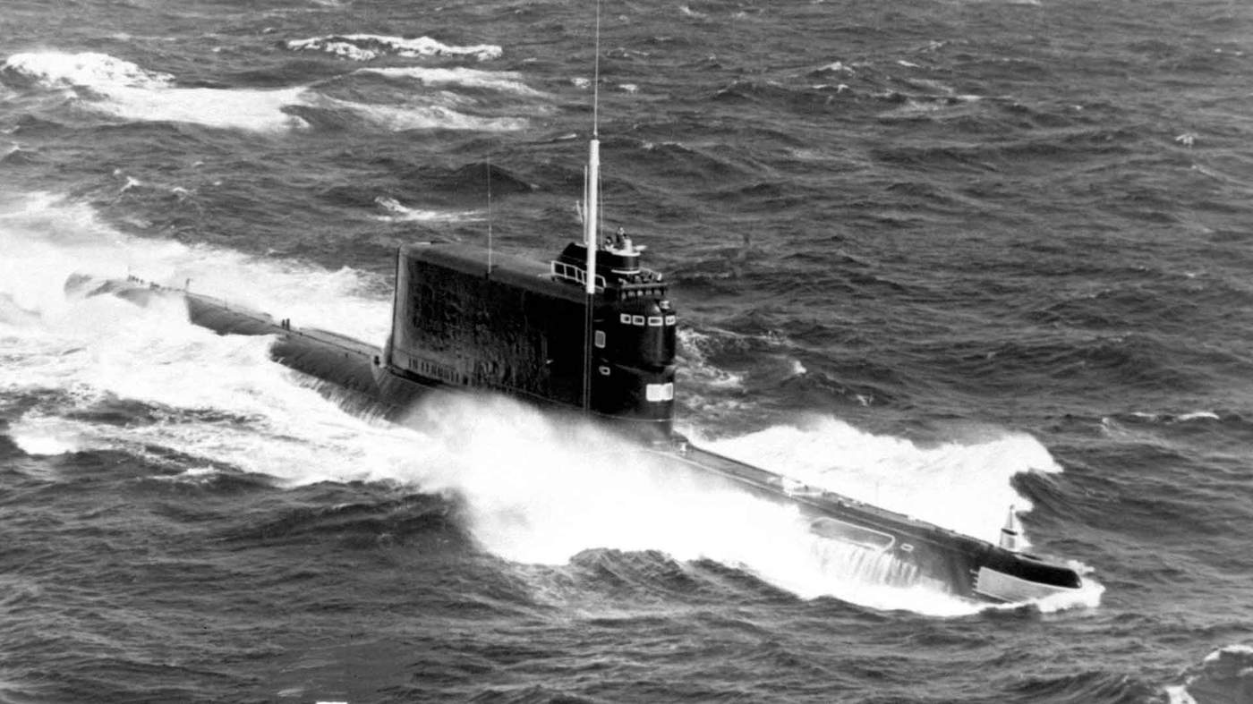
A Soviet submarine of the same class as K-129
The real target of the crew on board this giant ship was a lost Soviet submarine. Six years earlier, the K-129 had sunk 1,500 miles north-west of Hawaii while carrying ballistic nuclear missiles.
The Russians failed to find their sub despite a massive search, but an American network of underwater listening posts had detected the noise of an explosion that eventually led US teams to the wreck.
It was lying three miles down, deeper than any previous salvage operation. The weapons and top-secret code books were surely beyond reach.
But in the struggle for military advantage, the sub represented the crown jewels – a chance to explore Moscow’s nuclear missiles and to break into its naval communications.
So the CIA hatched an audacious plan, Project Azorian, to retrieve the submarine. That would have been hard enough. But there was another challenge as well - it had to be done without the Russians knowing.
The spies needed to create a smokescreen so they pretended to be exploring the possibility of deep sea mining.
A PR campaign conveyed a determined effort to find manganese nodules. These potato-sized rocks lie scattered in the abyss, the great plains of the deep ocean.
There had to be a frontman - someone rich and eccentric enough to be plausible. The reclusive billionaire inventor Howard Hughes was perfect for the role.
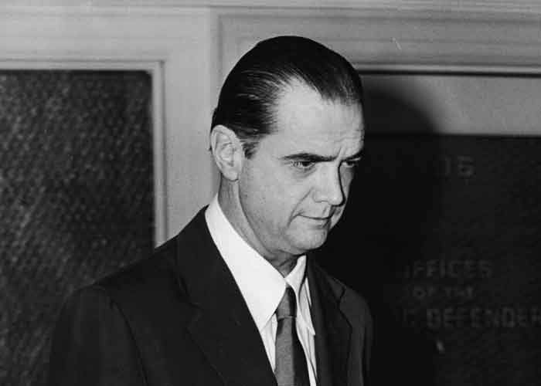
Howard Hughes, pictured in 1952 - by the 1970s the billionaire was living a reclusive existence
He agreed to take part and, in his name, a unique ship was designed. Publicly, it was fitted with everything needed to dig up the seabed.
But, covertly, the Hughes Glomar Explorer was also built with ingenious devices straight from a Bond film. The ship’s hull had enormous doors that could swing apart to create a “moon pool”, an underwater opening large enough to accommodate the Soviet sub and keep it hidden.
Tucked away out of sight inside the ship was a “capture vehicle” which had a giant set of claws to straddle the sub and secure it.
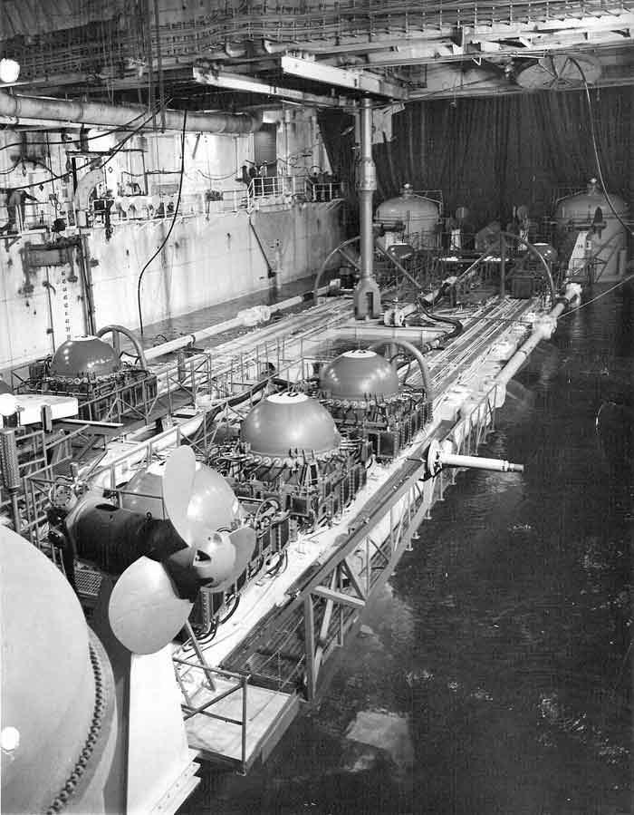
It took until 1974, six years after the sinking of the sub, for the CIA to be ready. The cost of the project - $500m - was equivalent then to building a couple of aircraft carriers or launching an Apollo mission to the moon.
We really misled a lot of people and it’s surprising that the story held together for so long”
Dave Sharp, former CIA operative
No-one had ever attempted anything on this scale in such incredible depths. The sub itself had a weight of nearly 2,000 tonnes but the three miles of thick steel pipe needed to haul it up added even more.
New systems were needed to keep the Glomar Explorer in position as well as to handle the huge load, and everyone on board was nervous. Dave Sharp, one of the few CIA figures happy to talk about the project, tells me it was “really frightening” when heavy seas threatened to tear their unusual vessel apart.
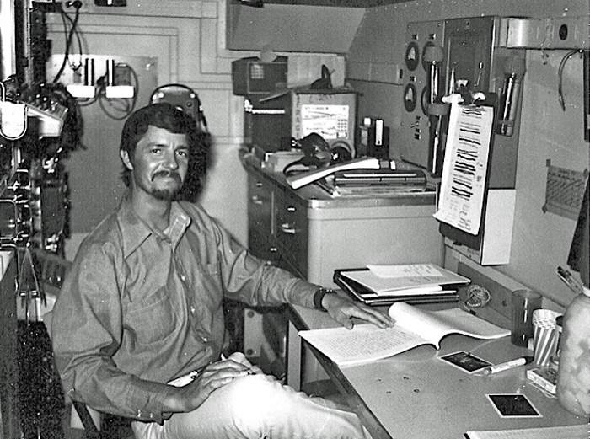
Dave Sharp, pictured aboard the Hughes Glomar Explorer
But even more alarming was the suspicion of the Russians. To convince them that Howard Hughes was genuinely interested in nodules, executives were despatched to conferences on ocean mining where they described in detail their plans to harvest the rocks.
“We made ocean mining seem a lot more credible,” Sharp says. “We really misled a lot of people and it’s surprising that the story held together for so long.”
The cover was so good that it prompted US universities to move to start courses in deep sea mining and it also whipped up the share prices of the companies involved. “People thought, ‘if Howard Hughes is into it, we need to be too’,” says Sharp.
“We even collected a few nodules,” he remembers, which was fortunate because Soviet spy ships kept a constant vigil and once even came close enough to overhear the Americans’ conversations.
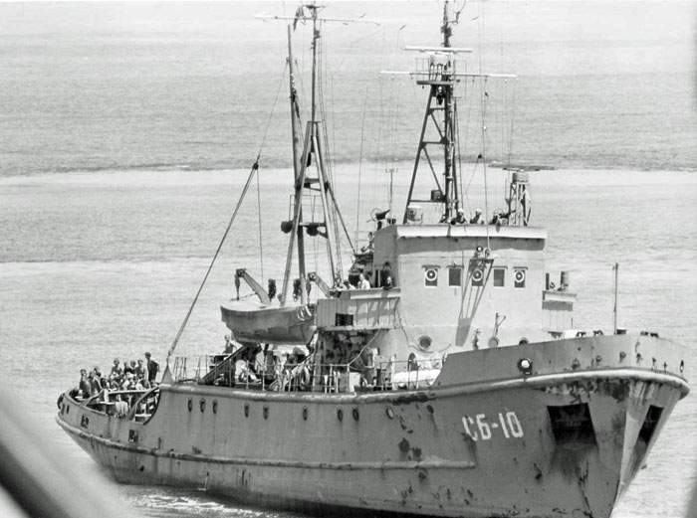
A Soviet spy ship monitoring the Hughes Glomar Explorer
“When we realised they were right alongside, we started talking about nodules, like ‘here’s a good one’ so it looked like we were checking them.”
Yet another complication arose. The project needed calm weather and that was only likely in summer. But just when it was about to begin in summer 1974, US President Richard Nixon was visiting Moscow for a peace-making summit.
Being caught stealing a Soviet sub would not exactly have helped, so Nixon insisted that the operation could not begin until he had left Russia. That was on 3 July. By then the Hughes Glomar Explorer was in position and the winches whirred into action the next day.
Things did not go smoothly. Sharp recalls that pumps and connections kept breaking. Huge vibrations rocked the ship as the “capture vehicle” was “banging back and forth in the waves”. But on 30 July, he watched as underwater cameras relayed video of the sub as well as “dozens of crawling crab-like crustaceans” and a big white fish that looked like a shark.
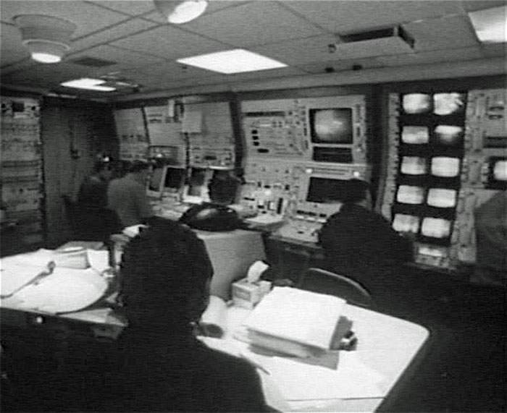
Inside the Hughes Glomar Explorer control room
Amazingly, the giant steel claws successfully seized the sub. But then disaster struck. At some point on the way up, the immense strain became too much, part of a claw snapped off and most of the sub slipped back to the seabed.
Only the front section made it up. The bodies of six Soviet submariners were recovered and were later given a formal burial at sea. But the missiles and code books were never found.
The CIA official history asserts that the operation was one of the greatest intelligence coups of the Cold War, but it had cost vast sums and questions immediately arose about its value. A year later, the sensational details became public and plans to recover the remaining section were abandoned.
As Sharp puts it, the revelation that the deep sea mining project was fake was “a sudden shock” to other mining companies and also to diplomats at the UN who were right in the middle of negotiating future rights to ocean minerals. Share prices tumbled amid a wave of recriminations.
This might have derailed the very notion of deep sea mining for good. But in fact it proved that with clever engineering and a lavish budget it was possible – just - to operate in the otherworldly depths. “It’s really difficult but we showed it could be done,” says Sharp.

The man who digs
In an air-conditioned cabin in a teeming port in Papua New Guinea, Leslie Kewa reaches for a joystick that will control a machine the size of a house. Nearly half a century after the CIA men pretended to mine the ocean floor, he’s about to do it for real.
A burly figure with a kindly face, Kewa is from a village in the remote highlands of Papua New Guinea. In a country blighted by poverty, he grew up in relative comfort because his father, and the rest of the men in his family, made careers in the mining industry. Kewa became a specialist in handling gargantuan devices.
But the one standing nearby is unique, not only because of the destructive power of its whirling steel teeth, and its menacing resemblance to something from a Mad Max film, but also because it’s designed to be used far beyond human reach.

As Kewa’s fingertips send the first commands, and the machine crunches over the ground outside, he admits to feeling a bit scared.
In these first trials, he’s learning to steer by remote control, relying on CCTV to show him where the huge steel tracks are pointing as they inch their way forward. “I’m used to the feel of machinery in my hands so having to trust the equipment and the screens is hard,” he says.

But there’s no other option. The machine will soon be deployed not in the huge pits of an opencast mine on land but in the sunless depths a mile underwater on the ocean floor.
If work starts as planned next year, Kewa will earn himself a place in history as the first person to break rock in the world’s first deep sea mine.
In an air-conditioned cabin in a teeming port in Papua New Guinea, Leslie Kewa reaches for a joystick that will control a machine the size of a house. Nearly half a century after the CIA men pretended to mine the ocean floor, he’s about to do it for real.
A burly figure with a kindly face, Kewa is from a village in the remote highlands of Papua New Guinea. In a country blighted by poverty, he grew up in relative comfort because his father, and the rest of the men in his family, made careers in the mining industry. Kewa became a specialist in handling gargantuan devices.
But the one standing nearby is unique, not only because of the destructive power of its whirling steel teeth, and its menacing resemblance to something from a Mad Max film, but also because it’s designed to be used far beyond human reach.
As Kewa’s fingertips send the first commands, and the machine crunches over the ground outside, he admits to feeling a bit scared.
In these first trials, he’s learning to steer by remote control, relying on CCTV to show him where the huge steel tracks are pointing as they inch their way forward. “I’m used to the feel of machinery in my hands so having to trust the equipment and the screens is hard,” he says.
But there’s no other option. The machine will soon be deployed not in the huge pits of an opencast mine on land but in the sunless depths a mile underwater on the ocean floor.
If work starts as planned next year, Kewa will earn himself a place in history as the first person to break rock in the world’s first deep sea mine.
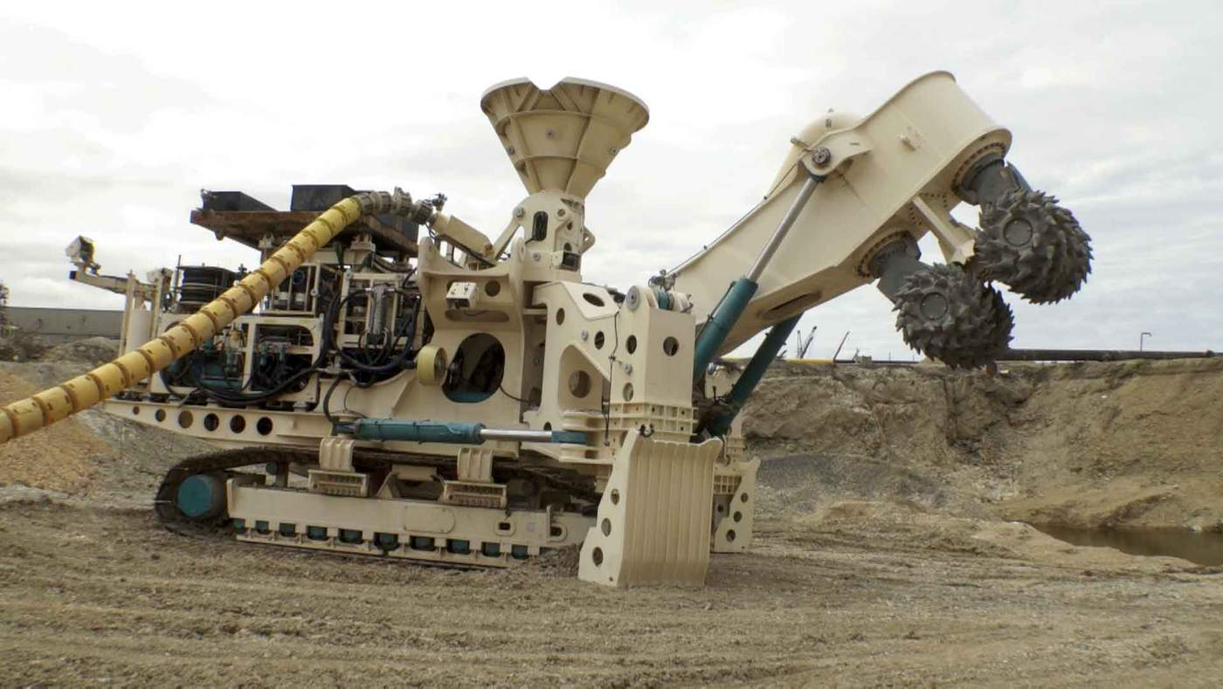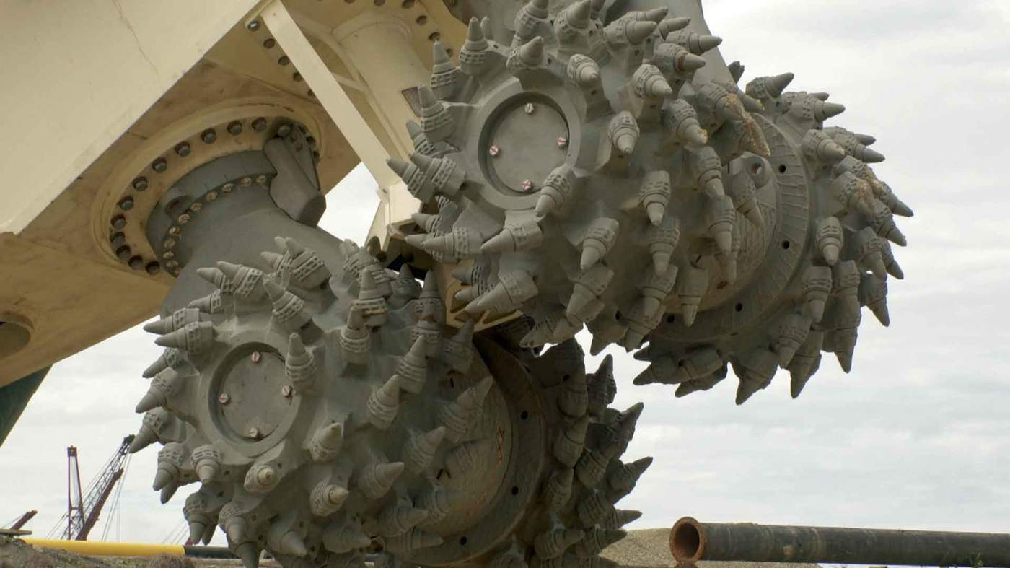
Run by a Canadian firm, Nautilus Minerals, the project will be managed from a ship in the tropical waters of the Bismarck Sea off Papua New Guinea. Three of the vast machines will be lowered to the slopes of an undersea volcano.

There they will encounter a stretch of seabed covered in hydrothermal vents. These strange twisting chimneys are formed by boiling water blasting up from the rock.
As with most fields of vents, this one is astonishingly rich in valuable metals. The site is named Solwara 1 - “salt water” in the local language.
But the hydrothermal vents host thriving communities of marine life - snails, worms and shrimp that have evolved to cope with very specific conditions.
In some cases these creatures are extremely rare, which is why the prospect of deep sea mining is highly controversial.

The plan is for Kewa to guide the steel teeth of the mining machines so they methodically demolish the vents, pulverising them into fragments.
The tiny pieces of rock should then be small enough to be piped up to the surface. On board the ship, a processing plant will churn out a multitude of specks of copper and gold that could be worth billions. A Chinese firm has already agreed to buy the lot.
Once the riches of Solwara 1 have been extracted, the machines will be moved to another dozen sites lined up nearby.

On the sea floor the ores are massively richer than those on land. Every tonne of material dug up in a typical copper mine on land only yields less than a gram of actual metal.
By contrast, the hydrothermal vents off Papua New Guinea are at least ten times richer.
And it’s the same story with gold and many other metals too. A Japanese expedition to another set of vents off Okinawa discovered enough zinc to keep Japan supplied for an entire year. Those behind that project kept it quiet until it was over, causing real surprise in the mining industry.
Nautilus Minerals forecasts that in copper alone an emerging undersea industry in oceans around the world could be worth $30bn a year by 2030. And it claims that by mining a small area of seabed, the venture will be friendlier to the environment. It contrasts its work with mines on land where trees and topsoil are swept away across vast areas.
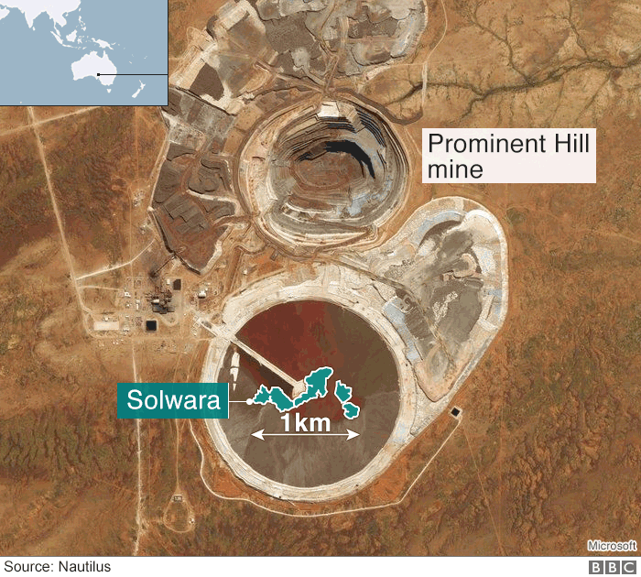
The footprint of the Solwara-1 mining area, compared with an existing copper mine in South Australia
For the government of Papua New Guinea, the attraction is obvious - badly needed income as a partner in the venture. And Nautilus has agreed to funnel some of the proceeds to local administrations too, to let ordinary people benefit.
But the history of mining in Papua New Guinea does not inspire confidence. Millions still live well below the poverty line despite the massive extraction of ores from the mountains.
And for some, venturing into the sea spells danger for precious waters.
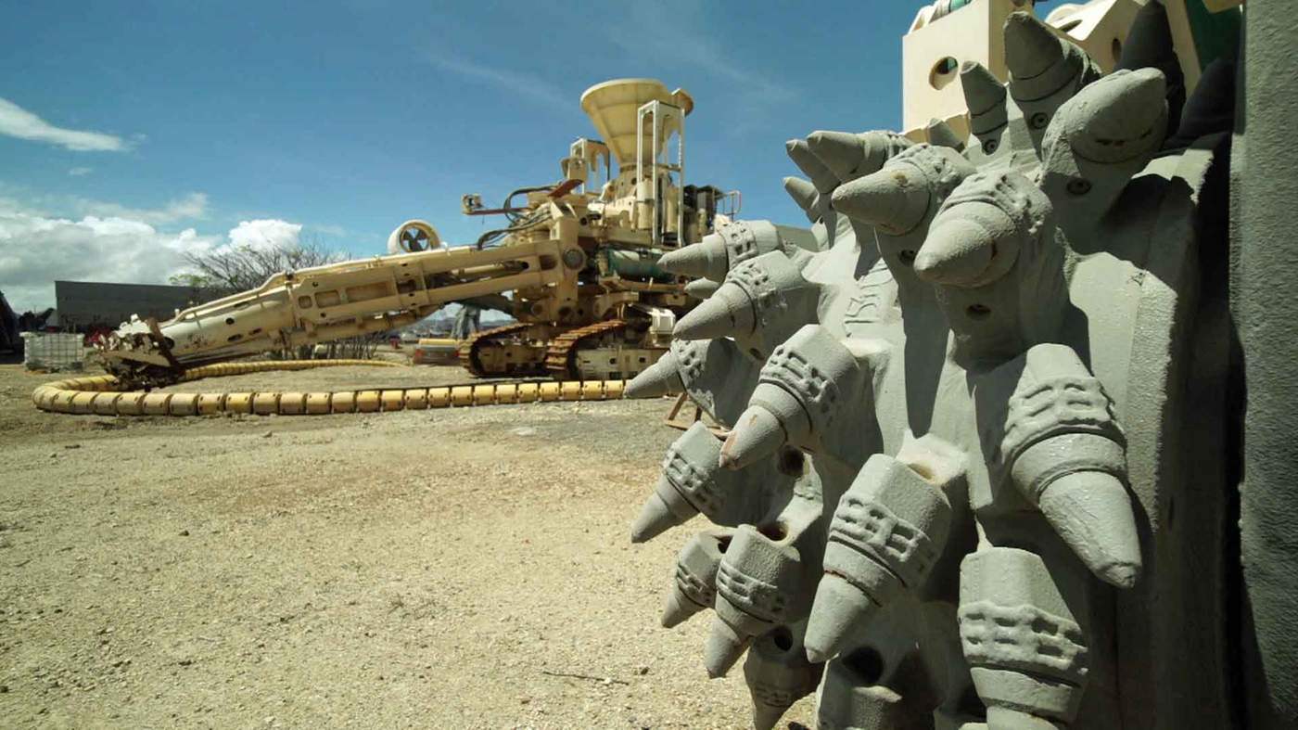
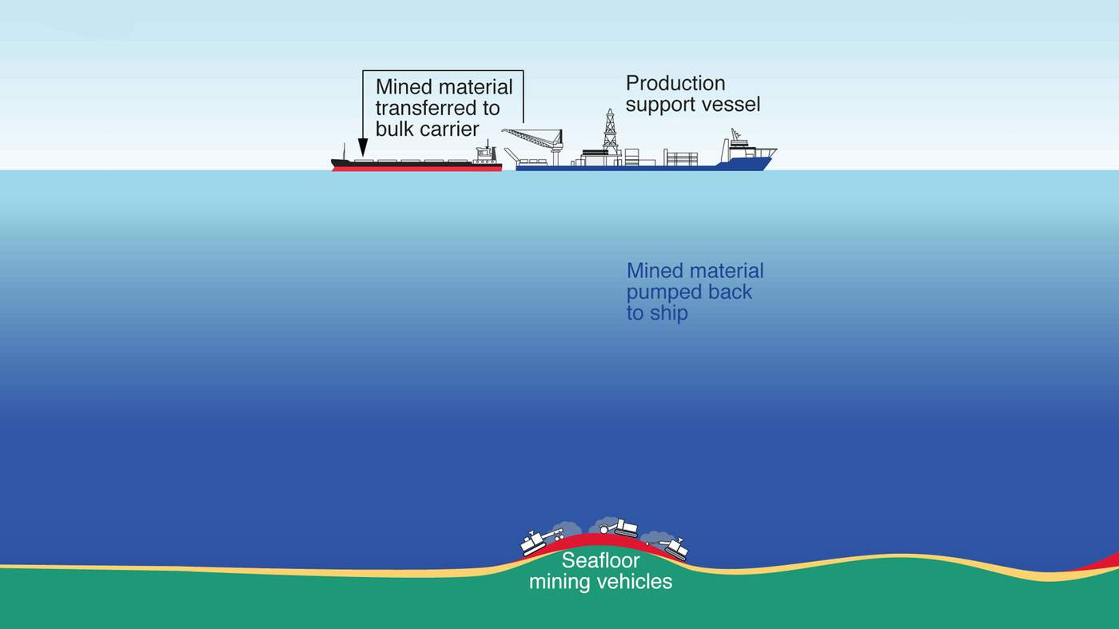
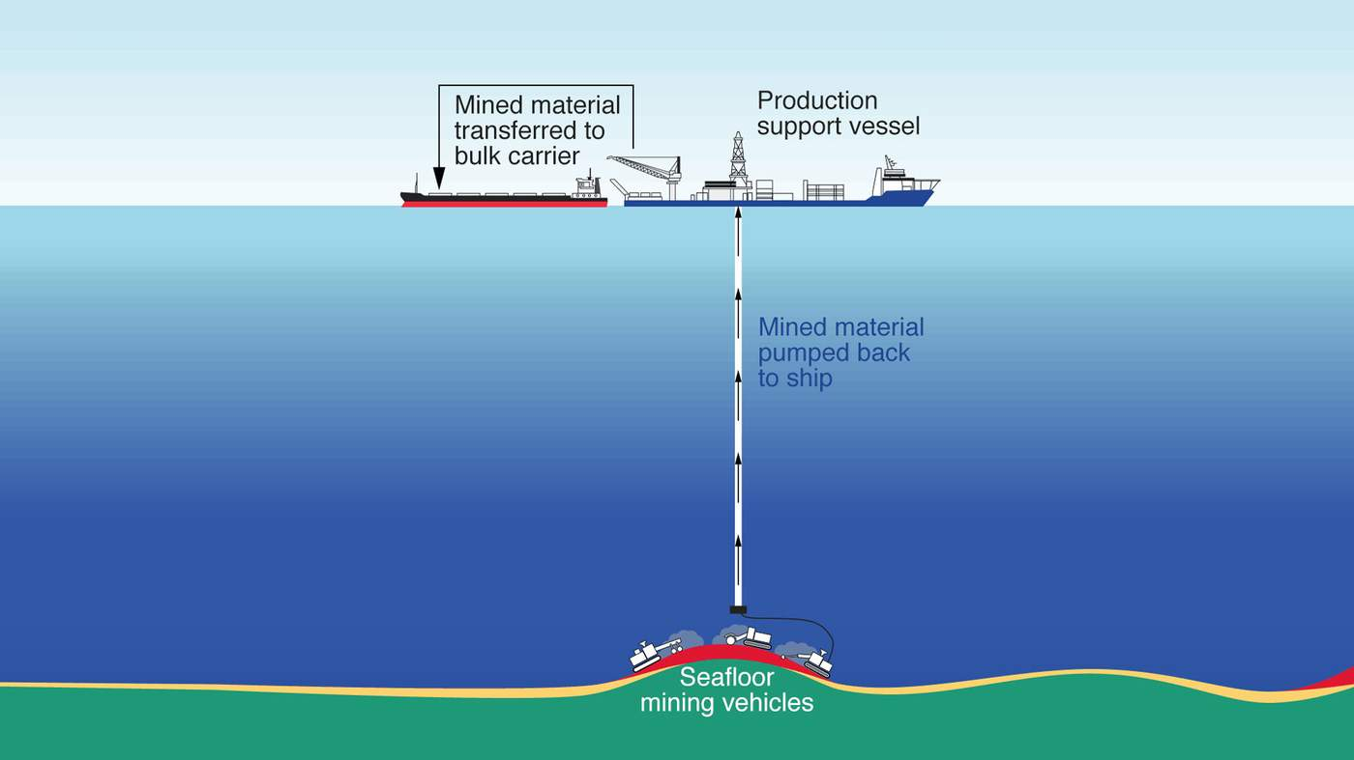

Threatened waters

Jonathan Mesulam first heard about deep sea mining when he was reading the business section of a newspaper. The story shocked him. Born and brought up in Papua New Guinea’s New Ireland, he realised that the site of Solwara 1 was only about 15 miles (25km) from his home on the shore.
“As soon as I read the article I felt so numb,” Mesulam says.
Like many parts of Papua New Guinea, his village has the appearance of a tropical paradise. Palm trees overlook aquamarine shallows and wooden fishing boats lie on the golden beaches.
But the beauty masks a chronic lack of development. People live in homes built of bamboo and sago leaves. Mesulam himself achieved a big break by becoming a secondary school teacher, but he has shunned city life to be at home to fight the mine.
“We have a connection with the sea,” he says. “It’s been part of our culture for generations and traditional knowledge of the sea goes back to our ancestors.”
Polite and softly spoken, Mesulam says the coastal communities depend on fishing which could be threatened if the waters are filled with dust generated by the mining, or if they are polluted.
Jonathan Mesulam is a leading opponent of plans for deep sea mining off the coast of Papua New Guinea
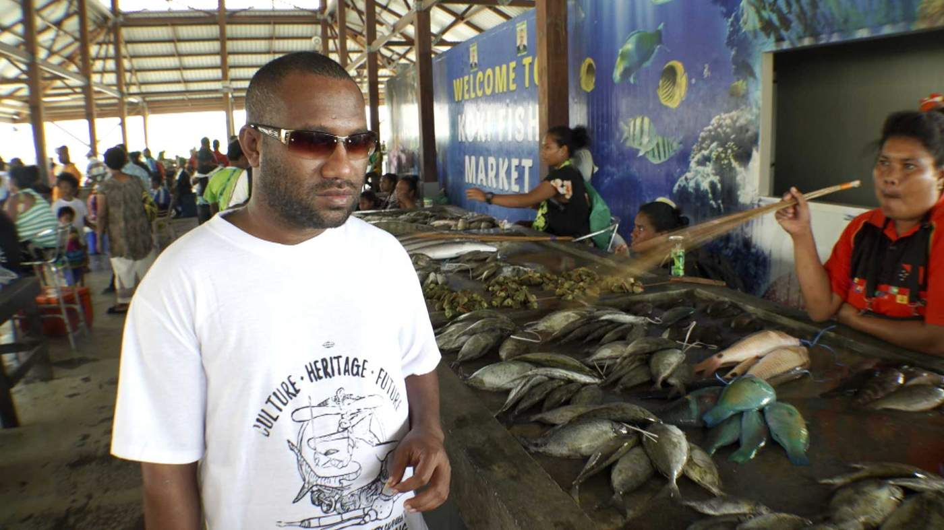
The tuna industry employs thousands in Papua New Guinea. And the villages on New Ireland are famous for the unique practice of “shark calling” - local people lure the creatures to their boats and soothe them before hauling them in.
All this, Mesulam says, could be “grievously harmed” by digging up the ocean floor, and he’s become a leading figure in a campaign group, the Alliance of Solwara Warriors, which is opposing Nautilus Minerals.
The company says that at a mile deep, the mining will be far below the habitats of any important fisheries and will not affect them.
“Where we’ll be operating, it’s cold and dark,” says one senior Nautilus executive. “There are no tuna there, they need entirely different conditions near the surface of the ocean.”
This reassurance has been emphasised in public meetings. And Nautilus has also been investing in community relations, paying for mobile health care and even a new bridge.
For Mesulam this is mere PR. He calls the mine “experimental” - there could be unexpected consequences, and he has the churches and some politicians on his side.
But he’s up against a great force - the incredible and surging demand the world has for key minerals.

Our need
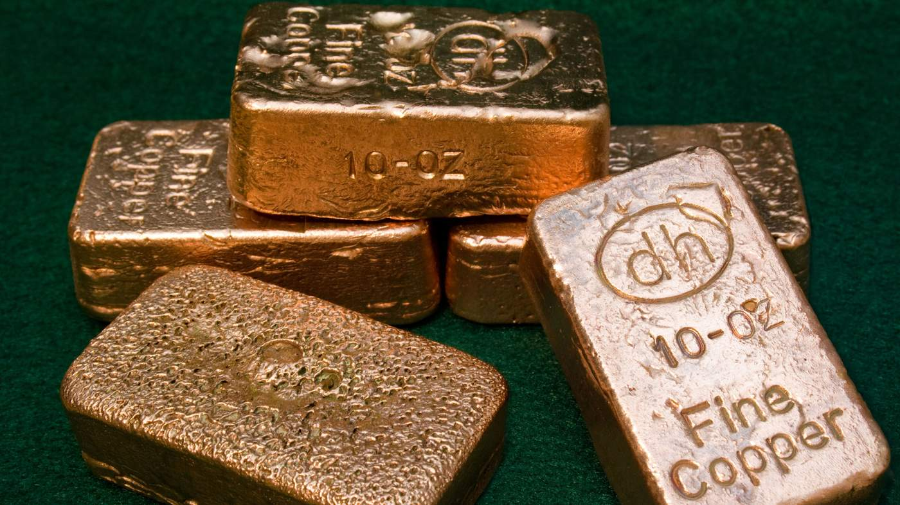
Stung by accusations that they are failing to tackle dirty air, governments around the world are setting new standards for cleaner vehicles. That means millions more electric cars in the next few years.
All the batteries and the wiring, the processors and the charging points, will need raw materials. Last year the German giant Volkswagen tried to corner the market in cobalt. Supplies of lithium are also in hot demand. And copper has never been so badly needed.
And with renewable power like wind and solar being installed at a frantic pace, every turbine and every panel also requires key metals. Add to that the boom in consumer electronics and there are real concerns about future supplies.
With cobalt, it’s estimated that by 2025 Volkswagen will need one-third of the current entire global supply for its electric cars.
Massive new battery factories are being constructed – like Tesla owner Elon Musk’s famous Gigafactory - and they too will be hungry for cobalt.
Bram Murton, a geologist with the UK’s National Oceanography Centre, says that if all the cars on Europe’s roads are electric by 2040, and if they use the same kind of batteries as the Tesla Model 3, that would require 28 times more cobalt than is produced right now.
At the moment more than 60% of all cobalt comes from the Democratic Republic of Congo. For decades allegations of corruption and human rights abuses have swirled around parts of its mining industry.
Last year Amnesty International said there were children as young as seven working in the DRC’s cobalt mines, “in narrow man-made tunnels, at risk of fatal accidents and serious lung disease”. Microsoft, Renault and Huawei were among the companies named as failing to check if their supplies of cobalt involved child labour. They’ve all since promised to improve their systems for checking how cobalt is sourced.
Amnesty International has raised concerns about child labour in African cobalt mines
Advocates of exploiting the ocean also point to the size of mines on land compared with those that would be operated underwater. Kennecott in Utah and Chuquicamata and Escondida in Chile involve mind-bogglingly large holes in the ground. They stretch nearly three miles across (4km) and reach more than half a mile deep (645m-1200m).
By contrast, the Solwara 1 mine, in the waters off Papua New Guinea, will be small – 1150ft (350m) across and 65ft (20m) deep.

For Michael Lodge, secretary general of the International Seabed Authority, a UN body set up to manage deep sea mining, there’s a clear case for pressing ahead.
“Are we going to continue to develop huge mines that destroy villages, alter rivers, pollute water courses, take thousands of years to restore, remove whole mountains? You don’t have any of that with deep seabed mining.”

Source: The Copper Alliance

Source: The Copper Alliance

Source: The Copper Alliance

Looking for nodules
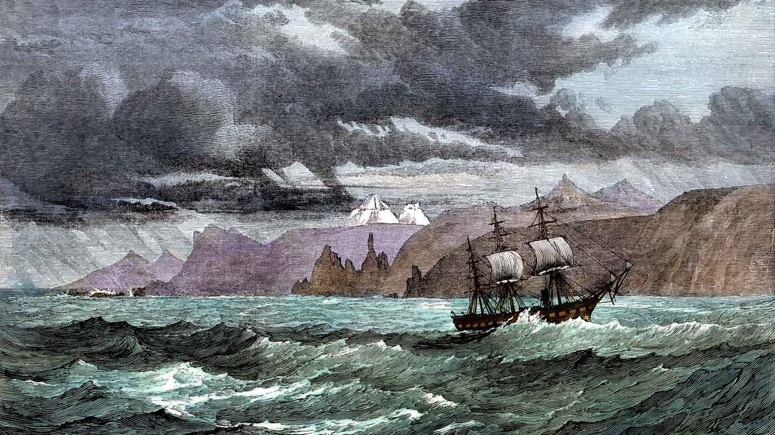
The first inkling that the ocean floor might hold a treasure trove of minerals came in the late 19th Century when a Royal Navy ship, HMS Challenger, was sent on a pioneering expedition. Instead of exploring the coasts of new lands, the ship was to investigate the oceans themselves.
The ship’s scientists discovered the existence of underwater mountains in the Atlantic, as well as establishing the presence of life in the deep. But perhaps their most unexpected find came from the seabed.
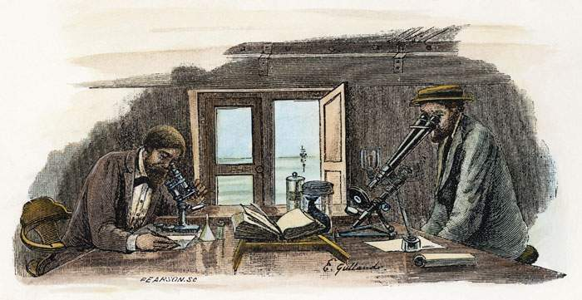
Scientists aboard the HMS Challenger
When the seabed was dredged, the nets brought up teeth from sharks and ear bones from whales but also small rocks. Initially described as “nodular concretions”, and looking a bit like cobblestones, it turned out that vast fields of them were lying on the sand and sediment.
In 1877, in a lecture given in Manchester, one of the expedition’s scientists, John Murray, reported that they were made up of manganese, iron and nickel.
Later expeditions confirmed that these manganese nodules were scattered across the seabed as far apart as the Pacific and Indian Oceans. By the 1950s, with the world’s population booming, researchers turned their attention to these potential resources.
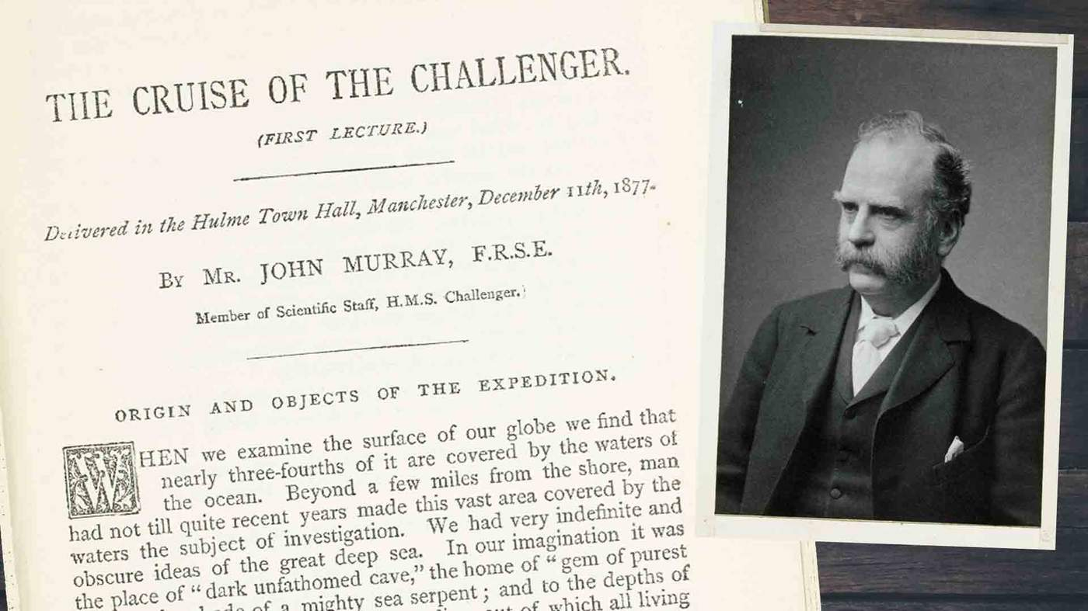
In a book published in 1964, American marine geologist John Mero wrote that the nodules were so plentiful and so rich that even if only 10% of them could be mined, they would keep a world of 20 billion people supplied with key metals for “thousands of years”.
At that time the nodules were inaccessible and the prices for the metals weren’t nearly high enough to justify the effort.
But Mero had planted a germ of an idea.
On 1 November 1967, a UN committee was meeting in New York and the ambassador from the island nation of Malta was invited to speak. Dr Arvid Pardo faced an uphill struggle. He was suggesting that the deep oceans should be reserved for peaceful activities and that the mineral wealth should be shared by all of mankind.
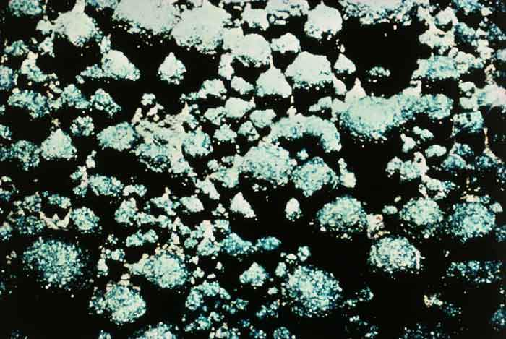
Manganese nodules on the bed of the Pacific Ocean
Some delegations were already hostile, but Pardo was well prepared and passionate, even lyrical. The dark oceans, he said, “were the womb of life”. He then quoted John Mero’s research into the “astounding” contents of the billions of nodules lying untouched on the seabed – enough aluminium to last 20,000 years, zirconium for 100,000 years and cobalt for 200,000 years.
Pardo floated a radical suggestion - a slice of any earnings from deep sea mining would have to go to developing nations. This controversial concept was to be haggled over for decades.
But today, Pardo’s vision is becoming reality as the UN’s International Seabed Authority has drawn up maps dividing the ocean into blocks.
There are 29 exploration areas, licensed for mineral prospecting for 15 years. In total they stretch over an astonishing 500,000 square miles (1.3m sq km) of seabed in the Pacific, the Atlantic and the Indian Ocean. Ventures from 19 different countries have paid for the rights to investigate them.
China has four of them. Russia and South Korea each have three. France and Germany have two. And so does the UK, via a company called UK Seabed Resources. The company’s owner, Lockheed Martin, has an interesting connection. It was one of the contractors secretly hired by the CIA to retrieve the Soviet submarine – and it has remained genuinely interested in manganese nodules ever since.
Although no-one has yet started mining the ocean floor, dozens of research expeditions are under way “at an intense pace”, says Michael Lodge, from the International Seabed Authority.
Based in Jamaica, the ISA must come up with a set of rules before exploitation of the seabed can start in international waters - what environmental controls there will be and how much money will go to poorer countries.
Companies digging for minerals close to shore – like those in Papua New Guinea or Japan – need not wait because individual governments can decide what to do in their own territorial waters.

Lost creatures
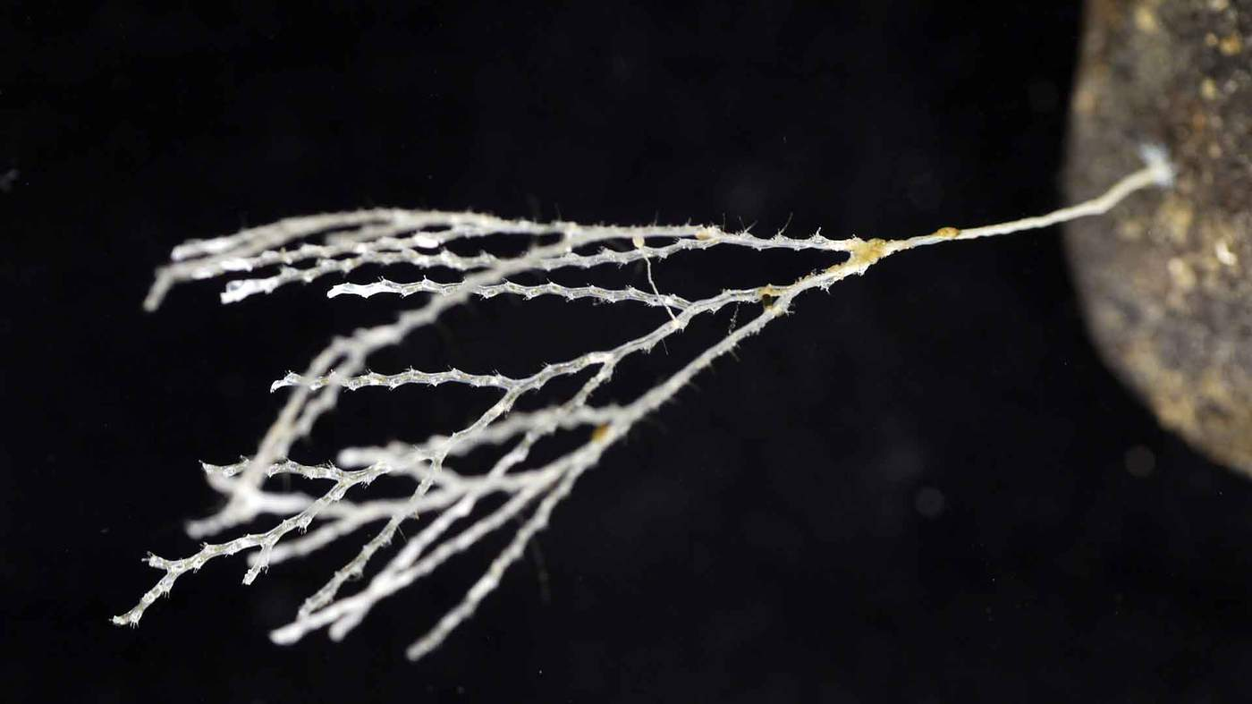
No deep sea mine can start operating until the ecology of each zone has been assessed. And the rush to mine has generated something unexpected - a wealth of new information about life in some of the least explored parts of the world.
Among those are thousands of new species ranging from sponges to crustaceans.
Pedro Martinez, who works at the Senckenberg Research Institute in Germany, told a conference at London’s Natural History Museum how hundreds of creatures spotted in the depths are completely new to science. “We don’t even have names for these species...there are no books to identify them.”
“The abyssal plains,” he asserted, “may have the highest biodiversity in the oceans, maybe the highest biodiversity on the planet.”
There’s an emerging scientific consensus that the tracts of ocean floor in line to be mined – whether hydrothermal vents or fields of nodules - are thriving habitats with intricate ecosystems. And they are still largely unknown.
Adrian Glover, a marine biologist at the NHM, has an analogy. Imagine trying to survey a rainforest while hovering in a hot air balloon. Making the task harder is a thick fog. And all you can do is lower a bucket at a few random points to drag up the odd branch and lump of soil. “Think of all the things you’d miss,” he says. “That’s what it’s like investigating the deep ocean.”
Some prospecting expeditions have not released their findings about marine life, as they’re meant to. And few of the ventures have the funding for biologists to publish detailed results. While Glover is optimistic that mining will not be allowed “in areas where they don’t know what lives there”, he says, “we do need a reasonable understanding and we just haven’t got that yet”. Until the biology is understood, the danger is that species will be wiped out.
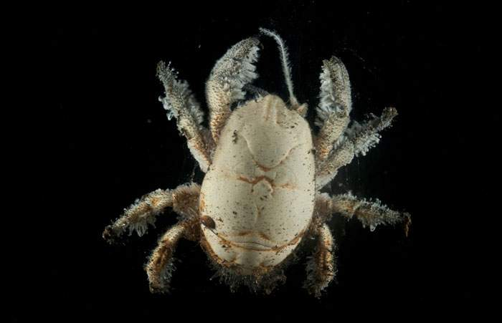
Hoff crab
One example is a type of hairy crab known as the Hoff. It lives in the Longqi – or Dragon’s Breath - hydrothermal vents in the Indian Ocean, an area which China is licensed to explore for minerals. Although it’s similar to crabs elsewhere, this particular variant may be unique.
The scaly foot snail is another rare creature only known to live in two spots in the ocean, both of which are licensed for mining.
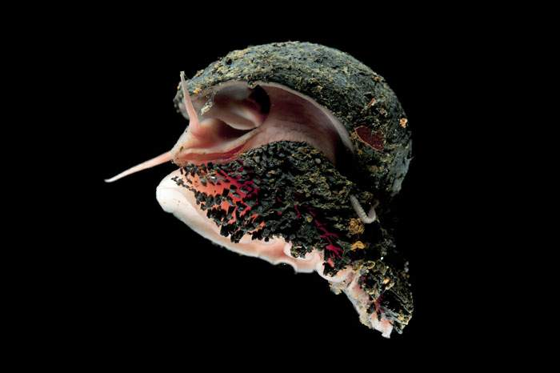
Scaly foot snail
While these might not be the most iconic symbols of conservation, they may later prove to have a key ecological role or even a medical application. Some deep sea organisms are known to have high levels of substances that may be useful in combating Alzheimers.
So what impact will mining have on marine life? Huge excavators will rumble over the seabed. Either they will tear up hydrothermal vents or they will vacuum up nodules. It will be highly destructive.
Michael Lodge admits that but also argues that the areas affected will be tiny compared with the vastness of the oceans – “much less than half a per cent” – and that big areas have been earmarked as reserves to be left untouched.
But many biologists wince at the thought of what might happen. Habitats in the path of the machines will obviously be wiped out. And a group of leading marine scientists recently warned of the risks of “unavoidable and possibly irrevocable” losses to biodiversity.
Mining will raise plumes of sediment - like clouds of dust from a quarry. This could affect marine life far beyond the mining site.
To assess what might happen if nodules are mined, Annemiek Vink and her colleagues at Germany’s Federal Institute for Geosciences and Natural Resources ran computer models. They assume that the massive mining machines might be as wide as five bulldozers, side-by-side, advancing over the sea floor.
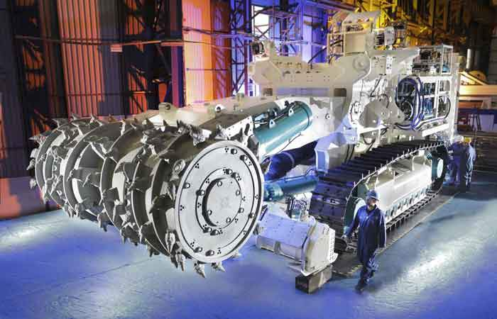
That would stir up as much as 1,000 tonnes of sediment an hour. Within 10 days, she estimates, a thin blanket of dust could settle up to 12km away, smothering everything that lives there. A study released at the NHM conference says the effects on the ecosystems would “last many decades”.
And with so much uncertainty about the risks to the marine environment, the European Parliament has called for a moratorium on mining until more research is done.
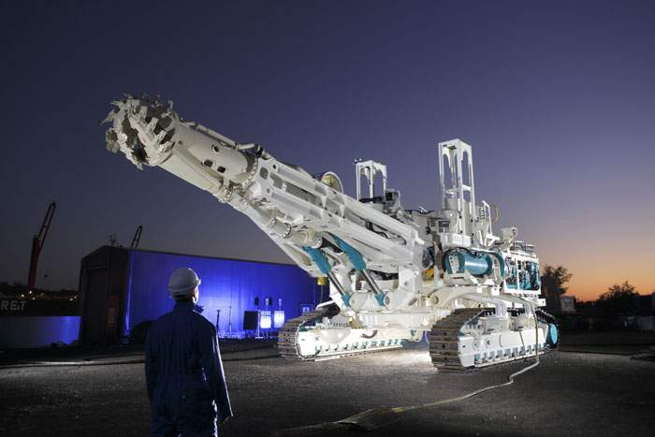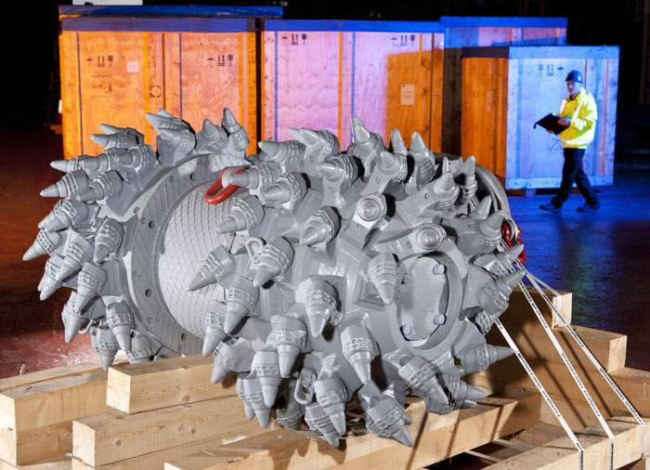
We’ve drilled the ocean floor for oil and gas, scarred it with trenches for communications cables, poisoned it with old radioactive waste and chemical weapons, and polluted its remotest corners with a blizzard of discarded plastic. So, is mining a step too far?
I put that question to Sir David Attenborough at the launch of his series Blue Planet II. When he sees our video of the giant machines being readied in Papua New Guinea, he is aghast. “It’s heartbreaking,” he says.
His greatest concern is for the hydrothermal vents, those delicate mineral-rich chimneys which act as oases for unusual creatures.
“That’s where life began, and that we should be destroying these things is so deeply tragic - that humanity should just plough on with no regard for the consequences, because they don’t know what they are.”

But there is a vigorous debate among scientists.
The geologist Bram Murton has warned of “an ill-informed knee-jerk reaction” to ocean mining which, he says, offers the potential to support a low-carbon future.
But Glover says that ultimately it’s about whether it’s right for humans to go into an area and destroy species we know nothing about.
All this raises an awkward set of questions. Where should we get our minerals from? Should phones and wind turbines and electric cars carry a label explaining the origins of their raw materials?
Tins of tuna state that they are “dolphin-friendly” so should products using cobalt say if the metal was mined on land or in the ocean? What would the best choice be anyway? Should the vents so special to Attenborough be spared and only nodule mining allowed?
Some argue that proper recycling of metals would negate the need for deep sea mining in the first place, but others think that that won’t produce a fraction of what’s needed.
Time is running out to come up with answers. More than 40 years since the CIA faked a deep sea mining operation, the first genuine ones may start work far sooner than most people realise.
Robert DeNiro Implicated in Underage Prostitution Ring

Robert De Niro was a client of an international prostitution ring that hired underage children and specialized in providing prostitutes to wealthy, high-profile clients.
According to court records from 1998, Independent journalist John Lichfield discovered that the prostitution agency routinely ensnared girls as young as 15, forcing them to have sex with Hollywood’s rich and powerful elite.
The French Vice Squad traced 89 young women who said they had been tricked or sometimes physically constrained by the agency into working for them. The girls were sometimes “sold on like cattle” to other call-girl agencies.
While it is not clear whether or not De Niro was supplied with underage girls, his involvement in the ring received little to no media coverage.
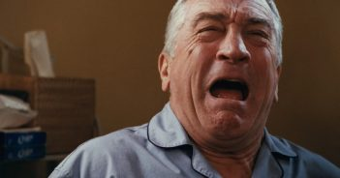

The case uncovers the brutal methods used to snare young women, some as young as 15, into a call-girl agency.
It also exposes attempts by the French government machine to block an investigation. Seems France did not want to embarrass senior politicians and damage French interests abroad.
According to the documents, the agency’s photographer, Jean-Pierre Bourgeois, hung about Parisian nightclubs or casting agencies, scouting victims. He picked on young women, often a teenager, and invited them to his apartment to take trial shots.
After gaining their confidence, he persuaded them to pose for more revealing pictures. The girls were then convinced, if possible, that prostitution was the best way to get into modeling or movie careers.
If they refused, they were blackmailed with the threat that the photographs would be sent to their families. In some cases, they were simply abducted. Several girls cited in the investigating judge’s report accuse Mr. Bourgeois of rape.

Six people were charged with the running the international prostitution ring.
Its call-girls entertained De Niro and many others. The agency specialized in tricking, or trapping, star-struck teenage girls into selling their bodies with the promise of careers as models or actresses.

The documents are worse than a trashy sex novel.
They mention Hollywood stars and high-ranking foreign dignitaries. They speak of arms deals and politicians from our country. The mainstream media has done everything they could to sweep it under the carpet in order to protect celebrities like De Niro.
John Lichfield, a journalist that works for London’s Independent, stated that the agency regularly hired young girls, some as young as 15 years old. They force them to have sex with Hollywood elites.
Lichfield discovered the documents and wrote, “Six people are charged with the running of an international prostitution ring, whose call-girls entertained the actor Robert De Niro, the former tennis player, Wojtek Fibak, two senior (but unnamed) French politicians and several Gulf princes. The agency specialized in tricking, or trapping, star-struck teenage girls into selling their bodies with the promise of careers as models or actresses.”
The files of clients’ names seized by the police are said to include many well-known members of the sports and show-business jet-set on both sides of the Atlantic. The only names to emerge so far are De Niro, Fibak and the French film producer, Alain Sarde.
De Niro was involved in a much-publicized “arrest” in Paris while filming a movie. He was questioned only as a witness and an occasional client of the network.

It has also been reported that a former employee of Robert De Niro’s at Tribeca Grill recently came forward.
She spoke to the New York Post regarding what it was like working for the Hollywood star. She revealed that De Niro treated his employees like trash.

Where does it end?
Just last year, De Niro decided to slam President Trump and dub him a sexual predator. He went so far as to call Trump “a dog.”
Now the tables have severely turned around. De Niro should be ashamed of himself for picking on President Trump for making an insignificant comment years ago… especially since he is was at the heart of an international prostitution ring.

