Jihad Report
May 05, 2018 -
May 11, 2018
Attacks | 40
Killed | 198
Injured | 215
Suicide Blasts | 7
Countries | 17
Trump Nukes Iran Deal
President Donald Trump announced Tuesday the U.S. will pull out of the landmark nuclear accord with Iran, declaring he’s making the world safer but dealing a profound blow to allies and deepening the president’s isolation on the world stage.
“The United States does not make empty threats,” he said in a televised address from the White House Diplomatic Room.
Trump said the 2015 agreement, which included Germany, France and Britain, was a “horrible one-sided deal that should never ever have been made.” He added that the United States “will be instituting the highest level of economic sanction.”
Trump’s decision means Iran’s government must now decide whether to follow the U.S. and withdraw or try to salvage what’s left of the deal. Iran has offered conflicting statements about what it may do — and the answer may depend on exactly how Trump exits the agreement.
One official briefed on the decision said Trump would move to reimpose all sanctions on Iran that had been lifted under the 2015 deal, not just the ones facing an immediate deadline.
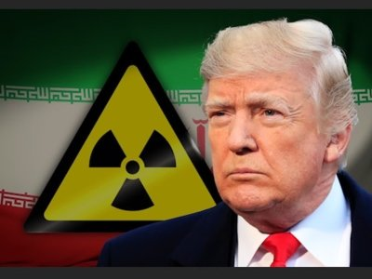
President Donald Trump is set to announce his decision on whether to keep the U.S. in the Iran nuclear agreement on Tuesday. One of the deal’s former negotiators suspects Trump will “light the fuse” of an “explosive cocktail” and withdraw. (May 7)
Supporters of trying to fix the agreement had hoped Trump would choose a piecemeal approach that could leave more room for him to reverse himself and stay in if he could secure the additional restrictions on Iran that European nations have tried unsuccessfully to negotiate with Trump. Still, the administration planned to allow a grace period of at least three months and possibly up to six months so that businesses and governments can wind down operations that would violate the reimposed U.S. sanctions, officials said.
As administration officials briefed congressional leaders about Trump’s plans Tuesday, they emphasized that just as with a major Asia trade deal and the Paris climate pact that Trump has abandoned, he remains open to renegotiating a better deal, one person briefed on the talks said.
The Iran agreement, struck in 2015 by the United States, other world powers and Iran, lifted most U.S. and international sanctions against the country. In return, Iran agreed to restrictions on its nuclear program making it impossible to produce a bomb, along with rigorous inspections.
In a burst of last-minute diplomacy, punctuated by a visit by Britain’s top diplomat, the deal’s European members gave in to many of Trump’s demands, according to officials, diplomats and others briefed on the negotiations. Yet they still left convinced he was likely to re-impose sanctions.
Trump spoke with French President Emmanuel Macron and Chinese leader Xi Jinping about his decision Tuesday. The British foreign secretary traveled to Washington this week to make a last-minute pitch to the U.S. to remain in the deal, according to a senior British diplomat. The diplomat, who spoke on condition of anonymity, said the British objective will remain to uphold and maintain the deal.
Hours before the announcement, European countries met to underline their support for the agreement. Senior officials from Britain, France and Germany met in Brussels with Iran’s Deputy Foreign Minister for Political Affairs, Abbas Araghchi.
If the deal collapses, Iran would be free to resume prohibited enrichment activities, while businesses and banks doing business with Iran would have to scramble to extricate themselves or run afoul of the U.S. American officials were dusting off plans for how to sell a pullout to the public and explain its complex financial ramifications.
In Iran, many were deeply concerned about how Trump’s decision could affect the already struggling economy. In Tehran, President Hassan Rouhani sought to calm nerves, smiling as he appeared at a petroleum expo. He didn’t name Trump directly, but emphasized that Iran continued to seek “engagement with the world.”
“It is possible that we will face some problems for two or three months, but we will pass through this,” Rouhani said.
Under the most likely scenario, Trump would allow sanctions on Iran’s central bank — intended to target oil exports — to kick back in, rather than waiving them once again on Saturday, the next deadline for renewal, said individuals briefed on Trump’s deliberations. Then the administration would give those who are doing business with Iran a six-month period to wind down business and avoid breaching those sanctions.
Depending on how Trump sells it — either as an irreversible U.S. pullout, or one final chance to save it — the deal could be strengthened during those six months in a last-ditch effort to persuade Trump to change his mind. The first 15 months of Trump’s presidency have been filled with many such “last chances” for the Iran deal in which he’s punted the decision for another few months, and then another.
Even Trump’s secretary of state and the U.N. agency that monitors nuclear compliance agree that Iran, so far, has lived up to its side of the deal. But the deal’s critics, such as Israel, the Gulf Arab states and many Republicans, say it’s a giveaway to Tehran that ultimately paves the path to a nuclear-armed Iran several years in the future.
Iran, for its part, has been coy in predicting its response to a Trump withdrawal. For weeks, Iran’s foreign minister had been saying that a re-imposition of U.S. sanctions would render the deal null and void, leaving Tehran little choice but to abandon it as well. But on Monday, Rouhani said Iran could stick with it if the European Union, whose economies do far more business with Iran than the U.S., offers guarantees that Iran would keep benefiting.
For the Europeans, Trump’s withdrawal constitutes dispiriting proof that trying to appease him is futile.
Although the U.S. and Europeans made progress on ballistic missiles and inspections, there were disagreements over extending the life of the deal and how to trigger additional penalties if Iran were found violating the new restrictions, U.S. officials and European diplomats have said. The Europeans agreed to yet more concessions in the final days of negotiating ahead of Trump’s decision, the officials added.
More Logan Acting
What you are about to hear is tantamount to war. Yes, I said it. And act of war. But, it was not committed by a foreign dictator or a despot. It was committed by a former Secretary of State in a foreign country. The now clear evidence has surfaced a could of days ago that former secretary of state John Kerry held not one but two secret meetings with Iran’s foreign minister to strategize over how to seize the presidency from Donald Trump.
The meeting was witnessed and photographed by a bystander in France. After the pictures and tweets surfaced, an Iranian Foreign Ministry spokesman could not help but confirm the meetings after the Boston Globe broke the news, declaring , “We don’t see the U.S. just as Mr. Trump; the United States is not just the current ruling administration.”
One does not need to think about this too long to realize the chilling consequences of such a meeting. Iran is a terrorist state responsible for the deaths of hundreds of Americans in Iraq, whose leaders hold rallies where thousands chant “Death to America!” Kerry was working with a sworn enemy of the United States to try to undermine the foreign policy of the elected president of the United States.
This is exactly, precisely WHY the Logan Act was passed in 1799. The penalty is 2 years in prison and an unprecise financial fine. The violation has to be someone capable of actually negotiating on behalf of the United States in a foreign country against the current policy positions of a sitting president. The penalty for such a person is severely career ending, and is why no one has ever dared violate it; until now.
Kerry’s meetings with Iran’s leaders were not isolated incidents, but part of a well-funded formal lobbying campaign that included phone calls with European Union leaders and meetings with the presidents of Germany and France in which, the Globe reports, he discussed “the details of sanctions and regional nuclear threats in both French and English.”
There’s more. Former president Obama, former presidential candidate Hillary Clinton, and others have been traveling to China, India, France, and the middle East assembling an international coalition to overthrow Donald Trump. They are selling influence, technology, and national secrets to enemies of America for billions in campaign and intelligence funding. The FBI has been paid millions. The INI, the CIA, and other foreign intelligence agencies have been employed to perform the opposition of Donald Trump.
On Twitter, Trump suggested that Kerry might have violated the Logan Act, which says: “Any citizen of the United States . . . who, without authority of the United States, directly or indirectly commences or carries on any correspondence or intercourse with any foreign government . . . with intent to influence the measures or conduct of any foreign government . . . in relation to any disputes or controversies with the United States, or to defeat the measures of the United States, shall be fined under this title or imprisoned not more than three years, or both.” In fact, no one has been prosecuted under the Logan Act in more than 160 years, and most conservative legal scholars consider it unconstitutional.
Although what Kerry did was the epitome of the Logan Act. If there ever was a person who should be arrested by Federal Marshalls at the airport, have his passport revoked, and be incarcerated without bond until his trial and conviction, it is John Kerry.
Recall that in 2015, when Sen. Tom Cotton (R-Ark.) and 46 other Republicans wrote to Iran’s leaders informing them of the Senate’s constitutional role in approving international agreements, Kerry was incensed. “My reaction to the letter was utter disbelief,” he said at the time. “To write leaders in the middle of a negotiation . . . is quite stunning . . . [and] ignores more than two centuries of precedent in the conduct of American foreign policy,” Kerry said, adding that he would never have interfered in that way “no matter what the issue and no matter who was president.” What a difference three years can make. This is not what the rule of law looks like. It is what the rule by law looks like.
Cotton is a sitting United States senator. The Senate has a constitutional role in foreign policy. Kerry is a private citizen. He has a constitutional role in nothing, but nevertheless is negotiating on behalf of the assets and credit of America.
Kerry’s defenders compare him to Henry Kissinger and other former secretaries of state who regularly meet with world leaders. “Secretary Kerry stays in touch with his former counterparts around the world, just like every previous Secretary of State,” a Kerry spokesman said. But Kissinger does not conduct rogue diplomacy. No other former official actually works to put together a global coalition to overthrow a sitting president. No other former leader promises weapons, intelligence, and technology in exchange for money and support in their attempt to regain the White House.
When these other leaders meet with foreign leaders, they always coordinate with the White House, often carrying messages for the president, and then they brief administration officials afterward. Kerry did none of this. His intention was clear.
This is not the first time Kerry has interfered in U.S. diplomacy as a private citizen. In 1970, he flew to Paris and met with the North Vietnamese while they were in the midst of negotiating the Paris Peace accords with Kissinger. Kerry admitted then that his actions were “on the borderline of private individuals negotiating.” What he did last month was not on the borderline.
Kerry would not have had to resort to rogue diplomacy if he had negotiated a better deal. The agreement he struck could not even muster the support of a simple majority in the Senate, much less the two-thirds majority needed to ratify a treaty. As Sen. Ben Sasse (R-Neb.) correctly points out, the Obama administration “made a bad deal with Iran without support from Congress. . . . American foreign policy makes lasting progress when it is led by the President, approved by Congress, and presented honestly to the American people.” Kerry has no one to blame but himself for Trump’s decision to withdraw. And he certainly has no business colluding with America’s enemies against America’s president.
Iran: Persia Rising
The deed is done.
U.S. President Donald Trump has kicked the Iran nuclear deal to the curb — just as he promised that he would, repeatedly, over the past two and a half years. Say what you will about the president, but he’s been relentlessly true to his word. Campaign promises made; campaign promises kept. Now, more than 71% of his campaign promises have been fulfilled. There is nothing to compare. He is not blown about by every wind of doctrine.
His research and analysis has been accumulating for more than 30 years for this moment in time. He vowed for decades to come when he was needed. Like a super-hero he waited until the last possible moment, and I believe it was the last possible moment for America. Globalist elites may scoff derisively at the notion in light of the geopolitical stakes at play, but they’d be wrong to dismiss its deep resonance with the tens of millions of Americans across more than 94% of the country who put Trump in the White House. A politician who actually does what he said he was going to do. We elected a man, yes. But the man had an agenda, more than a hundred million people support that agenda.
And this was no soft withdrawal, no easy exit from a deal made in dark rooms by dark souls. All nuclear-related sanctions are to be reimposed as quickly as possible, consistent with U.S. law. No later than the first week of November, every one of the most powerful U.S. economic penalties ever inflicted on Iran will be back in full force. That includes sweeping secondary sanctions against foreign firms caught doing proscribed business with the Islamic Republic. Despite the frantic efforts of their leaders, it appears there will be no reprieve, no carveouts, no shielding of European companies from the brutally harsh consequences of what Trump has wrought.
Commercial entities the world over now have a brief window to unwind their interests in Iran’s deeply troubled $400 billion economy or risk being shut out of America’s $20 trillion market, including the ability to conduct transactions in the U.S. dollar, the international currency of choice. There are hundreds and hundreds of capable companies ready to take their place as approved suppliers if they don’t, effectively guaranteeing their demise.
All of this likely renders moot any last-ditch effort by the Europeans and Iran to salvage the nuclear deal sans America. In the immediate aftermath of Trump’s announcement, Iranian President Hassan Rouhani dangled the prospect that Iran might keep the deal if the Europeans could guarantee that its benefits would continue to flow. For their part, the leaders of Britain, France, and Germany gamely committed their countries to “ensuring the continuing economic benefits to the Iranian people that are linked to the agreement.”
But if Trump truly means what he says about secondary sanctions, starving the Iranian regime of the revenue flows it uses to finance its continued assault on U.S. interests, this is not a check that the Europeans can cash. Any serious international business or financial institution worth its salt is simply not going to risk triggering the wrath of the U.S. government for the pleasure of making a few bucks in the irredeemably corrupt, horribly mismanaged economic dystopia of Iranian Supreme Leader Ali Khamenei and Qassem Suleimani, the general in charge of the Islamic Revolutionary Guard Corps. It’s most unlikely that they will be prepared to sacrifice their bottom lines on the altar of the Iran deal — no matter how hard their governments plead.
It is precisely why Kerry, Clinton, Obama, and others are meeting with foreign leaders in a frantic attempt to assemble a global coalition to fight Trump; defeat him if possible. Kill him if it is not, I am afraid.
Which means the countdown to the deal’s complete unraveling has probably begun. Will it take a few months? A bit longer? No one can say for sure. Much depends on Iran. In his response to Trump, Rouhani threatened that if the Europeans failed to make staying in the deal lucrative enough, Iran might throw its nuclear program into overdrive, commencing “industrial enrichment without any limitations.” Empty bluster? Hopefully. But still a real possibility that could spell the doom of the Mullahs in power.
At that point, the ball will be very much in Trump’s court. What does he do if Iran starts blowing past the agreement’s constraints on stockpiles of enriched uranium, numbers and types of deployed centrifuges, or the testing of even more advanced centrifuges? What happens if the timeline for an Iranian bomb starts creeping below the deal’s 12-month threshold?
In his withdrawal statement, Trump warned, “If the regime continues its nuclear aspirations, it will have bigger problems than it has ever had before.” The next day, he further amplified the threat: “I would advise Iran not to start their nuclear program. I would advise them very strongly. If they do, there will be very severe consequences.”
Meaning what, exactly? It sure sounds like a threat to use military force. And that would make perfect sense. Surely, the president and his advisors understand that one likely consequence of killing the deal and reimposing sanctions is that Iran might begin expanding its nuclear program again.
A credible threat of force is clearly intended to deter such a dangerous move. But what if it doesn’t? What if Iran calls Trump’s bluff before sanctions can have their intended effect or, indeed, are even fully operational again? Then he may have to strike Iran’s nuclear facilities with all the attendant dangers and unforeseen consequences that entails, or risk being exposed as a paper tiger. It goes without saying that absent a rock-solid commitment to move militarily against Iran’s nuclear program in short order should it prove necessary, the president’s decision to crater the Iran deal prematurely really would constitute not just a major gamble, but extreme diplomatic malpractice.

Which raises the broader question: What is Trump’s Iran strategy post-nuclear deal? He and members of his administration have spoken at great length about the urgent need to combat the totality of Iran’s threatening activities well beyond the nuclear sphere, including its regional aggression and ballistic missile program. In background materials that accompanied the president’s announcement, the administration set out a series of breathtakingly ambitious goals. In addition to never developing a nuclear weapon, the administration declared, the Iranian regime also must:
- Never have an intercontinental ballistic missile, cease developing any nuclear-capable missiles, and stop proliferating ballistic missiles to others;
- Cease its support for terrorists, extremists, and regional proxies, such as Hezbollah, Hamas, the Taliban, and al Qaeda;
- End its publicly declared quest to destroy Israel;
- Stop its threats to freedom of navigation, especially in the Persian Gulf and Red Sea;
- Cease escalating the Yemen conflict and destabilizing the region by proliferating weapons to the Houthis;
- End its cyberattacks against the United States and our allies, including Israel;
- Stop its grievous human rights abuses, shown most recently in the regime’s crackdown against widespread protests by Iranian citizens;
- Stop its unjust detention of foreigners, including United States citizens.
Here is my suggestion, Mr. President. I know your people are listening right now. You always listen. The Persian people are ready to be free. It is that simple. They are frustrated with living in the 15th century. The women of Persia are loving, intelligent, educated, and passionate humans who want their freedom back. They want liberty under some kind of Republic that would return them to their Persian glory and strip the Nazi title of Iran from their legacy. They no longer want to be called Aryan.
They want to have the same basic, God given rights all men desire. They see the freedom to pursue their dream and they want it. They see fashion and beauty, and they want it. They see the entrepreneur and they want to be one. They don’t want war. They want peace and they want to join the global community. They don’t want to focus all their power and resources on wiping Israel from the map.
Yes, evil souls come here to be born, and they are attracted to hatred like night insects to a flickering light in their dark world. I truly believe that Donald Trump can turn the love back on in their country. I believe he can free them from the death cult of Islam and uncloak the light that will chase the roaches of humanity into the cracks in the Earth.
Free the Persian people, Mr. President. Free the women of Persia. That is the key to world peace.
BAMN Gets the Book
Terror is a methodology employed by the Progressives and Globalist Elites to make people afraid. There are two types of weapons; lethal and non-lethal. Lethal weapons are usually indiscriminate and designed to kill people. Guns, bombs, chemicals, and other such weapons are designed to eliminate the enemy forever. Non-lethal weapons are designed to make men obey. A club, and whip, a tazer, and terror are designed to make men afraid of pain or loss. Terroristic litigation would also qualify. Mostly, it’s just burning things, beating people up, and smashing windows that are used to make people fear them and change their minds out of fear or appeasement.
Berkeley middle school teacher and liberal activist Yvette Felarca is connected to a group known as “By Any Means Necessary,” or BAMN. As you might guess by that name, the organization is radical and apparently believes that almost any action — including violence — are justified in removing or stopping Donald Trump. The name implies any means; even assassination. They threaten it hundreds of times a week against him, his family, and his friends and supporters. And yes, even radio hosts.
BAMN has close ties to Antifa, the violent and radical group that has staged protests and clashed with American voters over the last several years.
Felarca is facing serious charges: Assault by means of force likely to produce great bodily injury, and inciting a riot. She laughed at this and trusted George Soros to fix everything, intimidate the justice system, or somehow defend her civil rights to beat people up and burn cars. Those crimes allegedly occurred when BAMN and Antifa protesters attacked a permitted and peaceful demonstration of free speech near the California state capitol building in 2016.
The group that BAMN came to disrupt had the correct permits to hold a political rally and stayed within the boundaries of that permit. Felarca and others attacked them wearing black, masks, and bearing clubs and hammers. They put several people, including an officer in the hospital with serious injuries like stab wounds, broke windows, and destroyed several cars.
Video footage of the event shows Felarca, who has a history of radical activism, fully engaged in the violence. She was arrested and unmasked on the video. She was foul, vulgar, and enraged. The Antifa activists’ attorneys filed a motion for dismissal claiming that the DA and the California Highway Patrol colluded against them in what they describe as a politically-motivated ‘witchunt. Somehow, they pleaded that they were nothing more than political enemies of the right-wing State.
It didn’t work. Sacramento County Judge Michael Savage threw that argument out on Friday, and essentially called the claim rubbish. “Simply nothing in these exhibits supports the defendants’ claims … that they were unjustly or unfairly culled out,” Savage said.
The district attorney in the case had similar words, and pointed out that the charges against Felarca and other far-left rioters had nothing to do with their politics, and everything to do with the evidence of them committing the crimes.
“That’s not why they were charged,” Sacramento County deputy district attorney Paris Coleman said regarding the political beliefs of the suspects.
Over a hundred arrest warrants were issued after that riot broke out, but only a handful of people ended up being charged due to lack of evidence. The district attorney’s office pursued charges for the individuals with the most evidence against them, such as video proof.
“They are captured on video committing crimes, unfortunately for them,” Coleman continued, according to Berkeleyside.
There’s no disputing that the far-right group Felarca and the others allegedly attacked hold controversial and even ugly views, but they were just that… views. Exercising free speech while following the law and obtaining the necessary permits must be something that Americans protect.
The way to defeat foul ideas is by shining a light on them, and exposing why they are wrong. Stabbing people who are speaking begets only more hatred.
Felarca and others on the far left may believe that actions don’t have consequences, but the video speaks for itself. Perhaps she should have thought more carefully before she participated in bloody attacks on people engaging in their right to assemble.
By the way, No one from George Soros’s organization showed up the bail them out, hire hotshot attorneys for them, bribe judges, or attack the courtroom to secure their freedom arrived. They were indoctrinated, trained, pointed, and shot at America. They were also betrayed in the end. Their lives are ruined. They will never be free again. Think about that when you are convinced by someone to attack America.
The Case for Firing Rod Rosenstein
Why did Special Counsel Robert Mueller talk with former National Security Agency head, Mike Rogers, immediately prior to Deputy Attorney General Rod Rosenstein granting a third extension to spy on Trump under the Foreign Intelligence Surveillance Act?
According to detailed analysis from the Conservative Treehouse, the FISA court granted a third extension to spy on members of President Donald Trump‘s 2016 campaign, particularly Carter Page, right before Mueller met with Rosenstein at the Department of State.
A review of court documents and records clearly shows that the third FISA renewal came just after it became apparent the Rosenstein-Mueller cabal used the democrat-funded dossier to trigger the Russia investigation against Trump.
We know the FISA warrant to spy on Page and Trump’s team was illegal and bogus because it wasn’t renewed a fourth time; and, Page has never been charged with a single crime. Why is that?
The NSA uses contractors to conduct opposition research for the agency on potential targets. Rogers hired officials from Fusion GPS, the firm that was paid by Hillary Clinton and the democrats to fund the dossier, to help with the agencies “FISA-702″ program.
Nellie Ohr, wife of DOJ Deputy Bruce Ohr, worked for Fusion GPS. She handled Russia related matters for Fusion and also did contractor work for the NSA. Bruce Ohr has been demoted at the DOJ for failing to disclose to the department that his wife worked for Fusion. In fact, Bruce Ohr is under investigation for meeting with Fusion officials before the 2016 presidential election, where he more than likely discussed the dossier and using it to derail Trump’s presidency.
The alliance at the DOJ and Fusion between the Ohrs, democrats, and Clinton’s campaign infected the FBI and DOJ at the highest levels. This resulted in corrupt officials working together to use the dossier to obtain the FISA spy warrants and trigger the Russia investigation against Trump.
Here’s where it gets really good (and very scary).
In June 2017, one month after Mueller was appointed, The New York Times reported that Mueller had a private meeting with Rogers. We can reasonably assume the meeting was about the FISA warrants already approved to spy on Trump’s team. Mueller was likely gaining information about what he could use to build his case and request a third spy warrant, which was approved by Rosenstein in October 2016.
As detailed in the Times piece, one key line stands out from the official DOJ letter appointing Mueller has the special counsel in the Russia case.
“…to serve as Special Counsel to oversee the previously-confirmed FBI investigation of Russian government efforts to influence the 2016 presidential election and related matters.”
Rosenstein, who oversees Mueller’s probe, is clearly instructing the special counsel to begin his investigation exactly where the FBI and DOJ left off. And it says “related matters,” which is the vague term that Mueller has been using to go after Trump allies for alleged crimes that have nothing to do with Russia or the 2016 election.
Here’s the cherry on top: do you know who was leading the investigation before Mueller took over? Peter Strzok, the anti-Trump agent who sent countless text message denigrating and insulting Trump while he was leading the investigation into the president.
So here’s what we know: Clinton paid for the dossier. She used her allies at the DOJ and FBI to elevate the dossier to get spy warrants, which subsequently led to the Russia investigation.
Mueller was briefed on all of this and was directed by Rosenstein to pick up where the bureau left off, which was using unethical and possibly illegal tactics to derail Trump and go after his allies.
Rosenstein also granted Mueller a third FISA extension to spy on Page and likely other members of Trump’s campaign despite not a single agency charging Page with a crime. Why approve a warrant if no crimes can be proven?
Mueller is trying to charge Trump allies with outrageous crimes to pressure them into “turning” on Trump. And Rosenstein is doing absolutely nothing about it.
A Funny Thing Happens When You Stop…
Intimacy and physical contact are things humans need to survive, and yes that includes a little action between the sheets. Has it been a while since you've done the deed? Maybe you and your partner have lost a bit of the spark in your love life. Or maybe you're newly single or simply don't have the time to date. It's also possible you're just focused on other things in your life and don't feel like you're missing anything b not having sex.
Regardless of the reason behind the lack of lovemaking in your life, if you've noticed any sudden changes in your mood or your body, it might be about time to get back in the game. It turns out not having sex can actually cause some changes in your body and, sure, some of the changes you experience might be pretty pleasant, but we can tell you for certain that the vast majority of them aren't. Here's what you can probably expect to happen if making love has taken a backseat in your life.
Like an over-hormonal teenage boy, women who aren't having sex regularly may find that their body will remind them what they're missing in their sleep. That's right, we're talking about what teenage boys might call a wet dream. This is especially likely to happen if your sex life is not only at a standstill, but you've also given up on masturbating.
Researchers had it easy when they were studying nocturnal emissions in men, the most obvious reason being because men have erections that are visible and ejaculate as proof that they've climaxed. With women, studying these night time bouts of arousal was more complex.
For researchers to collect data on female arousal during their sleep, they had to measure heart rate, do brain scans, and watch for temperature jumps near the clitoris. While it wasn't easy, they managed to get it done and later revealed in a study reported by Broadly that 37 percent of women will have a wet dream before the age of 45 and that they're most common in women between the ages of 40 and 50. So, if it's been a while since you've gotten lucky, you can expect these little presents to find their way into your subconscious.
According to Psychology Today, the endorphins released during sex are ideal for leaving your worries behind and putting an instant smile on your face. So when you've gone a while without any nookie, you might notice that your stress level builds up.
If you're not one to get off as often as you'd like, have no fear! It's not only those endorphins that help reduce stress levels, it's those acrobatic moves we try in the bedroom as well. Sex can be a form of exercise, which we all know fights off stress and anxiety, so if you aren't getting any these days, try not to skip your cardio workouts.
If it wasn't bad enough that without sex you're feeling overstressed, you might also have high blood pressure. One study determined that those who had sex over a two week period had significantly lower blood pressure levels than those who were without sex or even compared those who masturbated or participated in sexual activities that excluded intercourse. So even taking care of things yourself or making out a bit won't help your stress levels very much. In this case, women actually do need a partner.
Seems like having sex provides some key benefits to our health, but when we're not rolling around in the sheets with our partner, we actually more susceptible to illness too. According to the Mayo Clinic, the DHEA, or Dehydroepiandrosterone, hormone is released during arousal, with even more released when you orgasm. This hormone gives your immune system a bit of a boost, helping your body to fight against bacteria, viruses, and other pretty nasty germs.
While not having sex certainly doesn't mean you're going to come down with some major illness, you'll be missing out on some of these other great benefits as well. The DHEA hormone is also said to act as an antidepressant, make your skin look great, help repair any damaged skin tissue faster, and even increase apprehension and learning abilities.
A study of college students also found higher levels of immunoglobulin A, an antibody that is important for immune function, in those who had sex at least once or twice a week when compared to those who didn't. So, no sex means no antibody to fight off that flu!
Apparently semen is the new antidepressant. That sounds like something a guy would say to get a girl in bed, but it's true! Psychology Today reported on a study in which 293 SUNY Albany female students were surveyed on their sex habits, such as frequency and whether or not they used a condom. They then gave the same women the Beck Depression Inventory to determine their moods and level of depression.
It turns out that those who were having sex without a condom were significantly less depressed than those who were using condoms or not having sex at all. When the mood elevating compounds found in semen are absorbed by the vaginal walls, they can literally cheer a woman up. Who knew?!
A break in sexual intercourse is also often due to a breakup, which can cause depression on its own. Dr. Lauren Streicher, author of Sex Rx: Hormones, Health, and Your Best Sex Ever explains, "You might be depressed because your boyfriend cheated on you and your life is in the toilet, but the specific lack of sexual activity is in no way going to cause [clinical] depression, even though there's a high correlation."
While "use it or lose it" may be true here, women don't actually lose anything they can't get back, at least while we're still in our baby-making years. According to an article in Prevention, when your body stops having the feelings associated with orgasms, it simply adjusts to not being given those feelings and stops seeking them out.
If you aren't too keen on losing your sex drive for even a short period of time, masturbation should do the trick. Sex therapist Holly Richmond, who has a PhD in Somatic Psychology even said, "People who are comfortable masturbating tend to be more thoughtful and giving lovers," so don't be shy!
Feel grateful you're a woman in this regard, as men actually can lose it if they don't use it. Like any other muscle in the body, studies have shown that when a man doesn't exercise his "Johnson" for an extended period of time, he's more likely to develop erectile dysfunction because sex helps to protect blood vessels and nerve fibers that are necessary for men to have an erection.
It seems that over the age of 50 or so, women risk not feeling any pleasure during sex if they don't have intercourse regularly. Typically, the vaginal walls will get thin and weaken to the point of tearing while entering menopause, making sex extremely painful. The best way to prevent this from happening is to keep doing the nasty well into retirement. Dr. Streicher told Reader's Digest that thinning of the vaginal walls is due to lack of blood flow, which can be increased by sexual arousal and penetration.
"Older women who are not having intercourse are more likely to have thinning and drying of the tissues," she said. "A big part of this is blood flow, and we know increased activity increases blood flow."
If painful sex isn't bad enough, a side effect of the weakening of a woman's vaginal walls is difficulty creating natural lubricant, making sex after a long dry spell not only painful but frustratingly dry. In this case, doctors have said if you don't use it then you will lose it, so end your dry spell and hop in bed with your partner ASAP! You're never too old to get your freak on.
Urinary tract infections are no joke. They're painful, frustrating, and seemingly never-ending. Have you ever noticed that nearly every time you've gotten an infection it was right after having sex? That's because research has shown that 80 percent of UTIs form within 24 hours of sexual intercourse, according to The New York Times. Most commonly, women will get an infection when having sex for the first time after a long period of time without getting it on. Even two or three weeks can be considered a long time, so even being away from a partner for a bit can leave women at risk for a UTI.
Likely the only positive thing that comes out of a long dry spell is the fact that you're pretty much in the clear when it comes to getting this nasty infection, but once you start being active in the bedroom again, you're almost guaranteed to get one. Seems like it might be a double edged sword.
You might not realize just how many calories you're burning in between the sheets, but you might notice after the sex has stopped. According to Woman's Day, light kissing only burns about 68 calories per hour, but you can burn around 476 calories making out in the same amount of time. Apparently the anticipation of these kisses leading to more than just heavy petting causes us to breathe heavier, resulting in more calories burned!
Giving your partner a sensual massage is not only great for setting the mood, but will help you burn 80 calories in just an hour. When foreplay starts to get frisky, hand stuff will burn about 100 calories in an hour, but giving oral will burn twice as much at about 200 calories. Sex itself will burn at least 144 calories in a half hour, but that's if you're pretty lazy and letting your guy or gal do all the work. Changing positions, taking control on top, and even moaning every now and then will burn significantly more.
That's about 1,200 calories a week you could be burning if you had sex three or four times, which is lot of extra calories you're no longer burning if you give up doing the dirty! So if you go from having regular sex to none, then you may notice that you've gained a few extra pounds.
Memory loss and absent mindedness are huge side effects of going without sex. Sex boosts the functionality of the hippocampus, which is a small part of the brain that helps with your long-term memory. During sex, new neurons are produced by this area of the brain, which significantly help you with your memory problems, according to at least one study. When the sex stops for an extended period of time, this boost in your memory and cognitive functions disappear.
Before you start thinking that having daily sex will give you a photographic memory, understand that the hippocampus isn't responsible for your entire memory bank. An article published in Broadly reported on a study in which 78 women were asked to analyze abstract words as well as neutral faces
The study found that women who had regular sex were able to remember the words better than those who weren't having sex, but neither group was able to remember the faces well because memory of images rely on a different area of the brain. This was only found to occur in women, not men, and can explain why women who just get out of a relationship and aren't having sex can seem a little absent-minded.
We've all had our scares and found ourselves sitting in a health clinic, admitting to a stranger in a lab coat how many partners we've had over the years and listing all the symptoms we're experiencing that have convinced us we're infected. Usually it's just a yeast infection or the result of some seriously tight jeans, but not having sex means you no longer have to worry — about most STIs at least.
While abstaining from sex is the only way to be sure you won't get HIV, many people don't know that you can contract by some infections through practically any form of sexual contact. That's right, you can get herpes from simply making out with someone.
The Huffington Post makes a hilarious, but true, statement about getting a sexually transmitted infection without having sex saying, "Even grandma kissing you at Christmas might pass on cold sores (a herpes virus)." So, while you can certainly worry less about STIs when you're not having sex, that doesn't necessarily mean you don't have to worry about them at all.
When you are in a relationship and the sex starts to dwindle, you may be left feeling insecure and distant. Studies have shown that married couples who do not have regular sex have higher divorce rates. A study in the Journal of Marriage and Family found that even unmarried couples are at risk. Couples who live together who stop having sex are also more at risk for breaking up. While it's hard to say whether relationship problems cause a drop in sexual activity or if less action in the bedroom leads to relationship problems, they're certainly related.
"Going without sex in a marriage can deliver a hit to your self-esteem, engender guilt, and decrease levels of oxytocin and other bonding hormones," Psychologist Les Parrott told Prevention. "It can also increase fears that one of you will look to others for your sexual needs, which can breed a little paranoia." If the sex department has been lacking in your relationship, talk to your partner before it takes on a life of its own.
It turns out that a great night with your partner could also lead to a great workout the next morning. This is because the hormones released during sex help with pain tolerance, motivation, and improved sleep. During an orgasm, the hormone dopamine is released, and this little friend makes you feel good and helps get you up and moving. That means you'll be more likely to get up and get to your workout and you might even be able to push through a bit more discomfort on the treadmill than usual. If you suddenly lose that fun source of dopamine in the bedroom, your workout motivation may go down as well.
Supermodel Miranda Kerr once confessed that she wasn't as toned after going through her divorce, because she was no longer having sex. "One thing I've noticed is now that I'm having less sex my body isn't as toned," she told Women's Health. "The more sex I have, the more defined my arms and stomach get." Hey, if it can happen to a Victoria's Secret model, it can happen to anyone!
One of the things that physical intimacy does for us is open us up to other forms as intimacy as well. That's part of why when we think of a relationship without sex, we can't help but think those two individuals must be distant in other ways as well. Not having sex is a symptom of a serious relationship problem, right? While a lack of intimacy might indicate an issue in some relationships, it's sometimes par for the course after having a baby. What's more, not having sex might even help new parents tap into their partner's feelings a bit more.
A study in the Journal of Sexual Medicine found that postpartum women who had not resumed sex yet were actually more concerned with their partner's needs and feelings about sex than their own. The new mothers reported focusing more on their partner's desire and fatigue levels, and that was the biggest predictor of when they would feel ready to resume sex.
There's a silver lining to be found in most situations, and that apparently includes what happens to you when you stop having sex for a while. We've noted how making love can keep our stress levels in check, so you'd think that not having that intimacy and stress-buster in your life would leave you completely at a loss. It turns out, however, that if you aren't having the sex that you crave, it forces you to cope with that stress and learn new ways to do so.
A study in the Journal of Marriage and Family found that when individuals who wanted sex found themselves in a celibate relationship, they learned new coping skills to keep themselves going. They also remained hopeful that sex would return, keeping them feeling positive. So look on the bright side. At least you're growing as a person!
The study didn't address people who are single and therefore not seeing any action, but like those in celibate relationships, let's stay hopeful.
FBI Covertly Spied on Trump Campaign
On Wednesday we reported on an intense battle playing out between House Intel Committee Chairman Devin Nunes (D-CA), the Department of Justice, and the Mueller investigation concerning a cache of intelligence that Deputy Attorney General Rod Rosenstein refuses to hand over - a request he equated to "extortion."
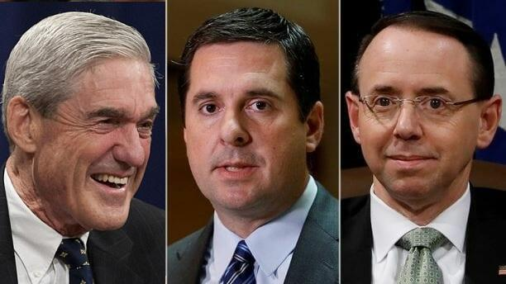
On Tuesday, the Washington Post reported that Nunes was denied access to the information on the grounds that it "could risk lives by potentially exposing the source, a U.S. citizen who has provided intelligence to the CIA and FBI."

After the White House caved to Rosenstein and Nunes was barred from seeing the documents, it also emerged that this same intelligence had already been shared with Special Counsel Robert Mueller as part of his investigation into alleged Russian involvement in the 2016 US election.

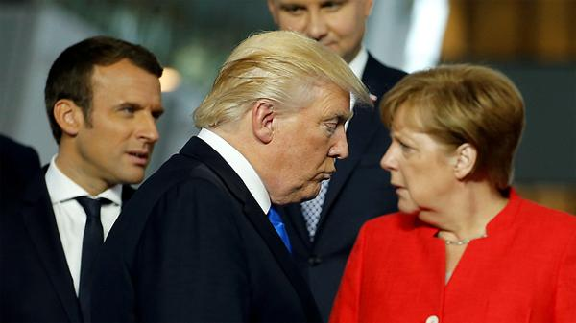

On Wednesday afternoon, however, news emerged that Nunes and House Oversight and Government Reform Committee Chairman Trey Gowdy (R-SC) would receive a classified Thursday briefing at the DOJ on the documents. This is, to put it lightly, incredibly significant.
Why? Because it appears that the FBI may have had a mole embedded in the Trump campaign.

In a bombshell op-ed in the Wall Street Journal, Kimberly Strassel shares a few key insights about recent developments. Perhaps we should start with the ending and let you take it from there. Needless to say Strassel's claims, if true, would have wide ranging implications for the CIA, FBI, DOJ and former Obama administration officials.
Strassel concludes:
"I believe I know the name of the informant, but my intelligence sources did not provide it to me and refuse to confirm it. It would therefore be irresponsible to publish it."
Authored by Kimberley Strassel, op-ed via The Wall Street Journal,
About That FBI ‘Source’
Did the bureau engage in outright spying against the 2016 Trump campaign?
The Department of Justice lost its latest battle with Congress Thursday when it allowed House Intelligence Committee members to view classified documents about a top-secret intelligence source that was part of the FBI’s investigation of the Trump campaign. Even without official confirmation of that source’s name, the news so far holds some stunning implications.
Among them is that the Justice Department and Federal Bureau of Investigation outright hid critical information from a congressional investigation. In a Thursday press conference, Speaker Paul Ryan bluntly noted that Intelligence Chairman Devin Nunes’s request for details on this secret source was “wholly appropriate,” “completely within the scope” of the committee’s long-running FBI investigation, and “something that probably should have been answered a while ago.” Translation: The department knew full well it should have turned this material over to congressional investigators last year, but instead deliberately concealed it.
House investigators nonetheless sniffed out a name, and Mr. Nunes in recent weeks issued a letter and a subpoena demanding more details. Deputy Attorney General Rod Rosenstein’s response was to double down—accusing the House of “extortion” and delivering a speech in which he claimed that “declining to open the FBI’s files to review” is a constitutional “duty.” Justice asked the White House to back its stonewall. And it even began spinning that daddy of all superspook arguments—that revealing any detail about this particular asset could result in “loss of human lives.”
This is desperation, and it strongly suggests that whatever is in these files is going to prove very uncomfortable to the FBI.
The bureau already has some explaining to do. Thanks to the Washington Post’s unnamed law-enforcement leakers, we know Mr. Nunes’s request deals with a “top secret intelligence source” of the FBI and CIA, who is a U.S. citizen and who was involved in the Russia collusion probe. When government agencies refer to sources, they mean people who appear to be average citizens but use their profession or contacts to spy for the agency. Ergo, we might take this to mean that the FBI secretly had a person on the payroll who used his or her non-FBI credentials to interact in some capacity with the Trump campaign.
This would amount to spying, and it is hugely disconcerting. It would also be a major escalation from the electronic surveillance we already knew about, which was bad enough. Obama political appointees rampantly “unmasked” Trump campaign officials to monitor their conversations, while the FBI played dirty with its surveillance warrant against Carter Page, failing to tell the Foreign Intelligence Surveillance Court that its supporting information came from the Hillary Clinton campaign. Now we find it may have also been rolling out human intelligence, John Le Carré style, to infiltrate the Trump campaign.
Which would lead to another big question for the FBI: When? The bureau has been doggedly sticking with its story that a tip in July 2016 about the drunken ramblings of George Papadopoulos launched its counterintelligence probe. Still, the players in this affair—the FBI, former Director Jim Comey, the Steele dossier authors—have been suspiciously vague on the key moments leading up to that launch date. When precisely was the Steele dossier delivered to the FBI? When precisely did the Papadopoulos information come in?
And to the point, when precisely was this human source operating? Because if it was prior to that infamous Papadopoulos tip, then the FBI isn’t being straight. It would mean the bureau was spying on the Trump campaign prior to that moment. And that in turn would mean that the FBI had been spurred to act on the basis of something other than a junior campaign aide’s loose lips.
We also know that among the Justice Department’s stated reasons for not complying with the Nunes subpoena was its worry that to do so might damage international relationships. This suggests the “source” may be overseas, have ties to foreign intelligence, or both. That’s notable, given the highly suspicious role foreigners have played in this escapade. It was an Australian diplomat who reported the Papadopoulos conversation. Dossier author Christopher Steele is British, used to work for MI6, and retains ties to that spy agency as well as to a network of former spooks. It was a former British diplomat who tipped off Sen. John McCain to the dossier. How this “top secret” source fits into this puzzle could matter deeply.
I believe I know the name of the informant, but my intelligence sources did not provide it to me and refuse to confirm it. It would therefore be irresponsible to publish it. But what is clear is that we’ve barely scratched the surface of the FBI’s 2016 behavior, and the country will never get the straight story until President Trump moves to declassify everything possible. It’s time to rip off the Band-Aid.
Speech Banning: The Power of Ignorance
Twitter is banning conservatives and others who don’t subscribe to the leftist mentality plaguing social media. Using the excuse that people are posting “hate facts,” the social media outlet is just shutting down accounts that post any truth that doesn’t fare well for the liberal agenda.
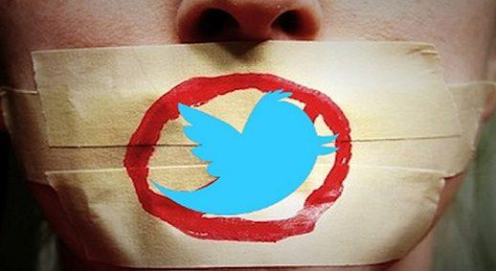
By now, it should be well understood that the terms “hate facts” and “hate speech” are nothing more than buzzwords used by the left as an excuse to suppress the speech of those with which they disagree. This is becoming more and more apparent as we devolve quickly toward a fully totalitarian system too.
Breitbart reported that the most high-profile individual to be banned on this basis was Islam critic Tommy Robinson, who received a permanent ban from Twitter after he posted statistics showing that Muslims are vastly overrepresented in child grooming gangs in the U.K. Robinson is now taking Twitter to court to prove that “facts are now treated as hate.”
The censorship of British accounts, including those of the Britain First team, is tied to increasing pressure from European governments for social media platforms to censor their users. Robinson claims that 10,000 Twitter accounts have been closed at the request of the U.K. government over alleged “hate.”
Facebook has banned the conservative political group Britain First for breaking its rules that prohibit “hate speech” on the social media platform. Facebook said they had “repeatedly posted content designed to incite animosity and hatred against minority groups.”
Britain First described itself as “a patriotic resistance and ‘frontline’ for our long-suffering people” that will “restore Christianity as the bedrock” of national life and put British workers first. –SHTFPlan
There are now concerns that the accounts of American users are also being shut down at the request of European governments. Nick Monroe, an independent journalist based in America, says he was banned from the platform after he began an investigation of Tell MAMA, an “anti-Islamophobia” organization based in the United Kingdom. Monroe’s account was eventually restored without explanation only after he publicized his story, and Breitbart contacted Twitter for comments.
Even when European politics aren’t involved, Twitter still punishes conservatives for making factual claims. Conservative twitter user Mark Samenfink had his account locked after claiming that black-on-black homicide was more common than other types of homicide and implying that Islamic terror attacks were more common than non-Islamic terror attacks. But these facts fly in the fact of the globalist and liberal agenda of complete government control over everyone, so Twitter is doing it’s part to suppress factual information, just like Google, and Adolf Hitler in Nazi Germany.
Twitter also refuses to address attempts by left-wingers to scam its reporting system. Pro-Israel account Ozraeli Dave was hit with a temporary suspension over a tweet in which he called out an anti-semitic tweet from another user. Facebook has used this tactic as well, suspending a conservative comedian for posting violent hate messages he’s received from liberals.
Williams stated that despite multiple reports drawing Facebook’s attention to the screenshots and the abuse he keeps receiving, Facebook failed to act. “Facebook said that they reviewed the screenshots and said that none of the threats violated Facebook’s guidelines,” said Williams. –SHTFPlan
In January, Twitter employees were caught on camera boasting about discriminating against pro-Trump, conservative accounts. One employee discussed shadowbanning political accounts, a practice that Twitter has continually denied using, while another claimed that accounts that expressed an interest in “god, guns, and America” were likely to be flagged as “bots.” Another employee, Mo Norai, explained that Twitter moderators regularly discriminated against accounts deemed to be pro-Trump.
“Censorship reflects a society’s lack of confidence in itself.” –Potter Stewart
“The things that are going to be blocked are not going to be fake stories. The things that are going to be blocked and censored, the things they are going to keep from people is going to be stuff they just don’t want you to focus on or know about.” – Melissa Dykes

Gun Free Zones Are Dangerous
So, think banning guns is going to solve America’s murder problem? The data should tell you to think again.
Yes, in spite of the fact that we’ve been told that Mr. and Mrs. America turning all their guns in is the best way to fix violence, that’s actually a complete lie. And the Crime Prevention Resource Center has the numbers to prove it.
The 2013 study looked at murder rates from places that had banned guns around the world, from Washington, D.C. and Chicago to England, Wales, Jamaica and even the Solomon Islands, an archipelago in the South Pacific which only had mass shootings after they decided to ban guns.
The most striking example might be that of England and Wales, both of which banned firearms back in 1997. Homicides rose from 676 to 734 the first year of the ban. And things only got worse from there.
“After the ban, clearly homicide rates bounce around over time, but there is only one year (2010) where the homicide rate is lower than it was in 1996,” the CPRC noted. “The immediate effect was about a 50 percent increase in homicide rates. Firearm homicide rate had almost doubled between 1996 and 2002 … The homicide and firearm homicide rates only began falling when there was a large increase in the number of police officers during 2003 and 2004. Despite the huge increase in the number of police, the murder rate still remained slightly higher than the immediate pre-ban rate.”
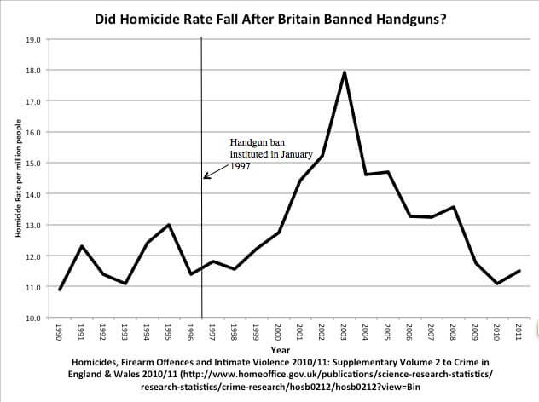
Advertisement - story continues below
(Data charts from the CPRC)
The highest recorded murder rate was in 2002/03, which saw 1,041 murders. That number included 172 murders by Dr. Harold Shipman, a notorious physician and serial killer who murdered his patients via lethal doses of morphine. That said, the general trend was still toward more killings after the gun ban was put into place.
Bottom of Form
Meanwhile, Jamaica’s murder rate was at roughly 10 killings per 100,000 people in 1974, when guns were banned. By 1980, that number spiked to over 40 per 100,000, and 58 per 100,000 in 2005. While the numbers have again bounced around, Jamaica didn’t see under 20 murders per 100,000 people between 1990 and 2007. According to the Jamaica Gleaner, 38 people were murdered in the first six days of this year alone.
Ireland also saw a spike when it banned guns, the CPRC reports, from under 0.4 murders per 100,000 in 1972 to over 1.6 per 100,000 in just a few years, an increase of well over 400 percent. While that was the peak of the murder rate, it never fell below what it was the year before the gun ban.
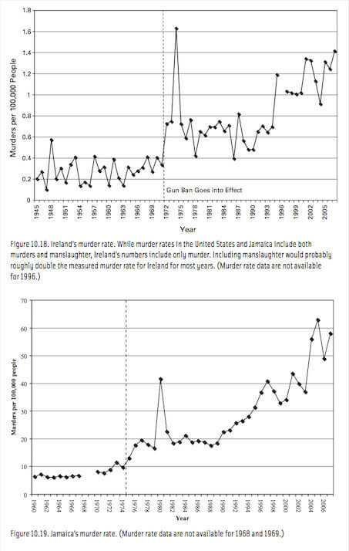
Advertisement - story continues below
(Data charts from the CPRC)
Chicago also banned guns in 1982. How did that work? Well, the Windy City has always had a high homicide rate, but as you can see, it rose dramatically in the years following the ban. While there was a reduction in the 2000s, it rebounded again in the 2010s to become the gunshot capital of America.
RELATED: Australia Hit with Largest Mass Shooting Since 1996 Gun Confiscation
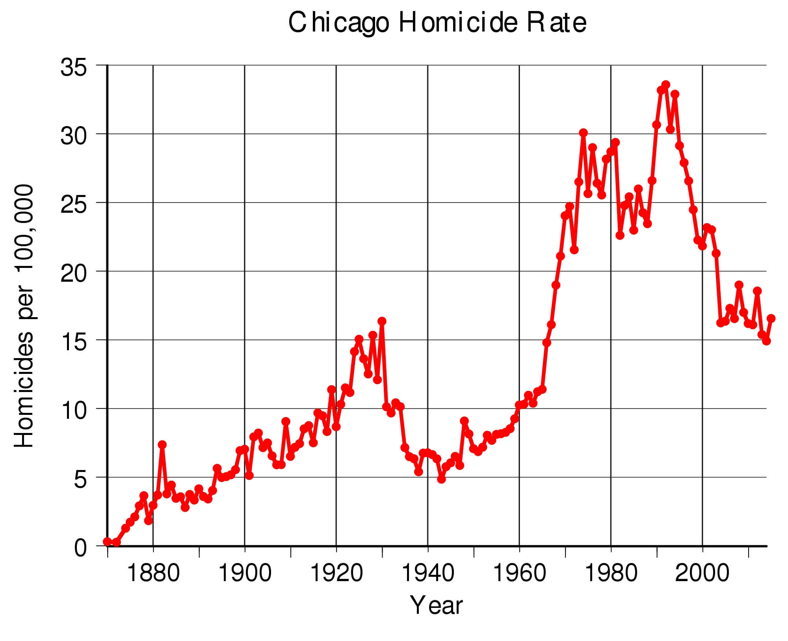
Washington, D.C., meanwhile, banned handguns in 1976. That year, there were 188 murders in the nation’s capital. In the first decade of the ban, only three years saw lower murder totals. Then, in 1988, murder began to explode in the city, with 369 murders. The next year, it was 434. D.C. wouldn’t see a year with fewer murders than that until 1994, when the city recorded 399 murders.
In 2007, Heller v. D.C. struck down the ban on guns in D.C. That year, there were 181 murders. In the years since, only one year — 2008 — exceeded that total.
Perhaps the most striking thing is that three of the case studies here — England and Wales, Jamaica and Ireland — are on islands. That means you don’t exactly have guns coming over a land border. So, why did murder not only persist but rise after these gun bans?
Maybe it’s because criminals found other ways to get guns. Maybe it’s because there were less armed citizens to protect themselves. Maybe it’s because criminals will always find ways to kill other people if they want to kill them. And maybe it’s all of these.
No matter what the reason, the conclusion from the data is clear: gun bans don’t stop murder. Far from it. This is the kind of data gun rights advocates need to know for themselves. And these are by no means the only examples — as the CPRC noted. The next time someone says that banning guns will stop violence, we need to confront gun-grabbers with the facts

The Solar Panel Rebellion
Sacramento
California officials have been obsessed this year about the ongoing housing crisis, as home prices soar out of reach of most of the state’s residents and as rent prices consume an ever-greater portion of people’s incomes. Absurdly high housing costs — driven by local growth controls and burdensome state regulatory requirements — are the main reason that California has the nation’s highest cost-of-living-adjusted poverty rate, at around 20 percent.
In a normal place, lawmakers would respond by pre-empting local growth restrictions, reforming a state law (the California Environmental Quality Act, or CEQA) that makes it too easy for no-growth types to mire housing projects in years of litigation, and paring back some of the regulations that add as much as 40 percent of the cost of every new housing unit built. They might even think about reducing the tax and bond burdens that drive up housing payments.
But this is California, so perish such thoughts. Instead, the Legislature recently killed a high-profile bill that would have granted developers “by right” approval to build higher-density housing around transit stations, which would have boosted housing supply in urban areas. And — grabbing headlines this week — the non-elected California Energy Commission voted unanimously on Wednesday to force virtually all new housing to include solar panels beginning in 2020.
The latter will add between $9,500 and $30,000 to the cost of every housing unit, depending on whose estimates you believe. When one is trying to reduce the cost of something, imposing a mandate that increases its cost is counterproductive. The commission argues that it will add only around $40 a month in payments but will save $80 a month in utilities (based on a $9,500 installation cost). My calculations suggest it will add $50 to $150 a month for a 30-year loan, and $75 to $225 with a 15-year note. Lenders don’t factor utility costs, but they do factor mortgage amounts. This will cut more people out of the housing market, despite the fancy government math.
It’s particularly disturbing that state commissions can simply impose such a far-reaching and costly regulation by edict. California’s Legislature is run by representatives who have an equally strong environmental tilt, but it’s doubtful that such a requirement would have easily made its way throughout the entire process. Housing activists would have complained. Builders would have lobbied for amendments. The issue would have been widely discussed.
Instead, five largely unknown commissioners, appointed by the governor with little fanfare, announced the rule as part of building-code change. (The commission has the statutory authority to mandate greenhouse-gas reductions and, in this case, they changed the energy rating on homes, which is a de facto solar requirement. It still needs approval by another commission.) The Legislature created the CEC in 1975 as part of the Warren-Alquist Act, which was designed to promote energy efficiency and the use of renewable energy sources. I’m doubting its backers envisioned this kind of far-reaching decision.
Solar energy offers a promising alternative to the local regulated monopoly utility giants, which depend on working the political system rather than competing in the marketplace to determine energy rates. I recall one electricity company official who told me he was one of the few executives who made a profit by remodeling his office — given that the companies are reimbursed based on a formula that added profits for every dollar they spent.
Energy policy long has been a mess here. California’s disastrous deregulation scheme in 2000 really wasn’t deregulation but a convoluted form of reregulation that capped the retail, but not wholesale, price of electricity. It led to rolling blackouts, market manipulations and Pacific Gas & Electric’s bankruptcy in 2001. There’s been no appetite since then for opening up electricity markets, which could be a boon to the growing solar industry.
But the state has promoted “net energy metering,” by which those regulated utilities are required to buy back solar power at market prices. The government also has granted tax credits for solar installations. Simply opening up electricity markets to competition would be far better than these hobbled-together policies of regulation, tax incentives, and renewable-friendly rate structures, but at least these standard-issue policies are designed around incentives rather than edicts.
But eventually government commissars run out of patience with such things and rely on just issuing orders. Even the California Building Industry Association came out in support of it. I suppose builders shouldn’t care too much, given the amount of pent-up demand for housing in the state. But we won’t hear much from the people who will be priced out of the housing market, or those who will pay more for their mortgages or for pricey solar leases. And increasing the price of new houses will of course drive up the cost of existing houses, too.
Not surprisingly, the solar industry backed the plan. “This is a very large market expansion for solar,” an executive from a solar-installation company told the New York Times. “It’s very cost effective to do it this way, and customers want it. There’s also this real American sense of freedom of producing electricity on my rooftop. And it’s another example of California leading the way.” That captured several of my pet peeves in one quotation.
Forcing people to buy things is not a great model for “market expansion.” If customers wanted more solar panels they would buy them given their availability in California. The most cost-effective way to provide a product is through competition, and that includes allowing customers to say no. There’s nothing American or freedom-loving about forcing the 80 percent to 85 percent of current buyers who don’t choose such panels to buy them. Of course, California is leading the way with a government edict. What else is new?
When I lived in a locale where energy prices were outrageous, many of my neighbors found that solar was a great way to get out of the utility’s monopoly pricing stranglehold. Once technology develops a little further, Americans will be able to store electricity generated in their homes or neighborhoods and free themselves from the big utility providers. I couldn’t care less if these utilities whine about the death spiral. But this should be accomplished by choice, not edict.
Writing this week in Forbes, former Orange County Republican Assemblyman Chuck DeVore, who now is vice president at the Texas Public Policy Foundation in Austin, wrote that “California government heavily regulates electricity while Texas allows free market competition in most of the state. Yet, Texas produces more than double the amount of wind, solar and other renewable electricity as California while California’s retail electric rates were 89 percent higher than Texas’ in 2017.” So markets do a better job promoting solar development anyway. But there’s little chance that command-and-control California will learn any of these lessons.
The Democrat Revealed
American liberals might have nothing but contempt for the freedom and strength that make the country great when they’re talking in private, but they used to be smart enough to know that they had to at least pretend to be patriotic in public.
But as the Trump administration keeps pushing its agenda of putting America first, even that mask is coming off — and what’s underneath is ugly.
In an op-ed published by The New York Times on Friday, two men who served on the staff of the National Security Council in the Obama White House openly called for traditional American allies in Europe to take the side of the world’s largest state sponsor of terrorism over the leader of their own country.
According to Steven Simon and Jonathan Stevens, President Donald Trump’s decision to pull the United States out of the Iran nuclear deal is an insult so grievous that European governments should consider pulling their ambassadors out of Washington — and expelling American ambassadors from their own capitals.
And do this to show their allegiance to the Islamic Republic of Iran. This is no small thing.
According to The Times biography note, Simon is the author of a forthcoming book about U.S. foreign policy and the so-called “Arab Spring.” He was also the National Security Council’s senior director for the Middle East and North Africa from 2011 to 2012.
Bottom of Form
Stevenson, meanwhile was the “director for political-military affairs, Middle East and North Africa, at the National Security Council from 2011 to 2013.”
That would put both men in key roles in the Obama national security team while the president and his first secretary of state, Hillary Clinton, were making building a disaster of U.S. policy in Libya that helped flood Europe with millions of “migrants”today. (The disaster also included the deadly terrorist attack on the American diplomatic outpost in Benghazi that Democrats are still lying about.)
In other words, this isn’t some loony commenter at Vox joining up with a half-stoned reader at Salon. This is the thinking of two serious — if demonstrably inept — leftist foreign policy mavens.
And it’s seriously infuriating. First, the two men acknowledge that the different countries of Europe have different leadership, but propose “Europe” acts as a whole as an opponent of the Trump decision on the Iran deal (as though the continent is governed by a bunch of faceless bureaucrats in Brussels).
And they want Europe to defy the Trump administration’s sanctions on Iran by continuing to do business with the murderous mullahs — and make the point with diplomatic strikes of their own against the U.S.
“The European Union could, for instance, announce the withdrawal of member-states’ ambassadors from the United States. Isn’t this what states do when diplomatic partners breach solemn agreements, expose them to security risks and threaten to wreak havoc on their economies? That is, after all, what the administration is threatening to do by courting the risk of a Middle Eastern war and applying secondary sanctions to European companies. Depending on the American response, European capitals might even follow up with expulsion of American ambassadors.”
If that provokes the Trump White House, they wrote (and it certainly would), it would be time to ratchet up the pressure:
“If the administration’s next move were to impose secondary sanctions on Europe, the Europeans (sic) could slap its own penalties on American multinational corporations, which in turn would place additional pressure on the White House.”
So these two men, high-ranking national security officials in the United States government not all that long ago, are literally pushing American allies to launch a trade war with the United States. They “justify” the argument by claiming that the Iran nuclear deal is of such crucial importance that Europe’s own commercial future is at stake, and Trump’s decision is imperiling that.
“If this doesn’t end the European Union’s doormat foreign policy, we might as well start referring to it as the 28 colonies ruled from across the ocean,” they wrote. “This is not an outcome the United States should welcome. As Britain learned in 1939, it’s a lot better to have allies than colonies.”
The historical jab is cute, and one can imagine the average New York Times reader nodding approvingly, secure in the knowledge that their own intellectual superiority has been affirmed by the Gray Lady’s writers once again.
But the real lesson from World War II isn’t what the map of Europe looked like in 1939. It’s what the map of the world looked like in 1945. And that was that any country — literally any country — that launches a full-scale war with the United States — trade or otherwise — is in for a rough few years before they give up the ghost.
And European countries — friend and foe — should have learned that lesson well. For the leader of any member of a European country to take the advice of Simon and Stevenson would be an. But it’s even more astonishing that two men who were once part of the national security team of a United States president would be so open about rooting for a costly and damaging economic and political confrontation with their own country.
Even for Democrats, it’s disturbing.
Drone Wars Update
Imagine a sky above us patrolled 24 hours a day by drones. Fast, stealthy, artificially intelligent sky robots that can be launched and retrieved by high-flying fuel or recharging stations much like flying aircraft carriers. One military craft could launch and maintain 20 to 1000 drones. The larger, faster aerial robots could fly thousands of miles an hour, turn on a dime, and outfly any pilot in the sky. They could deploy munitions that were powerful and accurate to within one meter of their targets on the ground.
The smaller swarm robots could be dropped like small assassins. They are designed to work together as a team to seek out the faces of specific people, or to remove any warm body that does not have the safety beacon under their skin. They contain a shaped charged with a small bit of steel that acts like a 45-caliber slug in being able to punch a hole in a door or window, through which the other drones could enter and each kill one person, precisely, at speeds up to 50 files an hour.
Will you feel safer? The Defense Advanced Research Projects Agency has revealed some details about the program as it moves toward development of multiple low-cost, reusable umanned aerial systems.
“A recent flight test at Yuma Proving Ground provided an opportunity to conduct safe separation and captive flight tests of the hard dock and recovery system,” the agency has confirmed. “Early flight tests have given us confidence we can meet our objective to recover four Gremlins in 30 minutes,” program manager for the agency’s Tactical Technology Office Scott Wierzbanowski said.
The program is to demonstrate systems that can launch and recover multiple UAS vehicles.
“Now in its third and final phase, the goals for the Gremlins program is to develop a full-scale technology demonstration featuring the air recovery of multiple low-cost, reusable UAV’s,” the agency said.
I can tell you the only way peace is realized. It is a period of undetermined length in the Peace, Mercy, Justice, War cycle. Peace is realized with surrender by the evil enemy. We extend mercy to those who have transgressed and cannot fend for themselves. We rebuild and replant. We forgive and forget. Oh, and we do forget.
Then, the evil souls are reborn into new bodies and they grow up and they begin hurting others, robbing, raping, murdering. We implement Justice and separate them from society one by one through incarceration. First a few dozen, then a thousand, and then millions. But it becomes too much. They obtain immeasurable wealth that insulates them from the law. They recruit and organize and arm and attack.
The cycle moves from Justice to War, when police actions are not enough. We fight, and defeat evil again, and the cycle starts anew.
Drones accelerate the cycle. Why? Three reasons:
- There is no risk of loss of life to the good people. No sons or daughters are blown to bits or shot or gassed or vaporized. No pollution from fires, depleted uranium or toxic chemicals. The lack of risk of loss makes the decision to commit war against an evil enemy easy to make. No loss of sleep or letters to write or chaplain visits to make.
- The cost is far less in time and money. A small drone can be mass produced for a few dollars. A large drone may cost a million. But the cost of training, managing, maintaining and replacing men and women is gone. Drones will sit on the shelf and wait for the mission. They will sacrifice themselves like speeding kamikazes anxious to fulfill the measure of their creation, without the slightest change of disobedience.
- They time it takes to execute an act of war would be hours or days. A million drones could decimate the world’s largest army within a few minutes of deployment. Nothing exists that could stop them, although I could design anti-drone technology that would stop them without question.
Hence, the cycle is accelerated. The evil souls will be born again, and will come at us again and again. The process is the same over the entire universe. Even God cannot stop them. So, I ask you the question again. Do you feel safer?
Making stuff in Space
Space is a dangerous place for humans: Microgravity sets our fluids wandering and weakens muscles, radiation tears through DNA and the harsh vacuum outside is an ever-present threat.
But for materials that show incredible strength, transmit information with barely any loss, form enormous crystals or even grow into organs, the harshness of space can be the perfect construction zone.
As the cost of spaceflight goes down, more of these materials may become cost-effective to make or study in space. And soon, more and more people might be carrying around objects built off the planet. [Top 10 Strangest Things in Space]
"We generally make things by subjecting them to a different environment," said Andrew Rush, president and CEO of Made In Space, an in-space manufacturing company. "We make food by cooking it in fire, heating it up and causing chemical reactions. We make steel by heating things up at high temperature and maybe, depending on the steel, [in a] high-pressure environment. We can quench things; we can make things cold to make different materials or improve on those materials.
"Really, space-enabled materials are just another version of that, but instead of throwing something in a furnace and heating it to 1,000 degrees Fahrenheit [540 degrees Celsius] or something, we take it to space," he told Space.com.
In space, microgravity lets materials grow without encountering walls, and it allows them to mix evenly and hold together without traditional supports. And a nearby ultrahigh vacuum helps things form without impurities.
ZBLAN fibers processed on the ground have a tree-bark-like structure on the outside, whereas ZBLAN made in space doesn't show crystallization.
Credit: NASA

Free fall
The International Space Station is falling at a constant rate around the Earth, which everyone on board experiences as a lack of gravity; on the station, you're always in free fall. That environment, called microgravity, comes in handy for growing things that need to expand evenly in every direction or avoid the contamination of touching an enclosure's walls.
Microgravity is of particular interest to people who create materials for miniaturized devices and computers, researchers told Space.com.
"Demand for high-tech solutions requiring higher resolutions, faster processors, more bandwidth, greater precision, novel materials, unique alloys, innovative processes, higher energy efficiency, more processes in a smaller volume and more sophisticated tools in general are pushing materials and processes for manufacturing to the point that defects at the atomic- and molecular-level matter," said Lynn Harper, the lead of integrative studies for the Space Portal partnerships office at NASA's Ames Research Center in California.
Building in microgravity can reduce those defects. The first major candidate for making money on something made in space today, a special type of fiber-optic cable called ZBLAN, is a good example: When manufactured in microgravity, the thin cable is less likely to develop tiny crystals that increase signal loss. When built without those flaws, the cable can be orders of magnitude better at transmitting light over long distances, such as for telecommunications, lasers and high-speed internet.
The fiber is light enough — and can demand a high enough price — that sending the materials to manufacture it in space may be able to pay off commercially. Made In Space sent a microwave-size machine to the space station in December to test making at least 300 feet (100 meters) of the cable, and another company is also developing a space station test payload. (Researchers mentioned a third with technology on the way, too.)
"One of the challenges for making money from space manufacturing is, it's still quite expensive to launch things to space," Alex MacDonald, senior economic adviser within NASA Headquarters' Office of the Administrator, told Space.com. "You're still dealing with thousands of dollars per kilogram. So, whatever you are going to be making in space that you're going to be sending down to Earth has to be incredibly valuable but also available per unit of mass."
"The reason they're doing this is the huge payout, which would be in billions of dollars if you can actually draw the fiber at least an order of magnitude better than silica," Dennis Tucker, a materials scientist at NASA's Marshall Space Flight Center in Alabama who has researched ZBLAN glass for decades, told Space.com. "There's a lot of potential applications if we can do this. Fiber amplifiers, there's lasers for cutting, drilling and surgery … infrared imaging, remote IR."
"I'd just like it to turn into the first real space-based industry," he added.
As the cost of sending things to space continues to decrease, experimenters can envision a number of other scenarios in which the space station environment could be key to manufacturing.
For instance, a substance called gallium nitride, used to make LEDs, is difficult to solidify in large amounts at a time because its two constituent molecules don't always bind perfectly in order, leading to defects. Reducing the movement of the melted fluid as hotter and less-dense fluid rises, which occurs because of gravity, can decrease those defects — as can preventing the highly reactive substance from touching the sides of its container, according to Randy Giles, chief scientist at the Center for the Advancement of Science in Space. Someday, substances like that could benefit from in-space creation.
The Electrostatic Levitation Furnace, a device that the Japan Aerospace Exploration Agency operates on the space station, is an example of the kind of setup that could avoid a container altogether, Giles said. The furnace can melt and solidify materials while levitating them in place using electrodes.
Experiments performed years ago using NASA's now-retired space shuttle orbiters also have provided reasons for optimism. Researchers pulled a stainless-steel disk called the Wake Shield Facility behind the shuttle, creating a vacuum in its wake that's 1,000 to 10,000 times emptier than what is possible on Earth. Experimenters used this cleaner vacuum of outer space to make thinner, purer samples of materials like semiconductors. (A large proportion of semiconductor components made on the ground end up being rejected because of impurities interrupting the matrix of atoms.)
As Rush put it, "If you have a piece of lint in your computer chip, it's not going to work very well."

A stable spot
Microgravity offers a promising environment for manufacturing, as it's free from the stirring of convection that sinks heavier material down through a solution. In microgravity, crystals can grow larger; in one experiment, crystals made from proteins grew to be 6 cubic millimeters, on average, compared with 0.5 cubic millimeters here on Earth. Once grown, those crystals can be analyzed to determine the proteins' 3D structures, which can help inform new strategies for drug discovery.
Growing other crystals, like those used to manufacture drugs or those that can detect gamma-rays and neutrons, in space so that they're bigger and purer can make the resulting material higher-quality.
The same holds true for metals. While metals made from a single element, like iron, can be useful, they can gain strength, flexibility or other special features when they incorporate other elements. For example, integrating carbon, and small amounts of other metals, with iron creates the much stronger and harder steel. Metals that are a combination of elements are called alloys, and some can form only in a low-gravity environment.
"Because you don't have stratification as a result of density differences — heavy stuff doesn't sink to the bottom, and light stuff [doesn't] go up to the top — you can create alloys that are a homogenous blend of metals or minerals that would not ordinarily be able to be manufactured in as large a size on the ground," Harper said. "And, in fact, you may have some unique ones that wouldn't produce an alloy under any conditions on the ground."

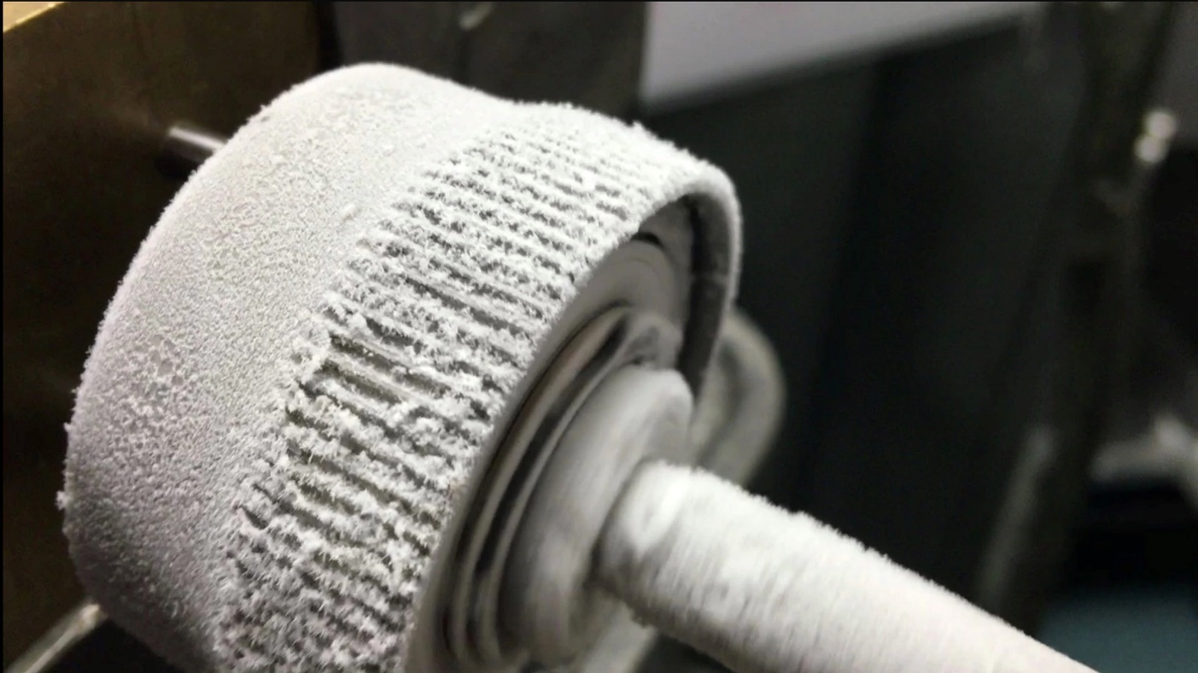
Metallic glasses don't get brittle in extreme cold, and so could make good materials for the gears of robots operating on icy planets or in space.
Credit: NASA/JPL-Caltech
Because materials in microgravity don't crystallize as quickly — such as the ZBLAN cable — you can even coax substances such as metal into amorphous, glass-like forms. Those metallic glasses can be molded at lower temperatures than ordinary metals can, and their noncrystallized structure makes them extra strong and resistant to corrosion. (A metallic glass called Liquidmetal — developed by NASA's Jet Propulsion Laboratory, the U.S. Department of Energy and the California Institute of Technology — mixes three or more metals to gain twice the strength of titanium.) While some metal alloys and glasses can be made on Earth, others can be developed — in large quantities, at least — only in the embrace of microgravity.
Such alloys and metallic glasses could someday form strong, easily molded spacecraft debris shields, paneling, mirrors and more, as well as contribute to manufacturing on Earth, experts say.
Space provides this strange, double-edged construction zone: It lets researchers test out materials to see how they withstand a harsh environment with powerful radiation and extreme temperature changes, but it also provides a particularly calm locale, gravity-wise, compared with Earth.
"Space as we know it is focused on being a resource; it gives us GPS communications and Earth observation, the valuable commodity that comes back in digital form: data," Giles told Space.com. "Whereas the materials experiments that are done in the microgravity environment [are] bringing data back that allows and informs people of the materials' behaviors and properties as it may be important for space applications, it also is kind of like a severe shake-and-bake test that can be done on materials that will have Earth applications.
"Also, by removing the convection, buoyancy and sedimentation, materials that you bring back can be like your gold standard to which you compare and determine how feasible it is to get a certain desired property," he added.

Organ growth
Humans don't fare well in space over time, but it might be an ideal place to grow parts of them — organs, that is. Cells can grow into larger networks without gravity pulling them down into their container as would happen on Earth.
"The idea of how microgravity can help cells grow has been around for a long time; in fact, one of the dominant tools that medical pharmaceutical research uses today, the rotating wall vessel, was actually developed as part of an '80s space shuttle effort at NASA," MacDonald said.
That vessel was developed to simulate an aspect of microgravity on Earth by continuously rotating at just the right speed to counter a substance's slow sedimentation down through a nutrient solution.
"The cells aren't smart, but they're adaptable," Harper said. "And if they touch a side or a surface, it gives them a message that's biologically misleading."
Tumor cells growing on microcarrier beads in a NASA bioreactor on Earth were able to grow in three dimensions over the course of 56 days because of their container's rotating walls. Growing cells in space offers a similar benefit.
But the larger a sample gets, the more energy you need to spend keeping its cells from hitting the bottom — a perturbation that can break up burgeoning colonies. In free fall in space, such cells can form much larger tissues. Some current work on growing tissue in space focuses on making sure engineered tissues have an adequate blood supply; otherwise, they'll die from the inside out. NASA is currently hosting a vascular tissue challenge which offers $500,000 in prizes for teams of researchers to grow vascularized heart, lung, kidney, liver and muscle tissues more than 0.4 inches (1 centimeter) thick in which most of the tissue can survive for 30 days — a feat currently impossible on Earth. (You can read more specifics about the challenge here.)
While it's certainly more speculative, this is actually another plausible reason for private companies to get into the space industry, MacDonald said.
"Organs, of course, are incredibly high-value, both in their ability to save life, but also their cost in terms of the medical economy," MacDonald said. "You've started to see companies start to experiment — so far, not on the space station, but on parabolic flights."
It's hard to imagine routinely growing organs in space, but that's one of many possible money-making avenues as it becomes less expensive to put things in orbit.
"We know that we don't know all the applications of the space environment for product development, material processing, product finishing," Rush said. "And we haven't explored it; we haven't plumbed the depths of the possibilities there, because of lack of access and high cost. But now we're kind of turning the corner on that. I think it's a very, very exciting time to be really exploring that."

The company Alpha Space recently sent the MISSE-FF platform to the International Space Station to test different materials' durability when faced with the harshness of space.
Credit: Alpha Space

Building for space
Another source of excitement for in-space manufacturing is building things for space that will never be constrained by the pull of Earth's gravity — or the crushing push of a rocket launch.
The International Space Station already harbors 3D printers, which Made In Space has used to produce tools right on the space station. But the company's vision is much grander: Large-scale structures, like space telescopes or solar panels, could be printed in space instead of being folded up to launch into orbit. And visitors to other worlds could someday use the resources locally available to print shelters and other components, traveling only with the digital blueprints.
Building in space will require a sound understanding of how materials react in space and how to get raw materials, as well as a rethinking of what can be used in a 3D printer or as the basis for space-made materials, researchers told Space.com.

"To me, the exciting part is looking at everything around me as potential feedstock to make new stuff, and that mindset and that paradigm shift has huge implications," Niki Werkheiser, NASA's in-space manufacturing manager, told Space.com. "Whether it be in situ resources, our food, foam, plastic bags, whatever's around us, I'll look at that as, how can I reuse or recycle? And it does require combining and understanding not only the machine's capabilities, but the materials' qualities and properties for what you need to make."
But whether microgravity-based materials research looks into building for Earth or for space, this area of investigation is making strange and wonderful things that have never been seen on the ground at those quantities or of that quality.
"There's so much potential to do things in this area now that we weren't able to do before, and it's not just dreams and ideas now — it's happening," MacDonald said. "There are facilities on orbit that you can use and you can think about improving, and you can think about developing your own facilities. It's a little like small satellites were 10 years ago. People could see that it was very exciting, and we were beginning to do experiments, but I think the really exciting stuff is still to come."

