ihad Report
Jul 21, 2018 -
Jul 27, 2018
Attacks | 41
Killed | 455
Injured | 523
Suicide Blasts | 11
Countries | 13
The Syndicate
Open Letter to America
I am one of the many who are watching these historic events unfold from the “outside”. I am neither American born, not domiciled. I have visited your fair country on several occasions during my fifty years on this planet, and have always felt an affinity with you, the average Joe American.
That is because the average Joe American is warm, welcoming, decent, and brave. You respect those that have put on your military uniform and risked all for your country, and I respect that. You honor your founders and foundational (and VERY unique) Constitution, and I can respect that. You look out for your communities and families and I respect that too. You have, in essence, a decency and strength that is truly worthy of the moniker “American Exceptionalism”. America is not just a word or idea; it is a people who share common values of freedom, independence, equality, family, loyalty. I appreciate this message is going to sound a little corny, but I see you being attacked by half the country, I see the frustration in some of you that arrests are not coming fast enough, and I saw tonight Q’s frustration that we weren’t seeing the progress that was occurring right before our eyes, nor the complexity and danger of the war that was raging around us.
We have all been chosen by God to live in this period of history, a time when in all likelihood the United States is all that stands between our civilization’s total capitulation to this Evil, and a future that we would want to pass on to those who inherit this Earth from us. However it is you, the citizens of the United States of America that are bearing the greatest burden in this fight.
Your media likes to tell you that you are despised throughout the world, that anti-Americanism is widespread and that you should tread more lightly. I would like to say to you that that is bullshit. What is happening at this moment in time, led by your President, and this phenomenon of Q is attracting the attention and support of the WORLD. We are you and you are us. We share your contempt for the corruption, for those that would sell out the interests of our countries for their own benefit, and most egregiously harm our children in ways we had not even believed were possible.
As you are attacked by both your own and the international media, and those in your community who have not yet (or may never) wake up to what has and is happening, please know that you are not alone in this fight. What you are doing is inspiring. It is glorious and just.
To President Trump and Q, and those at the sharp end of this war, whilst not American citizens, please know that we outsiders are in awe of you and those who stand beside you. We know that this has not been attempted before. We see the gravity of what is unfolding, and the courage and spirit it took to engage such an enemy. It is clear that this international cabal still has the ability to inflict pain and death, and no hesitation to do so. It is hidden, clever, evil, and well dug in. Lest we forget, this is a real war and good people are dying. Please know that there are many out here who understand your sacrifices and the risks being taken on our behalf. Thank you and God bless you all. WWG1WGA!

People that analyze the Syndicate and its roots refer a lot to Nazis, AM, ancestors, etc. Why? Because Hitler was part of the cabal. Everyone who studies this believes this. He was rogue, yes, but he was part of an effort to take over the world and submit everyone in it to a single government’s rules.

WW1 was obviously staged and just happens to be located in what Balkans refer to as Europe's Texas.
Bosnia & Herzegovina (=BiH) is a VERY peaceful and lovely country, with a Muslim MAJORITY, a big number of Orthodox and a Christian MINORITY. The same war continued with new leadership in 1939 with a major upgrade in equipment that was designed by America, facilitated with a technology transfer to Germany, and then funded by trans-Atlantic banks. These are the facts, and there is no denying that this was a treasonous action that was taken by companies like Ford, Alcoa, Reynolds, etc. Virtually all the death and destruction was caused by technology that the trans-Atlantic banks funded.

Whoever planned to start a war would search for a place as BiH, because there would be TOTAL chaos immediately if an incident like that happens. Read about the war if you're interested. The war was ended by setting up the "Versailles Treaty" (https://en.wikipedia.org/wiki/Treaty_of_Versailles) This is fundamental PROOF that it was staged by Bankers.

The German industrial stock was the highest value at that time and because of the major military spending during the war. Although the people were living in poverty, the factories making weapons were running full blast with full funding 24 hours a day. That was the best time for the Cabal to take over the industries and whole branches inside the country, because the Syndicate had all the cash, and every wage and price was at historic lows. It was a shopper’s paradise.

The Treaty of Versailles was the largest, most aggressive economic hit ever perpetrated. They set up a national debt of 132 Billion Deutsche Mark. That would equate to 450 Billion $ of today's value.
They knew it would put the whole country for at least 60 - 70 years into debt and poverty, yet the German government agreed to it. They had no choice whatsoever, except to become an instrument of war for the Syndicate.

All they needed was a war hero charismatic who could rally the masses with a sematic mastery of the language. The Germans thought he was their savior after they have lived for a dozen of years in extreme poverty and barely had enough money to feed their families. After his election it took them 5 years to get rid of their debts, they threw out all of those international bankers and established a labor-based bond which was EXTREMELY successful. At this time the German people LOVED AH, they also LOVED the established National Socialism (=Nazi).

BUT they didn't know this was all staged. Staged to sell socialism as a savior of mankind, when actually the Nationalism saved the country. The Treaty of Versailles was written by Allen Dulles (Devil incarnated in him, carefully read through his biography) and his brother John Foster Dulles. The CIA was meant to be a Mafia hot spot right from the beginning, today they are too powerful to just be dismantled. They have TECHNOLOGY.

Only key players have it, not everyone inside the agency, but these key players are opportunists which can control anyone else inside the Agency. The Mafia, Ford, Aloca, Reynolds, and the Trans-Atlantic Banks funded the Nazis. This is very well documented even though many people can't or won't believe it.
I recommend everyone to watch this documentary (https://d.tube/#!/v/clocking/uvr83d8v)

The origin of the Mafia is explained very well, too. Besides them the other big financier, the Royals across Europe, have all been of German origin. EVERYONE WITH HIS EYES WIDE OPEN CAN START THINKING FOR THEMSELVES WHO WAS FIGHTING WHOM BEHIND THE CURTAIN.

So why did I even started with questioning "Mirror"? Go to the Wiki page of the Treaty of Versailles and look for the location the Treaty was signed. https://en.wikipedia.org/wiki/Treaty_of_Versailles
Although it is often referred to as the "Versailles Conference", only the actual signing of the treaty took place at the historic palace. Most of the negotiations were in Paris, with the "Big Four" meetings taking place generally at the Quai d'Orsay.
The Fiat Dollar the Socialist Agenda
Yesterday I told you about the unstoppable trend towards more socialism in the US.
I think inflation is the primary factor driving this trend. Americans feel squeezed because the cost of rent, medical insurance, and tuition, as well as other basic living expenses, is rising much faster than their wages.
This creates very real problems for ordinary people. In response, more and more turn to Santa Claus politicians that promise supposed freebies, like a $15 minimum wage or universal basic income.

Why the Cost of Living Has Exploded
This is all a predictable consequence of the US abandoning sound money.

By every measure—including stagnating wages and rising costs—things have been going downhill for the American middle class since the early 1970s.
August 15, 1971, to be exact. This is the date President Nixon killed the last remnants of the gold standard.
Since then, the dollar has been a pure fiat currency. This allows the Fed to print as many dollars as it pleases. And—without the discipline imposed by some form of a gold standard—it does precisely that. The US money supply has exploded 2,106% higher since 1971.
The rejection of sound money is the primary reason inflation has eaten up wage growth since the early 1970s—and the primary reason the cost of living has exploded.
The next chart illustrates this dynamic. It measures US hourly wages priced in gold grams (the number of gold grams the average person’s hourly income could buy).
Measured in gold, wages in the US have fallen over 84% since 1971. That’s an astounding drop.

The next chart measures the federal minimum wage in terms of gold grams. Priced in gold, the minimum wage has fallen 87% since 1968.

Note that the federal minimum wage was $1.60 in 1968. It’s $7.25 today, or 353% higher in dollar terms.
But that $7.25 buys 87% less than $1.60 did back in 1968. That’s the story you won’t hear from the mainstream press.
This is why millennials and millions of others are gravitating toward socialism.
They feel the economic pain of inflation every day. They know it’s becoming harder and harder to maintain a middle-class lifestyle. They just don’t understand why. So, they succumb to the siren’s call of freebies.
Perverse as it is, the policies demanded by people suffering from inflation create even more inflation.
Inflation has a way of perpetuating itself. The more inflation reduces living standards, the more people push for programs that create even more inflation. This includes things like universal basic income and a higher minimum wage… which in turn creates a cycle of inflation.
It’s only a matter of time before “fight for $15,” the rallying cry for a $15 minimum wage, becomes “fight for $20.” Then it’s “fight for $50,” “fight for $100,” and so forth.
What people should really fight for is a return to sound money. It’s the only way to end this insidious cycle. But that’s not going to happen.
Inflation follows a clear pattern of corruption:
- In a fiat currency system, the government will invariably print an ever-increasing amount of currency.
- This makes prices and the cost of living rise faster than wages.
- The average person feels the pain but doesn’t understand what’s happening.
- More people support politicians who promise freebies.
- In order to pay for the “freebies,” the government prints more money.
- This creates even more inflation, and the cycle repeats.

Most of America Lives Off the Government
At this point, we have to ask ourselves whether the political situation in the US will improve. Unfortunately, the data points to a troubling, but inevitable, answer… “no.”
The reason is simple: a growing majority of US voters are addicted to the heroin of government welfare.
An estimated 47% or so of Americans already receive some form of government benefit. But I don’t think that accurately reflects the situation. At least, not when you consider all the government employees, along with those in the nominally private sector who feed off the warfare state. This includes defense and other government contractors who win huge, no-bid contracts.
People involved in the military-industrial complex live off government slops as much or more than those who collect food stamps and other traditional forms of welfare. Yet they aren’t counted in the statistics. Any honest account of who depends on the government needs to include them.
When you count everyone who lives off of political dollars, we’re already well north of 50% of the US population.
In other words, the US has already crossed the Rubicon. There’s no going back.
The growing majority of people who depend on the government guarantee that socialist policies will continue and likely accelerate. It’s why Bernie Sanders and his ilk are growing in popularity.
I think this trend is unstoppable. There’s no way a meaningful number of these people would ever vote to stop their government benefits. No one voluntarily breaks his own rice bowl.
The notion that a significant number of people living off of government largesse will come around to a libertarian way of thinking is a pipe dream.
Even the Libertarian Party has become a crude parody of a real libertarian, free market, voluntaryist philosophy.
There is simply no hope for positive change from the political system. That means one thing is certain: an ever-increasing amount of money printing to pay for all these government programs.
Recommended Link
Unfortunately, most people have no idea how bad things can get when socialist government policies spin completely out of control, let alone how to prepare.
Owning some physical gold is step one. This is something everyone should do.
Gold is the ultimate form of wealth insurance. It’s preserved wealth through every kind of crisis imaginable. It will preserve wealth during the next crisis, too.
The price of gold tends to be inversely related to the value of the dollar.
I expect gold to soar in the years ahead as the political inflation cycle plays out.
In addition to physical gold, you’ll also want leveraged upside to grow your wealth. For that, I suggest looking to companies that produce precious metals.

Nick Giambruno
Editor, Crisis Investing
John’s note: I am hard pressed to find an article that I so agree with as what Nick presents here. The fiat money that dominates the globe is exactly why governments that are entirely bankrupt from decades of horrible management are yet the most powerful organizations on the planet. They have a monopoly on counterfeiting the currency! This makes them as rich as the twin of Midas, at least until it all blows up. This is the biggest scam ever. And it causes ripples of casualties throughout the economy, and deep into our everyday lives. Fiat money is the biggest threat to liberty that exists, because it so empowers those who want to control and command no matter how incompetent and destructive they are. Imagine Bernie Sanders or Elizabeth Warren writing $100,000,000,000 checks to fund their economically ridiculous notions. I recommend you keep learning all you can about just how bad a pathogen the fiat dollar is.

Obama CIA is Going Down
Since President Donald Trump has taken control of the United States government, it seems like the holdovers from the Barack Obama days have done little other than attempted to make trouble for the new administration. However, it looks like the President has finally figured out a good way to stop them from making trouble after they leave the government.
Donald Trump and his administration have said that they are going to consider removing the ‘top secret’ security clearances for several of Obama’s politically-appointed staffers, who seem to have ‘politicized’ or ‘monetized’ their public service for personal gain. The administration is ‘exploring mechanisms’ for revoking this status from individuals who served in Obama’s CIA and National Security sectors.
White House Press Secretary Sarah Huckabee Sanders made a statement to that effect this Monday, and many think it is a good idea. It’s unheard of for a President to have to take this step.
Indeed, right before Mrs. Huckabee Sanders made the announcement, Senator Rand Paul, the junior Senator from the state of Kentucky, called on President Trump to remove the security clearance for John Brenna, the former director of the Central Intelligence Agency under Barack Obama.
She responded that the President was already considering it, and that he was considering doing the same thing to people like former Federal Bureau of Investigation Director James Comey and Deputy Director Andrew McCabe, former CIA director Michael Hayden, former Director of National Intelligence James Clapper, and former National Security Adviser Susan Rice.
Sanders said that the decision became necessary as all of the above have used their security clearances to give an air of false legitimacy to claims and accusations they’ve made, which have zero evidentiary basis.
The also pointed out that when you have people with the highest levels of security clearance who are out making false statements and undermining confidence in the nation’s elected leader, that’s a real problem.
At least one person listed allegedly no longer has their clearance, though. Andrew McCabe, formerly the Deputy Director of the FBI, doesn’t have his security clearance any more, due to the fact that he was fired.
At least that was the claim made by McCabe’s spokesperson, Melissa Schwartz, who tweeted that the whole thing was simply a shiny object for them to throw to the press corps.
The idea came to attention because Rand Paul tweeted a message directed at Donald Trump, asking if John Brennan was monetizing his security clearance and making millions of dollars divulging secrets while attacking the President.

Eventually, Senator Paul tweeted that he was going to meet with the Donald J. Trump, and ask him to remove Brennan’s security clearance.
The former CIA director has spent much of his time since leaving public ‘service’ haranguing Donald Trump, most recently claiming that his meeting with Vladimir Putin was ‘treasonous.’
It’s interesting that he would call the President ‘treasonous’ for daring to meet with a leader who is not at war with America. It’s even more interesting considering the fact that he most likely lied to Congress about whether or not his staff was tracking what they did on their computers.
Of course, Brennan is not the only former Obama minion who is now using their time in the government to turn a profit. Rice, famous for a number of ‘unmaskings’ and lying to the American people about the reason behind the assault on the Benghazi consulate and the CIA annex, makes regular media appearances on leftist news channels.
Elsewhere, James Comey has been pushing his book, which he titled “A Higher Loyalty,” and which is partially based on memos he took of private meetings with President Donald Trump, according to his own account.
He also appears to be making a media blitz, and some have even suggested that he is setting himself up to campaign for some sort of elected position.
Michael Hayden, perhaps best known for saying that the NSA spying on American citizens without any cause was completely legal, said that it wouldn’t matter if he lost his security clearance, as he is no longer sitting through briefings and it wouldn’t change the negative things he wrote about Donald Trump anyway.
Frankly, it seems like something that politicians should have been doing for years. Political appointees are so often removed from their positions because they cannot usually be trusted to show loyalty to the next president.
Obama removed the vast majority of George W. Bush’s political appointees, and President Trump, in turn, did the same. So why should these people, who have everything to gain from undermining the new administration, continue to enjoy top-secret security clearances?
It’s time that the individuals leaving the government was stopped, and prevented from using their government attachments and powers to profit personally.
Frankly, the fact that Comey was allowed to do so at all, let alone the gall he showed in pretending his book was anything other than a cash grab, is shocking. This is not what security clearances were meant for, and hopefully, Donald Trump puts a stop to it.
High Level PedoPhile Arrests
Back in March, we brought you the story of Keith Raniere, who was the co-founder and leader of a secretive self-help cult called NXIVM, who was arrested by the FBI in Mexico and charged with sex trafficking. Raniere was arrested in Mexico in March and charged with sex trafficking, conspiracy and forced labor and is being held without bail.
Raniere allegedly created a "secret society" within the organization in 2015 that recruited women from within the group to serve as "slaves" overseen by "masters," according to prosecutors. Prosecutors allege Nxivm operated like a pyramid scheme, charging participants thousands of dollars for courses while encouraging them to sign up for more and recruit others.
While NXIVM described itself as a self-help business that has helped thousands of people "reach their potential" through various courses, the women’s-only "inner sanctum" led by Raniere is known as 'DOS', which stood for “dominus obsequious sororium" - Latin for “master over the slave women”. Once they are a member - or “slave” - they are allegedly encouraged to recruit new women into their “slave pods”, stop dating, and be on call 24 hours a day to their “master”.
As a reminder, DOS required female members to give their recruiter - or "master," naked pictures or other compromising material which could be used as blackmail before being branded with Raniere's initials below the hip using a cauterizing iron.
Smallville actress Allison Mack who played Chloe Sullivan is (or was) allegedly a "master" in the cult, and required to obey orders from Raniere - including finding women to sleep with him.
Mack would require that prospective "slaves" place compromising collateral into a Dropbox account -- one of whom was India Oxenberg, the daughterr of Dynasty actress Catherine Oxenberg - who met with prosecutors in New York and presented evidence against Raniere.
Fast forward to today when Bloomberg reports that an heiress to the Seagram fortune was arrested today in the widening probe of the "self-help organization" that prosecutors now say operated as "a secretive cult that branded its victims and forced them to participate in sexual acts."
Clare Bronfman, the daughter of former Seagram chairman Edgar M. Bronfman, was one of four women charged Tuesday in connection with the investigation of Nxivm, an Albany, New York-based multi-level marketing company founded by Keith Raniere, according to John Marzulli, a spokesman for the Brooklyn U.S. Attorney.
Smallville actress Allison Mack, an actress who allegedly recruited slaves for Raniere, was apprehended shortly after Raniere was arrested in Mexico in March and charged with similar crimes. Both have pleaded not guilty.
According to the indictment, the four arrested women - Bronfman, Kathy Russell, Lauren Salzman and Nancy Salzman - were members of Raniere’s "inner circle" along with Mack, and recruited and groomed sexual partners for him. Bronfman is one of seven children of her father, a second-generation heir who captained Seagram’s expansion during his years leading the company.
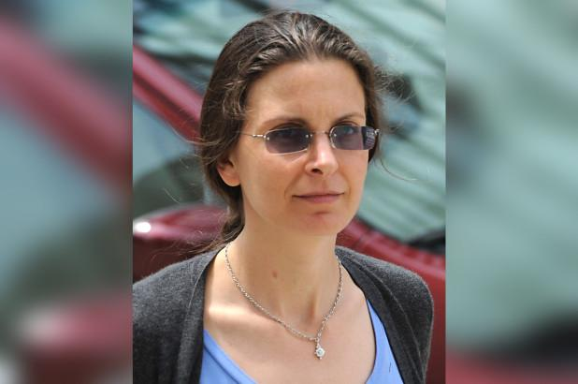Claire Bronfman
Recruits were expected to provide "collateral" before joining - including damaging information about friends and family, nude photographs and rights to assets - that could be used against them if they revealed the existence of the organization or tried to leave, prosecutors said.
The four women are scheduled to appear in federal court in Brooklyn and Albany later Tuesday.
Near Earth Objects
Scientists have taken much better stock of our neck of the cosmic woods over the past two decades, as a new NASA video makes clear.
The animation maps out all known near-Earth asteroids (NEAs) — space rocks that get within about 30 million miles (50 million kilometers) of our planet's orbit — from 1999 through January 2018, in roughly 10-year time steps.
The differences are stark. In 1999, identified NEAs speckled the inner solar system thinly, in a light dusting. Many more were discovered by 2009, and Earth's neighborhood looks absolutely swamped in the present-day portion of the video. [In Pictures: Potentially Dangerous Asteroids]
But even that last frame doesn't impart just how crowded near-Earth space actually is. Astronomers have detected just 18,000 near-Earth objects (NEOs, a classification that also includes comets) to date, out of a population thought to number in the millions.
There's good news, though: NASA scientists have found and tracked about 95 percent of the potential civilization-enders out there — rocks at least 0.6 miles (1 km) wide — and none of them pose a threat to Earth for the foreseeable future.
The space agency's NEO Observations Program is also working to discover and track 90 percent of the NEOs that are at least 450 feet (140 meters) wide by 2020 — a very ambitious goal laid out by Congress in 2005. It would take something of a miracle for NASA to do this on the prescribed timetable, however; scientists estimate that just one-third of the 450-footers out therehave been spotted to date.
The NEO Observations Program, which was created in 1998, is responsible for about 90 percent of all 18,000-odd NEO discoveries, NASA officials said.
The research and data-analysis hub of the program is the Center for Near-Earth Object Studies (CNEOS), which is located at NASA's Jet Propulsion Laboratory in Pasadena, California. (CNEOS was originally known as the Near-Earth Object Program Office; the name was changed in 2016.)
"We compute high-precision orbits for all asteroids and comets and map their positions in the solar system, both forward in time to detect potential impacts, and backward to see where they've been in the sky," CNEOS Director Paul Chodas said in a statement Monday (July 23). "We provide the best map of orbits for all known small bodies in the solar system."
The newly released video also maps all of the known asteroids in the main belt between Mars and Jupiter, and it's a sight to behold. The belt is home to the vast majority of all known space rocks, the current tally of which tops 780,000, according to NASA researchers.

Scanning the Heavens
Earth is hit every day by small bits of space dust. Slightly larger chunks burn up colorfully in the atmosphere, causing the shooting stars you see in the sky. Occasionally even bigger rocks hit our atmosphere; they are known as fireballs, because the light from them burning up is particularly bright. These tend to smack the Earth a few times a year and may produce a few fragments for rock-hunters to find.
NASA and other organizations do regular scans of the sky to catalog any small bodies that are at risk of crashing into our planet. No imminently threatening bodies have been found yet, but it's clear that sooner or later Earth will be struck by something big. The organizations are actively researching the best ways to protect Earth from asteroids, meteoroids or comets that may come crashing down. NASA's Center for Near Earth Object Studies and the International Asteroid Warning Network list recent "close calls."
Asteroids refer principally to small, rocky bodies. Comets contain more ice and can also pose a threat to Earth. Before fragments enter our atmosphere, they are known as meteoroids. During their path in the atmosphere, they are called meteors. If any of these pieces reach the ground, those pieces are called meteorites. The best hunting ground on Earth for meteorites is Antarctica because the ice makes it so easy to see the fragments, and the ground is not disturbed as much as a typical urban area or forest.
The difference between a meteoroid and an asteroid is a little vague. In 1961, The International Astronomical Union (the official body for naming objects in space) said a meteoroid is much smaller than an asteroid, but bigger than an atom. A 2010 Meteoritics and Planetary Science paper led by Alan Rubin, a geophysicist at the University of California, Los Angeles, suggested that the limit for meteoroids be about 1 meter in size. It's common for smaller bodies to escape notice until they are right beside the Earth, or slamming into it, because Earth's telescope network is designed for spotting asteroids of a much larger size. This is why in June 2018, for example, an estimated 6-foot (2-meter) rock called 2018 LA was found only a few hours before incinerating in the atmosphere.
Keeping track of these bodies is also difficult, due to their size and low reflectivity — as well as limited telescope time. In mid-May 2018, astronomers with the Harvard-Smithsonian Center for Astrophysics lost roughly 11 percent — or 900 near-Earth asteroids — of the over 17,000 candidates identified between 2013 and 2016, according to Newsweek. In other words, after the initial sighting, scientists lost track of where these asteroids moved next.
In 2017, scientists confirmed the first interstellar asteroid, which was known 1I/2017 U1 'Oumuamua. The interloper quickly zoomed through our solar system, showing its origins by its unusual path as it traveled by Earth at a safe distance. Scientists continue follow-up studies on the data, such as this 2018 study showing that 'Oumuamua is tumbling.
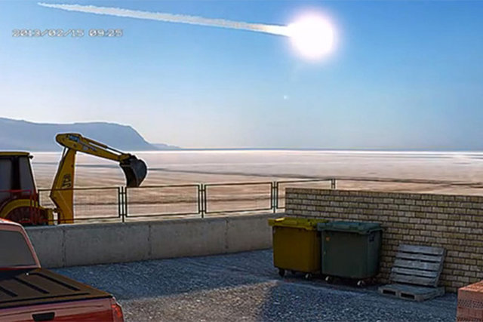
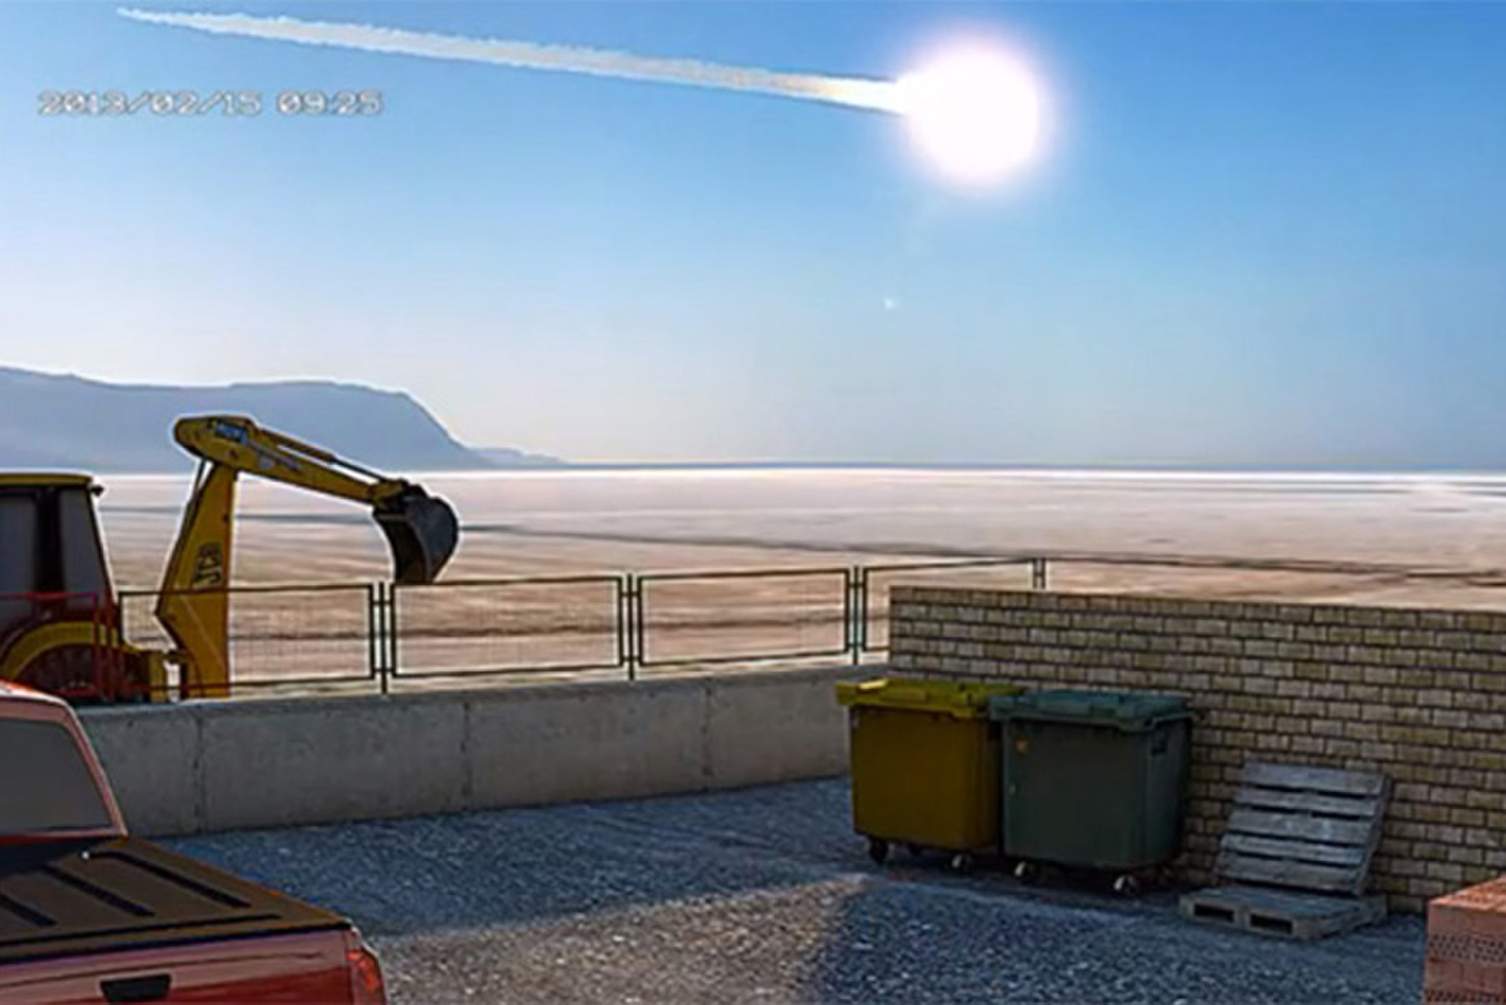
A 65-foot-wide (20 meters) asteroid exploded without warning over the Russian city of Chelyabinsk in February 2013, blazing a superbright trail across the winter sky.
Credit: Neuromainker via YouTube/Screenshot by Irene Klotz for Discovery News

Characterizing the threat
It is clear that even small bodies can pose a threat; the asteroid that broke up over without warning over Chelyabinsk, Russia, in 2013 was roughly 56 feet (17 meters) across, shattering glass and injuring hundreds of people. In 1908, an estimated 130-foot (40-meter) object exploded over Siberia and flattened trees over 825 square miles (2,137 square kilometers). Around 50,000 years ago, before human civilization began, a rock about 150 feet wide (46 meters) smacked into what is now called Arizona. It left behind Meteor Crater, which is roughly 0.7 miles (1.2 kilometers) wide today.
Even bigger collisions happened far in the past. The dinosaurs were wiped out 66 million years ago by an object about 6 miles (10 km) wide, which left behind a 110-mile (180 km) crater in Mexico known as Chicxulub. But that's nothing compared to evidence of another impactor found in 2014. A rock formation in our planet's crust pointed to a possible impactor 23 to 36 miles (37 to 58 kilometers) across that smacked into Earth 3.26 billion years ago, just a few million years after life evolved.
NASA began tracking near-Earth objects (NEOs) in the 1970s. Its goal is to find objects that are at least tens of meters in size, "which could cause significant harm to populated areas on the Earth if they were to strike without warning," NASA stated in 2014.
Congress directed NASA in 1994 to find at least 90 percent of potentially hazardous NEOs larger than 1 kilometer (0.62 miles) in diameter, which NASA fulfilled in 2010. Congress also asked NASA in 2005 to find at least 90 percent of potentially hazardous NEOs that are 140 m (460 feet) in size or larger. That's supposed to be finished by 2020; multiple media reports indicate NASA will miss that deadline due to funding challenges, although NASA points out its pace of discovery is accelerating due to better observatories NASA created a Planetary Defense Coordination Office in 2014 — a year after Chelyabinsk — to better coordinate its efforts, in response to an Office of the Inspector General report. Other space agencies such as the European Space Agency also have their own offices, and the different nations regularly collaborate with each other. NASA does regular "tabletop" exercises with its partners (such as this 2017 one) to simulate threatening asteroids and an appropriate response.
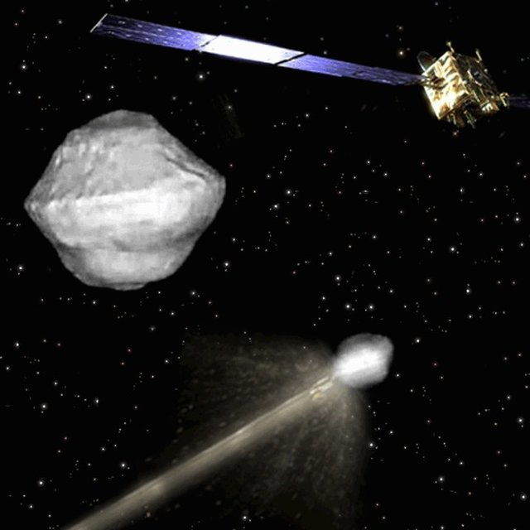
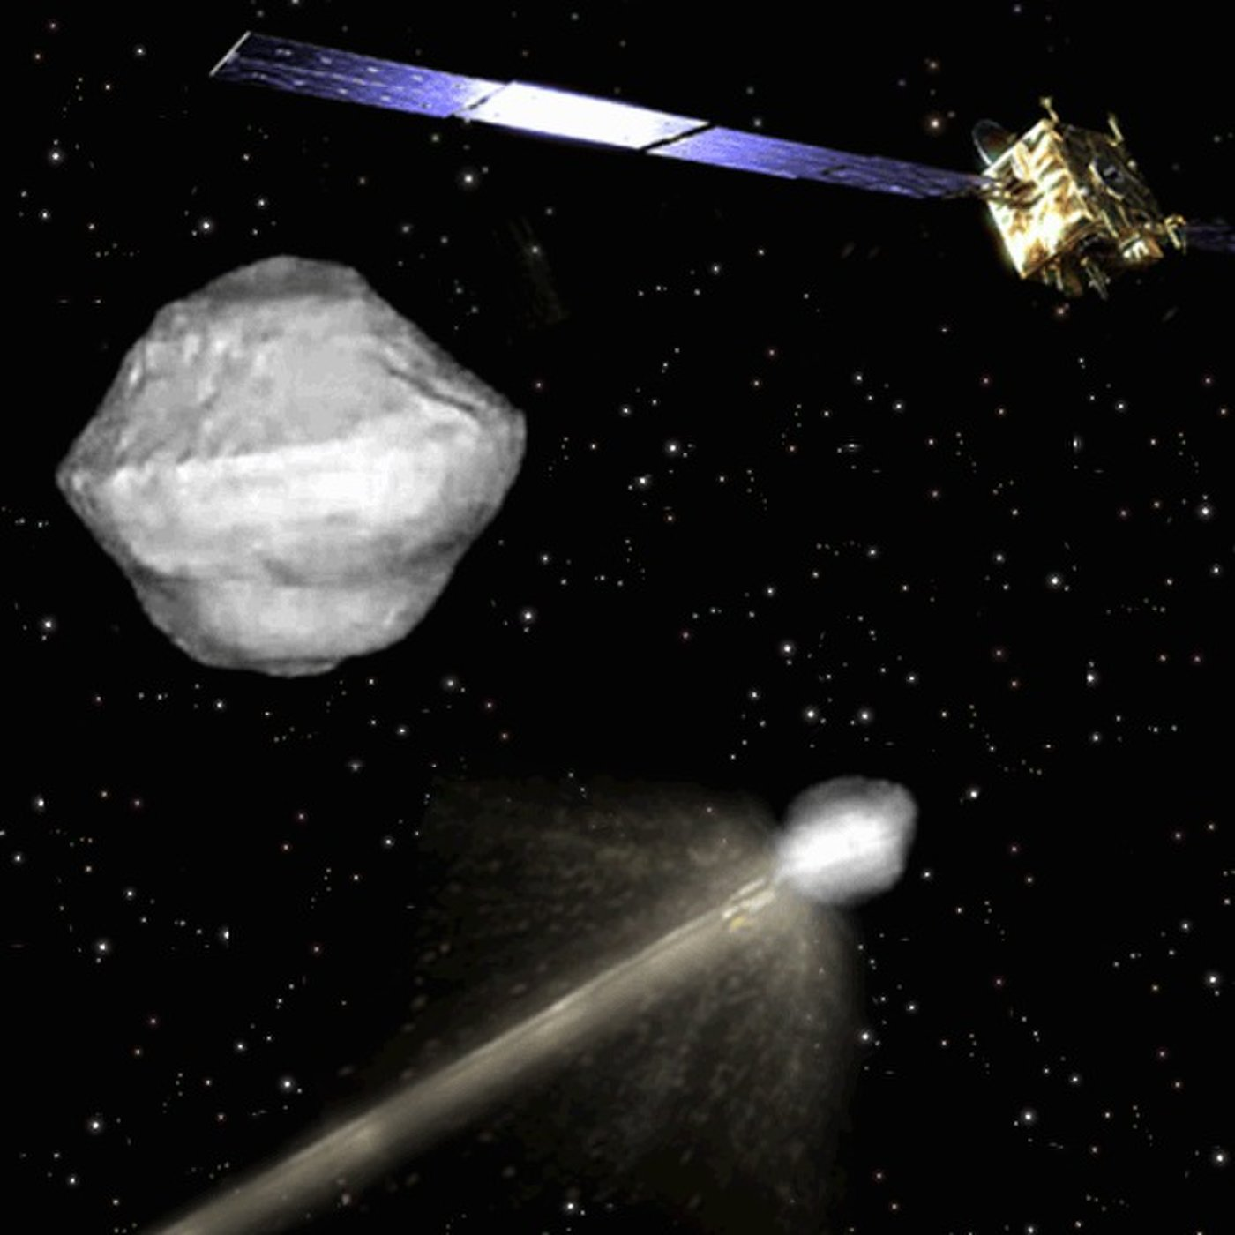
An artist's concept for the Asteroid Impact & Deflection Assessment (AIDA) mission led by the European Space Agency to intentionally strike an asteroid and test deflection capabilities that could protect Earth.
Credit: ESA

Scanning the sky
NASA works with several sky surveys to maintain a list of potentially hazardous objects. These include the Catalina Sky Survey (University of Arizona), Pan-STARRS (University of Hawaii), Lincoln Near-Earth Asteroid Research or LINEAR (Massachusetts Institute of Technology) and Spacewatch (University of Arizona). These observatories are constantly upgrading their capabilities to try to catch fainter asteroids.
Asteroids are also observed from space by several telescopes, but the one most regularly used for NEO searches is called NEOWISE. It's the new mission of the Wide-field Infrared Survey Explorer (WISE) telescope, which launched in 2009 and was revived from hibernation in 2013 to search for asteroids. The telescope is expected to keep operating until 2018, when the angle from the sun in its orbit will be too bright to search for asteroids. In April 2018, the mission released a fourth year of survey data, including information on 788 near-Earth objects and 136 comets. A follow-up mission called Near Earth Object Camera (NEOCam) was proposed for 2021, but it lost out to other missions. NEOCam received another year of funding and may compete in future mission proposals. NASA acknowledges that with roughly two-thirds of the near-Earth asteroid population unknown, a NEOCam-like mission would be helpful.
There are other NASA missions that are looking to get up close to asteroids to better characterize their composition. Some recent examples: The Dawn mission visited asteroid Vesta between 2011 and 2012, and has now been at Ceres (a dwarf planet) since 2015. OSIRIS-REx (Origins, Spectral Interpretation, Resource Identification, Security, Regolith Explorer) departed for asteroid Bennu in 2018 for a sample-return mission, which will come back to Earth in 2023. Additionally, NASA uses data available from other space agency missions that visited asteroids, such as the Japanese Hayabusa(completed) and Hayabusa 2 (in progress).
Some planned missions would have taken even more daring steps at asteroids. NASA previously worked on concepts for an Asteroid Redirect Mission (ARM) that would have a robot move a small body into the moon's orbit, for astronauts to study. ARM was abandoned in favor of long-term space exploration policies for the moon and Mars. Another mission would have seen NASA, the European Space Agency and other partners are planning a mission called AIDA, or Asteroid Impact and Deflection Assessment. The goal is to change the path of a small moon orbiting the asteroid Didymos using a kinetic impactor. ESA announced its part of the mission wouldn't be funded in 2016 to make more budgetary room for ExoMars (a rover), but NASA continues study of its part of the mission. (ESA has also expressed the hope it will participate in some form later on.)
A kinetic impactor (perhaps with a nuclear bomb inside) would deflect the orbit, tugging the asteroid slowly using a spacecraft, redirecting it with solar heat, or blasting it with a laser. That is just one idea. There is ongoing research as to what sort of asteroid deflection technique would be best. The best approach depends on many factors, such as cost, the composition of the asteroid, time to impact and technology maturity. Studies are ongoing in these fields; in 2007, NASA said that non-nuclear kinetic impactors had the most mature technology. In 2018, a group of U.S. scientists and engineers proposed an early-stage mission called HAMMER that would use a nuclear warhead to disintegrate large asteroids or move them off course.

- When do you think the Second Seal spoken of in Rev 6:3-4 was opened?
- Many people re still looking forward to the Tribulation, spoken about in the book. Do you think it has already begun?
- It seems nearly every country is divided into these two groups: the leftists and the conservatives. I always wonder what the leftist activists see in their politics for themselves. Don’t they realize that they seek the blue pill of slavery?
- I am curious how deep researchers feel about prophecy. Do you think that somehow God is not keeping His word, if the world is not destroyed in blood and horror?
- Do you think the hostility of Pyongyang has subsided? Do you think Little Kim likes the idea of being seen in history as the man who brought peace to the world, as opposed to the little shrimp that bothered the whale?
- I know the government of China and North Korea are aligned against South Korea and the idea of a free people doing free things. But, the people of North Korea have people in South Korea. They know 70% of the world’s top female golfers are Korean. They see this. They want it for their children. Do you think the people will influence their government?
- China’s President Xi is now there for life. He cannot be removed for perhaps 30 years or more. He will wait until Trump is defeated at the polls, or do you think he will conspire to destroy him?
- I your opinion, who is the antichrist? How do you think peace will be taken from the Earth, if the people desire peace so badly?
- Do you think the Internet is a tool created by God to bring His people together for the Gathering, or do you think it is a tool invented by Satan to stir the world into a global pot of chaos?
- Do you think the Deepwater Horizon tragedy was an attack by North Korea on America?
- Who knew this attack was coming?
- Do you think the globalist wealthy and Goldman Sachs were able to position themselves prior to the attack, because they knew about it? Helped it?
- Which god is behind the second seal?
- What is the great sword provided the second rider to the Red Horse?
- How vital do you think it is for the world to come to Christ in these last days?
- Do you feel this is happening?
- Which church do you think Jesus established and why?
- Many people think god’s word is guaranteed. It cannot be broken. Are there conditional predictions in the Bible? I mean, what happens if the people repent? Will God still come to destroy the world?
- Do you think that the world has an obligation to protect itself against an attack from space, heaven?
- Do you think there are people who do not want to be part of the house of Israel, when all that is promised is apocalypse and death without hope or love?
- What happens if the people themselves wake up and remove wickedness from power themselves?
- What happens if the human race chooses peace and love and joy, instead of war and power and slavery?
- I think we came close to world destruction during Obama’s reign of terror. I truly think that the world would have ended as you say in your book had Hillary become president. But what do you think now that the people have stopped that pathway toward global war?

