Jihad Report
Dec 14, 2019 -
Dec 20, 2019
Attacks | 26
Killed | 159
Injured | 142
Suicide Blasts | 0
Countries | 11
Space Forced
Flanked by two F-35 fighter jets and in front of a giant American flag, President Trump on Friday signed the 2020 National Defense Authorization Act that officially created the Space Force, the sixth and first new military branch since 1947.
“For the first time since Truman, we will create a brand new American military service,” Trump said. “You will witness the birth of the Space Force. That’s a big moment and we’re all here for it.”
I have been saying for almost 35 years that he who controls the Moon will control Earth. It is the high ground for our solar system. It is defensible and yet close enough to monitor, defend, or attack anything happening on or off planet. The creation of the Space Force marked the achievement of one of the president’s top national priorities. One thing is certain. This bill and the funding that is dedicated to it is only the beginning of a new race to the Moon and beyond. Hopefully, the focus on other frontiers will leave this world in peace as human factions worry more about getting a base on the Moon for the next 50 years that they do over a stupid island in the Pacific.
“Space is the world’s newest warfighting domain,” Trump added. “American superiority in space is absolutely vital.”
If you don’t believe him, then you are naïve. The seed of Lucifer is alive on Earth and there will never be peace as long as that comes to this world. This is necessary because Bill Clinton sold our space technology to China in exchange for a few hundred thousand dollars in campaign contributions.

Before then, the space-faring nations has all abided by the non-militarization of space treaty. China is a bad actor and does not honor treaties, even those to which it is a signatory. The world is now at a point where generations are willing to live in slavery. They are willing to give up their rights to learn and explore in exchange for free food, a place to live, and something mundane to do their entire lives. The human race has never been there before. Hardly an hour goes by now that the Global Syndicate is not at war with humans who do not want to live under global tyranny. The truth is that they do not have any weapons to fight, because they have been disarmed by the very governments that want to enslave them.
The Space Force will do more than expand the human race into the stars. It will save it by creating new frontiers that mankind will colonize and will declare to be free and independent from the Global Syndicate, just like Americans did hundreds of years ago.
The new branch will reside inside the Air Force. The president thanked Vice President Mike Pence for his work in helping to establish the Space Force. He also announced the appointment of Air Force Gen. John “Jay” Raymond as the new Space Force commander. “He will now join the Joint Chiefs,” Trump said.
To mark the historic moment, the president signed the bill inside a giant aircraft hangar at the Andrews Air Force Base in Maryland surrounded by an audience of several hundred young service members, Pentagon officials, and other distinguished guests.
Also in attendance were about a dozen Republican members of Congress: Reps. Mac Thornberry (TX); Joseph Wilson (SC); Mike Rogers (R-AL); Michael Turner (OH); Michael McCaul (TX); Robert Wittman (VA); French Hill (AR); Jack Bergman (MI); Matt Gaetz (FL); Greg Pence (IN); and Michael Waltz (FL).
The military’s top civilian and uniformed leaders were all in attendance, as well as United States Trade Representative Ambassador Robert Lightheizer and White House adviser and First Daughter Ivanka Trump.

First Lady Melania Trump opened the ceremony with remarks, wishing service members and their families a Merry Christmas. One airman told Breitbart News it was a “historic moment” to witness the creation of the Space Force.
The bill also pays for scores of new aircraft, tanks, and ships. The Senate passed the bill on Thursday, sending it to the president. It authorizes $783 billion for defense spending for fiscal year 2020. The bill was passed on a bipartisan basis, 11-81.
With the bill, Trump declared the rejection of “American decline.” Trump has raised spending for the military to new levels, after a decade of deep cuts under sequestration. He signed a defense bill authorizing $716 billion for the military in 2018, and $700 billion in 2019.
The War of Global Domination
The Democrats declared war this week by impeaching 80 million Americans.
What started as a coup to overturn the 2016 election has now morphed into a Civil War as Speaker Nancy Pelosi (D-San Fran-feces) presided over the passage of a bill which creates a clear Constitutional Crisis. And that means we have multiple factions vying for control of our government, the definition of a Coup. It could be war, soon.
23 radical Democrats have officially declared that Abuse of Power by a Donald Trump is an impeachable offense. In other words, the actions taken by the President to drain the swamp and destroy the wealthiest and most powerful money laundering operation in global history is seen as a direct threat to the government. Yes, I said it. The government has been run by thieves and robbers for more than 50 years.

Here’s how it works. Congress writes laws that collect and disperse taxpayer money as it sees fit. It was a small and manageable operation until Ronald Reagan. Bush and the US military showed Congress how to do launder money on a scale never attempted before. He would sell drugs inside America, use the off-the-books cash to buy guns and smugglers to ship those guns to South America. Everyone along the way, including governor Bill Clinton, skimmed cash for letting it happen illegally under their noses.
Instead of getting caught by the law, or by Congress, they stuffed their own pockets as well. The Clinton Crime Syndicate was born out of George Bush senior’s money laundering operation. The Clintons spent hundreds of millions to buy the super-delegates and compromise Bush Sr. They even hired a third party candidate to split the conservative vote and allow Clinton to win with just 43% of the vote.

The model was proven to work, but Presidents were thinking too small, or thinking with their penis instead of with a focus dream of global domination. Bush junior figured it out, but first they needed to be able to bring the armed American to his knees in one fell swoop. They didn’t do it by collecting all the guns. They did it by creating a demon enemy. The enemy became terror. They killed more than 3,200 Americans to make the sale. This time, it wasn’t a few billion dollars. It was trillions.

The Global Syndicate trained and installed Barack Obama. He ripped America apart. He divided America into dozens of small factions and then skillfully told them that they were alone and victims of America. He paid them, oppressed them, and indoctrinated their children. But then he did something much worse. He funneled $10 trillion in less than 8 years through the money laundering government established by the Clinton Crime Syndicate.

Congress would send the money to foreign countries where it would be sifted through layers of non-profits and shell corporations. Each time it was sifted, payments would go out to the elected officials to keep the money flowing. Within a few short years, every single member of Congress in both parties was a multi-millionaire. The trillion-dollar media empire, run by only six men, worked in movies, news programs, and the internet to create a surveillance and censoring system like nothing ever seen before. Hundreds of people were murdered and hundreds of thousands of people were killed to facilitate the major acquisitions and redraw national boundaries to form what some called a Caliphate, but accurate analysis would soon prove was nothing more than global domination by a small and ancient group of leaders.

There are some of us who saw what was being done, and we knew what needed to be done. Donald Trump spent his entire life building an empire of wealth that would allow him to be elected President so he could stop them before it was too late. He waited until the very last possible moment to make his move, because he knew it would kill him and his family. If Hillary Clinton had been elected President, the United States would cease to exist, and the world would be delivered to the Syndicate.

Trump was elected, only because 63 million armed Americans woke up and went to the polls. In their confidence and complacency, the Syndicate did not see this coming. But I did. Each hour of each day, he executes are part of his plan to dismantle the government money machine the Syndicate had built of decades of planning and subterfuge.

More than 50 Republicans retired and left government, knowing he was coming for them. Democrats decided to lock arms and fight. That is the war we are in. That is why the Democrats had to fabricate two articles of impeachment that took nearly three years to craft. They aren’t even violations of law, and they know it. These opinons and presumptions do not amount to High Crimes and Misdemeanors.
The implications of this impeachment article are, however, staggering.
It says explicitly that the U.S. president cannot discharge his duties as a law enforcement official if the person of interest is someone of the opposite party or a potential electoral opponent. It says that political considerations are all that are required to impeach a President. The Syndicate is so feared that 33 radical Democrats can command the unwavering allegiance of every single member to impeach 80 million Americans.

It is a clear violation of Congress’ role. This is the fear the founders had. They knew that once Congress figured out how to unify in their purpose to make themselves the supreme rulers of America and become richer than kings, they would happily destroy the Republic and take the people’s wealth as their own. This is precisely why they made the President so powerful and so directly connected to the people. This is precisely why they placed the Article V clause in the Constitution. It was not to reign in the President. It was to reign in Congress by temporarily removing their power to write laws while the States amended the Constitution to right the ship called America.

It is not an abuse of power for the President to obstruct Congress. It is precisely the use of Presidential power that has kept them from destroying the Republic for 232 years. The Constitutional Convention was in 1787, for those of you who went to government schools.

The second article is even worse. It claims that 33 radical Democrats rule America.
This is fully unconstitutional since it subverts the power of the Judicial branch to settle disputes between the Executive and Legislative branches as established by the Constitution. Pelosi merely wields the cudgel that is breaking the legs of the Presidency. The Democrats broadening of the definition of ‘the sole power of impeachment’ says that whatever Congress deems as worthy of an impeachment inquiry is therefore law and the other branches have no say in the matter.

This is patent nonsense and completely tyrannical.
Rod Rosenstein and Andrew Weismann tried to use an equally broad interpretation of ‘obstruction of justice’ to include future harm to continue the special council’s investigation into Trump’s alleged collusion with Russia.
Moreover it renders the concept of judicial review as laid down in Marbury vs. Madison null and void. Congress cannot just make up laws and crimes out of whole cloth and then unilaterally declare them constitutional under the rubric of impeachment. The Supreme Court has the right to strike down bills Congress passes as unconstitutional. Of course, they have been kept out of this process, so far.

The wedge pounded through the bones of the Republic with Pelosi’s cudgel is a blatant power grab by Pelosi and the Democratic House majority to protect themselves from Trump’s investigations into their crimes surrounding events in Ukraine.
When viewed dispassionately, Obstruction of Congress is not a crime but rather a duty of each of the other two branches of government. The Supreme Court cannot write laws. Congress cannot represent America to foreign powers, The President cannot assess taxes, or decide which laws he will and will not enforce, or declare war, but he can lead and set the spirit of the nation. That’s what the whole three co-equal branches of government is supposed to mean.

The Judicial branch routinely oversteps its authority. The President tries to write law. Congress tries to rule the country. At the end of the day, all three of these branches rule at the pleasure of the American people. We can use the Convention of States to correct things, if we have the resolve and leadership to follow through.

I’m no legal scholar so when I can see how ridiculous these articles are then you know this has nothing to do with the law but everything to do with power.
I thought just like you did that this impeachment was really about is distracting and covering up the multiple layers of corruption inside our government that forms the most powerful money laundering machine the world has every known. Many of the tendrils emanating from the events surrounding the FISA warrants improperly granted connect directly to the Clintons, Jeffrey Epstein, William Browder and the rape of Russia in the post-Soviet 90’s.

You and I both know that if Hillary had become president, none of these crimes would ever have seen the light of justice.
Congressman Steve King (R-Iowa) argued that House Democrats impeached President Trump to "shield" themselves from the "reckoning that will come" after U.S. Attorney John Durham releases his final report on the establishment of the Russia investigation
"I mean, how bad does this have to get before the American people understand here's what Democrats are doing: they're impeaching Donald Trump not just because they don't like him but it's a shield for them to defend themselves from the reckoning that will come when the Justice Department gets put back on the rails for law again," he added.
The DOJ Inspector General's report on the origins of the Russia report found errors with the FISA application process. King said Attorney General William Barr and U.S. Attorney John Durham will "come out with more of truth in this."

We’re talking an entire generation or more of U.S. officials and politicians implicated in some of the worst crimes of the past thirty years. Mass murder, embezzlement, bribery, assassinations, infanticide, and illegal drug and human trafficking the likes of which the world has never seen before. For example, Congress send $500 million a year to Planned Parenthood. They turn around and write a check for $56 million to the DNC. That is straight up money laundering, but no one will dare do anything about it. Why? Because not only is the DNC raking in $56 million a year, but they sacrifice millions of poor white and minority babies to bless the operation with the blood of the most innocent humans on Earth.
But, is this is why they are willing to risk a full-blown constitutional crisis and civil war to remove Trump from office?

The polls are shifting, because 80 million Americans support President Trump. Pelosi could just be following orders from a very ancient order of evil that is plotting to take over America and wipe away the 2016 Election. Or, she could be possessed with lust, and she is targeting the Presidency itself for herself. Think about it.
Trump is leading Americans against their plan. If the Democrats succeed in getting their articles submitted to the Senate, the President is impeached, officially. That creates two forms of Constitutional crisis.
The first is that we have never had an impeached President on the ballot for the presidency before. Johnson did not get the nomination from his party. Nixon resigned. Clinton was already in his final term. The trillion-dollar media empire will mobilize to prevent Trump from being placed on State ballots. If States refuse to put him on the ballot, then he cannot win the election. If the RNC is pressured to nominate someone else or face years of legal battles and expenses, then he could be asked not to run. Does the Supreme Court really want to face 6-10 States who refuse to issue a ballot with his name on it? Really? In 11 month’s time?
Pelosi told reporters on Capitol Hill she wanted to see how McConnell, R-Ky., would lay out the trial’s rules before she sent over the articles to the Senate.
“We can’t name managers until we see what the process is on the Senate side and I would hope that would be soon. So far, we haven’t seen anything that looks fair to us,” Pelosi said.
There is no set time frame for Pelosi to follow to carry out this step. But she suggested Wednesday night that she will hold off until she receives assurances about the Senate trial proceedings.
“This is what I don’t consider a fair trial,” she said when pressed by reporters. “That leader McConnell has stated that he’s not an impartial juror, that he’s going to take his cues, in quotes, from the White House, and he’s working in total coordination with the White House counsel’s office.”
The second comes when Ruth Bader Ginsberg dies shortly. Congress and the trillion-dollar media empire will assert than an impeached President cannot appoint a Supreme Court Justice because of a conflict of interest.
Nancy Pelosi is delaying the official presentation of the House’s ruling to the Senate……and now we know why. She has another foul and manipulative card up her sleeve. Pelosi is filing a motion to have the powers of the President suspended “until such a time as his innocence has been proven.” Democrat staffers are busily preparing the legal documentation necessary to enact the move and arguments will be made before a federal court next week.

Pelosi argues that it is reasonable for the people to have doubts about the intentions of the President in light of the fact that he faces a trial for criminality. The White House, of course, will present the assumption of innocence until guilt is proven.
Legal scholar, Satya Martin, feels that both arguments have merit.

The Trillion Dollar Media Empire
So the United States has “the world’s highest rate of children in detention.” Is this worth reporting? Maybe, maybe not. Nevertheless, Agence France-Presse, or AFP, and Reuters did report it, attributing the information to a “United Nations study” on migrant children detained at the US-Mexico border. It was official and complete with pictures and interviews with witnesses.
Then, a very strange things happened. The two agencies very suddenly and completely retracted, deleted, withdrew, and demolished the story. If they could have used one of those Men in Black memory-zappers on us, they would have. Sheepishly, the two news organizations explained that, you see, the UN data was from 2015 — part of a border crackdown that had begun years earlier.
We all know who the president was in 2015. It wasn’t the evil, child-caging monster President Trump. It was that nice, compassionate, child-caging monster President Barack Obama.
The story made Obama look bad. Hence the story was removed. Not updated or corrected, removed.
Most people think news organizations flat-out fabricate stories. That isn’t often the case. Fake news is a problem that does occur, but the much more systematic and deeply entrenched attack on truth is the casual, everyday bias of reporters. You see a great lie is not full of falsehood; it is full of truth. It is just twisted and misdirected like a birth defect. Most of the pieces are there, just in the wrong place.
AFP and Reuters deleted a story that was, in a narrow sense, true — that a UN study claimed the United States had some 100,000 children in migrant-related detention. What the agencies didn’t seem to like was that Obama, rather than Trump, locked up a lot of children. This is what’s important: Not that AFP and Reuters deleted a story, but that the implication of the story meant everything to them.
Every time you read something from AFP and Reuters (and CNN and the Washington Post), you should be thinking not “This is fake news” but: “What’s the agenda?” To paraphrase Chuck Schumer’s infamous, and instructive, comment on the CIA, news outlets have six ways from Sunday of getting you to think what they want you to think, none of which involve making up stuff. You can add to that Bloomberg. Yeah. The billionaire who’s running for president. Imagine that. One of the world’s richest media moguls actually using the presidential pen.
The truth is that Obama’s approval ratings were mostly really low, comparable to Trump’s, typically in the low to mid-40s. Polls would come out saying this, and the Ron Burgundys would simply not report it.
Using, or ignoring, facts in accordance with whether they create the desired impression is the principal agenda of today’s media.
Trump doesn’t enjoy this courtesy. No news organization is going to associate Trump with good news. A recent Newsbusters survey found that, over a recent six-week period, not even 1 percent of network news reporting on the Trump administration even mentioned positive economic news. Have you taken a look at the economy lately? Do you even open those 401k statements? One of my friends made $50k last year alone on 401k mutual funds.
Another trick is soberly reporting the policy proposals of Politician One but focusing entirely on the miscues and petty controversies of Politician Two. You might, if you are a news consumer, be under the impression that Sen. Elizabeth Warren has a sober, well-reasoned set of plans. These plans are, however, so far-fetched as to be breathtaking. She has vowed $20.5 trillion in new federal spending, an increase of 40 percent on top of current levels. Yet Warren isn’t the candidate the media habitually portray as unhinged.
Meanwhile, the gaffes of Democrats attract very little interest; network news basically ignored the mini-scandal involving Pete Buttigieg, who promoted a list of black supporters, many of whom either were not black or did not support him. The networks declined to cast Buttigieg as racially insensitive.
Still another trick is deciding that a matter that advances the wrong narrative is simply “local news,” hence not worthy of attention from the major outlets. Any crimes committed by illegal immigrants can be safely ignored by CNN, but any crimes associated with right-wingers become cause for national dismay and soul searching.
CNN did a massive story this week involving the talents of five reporters after someone at Syracuse University sent out a white supremacist manifesto to “several” cellphones and racist graffiti was discovered in a residence hall. Previously, similar outbreaks of campus fear turned out to be based on hoaxes. Yet if this story dissolves, CNN can accurately claim, hey, we were just reporting that students were scared.
The impression created by a thousand stories like this — that America in 2019 is a white supremacist nightmare — will linger all the same. Using, or ignoring, facts in accordance with whether they create the desired impression is the principal agenda of today’s media.

If Hillary had won, the billions in money laundering would have been protected. If Pelosi’s Coup succeeds the Democrats will succeed in covering up their crimes, albeit after we the people know about them. Either way, this coup attempt by Pelosi is now open warfare. There will be casualties. You cannot unsee this kind of evil. Watch your eyes. The bomb is in play.

How to Win a War

Step one. Seize and freeze the money.
Instead, police described the four as leaders of Spark Alliance, a mysterious organization that has been one of the main financiers of the protest movement, including by bailing protesters out of jail and helping to defray their legal fees.
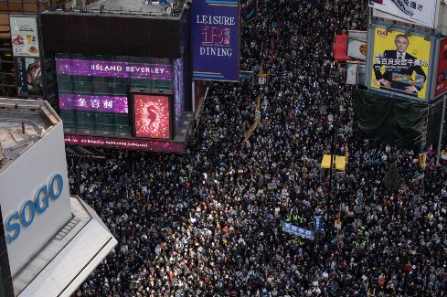
Police seized $9 million in bank deposits and personal insurance products from Spark, claiming that the group broke laws about money laundering.
In a response posted to its FB group, Spark blasted the police, accusing them of deliberately trying to cut off one of the most important avenues of financing in the protest movement.
On Thursday evening, police announced the arrests of four people connected with Spark Alliance for suspected money laundering, the first cases brought over financing the demonstrations after six months of protests against China’s tightening grip over Hong Kong. Authorities froze HK$70 million of bank deposits and personal insurance products linked to the fund, while also seizing HK$130,000 in cash.
"The police attempted, through false statements, to distort the work of Spark Alliance as money laundering for malicious uses," the group said in a statement on Facebook. "Spark Alliance condemns this kind of defamatory action."
The arrests and seizures, as Bloomberg explains, shed light on the innerworkings of the Hong Kong protest movement. Millions of Americans who have read the news reports about the protests have probably been left wondering how the protesters became so organized.
Well, this is how: Since the beginning of the movement, wealthy working HKers have observed their duty to help those battling it out on the front lines in any way possible. Mostly, they do it through donations to groups that purport to help bail out protesters after they've been arrested, or groups that simply provide food and shelter for the demonstrators, many of whom are teenagers, or in their early 20s.
This division of responsibilities is part of what's allowed the movement to continue on for as long as it has.
But by cracking down on the money, HK police are essentially pulling the rug out from under Hong Kongers facing criminal charges for protest-related activities.
Because Spark Alliance and another, more transparent, fund called the 612 Humanitarian Fund are responsible for financing the protest movement: According to BBG, the two funds account for 70% of the money raised by the protest movement.
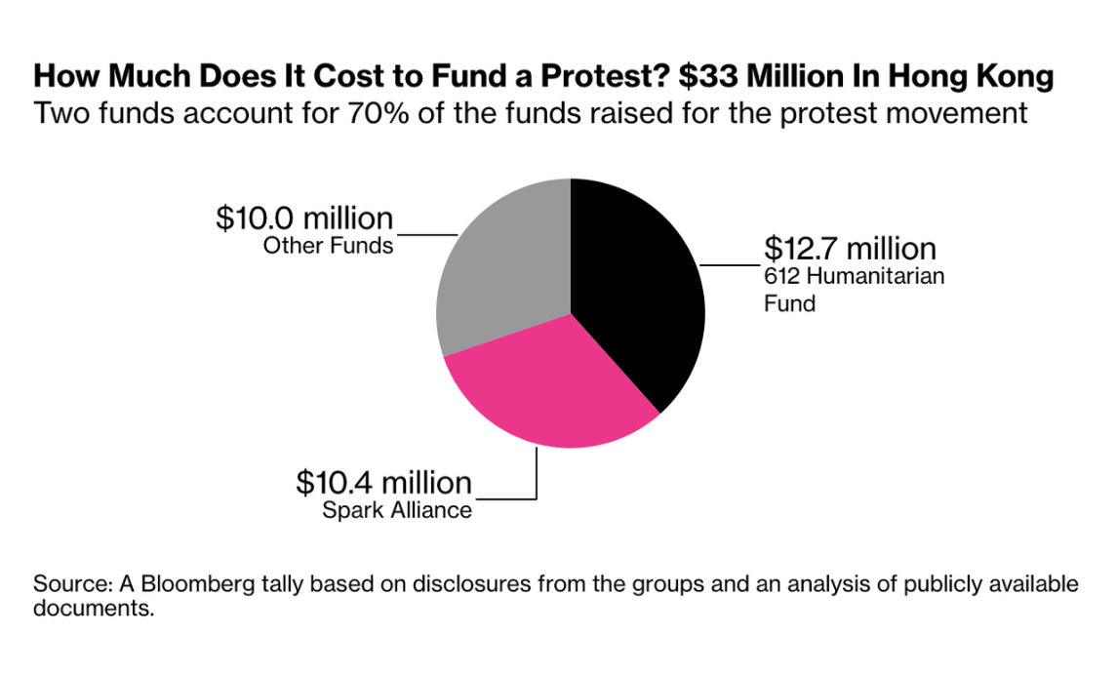
The impact of this crackdown is two-fold: not only will protesters counting on these funds to pay their legal fees be left out in the cold, but the renewed police scrutiny could deter some working Hong Kongers who have been supporting the movement with donations.
The crackdown deals a major blow to demonstrators as they face ever-mounting legal bills, with more than 6,000 people arrested since June. Spark Alliance, one of the largest crowd-funding campaigns supporting the protests, plays a crucial behind-the-scenes role - often sending anonymous representatives to bail protesters out of jail in the middle of the night.
The latest arrests risk deterring Hong Kong’s professional class from giving more cash, potentially curbing a substantial source of funds that have helped sustain the protests longer than anyone had expected. They also show the limits of the leaderless movement’s ability to manage tens of millions of dollars with little oversight outside of a formal financial system.
Funds bankrolling the protests have collectively raised at least HK$254 million ($33 million) since June, with 70% coming from just two groups, Spark Alliance and the 612 Humanitarian Fund, according to a tally based on disclosures from the groups and an analysis of publicly available documents. That figure doesn’t reflect all the money raised related to the protests, only the funds Bloomberg News could verify.
Before the arrests, most Hong Kongers didn't know the identities of anyone behind Spark Alliance. Its website and bank accounts (before they were shut down) all forwarded to a Pest Control company.
But Spark proved its reliability early on by helping bail protesters out of jail. But the group has been under scrutiny even before the police got involved. Last month, HSBC shut down the group's account, saying they had detected activity that differed from the stated purpose of the account.
“Spark is probably less transparent but people tend to believe them,” said Jason, a protester in his 30s who asked to be identified by his English name. He said he memorized the group’s phone number and called the group after he was arrested in August. Seven hours later, two lawyers helped arrange HK$4,000 in bail money.
"Everyone knows the cost to fight for this movement and not everyone can afford lawyer fees," he said. “We need protection."
Over the past few months he’s raised half a million dollars for Spark Alliance and other charities through the sale of Hong Kong-themed figurines, including a miniature Carrie Lam and a masked protester. Asked on Thursday night if he would still give the money to Spark Alliance, Jason said he wanted more information on the arrests.
The shadowy nature of some of these organizations has helped the Chinese government portray the protests as having been financed by foreign powers like the US. Of course, these accusations aren't entirely without merit. Beijing threatened sanctions this month against the National Endowment for Democracy, a US-based group which donated $686,000 to various Hong Kong nonprofits in 2019.
Meanwhile, the June 12 fund has already spent roughly a quarter of the money it has raised since June, mostly on legal expenses and bail.

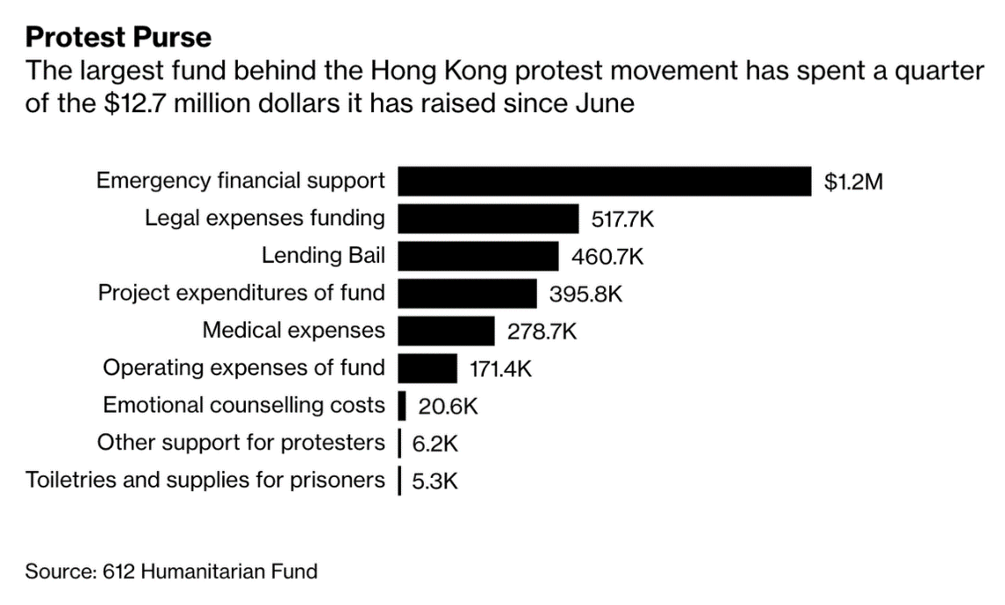
For many of the thousands of protesters who have been arrested, the criminal penalties that they could face without adequate legal representation could land them in prison for years.
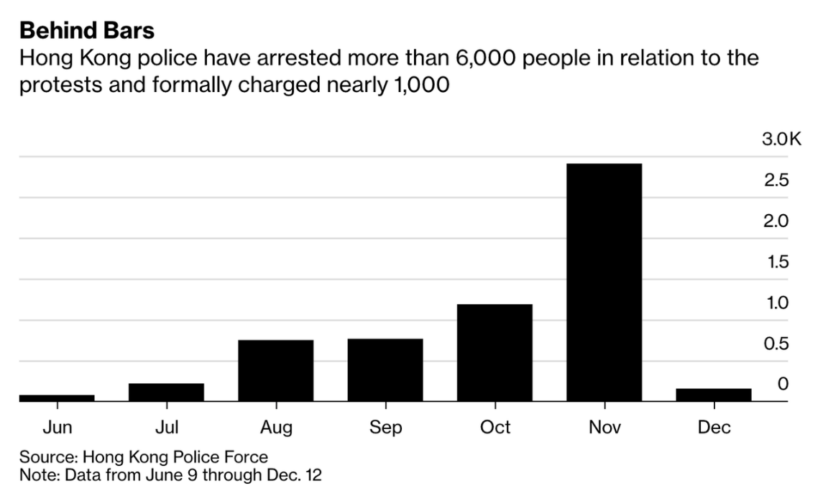
Without having the support of knowing their bail will be paid in the event of an arrest, many demonstrators wouldn't be so eager to fight their way past police barricades and take other risks like that.
But many members of the protest movement believe the 612 fund is too stodgy in how it operates. Most see organizations like Spark Alliance as being closer to the true ideals of the movement.
The 612 fund has been chided in online forums for deploying only 24% of the money it raised while asking protesters to first apply for legal aid from the city. Other critics see the 612 fund as part of an older political establishment in Hong Kong that has failed the younger generation of democracy advocates, and they believe Spark Alliance is closer to protesters in the trenches.
"The younger generation doesn’t trust in any institutions, not even those that advocate for democracy," said Patrick Poon, a researcher at Amnesty International in Hong Kong. "It’s an irrational decision to trust in a group believed to be closer to the people on the ground even if they don’t know who is behind the fund."
Ng, a 612 fund trustee, said the group is supported by “members of the public that are incensed by what is being done by police and government."
"The movement is ongoing and we are using the funds for the stated purpose of humanitarian aid," she said. "We don’t have any obligation to spend all the money immediately."
Now that police have set their sights on Spark, we imagine a new group will need to come forward and take up the mantle of the protest movement, or risk allowing it to fizzle out.

Step Two: Remove the Prosecutors
House Democrats are calling for the resignation of Attorney General William Barr and U.S. Attorney John Durham because they allegedly “inappropriately interfered in independent Department of Justice investigations.” They also “intentionally” used their positions “to mislead the American public in defense of President Donald J. Trump.”
The House Democrats also accused the senior DOJ officials of “acting as mouthpieces for Donald Trump rather than public servants bound to the rule of law.”
The letter was posted to Twitter by Democratic Congressman Hank Johnson, who signed onto the letter.
Other co-signers on the letter include Texas Congresswoman Shelia Jackson Lee, Michigan Congresswoman Rashida Tlaib, Missouri Congressman William Lacy Clay, California Congressman Jared Huffman, Illinois Congresswoman Jan Schakowsky.
Democratic Congressman Adam Schiff previously shared an op-ed with the Washington Post, where former Attorney General Eric Holder similarly argued Barr should resign.
In the op-ed, Holder wrote: “As a former U.S. attorney general, I am reluctant to publicly criticize my successors. I respect the office and understand just how tough the job can be. But recently, Attorney General William P. Barr has made a series of public statements and taken actions that are so plainly ideological, so nakedly partisan and so deeply inappropriate for America’s chief law enforcement official that they demand a response from someone who held the same office.”
Adding later, “When appropriate and justified, it is the attorney general’s duty to support Justice Department components, ensure their integrity and insulate them from political pressures. His or her ultimate loyalty is not to the president personally, nor even to the executive branch, but to the people — and the Constitution — of the United States.”
He then argued:
Virtually since the moment he took office, though, Barr’s words and actions have been fundamentally inconsistent with his duty to the Constitution. Which is why I now fear that his conduct — running political interference for an increasingly lawless president — will wreak lasting damage.
The American people deserve an attorney general who serves their interests, leads the Justice Department with integrity and can be entrusted to pursue the facts and the law, even — and especially — when they are politically inconvenient and inconsistent with the personal interests of the president who appointed him. William Barr has proved he is incapable of serving as such an attorney general. He is unfit to lead the Justice Department.
The Betrayal
Each time the Global Syndicate moves its agenda forward, there are humans that get crushed. They don’t care about us. They have one goal, and that is the capture of every soul in the world. They are highly successful on many worlds, and they are succeeding here as well. Sometimes, the guilty can squeeze out a few more years of life, if they belong to the Syndicate. Sometimes, rather than face their own death or the death of their families, they agree to resign and leave their duty station to avoid the Syndicate assassination.
Ambassador Tina Kaidanow, senior adviser for international cooperation, has left the Pentagon, the Department of Defense confirmed to Defense News Wednesday.
Why it matters: She's the fifth top official in seven days to exit or announce their departure from the Pentagon, according to Defense News and The Hill.
The big picture: Per the two news outlets, Kaidanow left her role on Dec. 16. It was announced on Dec. 12 that Randall Schriver, the top Asia policy official, would leave his position soon. A day later, Jimmy Stewart, the acting undersecretary of defense for personnel and readiness, said he was retiring.
- Steven Walker, head of the Defense Advanced Research Projects Agency, will leave in January "for an industry job," Defense News reported Tuesday.
- Earlier Wednesday, the Defense Department confirmed to the military news outlet that Kari Bingen, principal deputy undersecretary of defense for intelligence, would step down next month.
What they're saying: A Department of Defense spokesperson told The Hill the service of long-time official Kaidanow was appreciated and he wishes her well.
- DOD spokesperson Lt. Col. Michael Andrews told Defense News the department was "committed to the development and implementation of international cooperative programs and defense exportability efforts to foster cooperation with U.S. allies on research, development, production and support of weapons systems and related equipment."
- "The department will not provide anything further on this personnel matter," Andrews added.
So far, 55 of Trump’s appointees have resigned, for both reasons.
All Eyes are on Virginia
After passing extremely restrictive anti-gun legislation in early 2020, Virginia has a plan to deploy roadblocks at both the county and state levels to confiscate firearms from law-abiding citizens. The issue is that these are not soldiers. These are citizens in uniform working weekends as armored law enforcement under orders from the governor. Remember what happened the last time this happened? Governor Kate Brown ordered the premeditated murder of Lavoy Finnicum and the attempted murder of five other Americans, all of whom were unarmed!
The Second Amendment Foundation (SAF) is applauding the 100+ plus local governments that have declared themselves sanctuaries for gun rights.
Faced with increasing threats of restrictive gun control laws and even outright bans, activists working with local officials including county sheriffs have drawn the proverbial line in the sand. They’ve set an example for grassroots groups in other states to prevent the kind of gun control hysteria that now permeates legislatures in Richmond and Springfield.
We stand with these counties in their defense of the Constitution against anti-rights extremism disguised as ‘common sense. We remind gun-hating zealots everywhere this is still the United States, not a police state, and constitutional rights are not subject to popularity contests.

On December 18, 2019, Breitbart News reported that 86 of Virginia’s 95 counties were Second Amendment Sanctuaries. SAF reports that 67 counties in Illinois has taken the same stand.
Some might choose to dismiss such claims as speculation, this creates a situation where Virginia might become a flashpoint take the civil cold war to a civil hot war, engineered by the Global Syndicate. Their end game is to unleash a sufficient amount of violence to call for UN occupation of America as part of the current overthrow of President Trump and the Republic.
Such action may result in American gun owners being labeled “domestic terrorists” if they resist. Such language is already being used by Democrat legislators in the state of Virginia.
The Democrat-run impeachment of President Trump is a necessary component for this plan, since the scheme requires Trump supporters to be painted as “enraged domestic terrorists” who are seeking revenge for the impeachment. This is how the media will spin the stories when armed Virginians stand their ground and refuse to have their legal firearms confiscated by police state goons running Fourth Amendment violating roadblocks on Virginia roads.

The gun confiscation roadblocks are almost sure to start a shooting war
Roadblocks will be set up in two types of locations:
1) On roads entering the state of Virginia from neighboring states that have very high gun ownership, such as Kentucky, Tennessee and North Carolina. This is because both Tennessee and North Carolina have concealed carry reciprocity laws in place with Virginia. Law abiding citizens may enter Virginia armed, and are not subject to the gun confiscation laws in the Commonwealth.
2) Main roads (highways and interstates) that enter the pro-2A counties which have declared themselves to be Second Amendment sanctuaries. With over 90 Virginia counties now recognizing some sort of pro-2A sanctuary status, virtually the entire Commonwealth of Virginia will be considered “enemy territory” by the tyrants in Richmond who are trying to pull off this insidious scheme.
As the map shows below, every green county has passed a pro-2A resolution of one kind or another. As you can see, nearly the entire state is pro-2A, completely surrounding the Democrat tyrants who run the capitol of Richmond.
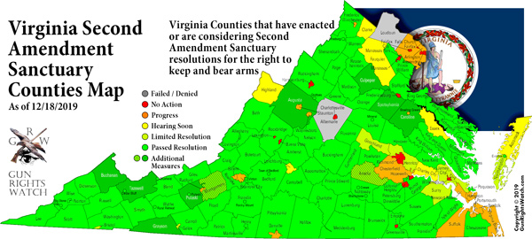
The purpose of the roadblocks, to repeat, has absolutely nothing to do with public safety or enforcing any law. It’s all being set up to spark a violent uprising against the Virginia Democrats and whatever law enforcement goons are willing to go along with their unconstitutional demands to violate the fundamental civil rights of Virginian citizens. Over 90 Virginian counties, cities and municipalities have so far declared themselves to be pro-2A regions, meaning they will not comply with the gun confiscation tyranny of Gov. Northam and his Democrat lackeys.
Democrats in Virginia have threatened to activate the National Guard to attack pro-2A “terrorists,” and a recent statement from the Guard unit in Virginia confirms that the Guard has no intention to resist Gov. Northam’s outrageous orders, even if they are illegal or unconstitutional. One county in Virginia — Tazewell — has already activated its own militia in response. These are mostly well-trained citizens with no record of infractions or citations, so if you are a member of the National Guard, you do not have the right or the authority to question or search these people.
In addition to passing their Second Amendment Sanctuary Resolution, the county also passed a Militia Resolution. This resolution formalizes the creation, and maintenance of a defacto civilian militia in the county of Tazewell. And to get a better understanding why the council members passed this resolution, Firearms News reached out to one of its members, Thomas Lester. Mr. Lester is a member of the council, as well as a professor of American History and Political Science.
Firearms News: Councilman Lester, what are the reasons behind passing this new resolution, and what does it mean for the people of Tazewell County?
Tom Lester: … the purpose of the militia is not just to protect the county from domestic danger, but also protect the county from any sort of tyrannical actions from the Federal government. Our constitution is designed to allow them to use an armed militia as needed. If the (Federal) government takes those arms away, it prevents the county from fulfilling their constitutional duties.
The situation is escalating rapidly in Virginia, which is precisely what Democrats and globalists are seeking. As All News Pipeline reports:
With many Virginia citizens angry with the threat of tyranny exploding there, ANP was recently forwarded an email written by a very concerned Virginia citizen who warned that Democrat leadership is pushing Virginia there towards another ‘shot heard around the world’ with Virginia absolutely the satanic globalists new testing ground for disarming all of America in a similar fashion should they be successful there.
And while we’ll continue to pray for peace in America, it’s long been argued that it’s better to go down fighting than to be a slave to tyranny for the rest of one’s life. And with gun registration seemingly always preceding disarmament and disarmament historically leading to genocide, everybody’s eyes should be on what’s happening now in Virginia.
With the mainstream media clearly the enemy of the American people and now President Trump confirming they are ‘partners in crime’ with the ‘deep state’ that has been attempting an illegal coup upon President Trump ever since he got into office, how can outlets such as CNN, MSNBC, the NY Times, Washington Post and all of the others continuously pushing the globalists satanic propaganda be held accountable and responsible for the outright madness they are unleashing upon America?

The enemies of America want to turn the entire country into a UN-occupied war zone and declare President Trump to be an “illegitimate dictator”
Where is all this really headed? The enemies of America intend to transform the country into a UN-occupied war zone, where UN troops go door to door, confiscating weapons from the American people. President Trump will be declared an “illegitimate dictator” and accused of war crimes, since Democrats and the media have already proven they can dream up any crime imaginable and accuse the President of that crime, without any basis in fact.
And as we know with the Dems, if they can’t rule America, they will seek to destroy it. Causing total chaos is their next best option to resisting Trump’s efforts to drain the swamp, since the Dems know they can’t defeat Trump in an honest election.
Expect Virginia to be the ignition point for all this. Even the undercover cops who work there are now warning about what’s coming. Via WesternJournal.com:
Virginia’s Democrat politicians appear to be ready to drive the state into a period of massive civil unrest with no regard for citizens’ wishes, but conservatives in the commonwealth will not be stripped of their rights without a fight.
In the face of expected wide-reaching bans on so-called assault weapons, high-capacity magazines, and other arms protected under the 2nd Amendment, Virginians are standing up to Democrat tyranny.
A major in the Marine Corps reserves took an opportunity during a Dec. 3 meeting to warn the Board of Supervisors of Fairfax County about trouble on the horizon.
Ben Joseph Woods spoke about his time in the military, his federal law enforcement career and his fears about where politicians are taking Virginia.
“I work plainclothes law enforcement,” Woods said. “I walk around without a uniform, people don’t see my badge, people don’t see my gun, and I can tell you: People are angry.”
Woods said that the situation in Virginia is becoming so dangerous that he is close to moving his own wife and unborn child out of the state.
The reason is because my fellow law enforcement officers I’ve heard on more than one occasion tell me they would not enforce these bills regardless of whether they believe in them ideologically,” Woods said, “because they believe that there are so many people angry — in gun shops, gun shows, at bars we’ve heard it now — people talking about tarring and feathering politicians in a less-than-joking manner.”
As Woods mentioned politicians themselves could very well be in danger because of their decisions, several rebel yells broke out as the crowd cheered him on.
Stay informed. Things are about to happen over the next 10 months that you would have never imagined just five years ago.
And to all those who mocked our warnings about the coming civil war, you are about to find yourself in one. Sure hope you know how to run an AR platform and build a water filter. Things won’t go well for the unprepared, especially in the cities.
And, by the way, Richmond is surrounded by patriots. Not one square inch of American soil will ever be occupied by anyone in the UN. Is that understood? Not one square inch.

Starliner Wrong Orbit
Boeing's first Starliner spacecraft built to fly astronauts returned to Earth in a predawn landing Sunday (Dec. 22), touching down in New Mexico after a shortened — yet still historic — test flight due to a timing error.

The uncrewed Starliner landed in the chilly desert of White Sands Space Harbor in New Mexico at 7:58 a.m. EST (1258 GMT), making history as the first crew-capable space capsule ever to make a land-based touchdown on U.S. soil. The landing capped a three-day Orbital Test Flight mission that began with a launch on Friday (Dec. 20).

"Watching the landing was a thing of beauty today," NASA Administrator Jim Bridenstine told Boeing and NASA flight controllers at Mission Control in Houston, according to NASA commentators.
A ghostly landing
It was 5:58 a.m. local time at the landing site as Starliner drifted back to Earth under darkness, its three main parachutes billowing in infrared views.
"It looked almost ghostly as it touched down," Boeing spokesperson Josh Barrett said from the landing site in NASA commentary. NASA and Boeing recovery teams (and astronauts who will fly on Starliner) were awaiting Starliner's return to retrieve the vehicle.
"Soft landing in the desert!" NASA astronaut Mike Fincke, who will fly on the first crewed Starliner test flight (called Crew Flight Test) next year, wrote on Twitter from White Sands Space Harbor. He also shared a photo of the spacecraft.
Starliner experienced scorching hot temperatures of up to 3,000 degrees Fahrenheit (1,650 degrees Celsius) as it plunged through Earth's atmosphere at Mach 25, or 25 times the speed of sound. It jettisoned that heat shield after its parachutes deployed.
The spacecraft cushioned its landing with six airbags, touching down at about 19 mph (30 km/h). NASA and Boeing watched the spacecraft from the ground and air using infrared cameras.
"It has been an absolutely amazing morning. I'm really trying to keep it together and not cry,," Boeing engineer Tori Wills Pedrotty, who worked on the heat shield, said during commentary."We landed an American capsule on land with an airbag system. This is the first time anybody has done this."
Starliner was originally scheduled to spend eight days in orbit, flying an automated mission to the International Space Station and returning to Earth to demonstrate the vehicle's readiness to ferry astronauts for NASA. But a mission clock error during launch prevented Starliner from reaching its intended orbit and continuing on to the space station.
According to Boeing, Starliner's mission clock thought the spacecraft was in a different, later phase of the flight for an as yet unknown reason. Boeing was able to reset the clock, but not before it used too much propellant to fly to the station.
Instead, Starliner entered a stable orbit of 155 miles (250 km), circled Earth 33 times and performed as many tests as possible to shake down its systems for future crewed flights.

While Boeing aced many of its demonstrations for NASA on this flight, it was not able to show Starliner's ability to dock itself at the International Space Station, a critical capability required for crewed flight. Bridenstine has said NASA is keeping its options open to decide whether to launch the first crewed test flight (called Crew Flight Test) on the next Starliner or require Boeing to perform a second uncrewed test flight.
The crew for that first Starliner to carry astronauts was onhand for its smooth landing Sunday. In addition to Fincke, the crew includes NASA astronaut Nicole Mann and Boeing astronaut Chris Ferguson, a former space shuttle commander.
"Three parachutes, six airbags and a beautiful soft landing," Fincke said. "I can't wait to try it out."
Fincke and his crewmates said they were confident Boeing and NASA would fix the timing error (which indeed was fixed after launch, just not in time to reach the space station) to clear the way for crewed flights next year.
Chief among those tests was the flight of "Rosie the Rocketeer," an anthropomorphic test dummy in a Boeing spacesuit covered in sensors to measure what astronauts would actually feel during launch and landing. Rosie flew aboard Starliner in an astronaut's seat and was part of 595 lbs. (270 kilograms) of cargo packed inside the spacecraft.
Starliner is one of two commercial spacecraft (SpaceX's Crew Dragon is the other) selected by NASA to fly astronauts to and from the International Space Station. It is designed to launch four astronauts and supplies into space, return them to Earth and then fly again. The reusable spacecraft is expected to fly up to 10 times, Boeing has said.
NASA picked Boeing and SpaceX as its Commercial Crew Program partners in 2014, with Boeing receiving $4.2 billion under that contract and SpaceX receiving $2.6 billion for its deal. Both companies have now flown uncrewed test flights of their vehicles (SpaceX's Crew Dragon flew to the space station in March of this year) and are expected to begin flying astronauts in early 2020.
This particular Starliner will fly on Boeing's second crewed flight, which will be NASA's first operational flight to the station. Sunita Williams, one of the astronauts who will command that mission, was at White Sands Space Harbor to see her spacecraft return to Earth.
"It was really unbelievable. It was picture perfect," Williams said of the landing, adding that she's picked the name Calypso for the capsule in honor of sea exploration.
"She's back," Williams said of the capsule. "She's home."

The FISA Affair
If you are a detective, and you want a warrant to search someone’s house, you have to go to the judge to get that warrant. This is basically a legal opinion and permission to violate someone’s 4th amendment right against search and seizure. You must present some evidence and swear that it is all true.
When the FBI went to FISA judges and asked for a warrant, they had nothing but a sheet of lies published by a British spy novelist and some cash from the Clinton Crime Syndicate. The judge allowed the spying of a presidential candidate Donald Trump by the person who was running against him, Hillary Clinton.
Normally, when a judge finds out someone lied in their court to get them to issue a warrant, the judge will issue a contempt charge and ask why that person should not by put in jail.
This week, Presiding Foreign Intelligence Surveillance Court (FISC) Judge Rosemary Collyer, released two stern Orders taking the FBI to task for its repeated failures, omissions, and misrepresentations in its application and subsequent renewals to surveil Carter Page.
And while one FBI employee has received a criminal referral for doctoring evidence in the scheme to defraud the court, key players with oversight responsibilities - under penalty of perjury - have been given a pass.
Judge Collyer’s December 17, 2019 Order, written after the publication of Inspector General Michael Horowitz’s long-awaited report on FISA abuse, emphasized the role the FBI plays when it makes its assessment on whether probable cause exists to a warrant. In particular, FISC requires the FBI agent swearing to the application fully and accurately provide “information in its possession that is material to whether probable cause exists.”
There is also a December 5 FISC Order - currently pending classification review - discussing the court's "concerns"
She noted that the IG Report revealed “troubling instances in which FBI personnel provided information to NSD which was unsupported or contradicted by information in their possession.” Judge Collyer also expressed concerns about the FBI Office of General Counsel attorney, reported to have been Kevin Clinesmith, who altered evidence to mislead about Carter Page acting as a source for the CIA.
That Order required:
(1) The government to inform the Court in a sworn written submission of what it has done, and plans to do, to ensure that the statement of facts in each FBI application accurately and completely reflects information possessed by the FBI that is material to any issue presented by the application. (A January 10, 2020 deadline was given for this submission and left the government with room to maneuver if it needed more time.)
On December 20, FISC released Judge Collyer’s mostly unredacted December 5, 2019 Order to the United States. This was apparently prepared in response to letters filed with FISC by the government relating to the issues found with the Carter Page application and renewals during the course of the Inspector General’s investigation. She ordered the United States inform FISC by writing of the following:
(1) Identify all other matters currently or previously before this Court that involved the participation of the FBI OGC [Clinesmith] attorney whose conduct was described in the Preliminary Letter and Supplemental Letter;
o be taken by the Department of Justice or FBI to verify that the United States’ submissions in those matters completely and fully described the material facts and circumstances; and
Advise whether the conduct of the FBI OGC [Clinesmith] attorney who has been referred to the appropriate bar association(s) for investigation or possible disciplinary action.
This is a serious Court that deals with serious matters of national security and counterintelligence. The secret nature of FISC requires the United States to be in strict compliance with all certification and verification requirements. It’s a matter of trust. As Judge Collyer observed: “FISC expects the government to comply with its heightened duty of candor in ex parte proceedings at all times. Candor is fundamental to the Court’s effective operation.”
This trust was broken by the FBI agents and officials whose factual assertions to FISC were inaccurate, incomplete, misleading, and unsupported by the evidence. The duty of candor was breached in the continued reliance on Christopher Steele via DOJ official Bruce Ohr (after they represented to FISC that he had been terminated as a source) and the omission of material facts and exculpatory evidence that undercut their now-debunked representation that Carter Page was operating as a Russian agent.
While it’s laudable that Judge Collyer has ordered the government to double-check their submissions in the prior FISA applications that involved Clinesmith, what about the previous FISA applications verified by the FBI agents who lied – under penalty of perjury, we might add – in the Carter Page applications and renewals?
In other words, whether an FBI lawyer changes an e-mail about a target’s history of cooperation with the CIA or an FBI agent lies about the underlying intelligence, the goal is the same: secure the warrant through deception. Both these acts are criminal. Why is only one deserving of review?
The Barr is Rising
Far left billionaire George Soros has been systematically targeting district attorney races throughout the United States. Many of his backed candidates have won their races and are causing havoc across the country.
This week US Attorney General Bill Barr spoke with Martha MacCallum on FOX News. Bill Barr called out George Soros for subverting the legal system in the US and creating more crime and violence.
Attorney Bill Barr is right!
St. Louis –
Chicago –
St. Louis again –
Boston –
Philly –
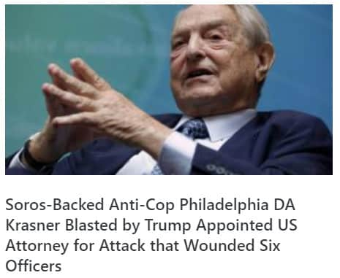
And St. Louis again –
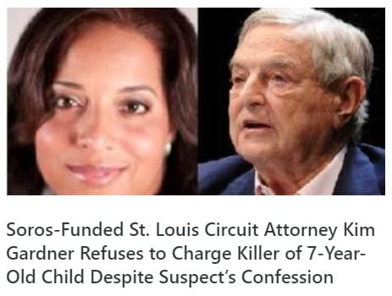

Soros-backed District Attorneys are causing mayhem across the US: Soros also backed the new District Attorney in San Francisco — Bill Ayers’ stepson Chesa Boudin.
Is it any wonder why Soros groups are banned from entire countries?
UFOs over Nuclear Powered Vessels
Two years ago Sunday, the New York Times broke the stunning story of a secret Pentagon program to study unidentified flying objects. That story led me to delve into this strange world. I've learned some interesting stuff about UFOs ("unidentified aerial phenomena," or "UAP," as the Pentagon refers to them) since then. But there's one problem.
The United States government makes it very hard to figure out what and where UFO-related stuff is going on. Is that because the government is behind some great conspiracy to cover up the proof of alien visitation to Earth? Is it because the government is in cahoots with alien species to create human-alien hybrids?
Perhaps, but I suspect not.
What I believe is really going on here is that the few individuals in the U.S. government who know about this issue believe the phenomena might be a threat. And that they don't know how to deal with it.
So, what informs the government's fear?
Well, first off, the nuclear issue.
If you ask a Pentagon representative about a specific UFO incident, as I did most recently last week, you'll get a boring response like: "Our aviators train as they fight. Any intrusions that may compromise the security of our operations, tactics, or procedures is of great concern. As the investigation of unidentified aerial phenomena sightings is ongoing, we will not discuss individual sighting reports or observations."
By "aviators," the Pentagon is referencing the particular frequency with which UFOs tend to interact with U.S. naval aviators operating off aircraft carriers. But what the Pentagon is leaving out is why the UFOs tend to run into those naval aviators. And that cuts to the heart of why the Pentagon is concerned about UFOs.
Because the government's assessment, though they won't admit it, is that the UFOs are popping up near the aircraft carriers due to those carriers being nuclear-powered. Note also that UFOs also like to pop up near nuclear submarines and Air Force nuclear weapons bases. Now recognize that this paradigm has been occurring since the Manhattan Project operations at Los Alamos, New Mexico, and also at nuclear sites in the Soviet Union and Russia.
Oh, and as Robert Hastings documents, these UFOs have sometimes even temporarily shut down U.S. nuclear weapons systems. Interesting, right?
Now recall what I just said: The modern UFO phenomena really gets going at exactly the same time as the Manhattan Project. Has humanity's perfection of nuclear energy piqued someone or something's curiosity in us?
Don't get me wrong.
This isn't to say that these UFOs are hostile (although it must be noted that the diverging shapes, behaviors, and capability patterns of UFOs suggest more than one originating source). On the contrary, UFOs appear to be quite friendly, except when rather ill-advised Russian aircrews attempt to engage them.
But pretend you're a senior military or intelligence officer.
You see the nuclear connection point, and you're struck by something odd going on. Now, add to the nuclear issue that some UFOs are intelligently operated machines capable of instantaneously reaching hypersonic speeds. Oh, and that they're also anti-gravity and invisibility capable, and they have been tracked moving in and out of Earth orbit, the atmosphere, and underwater. Suddenly, you have something that is making the U.S. military's most advanced capabilities, and those of every other military on Earth, look like an absurd joke in comparison.
You're left with an unpleasant conclusion: If whatever is controlling these things intends harm, we don't have a chance.
Again, put yourself in the military officer's shoes. Something has repeatedly shown it can easily find carrier strike groups, which are designed and operated to be hidden in the far oceans, and to find nuclear ballistic missile submarines running near totally silent deep under the water. Something can penetrate the most securely guarded areas of the most important areas in the U.S. military and render our most critical deterrent platforms improbable. For Pentagon planners, this is Armageddon-level stuff.
But the truth is clear: If it wanted to, something strange could defeat America without raising a sweat.
The extension is that even if the U.S. government believes, as it does, that these UFOs aren't Chinese or Russian, publicizing the issue itself risks another danger. Namely, that if the U.S. shares what it knows about UFOs, China or Russia (the Russian government has long been very interested in UFOs) might learn enough to replicate the associated technologies behind UFOs for themselves. And seeing as those technologies are almost certainly built around space-time manipulation, if Beijing or Moscow figures it out before the U.S. does, we have a rather large problem.
This isn't to say that the U.S. government is sitting idle. Whatever one thinks about the claims of those such as Bob Lazar, who says he worked on crashed UFOs at Area 51, and I'm not convinced of his story, civilian and military government agencies retain active programs to ascertain the source, capabilities, and intent of UFOs. Indeed, at least some material from crashed UFOs is in U.S. government possession.
Just don't count on the military to share more of what it knows anytime soon. Their understanding of the phenomena and professional instincts weigh heavily toward more secrecy.
What of the politicians?
President Trump has admitted he has been briefed on UFOs, and Presidents George W. Bush and Barack Obama likely were too. Interestingly, when asked about it, both former presidents jump to joking nondenials. But seeing as they have few good answers, they likely believe there's no point in scaring folks and scarring social norms absent a solution.
Where does this leave us?
We'll need to keep pushing the issue. But also with confidence. It will take time, but we'll get to the truth eventually. After all, the UFOs keep popping up. And considering their ability to cloak, there's only one obvious answer as to why they let themselves be seen.
I think they are as present as they want to be.
In the 15 years since Chad Underwood recorded a bizarre and erratic UFO — now called “the Tic Tac,” a name Underwood himself came up with — from the infrared camera on the left wing of his F/A-18 Super Hornet, he’s become a flight instructor, a civilian employee in the aerospace industry, and a father. But he has not yet spoken publicly about what he saw that day, even now, two years after his video made the front page of the New York Times. As he explained before speaking with Intelligencer, Underwood has mostly wanted to avoid having his name “attached to the ‘little green men’ crazies that are out there.”
The story of the Tic Tac begins around November 10, 2004, when radar operator Kevin Day first reported seeing odd and slow-moving objects flying in groups of five to ten off of San Clemente Island, west of the San Diego coast. At an elevation of 28,000 feet, moving at a speed of approximately 120 knots (about 138 miles per hour), the clusters were too high to be birds, too slow to be conventional aircraft, and were not traveling on any established flight path, at least according to Day.

In a military report made public by KLAS-TV in Las Vegas, Day would later observe that the objects “exhibited ballistic-missile characteristics” as they zoomed from 60,000 feet to 50 feet above the Pacific Ocean, alarmingly without producing sonic booms. All told, radar operators with the Princeton spent about two weeks attempting to figure out what the objects were, a process that included having the ship’s radar system shut down and recalibrated to make sure that the mysterious radar returns were not false positives, or “ghost tracks.”
Eventually, David Fravor, commanding officer of the Black Aces, made visual confirmation of one of the objects midair during a flight-training exercise. An hour later, Underwood made his infrared recording on a second flight. “That day,” Underwood recalls, “Dave Fravor was like, ‘Hey, dude. BOLO.’ Like, be on the lookout for just something weird. I can’t remember the exact terms that he used. I didn’t really think much about it at the time. But once I was able to acquire it on the radar and on the FLIR [forward-looking infrared camera], that’s kind of where things — I wouldn’t say ‘went sideways’ — but things were just different.”
The footage appears to depict what Fravor had identified as a 40-foot-long, white, oblong shape (hence “Tic Tac”), hovering somewhere between 15,000 and 24,000 feet in midair and exhibiting no notable exhaust from conventional propulsion sources, even as it makes a surprising dart leftward in the video’s final moments. Of the three UFO incidents captured by U.S. Navy airmen via infrared gun-camera pods, Underwood’s footage remains unique for its lack of cross talk between the pilots — a fact that has led to some speculation about its authenticity. But “there wasn’t anything on it that was protected,” Underwood’s retired former commanding officer Dave Fravor told Intelligencer. The missing audio, he says, “just didn’t make the copy that was taken from the storage drive.”
A former fighter pilot who served on the Nimitz in 2004, who spoke to Intelligencer on condition of anonymity, recalled an exhilarating group screening of the FLIR1 video inside the Nimitz’s Carrier Vehicle Intelligence Center (CVIC): “Debriefs were usually pro forma in the CVIC, but this one in particular was so odd,” the former pilot said. “There weren’t really a lot of skeptics in that room.” Years later, Fravor told ABC News that he didn’t know what the Tic Tac was, but that “it was really impressive, really fast, and I would like to fly it.” In the CVIC that day, the anonymous pilot told Intelligencer, “We all had that. We all wanted to fly it.”
Good News for Schools
President Trump signed an executive order Wednesday to start pulling the federal government out of K-12 education, following through on a campaign promise to return school control to state and local officials.
The order, dubbed the “Education Federalism Executive Order,” will launch a 300-day review of Obama-era regulations and guidance for school districts and directs Education Secretary Betsy DeVos to modify or repeal measures she deems an overreach by the federal government.
“For too long the government has imposed its will on state and local governments. The result has been education that spends more and achieves far, far, far less,” Mr. Trump said. “My administration has been working to reverse this federal power grab and give power back to families, cities [and] states — give power back to localities.”

He said that previous administrations had increasingly forced schools to comply with “whims and dictates” from Washington, but his administration would break the trend.
“We know local communities know it best and do it best,” said Mr. Trump, who was joined by several Republican governors for the signing. “The time has come to empower teachers and parents to make the decisions that help their students achieve success.”
Ms. DeVos and Vice President Mike Pence were on hand for the ceremony, which was attended by about 25 people, including teachers, lawmakers and the governors.
The executive order is not expected to have an immediate impact on school districts. Policy changes will follow a report on the findings of the review.

