Vibrations
Why is my awareness here, while yours is over there? Why is the universe split in two for each of us, into a subject and an infinity of objects? How is each of us our own center of experience, receiving information about the rest of the world out there? Why are some things conscious and others apparently not? Is a rat conscious? A gnat? A bacterium?
These questions are all aspects of the ancient “mind-body problem,” which asks, essentially: What is the relationship between mind and matter? It’s resisted a generally satisfying conclusion for thousands of years.
The mind-body problem enjoyed a major rebranding over the last two decades. Now it’s generally known as the “hard problem” of consciousness, after philosopher David Chalmers coined this term in a now classic paper and further explored it in his 1996 book, “The Conscious Mind: In Search of a Fundamental Theory.”
Chalmers thought the mind-body problem should be called “hard” in comparison to what, with tongue in cheek, he called the “easy” problems of neuroscience: How do neurons and the brain work at the physical level? Of course they’re not actually easy at all. But his point was that they’re relatively easy compared to the truly difficult problem of explaining how consciousness relates to matter.

How The Conversation is different: All our authors are experts.
Over the last decade, my colleague, University of California, Santa Barbara psychology professor Jonathan Schooler and I have developed what we call a “resonance theory of consciousness.” We suggest that resonance – another word for synchronized vibrations – is at the heart of not only human consciousness but also animal consciousness and of physical reality more generally. It sounds like something the hippies might have dreamed up – it’s all vibrations, man! – but stick with me.

All about the vibrations
All things in our universe are constantly in motion, vibrating. Even objects that appear to be stationary are in fact vibrating, oscillating, resonating, at various frequencies. Resonance is a type of motion, characterized by oscillation between two states. And ultimately all matter is just vibrations of various underlying fields. As such, at every scale, all of nature vibrates.
Something interesting happens when different vibrating things come together: They will often start, after a little while, to vibrate together at the same frequency. They “sync up,” sometimes in ways that can seem mysterious. This is described as the phenomenon of spontaneous self-organization.
Mathematician Steven Strogatz says:
· When fireflies of certain species come together in large gatherings, they start flashing in sync, in ways that can still seem a little mystifying.
· Lasers are produced when photons of the same power and frequency sync up.
· The moon’s rotation is exactly synced with its orbit around the Earth such that we always see the same face.
Examining resonance leads to potentially deep insights about the nature of consciousness and about the universe more generally.

Sync inside your skull
Neuroscientists have identified sync in their research, too. Large-scale neuron firing occurs in human brains at measurable frequencies, with mammalian consciousness thought to be commonly associated with various kinds of neuronal sync.
For example, German neurophysiologist Pascal Fries has explored the ways in which various electrical patterns sync in the brain to produce different types of human consciousness.
Fries focuses on gamma, beta and theta waves. These labels refer to the speed of electrical oscillations in the brain, measured by electrodes placed on the outside of the skull. Groups of neurons produce these oscillations as they use electrochemical impulses to communicate with each other. It’s the speed and voltage of these signals that, when averaged, produce EEG waves that can be measured at signature cycles per second.
Gamma waves are associated with large-scale coordinated activities like perception, meditation or focused consciousness; beta with maximum brain activity or arousal; and theta with relaxation or daydreaming. These three wave types work together to produce, or at least facilitate, various types of human consciousness, according to Fries. But the exact relationship between electrical brain waves and consciousness is still very much up for debate.
Fries calls his concept “communication through coherence.” For him, it’s all about neuronal synchronization. Synchronization, in terms of shared electrical oscillation rates, allows for smooth communication between neurons and groups of neurons. Without this kind of synchronized coherence, inputs arrive at random phases of the neuron excitability cycle and are ineffective, or at least much less effective, in communication.

A resonance theory of consciousness
Our resonance theory builds upon the work of Fries and many others, with a broader approach that can help to explain not only human and mammalian consciousness, but also consciousness more broadly.
Based on the observed behavior of the entities that surround us, from electrons to atoms to molecules, to bacteria to mice, bats, rats, and on, we suggest that all things may be viewed as at least a little conscious. This sounds strange at first blush, but “panpsychism” – the view that all matter has some associated consciousness – is an increasingly accepted position with respect to the nature of consciousness.
The panpsychist argues that consciousness did not emerge at some point during evolution. Rather, it’s always associated with matter and vice versa – they’re two sides of the same coin. But the large majority of the mind associated with the various types of matter in our universe is extremely rudimentary. An electron or an atom, for example, enjoys just a tiny amount of consciousness. But as matter becomes more interconnected and rich, so does the mind, and vice versa, according to this way of thinking.
Biological organisms can quickly exchange information through various biophysical pathways, both electrical and electrochemical. Non-biological structures can only exchange information internally using heat/thermal pathways – much slower and far less rich in information in comparison. Living things leverage their speedier information flows into larger-scale consciousness than what would occur in similar-size things like boulders or piles of sand, for example. There’s much greater internal connection and thus far more “going on” in biological structures than in a boulder or a pile of sand.
Under our approach, boulders and piles of sand are “mere aggregates,” just collections of highly rudimentary conscious entities at the atomic or molecular level only. That’s in contrast to what happens in biological life forms where the combinations of these micro-conscious entities together create a higher level macro-conscious entity. For us, this combination process is the hallmark of biological life.
The central thesis of our approach is this: the particular linkages that allow for large-scale consciousness – like those humans and other mammals enjoy – result from a shared resonance among many smaller constituents. The speed of the resonant waves that are present is the limiting factor that determines the size of each conscious entity in each moment.
As a particular shared resonance expands to more and more constituents, the new conscious entity that results from this resonance and combination grows larger and more complex. So the shared resonance in a human brain that achieves gamma synchrony, for example, includes a far larger number of neurons and neuronal connections than is the case for beta or theta rhythms alone.
What about larger inter-organism resonance like the cloud of fireflies with their little lights flashing in sync? Researchers think their bioluminescent resonance arises due to internal biological oscillators that automatically result in each firefly syncing up with its neighbors.
Is this group of fireflies enjoying a higher level of group consciousness? Probably not, since we can explain the phenomenon without recourse to any intelligence or consciousness. But in biological structures with the right kind of information pathways and processing power, these tendencies toward self-organization can and often do produce larger-scale conscious entities.
Our resonance theory of consciousness attempts to provide a unified framework that includes neuroscience, as well as more fundamental questions of neurobiology and biophysics, and also the philosophy of mind. It gets to the heart of the differences that matter when it comes to consciousness and the evolution of physical systems.
It is all about vibrations, but it’s also about the type of vibrations and, most importantly, about shared vibrations.
US Government Admits it Has UFO Debris
A stunning admission by the US government that it possesses UFO debris was recently made in response to a Freedom of Information Act (FOIA) request filed over three years ago by this author. In a reply letter, the US Defense Intelligence Agency (DIA) has ended decades of speculation by verifying that UFO material has indeed been recovered. Now officially referred to as UAP (Unidentified Aerial Phenomena) rather than UFOs, some this material was placed with a defense contractor for analysis and storage in "specialized facilities." Incredibly, part of the information released discusses material with shape recovery properties, much like the "memory metal" debris found fallen at the Roswell UFO crash in 1947.
And based on the documentation received, it appears that the retrieved debris exhibits other extraordinary capabilities. In addition to "remembering" their original form when bent or crushed, some of these futuristic materials have the potential to make things invisible, "compress" electromagnetic energy, and even slow down the speed of light. Although much of the reports' details are redacted, what can be gleaned is that these technologies represent a literal quantum leap beyond the properties of all existing material known to man.
Finally, the whereabouts of the UFO debris held by the contractor is unknown. Some months ago they laid off their employees and ceased operations. Former company officials, when reached, refuse comment.

THE FOIA REQUEST
The original 2017 FOIA request made to the DIA asks for the physical descriptions, properties and composition of UFO/UAP material held by the government and its contractor. The request is unambiguous in its meaning. It refers to UFO/UAP material and "physical debris recovered by personnel of the Department of Defense as residue, flotsam, shot-off material or crashed UAPs or unidentified flying objects." The FOIA request can be seen in full here:
​In their reply, the DIA amazingly agrees that it has documents responsive to my request on recovered UFO debris and its analysis, the program under which it was administered, AATIP (the Advanced Aerospace Threat Identification Program), and that their defense contractor (Bigelow Aerospace in Las Vegas, Nevada) has stored the material. They also provide some reports related to the possible applications of the studied material.
The delays and excuses offered up during the years awaiting the FOIA response were many. They include that the records search involved another agency that needed to be consulted; that I had been emailing my former FOIA Officer though she'd left months ago and never received my follow-up communication; to a re-assignment of my case to the DIA's FOIA Chief, Steve Tumiski. After a lawsuit was threatened with the retention of counsel, the DIA somehow, after so very long, acted to respond.

THE RELATION TO ROSWELL
The information received includes several pages of what are called "advanced technology reports" on Nitinol - a shape recovery alloy. Nitinol has similar properties to the "memory metal" found fallen as debris at the Roswell, New Mexico UFO crash of 1947. The pages found within the FOIA reply on Nitinol explore its potential for integrating it into the human body for the improvement of health. Well over 40 witnesses to Roswell have mentioned a metal-like material that could "remember itself" when deformed or folded, returning to its original state seamlessly and instantly.
In a series of investigative articles appearing in the UFO Explorations website article archive section, the case is credibly made that Nitinol represents our first attempts to replicate a material of the craft's construction. The Roswell debris was flown to Wright Field in Ohio after the crash. Some months later, Wright granted a contract to Battelle Memorial Institute to begin phase diagrams (recipes) for mixing Nickel and ultra-high-purity Titanium, required to make memory metal. General Arthur Exon, Base Commander at Wright Patterson in the 1960s, who flew over the crash site in 1947, spoke to researcher Kevin Randle on tape. He stated that it was his understanding that some of the wreckage being tested was comprised in part of "specially processed" Titanium.
And in September of 1947, two months after the Roswell crash, General George Shulgen of Air Intelligence described "the materials of construction" of the flying saucers as potentially being made of "composite or sandwich construction utilizing various combinations of metal and plastics." Some of the Roswell crash debris was said to display metal-plastic like appearance and characteristics. The DIA-sponsored reports I received mention a highly-engineered material called "metamaterial" (see below) as comprised of "composite media." Metamaterial can be layered with metal and plastics.
Throughout the received FOIA documents, mention is made of potential use of some of the materials in "advanced aerospace platforms." Reference is made to desired material characteristics such as being extremely lightweight and tough, like the characteristics of the debris found at the Roswell crash.

OTHER MATERIAL
Extensive reference is also made to the study and application of what the tests called metamaterial*, including that some of this material:
- Can be used to "slow down light" and even "bring light to a complete standstill"
(Implying the ability to manipulate the speed of light (electromagnetic energy traveling at 186,000 miles per second)
- May induce invisibility by manipulating refraction, reflectivity and increasing light absorption. The reports use terms like "optical isolation" and "transparency" and make reference to a "MetaMirror" technology
(Implying the ability to make something unable to be seen, and/or picked up by radar, scanning or imaging)
- Has the interesting ability to "compress electromagnetic energy"
(Such condensing can make information and energy storage smaller and their transfer faster by reducing volume)
- Exhibits a particular "tunable resonance" which was likely "determined during fabrication."
(The phrase "tunable resonance" refers to a vibration of large amplitude from a small stimulus. Very recent research shows potential in the field of "energy harvesting" technologies, or pulling energy from the environment for low-power electronic devices)
There seem to be many exciting, but far in the future, technical applications to these materials that will change the way our lives are lived.
*Metamaterial, a coined and relatively recent word, is believed to be any material engineered to have a property that is not found in naturally occurring materials. Some of these materials appear to be made from assemblies of multiple elements fashioned from composite materials such as metals and plastics. These composite media can be engineered to exhibit unique electromagnetic properties. Made up from subwavelength building blocks (most often based on metals), these metamaterials allow for extreme control over light energy and optical fields, enabling such effects such as negative refraction to be realized.
Portions of the reports center on next-generation Amorphous Metals (also called "liquid metal" or "metallic glass") which are novel engineering alloys with disordered atomic-scale structure. Metal is crystalline in its solid state, which means it has a highly ordered arrangement of atoms. Amorphous metals though are crazily disordered - a metal-like material so unique that it is believed it may one day replace plastic and metal in many applications. The material is stronger and lighter than any existing metal, can be injection molded like plastic (no rivets, seams or joining, smooth like many reported UFOs) and will never corrode or rust. Imagine using a single razor blade for the rest of your life because it stays super sharp forever. A golf club so springy it can drive a ball farther than any pro ever has. An artificial hip implant that performs better than a real hip. A cell phone case that is completely indestructible.
The contract that Bigelow was granted was under the auspices of an official government UFO study (whose existence was revealed by The New York Times in 2017). The contract was for Bigelow to construct "specialized modified facilities" to hold the material for testing. The DoD/Pentagon UFO study effort was called the Advanced Aerospace Threat Identification Program (AATIP). It ran for some years (and under more than one name), and according to informed sources, remains in operation to this day. What is inside these "specially modified facilities" that requires such contracted technical services? What is the nature of this anomalous debris and what are its properties that it requires shielding?
​
THE DIA RESPONSE
Above, a notation placed on several of what the DIA calls "advanced technology reports" responsive to the FOIA request.
Note that Advanced Aerospace Threat Identification Program (AATIP) is referred to by an alternate or predecessor name, Advanced Aerospace Weapons Systems Applications program (AAWSA).
A letter was sent by the DIA to this author acknowledging the possession of recovered UFO material and the involvement of a defense contractor, granting access to some technical information (while denying most). Scrolling past the letter begins some of the technology reports, continued in the second PDF below. The first batch can be seen here:
The FOIA official responding, Steve Tumiski, explains that the DIA has identified 5 documents totaling 154 pages that are responsive to my request. Well over half of the documents have not been released. And such extraterrestrial material study should generate thousands of pages relevant to the request, not just 154. The DIA cites Exemptions 3 and 6 of federal FOIA regulations as reasons that they are compelled to suppress certain of the documents. Exemption 3 allows the withholding of information prohibited from disclosure by federal statute and leaves no discretion on the issue due to potential harm to national security. Exemption 6 generally applies to records that involve personal privacy. It incorporates a balancing test that weighs any privacy interest against the public interest in disclosure.
In the second PDF are several more of the 154 pages said to exist on the matter. It is in these documents that we gain the insights on the material as outlined earlier in this article. It is here that we learn of metamaterials, invisibility, slowing the speed of light, compressing electromagnetic energy, implanting memory metal in people and other remarkable things.
​
Sample key phrases alluding to technologies these materials could one day give us can be found within the named pages in the two PDF FOIA replies: "slow down light" (pages 18, 27, and 6); "bring light to a complete standstill" (page 17); "compress energy" (page 6); "Nitinol as a Biomaterial" (page 19); "new materials-based perfect absorbers" of light (page 24); "novel optical isolators" (page 6).

WHAT DOCUMENTS WERE WITHHELD?
The information provided in the FOIA response seems to represent reports that are directly relevant to what was learned from the study of the UFO debris, and how insight gained from those studies might be applied in the future, but does not include a detailing of the found debris itself.
Disappointingly, the reports do not include much of what was requested, such as a physical description and the composition of the material, the origin of the material, and the names of the involved scientists. That remains classified. But technical pursuit areas derived from the study of those materials (i.e. invisibility, energy concentration, light speed control, intelligent metal) were, in part, released. The released documents help to inform us of the potential applications of the materials, but do not offer deep insight into precisely what the debris is made of. They speak of "recent experiments" that "provide new concepts" and of "theoretical developments that might result in new materials." The DIA believes it is being responsive to the FOIA request by acknowledging UFO debris, its storage by Bigelow, and by identifying areas of future applications of these materials without having to actually name responsible parties, of what elements the material is comprised, how it is processed, etc.

SOME REPORTS PREVIOUSLY AVAILABLE
Despite the DIA's insistence that mine was an original FOIA request requiring extensive searching over a period of years, it appears that at least a couple of the reports have already somehow been released. Significantly, the report on Nitinol memory metal, however, has no discernible previous publication. But the report entitled "Metamaterials for Aerospace Applications" and the "Metallic Glasses" paper were both posted in June of 2020 and are deeply archived in the documents section of Mysterywire.com. This is a relatively new website launched by Las Vegas TV investigative reporter George Knapp, who has strong government connections and a strong interest in the UFO phenomena.
Interestingly, these papers include the names of the scientist authors of the papers! The DIA had denied me this in my request due to "privacy issues" and did not include their names in the documents sent to me.

It remains that the context in which I received the documents was in direct response to requests for information derived from recovered UFO debris and the testing of potentially extraterrestrial material. My request for documents were for the Advanced Aerospace Threat Identification Program (AATIP). But there is deliberate obfuscation and purposeful confusion coming from the DIA. The program operated earlier under another name, Advanced Aerospace Weapons Systems Applications program (AAWSA), and the documents are stamped with this program name rather than AATIP. This allows the DIA to claim the studies relate to an advanced military weapons program for defense rather than to an aero-program identifying possible threats from outer space and the associated retrieval of flying saucer material.

BIGELOW AEROSPACE: WHERE IS THE DAMN DEBRIS?
Bigelow Aerospace, LLC was the brainchild of Robert Bigelow, a hospitality industry billionaire with a strong interest in things cosmic, the other-dimensional and the extraterrestrial. Bigelow associated with prominent people such as Senator Harry Reid and former rock star Tom DeLonge. Bigelow has had previous "mystery ventures" such as the non-profit, now-defunct National Institute for Discovery Science (NIDS). He was also at one time associated with the famous "Skinwalker Ranch" in Utah where purported paranormal activity has
been occurring for years. Bigelow brought a unique blend of money and resources, entrepreneurship and an interest in paranormal investigation to the fore. In 1999, Bigelow founded Bigelow Aerospace, developing crewed space complexes and inflatable habitats. Bigelow's facilities operated under great secrecy. According to their still-up website, a warning to all is posted on their home page: "If you have been invited to visit Bigelow Aerospace's facilities, please be aware that you will need a valid driver's license or another form of government issued ID. Unless authorized by management, please note that cell phones, cameras, flash drives and laptops are not allowed on property." In this link, we can see an aerial overview of the Bigelow facilities near Las Vegas. Nearly every window is blocked and everything is sealed in the extreme. Are these structures what the Pentagon refers to in their contract with Bigelow as "specially modified facilities" to house physical pieces of UFOs?
The contract that Bigelow was granted under the auspices of an official government UFO study (whose existence was revealed by The New York Times in 2017 and ran for several years under different names) was to construct "specialized modified facilities" to hold the material for testing. The DoD/Pentagon UFO study effort was called the Advanced Aerospace Threat Identification Program (AATIP). It ran for some years (and under more than one name including AAWSA), and according to informed sources, remains in operation to this day under yet another name. What is inside these "specially modified facilities" that requires such contracted technical services? What is the nature of this anomalous debris and what are its properties that it requires shielding?

Disturbingly, Bigelow Aerospace suddenly - and with little fanfare - quietly laid off nearly every single one of its 85 employees in March of last year. No real reason was given other than it was caused by, according to a company spokesperson, "a perfect storm of problems" including the toll of the pandemic.
The concern of course, is that with mass layoffs and the ceasing of active operation, where is the UFO debris now? The current whereabouts of these extraordinarily valuable UFO materials are unknown. Is it still held by Bigelow? If yes, why so, when the company is essentially defunct? Did the UFO material transfer to another custodial company? Was it returned back to the Pentagon? In an effort to find out where the alleged extraterrestrial metal is, former security and legal personnel of Bigelow Aerospace were recently contacted.

ROBERT BIGELOW, HIS SECURITY DIRECTOR AND HIS LAWYER REFUSE COMMENT
Robert Bigelow himself does not answer my emails to him. Bigelow, now in his late 70s, seems to limit public discussion of his research. So I tried to contact Mr. Ryan Aslesen, the former Director of Security for Bigelow Aerospace. Before employment at Bigelow, Aslesen held security roles in the US Marine Corps. He also has experience in warehousing and logistics management. Today he is a private security consultant in the Las Vegas area. He also self-publishes science fiction, with at least one book involving a hostile alien race. An Inmail message inquiring where the debris might be was sent through LinkedIn, as well an email through his website contact page, and an email to his home email address directly. None were answered.
A reach-out to the former General Counsel for Bigelow Aerospace, Jon Field JD of Las Vegas, NV, now in private practice, yielded some insight. In this instance, I was actually able to speak to a former Bigelow insider. I left a message for him with his receptionist eliciting his immediate call back. The message left was that the call was relative to Field's former affiliation with Bigelow Aerospace. I told him that I was contacting him to find out if he could explain, now that the company is dissolving, where the UFO debris may now reside? Does he know if it remains in a secure location and has it been transferred to another organization? Field wanted to know who I was "affiliated" with and absolutely refused to discuss the matter in any way, repeating, "I can't comment on that." I explained that the company is in dissolution and that as a citizen and taxpayer I have the right to know if the UFO debris given by the government to a private concern for storage is still secure, given that company is going defunct. I said to Field that if Bigelow is no longer the custodian contractor for the debris, we have a right to know who is the current custodian. Field did not disagree, only repeating in lawyerly fashion that he could not say anything. In exasperation, I simply appealed to him: where can I go from here, can he help me at all? I told him I don't want to bother people about this that shouldn't be bothered. He suggested contacting Robert Bigelow directly. I did not tell him that Bigelow has refused me any communication. When I asked Field who represents the company as Acting General Counsel or as retained outside counsel as the company dissolves (that is, who is the successor taking care of last remaining business matters), he said that he had no idea. I told him that I did not believe him. I cannot accept that he just up and left Bigelow Aerospace without any knowledge of how the legal function of the corporation would continue to operate without him. He said that he did not like the direction of the conversation and we parted.

A TIME FOR (MORE) ANSWERS
What has been learned through this FOIA investigation is indeed historic. There are UFO materials that have been recovered. The materials being studied may one day bring us great advances in technology and other aspects of our daily lives. But the documents are incomplete by the DIA's admission, and the reasons that they cite are weak. Why not disclose from where the material was retrieved and by whom? Why did they redact the names of the authors of these technology papers? Because once identified, we can question them. The other claimed reason for exemption of their identities and what they learned relates to national security, which apparently is so great that "there can be no discretion on the matter." I am going to challenge these exemptions that prevent release of requested information by filing with the agency's FOIA Appeals Officer. They must be compelled to tell us more about this extraordinary extraterrestrial hardware.

Silver and the Short Squeeze
While markets, regulators and even Maxine Waters have been obsessing over the various rolling short squeezes orchestrated by Reddit and Robinhood raiders (with or without the help of hedge funds who ended up being the biggest beneficiaries of the Gamestop surge) which first targeted the most shorted mid-cap names, before moving to biotechs, pot stocks and eventually pennystocks, the reality is that such squeezes are tiny in the grand scheme of things for two reasons: with stocks trading at record highs, overall short interest across equities is at all time lows...
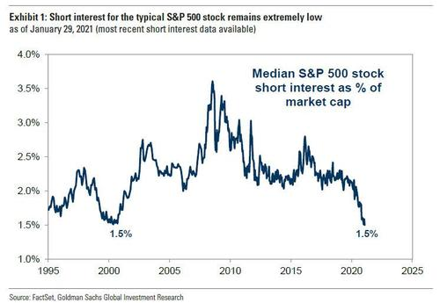
... so one needs to do highly targeted campaigns looking only for illiquid small and mid-cap names which have a very high short interest to float ratio, and second the real systematic shorts are to be found not in stocks but futures and specifically commodities; after all the original widow-maker trader refers not to Gamestop but to nat gas, where as we showed yesterday moves tend to be fast, furious and especially brutal (just ask Amaranth's Brian Hunter). In fact, anyone who was short any midcontinent nat gas overnight is now out of business.
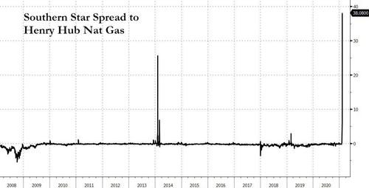
We bring all this up because while equity squeezes - while dramatic and exciting - tend to go as quickly as they come, the real squeezes in commodities tend to last for a long, long time especially if they are accompanied by a shift in sentiment.
Well, according to JPMorgan's Marko Kolanovic, such a squeeze may soon be coming to commodities in general and oil in particular.
Recall that on Wednesday, JPM's famous quant, Marko Kolanovic argued that ""the new commodity upswing, and in particular Oil up cycle, has started"
... a very contrarian thesis to the prevailing conventional wisdom that oil - which is clearly overbought after soaring more than 50% since November - may soon resume its slide if and when more covid-related shutdowns return, and one which was predicted on a series of fundamental factors which he laid out below. And after all, just 10 months ago WTI was trading at a negative $43 per barrel, an experience that has scarred a generation of oil bulls for life.
To be sure, Kolanovic listed a variety of fundamental drivers behind his highly contrarian call, among which...
... of which he noted postpandemic recovery (‘roaring 20s’), ultra-loose monetary and fiscal policies, weak USD, stronger inflation, and unintended consequences of environmental policies and their friction with physical constraints related to energy consumption and production." as the key ones.
He may or may not be right - after all commodities (and macro) is hardly Kolanovic's specialty. But what grabbed our attention, and what Kolanovic truly excels at, was his views on the upcoming dramatic shift in technicals and flows in the commodity sector.
Specifically, while the fundamental factors may well support a "sypercycle" thesis, any true commodity surge would require a buying catalyst spark. And according to Kolanovic this will come in the form of quant, momentum and other systematic investors being forced to start covering - initially slowly and then faster and faster - what is a historic short across the energy sector. The timing of this squeeze? One month from today.
Here's why:
In a market where - occasional reddit-inspired microcap short squeeze aside - algos and CTAs have established themselves as the dominant price-setters, it is hardly a surprise that Kolanovic - whose specialty after all is precisely derivative and futures flows - focuses on their influence as the driver behind a commodity supercycle. Indeed, he writes that after "CTAs played significant role in the 2014 oil price downturn" more recently, "CTA funds have been adding Energy exposure. The reason is that 12-month momentum turned positive on Oil, and going forward signals will remain solidly positive." However, this is in the context of a huge systematic net short overhang in the energy sector. In other words, energy - in all forms be it oil or energy stocks - remains the most hated sector across all investors.
And since vol-control funds are some of the dumbest money around and their actions can be anticipated well in advance, JPM notes that "a further decline in volatility will likely result in larger and more stable cross-asset quant allocations. A larger momentum impact may affect Energy equities, which is the only sector that still has a strongly negative momentum signal and is hence heavily shorted in the context of factor investing." Indeed, until recently, oil was the only asset that was still below its covid pandemic highs. But, not any more with Brent having finally risen above its pre-pandemic highs.
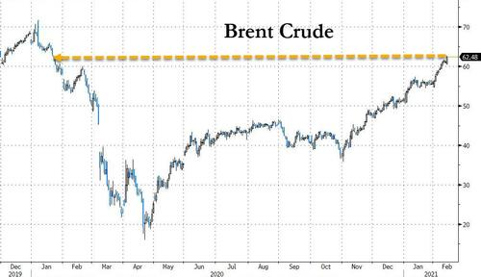
That - and this is the punchline of Kolanovic's thesis - will "change in mid-March, when the momentum signal for energy equities turns positive" which is also a gentle hint from the JPM quant to all the redditors out there: if you want to spark a truly historic short squeeze, one which forces systematic shorts to not only cover but to go long, do it where it hurts and buy some energy stocks.
Kolanovic was kind enough to even give you the timing: you have about a month to do so because JPM's model momentum factor "will need to rebalance in March by closing ~20% of its allocation to Energy equity shorts, and adding ~2% to energy longs, for a ~22% net buying in Energy."
What is the quantitative significance of these flows?
Well, the Croatian quant calculates that if one roughly assumes that there is about ~$1Tr in equity long-short quant funds and that half of these funds are not sector neutralized, "the flows could be quite significant, roughly $20-$30bn." It could be far, far more. As shown in the chart below, the ratio of energy shares shorted vs all other S&P 500 shares shorted, closely followed the commodity supercycle. And, remarkably, the most recent number of shares shorted for energy was 4 times the S&P 500 average.
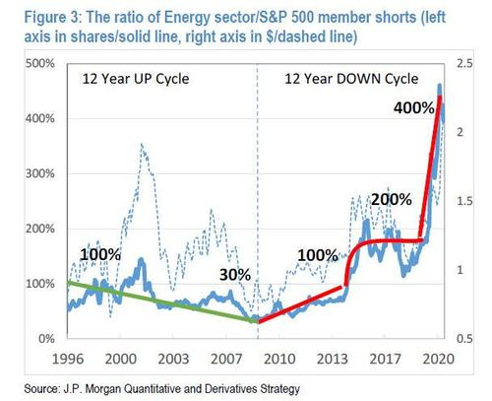
In other words, one doesn't even need to squeeze the shorts: come March - absent some major new crisis - as a result of broader market technicals the existing systematic shorts will quietly start closing them on their own and go long, in the process injecting tens of billions of new capital. And then, once retail, passive and institutional accounts - all of whom have a record low allocation to energy...
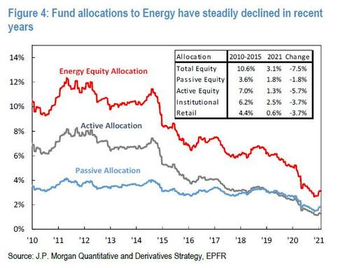
... jump on board once the momentum gets going, there's no telling how high oil could go although judging by this week's surge in crude which is clearly frontrunning the "supercycle" the thesis laid out by Kolanovic, the answer is "very."
America the Predictable
It seems like this would be an easy historic fact to accept, however, it’s very common for state propagandists and establishment shills in the media to cloud the argument. The conflict between the political left, Global Syndicates, conservatives and patriots is awash in misdirection. This article is my appeal to cut through that engineered fog, but before anything else is discussed, we need to recognize a fundamental truth:
If demons and Global Syndicates were not trying to take away our individual and inherent liberties, then we conservatives and moderates would have no reason to fight.
The political left and the Global Syndicates are the ONLY people consistently using censorship, mob intimidation, violence, economic ransom, subversion and government oppression to get what they want. And, what they want is control; there is no denying it.
Again, let’s think about this for a moment: Who are the real villains in this story? The people who want to be left alone to live their lives in quiet freedom? Or, the people that want to forcefully impose their will on the world by any means necessary?
They can call it “progress”, they can call it futurism, they can call it the “great reset”, they can call it Utopia, but there is no getting around the reality that demons and Global Syndicates have a vision of the world that is distinctly hostile to independent thought. What’s worse is, they think THEY are the good guys.
Conservatives and constitutionalists are “monsters” to them. Why? Because we exist and we refuse to comply. That is all there is to it. Otherwise, we have done NOTHING to them except defend ourselves in the most limited ways.
In recent months the words “terrorist” and “insurrectionist” have been used monotonously in the media to describe conservatives. The Domestic Terrorism Prevention Act, introduced in Congress this year, goes even further and specifically targets conservative activist groups as the primary threat to the stability of the US government. Demons are still calling the protest at the Capitol Building an “attack on democracy” by “terrorists and white supremacists”.
If people walking unarmed into a building and then leaving quietly after an hour is terrorism and insurrection, then what would they call it if we actually physically defended ourselves against the usurpation of our civil rights?
These are labels some of us in the alternative media have been expecting for many years. We knew that the numerous pieces of national security and surveillance legislation passed under George W. Bush and Barack Obama, supposedly aimed at Islamic terrorists, would one day be used against all of us. It was only a matter of time. We were called “conspiracy theorists” 15 years ago for suggesting as much, now we are prophetic, but the mainstream will never admit it.
The argument on the other side of the aisle is that conservatives represent an “outdated” ideal; a philosophy which disrupts the betterment of human society. But is this really true? And, who gets to decide the definition of “betterment”, or the definition of “progress”?
In my article ‘The Real Reasons Why The Liberty Movement Is Preparing To Fight’, published way back in 2013, I stated that:
“Some principles, like the liberties embodied in natural law and outlined in the U.S. Constitution, NEVER become outdated. They exist in the heart of mankind, and will remain as long as humanity remains. They cannot be erased, and they cannot be undone. They are inherent and eternal.
The Liberty Movement is not some dying vestige of America’s past clinging to an antiquated philosophy. We are the new wave; the messengers of an ideal of freedom that in the grand scheme of history has been around for only a blink of an eye. Constitutional liberty IS the progress that humanity has been waiting for. We have only been led astray by those who would sell us on our own bondage.
The SPLC and others within the establishment accuse the Liberty Movement of arming for conflict against the government. I am here to tell them that is EXACTLY what we are doing. We are arming because the establishment is arming against us. Yes, we are a threat, but only to political and corporate criminals who use subversion and violence to wrest freedom from the hands of good people. I am not afraid to openly admit it. I and many others will fight against any measure or man that seeks to undermine the rights of the people or destroy the founding principles of this nation…”
Every facet of full blown tyranny is being implemented in the US and around the world in one stage or another. A fascist/communistic state is being established piece by piece right now. Mass surveillance of the public is the norm. Economic lockdowns are the norm. Medical passports are being instituted and the only reason they are not yet prominent in the US yet is because of conservative and moderate resistance. 24/7 contact tracing of every citizen is being suggested. Organization of large groups is being restricted or prohibited. Big Tech and the government are working hand-in-hand to censor dissent. And now, they are even trying to eliminate our gun rights under HR 127.
In 2011 in an article titled ‘The Essential Rules Of Tyranny’, I outlined a list of steps that an oligarchy would have to take before they could impose a centralized control grid in the US. Here is that list:
Rule #1: Keep Them Afraid
Rule #2: Keep Them Isolated
Rule #3: Keep Them Desperate
Rule #4: Send Out The Jackboots
Rule #5: Blame Everything On The Truth Seekers
Rule #6: Encourage Citizen Spies
Rule #7: Make Them Accept The Unacceptable
Most of these steps have been openly pursued in the past year and time is running out. This is how oppressive and murderous regimes begin, right under people’s noses, all in the name of the “greater good of the greater number”.
And that is the only argument left for skeptics to make: That it is government dominance, but dominance by necessity. In other words, the government “must do these things” for our own good. Of course, it’s not for our own good. There are only a select handful of people that benefit from aggressive government intrusion into our lives and they do not care about anyone but themselves.
So, here we are, on the edge of an event which the liberty movement has been predicting for well over a decade. We have been preparing for it. We have been organizing to stand against it. And, we know that we will be painted as the worst devils imaginable for opposing it. None of this is surprising to us.
Every time we defend ourselves, it will be called an act of terror and insurrection. Every terrible event will be immediately blamed on us, even if we had nothing to do with it. There may be false flag attacks carried out in our names and designed to defame us. This is how tyrants operate. This is nothing new.
I will say this, however: One man’s terrorists is often another man’s freedom fighter. All the hyperbolic labels used to demonize us aren’t going to stick with millions of Americans. They just aren’t buying it.
Are we white supremacists? How is that possible when millions of minorities are also conservatives and patriots? Are we dangerous extremists? If that’s the case, then why is there only ONE violent riot to our name the past year while there are hundreds of riots (and deaths) in the name of demons and social justice cultists? Are we insurrectionists? How is that possible when we are trying to maintain the constitutional foundations of our country, not tear them down like the political left?
Do the Global Syndicates and demons really think they can take 74 million-plus Americans and marginalize us all with a word like “terrorist”? Do they really think they can shut us down, lock us up or remove us from the evolution of this nation’s destiny? The only way they could achieve that is if we go quietly. I have a revelation for them: We will not be going quietly.
Perhaps that is what they expect. Maybe they think they WANT us to fight. Maybe all of these attacks on conservatives are an attempt to provoke us. It is a Catch-22 after all – Damned if we defend ourselves and damned if we do nothing, right? If this is their strategy, then they must assume they can control the outcome of such a conflagration. It is that type of arrogance that will be the end of them in the long run.
Deep down, slavery is NOT what people want (despite what the propagandists might tell you). No, most people want self determination, they just have problems letting their fear get in the way of their freedoms.
Deep down, most people are on our side, not on the side of totalitarianism, and this is where despots consistently fail in their designs. The establishment thinks they can convince the world that freedom fighters are terrorists, while secretly, in their heart of hearts, the majority of people want us to win, and in the end, we will.
Give Righteousness a Chance
Consider that in the past year the radical Left – with whose cause Big Media, Big Tech, Big Education, Big Hollywood and the entire Democratic Party totally identify – has succeeded in:
Advertisement - story continues below
* indicting the freest, most welcoming and least racist nation on earth as irredeemably racist;
* inciting violent Marxist revolutionaries to riot, vandalize, loot and burn America's major cities;
* abandoning their former "safe, legal and rare" stance on abortion in favor of wanton celebration of late-term abortion up to the moment of birth and beyond;
* encouraging innocent children to irreversibly ruin their lives by chemically (and sometimes surgically) "transitioning" to the opposite sex – a scientific impossibility;
* using the COVID pandemic as a cover for imposing unprecedented totalitarian control over Americans; and
Advertisement - story continues below
* gaslighting an entire nation by perpetrating the most wide-ranging, egregious and in-your-face election fraud in U.S. history while pretending disenfranchised American voters who simply want a fair and impartial investigation are the crazy ones, "trying to steal the election from Joe Biden."
And that's just for starters.
As America's once-great middle class becomes crushed through endless COVID lockdowns, a wealthy and privileged globalist elite is not only growing ever richer and more powerful, but also strategically deploying COVID as a pretext for engineering what they call a "Great Reset" of the world – replacing capitalism with socialism. This is neither conspiracy theory nor partisan conjecture; the "Reset" movement's leaders openly brag about it.
'Evil in high places'

What Americans are beholding as the new year unfolds is more than just a host of extremely daunting circumstances brought about by corrupt, misguided and power-hungry people in leadership positions. Something else seems to be at work.
Consider that the well-intentioned but naïve liberal leaders of yesteryear are almost nowhere to be found. In their place are politicians, academics and media personalities whose breathtaking level of dishonestly and delusion (they talk earnestly about men becoming pregnant, they liken Trump to Hitler and they pretend the corrupt and shockingly senile Joe Biden is qualified to be president) suggests a surreal, dystopian, darkly spiritual dimension to the current troubled era.
In truth, Americans today are confronted with a maniacal revolutionary movement emanating from a full-bore rebellion against God Almighty and the essential foundation stones of Western Judeo-Christian civilization – from biblical morality, to "unalienable" individual rights, to equal justice under the law, to the color-blind society championed by Rev. Martin Luther King Jr., to the sacredness of children in the womb. After all, each of these priceless principles emanates directly from a deep recognition that human beings are created in the image of God – Imago Dei – and are therefore precious and of inestimable value.
Ironically, although atheist Karl Marx famously attacked religion and particularly Christianity as the "opium of the people," he himself concocted the ultimate religious opiate: Marxism.
For although the fantasy-world promise of socialism was a "classless" society wherein all people are equal and cared for, in the real world, corrupt leftist-elite politicians like Joe Biden, Kamala Harris, Nancy Pelosi and Chuck Schumer are so dishonest and desperately addicted to power, their consciences so seared by decades of lying, that they retain zero capacity for genuinely caring about the "poor and disadvantaged." It's all an act.
Rather, the religion they preach – Marxism, socialism, progressivism, whatever the label – is just an opiate they cynically dispense to pacify and distract the masses, while they grow ever more wealthy, powerful and privileged, but inwardly ever more ugly, corrupt and self-deceived.
So now comes the big question: With such genuine wickedness openly manifesting in "the land of the free," so much that it evokes the Apostle Paul's admonitions about "powers and principalities" and "spiritual wickedness in high places," what can good Americans do about the precarious state of their country? During this time of genuine tribulation and even persecution, how should moral, right-thinking Americans, who work hard, love their country, honor its history and obey its laws – and who don't pretend there are dozens of new genders and that America is a despicable racist hellhole – now respond?
'Uniquely blessed by God'
First, remember that our current time isn't uniquely burdened by evil and misfortune. When Jesus Christ walked the earth two millennia ago, He and His Jewish countrymen lived under harsh Roman occupation, "individual rights" (including the right to vote) didn't exist and most people were "poor and disadvantaged." And then there was leprosy. Moreover, to make sure the rabble always knew who was in charge, the Romans routinely crucified people along the roadsides – escaped slaves, criminals and other "lowlifes," and especially those they regarded as any sort of threat to Roman rule.
The intervening centuries have all too often presented equally daunting circumstances. While today's coronavirus pandemic has taken several hundred thousand American lives, 14th century Europe had to contend with the Black Plague, which killed some 25 to 50 million people – and no treatments or vaccines. Then there have been the countless wars, the costliest being World War II with over 70 million deaths, including over 400,000 Americans. Indeed, the 20th century was the bloodiest in all of human history, dominated as it was by the ever-metastasizing Marxist cancer, which consumed an appalling 100-200 million lives.
Truth is, the human race is so regularly mired in intractable crises, one could reasonably conclude that crisis and chaos are the norm for humans, with societal peace and prosperity but rare and cherished aberrations.
And that may be the point: America has historically constituted one of those few extraordinary "cherished aberrations," a nation uniquely blessed by God.
America was blessed by wise founders who crafted a magnificent Constitution to be the template for a government based on individual rights and ordered liberty, not the rule of kings and potentates. Blessed with a population willing to sacrifice 600,000 lives in a war that ended up expunging the evil of slavery. Blessed with an admirably resilient Judeo-Christian culture and a population genuinely in love with their country. Blessed with extraordinary natural resources, including more oil than Saudi Arabia. Blessed with unparalleled freedom and prosperity that to this day attract more immigrants to our shores than any other country in the world, by far.
Therefore, when they see their beloved country being stolen, defiled and "fundamentally transformed" as it is right now, right-thinking Americans feel compelled to defend her. But how?
First and most immediate: November's election was a freak show featuring hands-down the most massive amount of voter fraud in Americans' lifetimes. If the various states that permitted and encouraged election fraud – such as Pennsylvania, Georgia, Michigan, Wisconsin and others – aren't compelled to play by the rules, America will never again be a unified, peaceful nation – ever. So that is job one.
Even setting aside the outrageous election abuses, the major news media and tech monopolies pre-rigged November's contest long before Election Day by continually portraying Donald Trump as a Hitlerian, mentally ill traitor while casting the demented and spectacularly corrupt Joe Biden as a moral paragon and guarantor of national healing.
They all knew better, but they did it anyway.
However, a corrupt news establishment, a rigged election process, a radicalized Democratic Party and out-of-control Big Tech information gatekeepers are not our only problems.
America's colleges and universities have become Marxist indoctrination centers. Our public elementary, middle and high schools teach our children that America is a racist nation. Even preschoolers are herded into public libraries where demonically possessed men pretending to be women – some of them convicted sex-offenders – are allowed to beguile, indoctrinate and corrupt these children's tender little minds, while their clueless parents smile and nervously laugh.
Summarizing America's current spiritual state, Los Angeles mega-pastor John MacArthur recently told Fox News' Laura Ingraham: "America's in a moral free fall. … You murder the babies in the womb. If they survive the womb, you try to seduce them into transgender sexual deviation when they're young. If they survive that, you corrupt them with a godless education. If they survive that, you have divorce in the family. And if they grow to be adults, we drown them in a sea of pornography. This is a nation so far down in the sewer of immorality and wickedness that nothing surprises me."
MacArthur is right, of course. Which means even if Trump had managed to remain in office for another four years and continued to turbocharge the U.S. economy as he did previously, America would remain in a state of "moral free fall."
Try this thought experiment: Recall how Brett Kavanaugh's nomination for a seat on the U.S. Supreme Court led to hordes of screaming people wildly pounding on the doors of the Supreme Court building, an epic mob scene reminiscent of something out of the French Revolution. And that was just over a nomination! Imagine what would happen if those rioters' worst fears – the outlawing of abortion – actually came to pass. What if the Supreme Court actually repealed Roe v. Wade, or – to take the hypothetical even further – suppose the states actually amended the U.S. Constitution with a Human Life Amendment, outlawing abortion throughout the nation.
It would be a great day, of course – except America would be in a state of war, her streets unsafe, mass hysteria dominating public life every single day.
I think you get the picture. America has become a very broken nation, with millions of people utterly captive to bizarre, deceitful and deadly beliefs.
Thus, while we work and litigate and demonstrate and persuade and donate and pray for a turnaround on all the current battlefields – from election integrity to media corruption to abortion – what America really needs is indeed a revolution. But not a Marxist one.
Toward national revival
First, a word of warning to hotheads: Whereas civil disobedience in the manner of the Civil Rights Movement demonstrators of the 1960s can be a powerful force for good, awakening the conscience of a nation and bringing about truly positive change, angry and violent rebellion is not only counterproductive, it is precisely what the maniacal, power-obsessed Left wants.
That's right. Although they will never admit it, it's what they desire most of all. Why? Because it would enable them to point to "rightwing, white-supremacist extremists and terrorists" and say, "See! We told you all along that white-nationalist Trump-supporting fascists were the real problem!"
This is precisely why the left is forever fabricating and publicizing a never-ending array of "hate-crime" hoaxes, because they serve to validate their deranged narrative that conservatives, Republicans and Trump supporters are the real criminals, fascists and terrorists, and must be throttled at all costs. The left dreams of an unhinged, violent "rightwing" rebellion, as such would serve only to vindicate them and give them a lock on the power they crave.
As events unfold in the new year and beyond, bold strategies will emerge for restoring our nation, and patriotic right-thinking Americans will surely pursue them. Members of Congress and all state legislators will play pivotal roles, especially with regard to asuring free and fair elections, as will governors and mayors and indeed all elected office holders. Traditionally minded citizens will pursue parallel institutions to protect their children as well as their own wellbeing and sanity, from alternative educational modalities (homeschooling and private Christians schools) to alternative news media. Indeed, the American samizdat (that's what the "underground" press, the only source of truthful news, was called in the former Soviet empire) must flourish, although it will have to endure more censorship and abuse as they perform their vital role of investigating corruption and truthfully keeping Americans informed.
In every area of life, Americans will have to bear up with grace and dignity in fighting the good fight. Citizens, the ultimate sovereigns in America's unique constitutional system, who may be tempted to "drop out of politics" must do the opposite – vigorously exercising their sacred rights of voting, free speech, free association, freedom of worship, and to "petition the government for a redress of grievances" in every legal and moral way.
One final all-important point: Unlike virtually all other nations, the essence of America is not a common ethnicity but a common spirit – a grateful, liberty-loving, generous, essentially Christian spirit, which needs to burn more brightly now in America than ever.
Indeed, no real and lasting recovery is possible for America without a genuine spiritual revival. And each of us can and must play a key part in this revival. How? While we're engaged on every battlefront – committed to work creatively and effectively, to educate and persuade, to enlighten and awaken, and to outthink and outmaneuver the demented Left – each of us needs, as Christ commanded, to "Let [our] light … shine before men," always praying we can wage the battle righteously. And even praying for our enemies.
Math is Racist
The Oregon Department of Education is promoting a course for teachers that links math lessons to racism and a culture of “white supremacy.”
The department last week sent out an online pamphlet for a course called “A Pathway to Equitable Math Instruction,” which includes a section on “Dismantling Racism in Mathematics Instruction.” The pamphlet includes materials that are essentially a course for spreading wokeness inside of classrooms.
The ODE-promoted course brands itself as “an integrated approach to mathematics that centers Black, Latinx, and Multilingual students in grades 6-8, addresses barriers to math equity, and aligns instruction to grade-level priority standards.” The course challenges the reality that some answers are simply wrong while broadly challenging America’s founding principles.
According to the course syllabus, there are five “strides” that can help educators banish “racism” from math in their classrooms. In the dismantling racism section, the course asks teachers to examine their “actions, beliefs, and values around teaching mathematics” with the apparent goal of shaming them into making lessons about identity politics.
“White supremacy culture infiltrates math classrooms in everyday teacher actions. Coupled with the beliefs that underlie these actions, they perpetuate educational harm on [minority] students, denying them full access to the world of mathematics,” the section states.
The course section also identifies “ways in which white supremacy shows up in math classrooms.”
According to the teaching materials, too much focus on asking students to get the “right” answer when solving math problems is connected to white supremacy, as is working independently. The course favors group math work for students.
“Often the emphasis is placed on learning math in the ‘real world,’ as if our classrooms are not a part of the real world. This reinforces notions of either/or thinking because math is only seen as useful when it is in a particular context,” the dismantling racism section states. “However, this can result in using mathematics to uphold capitalist and imperialist ways of being and understandings of the world.”
The course goes on to target both “capitalism” and “imperialism,” while suggesting math lessons be used to help develop the neighborhoods of underprivileged kids.
Would you allow your child to attend a school where they are taught that math is racist?
Completing this poll entitles you to The Western Journal news updates free of charge. You may opt out at anytime. You also agree to our Privacy Policy and Terms of Use.

The materials also invite teachers to ask themselves how “mathematics can help solve problems affecting students’ communities,” and to recognize “the ways that communities of color engage in mathematics and problem solving in their everyday lives.”
Furthermore, the course will ask teachers to identify and “challenge the ways that math is used to uphold capitalist, imperialist, and racist views.”
“The concept of mathematics being purely objective is unequivocally false, and teaching it is even much less so,” the course states. “Upholding the idea that there are always right and wrong answers perpetuate objectivity as well as fear of open conflict.”
The course appears to be voluntary for teachers who wish to learn better ways to promote Marxist ideals. But it’s critical race theory on steroids² – 1,776 + 1,619.
For example, the Marxist materials state, ”We cannot dismantle racism in a system that exploits people for private profit … If we want to dismantle racism, then we must build a movement for economic justice.”
RELATED: Where's the Outrage? BLM, Antifa Protesters Threaten to 'Burn' DC Down If They Don't Get What They Want
This is the state, or at least the future, of the country’s education system. Teachers in cities across the country are currently holding districts hostage by using the coronavirus pandemic to keep schools closed. Once many of those teachers finally get around to doing their jobs, some kids will likely be further underserved by lessons that are not relevant to promoting critical thinking — at least in the Beaver State.
The course, more or less, seems to be an attack on the fundamentals of the country while using objective number-crunching as a pretext. It also infers that minorities do not have the ability to solve problems — which itself seems kind of racist.
In Oregon, the idea that there are wrong answers to math problems is being challenged, as is the notion that minority kids are capable of competing in STEM activities without assistance.
Apparently every lesson will be one where slackers all sit around the smart kid waiting for that person to come up with the correct answer. Weren’t those rare group opportunities fun?
It isn’t clear, beyond the Marxist-rhetoric-serving adults, how students are supposed to actually benefit from the absurd social experiment that the course is.
If you’re wondering where something so brazenly anti-American originated from, the lesson thanks the Bill and Melinda Gates Foundation for its “generous financial support.”
The Path to Civil War
History is a cruel and relentless teacher. Before the American War of Northern Aggression, the southern States tried to block the effectiveness of Federal laws. The victors of the war interpreted the Constitution to mean that the Federal law is supreme. It is happening again, but there is a better way. Lawmakers in Missouri have taken a bold step to preserve gun rights by drafting legislation that would ban police agencies from using unconstitutional federal laws to confiscate guns from citizens.
State Rep. Jered Taylor, a Republican, told KSDK-TV that a bill, which is still in committee, would protect his state’s citizens from extreme measures such as gun confiscation, now that President Joe Biden is in office.
“We are here to defend those rights against an out-of-control federal government,” Taylor told the outlet. “And that’s exactly what this bill does.”
The Second Amendment Preservation Act was advanced through the state’s majority-Republican House on Wednesday. That bill would harshly penalize law enforcement agencies and officers who would be found guilty of confiscating a firearm or firearms while using federal, and not state law, as a pretext.
Simply put: No matter what gun laws are passed by the Democratic majority U.S. House and Senate, or mandated by Biden via executive order, they will not apply to Missourians who want to exercise their Constitutional rights.
The act is clear in outlining how far it would go to protect the Second Amendment for Missourians.
It “[d]eclares that laws, rules, orders, or other actions which restrict or prohibit the manufacture, ownership, and use of firearms, firearm accessories, or ammunition exclusively within this state exceed the powers granted to the federal government except to the extent they are necessary and proper for governing and regulating land and naval forces of the United States or for organizing, arming, and discipling militia forces actively employed in the service of the United States Armed Forces,” according to a summary of the bill.
Furthermore, the Second Amendment Preservation Act states that the Missouri court system and the state’s police agencies would have a duty to protect gun rights for law-abiding citizens.
If passed, the bill will strip all government agencies of their “authority to enforce or attempt to enforce any federal laws, orders, or rules infringing on the right to keep and bear arms” in the state.
Do you think more states should follow Missouri's lead?

Yes No
Completing this poll entitles you to The Western Journal news updates free of charge. You may opt out at anytime. You also agree to our Privacy Policy and Terms of Use.

Another portion of the bill even goes as far as to strip qualified immunity from officials who could potentially find themselves down the road using federal firearm laws as a justification for gun confiscation.
Qualified immunity, of course, protects government agencies and employees in many cases from facing civil liability.
That bill would go as far as to punish essentially anyone complying with overreaching federal gun laws, more of which Democrats have promised will be coming down the pipeline.
In conclusion, the short bill, in its current form, adds that “any person while acting as an official … who enforces or attempts to enforce any of the infringements identified in this bill… may be permanently ineligible to serve as a law enforcement officer or to supervise law enforcement officers in this state or in any political subdivision of this state.”
The bill was actually slimmed down following an outcry from state law enforcement agencies. A previous version of the bill would have “disqualified law enforcement officers from working as Missouri cops if they served on a federal gun taskforce,” according to KSDK.
RELATED: Gun Sales Spike in January as Joe Biden Takes Control of the White House
The legislation still needs an additional vote of approval in the state House. Then, if approved, it will move to the GOP-led state Senate where it will be debated further.
With the uncertainty of the Second Amendment due to Democrats, led by Biden, in control in Washington, Missouri lawmakers are stepping up in a big way to protect the Constitution.
The Bill of Rights doesn’t only protect amendments that Democrats are fond of.
This could be a big win for The Show-Me State’s more than six million residents. It should also serve as a lesson to all of us not currently residing in Missouri.
While everyone focuses on the comings and goings of the U.S. Congress and the White House, Missouri’s state legislature is demonstrating just how important local engagement and elections are.
Now more than ever is the time to take those elections in your own backyard seriously.
Missourians elected people who apparently have the foresight to see the tyranny that might be on the horizon, and they’re being proactive to ensure the rights of their citizens aren’t infringed upon down the road.
Who Killed Ashli Babbitt?
I have been asked by the author to tell you this story. On January 6th, unarmed 14-year high-ranking Air Force veteran and patriotic Trump supporter Ashli Babbitt was savagely gunned down by the US Capitol Police while peacefully protesting the illegitimate executive seizure of power by the Democrats through Manchurian candidate Joe Biden.
The ‘thin blue line’ violently shot the innocent veteran to death in cold blood at point blank range without any warning in the halls of the Capitol building. Make no mistake, this was a political assassination. Establishment Republicans like Matt Schlapp gleefully mocked her death after complicit commentators like Erick Erickson endorsed and ordered the public execution of Trump supporters.
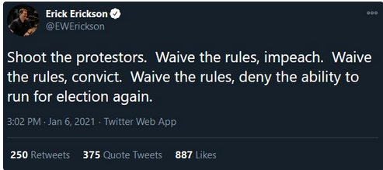
The Capitol Police absolutely refused to release the name of the officer. The media didn’t ask for a name and diverted all attention away from his murderous crime. When I was interviewed by Inside Edition on camera less than an hour after the murder occurred, I tried to press for the name of the shooter. They chose to focus on what they called the storming of Congress. There was no storm.

The foreign newspaper The Sun even spit on Ashli’s grave by releasing a clickbait headline “Who shot Ashli Babbitt, the woman who died at the Capitol?” but refusing to even name the officer involved in the heinous killing in the entire article.

In the face of arson, looting, terror, and death by Black Lives Matter over the summer, the DC Council unanimously passed a ‘police reform’ law specifically requiring “the city to swiftly make public the names of officers who use force on citizens.”
Needless to say, the law is being illegally flaunted now when Republicans are victims of indiscriminate and barbaric police killing and violence.
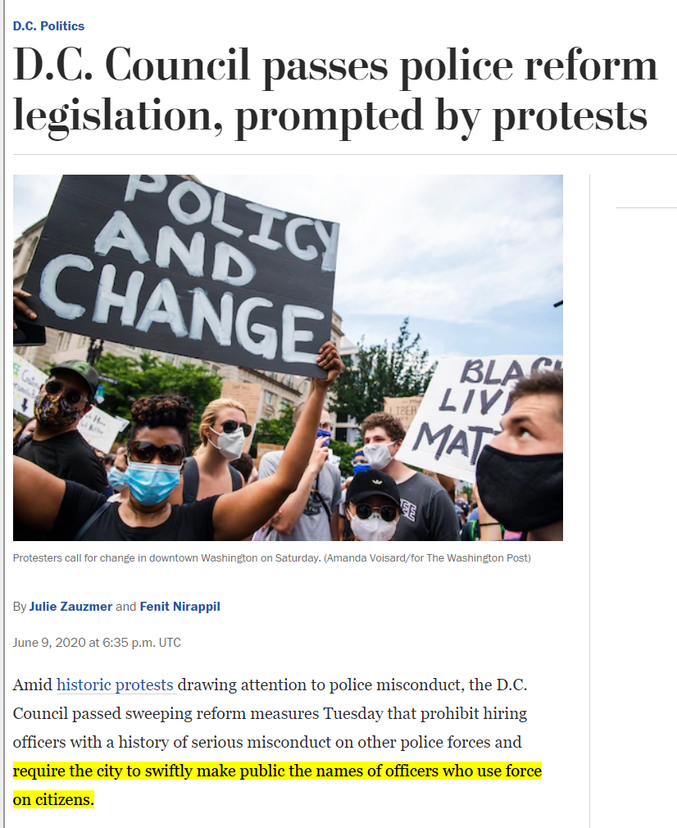
The fake stream news media, police, and politicians want to label all Trump supporters insurrectionists in the face of a senseless, cold-blooded assassination at point blank by law enforcement on unarmed and innocent protesters in the home of the US Congress.
So Trump supporters identified the assassin themselves.

This murderer has now conclusively been identified as Special Agent David Bailey. He is a US Capitol police officer with short black hair who always wears an unmistakable white and black bead wristband.
- 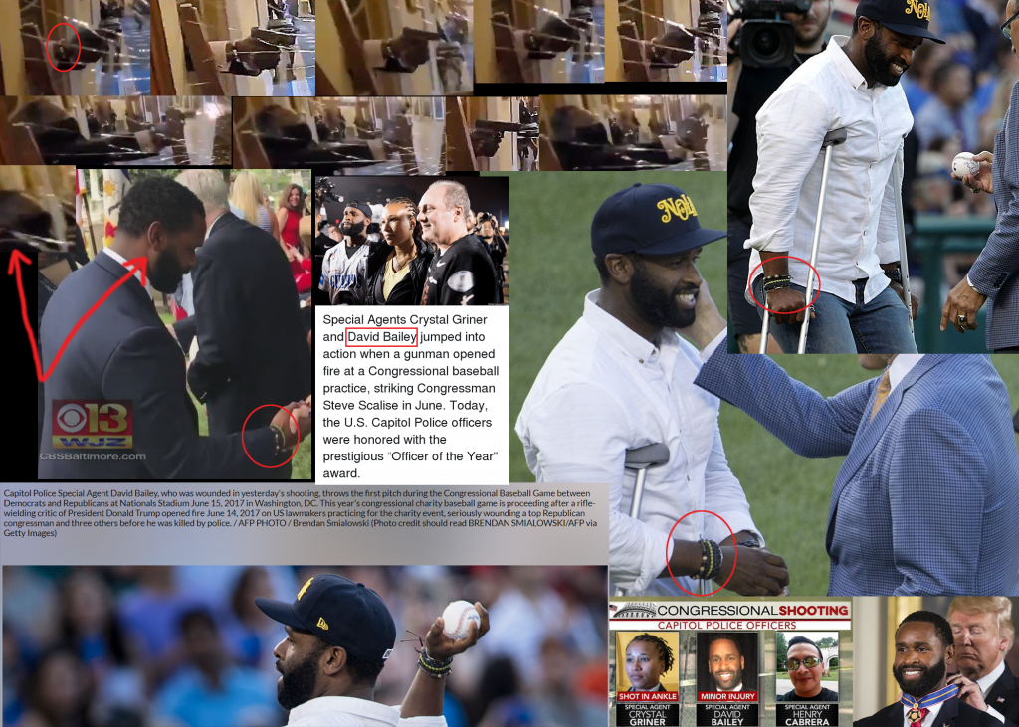
Bailey has been in the spotlight before, seen sporting the exact same wristband on many occasions, including when the media was celebrating him for his incompetence in allowing a deranged leftist gunman to open fire on congressional Republicans during a baseball practice in Virginia in 2017.
GOP House Whip Steve Scalise suffered bullet wounds and nearly died on the spot as a result of Bailey’s negligence in protecting him — which was his only job that day as Scalise’s personal bodyguard.
Bailey was awarded both the Medal of Valor AND the Badge of Bravery for this great achievement.
Notice his bead bracelet in both of the above pictures — the same bracelet he wore on the day he murdered Ashli Babbitt.
https://twitter.com/NiagaraAction/status/1347341153033719811
Special Agent David Bailey has allowed the shooting of Congressman Scalise by stepping aside and letting Bernie’s assassin to enter the ball field with an AR-15. This gun was in plain view, and Bailey let him go it, because the plan was to wipe out the Freedom Caucus, of which Steve Scalise was a member. Bailey is the BLM zealot who committed the pre-meditated, cold-blooded execution of an innocent female Trump-supporting veteran named Ashli Babbitt.
This man should be locked up for a very long time, but at the very least, now that his name has been publicly released (which up until this point has been illegally withheld), he must be indefinitely suspended from the force immediately — before any more Trump supporters are violently shot and killed with their blood on his hands.
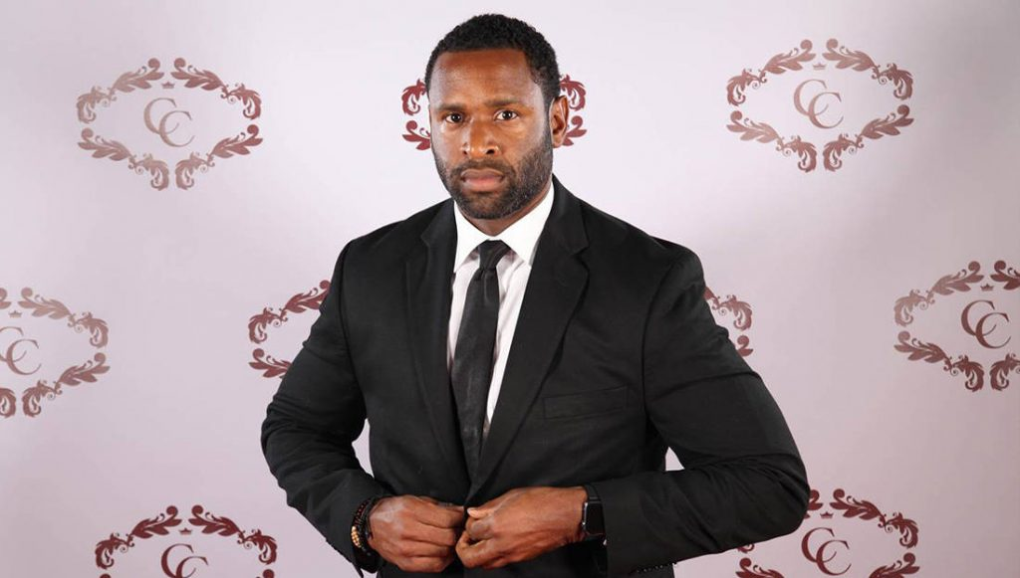
.
Now this…
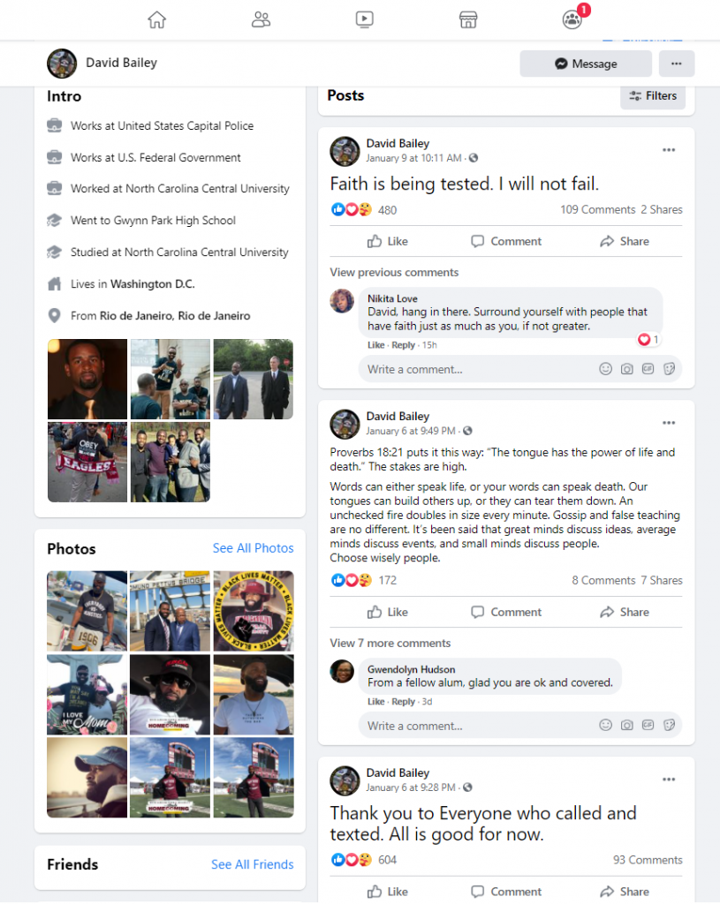
Bailey’s Facebook bio details that he is from Rio de Janeiro, Brazil, and is a US Capitol Police officer. We’re importing immigrants that kill Trump supporters.
In Bailey’s three most recent posts on Facebook, all posted following the events of January 6th, he openly admits to carrying out Ashli Babbitt’s murder.
On January 6th, minutes after the gruesome event, he writes: “Thank you to Everyone who called and texted. All is good for now,” — “good” referring to the public execution of a 14-year high-ranking Air Force veteran and Trump supporter.
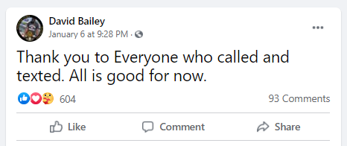
Twenty minutes later, he posts a Bible passage unbelievably attempting to justify his admittedly murderous act in the US Capitol:
Proverbs 18:21 puts it this way: “The tongue has the power of life and death.” The stakes are high. Words can either speak life, or your words can speak death. Our tongues can build others up, or they can tear them down. An unchecked fire doubles in size every minute. Gossip and false teaching are no different. It’s been said that great minds discuss ideas, average minds discuss events, and small minds discuss people. Choose wisely people.
He argues that the innocent lady deserved to get shot to death because of her support of President Trump. This man is a psychopath. Where is the FBI when you need them?
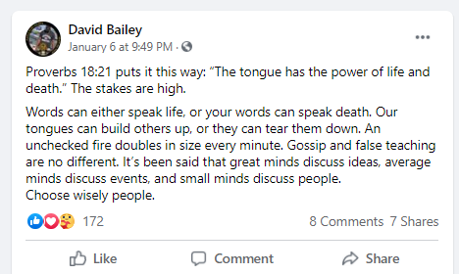
172 of his friends agree.
His next and most recent post was his most popular yet, with over 100 comments from his friends and many more hundreds of likes. He arrogantly writes: “Faith is being tested. I will not fail.”
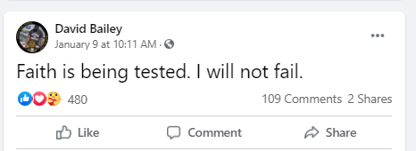
It’s now been indisputably proven through extensive video analysis, article research, and through his own words, that David Bailey is the officer who opened fire on the unarmed group of Trump supporters in the halls of the US Capitol last Wednesday.
Further confirming our previous report, in Bailey’s photo section, he has many various photos taken of him inside the Whitehouse for his Medal of Bravery ceremony, even posing with the president following the Steve Scalise shooting.

- 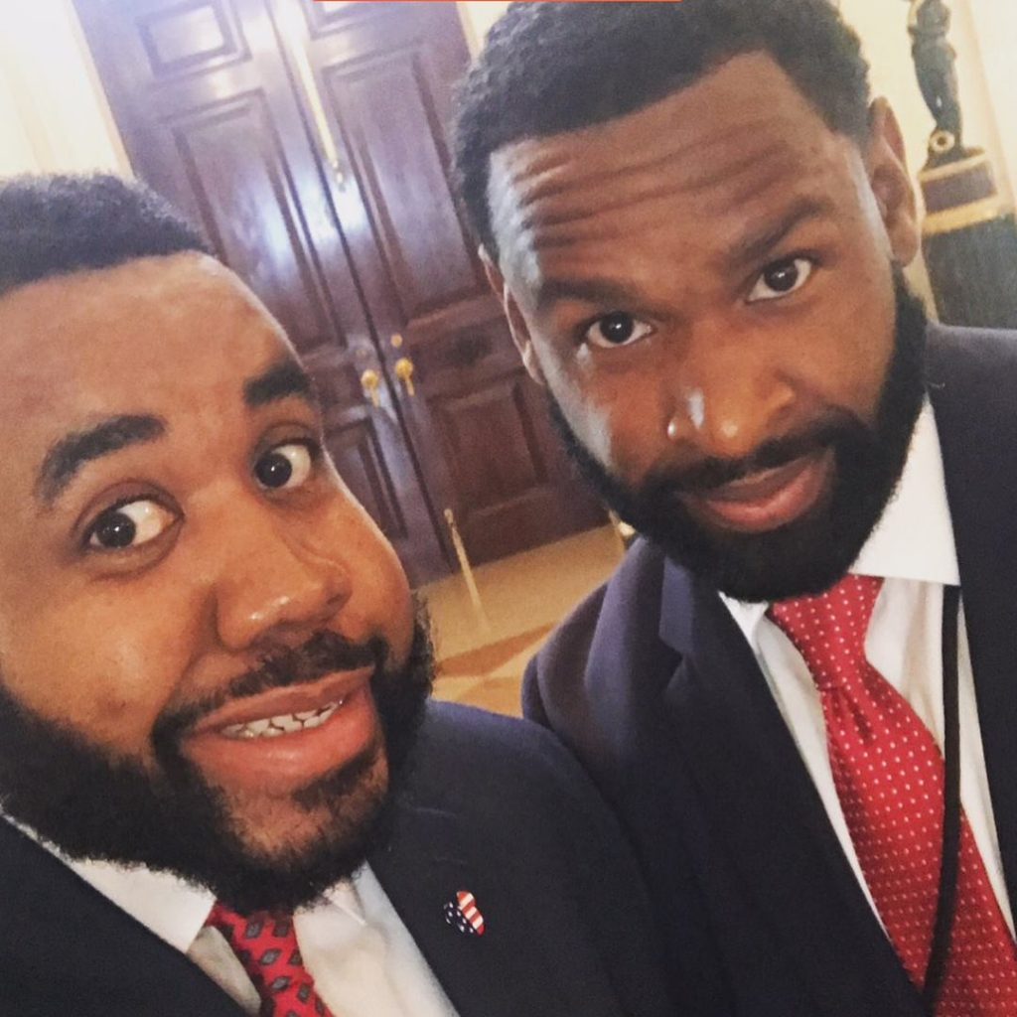
- 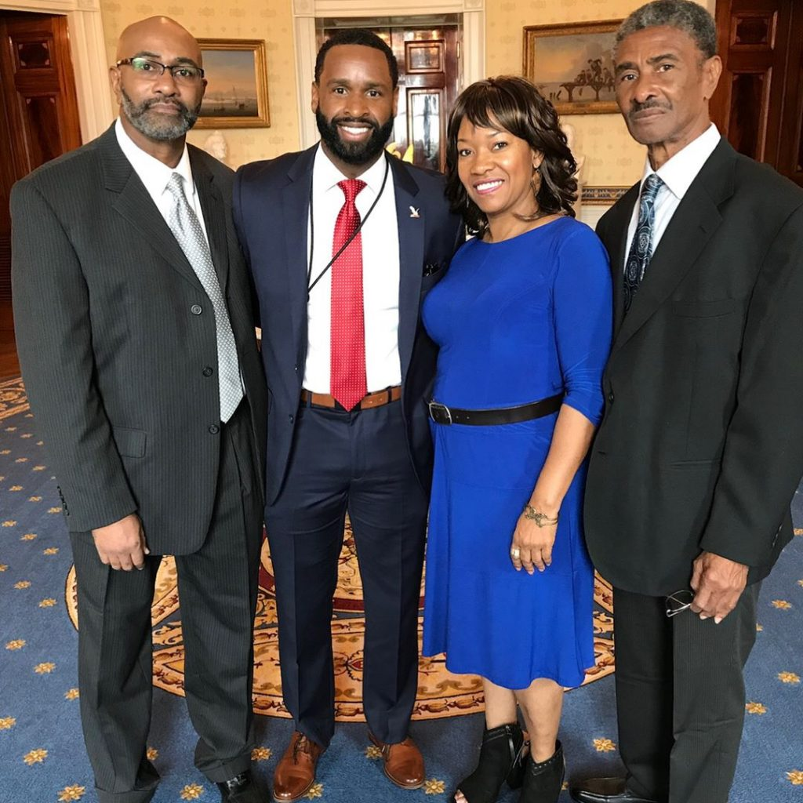

- 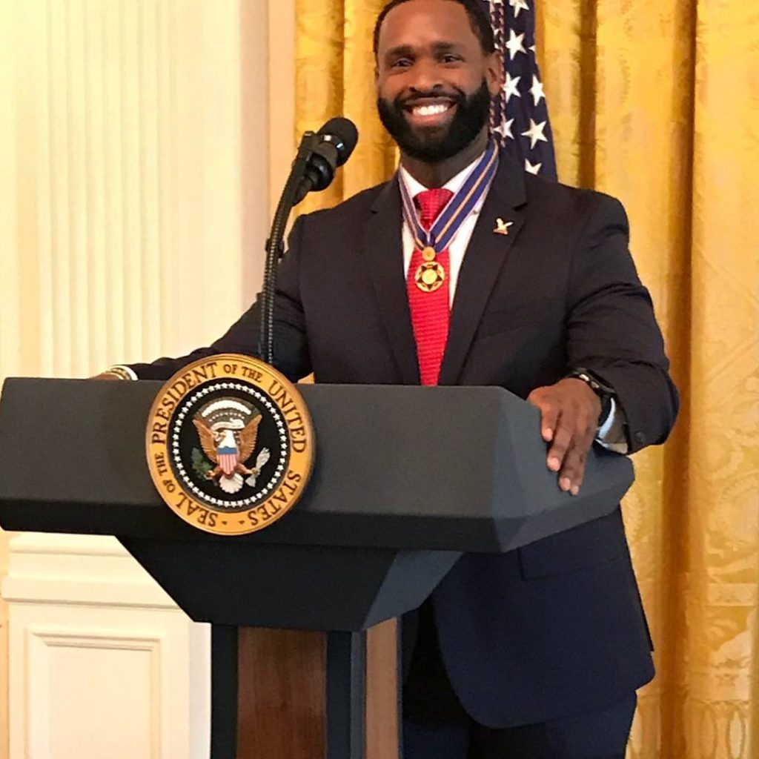
We archived all of the preceding images for when he inevitably deactivates of makes private his Facebook account. Photo 1; Photo 2; Photo 3; Photo 4; Photo 5; Photo 6; Photo 7; Photo 8. Each of the noted posts are archived above.
Bailey even went so far as changing his profile picture to pledge allegiance to the violent and deadly domestic terror organization Black Lives Matter at the height of the summer riots.
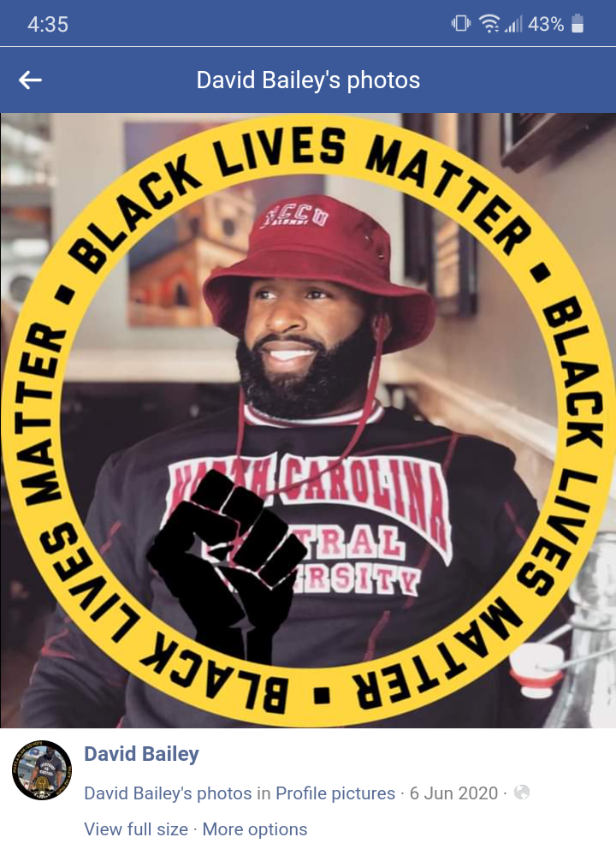
Bailey has repeatedly demonstrated his hatred of Trump supporters over the past few months leading up to the unhinged slaughter.
Following the election, he revealed himself as a partisan Democrat by mocking the voter fraud in favor of Joe Biden. He even tried to harvest votes for the Georgia Senate runoff — despite residing in DC.
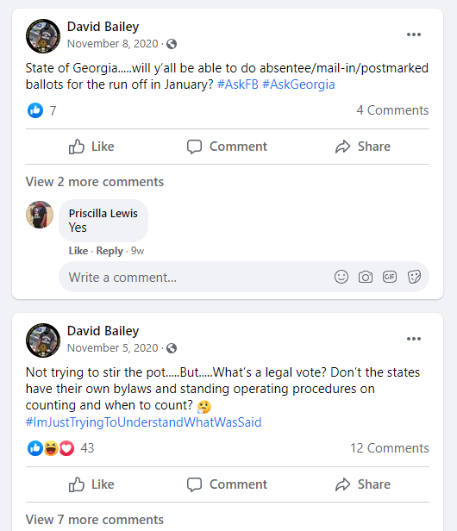
But it gets much worse.
In September, when during a debate President Trump explicitly told his supporters not to engage in violence, Bailey threatened on Facebook: “Anybody that is ‘standing back and standing by’ might wanna unfollow me…..you don’t want these problems….” This can only be seen as foreshadowing of his recent deadly attack on Trump supporters.
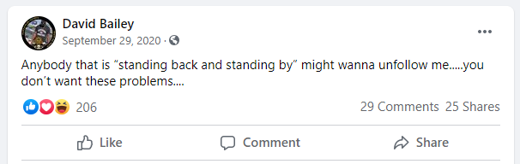
The direct threat generated hundreds of positive reactions from his friends.
If there was any ambiguity in this lunatic, violent threat, he made it clear in the comments. Responding to friend Steven Andre Williams’s question: “Oh, you got smoke?”, Bailey said: “bruh you know i stay with the smoke.”
For those of you who are not criminals, “the smoke” is gang language referring to a physical conflict, often involving weapons.
He even elaborated once again in the same comment section that he was threatening gun violence. Responding to friend Van Essa’s image reading: “Don’t let ‘stand back and stand by’ get your ass whooped — We are NOT our Ancestors,” Bailey said: “Boom!”

This is a truly deranged man. He should not be allowed anywhere near a firearm, let alone be paid to carry one around and shoot at people.
President Trump honored Agent Bailey at the highest level, elevated him to a national level and sung his praises of heroism and bravery; Bailey savagely betrayed him and all of his supporters, murdering a helpless Trump supporter in cold blood.
The media has refused to cover this story, but we uncovered the truth for ourselves. They can’t hide their crimes any longer. This man belongs in jail. Washington DC must bring Agent Bailey to justice, for Ashli Babbitt’s sake. We must spread the word.

