Where’s the wood?
One of the most important things we've learned over the past year is the vulnerability of global supply chains. Most notably, supply disruptions of lumber have catapulted prices to the moon.
The narrative touted in the public domain is that COVID-19 sparked a dramatic underestimate in capacity by sawmills early in the pandemic as the Federal Reserve slashed interest rates to zero, sparking a housing boom. The influx of demand outpaced supply and has caused lumber prices to jump 340% from a year ago, according to Random Lengths.
In terms of output, the lumber industry is controlled by just a handful of firms, including Weyerhaeuser Co., Georgia-Pacific LLC, West Fraser Timber Co., Ltd., among others, which makes it easier for capacity to be controlled.
Maybe there's more to the lumber story that we're not being told and should be investigated more in-depth by journalists.
YouTube account "Ken's Karpentry" recently published a video of "huge quantities" of lumber sitting and not in lumberyards. The exact location of the video is not mentioned but could be near Lyndonville, Vermont.
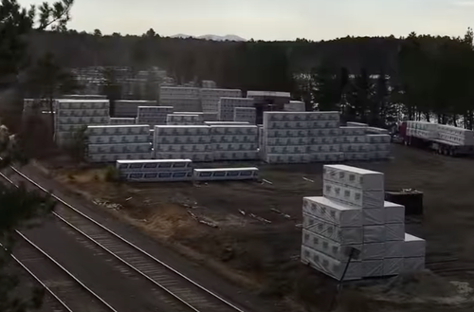
The narrator in the video, perhaps it's Ken, but we're not sure, explains that a train depot has been transformed into a makeshift lumber yard. He said train loads of lumber coming out of Canada are offloaded here and then transported by tractor-trailer to lumberyards across the country.
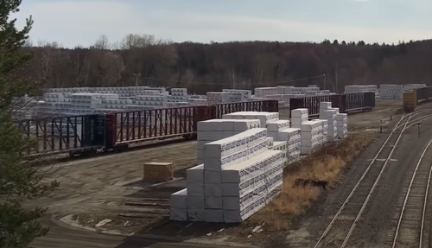
He said, "I am astounded by how much lumber is here, and I am wondering why there is such a problem at lumber yards." He added the facility stretches 3/8 of a mile.
The video has more than 300,000 views and over 1,300 comments in just a few weeks.
One person said, "Gee, could it be to keep the price gouging and profits up?? This whole excuse that "it's due to covid" b*llsh!t has got to stop!"
"It's too bad there are no investigative reporters left in the world. This lumber story needs to be investigated and exposed," some else said.
Another person said:
"This is what happens when a few companies own the entire market."
And this person makes an interesting point:
"There is no lumber shortage. It's just Weyerhouse and GP wanting to drive up profits."
So could the lumber industry, controlled just by a few players, be pulling the playbook straight out of the diamond industry to limit supply to drive up prices?
Serfdom
The concept of government is that the people grant to a small group of individuals the ability to establish and maintain controls over them. The inherent flaw in such a concept is that any government will invariably and continually expand upon its controls, resulting in the ever-diminishing freedom of those who granted them the power.
When I was a schoolboy, I was taught that the feudal system of the Middle Ages consisted of serfs tilling small plots of land that belonged to a king or lord.
The serfs lived a meagre life of bare subsistence and were subject to the tyranny of the king or lord whose men would ride into their village periodically and take most of the few coins the serfs had earned by their toil.
The lesson I was meant to learn from this was that I should be grateful that, in the modern world, I live in a state of freedom from tyranny, and as an adult, I would pay only that level of tax that could be described as “fair”.
Later in life, I was to learn that, in the actual feudal system, some land was owned by noblemen, some by common men. The commoners typically farmed their own land, whilst the noblemen parcelled out their land to farmers, in trade for a portion of the product of their labours.
As a part of that bargain, the nobleman would pay for an army of professional soldiers to protect both the farms and the farmers. Significantly, unlike today, no farmer was required to defend the land himself, as it was not his.
There was no exact standard as to what the noblemen would charge a farmer under this agreement, but the general standard was “one day’s labour in ten”.
This was not an amount imposed or regulated by any government. The nobleman could charge as much as he wished; however, if he raised his rate significantly, he would find that the farmers would leave and move to another nobleman’s farm. The 10% was, in essence, a rate that evolved over time through a free market.
Modern Serfdom
Today, of course, if most countries levied an income tax of a mere 10%, there would be dancing in the streets. And the days of one simple straightforward tax are long gone.
Today, the average person may expect to pay property tax (even if he is a renter), sales tax, capital gains tax, value added tax, inheritance tax, and so on. The laundry list of taxes is so long and complex that it is no longer possible to compute what the total tax level actually is for anyone.
And to this, we add the hidden tax of inflation. In the US, for example, the Federal Reserve has, over the last hundred years, devalued the dollar by 98%, a hefty tax indeed. And the US is not alone in this.
Only 50 years ago, the average man might work a 40-hour week to support a wife who remained at home raising the children. He often had a mortgage on his home but might have it paid off in ten years. He paid cash for nearly everything else that he and his family owned or consumed.
Today, both husband and wife generally must be employed full time. In spite of this, they can’t afford as many children as their parents could, and they generally remain in debt their entire lives, even after retirement. This is significant inflation by any measure.
In contrast, in the Middle Ages, the cost of goods might remain the same throughout the entire lifetime of an individual.
In light of the above, the 10% that was paid by the serfs is beginning to look very good indeed.
However, the great majority of people in the First World are likely to say, “What can you do; it’s the same all over the world. You might as well get used to it.”
Well, no, actually, it’s not.
There are many governmental and economic systems out there and many are quite a bit more “serf friendly” than those in the major countries.
Countries such as the British Virgin Islands, the Cayman Islands, Bermuda and the Bahamas have no income tax. Further, some have no property tax, sales tax, capital gains tax, value added tax, inheritance tax, and so on.
So how is this possible?
The OECD countries state that it is largely accomplished through money laundering, but this is not the case. In fact, low-tax jurisdictions are known to have some of the most stringent banking laws in the world.
The success of these jurisdictions is actually quite simple. Most of them are small. They have small populations and therefore need only a small government. Yet each jurisdiction can accommodate large numbers of investors from overseas. This results in a very high level of income per capita.
But unlike large countries, the money that is deposited or invested there is overseas money, so it is not captive. Investors can transfer it out overnight if need be.
So, even if the politicians are no better than those in larger countries (generally, they are of the same ilk), they’re aware that, like the noblemen of old, if they attempt to impose taxation, the business will dry up quickly.
In fact, such a free market dictates that the jurisdictions keep on their toes and keep trying to outdo their competitors by being more investment friendly.
Therefore, the politicians in these countries, who might be only too happy to promise entitlements to their constituents, then tax them to the hilt in order to pay for the entitlements, are kept restrained by their own system.
Are there downsides to living in a low-tax jurisdiction? Yes.
As most of them are small but require a very high standard of living in order to attract investors, they must import virtually all goods needed by residents. This means a higher cost of all goods, as compared to the cost in a country that produces such goods. However, the wage level is also higher, which tends to balance out the equation.
But there are also upsides.
Those who move to such a jurisdiction find that after the first year there (when the basics such as cars, televisions, etc., have been paid for), all further income that has been saved from taxation is beginning to get deposited in the bank.
At some point, the deposit level becomes great enough that investment becomes advisable. And as low-tax jurisdictions tend to be naturally prosperous, there is generally no limit to the opportunities for investment within the jurisdiction.
There is a further benefit to living in a low-tax jurisdiction that tends to become apparent over time. Any government that depends on major investments from overseas parties must, of necessity, be non-intrusive and non-invasive. Such a government stays out of people’s business, eschews electronic monitoring and most certainly is not given to SWAT teams crashing down doors for imagined wrongdoing.
Benjamin Franklin famously said, “Nothing can be said to be certain, except death and taxes.”
He was correct, but the level of tax can vary greatly from one country to the next. And just as important, the level of government intervention into the affairs of its citizenry varies considerably. In a country where the level of tax is low, the quality of life is generally correspondingly high.
A thousand years ago, noblemen, from time to time, became overly confident in their ability to keep the serfs on the farmland and demanded taxes beyond the customary “one day’s labour in ten”. When they did, the serfs of old often voted with their feet and simply moved. Today, this is still possible.
If the reader presently contributes more than one day’s labour in ten to his government, he may wish to consider voting with his feet.
Ballots-R-Us in Georgia
CDMedia has examined additional receipts found in trash receptacles outside Dekalb County election facilities after the Biden inauguration. The document found (in original article below) which shows Democrat-controlled county ordered 25 million voter registration applications for a population of less than one million seems to be valid. We found other receipts from counties with populations of the same order of magnitude and the order procedure, and discount codes used are the same. See Below.
CDMedia called Dekalb County director of Voter Registration and Elections Erica Hamilton and asked her if the Nov 11th, 2020 receipt for $20M was valid. She refused to answer and gave us a Gmail address for a PR person to answer for her.
Frankly, we find this absurd, as the county should field its own media inquiries, not a Leftist-controlled private media spin operation.
To solve the problem, we have filed an open records request with Erica Hamilton. She has three days to respond.
We will keep our readers advised to the progress.
The other receipts found are directly below.
Questions Raised
- Why did Dekalb order 25M voter registration applications prior to the Jan 5th Senatorial runoff, which decided control of American government?
- Why does Dekalb County use a private firm to interact with the public?
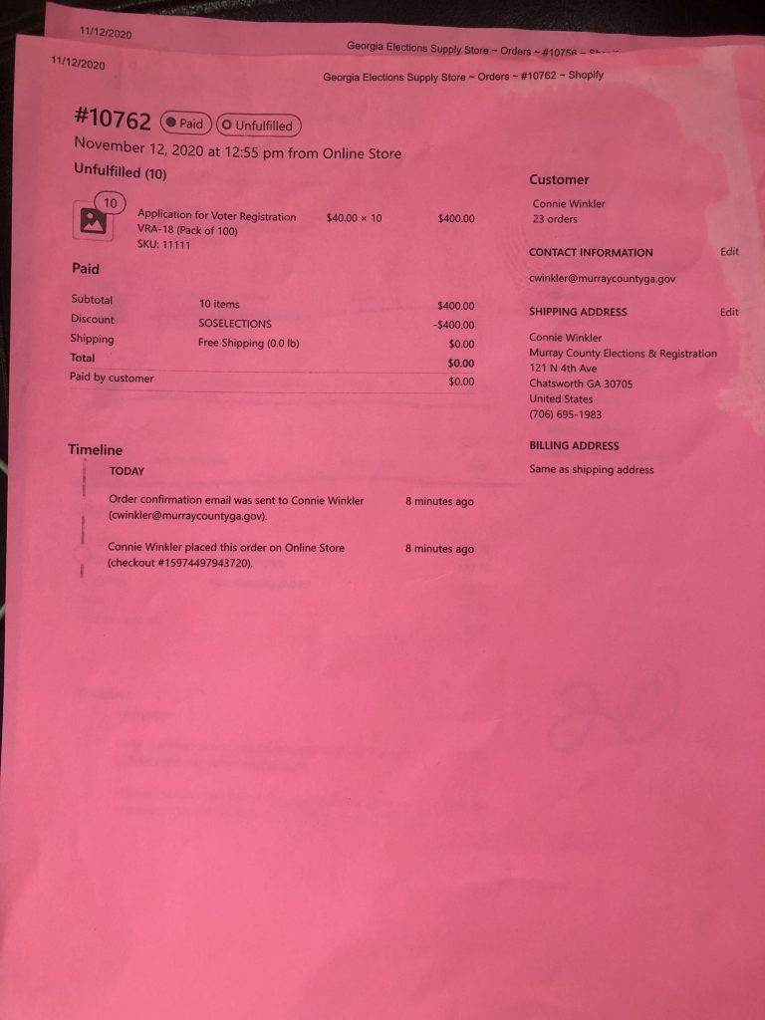
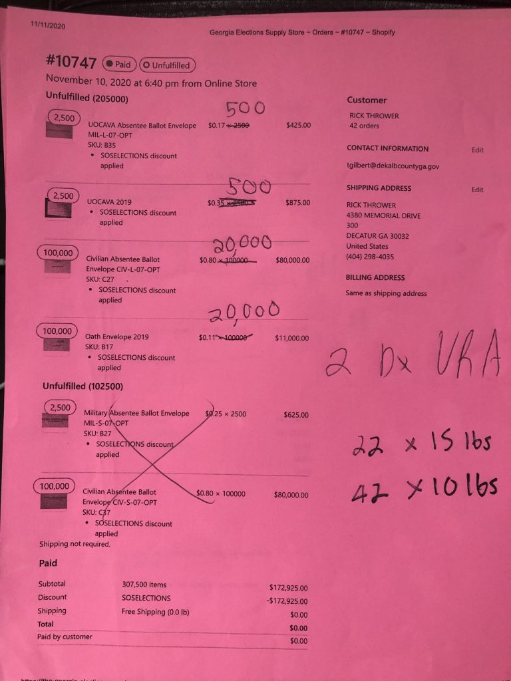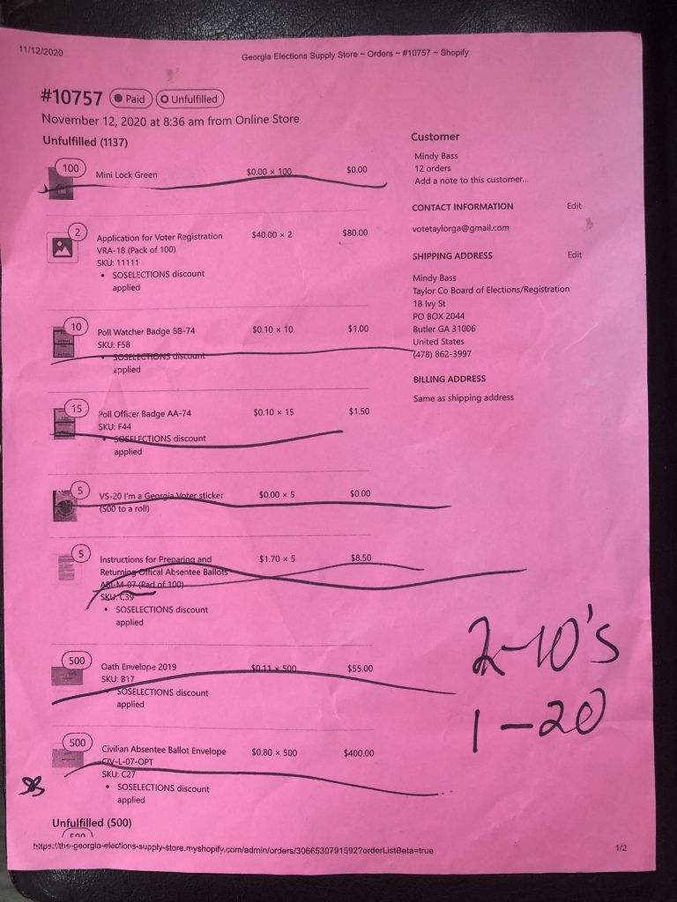
———————————-
CDMedia has been reporting on information found in dumpsters outside of GA election facilities. We thought this one was especially interesting. Dekalb County, on the east side of metro Atlanta, with a population significantly less than one million, possibly ordered in November of last year after the general election, 25 million voter registration applications.
Dekalb was suspiciously slow on the evening of the GA Senatorial runoff election on January 5th of this year.
You can see the receipt below.
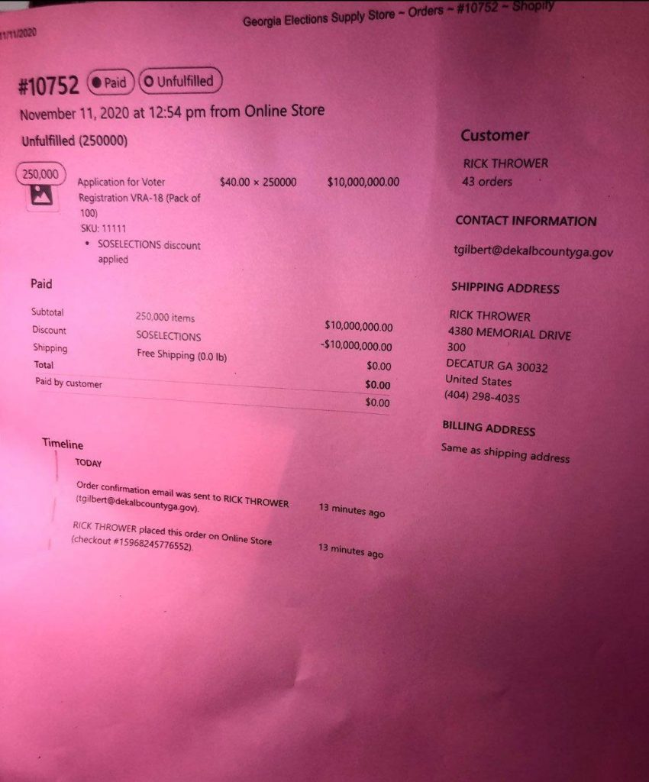
What could possibly be the reason for this order? At the very least, this needs to be investigated by GA election officials and law enforcement.

The Arizona Effect
Let me first hit you with the punchline: the entire planet is about to be dosed with the reality that President Trump won the election in a massive landslide, and Americans will be facing the fact that Creepy is factually indeed not the President.
After it's accepted fact by the masses that Trump dominated the election results, the question will then be "what now?".
You and I know the election was a massive coup, as do most people who can generate enough cerebral firepower beyond what's required to maintain core breathing functionality, but the intellectually void in our society vehemently call it a "conspiracy theory". Even they will be forced to deal with reality.
In Arizona, an audit is finally underway, and has been since last Friday. You can tell because AntiFa-BLM is ramping up and attention has been on the Fentanyl Floyd trial, attempting to distract Americans by creating outrage at the verdict.
Don't fall for such distractions. Nothing with respect to our country and Republic is more important than the elections. From the nanosecond it's understood the people are back in control, our culture will immediately snap back to normalcy.
What happens after the people are back in control? Criminals go to jail. The global warming hoax goes away overnight. Academia begins to expel the Marxist cancer that's made a joke of institutions trusted to actually educate. AntiFa-BLM intimidation ceases and the participants go back to their parents' house and take that much-needed shower. Our country goes back to normal like it was decades ago.
These audits are huge, as will be the upcoming "freight train" of audits. It's why GOP rodents in Georgia are in a panic. How about Wisconsin, where 97% of first-time no-ID ballots were fraudulent? I believe all 50 states will undergo and audit, and it will be proven to the masses that Trump won all of them.
We got this far with Republicans fighting us tooth-and-nail. What will it be like after the first audit is complete? Radio stations will be forced to tell their idiot RINO talk show hosts to stop saying Creepy won the election because the pressure and heat from pissed-off listeners will be too great. State Republican legislatures will feel whips cracking on their asses like they've never before felt.
These audits were never supposed to happen. The coup was supposed to be wrapped up and put to bed. Instead, President Trump has been in control this entire time, and the Marxist globalists who thought they'd be able to take over have been met with a sea of booby-traps preventing them from seizing control.
Here's an example: the Perkins Coie-connected Judge who took over for Judge Coury, who recused himself out of the clear blue, told the Democrats if they put up $1mm bond, he'd pause the audit. They couldn't do it.
The deep state and Democrat Party couldn't put that cash together? Really? Why? They're left to begging the DOJ to put a stop to it. Does that sound like they're winning and in control?
Meanwhile, President Trump has officially taken over the GOP, and has the now-Cheney-lead GOP on its knees. The GOP's fundraising is in the tank:
But instead of really listening to what Trump said at CPAC, the GOP establishment types responded the same way CNN did: either by derisively mocking the speech or calling it a threat to democracy. Plenty of establishment media covered the speech as the loud, angry whining of a sore loser. And then, when the first quarter’s fundraising results were announced, all Hell broke loose. The RINOs rubbed their eyes in shock as they looked at the numbers. It turns out that not only did the Conservative base hear Trump’s March 9 call for them to bypass the GOP and to send their money straight to him, but they also sent him enough to dominate the fundraising quarter by a wide margin.
By how much did Trump dominate the year’s first fundraising quarter now that he’s an outsider again? Trump’s Save America PAC raised a cool $23,000,000 more than the RNC and the DNC combined
And Trump didn’t put out that March 9 statement until the quarter was half over. Imagine the numbers Trump is going to pull in during the next quarter, at this rate. Understand what this means: Trump has diverted a tremendous amount of the stream of money coming from the base to the GOP. That money is now going to Trump himself. Which, of course, gives Trump an immense amount of clout.
I wonder if this audit is happening because of the dirt and information the Trump team has on, well, everybody? I am certain the election coup was allowed to happen, but in retrospect, was the confidence always high that we'd get here because of the goods gathered over the past four years?
My confidence continues to be sky-high, and the fact we're in the middle of these audits, with more on the way, is something you should take a moment to appreciate. Those on the fence, or know the election was stolen but lack the confidence or knowledge to debate or argue, will be able to point to legitimate audit results that say Trump won bigly.
Think about the people of whom you know, or have seen on social media that say "Biden won", or "Trump lost" and "is a sore loser". Think of the clowns using the word "President" before Creepy, as if that is remotely believable.
All of them will have no choice but to acknowledge Trump is the President, and needs to be sworn back into office. If they don't agree with that, then they admit it's OK to steal an election. Do you see how they're in an impossible check-mate?
The automatic response from the drones on our side is "but... but.. but the media will say...". You'd think by now they'd understand Trump won in a massive landslide while the media was against him. Same in 2016.
A country can't allow the person the country overwhelmingly voted against be considered President instead of the person for whom the entire country overwhelmingly voted. It doesn't work that way, and there are remedies.
In the Cave for 40 Days
Fifteen volunteers have emerged from a cave in the southwest of France after spending 40 days without clocks, phones, or sunlight for a human isolation experiment.
The group of eight men and seven women lived in the Lombrives cave as part of a $1.4 million project called Deep Time, which set out to explore the limits of human adaptability to isolation. The project, led by the Human Adaption Institute, ended on Saturday after 40 days.
Social media footage from the day shows the smiling volunteers emerging from the cave to a round of applause while wearing special sunglasses to protect their eyes after so long in the dark.
During their time in the cave, the volunteers slept in tents and made their own electricity with a pedal bike since there was no natural light. They also drew water from a well 146 ft below the earth.
Since there was no sunlight, the team had to follow their biological clocks to know when to sleep, eat, or do daily tasks.
To no one's surprise, they quickly lost their sense of time.
Project director Christian Clot, who was also part of the group, told reporters Saturday: "And here we are! We just left after 40 days … For us, it was a real surprise," according to The Guardian.
One volunteer said they thought he had been underground for 23 days.
The group had no communication with the outside world and was not able to use phones or other electronic devices.
One volunteer, math teacher Johan Francois, said he ran 10 kilometer (6.2 mile) circles in the cave to stay fit. He told reporters he had "visceral urges" to leave the cave, according to the BBC.
But other volunteers felt differently, with two-thirds saying they wanted to stay in the cave for longer.
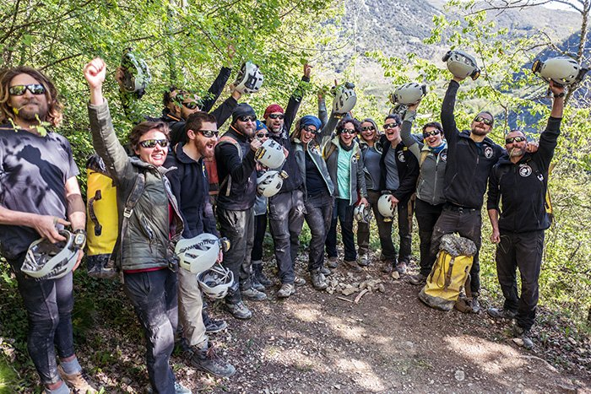Volunteers celebrate after leaving the Lombrives cave. (Fred Scheiber/AFP via Getty Images)
"For once in our lives, it was as if we could press pause," Marina Lançon, one of seven women to take part in the experiment, said, according to The Guardian. "For once in our lives, we had time and could stop to live and do our tasks. It was great."
However, Lançon did admit to feeling happy to be outdoors and hear birdsong again.
French and Swiss scientists at the Human Adaption Institute monitored the volunteers closely during their time in the cave. They would regularly check the team's sleeping patterns, social interactions, and cognitive functions via sensors.
The volunteers' brain activity was also collected before and after they entered the cave.
The scientists behind the project say it will help them understand how people can adapt to extreme living conditions and being in complete isolation.
"Our future as humans on this planet will evolve," Clot said after emerging from the cave. "We must learn to better understand how our brains are capable of finding new solutions, whatever the situation."
Earth is Passing Through Supernova Debris
Radioactive dust deep beneath the ocean waves suggests that Earth is moving through a massive cloud left behind by an exploded star.
Continuously, for the last 33,000 years, space has been seeding Earth with a rare isotope of iron forged in supernovae.
It's not the first time that the isotope, known as iron-60, has dusted our planet. But it does contribute to a growing body of evidence that such dusting is ongoing - we are still moving through an interstellar cloud of dust that could have originated from a supernova millions of years ago.
Iron-60 has been the focus of several studies over the years. It has a half-life of 2.6 million years, which means it completely decays after 15 million years - so any samples found here on Earth must have been deposited from elsewhere, since there's no way any iron-60 could have survived from the formation of the planet 4.6 billion years ago.
And deposits have been found. Nuclear physicist Anton Wallner of the Australian National University previously dated seabed deposits back to 2.6 million and 6 million years ago, suggesting that debris from supernovae had rained down on our planet at these times.
But there's more recent evidence of this stardust - much more recent.
It's been found in the Antarctic snow; according to the evidence, it had to have fallen in the last 20 years.
And, a few years ago, scientists announced that iron-60 had been detected in the space around Earth, measured over a 17-year period by NASA's space-based Advanced Composition Explorer.
In 2020, Wallner found more of the stuff, in five samples of deep-sea sediments from two locations dating back to 33,000 years ago. And the amounts of iron-60 in the samples are pretty consistent over the entire time period. But this finding actually poses more questions than it answers.
Earth, you see, is currently moving through a region called the Local Interstellar Cloud, made up of gas, dust and plasma.
If this cloud was created by exploding stars, then it's reasonable to expect that it's dusting Earth with a very faint rain of iron-60. This is what the Antarctic detection suggested; and this is what Wallner and his team were seeking to validate by examining the ocean sediments.
But if the Local Interstellar Cloud is the source of the iron-60, there should have been a sharp increase when the Solar System entered the cloud - which, according to the team's data, is likely to have occurred within the last 33,000 years. At the very least, the oldest sample should have had significantly lower levels of iron-60, yet it did not.
It's possible, the researchers note in their paper, that the Local Interstellar Cloud and the supernova debris are coincident, rather than one structure, with the debris remaining in the interstellar medium from supernovae that took place millions of years ago. That would suggest that the Local Interstellar Cloud is not a faint supernova remnant.
"There are recent papers that suggest iron-60 trapped in dust particles might bounce around in the interstellar medium," Wallner said last year.
"So the iron-60 could originate from even older supernovae explosions, and what we measure is some kind of echo."
The best way to find out, the researchers note, is to look for more iron-60, covering the gap between 40,000 years ago and around a million years ago.
If the iron-60 abundance grows greater farther back in time, that would suggest ancient supernovae.
However, a greater abundance more recently would suggest that the Local Interstellar Cloud is the source of the iron-60.
The research has been published in the Proceedings of the National Academy of Sciences.
Here’s the Beef
riticism of the beef industry this past week was thrust to the forefront of the U.S. political stage when the cooking brand Epicurious announced that it would no longer publish new beef-based recipes as part of "an effort to encourage more sustainable cooking."
Long a target of environmentalists due to its purported negative effects on the global environment, cattle farming has lately been pilloried by eco-activists for its alleged hastening of warming across the planet due to the high levels of greenhouse gasses that the industry produces every year.
Yet a relatively small but growing body of research suggests that certain types of cattle farming— namely, those in which cows are raised on pastures for their whole lives as opposed to in feedlots — may actually have a carbon-negative effect on the environment by helping to sequester greenhouse grasses under well-managed grasslands.
The vast majority of beef produced in the U.S. is sourced in feedlots in which cattle are fed primarily corn and grains, a diet which hastens their fattening and prepares them for slaughter much earlier than traditional methods.
Environmentalists have criticized those systems as ecologically ruinous due to their heavy carbon footprints, citing in part their dependence on chemically fertilized cattle feed and the copious amounts of methane that cows emit in the form of burps and flatulence.
The Washington Post, meanwhile, claimed recently that "science says beef should be on the chopping block" due to beef's "significant role in greenhouse gas emissions." And the Atlantic deemed beef the "main, mooing offender" driving livestock greenhouse gas emissions, with writer Annie Lowrey declaring that "trading your rib eyes and cheesesteaks for lentils and tofu is one of the best things you can do as a consumer for the environment."
Pastured livestock has different environmental profile
Yet other activists have pointed to a much smaller segment of the beef market as a possible answer to the conundrum of beef's carbon footprint: Pasture-raised beef, in which cattle are raised on grasslands from birth to slaughter.
Grass-fed beef still commands a very small fraction of the overall beef market. One 2017 estimate put it at just 4% of total U.S. beef sales. The relative scarcity of pastured beef, as well as its considerably heftier price tag, has kept it from gaining much of a foothold in the mammoth American meat economy, which in 2019 saw $111 billion in beef production.
Still, growing interest in pastured beef — spurred on by an explosive growth in farmers markets around the country over the past decade — has led to a steady rise in the product's visibility, with major corporations and even fast food chains such as Arby's seeking to capitalize on the niche market.
Alongside that growth has come a still-small but steady series of investigations looking into the environmental outcomes of pastured cattle operations. In many cases scientists have found that grass-fed beef farms can actually have a net-carbon-negative effect on environmental emissions.
One 2018 study by researchers in Michigan and Washington, D.C. applied "life cycle analysis" to "two different beef finishing systems in the Upper Midwest," one grass-fed and one feedlot-finished. The scientists found that intensive, rotational grazing "has the potential to offset [greenhouse gas] emissions through soil [carbon] sequestration, and therefore the finishing phase could be a net [carbon] sink."
Grasses, the researchers noted, can be highly efficient carbon sequesters. That sequestration "is a critical ecosystem service of grasslands," they write, a natural phenomenon "which can be maximized using best management practices for livestock grazing."
Another study, published last December, reviewed a "multispecies pasture rotation" in the southeastern United States that incorporated multiple species of livestock including cattle. The authors of that study note that feedlot beef are more efficient at "gaining more weight in less time," thus producing less total greenhouse gas emissions over their lifespan; however, the sequestration effects of the multispecies pastured rotation ultimately "reduced the [greenhouse gas] footprint of the [pastured] system by 80% ... ultimately finishing at 66% lower than comparative [feedlot] production."
Both studies noted a pointed downside to pastured systems: Pastured farms require considerably more land to produce beef compared to the more compact feedlot systems.
Other researchers have come to different conclusions regarding the environmental feasibility of pastured beef. A 2017 study by the Food Climate Research Network argued that the potential offsets of worldwide grazing systems would only effect between 0.6-1.6% of yearly greenhouse gas emissions, “to which of course livestock also substantially contribute," the network noted.
Still other advocates have expressed considerably ambitious goals for pastured farming. The Savory Institute, an ecological advocacy group that promotes what it calls Holistic Planned Grazing, says that that grazing method has "the potential to remove the excess atmospheric carbon that has been the result of both anthropogenic soil loss over the past 10,000 years and industrial-era greenhouse gas emissions."
"This sequestration potential, when applied to up to 5 billion hectares of degraded grassland soils, could return 10 or more gigatons of excess atmospheric carbon to the terrestrial sink annually thereby lowering greenhouse gas concentrations to pre-industrial levels in a matter of decades," the institute claims.
Regardless of the potential environmental benefits or downsides, one thing that may pose an insurmountable deterrent for many consumers is pastured beef's price: Average ground beef prices in U.S. cities in March were about $4 per pound, while grass-fed ground beef often runs twice as much as that or more.
Beef prices across the industry spiked last year due in part to the effects of coronavirus restrictions and processing woes amid the pandemic.
The Hypochondriac Nation
The Centers for Disease Control and Prevention revised its guidance on mask-wearing, advising that Americans who are fully vaccinated may now exercise and attend small outdoor gatherings without a mask.
It's too little, too late, argues Stanford University Professor of Medicine Jay Bhattacharya. The public health agency's hypervigilant coronavirus response over the past 12-14 months has paved the way for what he calls "the institutionalization of hypochondria" among the American public
"This sort of order should have come long ago," said Bhattacharya during an interview on "Just the News AM." "I think they're being entirely too cautious by saying, 'Okay, only if you're vaccinated ... People who have had the disease before are also immune. Why shouldn't they be 'allowed' to not wear masks?"
There has been "very little evidence of outdoor transmission of the disease to begin with," added Bhattacharya, coauthor of the Great Barrington Declaration, a manifesto that urges an alternative COVID-19 strategy focused on protecting those at greatest risk while minimizing disruption and damage to the larger society. The statement has been signed by close to 14,000 medical and public health scientists.
"[P]ublic health authorities, including the CDC have generated an enormous amount of fear and panic around the disease," says Bhattacharya.
On Tuesday, President Biden, who has been fully vaccinated for many months, wore a mask outside as he walked to the podium to address the press regarding the CDC's newest guidance. Last week, Biden wore a mask during a virtual climate summit with other world leaders.
Calling masks "a palpable symbol of panic and fear," Bhattacharya said Biden’s use of a mask in public "even though he has been vaccinated and is immune, sends the entirely wrong signal about the efficacy of vaccination and a whole host of other things."
"We basically have said, look at disease avoidance as the central problem in your life, no matter who you are," he explained. "It's not taking care of your kids. It's not practicing your faith. It's not doing as well as you can in your in your profession. None of that is as important as avoiding disease. And I think it's going to be very difficult to undo that."
Fascism at its Best
Newly-released documents suggest that one of the country’s most powerful teachers’ unions shaped Biden administration policies on the reopening of schools, despite President Joe Biden’s pledge to “follow the science” on pandemic policy.
The documents, obtained by the conservative group Americans for Public Trust through a Freedom of Information Act request, were reported Saturday by the New York Post. They show the American Federation of Teachers (AFT) lobbying the Centers for Disease Control and Prevention (CDC) — and succeeding in having some of their recommendations adopted.
The teachers’ unions had long opposed a rapid reopening of schools, even when science said there was no significant risk. The Los Angeles teachers’ union also claimed that a statewide school reopening plan would reinforce “structural racism.”
The Post reported:
The powerful teachers union’s full-court press preceded the federal agency putting the brakes on a full re-opening of in-person classrooms, emails between top CDC, AFT and White House officials show.
…
The documents show a flurry of activity between CDC Director Dr. Rochelle Walensky, her top advisors and union officials — with Biden brass being looped in at the White House — in the days before the highly-anticipated Feb. 12 announcement on school-reopening guidelines.
Biden campaigned against President Donald Trump by claiming that he would follow the science on the coronavirus, pandemic, implying that the Trump administration had not.
When he announced the administration’s policy on school re-openings February 12, Biden said he would “follow the science” and claimed that the CDC “has provided the best available scientific evidence on how to reopen schools safely.” Walensky also claimed that there had been no political interference.
Why the Teacher’s Union?
Amid complaints from parents that their children are being "indoctrinated," a Missouri school district official is advising English teachers to create a fake curriculum and keep the real one hidden.
The real one is focused on "antiracist" activism and issues of "white privilege," the Daily Wire reported.
The author of the memo is Natalie Fallert, the literacy speech coordinator for grades 6-12 in the Rockwood School District, serving several towns west of St. Louis that are overwhelmingly white.
She told middle and high-school English teachers in the district that parents had been complaining "we are pushing an agenda," "we are pushing Critical Race Theory (I had to look this one up!)," "we are making white kids feel bad about their privilege," we are "stereotyping," "we are teaching kids to be social activists" and "we are teaching kids to be democratic thinkers and activists."
The controversial curriculum included "Intersectionality 101," a video produced by the Southern Poverty Law Center. A handout for fifth-graders teaches "Michael Brown was murdered just steps from his mother's home in Ferguson, Missouri." And it says: "Disruption is the new world order. It is the way in which those who are denied power access power."
The complaints have come, the Daily Wire noted, as online teaching under COVID-19 protocols enables parents to see classroom instruction for the first time.
The assignments are now visible to at-home learners in a tool called Canvas. So Fallert has a solution:
This doesn't mean throw out the lesson and find a new one. Just pull the resource off Canvas so parents cannot see it …
Completing this poll entitles you to WND news updates free of charge. You may opt out at anytime. You also agree to our Privacy Policy and Terms of Use.

Keep teaching! Just don't make everything visible on Canvas. This is not being deceitful. This is just doing what you have done for years. Prior to the pandemic you didn't send everything home or have it available. You taught in your classroom and things were peachy keen. We are going old-school. …
You could Duplicate an entry/lesson in Canvas (making 2 copies) Publish ONE for the whole class that is a LEAN version of the lesson. The "original" that has all the stuff on it, can be published and only assigned to specific students (IF NEEDED), OR you could specifically email those students a copy of what they need.
The reason I say "make a copy" You can publish the NEW one that has less information on it. Then for that kid who is all virtual and needs to full lesson, you can publish it and assign it ONLY that kid…
Anything that "could" be picked apart I would suggest using this above approach… Again I wouldn't throw it out, but you could just not give them access to the story.
When you get to Power Imbalances – You might remove the two examples and just go over them in class (same as above). …
I hate that we are even having to have this conversation. 29 days and counting!
When parents learned of Fallert's memo, Shelley Willott, assistant superintendent of learning and support services, engaged in damage control.
She sent out an email to parents on April 23 expressing "regret" for the memo and declaring the district views parents as "allies" in the education of "our children."
"Yesterday an email was sent to middle and high school English Language Arts teachers from a district-level staff member that suggested teachers hide or alter content visible to parents in our learning management system," Willott wrote. "We want to assure you that the message was not reviewed or approved by anyone before it was sent. Asking teachers to conceal anything from parents does not reflect the mission, vision and values of the Rockwood School District and is counter to the goals set forth in our strategic plan, The Way Forward."
Willott acknowledged the memo "impacts the trust that is crucial for our partnership to be successful."
"Although we cannot share specifics related to a personnel matter, we can assure you that we find the email unacceptable, and it is certainly being addressed," she said.
District spokesman David Morrison told the Daily Wire classroom materials will continue to be posted online. And the district will train educators "on how to curate books so that teachers are giving students a wide variety of choices in their learning materials." He said teachers will be asked "to provide parents with book choices before a unit of study starts and information about read alouds that will be done in the classroom as part of regular communications with parents (i.e. weekly newsletters)."
'A disaster for this country'
The Biden administration, meanwhile, has submitted a new rule that would fund critical race theory in public schools.
Stanley Kurtz, writing for National Review Online, warns it would be "a disaster for this country."
"Put that new rule together with the massive federal Civics Secures Democracy Act that pushes both leftist 'action civics' and Critical Race Theory, and K–12 education in America will be transformed beyond recognition."
"Action civics" is a style of education described as learning by doing, with a focus on "collective action."
Kurtz, a senior fellow at the Ethics and Public Policy Center who has taught at Harvard University and the University of Chicago, said the way to stop the "power play" is through state legislation that keeps both action civics and critical race theory out of K–12.
He has formulated a legislative proposal called the Partisanship Out of Civics Act that does both, noting that most states are considering bills that bar only CRC.
On Monday, as WND reported, Idaho became the first state in the nation to put a bill on a governor's desk that would ban critical race theory in public schools.
Action civics is just as dangerous as critical race theory, Kurtz contended, "and in fact is directly allied with it."
He pointed out that the "new ultra-woke Critical Race Theory-inspired teaching standards in Illinois even encourage teachers to substitute 'social justice work' and 'action civics projects' for traditional testing when determining a student’s grade."
Kurtz warned that if the federal Civics Secures Democracy Act passes before the start of the 2022 state legislative session, it may be too late to keep action civics and critical race theory out of the states.

Cancel Culture Blocks Punk
Glenn Danzig, who founded the rock band, Misfits, said his band and “the punk explosion” could never happen today, because of “cancel culture and woke bullshit.” The rocker added, “you won’t have any of those kinds of bands ever again,” because “everyone’s so uptight and P.C.”
When asked about the meaning behind the Misfits’ song, “Last Caress,” Danzig told Rolling Stone, “it’s just a crazy-ass song. We would do things just to piss people off.”
The lyrics to “Last Caress,” read, in part: “I got something to say, I killed your baby today, and it doesn’t matter much to me, as long as it’s dead. Well I got something to say, I raped your mother today, and it doesn’t matter much to me, as long as she spread.”
“It was something else,” Danzig said. “I don’t think people will ever see anything like it again. There won’t be any new bands coming out like that. Now, they will immediately get canceled.”
When asked to explain what he meant by that, Danzig said, “people don’t understand, because everything’s so cancel-culture, woke bullshit nowadays.”
“You could never have the punk explosion nowadays, because of cancel culture and woke bullshit,” the rocker continued. “You could never have it. It would never have happened. We’re lucky it happened when it did, because it’ll never happen again.”
“You won’t have any of those kinds of bands ever again,” Danzig insisted. “Everyone’s so uptight and P.C., it’s just like, ‘OK, whatever.'”
Danzig is not the only punk rocker to express his disdain for the woke culture of today.
Sex Pistols frontman John Lydon — also known as Johnny Rotten — recently called “wokeness” a divisive political weapon being wielded by privileged, “tempestuous, spoilt children,” whom the media offer a platform to push their unpopular politically correct opinions.
“Wokeness,” Rotten said, is “a device used by the privileged to keep the working class in their place.”
Last October, Rotten confirmed that he was “definitely” voting for President Donald Trump in America’s November 2020 presidential election.

NORK Noise
North Korea on Sunday warned the United States will face “a very grave situation” because President Joe Biden “made a big blunder” in his recent speech by calling the North a security threat and revealing his intent to maintain a hostile policy against it.
Last week, Biden, in his first address to Congress, called North Korea and Iran’s nuclear programs “serious threats” to American and world security and said he’ll work with allies to address those problems through diplomacy and stern deterrence.
“His statement clearly reflects his intent to keep enforcing the hostile policy toward the DPRK as it had been done by the U.S. for over half a century,” Kwon Jong Gun, a senior North Korean Foreign Ministry official, said in a statement. DPRK stands for the Democratic People’s Republic of Korea, the North’s official name.
“It is certain that the U.S. chief executive made a big blunder in the light of the present-day viewpoint,” Kwon said. “Now that the keynote of the U.S. new DPRK policy has become clear, we will be compelled to press for corresponding measures, and with time the U.S. will find itself in a very grave situation.”
Kwon still didn’t specify what steps North Korea would take, and his statement could be seen as an effort to apply pressure on the Biden administration as it’s shaping up its North Korea policy.
The White House said Friday administration officials had completed a review of U.S. policy toward North Korea, saying Biden plans to veer from the approaches of his two most recent predecessors as he tries to stop North Korea’s nuclear program. Press secretary Jen Psaki did not detail findings of the review, but suggested the administration would seek a middle ground between Donald Trump’s “grand bargain” and Barack Obama’s “strategic patience” approaches.
Kwon’s statement didn’t mention Psaki’s comments.
After a series of high-profile nuclear and missile tests in 2016-17, North Korean leader Kim Jong Un launched summit diplomacy with Trump on the future of his growing nuclear arsenal. But that diplomacy remains stalled for about two years over differences in how much sanctions relief North Korea could win in return for limited denuclearization steps.
In January, Kim threatened to enlarge his nuclear arsenal and build more high-tech weapons targeting the U.S. mainland, saying the fate of bilateral ties would depend on whether it abandons its hostile policy. In March, he conducted short-range ballistic missile tests for the first time in a year, though he still maintains a moratorium on bigger weapons launches.
“If Pyongyang agrees to working-level talks, the starting point of negotiations would be a freeze of North Korean testing and development of nuclear capabilities and delivery systems,” Leif-Eric Easley, a professor at Ewha University in Seoul, said. “If, on the other hand, Kim shuns diplomacy and opts for provocative tests, Washington will likely expand sanctions enforcement and military exercises with allies.”
Also Sunday, an unidentified North Korean Foreign Ministry spokesman vowed a strong, separate response to a recent State Department statement that it would push to promote “accountability for the Kim regime” over its “egregious human rights situation.” He called the statement a preparation for “all-out showdown with us.”
Kim’s powerful sister, Kim Yo Jong, also slammed South Korea over anti-Pyongyang leaflets floated across the border by a group of North Korean defectors in the South. The group’s leader, Park Sang-hak, said Friday he sent 500,000 leaflets by balloon last week, in a defiance of a new, contentious South Korean law that criminalizes such action.
“We regard the maneuvers committed by the human waste in the South as a serious provocation against our state and will look into corresponding action,” Kim Yo Jong said in a statement.
She accused the South Korean government of “winking at” the leaflets. Seoul’s Unification Ministry responded later Sunday saying it opposes any act that creates tensions on the Korean Peninsula and it will strive to achieve better ties with North Korea.
Easley said the North Korean statements by Kwon and Kim Yo Jong show that “Pyongyang is trying to drive a wedge between South Korea and the United States” ahead of the May 21 summit between Biden and South Korean President Moon Jae-in.
© Copyright 2021 The Associated Press. All rights reserved. This material may not be published, broadcast, rewritten or redistributed.
We haven’t Had That Spirit Since 1968
Four astronauts have successfully returned to Earth from the International Space Station early Sunday morning in a "splashdown" that took place in the Gulf of Mexico.
Returning in a SpaceX capsule, the astronauts marked the first nighttime return to earth for NASA "in decades", according to the Wall Street Journal.
The Crew Dragon Resilience made its "soft splashdown" at 2:57am on Sunday and was then hoisted into a recovery vessel near Panama City, Florida. The astronauts had been in space for 168 days, completing SpaceX's first "operational round trip mission".
The crew, consisting of National Aeronautics and Space Administration astronauts Michael Hopkins, Victor Glover, and Shannon Walker and Soichi Noguchi of the Japan Aerospace Exploration Agency, was brought into orbit last year, before docking with the ISS.
Photo: WSJ
NASA and SpaceX are reportedly falling into an operational "cadence" with one another, with the return of the four astronauts marking the latest in a series of milestones for the two agencies. The two agencies "have regularly scheduled human shuttles to and from space using the company’s commercially built rockets and capsules," according to the Journal.
Another crew of four is also at the International Space Station, beginning their mission, after being launched into orbit last month on a SpaceX rocket.
SpaceX intends on launching 7 capsules for NASA, including three cargo variants, over the next 15 months, the report said.
Apollo 8 was the last nighttime splashdown, which occurred after the mission orbited the moon in 1968.
The FBI Needs to be Disbanded
The Federal Bureau of Investigation knowingly violated the Constitution to track down potential ‘racially motivated violent extremists.’ But the FBI didn’t conduct its unconstitutional dragnet following the January 6th Capitol riots, it actually started its probe in November — in the midst of a contested election.
A newly declassified report shows that the FBI pursued extremists in November that would fit the profile of future Capitol rioters by tapping into a National Security Agency database that trawls and records Americans’ communications.
“The FBI’s requests for access to masses of electronic communications harvested by the National Security Agency (NSA) is revealed in a newly declassified report from the United States’ secret surveillance court,” the Daily Mail reported on Monday.
“It shows the FBI has continued to perform warrantless searches through the NSA’s most sensitive databases for routine criminal investigations, despite being told by a federal judge in 2018 and 2019 that such a use was an unconstitutional breach of privacy,” the report continued.
The declassified FISA report makes the legal procedures for targeting an actor for surveillance clear.
“NSA is the lead agency in making targeting decisions under Section 702,” the report says. “It may not task a selector without first determining that the target is reasonably believed to be a non-U.S. person outside the United States (a ‘foreignness determination’).”
The FBI is extensively using the NSA’s database for routine domestic investigations, despite knowing that the practice is illegal.
“In other words, the FBI continues to perform warrantless searches through the NSA’s most sensitive databases—the ones the NSA is not required to get warrants before filling with communications information—for routine criminal investigations that are supposed to require warrants,” the Daily Beast reported.
While such reports focus on the extent that the FBI violated civil liberties, the rule of law, and Constitutional restrictions against illegal search and seizure, there is the matter of timing that makes them even more explosive.
The Democratic Party knew about and was planning for a volatile situation on January 6th that could potentially foment into a riot.
House impeachment manager Rep. Stacey Plaskett revealed a glimpse of such advanced knowledge on the second day of the Trump impeachment trial.
“The day before the rioters stormed the Congress an FBI office in Virginia also issued an explicit warning that extremists were preparing to travel to Washington to commit violence and, quote, war, according to internal reports,” she said.
“Leading up to the event there were hundreds, hundreds of posts online showing that his supporters took this as a call to arms to attack the Capitol,” she continued. “There were detailed posts of plans to attack online. Law enforcement warned that these posts were real threats and even made arrests days leading up to the attack.”
Rep. Maxine Waters also revealed in an interview just after the Capitol riots she had warned the Capitol Police Chief Steven Sund about the danger several days prior to the attack.
Nonetheless, the Capitol Police was effectively issued a ‘stand down’ order, the NY Times recently confirmed, and the National Guard was ordered to maintain a light presence. This is unusual on its face, given that the nation’s most influential politicians had gathered for one of the most divisive events in decades.
But the organized left’s planning for expected protests extends into early 2020, when a shadowy collection of union leaders, radical organizations, and corporations sought out ways to “fortify” the upcoming election against a potential uprising.

