The 2020 Selection
A lawyer who has been fighting for an accurate review of the 2020 presidential election results in Antrim County, Michigan, went on social media this week to charge the election system there was accessed by an anonymous user – remotely – days after the election.
Lawyer Matthew DePerno previously said the evidence appears to show the machines could have been accessed remotely through the internet, and there existed software in the machines that would have allowed manipulation of the results.
The county was where suspicions of vote interference were raised immediately because the GOP-leaning district was declared to have voted for Joe Biden last November. Officials later said there was human error and President Trump actually won.
But it became representative of shady actions or results across the country.
Further, Michigan was one of six battleground states that drew charges of election fraud. Several states suspended counting on Election Night with Trump leading. Hours later, after massive ballot dumps that were nearly 100% for Biden, the Democrat took the lead when counting resumed.
DePerno's lawsuit was dismissed but actions are on hold because the judge said he expects an appeal, which DePerno confirmed he will pursue.
Now DePerno has posted on social media:
"1. We have been lied to. The Antrim County election management system (EMS) was REMOTELY and successfully logged into anonymously on 11/05/2020 at 5:55 PM and again on 11/17/2020 at 5:16 PM. Yes, that is correct … REMOTELY.

"2. Those dates are significant because they correspond directly to the dates the county and SOS were trying to correct the intentional computer problems that subverted the election. These logons appear to have escalated privileges at the time of logon. Again .. REMOTELY."
He continued, "3. But we were told there was no internet connection. In an accredited system, an anonymous user should not be authorized by the accreditation authority, but would instead be required to enter a specific user name and password to utilize the system. 4. We were told there was no internet connection. We were told there was no remote access. We were told this was human error. All lies. This is fraud. This decertifies the Antrim County election. SOS Benson should resign or be impeached."
The Gateway Pundit called it a "BOMBSHELL report."
DePerno's social media statements did not include the documentation about the incident of the machines being accessed remotely. But that evidence presumably would be reviewed in his case challenging the integrity of the election in November 2020.
He had reported earlier that the machines could be reopened after an election was finished. "The machines can then run more ballots through the tabulator, print off new tabulator tape with new ballots, and then backdate that tape to November," he said.
His lawsuit was dismissed partly because the judge said state officials said they already had audited the outcome. But the judge said he expected an appeal and DePerno confirmed it will be pursued.
DePerno also noted during an interview that his investigation into voting machines used in the November election now is not limited to the state of Michigan.
DePerno is fighting the case on behalf of Antrim resident William Bailey.
13th Circuit Court Judge Kevin Elsenheimer said, "By deciding this motion, the court is not saying that there were no problems in the way that Antrim County conducting its November 2020 elections. The clerk has admitted that there were challenges and problems in the elections, although the hand count ultimately of the presidential election showed the results were largely consistent with the canvas totals that were entered by the state and reported by the county. Nor am I saying that the processing of election data here wasn't corrupted or corruptible. I don't have the facts to make that determination."
He added, ""The plaintiff's reports and news of the day, including a computer hack recently of a main petro fuel pipeline on the East Coast might well suggest that this is something that policymakers should be looking into in the future. If election results were to be held for ransom in the future, one could only imagine what would happen. I am saying that as pled, the plaintiffs' request for an audit is not available. Anticipating the possibility of appeal, this court will take all pending motions under advisement."
The fight in Michigan is one of several that have been stirring up "fact-checkers" across the political spectrum in recent weeks. They insist that the claims made by DePerno are "in dispute."
That's because, they say, government officials have claimed there are "safeguards" in place to protect "against fraud, including hand counts and audits."
Just days ago, DePerno explained, "And I'll tell you something we discovered this weekend. We can now show that after the election is done, someone, anyone really who has access to those tabulators, can reopen the election, run more ballots through the tabulator, print off new tabulator tape with a new balance and backdate that tape to November 3rd."
Fact-checkers explain Michigan uses paper ballots and they have been preserved, meaning the accuracy of voting machines can be verified.
DePerno earlier said his investigation had revealed that the voting machines there contained a software program that could have been used to manipulate vote totals.
In fact, DePerno said in a podcast interview that with the MySQL program installed on the machines, and them all being linked, someone with access could "do whatever you want."
Fact-checkers objected to his opinion, stating that many audits done in Michigan of elections all show they've been accurate.
DePerno also said recently in a court hearing that there were 1,061 "phantom votes" in the county during the 2020 presidential election, because while a recount of ballots tallied 15,962, the Michigan secretary of state's database showed only 14,901 votes were cast.
Wars-R-Us
Former deputy National Security Adviser K.T. McFarland noted only a short time ago that not even an administration assembled by Joe Biden could "screw up" the Abraham Accords brokered by President Trump and his administration.
But maybe it can.
Or at least it can suppress the name to change the dialogue about them.
A report from Israel365news explains that not only is the Biden administration actively suppressing the name of the historic Trump-brokered deals between multiple Arab neighbors and Israel, it apparently is trying "to dismantle the Abraham Accords in order to realign the U.S. with Iran and strengthen the Islamic regime."
A report in Tablet explained, "The alliance between Israel and the Gulf states is an impediment to the dream of a re-empowered, nuclear-armed Iran backed by the United States, which was Obama's main foreign policy aim – and an affront to peace processors convinced of their own never-ending importance."
The report continued, "The Biden administration apparently aims to sink the accords by penalizing Israel and its peace partners for getting too close, and returning the Palestinians to center stage – in order to prepare the ground for reentering the Iran deal."
There have been tense strident exchanges regarding the name of the agreements.

The Free Beacon explained that the Biden State Department "discourages employees from referring to the historic peace agreements signed by Israel and its Arab neighbors by its official name, the Abraham Accords, according to one source with direct knowledge of the Biden administration's internal decision-making process and emails reviewed by the Washington Free Beacon."
Instead, the Biden administration is calling the deals "normalization agreements," the report said.
In fact, the "Accords" name "has also been erased from a wide array of official State Department communications," the report said.
They were negotiated last year by the Trump administration "and paved the way for Israel to make peace with traditional Arab foes, including the United Arab Emirates, Bahrain, and, later, other Muslim nations," the report said.
"The Free Beacon reviewed two internal State Department emails detailing to employees that the agreements will no longer be referred to as the Abraham Accords but only as 'normalization agreements.' No reason was given for the policy, the source said. The department also purged the term 'Abraham Accords' from its talking points, documents, statements, and official communications, the source said, adding that senior department officials have been very 'cagey' about explaining the policy decision and have sought to keep it quiet."
The report continued, "Rumors of the policy first surfaced in early April, when Associated Press diplomatic correspondent Matthew Lee pressed State Department spokesman Ned Price to publicly state the official name of the peace agreements. Price bristled at first, before reluctantly calling them the 'Abraham Accords.'"
Price referred to the deals as "normalization agreements" three times when asked, but finally admitted, "I can say the term, Abraham Accords. But we call them normalization agreements."
Despite the historic agreements, White House press secretary Jen Psaki recently claimed Trump didn't to "anything constructive" in the Middle East.
Victoria Coates, who was on Trump's National Security Council, said, "The Biden administration's attempt to diminish and marginalize the Abraham Accords by referring to them as ‘normalization deals’ is both unfortunate and insidious. It’s a shame to try to undermine such a monumental, historic achievement because it was reached by the previous administration. But the term ‘normalization' is even worse—as they are well aware, the term carries a regional stigma, particularly with the Palestinians, of being a sell-out. The Abraham Accords are so much more and should be given the same bipartisan support as the peace treaties between Israel, Jordan, and Egypt reached by Democrat administrations."
The deals – there were reports more were pending when Trump left office – are with Morocco, Bahrain, Sudan and the United Arab Emirates.
McFarland noted, "It's the first peace agreement between Israel and Arabs in not just 10 or 20, it's like a couple of thousand years. What President Trump has done, as everybody was paying attention elsewhere, he was able to craft an agreement and convince the Arabs that their only sort of prosperity platform, the only way they could get to peace and prosperity, was by having a peace agreement with Israel."
President Trump's plan for the Middle East involved going directly to Israel's Arab neighbors, and bypassing the Palestinians, who long have been an obstruction for any peace plans.
President Trump was nominated for a Nobel prize based on his work on the agreements.
WND columnist Michael Brown said America is watching "history unfold before our eyes."
"And it is America that is brokering these deals with Israel and these Muslim nations," he pointed out.
The End of The Made-4-TV-Virus
The truth is that the Made-4-TV Virus could have been ended before it ever got started. The cure, yes the cure, was in hand all along. I told you about it for almost a year and how you could get past the Propaganda police and get your doses without a prescription. People are finally realizing that the entire bioweapon system was designed to get the jab into as many Americans as possible before they found out about the cure, and before they learned the vaccine could alter their DNA for generations to come.
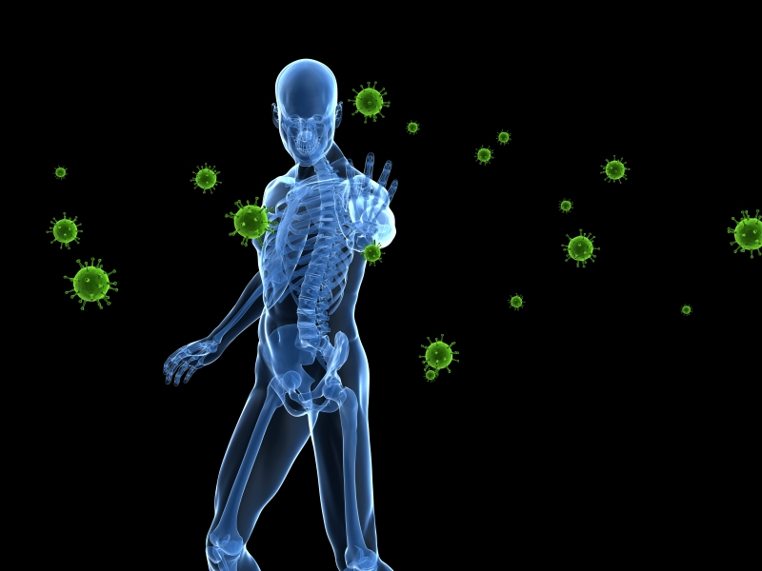
Ivermectin, a common anti-parasite drug, has shown great efficacy in the fight against covid-19. For the first time, medical researchers have documented how ivermectin docks to the SARS-CoV-2 spike receptor-binding domain that is attached to the ACE2 receptor. In this way, ivermectin effectively inhibits viral attachment and replication, assisting a precise antiviral response that can target the SARS-CoV-2 spike protein at its most advantageous cleavage site. The researchers showed how ivermectin interferes with the attachment of the spike protein to the human cell membrane.
Ivermectin is a simple medicine derived from the bacterium Streptomyces avermitilis. It weakens and kills parasites by interfering with their nervous system and muscle function. Ivermectin targets the glutamate-gated chloride channels in the parasite’s nerve and muscle cells, bolstering inhibitory effects in the parasite’s own neurotransmission. As the chloride ions permeate, the parasite’s cells are hyper-polarized and then paralyzed, resulting in their demise.
In this study, ivermectin docked in region of leucine 91 of the spike protein and at the histidine 378 of the ACE2 receptor. The binding energy and constancy of ivermectin was also measured and found to be sufficient at the ACE2 receptor, proving the anti-parasitic molecule a powerful force for blocking viral attachment of SARS-CoV-2.
Ivermectin blocks SARS CoV-2 at the ACE2 receptor in humans
The 17 randomized controlled trials that use ivermectin for early treatment and prophylaxis report positive effects, with an estimated improvement of 73 percent and 83 percent, respectively. Out of 37 early treatment and prophylaxis studies for ivermectin, 97 percent report positive effects. One of the studies documents how ivermectin inhibits the replication of SARS-CoV-2 in vitro and displays broad-spectrum anti-viral activity against the causative virus (SARS-CoV-2). This study showed a 5,000-fold reduction in viral RNA after just 48 hours.
The study also proves that effective treatments and prophylactics can mitigate the replication and spread of a virus thousands of times faster than the paranoid, isolationist approach of social distancing and lockdowns. If antivirals were encouraged early and often, then the spread of actual infectious virus would have been mitigated at rates thousands of times faster than the insane method of treating everyone as if they are infectious. By treating actual infections where symptoms are present, the spread is reduced at magnitudes thousands of times greater, while conveying immunity instead of terror.
The SARS-CoV-2 spike protein is designed to attach to angiotensin-converting enzyme 2 (ACE2) in humans. To see whether ivermectin could dock at this receptor site and block viral attachment, the researchers used a program called AutoDock Vina Extended. This docking study showed the crystal structure of the SARS-CoV-2 spike receptor binding domain. The researchers looked specifically at the human ACE2 receptor and calculated the root-mean-square deviation (RMSD) of its atomic positions. A lower RMSD value indicates a more accurate docking capacity. When the RMSD value is three or greater, no docking has occurred at the receptor site. Ivermectin did not dock at nine of the locations; however, it did dock at the leucine 91 region of the spike and histidine 378 at the intersection of proteins between SARS CoV-2 and the ACE2 receptor complex.
Previous studies proved ivermectin’s efficacy, but had to use high concentrations of the drug because the study relied on African green monkey kidney epithelial cells, which do not express the human ACE2 receptor. SARS-CoV-2 is specifically equipped to infect human ACE2 receptors, so this study could prove ivermectin to be effective in much smaller dosages. Clinical trials are now underway to determine if ivermectin is an effective treatment for covid-19.
The global conspiracy to suppress effective anti-viral medicines
The World Health Organization, the FDA, and the NIH have repeatedly suggested that no antiviral treatments exist for covid-19, even though multiple antiviral herbs and drugs have been studied during previous SARS and MERS epidemics and found to be effective. This time around, many of these antivirals were used with great effectiveness by doctors who were willing to go out on a limb and save lives.
Chinese hospitals used various antiviral herbs to treat covid-19 patients. These hospitals studied the effects of the herbs for impeding virus-cell receptor binding, for stimulation of the host’s immunity, for blocking virus entry into host cells through action on the host’s enzymes, and for prevention of SARS-CoV-2 RNA synthesis and replication. The research found numerous phytochemicals to be effective, including: quercetin, ursolic acid, kaempferol, isorhamnetin, luteolin, glycerrhizin, and apigenin. The top three most effective plants for treating covid-19 included licorice root, (Glycyrrhiza glabra) chicory root, (Cichorium intybus) and hibiscus flowers (Hibiscus sabdariffa). A number of antiviral plants contain compounds that target all three antiviral targets, including olive leaf (Olea europaea), white horehound (Marrubium vulgare), black cumin seed (Nigella sativa), garden cress (Lepidium sativum), Judean wormwood (Artemisia Judaica), guava (Psidium guajava), chrysanthemum (Glebionis coronaria), and Maryam’s flower (Anastatica).
Medical systems around the world are not properly equipped to strengthen the human immune response or understand what individuals need to overcome an infection. When it comes to fighting infections, the US FDA and European drug regulators parrot the same narrative of ignorance and apathy, withholding viable antivirals from the public. By the way, this is the only legal way to bring experimental vaccines to the global marketplace, by proving that no effective treatments exist. This suppression of science on antiviral treatments has paved the way for emergency use authorization of experimental vaccines and forced countless patients to suffer (and die) on ventilators, without treatment.
Abstract

Coronavirus disease 2019 (COVID-19) is an infectious disease caused by severe acute respiratory syndrome coronavirus 2 (SARS-CoV-2). According to the World Health Organization, there are no available vaccines nor specific antiviral treatments for COVID-19. Management involves the treatment of symptoms, supportive care, isolation, and experimental measures, among them, the repurposing of old drugs. On 1 May 2020, the United States gave emergency use authorization to the antiviral remdesivir for people hospitalized with severe COVID-19.
One drug that has attracted interest is the antiparasitic compound ivermectin, a macrocyclic lactone derived from the bacterium Streptomyces avermitilis. Ivermectin kills parasites by interfering with nervous system and muscle function and enhancing inhibitory neurotransmission. Ivermectin binds to glutamate-gated chloride channels in the membranes of invertebrate nerve and muscle cells, causing increased permeability to chloride ions, resulting in cellular hyper-polarization, followed by paralysis and death (1).
Ivermectin shows broad-spectrum anti-viral activity in vitro. Caly et al. demonstrated that ivermectin inhibits SARS-CoV-2, with a single addition to Vero-hSLAM cells 2 h post infection. Caly et al. found ivermectin was able to achieve ~5,000-fold reduction in viral RNA at 48 h (2). But Caly et al. used high ivermectin concentrations. The relevance of their studies to human infection has been questioned (3) and FDA has warned that ivermectin in veterinary products should not be used for human therapy (4).
Patel et al. found that the administration of ivermectin during COVID-19 illness in hospitalized patients is associated with a lower mortality and hospital length of stay, although these findings have been called into question (5).
SARS-CoV-2 viral spike protein binds to the membrane-bound form of angiotensin-converting enzyme 2 (ACE2) to infect the host cell (6). For this reason, we carried out a docking study to determine if ivermectin might be able to attach to the SARS-CoV-2 spike receptor-binding domain bound with ACE2.
We are the Cure. We always Have Been
Contradicting the claims of Dr. Anthony Fauci and the FDA, a study by the prestigious Cleveland Clinic concluded there is no need to vaccinate people who have been infected with the virus that causes COVID-19.
The study found individuals with previous SARS-CoV-2 infection do not get additional benefits from vaccination, reported News-Medical.Net
The finding aligned with a study published last month in Nature by researchers at the Washington University School of Medicine in St. Louis concluding that even mild or asymptomatic cases of COVID-19 can produce lasting immunity that would guard against repeated infections.
Fauci, the White House coronavirus adviser, recently told Business Insider that vaccines are "better than the traditional response you get from natural infection" and everyone should get a COVID shot. And last month, the Food and Drug Administration issued an advisory saying the same.
But the Cleveland Clinic study found no significant difference in COVID-19 incidence between previously infected and vaccinated participants.
Not a single incidence of SARS-CoV-2 infection was observed in previously infected participants with or without vaccination.
The Cleveland study monitored 52,238 employees of the clinic who each received two doses of the Pfizer/BioNTech or Moderna COVID-19 vaccine at an interval of 28 days. Among them, 5% had previous SARS-CoV-2 infection.
Infected people do not need the vaccine
"A practical and useful message would be to consider symptomatic COVID-19 to be as good as having received a vaccine, and that people who have had COVID-19 confirmed by a reliable laboratory test do not need the vaccine," the news site said.
That's also the conclusion of Yale University epidemiologist Dr. Harvey Risch.
He pointed WND to a massive study in Israel finding that people who had tested positive for the novel coronavirus in the previous three or more months had at least as much protection against new infection, hospitalization and death as vaccinated people.
"People become immune by surviving infection," argued Risch, professor of epidemiology in the Department of Epidemiology and Public Health at the Yale School of Public Health and Yale School of Medicine.
In an email to WND, he explained that serum antibodies and T-cell antibodies – the white blood cells that attack infections – demonstrate past history of infection.
Risch said the FDA is correct that antibodies from infection are not the same as post-vaccination antibodies. But this is irrelevant, he contended.
"These natural antibodies are proof of past infection," said Risch. "Past infection is extremely strong evidence of immunity."
'We are not seeing reinfections'
Dr. Marty Makary, a professor at Johns Hopkins University, believes that both immunity through vaccination and through infection are probably "life-long" and can be maintained without boosters.
"There is more data on natural immunity than there is on vaccinated immunity, because natural immunity has been around longer," Makary said in a recent interview with radio WMAL in Washington, D.C. "We are not seeing reinfections, and when they do happen, they’re rare. Their symptoms are mild or are asymptomatic."
Sen. Rand Paul, R-Ky., recently said he will not get vaccinated against COVID-19 because he already has immunity through infection.
"Until they show me evidence that people who have already had the infection are dying in large numbers or being hospitalized or getting very sick, I just made my own personal decision that I’m not getting vaccinated, because I’ve already had the disease and I have natural immunity," Paul said in an interview last month with John Catsimatidis on WABC radio in New York City.
In November, several researchers told the New York Times they had found that natural immunity from COVID occured and there were indications it is long-lasting.
People infected with the closely related virus SARS-CoV-1 have been shown to be immune for at least 17 nears, according to a study published by the journal Nature.

More Virtual Joe Mess
What would you say if I told you half the money dropped form helicopters was stolen and smuggled out of the country? As much as half of the unemployment benefits paid by the US government over the past year may have been stolen through fraud, with the bulk ultimately ending up outside the country - likely into the hands of foreign crime syndicates in China, Nigeria, Russia and elsewhere, according to Axios' Felix Salmon.
According to some estimates, unemployment fraud during the pandemic could 'easily reach $400 billion,' as states weren't prepared for the unprecedented wave of unemployment claims
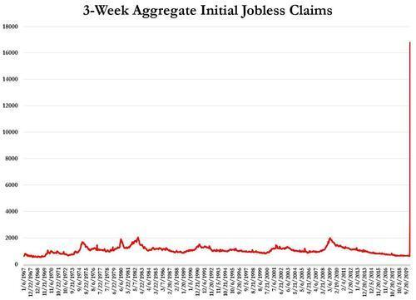Source: Bloomberg, April 09, 2020
States knew that fraud was inevitable, but opted to rush money out to people with minimal oversight, as opposed to laboriously vetting each application.
According to Blake Hall, CEO of ID.me - a fraud prevention service, America has lost over $400 billion to fraudulent claims, with as much as 50% of all unemployment payments possibly being stolen.
Of that, up to 70% of the money stolen by impostors ultimately left the country according to Haywood Talcove, CEO of LexisNexis Risk Solutions, who ways "These groups are definitely backed by the state."
The rest of the money was likely stolen by street gangs domestically, who have made up a greater share of the fraud in recent months.
How it works: Scammers often steal personal information and use it to impersonate claimants. Other groups trick individuals into voluntarily handing over their personal information.
- "Mules" — low-level criminals — are given debit cards and asked to withdraw money from ATMs. That money then gets transferred abroad, often via bitcoin.
The big picture: Before the pandemic, unemployment claims were relatively rare, and generally lasted for such short amounts of time that international criminal syndicates didn't view them as a lucrative target. -Axios
What's more, unemployment fraud can now be obtained on the dark web on a software-as-a-service (SAAS) basis - similar to ransomware. Naturally, states without fraud-detection services in place are the top targets, however several states are beginning to employ more sophisticated measures to prevent fraud.
As Axios' Salmon notes, however, "It's far too late."
What this means is that the US economy wasn’t helped even a little bit by half the cash sent out to bank accounts all over the country. That would be hundreds of billions of dollars that did nothing but make foreign thieves rich.
Obamanomics is Working as Planned
The Consumer Price Index jumped 0.6% in May, after having jumped 0.8% in April, and 0.6% in March – all three the steepest month-to-month jumps since 2009, according to the Bureau of Labor Statistics today. For the three months combined, CPI has jumped by 2.0%, or by an “annualized” pace of 8.1%. This current three-month pace of inflation as measured by CPI has nothing to do with the now infamous “Base Effect,” which I discussed in early April in preparation for these crazy times; the Base Effect applies only to year-over-year comparisons.
On a year-over-year basis, including the Base Effect, but also including the low readings last fall which reduce the 12-month rate, CPI rose 5.0%, the largest year-over year increase since 2008.
In terms of the politically incorrect way of calling consumer price inflation: The purchasing power of the consumer dollar – everything denominated in dollars for consumers, including their labor – has dropped by 0.8% in May, according to the BLS, and by 2.4% over the past three months, the biggest three-month plunge in purchasing power since 1982:
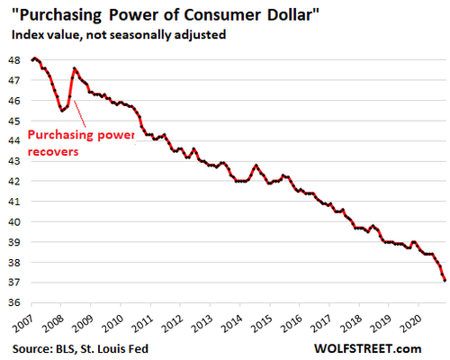
On an annualized basis, the three-month drop in purchasing power amounted to a drop of 9.5%, and this eliminates the Base Effect which only applies to year-over-year comparisons.
That plunge in purchasing power is “permanent” not “temporary.”
Yup, the current plunge in purchasing power is permanent. And the plunge in purchasing power in the future is also permanent.
The only thing that might make a small portion of it “temporary” is if there is a period of consumer price deflation, which has happened for only a few quarters in my entire life, for example in the last few months of 2008, which is indicated in the chart above. So I’m not getting my hopes up.
The rest of the time, we’ve had lots of decline in purchasing power. And that has proven to be rock-solid “permanent,” and we never got that lost purchasing power back.
Durable Goods inflation exploded by 10.3% from a year ago.
And it jumped by 3.0% in May from April, the biggest month-to-month jump since 1980. The problem is across the board, but the biggest biggie is used vehicles.
Used Vehicle CPI exploded by nearly 30% year-over-year, and by 7.3% just in May. I have long been fuming about and dissecting the reasons behind this price surge, based on data from the auto industry. And it is now seriously showing up in used-vehicle CPI.
This chart shows the actual CPI as a price index, not the year-over-year percentage change of that index. This eliminates the issue of the Base Effect.
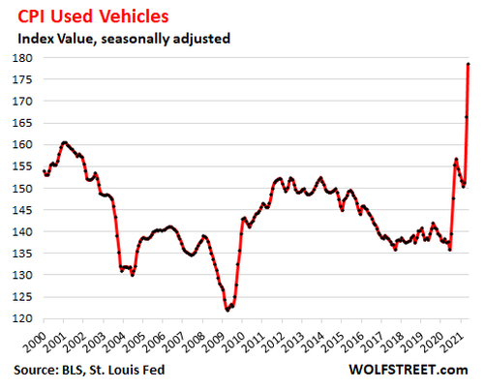
But “hedonic quality adjustments” over the years have held down the CPI for used vehicles, producing this astonishing chart above, where the index in 2020 was below where it had been 20 years earlier, even as in the real world, used vehicles got a lot more expensive. Only the scary-crazy price spikes in May and April pushed the index above its level 20 years ago.
These hedonic quality adjustments are applied to account for improvements in vehicles over the years, such going from a three-speed automatic transmission to a 10-speed electronically controlled transmission. The price increases theoretically associated with “quality improvements” are removed from the CPI.
In theory, CPI attempts to measure price changes of the same item over time; and when the price change is based on improvements, it is not inflation because you’re getting more as you pay more.
In practice, this has led to a consistent, purposeful, politically convenient, and bipartisan understatement of inflation as measured by CPI.
New Vehicle CPI repressed by hedonic quality adjustments. The adjustments have practically eliminated the appearance of inflation as measured by CPI in new vehicles, even though new vehicles have gotten a lot more expensive, with the cheapest cars disappearing from the automakers’ lineups.
Nevertheless, year-over-year new vehicle prices rose 3.3%, the biggest increase since 2012, despite vigorous hedonic quality adjustments. Note how the index used to rise into the mid-1990s, at which point the hedonic quality adjustments were applied and forced the index back down:
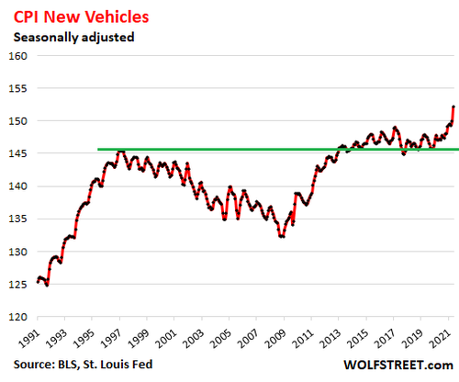
For a dose of reality, data from the auto industry shows that the “average transaction price” (ATP) of new vehicles sold to retail customers in May jumped to $38,255. The ATP is a function of the price of new vehicles sold and of the mix of new vehicles sold. Based on data provided by J.D. Power, the ATP has jumped by 28% over the past seven years since 2014. Note the huge jump since June 2020:
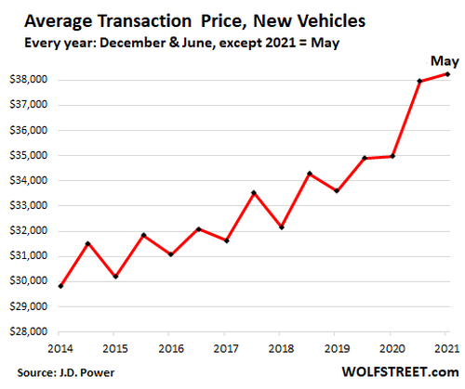
Services CPI jumped 3.1% year-over-year, held down by fake homeownership cost index.
About two-thirds of the overall CPI is for services. They include the biggest biggie of all: housing – more on that in a moment. They also include healthcare, insurance, education, subscriptions for services such as broadband, cellphone, streaming, etc.
The CPI for services rose by 3.1% year-over-year and jumped by 0.5% in May. Over the past three months, the CPI for services rose 1.3%, for an annualized increase of 5.2%.
The actual plunge in purchasing power is even worse.
Housing costs – rent and homeownership costs combined – account for about one-third of overall CPI – it’s the biggest category in CPI.
The rent component of CPI, called “rent of primary residence” (=7.7% of total CPI in May) has been rising month after month this year at a constant 0.2%, including in May, and is up 2.2% over the 12-month period.
The homeownership component, called “Owners’ equivalent rent of residences” (=23.8% of overall CPI in May), ticked up just 0.3% for the month and a mind-bendingly low 2.1% for the 12-month period, despite the explosion of home prices over the past 12 months.
The reason this homeownership component completely misses the red-hot inflation in housing – the loss of the dollar’s purchasing power with regards to homes – is that it’s based on surveys of homeowners’ estimates of how much their home would rent for. It is a measure of rent, as guessed by the homeowner (red line in the chart below).
The Case-Shiller Home Price Index is a more realistic house-price inflation measure. It’s based on the sales-pairs method, measuring the price changes over time for the same house, soared by 13.2% year-over year, the red-hottest increase since December 2005 (purple line):
The loss of purchasing power is “permanent.”
So, hedonic quality adjustments for durable goods, such as new and used vehicles, plus the elegant fiction of “Owners’ equivalent rent of residences” for housing costs, plus some other CPI reduction methods, such as “substitution,” see to it that the actual loss of purchasing power of the consumer dollar – and of labor that is paid in dollars – is far worse than even these very ugly inflation data released today.
And this loss of purchasing power is permanent. It won’t suddenly come back, except fractionally during these minor bouts of deflation we get every now and then.
What’s “temporary” is the pace of the loss of purchasing power, in the sense that it changes every month.
For sure, the spike in used vehicle prices cannot go on infinitely. At some point it will have to back off. But then other prices will spike, such as airline tickets, hotel bookings, restaurant meals, or insurance.
Inflation is a game of whack-a-mole. One pops up as another backs off. So it could very well be that CPI inflation may be 4% next May, down from 5% now, and we’ll be celebrating that the 5% was “temporary,” and was replaced by 4%, hahahaha. But the purchasing power of the dollar that is lost every month is lost permanently.
Charm of Favor Continues to Unfold as Truth
There is another name to add to the flawless list of stories in the #1 Best-Seller Charm of Favor. The rise of the most ruthless and powerful crime syndicate the world has ever known is considered a myth by the fake stream news. It is the unbreakable cord of truth that supports the false matrix, for those who have read the book and felt the spirit of darkness that floats the eternal dragon of evil.
I asked you to never forget the innocent people who were witnesses, lawyers, policemen, reporters, presidents, ambassadors, political staffers and even authors who dared to expose the humans who are members of this crime syndicate. There is no place to hide, and there is no protection from this syndicate. As long as good men do nothing, and we use the tactic of forgiveness and forgetting, they will continue to die one by one alone in the night. Their friends will quietly curse. Their followers will demand something be done. The Syndicate will walk in the day without fear, knowing the demons will never sleep until every enemy is dead.
Well, it has happened again. Christmas of 2018, Charm of Favor was published and raced to #1 is less than two weeks. It stayed in the top 100 books on Amazon for nearly two years. The murders, larceny, perjury, and terrorism that are the mainstay of the Global Syndicate keep eroding our lives, and the warning is real, and victims continue to fall.
In the book, there is an entire chapter on Chrisopher Sign, the former Alabama football star who became a reporter for ABC in Phoenix. He got a tip from a source in Baltimore that Obama’s attorney General, Loretta Lynch, after giving a speech that night, altered her flight plans to arrive hours ahead of schedule, virtually without a wink of sleep. Her and her husband, the only witness on earth who could not be compelled to testify against her, flew to Sky Harbor Airport to meet in the wee hours of the morning with Bill Clinton to make a deal to save Hillary from prosecution for obstruction of justice.
Chris showed up to witness it. The chapter in the book puts you on the tarmac that morning. It connects you with the fear Chris felt, and the struggle in his own mind that ensued to tell the story or not.
Yesterday morning, 911 got a call at 8:13 a.m. about a person down at a residence. When police and fire arrived they found Sign dead. The Clinton Crime Syndicate had Chris Sign assassinated because he broke a story that was politically damaging to them. It is a Syndicate that is built upon the principle of revenge. It goes without saying that every single authority that declares the death a suicide is in on it. Nobody will ever look into this sufficiently to question that finding. Chris Sign’s death serves as a warning about who really runs the country. The closer Arizona gets to revealing the fraud in the 2020 Selection of Virtual Joe, the more important it is to send a shockwave of fear throughout the world; whoever crosses the Clintons will pay with their life, no matter how long it takes.
There is a shared belief that it is dangerous to speak these unspoken assumptions aloud.
The result of all of the above is fear, emotional paralysis and an inability to truly stop and think about what happened here.
Most likely, this story will come and go, scaring the hell out of people, silently shared and serving as an unconscious trigger and warning about what happens to those who speak truth to power. The global media empire will define what is “true,” and whoever questions that seriously will be called names like “conspiracy theorist.”
Maybe it is true that it was a “hit” and people were paid to say that it wasn’t. If that is true, and truth remains hidden, then Trump did not eliminate the Deep State at all.
Think about how frightening that is, if true; the implications if we are back to Square One. If you are like me, you are sick and enraged about the word investigation. No more investigations! If the arrests had been made in 2016 the way the truth demanded by the Chris Sign’s report, then he would still be alive. He would still be watching his kids play ball in the evenings and fishing with them on the weekends. He would still be smiling and joining his friends for barbeques. Let’s air out the story around his death, instead of pushing it under the rug as usual.
He used his life to tell the truth and in doing so to help the public—we should return the same good deed in his memory. Chris Sign mattered. They killed him, just like the killed Seth Rich. Just like they killed Danny Casolaro, American freelance writer who came to public attention in 1991 when he was found cut to pieces on August 10th, 1991 in a bathtub in room 517 of the Sheraton Hotel in Martinsburg, West Virginia, the day before his scheduled testimony about the Clinton Crime Syndicate before Congress. The medical examiner ruled that death a suicide as well. Just like Vince Foster, and countless others. It is why I told my story in Charm of Favor. We will never forget.
Contact Tracing: The Core Technology of the Vaccine
Heavy Hitting Surveillance Under The Guise of Contact Tracing
As if the drones from China weren’t eye-opener enough, we’ve now moved into contact tracers digging into your personal life, quarantine camps, mandatory masks in public despite Dr. Fauci stating they don’t protect you, and mobile units showing up at your door. Gosh this sure sounds familiar, doesn’t it?
Dr. Michael Ryan (Executive Director of WHO Health Emergencies Program) spoke at a press briefing on April 13, 2020. He stated “WHO has been clear that there is no specific evidence that suggest a mask may protect you from infection. And equally a mask may provide protection from others if you happen to be symptomatic and coughing it may stop you from contaminating someone else, but there are a number of issues around the broader use of masks.” He followed up with the fact that the masks would have to be disinfected consistently, and putting the masks on and off means you are touching the mask and therefore possibly contaminating it. The WHO believes that masks are pointless unless they are in addition to a much broader control system – one that consists of tracking everyone who may be positive and separating families by removing those that test positive and isolating them away from their home, as he stated at a press conference in March.
This must have seemed like a good idea for Ventura County, California, who followed suit stating precisely the same thing. In fact, they received so much backlash that they had to walk it back. Dr. Robert Levin stated, “If they live in a home where there’s only one bathroom and there are 3 or 4 other people living there and those people don’t have COVID infection, we’re not going to be able to keep the person in that home. Every person who we’re isolating for instance needs to have their own bathroom. So, we’ll be moving people like this into other kinds of housing that we have available.”
The real alarm bells went off on April 18, 2020 when the Clinton Global Initiative organized a virtual conference and rolled out video clips with Bill Clinton, Gov. Cuomo, Gov. Newsom, Chelsea Clinton, Ophelia Dahl of Partners in Health, and others all discussing the need for contact tracing “armies.”
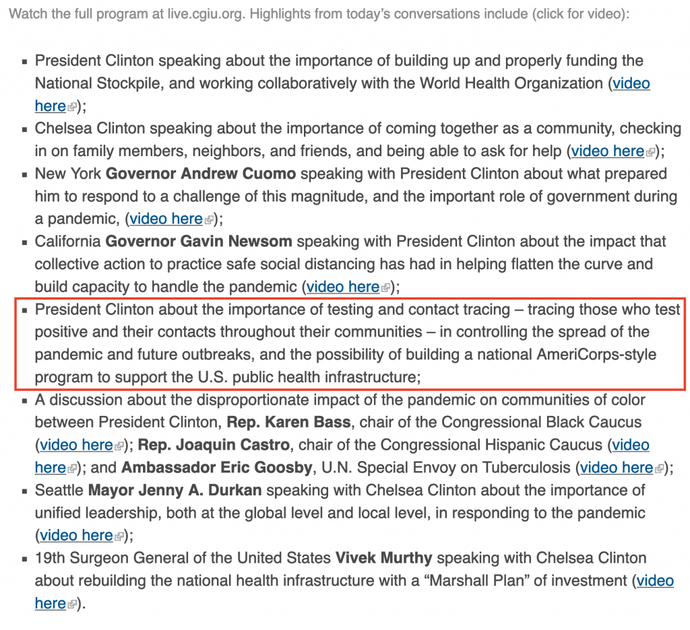
But the plan had long been masterminded and was already in place for Partners in Health (PIH). Their goal was to dominate the U.S. in these efforts, and they began by announcing their work in Massachusetts, with Paul Farmer leading the way, while Jim Yong Kim was behind the scenes meeting with governors across the country.
Less than two weeks after Congressman Bobby Rush introduced H.R.6666 for $100 billion to NGOs for contact tracing, Partners in Health put out a press release announcing their new ‘contact tracing accompaniment unit’ which would “coordinate and harmonize” approaches across the country by PIH providing small teams of experts, advisers, collaboration, and online toolkits and materials for free.
Yes free, because they will be seeking grants, or shall we say taxpayer dollars. Their initial funding came from The Audacious Project, which is a collaborative funding initiative housed at TED that launched in 2018. Their partners include the Gates Foundation, Virgin Unite, Children’s Investment Fund Foundation, and about 20 others.
PIH is already supporting programs in Massachusetts, New Jersey, Ohio, North Carolina, as well as advising in California, Minnesota, and Maryland.
They have a page designated on their website to join their team of contact tracers in Massachusetts, and the scripts for contacting potential COVID-positive people reads more like an interrogation. They have pages of personal questions asking about how you are feeling, symptoms, all other health conditions, race and ethnicity, next of kin, where you have been, about family members, what type of home you live in, where you work, who you’ve been in contact with, instructions for how to isolate and get tested, etc. These are easily hour-long conversations. One “script” is 10 pages long. Here is just a snippet of questions regarding “social events.”
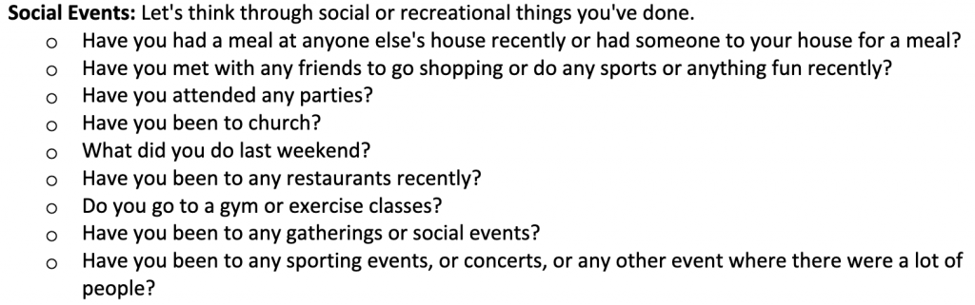
To be crystal clear, in Jim Yong Kim’s own words…
“And thus our public health efforts have to match the scale of the pandemic. Moreover, in order to ease restrictions on movement and thereby restart the economy, states must establish a system that can quickly respond to anyone with symptoms, test and isolate them if they are positive, and then trace, test and, if necessary, provide supported quarantine for all of their close contacts.
This expansion of a network of contact tracers, social support providers and public health professionals will be massive. But data and experience from countries that have been successful in bending the COVID-19 curve downward have shown us that we have no choice. It’s time to go on offense against the virus.”
Photo credit: Wikipedia
Not a lot of people are familiar with Jim Yong Kim, his history, or his longtime working relationship with the Clintons, Paul Farmer, Bill Gates, and countless others, which is why Corey’s Digs did an extensive report on Kim back in January 2019. Aside from being moved around like a peg on a board to very instrumental positions that would allow him to carry out their agendas as well as direct funds toward them, Kim’s early years and family background are a bit mysterious.
Prior to being the president of the World Bank, he was not only President of Dartmouth College who has had its fair share of scandals, Kim was the director of the HIV division for the World Health Organization. That’s correct, he has been working with the usual suspects on the HIV/AIDS agenda for decades. Corey’s Digs spent the last two years investigating this slush fund and has been working on a book, whereby the first three chapters have already been released. Coincidentally, Bill Gate’s Global Fund and Gates Foundation have funded Partners in Health over $44 million throughout the years. Just how tight of a group is this? They go way back to the 80s and have orchestrated countless agendas together. Corey’s Digs has covered many of these players and their agendas in numerous reports over the years to show how they all tie together and how they orchestrate them. Simply search their names or organizations and you will find a plentiful amount of reports on Corey’s Digs.
It should also be noted that Chelsea Clinton is on the board of trustees of Partners in Health, who boasts an extensive list of partners including George Soros’ Open Society Foundations, Abbott Laboratories, AbbVie Foundation, countless other big pharma companies, governments and UN factions, and hundreds of others – many of whom are also funders, such as George Soros. Here are eight reports Corey’s Digs has done over the years, which include Partners in Health’s endeavors and connections.
For those that aren’t aware, Kim was preceded by Robert Zoellick as the World Bank President. Why is this significant? There is a common theme. In March 2016, Zoellick signed an open letter by GOP national security leaders that outlined their reasons not to support Trump. Later that year, in August, he signed another letter from 50 GOP national security officials calling Trump a national security risk. He even went so far as to write an article in September 2017 urging Congress to assert constitutional powers over trade because Trump was going to “unravel vital ties across the Asia-Pacific region.” Guess where Zoellick is now? He has served on the board of directors for twitter since July 19, 2018. Surprise.
Guess who else serves on the board of directors for Twitter? Bret Taylor, President and Chief Operating Officer for Salesforce. What companies is Jim Yong Kim utilizing to gather their “contact tracing” data? Accenture, based out of Dublin, Ireland, and Salesforce, a San Francisco based company founded by Marc Benioff and Parker Harris. Let’s keep going – Marc Benioff is part of a group of 28 who created Breakthrough Energy Coalition in 2015, along with buddies Bill Gates, Richard Branson, George Soros, Tom Steyer, Mark Zuckerberg, Jeff Bezos, Jack Ma, Reid Hoffman, and more. This rabbit hole keeps going and ties straight to the Caribbean and the Clintons. Corey’s Digs reported on this back in August 2018, urging people to pay very close attention to the beginnings of a takeover of infrastructure and tourism all along the drug and child trafficking routes in the Caribbean, covering over 20 islands. Part 4 of the four-part report is a big eye-opener, showing a large network of individuals and organizations.
To understand this decades-long network, when it comes to their agendas in the healthcare industry, Bill Gates is the central bank. He funds universities, biotech companies, the WHO and seven other UN factions, the CDC Foundation, multiple big pharma companies, numerous labs currently working on a COVID-19 vaccine, clinical trials and research, major media outlets, Partners in Health, and the Clinton Health Access Initiative. Yes indeed, he funds it all. Every single aspect of the healthcare industry is funded by Bill Gates, and darn near everything pertaining to the COVID-19 virus is being funded by Gates as well. It’s amazing what money can buy when you don’t have a college degree, medical license, or science background. What happened to antitrust laws? Is this not the biggest monopoly that’s ever emerged in America? Some believe China is our biggest threat when it comes to the healthcare industry. They most certainly are a threat, but Bill Gates’ capital is the biggest threat because it feeds every single avenue that controls policies, priorities, science, research, media, drugs, and vaccines, in addition to his direct operations and funding to China. The whole shebang!
Other Organizations Jumping on Board The Contract Tracing Train
In addition to Partners in Health, their buddies over at Bloomberg Philanthropies, Johns Hopkins Bloomberg School of Public Health, and Resolve to Save Lives are working with governors of New York, New Jersey, and Connecticut. Mike Bloomberg and former CDC Director Thomas Frieden have worked on many agendas with Bill Gates, the Clintons, and Partners in Health. Of course, Frieden believes we will need several hundred thousand contact tracers. This is the same man who went on Tucker Carlson alleging we would see one million deaths by COVID in the U.S.
Thomas Frieden was appointed by Barack Obama. This particular character was also covered extensively by Corey’s Digs back in September 2018, because again, he is a key player in having carried out multiple criminal agendas and led the efforts on combatting the Swine flu, Ebola and Zika epidemics. He was also responsible for running the two-year test project for creating the electronic health record (EHR) that became everyone’s worst nightmare. The entire creation of the EHR system was packed full of corruption and detailed in this report, along with six other major red flags for data scraping, coverups, and funding to his pals. Frieden now works side by side with Bloomberg Philanthropies at Resolve to Save Lives, where they have of course turned their focus to assisting with contact tracing for COVID-19.
The Tracing Has Already Begun
In addition to all of the states listed above, Washington state is now “forcing” restaurants to keep daily customer logs to help with contact tracing. Meaning, if anyone wishes to dine in at a restaurant, they can expect to be asked their name, address, phone number, and the time they arrived at the restaurant so that their personal information can be kept in a 30-day log.
Indiana is outsourcing contact tracing to Maximus who will hire 500 people to staff a call center, to the tune of $43 million a year.
California Gov. Gavin Newsom is building a contact-tracing army of 10,000, while Michigan Gov. Gretchen Whitmer has already begun recruiting more than 2,000 volunteers in her state.
In Nashville, Tennessee they have setup the Nashville Fairgrounds to house the homeless during the pandemic. Yet, when Randle Kirkley “escaped after jumping the fence” he was charged and is being held at the Davidson County Jail in medical isolation. He had tested positive for COVID-19. The question is, what exactly was he charged with and why did he have to jump the fence “to escape?” Was he being held (quarantined) against his will?
Over in Singapore, a robot dog named Spot, engineered by Boston Dynamics, is patrolling parks to broadcast a message reminding people of social distancing rules. Because you know, people haven’t been reminded enough, so why not intimidate them with a robot in their face? Is this what we have to look forward to in the U.S.? Something tells me that won’t go over so well here.
On a high note, the Wisconsin Supreme Court just struck down the state’s stay-at-home order as “unlawful, invalid and unenforceable” stating a “vast seizure of power” after State Department of Health head Andrea Palm attempted to direct all individuals to stay home, with travel restrictions, business restrictions, and threats of fines or jail time for those who don’t comply, which was planned to run until May 26.
Is It All Leading to This – Vaccine Tracing?
On May 13, 2020, in an interview on Fox News with Maria Bartiromo, President Trump set off a wave of panic across social media when he said that they are mobilizing the Military and other forces on the basis that they would have a vaccine, so at the end of the year they would be able to give vaccines to people very rapidly. He said, “we are of the assumption that by the end of the year we will have a vaccine and then you have to be able to give it, to use it, on most of our population. We are going to focus on elderly, nursing homes, senior citizen centers…”
What’s curious is the fact that just one week ago, Trump said that he doesn’t know that we will even need a vaccine and that some viruses die off and never come back. In fact, he’s gone back and forth quite a bit on the vaccine, placing a stronger focus on therapeutics, while investigating the WHO, NIH, and looking into PEPFAR. Is this part of his strategy or does he really intend to vaccinate? He’s a smart man, and most certainly knows that he could very well lose a good chunk of his base if he pushes forward with vaccines that include a level of tracking.
Looking back on March 18, 2020 HHS put out a press release announcing a new public-private partnership to develop U.S.-based, high-speed emergency drug packaging solutions, and awarded ApiJect up to $456 million for research and development. Fast forward to May 12th, the U.S. Department of Defense published a press release announcing a $138 million contract to ApiJect Systems America for “Project Jumpstart” and “RAPID USA” for medical grade injection devices. Their goal is to manufacture more than 100 million prefilled syringes for distribution across the U.S. by end of 2020, with a total of 500 million by 2021. They plan to initially execute this in Connecticut, South Carolina, and Illinois. Surprisingly, New York isn’t on that list.
The syringes can come with an RFID/NFC tag on the exterior of them that will allow them to track usage of the vaccine for a real-time “injection map.” Note: this tracking it on the outside of the syringe, yet one can imagine how they may quickly incorporate additional data when capturing the NFC tag’s serial number, such as a person’s health data so that they can “certify” them as having received the vaccine. They are not stating this is what they intend to do, this is just a hypothesis of what may come.
Why would they need to know what bodies are bonded with their nano-technology? What is coming? Why is it so important to end privacy? Am I the only person who sees the end of liberty here?
The Earth’s Core Becoming Lopsided

There's a mystery brewing at the center of the Earth.
Scientists can only see it when they study the seismic waves (subterranean tremors generated by earthquakes) passing through the planet's solid iron inner core. For some reason, waves move through the core significantly faster when they're traveling between the north and south poles than when they're traveling across the equator.
Researchers have known about this discrepancy — known as seismic anisotropy — for decades, but have been unable to come up with an explanation that's consistent with the available data. Now, using computer simulations of the core's growth over the last billion years, a new study in the June 3 issue of Nature Geoscience offers a solution that finally seems to fit: Every year, little by little, Earth's inner core is growing in a "lopsided" pattern, with new iron crystals forming faster on the east side of the core than on the west side.
"The movement of liquid iron in the outer core carries heat away from the inner core, causing it to freeze," lead study author Daniel Frost, a seismologist at the University of California, Berkeley, told Live Science. "So this means the outer core has been taking more heat from the east side [under Indonesia] than the west [under Brazil]."
To visualize this lopsided growth in the core, imagine a tree trunk with growth rings radiating out from a central point, Frost said — but "the center of the rings is offset from the center of the tree," so that rings are spaced further apart on the east side of the tree and closer together on the west side.
A cross section of Earth's inner core might look similar to that. However, this asymmetric growth doesn't mean that the inner core itself is misshapen or at risk of becoming imbalanced, the researchers said.
The team's model proposes that Earth’s inner core grows faster on its east side (left) than on its west. Gravity equalizes the asymmetric growth by pushing iron crystals toward the north and south poles (arrows). This tends to align the long axis of iron crystals along the planet’s rotation axis (dashed line), explaining the different travel times for seismic waves through the inner core. (Image credit: Marine Lasbleis)
On average, the inner core's radius grows evenly by about 0.04 inches (1 millimeter) every year. Gravity corrects for the lopsided growth in the east by pushing new crystals toward the west. There, the crystals clump into lattice structures that stretch along the core's north-south axis. These crystal structures, aligned parallel with Earth's poles, are seismic superhighways that enable earthquake waves to travel more quickly in that direction, according to the team's models.
Unpacking the snowball
What's causing this imbalance in the inner core, anyway? That's hard to say without looking at all the other layers of our planet, Frost said.
"Every layer in the Earth is controlled by what's above it, and influences what's below it," he said. "The inner core is slowly freezing out of the liquid outer core, like a snowball adding more layers. The outer core is then cooled by the mantle above it — so to ask the question of why the inner core is growing faster on one side than the other might be asking the question of why is one side of the mantle cooler than the other?"
Tectonic plates could be partially to blame, Frost said. As cold tectonic plates dive deep below the Earth's surface at subduction zones (places where one plate sinks below another), they cool the mantle below. However, whether mantle cooling could impact the inner core is still a subject of debate, Frost said.
Equally puzzling is whether or not the lopsided cooling in the core could be affecting Earth's magnetic field. The modern-day magnetic field is powered by the movement of liquid iron in the outer core; this liquid's movement is powered in turn by heat lost from the inner core. If the inner core is losing more heat in the east than the west, then the outer core will move more in the east too, Frost said.
"The question is, does this change the strength of the magnetic field?" he added.
Questions this big are beyond the scope of the team's new paper, but Frost said he has begun work on new research with a team of geomagnetists to investigate some possibilities.

