Big Tech is Dying
I told you about a year ago when the purge occurred in October of 2020 that Big Tech was going to die. When they systematically purged the greatest content creators in the world like RedPill78 and Kate Awakening, and of course, America Free Radio, they also were purging their listeners. The listeners are what the advertiser were trying to reach, so when the purge occurred, the advertisers left as well. No one paying for the use of Big Tech meant that they were going to die. No business model is sustainable where you censor out of existence 75% of your revenue base.
Well, Facebook unveiled a new corporate name and logo this week, “Facebook Meta,” prompting some hilarity among tech-savvy Israelis, who noted that the phrase, when translated into Hebrew, also means “Facebook is dead” or “Facebook died.”
The word “meta” is the feminine form of the verb “met,” which means “dead.”
The BBC reported Friday that Hebrew speakers were ridiculing the new Facebook name and logo:
Facebook’s announcement that it is changing its name to Meta has caused quite the stir in Israel where the word sounds like that for “dead”.
To be precise, Meta is pronounced like the feminine form of the Hebrew word.
A number of people have taken to Twitter to share their take on the name under the hashtag #FacebookDead.
The emergency rescue volunteers Zaka even got involved, telling their followers on Twitter: “Don’t worry, we’re on it”.
Facebook also earned ridicule from English speakers over the new name, which the company adopted just as it came under intense scrutiny from both left and right.
The Wall Street Journal reported earlier this week that Facebook had suppressed Breitbart News’ traffic for political reasons (though Breitbart News continues to lead among political news sites on the platform).
Breitbart News also reported on the coordination among establishment media outlets in reporting the “Facebook papers,” which apparently led to a Slack channel among the various sites being shut down earlier this week.
Signs the Asian Blockade is Working
The Asian Blockade being conducted on the American west coast is having some success. Of course, my prediction that the Chinese financial markets would reflect it first came true. It is proof positive that a debt-based economy is a pathway to failure. No nation in history has survived for long trying to outrun the invoices to the bank. They all end up using the same tactic.
In the book Diary of an Economic Hit Man, the author reveals how the Monroe Doctrine was implemented by the CIA through predatory lending. If a 3rd world country needed a dam for electricity or a coal mine or a railroad, the CIA would arrange for the loans to that country.
The checks would arrive, the leaders would carve out 5% for themselves to maintain their lavish lifestyles and to support their private brothels and security forces, and the country would sink hopelessly into debt. Sometimes the dam or the airport would be completed, but the promised revenue somehow never showed up in time to make the payments.
The CIA would foreclose, and take over the country. If the leader did not want that to take place, they simply assassinated him and placed their own leader into position. It was successful for 50 years.
China has been working this plan for about two decades aggressively known ad the Belt and Road Initiative. Lyndon Laroche was a huge fan of China’s plan, and still very actively supports it. My assertion that the CCP is the military arm of the Global Syndicate made it impossible for me to support their agenda. No matter what proof I offered, their think tank simply would not retract that allegiance.
Well, any time you follow the Clinton Manual on Self-Enrichment, you run the risk of making the wrong enemies, and they will eventually gang up on you and kill you. The Clintons have had to exterminate dozens of people who were in a potion to expose them and destroy their empire. Almost every politician and fake stream reporter is deathly afraid to even mention their names to this day. They are not even permitted to mention George Soros’ name on national media.
The game requires money and a complicated and well-armed method of protecting the revenue channels. The Clintons used a complex network of foreign and domestic non-profits to launder billions of dollars in taxpayer, drug cartel, and human trafficking funds to make their organization, and themselves, untouchably wealthy. They were ruthless and greedy. They worked at the highest levels of world governments without fear, because they had a supernatural alliance with evil itself. They fear no one to this day and will live very long and very prosperous lives without want of anything or anyone. Even Donald Trump and John Durham will not touch them, despite all the campaign promises.
So, what is China to do, now that the Asian Blockade has stopped their cash flow? They cannot make their bond payments. Their economy, almost 70% of which is backed by real estate bonds, is going to collapse so hard it will make the bond market collapse of 1933, under Roosevelt’s master plan to exterminate the American middle class, look like a speed bump. How will they hope to recover?
The answer is plain enough to see, once you are shown. Fortunately, you are listening to America Free Radio, and you will know how to stay out of the way. The CCP will have to do three things.
First, they will have to expand their holdings using military force. That may be in the form of cyber-technology, actual military force with weapons, or physical theft using soldiers they already have on the ground and in position. The CCP is already in full operation using two of these methodologies. They have not, as yet tried military force any greater than a parade or two.
They are practicing. They are moving aggressively against anyone who cannot fight back. Or so they think. Amid persisting rumors that China is eyeing a future military presence at abandoned American bases inside Afghanistan, the neighboring country of Tajikistan has confirmed China has been approved to construct a special forces base on the Tajik-Afghan border.
The Chinese military outpost will reportedly be located in the eastern Gorno-Badakhshan Autonomous Province in the Pamir mountains, coming at a moment of heightened border security as thousands of Afghans have in recent months sought to flee hardline Taliban rule.
However, while it's Chinese funded, a Tajik parliament spokesman said the base will host a special forces unit of the national police, and rejected that Chinese troops would be directly deployed there. But the question of joint training operations wasn't ruled out. This is just where the bleeding begins.
However, according to US media arm RFERL, China is being allowed to expand its military footprint elsewhere in the central Asian country:
In a separate development, the Tajik government has offered to transfer full control of a preexisting Chinese military base in the country to Beijing and waive any future rent in exchange for military aid from China, according to a communique sent from the Chinese Embassy in Dushanbe to Tajikistan’s Foreign Ministry and seen by RFE/RL’s Tajik Service.
The two developments paint a picture of a growing Chinese military footprint in the Central Asian country. The CCP is filling the vacuum left by Virtual Joe and his gang of criminals, exactly as they were ordered by the Global Syndicate
RFERL analyst, Raffaello Pantucci, said this: "This decision to build such a facility is one of only a few known examples for China around the world."
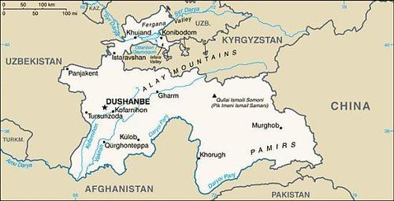
Underscoring that China is being greenlighted to build more outposts in Tajikistan after constructing the new base, an official of Tajik parliament’s lower house, Tolibkhon Azimzoda, confirmed the facility will be under direct command of Tajikistan’s Ministry of Internal Affairs, which in turn will allow China to be exempt from all customs duties for machinery and equipment.
The Taliban is getting money and weapons. The CCP is getting access to minerals. Sounds like a good deal, until everyone realizes it will take 3 troops for every worker to keep the operation going. One to watch the worker, one to watch the soldier’s back so the worker doesn’t kill him, and the third to watch the other two solders so they stay sober and loyal. Believe me. I have been in Tibet and felt the strength of a drunk Chinese solider deployed in a place where the women are tiny and humble and there is no law. Physical size and strength are the only things that keeps you from being hurt in these situations. I am glad I only encountered one drunk Chinese soldier.
Despite the Tajik government currently downplaying that Chinese forces would be deployed on the border at the new base, it's highly likely that there will be more than training of Tajik forces going on. Interestingly, this comes at a time that central Asian countries are also allowing an increased Russian presence amid the ongoing security breakdown in nearby Afghanistan.
This will eventually work out in favor of the free world. Afghanistan is where countries go to die. The CCP will die there, just like Persia, the Russians, the Nazis, and America. No one can make any sort of alliance with a viper. The leaders will rob you. The people will kill you. The deserts and mountains will parch your blood and drain hope from your soul. No wall will shield you. No threat or debt instrument is effective against a lineage soaked in blood and evil for millennia. For now, everyone is dying except America.
Keep a close eye on Taiwan, although this is one of the most technologically advanced nations on the planet, and they have 30 thousand known American special forces there to help. One thing is absolute. Without a 2-million-man invasion force, the CCP cannot make use of Taiwan’s wealth and technology. Currently, the CCP has no way of moving 2 million troops from the mainland to Taiwan except for shipping barges—most assuredly these will be sunk in the 120 miles of open ocean between them—or airborne. There is no countryside for airborne troops to parachute, and the CCP has no trained paratroopers or air transport craft. Taiwan has the most effective anti-air defense system on earth, making Israel’s Iron Dome look like a cheap inflatable tent in comparison.
Once thing is for sure, if the CCP cannot acquire assets in the next 90 days to back off the credit markets, their economy will crash. When it does, 1.3 billion Chinese will swarm the CCP leadership and the results will be complete extermination. The Global Syndicate will lose its entire military structure.
They will only have three pillars left. They will have the Global Media Empire, the Global Economic Forum, and the Establishment Party. It’s anyone’s guess which one will be the next to fall.
The time is short, because the global financial markets cannot be just told to wait. The CCP is heavily is debt, and their collateral is just about worthless. America’s GDP is about 7% backed by real estate bonds. The CCP’s is nearly 70% backed by real estate bonds. The CCP has been lending money to countries that cannot pay it back. When the Syndicate shut down the world to smash the Trump Economy, they also hurt the CCP’s cash cow. Now, they have to move quickly.
The Asian Blockade is working. I know you’re saying where is the military in this? You cannot have a blockade without the military blocking the way. True enough. They are there. In space. Under the sea. How do I know this? Listen,
An astonishing thing took place recently involving two United States fast-attack submarines, and what happened is an ominous sign that REAL trouble in the Pacific is much closer than any of us have been told.
On October 20, the USS Jimmy Carter, the single most advanced nuclear-propelled submarine in the US Navy, popped-up near San Diego, and headed into port.
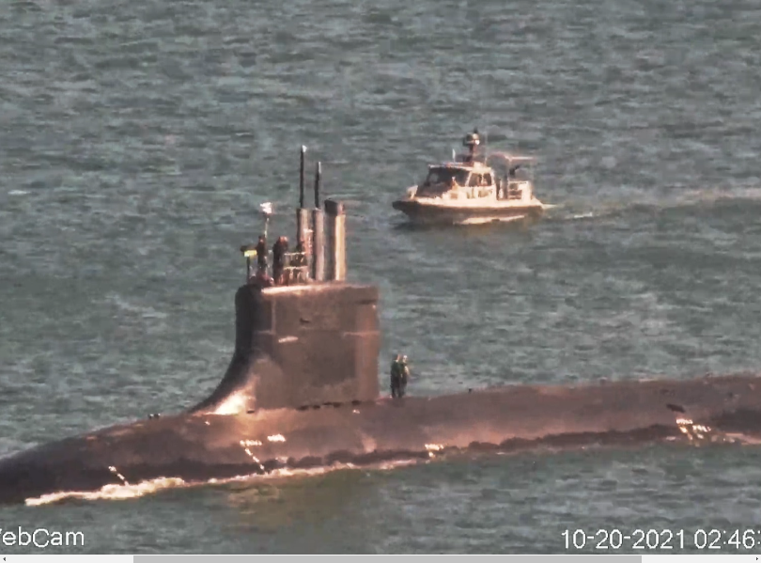
Two tug boats moved the sub to the dock, but the crew DID NOT go ashore. Instead, the tarps were placed along the entire dock to prevent satellite surveillance from seeing what was taking place. Normally they cover the screw, so that the enemy cannot extrapolate the sound it might make in the ware by its design. This time, they covered the entire loading area so that material-handling equipment like fork trucks could load the cargo in secret onto the sub. It could not wait for a clear satellite window. It could not wait for nightfall. It had to be done quickly, perfectly hidden in plain sight, and quickly.
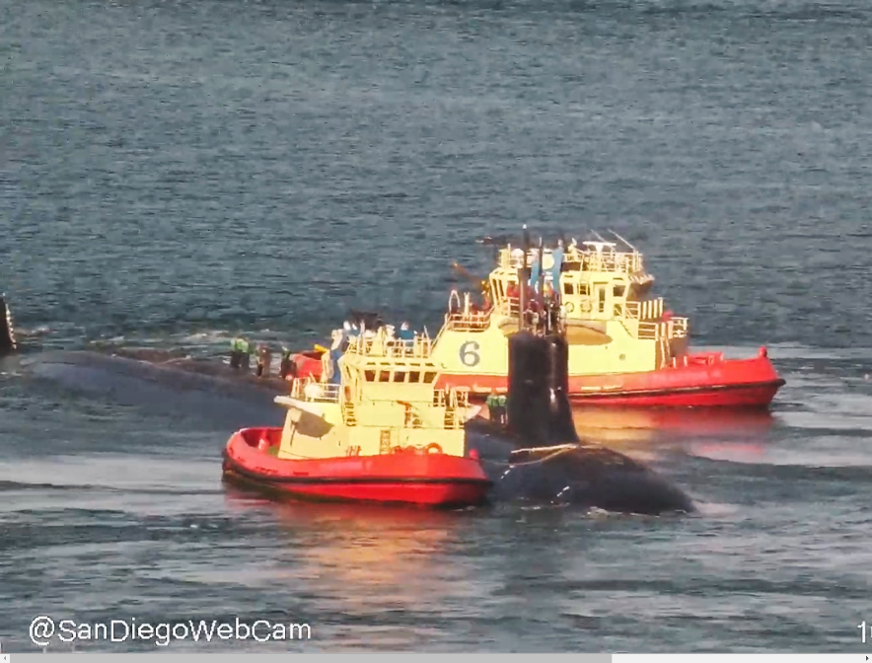
The trucks and material-handling equipment then departed off the dock, the tarps were taken down, and the submarine was pulled away from the dock by the same two tugboats, and sent immediately back to sea! It could have been food, but it is not likely they would have organized this level of planning, rehearsal and expense for food supplies.
It gets better.
Three days ago, on October 25, another submarine from the same fast attack class, the USS Seawolf (lead boat in its class), popped-up outside San Diego just like the USS Jimmy Carter five days earlier, was brought to dock by two tugboats and the entire operation that was done with the USS Jimmy Carter, was done with the Seawolf. You see that? Two of the world’s fastest and most secret nuclear-powered subs, in less than a week arrived at the same port, docked near the world’s most advanced Marine base.
By the way, fast attack subs are sub-killers. They are ship killers. They are designed to locate and follow enemy missile subs and boats with the assignment of sinking them at a moment’s notice. They don’t carry nuclear weapons. They carry fast torpedoes and other weapons. Rumor has it they can travel at speeds up to 60 miles an hour underwater. No one really knows.
This is was top secret. It was vital to get this done, and it was done on an expedited time table. Once whatever was loaded into these subs, the subs were towed away from the dock and put immediately back to sea. The crews never got off.
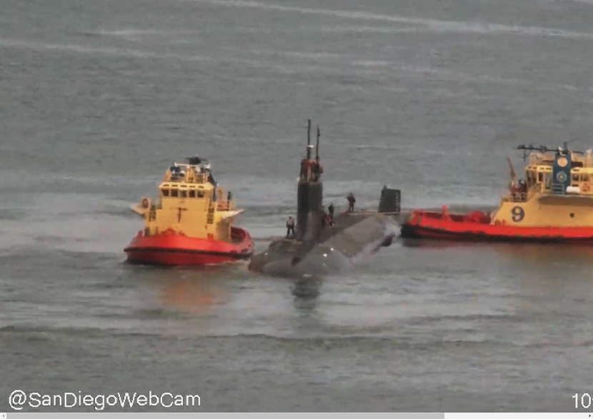
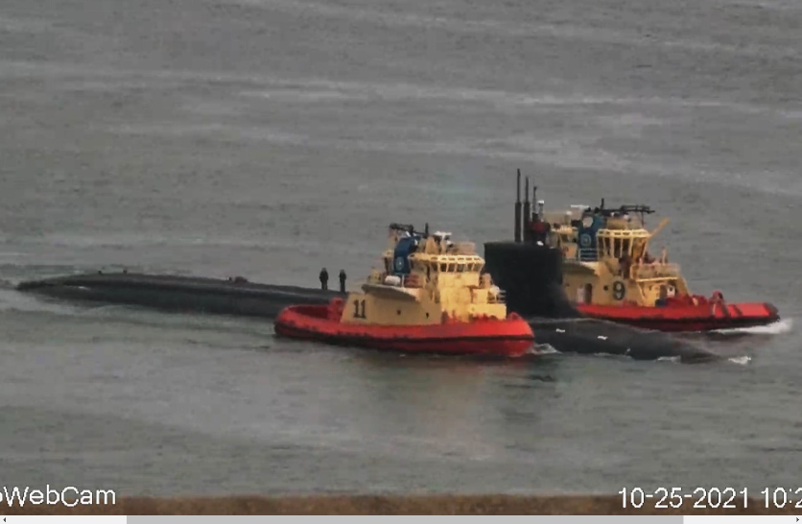
The way to tell the difference between the Sea Wolf and the Jimmy Carter, is by the length of the vessel:
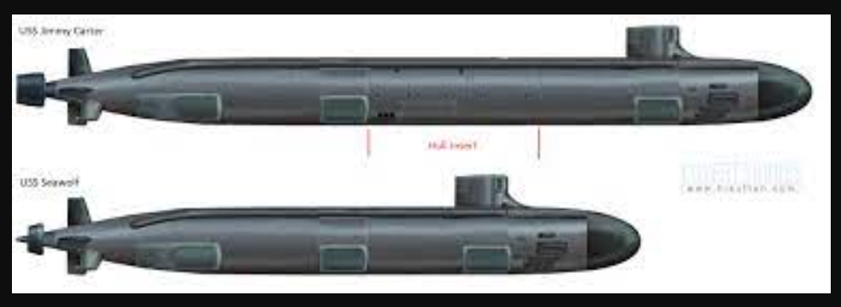
It is worth noting that both these submarines are normally based in Washington state. But travel from San Diego to Washington would add at least a full day of trucking from San Diego to Seattle, so apparently whatever needed to be put on those submarines, needed to happen fast, and it needed the top security of El Toro Marine base personnel overseeing the entire operation. This is President Donald Trump’s devolution forces at work. I personally guarantee that Virtual Joe and his Gang of criminals know only what I am telling you, and mostly because they have people listening to my program right now.
I need to impress upon you how warfighting operates. This war is one of ideologies that you see. But there is also the test of metal and blood that keeps the world free and at peace. When good men do nothing, evil will harvest the innocent. Rest assured, Earth explorers, that good men are doing something. They are doing everything that can be done short of firing the first shot to keep this evil at a distance. Any moment, that peace could be shattered. I have already explained the desperation of the CCP. I have informed you that time is running out for them.
These two fast attack subs were launched as an emergency alert. They left without some vital weaponry, because they had to be in position to stop what was out there. Two subs have already been damaged from undersea collisions in the Pacific. They were hit by other craft of some kind, underwater. These ships are made from half-inch thick titanium, and they were damaged while underwater. That may be why the Seawolf and the Jimmy Carter were launched so quickly. Whatever hit those other subs is still out there. It might be faster, tougher, and commanded by men who are not afraid to die underwater.
The weaponry that was loaded onto these two subs is so terrible and so new, it had to be expedited, hidden from sight, and immediately placed in harm’s way. This underwater weaponry will change the balance of power at sea. It was developed away from the eyes of the Pentagon. It was designed and built by forces and with money loyal to President Donald Trump. Virtual Joe knows nothing about it. He is not privileged to see it.
Devolution is real, and the decentralization of Patriotic military forces is real. The real commander in chief knows what is going on. The CCP thinks they control the world, because they control the White House right now. That is exactly why devolution was put into play by President Donald Trump in November of 2020. He knew that while the CCP owns the Pentagon and the White House, they shall not own the military of patriots that he rebuilt. The Space Force is expanding, in complete opposition to the efforts by the Manchurian candidate who is disabling our military at every turn.
The CCP cannot shoot down our F22 Raptors, so Virtual Joe simply shot down the pilots.
Global Syndicate Destroying American Active Duty Military
Approximately 12,000 Air Force personnel have reportedly refused orders to be vaccinated against the Chinese coronavirus despite the Pentagon’s mandate.
Officials said it was too late for them to take it by the Tuesday deadline which posed a test for leaders whose August directive apparently sparked defiance in one segment of the force, according to the Washington Post.
The Thursday report continued:
The vast majority of active-duty airmen, 96.4%, are at least partially vaccinated, according to data from the Air Force. But officials have warned that, barring an approved medical or religious exemption, those who defy lawful orders to be fully immunized are subject to punishment, including possible dismissal from the service or they could be charged in the military justice system.
The challenge now confronting Air Force leaders – how to address potential large-scale dissent in the face of a top health priority that has been deeply politicized – is a bellwether for the dilemma that’s in store across the military’s other services, which have staggered compliance deadlines ranging from the end of November to the middle of next summer and in some cases have experienced far greater resistance to President Joe Biden’s mandate.
In August, several members of the U.S. military expressed their concerns as the Pentagon issued the coronavirus vaccine mandate, Breitbart News reported.
“We get a lot of pressure from our commanders … and they tell you these sob stories to heavily persuade you, and it’s borderline harassment,” an Air Force member said, noting how he might need to “restart” if the vaccine became mandatory.
In addition, the Marine Corps warned in a message recently that Marines will be kicked out if they did not take the coronavirus vaccine.
The Marine Administrative Message (MARADMIN) posted on the Marine Corps’ website said, “Marines refusing the COVID-19 vaccination, absent an approved administrative or medical exemption, religious accommodation, or pending appeal shall be processed for administrative separation [in accordance with] this MARADMIN and supporting references.”
“General Court-Martial Convening Authorities (GCMCA) retain authority to take any additional adverse administrative or disciplinary action they deem appropriate,” it concluded.
Don’t worry, Earth Explorers. They may be Court-Martialed from one military, but they are still loyal to the Constitution, and they will follow the orders of the real commander in chief, when they are given. Stay alert. Stay prepared. Have no fear.
Once Again, The Marines are the First
When SC seceded in December of 1860, there were 56 Marine Corps officers serving in what was then a much smaller Marine Corps force than it is today. As soon as SC left the “union”, 19 of those 56 officers went with the Southern-Confederacy. As each Southern state began to secede, more officers and enlisted from the Corps sided with the Southern-Confederacy. So when all was said and done, roughly ¾ of the Marines Corps had left to fight with the Confederacy.
Most Marines living today, to include the citizenry, do not know that part of the Corps’ history – for understandable reasons. And most people do not know there was a Confederate States Marine Corps serving aboard our CSS ships. In fact, if you’d like to make a good barroom bet, ask someone when the last “official” Confederate flag came down.
It was Nov.6, 1865 in Liverpool, England. The CSS Shenandoah had received word at sea of Lee’s surrender. Instead of returning home and living under “yankee” rule, they headed across the Atlantic and ported some 3,000 miles from the homeland they were defending. To the compliment of Confederate Marines aboard the CSS Shenandoah was the honor, yet sad duty of lowering the Confederate flag off the main mast."
It would be an awesome boldness for the modern-day Corps to repeat this same stance – not wanting to live under GLOBALIST RULE.
“First to fight for RIGHT and FREEDOM, and to keep our HONOR CLEAN.” As well as OUR BLOOD.
And one final tidbit – both the Continental Navy and Marines were authorized to fly the Gadsden Flag, or better known as the “Don’t Tread On Me” flag as their first official banner during the 1st American Revolution against the tyrant King George III.
The Corps has a history of defiance against tyranny. Just wonder how many of today’s Leathernecks have that same spirit. By the way, you know why they are called leathernecks?
The story goes back to The Barbary Wars were a series of two wars fought by the United States, Sweden, and the Kingdom of Sicily against the Barbary states (including Tunis, Algiers, and Tripoli) of North Africa in the early 19th century. Sweden had been at war with the Tripolitans since 1800 and was joined by the newly-independent US.^{[3]} The First Barbary War extended from 10 May 1801 to 10 June 1805, with the Second Barbary War lasting only three days, ending on 19 June 1815.
The wars were largely a reaction to piracy carried out by the Barbary states. Since the 16th century, Muslim pirates operating out of North Africa had captured ships and even raided cities across the Mediterranean Sea. By the 19th century, pirate activity had declined, but Barbary pirates continued to demand tribute from American merchant vessels in the Mediterranean. Refusal to pay would result in the capturing of American ships and goods, and often the enslavement or ransoming of crew members.
After Thomas Jefferson became president of the US in March of 1801, he sent a US Naval fleet to the Mediterranean to combat the Barbary pirates. The fleet bombarded numerous fortified cities in present-day Libya, Tunisia, and Algeria, ultimately extracting concessions of safe conduct from the Barbary states and ending the first war.
During the War of 1812, with the encouragement of Great Britain,^{[4]} the Barbary corsairs resumed their attacks on American vessels. Following the conclusion of the War of 1812 and America's attainment of peace with Britain, James Madison, Jefferson's successor, directed military forces against the Barbary states in the Second Barbary War. Lasting only three days, the second conflict ended the need for further tributes by the United States, granted the U.S. full shipping rights in the Mediterranean Sea, and significantly reduced incidents of piracy in the region.
The Barbary corsairs were pirates and privateers who operated out of North Africa, based primarily in the ports of Tunis, Tripoli, and Algiers. During the American Revolutionary War, the pirates attacked American ships. On December 20, 1777, Morocco's sultan Mohammed III declared that merchant ships of the new American nation would be under the protection of the sultanate and could thus enjoy safe passage into the Mediterranean and along the coast. The Moroccan-American Treaty of Friendship stands as America's oldest unbroken friendship treaty^{[10][11]} with a foreign power. In 1787, Morocco became one of the first nations to recognize the United States of America.^{[12]}
Starting in the 1780s, realizing that American vessels were no longer under the protection of the British navy, the Barbary pirates had started seizing American ships in the Mediterranean. As the U.S. had disbanded its Continental Navy and had no seagoing military force, its government agreed in 1786 to pay tribute to stop the attacks.^{[13]} On March 20, 1794, at the urging of President George Washington, Congress voted to authorize the building of six heavy frigates and establish the United States Navy, in order to stop these attacks and demands for more and more money.
The First Barbary War (1801–1805), also known as the Tripolitian War or the Barbary Coast War, was the first of two wars fought between the alliance of the United States and several European countries^{[18][19]} against the Northwest African Muslim states known collectively as the Barbary states. The Second Barbary War (1815), also known as the Algerine or Algerian War, was the second of two wars fought between the United States and the Ottoman Empire's North African regencies of Tripoli, Tunis and Algeria, known collectively as the Barbary states.
In 1776, the Naval Committee of the Second Continental Congress prescribed new uniform regulations. Marine uniforms were to consist of green coats with buff white facings, buff breeches and black gaiters. Also mandated was a leather stock to be worn by officers and enlisted men alike. This leather collar served to protect the neck against cutlass slashes and to hold the head erect in proper military bearing. Sailors serving aboard ship with Marines came to call them “leathernecks.”
Jefferson’s leathernecks ended the Barbary Wars on the shores of Tripoli. It is precisely why Barack Obama made a major show of beheading Jordanian warfighters on the shores of Tripoli as he built his ISIS army to reestablish the Islamic State. He was symbolically defeating America by cutting of the heads of his enemies on the same shores that America has bested them in 1816.
The Marine Corps warned in a message to the force on Saturday that Marines will be kicked out if they do not get the coronavirus vaccine. The Marine Administrative Message (MARADMIN), signed October 23 and posted to the Marine Corps’ website, said:
Marines refusing the COVID-19 vaccination, absent an approved administrative or medical exemption, religious accommodation, or pending appeal shall be processed for administrative separation [in accordance with] this MARADMIN and supporting references. General Court-Martial Convening Authorities (GCMCA) retain authority to take any additional adverse administrative or disciplinary action they deem appropriate.
The MARADMIN applies to both active duty and reservists.
Active duty Marines face a November 28 deadline to be fully vaccinated, and Marine reservists face a December 28 deadline.
The message said a Marine is considered to have “refused the vaccine” when they do not have an approved administrative, medical, or religious exemption or pending appeal and have “willfully disobeyed a lawful order from a superior commissioned officer to be vaccinated against COVID-19;” or if they will not be fully vaccinated by the deadline.
Those with pending administrative, medical, or religious exemption requests or appeals will not be considered to have “refused the vaccine” until those requests or appeals are adjudicated, the message said.
According to Military.com, as of October 20, the Marine Corps has not approved any religious exemption. Furthermore, the message said Marines who are not fully vaccinated are not considered deployable, will not be reenlisted or promoted, and that unvaccinated Marine officers without approved or pending exemptions will be relieved of their command or be unable to assume a command assignment.
In addition, Marines separated for vaccination refusal will not be eligible for involuntary separation pay, and will be subject to “recoupment of any unearned special or incentive pays and advance educational assistance.”
Medical exemptions will be re-evaluated within no more than 365 days from approval, it said. Republican senators and lawmakers have expressed concern that the vaccine mandate is hurting morale in the military, and will lead to separations from the military that will hurt its readiness.
Pentagon Press Secretary John Kirby said:
Well, I would tell you that the secretary’s view is that one of the best ways to make sure that the force is able to do its job to defend the nation is to make sure that they’re protected against this virus. We would agree with people that argue that it’s a national security issue. And our view is that one of the best ways to be able to preserve our national security is to make sure that our men and women are protected against this virus, and therefore, are healthy and able to do their jobs to defend this country.
And we believe that the vast, vast majority, and the numbers are bearing that out, of our men and women understand that too and are getting the shots and are getting themselves protected so that they can also protect their families, their units, and their communities.
As of October 20, 17% of Marines were not fully vaccinated, and 8% had not received any vaccine dosages. Kirby said, “We want to respect people’s religious beliefs in the military,” but added that the number of those requesting religious exemptions “are typically very small.”
“In general, numbers of religious exemption requests for any vaccine or medicine are typically very small. We believe that, and you’ve heard the secretary say this, the vaccines are safe, they’re effective and they are really the — one of the best ways we can preserve the readiness of the force, to make sure that our men and women are healthy and vibrant and able to do their jobs, and we believe that the vaccines allow that,” he said.
The enemies of America cannot ever hope to defeat our marines at sea or on the land, but Virtual Joe and his gang of criminals has rendered them undeployable. Good job Joe.
They are in our army now.
The Trucker Testimony
Think of going to the port as going to WalMart on Black Friday, but imagine only ONE cashier for thousands of customers. Think about the lines. Except at a port, there are at least THREE lines to get a container in or out. The first line is the ‘in’ gate, where hundreds of trucks daily have to pass through 5–10 available gates. The second line is waiting to pick up your container. The third line is for waiting to get out. For each of these lines the wait time is a minimum of an hour, and I’ve waited up to 8 hours in the first line just to get into the port. Some ports are worse than others, but excessive wait times are not uncommon. It’s a rare day when a driver gets in and out in under two hours. By ‘rare day’, I mean maybe a handful of times a year. Ports don’t even begin to have enough workers to keep the ports fluid, and it doesn’t matter where you are, coastal or inland port, union or non-union port, it’s the same everywhere.
Furthermore, I’m fortunate enough to be a Teamster — a union driver — an employee paid by the hour. Most port drivers are ‘independent contractors’, leased onto a carrier who is paying them by the load. Whether their load takes two hours, fourteen hours, or three days to complete, they get paid the same, and they have to pay 90% of their truck operating expenses (the carrier might pay the other 10%, but usually less.) The rates paid to non-union drivers for shipping container transport are usually extremely low. In a majority of cases, these drivers don’t come close to my union wages. They pay for all their own repairs and fuel, and all truck related expenses. I honestly don’t understand how many of them can even afford to show up for work. There’s no guarantee of ANY wage (not even minimum wage), and in many cases, these drivers make far below minimum wage. In some cases they work 70 hour weeks and still end up owing money to their carrier.
So when the coastal ports started getting clogged up last spring due to the impacts of COVID on business everywhere, drivers started refusing to show up. Congestion got so bad that instead of being able to do three loads a day, they could only do one. They took a 2/3 pay cut and most of these drivers were working 12 hours a day or more. While carriers were charging increased pandemic shipping rates, none of those rate increases went to the driver wages. Many drivers simply quit. However, while the pickup rate for containers severely decreased, they were still being offloaded from the boats. And it’s only gotten worse.
Earlier this summer, both BNSF and Union Pacific Railways shut down their container yards in the Chicago area for a week for inbound containers. These are some of the busiest ports in the country. They had miles upon miles of stack (container) trains waiting to get in to be unloaded. According to BNSF, containers were sitting in the port 1/3 longer than usual, and they simply ran out of space to put them until some of the ones already on the ground had been picked up. Though they did reopen the area ports, they are still over capacity. Stack trains are still sitting loaded, all over the country, waiting to get into a port to unload. And they have to be unloaded, there is a finite number of railcars. Equipment shortages are a large part of this problem.
One of these critical shortages is the container chassis.
A container chassis is the trailer the container sits on. Cranes will load these in port. Chassis are typically container company provided, as trucking companies generally don’t have their own chassis units. They are essential for container trucking. While there are some privately owned chassis, there aren’t enough of those to begin to address the backlog of containers today, and now drivers are sitting around for hours, sometimes days, waiting for chassis.
The impact of the container crisis now hitting residencies in proximity to trucking companies. Containers are being pulled out of the port and dropped anywhere the drivers can find because the trucking company lots are full. Ports are desperate to get containers out so they can unload the new containers coming in by boat. When this happens there is no plan to deliver this freight yet, they are literally just making room for the next ship at the port. This won’t last long, as this just compounds the shortage of chassis. Ports will eventually find themselves unable to move containers out of the port until sitting containers are delivered, emptied, returned, or taken to a storage lot (either loaded or empty) and taken off the chassis there so the chassis can be put back into use. The priority is not delivery, the priority is just to clear the port enough to unload the next boat.
What happens when a container does get to a warehouse?
A large portion of international containers must be hand unloaded because the products are not on pallets. It takes a working crew a considerable amount of time to do this, and warehouse work is usually low wage. A lot of it is actually only temp staffed. Many full time warehouse workers got laid off when the pandemic started, and didn’t come back. So warehouses, like everybody else, are chronically short staffed.
When the port trucker gets to the warehouse, they have to wait for a door (you’ve probably seen warehouse buildings with a bank of roll-up doors for trucks on one side of the building.) The warehouses are behind schedule, sometimes by weeks. After maybe a 2 hour wait, the driver gets a door and drops the container — but now often has to pick up an empty, and goes back to the port to wait in line all over again to drop off the empty.
At the warehouse, the delivered freight is unloaded, and it is usually separated and bound to pallets, then shipped out in much smaller quantities to final destination. A container that had a couple dozen pallets of goods on it will go out on multiple trailers to multiple different destinations a few pallets at a time.
From personal experience, what used to take me 20–30 minutes to pick up at a warehouse can now take three to four hours. This slowdown is warehouse management related: very few warehouses are open 24 hours, and even if they are, many are so short staffed it doesn’t make much difference, they are so far behind schedule. It means that as a freight driver, I cannot pick up as much freight in a day as I used to, and since I can’t get as much freight on my truck, the whole supply chain is backed up. Freight simply isn’t moving.
It’s important to understand what the cost implications are for consumers with this lack of supply in the supply chain. It’s pure supply and demand economics. Consider volume shipping customers who primarily use ‘general freight’, which is the lowest cost shipping and typically travels in a ‘space available’ fashion. They have usually been able to get their freight moved from origination to delivery within two weeks. Think about how you get your packages from Amazon. Even without paying for Prime, you usually get your stuff in a week. The majority of freight travels at this low cost, ‘no guarantee of delivery date’ way, and for the most part it’s been fine for both shippers and consumers. Those days are coming to an end.
People who want their deliveries in a reasonable time are going to have to start paying premium rates. There will be levels of priority, and each increase in rate premium essentially jumps that freight ahead of all the freight with lower or no premium rates. Unless the lack of shipping infrastructure is resolved, things will back up in a cascading effect to the point where if your products are going general freight, you might wait a month or two for delivery. It’s already starting. If you use truck shipping in any way, you’ve no doubt started to see the delays. Think about what’s going to happen to holiday season shipping.
What is going to compel the shippers and carriers to invest in the needed infrastructure? The owners of these companies can theoretically not change anything and their business will still be at full capacity because of the backlog of containers. The backlog of containers doesn’t hurt them. It hurts anyone paying shipping costs — that is, manufacturers selling products and consumers buying products. But it doesn’t hurt the owners of the transportation business — in fact the laws of supply and demand mean that they are actually going to make more money through higher rates, without changing a thing. They don’t have to improve or add infrastructure (because it’s costly), and they don’t have to pay their workers more (warehouse workers, crane operators, truckers).
The ‘experts’ want to say we can do things like open the ports 24/7, and this problem will be over in a couple weeks. They are blowing smoke, and they know it. Getting a container out of the port, as slow and aggravating as it is, is really the easy part, if you can find a truck and chassis to haul it. But every truck driver in America can’t operate 24/7, even if the government suspends Hours Of Service Regulations (federal regulations determining how many hours a week we can work/drive), we still need to sleep sometime. There are also restrictions on which trucks can go into a port. They have to be approved, have RFID tags, port registered, and the drivers have to have at least a TWIC card (Transportation Worker Identification Credential from the federal Transportation Security Administration). Some ports have additional requirements. As I have already said, most trucking companies won’t touch shipping containers with a 100 foot pole. What we have is a system with a limited amount of trucks and qualified drivers, many of whom are already working 14 hours a day (legally, the maximum they can), and now the supposed fix is to have them work 24 hours a day, every day, and not stop until the backlog is cleared. It’s not going to happen. It is not physically possible. There is no “cavalry” coming. No trucking companies are going to pay to register their trucks to haul containers for something that is supposedly so “short term,” because these same companies can get higher rate loads outside the ports. There is no extra capacity to be had, and it makes NO difference anyway, because If you can’t get a container unloaded at a warehouse, having drivers work 24/7/365 solves nothing.
What it will truly take to fix this problem is to run EVERYTHING 24/7: ports (both coastal and domestic), trucks, and warehouses. We need tens of thousands more chassis, and a much greater capacity in trucking.
Before the pandemic, through the pandemic, and really for the whole history of the freight industry at all levels, owners make their money by having low labor costs — that is, low wages and bare minimum staffing. Many supply chain workers are paid minimum wages, no benefits, and there’s a high rate of turnover because the physical conditions can be brutal (there aren’t even bathrooms for truckers waiting hours at ports because the port owners won’t pay for them. The truckers aren’t port employees and port owners are only legally required to pay for bathroom facilities for their employees. This is a nationwide problem). For the whole supply chain to function efficiently every point has to be working at an equal capacity. Any point that fails bottlenecks the whole system. Right now, it’s ALL failing spectacularly TOGETHER, but fixing one piece won’t do anything. It ALL needs to be fixed, and at the same time.
How do you convince truckers to work when their pay isn’t guaranteed, even to the point where they lose money?
Nobody is compelling the transportation industries to make the needed changes to their infrastructure. There are no laws compelling them to hire the needed workers, or pay them a living wage, or improve working conditions. And nobody is compelling them to buy more container chassis units, more cranes, or more storage space. This is for an industry that literally every business in the world is reliant on in some way or another.
My prediction is that nothing is going to change and the shipping crisis is only going to get worse. Nobody in the supply chain wants to pay to solve the problem. They literally just won’t pay to solve the problem. At the point we are at now, things are so backed up that the backups THEMSELVES are causing container companies, ports, warehouses, and trucking companies to charge massive rate increases for doing literally NOTHING. Container companies have already decreased the maximum allowable times before containers have to be back to the port, and if the congestion is so bad that you can’t get the container back into the port when it is due, the container company can charge massive late fees. The ports themselves will start charging massive storage fees for not getting containers out on time — storage charges alone can run into thousands of dollars a day. Warehouses can charge massive premiums for their services, and so can trucking companies. Chronic understaffing has led to this problem, but it is allowing these same companies to charge ten times more for regular services. Since they’re not paying the workers any more than they did last year or five years ago, the whole industry sits back and cashes in on the mess it created. In fact, the more things are backed up, the more every point of the supply chain cashes in. There is literally NO incentive to change, even if it means consumers have to do holiday shopping in July and pay triple for shipping.
This is the new normal. All brought to you by the ‘experts’ running our supply chains.
The CCP Collapse is Near
That China faces structural problems is well-recognized. The list of articles in the August issue of Foreign Affairs dedicated to China reflects this:
Xi's Gamble: the Race to Consolidate Power and Stave Off Disaster
China's Economic Reckoning: The Price of Failed Reforms
The Robber Barons of Beijing: Can China Survive its Gilded Age?
Life of the Party: How Secure Is the CCP? (Chinese Communist Party)
These are thorny, difficult issues: a demographic cliff resulting from the one-child policy, soaring wealth-income inequality, pervasive corruption, public health issues (diabesity, etc.), environmental damage and a slowing economy.
What the conventional analysts do not fully grasp, in my view, are 1) the existential threat to the CCP and China's economy posed by its unprecedented, metastasizing credit-asset bubble and 2) its incipient energy crisis.
As I explained in a recent blog post, What's Really Going On in China?, the CCP and the government informally institutionalized moral hazard (the disconnection of risk and consequence) as a core economic policy.
Every financial loss, no matter how risky or debt-ridden, was covered by the state (via bail-out, refinancing debt, new loans, etc.) as a "cost of rapid development," a reflection of the view that some inefficiency and waste was inevitable in the rapid development of industry, housing, infrastructure and a consumer economy.
What China's leaders did not fully understand was this implicit guarantee of bail-outs--the equivalent of "The Fed has our backs"--incentivized debt-funded speculation as the lowest-risk, highest-return "investment," especially when compared to low-profit, risky investments in low-margin export industries. (Recall the average profit margins of Chinese exporting enterprises is 1% to 3%.)
This is the hidden driver of China's sagging productivity and economy: debt in all sectors is skyrocketing to fund speculation, not productivity.
This institutionalization of moral hazard has incentivized the least productive and highest-risk gambles--not just for large conglomerates like EverGrande, but for middle-class households who've invested in the shadow-banking system (unregulated private-sector pools of capital lent out to risky borrowers at high rates of interest) and bought second, third and fourth "investment" flats.
The contradictions in this mass investing of savings in empty condos are systemic and dangerous: 1) once a flat is rented, it loses value due to being "used" and 2) the vast majority of the market for "investment" flats is illiquid, as most new buyers want a new flat, not an old one, so the market for old flats is extremely thin outside the most desirable inner rings of Beijing and Shanghai.
This mass investment in illiquid empty flats has generated social and financial perversities: now that flats in desirable areas cost 30-40 times an average white-collar salary, young people must vacuum up the entire extended family's savings in order to afford a flat. Those young men who are unable to buy a flat find their marriages prospects are dismal.
One result of the marriage of state control and private-sector Wild-West speculation is a truly vast wealth-income divide that is bound up with corruption in a mutually reinforcing feedback: the richer you become, the closer to power you get, and vice versa.
Since China's informal shadow-banking system is opaque even to state regulators, it's quite possible that China's leaders do not have a full grasp of the extent of systemic risk bound up in the excesses of shadow banking. To paraphrase Donald Rumsfeld's famous dictum, this is an unknown unknown for China's policy makers.
This truly monumental accumulation of debt and speculation is now an existential threat to the Party on two levels:
1) since all bubbles pop regardless of any other conditions, when this bubble pops, the economic blow will be severe enough to threaten the Party's control of the economy
2) the crushing of phantom wealth will cause people to seek a scapegoat, and the Party is Target #1 since it coddled the well-connected and wealthy but did not protect the 99% from the dire consequences of the bubble bursting.
Having engineered the bubble's expansion by creating mountains of debt and implicit promises of bail-outs, the CCP and government have backed themselves into a corner: there is no pain-free way to deflate a speculative bubble of such astounding proportions.
Considering the life history of President Xi (especially his first-hand experience of the Cultural Revolution 1966-1976), his writings and his consolidation of power, it is very clear to me that Xi understands the bubble is close to escaping his control and so time is short and the policy options are limited to triage, that is, saving the healthiest and letting Nature take care of those closest to expiring.
I also see evidence that Xi grasps the absolute need to break the near-universal confidence that the state will bail out everyone who borrows and speculates so wildly that their gambles go bad.
The general assumption is that "China can't afford to let Evergrande fail" because this enormous conglomerate will obviously topple many dominoes, generating great financial pain.
I think the that President Xi's view is the opposite: "we can't afford to bail out Evergrande" because that would open the floodgates of moral hazard that Xi is trying to close.
The state bailing out private-sector gamblers (and state-owned enterprises) is what led to the massive moral hazard-debt bubble that Xi is determined to pop now while he still can control the process.
In other words, President Xi understands this is the do-or-die moment to regain control of an out-of-control moral hazard driven financial bubble, and the only way to do so is to push the losses onto everyone with exposure, the driver being the stark choice to either regain control by popping the bubble now or letting it expand and implode in an uncontrolled (and hence Party-threatening) fashion.
Xi concluded that the first step to being able to push the losses onto everyone with exposure to speculative bets was to consolidate power to such a degree that the usual self-interested factions that would use their power to evade the consequences could be forced to accept their share of the losses.
Given the history and structure of the Party, this required Xi to extend his control to levels not seen since Deng or Mao.
In my view, Xi correctly concluded the hour was getting late and the institutional resistance to the end of the implicit promises of state bailouts and endless debt expansion could only be overcome if his political power was near-absolute.
The popping of moral hazard and the debt-speculation bubble are necessary to preserve CCP and state power; half-measures that protected corrupt cronies would only increase the public's outrage when the bubble finally burst.
In this light, Xi's multi-year campaign against the most visible corruption and his recent touting of "common prosperity" have set the stage for his forcing the end of moral hazard and the controlled demolition of the excesses of debt and speculation that have harmed the economy and threatened the control of the CCP.
Now comes the grand ironies. China's ability to generate stupendous amounts of new debt basically bailed out the global economy in 2008-09, 2015-16 and 2020. Yes, the Federal Reserve bailed out the global banking sector (to the tune of $16 trillion in backstops and credit lines) in 2008-09 and inflated a speculative bubble in the U.S. by creating $3.5 trillion in quantitative easing, but China's expansion of debt was an equally important source of global demand, which is what stopped global economies from sinking into recession.
The cost of these "saves" were not understood at the time: the elevation of moral hazard to quasi-religious status in the U.S. and China and the expansion of debt-funded speculative bubbles to unprecedented heights.
There are only two policy options:
1) Grasp the nettle and refuse to bail out debt-funded speculative excesses, thereby popping the Everything Bubble, or
2) play the game of keeping the bubble expanding until it implodes on its own, an end-game made inevitable by the systemic instabilities intrinsic to bubbles.
Xi has correctly chosen Policy #1, and to do so has positioned the Party as the defender of the people, i.e. anti-corruption, shackling the Big Tech billionaires like Jack Ma, and announcing that the state will not bail out EverGrande.
The Federal Reserve and the political leadership of the U.S. have foolishly chosen Policy #2, inflating the bubble while letting the consequences of this moral hazard bubble--wealth-income inequality and corruption--explode higher, fatally undermining the credibility of both the Fed and America's political class.
As the supply chain disruptions have revealed, the global economy and financial system are tightly bound systems, and as such are extraordinarily exposed to the risks of cascading collapses as key nodes become chokepoints or break down.
While the Federal Reserve prints trillions to further inflate the bubble, the global energy shortages are already crippling key sectors in the economies of China and the EU. Reality is about to intrude on the Fed's fantasy that speculative bubbles can remain disconnected from the real-world economy forever.
In summary: the popping of the global Everything Bubble is not Xi's goal; it is the inevitable second-order effect (collateral damage) of China's debt-speculation bubble popping.
Given the tightly-bound financial system, the collapse of EverGrande is far more the story of dominoes toppling rather than direct losses: it's not the direct losses that will bring down the global financial system, it's the dominoes toppling as those who take the direct losses implode and become insolvent, missing their loan/bond payments, being unable to meet their counterparty obligations, and so on.
The consensus in the West is that China cannot afford to let its bubble pop because the pain will be so severe. Those who believe this have a poor grasp of Chinese history, especially in the 20th century.
If crashing China's bubble is the nuclear option, Xi has reason to be confident he can push the pain level to 11 and most will accept it, and those who don't will join Jack Ma in forced retirement.
I reckon Xi views ending moral hazard and popping the bubble in China as a situation that will only get worse the longer he puts it off.
The grand irony now is that rather than saving the global economy by expanding its own debt bubble, China will pop the global Everything Bubble. To state the obvious, being a linchpin in the global economy makes China a consequential domino. Anyone who thinks the Fed's speculative bubble in the U.S. can magically become immune to the collapse of tightly-bound dominoes is indulging in magical thinking.
China's extreme excesses of debt and speculation are already unraveling, and Xi is backed into a corner. There is no cost-free escape, only triage, and Xi has charted a path to preserve the Party's control by forcing everyone with exposure to absorb the inevitable losses when unprecedented bubbles pop.
The line of toppling dominoes extends around the entire global economy and financial system. Plan accordingly.
The Olmec Empire 3000 Years Gone
You can't see them from the surface, but they're definitely there. Scientists have revealed the discovery of hundreds of ancient ceremonial sites, many of which belonged to the Maya civilization, hiding in plain sight just underneath the landscape of modern-day southern Mexico.
The largest of these structures – called Aguada Fénix – was announced by archaeologists last year, representing the oldest and biggest monument of the ancient Maya ever found. But Aguada Fénix clearly was not alone.
In a new study, an international team of researchers led by anthropologist Takeshi Inomata from the University of Arizona reports the identification of almost 500 ceremonial complexes tracing back not just to the Maya, but also to another Mesoamerican civilization who made their mark on the land even earlier, the Olmecs.
As with the discovery of Aguada Fénix, the sites identified in the new analysis (478 in total) were found the same way: using LIDAR, which combs the land with lasers during an aerial survey, detecting three-dimensional archaeological structures buried beneath vegetation and other surface features.
3D image of the site of Aguada Fénix based on LIDAR. (Takeshi Inomata)
In this case, the LIDAR data were already publicly available, courtesy of Mexico's National Institute of Statistics and Geography, and covering a sprawling 85,000 square-kilometer area (about 33,000 square miles).
When Inomata and his team analyzed the dataset, they identified hundreds of ceremonial sites scattered across the Mexican states of Tabasco and Veracruz, most of them previously unknown.
Most of the new discoveries are much smaller than the sprawling Aguada Fénix – which measures over 1,400 meters (almost 4,600 ft) in length at its greatest extent – but even so, seeing them for the first time reveals a mysterious design influence that hadn't been fully appreciated before in Maya structures.
According to the researchers, a previously unseen layout in the ancient Olmec city San Lorenzo – the oldest Olmec urban center, dating to around 1150 BCE – can be seen as a recurring motif in later structures built by the Maya, which echo San Lorenzo's central rectangular space, adopting its "spatial template".
"People always thought San Lorenzo was very unique and different from what came later in terms of site arrangement," Inomata says.
"But now we show that San Lorenzo is very similar to Aguada Fénix – it has a rectangular plaza flanked by edge platforms. This tells us that San Lorenzo is very important for the beginning of some of these ideas that were later used by the Maya."
(Inomata et al., Nature Human Behaviour, 2021)
Above: Comparison of the San Lorenzo rectangular hallmark (top-left) and MFUs in other structures (with Aguada Fénix top-right).
If so, the architecture at work here reveals an important link between these two distinct civilizations, which partially overlapped in time but also peaked in different chapters of Mesoamerican history, with the Olmecs flourishing in what's known as the Formative period (2000 BCE–250 CE), while the Maya grew in dominance (and structural ingenuity) in the Classic period (250–900 CE).
The rectangular complex design, which the team calls the Middle Formative Usumacinta (MFU) pattern, and its related variants, suggest inter-regional interactions and influences between the Olmecs and the Maya were more complicated and diverse than we realized.
"The presence of this previously unrecognized pattern implies that the emergence of standardized ceremonial complexes in southern Mesoamerica was more complex than previously thought," the researchers write in their paper.
In addition to analyzing LIDAR data, the team also conducted preliminary ground observations on foot at 62 of the sites, which on the whole are estimated to date from around 1,050–400 BCE, and are thought to have been used as ritual spaces, where people gathered to meet, and to watch processions.
LIDAR-based image of the Buenavista ceremonial site. (Takeshi Inomata)
Some of the sites are oriented to align to the sunrise on certain dates in Mesoamerican calendars, suggesting the ritual processes involved cosmological concepts tied to the movements of the seasons.
"This means that they were representing cosmological ideas through these ceremonial spaces," Inomata says. "In this space, people gathered according to this ceremonial calendar."
While there is still much we don't yet understand about the significance, history, and evolution of these hundreds of ritual complexes – with the discoveries posing years of investigations ahead for archaeologists and anthropologists – it's clear the Olmecs and the Maya may have shared more than we realized, literally building their societies and cities alongside one another.
The National Awakening to the Union Problem
When Joe Biden entered office, he claimed it marked a new era of unity. But from what we’ve seen, the last thing Sleepy Joe wants is to unite the country. He has ignored every concern from both Republicans and regular Americans. He seems driven to put globalists and socialists first.
Americans, it seems, come dead last.
Meanwhile, Democrats blindly forge ahead with a wildly unpopular agenda. They keep the border open as they defund police departments. Cities are crumbling as liberals push for more taxes and heavy regulation. It seems like Trump supporters are getting increasingly impatient.
And it seems like they agree with liberals on at least one thing. From Mediate:
A shocking new poll from the Center for Politics at the University of Virginia reveals that over half of Trump voters surveyed, and 41% of Biden voters, are in favor of blue and/or red states seceding from the union…
Roughly 4 in 10 (41%) of Biden and half (52%) of Trump voters at least somewhat agree that it’s time to split the country, favoring blue/red states seceding from the union.
Politics and policies have become so polarizing that most Trump voters (and Biden voters) believe the red and blue states should split. This is thanks to toxic politicians, corrupt state governments, and the MSM dead set on dividing the country based on identity.
If you go out into your town, you’ll probably meet people from all walks of life. You might even meet people with different political views. Do you disagree with them? Sure. Are you unable to live, work, and coexist with them? Of course, not.
The only reason so many voters feel this way is because toxic politicians are ignoring their concerns. It’s especially bad in blue-run states, where Democratic majorities railroad their agenda through. Even in Texas (a conservative state that values democracy), Democrats disrupted the government by fleeing to D.C.
There appears to be no effort by lawmakers to work together, find compromises, and put their own egos aside for the good of the people. Long gone are the days where both blue and red leaders can find common ground and negotiate.
Who is really to blame for all this? We can’t say for sure. The MSM thrives off of division, controversy, anger, and propaganda. Powerful globalists influence our lawmakers to pass policies that weaken our country and make themselves rich.
And, there is always the toxic D.C. swamp, that would rather have us fighting each other than holding it accountable.
Regardless of the reason, the solution is the same: strong leaders who will work to unite the country.
But we just don’t seem to have any right now.
The Straw That May Break the Republic
Governments are historically the enemy of the people. The founding fathers warned us about it. They even put it into the Constitution, and the Federalist Papers are filled with it. This animosity is natural and healthy for a Republic, that should and does exist in fear of its people. When they ignore this fear, or pass laws that suppress the people, the time for a new government waxes stronger. What will be the straw that breaks the Republic, again?
Alabama Republican Gov. Kay Ivey is blocking efforts in her state to pass an across-the-board ban for coronavirus vaccine mandates.
As lawmakers convened for a week-long special session on redistricting Thursday, several demanded the governor add vaccine mandate protections to the agenda. The pressure comes as businesses with 100 employees or more prepare to follow a federal mandate handed down by President Joe Biden in the form of a press release.
“The Biden Administration is out of control, and needs to be challenged on these unconstitutional and un-American mandates,” state GOP Chairman John Wahl said in a statement supporting the push in Montgomery to ban medical coercion. “I want to see Alabama leading the charge to defend the rights and freedoms of our citizens… The Alabama Republican Party fully supports legislation opposing vaccine mandates in the upcoming special session.”
While Ivey signed an executive order barring mandates across state agencies on Monday, the governor’s ban does not apply to private businesses, as do new protections in Texas and Montana.
Ivey however, says Biden’s federal mandate should be challenged by the courts and not statehouse legislation.
“[It] makes no sense to have a federal law and state law at odds,” she said in a Mobile speech Tuesday, according to the local outlet AL.com, arguing such a law would place employers in a “bad position” of conflicting rules.
The explanation contradicts Ivey’s own order placing state agencies in such conflict with the federal government. No litigation can be launched, however, until President Biden implements his mandate with an official directive through the Occupational Safety and Health Administration (OSHA) beyond a press conference.
While six different anti-vaccine mandate bills fill the state Senate, Ivey has so far refused to allow any be adopted under the governor’s official call for the special session. Failure for Ivey to include them on the legislative calendar raises their threshold for passage to a two-thirds majority.
Ivey did not respond to The Federalist’s inquiries about whether she would relent.
Alabama Republican House Speaker Mac McCutcheon supports the governor’s apparent cop-out demand that Biden’s mandate be challenged in the judiciary rather than legislative action.
“The legislative body leadership is fully supportive of the governor’s executive order as well as working with the attorney general to find a solution,” McCutcheon told the Alabama Daily News. “But the last think we want to do is have a knee-jerk reaction to something that may sound good politically but in substance, what does it do?”
Republican businessman Tim James, who is a potential candidate for governor next year, is asking a similar question of Ivey’s current executive order. On the same day Ivey signed her directive, Auburn University declared the school would move forward with a requirement that employees provide proof of vaccination by Dec. 8.
“The executive order reads more like a ‘resolution’ which expresses an ‘opinion or will’ more than a force of law,” James said, according to Yellowhammer News. “The teeth of this executive order wouldn’t bite through a stick of butter as evidenced by Auburn University’s disrespectful response… We need a legislative act of law passed by the legislature and signed by the governor against any employer mandate, both public and private.”
Others in the state blasted the order as “horribly insufficient,” in Republican Auditor Jim Zeigler’s words, because “it protects only the state workers of the executive branch” and not private employees. Zeigler, who is also a potential gubernatorial candidate next year, added a political cartoon mocking Ivey on Twitter.
In July, Biden praised Ivey’s efforts to get residents to accept the vaccines.
“You notice a lot of our very conservative friends have finally had an altar call. They’ve seen the Lord,” Biden said at a summer campaign event for former Virginia Gov. Terry McAuliffe. “Thank God the governor of Alabama, at one of the lowest vaccination rates in the country, is now.”
According to a telephone poll conducted by the Alabama Republican Party Oct. 16-18, voters in the state where the GOP controls supermajorities in the capital overwhelmingly rejected support for Biden’s mandatory needle-jab. Nearly 65 percent said they were opposed, while more than 35 percent reported being in favor. The survey was completed with a +/- 3.5 percent margin of error.

