The Lying Virtual Joe Administration
The establishment media largely ignored the environmental strides the Trump administration made throughout Donald Trump’s presidency — from reducing CO2 emissions faster than any European allies to reducing air pollution by seven percent.
Wheeler, who served as the EPA administrator during the final years of Trump’s presidency, listed some of the progress the Trump EPA made during the previous administration and warned Virtual Joe’s decision to rejoin the Paris Climate Accord will have a negative impact on the American consumer, taxpayer, and worker while allowing China to “get off without doing anything on climate.”
“It’s going to hurt the American consumer as well as the American taxpayer,” he said of the Paris Climate Accord during an on-camera interview at the Conservative Political Action Conference’s (CPAC) annual gathering, which took place in Orlando, Florida.
“You know, at the end of the day, during the Trump administration, we were reducing our CO2 emissions faster than any of our European allies. We don’t have to join the Paris Climate Accord, but by joining it, it allows China to get off without doing anything on climate and it requires us to pay a lot of money to other countries that, quite frankly, aren’t meeting their own obligations,” he said, pointing to France and Germany specifically.
“But we always meet our obligations, so it hurts us, and there’s no real benefit because we were already reducing our CO2 emissions faster than any other Western economy,” he said.
The progress, he continued, is lost on most because the establishment media did not cover the Trump administration’s progress on those fronts. The former EPA administrator detailed one scenario, alleging that a reporter for the New York Times told his press secretary that they would “never write a positive news story” about Trump’s EPA.
“It is lost because the mainstream media does not cover it. They don’t report on these things. I hate to point fingers at particular publications, but you know two years ago, one of the environmental reporters for the New York Times told my press secretary that they will never write a positive news story about the Trump EPA,” Wheeler told Breitbart News. “You know, they just flat out refused to acknowledge the great things that we did.”
“Under the Trump administration, air pollution went down seven percent. Water, the cleanest levels ever. More Superfund sites cleaned up in a generation. We actually, on the enforcement side, imposed twice as much in civil and criminal penalties as the Obama-Virtual Joe administration did in their first four years,” he continued. “So we were out there enforcing the environmental laws, cleaning up the environment, but if you read the New York Times, everything was horrible all the time. There’s a lot of hypocrisy in the media.”
The mainstream media have largely ignored the strides the U.S. has made outside of the Paris Climate Accord, he continued.
“The establishment media, they think joining the Paris is doing the right thing, rah-rah this is great, we’re part of this international agreement,” he said, emphasizing that the U.S. “developing the technologies that we can then export to other countries– that was doing more to address global CO2 emissions than anything we will accomplish under the Paris Climate Accord.”
Wheeler also spoke of Virtual Joe’s decision to cancel the Keystone XL Pipeline, noting it does not just hurt the American worker but the “world environment.”
“When we export our jobs to other countries, when we depend on other countries for our natural gas, for our finished products, they produce those products, they produce the energy and a much worse environmental condition. We set the gold standard. When we have a facility here in the United States, we are meeting the best environmental standards and regulations of anywhere else in the world,” he said.
“So when we not only get rid of our jobs and it hurts the American worker, but then it exports those jobs to countries like China that do horrible things to the environment,” Wheeler explained. “So it’s really a lose-lose for us when we cancel pipelines like that or when we decide to stop using fracking and developing our natural gas resources here.”
Ultimately, Wheeler agreed such policies touted by the left benefit China over the American worker and world.
“It’s important for us to be energy dominant because that helps our allies. So many countries around the world become dependent upon bad regimes such as China for their energy or for their finished products instead of being trading partners with us,” he said. “It’s much better for geopolitical trade negotiations and geopolitical relationships for us to be supplying our allies with natural gas, with finished products, than it is for them to be dependent upon countries such as China.”
We Found Uranus on This Day
On March 13, 1781, Sir William Herschel discovered Uranus, the seventh planet from the sun.
Before Herschel discovered Uranus, other astronomers had seen it before, but no one realized it was planet. Instead, they thought it was a star. Herschel actually thought he was looking at a comet. Because it was moving, he figured it couldn't have been a star.
Herschel and other astronomers spent two years debating about whether it was a comet or a planet. In 1783, Herschel finally announced that Uranus was, in fact, a planet. But Uranus didn't receive its name until 1850. Herschel wanted to name it George's Star after King George III, but astronomers outside of England weren't cool with that.
Ultimately, the German astronomer Johann Bode named it Uranus after the ancient Greek god of the sky. While the international astronomy community liked that name better than George's Star, the planet was hereby destined to forever be the butt of all solar system jokes.
The gas giant planet Uranus is a world of strangeness. It is knocked on its side, giving it an extreme tilt. It has gossamer rings and a network of moons. Right now, there are massive storms brewing on the gas giant.
The Tail of the Moon
Like a comet soaring through the cosmos, the moon is followed by a slender tail of irradiated matter — and Earth passes directly through it once a month.
According to a study published March 3 in the journal JGR Planets, the lunar tail is made of millions of sodium atoms blasted out of the lunar soil and into space by meteor strikes and then pushed hundreds of thousands of miles downstream by solar radiation. For a few days a month, when the new moon sits between Earth and the sun, our planet's gravity drags that sodium tail into a long beam that wraps around Earth's atmosphere before blasting into space on the opposite side.
The lunar tail is harmless and invisible to the naked eye. During those few new-moon days each month, however, the beam becomes visible to high-powered telescopes that can detect the faint orange glow of sodium in the sky. According to the study's authors, the beam then appears as a fuzzy, glowing spot in the sky opposite the sun, about five times the diameter of the full moon and 50 times dimmer than human eyes can perceive.
Researchers first detected this "sodium spot" in the 1990s. But while the spot always appears at the same time in the lunar cycle, its brightness fluctuates wildly. To understand why, the authors of the new study used an all-sky camera (which can parse the faint wavelengths of light given off by specific elements, like sodium) to take some 21,000 images of the moon, from 2006 to 2019.
They noticed a few predictable patterns — for example, the spot appeared brighter when the moon's orbit brought it closer to Earth — but also an unexpected one. Meteor data showed that the moon's tail glowed more brightly during months when the rate of sporadic meteors (that is, meteors that aren't part of a regular shower) was higher over Earth. When Earth gets pummeled by meteors, so does the moon. And sporadic meteor encounters had an even greater correlation with the moon spot's brightness than recurring showers, such as the Leonid meteor shower, which peaks every November.
The reason for this? It may be that sporadic meteors have the potential to be faster, larger and more energetic than their counterparts in predictable showers, the study authors suggested. Meteors that slam into the moon with more force are more likely to blast large amounts of sodium higher into the atmosphere, the researchers said, creating a larger swarm of atoms for the sun's photons (electromagnetic particles) to collide with and push toward Earth.
If a large enough asteroid crashed into the moon with enough force, it could even produce a sodium spot that anyone on Earth could see with the naked eye, James O'Donoghue, a planetary scientist at the Japan Aerospace Exploration Agency, told The New York Times. (O'Donoghue wasn't involved in the research, but he did make the above lunar-tail animation for the research team.) In the meantime, we'll have to be content with the knowledge that, once a month, our companion in the sky showers Earth with a pinch of cosmic pixie dust.
The Election of 2020
I have said it before. Winning is everything. It used to matter how you won, but not anymore. More and more states are doing things now that should have happened last year. In mid-February, Michigan purged 177,000 voters from their roles AFTER Virtual Joe was decided as the winner by less votes than that and now someone in Virginia was able to identify a difference of 1.7 million votes between the final results and the external results that were reported on Election Night.
One of the things that we've seen is that numbers were changed on the night of the election, right before our eyes on live TV and no one seems to bat an eye about it.
I asked a liberal friend of mine what he thought about that and here's what he said about it:
I think the simplest explanation is vote totals aren't final until they're certified. Election night totals aren't definitive, they're a work in progress. Discrepancies one way or another are all but guaranteed to show up on the day of, those numbers aren't designed to be final, they're just ball park figures to get a general idea of how the election is going. It takes weeks or months to get an accurate enough count to certify.
The voter found the source data for the analysis at the New York Times – Edison news feed released after the election. The Virginia voter noticed Ballots-B-Us delivered 300,000 ballot drops for Virtual Joe in Virginia that were reversed after being posted twice and then entered a third time and left alone. No one has really questioned it since.
The final results of the NYT-Edison data feed were very close to the final results reported by the state. Therefore the voter believed these results at the NYT-Edison data feed were correct.
When the reconciliation was attempted between the results from Virginia’s change file with the results from the NYT-Edison data feed, there were 1.7 million votes missing in the change file. The change file was incomplete at best. The change file and the State results are supposed to match. The error is normally very small and found within a few hours, but this massive error was never found, and no one every said a word about it. Of course, the error was in favor of Virtual Joe.
All legal efforts to address the epic difference in the change file were ignored. Most people think it's too late to save President Trump from this catastrophe. But there are tens of millions who believe this travesty should be remedied. If not with legislators, then with the courts. If not with the courts, then through other means. The question is not, “Can the Election of 2020 be made whole and correct?” The question on everyone’s minds, including the 15 thousand troops on duty inside Virtual Joe’s wall, is “Who will do it, and when?”
In my opinion, it is matter of leadership. Technically speaking, it would be a coup to remove Virtual Joe from office and demand a new election. In reality, the election of 2020 was the coup, perpetrated by the media and the Global Syndicate. There is a methodology for reversing a coup. The resolve to take this action does exist, but the leadership to direct that action does not.
The Middle Class Enemy of the State
For thousands of years, the Global Syndicate has had only one true enemy. It seeks to protect its bowling greens and orphanages full of tasty playthings from this enemy by not just putting up a wall of secrecy and death. It creates a no-man’s-land for hundreds of miles in every direction to prevent anyone from even thinking about stopping them or sharing in the fun.
Throughout time, there are two classes of humans. There are the servants and slaves, and there are the masters. When the servants break free and manage to use their genius or save a few nickels and make some investments and get lucky enough to win a few times, they leave the shanty-towns. They wander across the no-mans-land, and they see the lights of the garden parties and open 5-star buffets.
But, they are carriers of the dreaded apocalyptic disease, called poverty. Members of the Global Syndicate are so afraid of this disease, that they create entire governments and armies of police and lawyers to keep it far away from them.
Most of the time, Syndicate officers occupy the highest offices in elected governments. They write the laws that keep it just the way they want it. Virtual-Joe’s budget-busting $1.9 trillion stimulus bill was marketed to the slave class as aid for struggling workers (classic slaver talk to the after the COVID-19 shutdowns obliterated their earnings. The legislation is also, as CNN described it, “a platform for a generational transformation of the economy to benefit the least well-off Americans and alleviate poverty.”
If the administration wants to boost the prospects of less-well-off Americans, it could loosen the shutdowns so they can get back to work. It could increase opportunities for poor Americans to have alternatives to the public school systems that leave their kids ill prepared for the new economy — or at least encourage its teachers union allies to stop resisting plans to reopen the schools (something that hurts the poor the most). That would be transformative.
Democratic leaders are far more concerned about transforming the economy than they are about helping lower-income workers.
At the very least, the new president could halt its attack on the gig economy by dropping his plan to reclassify contractors as permanent employees. We’ve already seen how that plan worked thanks to the “crazy idea” petri dish of California politics. In 2019, Gov. Gavin Newsom signed into law Assembly Bill 5, which largely banned companies from using freelancers. Lawmakers touted it as a nationwide model.
The truth is that instead of creating tens of thousands of new full-time jobs, as advertised, the law led to mass layoffs of contractors. The pushback was so severe that the state exempted 100 occupations – and voters approved an initiative that exempted app-based drivers. These contractor workers are actually Americans who rely on these part-time arrangements to get by financially.
There are consultants who serve many clients, fractionally. They are accountants, engineers, cyber security experts, maintenance personnel, landscapers, and many, many more one-man businesses who get paid on a 1099 status, and do not pay taxes on anything except the profit from that activity. If they are smart, their expenses are pretty close to the revenue, yielding little if any taxable income.
Keep in mind that California’s budget is awash in surplus money. It’s latest evidence that the state’s draconian coronavirus policies have spared the donor class and the wealthy, who pay the bulk of the state’s income taxes in our highly progressive tax system, but has obliterated workers who are trying to enter the middle class and buy a home and own a car. They pay little in income taxes, so their suffering flies under the radar.
Yet not only has Virtual Joe vowed to support that job-destroying idea at the federal level, but congressional Democrats have decided to help fund the new stimulus package on the backs of these same hard-pressed workers. The idea that the latest free-money scheme needs to be “funded” is wild, given that nothing really is “funded” at the federal level anymore given the $3.3 trillion deficit and $22.5 trillion federal debt. It takes an average of $17,000 from each slave-class worker and gives him back an average of $2,300 a year.
Congress needed to keep the package underneath a deficit cap, so it came up with a way to ramp up revenue. Basically, Democrats are taking it out of the hide of the people they claim to be helping. To come up with the extra cash, legislators included what amounts to a large tax increase on Uber, Lyft, and DoorDash drivers, as well as other Americans who earn income through what is called the gig economy. This would include consultants, engineers, advisers, experts, and musicians who have a unique and valuable skill or talent, but who cannot find a job. So, they make a job. Besides, once the need is filled, that high-value skilled person is not longer needed, so they are fired. Virtual Joe wants them hired, fired, and then rehired by the next client. The paperwork alone would preclude 90% of the clients, so essentially, hundreds of thousands of freelance workers are fired and now have no way to support themselves or their clients.
“Under current law, such online platforms only have to report to the IRS when they pay individuals at least 200 times a year, for a minimum $20,000. The change inserted into a managers’ amendment just before House floor debate on the $1.9 trillion measure would cut that threshold to $600, regardless of how many transactions, generating an estimated $8.4 billion in extra tax revenue through fiscal 2031,” per a Roll Call report by Doug Sword.
This is the equivalent of a homeowner, after spending wildly on a vacation in Cabo, a fancy new mini mansion, and a luxury SUV, is looking for loose change that has fallen beneath the sofa cushions. Of course, these reduced thresholds — something legislators have sought long before the stimulus bill — make it easier for the IRS to grab every penny it claims that it’s owed. That’s another reason welfare statists prefer that everyone be a W2 employee.
They absolutely hate that someone might be earning $150,000 a year by working for themselves 100 hours a week serving 20 clients. The State wants each of those clients to withhold and pay the tax to the State, even though only a fraction of the money they are paying the contractor is actually for labor. The rest is for knowhow and tools. It doesn’t matter to the State. They are forcing clients to pay the tax. They don’t want to, so the contractor is essentially fired.
Tech industry officials worry that, as a TechNet spokesperson told Roll Call, the proposal “adds a significant burden to gig economy and small business workers at the worst possible time.”
Once again, we see that Democratic leaders are far more concerned about transforming the economy than they are about helping lower-income workers. In his State of the State speech this week, the embattled Gov. Newsom took jabs at a likely recall election and detailed his “success” fighting the coronavirus, but he also offered a laundry list of free stuff that the California government now provides.
“Rewarding working families by nearly tripling the earned income tax credit and increasing child care subsidies, adding two more weeks of paid family leave, and raising the minimum wage to $14, on its way to $15 an hour,” Newsom said. “Providing first-ever health care subsidies for middle-class Californians so they can afford coverage. Increasing student financial aid and public assistance. Making community college free for two years.”
This approach is coming in an even bigger way to the national level, where boosting taxes, hiking transfer payments, and expanding government programs is preferable to simply helping workers, including hundreds of thousands of gig workers, earn a living.
Climate Change News
March 14th, 1975 it snowed in Las Vegas. It was the latest snow ever recorded for that city. Three days ago, on March 12th, it snowed again. For the third year in a row, the temperature in February in Los Angeles never made it above 70 degrees. Three years in a row. That is the coldest February in history. As long as humans have been recording the temperature in LA. The Northern hemisphere is cooling; rapidly. This winter was the first time in recorded history that a polar vortex penetrated past the 33rd parallel in North America, Europe, and Asia at the same time. Ever. The Thames froze for the first time in 60 years, as did Dallas, as did Beijing.
“We are plunging now into a deep mini ice age,” says British astrophysicist Piers Corbyn, “and there is no way out”.
For the next 20 years it’s going to get colder and colder, on average, says Corbyn who holds a B.Sc. in Physics and an M.Sc. in Astrophysics. The jet stream will be wilder: there will be more wild temperature changes, more hail events, more earthquakes, more extreme volcano events, more snow in winters, lousy summers, late springs, short autumns, and more and more crop failures.
“The fact is the sun rules the sea temperature, and the sea temperature rules the climate,” explains Corbyn.
“What we have happening now is the start of the mini ice age … it began around 2013. It’s a slow start, and now the rate of moving into the mini ice age is accelerating.
“The best thing to do now is to tell your politicians to stop believing nonsense,” concludes Corbyn.
LITTLE ICE AGE TRIGGERED BY ARCTIC SEA ICE
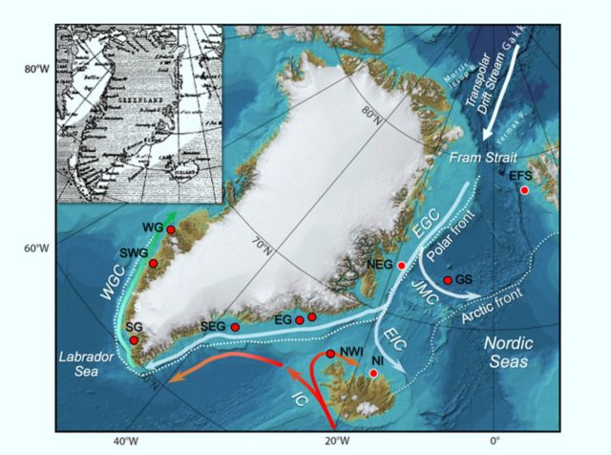
The Little Ice Age (LIA) was triggered by a large outflow of sea ice from the Arctic Ocean into the North Atlantic, according to the findings of a new paper published in the journal Science Advances.
The paper combines marine sediment cores drilled from the ocean floor from the Arctic Ocean to the North Atlantic, and what these records indicate is an abrupt increase in Arctic sea ice and cold waters exported to the North Atlantic starting around 1300, peaking in mid-century, and ending abruptly in the late 1300s.
Crucially, the provocative paper concludes that external forcing from volcanoes or any other cause may not be necessary for large swings in climate to occur — a previously widely held assumption: “These results strongly suggest that these things can occur out of the blue due to internal variability in the climate system,” said Dr. Martin Miles, researcher in the Institute of Arctic and Alpine Research at the University of Colorado. But the marine cores do also show a sustained, far-flung pulse of sea ice near the Norse colonies on Greenland, an event which coincided with their demise in the 15th century; a cooling climate is thought to have pushed hard on their resilience.
Today, it is feared a similar event may be about to occur.
“We are waiting for a huge burst of cold water to be released from the Beaufort Gyre,” says David Mauriello of the ORP, a release which is is long overdue with the gyre having circulated in-place far longer than is normal. “And when it does this,” continues Mauriello, “it will potentially shut down the Gulf Stream.”
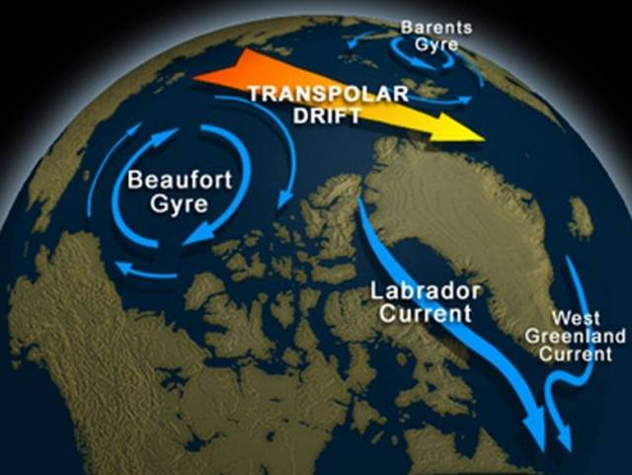The Beaufort Gyre has been circulating in-place for far longer than is normal. When it finally lets-up, cold water will outflow into the Atlantic, potentially disrupting/shutting-down the Gulf Stream.
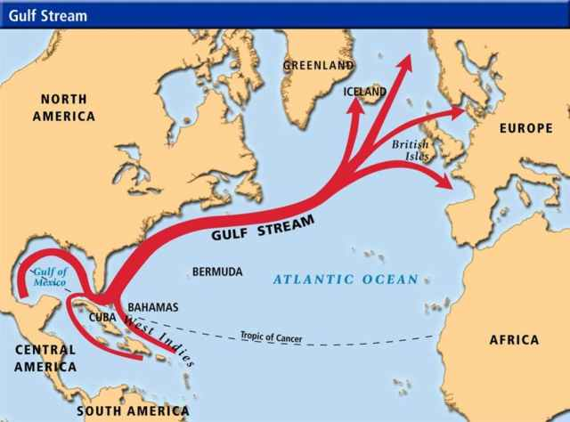The Gulf Stream is key to Europe having the mild, habitable climate that it does.
A shutting down of the Gulf Stream will lead to cold Arctic-like conditions invading Western Europe almost overnight, concludes Mauriello, with Britain, Ireland, and Scandinavia at the forefront of the blast.
Keep in mind that these planetary processes and mechanisms remain poorly understood, because the instruments to study them have not been in place for hundreds of years. That’s okay, actually. The data used to claim the planet is actually warming up are even more misleading. Sliding the temperature scale a fraction of a degree in models studying ice cores, has already created the biggest scientific hoax in history, costing inhabitants trillions in new taxes already.
As a scientist, I can tell you that “Whenever you hear the consensus of scientists agrees on something or other, you know it is lie. The truth is that Carbon dioxide levels have zero impact on the climate. Plants love carbon dioxide. In fact, global plant growth is governed by available carbon dioxide to feed them.
Don’t fall for bogus political agendas. Taxing carbon producers is designed to make a few white guys filthy rich off of your bad breath.
Historically low solar activity, cloud-nucleating Cosmic Rays, and a meridional jet stream flow are moving the farm belt steadily toward the equator, which is the smallest section of tillable ground on the planet. Both NOAA and NASA both report that the Sun is entering a ‘full-blown’ Grand Solar Minimum in the late-2020s. NASA correctly has predicted that this upcoming solar cycle (25) will be “the weakest of the past 200 years”, with the agency correlating previous solar shutdowns to prolonged periods of global cooling here.
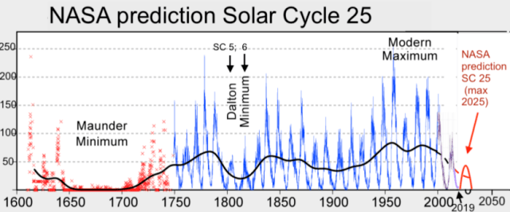
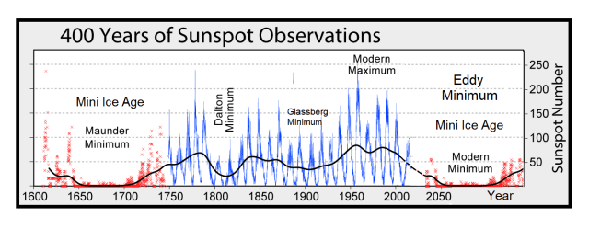
What does this mean? Ice Ages appear rapidly. They don’t take hundreds or even dozens of years to settle in. Less than 5 cold years can cause snow to fall on last year’s snow. That is how glaciers are formed.
Jakobshavn Glacier in western Greenland is notorious for being the world’s fastest-moving glacier. It is also one of the most active, discharging a tremendous amount of ice from the Greenland Ice Sheet into Ilulissat Icefjord and adjacent Disko Bay—with implications for sea level rise. The image above, acquired on June 6, 2019, by the Operational Land Imager (OLI) on Landsat 8, shows a natural-color view of the glacier.
Jakobshavn has spent decades in retreat—that is, until scientists observed an unexpected advance between 2016 and 2017. In addition to growing toward the ocean, the glacier was found to be slowing and thickening. New data collected in March 2019 confirm that the glacier has grown for the third year in a row, and scientists attribute the change to cool ocean waters.
“The third straight year of thickening of Greenland’s biggest glacier supports our conclusion that the ocean is the culprit,” said Josh Willis, an ocean scientist at NASA’s Jet Propulsion Laboratory and principal investigator of the Oceans Melting Greenland (OMG) mission.
Global Glacier growth shows that 87% of the world’s glaciers have actually been growing, and that ice feeding glacial lakes has expanded by 200% in the last two decades. This is not caused by global warming. It is caused by glaciers growing so far that they reach lower altitudes or geothermal zones where the ice creates giant lakes. NASA has confirmed the expansion of glacial lakes over the entire planet, storing billions of gallons of fresh water in lakes contained by glaciers on all sides.
17 Jan 2010 - "A warning that climate change will melt most of the Himalayan glaciers by 2035 is likely to be retracted after a series of scientific blunders by the United Nations body that issued it," says this article on TimesOnLine.
Were these really "blunders"? Or were they deliberate fraud?
Two years ago the IPCC claimed that "glaciers were melting so fast that those in the Himalayas could vanish by 2035."
The scientists behind the warning now admit that it was based on a news story in the New Scientist, which was itself based on a short telephone interview with Syed Hasnain, a little-known Indian scientist.
Hasnain has since admitted that the claim was "speculation" and "not supported by any formal research." (Italics added.)
"If confirmed it would be one of the most serious failures yet seen in climate research," the article continues.
Professor Murari Lal, who oversaw the chapter on glaciers in the IPCC report, said he would recommend that the claim about glaciers be dropped.
Fred Pearce, who conducted the original interview for the New Scientist, said he called Hasnain in 1999 after spotting his claims in an Indian magazine. "Hasnain told me then that he was bringing a report containing those numbers to Britain," said Pearce. "The report had not been peer reviewed or formally published in a scientific journal and it had no formal status so I reported his work on that basis. Since then I have obtained a copy and it does not say what Hasnain said."
Still, the IPCC used the New Scientist article (non-peer reviewed) as backup for its claim that the likelihood of the glaciers melting was "very high," with a probability of greater than 90%.
"Glaciologists find such figures inherently ludicrous, pointing out that most Himalayan glaciers are hundreds of feet thick and could not melt fast enough to vanish by 2035 unless there was a huge global temperature rise. The maximum rate of decline in thickness seen in glaciers at the moment is 2-3 feet a year and most are far lower. (Italics added.)
Lal himself admits that he knows little about glaciers. "I am not an expert on glaciers and I have not visited the region so I have to rely on credible published research," he said.
The IPCC has yet to explain "how someone who admits to little expertise on glaciers was overseeing such a report."
"Rajendra Pachauri, the IPCC chairman, has previously dismissed criticism of the Himalayas claim as "voodoo science".
See all of this great article, entitled "World misled over Himalayan glacier meltdown":
http://www.timesonline.co.uk/tol/news/environment/article6991177.ece
Thanks to Craig Adkins (US), Burt Rutan (US), Ray Lynch (Dublin) and Arjan Weijdema (The Netherlands) for this link
A similar article was also posted in the Australian:
http://www.theaustralian.com.au/news/united-nations-blunder-on-glaciers-exposed/story-e6frg6n6-1225820614171
Thanks to Kai Ullner for this link
"The west Himalayan range includes 15,000 glaciers," says the article.
I'm guessing that more than 14,000 of these glaciers are not monitored
at all. This would mean that we have no way of knowing whether the
preponderance of Himalayan glaciers are growing or shrinking.
I'm aware of at least 230 Himalayan glaciers - including Mount Everest,
K2 and Nanga Parbatg - that are actually growing.
Greenland Glacier
Carl Allon who authored the Electroverse article offers a very rational theory regarding why Greenland and Iceland have gained about 45 percent more ice mas that "normal" over the past three years at a time when global carbon dioxide levels have risen. He suggests, as do others who are familiar with the subject, that we can look to the sun for answers to the mystery.
Allon cites research by Prof. Valentina Zharkova from Northumbria University in the UK indicating that our star has just exited a "Modern Maximum"—a 30-or-so year period of high solar activity — and is now on the slide back down to a prolonged period of cooling.
Speaking last October at the Global Warming Policy Foundation, Dr. Zharkova predicted that by about 2020 we are likely to be in for a new "Super Grand Solar Minimum" which will bring about a multi-decadal cold global temperature period similar to the "little ice age" between about 1300 and 1850.
Zharkova’s model draws upon dynamo wave effects in two layers of the sun – one close to the surface, and the other deep within the convection zone. Both effects have a frequency of about 11 years, yet which are slightly different with cycles that are slightly offset to each other in time.
This pair of waves will become increasingly offset during solar cycle 24 which peaks in 2022, and will become exactly out of synch during the solar cycle 26 decade from 2030 to 2040.
Valentina Zharkova has a good record of being right. Her models have run at 93 percent accuracy, and she was of very few to correctly predict that solar cycle 24 would be weaker than cycle 23.
In any case, you might want to consider holding off putting that long flannel underwear on EBay just yet.
Counterfeiting for Fun and Profit
Fiscal stimulus, including the latest $1.9 trillion American Rescue Plan Act, is a terrible joke. And the means for financing it is a terrible fraud. A massive deficit, piled upon a mammoth debt, made possible by dollar debasement.
Extreme credit market intervention by the Federal Reserve is a prerequisite. So, too, is the utter denial of price inflation by the Bureau of Labor Statistics. This week’s consumer price index (CPI) propaganda reported the all items index increased 0.4 percent in February and 1.7 percent over the last 12 months.
The combination of extreme credit market intervention and bogus inflation reporting is making a mockery of credit markets. Where to begin?
When you purchase a Treasury note you are lending money to the government for a specified period of time (i.e. 30 days to 30 years) at a fixed rate of interest or yield. The risk of default on Treasuries has generally been considered nonexistent.
The federal government, with assistance from the Federal Reserve, can always print money to pay its debts. But this isn’t without risks. Because printing dollars to pay debts devalues the existing stock of dollar. So while the nominal return is preserved…the inflation adjusted return goes negative.
In short, inflation destroys Treasury values for investors. To account for expectations of rising inflation, yields rise. But this presents another problem for long term Treasury investors.
When Treasury yields go up, Treasury prices go down. Over the last eight months, the yield on the 10-Year Treasury note has increased from 0.5 percent to over 1.54 percent – or 104 basis points.
Treasury investors stand to face major losses. Moreover, as interest rates rise, and borrowing costs become more expensive, several other things happen.
High priced stocks become less attractive. In addition, higher borrowing costs make it harder for over leveraged zombie corporations, state governments, municipalities, and Washington to roll over their debts.
When interest rates rise, explosives things happen. There are financial blow ups. Long Term Capital Management, for example, in 1998. Or Lehman Brothers in 2008. Sometimes the stock market crashes…like the Black Monday crash of 1987.
There are many well-known examples. However, here we revisit a lesser known blow up. One we believe is particularly instructive.
Given the burden pension fund managers have to overcome significant cash shortfalls, similar iterations of the story that follows may soon play out in various hamlets across America…including a city or town near you.
Leveraged Arbitrage
Robert Citron loved his job. His wife Terry once remarked:
“He can barely stand the weekend at home. He can’t wait to get back. I think he’d go crazy without that job.”
Perhaps Citron should have taken up a hobby. Soap making or yo-yoing or even taxidermy. Anything to distract from trying to outdo himself. The people he served would have been much better off.
Robert Citron, if you’ve never heard of him, accomplished a remarkable achievement. In 1994, the 69-year old treasurer for Orange County, a position he’d held for 25 years, oversaw a $1.64 billion dollar loss of public funds. At the time this resulted in the largest municipal bankruptcy in U.S. history.
The fuse for Citron’s ticking time bomb was Alan Greenspan’s increases to the federal funds rate. This was in the rough and tumble days before the Fed telegraphed its rate hikes two years in advance with dot plots and other nonsense.
Citron always just knew what was going to happen. He always had. His acumen had made him an investing bigshot. He consistently beat nearby investment pools by at least 2 percent. Thus, a steady flow of cash came his way.
Dazzled by Citron’s results, schools, cities, and districts tripped over themselves in their rush to invest with him. Few looked into how he produced these miraculous returns.
Citron’s strategy was centered on a core belief. That interest rates would remain low and that the difference between short-term yield and long-term yield offered an opportunity for arbitrage. Citron used structured notes to exploit this. Then he leveraged the entire portfolio to further amplify the gains.
Through a series of reverse repurchase agreements, Citron used his securities as collateral for loans to buy even more securities. He levered a sizable $7 billion portfolio into a $20 billion position.
The leveraged strategy worked swimmingly, amplifying gains, while interest rates followed his predicted path. But when interest rates rose, the fund quickly sank.
In February 1994, the Fed began to raise interest rates. Citron’s amplified gains quickly turned to amplified losses. As the rate hikes continued, the losses became overwhelming. The County fell into bankruptcy.
Fifty Basis Points To Disaster
At the moment, Fed Chairman Jay Powell says he wants inflation to run hot. That the Fed will hold the federal funds rate near zero until at least 2023.
But what if the credit market has other thoughts?
The yield on the 10-Year Treasury note has increased 104 basis points over the last 8 months. But for every market trend there is a countertrend. Over the next month or two there could be a countertrend in bonds and interest rates could fall.
However, the great monetary inflation has already happened. The great price inflation is picking up, regardless of what the Bureau of Labor Statics’ bogus CPI report says. Thus, it is certainly possible that the yield on the 10-Year Treasury note could increase another 50-basis points come summer.
And by our estimation, we’re about 50-basis points to disaster.
The financial system, lured by a seemingly endless supply of cheap credit from the Fed is levered up to its eyeballs. Just wait and see. When the yield on the 10-Year Treasury note eclipses 2.10 percent something will blow.
There could be corporate debt, hedge fund, and pension fund financial blow ups galore. But this is exactly what the Fed is trying to avoid. The Fed wants inflation without higher interest rates.
Thus, the Fed will expand its balance sheet – whatever it takes – and buy bonds with printing press money to keep interest rates from rising. In fact, the Fed is already pumping $80 billion per month into Treasuries and $40 billion per month into mortgage backed securities to suppress interest rates.
Yet these Fed asset purchases will likely balloon to keep interest rates in check. So in addition to a debt crisis, the Fed is propagating a dollar crisis.
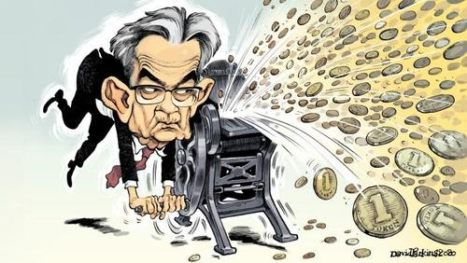
In Orange County’s 1994 experience, the grand jury investigation found that Citron, “relied upon a mail-order astrologer and psychic for interest rate predictions.”
Nowadays, we have the Fed’s dots. And like astrology or psychic predictions, dot plots have nothing to do with the realities of inflation or a free functioning credit market.
The reality is we’re 50-basis points to disaster. The Fed can resist it with ever greater amounts of printing press money. And certainly the Fed will. It’s the only way for the government to stay in business.
But it doesn’t take much imagination to see where this leads. And if you still don’t own some gold and silver you probably never will.
Icelandic Volcano
The number of earthquakes is rapidly increasing since Mar. 4, when we first told readers a volcanic eruption could be brewing in Iceland. According to Financial Times, in the last few weeks, more than 34,000 quakes have been recorded on the Reykjanes Peninsula as the country is on "high alert" for the next volcanic eruption.
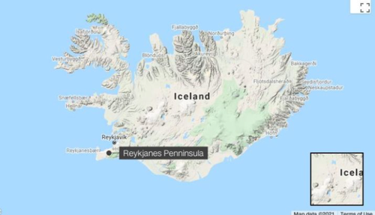
"Never before have so many people in Iceland experienced so much seismic activity," Thorbjorg Agustsdottir, a seismologist at the government-run Iceland GeoSurvey, told FT. "They're getting tired of being woken up and ask: when's it going to stop?"
Most of the quakes are around the south-west Reykjanes peninsula that includes Reykjavík, the capital of Iceland, home to 122,000 residents, the Keflavík International Airport, and critical infrastructure.
34,000 Quakes Rock Iceland In Weeks
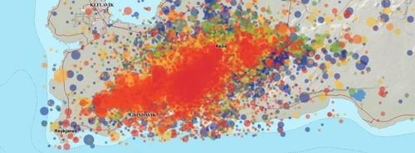
Melissa Anne Pfeffer, an atmospheric volcanologist at the Icelandic Meteorological Office (the nation's volcano monitoring agency), said the magma is one or two kilometers below the surface; an eruption could happen at any time.
"The magma intrusion was about 7km long, up to 2km deep but only 1 metre wide," she said.
Evgenia Ilyinskaya, a volcanologist at the University of Leeds in the UK, said the swarm quakes are occurring near Reykjavik and the country's main airport. She said critical infrastructure such as power plants are also nearby.
The latest swarm of quakes has annoyed the heck out of residents who are constantly woken up in the middle of the night.
"It's quite annoying . . . to have your house swaying all the time," Agustsdottir said of residents in the town of Grindavik that is the worst affected by the quakes.
The last major incident was the Eyjafjallajökull eruption in 2010, which caused a massive shutdown of the world's airline industry as ash plumes circulated into the atmosphere. If an eruption is seen, this could be disastrous for the industry as it attempts to recover from the pandemic downturn.
The Global Syndicate
During a Tuesday hearing before the Senate Armed Services Committee, U.S. Indo Pacific Command (INDOPACOM) commander Adm. Phillip Davidson said “China has a vast disinformation machine” with a million people behind it that it uses to undermine the U.S. Do you understand the impact of this kind of machine? 1 million people with 1 million computers on the job with one mission. They are writing laws, speeches, articles, scripts, radio copy, and even forming non-profits inside the United States with the mission of destroying America. They are working closely with the Establishment Party.
Responding to questions by Sen. Jeanne Shaheen (D-NH) about the threat Chinese disinformation presents in the Indo-Pacific region, Davidson said, “They use regular media and social media and have nearly a million people in their propaganda machine.”
Davidson said the goal of China’s disinformation efforts is “to undermine U.S. interests, to capture the narrative to their own benefit and to … corrupt the environment in a way that creates doubt amongst our allies and partners in the reliability of the United States.”
It is absolutely unavoidable that the recent $1.9 trillion stimulus package was written in large part by this massive tech army. They are responsible for creating the Global Media Empire than makes movies, writes songs, advertisements, school curricula, and even campaign speeches for play actor candidates who occupy our elected offices and bureaucracies. These soldiers are the ones who ban you from Twitter, Facebook, Linkedin, and YouTube. These soldiers manipulate your credit score, your bank fraud, and probably even your lottery winnings.
They cannot be stopped by any known method. The only way to be safe from them is to limit your exposure. If you limit yourself too much, you will be off grid and unable to save the world at all.
And the Spirit of God Moved Across the Face of the Deep
And the earth was without form, and void; and darkness was upon the face of the deep. And the Spirit of God moved upon the face of the waters. Gen 1:2
It's tricky to figure out what Earth might have looked like in the early years before life emerged. Geological detectives have now obtained more evidence that it was rather different to the planet we live on today.
According to a new analysis of the features of Earth's mantle over its long history, our whole world was once engulfed by a vast ocean, with very few or no land masses at all. It was an extremely soggy space rock.
So where the heck did all the water go? According to a team of researchers led by planetary scientist Junjie Dong of Harvard University, minerals deep inside the mantle slowly drunk up ancient Earth's oceans to leave what we have today.
"We calculated the water storage capacity in Earth's solid mantle as a function of mantle temperature," the researchers wrote in their paper.
"We find that water storage capacity in a hot, early mantle may have been smaller than the amount of water Earth's mantle currently holds, so the additional water in the mantle today would have resided on the surface of the early Earth and formed bigger oceans.
"Our results suggest that the long‐held assumption that the surface oceans' volume remained nearly constant through geologic time may need to be reassessed."
Deep underground, a great deal of water is thought to be stored in the form of hydroxy group compounds - made up of oxygen and hydrogen atoms. In particular, the water is stored in two high-pressure forms of the volcanic mineral olivine, hydrous wadsleyite and ringwoodite. Samples of wadsleyite deep underground could contain around 3 percent H2O by weight; ringwoodite around 1 percent.
Previous research on the two minerals subjected them to the high pressures and temperatures of the mantle of modern day Earth to figure out these storage capacities. Dong and his team saw another opportunity. They compiled all the available mineral physics data, and quantified the water storage capacity of wadsleyite and ringwoodite across a wider range of temperatures.
The results showed that the two minerals have lower storage capacities at higher temperatures. Because baby Earth, which formed 4.54 billion years ago, was much warmer internally than it is today (and its internal heat is still decreasing, which is very slow and also has absolutely nothing to do with its external climate), it means the water storage capacity of the mantle now is higher than it once was.
Moreover, as more olivine minerals are crystallizing out of Earth's magma over time, the water storage capacity of the mantle would increase that way, too.
In all, the difference in water storage capacity would be significant, even though the team was conservative with its calculations.
"The bulk water storage capacity of Earth's solid mantle was significantly affected by secular cooling due to its constituent minerals' temperature‐dependent storage capacities," the researchers wrote.
"The mantle's water storage capacity today is 1.86 to 4.41 times the modern surface ocean mass."
If the water stored in the mantle today is greater than its storage capacity in the Archean Eon, between 2.5 and 4 billion years ago, it's possible that the world was flooded and the continents swamped, the researchers found.
This finding is in agreement with a previous study that found, based on an abundance of certain isotopes of oxygen preserved in a geological record of the early ocean, that Earth 3.2 billion years ago had way less land than it does today.
If this is the case, it could help us answer burning questions about other aspects of Earth's history, such as where life emerged around 3.5 billion years ago. There's an ongoing debate over whether life first formed in saltwater oceans or freshwater ponds on land masses; if the entire planet was engulfed by oceans, that would solve that mystery.
Furthermore, the findings could also help us in the search for extraterrestrial life. Evidence suggests that ocean worlds are abundant in our Universe, so looking for signatures of these soggy planets could help us identify potentially hospitable worlds. And it could strengthen the case for looking for life on ocean worlds in our own Solar System, such as Europa and Enceladus.
Not least, it helps us better understand the delicate evolution of our planet, and the strange, often seemingly inhospitable turns along the way that eventually led to the emergence of humanity.
The Fake Insurrection
Ever since the January 6 breach of the U.S. Capitol, a heightened anxiety level has been palpable in the District of Columbia. However, the facts of that event – which have been ever-so-slowly seeping out – are worthy of examination amid all this fearmongering. Liberty Nation’s Pennel Bird has done a little homework and accessed the charging documents regarding the Capitol breach. Bird found “310 arrests, by my count, of which exactly five listed possession of a firearm. There was no mention of brandishing or discharging – just possession. There’s your ‘armed insurrection.'”
This is not to make excuses or say it was all fun and games on January 6, but facts are facts. Robert Knight of The Washington Times pointed out:
“Reality: The rioters had no firearms or even knives. Two of the five died from a stroke and heart attack. The officer, Brian Sicknick, was not hit by a fire extinguisher, did not die from ‘blunt trauma,’ and his death the next day was from ‘unknown causes,’ as The New York Times eventually admitted.”
Herein lies the problem: When facts are twisted into false narratives, who knows what to believe? Thus, law enforcement takes a cover-your-derriere stance, and Congress runs for cover. So, when the United States Capitol Police put out a March press release claiming they had intelligence that a militia group had plans to breach the U.S. Capitol building, brave legislators halted their lawmaking activities and holed up in their homes. They were even urged to “use the underground tunnels” if it became necessary to traverse the Capitol Hill complex.
These unidentified intelligence reports of “possible threats” were weaponized to ratchet up the fear in the nation’s capital. Never mind that intelligence sources are not always accurate. Remember all those weapons of mass destruction in Iraq? What WMD? Exactly.
Scaring the bejesus out of folks living in D.C. carries no real downside for authorities. No insurrection and they can claim that it was because of their meticulous preparation that caused these militiamen to stand down. So, what is the harm?
Anxiety Derangement Syndrome
Psychologists maintain that living in a continual state of fear causes generalized anxiety, and those with this disorder have a disproportional tendency to want to control everything. As well, they become increasingly neurotic, with an excessive need to dominate and oppress others. Ultimately, psychologists say that a person filled with unwarranted apprehension turns into an obsessive-compulsive with a desire to rule over everyone else because they see it as the only way to protect themselves.
Sound familiar?
The human brain has an extraordinary ability to adapt. A mind that has been rewired is most often achieved through repeated exposure to false information or propaganda. Those on the left wholeheartedly believe that the only way to assuage their anxiety is by controlling every possible situation – which is an irrational, abnormal behavior.
Since actions are fueled by beliefs, there is a powerful need for leftists to protect themselves from illusory militias because they imagine an insurrectionist Armageddon around every corner. Such as it is, this is likely the leading edge of many mythological battles that will play out in the minds of this frightened class, which unfortunately has control over the presidential and legislative branches of the U.S. government.
And so, journalists in the activist media are scratching their poorly rewired heads this morning. The much-anticipated secondary insurrection they were convinced was real, turned out to be nothing more than a mirage.
More
Twice in the last six weeks, warnings were issued about imminent, grave threats to public safety posed by the same type of right-wing extremists who rioted at the Capitol on January 6. And both times, these warnings ushered in severe security measures only to prove utterly baseless.
First we had the hysteria over the violence we were told was likely to occur at numerous state capitols on Inauguration Day. “Law enforcement and state officials are on high alert for potentially violent protests in the lead-up to Inauguration Day, with some state capitols boarded up and others temporarily closed ahead of Wednesday’s ceremony,” announced CNN. In an even scarier formulation, NPR intoned that “the FBI is warning of protests and potential violence in all 50 state capitals ahead of President-elect Joe Virtual Joe’s inauguration.”
The resulting clampdowns were as extreme as the dire warnings. Washington, D.C. was militarized more than at any point since the 9/11 attack. The military was highly visible on the streets. And, described The Washington Post, “state capitols nationwide locked down, with windows boarded up, National Guard troops deployed and states of emergency preemptively declared as authorities braced for potential violence Sunday mimicking the Jan. 6 attack on the US Capitol by a mob of pro-Trump rioters.” All of this, said the paper, “reflected the anxious state of the country ahead of planned demonstrations.”
But none of that happened — not even close. The Washington Post acknowledged three weeks later:
Despite warnings of violent plots around Inauguration Day, only a smattering of right-wing protesters appeared at the nation’s statehouses. In Tallahassee, just five armed men wearing the garb of the boogaloo movement — a loose collection of anti-government groups that say the country is heading for civil war — showed up. Police and National Guard personnel mostly ignored them.
All over the country it was the same story. “But at the moment that Virtual Joe was taking the oath of office in Washington, the total number of protesters on the Capitol grounds in Topeka stood at five — two men supporting Trump and two men and a boy ridin’ with Virtual Joe,” reported The Wichita Eagle (“With Kansas Capitol in lockdown mode, Inauguration Day protest fizzles). “The protests fizzled out after not many people showed up,” reported the local Florida affiliate in Tallahassee. “The large security efforts dwarfed the protests that materialized by Wednesday evening,” said CNN, as “state capitols and other cities remained largely calm.”
Indeed, the only politically-motivated violence on Inauguration Day was carried out by Antifa and anarchist groups in Portland and Seattle, which caused some minor property damage as part of anti-Virtual Joe protests while they “scuffled with police.” CNN, which spent a full week excitedly hyping the likely violence coming to state capitols by right-wing Trump supporters, was forced to acknowledge in its article about their non-existence that “one exception was Portland, where left-wing protesters damaged the Democratic Party of Oregon building during one of several planned demonstrations.”
Completely undeterred by that debacle, Democrats and their media spokespeople returned with a new set of frightening warnings for this week. The date of March 4 has taken on a virtually religious significance for the Q-Anon movement, announced NBC News’ Ben Collins, who was heard on NPR on Thursday speaking through actual, literal journalistic tears as he recounted all the times he called Facebook to plead with them to remove dangerous right-wing extremists on their platform (tears commence at roughly 7:00 mark). Valiantly holding back full-on sobbing, Collins explained that he proved to be so right but it pains and sorrows him to admit this. With his self-proclaimed oracle status fully in place, he prophesized that March 4 had taken on special dangers because Q-Anon followers concluded that this is when Trump would be inaugurated.
This is how apocalyptic cult leaders always function. When the end of the world did not materialize on January 6, Collins insisted that January 20 was the day of the violent reckoning. When nothing happened on that day, he moved the Doomsday Date to March 4. The flock cannot remain in a state of confusion for too long about why the world has not ended as promised by the prophet, so a new date must quickly be provided with an explanation for why this is serious business this time.
This March 4 paranoia was not confined to NBC’s resident millennial hall monitor and censorship advocate. On March 3, The New York Times warned that “the Capitol Police force is preparing for another assault on the Capitol building on Thursday after obtaining intelligence of a potential plot by a militia group.” All this, said the Paper of Record, because “intelligence analysts had spent weeks tracking online chatter by some QAnon adherents who have latched on to March 4 — the original inauguration date set in the Constitution — as the day Donald J. Trump would be restored to the presidency and renew his crusade against America’s enemies.”
These dire warnings also, quite predictably, generated serious reactions. “House leaders on Wednesday abruptly moved a vote on policing legislation from Thursday to Wednesday night, so lawmakers could leave town,” said the Times. We learned that there would be further militarization of the Capitol and troop deployment in Washington indefinitely due to so-called “chatter.” NPR announced: “The House of Representatives has canceled its Thursday session after the US Capitol Police said it is aware of a threat by an identified militia group to breach the Capitol complex that day.”
Do you know what happened on March 4 when it came to violence from right-wing extremists? The same thing that happened on January 20: absolutely nothing. There were no attempted attacks on the Capitol, state capitols, or any other government institution.

