Mystery Drones Kept Buzzing U.S. Destroyers During Exercises Off California
New details have emerged of how mysterious drones harassed U.S. warships off California on multiple occasions in 2019. The Navy has yet to determine where the drones came from, who was operating them, or why they buzzed around a group of U.S. destroyers.
The incidents were first reported by documentary filmmaker Dave Beaty, with new details obtained by news website The Drive using Freedom of Information Act requests to get the ships' logs of the encounters.
The vessels involved were the destroyers USS Kidd, USS Rafael Peralta and USS John Finn. They were engaged in a training exercise in a military area about a hundred miles off Los Angeles in low visibility. This location tells us something immediately: these were not hobbyist quadcopters that happened to see some cool ships and flew over for a look, but something far more deliberate.
The USS Kidd, DDG-100s, a modern Arleigh Burke-class destroyer which attracted the attention of ... [+]
U.S. NAVY
At 10 pm on July 14th, lookouts on the USS Kidd spotted two drones, which they describe in the log as 'Unmanned Aerial Vehicles' or UAVs without providing details. Ten minutes later USS Rafael Peralta and USS John Finn made their own sightings. During this period, the ships were carrying out a form of radio silence with minimal communication, a common practice during exercises to make the ships difficult for electronic eavesdroppers to spot.
The ships logs note that the drones followed the Kidd, and at one point matched its speed and bearing, with one drone hovering above the helicopter pad. The encounter lasted some ninety minutes, much longer than the endurance of small drones which typically have a flights endurance of half an hour.
The drones departed, and despite the destroyer’s impressive array of sensors, which include radar, thermal imaging, electro-optical systems which can see in the dark and devices which can detect and locate radio transmitters, they were not able to determine where they went.
A similar event occurred on the following night starting at 10 pm. On this occasion the warships contacted the nearby cruise liner Carnival Imagination, which confirmed that the drones were not theirs, also that they could see five or six drones flying around the Navy vessels. This time the encounter lasted three hours, with the USS Rafael Peralta identifying four drones shadowing them at one point.
Similar incidents occurred on the 25th and 30th of July; here may have been others, but these were the only ones turned up by The Drive’s FoIA trawl.
A formal investigation followed, involving the Navy, Coast Guard, FBI and other agencies. Investigators contacted the operators of several commercial ships in the area, as these were seen as the most likely source for the drones, but drew a blank.
Many suspected that the drones must have originated from another unit in the US Navy. The Navy’s Fleet Area Control and Surveillance Facility (FACSFAC) based in San Diego, which is responsible for drone operations, said that the drones were not theirs. They may have come from another element of the military, but whoever it was is not coming forward.
The incident is immediately reminiscent of the multiple incursions of drones over U.S. nuclear facilities we reported last year. Some 24 sites suffered 57 drone incursions from 2014-to 2019. In one of the more dramatic incidents in September 2019, “five or six” drones flew over the Palo Verde nuclear power plant for around ninety minutes.
As with the Navy incident, the drones were not single but operated as part of a coordinated group. As with the Navy, these were larger craft with greater endurance than consumer models, suggesting an operator with considerable resources. And as with the Navy encounter, investigators failed to establish who flew the drones, where they were flown from – and most of all why.
The most obvious explanation for both sets of drone incursions is that they were testing security – and in both cases the targets seem to have failed. They might have been sent by some unknown U.S. government agency; or they might have been operated by some foreign power or other organization. Where they were launched from – one of the ships previously noted, a small unmanned vessel or submarine or even an aircraft – would of course give plenty of clues, but this remains a matter of speculation.
What we cannot do is assume that such encounters are trivial and can be ignored. It seems likely the drones were gathering intelligence, possibly about the radio signatures of particular warships, but they might have more serious purpose. Simply by flying around a warship, a drone can cause problems – not least by interfering with helicopter operations. And a drone nearby with a jammer can cause far more disruption than a larger aircraft at a longer range, because jamming strength falls off with the square of distance.
Small quadcopters have already been used extensively to drop bombs, in Iraq, Syria, Afghanistan and elsewhere. And even a small explosive charge is enough to knock out radar, communication antennas, or kill personnel. It would also be a mistake to assume that current destroyer weapons can easily knock down all drones. A 2020 USNI study highlights how small drones can ‘mission kill’ a destroyer, not sinking it but preventing it from carrying out its mission.
Expect to read more about this story as the facts emerge. But, for the present, many mysteries remain.
EPA Actions Lead to Dark Ages
In a healthy scientific community, dissenting voices and disagreements are often accepted and even encouraged. Under the Biden administration, you could be fired for such attributes.
The new Biden-appointed Administrator of the Environmental Protection Agency, Michael Regan, reportedly purged dozens of “scientists and other experts” put on “key advisory boards” under former President Donald Trump on Wednesday, according to the Associated Press.
Rather than in the shadows, as is the norm for these sorts of purges, Regan happily told the AP about his “reset” in an interview, according to the AP. Ironically, the administrator said in the interview that his purge would return the EPA to its “time-honored practice of relying on advice from a balanced group of experts.”
Regan told the AP, “Scientific integrity is a foundational value for EPA. And I am committing to ensuring that every single decision we make meets rigorous scientific standards.”
The administrator is reportedly attempting to restore public confidence in the EPA, and one would think this process would begin with not removing the opposition outright. Regan, however, says. “to do that, we have to identify and root out any decisions from the past that were not properly aligned with science.”
According to the AP, Regan unceremoniously axed 40 members of the Science Advisory Board and the Clean Air Scientific Advisory Committee, which “provide scientific expertise and recommendations for air quality standards and other policies intended to protect public health and the environment.”
Regan seemingly had it out for these people. The administrator took office less than a month ago and already specified in a Wednesday media release that “Resetting these two scientific advisory committees will ensure the agency receives the best possible scientific insight to support our work to protect human health and the environment. Today we return to a time-tested, fair, and transparent process for soliciting membership to these critically important advisory bodies.”

The administrator couldn’t even keep up bipartisan appearances. Regan told the AP that “We set the agenda here, based on the president’s vision, and we are charged with protecting the public health and the environment.”
This purge is seemingly just part of a much larger White House-led investigation into “Trump-era political interference in science across the government.”
The White House Office of Science & Technology Policy tweeted Monday about its new “Scientific Integrity Task Force,” claiming it would deliver “real results based on science, not politics.”
If the Biden administration’s displays of bipartisanship thus far are representative of this task force’s policy, though, I wouldn’t be so sure of that statement.
Some, rightfully, have pushed against this move. John Graham, leader of the SAB, reportedly defended his board’s work in an email, saying it has “exposed the scientific shortcomings of the Trump EPA’s plans to weaken greenhouse gas standards for autos and remove numerous water bodies from federal pollution protection,” according to the AP.
In other words, Regan assumes this board can now, thanks to the removal of experts, do the work it had already been doing throughout the Trump administration.
Graham was reportedly “saddened” by Regan’s “radical action,” and frankly, he’s absolutely right to be.
Regardless of the political affiliation of the board members Regan decided were either unnecessary or too politically charged to make science-backed decisions, these people were already fighting for the “scientific integrity” the administrator wants to see the return of.
It’s self-sabotage, and unfortunately, it’s once again a case that will likely end up hurting the American people far worse than Biden’s approval rating.

Psyche Mission
If you don’t think people are paying attention to my latest book Asteroid Mining: The future of energy, you’re mistaken.
Set to launch next year, the agency’s Psyche spacecraft will explore a metal-rich asteroid in the main asteroid belt between Mars and Jupiter.
A major component of NASA’s Psyche spacecraft has been delivered to the agency’s Jet Propulsion Laboratory in Southern California, where the phase known as assembly, test, and launch operations is now underway. Over the next year, the spacecraft will finish assembly and undergo rigorous checkout and testing before it’s shipped to Cape Canaveral, Florida, for an August 2022 launch to the main asteroid belt.
The Solar Electric Propulsion (SEP) Chassis, crafted by Maxar Technologies’ team in Palo Alto, California, is the size of a van and represents more than 80% (by mass) of the hardware that will ultimately make up the Psyche spacecraft. The large, box-shaped structure made a dramatic entrance as it rolled into the white-walled clean room of JPL’s storied High Bay 1 of the Spacecraft Assembly Facility. Some of the chassis’ most visible features include the 6.5-foot-wide (2-meter-wide) high-gain antenna, the frame that will hold the science instruments, and bright red protective covers to safeguard delicate hardware.
“Seeing this big spacecraft chassis arrive at JPL from Maxar is among the most thrilling of the milestones we’ve experienced on what has already been a 10-year journey,” said Arizona State University’s Lindy Elkins-Tanton, who as principal investigator leads the Psyche mission. “Building this complex, precision piece of engineering during the year of COVID is absolutely a triumph of human determination and excellence.”
An illustration depicting the target of NASA’s Psyche mission: the metal-rich asteroid Psyche, in the main asteroid belt between Mars and Jupiter.
Credits: NASA/JPL-Caltech/ASU
Psyche’s target is a metal-rich asteroid of the same name, which orbits the Sun in the main asteroid belt between Mars and Jupiter. Scientists think that Psyche is largely iron and nickel and could be the core of an early planet. Exploring the asteroid Psyche (about 140 miles, or 226 kilometers, wide) could lend valuable insight into how Earth and other planets formed.
Over the next 12 months, the project team will be working against the clock to meet deadlines in the runup to launch.
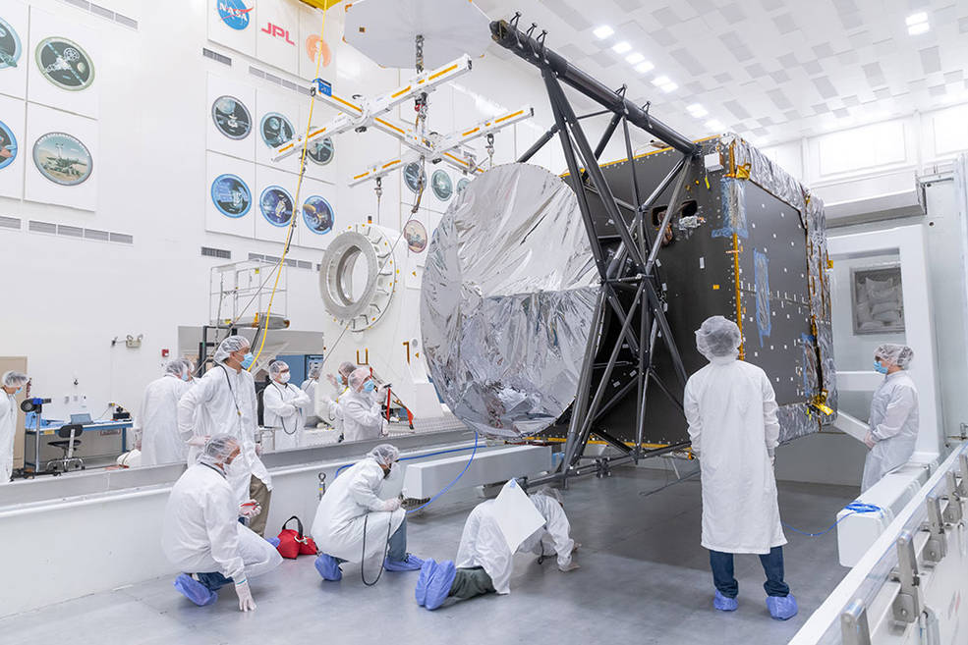
Engineers and technicians prepare to move the chassis of NASA’s Psyche spacecraft from its shipping container to a dolly inside JPL’s Spacecraft Assembly Facility just after the chassis was delivered by Maxar Technologies in late March of 2021.
Credits: NASA/JPL-Caltech
“It’s exciting watching it all come together, and it’s the part of the project life cycle that I love the most,” said Psyche Project Manager Henry Stone of JPL. “But it’s a really intense phase as well. It’s intricate choreography, and if one activity runs into a problem, it can impact the whole process. Staying on schedule at this phase of the mission is absolutely critical.”
The SEP Chassis comes to JPL with most of the engineering hardware systems already integrated. The Maxar team built the entire structure and integrated the hardware needed for the high-power electrical system, the propulsion systems, the thermal system, and the guidance and navigation system. The Psyche mission will take advantage of Maxar’s superefficient electric propulsion system to push Psyche through deep space. Maxar will also deliver the large, twin five-panel solar arrays that provide the power for the spacecraft systems.
Delivering the SEP Chassis to NASA’s JPL is an incredible accomplishment for us at Maxar,” said Steven Scott, Maxar’s Psyche program manager. “I am so proud of our team. We’ve managed to design and build an SEP spacecraft for a billion-mile journey through a low-power environment, all while prioritizing the health and safety of our team during a global pandemic. The collaboration between Maxar, Arizona State University, and NASA’s JPL is a model for success, and we’re honored to be part of the Psyche Mission.”
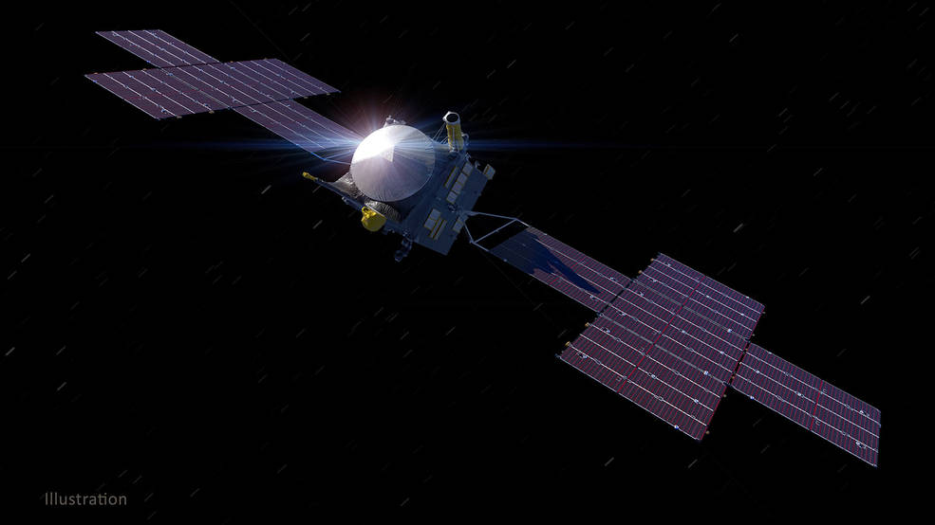
The assembly, test, and launch operations phase kicked off March 16, when engineers gathered in High Bay 1 to begin checking out the JPL-supplied subsystems, the flight computer, the communications system, and the low-power distribution system to be sure they work together. Now that the chassis has arrived, JPL and Maxar engineers will begin installing the remaining hardware, testing as they go.
The mission’s three science instruments will arrive at JPL over the next few months. The magnetometer will investigate the asteroid’s potential magnetic field. The multispectral imager will capture images of its surface. And the spectrometer will analyze the neutrons and gamma rays coming from the surface to determine the elements that make up the asteroid. JPL is also providing a technology demonstration instrument that will test high data-rate laser communications that could be used by future NASA missions.
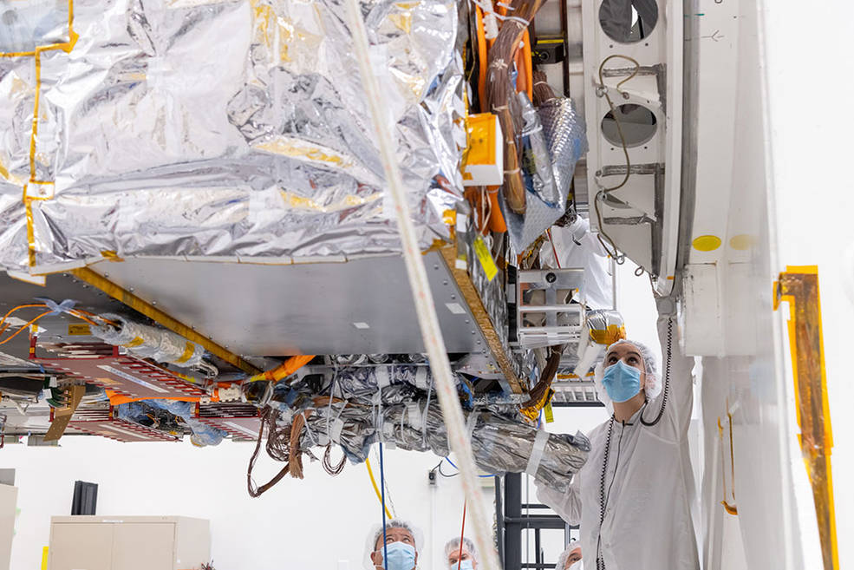
After its delivery to JPL in late March of 2021, NASA’s Psyche spacecraft chassis was attached to a rotation fixture, where it will be integrated with additional flight hardware three science instruments. Once assembled, the spacecraft will ship to Cape Canaveral, Florida, for an August 2022 launch.
Once the full spacecraft is assembled, the orbiter will move from the Spacecraft Assembly Facility to JPL’s large thermal vacuum chamber – a massive undertaking in itself – to simulate the harsh environment of deep space. The chamber is where JPL engineers will begin the heavy-duty testing to ensure the entire machine can survive deep space, thrust with the electric propulsion system, take science measurements, and communicate with Earth.
By next spring, the fully assembled Psyche will be shipped to NASA’s Kennedy Space Center in advance of its August 2022 target launch date. The spacecraft will fly by Mars for a gravity assist in May 2023 and in early 2026, will go into orbit around the asteroid, where it will spend 21 months gathering science data.
First Helicopter on Mars
The first helicopter on Mars is officially on Martian soil.
NASA's Mars helicopter Ingenuity touched down on the surface of the Red Planet after being dropped by its mother ship, the Perseverance rover, the space agency announced late Saturday (April 4). The helicopter's first flight is just over a week away.
"#MarsHelicopter touchdown confirmed! Its 293 million mile (471 million km) journey aboard @NASAPersevere ended with the final drop of 4 inches (10 cm) from the rover's belly to the surface of Mars today," officials with NASA's Jet Propulsion Laboratory in Pasadena, California wrote in a Twitter announcement. "Next milestone? Survive the night."
The first helicopter on Mars is officially on Martian soil.
NASA's Mars helicopter Ingenuity touched down on the surface of the Red Planet after being dropped by its mother ship, the Perseverance rover, the space agency announced late Saturday (April 4). The helicopter's first flight is just over a week away.
If all goes well, Ingenuity will perform a series of ever-longer flights over Jezero Crater (where the Perseverance rover landed on Feb. 18) over the next 31 Martian days, which are called sols. Each flight should reach no higher than 16.5 feet (5 m) and will be conducted over a 300-foot-long (90 m) flight range.
NASA plans a series of tests before that first flight to fire up Ingenuity's four rotor blades (they spin at up to 2,537 revolutions per minute) while Perseverance watches from a safe distance. The rover will be stationed a safe 16.5 feet away from the drone before the first flight.
But first, of course, Ingenuity must survive the bitter cold of its first night alone on Mars. The helicopter's battery will power its heater enough to maintain a steady temperature of about 5 degrees F (minus 15 degrees C).
"The Ingenuity team will be anxiously waiting to hear from the helicopter the next day," Balaram wrote Friday. "Did it make it through the night? Is the solar panel working as expected?"
Mission team members will closely watch Ingenuity's temperature and battery performance over the weekend to ensure the helicopter is healthy, Balaram added. If everything looks good, Ingenuity can then move on to its rotor tests and other system checks ahead of the first flight, he said.
As novel as Ingenuity is, the helicopter is just part of NASA's ambitious Perseverance rover mission to explore an ancient delta in Mars' Jezero Crater. The rover is expected to spend the next two years exploring the area to seek out signs of ancient life. Perseverance will also collect samples of Mars rocks to be collected and returned to Earth on a later mission.

Marxist Sanctions Against Americans
In case you missed it, Virtual-Joe has, for the first time in American history, called for Presidential economic sanctions of a member State because the citizens of that State dutifully and legally passed legislation requiring voters to have ID in order to receive a ballot. This attacks the very core of our Republic and violates the Constitution so directly, that the State has no choice but to resist. These sanctions would be meaningless, except that they economically attack people of color and the city of Atlanta more than $190 million in a single fiscal year. This is what the US would do against a foreign enemy, not against a State.
The Marxist puppet, Virtual-Joe is ordering federal economic sanctions against The Masters, the Atlanta Braves, the Atlanta Falcons, and the Atlanta Hawks along with UGA & GA Tech. football? They are doing everything they can do, short of marching federal troops into Georgia, to ensure cheat-by-mail is the only election system in America. They have used it twice in George in less than 3 months, and it worked flawlessly both times. True, a few young staffers had to be assassinated who were about to go public about the criminal nature of Ballot-R-Us, the massive counterfeiting operation that creates bogus ballots needed by the Marxists to cancel out the vote of US citizens. That is a small price to pay for unmitigated victory.
It is now the internal policy of Virtual-Joe to use the Establishment Party in Washington to sanction any legislation any State happens to signed into law. He has already made public his intent to punish the local population for what he personally decides are their errors?
In order to avoid these sanctions, Virtual-Joe is requiring state and local municipalities to seek approval by President Biden on legislation they are considering.
The Democrat Party is no longer elected, as is also a large portion of the Republican Party that are the remnants of the Fascist Establishment party originally established by FDR and codified by Jimmy-give-away-Panama-Canal-Carter. They are openly and unabashedly instructing, promoting, assisting, and condoning federal employees punishing their political opponents. Virtual-Joe is deeply compromised by Ukrainian crime bosses and the Communist government of China. He simply is not in a position to represent Americans any longer.
The Fascists in Washington need to stay in power and make sure that young allies are also appointed into office through the cheat-by-mail program that worked so well for them in 2018, 2020, and 2021. In order for that program to continue, they must drive home their assertion that African Americans are not intelligent enough to get a driver’s license/photo ID so they can equally participate in American society? This includes voting and getting vaccinated, if they so choose.
The call for unity by Virtual-Joe is nothing less that an extermination order issued for all Americans who oppose his dictatorship. When your time comes to stand up for your rights, what will you do? How about your neighbor’s rights? Will you stand there and let your neighbor be tazed and beaten at the local market for not wearing mask? Will you defend your neighbor’s right to vote and have his vote protected against a fraudulent ballot printed and counted to cancel his vote out? Will you put your mask on and bow your head and roll up your sleeve, because you think Virtual-Joe has your best interest at heart, or because you just want to get on an airplane or go to a movie?
What are you willing to live without, if Virtual-Joe sanctions your way of life? A bus ticket? An Uber or Lyft? Eating at a restaurant? A baseball game? A first date? A family reunion? Church? When will you remember who you are and stand your ground for rights given to you by God? Are you a free people? It is time to say, “Not one more inch.”
The Night Before Eternity
- “Father forgive them, for they don't know what they are doing” (Luke 23.34).
The play Jesus had watched so many times as a youth in Abydos was unfolding exactly as rehearsed. The record has to be written by one worthy to open the gate. Jesus was becoming the Christ, through the things He suffered. The guards were just actors in the play, doing what they had done thousands of times on that hill for their dark and ruthless lord. He asked for their forgiveness in front of their faces. Did they care? No more than if you asked for forgiveness of your mortal enemy before he cut off your head in public.
Jesus was the most wanted enemy of the State. You sort of know what that feels like right now, don’t you? Except you are afraid to turn over the tables of the money changers. You are too afraid of losing your possessions and your credit score to do what Jesus did. You want peace, instead of justice. You want mercy, instead of war. This cycle is well known for billions of years. Peace, justice, war, mercy. Over and over again we go around this compass, and until we understand the pure truth of it, we are cursed to tread this mill.
Jesus showed the first step of the tangent away from Lucifer’s game by telling us what to do. Ask for forgiveness for your enemy. Then, prepare for battle.
- “Today you shall be with me in Paradise” (Luke 23:43).
Here is all the proof you will ever need that we are eternal beings having a mortal experience. When I was killed in May of 2012, the most amazing epiphany for me was arrived when I came back to the living on that warm evening street, lying on my back as the police officer removed my helmet. “That was easy,” I said.
And it was. There was no pain. I still cannot recall the impact of that mindless driver slamming that car into my motorcycle. At that moment, I realized that once you’re dead, it is paradise, with one exception. We regret the people we leave behind. It feels like a letter, perhaps only partially written and yet unmailed.
The two thieves hanging on nearby crosses are poor. They probably only know stealing a meal or a cloak to stay warm as a way of life. They will all die that afternoon, because Jewish law forbids the Romans from letting anyone die on the Sabbath. They will come along soon with a cudgel, and smash their femur bones, so that they cannot push themselves up to catch another breath during the long torture of crucifixion. The rule of Roman law caught them and sentenced them to be crucified on the road to Jerusalem so that the other thieves, coming from all over the land to steal from the Passover pilgrims, would get the message by their dying example.
Jesus tells them that when they shed this third dimensional body for a time, they will feel no hunger or pain or poverty. No one will care how you’re dressed in the spirit world. Like the words of John Lennon’s song, there are no possessions. There are no countries. There is no hell. No one will do you harm. Paradise, yes, but it is only a place to rest for a time and to decide what you will become next. When all your friends, or as I like to call them your pod, arrive, the next great adventurous challenge can be planned. Again and again you live and grow and learn and progress toward completion, even as your Father who is in heaven is complete.
- “Behold your son! Behold your mother!” (John 19:26,27).
This utterance is for John. Jesus is simply saying to his closest male friend on the Earth, “Take care of my mom.”
She was 14 generations deep from the House of David. It was she who carried the right of the crown with her. She was the one from whom he inherited the birthright of king. You would think it was a great honor to be called and to choose to be the mother of the Savior. She was only 47 years old, but she had carried a burden few people understand.
From the time he was a young boy, missing from the caravan and found in the temple, he pierced her soul with pain. No one crosses the desert alone. People pay to travel with caravans. It is the only way to stay safe from bandits, as they usually had small security forces that enjoyed killing bandits when they tried to pick off supplies or rich travelers who might straggle. Back and forth from Jerusalem the caravans would go.
But once you are with one, you do not simply leave and run back because you forgot something, because your son is missing. You have to wait until you pass another caravan going back the other way. It could have been one or two days of going crazy with anxiety. Have you ever suffered the anxiety of a Jewish mother? Then, you might know of what I speak.
Finally, Mary and Joseph and James arrive back at Jerusalem and begin asking around. It doesn’t take long before they get a lead, and then another. When they find him, she goes to scold him about being careless and not obeying his mother. He tells her, “Woman. (what young boy calls his mother woman?) Knowest thou I must be about my Father’s business?”
His Father. Ah, yes. Him. Doesn’t come around much. Ever. Just over the horizon, all powerful and fearsome to many. That Father. After a dozen years of watching him grow up in Egypt and learn Joseph’s trade, she had almost forgotten. Maybe someone else would come along. Maybe another boy, born to a rich merchant or a warrior would answer the call. Not her boy. Maybe the angel was mistaken. Maybe it was a dream.
And then it was no longer a dream. And then Jesus was moving the universe, one mind changed at a time in the temple. He was fulfilling the prophecy.

- “My God! My God! Why have you forsaken me?” (Matthew 27:46).
From the time He was a small boy until this very moment, Jesus was linked to His Father. He simply reached out with his heart, and God said ‘Here am I.’ He got instructions along the way. Choose this man. Turn this way. Travel to this land. Heal this one, not that one. As long as His heart remained pure and tuned to the spirit, that communication was ceaseless like they were walking side by side along the dusty roads from one village to another.
As Jesus had been carrying some of the sins of the world with Him all night, from the Garden, and the burden was great. But then, there was a space for His father to sit. Suddenly, His Father got up and left. The remaining space was immediately filled with a mudslide of sins that He was to carry with Him through the veil.
The Father cannot dwell where there is sin. So he left. For the first time in Jesus memory, there was no link. There was no hand to hold. There was no warm embrace. There was no voice. At this moment, He was just like you, and me. The Father was far away in a distant part of the universe; perhaps weeping. I think He was. I do when I think about it.
Jesus knew, but no faith could prepare Him for the act itself. Like watching a loved one die before their time, we delay and deny that moment some consideration, but then it is there, real and consuming every morsel of energy in the room, and you as well. He was consumed, and yet He knew. He did not have faith, any longer. It had become knowledge.
- “I am thirsty” (John 19:28).
Only through the things that He suffered, did he become the Christ. While he was there, dying and feeling the pain of it, a short distance away the final night of the Passover was celebrated with the supper, eaten by thousands of households all over the city of Jerusalem. Half a million pilgrims sat at small tables with 8 candles and a shankbone, karpas, chazeret, charoset, maror, and a roasted egg waiting for the lamb to be delivered to their house.
Just up on the hill in the city, 256 thousand lambs were being slaughtered at the temple; their blood shed and dribbled over the alter where hundreds of priests worked to prepare the meat. The lambs, for hundreds of years had been sacrificed in this way, according to strict rules laid out by God for them. Over and over again they practiced the words and the symbols and asked for forgiveness as the lambs took their sins away.
And while they ate and laughed and hugged and celebrated their bounty at being able to celebrate as a pilgrim in Jerusalem, the genuine lamb, the one for whom all the millions of lambs had been slain, was hanging on a cross and near to death for the very sins they lamented this night.
- “It is finished!” (John 19:30).
He did not die a moment too soon. He waited. For what? What was He waiting for? He was waiting for you. He was waiting for your sins. All of them. Those that you have done and those that you will yet do. His mission was not to come to Earth to proclaim His divinity. Why would He ever need our affirmation of that? No.
He came to show us of our divinity. He came to show us that we were so important to Him and to His Father that He was willing to come and pay the price for your sins. You are the divine ones, if you will choose it. For many are called, but few there be that choose. You choose. No one else chooses. No God or host of gods can change that. It’s important that you know that. In fact, it is the most important thing you can learn in mortal life.
Now, the waiting was over. It was just Him and your sins. He was ready. The section in the Akashic Record for the resurrection of mankind was bring written by the one and only author who could write it. And now it was done.
- “Father, into your hands I commit my spirit” (Luke 23:46).
Nothing more in this mortality to do, except to carry the sins through the veil and pay the price for them. There will be no grounds for an accuser. We all have those, now don’t we? We accuse ourselves as well. If we choose to accept this payment for our sins, then we are free to go. Free to go.
How does that sound, when you are at the end and there is nothing you can do to make right what you have done? When your heart is in pain, or when you have all but extinguished that light inside you, to hear the words, “You are free to go,” might be the coals heaped upon your head. It might be the fork in your path that you can take away from fear and toward the love of yourself and thus of your neighbor, and thus of God.
Listen to HIS HANDS
Climate Change Update
From time to time, I share with you evidence that Earth is nearing a climate change toward an ice age. The Global Syndicate wants America and Europe to pay them a weather tax, so they can fight against global warming. As you and a couple billions other people around the world know, this is a scam. The truth is that the Earth is not warming. The Sun is not warming the Earth at all. Less and less, as a matter of recorded fact.
A severe thunderstorm cloud that formed over the Pacific Ocean in 2018 reached the coldest temperatures ever recorded, according to a new study.
The very top of the storm cloud reached a bone-chilling minus 167.8 degrees Fahrenheit (minus 111 degrees Celsius), colder than any storm cloud measured before.
Thunderstorms and tropical cyclones, a circular low-pressure storm, can reach very high altitudes - up to 11 miles (18 kilometers) from the ground - where the air is much cooler, according to a statement from the UK's National Center for Earth Observation.
But this new temperature is on another level. The top of the storm cloud was about 86 F (30 C) colder than typical storm clouds, according to the statement.
(National Centre for Earth Observation)
Above: Storms near Nauru on 29 Dec 2018 captured in infrared by an orbiting satellite. The cold parts of the clouds are in purple and the warm Pacific Ocean is in orange.
The beast of a storm loomed about 249 miles (400 km) south of Nauru in the Southwest Pacific on 29 December 2018, and its clouds' temperature was picked up by an infrared sensor aboard the US's NOAA-20 satellite orbiting the planet.
Storms typically spread out into an anvil-like shape when they reach the top of the troposphere, the lowest layer of Earth's atmosphere. But if a storm has a lot of energy, it will shoot into the next layer, the stratosphere.
This phenomenon, known as an 'overshooting top', pushes storm clouds to very high altitudes, where it's bitterly cold.
Overshooting tops are "reasonably common", lead author Simon Proud, a research fellow at the National Centre for Earth Observation and at Oxford University told the BBC. Typically, an overshooting top cools by about 12.6 F (7 C) for every kilometer it rises in the stratosphere, he said.
But this storm was particularly extreme. "This storm achieved an unprecedented temperature that pushes the limits of what current satellite sensors are capable of measuring," Proud said in the statement.
"We found that these really cold temperatures seem to be becoming more common."
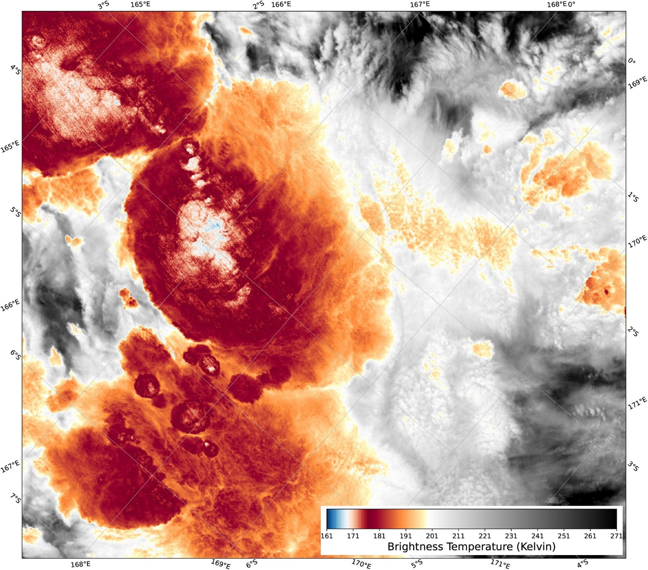(Proud & Bachmeier, Geophys. Res. Lett., 2021)
Above: VIIRS I5 brightness temperatures (BTs) for 13:38 UTC on December 29, 2018. The cluster of particularly cold BTs is slightly to the left of the image center. VIIRS, Visible Infrared Imaging Radiometer Suite.
In the last three years, scientists have logged the same number of extremely cold temperatures in clouds as they did in the 13 years before that, he added. "This is important, as thunderstorms with colder clouds tend to be more extreme, and more hazardous to people on the ground due to hail, lightning and wind."
This particular storm may have been energized by a combination of very warm water in the region and eastward-moving wind, according to the BBC. However, it's not clear why these colder temperatures in storm clouds are becoming more common.
"We now need to understand if this increase is due to our changing climate or whether it is due to a 'perfect storm' of weather conditions producing outbreaks of extreme thunderstorms in the last few years," Proud said.
Sunlight Kills COVID
A team of scientists is calling for greater research into how sunlight inactivates SARS-CoV-2 after realizing there's a glaring discrepancy between the most recent theory and experimental results.
UC Santa Barbara mechanical engineer Paolo Luzzatto-Fegiz and colleagues noticed the virus was inactivated as much as eight times faster in experiments than the most recent theoretical model predicted.
"The theory assumes that inactivation works by having UVB hit the RNA of the virus, damaging it," explained Luzzatto-Fegiz.
But the discrepancy suggests there's something more going on than that, and figuring out what this is may be helpful for managing the virus.
UV light, or the ultraviolet part of the spectrum, is easily absorbed by certain nucleic acid bases in DNA and RNA, which can cause them to bond in ways that are hard to fix.
But not all UV light is the same. Longer UV waves, called UVA, don't have quite enough energy to cause problems. It's the mid-range UVB waves in sunlight that are primarily responsible for killing microbes and putting our own cells at risk of Sun damage.
Short-wave UVC radiation has been shown to be effective against viruses such as SARS-CoV-2, even while it's still safely enveloped in human fluids.
But this type of UV doesn't usually come into contact with Earth's surface, thanks to the ozone layer.
"UVC is great for hospitals," said co-author and Oregon State University toxicologist Julie McMurry. "But in other environments – for instance, kitchens or subways – UVC would interact with the particulates to produce harmful ozone."
In July 2020, an experimental study tested the effects of UV light on SARS-CoV-2 in simulated saliva. They recorded the virus was inactivated when exposed to simulated sunlight for between 10-20 minutes.
"Natural sunlight may be effective as a disinfectant for contaminated nonporous materials," Wood and colleagues concluded in the paper.
Luzzatto-Feigiz and team compared those results with a theory about how sunlight achieved this, which was published just a month later, and saw the math didn't add up.
This study found the SARS-CoV-2 virus was three times more sensitive to the UV in sunlight than influenza A, with 90 percent of the coronavirus's particles being inactivated after just half an hour of exposure to midday sunlight in summer.
By comparison, in winter light infectious particles could remain intact for days.
Environmental calculations made by a separate team of researchers concluded the virus's RNA molecules are being photochemically damaged directly by light rays.
This is more powerfully achieved by shorter wavelengths of light, like UVC and UVB. As UVC doesn't reach Earth's surface, they based their environmental light exposure calculations on the medium-wave UVB part of the UV spectrum.
"The experimentally observed inactivation in simulated saliva is over eight times faster than would have been expected from the theory," wrote Luzzatto-Feigiz and colleagues.
"So, scientists don't yet know what's going on," Luzzatto-Fegiz said.
The researchers suspect it's possible that instead of affecting the RNA directly, long-wave UVA may be interacting with molecules in the testing medium (simulated saliva) in a way that hastens the inactivation of the virus.
Something similar is seen in wastewater treatment – where UVA reacts with other substances to create molecules that damage viruses.
If UVA can be harnessed to combat SARS-CoV-2, cheap and energy-efficient wavelength-specific light sources might be useful in augmenting air filtration systems at relatively low risk for human health.
"Our analysis points to the need for additional experiments to separately test the effects of specific light wavelengths and medium composition," Luzzatto-Fegiz concludes.
With the ability of this virus to remain suspended in the air for extended periods of time, the safest means to avoid it in countries where it's running rampant is still social distancing and wearing masks where distancing isn't possible. But it's nice to know that sunlight may be helping us out during the warmer months.
Their analysis was published in The Journal of Infectious Diseases.
Ukraine Update
As you know, Virtual-Joe is heavily compromised by wealthy oligarchs in Ukraine who have been laundering US taxpayer funds and feeding Hunter and Joe money on the side for filling the funnel with money. Those oligarchs don’t want any part of Ukraine to be annexed to Russia. Two States in particular I have been talking to you about; Donetsk and Luhansk.
Fighting has been ongoing for about 6 years, although your news doesn’t tell you about these things. There are three factions involved.
There is NATO with their SS style soldiers trying to take over the States for the Global Syndicate to control. They also use Al Qaeda fighters, as they are good at it.
There are what people call the Separatists. These are people who want to be annexed back into Russia. They are communists, but only in their form of government. They are fighting the NATO SS soldiers on the streets.
There are the Oligarchs who want to hold onto Ukraine as a sovereign country and continue to take the spoils of their centuries-old fiefdoms. They fight the separatists and the NATO soldiers. These are the ones primarily fighting to keep Putin out of the country.
Thus far, Russian forces are moving into defensive positions to counter the aggressive advances of NATO forces. For about 9 years, NATO has been moving artillery, planes, and troop positions closer and closer to the border of Ukraine. NATO tell the news that the people of Ukraine are asking for their protections and their assistance. Putin knows from a century of fighting them, that they are moving their supply chain close to Russia in order to attack. He warns them to stop, but they do not listen.
Heavy artillery fire from the Ukrainian Army is rained down on Luhansk, Ukraine, late Friday evening as the army attempted to conquer the breakaway state. Numerous civilian buildings have been hit. Huge explosions in the area of the capital school №50 (Malaya Vergunki district) MLRS also being used by Ukrainian military, Donetsk forces front lines are being struck. Numerous civilians have been injured or killed. These States want to be annexed the way Crimea was annexed 6 years ago.
The Global Syndicate is trying to block the Nords Stream 2 pipeline, that is being laid next to the Nords Stream 1 pipeline through the Nordic waters to reach Germany directly. European vessels have recently been filmed RAMMING pipe-laying ships, and Submarines being deployed to screw-up the pipe being laid for the Nordstream-2 gas pipeline from Russia to Europe. The Nordstream-2 gas pipeline is being constructed from Russia to northern Germany along the floor of the Baltic Sea.
President Donald Trump spoke bluntly to Europe saying "You want the US to protect you from Russia, then you enter into an agreement to buy billions of dollars in gas from . . . .Russia!" Trump went on to ask, "Why should the US continue to pay billions to protect Europe when Europe chooses to do business with the very entity they seek protection from?"
That was a valid point. The answer lies with Virtual-Joe being deeply compromised by the Global Syndicate in his criminal money laundering in Ukraine. This is why Johns McCain and Kerry and Victoria Nuland started the civil war in Ukraine in the first place. They want the gas to be supplied from the Golan Heights, through Iranian control. It will be the cash cow for the Syndicate and give them control over half of Europe.
This is why I have been saying that the Nordstream-2 pipeline has become a very much larger issue than anyone was lead to believe.
Video and photos have emerged showing UNMARKED Naval War Ships entering the pipeline construction area at sea, and meeting-up with unmarked SUBMARINES which are apparently making sure the pipeline does not get finished. BTW, it was about 90% finished during Trump’s presidency.
Now, Virtual-Joe wants to stop it from being completed. His high crimes go beyond anything any president has ever done. He is using our own naval warship vessels to conduct this criminal activity. This isn't private industry doing this; it's one or more GOVERNMENTS doing it. When a state orders and uses its own assets to conduct acts of aggression like this, it is considered an act of war. Ships ramming one another in open ocean to stop the laying of pipeline is not accidental.
With "The West" attacking Russia gas pipelines in the Baltic Sea, and attacking the vessels laying those pipelines, and the West attacking Russian ally, Syria, in the Middle East (and stealing tens-of-millions of dollars in Syrian oil every month for years in the process) and now the West pushing Ukraine to go to war with Russia, is it any wonder at all why Russia is fortifying its borders and preparing for an attack by NATO forces.
The ONLY question on my mind right now is this. If the Ukrainian president Zelensky announces he has been attacked by Russia, wil Virtual-Joe send American kids to die for their civil war? Will Russia dare invade Ukraine? Will Russia move to block the Suwalki Gap?
The possible isolation of the Baltic region is linked to the so-called Suwalki Gap and the geostrategic location of the Kaliningrad region. The Kaliningrad region has historically belonged to East Prussia, but it was annexed by the Soviet Union after World War II and operates now as a federal subject of the Russian Federation, although it is completely separated from the Russian mainland (see Sukhankin, this volume, for more). The Suwalki Gap or Corridor – an about 110–115 kilometres wide land border between Lithuania and Poland – connects Kaliningrad with Belarus, Russia’s long-standing ally in the region. In fact, all the land access connections between Russia and Kaliningrad pass through the Suwalki Gap, and Russian citizens have a visa waiver arrangement for passing through the area.
The aim of Russia’s well-targeted actions in the region is to delegitimise the NATO alliance and, furthermore, to challenge the current international security order and replace it with a new one, where Russia has significantly greater authority and influence. In a nutshell, Russia is ready to systematically and gradually – as much as the country’s budget will allow – increase tensions in the areas near Russia’s mainland with historical and symbolic value to maintain and increase internal support. Internally, Russian expansionism is framed as an appropriate response to the supposedly imperialist actions of NATO and the US.
From Russia’s perspective, both Kaliningrad and the Suwalki Corridor constitute favorable places where Russia’s ability to mobilize in time of peace and to escalate the conflict is greater than that of the NATO alliance. The country has at most three armies available in the Western Military District. Furthermore, Russia also has a clear advantage in mobilizing up to another 20 brigades in time of peace as well as in benefitting from greater territorial depth and more alternatives in terms of logistical routes than the NATO forces in the Baltic countries and close to Suwalki. Since Russia could move military resources more easily and more extensively in this region compared to the NATO alliance, it is reasonable to assume that escalation of the conflict would most likely be favorable to Russia, insofar as direct conventional conflict is out of the question.
For the NATO alliance, all scenarios, from increasing regional security to actual conventional mobilization, are marked by serious complications. Additional deployments in the region under the auspices of increasing security would be both costly and institutionally complicated. For example, the former commander of the US Army in Europe and retired Lieutenant General in the US Army Ben Hodges has suggested many reasons (Hodges 2018) why Poland’s recent offer to establish a permanent US military presence in Poland (Zemla & Turecki 2018) would undermine the cohesion of the NATO alliance. Furthermore, in real terms this step would not even contribute to the regional conventional balance, which would actually need another 18 brigades instead of merely a single brigade. Should the alliance still decide for the latter, it would allow Russia to both maintain its moral ‘upper hand’ in the region and justify its additional deployments, based on the argument that NATO is both aggressive and offensive.
Economic conditions clearly set significant restrictions on Russia in terms of choosing between escalation and de-escalation of the conflict. The size of the Russian economy (its nominal GDP in 2017 was USD 1.72 billion) is smaller than that of Germany, the United Kingdom, France and Italy (respectively, USD 4.21 billion, USD 2.94 billion, USD 2.93 billion and USD 2.18 billion in 2017) and basically on the same level as Spain (USD 1.51 billion in 2017) (IMF 2018). Limited economic resources have forced Russia to prioritise, as not enough resources are available for ‘half-hard’ initiatives. Under these circumstances, Russia clearly pursues a highly concentrated security and defence policy, without any possibility of hesitation, morality or questionable efficiency. However, limited resources play a central role in Russia’s coercive bargaining, as assets may end before motivation (Altman 2018: 58–60).
For both parties to the potential confrontation, Russia and the NATO alliance, the ‘costs’ of conflict in the Suwalki Gap and Kaliningrad are first and foremost determined by geographical and ethnic factors. The most extensive study covering the geographical aspect is conducted by Elak and Šliwa (2016), who argue that the terrain of the Suwalki Corridor supports particularly defensive operations. The potential ‘costs’ associated with geographical factors would most likely be significant for both parties, because specific capabilities and tactics will be needed to conduct military operations, and at the same time, the outcome of the operations will be unpredictable. However, what should worry the alliance is that, due to geographical characteristics, it would be difficult to regain control over the Suwalki Gap if the area is lost.
As far as the ethnic factor in the Suwalki Corridor is concerned, at first sight Russia seems to have a disadvantage. Elak and Šliwa (2016) point out that the population in the Suwalki Corridor mainly comprises Polish nationals (about 2 million people), whereas the ethnic minorities in the region are Ukrainians (65,000) and Lithuanians (about 25,000). There are only 11,000 Russians living in the Suwalki Corridor. Thus, there is no significant Russian-minded community living in the Suwalki Corridor that could be used by Russia in a similar way as during the annexation of Crimea, allowing Russia to diminish the ‘costs’ of the aggression. However, it has been argued that a potential Russian influence still exists in Suwalki, referring to Russia’s attempts to attract Polish citizens to take part in militarised tournaments and other events, for example the International Paintball Tournament ‘Road to Victory’ which in various years has also involved participants from Poland. Also some Lithuanian radicals, most likely supported by Russia, have raised claims in social media that Lithuania should regain the Suwalki Corridor from Poland (Grigas 2016).
Another issue is whether the population of Kaliningrad could be exploited by Russia to initiate conflict in the region by relying, for example, on a ‘near neighbourhood’ argument or through broad public support in this region. The majority of the population living in the Kaliningrad region are, of course, Russian citizens (about 95% of the total population or 896,000 individuals based on the survey from 2010) (Federal’naya sluzhba gosudarstvennoy statistiki 2012). At first glance, this aspect seems to speak in favour of Russia and to diminish the potential ‘costs’ of the conflict, for example costs related to information warfare, justifying and searching support for Russia’s aggressive actions in the region.
Next to geographic and ethnic factors, the level of economic development of the Kaliningrad region together with the region’s economic outlook indicates that economically the Kaliningrad region is rather insignificant to Russia. Since 1996, the Kaliningrad region has enjoyed the privileges of a ‘special economic zone’ (SEZ),1 which has allowed the region to trade tax-free and pay no duties to Russia. For this reason, in the early 2000s and before the economic crisis, the region showed the fastest annual growth numbers among Russia’s regions (Palet 2014). In 2006, the SEZ was updated with the new federal law, giving enterprises the right to export goods manufactured on the basis of imported components to Russia without paying any duties or taxes until April 2016 and the right to export such products until 2031 (Mladin & Duarte Gomes 2013). These privileges have expired amid Western sanctions on Russia, and the end of the SEZ is expected to have a negative impact on at least 785 local companies that currently employ 24% of the local workforce (Sukhankin 2016).

Although Russia was not able to prevent NATO enlargement into Visegrad its leaders have informed the West with unmistaken clarity that they view the Baltic membership in NATO as ‘red line’ that should not be crossed and will consider any NATO expansion into that region as direct threat to Russia’s vital national interests. NATO has launched several initiatives such as the establishment of the Baltic Air Policing mission in 2004 to guard the airspace over the three nations, joint exercises, investments into the BALTNET (Baltic Air Surveillance Network and Control System) and military exchanges. Russia has constantly criticized these initiatives. As a response, Russian armed forces have conducted large-scale snap exercises, violated airspace and conducted navy maneuvers close to its exclusive economic zones to demonstrate its significant capabilities when it comes to facing NATO.
To sum up, both the NATO alliance and Russia have different advantages and disadvantages with respect to a potential future escalation in the Suwalki Corridor and the Kaliningrad region. The main weakness of NATO is its reliance on public opinion, which limits its ability to counter Russian escalation. Conceptually, at least, the alliance has much deeper pockets, although it is an entirely different matter whether its superiority of resources could be realized in practice. Russia enjoys a public affairs advantage, in that it must meet few demands to justify its military actions, which may allow it to outlast NATO in a conventional force brinkmanship scenario despite having much fewer resources.
Unhappily and despite the apparent irrationality for all parties, the dynamics of the current relations between Russia and the NATO alliance clearly point towards escalation. Today, Russia is accusing the alliance of provocations and instability in the neighborhood regions of Russia. To quote a recent statement by Vladimir Putin:
“NATO is building up its military potential near our borders and attempts are being made to halt integration processes with Russia’s participation, provoke new and stir up old conflicts in the post-Soviet space and in regions neighboring on Russia, with all the ensuing consequences – military and political instability, the growth of smuggling and crime and acute humanitarian problems.”
It seems that although both parties to the confrontation have sent each other ‘costly signals’, the current deterrence strategy is not working. Conducting more and more complex military exercises and increasing military capabilities in the Suwalki Corridor and the Kaliningrad region have not made the opponent more afraid; on the contrary, it has forced both sides to further mobilize their resources.
In my opinion, Russia is quite capable not just of sealing off the Baltic states in the ‘bubble’ that covers air, sea and land dimensions, but also of fiercely contesting other spaces of critical importance to military operations. They are clearly superior in the electromagnetic spectrum, cyberspace, and even outer space, as Barack Obama diverted funding away from space research to favor his building of ISIS. Putin fought against ISIS and kept them from unseating Bashar Al Assad.
Right now, I think that military conflict between Russia and the NATO alliance cannot be fully excluded as a possibility in the near future. The Global Syndicate may choose to push Russia to the last line of escalation or else force Russia either to surrender in economic terms or to get involved in an actual conflict. I believe they have concluded that if they can push Russia into armed conflict in the Baltic Region, it will mean the end of Vladimir Putin’s political regime.
It is obvious that today Putin will not take the initiative to find a common ground with the NATO alliance. He is a nationalist and will not surrender to the Global Syndicate. This means that the ‘carrot’ must be something very special for Russia, something that would allow its elites to send a clear signal to their domestic audiences that Russian authority and influence are holding off the Globalists.
It is clear that this type of solution is not going to be reached as long as Virtual-Joe is in office, because he is compromised by his decades of money laundering through the region. They control him, and he knows it. Putin knows it as well. A lasting peace between NATO and Putin requires both the good will of the parties and a neutral platform for conducting strategic discussions. I do not think there is any chance either side will scale down their military posturing. There is no support for that at this point.
Why? Because the memory of death in this region is too old. If Victoria Nuland, or someone like her, gets anywhere close to the planning table, Putin will wipe out NATO forces where they stand, and let the chips fall as they may. The people of the world know the truth, and there is no possible way NATO leaders can get around that.
On the other hand, if Virtual-Joe is removed from power, and the crimes of the 2020 Election are answered for with arrests and convictions of the powerful criminals currently in power, I believe that world peace is possible without a single soldier having to die.
Fake Shot Records. Fake Vaccines
Sooner that the announcement that vaccination passports would be required in order to get back your rights from government, counterfeit passports are hot off the presses. They totally stole my idea. Now, there is something even worse out there.
Consumers in America and around the world are being warned about fake COVID-19 vaccines that are being pushed by scammers.
The INTERPOL organization, based in Lyon, France, is working with the U.S. Homeland Security Investigations division to issue warnings about "vaccines and treatments" offered online.
"With criminal groups producing, distributing and selling fake vaccines, the risks to the public are clear: these can include buying a product which not only does not protect against COVID-19, but poses a serious health hazard if ingested or injected. Such products are not tested, regulated or safety-checked," the group said.
Legitimate vaccines, the police force warned, "are not for sale."
"They are strictly administered and distributed by national healthcare regulators," INTERPOL said.
"Anyone buying these products online also runs the risk of potentially giving their money to organized criminals."
The vaccine market for COVID-19 has been thriving since former President Trump pushed regulators and industry to develop vaccines in record time. Several have been approved for use in the United States on an emergency basis, and by the time Trump left office more than a million doses were being administered daily.

"From the very beginning of the pandemic, criminals have preyed on people’s fears in order to make fast cash. Fake vaccines are the latest in these scams, which is why INTERPOL and HSI are warning the public to be extra vigilant," said INTERPOL Secretary General Jürgen Stock.
"Anyone ordering a vaccine online rather than obtaining it from their national provider, will be buying a fake product."
He continued: "The networks behind these crimes have global ambitions. No country or region can fight this type of crime alone. INTERPOL is assisting law enforcement around the world to both identify criminal networks and to dismantle them."
Police around the world already have been making arrests and seizing fake products in their investigation of vaccine scams, INTERPOL said.
"Counterfeit vaccines threaten the health of consumers who are duped by nefarious actors seeking to exploit the pandemic situation for financial gain. HSI and its law enforcement partners will vigorously investigate and seek prosecution for criminals taking advantage of the public’s quest for COVID-19 vaccinations and those who endanger the lives of the very people the vaccines are intended to protect," said HSI Assistant Director Steve Francis.
"HSI will continue to work with INTERPOL to coordinate investigations targeting every level of the transnational criminal organizations trafficking in counterfeit COVID-19 vaccines," he said.
Often, criminals set up websites purporting to represent legitimate organizations offering vaccine help.
"These websites offer payments in Bitcoins and other payment processing methods," INTERPOL said.
The sites also use trademarks of pharmaceutical companies to deceive. In December, HSI seized two websites "purporting to be those of biotechnology companies developing treatments for the COVID-19 virus."
"Instead they appeared to have been used to collect the personal information of individuals visiting the sites, in order to use the information for criminal purposes, including fraud, phishing attacks, and/or deployment of malware."
Who is Actually Running America?
Virtual-Joe reads from index cards or a prompter. The person who writes those words is the person running the country. They are unelected, and you can’t even speak to this person, but make no mistake. Practically since Virtual-Joe assumed office as president of the United States, the world has been wondering who is really in charge. At this point, all we know is that it isn't Joe.
Many have surmised that it must be Biden's vice president, Kamala Harris. I disagree. This is a monumentally unlikable an unintelligent individual. Harris was so unpopular that she was the first candidate to withdrawal from the Democratic primary. Black men especially know what she is.
In my humble opinion, the person or persons actually running this presidential puppet show want nothing to do with allowing a megalomaniac in waiting, heels up Harris, into the highest office in the land. She has zero powerful allies. And despite her success with trading sexual favors for powerful jobs, she's not all that bright. No sex is good enough to become president.
Then there's the wicked witch of West. Daniel Greenfield at FrontPage Mag believes that, "the most powerful elected official in the country isn't Joe Biden or Kamala Harris. It’s Nancy Pelosi.
I disagree with this also. Although Pelosi thinks she is the most powerful woman in the world. She may think she deserves to hold the pen instead of the mallet. But she is not running the show.
I believe it is actually Susan Rice that's really running things, as far as policy and the speech writing. She is wicked enough and smart enough. She is, after all, an Obama loyalist and confidant. She appears highly intelligent, much more so than the current VP or the wicked witch, and likely has many more inside-the-beltway allies than the other two combined.
She's proven herself to be more than capable and as devious as any on the left. Need an example? Here's one.
Do we recall her handling of the Benghazi disaster in Libya? Rice was the point person of the anti-Islam YouTube video excuse for the attack on the faux embassy. She appeared on practically every network and news program in the nation, spouting the same propagandist lies that the death of our ambassador and others was due solely to a spontaneous uprising.
She didn’t care who said what about her. She laughed at the law. She grinned in the sight of blood. She lied unflinchingly in her sincerity and delivery. I mean, who better to take the reins of the Biden crime family than a serial liar?
One of the pundits who promoted this theory early on is a little more than just a talking head – former Acting Director of National Intelligence (DNI) Ric Grenell. He says it's Rice who's really "calling all the shots in the new administration."
"She [Rice] knows the State Department. … She's run the national security portfolio and certainly has run the U.N. portfolio," Grenell explained.
"So there's no question that she's running domestic and foreign policy," Grenell said. Then added that in his opinion, it's Rice who is really the "shadow president."
I think the jury is still out as to who is really in charge of the Executive Branch. But if I had to choose among these three, my money would be with Grenell and his choice of Susan Rice.
She has a similar mind to Obama, but with more drive, and obviously knows how to properly navigate the bowels of Washington D.C. That, and the fact Barack is just too lazy to wade back in again.

