Space Junk Law
On 8 May 2021, a piece of space junk from a Chinese rocket fell uncontrolled back to Earth and landed in the Indian Ocean near the Maldives.
A year ago, in May 2020, another Chinese rocket met the same fate when it plummeted out of control into the waters off the West African coast. No one knew when or where either of these pieces of space junk were going to hit, so it was a relief when neither crashed on land or injured anyone.
Space debris is any nonfunctional human-made object in space. As a professor of space and society focused on space governance, I've noticed that there are three questions the public always asks when falling space debris gets into the news.
Could this have been prevented? What would have happened if there was damage? And how will new commercial companies be regulated as space activities and launches increase exponentially?
For space law to be effective, it needs to do three things. First, regulation must prevent as many dangerous situations from occurring as possible. Second, there needs to be a way to monitor and enforce compliance. And finally, laws need to lay out a framework for responsibility and liability if things do go wrong.
So, how do current laws and treaties around space stack up? They do OK, but interestingly, looking at environmental law here on Earth may give some ideas on how to improve the current legal regime with respect to space debris.
What if a rocket landed on your house?
Imagine that, instead of landing in the ocean, the recent Chinese rocket crashed into your house while you were at work. What would current law allow you to do?
According to the 1967 Outer Space Treaty and 1972 Liability Convention – both adopted by the United Nations – this would be a government-to-government issue. The treaties declare that states are internationally responsible and liable for any damage caused by a spacecraft – even if the damage was caused by a private company from that state.
According to these laws, your country wouldn't even need to prove that someone had done something wrong if a space object or its component parts caused damage on the surface of the Earth or to normal aircraft in flight.
Basically, if a piece of space junk from China landed on your house, your own country's government would make a claim for compensation through diplomatic channels and then pay you – if they chose to make the claim at all.
While the chances are slim to none that a broken satellite will land on your house, space debris has crashed onto land. In 1978, the Soviet Cosmos 954 satellite fell into a barren region of Canada's Northwest Territories.
When it crashed, it spread radioactive debris from its onboard nuclear reactor over a wide swath of land. A joint Canadian-American team began a cleanup effort that cost over CAD$14 million (US$11.5 million). The Canadians requested CAD$6 million from the Soviet Union, but the Soviets paid only CAD$3 million in the final settlement.
This was the first – and only – time the Liability Convention has been used when a spacecraft from one country has crashed in another. When the Liability Convention was put into use in this context, four governing norms emerged.
Countries have a duty to: warn other governments about debris; provide any information they could about an impending crash; clean up any damage caused by the craft; and compensate your government for any injuries that might have resulted.
However, if you owned a small orbiting satellite that got hit by a piece of space junk, you and your government would have to prove who was at fault. Currently, though, there is no globally coordinated space traffic management system.
With tens of thousands of tracked pieces of debris in orbit – and multitudes of smaller, untrackable pieces, figuring out what destroyed your satellite would be a very difficult thing to do.
Space pollution is the bigger problem
Current space law has worked so far because the issues have been few and far between and have been dealt with diplomatically. As more and more spacecraft take flight, the risks to property or life will inevitably increase and the Liability Convention may get more use.
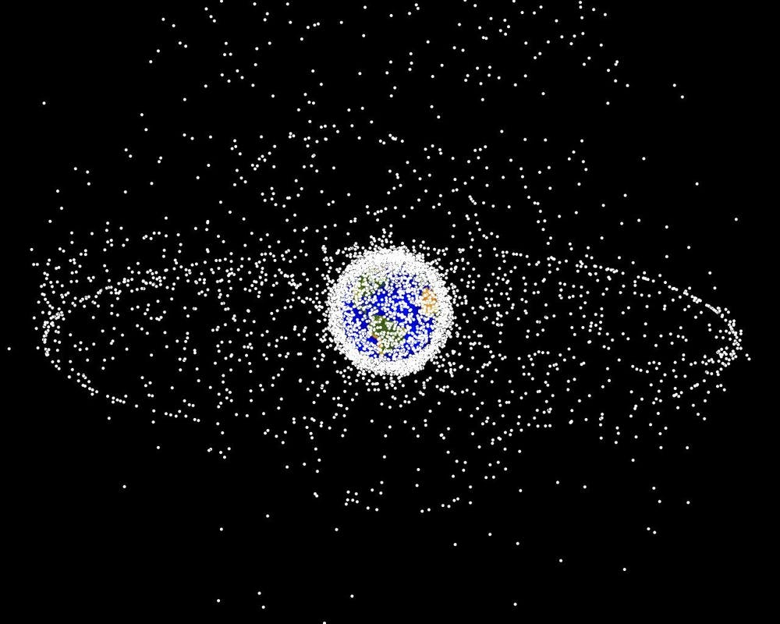Every dot in this image represents a known piece of space debris. (NASA Orbital Debris Program/Wikimedia Commons)
But risks to life and property are not the only concerns about a busy sky. While launch providers, satellite operators and insurance companies care about the problem of space debris for its effect on space operations, space sustainability advocates argue that the environment of space has value itself and faces a much greater risk of harm than individuals on Earth.
The mainstream view is that degrading the environment on Earth through pollution or mismanagement is bad because of its negative impact on the environment or living beings. The same is true for space, even if there is no clear direct victim or physical harm.
In the Cosmos 954 settlement, the Canadians claimed that since the Soviet satellite deposited hazardous radioactive debris in Canadian territory, this constituted "damage to property" within the meaning of the Liability Convention.
But, as Article 2 of the Outer Space Treaty declares that no state can own outer space or celestial bodies, it is not clear whether this interpretation would apply in the event of harm to objects in space. Space is shaping up to be a new frontier on which the tragedy of the commons can play out.
Removing from orbit existing large objects that could collide with one another would be a great place for governments to start. But if the United Nations or governments agreed on laws that define legal consequences for creating space debris in the first place and punishment for not following best practices, this could help mitigate future pollution of the space environment.
Such laws would not need to be invented from scratch. The 2007 United Nations Space Debris Mitigation guidelines already address the issue of debris prevention. While some countries have transferred these guidelines into national regulations, worldwide implementation is still pending, and there are no legal consequences for noncompliance.
The chances of a person being killed by a falling satellite are close to zero. On the off chance it does happen, current space law provides a pretty good framework for dealing with such an event.
But just like during the early 20th century on Earth, current laws are focusing on the individual and ignoring the bigger picture of the environment – albeit a cold, dark and unfamiliar one.
Adapting and enforcing space law so that it prevents and deters actors from polluting the space environment – and holds them accountable if they break these laws – could help avoid a trash-filled sky.
The Path of Thought
A study using epilepsy patients undergoing surgery has given neuroscientists an opportunity to track in unprecedented detail the movement of a thought through the human brain, all the way from inspiration to response.
The findings, published in 2018, confirmed the role of the prefrontal cortex as the coordinator of complex interactions between different regions, linking our perception with action and serving as what can be considered the "glue of cognition".
Previous efforts to measure the passing of information from one area to the other have relied on processes such as electroencephalography (EEG) or functional magnetic resonance imaging (fMRI), which, while non-invasive, offer less than perfect resolution.
The study led by researchers from the University of California, Berkley, recorded the electrical activity of neurons using a precise technique called electrocorticograhy (ECoG).
This required hundreds of tiny electrodes to be placed right up against the cortex, providing more spatial detail than EEG and improving the resolution in time of fMRI.
While this poses an unethical level of risk for your average volunteer, patients undergoing surgery for epilepsy have their brain activity monitored in this very way, giving the researchers a perfect chance to conduct a few tests.
Each of the 16 test subjects performed a number of tasks varied to suit their individual arrangement of electrodes, all while having their neural activity monitored and tracked.
Participants were required to listen to a stimulus and respond, or watch images of faces or animals on a screen and asked to perform an action.
Some tasks were more complex than others; for example, a simple action involved simply repeating a word, while a more complex version was to think of its antonym.
Researchers monitored the split-second movement of electrical activity from one area – such as areas associated with interpreting auditory stimuli – to the prefrontal cortex, to areas required to shape an action, such as the motor cortex.
While none of this threw up any surprises, the results clearly emphasized the role of the prefrontal cortex in directing activity.
For some tasks its input was fairly limited. In others the area was required to work hard, managing signals from multiple parts of the brain to coordinate the recognition of words, possibly dredging up memories before setting to work a bunch of muscles to provide a novel answer.
"These very selective studies have found that the frontal cortex is the orchestrator, linking things together for a final output," neuroscientist Robert Knight from UC Berkeley said at the time.
"It's the glue of cognition."
The prefrontal cortex was seen to remain active throughout most of the thought process, as would be expected for a multitasking region of the brain.
The quicker the handoff from one area to the other, the faster people responded to a stimulus.
"fMRI studies often find that when a task gets progressively harder, we see more activity in the brain, and the prefrontal cortex in particular," said the study's lead author, neuroscientist Avgusta Shestyuk.
"Here, we are able to see that this is not because the neurons are working really, really hard and firing all the time, but rather, more areas of the cortex are getting recruited."
What did come as something of a surprise were details on the precise timing of each area.
Some of the responding areas lit up remarkably early, often during the stimulus, suggesting that even before we have a complete response handy, our brain is already getting those parts of the cortex ready for action.
"This might explain why people sometimes say things before they think," suggests Shestyuk.
This research was published in Nature Human Behaviour.
Celestine Star
Dr. Celestine Star, D.D. has been called a "Renaissance Woman" for our evolutionary times, possessing profound knowledge, wisdom and expertise in many fields of endeavor. Dr. Star has been offering humanity her sacred healing wisdom, extra intuitive and perceptive abilities, worldly business knowledge, and joyous creative artistic gifts for over 40 years.
Star continues today dedicating her life through her current businesses; Temple of Light, Papillon Life Services, and affiliates; the Fellowship and Temple of Isis, Mother Mary/Mary Magdalene communities and other conscious organizations. Star shares her wisdom, offers guidance, knowledge, and direction for the "Way Through" out of suffering, ignorance and pain.
By recognizing and experiencing her own ascension of consciousness and divine awakening Star now gives assistance to those who are going through the "Eye of the Needle", as they say, or are on the "Path of Ascension".

For over 40 years Star has assisted thousands of people to embrace their lives, no matter how painful, by recognizing they are were born on Earth to mastering that which has caused them such pain, once mastered their pain becomes the wisdom and the "Divine Gift" they were here to offer to Humanity. Star teaches how in embracing one's "Human Story" we can experience an elevation of consciousness and the awakening of the our true "Divine Selves."
As a "Gateless Gate Keeper", carrying the sacred teachings of her Near Death contact with our Creator, her Native American and Kemetic-Egyptian ancestors, along with her wisdom and extensive studies in Tibetan Buddhism, Hinduism, Taoism, Celtic/Druid, and Arcane Magick Star is able to show the way through to the higher consciousness and the Truth of our Divinity.

Dr. Celestine Star is here to assist those looking to transform their trauma and pain, evolve their consciousness, study the deeper mysteries of life or move through the alchemical process of ascension.
Star Light Healing Modalities are: Alchemical Transformative Healing Practices, Intuitive/Therapeutic Readings,
Life/ Relationship/Business Counseling, and Quantum Technologies: Bio Electric Magnetic Energy Regulation (B.E.M.E.R.), Radianic Healing tools, Gemstone Healing Technologies, Aroma Therapies and Nature. Will take your Life to the next level.

The Georgia Domino
A Georgia judge is allowing officials to audit roughly 145,000 absentee ballots cast in Fulton County in the 2020 election, attempting to ensure the integrity and security of the state’s elections.
The audit will allow for the examination of signatures on the ballots to ensure that they are legitimate, according to a Georgia Star News report.
“Voter confidence in our election system is the bedrock of our republic. Unfortunately, inconsistencies in Fulton County’s November 2020 absentee ballots cast serious doubt on voters’ faith in our elections,” former Sen. Kelly Loeffler said in a statement.
Georgia residents have been particularly concerned about Fulton County.
Files provided by county officials show there are no chain of custody documents — absentee ballot transfer forms — for 385 out of the 1,591 dropbox collections that took place in Fulton County between September 24, 2020, and November 3, 2020, the Georgia Star News reports.
Meanwhile, Arizona’s Maricopa County is undergoing a complete forensic audit of the November 2020 election after the state’s Senate Republicans expressed their desire to ensure the legitimacy of the votes.
The audit in Arizona, however, has been met with relentless resistance. In early May, officials held back materials subpoenaed by the state legislature, claiming that submitting them would create a security risk for both law enforcement and federal agencies.
The Arizona state Senate claimed Maricopa County election officials then tampered with election records just days before the equipment was delivered to the Arizona Senate, the Georgia Star News reports.
Last week, the president of the Arizona State Senate asked the chairman of the Maricopa Board of Supervisors to address “three serious issues that have arisen in the course of the Senate’s ongoing audit of the returns of the November 3, 2020 general election in Maricopa County.”
The Maricopa County Board of Supervisors later refused the invitation to meet with the Arizona State Senate to discuss how to resolve the issues.
Unlike the audit in Arizona, however, the Fulton County ballots in Georgia will not be transferred to an independent third party for examination, as Superior Court Judge Brian Amero has ruled that the ballots must remain with Fulton County officials, according to a report by the Atlanta Journal-Constitution.
From Arizona with Hate
The Arizona company who is named as the sender of the alleged fraudulent ballots sent to Georgia which were discovered in a warehouse in Fulton County has very close ties to the Democrat Party.
Yesterday we reported on the ballots from Arizona that showed up in Georgia during the 2020 election:
The ballots had mailing instructions on them which showed that the firm mailing the ballots was from Arizona:
Runbeck Election Services has a website where they affirm:
Since 1972, Runbeck Election Services has preserved the integrity of the American democratic process. We partner with cities, counties and states to provide a trusted election experience with ballot print and mail services, and equipment and software technology solutions that are accurate, transparent and efficient.
Rey Valenzuela, the Director of Elections for Maricopa County Arizona is listed on the front page of Runbeck’s website. He provides the one and only testimony of Runbeck where he shares:
Runbeck Elections is a subject matter expert on the process. They are always involved and want to know more. Runbeck is reliant as a partner, not a vendor; their competence helps them identify issues before they become an issue.
Having the Director of Elections for Maricopa County Arizona as your reference is not a good thing; it clearly indicates connections to corrupt election activities.
Although not listed as a member of the Executive Team, Brian Runbeck identifies himself as the Client Services Manager/Project Manager and Production Coordinator at Runbeck Election Services.
He manages the production of election ballots and related official election material. He says he handles high-pressure deadlines and high volume production.
Mr. Runbeck also made 50 different donations to Act Blue, Biden for President, and the Democratic Senatorial Campaign Committee between August 15 and October 30, 2020:

The End of Smart People
Approximately 60 percent of U.S. colleges have nixed testing for student admission amid claims the tests give an advantage to applicants who are white and wealthier than other potential students because they have access to test preparation.
The debate about the claim’s accuracy has not been settled, some saying testing can help disadvantaged students, according to a Bloomberg report:
The decision by the regents of the University of California—whose 10 campuses educate 280,000 undergraduate and graduate students—resolves a 2019 lawsuit charging that the SAT and ACT are biased against the poor and Black and Hispanic students. Another lawsuit filed last year, and aimed mainly at protecting students with disabilities, said that even making the tests optional didn’t go far enough and that they should not be considered under any circumstances.
In May 2020, when the University of California regents voted to phase out use of standardized tests, they faced pushback from within their own system. A review by the Academic Senate found that the SAT helps, not hurts, disadvantaged students and that “campuses adjust for socioeconomic differences and admit disadvantaged students with lower test scores compared with more advantaged peers,” the Los Angeles Times reported.
According to the Los Angeles Times, “UC Riverside Chancellor Kim A. Wilcox said his campus — the most diverse in the UC system after Merced — has prospered using the current admissions process, winning top rankings for helping low-income, first-generation and underrepresented students succeed.”
Washington state also announced its five public four-year universities and Evergreen State College will get rid of SAT and ACT testing for admission, according to the My Northwest website:
Beginning in fall 2021, the University of Washington, Washington State University, Western Washington University, Eastern Washington University, Central Washington University, and Evergreen State College will be “test optional” going forward.
This rule change is part of a growing trend to evaluate students on more than their academic abilities and consider things such as community service or special skills and accomplishments.
“The decision, in terms of reducing further barriers and strengthening our engagement with students in the admissions process had led to this decision,” Dr. Julie Garver, senior director of Policy and Academic Affairs at the state’s Council of Presidents, said in the My Northwest report.
“[The test score requirement] was potentially negatively impacting the college-going culture here in Washington,” Garver said.
“What is the student doing in community service? What is their background? Really looking at the whole student,” Garver said.
The Real Tim Tebow Story
ESPN host Stephen A. Smith recently argued that Tim Tebow’s attempted NFL comeback with the Jacksonville Jaguars is an example of “white privilege.”
Tebow, 33, recently walked away from his attempt to make the major leagues as a member of the Mets organization and signed a one-year deal to play for his former college coach Urban Meyer as a tight end.
That, Smith argues, is not necessarily a bad look for Tebow, whom he describes as “deserving” and says he even text him to tell him so. But, instead, when looking at the “totality of the situation,” Smith says Tebow’s second chance is an example of “white privilege.”
Smith also had an issue with Tebow getting a chance to play tight end, which he has never played.
After being dutifully set up to go on a race rant by co-host Max Kellerman, Smith begins talking at the 1:48 mark:
Smith’s point about not “giving a damn” about his audience’s feelings is evidently a company-wide sentiment given the steady and steep plummeting of ESPN’s ratings over the years as the network continues its quest to turn anything and everything into a political or racial issue.
Smith’s incoherence began with congratulating Tebow on his opportunity and calling it “deserving,” only to turn around and accuse the Jags of “white privilege,” but it did not end there.
“The reality is that Urban Meyer is in a position where he could exercise – I’m not saying he did it for Tim Tebow because he was white or anything like that,” Smith added. “It has nothing to do with race in regard to that. I’m simply saying when you see an opportunity like that happen, it is clear that it happens for white folks, and it doesn’t happen for everybody else, and that’s problematic.”
But wait a minute, if Tebow being white wasn’t the reason why he was given a tryout, then what the hell is the point of Smith’s rant here? Where’s the “white privilege?” There certainly is “privilege.” Tebow and Meyer produced national championships together, a Heisman Trophy, and are good friends. There’s no question that history and relationship are what led to a 33-year-old getting a chance to play a position he’s never played before.
Certainly, no other 33-year-old washed-up QB’s would get a chance to come back at a different position.
However, as Smith admits, that opportunity was not based on race.
So, after “bizarrely” calling Tebow “deserving” of his opportunity and then attacking the whole thing as a fraud, Smith then ices the contradictory/schizophrenic cake by admitting race had nothing to do with Tebow’s tryout while still calling the whole thing an example of “white privilege.”
The only fraud taking place here is Stephen A. Smith.
Smith is better than this. This is the same Stephen A. who fearlessly and correctly blasted Kaepernick for not voting and being more consumed with becoming a “martyr” than a football player. This is the same Stephen A. who credited Donald Trump with giving him important career advice despite the deep hatred his network has for the former president. And this is the same Stephen A. who had the guts to warn the sports media that they were “stepping out of our lane” by attacking Trump and talking politics in general.
Again, Smith is actually not the idiot he portrays himself to be on TV. As this writer knows from having spoken with him,
The problem with Smith is that he says the quiet things out loud. Such as revealing his friendly and entirely appropriate text message to Tebow and admitting that race played no role in his tryout.
The trick with being a heel or a controversial click-bait guy is that you have to be all-in, or people can find the holes in your game. ESPN, Smith’s employer, clearly wants him to be the network’s Racial-Antagonist-in-Chief. The problem is Smith is really not that guy.
But those $8 million per year paychecks sure are nice.
Of the People
A majority of U.S. likely voters prefer a smaller government with “fewer services and lower taxes,” a Rasmussen Reports survey released Friday found.
The survey, taken May 17-18, 2021, among 1,000 likely voters, asked respondents if they preferred a “more active government with more services and higher taxes or a smaller government with fewer services and lower taxes.”
Fifty-five percent said they prefer a smaller government with fewer services and lower taxes compared to 37 percent who chose a more active government with more services and higher taxes.
Predictably, opinions were sharply divided on party lines, with 57 percent of Democrats supporting a more active government with more services and higher taxes and 78 percent of Republicans choosing a smaller government. Fifty-six percent of independents sided with the majority of Republicans, who prefer a smaller government and lower taxes.
Notably, 51 percent of non-white voters prefer a smaller government, as do the plurality of black voters specifically, 46 percent.
According to the survey, the vast majority of respondents, 68 percent, say the government does not spend taxpayer money wisely or carefully. Just 18 percent believe it does, and 14 percent remain unsure. Although the majority of Democrats expressed support for a larger, more active government, 51 percent agreed the government does not spend taxpayer money wisely or carefully:
President Biden’s strongest supporters are most likely to prefer more government and to think government spends taxpayer money wisely. Among voters who Strongly Approve of Biden’s job performance as president, 75% prefer a more active government with more services and higher taxes, and 41% think government spends taxpayer money wisely and carefully. By contrast, among voters who Strongly Disapprove of Biden’s performance, 92% prefer a smaller government with fewer services and lower taxes and 95% believe government does not spend taxpayer money wisely and carefully.
The survey’s margin of error is +/- 3 percent.
Corona Round Two
former HHS Assistant Secretary Adm. Brett Giroir said it’s “very possible” that the United States funded gain of function research on coronavirus and that this sort of research “is probably still ongoing there and in a number of other labs in China and probably around the world, many of whom we probably fund.”
Giroir stated, “I think, very clearly, back in the 2014, 2015 era, the NIH was funding research that was published and we know about it, about gain of function mutations on this type of virus. And I think there’s a lot of investigation that needs to be done. If you look at the series of grants that were funded, they all talked about bats. They all talked about coronavirus. But I would bet dimes to doughnuts, as they say, that the NIH does not have record[s] or controls to understand exactly what was done. So, it’s very possible we did fund this research.”
He added, “It’s not just about funding good science, there are implications to what gets funded. There’s danger, a worldwide pandemic that could have arisen because of it. There’s a potential for funding biological weapons that could be used against our allies. So, it’s not just about getting a good grant in and everybody saying, this is great, let’s fund it. … I think we need a congressional investigation, I think we need specific oversight. We have to get to the bottom of this. Because that research is probably still ongoing there and in a number of other labs in China and probably around the world, many of whom we probably fund.”
He also stated, “I believe the Wuhan Institute of Virology is “the most likely origin” of the coronavirus, and that the circumstantial evidence in favor of that theory is “overwhelming and the lack of another explanation is equally overwhelming.”
Giroir said, “I do share the assessment of the Republican security committee that the most likely origin of this virus was the Wuhan Institute of Virology.”
Star Forge
Astrophysicists have developed the first high-resolution 3D model of a gas cloud coalescing to form a star — and it's mind-blowing.
The "Starforge" model (which stands for “star formation in gaseous environments'') allows users to fly through a colorful cloud of gas as it pools into stars all around them. Researchers hope that the visually stunning simulation will help them to explore the many unsolved mysteries of star formation, such as: Why is the process so slow and inefficient? What determines a star’s mass? And why do stars tend to cluster together?
The computational framework is able to simulate gas clouds 100 times more massive than was previously possible and will enable scientists to model star formation, evolution and dynamics while taking into account things like jets, radiation, wind and even supernovas — the explosions of nearby stars.
"How stars form is very much a central question in astrophysics," senior author Claude-André Faucher-Giguère, an astrophysicist at Northwestern University, said in a statement. "It’s been a very challenging question to explore because of the range of physical processes involved. This new simulation will help us directly address fundamental questions we could not definitively answer before."
Stars can take tens of millions of years to form — growing from billowing clouds of turbulent dust and gas to gently glowing protostars, before materializing into gigantic orbs of fusion-powered plasma like our sun. While studying the night sky enables astrophysicists to glimpse brief snapshots of a star’s evolution, they need to use an accurate simulation to view and study the full process.
"When we observe stars forming in any given region, all we see are star formation sites frozen in time," co-author Michael Grudić, a postdoctoral fellow at Northwestern University, said in the statement. "Stars also form in clouds of dust, so they are mostly hidden."
The model is enormous, and it can take three months to run one simulation on one of the world’s largest supercomputers, housed at the Texas Advanced Computing Center. It is the sheer size and computational complexity that makes this new model’s predictions so much more accurate, according to the researchers.
"People have been simulating star formation for a couple decades now, but Starforge is a quantum leap in technology," Grudić said. "Other models have only been able to simulate a tiny patch of the cloud where stars form — not the entire cloud in high resolution. Without seeing the big picture, we miss a lot of factors that might influence the star’s outcome."
The simulation starts with a cloud of gas — up to many millions of times more massive than our sun — floating in space. As time passes, the gas cloud evolves. It swirls around itself, forming larger structures before breaking apart again. From this creative destruction, small pockets of gas remain that, drawn in by gravity and made ever hotter through constant friction, eventually become stars. The climax of a star’s birth is when two enormous jets of gas are launched outward from its poles at high speed — piercing the clouds around it.
Astrophysicists used the simulation to understand the role these gas jets play in determining a star’s mass. When they ran the simulation without accounting for the jets, they got stars that were much bigger than usual — roughly 10 times the mass of the sun. Adding the jets back in produced more realistically sized stars, which were around half the mass of the sun.
"Jets disrupt the inflow of gas toward the star," Grudić said. "They essentially blow away gas that would have ended up in the star and increased its mass. People have suspected this might be happening, but, by simulating the entire system, we have a robust understanding of how it works."
By giving them a better understanding of how stars form, the researchers also think that their simulation could provide some vital insights into how galaxies spread across the universe, as well as how heavier elements, like carbon and nitrogen — the key building blocks to complex life — are forged inside stars’ fiery hearts.
"If we can understand star formation, then we can understand galaxy formation. And by understanding galaxy formation, we can understand more about what the universe is made of," Grudić said. "Understanding where we come from and how we're situated in the universe ultimately hinges on understanding the origins of stars."
The Panicdemic: Caught red-handed
What is it that caused the lockdown? What was the hammer that smashed the Trump economy and sent the entire world running for their lives? It was the infection rate. And it was the Faucists equating infection with instant and unavoidable death. By the millions.
Well, New Faucist policies will artificially deflate “breakthrough infections” in the vaccinated, while the old rules continue to artificially inflate case numbers in the unvaccinated, of course closely correlated with Trump rallies of any kind.
The US Center for Disease Control (CDC) is altering its practices of data logging and testing for “Covid19” in order to make it seem the experimental gene-therapy “vaccines” are effective at preventing the alleged disease.
They made no secret of this, announcing the policy changes on their website in late April/early May, (though naturally without admitting the fairly obvious motivation behind the change).
The trick is in their reporting of what they call “breakthrough infections” – that is people who are fully “vaccinated” against Sars-Cov-2 infection, but get infected anyway.
Essentially, Covid19 has long been shown – to those willing to pay attention – to be an entirely created pandemic narrative built on two key factors:
- False-positive tests. The unreliable PCR test can be manipulated into reporting a high number of false-positives by altering the cycle threshold (CT value)
- Inflated Case-count. The incredibly broad definition of “Covid case”, used all over the world, lists anyone who receives a positive test as a “Covid19 case”, even if they never experienced any symptoms.
Without these two policies, there would never have been an appreciable pandemic at all, and now the CDC has enacted two policy changes which means they no longer apply to vaccinated people.
Firstly, they are lowering their CT value when testing samples from suspected “breakthrough infections”.
From the CDC’s instructions for state health authorities on handling “possible breakthrough infections” (uploaded to their website in late April):
For cases with a known RT-PCR cycle threshold (Ct) value, submit only specimens with Ct value ≤28 to CDC for sequencing. (Sequencing is not feasible with higher Ct values.)
Throughout the pandemic, CT values in excess of 35 have been the norm, with labs around the world going into the 40s.
Essentially labs were running as many cycles as necessary to achieve a positive result, despite experts warning that this was pointless (even Fauci himself said anything over 35 cycles is meaningless).
But NOW, and only for fully vaccinated people, the CDC will only accept samples achieved from 28 cycles or fewer. That can only be a deliberate decision in order to decrease the number of “breakthrough infections” being officially recorded.
Secondly, asymptomatic or mild infections will no longer be recorded as “covid cases”.
That’s right. Even if a sample collected at the low CT value of 28 can be sequenced into the virus alleged to cause Covid19, the CDC will no longer be keeping records of breakthrough infections that don’t result in hospitalisation or death.
From their website:
As of May 1, 2021, CDC transitioned from monitoring all reported vaccine breakthrough cases to focus on identifying and investigating only hospitalized or fatal cases due to any cause. This shift will help maximize the quality of the data collected on cases of greatest clinical and public health importance. Previous case counts, which were last updated on April 26, 2021, are available for reference only and will not be updated moving forward.
Just like that, being asymptomatic – or having only minor symptoms – will no longer count as a “Covid case” but only if you’ve been vaccinated.
The CDC has put new policies in place which effectively created a tiered system of diagnosis. Meaning, from now on, unvaccinated people will find it much easier to be diagnosed with Covid19 than vaccinated people.
Consider…
Person A has not been vaccinated. They test positive for Covid using a PCR test at 40 cycles and, despite having no symptoms, they are officially a “covid case”.
Person B has been vaccinated. They test positive at 28 cycles, and spend six weeks bedridden with a high fever. Because they never went into a hospital and didn’t die they are NOT a Covid case.
Person C, who was also vaccinated, did die. After weeks in hospital with a high fever and respiratory problems. Only their positive PCR test was 29 cycles, so they’re not officially a Covid case either.
The CDC is demonstrating the beauty of having a “disease” that can appear or disappear depending on how you measure it.
To be clear: If these new policies had been the global approach to “Covid” since December 2019, there would never have been a pandemic at all.
If you apply them only to the vaccinated, but keep the old rules for the unvaccinated, the only possible result can be that the official records show “Covid” is much more prevalent among the latter than the former.
This is a policy designed to continuously inflate one number, and systematically minimize the other.
What is that if not an obvious and deliberate act of deception?
Space Force vs Marxists
You will recall that we reported to you that Garrison’s Gestapo goostepped its way around the halls of the Pentagon and into the United States Space Force office and fired Lt. Colonel Matthew Lohmeir for saying that Marxism was bad and was infiltrating the US military. Well, two dozen Republican lawmakers are calling on the acting Air Force secretary to reinstate him to his Space Force position after he published a book warning that Marxism was spreading within the military.
Rep. Doug Lamborn of Colorado initiated the letter to acting Secretary John Roth and Space Force Commander Gen. Jay Raymond on Wednesday on behalf of Lt. Col. Matthew Lohmeier.
Lohmeier was fired after appearing on several podcasts to discuss his new book, "Irresistible Revolution: Marxism's Goal of Conquest & the Unmaking of the American Military." The description of the book states that many pundits have been "perplexed" by current policy decisions, particularly the infusion of the Marxist-based critical race theory in school curricula. But it's all part of a "longstanding plot against America, patiently and methodically pursued by those with a mind intent on the overthrow of the US Government and its replacement with a communist dictatorship."
The Republican lawmakers argue that whether "you agree with him or not, no rational American can review his level-headed critique of critical race theory-based 'diversity, equity, and inclusion' training the military is currently conducting and conclude that his comments on that subject deserve relief of command."
Lamborn said in a separate statement that he is "growing increasingly concerned about the proliferation of training and discussions rooted in critical race theory throughout the Department of Defense."
"This Marxist ideology teaches racial prejudice and collective guilt. The fact that it would be taught and promoted in the U.S. military is deeply disturbing," he said.
Advertisement - story continues below
The Colorado lawmaker argued that advancing critical race theory "will make it more difficult to attract patriotic talent to join the Armed Forces."
He said the military should focus on national security threats instead of "pandering to one political ideology."

"I can't imagine a better way to weaken ourselves in the midst of a great-power competition with China and Russia," he said. "Lieutenant Colonel Lohmeier listened to the Secretary of Defense and stood up against extremism on the left. He should be praised for his courage."
The Republican letter also pointed out a double standard, with the military brass affirming senior officers who voice support for left-wing views.
The lawmakers noted then-Air Force Chief of Staff Gen. David Goldfein in June 2020 said after the death of George Floyd, "Every American should be outraged that the conduct exhibited by police in Minneapolis can still happen in 2020."
"While a reasonable person can share that sentiment, it is an extremely political statement for a Service Chief to make about a then-pending legal case," they argued.
Other officers have accused the Air Force of racism, including one who was offered a position on the Air Force headquarters staff after ghost-writing articles.
A number of senior leaders attacked Fox News host Tucker Carlson for comments he made on his political opinion show, and no actions were taken, the Congress members noted.
"We have never seen anything like it," they said.
"Ultimately there seems to be no material difference between the very public statements made by many senior leaders while in uniform and on official social media accounts, and those made by Lieutenant Colonel Lohmeier in an unofficial capacity. The sole difference seems to be the ideological content of his remarks," the lawmakers wrote.
They warned that leaders who are "complicit with this poisonous philosophy which promotes racial essentialism and collective guilt in our beloved military will be judged by history accordingly."
Rally Season Begins
It’s bigger, better, and more patriotic than ever before. Bigly. President Trump and his surrogates are launching the 2022 Rally Season this weekend in Dallas, Texas. The idea is to remind Americans that patriots will save the Republic from the slimy clutches of Virtual Joe and his gang of criminals who are turning the country into a Marxist state.
You can participate is a variety of ways. President Donald Trump is preparing to relaunch his popular large-scale rallies in key battleground states this summer as he continues to fuel speculation regarding a 2024 comeback presidential run.
"We'll be doing one in Florida, we're going to do one in Ohio, we're going to do one in North Carolina," Trump said during an interview that aired Thursday on One America News, according to CNN.
"We'll be announcing them very soon over the next week or two," the former president added.
I will be at the one in Dallas this weekend with General Mike Flynn and Sydney Powell and my friends Zach with RedPill78 and Jordan Sather. I will also be at the one in North Carolina. Meet me there. You can find out more by subscribing to my newsletter, which is free.
The Labor Shortage Scam
It’s no secret that U.S. businesses are struggling to find workers. Recent surveys have shown that small businesses are reporting record job openings. Companies are reporting a 13% absentee rate nationwide, but in some areas it is even higher.
Marxist operators and propagandists inside Virtual Joe’s cabinet have described the phenomenon as a labor shortage. That would be a lie. There are plenty of skilled people in America to do the work. The tens of millions that President Trump’s economy enriched are still out there. But something has changed.
“Walk outside: labor shortage is the pervasive phenomenon,” economist Lawrence Summers recently observed at a conference hosted by the Federal Reserve Bank of Atlanta.
At first glance, calling what the U.S. is experiencing a labor shortage makes perfect sense. After all, there are millions of job openings without people to fill them, which usually means there are not enough qualified job candidates to fill the market’s employment demands. That’s pretty close to a textbook definition of a labor shortage. But, like everything else in Virtual Joe’s government, it is fake.
An Incentive Shortage, Not a Labor Shortage
America has a record 8.1 million job openings above $15 an hour that are going unfilled week after week. The media call it a ‘labor shortage.’ But it’s not a labor shortage; it’s an incentive shortage.
The juiced-up unemployment benefits, which pay unemployed workers an additional $300 a week on top of their state unemployment benefits, have resulted in a perverse incentive. If a person can make $630 a week in take-home pay, tax free, that is the same as $950 a week gross, which is about $50k a year. A job that would take up at least 40 hours a week of that precious free time would pay about the same. That is not a hard choice for many short-term thinkers.
“The American Rescue Plan, passed in March, increased unemployment payments by hundreds of dollars and extended them for up to 73 weeks. That is almost 18 months. Given the cost of commuting, childcare, clothing, wear and tear on the vehicles, etc., many people find they are better off financially not working. They don’t plan further than 18 months into the future. In many states, workers are taking a pay cut to go back to work.
It’s no surprise that people are not rushing back to work to make less money than staying home. It’s exactly what economists brave enough to say something predicted would happen, and explains why the April jobs report was the biggest miss in history.
Incentives Matter
Charlie Munger, the billionaire investor and right hand man of Warren Buffett, once famously noted the power of incentives.
“Show me the incentive and I will show you the outcome,” Munger said.
The idea that incentives matter is a truism repeated often in economics, yet it’s one that politicians often overlook — evidenced by the 8 million job openings that threaten to stall the economic recovery following the disruptions of 2020.
Fortunately, many appear to recognize the government-created disincentives and are taking action. Texas recently became the latest state — one of 19 — to decline the federal unemployment payouts. On Monday, Texas Gov. Greg Abbott announced his state’s addition to the list, the largest state to do so thus far.
This action will be far more effective and cost efficient than trying to lure workers back with $1,000 or $1,200 bonuses (courtesy of taxpayers). Workers don’t need extra incentive to go back to work. They simply need the disincentives that the government created removed.
And we are only one of very few who are talking about the credit card checks being written by Virtual Joe to keep the voters from storming the White House. Yeah, that would be what storming really looks like. People only spend money to keep the party going week after week for two reasons. Either they are going bankrupt, and they just want to burn the whole place to the ground on their way out. Or, they are expecting a huge windfall or to win the lottery. I highly doubt the latter is going to happen. The only way to stop the whole Republic from burning down is to get back to work, and stop taking the handout. He can’t spend it, if we don’t take it.
#GetOffTheDole #SayNotoJoe
The History of the Dole
A generation ago, they made money the old-fashioned way: they earned it.
To address catastrophic unemployment that reached as high as 23 percent, the government constructed millions of jobs through programs such as the Works Progress Administration (WPA) and the Civilian Conservation Corps (CCC). I interviewed people who worked in those programs. They worked.
That’s not to say the New Deal was a socio-economic panacea (it wasn’t), but that in those days people were willing to work to survive. They were offered a hand up, not a hand-out—a concept Democrats still embraced at the time. They retained their dignity, because they built houses, laid pipe, cut passes through hillsides with shovels and pickaxes, painted, and even cooked meals for the homeless.
The work was arduous and sometimes dangerous, involving every extreme of weather and terrain. Between 1935 and 1943, eight million workers supported by the WPA built 620,000 miles of streets, 10,000 bridges, and 40,000 new buildings (also improving 85,000 others), as well as myriad other projects to benefit the public such as swimming pools, playgrounds, zoos, botanical gardens, and more. For their sweaty toil, they received compensation based on individual skill, averaging $52 a month, or roughly $1,000 in current inflation-adjusted dollars.
The National Youth Administration (NYA), which operated initially under the WPA, allowed those as young as 16 to work part-time on construction and repair projects for $10 to $25 a month, or approximately $200 to $500 in current dollars. At its peak in 1937, more than 400,000 youth were employed in occupational training under the NYA. Many of those who learned new skills later put them to use for our nation’s defense with the onset of World War II.
Through the Civilian Conservation Corps (CCC) three million men aged 18-28 worked manual labor jobs to improve the nation’s natural resources through projects such as tree planting, fire prevention and fighting, insect control, fish stocking, erosion control, and landscaping. It was dirty, hands-on work. But those who signed on were glad for the opportunity to earn money to live. One camp’s newsletter, titled “Happy Days,” wrote that “this is a training station; we’re going to leave morally and physically fit to lick ‘Old Man Depression.”
The camps were organized and governed in a military style, with members of the Army reserve commanding those who volunteered for the minimum six-month enrollments. Tents were used for early units and later wood barracks were constructed. Compensation was $30 per month, roughly $600 in current dollars, of which more than 70 percent was required to be sent to a family dependent. Participation was a privilege, not a right, and the threat of “dishonorable discharge” was sufficient to maintain peace and order.
(Pictured Above: CCC camp in Michigan)
Hard work wasn’t a partisan issue at the time. A Gallup poll from 1936 found that 92 percent of Democrats and 67 percent of Republicans supported the CCC. Sociologist Robert Leighninger Jr. noted that “millions of people needed subsistence incomes. Work relief was preferred over public assistance (the dole) because it maintained self-respect, reinforced the work ethic, and kept skills sharp.”
Before the government stepped in with these programs, families did anything they could to survive. As the Great Depression took hold in 1930, many hopeful laborers went to Las Vegas and camped in the desert for the chance to work on a new project that would harness the power of the Colorado River with a mammoth 60-story arch dam later known as Hoover Dam. The work involved continuous blasting and moving of rock debris, day after day. They labored in steep tunnels often contaminated with deadly gases and dust.
By the time it was finished, 96 workers had died during construction of the dam. Not included in this total were those whose deaths were recorded as due to pneumonia, which many claimed was a cover for carbon monoxide poisoning caused by vehicles used underground. Despite the danger, they continued.
There was no Occupational Safety and Health Administration or Centers for Disease Control at the time, and any work was preferable to starvation. Not to minimize the risk of COVID, especially for those particularly vulnerable, but the thought of germs on a door handle is now enough to keep young healthy folks huddling at home behind double masks.
For all that they endured, and all that they accomplished, it’s no surprise that the people of this era are now called the “Greatest Generation.”
Contrast that America with the one today. Annual personal income was $474 in 1935, or about $9,200 in current dollars, versus about $36,000 median income today. Only 11 percent of WPA workers had finished high school and less than 5 percent of the population held a college degree.
Today, more than 90 percent have a high school diploma and 33 percent have earned a college degree. Despite a population that is now more prosperous and more educated by several orders of magnitude, we have seemingly become—and let’s not sugar-coat it—more lazy.
Unfortunately, the New Deal programs of old were the ideological catalyst for the ever-growing welfare state that we see today—one without the work requirement. President Lyndon Johnson’s proclamation of a “war on poverty” in 1964 has since cost more than $28 trillion with no discernable impact on poverty rate.
It has, however, yielded an implosion of the traditional family, particularly affecting the African American community in which only 39 percent of children now live with both parents. And the largesse is inexorably contributing to the destruction of the American work ethic – evidenced by jubilation over anything free, from “Obama phones” to “stimmy checks.”
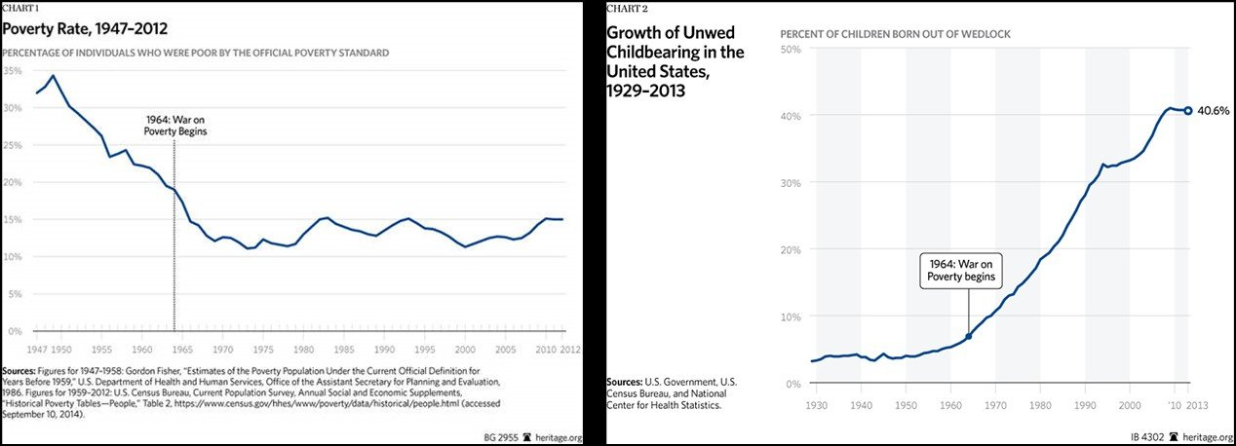
Source: Heritage Foundation – chart 1 and chart 2
Meanwhile, scores of businesses across America hang signs pleading for workers. Restaurants, hotels, landscaping companies, and many others cannot fill open jobs. Despite politicians’ stated intent to help with recovery from the pandemic, the truth is that some federal relief benefits are inducing the opposite effect.
The “Stimmy Shimmy” dancers and others celebrating the easy money flowing from D.C. aren’t stupid. White House Press Secretary Jen Psaki may have missed it, but most people know “stimmy” checks and federal unemployment compensation dwarf current wage levels in some areas of the country. While the rationale isn’t illogical (“Shall I go to work today or earn more in my recliner?”), the attitude that arises from it will ultimately harm their personal growth.
Our politicians should be the adults in the room, but instead they choose to give out free candy, creating a generation of dependent children. Old values of hard work and self-sufficiency are succumbing to the thrill of free “$$$ IN THE POCKET” from “POTU$.” Tough times once produced the Greatest Generation, but we may now be witnessing the rise of the Gimme Generation—and that cannot bode well for our nation.

We are the Cure
Having already contracted COVID-19, Sen. Rand Paul, R-Ky., said he is not going to get vaccination for the virus, because he already has developed natural immunity.
"Until they show me evidence that people who have already had the infection are dying in large numbers, or being hospitalized or getting very sick, I just made my own personal decision that I'm not getting vaccinated because I've already had the disease and I have natural immunity," Paul told Sunday's "The Cats Roundtable" on WABC 770 AM-N.Y., The Hill reported.
Paul was the first known senator to come down with COVID-19 in March 2020. Scientists have speculated – without empirical evidence – the immunity to the virus might not last after six months.
Still, Paul, both an ophthalmologist and one of Congress' stout conservative thinkers, defended one's right to refuse being vaccinated.
"In a free country you would think people would honor the idea that each individual would get to make the medical decision, that it wouldn't be a Big Brother coming to tell me what I have to do," Paul told host John Catsimatidis.
"Are they also going to tell me I can't have a cheeseburger for lunch? Are they going to tell me that I have to eat carrots only and cut my calories?
"All that would probably be good for me, but I don't think Big Brother ought to tell me to do it."
Earlier this week, Paul also warned Americans to "wake up" on the spending plans of the Biden administration and the "profound repercussions" it will have on the American economy, amid a 12-year high on inflation.
"When the [Federal Reserve] says this [inflation] is transitory, I think that's an excuse for government spending and borrowing," Paul told Fox Business. "It's sort of from the same kind of lexicon of 'deficits don't matter.'"
The influx of cash into the economy last year will likely be repeated this year, Paul warned.
"What you've caused is a massive misallocation of resources, a massive infusion of cash into the stock market," Paul said. "There is a time in which people wake up and say 'the emperor has no clothes.'
"And at that moment in time, you will discover that there's a lot of capital that's gone in the wrong direction, that demand is exceeding supply . . . because we've disrupted the normal marketplace."
Paul was referring the Austrian Business Cycle Theory, which predicts a "crash" when printing new money distorts economic conditions.
"I don't think it's as benign as people say it's going to be," Paul said. "I think it is going to have profound repercussions — and that we're just getting started."
As Expected, Iran Never Quit Building a Nuke
As planned all along, the Global Syndicate wants a new player in the nuclear area. They want a rabid dog that does not value human life to have a nuclear bomb. A three-month monitoring deal between Tehran and the United Nations nuclear watchdog expired on Saturday, Iran's parliament speaker told the country's state TV on Sunday, adding that access to images of nuclear sites would cease.
The head of the International Atomic Energy Agency (IAEA), Rafael Grossi, is to hold a news conference on Sunday afternoon. He is in talks with Iran on extending the monitoring arrangement which could have an impact on negotiations between Tehran and six powers to revive a 2015 nuclear deal, the IAEA said.
"From May 22 and with the end of the three-month agreement, the agency will have no access to data collected by cameras inside the nuclear facilities agreed under the agreement," state TV quoted Mohammad Baqer Qalibaf as saying.
Iran's state TV also quoted an unnamed official saying that the agreement between the agency and Tehran could be extended "conditionally" for a month.
"If extended for a month and if during this period major powers ... accept Iran's legal demands, then the data will be handed over to the agency. Otherwise the images will be deleted forever," according to the member of Iran's Supreme National Security Council.
Western diplomats have warned that not extending the IAEA deal could seriously harm efforts to salvage the 2015 nuclear accord, which aims to keep Iran from being able to make nuclear arms, which Tehran says it has never wanted to build.
Iran and global powers have held several rounds of negotiations since April in Vienna, working on steps that Tehran and Washington must take, on sanctions and nuclear activities, to return to full compliance with the nuclear pact.
Iran began gradually breaching terms of the 2015 pact with world powers after former President Donald Trump withdrew the United States from the deal in 2018 and re-imposed sanctions.
Without commenting on the parliament speaker's earlier announcement, Iran's pragmatist President Hassan Rouhani said on Sunday that Tehran will continue the talks in Vienna "until reaching a final agreement." He also repeated his statement earlier this week that "Washington has agreed to lift sanctions" on Iran, according to Iranian state media.
However, other parties to the talks and Iran's top nuclear negotiator said earlier this week that some key issues needed further discussions for revival of the nuclear deal.
To pressure President Joe Biden’s administration to return to the nuclear pact and lift sanctions, Iran’s hardline-dominated parliament passed a law last year to end its obligation to allow the IAEA short-notice inspections to check nuclear work is not being covertly put to military ends.
To give diplomacy a chance, the watchdog and Iran agreed in February to keep “necessary” IAEA monitoring and verification activities in the Islamic Republic, although Tehran would reduce cooperation with the agency.
Qalibaf told parliament's open session, aired by state TV, that Iran's ultimate authority, Supreme Leader Ayatollah Ali Khamenei, backed the law.
"Yesterday it was discussed and the decision was made. The law passed by the parliament will be implemented. The supreme leader has underlined the importance of implementing the law as well," Qalibaf said.
Smashing the Trump Economy is Top Priority
Money is freedom. The Global Syndicate knows the best, long-term way for wealth to accumulate is inheritance. The elite protect their estates with trusts, non-profits, and shell corporations so their kids and grandkids can take over the wealth building activities generation after generation. President Donald Trump made it possible for the Middle Class to pass on their hard-won earnings to their kids. Farms, restaurants, laundries, and shops were spared the ravages of federal greed upon the death of the patriarch.
That is all about to change. Again. Virtual Joe and his gang of traitors propose to dramatically expand the inheritance tax bill to stop the middle class from becoming wealthy.
Virtual Joe’s sweeping expansion of social spending programs would be financed in part by tax hikes on the rich. A key element of that is ending “step-up in basis,” which allows heirs to use the market value of assets at the time of inheritance -- rather than the historical purchase price -- as the cost basis for capital gains.
Instead of hitting heirs with a hefty tax payment at the time of the death of their benefactor, staff for House Ways and Means Chair Richard Neal have floated allowing the beneficiaries to defer the bill as long as they hang on to the asset, according to people familiar with the matter.
That possibility was presented on a Tuesday call with progressive groups and tax policy experts, according to the people, who spoke on condition of anonymity as the discussion was private.
Asked about the call, Neal, a Massachusetts Democrat, said in a statement, “When Treasury releases its Green Book in the coming weeks, I look forward to reviewing the administration’s various revenue proposals and working with other Ways and Means members to chart a path forward.”
Less Money
The so-called Green Book is a report from the Treasury Department that’s expected to detail the Biden tax plans, which have so far been released only in outline form.
The White House declined to comment.
A separate push by the Virtual Joe to raise the corporate tax to 28% from 21% met with a call from moderate Senator Joe Manchin of West Virginia for a less dramatic increase. Biden has also proposed boosting the top income tax rate and the capital gains rate for those earning more than $1 million.
The change floated by Neal’s staff would give beneficiaries of large estates the incentive not to sell, known as the lock-in effect, and it would mean bringing in less money to pay for Virtual Joe’s $1.8 trillion American Families Plan. The Urban-Brookings Tax Policy Center estimates that Biden’s capital-gains proposals, including taxing unrealized gains at death, would generate $372.7 billion over a decade.
“Because you give people the opportunity to postpone the realization of taxation on their appreciated assets you are going to get less revenue,” said Hank Gutman, a former congressional and Treasury aide. Gutman recently testified at the Ways and Means Committee about how lawmakers could go about eliminating step-up in basis.
The change also would not go as far in confronting the inequality that the Biden administration has campaigned to address, some of which, aides say, results from wealth being passed from generation to generation without taxation.
A separate person briefed on the Tuesday call said that Neal’s staff wasn’t floating a definitive idea, but discussing the range of options for Democrats.
One Democratic lawmaker, New Jersey Representative Bill Pascrell, a senior Ways and Means member, has introduced legislation that would end step-up in basis and make the tax bill due at the time of death of the benefactor.
Inequality Focus
“By allowing the richest people in American to avoid paying taxes on their capital gains, stepped-up basis is a seminal driver of the economic inequality that is slowly poisoning the United States,” Pascrell said in a statement. “I am always open to discussing avenues to strengthen legislation that addresses tax inequities. But our focus remains on sealing shut this loophole.”
Neal said in his statement, “I’ve been very clear that no decisions have been made on this subject, though I know Congressman Pascrell has put forward legislation on the matter.”
These early discussions indicate the challenges the Biden administration will face as it seeks to raise roughly $4 trillion to pay for both its infrastructure and families plan. It also shows the extent to which centrist Democrats on Capitol Hill may be reluctant to embrace the magnitude of tax increases on the rich and on corporations proposed -- even as Biden’s top aides tout polling that shows the majority of Americans approve of higher taxes on both.
The idea suggested by Ways and Means staff would address criticisms of Biden’s estate-tax proposal that it could force people who receive illiquid assets -- such as real estate or businesses -- to sell their inheritances right away because they didn’t have the cash on hand to pay the tax.
Family Assets
Virtual Joe’s plan does have an exception for family-owned farms and businesses, but the administration hasn’t spelled out the specifics about who would qualify.
Representative Mike Thompson, a California Democrat who chairs the Ways and Means panel that oversees tax issues, said at a hearing earlier this month that family farms and business shouldn’t be forced to sell, because they cannot pay the taxes.
Progressives who have been proposing to tax assets at death for years, and are likely to oppose changes that would greatly weaken Virtual Joe’s proposal.
The Founder of the Cancel Culture
Nandini Jammi And Sleeping Giants
In 2016, Jammi co-founded the ad company Sleeping Giants to pressure advertisers to stay clear of certain companies, especially conservative businesses. Her website touts her accomplishments with the company as: “the award winning social media campaign that successfully urged advertisers to block Breitbart.com from their media buy.” It further states: “At Sleeping Giants, she led campaigns that convinced advertisers to flee Fox News’ The O’Reilly Factor, Tucker Carlson Tonight and the Ingraham Angle. She also convinced tech companies to suspend Alex Jones’ Infowars, Proud Boys and dozens of other high-profile extremist groups.”
Woke companies, worried about offending their customers, jumped on the Sleeping Giants bandwagon to make sure they were only advertising with other woke businesses. Disney, for example, with its “Stories Matter” program, was concerned enough to create a council of near a dozen groups to lecture executives in monthly meetings on how to handle racially insensitive material from its archive. Twitter CEO Jack Dorsey donated $10 million to the Center for Antiracist Research, and Purdue University paid “whiteness studies” scholar Robin DiAngelo $7,000 for a two-hour virtual event, according to The Epoch Times.
Jammi’s website further congratulates her efforts:
“As the cofounder of a social media campaign called Sleeping Giants, Jammi had perfected the art of pressuring advertisers to stop funding websites that peddle hateful content. In 2017, Sleeping Giants attained national notoriety when its viral protests on Facebook and Twitter helped cause a 90 percent drop in Breitbart News’ ad revenue—kneecapping one of the most important and inflammatory right-wing publications of the 2016 election.”
Not everyone agrees with this approach, however. Dan Granger, CEO of Oxford Road, which is an ad agency that launched Lyft and Hulu, to name a few brands, said media monitors such as Sleeping Giant are “all stick, no carrot. And I think that they’re making the problem of polarization in this country worse, whether or not there is merit behind the claims that they make.”
One prime example of the kind of work Sleeping Giants is the boycott of Facebook by the NAACP and other left-leaning groups because CEO, Mark Zuckerberg decided they would not censor former President Trump’s posts that criticized the riots after the death of George Floyd. Obviously, this was before Trump was banished from Facebook for good. Approximately 1,000 companies pulled ads from Facebook, including Coca-Cola. Sharyl Attkisson, a former reporter for CBS News, explained:
“Advertising boycotts can be very effective. We’ve seen where the news has become an almost entirely managed commodity, that the special interests and propagandists have successfully been able to co-opt in the past 15, 20 years—and particularly using the internet in the past four to five years in a way that has not been done before.
“I think we’re in an information war and people want to be sure to control what others say and think and do.”
But then something happened and Jammi changed tactics, realizing that her method of business was actually hurting not only advertisers but news as well.
Switching Tactics
According to her website, Jammi remembers “the moment she learned she was accidentally destroying the news industry.” This epiphany occurred during the pandemic when companies were slashing their ad campaign funding. Other businesses started advertising that if a company wanted to avoid Sleeping Giant’s boycott list, then to do business with them. Suddenly, marketers were using branding tools such as keyword blockers to make sure their ads did not end up on a page or site with “controversial” topics.
Twitter CEO Jack Dorsey and Facebook CEO Mark Zuckerberg
Concerned that there would be retribution if an ad appeared next to content someone might find offensive, keyword blacklists were utilized. Some of the high-profile keywords included “shootings,” “raising the minimum wage,” and, of course, “Trump.” In January 2020, The Guardian reported that the keyword blacklists were “ballooning in some cases as many as 3,000 or 4,000 words, blocking ads from many different stories.” After the report, keywords such as “coronavirus,” “COVID,” and “virus” were added to the list. Between February and June 2020, publications lost $1.3 billion in ad revenue.
Jammi admitted her part in the mess: “As keyword blacklisting ‘coronavirus’ continues to decimate the news industry, I have had the sinking feeling that Sleeping Giants (a campaign which I co-run) has something to do with it.” Jammi had been so successful in making companies and advertisers scared of not only what they were trying to promote, but also who they were advertising with, that fear was now directing advertising and the news.
She had done her job so well that corporations were afraid of ending up a target of Sleeping Giants and other activist organizations that popped up with their own lists of companies to avoid. Julián Villanueva, a digital marketing professor at IESE Business School in Spain, wrote about the website ethicalconsumer.org which reportedly targets big companies for specific practices:
“The site contains a list of initiatives to persuade ‘ethical consumers’ to stop purchasing from brands like Air France for shipping monkeys to laboratories; Amazon, for avoiding taxes; Bluefin Tuna, for fishing endangered species; or Caterpillar, for selling bulldozers to Israel, as these will be used to destroy Palestinian houses. All of these are accusations that might have to be proven, but that many people believe instantly.”
Also last year, Jammi – claiming a difference of opinion with her partner – left Sleeping Giants and started another business, Check My Ads, and released a list of 51 media outlets that she recommended were safe to advertise on. Some of these include Vox.com, The Atlantic, and The New Yorker. There was not a single conservative publication or media source on her list. The Wall Street Journal, the largest publication, didn’t make her safe list either.
But then she started noticing that her favored outlets were also being hurt by boycott advocates and Jammi had a change of direction. “Check My Ads” is supposed to serve as protection for companies. She claims it provides “brand safety training that empowers marketers to protect their brands … We help you identify where your dollars are going and to align your media buy with your values.”
Critics, however, consider this shift from boycotting queen to protector a “pure protection racket,” saying it is “a growing field of progressive groups and personalities exploiting cancel culture for both political gain and personal profit,” as The Epoch Times puts it. To some, had Jammi not been so successful in her boycott campaigns then there wouldn’t be a need for her “protection” now. There are those that argue she created the trouble and now comes in riding a white horse to save the day.
The US Secret Army
The Pentagon is running a 60,000-strong secret army made up of soldiers, civilians and contractors, who travel the world under false identities embedded in consultancies and name-brand companies — without the knowledge of the American people or most of Congress — according to a report.
The top-secret army was created by the Pentagon over the past 10 years as part of a program called “signature reduction,” and operates both domestically and internationally using a low-profile force of clandestine warriors who sometimes wear civilian clothes as they carry out their assignments, Newsweek reported.
The force is 10 times the size of the covert elements of the CIA, comes with a cost of more than $900 million, and engages about 130 private companies in operations in locales like the Middle East and Africa, the report said.
Despite the undercover army’s size and budget, Congress has never held a hearing on it.
The reported secret army was created as part of a program called “signature reduction.”Alamy Stock Photo
About half of the “signature reduction” force is made up of special forces, the highly trained commandos who pursue terrorists around the world, including in Iran and North Korea.
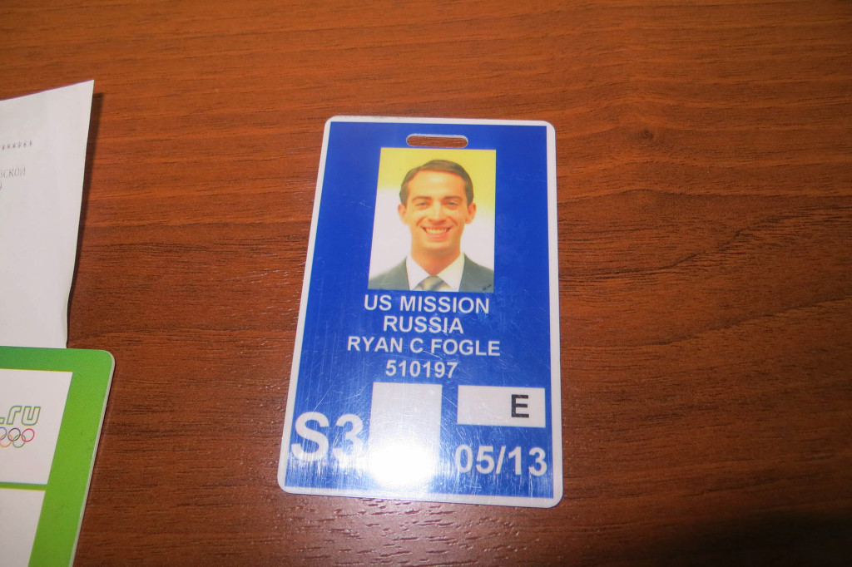Ryan Fogle is reportedly part of the secret army, and was found out while trying to recruit a “double agent” in Russia.AP/FSB Public Relations Center
Military intelligence specialists comprise the second-largest element inside the force.
But the newest and fastest-growing group in the unit is made up of cyber-warriors who use false personas and “nonattribution” or “misattribution” techniques online to disguise themselves so they can track high-value targets, collect “publicly accessible information” and engage in influence campaigns to manipulate social media.
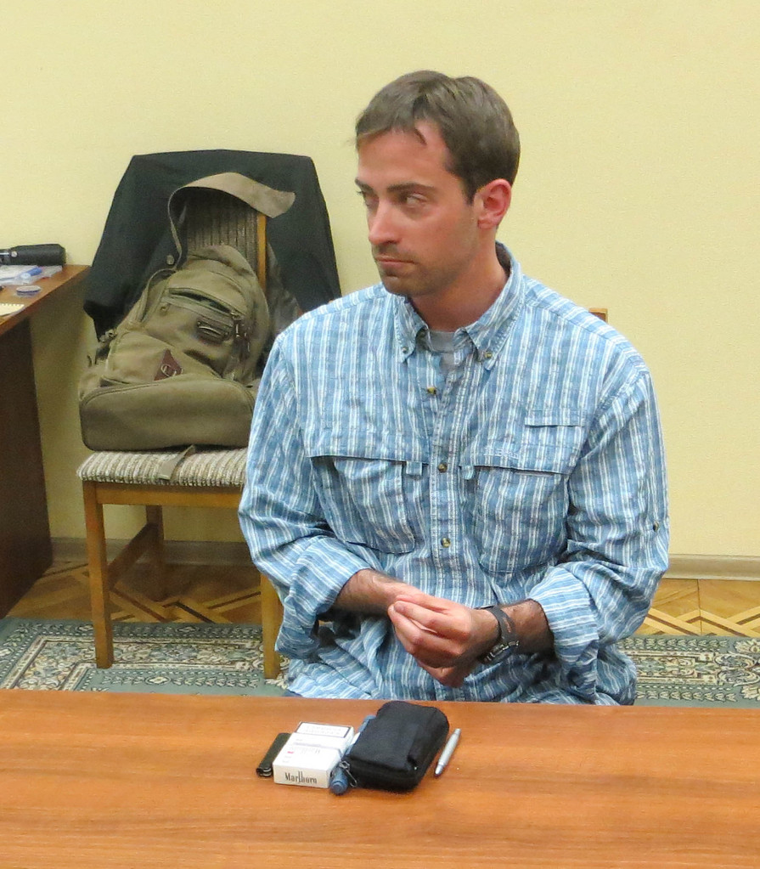Ryan C. Fogle is questioned by the Russian Federal Security Service after he was arrested in Russia while working at the US Embassy.AFP PHOTO / FSB
“Signature reduction” programs, which are administered by a number of shadowy government organizations, have no unclassified definition, and are portrayed by the Defense Intelligence Agency as what “individuals might use to … describe operational security measures for a variety of activities and operations.”
The report said ultimately the programs shield ​the ​operators from being identified by the groups they are tracking ​online ​and cover their cyber tracks to keep their identities secret to protect them from retaliation.
One recently retired senior officer ​who oversaw one of the programs said no one is fully aware of their extent or the implications they have for military warfare.
“Everything from the status of the Geneva Conventions​ ​– were a soldier operating under false identity to be captured by an enemy​ — to Congressional oversight is problematic,” the person ​told Newsweek. “Most people haven’t even heard of the term ‘signature reduction’ let alone what it creates​.​”
SEE ALSO
USPS admits to spying on Americans’ social media posts: report
T​he report cited one instance in which a clandestine operative had been outed while trying to recruit a double agent.
Moscow in May 2013 ordered a “third secretary” by the name of Ryan Fogle to leave the country and released photos of him wearing a blond wig and carrying four pairs of sunglasses, a street map, a compass, a flashlight, a Swiss Army knife, and a cellphone that, according to one media article, looked like it had “been on this earth for at least a decade.”
​Fogle’s expulsion attracted the attention of the international news media and brought scorn from retired CIA officials about the lack of tradecraft.
But Fogle’s mocked cellphone hid a more sophisticated device.
Brenda Connolly — not her real name, Newsweek pointed out — works for a small defense contractor that produces instruments for “signature reduction.”
Amid Ryan Fogle’s 2013 arrest, Moscow reportedly found his disguises — including wigs and four pairs of sunglasses.AFP/Getty Images
Connolly said Fogle’s seemingly outdated phone concealed a “covert communications” device and that he was wearing a radio frequency identification shield to block electronic tracking. ​
“And who do you think implants those devices?” Connolly asks, then answers. “Military guys, special ops guys working to support even more secretive operations.”

