Automatic Banning
How did you vote? Well, if you voted Republican, you may never be able to access your money again. PayPal routinely closes accounts and seizes the money of Trump voters. Did you know that? Yes, it’s true. Thousands of bank accounts totaling millions of dollars each month are cleaned out by online banks and the account holders are banned for life because they voted wrong in the last election
The same goes for YouTube, Shopify, Venmo, and even Patreon. Billions of dollars, one small account at a time, and thousands of account holders too small to defend themselves may never be able to pay rent, buy gasoline, or even food again.
The same goes for vaccine status in some places. The same will eventually be true if you drive the wrong typo of vehicle to the gas station. Even fast food will be off limits to you. I predicted this in my book The Ark of Millions of Years Volume One in chapter 4. Listen closely.
Highly vaccinated and "boosted" Israel was among the world's first countries to impose a vaccine passport requirement on its population, which the government calls a 'Green Pass'. And yet the pandemic has continued there unabated, and all that average citizens are left with is immensely curtailed freedoms.
As a glaring case in point, Israelis apparently can't even order a Big Mac from an automatic kiosk at McDonald's unless their Green Pass status is up to date. Most recently, this means a citizen has to have not just been double-jabbed, but they have to have received the booster. This also as Israel has approved a second booster for the immunocompromised and elderly. Watch the absurdity unfold:
"Mcdonald’s appears to be the first food provider in Israel to deny customers who do not have proof of vaccination," one local news source comments on the disturbing video.
"Activist Shlomo Walfish went to the McDonald’s in Bet Shemesh to try to order food," the report descsribed. "The computer that takes orders then denied him service after selecting that he does not have a green passport."
With the green pass system, other public venues like bars, gyms, and theaters are denying people access; however, this could be a first example of a machine literally being programed to halt service to unvaccinated people - or at least those without proper vaccine "credentials".
And we are being told this is all in the name of public "health" and "safety"... No Covid passport = no food.
State vs People
The Democrat governor in Washington state says he wants to regulate lying.
Actually, the target of Gov. Jay Inslee is "false statements," and the Daily Caller News Foundation explains he announced he is working on legislation that would regulate candidates and elected officials from "spreading lies about elections that are likely to result in violence."
Democrats have portrayed President Trump's claims about a mismanaged and stolen 2020 presidential election as the "Big Lie," while Trump has pointed out that it actually was the election that was the "lie."
At least two extracurricular Democrat campaigns have been found to likely have impacted the election results enough to install Joe Biden in the White House.
One was a study that found the $420 million handed over by Mark Zuckerberg to various mostly partisan elections officials with instructions to adopt Democrat elections procedures and recruit voters from Democrat areas essentially purchased the election for Biden.
The other was the conclusion from the Media Research Center that had not legacy and social media outlets suppressed accurate reporting about Biden family scandals, specifically involving Joe Biden's son, Hunter, enough people would have declined to support him that President Trump would be in office today.
The Daily Caller News Foundation pointed out Inslee's legislation still is being written but said it would be "narrowly tailored" to target those statements made for the "purpose of undermining the election process or results."
"This legislation attempts to follow the relevant U.S. and state supreme court opinions on this issue. We’re talking about candidates and elected officers knowingly throwing bombs at democracy itself when doing so is likely to result in violence," Inslee said.

The foundation report said the Democrat announced the planned proposal on the first anniversary of the Jan. 6 Capitol riot, and he cited the event, as well as statements made by elected officials casting doubt on the results of the 2020 presidential election, as justification for the new speech restrictions.
He didn't address the fact that multiple Democrats, including 2016 race loser Hillary Clinton, repeatedly described President Trump as an illegitimate president.
Inslee did say, "January 6 is a reminder not only of the insurrection that happened one year ago, but that there is an ongoing coup attempt by candidates and elected officials to overturn our democracy. They are willing to do this by provoking violence, and today I proposed we do something about that in Washington."
Inslee cited a 1969 Supreme Court ruling in Brandenburg v. Ohio that said speech "inciting or producing imminent lawless action and is likely to incite or produce such action" is not protected by the First Amendment, which normally covers political statements.
"We can outlaw actions that provoke political violence and in doing so also protect our democracy. There is more that can be done by states and Congress to protect our democracy,” Inslee said. “I am open to any proposal that will protect the will of the voters and the institutions they use to decide who governs them."
Besides the statements the Democrats have issued in conflict with the 2016 results, a Real Clear Politics column a short time ago pointed out another 10 Democrat "smears and lies."
The report listed:
- When they insisted that Trump was a Russian asset, we were told to believe they were safeguarding national security.
- When they accused Brett Kavanaugh of sexual assault and even gang rape, we were told to believe they were protecting the Supreme Court.
- When in 2019 they made Trump only the third president in history to be impeached – and the only one not accused of committing a high crime or misdemeanor – we were told to believe they were defending the rule of law.
- When scores of BLM protests turned violent [in 2020], they told us to believe that the gatherings were mostly peaceful.
- When antifa thugs destroyed property, beat citizens and occupied public lands, they told us to believe that the group didn’t even exist.
- When some undefined, unaffiliated people online appeared to subscribe to crazy conspiracy theories involving Satan and pedophiles, they told us to believe it was a vast and highly organized group intent on overthrowing the government.
- When they argued that “whiteness” and “white privilege” are the underlying source of America’s problems, they told us to believe they were trying to heal the nation.
- When they censored allegations of the Biden family’s corruption, they told us to believe they were fighting disinformation.
- When they allowed Twitter mobs to destroy people who had once said something they didn’t agree with or like, they told us to believe that they were seeking justice.
- And, when they demonize and silence the tens of millions of people who oppose their quest for domination, they tell us to believe they are seeking unity.
Generational Civil Indoctrination
As I have told you for quite a while now, the Global Syndicate plays the long game. They have been around for millennia, and their tactics are the same all over the galaxy. Thousands of worlds have been conquered using these techniques. Some spirits are stronger than others, but the Syndicate always targets the weak minded who have very little light inside of them. You can call them victims, if you like, but they soon become soldiers willing to die for Lucifer’s plan.
The Global Media Empire, a major division of the Global Syndicate, dedicates 25% of its mission to education. It goes after the children, who are raised to trust their teachers as authorities of truth. The fact is that teachers are sycophants for Lucifer. They groom and sexualize 5 year old boys and girls for the vast community of pedophiles that run our State and federal agencies and court systems. They teach them that the most important feature of their mortal bodies are their genitals and their skin color. Nothing else matters.
Despite officials at Riverside Unified School District claiming critical race theory is not taught in the California district, public records, as well as a cursory glance at the district’s website, proves such claims are blatant lies.
According to records of the minutes taken at two local school board meetings, one of which was held on July 15, 2021 and another on August 5, 2021, multiple public employees at Riverside Unified School District claimed that critical race theory was not taught in the school district. Superintendent Renee Hill is one such public employee.
The records note that during the meeting on July 15, Hill addressed various topics “that seemed to be on the minds of some RUSD stakeholders. First, she said, RUSD does not teach Critical Race Theory.” The divisive theory was discussed again during the August 5 meeting, when community members spoke on CRT during the public comments section of the meeting. It was directly after these public comments that Board of Education member Tom Hunt also lied about the presence of CRT in the district.
The minutes records noted that Hunt “addressed the fact that there are rurmors floating around that RUSD is teaching critical race theory, but they are not. A company was hired to work with RUSD staff in order to enhance ethnic relations, and this has created a misconception, because the design for Ethnic Studies is not critical race theory. Hunt said there is fake news happening across the nation, including Riverside.”
The Local Control and Accountability Plan revealed the district spent a whopping $942,103 on programs for cultural proficiency training, culturally responsive teaching, and other programs that frequently feature the themes of CRT.
One hired to deliver such trainings was Epoch Education, which, according to the district’s LCAP, was commissioned to train as many as 400 administrators in “cultural proficiency.” On August 15, 2020, Assistant Superintendent Jacqueline Perez gave a presentation to the board that outlined the district’s partnership with Epoch Education, as well as their strategic plan to advance CRT.
The presentation, which can be downloaded and accessed through the meeting’s records, left no room for doubt regarding the presence of CRT in the district. One slide, labeled “Superintendent Call To Action,” demands that the board “reflect on your own mindset on race and privilege.” It also says that an “equity champion” “Explore[s] Whiteness [sic] as Property through Critical Race Theory.”
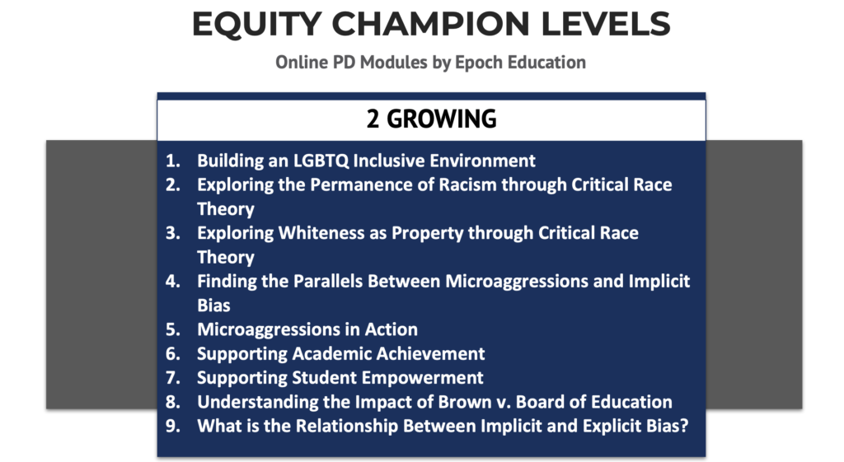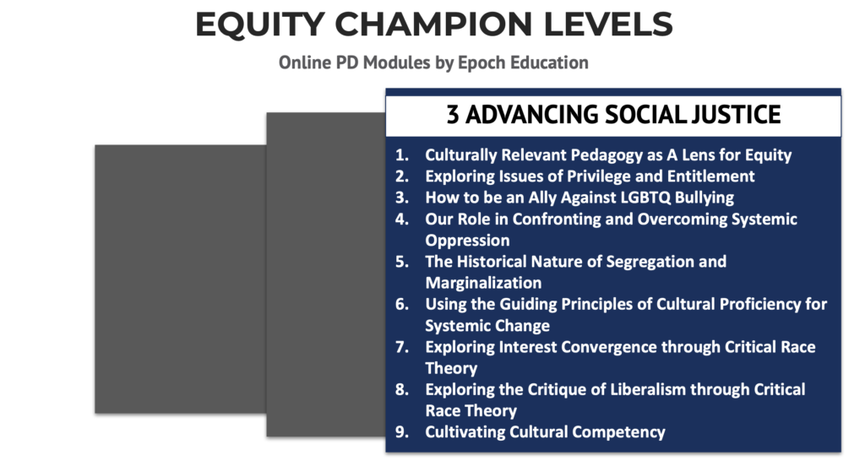
It’s also evident that these themes are intended to affect the instruction of students. For one thing, the presentation quickly transitions to a conversation on the new ethnic studies curriculum the district will be teaching. The presentation also features an “Equity, Access, and Community Engagement Division” graphic that includes “District Student Equity Leaders,” further evidence that the student body is directly involved in equity initiatives that are explicitly rooted in CRT.

Riverside’s Materials Reveal The Presence Of CRT
While public records offer ample proof that CRT is being taught at Riverside Unified School District, even a cursory glance at their website’s Equity, Access, and Community Engagement Resources page disproves the claims of Hill and Hunt. The resources page links to an academic article called “The Integration of Response to Intervention and Critical Race Theory–Disability Studies: A Robust Approach to Reducing Racial Discrimination in Evaluation Decisions.”
Particularly striking was a link to a pdf entitled “Transforming Our Public Schools: A Guide to Culturally Responsive-Sustaining Education,” which preached the need for “culturally responsive education.”
The guide discusses what culturally responsive education would tangibly look like and encourages teachers and administration to “receive anti-bias trainings on race, power, and privilege.” The guide’s glossary includes CRT buzzwords like “oppression,” “decolonize,” “intersectional,” “privilege,” and “liberation.”
The document was created by the NYC Culturally Responsive Education Working Group and the Education Justice Research and Organizing Collaborative (EJ-ROC) at the NYU Metro Center. Their website prominently features a CRT toolkit that explains how leftwing school administrations and teachers can defend CRT against the right, whom they claim are “amping up their racist strategies.” The document also uses the term “culturally responsive sustaining education” virtually interchangeably with CRT and even cites the aforementioned “Transforming our Public Schools” guide.
A reading guide for Robin DiAngelo’s “White Fragility” is linked by the district as a resource under “professional development.” It presents a list of discussion questions for each chapter, such as “what are some examples of white feminism?” It also doubles down on DiAngelo’s assertion that “it isn’t enough for white people to be nice and that, in fact, racism depends on white people simply being nice.”
A document called “Justice in June” showcased a calendar, with each day featuring an article, video, podcast, or an action item for those who want to be an “active ally.” One such action item reads “Help reallocate city budgets by defunding the police.” Robin DiAngelo’s “White Fragility,” as well as Ibram X. Kendi’s “How to be an Antiracist,” both prominent texts in the critical race theory movement, are also promoted by the document.
Key Equity Terms and Concepts were also promoted on the district’s website. The glossary perpetuates the lie that white people can’t be victims of racism, arguing in the definition of the term that “Racism differs from prejudice, hatred, or discrimination because it requires one racial group to have systematic power and superiority over other groups in society.” It also contends that racism exclusively targeted those who are “racialized as non-white, as means to uphold white supremacy.”

Public Schools Are Lying About Teaching Racism
The blatant lies from Hill and Hunt are in no way unique. Randi Weingarten, the president of the American Federation of Teachers union, denied the divisive theory was taught in public schools after she bragged about teaching it.
The Los Angeles Unified School District, the second largest school district in America, also claimed that CRT is not taught in K-12 schools despite hosting a critical race theorist to conduct a training for staff members and even hosting the director of UCLA’s Center for Critical Race Studies to give input while they crafted their ethnic studies curriculum.
The persistent presence of CRT in public schools coupled with the dishonesty that surrounds it may drive some parents to support measures that would grant them more authority over their children’s education, such as a recently announced school choice initiative in California.

Unhappy Drivers Could One Day be Dead Drivers
Sometimes we are left to wonder whether unseen forces may be at work trying to get us to rethink whether certain planned initiatives are smart to undertake, at least without giving the dire consequences of doing so additional thought.
Thousands of unhappy drivers were given such an opportunity – including at least one member of Congress – on Jan. 3. Commuting into Washington, D.C., they got caught up in a 24-hour-plus delay on Interstate 95 leading into the city. It happened after six tractor-trailers crashed in Virginia in a heavy snowstorm, which left them stranded. Many motorists ran car heaters to stay warm, were without food and hampered by vehicles abandoned on the roadway. They were left to await the clearing of numerous road bottlenecks before being able to proceed, assuming they still had enough fuel to get to a gas station. Fortunately, there were no injuries or deaths caused by the delay.
Due to numerous cars that did run out of gas, fuel had to be transported to them or else they had to be towed to a fuel source.
This incident comes at a critical time. President Joe Biden has put us on a course to increase electric vehicle (EV) manufacturing while reducing manufacturing for internal combustion engine (ICE) cars. Supported by the United Auto Workers (UAW) union, Biden announced a combined target of 50% EVs, including plug-in hybrids and fuel cell models, by 2030. All government vehicles are to be EVs by 2050. While Tesla, having produced its first EV in 2008, has built more EVs in the U.S. than any other automaker, it has done so without UAW labor.
The major car manufacturers are already onboard. Chrysler announced that by 2028, it plans to go completely electric. It seeks to embed in its vehicles an artificial intelligence (AI) software system powered by a battery capable of traveling 350 to 400 miles per charge.
Interestingly, as other automakers such as Volkswagen, Toyota, General Motors, Ford, BMW and Nissan also announce transitioning to EV manufacturing, a newcomer – never before in the car manufacturing industry – announced its entry into the market. The company that brought us PlayStations – Sony – is now cutting its teeth on EVs, hoping eventually to bring autonomous vehicles to the market. It will do this by creating a new division focusing on vehicle development known as Sony Mobility Inc. It has already built a prototype seven-seat, sport-utility EV with all-wheel drive.
But while the leading car manufacturers, and now Sony, announce their run for the roses in the EV race, a question must be asked based on the recent I-95 snow delay. That question is how well would EVs have performed during a 24-hour-plus delay in keeping drivers and passengers warm and able, once road bottlenecks were cleared, to get moving again?
While a century ago we proved able to quickly transition from the horse to mass-produced cars, the transition from ICE cars to EVs will not go as smoothly. Nor will it go without devastating consequences absent such consideration.
One of the automakers that has established itself as a leader in the market, having grown its footprint the old fashioned way by building reliable cars without resorting to acquisitions to expand, is Toyota. Before the Jan. 3 storm, and despite its heading in the EV direction as well, it went on record before the U.S. Senate stating its concerns that the world is not yet ready to support a fully electric auto fleet.
In March 2019, Robert Wimmer, head of Toyota’s energy and environmental research, gave testimony which, had it been played for EV drivers stranded on I-95, would have had them nodding in full agreement.
Despite auto manufacturers' ambitious goals, Wimmer noted just 2% of the world’s cars are EVs amid a slew of pro-ICE factors, such as price, range and infrastructure. Cheaper ICE pricing exists even after EV tax subsidies are factored in.
Additionally, Wimmer reported how the scale involved in switching to EVs has yet to be seriously discussed in any systematic way. With 290 million cars on U.S. roads in 2021, of which 98% are gas-powered, installation of a massive EV infrastructure system is necessary.
A U.S. government study determined at least 8,500 strategically placed charge stations would be needed just to support a fleet of 7 million EVs – six times larger than the number today. But no one is even discussing the support needed for 7 million electric cars. And if manufacturers stop making ICE cars within the next two decades, we are looking at 300 million EVs. We need an improved power infrastructure at a time when places such as California and Texas are experiencing power outages. Whether charged at home or on the road, EVs need to be charged frequently, with fast charging at home still a future dream, drawing on generators fueled by natural gas, coal, petroleum, etc.
Wimmer was not claiming the above could not be done, but he believes little conversation is being undertaken to initiate it.
It would be interesting to hear from the Virginia Department of Highways how EVs caught up in the I-95 snow delay faired. There are questions such as how far the closest charging sources were located, the waiting time for a charge if multiple EVs were involved and the time it took after the highway was cleared for EVs to get back on the road. These are all valid considerations that need to be weighed before embarking upon putting at least 300 million cars on our highways.
As reported, Sony is now jumping into the EV market. It is hoped the company learned a lesson from an earlier plunge into the cassette recording market in the mid 1970s with Betamax. Sony ended up losing its battle for market share but did not stop making Betamax tapes until 2016, long after the public had lost interest in them, with most unaware that the tapes were still in production. Betamax goes down in history as one of 10 most famous project failures.
If Biden fails to ensure an EV support infrastructure capable of handling a massive transition to electric power from gas power, his initiative will top the list of project failures. But worse than that for EV drivers, every day will become an I-95 snow day. Thousands of unhappy drivers in ICE vehicles is better than thousands of dead drivers in EVs.

Math: The Language of Creation
Nature is an unstoppable force, and a beautiful one at that. Everywhere you look, the natural world is laced with stunning patterns that can be described with mathematics. From bees to blood vessels, ferns to fangs, math can explain how such beauty emerges.
Math is often described this way, as a language or a tool that humans created to describe the world around them, with precision.
But there's another school of thought which suggests math is actually what the world is made of; that nature follows the same simple rules, time and time again, because mathematics underpins the fundamental laws of the physical world.
This would mean math existed in nature long before humans invented it, according to philosopher Sam Baron of the Australian Catholic University.
"If mathematics explains so many things we see around us, then it is unlikely that mathematics is something we've created," Baron writes.
Instead, if we think of math as an essential component of nature that gives structure to the physical world, as Baron and others suggest, it might prompt us to reconsider our place in it rather than reveling in our own creativity.
(Westend61/Getty Images)
A world made of math
This thinking dates back to Greek philosopher Pythagoras (around 575-475 BCE), who was the first to identify mathematics as one of two languages that can explain the architecture of nature; the other being music. He thought all things were made of numbers; that the Universe was 'made' of mathematics, as Baron puts it.
More than two millennia later, scientists are still going to great lengths to uncover where and how mathematical patterns emerge in nature, to answer some big questions – like why cauliflowers look oddly perfect.
"We spent many hours frantically dismantling [cauliflower] florets, counting them, measuring angles between them," writes University of Nottingham mathematician Etienne Farcot, who studied cauliflower growth in an effort to understand these "mysterious cabbages."
Fractals are exquisite, self-repeating patterns which, besides some cauliflowers, are also found in fern fronds, branching blood vessels, and the rings of Saturn. Fractals are geometrical shapes made up of smaller and smaller copies of themselves, creating a mesmerizing 'self-similarity' that is infinitely deep.
Mandelbrot set (black) in a continuously colored environment. (Wolfgang Beyer/Wikimedia, CC BY-SA 3.0)
Although only mathematical or computer-generated fractals are truly perfect fractals, nature comes pretty close.
"These repeating patterns are everywhere in nature," says mathematician Thomas Britz of the University of New South Wales in Sydney, Australia. "In snowflakes, river networks, flowers, trees, lightning strikes – even in our blood vessels."
(VerboseDreamer/Wikimedia Commons)
Part of the charm of fractals is that they help to explain how complexity is born out of simplicity. As Benoît Mandelbröt, the Polish-born mathematician who coined the term fractal, said in 2010: "Bottomless wonders spring from simple rules which are repeated without end."
Branching river systems also carve near-perfect fractal patterns in the landscape.
So persistent are these patterns that in one instance, archaeologists looked for missing fractals to deduce ancient Egyptians might have modified river channels when building pyramids nearby.
Lake Erepecu and Trombetas River in Brazil. (NASA Earth Observatory)
Insects appear to follow mathematical principles, too.
Whether they know it or not, bees build hexagonal honeycomb in a way that produces the most storage space using the least materials – a theory known as the 'honeycomb conjecture' which was finally demonstrated by American mathematician Thomas Hales in 1999.
Some species of cicadas also have a life cycle geared towards prime numbers. Swarms of two North American species emerge from their subterranean burrows every 13 or 17 years, a trick which scientists think helps cicadas avoid predators with more regular rhythms.
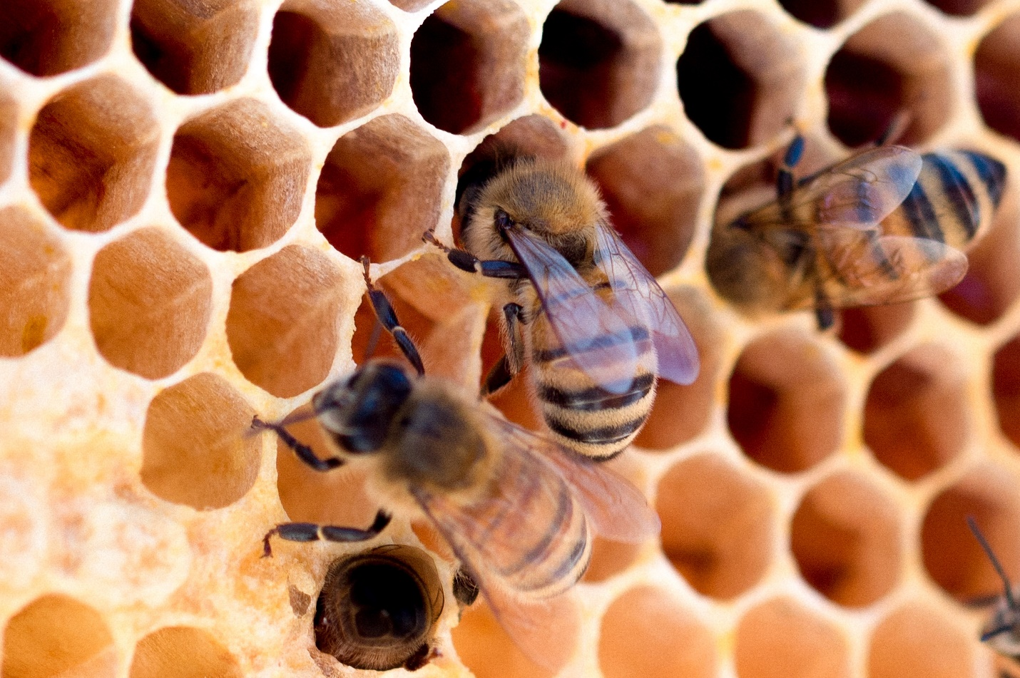(Meggyn Pomerleau/Unsplash)
Let's not forget nature's 'favorite' numbers, Fibonacci numbers, where each number in the sequence is the sum of the previous two. Fibonacci numbers are seen in sunflower seeds, pine cones and pineapples.
Spiral galaxies and nautilus shells also mimic so-called golden spirals by growing in a logarithmic ratio with every quarter turn.
But even though mathematical patterns are everywhere to be seen in nature, recent discoveries suggest the connection between math and nature runs deeper still, in ways we're only just beginning to appreciate.
(James L. Amos/Getty Images)
Earlier this year, researchers discovered what they described as a previously unknown law of nature: a growth pattern which describes how pointed shapes form again and again in nature – from shark teeth and spider fangs to bird beaks and dinosaur horns.
"The diversity of animals, and even plants, that follow this rule is staggering," evolutionary biologist Alistair Evans from Monash University in Australia said at the time they discovered the mathematical formula, dubbed the 'power cascade'.
"We found it almost everywhere we looked across the kingdoms of life – in living animals, and those extinct for millions of years."
Back in 2015, scientists were also delighted to find a classic formula for Pi – the ever-constant ratio between a circle's circumference and its diameter – lurking in hydrogen atoms.
In a roundabout way, that discovery leads us back to the idea that mathematics provides a structural framework for the physical world. It's an interesting idea to entertain – so long as your head doesn't explode.

The Truth About Kazakhstan
What really is happening in Kazakhstan? When the CIA and MI6 on behalf of the Global Syndicate use automatic weapons and contract fighters to do in Almaty was Johns McCain and Kerry did in Kiev, this is really an apocalyptic threat to Russia's security. Deposing president Takarov with their puppet globalist would put NATO forces 7 minutes from Moscow
The fake stream media is trying to sell the world on mass protests and anti-government violence against vax passport being required to withdraw cash from the bank that has have left dozens dead. Machine gun fire and grenades are not protests. That is a full-on paramilitary skirmish, just like Victoria Nuland did in Kiev, massacring 100 Ukrainians in the streets to get globalist pressure on Yanukovych to be expelled for not signing the World Bank’s debt trap. Unlike that CIA op, Russia is deploying 3,000 paratroopers after Kazakh security forces were overrun. Mazarov, the country’s chief of security, is in jail facing high treason charges. Turns out, he may have taken bribes from an expat billionaire living in Paris.
The largest city, Almaty, looks like a warzone. I have business partners who live there right now. To appreciate why Russia is willing to deploy troops to Kazakhstan, it's critical to understand the depth of Russia's vital national interests inside the country. This isn't just any former Soviet republic. It's almost as important to Russia as Belarus or Ukraine. Kazakhstan is a major trading partner with direct access to the American financial markets.
First, Russia and Kazakhstan have the largest continuous land border on planet earth. If Kazakhstan destabilizes, a significant fraction of the country's 19 million residents could become refugees streaming across the border. It is four times the size of Texas and loaded with natural resources and highly skilled engineers and technicians. Russia is not willing to let NATO take over that country. Period.
Second, roughly one-quarter of the population of Kazakhstan is ethnic Russians. Kazakh nationalists are overwhelmingly Muslims, who resent the Orthodox-Christian Russian minority. Russia believes that civil war would entail a non-trivial risk of anti-Russian ethnic cleansing.
Third, the Baikonur Cosmodrome in Kazakhstan was the heart of the Soviet space program. Russia still uses it as its primary space-launch facility. The Vostochny Cosmodrome in Russia's Far East will lessen that dependence, but it still isn't complete.
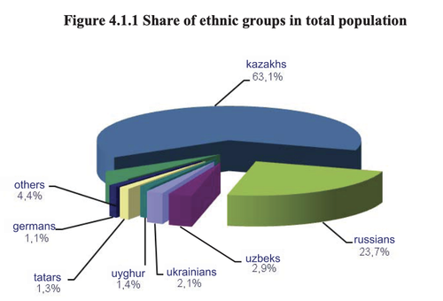
Fourth, Russia conducts its Anti-Ballistic Missile testing at the Sary-Shagan test site within Kazakhstan. This is where ongoing development of the S-550 ABM system is occurring, one of the foundations of Russia's national security.
Fifth, Russia's nuclear fuel cycle is intimately linked to Kazakhstan. Russian-backed Uranium mining operations are active in the country. Uranium from Kazakhstan is enriched in Novouralsk, Russia and then returned to Kazakhstan for use in Chinese nuclear-fuel assemblies. The previous president was corrupt and sold a major uranium mine to friends of the Clintons, earning them $145 million in commissions, and eventually transferred 20% of Westinghouse’s uranium refined output to Putin.
Collectively, these security interests make Kazakhstan a region that Russia is willing to stabilize with force. The 3,000 troops it has already committed are not even close to what it is willing to deploy. If necessary, these will only be the first wave of RU forces in the country. The biggest question is how the situation in Kazakhstan will affect the existing standoff between Russia and NATO over Ukraine. Will Russia be deterred from intervention in Ukraine by the need to maintain reserves to deploy to Kazakhstan? Or will it simply be provoked?
Russia sees it as strategic defense to save its people in Kazakhstan. The Global Syndicate will try to sell you on the idea it is a Russian invasion to try to reestablish the USSR.
Recall that, before things escalated in Kazakhstan, Russia had massed troops along its border with Ukraine. Moscow issued an ultimatum: Back NATO assets a safe distance from Ukraine "or else." Crimeans voted to be annexed to Russia to avoide NATAO weapons from being placed in their country, thus turning them into a war target, when 90% of the country is Russian and currently enjoys tariff free trade with Russia. This was already a very dangerous situation. NATO-Russia talks to resolve the crisis in Ukraine were set to begin next week. Yet, on their eve, the revolution against the government of Kazakhstan began. You’re smart enough to see the cause and effect here. NATO is already at war with Russia, because they do not belong to the World Bank. They are free and independent and will not agree to print or bank EU currency.
What is "hybrid war"? From the Russian perspective, it is a two-pronged approach to regime change. First, Western-backed NGOs, backed by the CIA and MI6, fund and arm large protests against an incumbent government. Second, armed provocateurs use the protests as cover to stage kinetic attacks.
Moscow believes that this playbook was employed successfully in Ukraine to oust the Russian-aligned government in 2014. And it believes that the Global Syndicate unsuccessfully attempted to employ the same strategy to topple Russia's allies in Syria and Belarus. It's debatable whether the Syndicate has anywhere near the power to spark revolutions that Russia contends. Yet America plays into Russian paranoia by funding "civil society" NGOs overseas.
See the NED's Kazakhstan page here.
When revolutions occur in countries where they're active, America Free Radio connects the dots. Kazakhstan is the latest example. In the year before the attempted revolution, the US National Endowment for democracy spent more than $1M in the country. The money went to PR campaigns against the government and training anti-government protesters. The Russians are convinced that NED is a front for the CIA. When you watch the videos and hear automatic weapons fire, and see grendaes going off between the two sides, you can see that these are the weapons of war. These are not the weapons of locals mad about a vax passport, and the fake stream news would have you believe. These are the weapons of a war.
The NED looks like a bunch of Democrats, but they are members of the CIA's mission. In 1986, the founder of NED, Carl Gershman, said the group was created because "[i]t would be terrible for democratic groups around the world to be seen as subsidized by the CIA." Today, instead of receiving CIA money, they receive NED money. It is all the same donors. It is all the same blood. Middle class sons dying for the elite’s Global Syndicate.
In 1991, NED President Allen Weinstein said, "A lot of what we do today was done covertly 25 years ago by the CIA." He claimed that operating overtly via NED, rather than covertly through the CIA, made the risk of blowback "close to zero." The Russians do not see things that way. When they witness overt US support for ousting pro-Russian governments, they assume there is also covert support being provided. To them, NED is only 1/2 of a "hybrid war" strategy in Kazakhstan that includes kinetic operations. Russia's Foreign Ministry made that clear yesterday.
It describes the situation in Kazakhstan as "an attempt to undermine the security and integrity of the state by force, using trained and organized armed formations, that is inspired from the outside." It is the same exact tactic Victoria Nuland commanded when her U.S. Army special ops assassins slaughtered 100 Ukrainians in the streets after the global news wouldn’t give her the press she wanted to support John McCain’s attempt to assassinate then president Yanukovych for refusing to sign the World Bank’s debt trap. Putin called Yanukovych and made him a better offer. He is, after all, Crimean. McCain and Biden stood to make millions off the loans.
Putin knows exactly what happened and commanded by the "Collective Security Treaty Organization," the Russian-led equivalent of NATO to take action to stop it. It's the first ever CSTO intervention, and it's based on the accusation of a foreign attack on the sovereignty of Kazakhstan. White House Press Secretary Jen Psaki has questioned the legal legitimacy of the CSTO operation, but she is also a Syndicate mouthpiece. She is not a white hat. She is a press consiglori for the Global Syndicate.
The undisputed President of Kazakhstan, Tokayev, officially requested CSTO support, claiming his nation was under attack. To bolster the appearance of multilateralism, RU forces are deploying alongside smaller number of troops from two other CSTO states, Belarus and Armenia. These CSTO forces will secure critical government installations, freeing up the Kazakh military to perform "anti-terrorism." The most critical function of the CSTO deployment is internal signaling within Kazakhstan.
In the U.S., we would call this continuity of government. To date the U.S. has never implemented devolution to save the government from a hostile takeover. It happened right in from of our eyes in November of 2020 and the fake inauguration took place on January 20th 2021, and nothing was done to stop it, because there are no generals left in America willing to fight. It is as simple as that. There is no one to call. No one would come. To this date, there are 600 Americans in a D.C. dungeon being tortured in total violation of the Constitution, and no one is willing to do a damned thing about it.
Now that Kazakh forces know Russia is backing their government, fewer of them will be willing to join the side of the Syndicate. We saw that happen before. I doubt we'll see it again. In the short term, while Kazakhstan remains volatile, Russian forces will stabilize the duly elected government in a day or so. They could not do the same in Ukraine, because Obama told Putin he could not enter Ukraine.
The Global Media Empire will craft and publicize perceptions that Russia is an existential threat. Activists from prior color revolutions are already publicly taking credit for what is happening in Kazakhstan. A Belorussian activist, Dzmitry Halko claims that he helped organize the uprising in Kazakhstan along with veterans of the Ukraine revolution.
You don’t know anything about this, and Telegram is a complete cesspool of fake news and pundit wannabees who are forwarding the Syndicate’s lies about the situation. Remember this has zero to do with Vax passports. That is total bullshit.
It's important to note that this weekend (Jan.7) is Christmas in Russia. (They celebrate it on January 7th rather than December 25th, due to the Russian Orthodox church still adhering to the Julian Calendar.) When Christmas is overshadowed by a security crisis, it's a very big deal.
Ballots R Us
On Easter Sunday 2020 I told you what would happen during the election. I uncovered a small non-profit called Common Cause that contracted with 15 States to hold back their electors until the national popular vote was known. They agreed to cast their electors with that national total, like a Democracy, instead of as a Republic. The plan was to stop counting with 40-50% of the vote totals reporting. Then, the A.I. connected to the Dominion Systems would calculate the number of counterfeit ballots needed to tip the balance against President Trump. The order would be placed, the ballots would be loaded onto hot shot trucks, and then they would be delivered to precinct in the next 8-10 hours. Sometimes, the total of the ballots, after the counterfeit ballots were added, would be higher than the population of the precinct, so thousands of legitimate ballots would have to be discarded.
Every single week since the election, there are more reports of tampering with the election in some fashion. It's mostly coming in the form of mail-in ballots being thrown out somewhere and someone finding them in a ditch or in a dumpster.
Well, it's happened again, this time it's in a suburb of Seattle. It's even being reported that this particular suburb tends to lean more Republican than the rest of King County.
Sammamish Police are investigating potential mail theft after two garbage bags of mail, which included ballots, were found on the side of the road and several unopened ballots were found in incorrect mailboxes.
The City of Sammamish says USPS delivered about 90% of ballots to Sammamish residents on Thursday. Mail carriers were out delivering Amazon packages early Friday morning when they found two garbage bags of mail on the side of the road. There were several unopened ballots inside the bags of mail.
The City of Sammamish says Sammamish Police were also notified by the postmaster of reports of numerous ballots being stolen and placed in other mailboxes.
While the Sammamish Police Department and the USPS are to working to deliver the ballots once again, there is no guarantee that this will even happen. There's no reason why they shouldn't have been received the first time and been able to return them. The Ballots-R-Us business model is blatant fraud. It is corruption at its highest. It is all the most effective tool the Global Syndicate has at stealing elections. They have been using it for 50 years all over the world to steal elections. 2020 is the first time it has been done on this scale in the U.S. After all, utilizing cheat-by-mail to overcome 12 million more people voting for President Donald Trump was impossible to hide. As it turns out, they didn’t even try. No one could stop them, once the inauguration took place.
The only way that you can be remotely confident that your vote will be counted and counted properly is to go to the poll yourself and vote in person. Even that proved to be stoppable in California when less people voted against Adolph Newsome than signed the petition for the recall in the first place. Talk about fraud.

Free the J6 Prisoners
Liberal Democrats are trying to hoodwink Americans into believing the January 6 commission’s ongoing investigations are critical to our democracy. They are not. The January 6 commission is a sham. It is yet another mainstream media supported hoax.
From the left-leaning list of lawmakers, to the actual people targeted by the investigation, it is a bogus attack on conservative values. As new facts continue are unearthed, it also becomes clearer and clearer the most dramatic aspects of the protest were orchestrated.
Proud conservative Americans came to Washington, D. C., to exercise their constitutional rights. The obvious was all too clear to them. Joe Biden stole the 2020 Presidential Election. With it, he stole a cherished part of our American democracy. They were mad, and rightfully so.
However, these people did not come to the U.S. Capitol intent on causing violence. They came to voice their anger at watching a crooked politician deceitfully steal a second term from President Donald Trump. The U.S. Constitution protects the right to voice their frustration.
However, there were nefarious actors already awaiting these protestors before many of them even left their homes for the U.S. Capitol. These federal operatives had a plan. They laid out their devious plot with precise detail.
Undercover federal operatives and left-wing President Trump haters were strategically positioned to entice innocent protestors to breach the Capitol. The whole plot began to unfold as a man named Ray Epps egged on the angry protestors.
Epps was standing directly beside a documented BLM activist John Sullivan. These two men held no sympathy for President Trump’s calls to challenge the 2020 election based on widespread fraud. They both bitterly hated President Trump.
Their clear agenda was to disrupt the peaceful “Stop the Steal” protest. For a while, it seemed that they would get away with their scheme. However, diligent undercover reporting by Darren Beattie’s Revolver News may have shattered the foundation of the January 6 commission.
Ray Epps is an undercover spy, placed among the protestors to disrupt the otherwise orderly protest. Both Epps and Sullivan worked fervently to rile up the protestors. Epps especially was guilty of inducing protestors to breach the Capitol.
While Epps shouted at protestors, encouraging them to violate the law, many in the crowd began to shout “Fed, Fed, Fed”. Some know that Ray Epps was a federal plant. They were also well aware of who John Sullivan was.
Each of these men played an integral part in what ignited the chaos on January 6. However, there is one peculiar part of their story. Neither of these men, both videoed as primary instigators of the chaos that ensued, have been arrested or charged with a single crime.
Is this just a coincidence? We think not. Despite being video recorded on multiple occasions, veraciously trying to incite peaceful protestors to riot, the FBI has made no attempts to question or detain Mr. Epps or Mr. Sullivan. They remain free, while protestors sit in jail.
The report uncovers even more suspicious evidence. There were nine points of entry that protestors could have used to enter the Capitol. Eight of these had a substantial number of barricades that would have prevented access.
However, the one point where every protestor seemed to navigate to was a spot where Ray Epps was instigating potentially criminal activity. Could this just be a coincidence? I suppose if you believe the sun comes up every day to be a coincidence.
Ray Epps and his “breach team” knew exactly where to funnel protestors. They had to have been given a diagram of all points. They conveniently chose the single access point that could be the most easily breached. This is not by coincidence. This was by design.
Federal operatives want the Capitol breached. They let it happen. The protestors saw a wide-open, uninhibited portal into the Capitol. Epps and the rest of his operative team lured them into the building. These angry, but all the while peaceful protestors were tricked.
None of them ever imagined they would be charged with federal criminal trespassing. The January 6 commission is a sham. They scream that the January 6 protests from roughly one year ago were an assault on our democracy. They were not.
This sham attack on innocent Americans is an assault on democracy. Their sham is beginning to unravel. As more evidence is revealed, it becomes obvious that the liberal operatives purposefully ignited a peaceful crowd. These radicals are the real threat to our democracy.
Lie # 1: The events of Jan. 6, 2021, constituted an armed insurrection.
President Joe Biden repeated this nonsense shortly after 9 a.m. yesterday during his remarks about the riot: “This wasn’t a group of tourists. This was an armed insurrection.” This characterization conjures up images of machine gun-wielding commandos bursting into the Capitol building and announcing the overthrow of the republic. The irony of this whopper is that dozens of video recordings reveal a group of people who actually did behave more like tourists than wild-eyed revolutionaries. They were “armed” with cell phones which they used to take selfies, and not a single protester has been charged with insurrection or treason.
Lie # 2: President Donald Trump purposely incited the alleged insurrection.
Biden also leveled this preposterous charge at his predecessor during his Thursday morning remarks, saying the former president had “rallied the mob to attack.” In reality, Trump explicitly told his supporters at his Jan. 6 rally to “peacefully and patriotically make your voices heard.” These are not the words of a man attempting to incite a riot or overthrow the government. Yet this inconvenient fact did not stop NBC from printing the following on its news site: “President Donald Trump incited a mob to storm the Capitol.” Nor did it prevent Rep. Liz Cheney (R-Wyo.) from telling Fox News, “The president incited the mob.”
Lie # 3: GOP lawmakers tried to overturn the 2020 presidential election.
The basis of this claim is sheer hypocrisy. Congress has the final word on all presidential elections in a quadrennial joint session to certify the Electoral College results submitted by the states. In 2016, half a dozen Democrats objected to the results of the presidential election — including Rep. Jamie Raskin (D-Md.) who serves on the House Select Committee investigating the Jan. 6 “insurrection.” When some GOP lawmakers objected to the results in 2020, however, the Democrats accused them of attempting to subvert the presidential election and the media tossed around words like “sedition.” Can anyone here spot the double standard?
Lie # 4: The Jan. 6 “insurrection” resulted in the deaths of five people.
One person died inside the Capitol on Jan. 6, 2021 — Air Force veteran Ashli Babbitt. Despite being unarmed and presenting no physical threat to anyone, she was shot dead by Capitol Police Lt. Michael Byrd. Fake news reports claimed that Capitol Police Officer Brian Sicknick was killed by rioters wielding a fire extinguisher. However, as George Parry reported at The American Spectator, Sicknick died on Jan. 7 of a stroke. The medical examiner found no evidence of physical trauma. Kevin Greeson, Benjamin Phillips, and Roseanne Boyland were all protesters who died outside of the Capitol building pursuant to ongoing health issues.
Lie # 5: Jan. 6 was the worst attack on our democracy since the Civil War.
This absurd claim was made by Biden last spring, and he echoed it in his remarks Thursday. A similarly ridiculous claim was made by Vice President Kamala Harris: “Certain dates echo throughout history, including dates that instantly remind all who have lived through them … Dates that occupy not only a place on our calendars, but a place in our collective memory: December 7th, 1941. September 11th, 2001. And January 6th, 2021.” So, a riot at the Capitol in which no government employees were killed is the equivalent to the Japanese attack that killed 2,403 sailors and soldiers and the 9/11 attack that killed 2,996 Americans? Really?
Lie # 6: The Jan. 6 “insurrection” was the worst ever attack on Congress.
In March of 1954, Puerto Rican terrorists — Lolita Lebrón, Irvin Flores Rodríguez, Rafael Cancel Miranda, and Andres Figueroa Cordero — launched an armed attack from the gallery of the House of Representatives. Five congressmen — Republicans Alvin Bentley and Ben Jensen, and Democrats Clifford Davis, George Hyde Fallon, and Kenneth Roberts — were injured by gunfire. All four terrorists were tried, convicted, and sent to prison. Former President Jimmy Carter commuted their sentences at the end of his single incompetent term as president. Moreover, in 1971 and 1983, bombs planted by leftist terrorists exploded in Congress but no one was killed.
Lie # 7: Democrats care about Jan. 6, democracy, or anything beyond power.
Thursday’s speeches and transparent posturing were nothing more than politics as usual for the White House and congressional Democrats. They know they won’t survive in 2022 or 2024 unless they can claim the moral high ground and portray the “Trumpist GOP” as the enemy of democracy. Consequently, the third-rate theater we witnessed Thursday shouldn’t have been surprising. The Democrats are desperate and will therefore exploit anything — Jan. 6, COVID-19, global climate change — anything to remain in power. Now they will pivot to “democracy reform” to save us from Emmanuel Goldstein (a.k.a. Donald J. Trump).
The Tech War
President Donald Trump was permanently suspended from Twitter one year ago this day. In the ensuing turmoil, it’s easy to forget why. Ask near-any self-declared politico around Washington, D.C., and you’ll hear an unsure and uncertain allusion to the Capitol riot.
It’s important to understand their reasons, however, to understand what’s in store for the rest of our country.
Fortunately, we don’t need to wonder; Twitter was open and upfront on the issue — at least as much as they ever are: The sitting president of the United States, they declared, had sent two terrible and unpardonable tweets.
First, he’d written that the political movement he’d started would continue into the future, and wouldn’t be disrespected:
The 75,000,000 great American Patriots who voted for me, AMERICA FIRST, and MAKE AMERICA GREAT AGAIN, will have a GIANT VOICE long into the future. They will not be disrespected or treated unfairly in any way, shape or form!!!
Second, he said he wouldn’t be attending President-elect Joe Biden’s inauguration in two weeks’ time. “To all of those who have asked,” he wrote, “I will not be going to the Inauguration on January 20th.”
These violated their “Glorification of Violence” policy, Twitter claimed, and so the president was “immediately permanently suspended from the service.”
It’s a private company, Twitter’s defenders insist, so it doesn’t need remotely passable reasons to ban the president from messaging his 90 million followers. “If you don’t like it, build your own,” sort of thing.
But that was as much a lie as the justification for banning the president, and the next night, Parler — an alternative to Twitter that had rocketed to the most-downloaded app on the planet literally overnight — was nearly destroyed by a combined attack from Apple, Google, and Amazon Web Services.
Parler had been used to organize the riot, Big Tech claimed. This turned out to be another lie, but it didn’t matter. The week’s riot had given them all the rope they needed for hangings, with corporate media — those bold lovers of the First Amendment — jeering and cheering them on their way.
The Capitol riot was used as an excuse for deplatforming an American president and smashing a private company, but it wasn’t the reason: The illiberal left has long used any pretense at all to justify its centralization of control and crushing of dissent; and Big Tech, once a free-wheeling vehicle for decentralized innovation, is now no more than an arm of the illiberal left.
During the 2020 election, Big Tech worked hand in glove with Democrats and corporate media to suppress the true story of Hunter Biden’s corruption and defend their candidate under completely unproven pretenses.
In 2021, they went after conservative leaders on their platforms and cut the foundations out from a competitor’s platform.
Barring dissenting voices from social media wasn’t enough, however. Democratic politicians had fled Texas for weeks in an attempt to stop their colleagues from curtailing their states’ abortion regime, but once the left was defeated, Big Tech deplatformed Texan Christians on their own website. Corporate media cheered.
Public health is the excuse used to silence doctors, scientists, and parents challenging the administration’s COVID orthodoxy. “Graphic content” is used as the excuse to silence artists highlighting the Taliban’s brutal rule in the wake of the administration’s retreat from Afghanistan.
Every week, the left grows bolder in their censorship-and-control campaign: On Jan. 6, Washington Gov. Jay Inslee introduced legislation to, “outlaw attempts by candidates and elected officials to spread lies about free and fair elections when it has the likelihood to spread violence.”
What constitutes a lie — and what constitutes violence — well, that’s up to Jay and the boys.
There was a day when America’s Democratic leaders claimed to stand for freedom, individuality, and speech. That day is long gone, as is the day Silicon Valley stood for an open and interconnected planet.
Today, these forces stand for centralization. They want to control our opinions, decide who speaks and who doesn’t, decide who can do business and who can’t, and decide who’s in power in Washington. The sooner we understand this, the better.
On Jan. 7 and 8 last year, they went too far, and now an alternative economy is afoot. It’s incredibly rare to see a dominant industry turn so wildly on half its customers, and entrepreneurs of all stripes have seized the opportunity it affords.
Big Tech hates us, and they aren’t going to stop. It doesn’t stop there. If you voted for President Trump, PayPal will close your account and steal all your money. Venmo, Shopify, and eventually Patreon will do the same thing. One day, you are making money, and then next you can’t buy gas or food, just because you voted the wrong way. I went to two different large Crypto-currency payment systems. They refused to do business with me, because I was a Trump supporter. I live in fear every second of the day that my money in the bank will be seized, rendering me penniless unless I start hocking things at the pawn shop. I am not paranoid. I have already had thousands stolen from me in the last 90 days by PayPal and other online banks. I spoke to a man in October who had $65 thousand stolen by PayPal because he had a website called Cowboys for Trump. He sold T-shirts and hats.
Sooner or later, someone is going to launch an online payment system that doesn’t care how you vote. We, however, can stop working with them. We know who they are; it’s time they learn what we’re about. The Cancel culture goes both ways.
A Second Internet
President Trump was far from the first to be banned by Twitter, but his permanent suspension marked the start of a long, dark night, when anyone anywhere might be banned for anything at the whim of a technocrat. They happily dumped 80 million subscribers into darkness, just to win an election. Twitter was put up for sale, you know. No bidders. They are nothing more than a screaming leftist echo chamber of horrors now. No one advertises there, because zombies down buy shit.
We’d seen warnings the sun was setting on a free internet: Mozilla Firefox President and cofounder Brendan Eich was fired over his Christian religion in 2014; Google, and its once enormously successful YouTube, worked openly and massively to demonetize content it didn’t like in 2020. It was the same content that made that platform rich beyond measure. The advertisers loved the audience. Google hated the audience. That same year social media giants censored a true story from a major newspaper founded by Alexander Hamilton in order to assist their political allies. Attacking a sitting U.S> president was something new. This was something dark and sinister.
Dumped into limbo, President Trump’s followers flocked to Parler, a Twitter competitor that hadn’t banned him from their platform, quickly making it a top-downloaded app in the Apple and Google Play stores. Seeing the threat to their censorship, on following Saturday both stores announced they would ban the company’s app. That evening, their web host, Amazon Web Services, took Parler entirely off the internet. Again, Americans were ostracized.
Now you know why Congressmen and Senators do nothing. 30 days of Facebook or YouTube jail, and you lose your election, because no one can find you. Your voice is silenced.
These actions can’t be overstated: To ban an app from the major stores is to essentially ban it from being used by any of your customers — and at the moment of its greatest momentum. To ban it from the very servers it uses is to lower it into its grave. For three of the most powerful companies on the planet to do so in concert is nothing less than the end of a crucial idea — that if you don’t like the way something’s done, you can do it yourself, and if you’re good and lucky enough you might even succeed. We called that idea the American dream.
But the very existence of men like Eich, as well as the ongoing occasional leaks and small rebellions within the tech giants, speak to a community of dissidents throughout Silicon Valley that until this final moment had seen few reasons to start something new. By the end of the weekend, that calculus had irrevocably changed — and Avila and a small number of other conscientious objectors had launched the first salvo against the core of Big Tech by starting a new company called RightForge.
The mission is simple on its face: create an internet governed by the principles enshrined in our Declaration, Constitution, and Bill of Rights. The execution, however, requires something more than previous attempts to combat Big Tech supremacy: Instead of playing whack-a-mole by challenging platforms and software, go after the rot at the core, creating a separate, sprawling infrastructure built on hard work, skill, and servers. That is, a second internet.
It’s a fundamental problem we’d never had to think about before. What happens when the companies that own the ground say you can’t build here anymore if you’re a conservative, a free-thinking scientist, an upset parent, or simply a Christian?
This is reality. Just last month, GoDaddy cut the legs out from Texas Right To Life for providing a forum to protect the constitutional right to life by reporting violations of the state’s new law. The publicity GoDaddy received from the corporate press was so unanimously positive, a company called DigitalOcean jumped on the bus, crowing that they deserved credit for preemptively deplatforming Christians they weren’t even officially doing business with yet.
The tyrants who seek to control aren’t brave They are not new — and it’s far from the first time the lords who own the land have told the rest they can’t build there anymore. 400 years ago, the Puritans set sail for the Americas under exactly the same circumstances. They could not own land. They could not start businesses. They could not accumulate wealth or even worship the way they wished. So they sold everything, including their freedom, to get to a land where their children and grandchildren could be free. They’d hoped to land in the colonies down south, just as Americans had hoped for a free internet, but forces outside their control had a different plan — so they chartered their own founding and forged their own destinies. Many of them died trying to get there, but it was worth it.
The same Global Syndicate is doing it again. The problem is, there is no frontier left. There is no place left for freedom seeking peaceful people. That is why RightForge seeks to make a new digital frontier, because today that is the only way forward. Everything is at stake; if the internet is not free, honest journalism itself is threatened — along with honest political debate, education, science, and the rest.
“Wherever despotism abounds,” President Calvin Coolidge warned the American Society of Newspaper Editors nearly a century ago, “the sources of public information are first to be brought under its control.”
Few in politics, the press, or tech recall his warning; worse yet, few still believe it. The most powerful insiders in the world have turned on the American people and the heritage of liberty we cherish, proudly taking aim at our open society. The only choice remaining is to create an alternative; if we don’t forge our own path free from their control, this night we’ve entered will only grow darker — and longer.
So, on the first Monday of the month I joined them in their fight as chief communications director, where I’ll be defending — and expanding — an internet where people of all politics and religions can communicate, interact, and conduct commerce free from arbitrary power.
This mission stands in support of honest journalism and against those who seek to censor it, so far from leaving, I’ll be remaining at The Federalist. We’re on the front lines of every single battle for our culture and country, and I’m anxious for the fray.
This fight is a crucial one. One by one, from science and the universities to banking and commerce, press and opinion, conservatives are losing access. We may soon need alternates to all these things — and will need access to an internet infrastructure to build them.
It’s as easy to be optimistic as it is pessimistic — neither posture requires much effort beyond a smile or a frown. Assuming everything will be OK — that the rulers will overreach and grow weary, or that some mythical “backlash” is coming — isn’t realistic, and is as incompatible with the American way as defeatism in the face of difficult odds. Big Tech might be big, but we’re a strong people with the intelligence, the technology, the means, and the grit to fight for our freedoms and forge our own destinies.
We’ve done it before; we’re doing it again.

