Journey to the Center of the Earth
Since its launch in 2020, a pioneering energy company called Quaise has attracted some serious attention for its audacious goal of going deeper into Earth's crust than anybody.
Following the closure of first round venture capital funding, the MIT spin-off has now raised a total of US$63 million: a respectable start that could potentially make geothermal power finally achievable.
The company's vision for getting closer to the center of the Earth is to combine conventional drilling methods with something I invented way back in 1982. A multi-megwatt laser drill can bore a hole lined with super-hard glass. as straight as a beam of light. Sounds crazy, huh? Well someone at MIT liked the idea.
Geothermal energy has become the forgotten renewable, because we have always [picked the low hanging fruit of using hot water to reduce the amount of energy needed to make steam to turn turbines, and yea yea yea. With solar and wind consuming all the green energy capital right now, efforts to tap the vast reservoir of heat deep beneath our feet remain stubbornly well behind.
It's not hard to understand why. Despite being a perfectly good choice of clean, uninterrupted, limitless power, there are very few places where hot rocks suitable for geothermal energy extraction sit conveniently close to the surface.
Quaise aims to change that by developing technology that will allow us to bake holes in the crust to record depths.
To date our best efforts at chewing our way through the planet's skin have bottomed out at around 12.3 kilometers (7.6 miles). While the Kola Superdeep Borehole and others like it may have reached their limit, though, they nonetheless represent amazing feats of engineering. The Kola Superdeep Borehole is the result of a scientific drilling project of the Soviet Union in the Pechengsky District, near the Russian border with Norway, on the Kola Peninsula. The project attempted to drill as deep as possible into the Earth's crust.
Drilling began on 24 May 1970 using the Uralmash-4E, and later the Uralmash-15000 series drilling rig, and it became the deepest manmade hole in history in 1979. The 23-centimeter (9 in) diameter boreholes were drilled by branching from a central hole.^{[1]} The deepest reached 12,262 meters (40,230 ft) in 1989, the deepest artificial point on Earth.
In terms of true vertical depth, it is the deepest borehole in the world. For two decades, it was also the world's longest borehole in terms of measured depth along the well bore until it was surpassed in 2008 by the 12,289-meter-long (40,318 ft) Al Shaheen oil well in Qatar.
Enhanced geothermal systems contain heat similar to conventional hydrothermal resources but lack the necessary groundwater and/or rock characteristics to enable energy extraction without innovative subsurface engineering and transformation. The technology that Quaise Energy is working on would allow drilling down as far as 20 kilometers (12.4 miles) to utilize heat from dry rock formations, which are much hotter and available in almost all parts of the world.
“The key thing is we’re going for hotter rock, because we want the water to get hotter,” Carlos Araque, CEO of Quaise Energy, said as a guest on The POWER Podcast. “We want it even to be supercritical, which is the fourth phase of water—when it goes above a certain temperature and pressure—that’s what we’re looking for.”
But drilling to those depths is difficult. “It really boils down to temperature,” Araque said. “The state-of-the-art of drilling technologies is in the 200C neighborhood, and the reason for that is electronics that go with the drilling systems. Making higher-temperature electronics is a very, very difficult task.”
Another problem is the hotter the rock gets, the faster drill bits wear out. “So, if you imagine drilling at five kilometers below the surface of the earth, your drill bit will only last a few hours, because the rock is so hot and so hard,” said Araque. He explained that pulling the drill string out of a five-kilometer-deep hole so that the drill bit can be changed, and then pushing it back into the hole can take a significant amount of time. “So, a week to pull out of the hole, a few hours to change the drill bit, a week to push down into the hole to drill a few more hours. It becomes exponentially impossible to do that,” he said.
“That’s where the drilling technology that we’re proposing comes into play. We’re basically trying to do directed-energy drilling with millimeter waves,” Araque said. “Imagine a microwave source on the surface, it’s called a gyrotron. We beam this energy through a pipe into the hole. Together with this energy, we push a gas—could be nitrogen, could be air, could be argon, if necessary—and at the bottom of that pipe, this energy comes out, evaporates the rock, and the gas picks up the vapor of that rock and pulls it back out. What comes out of the hole looks like volcanic ash, and the hole actually burns its way down, you know, five, six, 10, 15, 20 kilometers, as needed, to get to the temperatures we’re looking at.”
The fundamental physics behind the technology has been proven, now Quaise Energy is moving from the lab to installing a prototype in the field.

To push further, we'd need to find ways to grind away at material squeezed by dozens of kilometers of overhead rock, and then cart it back up to the surface.
Digging tools would also need to still be able to grind rock at temperatures exceeding 180 degrees Celsius (356 degrees Fahrenheit). Turning the drill bits over such a long distance would also need some clever thinking.
One potential alternative to the above obstacles is to drill less – and burn more.
Born out of nuclear fusion research at MIT Plasma Science and Fusion Center, Quaise's solution is to use millimeter long waves of electromagnetic radiation that force atoms to melt together.
Devices called gyrotrons can efficiently churn out continuous beams of electromagnetic radiation by shaking electrons at high speed inside powerful magnetic fields.
By hooking a megawatt-power gyrotron up to the latest in cutting tools, Quaise expects to be able to blaze its way through the toughest, hottest rock, down to depths of around 20 kilometers (12.4 miles) in a matter of months.
At these depths, the heat of the surrounding rock can hit temperatures of around 500 degrees Celsius – enough to transform any liquid water pumped down there into a vapor-like supercritical state that's perfect for generating electricity.
Using its seed and investment funding, Quaise anticipates having field-deployable devices providing proof-of-concept operations within the next two years. If all goes well, it could have a working system producing power by 2026.
By 2028, the company hopes to be able to take over old coal-fueled power stations, transforming them into facilities powered by steam instead.
It's a technology at once so old and yet so novel, we're bound to have plenty of questions on how, and whether, it might ever succeed. Lucky for us, Loz Blain over at New Atlas has listed a bunch of them for Quaise's CEO and co-founder, Carlos Araque, to answer.
Even without this technology, roughly 8.3 percent of the world's energy could come from a geothermal source, supplying around 17 percent of the world's population. Close to 40 nations could rely completely on geothermal energy right now.
Yet currently, less than half a percent of the world's electricity is provided by the heat beneath our feet. To remain on track for net zero emissions by 2050, geothermal energy should be growing at around 13 percent each year. Right now, its expansion is a mere fraction of that.
That leaves a lot of room to grow, even if we don't find a way to expand its reach. Whether companies like Quaise will help invigorate interest this underdog is left to be seen.
What's certain though is that time to cut emissions and cap global warming to something less catastrophic is rapidly shrinking. We're hitting rock bottom, so maybe it's time for us to dig a little deeper.

The Jolly Green Tyrant
White House National Economic Council director Brian Deese on Wednesday addressed the notion of increasing the use of domestic energy to stem the rising gas prices.
Deese argued on CNBC’s “Squawk on the Street” that “no amount of domestic production we can do to reduce” global prices. He suggested the only way to fix prices would be “shifting to cleaner sources of energy.”
“[W]hat we’re trying to underscore is that in the short term, production comes back based on facilities and rigs that were in process previously or are close to production,” Deese outlined. “And in those cases, there is no constraint. There’s no federal constraint to bringing that production back online, and that’s why we’re seeing that production come back. As you say, it takes some time in some cases. But we’re seeing that production come back quite significantly. So, I think that’s the pragmatic conversation we should have about the very short term.”
“The medium and long term, I think … the path and the trajectory is clear — there is no amount of domestic production that we can do when we’re dealing with a volatile global commodity, where the price is set globally, there’s no amount of domestic production we can do to reduce or eliminate our vulnerability as a country to that volatility,” he continued. “The only way to do that is to reduce the energy intensity of the economy overall, which means shifting to cleaner sources of energy.”
Biden Appears to be Working for Someone Else
Virtual Joe and his gang of criminals are working on the destruction of America. You must see that by now. The fake stream news is cranking out fake after fake to keep you distracted, and even the conservative pressers want you to believe that Joe is losing his mind. Although the latter may be true, that is not the issue.
The issue that we need to stay focused on, during this fog of war, is that global think tanks are writing bills, executive orders, and speeches for the executive. There are no thoughts in Biden’s head. That is why we call him virtual Joe. He is trying desperately to read the teleprompter. Just like Obama. He reads the speeches crafted for him.
That means that what you are watching, rather passively I might add, is the result of careful infiltration of American government by foreign spies and agents of mayhem. Jake Sullivan worked for Victoria Nuland, Obama, Hillary, and the highest levels of the Global Syndicate. He is nothing more than a lieutenant following the orders of Klaus Schwab.
Russia, a long time ally of America for more than 325 years, is doing its best to take down the Nazi core in the Ukraine. He alone has taken decisive action against the Pan-European Army that is hell-bent on the conquest of Russia. They have attacked many times over the past century, but Russia seems to resist conquest.
Putin just shot "King Dollar" in the head. That doesn’t mean he is trying to defeat America. He is trying to defeat the Global Banking System.
We can see it in the financial markets, as the price of everything commodity related is going up relentlessly in dollar terms. The dollar will soon become so inflated, that the world will lose faith in it. Who else could do this? What other country could pick up the battle axe and take down the corruption of the US dollar? 80% of US dollars printed in the last 2 years are outside the country. Get it? They are in foreign warehouses, outside the system, because they are all illegal. Drugs, human trafficking, and bribery has extracted nearly all the cash out of the American economy. Cash is king, and the king is the enemy, right now.
Russia is long commodities, long on gold and doesn't need fiat currency. Its debt to GDP ratio is lower than any major nation on earth and taxes are low. If the world financial markets collapse because of fiat inflation caused by Biden’s runaway printing press, the position of Russia will only improve. Virtual Joe is playing right into Putin’s game, and he has the next 20 moves already calculated. Investors who do not recognize what I am saying right now will be caught wrong footed. That means their feet are facing the wrong way on the board for this wave that is coming. It’s called a wipeout for a reason.
The implications for investors are quite clear. None of us own enough gold, real assets or commodities. They did not listen to be and turn their cash into hard assets like land, gold and silver in the last two years. Fiat currencies are going to fail spectacularly, and soon, in my opinion. This may happen by Tuesday of this week. All it will take is one or two more pieces to be taken on the board.
Do not listen to the fake stream news. Remember the Art of War. In Waging War; verse 11 it says:
“The proximity of an army causes prices to go up; and high prices cause the people’s substance to be drained away. When their substance is drained away, the peasantry will be afflicted by heavy exactions.”
And in Energy: verses 16 & 17 it says, “Simulated disorder postulates perfect discipline; simulated fear postulates courage; simulated weakness postulates strength. Hiding order beneath the cloak is simply a question of subdivision; concealing courage under a show of timidity supposes a fund of latent energy; masking strength with weakness is to be effected by tactical dispositions.”

Before Russia invaded Ukraine, the Pan-European Army (using the public name of NATO) had been purchasing and positioning artillery, tanks, planes, cruise missiles and troops along the southern border of Ukraine and in Romania and in Poland. Putin warned them every step of the way that he knew their design against him. They conquered Libya, Kosovo, Serbia, attempted to conquer Syria, but they could not kill Assad. Putin protected Assad, and now Assad is going to protect Putin. Russia built the Aswan Dam, transforming the entire region of Egypt, and now Egypt stands with Putin. Putin fought the Global Syndicate, and they destroyed the Ruble, hoping to discourage the Russian people and force Putin from office, but they reelected him for 6 terms.
After Xi met face to face with Xi in China during the Olympics, they played Go to the end. Each time, the end was the same. The Global Syndicate would write a script and executive orders and pass budgets to make their generals wealthy beyond measure in dollars. And so, Putin would make his move, which would drag the bloated and drunken dollar into the deep quicksand. Exactly as President Trump explained to us in 2020, it would struggle and scream for mercy and for oil and food, but it will sink beneath the surface and die. No election will save them.
Precise and to measure, the Russian invasion of Ukraine has likely catalyzed a number of his scenarios. The reactors were captured without even a slight struggle, while the Global Media Empire flooded the internet and television with fake news of defeat and confusion and humanitarian crimes.
All the American biolabs were seized intact. All the records, samples, scientists, and of course weapons were captured. The UN was notified of the horrendous research being done. They didn’t care. The Empire deleted every post and every story about the victories and produced fake stories of old buildings long in ruin being freshly bombed as though they were modern hospitals full of patients. It was all fake. The address they published for the Maternity Hospital appears to be untouched and in full operation at this very hour. The old building they posted photos of, has not had electricity for many years and has long since been ransacked and vandalized.
The bottom line is that the monetary system is exhibiting many of the early characteristics of the crash of the credit and monetary system due to continual credit expansion and price increases that cannot be sustained long-term.
In the face of excessive credit expansion, consumers' inflation expectations accelerate to the point that money becomes worthless and the economic system crashes. They say 8% inflation? Ridiculous. 30-33% is more like it. Who does it hurt? Not the wealthy. They have enough for ten lifetimes. The poor? No. They don’t travel or buy things. They get their food for free. No, this is targeted directly at the middle class. They are always the target of the Global Syndicate.
I know it sounds familiar. I have been saying it for a year. I told you that Virtual Joe would sign orders to enact a “Real resource crunch.” They would import cheap labor that pays no taxes. They would strike fear into every wage earner not to even think about cheating the system or hiding a dollar from them. They would hire another army of IRS agents with guns and magic to break into vaults and take your money, your crypto-currencies, your land and your pensions.
You don’t believe me? Well, ask the people in Europe who are worried about their costs for electricity, natural gas and heating oil this winter. Or, how about the labor shortages that we are seeing develop everywhere? How about the shortages of goods that are backed up in ships off the California coast? Supply chain issues have been blamed on COVID and government officials have, until recently, tried to spin the resulting inflation as transitory. It was all engineered and planned and executed all while telling you they were doing everything in their power to stop it.
Certainly some of the current rip-roaring inflation could abate as supply chain delivery times improve, but to date there is little evidence of abatement. Perhaps there is also something else going on.
Labor and product supply shortages can easily lead to further price increases and there is the potential for a vicious “cost-push” spiral upward. Eventually businesses may not be able to operate and business failures begin to occur. The supply side is cut off. The demand side will keep going. There is no stopping it. Normally, business would borrow to improve productivity with more equipment or space or technology, but highly levered businesses that borrowed cheap money to buy back stock and make their executives wealthy populate half the Fortune 500. These over-leveraged businesses cannot borrow any more money, and so they will fail, and the destruction of credit and demand soon follow. That is called a Depression, folks. And it happens in a matter of hours., even if you shut off the trading computers. Did you see what happened to Nickle last week?
Historically, the Government response is to print more cash in a vain attempt to prevent failures - as if money printing could produce goods and services. That is when inflation goes from 33% to 1,500% or more.
You can see the same things I see, if you open your eyes. Builders in certain areas of the country cannot get needed supplies to build houses. One builder in Las Vegas reported that his cost of building a house went up 40% LAST QUARTER. One of the world’s largest makers of refrigerators is not even accepting orders until July of this year.
We are concerned that if inflationary expectations continue to grow, inflation expectations will continue to grow as this present inflation is “cost-push” rather than the more temporary “demand-pull” form of inflation. Demand-pull has the energy to succeed. Cost-push will always fail. Ask the makers of Pelotron.
Investors must begin to consider the “tail risk” that all confidence could be lost in our current monetary system. That means that the capital needed for startups has evaporated. It also means that the mezzanine and second round financing will dry up. Demand is so strong that it will snap the rope that normally pulls business along to success. You can hear the threads breaking now. It means people will do one of two things. They will either pull harder in panic that they won’t get what they paid for, or they will withdraw suddenly and go hunker down until the storm passes.
When price signals are so distorted that markets no longer function, the only possible outcome is total collapse of the market structure. We believe that the US Treasury and Federal Reserve see these risks, but they do not care at all. They are writing bad checks and charging up credit cards like there is no tomorrow. The leaders and managers of those bureaucracies will sacrifice every American so they can live in luxury for the rest of their lives. Be very quiet and very polite as you get your cash into land and gold and silver in the next week or so. Do not run. Do not attract attention to this. We only have a few listeners out there, so you can each look for the opportunity to save yourselves and your families. Once the cash in the bank has been converted, you are safe.
Hacking Humans
The problem with elected officials isn't always the elected politician themselves, but their behind-the-scenes crew of so-called advisers, counselors and strategists.
It's been said, though not anymore, that "behind every great man is a great woman."
Oh, is that sexist? Well, too bad.
Take, for example, one of our Founding Fathers and second president of the United States, John Adams. He would have never reached the heights he did without the intelligent counsel of his wife Abigail.
But the opposite is also true. Behind every bad politician, or bad leaders of any kind, are often even worse advisers. Heck, even good leaders will often have bad advisers.
President Trump is a perfect example of good leader who had many bad advisers. They didn't work in his or the nation's interest, but worked against him, covertly pushing their own agendas.
But none of them held a candle to someone like Cass Sunstein and his America- and Israel-hating wife, Samantha Power. There's a match made in … well, you know.
Sunstein, President Obama's regulatory czar, was/is a dangerous leftist "thinker." More like schemer. He penned the book "Nudge," in 2008. You know – the first part of the infamous trio, Nudge, Shove, Shoot. I'm sure he's so proud that we are well into the second phase. Hopefully, we never descend into the third.
He's a great proponent of behavioral manipulation and was a fan of China's rather successful "experiment" to alter the views of Chinese high school children – to move them away from any thoughts of freedoms and free markets to "a correct worldview, a correct view of life and a correct value system." And who decided what is "correct"? That would be the Chinese government, of course.
For this and other reasons, commentator Glenn Beck called Sunstein the most dangerous man in America.
Well, today, we're way past America and on to the globe. The World Economic Forum (WEF) is seeing to that.
Rather than just a desire to control the minds of Americans or even the Chinese, the WEF has designs on the world. And no, as Joe Biden has often said – it's not hyperbole!
Many conservatives have named a new "Most Dangerous Man," and his name is Dr. Evil. Scratch that. He's Klaus Schwab, the executive chairman and founder of the WEF. He does look like Dr. Evil though – you have to admit.
However, I disagree, that Schwab is the most dangerous, for behind this evil S.O.B. is one who is worse. His name is Dr. Yuval Noah Harari, transhumanist and the top adviser to old Klaus. I wonder if he spent six years in evil medical school? (h/t: Austin Powers)
Harari has taken Sunstein's nudge principle and thrown it in the crapper.
Instead of simply "nudging" people's behavior into compliance, Harari thinks this is a much better idea: "Data might enable human elites to do something even more radical than just build digital dictatorships. By hacking organisms, elites may gain the power to reengineer the future of life itself."
Now who considers themselves the "elites"? Oh, that's right – the members of the WEF.
And lest you think he is sounding an alarm – he's not. He's talking about natural evolution, as he states, that science is replacing evolution by natural selection with evolution by intelligent design. And in case there's any question where his head's at, he says, "not intelligent design by some God above the clouds [you know, God], but our intelligent design."
By the way, Harari said this in a speech in Davos at the 2018 World Economic Forum. And as he was saying, "but our intelligent design," he was pointing at himself – effectively putting himself and the other world elites above God. That's not at all worrisome.
So, as I stated in the beginning, behind every power-mad megalomaniac is at least one adviser drawing him a road map.
What is Harari’s roadmap? Who is really at war with the human race in Ukraine, in Wuhan, in Davos?
If you know enough biology and have enough computing power and data, you can hack my body and my brain and my life, and you can understand me better than I understand myself. You can know my personality type, my political views, my sexual preferences, my mental weaknesses, my deepest fears and hopes. You know more about me than I know about myself. And you can do that not just to me, but to everyone.
A system that understands us better than we understand ourselves can predict our feelings and decisions, can manipulate our feelings and decisions, and can ultimately make decisions for us.
Now in the past, many governments and tyrants wanted to do it, but nobody understood biology well enough and nobody had enough computing power and data to hack millions of people. Neither the Gestapo nor the KGB could do it. But soon at least some corporations and governments will be able to systematically hack all the people. We humans should get used to the idea that we are no longer mysterious souls – we are now hackable animals. That's what we are.
The power to hack humans can be used for good purposes – like providing much better healthcare. But if this power falls into the hands of a twenty-first-century Stalin, the result will be the worst totalitarian regime in human history. And we already have a number of applicants for the job of twenty-first-century century Stalin.
Just imagine North Korea in twenty years, when everybody has to wear a biometric bracelet which constantly monitors your blood pressure, your heart rate, your brain activity twenty-four hours a day. You listen to a speech on the radio by the great leader and they know what you actually feel. You can clap your hands and smile, but if you're angry, they know, you'll be in the gulag tomorrow.
And if we allow the emergence of such total surveillance regimes, don’t think that the rich and powerful in places like Davos will be safe, just ask Jeff Bezos. In Stalin’s USSR, the state monitored members of the communist elite more than anyone else. The same will be true of future total surveillance regimes. The higher you are in the hierarchy – the more closely you’ll be watched.
Do you want your CEO or your president to know what you really think about them?
So it is in the interest of all humans, including the elites, to prevent the rise of such digital dictatorships. And in the meantime, if you get a suspicious WhatsApp message, from some Prince, don't open it.
Now if we indeed prevent the establishment of digital dictatorships, the ability to hack humans might still undermine the very meaning of human freedom. Because as humans will rely on AI to make more and more decisions for us, authority will shift from humans to algorithms and this is already happening.
Already today billions of people trust the Facebook algorithm to tell us what is new, the Google algorithm tells us what is true, Netflix tells us what to watch, and the Amazon and Alibaba algorithms tell us what to buy.
In the not-so-distant future, similar algorithms might tell us where to work and who to marry, and also decide whether to hire us for a job, whether to give us a loan, and whether the central bank should raise the interest rate.
And if you ask why you were not given a loan, and why you the bank didn't raise the interest rate the answer will always be the same – because the computer says no. And since the limited human brain lacks sufficient biological knowledge, computing power and data – humans will simply not be able to understand the computer’s decisions.
So even in supposedly free countries, humans are likely to lose control over our own lives and also lose the ability to understand public policy.
Already now how many humans understand the financial system? Maybe one percent to be very generous. In a couple of decades, the number of humans capable of understanding the financial system will be exactly zero.
Now we humans are used to thinking about life as a drama of decision-making. What will be the meaning of human life, when most decisions are taken by algorithms? We don’t even have philosophical models to understand such an exsistence.
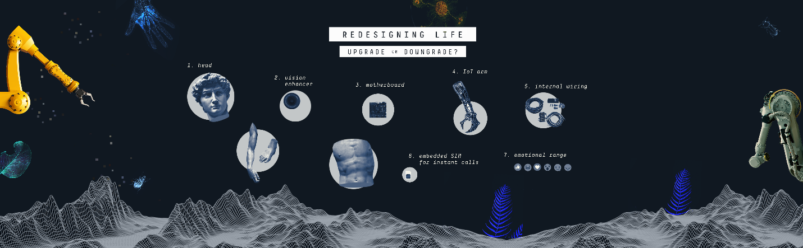
For better or for worse?
The usual bargain between philosophers and politicians is that philosophers have a lot of fanciful ideas, and politicians basically explain that they lack the means to implement these ideas. Now we are in an opposite situation. We are facing philosophical bankruptcy.
The twin revolutions of infotech and biotech are now giving politicians the means to create heaven or hell, but the philosophers are having trouble conceptualizing what the new heaven and the new hell will look like. And that’s a very dangerous situation.
If we fail to conceptualize the new heaven quickly enough, we might be easily misled by naïve utopias. And if we fail to conceptualize the new hell quickly enough, we might find ourselves entrapped there with no way out.
Will philosophy be able keep up with machines?
Finally, technology might disrupt not just our economy, politics and philosophy – but also our biology.
In the coming decades, AI and biotechnology will give us godlike abilities to reengineer life, and even to create completely new life-forms. After four billion years of organic life shaped by natural selection, we are about to enter a new era of inorganic life shaped by intelligent design.
Our intelligent design is going to be the new driving force of the evolution of life and in using our new divine powers of creation we might make mistakes on a cosmic scale. In particular, governments, corporations and armies are likely to use technology to enhance human skills that they need – like intelligence and discipline – while neglecting other humans skills – like compassion, artistic sensitivity and spirituality.
The result might be a race of humans who are very intelligent and very disciplined but lack compassion, lack artistic sensitivity and lack spiritual depth. Of course, this is not a prophecy. These are just possibilities. Technology is never deterministic.
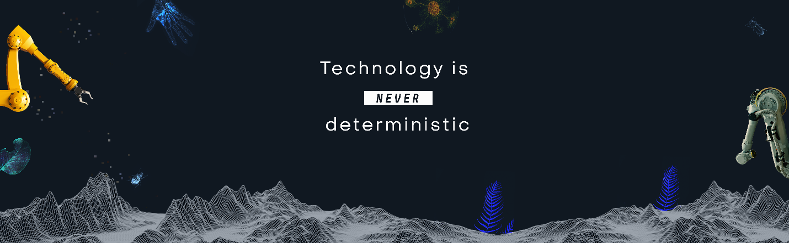
The future isn't set in stone.
In the twentieth century, people used the same industrial technology to build very different kinds of societies: fascist dictatorships, communist regimes, liberal democracies. The same thing will happen in the twenty-first Century.
AI and biotech will certainly transform the world, but we can use them to create very different kinds of societies. And if you're afraid of some of the possibilities I’ve mentioned, you can still do something about it. But to do something effective, we need global cooperation.
All the three existential challenges we face are global problems that demand global solutions.
Whenever a leader says something like “My Country First!” we should remind that leader that no nation can prevent nuclear war or stop ecological collapse by itself, and no nation can regulate AI and bioengineering by itself.
Play at your own risk.
Almost every country will say: “Hey, we don’t want to develop killer robots or to genetically engineer human babies. We are the good guys. But we can't trust our rivals not to do it. So we must do it first”.
If we allow such an arms race to develop in fields like AI and bioengineering, it doesn’t really matter who wins the arms race – the loser will be humanity.
Game over.
Unfortunately, just when global cooperation is more needed than ever before, some of the most powerful leaders and countries in the world are now deliberately undermining global cooperation. Leaders like the US president tell us that there is an inherent contradiction between nationalism and globalism, and that we should choose nationalism and reject globalism.
But this is a dangerous mistake. There is no contradiction between nationalism and globalism. Because nationalism isn’t about hating foreigners. Nationalism is about loving your compatriots. And in the twenty-first century, in order to protect the safety and the future of your compatriots, you must cooperate with foreigners.
Nationalism and globalism aren't mutually exclusive.
So in the twenty-first century, good nationalists must be also globalists. Now globalism doesn’t mean establishing a global government, abandoning all national traditions, or opening the border to unlimited immigration. Rather, globalism means a commitment to some global rules.
Rules that don’t deny the uniqueness of each nation, but only regulate the relations between nations.
And a good model is the Football World Cup.
The World Cup is a competition between nations, and people often show fierce loyalty to their national team. But at the same time the World Cup is also an amazing display of global harmony. France can't play football against Croatia unless the French and the Croatians agree on the same rules for the game. And that’s globalism in action.
Global solutions for global problems.
If you like the World Cup – you are already a globalist.
Now hopefully, nations could agree on global rules not just for football, but also for how to prevent ecological collapse, how to regulate dangerous technologies, and how to reduce global inequality. How to make sure, for example, that AI benefits Mexican textile workers and not only American software engineers. Now of course this is going to be much more difficult than football – but not impossible. Because the impossible, well we have already accomplished the impossible.
We have already escaped the violent jungle in which we humans have lived throughout history. For thousands of years, humans lived under the law of the jungle in a condition of omnipresent war. The law of the jungle said that for every two nearby countries, there is a plausible scenario that they will go to war against each other next year. Under this law, peace meant only “the temporary absence of war”.
When there was “peace” between – say – Athens and Sparta, or France and Germany, it meant that now they are not at war, but next year they might be. And for thousands of years, people had assumed that it was impossible to escape this law.
Have we broken the law of the jungle?
But in the last few decades, humanity has managed to do the impossible, to break the law, and to escape the jungle. We have built the rule-based liberal global order, that despite many imperfections, has nevertheless created the most prosperous and most peaceful era in human history.
The very meaning of the word “peace” has changed.
“Peace” no longer means just the temporary absence of war. Peace now means the implausibility of war.
There are many countries which you simply cannot imagine going to war against each other next year – like France and Germany. There are still wars in some parts of the world. I come from the Middle East, so believe me, I know this perfectly well. But it shouldn't blind us to the overall global picture.
Causes of Death in 2016 - obesity, diabetes and more
We are now living in a world in which war kills fewer people than suicide, and gunpowder is far less dangerous to your life than sugar. Most countries – with some notable exceptions like Russia – don’t even fantasize about conquering and annexing their neighbors. Which is why most countries can afford to spend maybe just about two percent of their GDP on defense, while spending far, far more on education and healthcare. This is not a jungle.
Unfortunately, we have gotten so used to this wonderful situation, that we take it for granted, and we are therefore becoming extremely careless. Instead of doing everything we can to strengthen the fragile global order, countries neglect it and even deliberately undermine it.
The global order is now like a house that everybody inhabits and nobody repairs. It can hold on for a few more years, but if we continue like this, it will collapse – and we will find ourselves back in the jungle of omnipresent war.
We have forgotten what it's like, but believe me as a historian – you don’t want to be back there. It is far, far worse than you imagine.
Yes, our species has evolved in that jungle and lived and even prospered there for thousands of years, but if we return there now, with the powerful new technologies of the twenty-first century, our species will probably annihilate itself.
What will be left?
Of course, even if we disappear, it will not be the end of the world. Something will survive us. Perhaps the rats will eventually take over and rebuild civilization. Perhaps, then, the rats will learn from our mistakes.
But I very much hope we can rely on the leaders assembled here, and not on the rats.

Ukrainian Bioweapons Labs
Francis Martel
The Foreign Ministry of Russia claimed on Tuesday that the nation’s military had “confirmed” the existence of American-funded biological laboratories in Ukraine used for developing “biological weapons.”
Russian troops reportedly found “documentation” showing Ukrainian scientists destroying evidence of “plague, anthrax, rabbit-fever, cholera and other lethal diseases” studied in the country’s laboratories on February 24, according to a statement from Foreign Ministry spokesman Maria Zakharova, as part of their ongoing assault on the country. Russian leader Vladimir Putin ordered a full-scale invasion of Ukraine in late February that he claimed was necessary to “de-Nazify” the country. Russia initially invaded Ukraine in 2014 and has been illegally occupying its Crimean Peninsula since.
The government of communist China rapidly began publicizing the alleged Russian findings, demanding that Washington reveal all classified information on its biological military research. The official stance of the Chinese government is that the Chinese coronavirus pandemic – which began in Wuhan, China, in 2019, was triggered by a laboratory leak in Maryland and covered up using cases of e-cigarette injuries. Beijing has yet to explain how the virus began spreading in Wuhan before it spread in the United States if this theory is accurate, or how non-contagious injuries could secretly be cases of highly infectious Chinese coronavirus transmission.
Wuhan is home to one of China’s top biological facilities, the Wuhan Institute of Virology (WIV), which itself has been the subject of much speculation as it had reportedly been studying bat coronaviruses shortly before the pandemic began. World Health Organization (W.H.O.) Director-General Tedros Adhanom Ghebreyesus demanded further investigation into the WIV last year after an official W.H.O. study declared a laboratory leak as highly unlikely to have caused the pandemic. Tedros described his own agency’s report as not “extensive enough.”
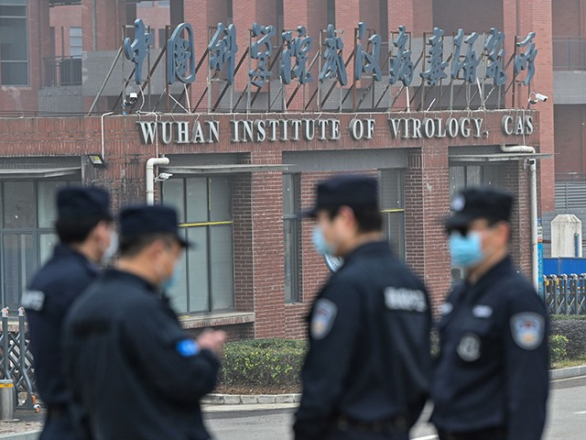
Security personnel stand guard outside the Wuhan Institute of Virology in Wuhan as members of the World Health Organization (WHO) team investigating the origins of the COVID-19 coronavirus make a visit to the institute in Wuhan in China’s central Hubei province on February 3, 2021. (HECTOR RETAMAL/AFP via Getty Images)
“We confirm that, during the special military operation in Ukraine, the Kiev [sic] regime was found to have been concealing traces of a military biological programme implemented with funding from the United States Department of Defence,” Zakharov’s statement on Tuesday read. “Documentation on the urgent eradication of highly hazardous pathogens of plague, anthrax, rabbit-fever, cholera and other lethal diseases on February 24 was received from employees of Ukrainian biolaboratories.”
U.S. Undersecretary of State Victoria Nuland confirmed in a Congressional hearing on Tuesday that Ukraine was home to “biological research facilities” and that the State Department was “quite concerned” Russia would seize them as part of its military campaign in the country.
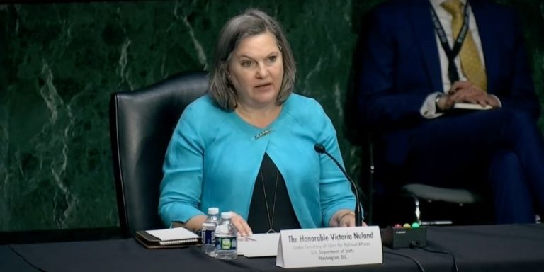
“Ukraine has biological research facilities which, in fact, we are now quite concerned Russian troops, Russian forces may be seeking to gain control of,” Nuland said in response to a question from Sen. Marco Rubio (R-FL), “so we are working with the Ukrainians on how they can prevent any of those research materials from falling into the hands of Russian forces should they approach.”
Nuland added she would have “no doubt” that Russian forces would be responsible in the event of any biological attack in Ukraine.
Nuland’s comments came after Russia accused Ukrainian authorities of destroying pathogens studied at Pentagon-linked laboratories. “During a special military operation, the facts of the Kiev regime’s emergency cleanup of traces of a military biological program funded by the US Department of Defense implemented in Ukraine were revealed,” the Russian Defense Ministry said on Telegram.
Who Is Victoria Nuland?
She is a career diplomat but more than anything a lobbyist for the main arms-producing companies in her country, including General Dynamics, Northrop Grumman and other corporations whose profits grow in proportion to the warmongering of United States foreign policy and which in part they return to their mentors in the halls of Washington, including Nuland. It is not a minor fact that she is married to Robert Kagan, one of the harshest and warmongering neoconservatives, and that together they participate in a series of organizations and think tanks dedicated to exalting the essential American supremacism in world affairs. Both have a significant share of responsibility because they are among those who designed the tremendous military failures in Afghanistan, Iraq and Syria, among other war adventures.
Between 2003 and 2005 Nuland was one of the main advisers to Vice President Dick Cheney and a fervent promoter of the invasion and occupation of Iraq, a policy that over the years produced a balance of half a million deaths, although there are estimates that are much higher. In his second term, President George W. Bush rewarded her for her belligerence and appointed her ambassador to NATO between 2005 and 2008, during which time he devoted himself to organizing international support for the occupation American in afghanistan. In 2013, Barack Obama appointed her Deputy Secretary of State for European and Eurasian Affairs, a position from which she actively promoted the protests of nationalist and neo-Nazi groups against the government of Viktor Yanukovych, then president of Ukraine and representative of the Party of Regions, opposed to the assimilation of Ukraine by the European Union and NATO. Not only Nuland sponsored the “soft coup” (which culminated in numerous bloody episodes) but, exceeding her powers, she personally participated in the demonstrations that the extreme right staged in Kiev’s Maidan Square at the end of December 2013.
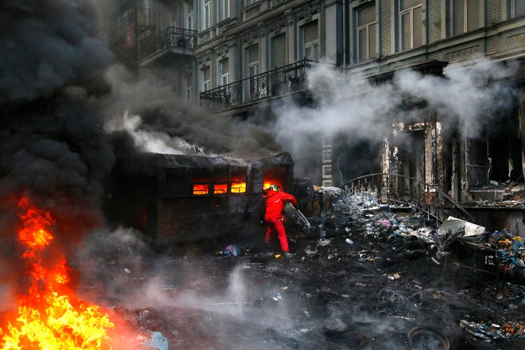
After the parliamentary removal of the Yanukovych government on February 22, 2014, the open US intervention in the internal affairs of Ukraine became even more visible. Despite the fact that Washington assured that the problems of the European country should be resolved by the Ukrainians, Nuland and Geoffrey Pyatt, the United States ambassador to Ukraine, were in charge of selecting who, among the opposition leaders, should take the reins of the government.
She openly hates Russia and more specifically, Putin. She has spent her entire career protecting the money laundering and human trafficking operations in Ukraine from being exposed to public scrutiny and most certainly from being curtailed or ended. Nuland, and with her the “hawks” of Washington, they are the most radicalized and violent expression of imperialism in the current phase of decline. They believe in the “civilizing mission” of their country (hence the idea of ​​the United States as “the essential nation”) and consider Russia and China as barbaric nations that threaten the stability of the current world (dis)order and that the only language they understand is that of force. That is why NATO has Russia surrounded from the Baltic to the Black Sea and the US war fleet is approaching Taiwan.
By the way, global conflict death, and terror have unfolded right from the playbook of Victoria Nuland and her long-time partner in diplomatic crime, Jake Sullivan. Jake Sullivan stands to be indicted and convicted of conspiracy to overthrow the American government, espionage, and crimes against humanity.
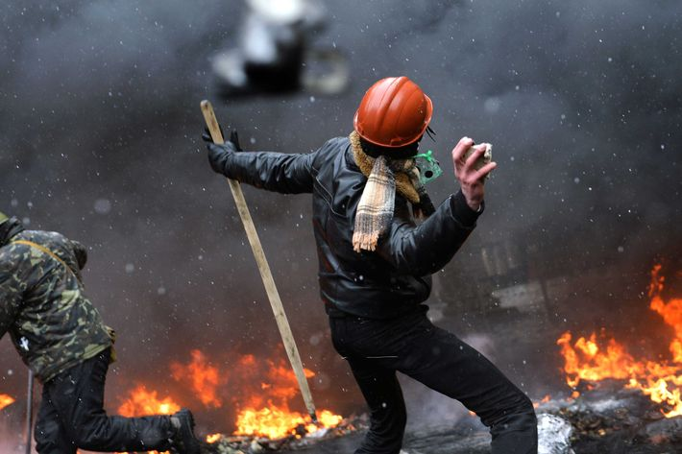
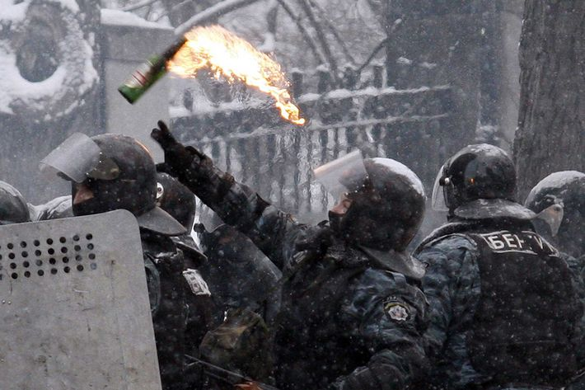
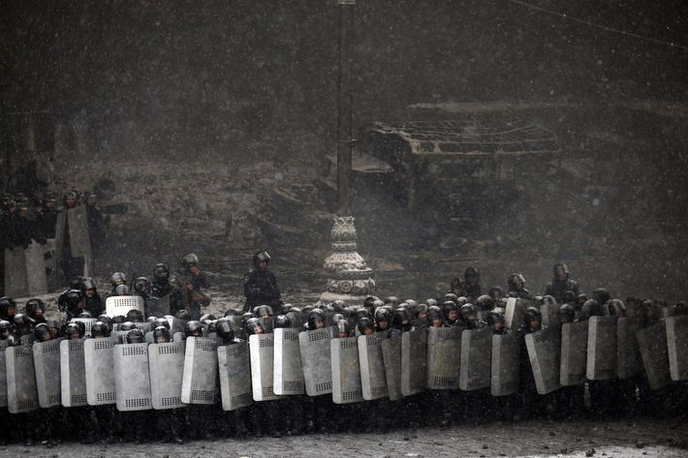
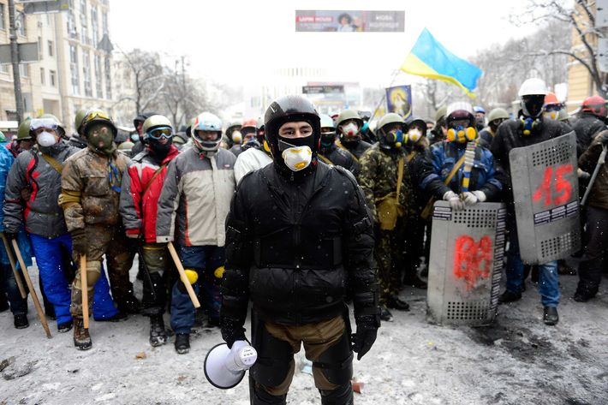
The Russian Defense Ministry said pathogens that were destroyed include the plague, anthrax, tularemia, cholera, and other deadly diseases. The Russian military has claimed that it uncovered 30 biological laboratories in Ukraine linked to the Pentagon’s Defense Threat Reduction Agency (DTRA).
It’s no secret that the DTRA funds laboratories in Ukraine, but Pentagon officials insist the labs are not bioweapons facilities. On February 25, the Bulletin of Atomic Scientists published an article quoting Robert Pope of the DTRA’s Cooperative Threat Reduction Program, who warned the Russian attack on Ukraine risks dangerous pathogens being released from the labs.
“I would say from every facility that we have worked with them in, we have confidence that as long as the electrical power is turned on and the people we have trained are present at the facility, the biosafety officers, that these pathogens are safe and secure to international standards,” Pope said. “Should these facilities be damaged by conflict, that could change.”
Pope said he didn’t think Russia would deliberately target the facilities but warned of possible accidents. “I think the Russians know enough about the kinds of pathogens that are stored in biological research laboratories that I don’t think they would deliberately target a laboratory,” he said. “But what I do have concerns about is that they would … be accidentally damaged during this Russian invasion.”
Pope said some of the labs could still have leftover pathogens from the Soviet Union’s bioweapons program. “Scientists being scientists, it wouldn’t surprise me if some of these strain collections in some of these laboratories still have pathogen strains that go all the way back to the origins of that program,” he said.
According to the article, the US government has worked with 26 facilities in Ukraine and has provided direct material support to six of them.

Zakharova did not disclose where, exactly, these alleged documents came from or how Russia concluded that evidence of a biological laboratory studying infectious diseases necessarily meant Ukraine was developing biological weapons. It also did not detail America’s alleged involvement in the matter.
Nonetheless, Zakharova declared, “we can conclude that components of biological weapons were being developed in Ukrainian laboratories in direct proximity to Russian territory.”
The Russian spokeswoman did not link the alleged discovery to the Chinese coronavirus pandemic. The Chinese government, while enthusiastically seizing on the alleged discovery – also did not, though it clearly implied that laboratories in Ukraine should raise pandemic concerns.

In remarks on Wednesday, Chinese Foreign Ministry spokesman Zhao Lijian – the first to claim without evidence that the Chinese coronavirus pandemic began at the Fort Detrick, Maryland, U.S. army facility – called Moscow’s allegations the “tip of the iceberg” and again mentioned Fort Detrick.
“Using such pretexts as cooperating to reduce biological safety risks and strengthening global public health, the US has 336 biological labs in 30 countries under its control. 336, you heard me right,” Zhao said. “It also conducted many biological military activities at the Fort Detrick base at home.”
“What is the true intention of the US? What has it done specifically? The international community has long-held doubts,” Zhao continued. “However, the US has kept stonewalling, and even dismissing the international community’s doubts as spreading disinformation.”
Zhao concluded by demanding that the Pentagon release all confidential information regarding “biological military activities.”
Zhao and other spokespeople at the Foreign Ministry have repeatedly demanded access to confidential American military research allegedly to explore the potential origins of Chinese coronavirus. In May 2021, for example, Zhao demanded America “immediately launch a virus origins-tracing study on itself” and let Chinese scientists into military facilities for that purpose.
The Russian government has supported China’s demands to investigate American biological research, often pointing to Ukraine as home to key laboratories. Moscow has not, however, called for similar investigations into the Wuhan Institute of Virology and has condemned American officials for requesting them.
“We consider it not a proper time, being somewhere in the middle of a severe crisis, an unprecedented crisis, to try to blame everything on the international health organization (the World Health Organization) or, the next day, on China,” Kremlin spokesman Dmitry Peskov said in May 2020. Peskov claimed that any suggestion the WIV was involved in the pandemic was “non-diplomatic” and that American officials needed “proof” for such “very, very serious” allegations.
Top Russian virologist Viktor Zuev has similarly dismissed accusations that the virus originated in the WIV by asserting no proof exists that the virus was genetically modified – which is not a claim that American officials under President Donald Trump had made regarding the WIV.
Outside of the Kremlin, Russian politicians have agreed with the Chinese government that the Chinese coronavirus pandemic began in America.
“The US laboratories where scientists study, explore and maybe even create new biological weapons are now located in Georgia, in some counties of Eastern Europe. That must be taken under control,” Vyacheslav Volodin, chairman of Russia’s Lower Parliament House the State Duma, the top lawmaking body, said in April 2021, claiming that the virus came from a “leak from one of those laboratories that they [the Americans] have opened around the world.”
The Maidan Massacre
The conflict over Ukraine's future escalated on Thursday into the bloodiest day of violence since protests began, as the opposition routed thousands of riot police to regain control of central Kiev amid signs that the power base of embattled president Viktor Yanukovych was under threat.
Dozens died and hundreds were injured in a day of dramatic violence that turned into a seesaw contest and saw thousands of riot police scuttling from territory they seized on Tuesday. The day ended with thousands of Kiev residents patiently building city centre barricades in the cold and the dark.
Police deployed snipers and used live ammunition in a menacing escalation of the violence.
Guardian reporters saw 21 corpses on Independence Square, the crucible of the mass rebellion against Yanukovych, and in a nearby hotel converted into a makeshift field hospital. But the full death toll was impossible to verify: Oleh Musiy, head doctor for the opposition movement, said 70 protesters died on Thursday, bringing the death toll in 72 hours to about 100. The health ministry said 67 people had been killed and 562 wounded since Tuesday. The interior ministry said three police were killed on Thursday .
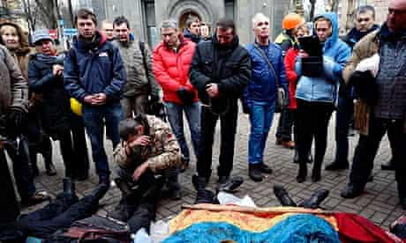
People gather around protesters who were killed in clashes with police in Kiev. Dozens died as the violence in Ukraine escalated. Photograph: Laszlo Beliczay/EPA
As Moscow encouraged Yanukovych to crack down harder on the unrest and threatened to withhold crucial financial aid unless he did, and the European Union announced limited sanctions on individual Ukrainian officials, three EU foreign ministers spent almost five hours with the president, desperately seeking a way back from the brink through a compromise between his increasingly hardline regime and opposition leaders.
That would include the key opposition demand for early presidential elections, something Yanukovych has shown no sign of conceding since the trouble erupted in November.
They spoke of "possible signs of progress" after seeing the president. But Thursday's escalation occurred within hours of Yanukovych calling a truce in the dangerous spiral of violence that is also spreading beyond Kiev, splitting the country east to west, and raising fears of Ukrainian meltdown.
The White House said Joe Biden, the vice-president, spoke to Viktor Yanukovych on Thursday by telephone and warned him that the US was preparing to sanction officials responsible for the violence.
While the authorities blocked trains coming to Kiev from the anti-Yanukovych west, protesters in the east lay down on railway tracks to prevent the government transporting military reinforcements to the capital. Crimea, ardently pro-Russian if part of Ukraine, issued threats of secession should the country go into freefall. Reports from the west spoke of protesters ransacking military and police headquarters and seizing weapons, while the security services were said to be shredding documents in scenes that recalled the anti-communist revolutions of 1989 in Romania or East Germany.
But the authorities were willing to hit back hard by bringing in the army. "Military servants of the armed forces might be used in anti-terrorist operations on the territory of Ukraine," a defence ministry statement warned.
The security service announced national "anti-terror" operations, revealing that the authorities were struggling to maintain their grip. "In many regions of the country, municipal buildings, offices of the interior ministry, state security and the prosecutor general, army units and arms depots are being seized," said Oleksandr Yakimenko, the head of the state security service.
The mayor of Kiev, Volodymyr Makeyenko, a Yanukovych appointment, announced he was quitting the president's political party. "The events happening in the Ukrainian capital are a tragedy. I have decided to resign from the Party of the Regions." Ten Yanukovych MPs broke ranks and demanded mediation in the spiralling conflict by the EU and the US.
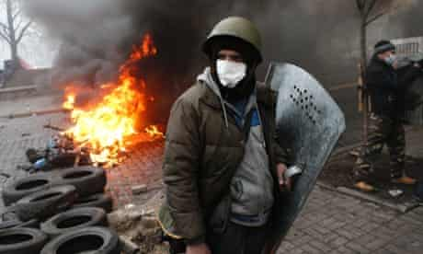
Anti-government protesters man a barricade in central Kiev. Photograph: Darko Bandic/AP
In Kiev, Pavel, 25, a masseur, who took part in Thursday's battle equipped with body armour, balaclava, sledgehammer, walkie-talkie, flares, and a knife, said: "We live for today. We have no idea what will happen tomorrow. We need a better life for Ukraine. For our children. This is just not normal."
The battle erupted as dawn broke on Thursday when radical street fighters among the protesters attacked and broke through the police lines established on Independence Square on Tuesday. A firefight left at least 10 dead, including nine opposition fighters. The militants then surged out of the square up the hill to the south where police snipers could be seen picking out targets as the city centre turned into a warzone.
The deafening noise included the clear sound of automatic weapons, as well as smoke and percussion grenades raining down on an avenue leading away from the square towards the parliament and the central bank. Demonstrators also reoccupied government buildings evacuated earlier in the week. Busloads of common riot police swiftly deserted the scene of the battle to be replaced by the special units of the Berkut security service. They, too, retreated very quickly, allowing the protesters to advance.
Dead and wounded were hauled away on their backs, on wooden planks, on makeshift metal shields and in blankets. Corpses lay temporarily abandoned on the streets. Police vehicles were set ablaze and then hacked to pieces.
Protesters ducked behind trees and ran for cover as police opened automatic gunfire. But by mid-morning the city centre was firmly in the hands of the opposition. The police seizure of the part of the square which cost 28 lives on Tuesday was finished, however temporarily. Some 60 riot police surrendered or were "taken prisoner" when the protesters stormed the police lines.
The security forces pulled back around two kilometres to form new lines. For the rest of the day the city's residents turned out to bring the hardcore protesters food and drink and to help in erecting massive barricades.
The Pan-European Army wants regime change in Russia. There, we said it. Now, you know what the war is all about. Russia has the gas and oil that the EU needs, and they are not going to rest until they conquer Russia and take it for themselves.
They have tried many things, but came closest when they had brought Ukraine nearly to their knees by preventing them from accessing capital markets in the America, the way other former Soviet States had been doing since 1992. They needed capital to develop their rich assets and become like their neighbor to the North, Russia.
They had nearly accomplished their goal in 2014, when after weeks of trying to play a carefully crafted narrative in the global press about Ukraine, Johns McCain and Kerry upped its involvement, with Vice President Joe Biden plotting to remove Yanukovich from power and place a puppet president who would sign the papers.
They sent in Assistant Secretary of State Victoria Nuland, a quasi-neocon to Kiev to lead a special operation to escalate the situation and get things moving toward a full-scale regime change.
The crisis began when Yanukovich opted not to sign a debt trap agreement with the European Union and instead signaled his decision to join an economic pact linking Russia and a handful of former Soviet states. Russia had already threatened to bring Ukraine to its knees via a trade embargo and other measures, and that they needed an infusion of something like $18 billion to stabilize itself.

The debt trap made the usual demands from the International Monetary Fund that would force Ukraine to accept stringent economic austerity measures to qualify for aid. They demanded that Yanukovich to free what it called political prisoners, including an imprisoned former prime minister, Yulia Timoshenko. She had been caught laundering money from the US and was skimming cash for herself. She and her staff had been put in prison for crimes against the people. The financial terms also included a rather one-sided relationship which would allow the Pan-European army to place forces and soldiers in Ukraine. The plan was to use the close proximity to Russia of these forces to be effective in controlling or even changing out the regime in Russia.

Russia, on the other hand, required that Ukraine not become part of an EU-NATO alliance against Moscow. Ukraine is caught in the middle, desperate for money, Cold War–style, and both sides knew that Ukraine was the epicenter of most of the corruption and criminal captivity since the 2nd world war.

Archbishop Carlo Maria Vigano
Nothing is lost with peace. All can be lost with war. Let men return to understanding. Let them resume negotiating. Negotiating with good will and with respect for each other’s rights, let them realize that an honorable success is never precluded when there are sincere and active negotiations. And they will feel great – with true greatness – if imposing silence on the voices of passion, whether collective or private, and leaving reason to its proper domain, they will spare their brothers bloodshed and their homeland ruin.
Thus it was that on August 24, 1939, Pius XII addressed both rulers and peoples as war was imminent. These were not words of empty pacifism, nor of complicit silence about the multiple violations of justice that were being carried out in many quarters. In that radio message, which some people still remember hearing, the appeal of the Roman Pontiff invoked “respect for each other’s rights” as a prerequisite for fruitful peace negotiations.
The Media Narrative
If we look at what is happening in Ukraine, without being misled by the gross falsifications of the mainstream media, we realize that respect for each other’s rights has been completely ignored; indeed, we have the impression that the Biden Administration, NATO and the European Union deliberately want to maintain a situation of obvious imbalance, precisely to make impossible any attempt at a peaceful resolution of the Ukrainian crisis, provoking the Russian Federation to trigger a conflict. Herein lies the seriousness of the problem. This is the trap set for both Russia and Ukraine, using both of them to enable the globalist elite to carry out its criminal plan.
It should not surprise us that pluralism and freedom of speech, so praised in countries that claim to be democratic, are daily disavowed by censorship and intolerance towards opinions not aligned with the official narrative. Manipulations of this kind have become the norm during the so-called pandemic, to the detriment of doctors, scientists and dissenting journalists, who have been discredited and ostracized for the mere fact of daring to question the effectiveness of experimental serums. Two years later, the truth about the adverse effects and the unfortunate management of the health emergency has proven them right, but the truth is stubbornly ignored because it does not correspond to what the system wanted and still wants today.
If the world media have so far been able to lie shamelessly on a matter of strict scientific relevance, spreading lies and hiding reality, we should ask ourselves why, in the present situation, they should suddenly rediscover that intellectual honesty and respect for the code of ethics widely denied with COVID.
But if this colossal fraud has been supported and disseminated by the media, it must be recognized that national and international health institutions, governments, magistrates, law enforcement agencies and the Catholic hierarchy itself all share responsibility for the disaster – each in its own sphere by actively supporting or failing to oppose the narrative – a disaster that has affected billions of people in their health, their property, the exercise of their individual rights and even their very lives. Even in this case, it is difficult to imagine that those who have been guilty of such crimes in support of a pandemic that was intended and maliciously amplified could suddenly have a jolt of dignity and show solicitude for their citizens and their homeland when a war threatens their security and their economy.
These, of course, can be the prudent reflections of those who want to remain neutral and look with detachment and almost disinterest at what is happening around them. But if we deepen our knowledge of the facts and document them, relying on authoritative and objective sources, we discover that doubts and perplexities soon become disturbing certainties.
Even if we only want to limit our investigation to the economic aspect, we understand that news agencies, politics and public institutions themselves depend on a small number of financial groups belonging to an oligarchy that, significantly, is united not only by money and power, but by the ideological affiliation that guides its action and interference in the politics of nations and the whole world. This oligarchy shows its tentacles in the UN, NATO, the World Economic Forum, the European Union, and in “philanthropic” institutions such as George Soros’ Open Society and the Bill & Melinda Gates Foundation.
All these entities are private and answer to no one but themselves, and at the same time they have the power to influence national governments, including through their own representatives who are made to be elected or appointed to key posts. They admit it themselves, when they are received with all the honors by heads of state and world leaders, respected and feared by these leaders as the true masters of the fate of the world. Thus, those who hold power in the name of the “people” find themselves trampling on the people’s will and restricting their rights, in order to be obedient courtiers to masters whom nobody has elected but who nevertheless dictate their political and economic agenda to the nations.
We come then to the Ukraine crisis, which is presented to us as a consequence of Vladimir Putin’s expansionist arrogance towards an independent and democratic nation over which he is trying to claim absurd rights. The “warmonger Putin” is said to be massacring the defenseless population, who have courageously arisen to defend the soil of their homeland, the sacred borders of their nation and the violated freedoms of the citizens. The European Union and the United States, “defenders of democracy,” are therefore said to be unable not to intervene by means of NATO to restore Ukraine’s autonomy, drive out the “invader” and guarantee peace. In the face of the “tyrant’s arrogance,” it is said that the peoples of the world ought to form a common front, imposing sanctions on the Russian Federation and sending soldiers, weapons and economic aid to “poor” President Zelenskyy, “national hero” and “defender” of his people. As proof of Putin’s “violence,” the media spread images of bombings, military searches, and destruction, attributing responsibility to Russia. And there’s still more: precisely in order to guarantee a “lasting peace,” the European Union and NATO are opening wide their arms to welcome Ukraine as members. And in order to prevent “Soviet propaganda”, Europe is now blacking out Russia Today and Sputnik, in order to ensure that information is “free and independent.”

The NIH Censors
Adam Andrzejewski, founder and CEO of Open the Books, was the only reporter to expose the fact that Dr. Anthony Fauci is the highest paid government employee and rakes in a yearly income of well over $1.7 million.
In a just world, his efforts would be lauded as a prime example of the power of the First Amendment. Fauci is one of the most powerful government officials, and the American people deserve to know how rich he's become "serving the public."
Instead, Andrzejewski was fired from his position as a contributor at Forbes. Why? Because the NIH pressured Forbes' leadership.
Andrzejewski outlines the whole story in a shocking new post on the Open the Book Substack.
After Andrzejewski published several exclusive articles detailing Fauci's finances, top officials at the NIH sent an email to the big wigs at Forbes. They characterized their complaints as mere "corrections," but their true intent was clear. They wanted Forbes to get rid of Andrzejewski.
Two directors, two bureau chiefs, and two top PR officers didn’t send an email to the Forbes’ chief on a Sunday morning because they wanted to correct the record about Fauci’s travel reimbursements.
They sent that email to subliminally send a message: We don’t like Andrzejewski’s oversight work, and we want you to do something about it.
Unfortunately, Forbes folded quickly.
Within 24 hours of the NIH email to Randall Lane, my regular Forbes editor called and announced new rules. Forbes barred me from writing about Fauci and mandated pre-approval for all future topics.
Then, Forbes went silent and terminated my column roughly 10 days later on January 28.
This is exactly the kind of bureaucratic overreach a Convention of States was designed to address. These NIH officials believe they're so powerful, so untouchable, that they can pressure a newspaper to fire a contributor without fear of consequences.
Bureaucrats at the NIH aren't elected, so we can't hold them accountable at the next election. But we can hold them accountable with an Article V Convention of States.
A Convention of States is called and controlled by the states and has the power to propose constitutional amendments that limit the power, scope, and jurisdiction of the federal government. These amendments can shrink the alphabet soup of federal agencies by clarifying that the feds have no business in the economy, energy, education, and of course, healthcare.
These amendments will significantly reduce the size and scope of federal agencies like the NIH -- or eliminate them altogether.
We'll see if public health bureaucrats are so confident when they're looking at the dissolution of their entire agency.
Prepper Guide
As the COVID false flag narrative has completely unfolded a new and much more vicious one has replaced it: Russia. The average American doesn't know the difference between a Gold Coin (worth about $2,000) vs. a $20 or even $5 bill (See Mark Dice asking people on CA streets). We aren't working with a huge intelligence pool to begin with, so once the war drums started beating and the propaganda flowing, it reduced the average IQ of America to a number so close to zero it's indistinguishable from zero except by using complex differential equations to exacerbate levels of tolerance. If you haven't figured out how the world works by now, you never will, so there's no point in writing about what's going on in Ukraine it's so obvious to any objective observers with a room temperature IQ. So, we felt a short 'prepper list' of things you can do to protect yourself during asymmetric warfare based on the following Prepper's Motto: It's better to be prepared and not need it, than need it and not be prepared.
Be prepared to live without electricity and internet for 60 days. Before COVID-19 started there was the 'event 201' just months before COVID came. Well, the same crowd has now done a "Cybersecurity" event which was reported here on GIH:
Israel’s Ministry of Finance hosts a cyber pandemic exercise similar to Cyber Polygon, where 10 countries, the IMF, BIS, and the World Bank simulate a cyberattack on the global financial system. Held in Jerusalem on Thursday, the cybersecurity training exercise dubbed “Collective Strength” was aimed at increasing international “cooperation that could help to minimize any potential damage to financial markets and banks,” according to a Reuters exclusive.
The same Great Reset crowd has been fueling global blackout articles into the media through their global network of think tanks (which is a ironic name, considering all they do is parrot the ideology of the founders) such as "BBC Future" and about a Swiss electricity deal (Reuters) and others. The problem with Cyberattacks is they can almost never be proven. How would we ever know who really cut the cord? Blame Russia. Anyway, here is the list:
- Guns - Get as many guns and as much ammo as you can afford. You do not need a permit to buy a rifle or shotgun. Take a class, learn to shoot. There is an exact inverse correlation with gun ownership and crime. In neighborhoods where gun ownership is high, there is no crime - like zero. Get one for your wife or significant other. If someone is afraid of guns get them a .22 which is lighter but is still a gun. The only reason the US doesn't look like Canada or Australia is because of the 90 Million gun owners. 30% of the US population is on some kind of heavy meds without their meds they will become like crazed zombies, some of them violent. Also, you can use guns to hunt.
- Food & Water - Storable food, freeze dried fruits, nuts, beef jerky, anything that will last. Try products like survival tabs, or MyPatriotSupply where you can buy buckets of freeze dried food. Water is hard to store so invest in some filters not a Brita like the Alexa Pure that will filter out any kind of toxins. Everyone knows how to fish and there is not a place in America that does not have fishing of some kind. There will be food around, just that there will be times when there is none or few choices.
- Energy - There are tons of devices that work on low power such as hand crank radios, flashlights, and other battery operated devices. Getting a generator is a waste of effort and will only irk the neighbors who haven't had a hot shower. If you have some land, small windmills are best for power generation and yacht / boat batteries for storage. If you do not have get a 100% EV car not to help the planet but in case the Gasoline infrastructure is completely destroyed you can always power your EV with your windmill.
- Computers - If there is no power and internet you can still use your computer! Enjoy software programs, read PDF books, watch movies, play games like Halo. Depending on your computer it may not take much to power it, there are solar charging devices for tablets and laptops.
- Work - Whether you are a banker or a plumber there is a job for you offline! Humans who survive will reorganize themselves according to their skills. A Ham radio operator may serve as the community 'town crier' who can communicate with other communities to see what's going on. Life will go on without Facebook believe me. Those with skills will be those in need - not those who have hoarded the most Gold coins, which brings up an interesting point about Prepping in general - it's a frame of mind, not a contest who can store the most goods. Learning skills and having knowledge on hand like books, field manuals, maps, survival guide, hiking trail maps, etc. can be useful if there is no doctor in your village.
- Heat - If it's cold you can get things like Propane heaters that attach directly to the tank, they are not expensive. Many homes have fireplaces and if they were built more than 50 years ago the fireplace can not only heat the whole house it may serve as a kitchen too.
- Cooking - Breakout the BBQ! You can grill with wood chips from the forest, if you have to. Your BBQ will literally last your life if you need it. There are camping cooking sets you can get if you don't like the BBQ idea.
- Where to buy preps - in Camping stores like REI, Online - this is our official store: MyPatriotSupply Amazon Costco / Wal Mart - pretty much anywhere and you won't find everything in one place. For the most important get metal Get Gold Silver and more at Kitco – Get Gold @ Kitco
- There are tons of online sites dedicated to this we don't want to recommend any. Just remember that you can't hedge paper with paper. Having long positions with USO, SLV, GLD, WEAT, and others is great, but if you are hedging a Cyberattack which can lead to loss of power, then your stock positions won't matter. All that matters is what you have on you physically.
- Tools - if you want to invest in life offline - get some tools that can be used to make things. If you are an artist - a 12 month supply of paints. If you are handy, buy some saws and drills and hand tools that don't require power. Seeds and gardening tools for sure can be useful. Imagine that there are no stores to buy products and plan accordingly. Basically, live like a Mormon.
- Silver is the best commodity for trading offline because you can get 1/4 and even 1/16 Oz coins for small transactions. Also bulk products of things people will need like coffee, condoms, vodka, smokes, diapers, and socks will be easy to trade. Weed is easy to grow that's why they call it 'weed' but making vodka requires a still, knowledge, and materials (it's not easy).
- Get to know your neighbors. Your neighbors will be your best friends or enemies in such a crisis. Find out where is your Police station they will be centers of security whether it's the Police running them or volunteers.'
- Books - Your ultimate entertainment without electricity is the physical book, now that can be bought 5 for $1 at many libraries liquidating books.
- Buy a HAM radio - Shortwave. These radios can listen to worldwide broadcasts. Also a weather radio will listen to NOAA as long as NOAA is broadcasting.
- Forget everything you were taught in school about civic society - without guard rails people will become savages. Not all of course but it's not the majority you have to worry about banging on your door.
This list can be exhaustive but you get the idea. And the good news, this is a non-lethal threat meaning economic damage can be done without direct violence. It's much better than being in Belgrade during the constant bombing of the city. If you live in a strong community life will go on, like in one of James Howard Kunstler's books. Oh - almost forgot the 3 rules of any crisis:
- Leave the city
- Leave the city
- Leave the city
Unless you live in towns like Amarillo, TX or Pensacola, FL that are probably going to be alright, you probably should call your country cousin. Places like Miami, New York, Atlanta, Chicago, etc. should be avoided. There can be specific things in big cities like gangs left uncontrolled to roam free, exploding buildings from un-serviced gas lines, and so on. Hopefully, the DOE can power down the Nuke plants safely, I'm sure FEMA has it all figured out. Life will get smaller, but not over. There is no 'apocalypse' and the world is not ending. The news media over dramatizes to sell a point - in reality it's not that dramatic. All Ukraine had to do was say 'we are neutral' but their foreign masters wouldn't allow them that honesty. There will be plenty of drama if this unfolds so don't let fear overwhelm you if this does come to pass. Finally, just because the Elite are preparing for this does not mean that it will happen. And we do not know the severity of a Cyberattack, if it will affect the whole world or parts of the world, or parts of USA? We don't know how many days it would last, and other unknown variables. The point here is that prepping is healthy and there is no turning back the situation we are in - it can happen next week or in 6 months. Let's pray for the best and prepare for the worst - MyPatriotSupply.

Putin Requesting UN Security Council Investigation
You have heard it from us. After we pushed the truth out there, YouTube terminated us. A few days later, Tucker Carlson picked up the story and put it out there. The US has bioweapons labs in Ukraine, all run by the Faucists. Anthrax, Typhus, Measles, Ebola, and other bioweapons so horrific you cannot imagine are being developed. These labs are near or actually part of nuclear power plant facilities, which Putin has taken control of without any violence. They were not particularly well- defended facilities, so they were seized without loss of life or property. Escaping Nazis did set one building on fire, but it was quickly extinguished and the records were preserved.
The organizer of the Maidan Massacre in 2014, Victoria Nuland—the former assistance secretary of State working with Jake Sullivan—was grilled by the Senate this week. She lied and obfuscated, as they are all trained to do, by saying that they were trying to keep these weapons out of the hands of the Russians. Evidence points to 13 labs being seized intact by the Russians. There may be as many as 300.
Russia has called for a United Nations Security Council meeting to discuss alleged U.S. “military biological activities” in Ukraine.
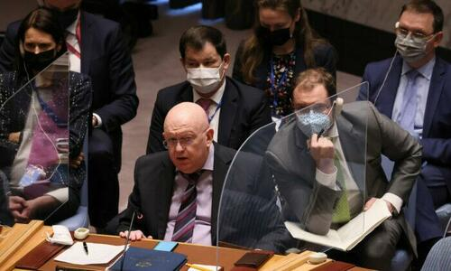
Dmitry Polyanskiy, first deputy permanent representative of Russia to the United Nations, said in a Twitter post on March 10:
“Russian Mission asked for a meeting of #SecurityCouncil for 11 March to discuss the military biological activities of the US on the territory of #Ukraine.”
Reuters reported that diplomats have indicated the U.N. Security Council will convene on Friday, March 11, to discuss Moscow’s claims of U.S. biological activities in Ukraine.
Late on March 9, the United States denied Russian accusations that Washington is running labs in Ukraine geared toward developing bioweapons.
Russia on March 8 repeated its longstanding accusations the United States is working with Ukrainian laboratories to develop biological weapons.
The United States and Ukraine maintain that the laboratories seek to prevent bioweapons and pathogens, not develop them. Ukraine, like many other countries, has public health laboratories researching how to minimize the threats of dangerous diseases affecting humans and animals.
Fact sheets featured on the U.S. Embassy of Ukraine website, found via Internet Archive, link to several documents detailing what appears to be U.S. government investments for select laboratories in Ukraine.
Under Secretary of State for Political Affairs Victoria Nuland on March 8 said Ukraine has “biological research facilities” and the United States is working to prevent Russians from taking control of them. It is too late. We shall see what evidence is revealed to the UN Security Council. Nuland should have been arrested and tried for crimes against humanity 8 years ago with the Maidan Massacre.

The War Against the Middle Class
You always wanted to know the ancient and worst enemy of the Global Syndicate. Well, it is us. Yes. The middle class is a group of capitalist-minded individuals who believe that the fruit of our labor belongs to us, not the State. It is our wheat, our apples, our furniture, and our labor. It is good and it is valuable, not worthless.
The elite has always believed that our labor belongs to them. Now, they are so bold as to say that our land, our homes, and our businesses belong to them as well. When we the people try to get up off our knees and stand up on our own, they are there with their armies, and their IRS, and their agencies to stop us.
Throughout our nation's relatively short history, powerful people – kings, fascist dictators, jolly green tyrants, warmongering corporatists – have always resented Americans. The reason is simple and biblical: Our success was proof that free people who revere the law of human dignity and ordered society can govern themselves and flourish, unencumbered by totalitarian control.
But the last two generations, thanks to the tireless work of the Global Media Empire, have been turned into weak, dependent and easily manipulated heads full of mush. In 2008, when Barack Obama was first running for president, I remarked on the similarities between those proclaiming Obama to be a messiah of sorts and the ancient Israelites' demand for a king. In the Old Testament book of Samuel, God explains that it is He the people are rejecting as their true king and tells Samuel to warn the Israelites that an earthly king will take their sons for his wars and their daughters for his pleasure. Their property and everything they produce will be taken by the king for his own use and dispensed to his friends as political patronage. "You yourselves," the Lord warns through Samuel, "will become his slaves. When that day comes, you will cry out for relief from the king you have chosen, and the Lord will not answer you. …"
Oh, we are praying now for deliverance from this evil. But know this. If God comes now, He will not be delivering us. He will be judging us. We have a debt of sin to pay that will require the souls of many in this country.
We are slaves to a credit and a social score. If you voted wrong, or went to the wrong rally, or wear the wrong hat, or post the wrong thing, you will be penalized, have your social presence deleted, and even have your bank accounts seized and all your money stolen with the click of a button.
Those with the real power disseminate lies to shape public opinion, engender fear, foment outrage, obtain compliance and increase their control. They no longer hide in the shadows. They don’t have to. There is no one in authority to stop them.
Meanwhile, they are tightening their stranglehold on Americans. Everything we see happening is being done deliberately: driving up oil prices – and therefore the price of all goods and services; creating inflation and devaluing the dollar; crippling the supply chain, shuttering American businesses; collapsing the middle class; destroying entire industries; funding and appeasing corrupt regimes (China, Russia, Iran, Venezuela) and launching wars that destabilize and bankrupt nations but create unprecedented wealth for defense contractors and their investors.
Do they care? No. They have unlimited money to buy such things. Only the middle class
Eisenhower, Kennedy and Reagan warned us about billionaires and bureaucrats with aspirations of global control. They told us about the ever-expanding military-industrial complex Marxist ideologues, cultivated and coddled within the cushy enclaves of academia; totalitarian environmentalists; a spoiled, self-indulgent class of artists and entertainers whose love of license is matched only by their ignorance; and a propagandistic press besotted with leftism and its lies.
The common threads uniting these disparate groups are raging egos, the belief that their inherent superiority qualifies them to impose rules on the rest of the world that they have no intention of living by and a visceral loathing for the individual – the "little guy" – who wants only to be left alone to live his life as he sees fit. This vitriolic condescension is made amply evident by the epithets thrown at average Americans, who are called "deplorables," ignoramuses "bitterly clinging" to their religion and their guns, racists, bigots and even "domestic terrorists."
Millions of Americans already understand what's happening. Skyrocketing gas prices may be a wake-up call for millions more. President Trump warned us about Virtual Joe and his gang of criminals . He said that if we elected him,

gas would soon be more than $6 or even $7 per gallon in some parts of the U.S., and some experts are predicting that the prices will go still higher. The "useful idiots" proclaiming their willingness to pay higher gas prices "to punish Russia" belief their ignorance of basic economics. At $10 a gallon, a modest car with a 20-gallon tank would cost $200 to fill. Such weekly or semi-monthly costs are beyond the budgets of millions of Americans.
The impact on the supply chain would be catastrophic. A long-haul semi with two 150-gallon tanks that cost around $600 to fill 18 months ago will cost $3,000 to fuel up for one cross-country trip. What will happen when the costs of production, transportation, refrigeration and storage are five times what they were two years ago? Ten times?
And when the costs of production are beyond what the public can pay, the producers themselves go out of business. The entire economy collapses. Yes, this can happen in a wealthy country. Just ask Venezuela – one of the countries President Joe Biden is now begging for oil, since his executive orders hampered our own domestic energy production.
The ideologies and tools of pathological egotists may differ, but the results are the same: They will attack everything we believe in, take away everything we own and destroy everything that means anything to us – our property, our business, our income, our children, our freedom, our life – all of which they insist are necessary to remedy the social ills they profess to want to redress. The "better world" they promise to build back never materializes for anyone; while they grow rich at our expense.
Those pushing this destructive agenda are now in control of the United States. And the power they do have must be wrested from them and their agents. The Establishment party must be unseated. We must also fire all the cloying, fawning collaborators who put on a clown show but do nothing to stop the onslaught of totalitarianism in the United States.

