Jihad Report
Mar 04, 2017 -
Mar 10, 2017
Attacks | 30
Killed | 309
Injured | 228
Suicide Blasts | 3
Countries | 12
The Fed May Crash the World to Stop Trump
Trump might want to put a call in to Janet Yellen.
The Fed is supposed to be a neutral, independent entity. However, that myth went out the window when Bernanke “gifted” QE 3 to Obama in 2012 to aid with the latter’s re-election bid.
The Yellen Fed seems to be even more committed to defining the Fed as nothing more than a leftist establishment mechanism. Back in October when it still looked like Hillary Clinton would win the 2016 Presidential election, Yellen commented that she was considering letting the economy run “hot” meaning allowing inflation to rise without implementing additional rate hikes.
One month later, Donald Trump won the Presidency and Yellen announced she wanted to hike rates in December with three more additional hikes in 2017.
Now, 3Q16 growth was supposedly 3.5%. If that had been true, then Yes, the Fed should consider hiking.
However, since that time GDP growth has collapsed. 4Q16 growth came in at a measly 1.9%. And 1Q17 GDP growth has collapsed from a forecast of 3% in early February to 1.2% today!
And Yellen is still pushing to hike rates.
So, back in October, when the economy was supposedly growing at an annualized rate of 3.5% Yellen wanted to let the economy run “hot.” And now that the economy is growing 2% rate (and soon to be sub-1% rate based on projections) she wants to hike rates multiple times.
Let that sink in for a moment.
It is very difficult to look at the above and not come to the conclusion that Janet Yellen is actively trying to thwart the Trump Presidency. For 8 years under Obama she signed off on maintaining interest rates at zero, permitting the debt to double.
Now that Trump is in office, Yellen wants to hike rates four times in 12 months. And she’s begun worrying about debt levels in her speeches.
Seriously?
The wise thing for Trump would be to ask for Yellen’s resignation. She has completely compromised any last credibility the Fed might have. And she’s now actively pushing to hurt the economy by hiking rates at a time when growth is already rapidly slowing.
The Agency Wars
The Agency Government has never supported governments that put the interests of their peoples ahead of the interests of those who really rule the US. From Africa to South America to Indonesia to Cuba to Vietnam to Iran to Egypt, The Agency Government has always misrepresented the forces for change as communist. The Agency Government overthrew the first democratically elected government in Iran http://www.history.com/this-day-in-history/cia-assisted-coup-overthrows-government-of-iran , the first in the Congo https://www.theguardian.com/global-development/poverty-matters/2011/jan/17/patrice-lumumba-50th-anniversary-assassination , the first in Egypt http://www.timesofisrael.com/announced-as-president-of-egypt/ , and a large number of others. Read Stephen Kinzer’s The Brothers. Read General Smedley Butler who said that he and the US Marines made South America safe for the United Fruit Company and investments of the New York Banks. Read John Perkins, Confessions of an Economic Hit Man.
The Agency Government opposes democratic change with an iron fist, because a mob is unpredictable, when they are given too many choices. The entire purpose of using regulations that have the force and penalties of law is to limit the number of choices in the maze for the rats they bleed for money and power. Now Marine Le Pen, the favored candidate for the presidency of France in the upcoming election, is in the process of being destroyed by The Agency Government, because like Donald Trump she is attracting tens of thousands to her rallies by talking about France, and the French people, and the heritage and history of France. She rightly says that when thousands of young men flood the streets waving foreign banners, it is an invasion, not immigration. The Agency Government wants the borders of France to be blurred into the Atlantic and the Alps and the flatlands of the Netherlands. They want a single population with no identity, so they can control the choices of the country that never was.
Marine is not on The Agency Government’s approved list. She was not groomed like 12 of the 17 Republican candidates for president in 2016. She did not go to the classes, or agree to be compromised to the collar and the clip to the leash in Brussels. She speaks to French interests, not to The Agency Government’s or the EU’s. She opposes the Trans-Atlantic Partnership, which gives global, trillion-dollar corporations immunity to French laws against GMOs, and French labor, safety, and environmental standards. She supports French opinion that the French are French and not “European” and wants out of the European Union. She wants France out of NATO, which uses France as a financial and military tool for UN aggression against other countries who will not bow to the lash.
The Agency Government first attacked Marine via its surrogates in the French press and government, who managed to nullify her parliamentary immunity. Sounds familiar, doesn’t it? Without the mantra of Russian hacking to generate fake crowds at her massive rallies, she is now accused of “misuse of EU funds.”
The charge, of course, is a hoax, repeated over and over again in a propagandic chant by the fake stream news like CNN. The charge, if it proves effective, will rely on the global corporate media’s portrayal of Marine as a “fascist” for representing French nationalism. Talk about an oxymoron. Today, if a European person is loyal to his or her own country and not to the EU, the person is considered to be a “nationalist,” a term that has been merged with “fascist.” The uneducated will grab up the pre-printed propaganda signs and smear blood on the faces and march and scream and burn and vandalize. The consequence is that anyone in France who wants to represent the French is attacked a “fascist.” The media has adapted to a new universal methodology. They not only attack the candidate; they also attack the voter who considers the candidate. The Agency Government doesn’t care about those votes, because they control the counting of the votes. If they say the polls show their glove puppet in the lead, then they are in the lead.
Marine Le Pen lost her parliamentary immunity because she posted photos of ISIS victims who were beaten, raped, drowned, beheaded, and burned alive in cages in full view of the public on Twitter. Like the crucifixes of the Romans lining the roads entering Jerusalem reminded pilgrims to keep their heads down and obey the law, the public display of brutality is designed to spread their religion of death and oppression of women. The photos she posted were accurate and correct. They were as true as showing the pictures of aborted babies. We know what ISIS is.
But the charge levied against her in the globalist media army of the Agency Government is that to tell the truth about ISIS means that you are anti-Muslim, which today is like being anti-Jew, anti-black, anti-homosexual and anti-transgendered. Like president Trump cautiously protecting Americans by reevaluating newcomers from 6 countries that no longer have any form of government that will provide any sort of validated background on those newcomers. The protection of Identity Politics now extends not only to the Muslim refugees from Fascist wars who are overrunning the Western world but also to ISIS. The accurate and truthful photos violated the Identity Politics that made up the narrow choice provided by the maze masters.
The Agency Government leaks rumors to the public through a variety of outlets that the CIA will not permit Le Pen to become President of France. She is a threat to The Agency Government’s empire. If she cannot be destroyed with scandal and false charges, like Dominique Strauss-Kahn, she will be assassinated. I will say that there is scarcely an American who does not harbor this same fear for Donald Trump.
Democracy cannot function without an honest media. The fake stream news is wealthy, beautiful, well produced, and everywhere you look. Well, almost everywhere. There are a relatively few sites on the Internet media, such as this one, that are independent of ruling elites and speak the truth to the extent that they can find it. There are also government plants among us in the free press. They too have charismatic or zealous hosts who are clamoring for a following. They are spreading breaking news, or alerts, or bombshells, or other such unsubstantiated news stories that are designed to pick off the weak and the fearful and fill them with hate. They pound the Russian hacking drum. They rattle the fascist tambourine. They speak about law enforcement like a bunch of murdering thugs while trucking heroin into our middle schools and flooding our homes with pornography. They scream about religious freedom while litigating every small bakery or coffee shop who will not embrace Islam or allow men to change clothes in the girl’s locker room.
One or two Russian Satan 2 ICBMs are sufficient to destroy the United States. Oh, not the nuclear fallout or its fearsome blast. The EMPs would turn out the lights and shut off the police radios. The instant law enforcement stops protecting and serving the communities in which they live, the murderous purge will consume every major city in America. They have been trained. They have been starved and fed nothing but rancid meat and blaring propaganda for 8 years. Like a kennel full of starving timber wolves, they will tear through the dead electric fence and rip white flesh from the bones of every snowflake they can find. All it takes is the element of surprise on the right day, and the Russians, the Chinese, or even the Koreans could destroy America in a weekend. One of these weapons is sufficient to destroy France, the UK, or Texas. http://www.telegraph.co.uk/news/2016/10/25/russia-unveils-satan-2-missile-powerful-enough-to-wipe-out-uk-fr/ There are enough trained ISIS fighters carefully seeded into the soft underbelly of these places to destroy them with a word. Why is The Agency Government and The Agency Government’s European, Canadian, and Australian puppets goading such an outcome with continuous false accusations against Russia (and China)? Open insults, sanctions, currency manipulations, blockades, assassinations of ambassadors, cyber-attacks, and computer viruses against these countries will eventually make them hit back. And hitting back, is exactly what the Agency Government wants. Once the popular leadership is dead, they will swoop in like the economic and ideological saviors of Earth and rescue mankind into labor camps, from which we will never escape. And liberty, Earth explorers, is all about escape.
By orchestrating Russophobia in the West, The Agency Government has put all of humanity at risk. Even their own families and their own palaces are at risk. They don’t care, because their master has demanded it. The Russians have watched The Agency Government’s false accusations against Afghanistan, Iraq, Syria, Somalia, Libya, Yeman, Pakistan, Iran and against Russia herself—“invasion of Ukraine.” They have seen a half-dozen of their ambassadors assassinated in less than 5 months. They have seen their honor sullied by Lindsay Graham and John McCain. They have seen their name used in vain by the global media elite. This is always how it begins. Then comes the demand for regime change. Then comes the revolution. And the freedom fighters will be assisted by the UN and NATO, and then those who started the revolution will be shot in the back as they rush for the throne, and the UN and NATO will place their programmed glove puppet on it instead.
The misunderstanding is nearly complete. One attempt on the president’s life will trigger the events they have designed. One major guerilla event will cause the military beast to rise up and bite at the wound.
When you read the New York Times, the Washington Post, or listen to CNN, NPR, or MSNBC or the British, Canadian, German, French, and Australian media, you are being indoctrinated with war with Russia (and China) and, thus, you are being prepared for your funeral. I am urging you to stop listening. Stop buying the drugs. Stop buying the products advertised on those media outlets. Don’t buy their paper or their magazine. Don’t watch their programs. Without you, they are powerless.
Accustomed to looking for hope from within their own country, Americans have become depressed when faced with these facts. Whereas the American Oligarchy is too strong for change, the situation in Europe is more hopeful. The EU is a collection of countries that have little in common. The British have concluded that submerging their identity into something called “Europe” is not in their interest. Other countries—Hungary, the Czech Republic, Greece and Portugal—are realizing that capitalists are more rapacious than commissars and might seek salvation in reclaiming their sovereignty. The exit from the European Union, a CIA-sponsored organization, could gain momentum.
NATO also could come unglued as European populations realize that it is not Russia that is the threat. The threat is that The Agency Government is forcing Europe into conflict with Russia, a conflict in which Europe has nothing to gain. For Europe, conflict with Russia means the death of Europe. A few Germans and French and Brits have gained sufficient awareness to begin asking: “Why die for The Agency Government’s hegemony?”
This is Marine Le Pen’s question. It resonates. As Europeans gain awareness of The Agency Government’s insanity, the question will grow. The millions of Muslim refugees, who strangely enough are 90% young, strong, angry men, ostensibly running from The Agency Government’s wars, are flooding Europe and bringing home to emasculated Europeans the price of accepting The Agency Government’s overlordship.
The cheap privatizations, which have wrecked the prospects for Latvia, Ukraine, Kazakhstan, and Greece, while concentrating income and wealth at the extreme top of the income distribution, are killing the will of the people. Investors who bought railcars and shipping containers to supply small companies with secure ways to trade were destroyed by taxpayer subsidized railcars that flooded the market and destroyed the value in the industry. Precious metals like gold, silver and platinum were shorted to values so low, mines can’t even afford to produce them. Then, the global elites borrowed money at zero percent interest and bought every ounce of them on the Earth, and forced the price so low, private investors are selling every precious metal holding like a rotting banana.
We here at X-Squared Radio are making sure the Agency Government’s mask of benevolence is torn away, revealing the face of greed and evil that is its true face. This face is far more terrifying than the cartoon fairy tale “Russian threat.” If more Europeans can gain awareness and vote for Marine Le Pen, the threat of thermo-nuclear war will crumble with The Agency Government’s empire. They will choke on their cake. The disease of their hatred and disdain for mankind will consume them, if only we can keep them in their gilded prison a little while longer. Oh yes. Make no mistake. The few families that are trying to get us to kill one another are themselves in prison. They cannot go to the beach like you. They cannot leisurely go to the mall or the grocery and shop. They cannot sit in a crowded movie theater or enjoy a quiet meal at a restaurant. They are in a prison of their own making.
In a report demonstrating the collapse in diplomatic relations between the current and previous president, the WSJ wrote overnight that rapport between Barack Obama and Donald Trump has "unraveled" with Trump "convinced that Mr. Obama is undermining his nascent administration" while Obama is "furious" over Trump tweets accusing him of illegal wiretapping. The WSJ notes that after shaking hands on Jan. 20, the day of Trump's inauguration, the two presidents haven’t spoken since, "although Trump tried to call Obama to thank him for the traditional letter that one president leaves for his successor in the Oval Office." The reason: Obama was traveling at the time to the billionaire Branson’s private island, and the two haven’t spoken to one another since.
Whether real or imagine, Trump and other White House officials believe that Obama loyalists embedded throughout the Agency Government are loyal to Obama and are behind leaks that have his entire administration mired in traps, dead ends, and a hopeless maze of deception. In less than two months, the Trump Administration doesn’t know who to trust, doesn’t know where to turn, and has no one at the controls of the mightiest ship the world has ever known. A spokesman for Mr. Obama wouldn’t comment to the WSJ on the claim. In fact, as NewsMax CEO Christopher Ruddy, a friend of Mr. Trump who sees him on weekends at the president’s Mar-a-Lago, said in an interview: “From what I’m hearing, Trump’s people think Obama is at war with them.”
“This president has been under siege since Day One from both the press and Obama loyalists and he’s reacting to it,” Mr. Ruddy said. “I don’t think there’s any doubt that Obama loyalists inside the administration and outside are giving Donald Trump a lot of grief and a lot of problems.”
As is well-known by now, the animosity between Trump and Obama hit a climax last weekend, when Trump responded to recent allegations of ties to Russia by tweeting “How low has President Obama gone to tapp my phones during the very sacred election process. This is Nixon/Watergate. Bad (or sick) guy!”
Keeping a low profile behind his newly constructed compound walls in post-presidency, Obama - who is currently writing a book for which he will receive tens of millions in proceeds - has decided he wouldn’t respond to every intemperate Trump tweet, an aide said. "But he was livid over the accusation that he bugged the Republican campaign offices, believing that Mr. Trump was questioning both the integrity of the office of the president and Mr. Obama himself, people familiar with his thinking said." Trump was brilliant by accusing, trying, and convicting Obama in the court of public opinion, with 140 characters. It was a 19 inch gun fired across the bow of Obama’s destroyer. “Keep your army off American streets, or I will bring the full force of the United States down on you and your soldiers,” Trump was saying. The violent assaults continue, but we have not heard a peep from BLM or from the Black Block, or from the OFA in a week.
Ironically, as the WSJ adds, Obama had been critical of the few leaks he experienced when he was president, specifically those related to the Federal Bureau of Investigation’s probe into the email use of Mrs. Clinton, his former secretary of state. “He was very quick to condemn it then and obviously his silence now is stunning,” one White House official said Tuesday
For now, Trump's pressure on Obama continues, first responding to a Fox News report yesterday when he claimed that a number of Guantanamo Bay detainees who returned to the battlefield were released under Mr. Obama’s watch (most were released under President Bush), followed by calling Obamacare “a total disaster” and said Mr. Obama had left him a complete mess as well as countless land mines.
BCM Drone Update
In 2011, the Bearth Movie Screenplay was written. In this movie, one of the characters is nearly assassinated by the Agency Government hacking her BCM in her car. In 2013, Michael Hastings was murdered by his car, hours after he stopped by a friend’s apartment and warned him that the FBI was following him after he wrote a story about killer drones. Then, in 2016, media outlets reported a privacy organization’s warning that vehicle computer systems could be hacked and people could end up being injured. Virtually everyone still thought it was fictional.
Hacking these vehicles isn’t a possibility; it’s a certainty. It might be a kid spoofing you, trying to make you crash. Maybe a gang that’s going to reprogram your destination and part out both you and your vehicle. Heck, they could even operate from overseas via your onboard Internet.

Now a Wikileaks release of CIA documents shows the government had been working on plans to infiltrate the vehicle-control systems.
The concept is not fully described in the documents, but WikiLeaks summarized its finding: “As of October 2014 the CIA was also looking at infecting the vehicle control systems used by modern cars and trucks. The purpose of such control is not specified, but it would permit the CIA to engage in nearly undetectable assassinations.”
It was in an Oct. 23, 2014, CIA “Branch Direction Meeting” of at least 10 people that the issue of “vehicle systems” being a “potential mission area” came up.
Also listed at the time were the “Internet of Things,” “Firmware targets,” “Network devices” and “Software targets.”
The document, as with many leaks by anonymous insiders to shadowy organizations like WikiLeaks, could not be verified immediately.
WikiLeaks said in a statement that the 8,700 documents reveal the “scope and direction” of the CIA’s agenda.
WikiLeaks says its source “details policy questions that they say urgently need to be debated in public, including whether the CIA’s hacking capabilities exceed its mandated powers and the problem of public oversight of the agency.”
“The source wishes to initiate a public debate about the security, creation, use, proliferation and democratic control of cyberweapons.”
The concept of hacking vehicle systems long has raised concerns.
Last year, the Electronic Privacy Information Center asked the 9th U.S. Circuit Court of Appeals to restore a case, "Helene Cahen v. Toyota," focused on the electronic monitoring and Internet connectivity built into cars. A trial judge dismissed the case for lack of standing, but the brief contended the ruling should be reversed.
And it’s no longer just about privacy, it’s also about public safety, EPIC argued.
“The internal computer systems for these vehicles are subject to hacking, unbounded data collection, and broad-scale cyber attack,” the brief explained. “Despite this extraordinary risk, car manufacturers are expanding the reach of networked vehicles that enable third party access to driver data and vehicle operational systems.
“The plaintiffs in this case seek the opportunity to present legal claims stemming from the defendants’ sale of vehicles that place them at risk. That should be allowed to proceed.”
Two U.S. senators proposed the SPY Car Act of 2015 to create privacy standards for computer systems that control today’s electronics-heavy vehicles.
The proposal came just as a Wired.com contributor reported hackers who set him up in a new vehicle were able to take over its controls while he was driving at 70 mph.
“As the two hackers remotely toyed with the air-conditioning, radio and windshield wipers, I mentally congratulated myself on my courage under pressure,” wrote Andy Greenberg at Wired in an article headlined “Hackers remotely kill a Jeep on the highway.”
In the 2015 article, he reported suddenly his vehicle slowed to a crawl, an 18-wheeler approached from behind and “the experiment had ceased to be fun.”
Privacy advocates have warned since 2011 about in-car tracking and other computer devices. Marc Rotenberg of the Electronic Privacy Information Center wrote then that data from embedded “black boxes” in vehicles could provide unwanted information to state agencies.
Later, the systems were upgraded, connecting vehicles to the Internet.
Greenberg explained that the industry’s Uconnect is prompting questions.
It’s an Internet-connected computer feature in hundreds of thousands of Fiat Chrysler cars, SUVs and trucks that controls the vehicles’ entertainment and navigation, enables phone calls and provides a Wi-Fi hot spot.
Greenberg noted the cell connection also “lets anyone who knows the car’s IP address gain access from anywhere in the country.”
The hackers with whom he was working, he said, have “only tested their full set of physical hacks, including targeting transmission and braking systems, on a Jeep Cherokee, though they believe that most of their attacks could be tweaked to work on any Chrysler vehicle with the vulnerable Uconnect head unit.”
Experts explain that in vehicles, everything, “engine management system, brake controller, airbags, seatbelt pretensioners, door locks, throttle and transmission, gauge cluster, sound system, seat controls, communications systems and telematics units are all interconnected.”
In short, that means “window switches have a potential path of communication to the brake controller, the entertainment system has a channel to communicate through to the vehicle’s airbags, and so on.”
“Professional criminal gangs already orchestrate crashes on freeways and busy streets to bilk insurance companies; why wouldn’t they turn to hacking as well? A skilled team of such experts could probably hack you right up into a semi tractor trailer, bolt the door and take you and the vehicle anywhere they wanted.”
“Twitter, Facebook, and sharing site Reddit were abuzz Wednesday, with some users commenting that it was suspicious that Hastings, who famously brought down U.S. Army Gen. Stanley McChrystal in a Rolling Stone cover story, in 2013 that 33-year-old reporter Michael Hastings died while in the middle of covering several hot-button topics like monitoring by the National Security Agency and the CIA,” the report said.
BuzzFeed’s editor-in-chief, Ben Smith, said: “He knew that there are certain truths that nobody has an interest in speaking, ones that will make you both your subjects and their enemies uncomfortable. Just ask Julian Assange or Edward Snowden about this. They’re stories that don’t get told because nobody in power has much of an interest in telling them.”
Rare Earth Metals: The New Global Power
You have often heard me claim on X-Squared Radio that he, who controls the Moon, controls Earth. There is not only Helium Three on the Moon, there are millions of tons of rare earth metals. What does this mean? Words better suited to a high school chemistry class than a high-level policy debate—terms such as praseodymium and dysprosium—have raised alarms around the world about the future of the alternative energy economy.
Seventeen metals on the periodic table of elements have caused the commotion from Tokyo to Washington, D.C. They are known as rare-earth metals, important ingredients in making the motors and batteries of hybrid and electric cars, high-efficiency LED lights, solar panels and wind turbines. The vast majority of the world’s supply of these metals comes from one source—China—raising the issue of whether foreign dependence will bedevil the new energy economy just as it has been a standing feature of the economy powered by fossil fuel.
“This issue isn’t just about mining. It’s about the entire supply chain, from mining, refining, incorporation of metals, and then into final products that go to consumers,” said David Sandalow, assistant secretary for policy and international affairs at the U.S. Department of Energy, at a Senate hearing in Washington, D.C. on Thursday. “We’re paying a lot of attention to the clean energy supply chain. Our role in this is critical going forward. We’re looking at strategic review and not just at policy.”
‘A One-Nation OPEC’
Rare-earth metals, also called rare-earth minerals, include element number 21, scandium; number 39, yttrium; and the 15 lanthanides, numbers 57-71, on the periodic table. However, the name is a misnomer. Rare-earth metals are often found in a cluster, but are not actually rare. Rather, they are valuable because it is difficult to find the minerals concentrated in great enough amounts so that mining the deposit makes economic sense.
The United States, second only to China in energy consumption, is not devoid of rare-earth metals. But the only U.S. mine, near the Mojave National Preserve in Mountain Pass, California (map), became inactive in 2002 after 50 years of production, largely because of economic and environmental issues. The mine, for a time owned by Chevron, was taken over in 2008 by Molycorp Minerals LLC, which has spent more than $400,000 since that time lobbying Congress on rare-earth minerals, according to its Senate disclosure records. On its website, Molycorp says it has plans to modernize and expand the mine and bring it back into full production “with appropriate federal assistance for research, development and capital costs.”
Legislation already has been proposed in the U.S. Congress to extend subsidies and funding to reopen domestic mines, and the focus on the issue intensified after a dispute erupted between Japan and China over rare-earth minerals last week. Japanese industry sources accused China of withholding crucial supplies, an accusation that Beijing denied, but the Japanese government vowed to take action. Foreign Minister Seiji Maehara of Japan said Friday that Tokyo aims to secure more mining development rights overseas to diversify its sources of rare-earth minerals. “Relying on one country is not good,” Maehara said at a news conference.
The discussion this week was much the same in Washington, D.C. Last year, 90 percent of the U.S. imports for rare-earth metals were from China, according to data from the U.S. Geological Survey. But this year, according to USGS, the figure is 97 percent.
“Just as we’ve seen with our reliance on foreign oil, the United States’ total reliance on foreign sources of rare earths puts us in a perilous situation,” said Republican Senator Lisa Murkowski of Alaska, in a prepared statement accompanying legislation she introduced to create a U.S. strategic stockpile of rare-earth minerals and to provide federal loan guarantees to assist the domestic mining industry. “Some have compared China to a one-nation OPEC for rare earths— and China’s recent actions signal that they are well aware of their immense power over the supply of this sought-after commodity.”
Even though demand for rare-earth minerals presumably would rise as electric cars and more alternative energy and efficiency applications came to market, consumption of those products has actually decreased dramatically during the economic downturn, according to a USGS report. In 2009, the estimated value of these products imported by the United States was $84 million, a 55 percent decrease from $186 million imported in 2008.
Some academics aren’t too concerned that the United States would be held hostage by China over rare-earth minerals.
“The fact is that the more the Chinese and American economics are interrelated, the less likely conflict might be,” said Jerry Taylor, senior fellow at the Cato Institute, a libertarian public policy think tank in Washington, who has written extensively on energy issues. “What would it [China] gain at the end of the day? They would risk a trade war with a country where a huge volume of its liquid capital assets are invested.”
At the hearing Thursday, one of the witnesses, Roderick Eggert, a professor and director of the division of economics and business at the Colorado School of Mines, confirmed that mineral resources were still abundant, and that China’s supply and low prices are currently sufficient to meet the world’s needs.
“Markets provide incentives for investments that reinvigorate supply and reduce supply risk, Eggert said. “The Chinese mineral deposits are quite large and rich . . . and will satisfy [world demand] and have been meeting demand in the last few years.”
Critical to National Defense?
But there’s an important backstory: national defense.
Besides green energy, rare-earth minerals are essential in creating weapons. “Smart bombs” that use neodymium-iron-boron magnets to control the direction when dropped from an aircraft, lasers that employ neodymium, yttrium-aluminum-garnet used to determine the range of enemy targets at distances over 22 miles, and neodymium-iron-boron permanent magnets used for sound system components used in psychological warfare are among the many, according to a 2004 USGS paper.
The U.S. Department of Defense is currently in the early stages of evaluating its dependency on these minerals, as well as the potential national security risks, according to a study by the U.S. Government Accountability Office.
The jury is still out on alternative energy. With the advancement of new technology, certain products, such as high-efficiency solar cells, do not even need rare-earth metals. Other renewable energy products, such as wind turbines, can be created without rare-earth minerals, but their use is highly advantageous and makes for a much more efficient process.
“Are they critical to the [alternative energy] sector? It’s hard to say that they have the choke hold on the industry,” said Mark Brownstein, deputy director of the energy program at the Environmental Defense Fund. “These are valuable materials in that they have facilitated a tremendous innovation in some of the basic building blocks of renewable energy and energy efficiency technologies. The continued access isn’t only important to existing renewable energy, but also for future advances.”
Catherine Ngai is a reporter for Medill News Service in Washington, D.C.
When REM’s are Found in Poor Countries
Somewhere in the trackless lands that make up much of Afghanistan (map), just to the right or left of the Old Silk Road, there are apparently huge caches of untapped wealth in the form of metal and stone prized in both the ancient world and the modern: gold, copper, and lapis lazuli, to name a few.
In recent days, the U.S. military and geologists working with the Pentagon have pointed to the deposits, whose value has been estimated at about a trillion dollars, as an elixir that promises to drastically alter the troubled Afghanistan economy. The portion of this underground store with perhaps the greatest promise, they suggest, are the deposits of lithium, the soft metal used in the small batteries that power ubiquitous electronics like cell phones, laptops, and iPods, and widely seen as the storage solution that will spur an electric car revolution. Afghanistan could be transformed from a war-torn economy dependent on narcotics trade to the wellspring of a new energy future—the Saudi Arabia of lithium.
However, as with much about the country that is known as the Graveyard of Empires, all is not as it seems.
Afghanistan’s metal and mineral deposits—far from newfound—have been known and fantasized about for millennia. But the ability to harvest the riches does not currently exist. And, in the case of lithium, the market is uncertain.
A Long-Known Treasure
The Afghanistan Ministry of Mines reports on its website that the country has been known as a source of precious stones and minerals for thousands of years. However, it was not until the 1800s that systematic attempts, first by the British and then the Geological Survey of India, were undertaken to assess the resources.
“From the 19th Century onwards, various geological expeditions investigated areas along the main caravan routes and later along the arterial motor roads,” the Ministry reports.
Efforts to map and tap the resources were launched sporadically in the 20th Century.
(Video: “Secret Treasure of Afghanistan”)
But these gambits were interrupted by continual conflict, including invasions by the Soviets in 1979, and by the United States and Great Britain in 2001, as well as by civil war and the Taliban siege. But by 2004 the British Geological Survey, the United States Geological Survey, and the Afghanistan Geological Survey and Ministry of Mines renewed efforts to evaluate the resources. The USGS said back in 2007 that it was clear Afghanistan had significant undiscovered resources.
Michael T. Klare, author of Resource Wars: The New Landscape of Global Conflict and Blood and Oil: The Dangers and Consequences of America’s Growing Dependency on Imported Petroleum, notes that Great Britain, India, and the Soviet Union had little success in tapping Afghanistan’s riches. And it’s not at all clear it will be any different this time around.
“In the past we were unable to get at it because of the constant warfare and lack of infrastructure such as railroads,” he said.
Klare suggests that China, a prodigious builder of railroads, may be the only candidate with the ability to undertake such a project, but it would face obstacles as daunting as the mountainous terrain. “They will probably be dealing with warlords who will want bribes,” he said. “There are no regulatory bodies, no rule of law. That is the likely outcome.” He said it could take decades for actual production of minerals to begin.
The development of lithium deposits is particularly problematic.
Certainly demand for lithium has skyrocketed with the proliferation of cell phones, portable computers, and other electronic devices that rely on rechargeable lithium-ion batteries. A 2008 U.S. Geological Survey report notes that the use of lithium in cell phone batteries skyrocketed from 1.8 metric tons in 1996 to 170 metric tons in 2005.
And, as with oil, the United States flipped from producer to a prodigious importer dependent on foreign sources for more than half its lithium use. Chile (map) is the leading lithium producer in the world, and top source of imports for the United States, according to the U.S. Geological Survey’s latest market report on lithium.
(Related: “Lithium Rush”)
Chile’s neighbor to the north, Bolivia (map), also has huge stores of lithium, but these have not yet been developed. Foreign mining companies have been wary of President Evo Morales, who has nationalized many of Bolivia’s industries, and has made clear his intention to maintain state control of resources, even as he aims to develop the country’s lithium reserves.
Lithium’s Uncertain Future
Meanwhile, despite predictions of future surging demand for lithium, market conditions deteriorated during the economic slowdown, according to the USGS report. “Sales volumes for the major lithium producers were reported to be down between 15% and 42% by mid-2009,” the report said. “Consumption by lithium end-use markets for batteries, ceramics and glass, grease, and pharmaceuticals all decreased. The leading lithium producer in Chile announced it would lower its lithium prices by 20% in 2010.”
And although auto companies continue to explore the use of lithium energy storage for electric cars, the hybrids on the roads today continue to use nickel metal hydride batteries. Although most observers believe there will be a transition to the lighter, smaller and more efficient lithium batteries in transportation, there have been voices of skepticism. Former Honda engineer and hybrid expert John German said in an interview late last year with the HybridCars.com website that he believed lithium ion batteries were not yet able to deliver enough range to be the storage solution of choice in all-electric vehicles. German did think lithium had a role in hybrid gas-electric vehicles, like those already on the road. Former Bell Labs director Don Murphy, an expert on lithium ion batteries, drew similar conclusions in a speech in the Silicon Valley earlier this year; he said he thought that lithium battery technology would improve, but slowly.
But the debate on lithium batteries and cars may not matter to the citizens of Afghanistan.
Klare, professor of Peace and World Security Studies based at Hampshire College in Amherst, Massachusetts, predicted that mineral wealth “would not do much good for the ordinary people of Afghanistan and probably will make things worse, not better.” The country has the classic conditions to fall victim to what has been called the “resource curse.”
“In very poor countries, when suddenly a new source of wealth is discovered, various factions fight to control that wealth, to keep it in their own hands and they use the military and the police to control it causing a perpetual state of corruption and violence,” Klare said.

Religiosity: The High Priests of Science
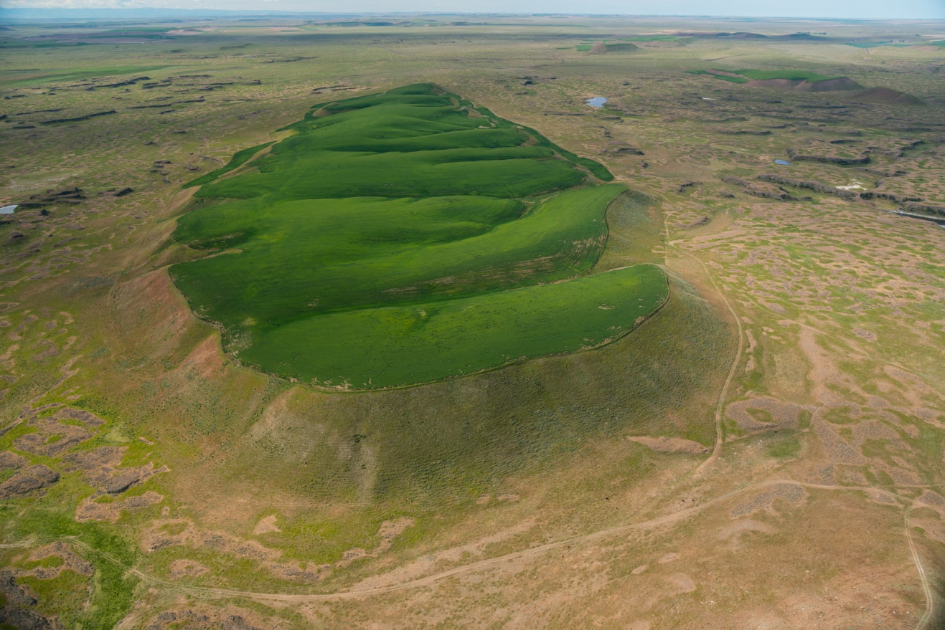

Photographs by Michael Melford
In the middle of eastern Washington, in a desert that gets less than eight inches of rain a year, stands what was once the largest waterfall in the world. It is three miles wide and 400 feet high—ten times the size of Niagara Falls—with plunge pools at its base suggesting the erosive power of an immense flow of water. Today there is not so much as a trickle running over the cataract’s lip. It is completely dry.
Dry Falls is not the only curiosity in what geologists call the Columbia Plateau. Spread over 16,000 square miles are hundreds of other dry waterfalls, canyons without rivers that might have carved them (called “coulees”), mounds of gravel as tall as skyscrapers, deep holes in the bedrock that would swallow entire city blocks, and countless oddly placed boulders. All across southeast Washington, fertile rolling hills border eroded tracts of volcanic basalt, as if Kansas farmland and Utah canyon land had been chopped up and sewed together into a topographic Frankenstein.
The first farmers in the region named the rocky parts “scablands” and dismissed them as useless as they planted their wheat on the silt-rich hills. But geologists were not so dismissive; to them, the scablands were an enigma. What could have caused this landscape? It was a question hotly debated for several decades, and the answer was as surprising and dramatic as Dry Falls itself.
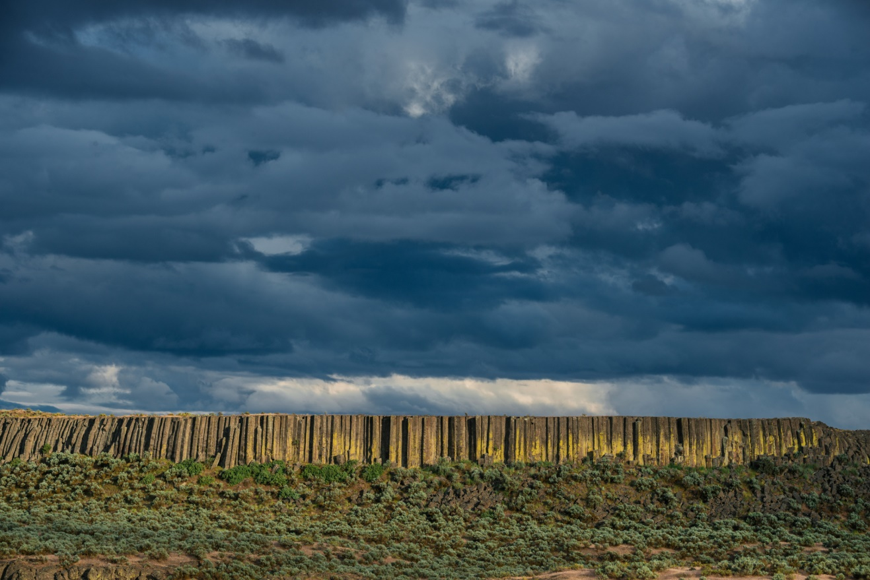
For that matter, so was the source of that answer: a high school science teacher named Harley Bretz. In 1909, the Seattle teacher visited the University of Washington to see the U.S. Geological Survey’s new topographic map of the Quincy Basin, a large area on the west side of the Columbia Plateau. He was 27, with no formal training in geology, but when he looked at the map, he noticed a striking feature: a huge cataract (much like Dry Falls) on the western edge of the basin, a place where water appeared to spill out of the basin and into the Columbia River, gouging a canyon several hundred feet deep. The falls would have been bigger than Niagara, but there was no apparent source of water for them—no signs whatsoever of a river leading to the cataract.
Bretz asked faculty in the department about the feature, called Potholes Coulee, but they had no answers for him. Nor could they explain many of the other unusual features of the region. That’s when, as legend has it, Bretz decided to become a geologist. He earned his Ph.D. in geology from the University of Chicago four years later, changed his professional name from Harley to “J Harlen” to sound more respectable, and in 1922 returned to eastern Washington to take a closer look at the plateau and its scablands. And after two seasons in the field, his conclusions shocked even himself: The only possible explanation for the all the region’s features was a massive flood, perhaps the largest in the Earth’s history—“a debacle which swept the Columbia Plateau,” ripping soil and rock from the landscape, carving canyons and cataracts in a matter of days. “All other hypotheses meet fatal objections,” he wrote in a 1923 paper.
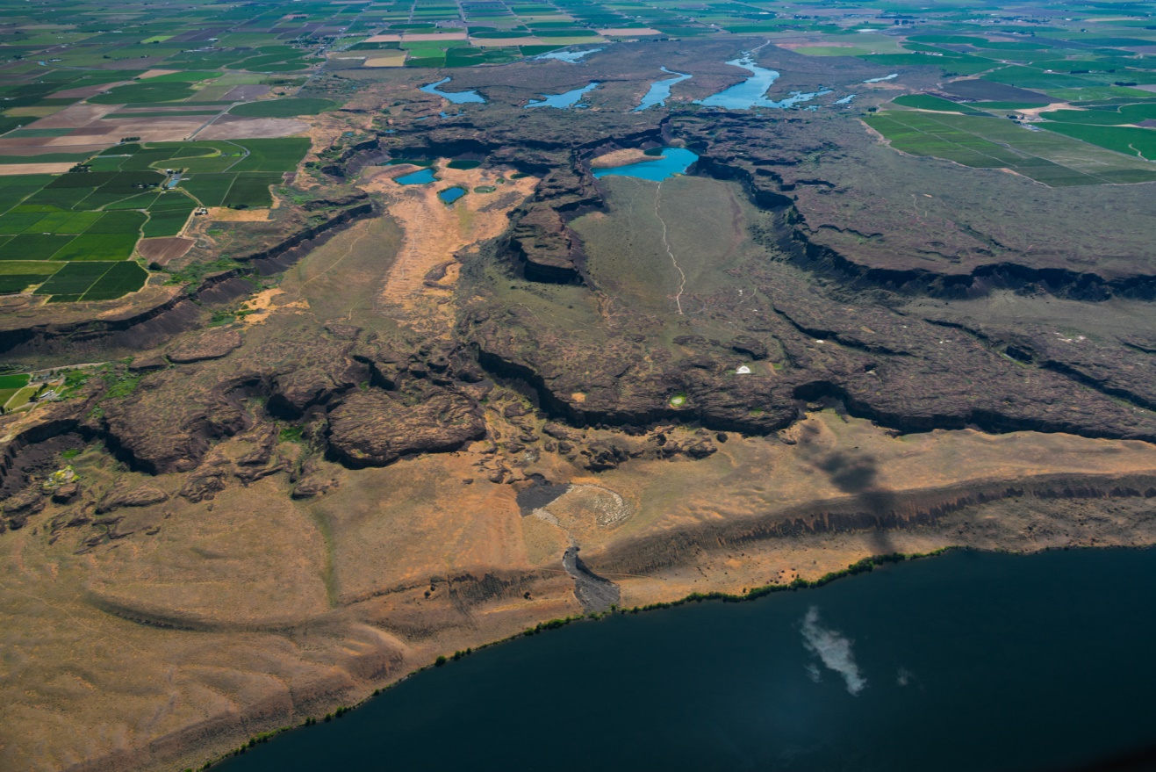
It was geological heresy. For almost a century, ever since Charles Lyell’s 1830 text Principles of Geology set the standards for the field, it had been assumed that geological change was gradual and uniform—always the product of, as Lyell put it, “causes now in operation.” And floods of quasi-Biblical proportions certainly did not meet that standard. It didn’t matter how meticulous Bretz’s research was, or how sound his reasoning might be; he seemed to be advocating a return to geology’s dark ages, when “scientists” used catastrophic explanations for the Earth’s features to buttress theological presumptions about the age of a Creator’s divine handiwork. It was unacceptable. How did canyons and cataracts form? By rivers, of course, over millions of years. Not gigantic floods. Period.
So in 1927, after Bretz had published yet another paper about the “Spokane Flood” and the landscape it carved, the nation’s geological bigwigs invited him to Washington, D.C., to present his findings—and receive his beatdown. Bretz was game, and explained to the expert assemblage how a massive ice-age flood had carved three parallel tracts of flood channels south of the Cordilleran ice sheet (which covered Canada and the northern United States), pooled in a temporary lake twice the size of Rhode Island at the southern edge of the scablands, and then drained like an overflowing tub into the Columbia River Gorge. On the way, the floodwaters carved the famous Grand Coulee, a canyon up to three miles wide with walls up to a thousand feet high, cut hundreds of waterfalls, washed away entire hillsides, deposited gravel bars hundreds of feet high, carried rocks the size of cars and even small houses, and created a terrain of braided channels across eastern Washington.
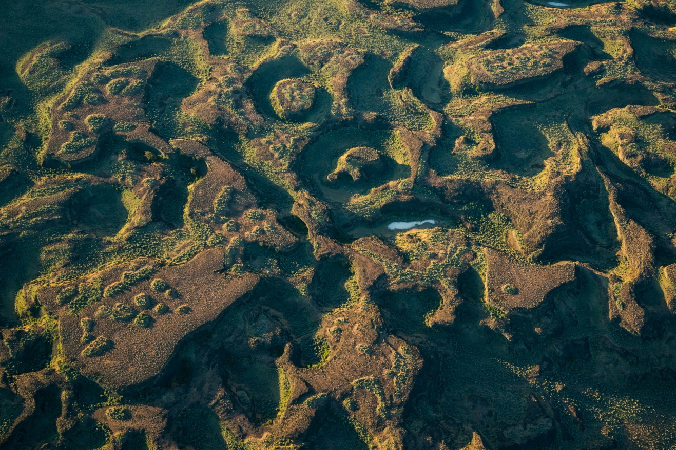
View Images
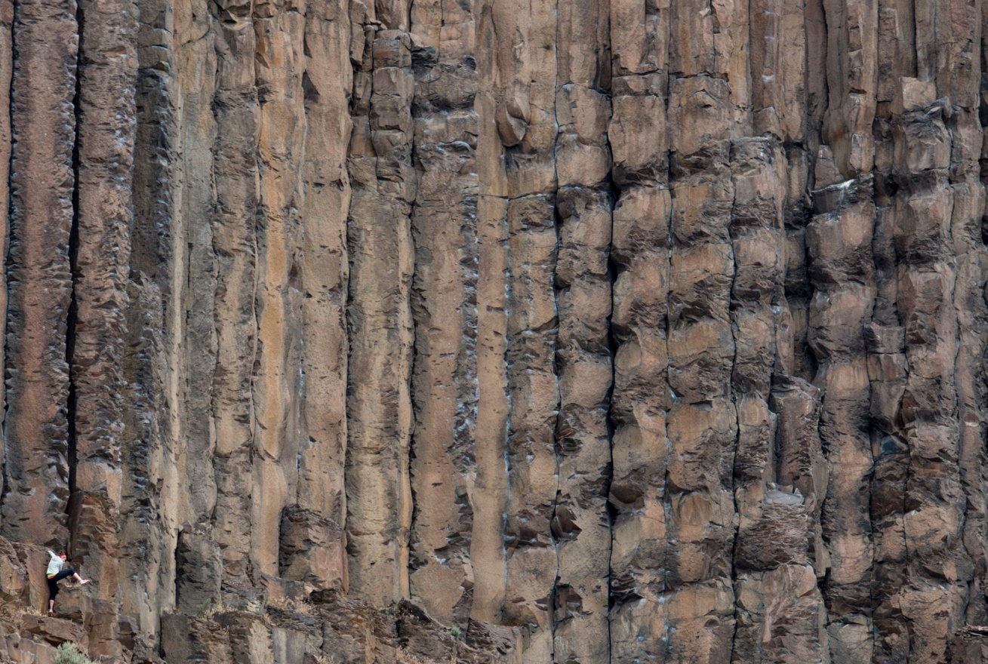
Rivers and streams could not have done this, Bretz said. The landscape bears none of the marks of riverine systems, with smaller tributaries joining into larger ones, forming tree-like, branch-and-trunk patterns. Instead, you see a pattern of braided channels—the crisscrossing pattern that flowing water creates when it makes its way across fresh terrain. The difference between the channels we typically see—say, after a rainfall or on the margins of a flooding river—and the channels in the scablands is simply scale. These are just much larger, and were carved into rock instead of sand or silt.
The key to the rapid erosion, Bretz said, was the volcanic basalt that forms the bedrock of the Columbia Plateau. When basaltic lava cools into rock, it forms vertical hexagonal pillars that have weak bonds to each other. Compared to, say, granite, which erodes grain by grain, basalt can erode chunk by chunk as these pillars separate. So a massive, high-energy flood could pluck apart the bedrock so quickly that a canyon like the Grand Coulee might be formed virtually overnight.
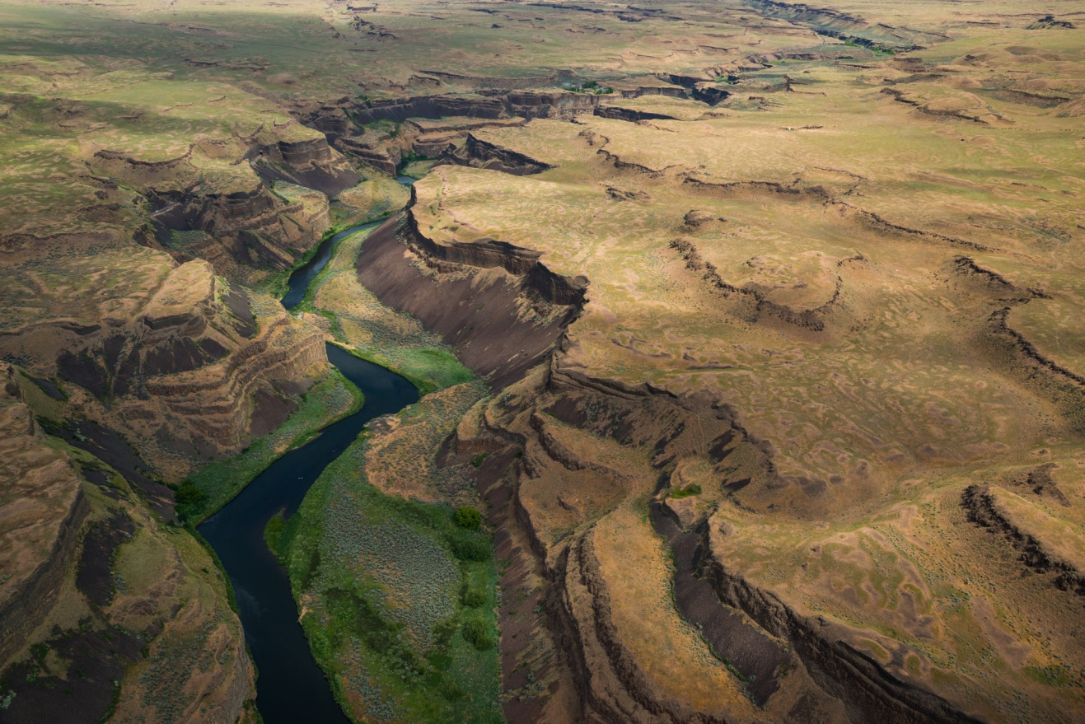
“During the ice-age floods, this entire scene was submerged beneath hundreds of feet of water,” says geologist Bruce Bjornstad. The Palouse River, shown here, "was hijacked and forced to follow a new route to the Snake River.”
Bretz’s research was thorough, and his map of the channeled scablands was so accurate that it’s a virtual tracing of modern-day satellite images, creating the immediate impression of channeled floodwaters. But his audience—none of whom had visited, much less studied, the scablands—was having none of it. Bretz’s hypothesis was not just “wholly inadequate,” in the words of one critic, but “preposterous” and “incompetent.” Compounding the problem of his unlikely hypothesis was the question of where all this water would have come from, and Bretz had no convincing answer.
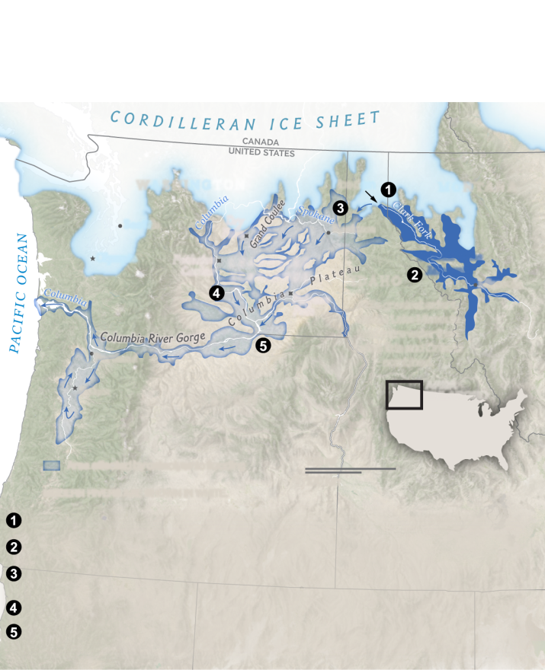
Creating the Channeled Scablands
During the last ice age, 18,000 to 13,000 years ago, the landscape of eastern Washington was repeatedly scoured by massive floods. They carved canyons, cut waterfalls, and sculpted a terrain of braided waterways today known as the channeled scablands.
For more than a decade afterward, Bretz was on the losing side of a pre-ordained conclusion, as the other geologists who began studying the area concocted one labored hypothesis after another for how the scablands’ features might have been created by gradual erosion. Then, in the early 1940s, the other shoe dropped: Joseph Pardee, a geologist for the USGS, reported that he’d discovered strong evidence of a massive flow of water in western Montana: a swath of current ripples 30 to 50 feet high—like the sand ripples that might form in river or tidal water, but made of gravel and orders of magnitude larger. Their source? A giant ice-age lake—Glacial Lake Missoula—that formed when the Cordilleran ice sheet progressed south and blocked the Clark Fork river valley, forming a dam of ice 2,000 feet high.
Behind that dam, water from the Clark Fork gathered, forming a lake with as much water as Lake Erie and Lake Ontario combined, stretching for hundreds of miles in Montana’s mountainous river valleys. Then the dam broke, and a torrent of water with ten times the combined flow of all the world’s rivers barreled into eastern Washington, reaching speeds approaching 80 miles an hour, decimating the terrain and leaving giant current ripples and gravel bars in its wake.
View Images
Rich soil called Palouse loess covers the rolling fields of eastern Washington. “This is what the topography might have looked like before the floods removed the loess,” says Bjornstad.
It would take another two decades to win the establishment over, but for many geologists this was convincing evidence that Bretz’s flood was real. The impossible had happened after all.

Seeing Like a Geologist
It takes practice to see the world as a geologist does. When I got my first glimpse of the Channeled Scablands more than 20 years ago on Interstate 90 west of Spokane, I was struck by their strange beauty, by the way rolling fields of wheat could suddenly yield to a landscape of rocky buttes. I had no explanation for the terrain, and I didn’t need one—I had that primitive eye that looks at rocks and just sees rocks. But when I returned to the scablands with Bretz’s story in mind, suddenly I was in an entirely different world.
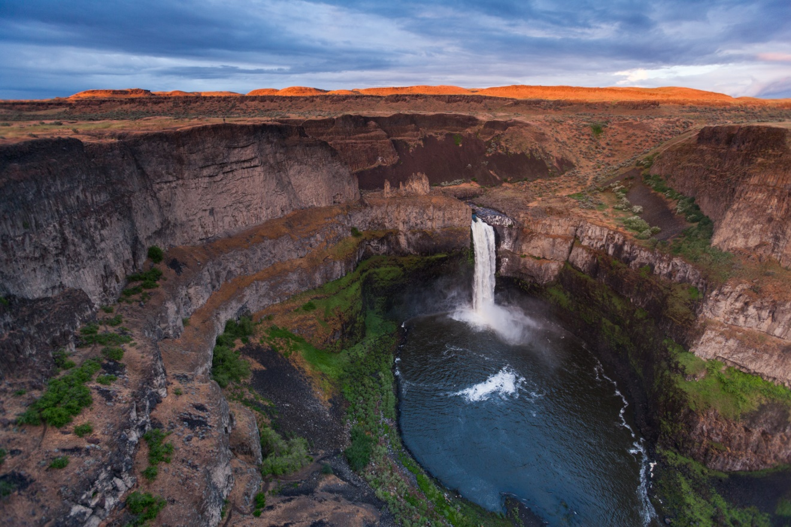
Plummeting nearly 200 feet, Palouse Falls is a trickle compared to the megafloods that carved this canyon and shaped the surrounding landscape of eastern Washington State.
Standing in the middle of a broad swath of scablands extending from horizon to horizon, my mind’s eye could clearly see the floodwaters blasting through, like a raging inland sea, ripping up everything not strong enough to stay moored. Driving through what’s known as the Ephrata Fan, a broad open area where floodwaters left the confines of the Grand Coulee and spread out and slowed as they neared what would become Ancient (and very temporary) Lake Lewis, I easily understood why the landscape was riddled with boulders: As the water lost speed, it began dropping all the rocks it was carrying. And when I stood on the lip of the dry falls of Potholes Coulee, looking at this immense canyon with farmland on three sides and a precipitous drop on the other, I felt what Bretz was thinking when he looked at that map a century ago: If a river didn’t carve this, what did?
With the flood story in mind, it all seems so obvious—so obvious, in fact, that it’s almost impossible to see the terrain and not see the floodwaters that shaped it. Why, then, were the experts in Bretz’s day so blind to what now seems like a self-evident geological record? I posed that question to Vic Baker, a geologist with the University of Arizona who became the pre-eminent scablands expert in Bretz’s wake, when we met to tour several of the region’s features. “It’s the mistake people have made most in the history of science,” he said. “They forgot that nature has the answers, not us.”
“Bretz was making arguments, and no one was going into the field to see anything,” Baker said. “They were just countering his arguments with theory.” And because scientists are first and foremost human beings, they’re loathe to change their theories or their minds because of mere data.
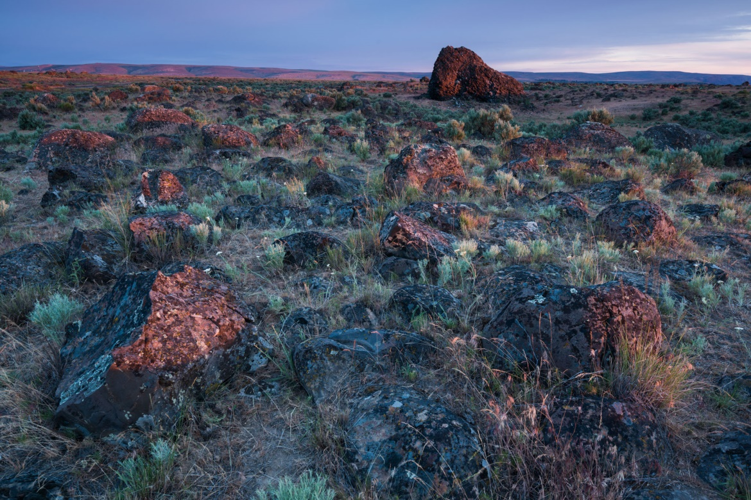
The basalt and granite boulders now littering the Ephrata Fan were carried there by torrents of water that gushed out of a canyon called the Grand Coulee. The largest piece of rock is more than 25 feet tall.
Sometime in the late 1950s or early ’60s, a geologist named Aaron Waters brought one of Bretz’s most vocal critics—James Gilluly, the one who’d called his ideas “preposterous” and “incompetent”—to the scablands for a first-hand look. As they took in the sight of the falls and the canyon, Gilluly was dumbfounded by their scale. “Gilluly was just quiet the whole time,” Baker said, “and as they were leaving, he broke out into this immense laugh and said, ‘How could anybody be so wrong?’” After resisting Bretz’s theory for decades, simply seeing the landscape with his own eyes had changed his mind.
Of course, for some of Bretz’s most stubborn critics, even eyewitness experience wasn’t enough. Bretz’s arch-adversary, Richard Foster Flint, a Yale geologist who remained a premier authority in the field until the 1970s, spent years studying the scablands and resisted Bretz’s theory until he was virtually the only one left who did. He finally acknowledged the scablands flooding (grudgingly, with a single sentence in a textbook in 1971), but as philosopher Thomas Kuhn observed, new scientific truths often win the day not so much because opponents change their minds, but because they die off. By the time the Geological Society of America finally recognized Bretz’s work with the Penrose Medal, the field’s highest honor, it was 1979 and Bretz was 96 years old. He joked to his son, “All my enemies are dead, so I have no one to gloat over.”
It is tempting to see this story as a simple morality tale, with “good guy” geologists lining up against “bad guy” geologists in a battle between open-minded inquiry and closed-minded dogmatism. But that might just compound the error, because it neglects the fact that scientists almost always favor their own theories over others’, and rarely are those theories completely right. Enter Richard Waitt, a geologist with the USGS. In 1977 Waitt was exploring the Walla Walla valley in southern Washington when he noticed that one of the 40 sediment layers from the temporary flood lake contained ash from an eruption of Mt. St. Helens. It had been assumed that all those layers had been laid by one flood event—but if only one of them had the volcanic ash, it meant that each of those layers must have represented a separate flood.
“I knew right away that there couldn’t have been just one flood,” Waitt said. But when he published his findings in 1980, arguing that there had been at least 40 ice-age floods in the scablands, he faced such stiff resistance that he felt like Bretz himself. “Baker and his students were totally against it for years,” he said. And the irony for Waitt is that the lines seemed to be drawn just as they had been during the initial controversy. The authorities in the field were invested in a particular theory, and contrary evidence was dismissed without an adequate hearing.
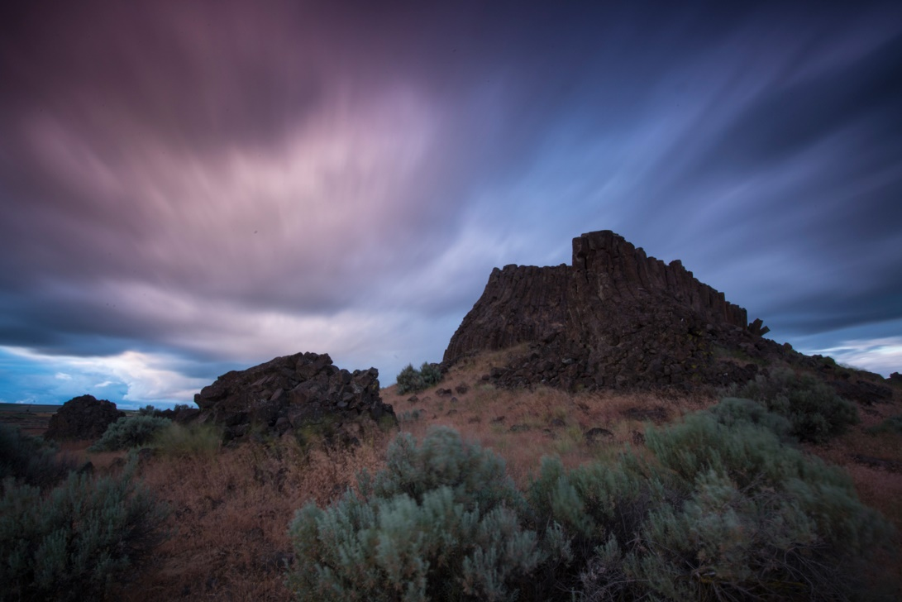
It turns out that Waitt was right. In fact, subsequent research indicates that 80 or more floods ravaged the scablands near the end of the last ice age. Repeatedly over a two- to three-thousand-year span ending roughly 13,000 years ago, the Cordilleran ice sheet advanced to block the Clark Fork river, a new iteration of Glacial Lake Missoula formed, and then the ice dam broke, each time unleashing such a torrent of water that if it were to happen today, most of Portland’s skyline would be submerged by the floodwaters. What’s more, something similar might have happened during previous ice ages—meaning that perhaps the most dramatic features of the scablands, like Grand Coulee and Dry Falls, didn’t form in the blink of a geological eye after all, but were shaped by catastrophic erosion over an extended period of time. Which would make both Bretz and his early critics right—Bretz about the flooding, and his critics in their skeptical assessment of his timetable.
This wouldn’t have come as a complete surprise to Bretz. By the early 1950s he’d noticed that some scabland features appeared to be more weathered than others, and in his last paper on the subject, in 1969, he argued that there had been at least seven scabland floods. But by then the controversy that had defined his professional life had already come and gone. When I asked Waitt about the irony of Bretz’s story, he said, “I think if Bretz could have made the argument in the 1920s for several floods, it would have muted the opposition a great deal.”
Perhaps it’s just as well that he didn’t. That sort of neat resolution might obscure what’s arguably the most important lesson of the scablands’ story—the caution that “nature has the answers, not us.” Just when we think we’ve got nature figured out, we find that among her many powers is the power to confound us, again and again and again.
Alien Space Probes are Proposed as Answer
Bizarre flashes of cosmic light may actually be generated by advanced alien civilizations, as a way to accelerate interstellar spacecraft to tremendous speeds, a new study suggests.
Astronomers have catalogued just 20 or so of these brief, superbright flashes, which are known as fast radio bursts (FRBs), since the first one was detected in 2007. FRBs seem to be coming from galaxies billions of light-years away, but what's causing them remains a mystery.
"Fast radio bursts are exceedingly bright given their short duration and origin at great distances, and we haven't identified a possible natural source with any confidence," study co-author Avi Loeb, a theorist at the Harvard-Smithsonian Center for Astrophysics, said in a statement Thursday (March 9). "An artificial origin is worth contemplating and checking." [5 Bold Claims of Alien Life]
One potential artificial origin, according to the new study, might be a gigantic radio transmitter built by intelligent aliens. So Loeb and lead author Manasvi Lingam, of Harvard University, investigated the feasibility of this possible explanation.
Artist's illustration of a light sail powered by a radio beam (red) generated on the surface of a planet. The leakage from such beams as they sweep across the sky would appear as superbright light flashes known as fast radio bursts, according to a new study.
Credit: M. Weiss/CfA
The duo calculated that a solar-powered transmitter could indeed beam FRB-like signals across the cosmos — but it would require a sunlight-collecting area twice the size of Earth to generate the necessary power.
And the huge amounts of energy involved wouldn't necessarily melt the structure, as long as it was water-cooled. So, Lingam and Loeb determined, such a gigantic transmitter is technologically feasible (though beyond humanity's current capabilities).
Why would aliens build such a structure? The most plausible explanation, according to the study team, is to blast interstellar spacecraft to incredible speeds. These craft would be equipped with light sails, which harness the momentum imparted by photons, much as regular ships' sails harness the wind. (Humanity has demonstrated light sails in space, and the technology is the backbone of Breakthrough Starshot, a project that aims to send tiny robotic probes to nearby star systems.)
Indeed, a transmitter capable of generating FRB-like signals could drive an interstellar spacecraft weighing 1 million tons or so, Lingam and Loeb calculated.
"That's big enough to carry living passengers across interstellar or even intergalactic distances," Lingam said in the same statement.
Humanity would catch only fleeting glimpses of the "leakage" from these powerful beams (which would be trained on the spacecraft's sail at all times), because the light source would be moving constantly with respect to Earth, the researchers pointed out.
The duo took things a bit further. Assuming that ET is responsible for most FRBs, and taking into account the estimated number of potentially habitable planets in the Milky Way (about 10 billion), Lingam and Loeb calculated an upper limit for the number of advanced alien civilizations in a galaxy like our own: 10,000.
Lingam and Loeb acknowledge the speculative nature of the study. They aren't claiming that FRBs are indeed caused by aliens; rather, they're saying that this hypothesis is worthy of consideration.
"Science isn't a matter of belief; it's a matter of evidence," Loeb said. "Deciding what’s likely ahead of time limits the possibilities. It's worth putting ideas out there and letting the data be the judge."
The new study has been accepted for publication in The Astrophysical Journal Letters. You can read it for free on the online preprint site arXiv.org.
The Agency War: The Parley Before the Battle

Everyone’s talking about the Deep State now. The other day, Virgil searched “deep state” and found, just in the Google News section, no less than 3.86 million hits. Republican politicians are using the phrase, and so are Democratic pols. In fact, one Democrat, Rep. Ted Lieu of California, chose to “own” the phrase, tweeting, “We are #Deep State.” Translation: Trump, we are coming for you.
Indeed, the Deep State hashtag is now busy, used by both fans and foes of the DS. There are even a bunch of Twitter accounts on the Deep State theme—which may or may not have any connection to reality.
And there are even plays on the phrase, such as DeepStateGate, which by now is familiar to Breitbart readers, and also “Shallow State,” an anti-Republican coinage from David Rothkopf, an appointee in the Clinton administration.
It was different back on December 12, when Virgil first started writing about the Deep State; back then, references were scarce. Yet today, if one goes to Google Trends and types in “deep state,” this is what one sees: a recent sharp spike in usage. It’s fun to have company!
And speaking of company, I’ll hope you’ll continue to join me on our tour of the Federal Triangle, the heartland of the Deep State. We started our tour at the Department of Commerce, and so next we’ll visit the federal bureaucracy in the next building over.
The Federal Triangle (Source: Wikimedia Commons)
That would be the Environmental Protection Agency, which fills up, in fact, three different buildings, stretching from Constitution Avenue to Pennsylvania Avenue, from 14th Street to 12th Street. (Plus, of course, the EPA has myriad satellite offices all over the country; the total head-count is more than 15,000, not counting contractors and grantees.)
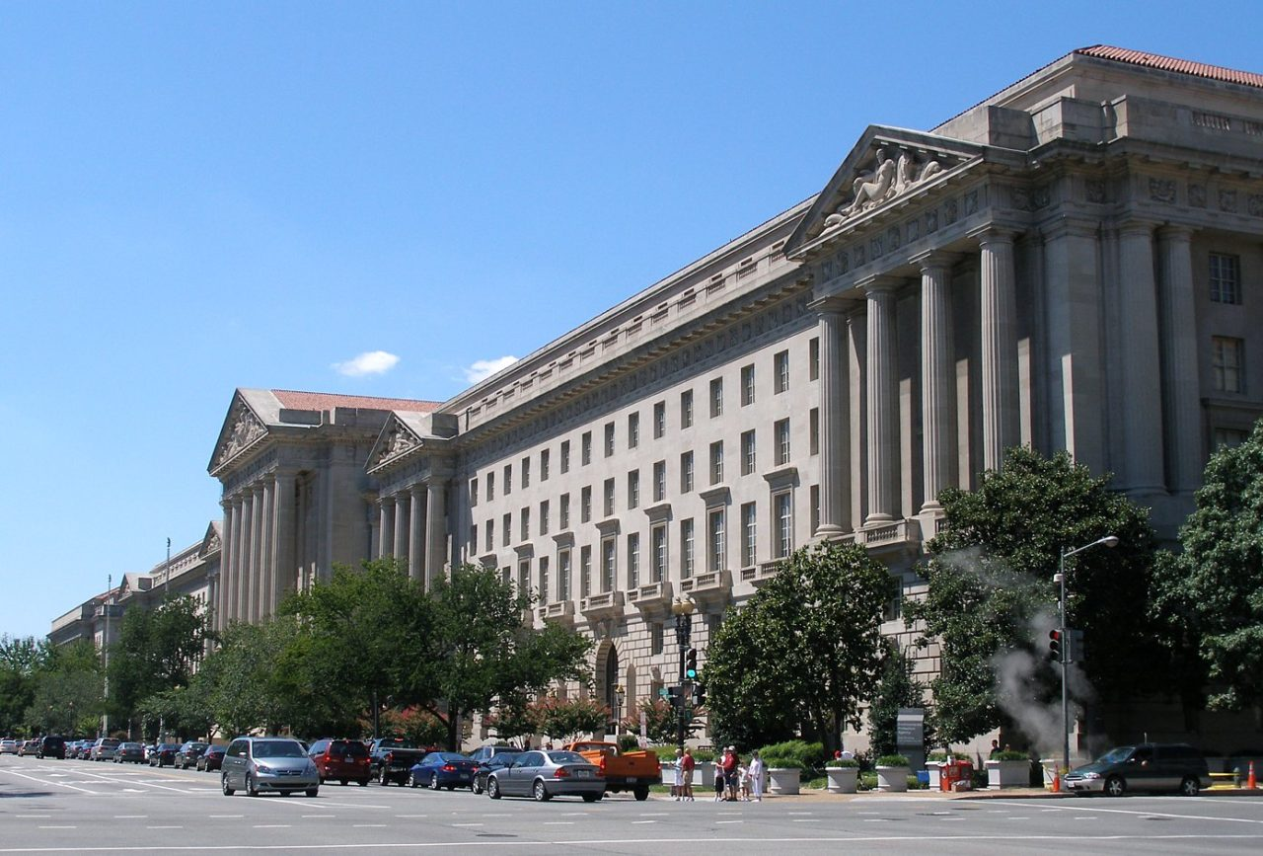
Environmental Protection Agency Headquarters (Source: Wikimedia Commons)
The EPA, of course, is right in the middle of the ongoing DC power struggle, which has spilled into open bureaucratic revolt. On February 16, for example, The New York Times reported that EPA employees had brazenly been calling senators to urge them to vote against Scott Pruitt, President Trump’s pick to head the agency. It was, the Times’ Coral Davenport observed, “a remarkable display of activism and defiance that presages turbulent times ahead for the EPA.”
Speaking of turbulence, the career staff at EPA is feeling it. On March 7, Axios’ Jonathan Swan tweeted a picture of a sign at EPA, offering counseling sessions to fearful careerists:
Feeling Pressured? Worried About Change at EPA? The EPA’s Employee Counseling and Assistance Program presents a 45 min. seminar on “Dealing with Change.”
Yes, the delicate snowflakes at the agency need help—your tax dollars at work.
Yet whether they have had counseling or not, EPA-ers seem to be girded for battle. A rogue Twitter account, AltEPA, billing itself as the “resistance,” has 382,000 followers—and there are many more such accounts in existence. It’s possible, of course, that some, perhaps most, of these accounts are fakes. But probably not all.
In the meantime, some EPA people, long ago, developed their own “resistance strategies.” For instance, Lisa Jackson, the EPA administrator in Barack Obama’s first term, had a nifty Deep State tactic—she hid her identity, even with her own agency. As far back as 2009, Jackson was using a fictitious name, “Richard Windsor,” for her e-mail, in a seeming attempt to evade the requirements of the Freedom of Information Act and other transparency laws. By some reckonings, such evasion might be counted as a crime, but Jackson suffered no ill consequences. In fact, she is now a well-paid vice president at Apple.
Given that sort of no-penalty precedent, it’s little wonder that a pervasive culture of clandestine operating still permeates EPA. To illustrate, we might recall an EPA inspector general’s report prepared at the behest of the House Republicans: In 2014-2015, EPA employees sent or received 3.1 million text messages on government-issued devices; of these, just 86 were archived for the federal records. So what were all the rest of those 3-million-plus texts about? Maybe they were all personal, or maybe they were leaks, or maybe they were back-and-forths with Lisa Jackson—we’ll never know. And we can underscore: that’s just on government equipment; who knows what’s been happening on personal equipment, and on personal accounts.
So as we can see, secrecy is one weapon that EPA lifers can deploy. Another weapon is complexity. The same Times reporter on the environmental beat, Coral Davenport, recently interviewed Jackson’s successor at EPA, Gina McCarthy, who served from 2013 to 2017. McCarthy was eager to outline the torturous process that the Trump administration would have to follow to undo Obama regulations:
If you want to do these executive orders that require a whole rewrite of the rule, you have to get that right, legally. It took years to do those rules. To now ask for those things to be undone with less staff and low morale—how are they going to do it?
Yes, that’s standard Deep State stuff. As bureaucrats like to say to the political appointees of any administration, “We were here when you arrive, and we’ll still be here when you depart. In fact, by the time you figure out how things really work, it’ll be time for you to go!” In other words, the Deep State is eternal, and throughout that eternity, Deepists have mastered the arcane procedures needed to make any sort of change. So the message to interlopers is simple: Do it our way, or else face frustration, or even failure.
Moreover, perhaps more than any other government agency, the Deep Statists at EPA can call upon powerful outside allies—in the media, in partisan politics, and in the realm of litigation activism.
Let’s take a look, starting with the media. On March 8, that same Times reporter, Coral Davenport, printed the names of five aides that Scott Pruitt, having been confirmed for his post, now plans to bring with him. Just a hunch: Davenport didn’t get those names from Pruitt; instead, most likely, she got them from some EPA worker with inside access to his doings. And so the Democratic war rooms, joined by so many others, can get to work building their “oppo” dossiers on each new hire.
Meanwhile, other media outlets, too, are piling on. Thus we get dozens of Pruitt/Trump administration-bashing headlines every day. For example, here’s Slate: “Trump’s EPA Plans Are ‘Just Racist.’” And MinnPost: “Trump’s EPA cuts would undo local efforts to restore iconic places—like the Great Lakes.” And Quartz: “Leaked document details plan to starve an already malnourished EPA budget.”
Ah yes, there’s the “l” word again—“leaked.” Indeed, it seems that back on March 3, the National Association of Clean Air Agencies got its hands on a Trump administration document calling for $2 billion in cuts at EPA, and then shared it with various publications, including The Oregonian.
And then on the second bounce of that particular leak-story, as reporters sought to give it “legs,” we saw headlines such as this, in Science: “Trump plan for 40% cut could cause EPA science office ‘to implode,’ official warns.” The EPA official doing the warning, of course, was unnamed. Meanwhile, the internal communications at EPA have been leaking out in near real-time. That’s how things work in DC, every day. Warning to Trumpsters at EPA: You’re going to be parachuting in far behind enemy lines, and they know where to find you.
Now we come to a second ally of the permanent regime at EPA, the increasingly greened Democratic Party. Yes, it’s the Democrats who put the wind beneath the wings of the environmental- (anti) industrial complex.
We can recall that it was not always this way: As recently as the 1960s, the Democrats cared more about growing the economy than greening the environment. That is, Democrats worried about workers and their wages, and to that end, they focused on the development—the word often used back then was “reclamation”—of natural resources.
For example, the 1960 Democratic platform, the one that helped elect John F. Kennedy, was emphatic:
The new Democratic Administration will develop a comprehensive national water resource policy. In cooperation with state and local governments, and interested private groups, the Democratic Administration will develop a balanced, multiple-purpose plan for each major river basin.
Indeed, in those days, the Democrats attacked the outgoing Eisenhower administration for its alleged cheapness when it came to funding new projects:
We will erase the Republican slogan of “no new starts” and will begin again to build multiple-purpose dams, hydroelectric facilities, flood-control works, navigation facilities, and reclamation projects to meet mounting and urgent needs.
By contrast, the 2016 Democratic platform offered a much different worldview: workers and wages were an afterthought, well behind penguins and polar bears. In fact, the old concept of “reclamation” never appears at all; instead, we get 16 paragraphs, for instance, on “climate change.”
Of course, at this precise moment, in 2017, the Democrats lack the political power fully to protect their friends at EPA, although they’ll certainly always be trying.
And now to a third ally of Deep EPA: the activist litigators.
As every conservative knows, the left has been far more effective, in recent decades, at winning in the courts than winning at the ballot box. And yet on many issues, a win is a win: If a judge orders the government to take action of a certain kind, well, oftentimes that’s it—that’s the ballgame. No wonder the left is so tight with the lawyers!
And as a sign of the anti-Trump eco-litigation flood to come, on March 8, nearly three dozen green groups filed a formal legal petition with EPA, demanding that the agency tighten the regulations on concentrated animal-feeding operations (CAFO), also known as “factory farms.” As the lead plaintiff, Wenonah Hauter, executive director of Food & Water Watch, declared,
This petition paves the way for EPA to finally regulate CAFOs as required under the Clean Water Act, and explains that allowing CAFO pollution to continue unabated by maintaining the woefully inadequate status quo would violate federal law.
That petition, we might note, is 58 pages of closely argued legalese, boasting 294 footnotes. And there’s a clear call to action in the document’s conclusion; as it reads, “Petitioners believe that EPA has an obligation pursuant to its [Clean Water Act] duties to [take new action against CAFOs] without further delay.”
In other words, it’s a serious legal demand, aimed at forcing EPA to take additional regulatory action. Or, failing that, to persuade a judge somewhere to order such additional regulation into existence.
So now Virgil wonders: Who among Team Trump at EPA is actually going to have time to read this petition, let alone develop an appropriate legal counter-strategy?
And so what might happen if the Trump people choose to delegate the handling of this case to the EPA career staff? Well, we know what could easily happen: The Deep Statists at EPA could consult with their like-minded friends, neighbors, and former law-school classmates—quite possibly, including the very people who filed the CAFO case—and come up with a nice green answer.
That is, it’s easy to see EPA Deep Statists communicating with their friends—perhaps even their spouses—in the activist legal world. Suppose, for example, that two grocery shoppers at the Whole Foods in Northwest DC’s Tenleytown neighborhood just happen to have a friendly ex parte conversation? You know, about maybe, legal strategy in the CAFO case? What would be the policy upshot of such a chat?
As an answer, here’s one scenario that we’ve seen many times before: The career legal staff tells the thin layer of political appointees at an agency that the plaintiffs have a strong case, and so it’s best to settle. That is, except for maybe a few face-saving tweaks, give the plaintiffs what they want. After all, the careerist could be saying to the politicals, if you choose to fight, it could get really messy, and, in the end, you’d likely still lose. So why not do it the easy way? Why not do it our way?
That’s the pitch that’s been heard a million times within the Deep State. And while it doesn’t always work, since it’s the path of least resistance, it’s a familiar course of action. And so we see how the Deep State so often wins.
So now the Deep State stands ready to welcome Scott Pruitt and the rest of the Trump contingent to their humble outpost at 1200 Pennsylvania Avenue. Well, okay, maybe “welcome” isn’t quite the right word. Maybe it’s a government guided tour. “Keeps your arms inside the vehicle please.”
I have a feeling that the 15,376 federal employees of the EPA see Trump as the hatchet man come to cut them down to size. The EPA’s budget increased by nearly 50% under Obama, and he wielded its power against entire American industries, crushing them. Offshore drilling, coal mining, and precious metal mining was brought to a crumbling halt. Hundreds of thousands of jobs were permanently lost. They will never come back, because those people moved on. They sold or lost their homes. Their cars were repossessed. Their credit was destroyed.
This is precisely why we call it the Environmental Protectionist Agency. Although its federal budget is a bloated $8,139,887,000, it is only a fraction of the money they take in. Triple this amount, and you will see what they gather in fines, fees, and enforcement actions against American industries. Who pays for these costs? You do. Everything you buy has EPA costs in it, which are funneled to the Agency to pay the employees more and more money.
When Trump finishes his tour of the EPA palace and shakes the hands of the ministers of extortion and intimidation at the very core of the Fascist Protectionist military, he will look them in the eye. And then he will lower his chin slightly, thin his eyes, and say, “You’re fired.”
Guess What Happened When More Taxpayers Showed Up
Is it the federal government’s hiring freeze on non-essential employees? Or is it a miracle?
The U.S. debt clock is actually spinning backwards since Donald Trump moved into the White House Jan. 20. On inauguration day, the debt stood at $19.947 trillion. Since then it has reversed by $68 billion, or 0.3 percent, for the first time in at least 10 years. You know, this could be the start of something great, no pun intended. $68 billion a month would be about $1 trillion a year. Within 6 years, Trump could cut the national debt in half, totally erasing the effects of the Obama farcical presidency. What person could hold their head up having golfed or played one fifth of his presidency away?
What happened in the same period after Barack Obama’s inauguration in 2009? The debt rose $320 billion in the same period – an increase of 3.1 percent. Overall, the debt nearly doubled in Obama’s eight years, by far the largest increase in any administration in any nation in history. What a legacy. And that’s hardly the only good economic news for the new administration.
Trump used the first federal jobs report reflecting a full month of his presidency to send a message: He’s already making America great again.
“GREAT AGAIN: +235,000,” Trump posted on his Twitter account in a retweet of a Drudge Report headline on Friday after the Bureau of Labor Statistics released payroll data for February showing the U.S. added 235,000 jobs.
In January some 238,000 jobs were added.
Trump also released a video praising Exxon Mobil Corp. for announcing a $20 billion building spree that would create 45,000 jobs along the Gulf Coast. While the announcement dates back to plans the company was making as early as 2013, Trump took credit, saying it was a sign his policies were already working.
“I said we’re bringing back jobs,” he said. “This is one big example of it.”
During the final year of Obama’s presidency, job gains averaged an appalling 187,000 per month. Most of those jobs were part time or service jobs like food service or retail sales. There were fewer manufacturing jobs in America than existed after the second world war, even though the population has tripled since then.
Still there is more. Average hourly earnings increased by a healthy 2.8 percent on an annualized basis, with construction leading the way, growing by 58,000, the most in almost a decade, while manufacturing also posted strong gains with 28,000 new jobs. That is the first significant gain in this job sector in 8 years.
The performance by the economy exceeded expectations: Economists surveyed by Reuters had expected the economy to add 190,000 jobs. What can explain so much good news so fast?
“You’re getting more strength in the labor market than I would have anticipated,” said John Canally, chief economic strategist at LPL Financial. “There’s been a burst in animal spirits since Trump was elected.”
A record 152,528,000 Americans were employed in February, 447,000 more than in January, and the labor force participation rate went up, the Labor Department’s Bureau of Labor Statistics reported Friday. Sixty-three percent of Americans either held a job or actively looked for one in February, the highest participation rate in 10 months.
What would really accelerate things is to start laying off 100,000 federal workers a month for a couple of years. This would save Americans $120 billion per year, plus those fat juicy benefits like retirement, free healthcare, and expenses. Better put that at $200 billion per year. Within 2 years, we would be paying off a trillion a year in national. And, let’s not forget the plan to discount the debt and pay it off. Imagine that. A debt free country. Actually, that is the way it is supposed to work.
The Muslim Problem
One of the real danger points of our time is the infiltration of America by jihadists, many of whom are coming in with waves of refugees.
Much debate has ensued since outgoing President Barack Obama began opening the doors of our shores to ever-increasing numbers of refugees from Syria and Iraq. Oddly, only a handful of those refugees have been Christians; the rest are Muslim.
How odd indeed.
Weak-kneed Washington establishment-types caved to Obama, and now that President Donald Trump is attempting to put the brakes on such immigration through what he calls “extreme vetting,” he is being attacked on all sides, from clueless college students to seasoned political operatives and media hacks.
All this makes a new book by Leo Hohmann especially timely. “Stealth Invasion: Muslim Conquest Through Immigration and Resettlement Jihad” will make the hair stand up on the back of your neck.
And that’s a good thing.
Too many Americans either want to stick their heads in the sand, or wring their hands over their perception that we must “welcome the stranger” no matter the cost. In actual fact, the demons of ISIS are already making their way here and will exist in sleeper cells until they determine the time is right to unleash jihad on Americans. Hohmann outlines this and much more in “Stealth Invasion.”
The author makes a critical point, that only one side in this new war is fully engaged. That is the enemy:
With such huge stakes, it’s remarkable that so few Americans are aware of what’s happening. Most of us are lost in our diversions – sports, music, movies, work, and families who need our attention. The buzz of everyday life, filled with mindless media offerings, is too noisy for reality to penetrate. So we continue life in the matrix with a false view of reality.
He’s right. Very few Americans really know anything about Islam. They don’t know that the Koran commands the true believer to conquer the world for Allah. For many Americans, this is hyperbole. For the jihadist, one engaged in “holy war,” it is real life.
What Hohmann uncovers is staggering. Consider that a busload of Somalis in 2015 were processed in California, then released to enter the American city of their choice. Now consider another group’s experience:
Contrast the treatment of the busload of Somali Muslims with another group of asylum seekers who tried to cross the U.S.-Mexico border at about the same time, in April and May 2015. A group of 27 Chaldean Christians from Iraq set out to cross the border and were detained and held for six months; five of them were charged criminally with falsifying their asylum applications and the rest were promptly deported by the Obama administration.
I think we know what was going on within the Obama administration. Let’s use common sense. Perhaps Trump can turn things around, but the fact is, we already have a jihadist presence on our soil, and it entered under stealth.
In Chapter 8 (“Transforming Small-Town America”), Hohmann gets to the heart of the matter. While we understand jihadists settle in places like New York City and Los Angeles, the really scary thing is realizing they are in Everytown, USA.
You really should read how a small town in Minnesota was virtually taken over by Somali immigrants, and when tensions flared in the workplace and at schools, groups like the Muslim Brotherhood intervened with local and state officials to side with … the Muslim immigrants. Such outrage is happening all over, courtesy of successive American governments and a leftist agenda that is entrenched.
Hohmann also bravely – correctly – points out some of our own are aiding and abetting the enemy:
Once these Islamists gain control of a country, with the help of their leftist allies, the political game is over. It’s too late at that point to push back with political activism, freedom of information requests, political campaigns, billboards, and letters to the editor. If we fight only on this level, it leaves us naked before God when those worldly options are taken away.
We are left with a shallow, hollowed-out church lacking the Spirit of God, a shell of its former self, with houses of worship that look and sound more like mausoleums. Where prayer warriors and bold preachers once came to worship, we increasingly see prayerless purveyors of a milquetoast social gospel. Oh, the message sounds politically correct, but it is a classic use of the laws of a country to undo that country from within with invaders from without.
Jesus once said, “Behold, I come like a thief in the night.” There is a difference between a thief and a robber. A robber comes from outside your house. A thief is already inside the house.

