Mar 18, 2017 -
Mar 24, 2017
Attacks | 27
Killed | 227
Injured | 228
Suicide Blasts | 5
Countries | 13
The Great Moon race
The first private Moon landing could be made by a group of European scientists next year.
A group of rocket engineers called PTScientists (Part-time Scientists), has built a landing module and two rovers, which are expected to launch in 2018 on board Elon Musk’s SpaceX Falcon 9 rocket.
The landing module will be programmed to touch down in the Taurus-Littrow valley, around two miles from the site of the final Apollo 17 mission.
It will deploy two rovers with the aim of tracking down Nasa’s moon buggy which was left behind by Gene Cernan, the last man on the Moon.
The team is keen to find out how well the buggy has survived on the lunar service for more than four decades and, if successful, it will mark 46 years since humans drove on another world.
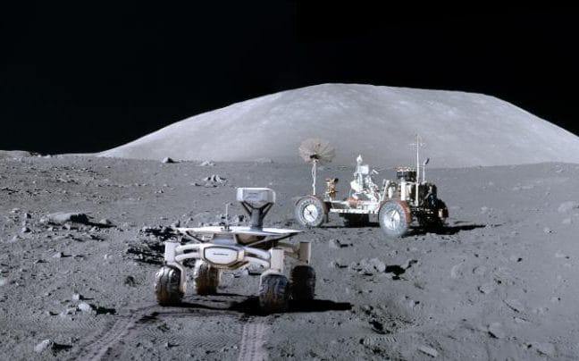
The spacecraft will land two miles from the Apollo 17 site then rovers will be deployed to track down Nasa's moon buggy Credit: PTScientists
The site was also chosen because pictures taken by the Apollo 17 team show it is flat, with few stones to slow down the rovers, which are packed with scientific equipment to carry out tests.
On Sunday the group announced it had teamed up with British telecommunications giant Vodafone who will provide the high-speed link up to Earth for the mission.
“This is a crucial first step for sustainable exploration of the solar system” said Robert Boehme, the chief executive of PTScientists.
“In order for humanity to leave the cradle of Earth, we need to develop infrastructures beyond our home planet.
“With Mission to the Moon we will establish and test the first elements of a dedicated communications network on the Moon.”
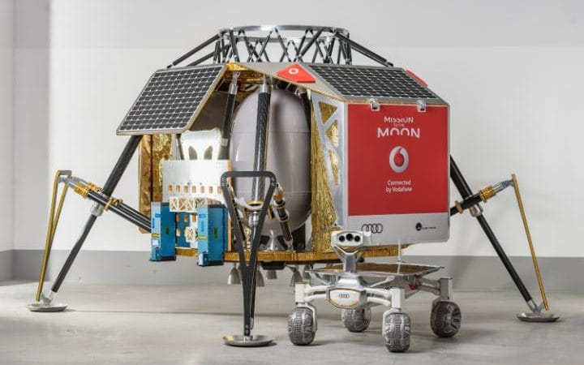
The landing module, Alina, has room for science experiments, and will become a communications base-station for future missions Credit: PTScientists
The launch will come ten years after the team started work on its Autonomous Landing and Navigation Moduline (Alina) and Audi lunar quattro rovers. The team worked with Audi to build the solar powered rovers which will trundle across the lunar surface at around 2.2 mph (3.6kmph) and have stereo cameras capable of taking 3D images, as well as a third camera to record video and capture panoramic images.
The Alina spacecraft will also be carrying scientific experiments from researchers in the US. Canada and Sweden.
“We will be collecting a lot of scientific data on the Moon and the high-speed data connectivity will enable the rovers to communicate with Alina to send that valuable data back to Earth,” said ” said electrical engineer and rover driver Karsten Becker.
“Our rovers are packed with sensors and equipped with high definition cameras.”
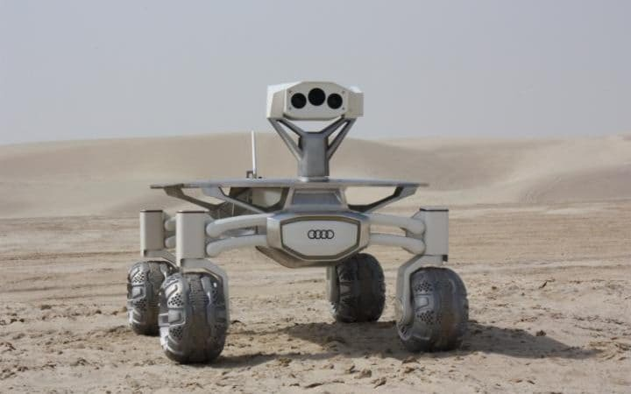
The rovers have been built by Audi and include stereo cameras to capture images in 3D Credit: PTScientists
However the team could still lose the space race to five other companies who are competing for the Google Lunar X Prize, a $20 million competition to become the first team to put a probe on the Moon, have it travel at least a third of a mile (500 metres) and send live video and photos back to Earth.
To qualify for the prize the probe has to be launched by the end of this year and teams from Israel, Japan and the US are in the running.
PTScientists were ruled out of the prize because they could not secure a launch date until 2018, but they are still hoping to be the first. And they are the only group which is planning to build a working communications infrastructure on the Moon, which can make ‘make humanity a fully-fledged space-faring species.’
“With this this step we are laying the groundwork for all future moon missions to come,” said Hannes Ametsreiter, Chief Executive of Vodafone Germany.
“When Elon Musk sends his first private passengers to Orbit the Moon in 2018 or ESA opens the doors of its moon village our Vodafone network will already be there.”
Black Hole Ejected from Center of Galaxy
A supermassive black hole heftier than 1 billion suns has been ejected from the core of its galaxy by gravitational waves, a new study suggests.
The monster black hole has already zoomed 35,000 light-years away from its galaxy's center, farther than Earth and its sun are from the core of our own Milky Way. And the behemoth is currently traveling outward at 4.7 million mph (7.6 million km/h) — fast enough for the black hole to escape its galaxy completely in 20 million years, researchers said.
“We estimate that it took the equivalent energy of 100 million supernovae exploding simultaneously to jettison the black hole,” study co-author Stefano Bianchi, from Roma Tre University in Italy, said in a statement.
The study team used NASA's Hubble Space Telescope to study the galaxy 3C186, which lies about 8 billion light-years from Earth. Hubble images revealed a quasar — the incredibly bright energetic signature of a supermassive black hole — within the galaxy.
That's not surprising; most if not all galaxies harbor supermassive black holes at their cores. But 3C186's quasar is not at its galaxy's core. Indeed, it's farther away from the center than any such black hole ever observed, researchers said.
Why did this strange object go rogue? Hubble data also revealed that 3C186 has arc-like features called tidal tails, which are generated by gravitational forces during galaxy mergers. Based on this observation and theoretical work, the study team thinks everything started with the collision of two galaxies 1 to 2 billion years ago.
The two galaxies' central black holes circled closer and closer to each other during the collision. As this happened, the black holes emitted gravitational waves — the ripples in space-time first proposed by Albert Einstein a century ago, and first detected directly last year by the Laser Interferometer Gravitational-Wave Observatory (LIGO) project.
This gravitational-wave emission occurred preferentially in one direction, the idea goes. When the two central black holes finally merged, this emission stopped, and the newly created leviathan rocketed off in the opposite direction.
"If our theory is correct, the observations provide strong evidence that supermassive black holes can actually merge," Bianchi said in the same statement. "There is already evidence of black hole collisions for stellar-mass black holes, but the process regulating supermassive black holes is more complex and not yet completely understood."
The new study, which also incorporates data from the Sloan Digital Sky Survey and NASA's Chandra X-ray Observatory, will be published next week in the journal Astronomy & Astrophysics. You can read it for free on the online preprint site arXiv.org.

The Molenbeek Muslims

Police have uncovered 51 organisations with suspected terrorist ties in the migrant-dominated Molenbeek district of Brussels, according to a new report into anti-terror measures.
Belgium’s Interior Minister Jan Jambon promised to “clean up” the now-notorious municipality, which has a reputation for being a jihadi safe-haven, after authorities discovered the Brussels commune acted as a hub for many of the suspects involved in the Paris and Brussels terror attacks.
The confidential report revealed that under the Channel Plan, police have carried out door-to-door checks on more than 8,600 houses and 22,668 inhabitants — a quarter of all Molenbeek residents — in the last year, in a bid to tighten security.
Under the Channel Plan, which began a year ago and added 300 officers and €39 million to the force, police have produced a list of 72 terror suspects — 26 of whom live in Syria or Iraq and 46 who live in Belgium.
Of Belgium-based jihadists identified, 20 are incarcerated while the other 26 are “closely monitored” by authorities. However, the report revealed that only five of the terror suspects listed are being accompanied by deradicalisation staff.
In total, 6,168 people in Molenbeek are being monitored.
The Channel Plan also had police review the 1,617 NGOs and nonprofit groups situated in the district, with the report revealing police found at least 51 of these had links to terrorism and radical Islam and uncovered a further 102 which were associated with crime.
But deputy mayor of Molenbeek, Ahmed El Khannouss, is among voices who have condemned the “clean up” of the district, branding the Channel Plan “wicked and unjustified”.
“We thought we had overcome such practices [as inspecting mosques] since the Second World War when people were singled out for their religion — a thing which led to one of the worst ignominies of history,” he wrote in an open letter to Mr. Jambon.
The Union of Mosques of the Brussels Region (UMRB) and the Platform of Muslims of Belgium (PMB), too, attacked the programme, writing: “[Police] checks have been carried out with unjustifiable brutality. The prejudices and generalisations we see are not only harmful to our community but society as a whole.”
The groups argued that mosque inspections result in Muslim groups in Belgium feeling “stigmatised” and like they are the victim of “hatred and rejection” from non-Muslims in Belgium.
However, in February, a report by Belgium’s Coordination Unit for Threat Analysis (OCAD) warned radical Islam is spreading in the nation to the detriment of moderate Islam, and empowering extremist and jihadist groups.
Used Car Market is Crashing
Used Market Update
In a reversal of what typically occurs in February, wholesale prices of used vehicles up to eight years old fell substantially last month, dropping 1.6% compared to January. The drop was counter to the 1% increase expected for the month and marked just the second time in the past 20 years prices fell in February (last years’ scant 0.2% being the other instance).
NADA Used Car Guide’s seasonally adjusted used vehicle price index fell for the eighth straight month, declining 3.8% from January to 110.1. The drop was by far the worst recorded for any month since November 2008 as the result of a recession-related 5.6% tumble. February’s index figure was also 8% below February 2016’s 119.4 result and marked the index’s lowest level since September 2010.

Incentives Jump by 18.1%
Automakers grew incentive spending once again in February, making it the 23rd month in a row where spending was increased. On average, spending reached $3,594 per unit versus $3,043 per unit in February 2016 according to Autodata.

Among the U.S. Big Three, GM raised incentives by 27.4% in February to an average of $5,125 per unit. Spending at Ford Motor Company rose by 20.9% to $4,012 per unit, while FCA increased incentives by 10.6% to $4,365.

As for Import automakers, Toyota Motor Sales raised incentives by 7.9% in February, reaching an average of $2,267 per unit. American Honda grew incentives by 26.6% to $1,886, while Nissan North America increased spending by 20.1% to $4,080 for the month.

Inventory Falls to 74 Days
Compared to January, days’ supply fell by 11 days in February, landing at 74 days for the period. Looking back, February 2016 saw a supply of only 69 days according to Wards Auto.

GM’s supply reached 91 days over the month, due largely to Buick’s industry high 167-day inventory. Ford Motor Company’s supply fell to 78 days, while FCA’s inventory dropped to 83 days.

Toyota Motor Sales’ supply decreased to a lean 67 days, matching Nissan’s figure for 67 days for the month. Meanwhile, inventory for Honda fell to 74 days. Subaru’s 38 days of supply remained lowest in the industry.

As for luxury automakers, BMW’s inventory fell to 46 days, while Daimler inventory remained unchanged versus January at 44 days’ supply. Cadillac’s inventory of 107 days was the highest in the luxury sector, while Tesla’s two days was the lowest.
Desutche Bank is gravely concerned...
We’ve grown increasingly concerned about U.S. Used Vehicle Pricing down 7.7% yoy during February, per NADA. A decline in used prices has been widely anticipated given a significant increase in used vehicle supply (off-lease vehicles). But the magnitude of the recent drop was nonetheless surprising (February’s drop was largest recorded for any month since Nov. 2008). NADA cited a number of factors contributing to the drop, including an increase in late model auction supply from rental fleets, and delayed tax refunds. Used prices have a significant impact on New Vehicle demand/pricing through their effect on affordability (most new car purchases involve a trade-in).
Noboby has any money left to buy a used car. But, a loan for a new car is as easy as 1,2,3!
Nothing down. No credit check. 500 monthly payments. Easy credit!

paid $33K for my model year 2000 Grand Cherokee… at the end of 1999.
Still have it and sometime within the next year it will turn over 50K miles,
Shove that up your used car market.
.. BTW.. it cannot be hacked by anyone and I can drive it over most road obstacles.. you know like curbs,
belligerent Trump protesters and such.

Human Intention Measurement
Three different studies, done by different teams of scientists proved something really extraordinary. But when a new research connected these 3 discoveries, something shocking was realized, something hiding in plain sight.
Human emotion literally shapes the world around us. Not just our perception of the world, but reality itself.
In the first experiment, human DNA from a donor subject was isolated in a sealed container in one room, The test subject was placed in an adjacent room. Scientists gave the donor subject emotional stimulus and fascinatingly enough, the emotions affected their DNA in the other room.
In the presence of negative emotions the DNA tightened. In the presence of positive emotions the coils of the DNA relaxed.
The scientists concluded that “Human emotion produces effects which defy conventional laws of physics.” This was more than spooky action at a distance. This was communication between the test subject and their DNA in a dish in the other room.
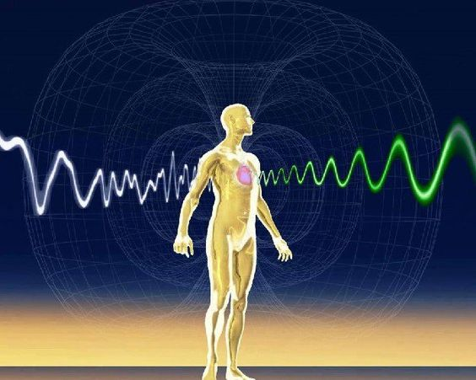
In the second, similar but unrelated experiment, different group of scientists extracted Leukocytes (white blood cells) from donors and placed into chambers so they could measure electrical changes.
In this experiment, the donor was placed in one room and subjected to “emotional stimulation” consisting of video clips, which generated different emotions in the donor.
The DNA was placed in a different room in the same building. Both the donor and his DNA were monitored and as the donor exhibited emotional peaks or valleys (measured by electrical responses), the DNA exhibited the IDENTICAL RESPONSES AT THE EXACT SAME TIME.
There was no lag time, no transmission time. The DNA peaks and valleys EXACTLY MATCHED the peaks and valleys of the donor in time.
The scientists wanted to see how far away they could separate the donor from his DNA and still get this effect. They stopped testing after they separated the DNA and the donor by 50 miles and STILL had the SAME result. No lag time; no transmission time.
The DNA and the donor had the same identical responses in time. The conclusion was that the donor and the DNA can communicate beyond space and time.
The third experiment proved something pretty shocking!
Scientists observed the effect of DNA on our physical world.
Light photons, which make up the world around us, were observed inside a vacuum. Their natural locations were completely random.
Human DNA was then inserted into the vacuum. Shockingly the photons were no longer acting random. They precisely followed the geometry of the DNA.

Scientists who were studying this, described the photons behaving “surprisingly and counter-intuitively”. They went on to say that “We are forced to accept the possibility of some new field of energy!”
They concluded that human DNA literally shape the behavior of light photons that make up the world around us!
So when a new research was done, and all of these 3 scientific claims were connected together, scientists were shocked.
They came to a stunning realization that if our emotions affect our DNA and our DNA shapes the world around us, than our emotions physically change the world around us.
And not just that, we are connected to our DNA beyond space and time.
We create our reality by choosing it with our feelings.
Science has already proven some pretty MINDBLOWING facts about The Universe we live in. All we have to do is connect the dots.
ObamaGate Blows Wide Open
Wednesday, the House Intelligence Chairman Rep. Devin Nunes (R-CA) said the U.S. intelligence community “incidentally collected” information on President Donald Trump transition team.
Nunes said, “So first I recently confirmed that on numerous occasions, the intelligence community incidentally collected information about U.S. citizens involved in the Trump transition. Details about U.S. persons associated with the incoming administration, details with little or no apparent foreign intelligence value were widely disseminated in intelligence community reporting. Third, I have confirmed that additional names of Trump transition team members were unmasked. And fourth and finally I want to be clear, none of this surveillance was related to Russia or the investigation of Russian activities or of the Trump team.”
When asked by Breitbart News if he could rule out any involvement of senior members of the Obama administration, Nunes replied, “No, we cannot.”
Nunes briefed President Donald Trump at the White House this afternoon, speaking to reporters immediately after the meeting.
He confirmed that the new intelligence had nothing to do with the FBI investigation into Russia, but that it was picked up in normal intelligence efforts.
“What I’ve read bothers me, and I think it should bother the president himself and his team, because I think some of it seems to be inappropriate,” he said.
Nunes said that Trump was “concerned” by the news, “And he should be.”
“I don’t think the American people would be comfortable with it,” he said when asked to characterize the nature of the intelligence.
Nunes said that some of the information was communicated to him by intelligence sources.
“We’ve been asking for people to come forward and they came through the proper channels … I’m just going to leave it at that,” he said.
He added that the National Security Agency was “cooperating very very well” with the ongoing investigation.
Nunes recalled his recent confirmation that information on members of the Trump transition team had been incidentally collected by the intelligence community on numerous occasions. “Details about U.S. persons associated with the incoming administration, details with little or no apparent foreign intelligence value, were widely disseminated in intelligence community reporting.”
“Third, I have confirmed that additional names of Trump transition team members were unmasked,” said Nunes. When later asked by reporters if the President was also included in the incidental collection of information, Nunes replied, “Yes.” In response to another reporter, Nunes said “it’s possible” that Trump’s personal communication was collected.
Rep. Nunes later went on to say of “dozens” of reports he has seen thus far, “I have seen intelligence reports that clearly show that the President-elect and his team were, I guess, at least monitored and disseminated out in intelligence in what appears to be…intelligence reporting channels.” He added that he is, however, awaiting further information.
The representative’s fourth point was emphatic, “…none of this surveillance was related to Russia or the investigation of Russian activities or of the Trump team.”
He made clear that the House Intelligence Committee will investigate surveillance of Trump associates and subsequent dissemination of information gathered. He stated that the goal is to determine:
Who was aware of it
Why it was not disclosed to Congress
Who requested and authorized the additional unmasking
Whether anyone directed the intelligence community to focus on Trump associates
Whether any laws, regulations, or procedures were violated
Nunes said that he believes the collection was done legally, but questions remain as to unmasking and the dissemination list of information collected during the transition during the months of November, December, and January.
Rep. Nunes characterized the information that was collected as “A lot of it appears like it was…it was essentially a lot of information on the President-elect and his transition team and what they were doing.”
He said he has asked the Directors of FBI, NSA, and CIA to “expeditiously comply” with his March 15 letter and provide a full account of such surveillance activities. Nunes called the NSA very, very helpful. He expects additional information to come on Friday.
Rep. Nunes said he has not seen any information that has anything to do with Russia or the Russian investigation. He said that while he expects more information and did not make an absolute determination on how the information was collected, “It was not criminal, it was normal, foreign surveillance is what it looked like to me, but let’s wait until we get all the information.”
“This appears to be all legally collected foreign intelligence under FISA, where there was incidental collection that then ended up in reporting channels and that was widely disseminated,” said Nunes.
Rep. Nunes said he was surprised and alarmed by the discovery of this information, “because we went through this about a year and a half ago as it related to members of Congress…”
"And I'll tell you, NSA is being cooperative," Nunes continued, "but so far the FBI has not told us whether or not they’re going to respond to our March 15th letter, which is now a couple of weeks old.”
Nunes also reported that as of now, he "cannot rule out" President Obama ordering the surveillance.
Finally, and contrary to earlier media reports, Nunes clarified that the surveillance was not related to the FBI's investigation into possible collusion with Russia. This surveillance, he emphasized to reporters, does not "have anything to do with Russia." As a reminder, this has been the strawman argument proposed by much of the liberal media, which has said that a wiretapping of Trump or his aides, would only confirm that his relations with Russia were suspect and thus prompted a FISA warrant.
If Nunes is correct, and Trump was being wiretapped for reasons having nothing to do with Russia, that entire narrative falls apart, and the press will now have to spend the next few weeks building up an entirely new narrative to "justify" why Trump was being wiretapped on Obama's watch.

Nunes stated that he would travel to the White House in the afternoon to share the new information he has with President Trump. Afterward, he shared his discovery with the American people, sending Democrats into a frenzy of hate and calls for the public execution of Nunes. 150 million Americans now know that Obama used the full intelligence power of the US government to overthrow Trump before he was confirmed. Obama has been fleeing the press through a series of foreign countries ever since the near miss in the Caribbean’s largest drug bust in history aboard the Lady Michelle. Obama’s staff, traveling with him, tried unsuccessfully to reach the Lady Michelle while it was at sea before the rendezvous was interrupted by the US Coast Guard, ordered by US Attorney general Jeff Sessions. Obama escaped just hours before the boat arrived, being towed with $150 million in cocaine aboard. He has been traveling aboard his chartered jet ever since to Polynesia and then Tahiti.
NASA May Have Found the Fountain of Youth
Can the fountain of youth be found in the form of a pill? That’s what startup Elysium Health believes.
The company is led by its chief scientist and co-founder, Leonard Guarente, who heads the anti-aging center at MIT. It’s through his research and direction that Elysium is banking on this product having a positive impact on extending the lives of people who take the supplement. The company’s lead product is called Basis, which Elysium says is used for metabolic repair and optimization. On its website, the company said science is enabling the company to focus on “the cellular level to achieve optimal health, beyond what can be accomplished with diet and exercise.” Its product Basis is designed to optimize NAD+ levels and sirtuin function in cells to support several metabolic processes, such as cellular detoxification, DNA repair and energy production.
The active ingredients in Basis pterostilbene and NR are naturally occurring substances, which has allowed the company to bypass regulation from the Food and Drug Administration and market the product. That doesn’t mean Guarente wants the company to avoid scientific research. On the contrary. In an interview with New York Magazine, Guarente said he insists the company conduct human trials and testing on the product.
“Never, ever, make a claim that’s not substantiated by evidence,” he said, according to the magazine.
Elysium has an impressive leadership team, particularly the six Nobel Laureates on its scientific advisory team. Despite the scientific pedigree of its team, there are skeptics about whether or not the supplements will benefit one’s health in the long-run and extend life. In a 2015 interview with Business Day Live, Guarente said it would take decades to show the supplement had anti-aging qualities.
The quest for an anti-aging product is nothing new. Last year pharmaceutical giant Novartis (NVS)noted the bacterial agent rapamycin, which was originally discovered on Easter Island, has shown promise in blocking the genetics of aging and aging-related diseases such as cancer, heart disease and Alzheimer’s disease. A 2014 Novartis study of rapamycin showed that elderly patients ages 65 and up showed a 20 percent improvement in their immune response after being given an influenza vaccine. Additionally, the study showed the reduction of PD-1 receptors in patients, which inhibits T-cell signaling.
Novartis isn’t the only company to seek a “fountain of youth” drug solution. Other pharmaceutical companies have attempted to defy the aging process, including a $720 million gamble by GlaxoSmithKline (GSK) that did not pan out. That drug, resveratrol, was acquired from Sirtris Pharmaceuticals, a company that Guarente was involved with. More recently Calico, aGoogle (GOOG) science division specifically targeted at aging, has partnered with Illinois-based AbbVie (ABBV) to reverse engineer the biological aging process in people. The $500 million partnership is slated for a 10-year period to advance its experimental drugs through Phase IIa studies and small mid-stage trials that will establish a likelihood the drugs may work in larger studies.
The company has also set up various relationships with companies like AncestryDNA, the Buck Institute for Age Research in Novato, California, the University of California, San Francisco and the University of California’s QB3 institute. My question is, did the world’s largest human genome project, 23 and me, have anything to do with discovering this breakthrough? Did they find Captain America?
Yeah, I’ve done that
Alan Bean, 85, is one of only 12 people to have taken “one small step for man and one giant leap for mankind” on the moon.
The lunar module pilot was one of two crew members on-board Apollo 12 who walked on the moon days after it launched on November 14, 1969.
The crew’s primary mission objectives included an extensive series of lunar exploration tasks by the lunar module and the deployment of the Apollo Lunar Surface Experiments Package to be left on the moon’s surface to gather seismic, scientific and engineering data.
Mr Bean has logged 1,671 hours and 45 minutes in space — 10 hours and 26 minutes of that were spent on the moon and in Earth’s orbit.
His experiences in space have led Mr Bean to develop some interesting theories about the possibility of alien life.
“I do not believe that anyone from outer space has ever visited the Earth,” Mr Bean told news.com.au from his home in Houston, Texas.
“One of reasons I don’t believe they have been here is that civilisations that are more advanced are more altruistic and friendly — like Earth, which is better than it used to be — so they would have landed and said ‘we come in peace and we know from our studies you have cancer that kills people, we solved that problem 50 years ago, here’s the gadget we put on a person’s chest that will cure it, we will show you how to make it’.
“Just like some day, say 1000 years from now, when we can go to another star and see a planet, that’s what we would do because we will know how to cure cancer, cure birth defects, so we would teach them.”
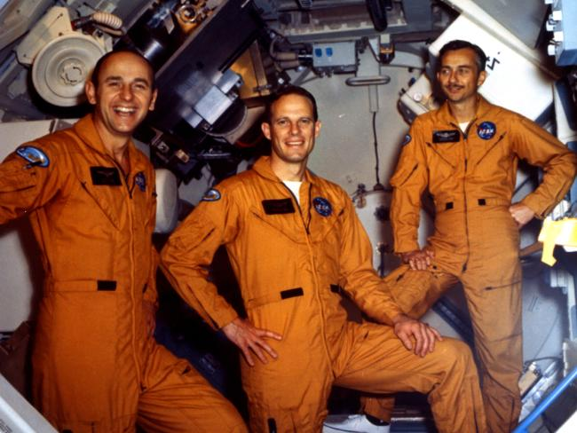
The crew members of Skylab 3: commander and astronaut Alan L. Bean; scientist, pilot and astronaut Owen K. Garriott, and astronaut and pilot Jack R. Lousma. This crew spent 59 days and 11 hours in orbit.Source:Supplied
Mr Bean doesn’t doubt for a second that we are not alone.
“There’s so many billions of stars and these stars have planets around them so there must be statistically many planets around many stars that have formed life,” he said.
“Maybe some of them are like our life was 100,000 years ago, and some of them are like we are now, and there are probably some out there that are a 10,000 years in the future from where we are now.”
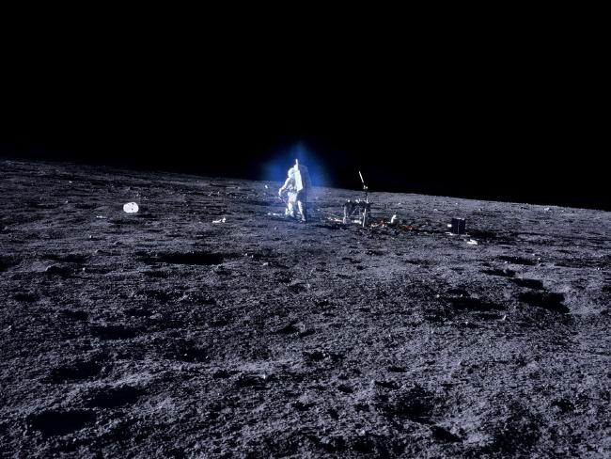
Astronaut Alan Bean on the moon, surrounded by a blue halo caused by vapour emissions from his backpack, featured in Michael Light's 2000 photographic exhibition ‘Full Moon’.Source:News Corp Australia
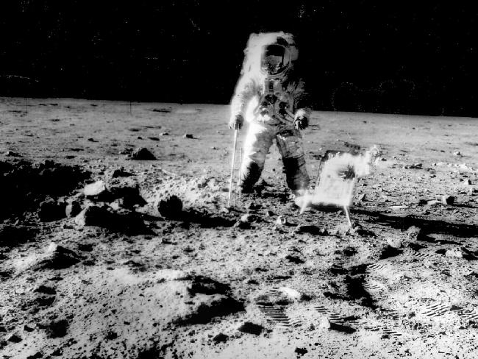
Astronaut Alan Bean on the second manned moon landing mission in November 1969. Picture: November 1969.Source:News Corp Australia
Mr Bean resigned from NASA in 1981 to become an artist. In his paintings he depicts the experiences of astronauts, including himself, who have walked on the moon. It’s a small club but it’s also one that he draws never-ending inspiration from.
“Even if I lived to 185 years old I wouldn’t run out of ideas of things to paint on this topic,” he said.
He uses textured and lunar tools, “sprinkled with bits of Apollo spacecraft and a touch of moon dust” to create his masterpieces, which sell for tens or hundreds of thousands of US dollars each via his website.
“I’m the only person on Earth who can do these paintings (from a first hand perspective),” he said.
“I work seven days a week painting to this day.”
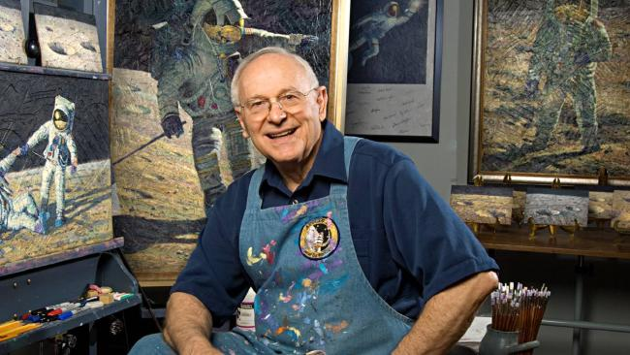
Alan Bean in front of his painting easel at his art studio in Houston, Texas on October 14, 2008. Picture: AFP.Source:AFP
WHAT IT WAS LIKE ON THE MOON
Mr Bean still remembers the first time he saw an “earthrise” from the moon.
“It was hard to believe (we) were 235,189 miles from home,” he said.
“I never heard any astronaut say that he wanted to go to the moon so he would be able to look back and see Earth.
“We all wanted to see what the moon looked like close up. Yet, for most of us, the most memorable sight was not of the moon, but of our beautiful blue and white home, moving majestically around the sun, all alone in infinite black space.”
Mr Bean said the Earth appeared small.
“To think everyone I ever knew, saw on television, or at the Super Bowl, was down there on the skin of that beautiful, colourful sphere,” he said.
“It did not seem possible. (I thought) there is just not enough room, and folks on the bottom will surely fall off.”
He didn’t leave anything personal behind on the moon because, according to him, that would have made him a “bad astronaut”.
The speed of which they travelled on the return trip was something that stunned the former naval aviator, who was used to flying at top speeds of about 600 miles per hour.
“We were travelling at speeds that are difficult for most humans, including us, to really grasp,” he said.
“For example, after a brief 11-minute rocket ride, we were in Earth’s orbit travelling at 17,431 miles per hour.
“That is about 290 times faster than the 60 miles per hour speed limit we drive our cars here on Earth.
“There were no sign posts along the way. As we sped along, we did not zip past any cities, towns, clouds, other spaceships, or anything else, for that matter.
“Except for the first few hours after leaving earth orbit, earth did not seem to move away or get smaller, and the moon did not seem to move toward us or get larger.
“If we waited an hour or so and looked out again, earth would look smaller ... maybe, and the moon would look larger ... maybe.”
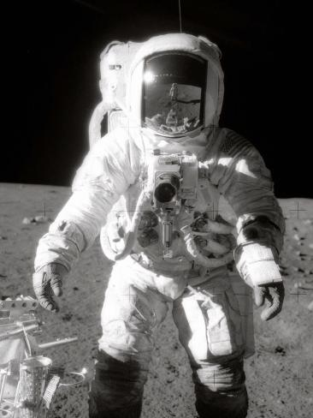
Astronaut Alan L. Bean near a tool carrier during extravehicular activity (EVA) on the Moon’s surface. Commander Charles Conrad Jr., who took the black and white photo, is reflected in Bean's helmet visor.Source:News Limited
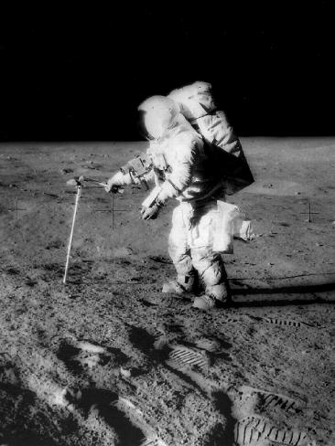
Astronaut Alan Bean taking a core sample on the Moon’s surface in November 1969. Picture: NASA.Source:News Corp Australia
Mr Bean said the main thing he took away from the Apollo 12 mission was that “humans can do a lot of amazing things”.
“President Kennedy said we were going to go to moon by the end of the decade (in the 1960s),” Mr Bean said.
“It was an impossible dream and human beings got behind the whole idea and planned and worked to achieve it.
“I think the most important thing about us going to the moon back in the 60s was not what we invented but the feeling that throughout the world there are humans that can do a lot more than we imagined we could before.
“I know humans will go back again some day.”
Now when Mr Bean looks at the moon at night he fixes his eyes on where he once landed and reflects on how he was apart of something so special.
“It changed my attitude that we were able to do it and I thought a lot more of myself and friends,” he said.
“I thought ‘wow look what we did’.
“Now when I look at the moon, it just seems so far, far away.”
The Sword Robots
Last Wednesday, we ran an analysis from the 2008 RoboBusiness Conference in Pittsburgh that included a comment from an Army Program Manager, Kevin Fahey, about the SWORDS armed unmanned ground vehicle (UGV) system. This program, which resulted in the first armed UGVs to be deployed—specifically, three were deployed in Iraq in June 2007—has been the subject of considerable online rumors, after reports surfaced that the program was in trouble. It's a hot topic for tech bloggers and anyone interested in the future of military robots. Which is probably why our story traveled so fast online—and a big reason why we put SWORDS on the cover of Popular Mechanics earlier this year.
It might also explain why our story was taken so blatantly out of context. What began as a straightforward update about the state of the SWORDS system was repurposed and sensationalized as breaking news about the sudden withdrawal of those three armed robots deployed in Iraq—and as several breaking follow-up reports. Qinetiq, the UK-based company that owns SWORDS-maker Foster-Miller, is disturbed about coverage of our piece, particularly because it appears to be fueling the urban legend of a rogue SWORDS suddenly aiming at hapless humans. But it's not Popular Mechanics that is stoking the fire.
Fahey's comments about SWORDS, particularly his quoted statement that "the gun started moving when it was not intended to move" was not pulled from a sit-down interview with Popular Mechanics. PM's requests for interviews to find out why SWORDS has never fired a shot at a hostile target, despite being in Iraq since last summer, have all been denied by Qinetiq and Foster-Miller. Fahey was answering a question following his keynote presentation at the RoboBusiness Conference, which other members of the press attended. When an audience member asked what happened to SWORDS, Fahey's response was vague, and there was no indication of a timeline in his comments. So the unintended movement he mentioned could have occurred before or after the robot's deployment in Iraq. Still, any answer regarding SWORDS is worth noting, which is why we were suddenly glad to be at an otherwise uneventful robotics conference in western Pennsylvania.
The other Fahey comment we quoted—"once you've done something that's really bad, it can take 10 or 20 years to try it again"—appeared to be in the context of why he believes the military has treaded so lightly with armed ground robots. Let's be clear: Fahey was not stating that a SWORDS unit made a blunder that it will take 10 or 20 years to recover from. If anything, Fahey was trying to express the exact opposite: The goal is to avoid an incident that could set military robotics back a decade or more.
Rather than rehashing the history of the SWORDS program and its apparent difficulties, we treated this story as a minor update to the ongoing saga of armed military ground bots. We said that SWORDS was "yanked," and that the three robots were "pulled off the battlefield." Without additional clarification, those sentences were picked up by bloggers looking for a more solid update, and the story took on a mutated life all its own.
Officially, the three SWORDS units deployed to Iraq are still there. While working on that cover story about armed UGVs for PM's March issue, we spoke to sources about the decision not to use the weapons capabilities of those SWORDS units, but no one was willing to be quoted. This is a sensitive issue for the entire industry. When we stated that the robots were pulled off the battlefield, we were talking about their potential use as armed participants in firefights. Qinetiq had no comment about reports that SWORDS units were no longer intended to be used to engage the enemy, and Foster-Miller directed us to the Robotic Systems Joint Project Office. Duane Gotvald, deputy project manager at that office, sent this statement via e-mail:

The Special Weapons Observation Remote Direct-Action System (SWORDS) capability is in theater. The SWORDS robot represents a new technological concept currently in the developmental stage. Three robots have been built so far; and while there has been considerable interest in fielding the system, some technical issues still remain and SWORDS is not currently funded. The U.S. Army's 3rd Infantry Division has used the robots for surveillance and peacekeeping/guard operations. The robot is armed with Squad Automatic Weapon (SAW), M249 Light Machine Gun, and has not yet been used with this weapon in combat.
The fact that SWORDS lost its funding after just three units were deployed is, to us, the definition of a program that was "yanked." Some bloggers used our shorthand to drum up a new SWORDS-related event. In addition, we did not state that SWORDS had pointed a gun at anyone, but that's how some commentators have recast the story. Every UGV maker we've spoken to has stressed the importance of having a "man in the loop" when dealing with armed robots. As Predator drones have proven, an unmanned vehicle is capable of friendly fire, but the decision to engage will always be made by a human operator.
When Qinetiq contacted us about the article, we asked for an official statement to post about the status of SWORDS. It's essentially the same information that has been released previously about SWORDS, and recently posted by Danger Room, but here it is, in the company's words:

• SWORDS is currently deployed in Iraq, and has been there uninterrupted for almost a year.
• There have been no instances of uncommanded or unexpected movements by SWORDS during this period, whether in-theatre or elsewhere. A few years ago during the robot's development, there were three minor movement issues that were expected, identified and addressed during rigorous stateside testing—prior to the Army's Safety Confirmation back in 2006. Here is what actually happened:
- One uncommanded movement was caused by a loose wire (result: redundant wiring on every circuit).
- One was caused by a solder break (result: double solder).
- The third, which may not even count, was a test of the robot sitting on a 45-degree incline in 90-degree heat to see how long it would last. After about two hours and 30 minutes, the motor started to overheat and shut down so it wouldn't burn out. That caused SWORDS to start to slide backward down the incline. The operator stopped it.
Any comments made after this timeframe about setbacks related to the robotics industry were hypothetical—never in response to some nonexistent SWORDS incident after the Safety Confirmation.
Although others have used our story to generate a false online rumor about these armed UGVs, the nature of those "technical issues" that Gotvald mentioned in his statement, and that Qinetiq and Foster-Miller have yet to address directly, remains a mystery. Until someone can explain why SWORDS lost its funding, and what exactly it is—and isn't—being used for in Iraq, the rumors are likely to continue. If this is the dawn of the era of robotic infantry, things are off to a decidedly rocky start. —Erik Sofge
UPDATE (April 15): We just received a statement from Robert Quinn, vice president of TALON Robot Operations for Foster-Miller, in response to our query concerning any withdrawal of funding for SWORDS—and whether the robot's weapons would be used in live combat against hostile targets:

