Jihad Report
May 20, 2017 -
May 26, 2017
Attacks | 52
Killed | 358
Injured | 485
Suicide Blasts | 11
Countries | 14
Surviving a Nuclear Attack
The first thing you'd see if a nuclear bomb exploded nearby is a flood of light so bright, you may think the sun blew up.
Wincing from temporary blindness, you'd scan the horizon and see an orange fireball. The gurgling flames would rise and darken into purple-hued column of black smoke, which would turn in on itself. As a toadstool-like mushroom took shape, the deafening shock front of the blast would rip through the area — and possibly knock you off your feet.
Congratulations! In this hypothetical scenario, you've just survived a nuclear blast with an energy output of about 10 kilotons (20 million pounds) of TNT. That's roughly 66% of energy released by either atom bomb dropped on Japan in 1945.
The fireball of a nuclear explosion. Public domain
This scenario may sound far-fetched, but more than 14,900 nuclear weapons exist in the world, and kiloton-class nukes (like the one we just described) are now proliferating in weapons stockpiles. In fact, a 10-kiloton-or-less nuclear detonation by a terrorist is the first of 15 disaster scenarios that the US government has planned for.
No one could fault you for panicking after the sight and roar of a nuclear blast. But there is one thing you should never do, according to Brooke Buddemeier, a health physicist and radiation expert at Lawrence Livermore National Laboratory.
"Don't get in your car," he tells Business Insider — don't try to drive, and don't assume that the glass and metal of a vehicle can protect you.

Why vehicles and nuclear survival don't mix
Avoiding driving after a nuclear blast is wise because streets would probably be full of erratic drivers, accidents, and debris. But Buddemeier says there's another important reason to ditch the car: a fearsome after-effect of nuclear blasts called fallout.
Fallout is a complex mixture of fission products, or radioisotopes, that are created by splitting atoms. Many of the fission products decay rapidly and emit gamma radiation, an invisible yet highly energetic form of light. Exposure to too much of this radiation in a short time can damage the body's cells and its ability to fix itself — a condition called acute radiation sickness.
"It also affects the immune system and the your ability to fight infections," Buddemeier says.
Only very dense and thick materials, like many feet of dirt or inches of lead, can reliably stop the fallout.
"The fireball from a 10-kiloton explosion is so hot, it actually shoots up into the atmosphere at over 100 miles per hour," Buddemeier says. "These fission products mix in with the dirt and debris that's drawn up into the atmosphere from the fireball."
Trapped in sand, dirt, cement, metal, and anything else in the immediate blast area, the gamma-shooting fission products can fly more than five miles into the air. The larger pieces drop back down, while lighter particles can be carried by the wind before raining over distant areas.
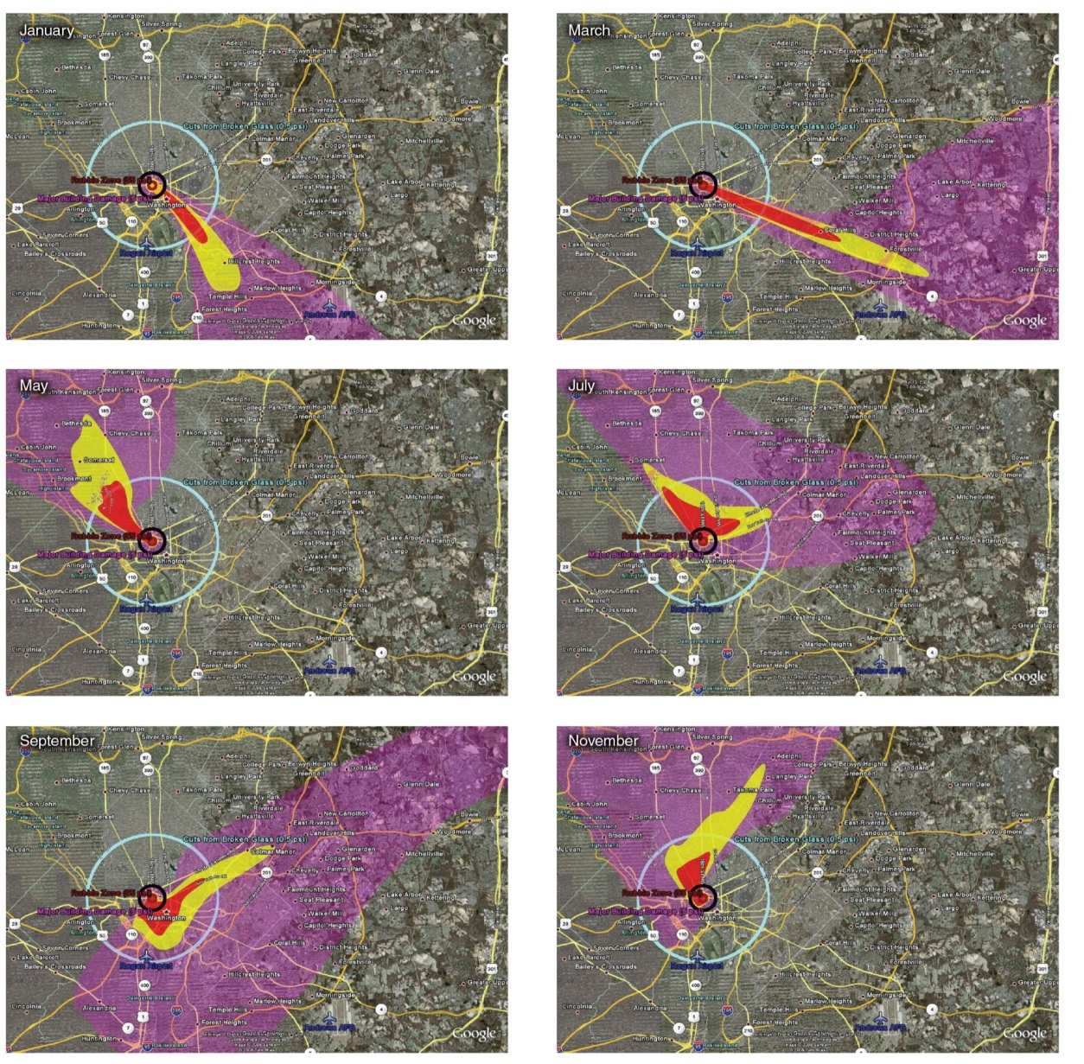A simulation of nuclear fallout conditions over Washington DC at different times of the year. Bruce Buddemeier/Lawrence Livermore National Laboratory
"Close in to the [blast] site, they may be a bit larger than golf-ball-size, but really what we're talking about are things like salt- or sand-size particles," Buddemeier says. "It's the penetrating gamma radiation coming off of those particles that's the hazard."
Which brings us back to why a car is a terrible place to take shelter.
"Modern vehicles are made of glass and very light metals, and they offer almost no protection," he says. "You're just going to sit on a road some place [and be exposed]."
Buddemeier says he's asked people what their knee-jerk response to a nuclear blast might be. It wasn't comforting.
"There was actually a lot of folks who had this notion — and it may be a Hollywood notion — of 'oh, jump in the car and try to skedaddle out of town if you see a mushroom cloud.'" he says.
However, fallout is carried by high-altitude winds that are "often booking along at 100 miles per hour," he says, and "often not going in the same direction as the ground-level winds. So your ability to know where the fallout's gonna go, and outrun it, are… Well, it's very unlikely."

What you should do instead of driving
The protection factor that various buildings, and locations within them, offer from the radioactive fallout of a nuclear blast. The higher the number, the greater the protection. Lawrence Livermore National Laboratory
Your best shot at survival after a nuclear disaster is to get into some sort of "robust structure" as quickly as possible and stay there, Buddemeier says. He's a fan of the mantra "go in, stay in, tune in".
"Get inside ... and get to the center of that building. If you happen to have access to below-ground areas, getting below-ground is great," he says. "Stay in: 12 to 24 hours."
The reason to wait is that levels of gamma and other radiation fall off exponentially after a nuclear blast as "hot" radioisotopes decay into more stable atoms and pose less of a danger. This slowly shrinks the dangerous fallout zone — the area where high-altitude winds have dropped fission products. (Instead of staying put, however, a recent study also suggested that moving to a stronger shelter or basement may not be a bad idea if you first ducked into a flimsy one.)
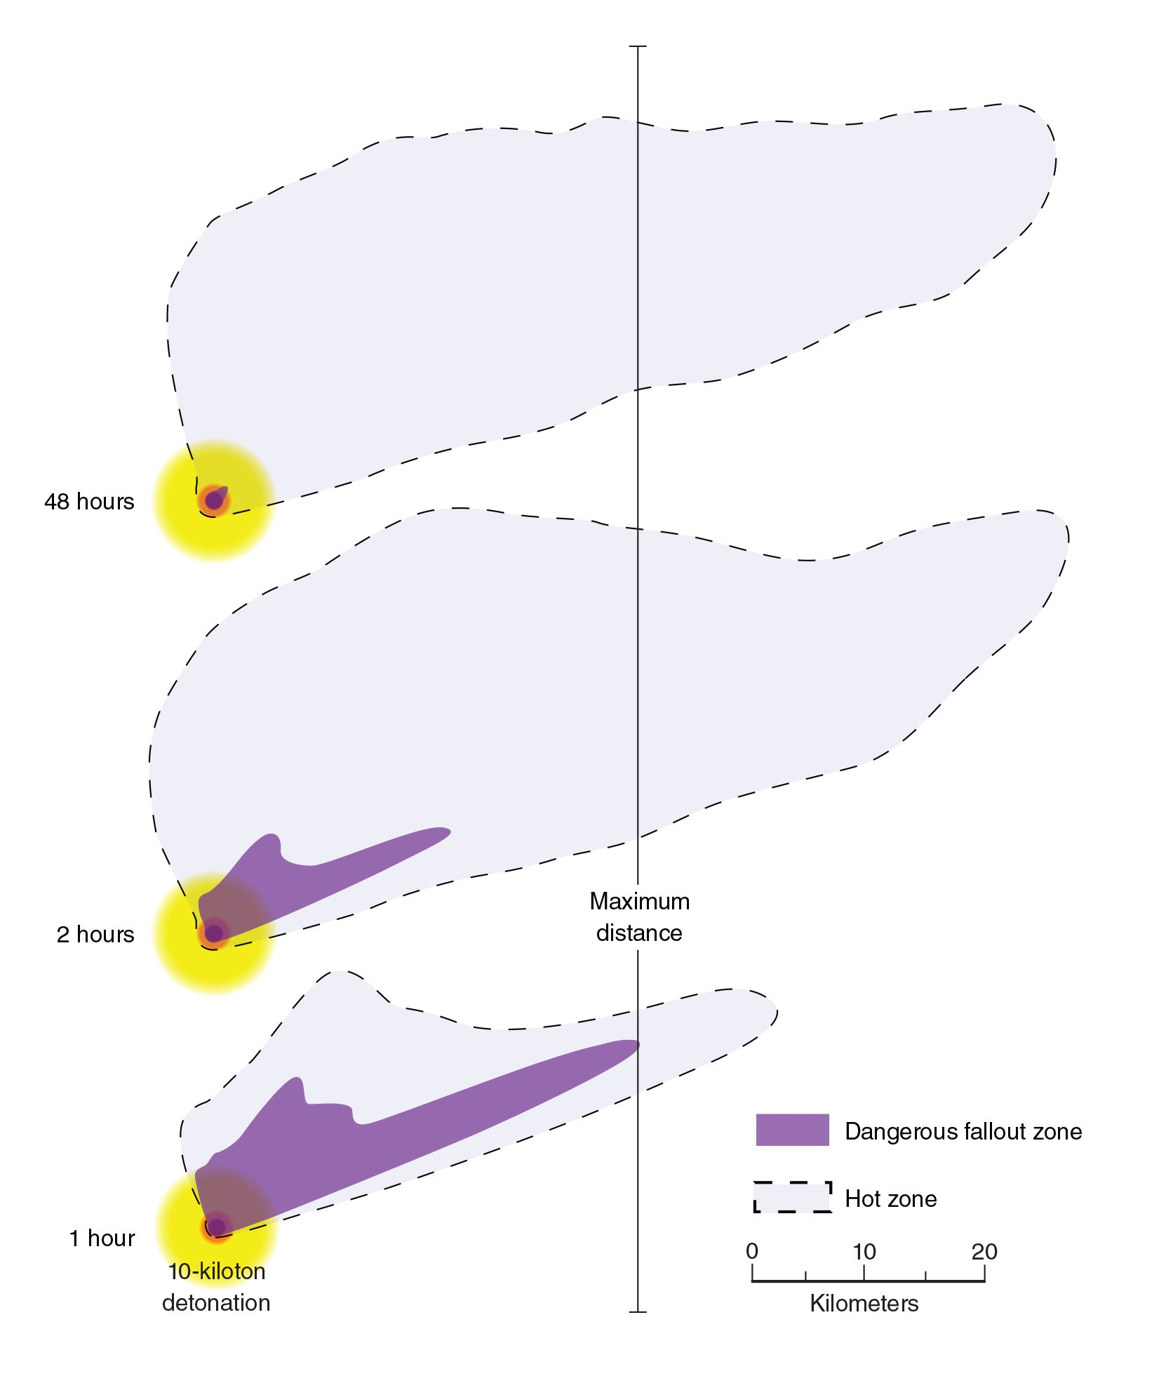The dangerous fallout zone (dark purple) shrinks quickly, while the much less dangerous hot zone (faint purple) grows for about 24 hours before shrinking back. Bruce Buddemeier/Lawrence Livermore National Laboratory
Finally, tune in.
"Try to use whatever communication tools you have," he says. He added that a hand-cranked radio is a good object to keep at work and home, since emergency providers, in addition to broadcasting instructions, will be tracking the fallout cloud and trying to broadcast where any safe corridors for escape are located.
There is only one exception to the "no cars" rule, says Buddemeier: If you're in a parking garage with your car, the concrete might act as a shield. In that case, you could stay there and listen to a radio inside your car.
If everyone followed these guidelines after nuclear blast, he says, hundreds of thousands of lives could be saved.
Fraulein Shultz Threatens Police
Rep. Debbie Wasserman Schultz threatened the chief of the U.S. Capitol Police with “consequences” for holding equipment that she says belongs to her in order to build a criminal case against a Pakistani staffer suspected of massive cybersecurity breaches involving funneling sensitive congressional data offsite.

The Florida lawmaker used her position on the committee that sets the police force’s budget to press its chief to relinquish the piece of evidence Thursday, in what could be considered using her authority to attempt to interfere with a criminal investigation.
The Capitol Police and outside agencies are pursuing Imran Awan, who has run technology for the Florida lawmaker since 2005 and was banned from the House network in February on suspicion of data breaches and theft.

“My understanding is the Capitol Police is not able to confiscate Members’ equipment when the Member is not under investigation,” Wasserman Schultz said in the annual police budget hearing of the House Committee On Appropriations’ Legislative Branch Subcommittee.
“We can’t return the equipment,” Police Chief Matthew R. Verderosa told the Florida Democrat.
“I think you’re violating the rules when you conduct your business that way and you should expect that there will be consequences,” Wasserman Schultz said.
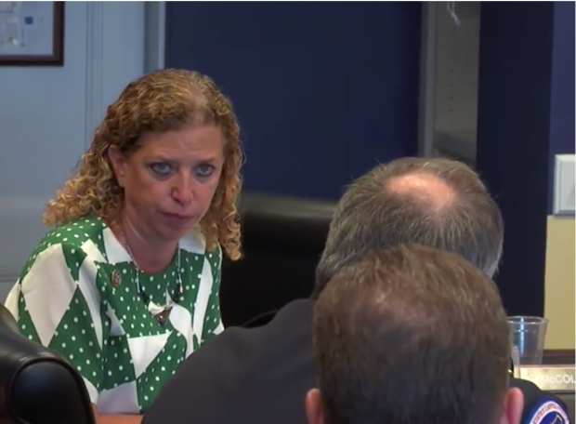
Rep. Wasserman Schultz promises “consequences” for Capitol Police chief investigating her staffer. (Screen shot/House Committee on Appropriations video)
As one of eight members of the Committee on Appropriations’ Legislative Branch subcommittee, Wasserman Schultz is in charge of the budget of the police force that is investigating her staffer and how he managed to extract so much money and information from members.
In a highly unusual exchange, the Florida lawmaker uses a hearing on the Capitol Police’s annual budget to spend three minutes repeatedly trying to extract a promise from the chief that he will return a piece of evidence being used to build an active case.

“If a Member loses equipment and it is found by your staff and identified as that member’s equipment and the member is not associated with any case, it is supposed to be returned. Yes or no?” she said.

Police tell her it is important to “an ongoing investigation,” but presses for its return anyway.
A federal employee with knowledge of the situation and who requested anonymity told The Daily Caller News Foundation’s Investigative Group that as House authorities closed in on Imran Awan and his brothers, a laptop used by Imran was hidden in an unused crevice of the Rayburn House Office Building. Wasserman Schultz’s office is in Longworth House Office Building, a separate structure.

The laptop was later found by Capitol Police and seized because it was relevant to the criminal investigation, the source said. The investigation is examining members’ data leaving the network and how Awan managed to get Members to place three relatives and a friend into largely no-show positions on their payrolls, billing $4 million since 2010.

The congresswoman characterizes the evidence as “belonging” to her and argues that therefore it cannot be seized unless Capitol Police tell her that she personally, as opposed to her staffer, is a target of the investigation.
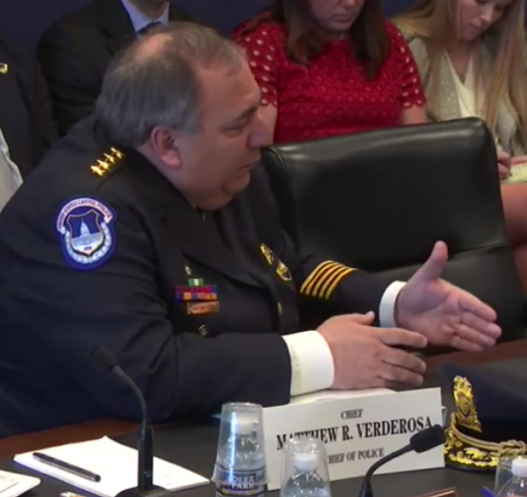
US Capitol Police Chief Matthew R. Verderosa. (Screen shot/House Committee on Appropriations video)

When TheDCNF asked Wasserman Schultz Monday if it could inquire about her strong desire for the laptop, she said “No, you may not.” After TheDCNF asked why she wouldn’t want the Capitol Police to have any evidence they may need to find and punish any hackers of government information, she abruptly turned around in the middle of a stairwell and retreated back to the office from which she had come.

Her spokesman, David Dameron, then emerged to say “We just don’t have any comment.”
Though on the surface Wasserman Schultz would have been a victim of Awan’s scam, she has inexplicably protected him, circumventing the network ban by re-titling him as an “adviser” instead of technology administrator.

Politico described him and his wife, Hina Alvi, as having a “friendly personal relationship” with both Wasserman Schultz and Rep. Gregory Meeks of New York.
That baffled a Democratic IT staffer, who said “I can’t imagine why she’d be that good of friends with a technology provider.”
“Usually if someone does bad stuff, an office is going to distance themselves” rather than incur political fallout for a mere staffer, he added.

Wasserman Schultz resigned as Chairman of the Democratic National Committee in 2016 after Wikileaks published thousands of internal emails obtained by an as-yet unidentified hacker.

Asteroid Mining
NASA scientists are outdoing themselves yet again: by reworking the planned route for a robotic mission to a giant asteroid worth $10,000 quadrillion, they’ve managed to cut costs, launch sooner and arrive four years earlier than planned. Not bad.
The Psyche planetoid, measuring 240km (149 miles) in diameter, is located in the asteroid belt between Mars and Jupiter and is made almost entirely of iron and nickel.
At current market prices, such an asteroid, a truly unique object in our solar system, is estimated to be worth $10,000 quadrillion ($10,000,000,000,000,000,000). That is, if you could successfully tow it into orbit and then mine it (and find someone to buy all of it, of course). For scale, the entire global economy is worth over $74 trillion.

The Case of a Special Counsel to Investigate the Seth Rich Murder
To listen to the Democratic National Committee, the major media and the Washington, D.C., police department, the murder of Seth Rich last year is a simple case of a random, violent, unsolved street crime in the nation’s capital.
Maybe that’s true.
But there are enough peculiarities about the way this case has been investigated to suggest otherwise.
Here are only a few:
- Police never questioned the slain DNC information technology employee’s co-workers, as would be routine in a homicide investigation.
- Police never questioned the owner and other employees of the bar Rich had left shortly before he was murdered.
- Police never viewed the surveillance cameras in and around the bar that might show if anyone left with Rich or was following him.
- Police in Washington’s overwhelming Democratic city have had a strange relationship with the DNC throughout the investigation. When a private investigator called police to check on progress in the case, he was called back by then DNC Chairwoman Donna Brazile.
- The DNC has provided a media spokesman for the Rich family.
- The DNC has denied any suggestion that Rich may have been working with WikiLeaks on the huge dump of emails released during the campaign last year, insisting, of course, on its narrative of a Russian hack.
In short, the DNC seems to be attempting to guide the police investigation from even considering the possibility that Rich’s murder could have anything to do with his work.
That’s a huge red flag and borders on obstruction of justice considering the total political control Democrats wields over the city.
So, what’s going on here?
Will Rich’s murder be just another unsolved crime for which there is no apparent motive and no suspects?
The concern about a possible cover-up in this case is reaching epidemic proportions throughout the U.S. And the attitude of the so-called “mainstream media” only compounds those concerns.
Why are the media so stridently incurious? Don’t they want to solve the murder by following standard investigatory protocols and by investigating all the possibilities? Why should this murder case be handled differently than every other murder case? Why are the reporters and news organizations and private investigators who ask questions about the lack of progress in the case vilified as “conspiracy theorists”?
And what’s the obvious solution?
In the case of the allegations of Russian involvement in the hacking of the DNC during the 2016 election campaign, a special counsel has been appointed to oversee the investigation.
Yet, after many months of multiple investigations, no evidence of Russian involvement has been produced.
Meanwhile, we have the Seth Rich murder case – seemingly going nowhere, with DNC officials openly restricting the flow of information.
Is it possible Seth Rich could have been involved in leaking DNC emails to WikiLeaks, as even Julian Assange has broadly hinted? Could it be that Rich, and possibly others at the DNC, risked their lives as whistleblowers to reveal scandal within the DNC – only to see their heroic work attributed to Russia for political reasons?
I’m not certain. But I am curious. And I can’t understand why others would attempt to thwart an open and honest murder investigation by narrowing the parameters of the probe. What would be their motivation?
Does that make sense?
That’s my case for a truly independent counsel investigation. This shouldn’t take a year to conduct. After all, it’s a murder case. The focus should be on who was responsible – like any other murder case. Who had the motive, means and opportunity? And all the evidence should be examined without regard to where the investigation leads.
What’s wrong with that?
Why should that even be controversial?
It’s time to conduct a real investigation into the murder of Seth Rich – for his sake, his family’s sake and for the sake of the American people and the principle of equal justice under the law.
To Pop or Not to Pop
The key to bubble analysis is to look at what’s causing the bubble. If you get the hidden dynamics right, your ability to collect huge profits or avoid losses is greatly improved.
Based on data going back to the 1929 crash, this current bubble looks like a particular kind that can produce large, sudden losses for investors.
The market right now is especially susceptible to a sharp correction, or worse.
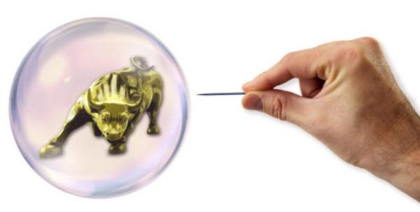
Before diving into the best way to play the current bubble dynamics to your advantage, let’s look at the evidence for whether a bubble exists in the first place…
My preferred metric is the Shiller Cyclically Adjusted PE Ratio or CAPE. This particular PE ratio was invented by Nobel Prize-winning economist Robert Shiller of Yale University.
CAPE has several design features that set it apart from the PE ratios touted on Wall Street.
The first is that it uses a rolling ten-year earnings period. This smooths out fluctuations based on temporary psychological, geopolitical, and commodity-linked factors that should not bear on fundamental valuation.
The second feature is that it is backward-looking only. This eliminates the rosy scenario forward-looking earnings projections favored by Wall Street.
The third feature is that that relevant data is available back to 1870, which allows for robust historical comparisons.
The chart below shows the CAPE from 1870 to 2017. Two conclusions emerge immediately. The CAPE today is at the same level as in 1929 just before the crash that started the Great Depression. The second is that the CAPE is higher today than it was just before the Panic of 2008.
Neither data point is definitive proof of a bubble. CAPE was much higher in 2000 when the dot.com bubble burst. Neither data point means that the market will crash tomorrow.
But today’s CAPE ratio is 182% of the median ratio of the past 137-years.
Given the mean-reverting nature of stock prices, the ratio is sending up storm warnings even if we cannot be sure exactly where and when the hurricane will come ashore.
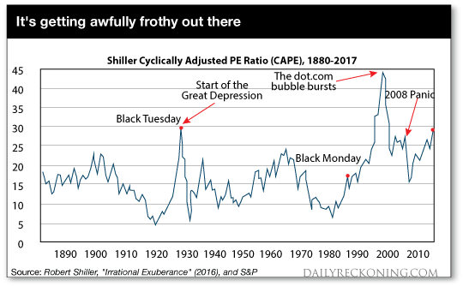
This chart shows the Shiller Cyclically Adjusted PE Ratio (CAPE) from 1880-2017. Over this 137-year period, the mean ratio is 16.75, media ratio is 16.12, low is 4.78 (Dec 1920) and high is 44.19 (Dec 1999). Right now the 29.45 ratio is above the level of the Panic of 2008, and about equal to the level of the market crash that started the Great Depression.
With the likelihood of a bubble clear, we can now turn to bubble dynamics. The analysis begins with the fact that there are two distinct types of bubbles...Some bubbles are driven by narrative, and others by cheap credit.
Narrative bubbles and credit bubbles burst for different reasons at different times. The difference is critical in knowing what to look for when you time bubbles, and for understanding who gets hurt when they burst.
A narrative-driven bubble is based on a story, or new paradigm, that justifies abandoning traditional valuation metrics. The most famous case of a narrative bubble is the late 1960s, early 1970s “Nifty Fifty” list of fifty stocks that were considered high growth with nowhere to go but up.
The Nifty Fifty were often referred to as “one decision” stocks because you would just buy them and never sell. No further thought was required. Of course, the Nifty Fifty crashed with the overall market in 1974 and remained in an eight-year bear market until a new bull market began in 1982.
The dot.com bubble of the late 1990s is another famous example of a narrative bubble. Investors bid up stock prices without regard to earnings, PE ratios, profits, discounted cash flow or healthy balance sheets.
All that mattered were “eyeballs,” “clicks,” and other superficial internet metrics. The dot.com bubble crashed and burned in 2000. The NASDAQ fell from over 5,000 to around 2,000, then took sixteen years to regain that lost ground before recently making new highs. Of course, many dot.com companies did not recover their bubble valuations because they went bankrupt, never to be heard from again.
The credit-driven bubble has a different dynamic than a narrative-bubble. If professional investors and brokers can borrow money at 3%, invest in stocks earning 5%, and leverage 3-to-1, they can earn 6% returns on equity plus healthy capital gains that can boost the total return to 10% or higher. Even greater returns are possible using off-balance sheet derivatives.
Credit bubbles don’t need a narrative or a good story. They just need easy money.
A narrative bubble bursts when the story changes. It’s exactly like The Emperor’s New Clothes where loyal subjects go along with the pretense that the emperor is finely dressed until a little boy shouts out that the emperor is actually naked.
Psychology and behavior change in an instant.
When investors realized in 2000 that Pets.com was not the next Amazon but just a sock-puppet mascot with negative cash flow, the stock crashed 98% in 9 months from IPO to bankruptcy. The sock-puppet had no clothes.
A credit bubble bursts when the credit dries up. The Fed won’t raise interest rates just to pop a bubble — they would rather clean up the mess afterwards that try to guess when a bubble exists in the first place.
But the Fed will raise rates for other reasons, including the illusory Phillips Curve that assumes a tradeoff between low unemployment and high inflation, currency wars, inflation or to move away from the zero bound before the next recession. It doesn’t matter.
Higher rates are a case of “taking away the punch bowl” and can cause a credit bubble to burst.
The other leading cause of bursting credit bubbles is rising credit losses. Higher credit losses can emerge in junk bonds (1989), emerging markets (1998), or commercial real estate (2008).
Credit crack-ups in one sector lead to tightening credit conditions in all sectors and lead in turn to recessions and stock market corrections.
What type of bubble are we in now? What signs should investors look for to gauge when this bubble will burst?
My starting hypothesis is that we are in a credit bubble, not a narrative bubble. There is no dominant story similar to the Nifty Fifty or dot.com days. Investors do look at traditional valuation metrics rather than invented substitutes contained in corporate press releases and Wall Street research. But even traditional valuation metrics can turn on a dime when the credit spigot is turned off.
Milton Friedman famously said the monetary policy acts with a lag. The Fed has force-fed the economy easy money with zero rates from 2008 to 2015 and abnormally low rates ever since. Now the effects have emerged.
On top of zero or low rates, the Fed printed almost $4 trillion of new money under its QE programs. Inflation has not appeared in consumer prices, but it has appeared in asset prices. Stocks, bonds, commodities and real estate are all levitating above an ocean of margin loans, student loans, auto loans, credit cards, mortgages, and their derivatives.
Now the Fed is throwing the gears in reverse. They are taking away the punchbowl.
The Fed has raised rates three times in the past sixteen months and is on track to raise them three more times in the next seven months. In addition, the Fed is preparing to do QE in reverse by reducing its balance sheet and contracting the base money supply. This is called quantitative tightening or QT, which I’ve discussed recently.
Credit conditions are already starting to affect the real economy. Student loan losses are skyrocketing, which stands in the way of household formation and geographic mobility for recent graduates. Losses are also soaring on subprime auto loans, which has put a lid on new car sales. As these losses ripple through the economy, mortgages and credit cards will be the next to feel the pinch.
A recession will follow soon.
The stock market is going to correct in the face of rising credit losses and tightening credit conditions.
No one knows exactly when it’ll happen, but the time to prepare is now. Once the market corrects, it’ll be too late to act.
PrayingMantis May 25, 2017 9:34 PM

... here's one of the major causes of an economic “bubble” ...

... let's shine more light on the DEEP SWAMP critters and how they enable and help each other hide their loot from the American public ...

... this must be one of the “Russian” connections that the Famous But Incompetent “law enforcement” agency had been hiding and instead to keep the MSM (and the sheeple) “focused” on a “Russian Narrative” against Trump's administration ...
... in case you missed it, here's the article written and posted by The European Union Times on Oct 16th, 2016 entitled “
Hillary Clinton’s “Sudden Move” Of $1.8 Billion To Qatar Central Bank Stuns Financial World

... which begs the question, “did Hillary know she will lose the election to Trump?
... here's the full EUTimes article:

“An intriguing Ministry of Finance (MoF) report circulating in the Kremlin today says that elite Western bankers were “stunned/bewildered” a few hours ago after the Bank For International Settlements (BIS) registered a $1.8 billion transfer from the Clinton Foundation (CF) to the Qatar Central Bank (QCB) through the “facilitation/abetment” of JP Morgan Chase & Company (JPM)—and for reasons yet to be firmly established. [Note: Some words and/or phrases appearing in quotes in this report are English language approximations of Russian words/phrases having no exact counterpart.]

According to this report, the Bank for International Settlements is the world’s oldest international financial organization and acts as a prime counterparty for central banks in their financial transactions; the Qatar Central Bank is the bank of that Gulf State nations government and their “bank of banks”; JP Morgan Chase & Company is the United States largest “megabank”; and the Clinton Foundation is an international criminal money laundering organization whose clients include the Russian mafia.

With Hillary Clinton’s US presidential campaign Chairman John Podesta having longstanding ties to the Russian mafia and money laundering, this report continues, the Foreign Intelligence Service (SVR) maintains “complete/all times/all ways” surveillance of him and his criminal associates—including both Hillary Clinton and her husband, and former US President, Bill Clinton, and who are collectively designated as the “Clinton Crime Family”.

On Saturday 15 October (2016), this report notes, the SVR reported to the MoF that Hillary Clinton and John Podesta met with JP Morgan Chase & Company CEO Jamie Dimon at Clinton’s Chappaqua Compound outside of New York City—and who, in 2009, both President Obama and Hillary Clinton allowed to break US laws by his, Dimon’s, being able to buy millions-of-dollars of his company’s stocks prior to the public being told his JP Morgan bank was receiving a Federal Reserve $80 billion credit line—and that caused JP Morgan’s stocks to soar and that have had an astonishing 920% dividend growth since 2010.
Within 12 hours of the Hillary Clinton-John Podesta-Jamie Dimon meeting at the Chappaqua Compound, this report continues, the BIS registered the transfer of $1.8 billion from the Clinton Foundation to the Qatar Central Bank.

To why the Clinton Foundation transferred this enormous sum of money to Qatar, this report explains, is due to the longstanding ties between this Islamic neo-patrimonial absolute monarchy and then US Secretary of State Hillary Clinton who “oversaw/managed” the “massive bribery scheme” that allowed this Gulf State nation to secure the 2022 World Cup—and that the Qataris were so appreciative of they donated millions to the Clinton Foundation, and incredibly, in 2011, gave former US President Bill Clinton $1 million for a birthday present—bringing Hillary Clinton’s total “cash grab” from these Persian Gulf sheiks of $100 million—all occurring as recently released secret emails revealed Hillary Clinton’s knowledge that both Qatar and Saudi Arabia were, and still are, funding ISIS.

To what Jamie Dimon “related/said to” Hillary Clinton that caused her to suddenly transfer $1.8 billion to Qatar, this report notes, revolves around his JP Morgan bank being told by the US Federal Deposit Insurance Corporation (FDIC) in April (2016) that this “megabanks” master plan to save itself had “serious deficiencies” that could “pose serious adverse effects to the financial stability of the United States”.

Two months after the FDIC’s warning letter to Jamie Dimon, in June (2016), this report says, he cryptically “sounded a warning” that the United States sub-prime auto loan bubble was nearing collapse and stated that “someone is going to get hurt”.

Unbeknownst to the American people, MoF experts in this report explain, is that just 8 weeks ago multiple warnings began to be issued that the United States $1 trillion sub-prime auto loan bubble was beginning to collapse—and that this past week became so severe the Bank of America issued a recession warning telling its elite customers that “this market is scary”, and the British-based multinational banking and financial services company HSBC, likewise, issued a “Red Alert” warning all of its clients warning them to “prepare for a severe market crash”.
With one of the first “victims/casualties” of this sub-prime auto loan bubble being the German global banking giant Deutsche Bank that is “nearing its doom” and laying off tens-of-thousands of it workers worldwide, this report grimly states, the American mainstream propaganda media is failing to allow the people of that nation to know the full extent of this looming catastrophe—who unlike Hillary Clinton who has just protected $1.8 billion of her wealth, will be left defenseless once again at the hands of their elite rulers.
As Wikileaks secret Hillary Clinton emails have now proven that the US propaganda mainstream media is now totally controlled by her, and who continue their blackout on the “Clinton Crime Story of the Century”, this report continues, the absolutely horrifying statistics released this week showing that an astounding 35% of American who have been brutalized by the Obama-Clinton regime these past 8 years are so buried in debt they can no longer pay their bills is, likewise, being kept from these most innocent of peoples.
And rather than the US propaganda mainstream media warning the American people of their economies looming destruction, this report concludes, they have, instead, begun a “systemic mainstream misinformation” campaign to manipulate the presidential election polls showing Hillary Clinton leading—but that stands opposed to actual (but unreported) polls showing Donald Trump leading.
Critical Note: A highly classified SVR amendment to this MoF report states that upon Qatar receiving Hillary Clinton’s $1.8 billion earlier today, one of that sheikdoms royal places was “ordered emptied” in preparation for the “early November arrival” of a “high value” dignitary—Hillary Clinton perhaps?”

Trump Takes on the Judges
President Donald Trump's revised travel ban "speaks with vague words of national security, but in context drips with religious intolerance, animus and discrimination," a federal appeals court said Thursday in ruling against the executive order targeting six Muslim-majority countries.
Trump's administration vowed to take the fight to the U.S. Supreme Court.
In a 10-3 vote, the 4th U.S. Circuit Court of Appeals said the ban likely violates the Constitution. And it upheld a lower court ruling that blocks the Republican administration from cutting off visas for people from Iran, Libya, Somalia, Sudan, Syria and Yemen.
The Richmond, Virginia-based 4th Circuit is the first appeals court to rule on the revised travel ban unveiled in March. Trump's administration had hoped it would avoid the legal problems that the first version from January encountered. A second appeals court, the 9th U.S. Circuit based in San Francisco, is also weighing the revised travel ban after a federal judge in Hawaii blocked it.
The Supreme Court almost certainly would step into the case if asked. The justices almost always have the final say when a lower court strikes down a federal law or presidential action.
Trump could try to persuade the Supreme Court to allow the policy to take effect, even while the justices weigh whether to hear the case, by arguing that the court orders blocking the ban make the country less safe. If the administration does ask the court to step in, the justices' first vote could signal the court's ultimate decision.
A central question in the case before the 4th Circuit was whether courts should consider Trump's public statements about wanting to bar Muslims from entering the country as evidence that the policy was primarily motivated by the religion.
Trump's administration argued the court should not look beyond the text of the executive order, which doesn't mention religion. The countries were not chosen because they are predominantly Muslim but because they present terrorism risks, the administration said.
But Chief Judge Roger L. Gregory wrote that the government's "asserted national security interest ... appears to be a post hoc, secondary justification for an executive action rooted in religious animus and intended to bar Muslims from this country."
Attorney General Jeff Sessions said the court's ruling blocks Trump's "efforts to strengthen this country's national security."
Trump is not required to admit people from "countries that sponsor or shelter terrorism until he determines that they can be properly vetted" and don't pose a security threat, Sessions said.
The three dissenting judges, all appointed by Republican presidents, said the majority was wrong to look beyond the text of the order. Calling the executive order a "modest action," Judge Paul V. Niemeyer wrote that Supreme Court precedent required the court to consider the order "on its face." Looked at that way, the executive order "is entirely without constitutional fault," he wrote.
Ilya Somin, a law professor at George Mason University, said if the Supreme Court follows a partisan divide, the Trump administration may fare better since five of the nine are Republican nominees. Still, he said, it's difficult to make a confident prediction because "Supreme Court justices don't always vote in ideological lockstep."
The first travel ban issued Jan. 27 was aimed at seven countries and triggered chaos and protests across the country as travelers were stopped from boarding international flights and detained at airports for hours. Trump tweaked the order after the 9th U.S. Circuit Court of Appeals refused to reinstate the ban.
The new version made it clear the 90-day ban covering those six countries doesn't apply to those who already have valid visas. It got rid of language that would give priority to religious minorities and removed Iraq from the list of banned countries.
Critics said the changes don't erase the legal problems with the ban.
The case ruled on by the 4th Circuit was originally brought in Maryland by the American Civil Liberties Union and the National Immigration Law Center on behalf of organizations as well as people who live in the U.S. and fear the executive order will prevent them from being reunited with family members from the banned countries.
"President Trump's Muslim ban violates the Constitution, as this decision strongly reaffirms," said Omar Jadwat, director of the ACLU's Immigrants' Rights Project, who argued the case. "The Constitution's prohibition on actions disfavoring or condemning any religion is a fundamental protection for all of us, and we can all be glad that the court today rejected the government's request to set that principle aside."
The Comey Chameleon
Comey was a minor assistant US attorney in the late 90’s. He only gained power and money by being the DOJ official who “investigated” and cleared Bill Clinton of any wrongdoing in Clinton’s totally corrupt pardon (for huge payoffs) of criminal financier Marc Rich as Clinton was leaving the Presidency. This is how Comey began his career as a creature of the “swamp” years ago, as a servant of the Clintons.
Comey provided “cover” for the Clintons in their gaining incredible power and wealth after leaving office through pardoning a billionaire money-launderer, arms dealer and criminal. Comey was a key piece in how the Clintons upped their corruption game and gained incredible wealth through their foundation after leaving the White House. A huge part of the scheme was giving Marc Rich a free pass when he should have spent life in prison, and that is what Comey covered-up for the Clintons. This set up Comey to be part of the corruption machine, making him powerful and wealthy.
Immediately after doing the Clinton’s dirty work as a DOJ official, Comey resigned from the DOJ and took a position as the head attorney (Counsel) of the Lockheed Martin company, a huge military contractor. While he was in that position Lockheed became a major contributor (millions) to the Clinton Foundation and its fake charity spin-offs. In return for these payment to Clinton Inc., Lockheed received huge contracts with Hillary’s state department. Comey was the chief legal officer of Lockheed throughout this period of contributions to Clinton Inc. in return for State Dept. contracts.
In late 2012, after overseeing Lockheed’s successful relationship with the Hillary State Department and the resulting profits, Comey stepped down from Lockheed and received a $6 million dollar payout for his services.
In 2013, the largest bank of England, HSBC Holdings, was deep into a scandal. Investigations by federal authorities and law-enforcement had revealed that for years HSBC had been laundering billions of dollars for Mexican Drug Cartels, channeling money for Saudi banks who were financing terror, moving money for Iran in violation of the sanctions, and other major criminal activity. HSBC’s criminality was pervasive and deliberate by the Bank and its officials. HSBC was a huge Clinton Foundation contributor (many millions) throughout the “investigation” and Bill Clinton was being paid large personal fees for speaking at HSBC events (while Hillary was Sec of State). Eric Holder and the Obama Justice Department did what they were paid to do, and let HSBC off of the hook for a paltry 1.2 Billion dollar fine (paid by its stockholders), and not one Director, officer or management member at HSBC was fired or charged with any criminal. Exactly when everyone involved with HSBC Bank (including the Clintons and all of their “donors”) were being let off without penalty, and cover had to be provided to HSBC, Comey was appointed as a Director and Member of the Board of HSBC (in the middle of the fallout from the scandal). He was part of the effort to cover up the scandal and make HSBC “respectable” again.

After about a year as HSBC director, despite his lack of any law enforcement experience, no DOJ leadership experience, and no qualifications for the job, Comey was appointed FBI director by Obama. The only qualification Comey had was that the Clinton’s and their cronies knew Comey was in bed with them, was compromised and was willing to do their dirty work. Comey was appointed to the FBI right when Hillary was leaving the State Department, and was vulnerable to the FBI because she had been using a private-server, mis-handling classified information, selling access to favors/contracts from the State Department to Clinton Foundation Donors (including Comey’s Lockheed Martin), and much more. Remember that this was about the time the Inspector General of the State Department found over 2 billion “missing” from the State Department finances during Hillary’s tenure.
The obvious conclusion is that Comey was appointed to the FBI (along with other reliable Clinton-Obama cronies) to run interference for the Clinton’s and Obama’s at the nation’s federal law enforcement agency (in conjunction with a corrupt Department of Justice). Comey was and is owned by the Clintons. He owed all of his power and wealth to being part of their machine and providing them with cover.
In late 2015 and early 2016, information began to come out about the Clinton Foundation and its use by the Clinton’s as a multi-billion dollar slush fund for corruption and political favors. (Even Chelsea’s wedding had been paid for by the “charity.”) This was right as Hillary was beginning her campaign for President. It was revealed that the Foundation had never completed required reports or had an audit. Supposedly the FBI, under Comey, began an “investigation” of the Clinton Funds. A “professional” accounting firm was brought in by the Clintons to do a review, file some reports, make recommendations to the Clinton Foundation Board, and provide a veneer of legitimacy to the Clinton Fund operations. Predictably, one of the partners in the firm that was chosen (and paid lots of money) is the brother of James Comey (FBI Director). This brother owes James Comey $700,000 for a loan James gave him to buy a house, and presumably some of the money from the Clinton Fund was used to make payments to James on the loan. Over 2 years later and nothing has happened as a result of the FBI “investigating” the Clinton Funds under Comey.
No one in congress or federal law enforcement was intending to actually pursue the Clintons, but Judicial Watch and other independent sources obtained information proving that Hillary had been running her own server, sending out classified information, etc. This information began to come out right in the middle of her campaign to be coronated as President. A “show” investigation had to be performed to appear to look into it and clear her. Who to use?…the reliable shill James Comey.
As head of the FBI, Comey (and his lackeys in key positions) deliberately screwed up the investigation into Hillary’s use of a private server and her plain violation of national security law on classified information. The investigation was deliberately mis-handled in every aspect. Comey gave immunity to all of Hillary’s lackeys, did not use subpoenas or warrants, lost evidence, allowed the destruction of evidence, failed to do any searches or seizures of evidence, did not use a grand-jury, did not swear witnesses, did not record testimony, allowed attorneys to represent multiple suspects (corrupting the testimony). Everything that could be done to ruin the FBI investigation and to cover for Hillary was done. A “slam-dunk” case became a mess. Immunity was given every witness even though they provided no help. Maybe more importantly, by focusing the FBI on the email scandal, attention was drawn away from the much bigger scandal of the Clinton Foundation. Make no mistake, Earth Explorers. The Clinton Crime Syndicate is larger, richer, and more powerful that any crime gang in history. They have billions in uncharted cash. They won’t hesitate to murder. They can threaten police departments and yes even the FBI to bring them to heel. They command ISIS. They command Antifa. They command Black Lives Matters. They command the Black Block. They are flooding our country with heroin as we speak, and the billions a month in cash that we pay for that heroin is being used to buy entire political parties. The only person with the courage to stop them is Trump.
The Musical Soul
Anciently, there was a race of beings that are not only remembered in stone. They used music and the sound of singing to wield great power. The Hathors are depicted in small statues as cow-head people. But in the large statues all over Egypt they are depicted as a more alien looking being with a flat face, large ears and wide set eyes. Dendera is a phenomenal place of split heritage. The older part is gorgeous, mysterious, and connected to other dimensions. After the Hathors left this planet, the Egyptians tried to build onto the temple they had built, but the attempt was a pile of mud compared to what the ancients had built.
The point I’m trying to make here, is that there are souls in the universe who understand the great power and soul connection in music. Have you ever been listening to a great piece of music and felt a chill run up your spine? Or goosebumps tickle your arms and shoulders?
The experience is called frisson (pronounced free-sawn), a French term meaning “aesthetic chills,” and it feels like waves of pleasure running all over your skin. Some researchers have even dubbed it a “skin orgasm.”

Listening to emotionally moving music is the most common trigger of frisson, but some feel it while looking at beautiful artwork, watching a particularly moving scene in a movie or having physical contact with another person. Studies have shown that roughly two-thirds of the population feels frisson, and frisson-loving Reddit users have even created a page to share their favorite frisson-causing media.

But why do some people experience frisson and not others? Why do some people gravitate to the pounding, metal collision of metal music, while others look as though they are aroused sensually by listening to strings, or the French horn, or the music of Lisa Gerrard or church hymns? Working in the lab of Dr. Amani El-Alayli, a professor of Social Psychology at Eastern Washington University, I decided to find out.

What causes a thrill, followed by a chill?
While scientists are still unlocking the secrets of this phenomenon, a large body of research over the past five decades has traced the origins of frisson to how we emotionally react to unexpected stimuli in our environment, particularly music.

If a violin soloist is playing a particularly moving passage that builds up to a beautiful high note, the listener might find this climactic moment emotionally charged, and feel a thrill from witnessing the successful execution of such a difficult piece.
But science is still trying to catch up with why this thrill results in goosebumps in the first place.
Some scientists have suggested that goosebumps are an evolutionary holdover from our early (hairier) ancestors, who kept themselves warm through an endothermic layer of heat that they retained immediately beneath the hairs of their skin. Experiencing goosebumps after a rapid change in temperature (like being exposed to an unexpectedly cool breeze on a sunny day) temporarily raises and then lowers those hairs, resetting this layer of warmth.

Why do a song and a cool breeze produce the same physiological response? EverJean/flickr, CC BY
Since we invented clothing, humans have had less of a need for this endothermic layer of heat. But the physiological structure is still in place, and it may have been rewired to produce aesthetic chills as a reaction to emotionally moving stimuli, like great beauty in art or nature.
Research regarding the prevalence of frisson has varied widely, with studies showing anywhere between 55 percent and 86 percent of the population being able to experience the effect.
Monitoring how the skin responds to music
We predicted that if a person were more cognitively immersed in a piece of music, then he or she might be more likely to experience frisson as a result of paying closer attention to the stimuli. And we suspected that whether or not someone would become cognitively immersed in a piece of music in the first place would be a result of his or her personality type.

To test this hypothesis, participants were brought into the lab and wired up to an instrument that measures galvanic skin response, a measure of how the electrical resistance of people’s skin changes when they become physiologically aroused.
Participants were then invited to listen to several pieces of music as lab assistants monitored their responses to the music in real time.
Examples of pieces used in the study include:
- The first two minutes and 11 seconds of J. S. Bach’s St. John’s Passion: Part 1 – Herr, unser Herrscher
- The first two minutes and 18 seconds of Chopin’s Piano Concerto No. 1: II
- The first 53 seconds of Air Supply’s Making Love Out of Nothing At All
- The first three minutes and 21 seconds of Vangelis’ Mythodea: Movement 6
- The first two minutes of Hans Zimmer’s Oogway Ascends
- The toning of crystal or metal bowls layered with harmonics
- Tchaikovsky’s Cherubic Hymn will bring me to tears of humility within seconds
- How about Lady Gaga’s rendition of the Star-Spangled Banner at the 2016 Super Bowl and a fan-made trailer for the original Star Wars trilogy as especially chill-inducing.
Each of these pieces contains at least one thrilling moment that is known to cause frisson in listeners (several have been used in previous studies). I used to drive listening to what I call Space Music. Everyone in the car would be passed out in bliss, but I would be wide awake designing complex machines or remembering the future. For example, in the Bach piece, the tension built up by the orchestra during the first 80 seconds is finally released by the entrance of the choir – a particularly charged moment that’s likely to elicit frisson.

As participants listened to these pieces of music, lab assistants asked them to report their experiences of frisson by pressing a small button, which created a temporal log of each listening session. By comparing these data to the physiological measures and to a personality test that the participants had completed, we were, for the first time, able to draw some unique conclusions about why frisson might be happening more often for some listeners than for others.
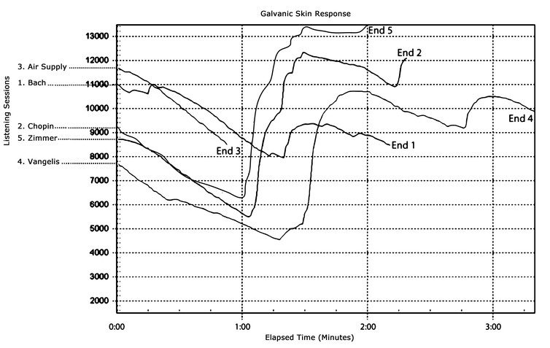
This graph shows the reactions of one listener in the lab. The peaks of each line represent moments when the participant was particularly cognitively or emotionally aroused by the music. In this case, each of these peaks of excitement coincided with the participant reporting experiencing frisson in reaction to the music.

This participant scored high on a personality trait called ‘Openness to Experience.’

Results from the personality test showed that the listeners who experienced frisson also scored high for a personality trait called Openness to Experience. Studies have shown that people who possess this trait have unusually active imaginations, appreciate beauty and nature, seek out new experiences, often reflect deeply on their feelings, and love variety in life. Ones that lack this trait are lulled to sleep or actually have an allergic reaction to the music itself much like pouring holy water on a vampire.

Some aspects of this lovely trait are inherently emotional (loving variety, appreciating beauty in the smallest and most unlikely places), and others are cognitive (imagination, intellectual curiosity). In fact, love oozes from these people. They don’t have to say anything, or do anything. In many cases they don’t even have to touch you. But, if they do touch you, it is an experience you will never forget; ever.

While previous research had connected Openness to Experience with frisson, most researchers had concluded that listeners were experiencing frisson as a result of a deeply emotional reaction they were having to the music. In contrast, the results of our study show that it’s the cognitive components of “Openness to Experience” – such as making mental predictions about how the music is going to unfold or engaging in musical imagery (a way of processing music that combines listening with daydreaming) – that are associated with frisson to a greater degree than the emotional components.
These findings, recently published in the journal Psychology of Music, indicate that those who intellectually immerse themselves in music (rather than just letting it flow over them) might experience frisson more often and more intensely than others.

And if you’re one of those souls that seem to be visitors here, or better yet newcomers here, who can feel frisson, you have the capability to change the world. You know that. Please, do not get trapped in the solids of this world of bounty and sometimes horror. Set about your real mission tomorrow. To that, I simply say, “Remember who you are.”

STAR WARS INSERT HERE
Insert Tchaikovski Cherubim here
The Weird Search for Life on Mars
Since the dawn of the space age NASA and other agencies have spent billions of dollars to reconnoiter Mars—assailing it with spacecraft flybys, photo-snapping orbiters and landers nose-diving onto its surface. The odds are good, many scientists say, for the Red Planet being an extraterrestrial address for alien life—good enough to sustain decades' worth of landing very expensive robots to ping it with radar, zap it with lasers, trundle across its terrain and scoop up its dirt. Yet against all odds (and researchers' hopes for a watershed discovery), Mars remains a poker-faced world that holds its cards tight. No convincing signs of life have emerged. But astrobiologists continue to, quite literally, chip away at finding the truth.
As the search becomes more heated (some would say more desperate), scientists are entertaining an ever-increasing number of possible explanations for Martian biology as a no-show. For example, could there be a "cover up" whereby the harsh Martian environment somehow obliterates all biosignatures—all signs of past or present life? Or perhaps life there is just so alien its biosignatures are simply unrecognizable to us, hidden in plain view.
Of course, the perplexing quest to find life on Mars may have a simple solution: It's not there, and never was. But as the proceedings of this year's Astrobiology Science Conference held here in April made clear, life-seeking scientists are not giving up yet. Instead, they are getting more creative, proposing new strategies and technologies to shape the next generation of Mars exploration.

A Slumbering Biosphere?
Talk about looking for Martians and you inevitably talk about water, the almost-magical liquid that sustains all life on Earth and seems to have served as an indispensable kick-starter for biology in our planet's deepest past. "It all started out with 'follow the water;' not necessarily 'follow the life'…but 'follow one of the basic requirements for living systems,'" says Arizona State University geologist Jack Farmer, referring to NASA's oft-repeated mantra for Martian exploration. "There are many indications of water on Mars in the past, perhaps reservoirs of water in the near subsurface as well," he says. "But what is the quality of that water? Is it really salty—too salty for life?"
Without liquid water, Farmer points out, one would naively think organisms cannot function. The reality may be more complex: on Earth, some resilient organisms such as tardigrades can enter a profound, almost indefinite state of hibernation when deprived of moisture, preserving their desiccated tissues but neither growing nor reproducing. It is possible, Farmer says, that Martian microbes could spend most of their time as inert spores "waiting for something good to happen," only springing to life given the right and very rare conditions. Certain varieties of Earthly "extremophiles"—microbes that live at extremes of temperature, pressure, salinity and so on—exhibit similar behavior.
Farmer says there is as yet no general consensus about the best way to go about life detection on the Red Planet. This is due in no small part to the runaway pace of progress in biotechnology, which has led to innovations such as chemistry labs shrunken down to fit on a computer chip. These technologies "have been revolutionizing the medical field, and have now started to enter into concepts for life detection on Mars," he explains. Things move so fast that today's best technology for finding Martian biology may be tomorrow's laughably obsolete dead-end.
But no matter how sophisticated a lab on a chip might be, it won't deliver results if it is not sent to the right place. Farmer suspects that seriously seeking traces of life requires deep drilling on Mars. "I basically think we're going to have to gain access to the subsurface and look for the fossil record," he explains. But discovering a clear, unambiguous fossil biosignature on Mars would also raise a red flag. "We probably would approach the future of Mars exploration—particularly accessing habitable zones of liquid water in the deep subsurface—more cautiously, because life could still be there. So planetary protection would be taken very seriously," he says. ("Planetary protection" is the term scientists commonly use for precautions to minimize the chance of biological contamination between worlds. Think of it not so much in terms of bug-eyed aliens running rampant on Earth but of billion-dollar robots finding "Martians" that prove to only be hardy bacterial hitchhikers imported from our own world).

The Martian Underground
Like-minded about deep diving on Mars is Penelope Boston, director of the NASA Astrobiology Institute at the agency's Ames Research Center. "That's my bias," she says. "Given Mars' current state, with all the challenging surface manifestations of dryness, radiation and little atmosphere, the best hope for life still extant on Mars is subsurface." The subsurface, she says, might also offer better chances of preserving past life—that is, of fossils, even if only of single-celled organisms.
The planet's depths hold the potential for harboring liquid water under certain circumstances, Boston thinks. But how far down might that water be? "I suspect it's pretty far…and how we get to it, that's a whole other kettle of fish," she says. Over the years scientists have estimated the average depth of the planet's possible liquid reservoirs as anywhere between tens of meters to kilometers. Then again, recent observations from orbiters have revealed mysterious dark streaks that seasonally flow down the sunlit sides of some Martian hillsides and craters. These "recurring slope lineae" could conceivably be brines of liquid water fed by aquifers very close to the surface, some researchers say.
Such lingering uncertainties emerge from the indirect and scattered nature of our studies of Mars, and ensure that any argument for life there is based solely on circumstantial information, Boston notes. "Each individual piece of evidence is, on its own merits, weak," she says. Only by amassing a diverse suite of independent measurements can a well-built case for life on Mars be made, she says: "In my opinion, we can't make that strong case unless we push to do all of those measurements on exactly the same precise spot. We don't do that because it's very difficult, but it's something to aspire to." Despite decades of sending costly hardware to Mars, Boston believes that what is still missing is a sense of harmony between instruments, allowing them to work together to support a search for alien life. "I think that the precise requirements of a really robust claim of life at the microscopic scale require us to push on further," she notes.
Attendees at the astrobiology meeting in Arizona showcased an assortment of high-tech devices for next-generation exploration, ranging from microfluidic "life analyzers" and integrated nucleic acid extractors for studying "Martian metagenomics" to exquisitely sensitive, miniaturized organic chemistry labs for spotting tantalizing carbon compounds and minerals at microscopic scales. Missing from the mix, however, was any solid consensus on how these and other tools could all work together to provide a slam-dunk detection of life on Mars.

What's the Weather?
Some scientists contend a new kind of focus is sorely needed. Perhaps the pathway to finding any Martians lurking in the planet's nooks and crannies is to learn where exactly on Mars those potentially life-nurturing niches exist, and how they change over the course of days, months and years rather than over eons of geologic time. That is, to find homes for extant life on Mars today, researchers should probably not just be studying the planet's long-term climate but also its day-to-day weather.
"Right now we're sort of shifting gears. Once you've found out that a planet is habitable, then the next question is, 'Was there life?'—so it's a completely different ball game," says Nathalie Cabrol, director of the Carl Sagan Center at the SETI Institute. "On Mars you cannot look for life with the tools that have been looking for habitability of that planet," she argues. "We should be looking for habitats and not habitable environments. You are dealing on Mars with what I call extremophile extreme environments on steroids," she says, "and you don't look for microbial life with telescopes from Mars orbit."
Cabrol advocates making an unprecedentedly robust, high-resolution study of environmental variability on Mars by peppering its surface with weather stations. Sooner or later telltale signs of the possible whereabouts of extant life may emerge from the resulting torrents of data. "Today's environment on that planet is a reflection of something in the past," she says, and planting numbers of automated stations on Mars does not need to be expensive. "This is of interest not only to astrobiology but to human exploration. The first thing you want to know is what the weather is like," she says, adding, "Right now we're not equipped to do this and I'm not saying it's going to be easy to look for extant life. I'm not saying what we're doing now is wrong. Whatever we put on the ground we are learning. But there is variability on Mars. You go up or down one meter, things change. Habitats at a microscopic level can happen at the scale of a slope. It can happen at the scale of a rock!"

Might We Be Martians?
"I think Mars offers us the highest chance of finding life" somewhere beyond Earth, says Dirk Schulze-Makuch, a planetary scientist at Technical University of Berlin in Germany. But, like Boston and others, he maintains confirmation of life will only come from multiple "layers of proof" that have to be consistent with one another. "We really need at least four different kinds of methods," he says. "My point is that there's no slam-dunk. We need several instruments. You have to build a case, and right now we can do better…unless the biosignature through a microscope is waving hello." The trouble, he adds, is that too-stringent planetary protection rules may preclude getting the evidence necessary for that proof. "We have the technology to go to places where there could be life," he says. "But we can't go to certain areas on Mars, like recurring slope lineae or…under patches of ice. It seems to be ridiculous."
Indeed, Schulze-Makuch speculates planetary protection may be a lost cause for Mars—or at least a misguided endeavor. It may even be that any Martian microbes are actually Earth's long-lost cousins. Or, conversely, Mars rather than Earth is really the sole site of biogenesis in our solar system. Both scenarios are possible, considering that single-celled organisms can likely survive world-shattering impacts and the subsequent interplanetary voyages if embedded in ejected shards of rock that could fall elsewhere as meteorites. Innumerable impacts of this scale battered the solar system billions of years ago, potentially blasting biological material between neighboring worlds. On balance, Schulze-Makuch says, "the chances are higher that we are actually Martians."

Crypto-Currencies: The New Age Counterfeiters

Bitcoin is the original cryptocurrency, and its meteoric rise has made it a mainstay of conversation for investors, media, and technologists alike.
In fact, as Visual Capitalist's Jeff Desjardins details, the innovation of the blockchain is changing entire markets, while causing ripples with central banks and the financial industry. At time of publication, the bitcoin price now hovers near US$2,200, a massive increase from this time last year.
But the true impact of Bitcoin is actually far more reaching than this – it’s actually helped to birth new markets for over 800 other cryptocurrencies and assets that are available for online trading. And while the market for bitcoins is worth nearly $40 billion itself, the rest of these cryptocurrencies are actually worth even more in combination.

So what are the other altcoins that make up the rest of this universe, and where did they come from?
Litecoin
Litecoin is one of the first altcoins, and it is nearly identical to Bitcoin after being “forked” in 2011. Litecoin aims to process blocks 4x faster than Bitcoin to speed up transaction confirmation time, though this creates several other challenges as well. At time of writing, Litecoin’s market capitalization is worth $1.3 billion.
Ethereum
Ethereum, launched in 2015, is the largest coin by market capitalization aside from Bitcoin. However, it is also quite different. While Bitcoin is designed to be a payments protocol first, Ethereum enables developers to build and deploy decentralized applications, while also enabling smart contracts. The tokens used to power the network are called Ether, but they can also be traded online. At time of writing, Ethereum’s market capitalization is $15.4 billion.
Also interesting: the Ethereum network actually split into two in 2016. It’s a complicated situation, but read about it here. There is now a separate Ethereum, based on the original Ethereum blockchain, trading as “Ethereum Classic” with its own market capitalization of $1.4 billion.
Ripple
Ripple (XRP) is the native currency of the Ripple Protocol – a broader catch-all for an open-source, global exchange. It’s already being used by banks such as Santander, Bank of America Merrill Lynch, UBS, and RBC. It solves a different problem than Bitcoin, allowing for settling payments between different currencies and even different payment systems. Today, Ripple’s native coin (XRP) has a market cap of $10.9 billion.

With over 800+ altcoins or assets out there, there’s plenty of information to absorb.

It was cold. It was raining. And it was the final gathering in a week of back-to-back cryptocurrency and blockchain conferences. Attendees should have been inclined to flake or tempted to sell their tickets for a tidy sum. Instead, rumor was that, for the $349 ticket, scalpers were charging a bitcoin — about $2,500 these days. The morning of, 70 ticketed guests, some of whom had flown in from foreign countries, had to be turned away, raindrops pelting them as they went.
Inside, the 560 who remained -- about half of whom were entrepreneurs, with investors and ancillary service providers such as lawyers making up the other half -- mingled over coffee and pastries. They then filed in to an NYU auditorium to fill every seat, each outfitted with a folding desk. It was a conventional setting for what would be a day of unconventional thinking. Thus began the wildly anticipated Token Summit.
That morning, despite the legitimate claims of scams and a bubble in the space, bitcoin was reaching a new high, nearing $2,800, Ether was trading in its highest ranges — around $200 — and the total market capitalization of all cryptocurrencies was trading near the all-time high it hit the day before, $91 billion. (It hadn’t hurt that a couple days before, Fidelity CEO Abigail Johnson had expressed her “love” of Bitcoin.)
But in a day of 15 sessions with 40 speakers, the euphoric prices came up only briefly. Business models, fundamental price analysis, regulations and ways of governing blockchain-based projects were on the agenda, and meetings outside the packed auditorium initiated deals in what everyone was comparing to the dot-com revolution.
“This is not about the price of tokens and the price of cryptocurrency. This is a conference about the business models behind the cryptocurrencies and tokens. That is what we’re here to explore,” said organizer William Mougayar, a venture capitalist and author of the book The Business Blockchain, in his opening remarks. His cohost Nick Tomaino, principal at Runa Capital and author of the blog The Control, about the token economy, said, "The price of these tokens is the most interesting thing for people outside of this ecosystem to talk about, but the long-term success of this ecosystem is really about what the entrepreneurs and investors are building right now."
But the attendees, who came from 44 countries including Brazil, Estonia, Japan, Belarus, France, Colombia, Croatia, and Singapore, were only at the earliest stages of building their vision of a blockchain-based world of multiple tokens that power decentralized businesses.
When Mougayar asked who owned cryptocurrency or a token, such as bitcoin or Ether, everyone raised their hands. When he queried who was using them in a utility (meaning who was using them not just for speculative purposes but because they were the central function of a service), only a dozen or so hands went up.
The recognition that the few hundred people in the room had barely started their journey was reflected in remarks by NYU Stern Business School professor Luke Williams. “It takes a long time for people’s thinking to catch up to the technology,” he said. “One of the reasons we’re here today is to allow our thinking to keep track with the mechanism of technology. Thinking changes much slower because we’re dealing with really well-established concepts like money.”
The data showed that something new was afoot. In a panel on data about the industry, Brian Lio, CEO of industry data site Smith and Crown, showed that the amount raised in “initial coin offerings” — crowdsales of new crypto assets — in 2017 has already eclipsed the total from 2016. It also already surpasses seed and Series A venture funding in the space. The average project raised $2 million, and while more than half of funds went to the top 10% of projects, a massive long tail of shows that even smaller, less well-known projects are raising money this way.
While those numbers seem impressive, the comparisons to venture capital are not entirely apt. A significant portion of the ICO money likely went to projects that would not have gotten venture capital anyway — whether due to lack of access or quality of project or another reason. Plus, in many cases, because the token is integral to the functioning of the network and would need to be widely distributed for the ecosystem to work, it wouldn’t even make sense to give a venture capitalist a substantial cut. “You generally need an ICO just for distribution,” said Sid Kalla of Smith and Crown.
Also, despite the amount of money flowing in the space, the audience fueling the trend was decidedly niche. According to a survey by CoinFund, a blockchain technology research investment company, 91.5% of respondents were male, two-thirds were between ages of 25-40, 60% worked in technology and 26% had participated in equity crowdfunding, suggesting they’re accredited investors. “It’s still a very niche market. It could probably have a few more women in it,” said CoinFund cofounder Jake Brukhman to the almost entirely male audience, which erupted in laughter.
CoinFund survey respondents also seemed to be a highly (and dangerously) risk-tolerant crowd. The average respondent had invested 50% of all their investment capital in blockchain assets, and one out of three had more than 75% of their investment capital in blockchain.
The same foolhardy thinking has also created a bubble in tokens, the existence of which attendees widely recognized. Explaining that companies receiving seed funding typically get valuations around $5 million, and firms raising series A funding are valued on average at $15 million to $20 million, Alex Sunnarborg, research analyst at industry trade publication CoinDesk, said, “This morning when I logged into Coinmarketcap” — a resource for data such as price and market cap of the top cryptocurrencies — “every single coin on the top 100 page had over a $10 million valuation. That’s pretty crazy. A seed round is hard enough to raise. A series A requires you to have a decent traction and revenue model.”
But others in the space are already thinking up better ways of evaluating the assets to make smarter financial choices. Chris Burniske, blockchain products lead at ARK Investment Management, the first public fund manager to invest in bitcoin, explained, “It’s important for us to figure out what’s utility and what’s speculative, because in times of correction, we will likely compress through speculative value until we hit utility value.” He walked through an example in which one might project, say, that bitcoin will someday account for 10% of the $500 billion remittance market, which would require bitcoin to facilitate $50 billion of transactions. Assuming that the bitcoins turn over five times a year, bitcoin would need to store $10 billion in value to facilitate 10% of remittances.
Burniske said the current value of any token, which he refers to as network value, would take into account the current utility value, the expected utility value out to the year the investors plan to make their investment, the annual rate of inflation for the number of tokens, and the discount rate, which, for his example of privacy coin Zcash, he estimated at three to four times that of tech stocks. He also described a metric created by cryptocurrency investment analyst Willy Woo, that he called the crypto equivalent of price-earnings (P/E) ratio: market cap divided by daily transaction value. He then emphasized the financial value of developers contributing to the code, which can be estimated by dividing the market cap by the number of code repository points, a proxy for developer activity on that token.
But the majority of the day was focused on other issues such as what business models are enabled by tokens, how these open source protocols should be governed, and how the laws and regulations around these tokens are developing, among other subjects.
Many companies are willing to blaze the trail. The biggest news of the day was an announcement by chat service and unicorn Kik, which as 50 million monthly users, that it would be launching a token, and a number of other well-known projects took the stage to present their efforts, such as smart contract system Tezos, peer-to-peer exchange 0x, decentralized court system Aragon, and identity startup Civic. Fireside chats were held with luminaries of the space such as Coinbase CEO Brian Armstrong (who was also the subject of my magazine feature on the company), Erik Voorhees, CEO of Shapeshift, and Fred Wilson, managing partner at Union Square Ventures.
In that last session, fielding an audience question about why a startup would go for an ICO in which it would raise a lot of money but also give away much of the company with a low probability of being able to get more funding, Wilson responded, “If you think about it as just a way to finance your company, you’re not thinking about it properly. The way to think about it is that the token is also the native monetization model for your business, and if you execute your business well, the value of that token should rise as the utility of the product you ship goes up in value.” Then, he said, though you’re giving away a lot of the tokens right away, the value of the tokens you keep should rise substantially and net you a tidy profit. For example, he and Mougayar speculated that Ethereum founder Vitalik Buterin had a half percent of all Ethers, which at that moment was about $90 million.
The crowd seemed largely to agree that despite the current scams and price bubble, the tokens were mostly about a new business model — one that could someday prove highly valuable. “The ICOs are highly unstable, but … I can imagine the utility value,” said Catherine Wood, CEO of ARK. Noting how far these projects are from pulling off their vision, she said, “but you have a few of these networks showing the network effect. It’s going to be boom-bust-boom-bust, I think. It’s going to be unstable but very exciting. I was there at the beginning of the internet, and this is more exciting than that.”
As for the current irrational exuberance, Wood noted that the internet bubble popped at about $3 trillion, which would be $5 trillion in today’s dollars. But today, the network value of all crypto assets is less than $100 billion.
One prominent skeptic, Tone Vays, of the CryptoScam podcast, reflected the stance of much of the world outside: “We are standing at almost the pinnacle of the dot-com bubble.” He put tokens in the same category as tulip mania, the South Sea bubble and the dot-com bubble, and asserted that after this flourishing of multiple tokens, many would fail, leaving only bitcoin.
But as people exchanged cards and email addresses over wine and beer in the post-conference reception, Olaf Carlson-Wee founder and CEO of hedge fund Polychain Capital (and a recent guest on my podcast), which has backing from Andreessen Horowitz and Union Square Ventures, summed up the most common sentiment. As the first employee of Coinbase, and as someone who spent the greater part of the last several years earning and spending almost exclusively cryptocurrency, he had a long-term perspective.
“This is my favorite conference since the San Jose Bitcoin conference in 2013,” he said, referring to the first bitcoin conference ever. “This is the same buzzy energy.”
As the event came to a close, the attendees convened again at a separate reception a few blocks away. They were eager for more face-to-face time before they would each fly back to their homes around the world, from which they would keep building the decentralized web.
So, now you see why dollars, Yen, Yuan, Pounds, Euros are not the only game in town. Most people want a reliable, tamper-free way system of exchange. But there are a few who want to profit from the system of exchange itself. The overall feeling it, that if you can get in on the ground floor of these new currencies, any of them, you can make a small fortune. That much is true, but the risk is that the game will close, and you will be left holding something as worthless as an Iraqi Dinar or a Vietnamese Dong. Hundreds of thousands of people are ripped off every year by duping them into buying something that will take them from rags to riches.

Police Death Statistics
You may have heard that police officer deaths continue to rise. That much is true. But what you don’t know, is that militant groups like Black Lives Matters are not as active since the Dallas Massacre. Law Enforcement Officer deaths by firearm are down slightly through May 20th, as compared to this time last year. In 2016, according to the National Law Enforcement Officers Memorial Fund (NLEOMF), 18 officers were killed by firearms.
So far this year, only 17 officers have been killed by firearms.
With nearly one million sworn officers in the U.S., the preliminary report may be welcome news to officers everywhere. Unfortunately, however, an epidemic of officer-involved shootings persists.
The NLEOMF has been tracking police deaths for decades now. Their mission statement reads in part, “Founded in 1984, the National Law Enforcement Officers Memorial Fund is dedicated to telling the story of American Law Enforcement and making it safer for those who serve.”
Unfortunately, in 2017 a surge of officers dying accidentally has been observed.

Total Fatalities: 51—↑ 42%
Firearms-related: 17—↓ 6%
Traffic-related: 22—↑ 69%
Other Causes: 12—↑ 140%

While firearms-related officer deaths are down across the nation, traffic-related and other causes for death, like heart attacks, appear to have skyrocketed. Also, not all of the firearms-related deaths can be attributed to shootouts with bad guys, presumably, as death by friendly fire is also included in that category. We contacted the NLEOMF who confirmed suicides by cops either on or off-duty were not recorded in the publication.
Although 2016 was a tragic year for law enforcement (as several officers were targeted in planned ambushes…NLEOMF noted the 7/7/16 killings of 5 Dallas PD officers), it can hardly reflect a war on police officers as some members of the media may want it to seem. During times of war and most notably, during prohibition, police officer deaths have skyrocketed, rising above the 300 mark during the height of state’s war on alcohol.
That fact, alone, is enough for those who care about police officer safety to consider becoming anti-war, and even stand against the failed War on Drugs which has led to the United States having a large prison population than any other developed country on earth.
In 2016, 64 officers were shot and killed, 21 of those dying in ambushes. Contrasting those statistics published by the NLEOMF are citizen-led organizations who track the number of people killed by police in the line of duty. Killed by Police tracks the number of officer-involved shootings which lead to someone’s death.
From Jan. 1 to May 20th of 2017, KBP has documented 453 deaths by cop, many of whom as TFTP has reported, were unarmed at the time of their deaths. Several officers in 2017 have already been charged with homicide, with more charges coming for investigations which have not yet concluded.
Deaths by cop are equal to 2016. From January 1-May 20th of 2016, 453 deaths by cop were documented by KBP, an organization which depends largely on news reports for its source work. As TFTP has reported, 2017 is the first year the FBI has tracked the death by cop statistics, depending upon voluntary reporting by law enforcement agencies (LEA). Many fear the number of those killed by cops are much higher and simply don’t get reported in the news.
Worth noting is the fact that the NLEOMF and the DBC statistics both pale in comparison to the number of Americans killed by criminals. While we are still waiting on 2016’s official numbers, there were 15,696 murders in 2015, with guns being used in nearly three-quarter of those killings.
Both organizations, one which tracks officer deaths, and the one which tracks those killed by cops, have equally important tasks. Being a police officer in the United States is a dangerous job, but certainly not the most dangerous.
There are a great number of occupations and professions which are much more dangerous than being a police officer, the most dangerous of which is being a truck driver. Nearly 800 truck drivers died in their line of work. Construction worker deaths (mostly Latino) come in second.
And there’s certainly no war on cops. There is, however, as some have called it, a staggering phenomenon taking place in law enforcement — nearly 1,200 people are being killed by police every year.
As NLEOMF reported, it’s more dangerous for police officers who are responding in their vehicles to calls for backup, than it is for them to be confronted with someone suspected of being armed. From 2011-2015, 167 officers died in automobile accidents. Almost 50 percent (49%) of the officers killed in those automobile accidents died in single car accidents, their own, presumably from driving recklessly or going too fast.

Sean Hannity May be Fired Next Week
Fox insider, Rambo Biggs, stated the following this week:
“I had a conversation with a source close to Hannity who showed me an internal email at fox where Adam Housley spoke to Sean and he said he believes he will be fired next week sometime by Fox News for his coverage of the Seth Rich murder.
I also have a source within the FBI that will be sending me documents that show that Seth Rich was the Wikileaks source. The DC police said that they didn’t hand off the laptop to the FBI, which is true. But The Police did contact the FBI to unlock the computer and when the FBI tech unlocked it he also took the information from the laptop. This is coming my source within the FBI.
Let’s hope this puts pressure on Fox to do the right thing and not fire a good man for covering a real story.”
Rumor seems to supported by recent actions to kill Fox News by the Murdoch boys. The sons are not like the founder, Roger Ailes, or like the owner, Rupert Murdoch. The boys appear to be taking the brand in a more progressive direction. Which, to me, means they fully intend to kill it. This will mean that Trump and the swamp corps of engineers will have to go straight to the people with their news. I’m okay with it. Aren’t you?

