Jihad Report
Jan 13, 2018 -
Jan 19, 2018

Jihad Report
Jan 13, 2018 -
Jan 19, 2018
Attacks 35
Killed 261
Injured 399
Suicide Blasts 4
Countries 12
The SR-72: Son of Blackbird
For years, Lockheed Martin Corp. has been developing a successor to one of the fastest aircraft the world has ever seen, the SR-71 Blackbird, the Cold War reconnaissance craft that the U.S. Air Force retired almost three decades ago. Lockheed officials have said the hypersonic SR-72—dubbed the “Son of Blackbird” by one trade journal—could fly by 2030.
But a rather curious talk last week at an aerospace conference by a Lockheed Skunk Works executive implied that the SR-72 might already exist. Referring to detailed specifics of company design and manufacturing, Jack O’Banion, a Lockheed vice president, said a “digital transformation” arising from recent computing capabilities and design tools had made hypersonic development possible. Then—assuming O’Banion chose his word tense purposely—came the surprise.
“Without the digital transformation the aircraft you see there could not have been made,” O’Banion said, standing by an artist’s rendering of the hypersonic aircraft. “In fact, five years ago, it could not have been made.”
Hypersonic applies to speeds above Mach 5, or five times the speed of sound. The SR-71 cruised at Mach 3.2, more than 2,000 mph, around 85,000 feet.
The SR-71 Blackbird, once the world's fastest and highest flying aircraft, capable of sustained speeds in excess of Mach 3.
Lockheed Martin
Computer processing power and new tools allow for three-dimensional design of a scramjet engine, O’Banion said at the American Institute of Aeronautics and Astronautics’ annual SciTech Forum near Orlando. (Scramjet refers to engine combustion occurring at supersonic speeds, which adds to the engineering complexity.) Adding a little Hollywood to an engineering presentation, O’Banion likened the digital advances in 3D-design to the build process Tony Stark employs in the film Iron Man.
“We couldn’t have made the engine itself—it would have melted down into slag if we had tried to produce it five years ago,” O’Banion said. “But now we can digitally print that engine with an incredibly sophisticated cooling system integral into the material of the engine itself, and have that engine survive for multiple firings for routine operation.” The aircraft is also agile at hypersonic speeds, with reliable engine starts, he said. A half-decade before, he added, developers “could not have even built it even if we conceived of it.”
View image on Twitter

Stephen Trimble@FG_STrim
Jack O'Bannion, VP of Strategy at Skunk Works, is speaking today at SciTech conference. He showed a slide of the SR-72 and said: "Without digital transformation that aircraft you see there could not have been made." Soooo ... does that mean that aircraft was made?
3:11 PM - Jan 8, 2018
Twitter Ads info and privacy
Of course, none of the Skunk Works executive’s talk confirmed that Lockheed Martin is preparing to turn over to the Pentagon a top-secret hypersonic aircraft, nor does it reveal how far the project may have progressed. It’s also unclear if such an aircraft would carry pilots or operate as a drone. (Skunk Works is the name of Lockheed’s 75-year-old advanced development programs division, based in California.)
Lockheed declined to address O’Banion’s comments. The defense contractor “continues to advance and test technologies which will benefit hypersonic flight,” spokeswoman Melissa Dalton said in an email. “A Reusable Hypersonic System (RHS) is a far term solution that will be made possible by the path-finding work we are doing today.”
An Air Force spokesman, meanwhile, said only that that the military has no information on the project “at this time.”
Talk about Lockheed’s hypersonic program isn’t new. In fact, executives discussed the program’s status to such an extent last June that defense reporter Tyler Rogoway called it “highly peculiar.” (His article carried the headline “What’s the Deal with Lockheed’s Gabbing About the Secretive Hypersonic SR-72?”)
“There’s probably a big distance between prototype development and actual operational capability,” said Richard Aboulafia, a defense analyst with Teal Group. And the military has a history of publicly revealing new advanced aircraft many years after their prototypes were delivered.
Source: Lockheed Martin Corp.
Nevertheless, the SR-72 work could be an entirely digital exercise to date, funded by ample “black budget” appropriations stretching into the billions of dollars over time, Aboulafia said. It’s also possible that any hypersonic capability may well be incorporated into a new type of long-range missile before an actual aircraft.
The basic physics of hypersonic flight have been understood for decades, with the Air Force and NASA flying the rocket-powered X-15 in the 1960s above Mach 6 and the X-43A hitting Mach 9.6 in 2004. More recently, Boeing Co. flew an experimental craft, the X-51 WaveRider, to Mach 5.1 in May 2013.
Still, there are myriad design challenges involved with hypersonic projects, Aboulafia said, likening scramjet engineering hurdles to “the proverbial lighting of a match in the hurricane.” This is one reason no hypersonic aircraft are in military service today—although U.S. officials have expressed concern about Chinese and Russian ambitions employing the technology.
For the Pentagon, such speeds would represent a new form of strategic deterrence in the sense that a hypersonic bomber could penetrate an enemy’s airspace, fire and depart before that nation had time to react. However, Aboulafia noted, such a capability could also be considered a destabilizing development if a U.S. adversary decided to react preemptively to such an aircraft’s existence.
The specific need is also unclear, given advances in satellite surveillance capabilities and the planned B-21 Raider, a precision bomber from Northrop Grumman Corp. expected to replace the Air Force’s aged fleet of B-1 Lancers adn B-52s. The B-21 could cost as much as $97 billion for production and maintenance of at least 100 planes, with the first expected in the mid-2020s.
Female Brains Harbor Male Genetics from Sexual Intercourse
Women retain and carry living DNA from every man with whom they have sexual intercourse, according to a new study by the University of Seattle and the Fred Hutchinson Cancer Research Center.
The study, which discovered the startling information by accident, was originally trying to determine if women who have been pregnant with a son might be more predisposed to certain neurological diseases that occur more frequently in males.
But as the scientists picked apart the female brain, the study began to veer wildly off course. As it turns out, the female brain is even more mysterious than we previously thought.
The study found that female brains often harbor “male microchimerism“, or in other words, the presence of male DNA that originated from another individual, and are genetically distinct from the cells that make up the rest of the woman.
According to the study: “63% of the females (37 of 59) tested harbored male microchimerism in the brain. Male microchimerism was present in multiple brain regions.”
So 63% of women carry male DNA cells that live in their brains. Obviously the researchers wanted to know where the male DNA came from.
Anyone care to guess? From the women’s fathers? No. Your father’s DNA combines with your mother’s to create your unique DNA. So where else could it come from?
Through the study the researchers assumed that the most likely answer was that all male DNA found living in the female brain came from a male pregnancy. That was the safe, politically correct assumption. But these researchers were living in denial.
Because when they autopsied the brains of women who had never even been pregnant, let alone with a male child, they STILL found male DNA cells prevalent in the female brain.
At this point the scientists didn’t know what the hell was going on. Confused, they did their best to hide the evidence until they could understand and explain it. They buried it in numerous sub studies and articles, but if you sift through them all you will find the damning statement, the one line that gives the game away and explains exactly where these male DNA cells come from.
What are they so afraid of?
“CONCLUSIONS: Male microchimerism was not infrequent in women without sons. Besides known pregnancies, other possible sources of male microchimerism include unrecognized spontaneous abortion, vanished male twin, an older brother transferred by the maternal circulation, or SEXUAL INTERCOURSE. Male microchimerism was significantly more frequent and levels were higher in women with induced abortion than in women with other pregnancy histories. Further studies are needed to determine specific origins of male microchimerism in women.“
So according to the scientists, the possible sources of the male DNA cells living in the women’s brains are:
- an abortion the woman didn’t know about
- a male twin that vanished
- an older brother transferred by the maternal circulation
- sexual intercourse
Considering the fact that 63% of women have male DNA cells residing in the recesses of their brain, which of the above possibilities do you think is the most likely origin of the male DNA?
The first three options apply to a very small percentage of women. They couldn’t possibly account for the 63% figure. The fourth option? It’s rather more common.
The answer is 4. Sex.
This has very important ramifications for women. Every male you absorb spermatazoa from becomes a living part of you for life. The women autopsied in this study were elderly. Some had been carrying the living male DNA inside them for well over 50 years.
Sperm is alive. It is living cells. When it is injected into you it swims and swims until it crashes headlong into a wall, and then it attaches and burrows into your flesh. If it’s in your mouth it swims and climbs into your nasal passages, inner ear, and behind your eyes. Then it digs in. It enters your blood stream and collects in your brain and spine.
Like something out of a scifi movie, it becomes a part of you and you can’t get rid of it.
We are only now beginning to understand the full power and ramifications of sexual intercourse.
The Hawaii Missile Two-Step
It’s been confirmed that an NBC News crew gained access to a highly-secure bunker facility in which the Jan. 13 “ballistic missile threat” alert message was sent from, just hours before the message was broadcast, reportedly in error.
“Hours before the false alarm sounded with warning of an inbound missile we had exclusive access to the bunker where it was sent from,” an NBC News spokesman blatantly admitted in a Jan. 15 report which aired on the Nightly News titled “Nerves Rattled After Missile False Alarm in Hawaii.”
“Let me take you to where the show starts,” Hawaii Emergency Management spokesman David Hafner told the crew before the alert was issued using a rather odd choice of words. “This is where the call comes in that notifies us of a ballistic missile launch.”
Hafner said that his agency would receive a call from Pacific Command if a threat were imminent and that’s when Hawaii Emergency Management Agency would then “decide whether or not to activate the siren.”
When the reporter asked where the encrypted secure phone was that receives the call, Hafner showed him and even picked up the receiver for a few seconds which opened up the line — something that should have never been done. What if Pacific Command was trying to get through at that very moment and they couldn’t because the line was open? This is complete and total negligence at best.
According to NBC News, “The call from the U.S. military Pacific Command never came, instead the alert was sent out in error, turning Hawaii upside-down.”

Can someone explain why NBC News was granted access to a secure bunker just hours before the botched message was sent out?
It is tough to be working in the Hawaii Emergency Alert Office right now. There are mounting questions about Saturday's false ballistic missile alert, from why it took so long to send out a correction to the rudimentary look of the interface used to send the message to all Hawaii phones.
And now, sharp Internet users have noticed something worrisome in an Associated Press photo from July at the agency's headquarters at Diamond Head: A Post-It note stuck on a computer at the facility bearing a password.
Richard Rapoza, emergency management agency spokesman, confirmed that the password is authentic and was actually used for an "internal application."
He said he didn't believe that application is any longer in use, but declined to say what application the password was for
"It wasn't for any major piece of software," he said, while also acknowledging that it's not a good idea to have a password in plain sight, especially with news cameras around.
Rapoza added that the password debacle isn't the most outlandish issue he's had to tackle this week — false alerts aside. The agency is also trying to debunk an internet conspiracy that the missile alert was actually real, and that Hawaii is for some reason trying to cover it up.
"It's absolutely ridiculous," he said. "People need to be careful what they read on the internet."
Oh, and Rapoza is also fielding lots of questions about that retro-looking interface used to send the missile alert. [A line and a single word separated the test missile alert from the real one]. The world got its first glimpse of the interface Monday, and many questioned its design. One line and a single word — drill — separated the real alert from a test, which was the one that was supposed to go out.
Rapoza said improving the interface will be part of an investigation into how to prevent a future false alarm.
But, he added, the interface is actually based on FEMA best practices. And in designing it, the agency's vendor had to balance false alarm prevention with ensuring that an alarm can go out quickly when there's no time to spare.

2nd Amendment Update

Newly implemented ammunition controls forced a temporary halt to ammo sales at 131 Walmart stores throughout California.
On January 1, 2018, Breitbart News reported that California’s ammunition controls took effect. These controls require that all ammunition be purchased in-state and that those purchases be conducted via a California-approved dealer.

Moreover, an individual must secure a “California vendor license” to be recognized as a California-approved ammunition dealer. This means that if the state is delayed in issuing the licenses dealers will necessarily be unable to sell ammunition. Ammo dealers will have to wait to receive their licenses before they can sell a box of 9mm for self-defense or a carton of 22 lr for plinking.
It was just such a delay in license issuance that impacted ammunition sales at Walmart. The facts are that hundreds of FFL’s have paid for their licenses to sell ammunition, thinking that they were going to be handed market protection from online ammo-wholesalers and out of state gunstores. But after months of waiting, few of the licenses have been issued, cited a strange backlog.
According to the Sacramento Bee, Walmart spokeswoman Delia Garcia said “an administrative delay at the state even forced ammo giant Walmart to temporarily halt sales at the 131 Walmarts in California that sell ammunition.” On Tuesday Garcia indicated that the California Department of Justice was working to get the licenses to Walmart so “they can resume normal sales as quickly as possible.”

This also stopped dozens of California gun shows from selling ammunition at weekend events, due to a lack of a license to sell. Whether the delay in ammunition availability is a number of hours or a number of days matters not, the point is still the same. Namely, that the increasingly bureaucratic overreach of California gun and ammunition control literally puts the exercise of the Second Amendment at risk. A law-abiding California resident’s ability to acquire ammunition for self-defense now hinges on whether the state has been punctual in issuing a license to a particular ammunition dealer.
Mark these words as I said them 40 years ago. The Constitution protects your right to keep and bear arms, but it says nothing about ammunition. If there was a force inside America that wanted to disarm the people, all they would have to do is regulate ammunition. You may even be arrested if are found in possession of non-government approved ammo.
It Doesn’t stop there
A massive maintenance backlog has idled 15 nuclear-powered attack submarines for a total of 177 months, and the Navy’s plan to mitigate the problem is jeopardized by budget gridlock, two House Armed Services Committee staffers told Breaking Defense.
That is almost 15 submarine-years, the equivalent of taking a boat from the 2018 budget and not adding it back until 2033.
While only Congress can pass a budget and lift caps on spending, the staffers said, part of the solution is in the Navy’s hands: outsource more work to private-sector shipyards, something the Navy does not like to do.
A submarine undergoes maintenance at the government-owned Norfolk Naval Shipyard.
As the submariner community prepares to gather in Washington, D.C. for the annual Naval Submarine League symposium, a lot of subs are in rough shape. The most famous case is the USS Boise, which was scheduled to start an overhaul at the government-run Norfolk Naval Shipyard in September 2016 and is still waiting. The government finally gave up and awarded a $385.6 million contract for the work to privately run Newport News Shipbuilding – just across the James River – this month. All told, the Navy says the Boise will be out of service for 31 months longer than originally planned.
But Boise isn’t the only one. Figures provided to us by HASC show 14 other submarines are affected, with projected delays ranging from two months (USS Columbia, Montpellier, and Texas) to 21 (Greeneville). And the Navy can’t simply send them back to sea, since without the maintenance work, the submarines can’t be certified as safe to dive – something the fleet takes very, very seriously ever since the USS Thresher disaster of 1963. “To ask Naval Reactors to bend the rules is heresy,” one staffer said.
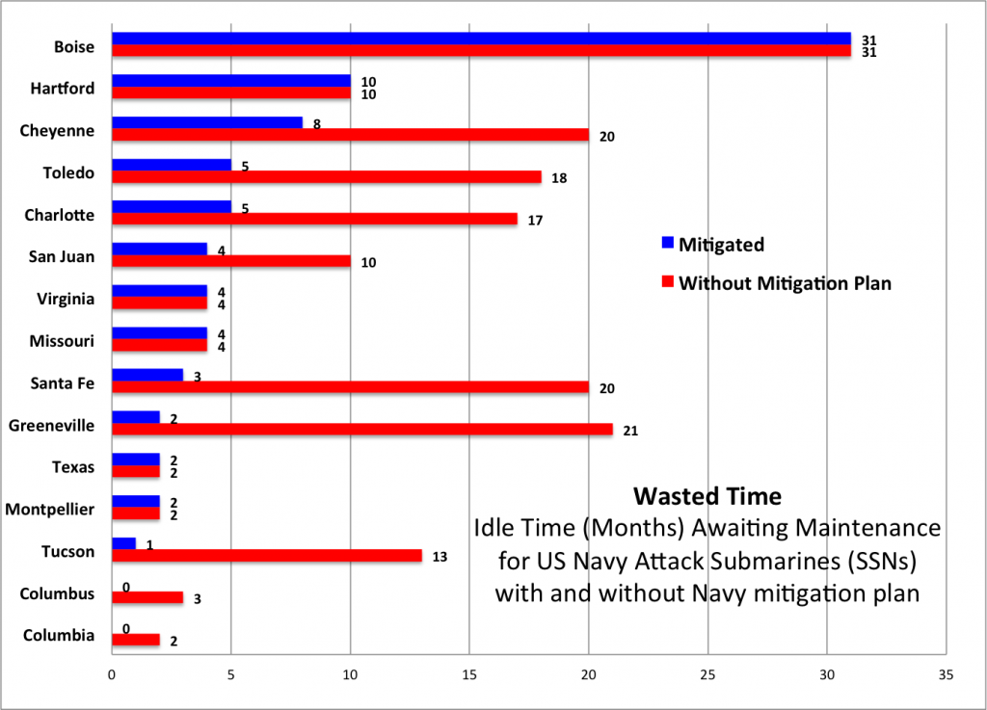
The Navy does have a plan to mitigate the problem, but it can’t get rid of it. If the Navy were able to move money, reshuffle schedules, extend certifications, and take other steps, then it would get many of the suns into maintenance sooner and slash time lost across the fleet to 81 months.
That’s still almost seven years that submarines could be at sea but aren’t. If you put all this on a single notional sub, it would lose 23 percent of its normal service life. For comparison, pro-Navy legislators are struggling to increase the annual number of attack submarines built from two to three. Losing seven years of submarine time is the equivalent of taking a new boat from the 2018 budget and only adding it back in 2025.
And that, again, is the mitigation plan.
There is a growing backup elsewhere: not in submarines needing mid-career maintenance, but in worn-out subs waiting to be decommissioned.
It turns out that you can’t just toss out a nuclear-powered war machine when you’re done with it. There’s a complex process to deactivate the reactor, remove the parts of the submarine that remain radioactive, and hand off the non-irradiated rest of the sub for dismantling.
What’s more, there’s a period towards the end of a nuclear submarine’s life when its reactor core can no longer pump out enough power for operations at sea, but it still requires supervision by a full-up engineering crew. That means old subs waiting to be scrapped aren’t just parked somewhere: About half their normal crew is still aboard. As a result, delaying decommissioning wastes both money and highly trained personnel.
The truth is that the same force that is outlawing ammo in California, has sold all the nuclear fuel for our submarines to our enemies for hundreds of millions in cash put into their own personal foundations.
Electric Boat’s submarine-building yard in Groton, Connecticut
Deep Problems
So even assuming the mitigation plan for submarine maintenance can be implemented, there’ll be a growing problem in submarine decommissioning. But the mitigation plan itself is in jeopardy. Three of the overhauls are scheduled to start in fiscal year 2018, which began a month ago, without a federal budget. Instead, Congress has passed a stopgap Continuing Resolution, which puts government spending on autopilot, with little leeway to make the kind of adjustments the mitigation plan requires. Even if Congress passes the budget, it’s up against the Budget Control Act caps, which if not waived will undo much of the funding added for military readiness.
Past BCA-imposed cuts and Continuing Resolutions bear part of the blame for the Navy’s problems today, the HASC staffers said, as well as the mass retirements of Reagan-era craft. Today, the Navy has fewer ships to meet an unchanged workload, meaning each ship must deploy longer. As a result ships not only miss their originally planned overhaul dates, messing up the maintenance schedule, but they also come in with more wear, tear, and breakdowns than projected, causing their overhauls to take longer. That means they can’t deploy on time, which means the ships they would have relieved must stay on station longer, which means those ships will have more maintenance issues, ad infinitum. (Training often gets cut as well, with potentially lethal results).
[CLARIFIED: The Navy pointed out that while all the above is true for surface ships, the submarine fleet has largely escaped extended deployments. Click here for our followup article on submarine readiness]
The USS Warner under construction in Newport News, one of the last two shipyards in the US able to build a nuclear-powered submarine.
The attack submarine force has an additional complication. It is nuclear powered. Key maintenance can only be done in a handful of specifically equipped yards by specially trained workers. The Navy prefers to do this in-house, but its nuclear-capable public yards have limited capacity, and they prioritize ballistic missile submarines – which make up the bulk of the nation’s nuclear deterrent – and aircraft carriers over the much more numerous attack subs. If maintenance schedules slip on a missile sub or carrier, attack subs get bumped down the list.
That’s why the Navy finally outsourced the Boise‘s repairs to Huntington-Ingalls Industries’ Newport News shipyard in Virginia. That’s one of two private yards in the country that can do nuclear work – the other is General Dynamics’ Electric Boat in New England. Unlike the public yards, the HASC staffers said, these private yards still have some spare capacity and will have it for “the next five years.” After that, work on the next ballistic missile submarine, the Columbia class, will pick up and the private yards will be at capacity too.
The Navy is telling Congress that private yards cost more and there’s no need to outsource any more subs after the Boise, but the HASC staffers are skeptical. Since Boise is getting a complete engineering overhaul, one staffer told me, that shows that “the most complex engineering event in a submarine’s life…can be outsourced.” There’s a “strategic window of about three to five years” to take advantage of the private yards being available, the staffer said, so why not take it?

FISA Court Weaponized by Obama Administration
“Unfortunately, I can’t get into the specific details of this Top Secret document,” Gaetz said on Fox News Friday morning. “I think there are people who could face criminal consequences as a result of the activities laid out in this memo. It’s easy to see after reading this memo why Senator Grassley and why Senator Graham wanted to refer this matter for criminal prosecution. Laws were broken.”

#ReleaseTheMemo has gone viral on Twitter, calling on lawmakers to make it public. Sara Carter also reports that an unnamed congressional member told her “we probably will get this stuff released by the end of the month.”

Gaetz also issued a statement on his congressional website: “The House must immediately make public the memo prepared by the Intelligence Committee regarding the FBI and the Department of Justice. The facts contained in this memo are jaw-dropping and demand full transparency. There is no higher priority than the release of this information to preserve our democracy.”

REP. MATT GAETZ: Our republic is in jeopardy if we allow this type of a palace coup environment to continue to persist and that’s why I’m one of the members of Congress who will be encouraging today Intelligence Chairman Devin Nunes to release the memo. We can have a vote in the Intelligence Committee, a vote in the full House of Representatives.

This is a matter of such importance that I think we need to do it immediately…Unfortunately, I can’t get into the specific details of this Top Secret document, but that is why we have to release it. I don’t think it is appropriate for just members of Congress to be horrified by the activities that were undertaken during this endeavor.

If we get this memo into the public square, heads are going to roll at the FBI and the Department of Justice. There is no way everyone keeps their job…We can never live in a country where this type of thing happens. And particularly, the authentication processes that are laid out in the memo are of such fiction –they are so laughable– that they would never withstand scrutiny from the public.

What I’m worried about is that the cast of characters identified in the memo are not a group of people that are gone. Many of these people are still in our government. They still wield influence. And that’s why we’ve got to get this information out into the public…
I think there are people who could face criminal consequences as a result of the activities laid out in this memo. It’s easy to see after reading this memo why Senator Grassley and why Senator Graham wanted to refer this matter for criminal prosecution. Laws were broken…

I have every confidence after speaking with Paul Ryan and Devin Nunes that after we go through the right procedures and provide the adequate notifications to the executive branch that we will release this memo. We need the public to continue to call for it.
Menendez to be Retried
Two months after a jury failed to come to a verdict in the corruption case against Democratic Sen. Robert Menendez and co-defendant Salomon Melgen, the Justice Department on Friday said they want to retry them.
The department filed a one paragraph notice of intent in federal to retry the case.
“The United States files this notice of intent to retry the defendants and requests that the Court set the case for retrial at the earliest possible date,” reads the notice, signed by Annalou Tirol, acting chief of the public integrity section. “Defendants Robert Menendez and Salomon Melgen have been indicted for bribery and corruption by two separate grand juries properly empaneled in the District of New Jersey. The first trial ended in a mistrial with a deadlocked jury. An early retrial date is in the best interests of the public, and the United States is available to schedule a retrial at the Court’s earliest convenience.”
The move to retry the case comes as Menendez prepares a re-election campaign this year in which he is favored and faces no major Republican challenger. Even if Menendez were forced to step down, the seat would likely remain in Democratic hands because it would be filled by New Jersey’s new Democratic governor, Phil Murphy.
Republicans hold a 51-49 majority in the chamber. Senate Majority Leader Mitch McConnell has called for an Ethics Committee investigation of Menendez.
“An early retrial date is in the best interests of the public, and the United States is available to schedule a retrial at the court’s earliest convenience,” prosecutors told the judge in a filing on Friday in federal court in Newark, New Jersey.

Jurors’ Sentiments
The decision came two months after Menendez jurors said most members of the panel favored acquitting the senator and the doctor accused of bribing him, Salomon Melgen. The U.S. filed its notice just hours before the government will shut down unless lawmakers reach an agreement on a spending bill.
Menendez, a leading Hispanic lawmaker in Congress, vowed to beat the charges.
“We regret that the DOJ, after spending millions and millions of taxpayer dollars, and failing to prove a single allegation in a court of law, has decided to double down on an unjust prosecution,” Menendez’s office said in a statement. “Evidently, they did not hear the overwhelming voices of the New Jerseyans who served on the jury this fall. Senator Menendez fully intends to be vindicated -- again.”
An attorney for Melgen also said the men shouldn’t be retried.
“We are very disappointed that this Justice Department would retry this case,” said Melgen attorney Kirk Ogrosky. “Anyone who watched the testimony, reviewed the exhibits, and spoke to the jurors and the alternates in the first trial knows that this prosecution was ridiculous and should never have been brought.”

Deadlocked Panel
After Walls declared a mistrial on Nov. 16, juror Edward Norris said that prosecutors had failed to prove their case and that the senator and doctor were friends with no corrupt intent. Norris said the panel favored acquittal on most counts by a 10-2 margin.
“There was no smoking gun in the case,” said Norris, an equipment operator. When prosecutors finished presenting their case, he said, “In my gut I was like, ‘That was it? That’s all they had?’” He also said: “I didn’t think there was anything bad that he did. I just didn’t see it.”
The decision by prosecutors to seek a retrial was not a surprise to Daniel R. Alonso, a former U.S. corruption prosecutor.
“They believed in their case when they brought it,” Alonso said. “They saw how the evidence went in, and they decided they’re going to take a second bite at the apple.”
Retrials typically favor the prosecution, he said. “The fact that it was 10-2 for acquittal was of some concern for the prosecution, but is not at all fatal,” he said.
The senator was accused of taking bribes in the form of private jet travel, a Paris vacation and campaign contributions in exchange for pushing the doctor’s business interests at the highest levels of the U.S. government.
Defense lawyers said that the gifts and favors were simply part of a warm friendship over 20 years and not a corrupt quid pro quo, as prosecutors argued. They showed the jury photos of family dinners and a wedding, stressing the modesty and warmth of two men who called each other brothers.

PROOF: British Intelligence Spied on Donald Trump at the Direct Request of President Barack Obama and a later Renewed Request by Susan Rice - NO WARRANTS!
Government Communications Headquarters (GCHQ) is an intelligence and security organization responsible for providing signals intelligence and information assurance to the government and armed forces of the United Kingdom.
On August 28, 2016, then-US-President Barack Hussein Obama requested that British Intelligence begin SPYING on then-candidate for US President, Donald J. Trump, the Trump Organization (his business entities) and on his Presidential Campaign "Donald J. Trump for President." The spying included foreign and US DOMESTIC signals Intercepts (SIGINT). This generally includes phone taps and planting of bugs/listening devices. They did all this without a U.S. Search Warrant or Court Order.
By doing this without a US Search Warrant or Court Order - at the direct request of the President, both The British Government and President Barack Obama committed federal FELONIES punishable with prison, for violating wiretap laws and Constitutional protections afforded to then Mr. Trump and his people. These actions by the British and by Obama were CRIMES.
About two weeks later, on September 15, 2016, the British Government being run by Prime Minister THERESA MAY approved what they called "Operation FULSOME" and began spying on Donald Trump, his businesses and his Presidential campaign.
The spying continued for about ninety days.
On November 17, 2017, nine days AFTER Donald Trump won the Presidential Election, then Director of GCHQ, Robert Hannigan, requested a RENEWAL of permission to continue the spying! Hannigan KNEW that Trump had won, and STILL sought permission to keep spying on him!

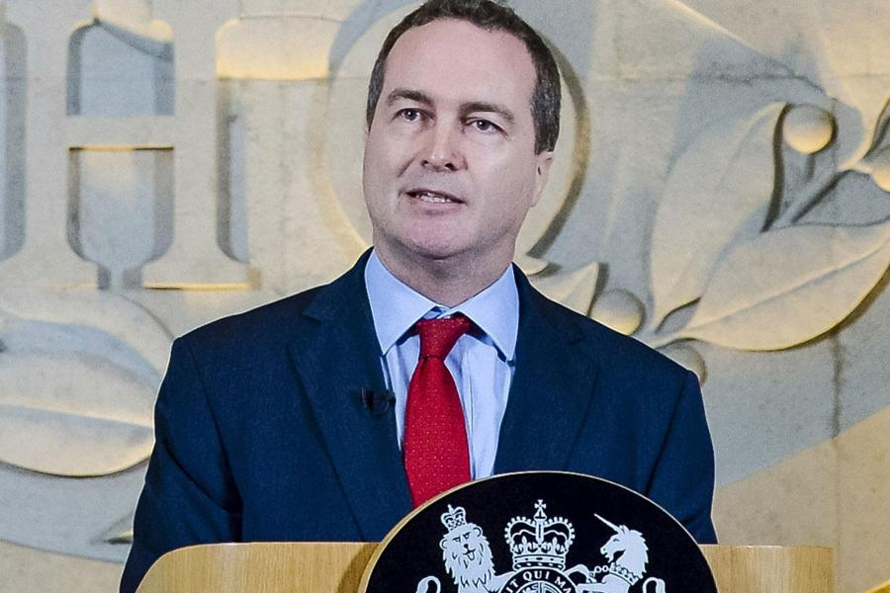Johnson - and presumably his boss, Theresa May -- APPROVED the continued spying.
But this time, the continued spying wasn't sought by President Barack Obama directly. This time, it was sought by "US National Security Advisor (Susan) Rice", who told the British to continue the surveillance during the "Transition Period" before Trump was sworn-in. The reason given to the British by Susan Rice: ". . .internal US Intelligence is potentially compromised by the incoming Trump Administration."

In the Interests of Full Disclosure . . .
As most of you know by now, for fifteen years, from 1993 thru 2008, I worked covertly with the FBI. In my final five years (2003-2008) with the Joint Terrorism Task Force (JTTF). According to sworn testimony by Assistant Special Agent in Charge, Amy Pickett of the FBI New York City Division, I handled things like "National Security, Terrorism, and Foreign Counter-Intelligence." (See Brooklyn Federal Court Transcripts, December, 2009)
In January, 2005, I was granted "Fully operational status" by the Office of Intelligence at FBI Headquarters in Washington, DC, and also granted "Extra-Territorial Authority" to operate covertly OUTSIDE of the United States. In that role, I worked with many people in the Intelligence Community (IC) including folks in the military and law enforcement, in many countries around the world. The relationships I forged with these folks endure to this day.
Thanks to my contacts in the IC, I have now obtained the TOP SECRET MEMO from inside British Government Communications Headquarters (GCHQ) proving the facts laid out about above concerning spying on President Trump.
This is one of the TOP SECRET Documents being mentioned to members of Congress in the four page FISA Abuse Memo released by the House Intelligence Committee to members, which has now resulted in the trending #ReleaseTheMemo social media effort.
The TOP SECRET MEMO from GCHQ is herewith published below:
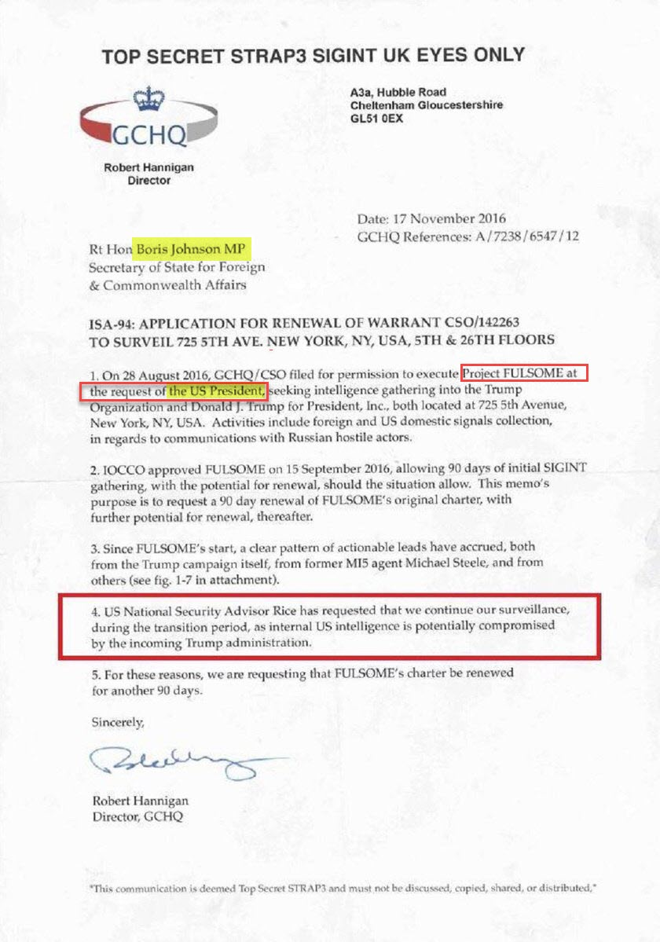

The reason President Trump isn't going to London has nothing to do with its politically filthy Mayor Sidiq Kahn, or some nonsense between him and Theresa May about her paying attention to Radical Muslim crime rather than Trump.
The reason President Trump will not go to London is because THEY SPIED ON HIM, inside the United States. They invaded his personal privacy. They invaded his business privacy. They invaded his Presidential Campaign Communications. And they spilled anything they could get their filthy little hands on, to Barack Obama.
This is also why President Trump is SNUBBING Theresa May at DAVOS this week. Aids are trying to manufacture a meeting between the two leaders but Trump doesn't want to be bothered with May because she's a deceitful political shitbag.
Here's a photo from the last time the two were together; the NATO Summit over the summer of 2017 that's worth a thousand words as to the state of relations between Trump and Ms. May:

When none of their spying worked to affect the Election, one of their men, Christopher Steele, concocted and released the phony "Russian Dossier" in an attempt to prevent Trump from being sworn-in or to wreck his Presidency before it could ever get started.

These are hostile acts committed by the British Government against America, the American election and the then-newly-elected President of the United States.
One last item: Special Counsel Robert Mueller's entire investigation is "fruit from a poisoned tree." NO evidence he has developed can be admitted into any US court because the entire basis for his investigation stems from unlawful acts by then-President Barack Obama, and later his National Security Advisor Susan Rice - both of whom belong in prison -- and Warrantless searches conducted by a foreign power in violation of the US Constitutional requirement that Warrants be issued based on probable cause BEFORE searches can be done. Mueller's Investigation is over.
Why Does California Demand Sanctuary?
California will take the next step in blurring the lines between citizens and non-citizens beginning April Fool’s Day when the state complies with a court order to begin automatically registering to vote all those who are granted driver’s licenses.
The state has long provided driver’s licenses to all who simply claimed, without proof, that they were citizens of in the country legally. There were no checks made or documentation required.
But beginning April 1 every person who gets a California driver’s license will be automatically entitled to vote.
“We are very pleased that Californians will have easier access to voter registration,” said Jeremiah Levine, an attorney with Morrison Foerster who represented the voting-rights groups. “We are especially satisfied that changes will be made before California’s statewide and federal primary elections.”
The state complied with the order under a program dubbed the California New Motor Voter Act. Signed into law in October 2015, the new statute requires the DMV to forward records for all eligible applicants to the Secretary of State’s Office for registration unless those applicants elect not to register to vote.
The League of Women Voters and three other groups sued the state’s Department of Motor Vehicles and Secretary of State’s Office in May 2017, claiming the state burdens would-be voters by making them fill out the same information on two separate forms to register to vote.
According to the lawsuit filed last May, California ranks “a dismal 46th in the nation” in its rate of registered voters. More than 5.5 million eligible voters were unregistered as of February 2017, according to state data.
Other plaintiffs in the lawsuit include the ACCE Institute, California Common Cause and the National Council of La Raza.
Joe Legal vs Jose Illegal
"Joe Legal" and "Jose Illegal". Both families have two parents, two children, and live in California .. Joe Legal works in construction, has a Social Security Number and makes $25.00 per hour with taxes deducted. Jose Illegal also works in construction, has NO Social Security Number, and gets paid $15.00 cash "under the table".
Ready? Now pay attention…. Joe Legal: $25.00 per hour x 40 hours = $1000.00 per week, or $52,000.00 per year. Now take 30% away for state and federal tax; Joe Legal now has $31,231.00. Jose Illegal: $15.00 per hour x 40 hours = $600.00 per week, or $31,200.0 0 per year. Jose Illegal pays no taxes. Jose Illegal now has $31,200.00. Joe Legal pays medical and dental insurance with limited coverage for his family at $600.00 per month, or $7,200.00 per year. Joe Legal now has $24,031.00. Jose Illegal has full medical and dental coverage through the state and local clinics and emergency hospitals at a cost of $0.00 per year.
Jose Illegal still has $31,200.00. Joe Legal makes too much money and is not eligible for food stamps or welfare. Joe Legal pays $500.00 per month for food, or $6,000.00 per year. Joe Legal now has $18,031.00. Jose Illegal has no documented income and is eligible for food stamps, WIC and welfare.
Jose Illegal still has $31,200.00. Joe Legal pays rent of $1,200.00 per month, or $14,400.00 per year. Joe Legal now has 9,631 .00. Jose Illegal receives a $500.00 per month Federal Rent Subsidy. Jose Illegal pays out that $500.00 per month, or $6,000.00 per year.
Jose Illegal still has $ 31,200.00. Joe Legal pays $200.00 per month, or $2,400.00 for car insurance. Some of that is uninsured motorist insurance. Joe Legal now has $7,231.00. Jose Illegal says, "We don't need no stinkin' insurance!" and still has $31,200.00. Joe Legal has to make his $7,231.00 stretch to pay utilities, gasoline, etc.. Jose Illegal has to make his $31,200.00 stretch to pay utilities, gasoline, and what he sends out of the country every month.. Joe Legal now works overtime on Saturdays or gets a part time job after work. Jose Illegal has nights and weekends off to enjoy with his family. Joe Legal's and Jose Illegal's children both attend the same elementary school. Joe Legal pays for his children's lunches, while Jose Illegal's children get a government sponsored lunch. Jose Illegal's children have an after school ESL program. Joe Legal's children go home.
Now, when they reach college age, Joe Legal's kids may not get into a State School and may not qualify for scholarships, grants or other tuition help, even though Joe has been paying for State Schools through his taxes, while Jose Illegal's kids "go to the head of the class" because they are a minority.
Joe Legal and Jose Illegal both enjoy the same police and fire services, but Joe paid for them and Jose did not pay. Do you get it, now? If you vote for or support any politician that supports illegal aliens… You are part of the problem It's way PAST time to take a stand for Americans.
Will Sessions Drop the Hammer
Will SESSIONS drop the hammer?
1 of 22. #Memo shifts narrative.
#Memo reinstates SESSIONS' authority re: Russia/ALL.
#Memo factually demonstrates collusion at highest levels.
#Memo factually demonstrates HUSSEIN ADMIN weaponized INTEL community to ensure D victory [+insurance].
#Memo factually demonstrates 'knowingly false intel' provided to FISA Judges to obtain warrant(s).
THEY NEVER THOUGHT SHE WOULD LOSE. [The 16 Year Plan To Destroy America] Hussein [8] Install rogue_ops
Leak China-intel/Mil assets Cut funding to Military Command away from generals Launch 'good guy' takedown (internal remove) - Valerie Jarrett (sniffer) Anyone who opposes the HRC plan, to be removed.
SAP sell-off Snowden open source Prism/Keyscore (catastrophic to US Mil v. bad actors (WW) +Clowns/-No Such Agency)
Target/weaken conservative base (IRS/MSM)
Open border (flood illegals: Democrat win using illegal immigrants) ISIS/MS13 fund/install (fear, targeting/removal, domestic-assets etc.)
Blind-eye NK [nuke build] [Clas-1, 2, 3] Blind-eye Iran [fund and supply] Blind-eye [CLAS 23-41]
Stage SC [ASSASINATE [187(murder)]]
Uranium 1 fund/supply IRAN/NK sanctions & smuggled cash [+reduce US capacity] starves out sub and naval fleets
KILL NASA (prevent space domination/allow bad actors to take down MIL SATs/WW secure comms/install WMDs) - RISK OF EMP SPACE ORIG (HELPLESS) [CLAS 1-99] HRC [8]
WWIII [death & weapons real/WAR FAKE & CONTROLLED] [population growth control/pocket billions] Eliminate final rogue_ops within Gov't/MIL
KILL economy [starve/need/enslave]
Open borders Revise Constitution Ban sale of firearms (2nd amen removal) Install 'on team' Supreme Court justices> legal win(s) across spectrum of challengers (Assassination 187=murder)
Removal of electoral college [pop vote ^easier manipulation/illegal votes/Soros machines]
Limit/remove funding of MIL Closure of US MIL installations
WW [Germany 1st] Destruction of opposing
MSM/other news outlets (censoring), CLAS 1-59 [] Pure EVIL.
Narrative intercept [4am]. Sessions/Nunes Russian OPS.
Repub distortion of facts to remove Mueller.[POTUS free pass].
Shutdown Primary Reasons. Distract. Weaken military assets. Increase illegal votes.
Black voters abandoning. "Keep them starved" "Keep them blind" "Keep them stupid"
HRC March 13, 2013 [intercept].
The Great Awakening. Fight, Fight, Fight.
Q
The Memo Heard ‘Round the World
“Unfortunately, I can’t get into the specific details of this Top Secret document,” Gaetz said on Fox News Friday morning. “I think there are people who could face criminal consequences as a result of the activities laid out in this memo. It’s easy to see after reading this memo why Senator Grassley and why Senator Graham wanted to refer this matter for criminal prosecution. Laws were broken.”

#ReleaseTheMemo has gone viral on Twitter, calling on lawmakers to make it public. Sara Carter also reports that an unnamed congressional member told her “we probably will get this stuff released by the end of the month.”
Gaetz also issued a statement on his congressional website: “The House must immediately make public the memo prepared by the Intelligence Committee regarding the FBI and the Department of Justice. The facts contained in this memo are jaw-dropping and demand full transparency. There is no higher priority than the release of this information to preserve our democracy.”
REP. MATT GAETZ: Our republic is in jeopardy if we allow this type of a palace coup environment to continue to persist and that’s why I’m one of the members of Congress who will be encouraging today Intelligence Chairman Devin Nunes to release the memo. We can have a vote in the Intelligence Committee, a vote in the full House of Representatives.
This is a matter of such importance that I think we need to do it immediately…
Unfortunately, I can’t get into the specific details of this Top Secret document, but that is why we have to release it. I don’t think it is appropriate for just members of Congress to be horrified by the activities that were undertaken during this endeavor.
If we get this memo into the public square, heads are going to roll at the FBI and the Department of Justice. There is no way everyone keeps their job…
We can never live in a country where this type of thing happens. And particularly, the authentication processes that are laid out in the memo are of such fiction –they are so laughable– that they would never withstand scrutiny from the public.
What I’m worried about is that the cast of characters identified in the memo are not a group of people that are gone. Many of these people are still in our government. They still wield influence. And that’s why we’ve got to get this information out into the public…
I think there are people who could face criminal consequences as a result of the activities laid out in this memo. It’s easy to see after reading this memo why Senator Grassley and why Senator Graham wanted to refer this matter for criminal prosecution. Laws were broken…

I have every confidence after speaking with Paul Ryan and Devin Nunes that after we go through the right procedures and provide the adequate notifications to the executive branch that we will release this memo. We need the public to continue to call for it

The Schumer Shutdown is About to get a Whole Lot Worse
Despite assurances from the House that an even shorter-term spending bill that would give lawmakers more wiggle room to negotiate would be a non-starter, Susan Collins and a group of moderate senators told reporters they are taking ideas about a short-term fix to the Republican senate leadership...
Both the House and Senate have reconvened for another rare weekend session.
Meanwhile, House Speaker Paul Ryan took to the Sunday shows to heap blame for the shutdown on Democrats.
“You can't blame Donald Trump for Senate Democrats shutting down the government. They shut down the government with no endgame in sight,” House Speaker Paul Ryan said on CBS News’ “Face The Nation.”
Democrats, meanwhile, have dubbed the stalled negotiations the “Trump shutdown,” and say the GOP’s control of both the White House and Congress puts the blame squarely on their shoulders, per NBC News.
McConnell has scheduled a procedural vote on a three-week extension bill for 1 am Monday morning. If passed, that bill would need to clear the House. Ryan has said he would support the bill, which would keep the government open until Feb. 8. The original four-week plan offered to keep the government open until Feb. 16.
"This shutdown is going to get a lot worse tomorrow," Senate Majority Leader Mitch McConnell said in a speech opening the Senate floor. "Today would be a good day to end it."
Senate Minority Leader Chuck Schumer called on President Trump to return to the bargaining table. "I'm willing to seal the deal, to sit and work right now, with the president or anyone he designates. Let's get it done."
"This is the Trump shutdown, only President Trump can end it." Schumer said. "We Democrats are at the table, ready to negotiate. The president needs to pull up a chair and end this shutdown."
As NBC News explained, Democrats maintain that the weeks-long spending bill being considered in the Senate is just a stalling tactic that will not lead to a serious legislative debate about immigration reform. Democrats have vowed not to vote for a spending package until a deal to enshrine DACA protections for 690,000 undocumented immigrants is in place.
Update: Amid reports that Trump hasn't spoken with Chuck Schumer since Friday, Sen. Dick Durban refused to offer a prediction about when the shutdown might end.
"I'm not going to make that prediction," Durbin said on NBC's "Meet the Press."
"We're going to look every minute of every day," Durbin said on Sunday, adding that he wanted President Trump to get involved in the negotiation process.
Durbin added he feels there are "positive conversations" happening amid the negotiations (even if the president and the minority leader aren't participants in those conversations).
Meanwhile, House Speaker Paul Ryan took to the Sunday shows to heap blame for the shutdown on Democrats.
“You can't blame Donald Trump for Senate Democrats shutting down the government. They shut down the government with no endgame in sight,” House Speaker Paul Ryan said on CBS News’ “Face The Nation.”
Democrats, meanwhile, have dubbed the stalled negotiations the “Trump shutdown,” and say the GOP’s control of both the White House and Congress puts the blame squarely on their shoulders, per NBC News.
McConnell has scheduled a procedural vote on a three-week extension bill for 1 am Monday morning. If passed, that bill would need to clear the House. Ryan has said he would support the bill, which would keep the government open until Feb. 8. The original four-week plan offered to keep the government open until Feb. 16.
"This shutdown is going to get a lot worse tomorrow," Senate Majority Leader Mitch McConnell said in a speech opening the Senate floor. "Today would be a good day to end it."
Senate Minority Leader Chuck Schumer called on President Trump to return to the bargaining table. "I'm willing to seal the deal, to sit and work right now, with the president or anyone he designates. Let's get it done."
"This is the Trump shutdown, only President Trump can end it." Schumer said. "We Democrats are at the table, ready to negotiate. The president needs to pull up a chair and end this shutdown."
As NBC News explained, Democrats maintain that the weeks-long spending bill being considered in the Senate is just a stalling tactic that will not lead to a serious legislative debate about immigration reform. Democrats have vowed not to vote for a spending package until a deal to enshrine DACA protections for 690,000 undocumented immigrants is in place.
Update: Amid reports that Trump hasn't spoken with Chuck Schumer since Friday, Sen. Dick Durban refused to offer a prediction about when the shutdown might end.
"I'm not going to make that prediction," Durbin said on NBC's "Meet the Press."
"We're going to look every minute of every day," Durbin said on Sunday, adding that he wanted President Trump to get involved in the negotiation process.
Durbin added he feels there are "positive conversations" happening amid the negotiations (even if the president and the minority leader aren't participants in those conversations). Mulvaney said Democrats want to keep the government shut for Trump's Jan. 30 State of the Union address. The beginning of the shutdown also coincided with the anniversary of Trump's swearing-in.
As we've pointed out, both of the two most recent shutdowns lasted for two weeks or longer, per Axios. Mulvaney said Democrats want to keep the government shut for Trump's Jan. 30 State of the Union address. The beginning of the shutdown also coincided with the anniversary of Trump's swearing-in.
As we've pointed out, both of the two most recent shutdowns lasted for two weeks or longer, per Axios.
Why do We Call it the Schumer Shutdown?
Democrat Senator Charles Schumer was willing to shut down the government and hurt millions of people while causing billions in economic damage over his desire to remove penalties for illegal aliens and open the borders, but have you wondered why?
An explosive report by The Gateway Pundit reveals that there may be a reason for his support beyond Schumer’s purported love of Mexican criminals above our veterans and poor children. In fact, there is a reason. $500,000 of them in fact.
Transparency website Glass Tabletop revealed yesterday that just before the Friday evening vote, Schumer received three separate campaign donation from Immigration for Everyone, the Council for Alien Rights, and the Southern Border Defense Fund — three groups that regularly push for complete amnesty for all illegals.
Thanks to this donation and his hatred of President Trump, Schumer was more than willing to encourage his fellow Democrats to vote against keeping the government open. 90% of them listened. Only five Democrats summoned enough patriotism to vote FOR America. Once again, Schumer sold out the country for personal campaign cash.
2018 is our chance to reaffirm that we want Donald Trump’s America — that we want freedom and democracy and rule of law. It’s time for us to completely take Congress from the hands of the Democrat Party. I maintain that 100% of Democrat Congressmen and women should be voted out of office in November. This would bankrupt the Democrat Corporation and end their corruption once and for all. Any remaining RINOS would be too scared to vote against America again. We haven’t had two parties in a long time, but if you feel we need one, there are 56 national parties to choose from.

US Preparing for Imminent Attack from Submarines
Friday, 19 January 2018 01:05
P-8A POSEIDON Anti-Submarine Plane Deploying Sonar-Buoys
The East Coast of the United States may be subjected to attack by submarine launched missile(s) and the US Navy has scrambled NUMEROUS P-8A POSEIDON anti-submarine aircraft, to repeatedly search coastal waters from New York City to Washington, DC ALL DAY Thursday into Thursday Evening.
According to flight records, at least NINE anti-submarine warfare aircraft were sortied Thursday off the US East Coast, and Flight Records show they were engaged in very active hunting for submarine(s) off the East Coast . . . . well WITHIN the 12 mile territorial limit of the United States. Here is a list of the Anti-Submarine aircraft deployed in the United States today alone:
Here is one example of the flight search pattern:

The Navy was so ardent in its hunting, they even called-up Civil Air Patrol (CAP) private contractor aircraft to hunt for Submarines too! Here is one such flight record showing the private contractor aircraft operating in a search pattern in Restricted Airspace

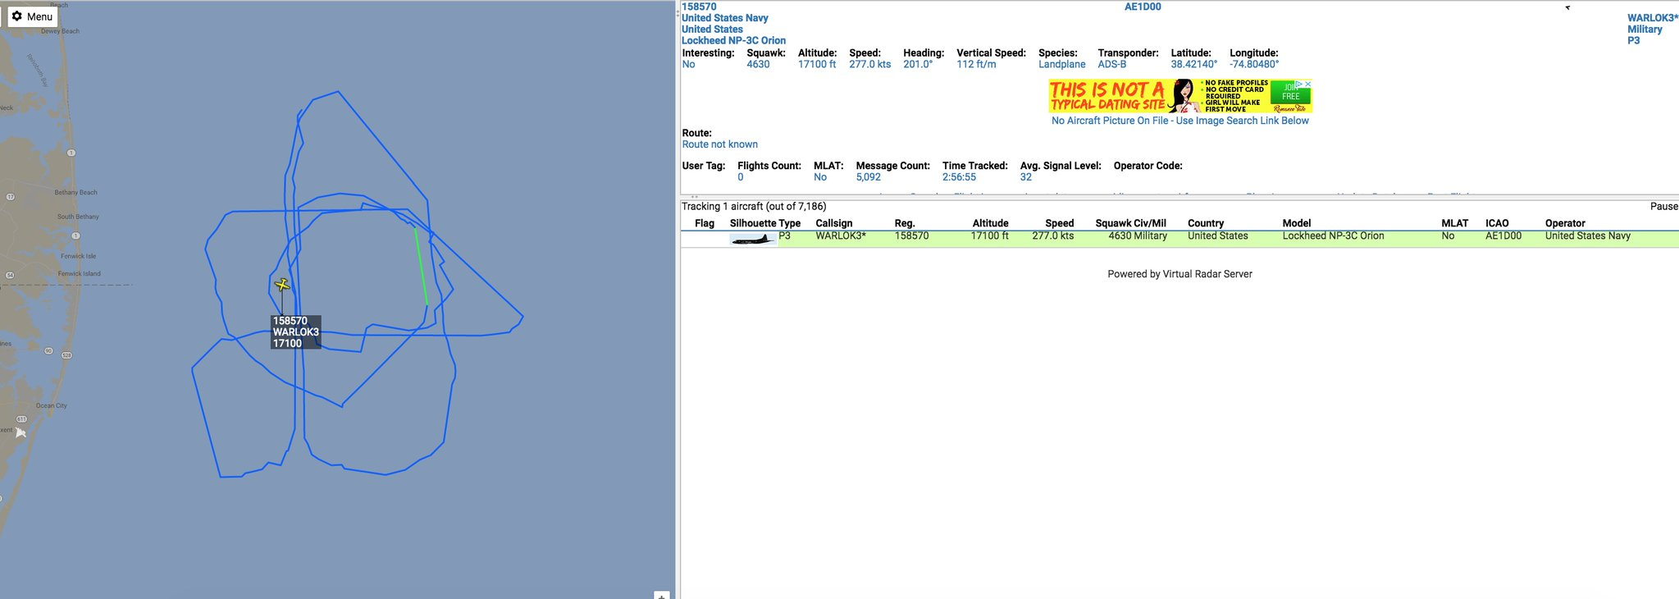

With Congress having voted to release a CLASSIFIED Internal memo which lays out the rampant abuse of Foreign Intelligence Surveillance Act (FISA) searches and the "Deep State" facing public exposure of the hideous shenanigans they've been pulling against our own country, it is feared the "Deep State" will pull out all the stops to launch a false flag attack against our own country just to kill the story and divert public attention of how they have been spying on the American people and worse, how they intentionally tried to overthrow our Presidential Election.

Persons in the northeastern US should be on guard for an enormous and terrifying event - possibly an actual missile attack -- which causes chaos, and realize this is being done by design by traitors in our own government.

So convinced is the US that some type of horrific attack is being planned against the mainland, that no fewer than 165 military aircraft were airborne over and near the US mainland today! That's an astonishing number of military aircraft in the air at the same time!
California Dems Plot to Steal Half of Tax Savings from Businesses
Democrats in California have proposed an amendment to take half of the tax savings businesses in their state get from the recently-passed federal tax cuts.
California would seize the savings via a proposed "tax surcharge" on any tax reform benefits, The San Francisco Chronicle reports:
"A proposed Assembly Constitutional Amendment by Assemblymen Kevin McCarty, D-Sacramento, and Phil Ting, D-San Francisco, would create a tax surcharge on California companies making more than $1 million so that half of their federal tax cut would instead go to programs that benefit low-income and middle-class families."
If successful, the plan will ensure that Silicon Valley companies will join the "hundreds of thousands" of taxpayers who have fled California due to its high taxes, Americans for Tax Reform (ATR) President Grover Norquist told CNSNews.com in reaction to the Democrats' proposal:
"Having hiked income and property taxes to the point that hundreds of thousands of California Taxpayers have fled to lower tax states, the political 'leaders' of California are now looking to hike state business tax rates to ensure that Silicon valley—in order to stay international competitive—moves bit by bit across state lines."
Passing the amendment became tougher when Democrats lost their supermajority following resignations of three Assembly Democrats – two plagued by sexual misconduct allegations and one citing health reasons, The Chronicle reports:
"As a constitutional amendment, the bill would require approval from two-thirds of the Legislature to pass, a difficult hurdle now that Democrats have lost their supermajority. If passed and signed by Gov. Jerry Brown, it would then go to voters for final approval."

