Jihad Report
Feb 03, 2018 -
Feb 09, 2018
Attacks | 40
Killed | 195
Injured | 260
Suicide Blasts | 2
Countries | 15
The Uranium Nail
During a Thursday appearance on “America’s Newsroom,” Victoria Toensing, attorney for FBI informant Douglas Campbell, fired back at Hillary Clinton spokesman Nick Merrill for saying her client was participating in a “charade” by informing the FBI that Russia paid a lobbying group $3 million to “provide in-kind support for the Clintons’ Global Initiative.”
Toensing argued that $3 million is “a lot of money for a year of lobbying” and defended her client’s credibility.
“[Campbell] came out because he thought he was dying from cancer and he wanted his story to be told,” Toensing explained. “They can go attack all they want to. He’s got the truth, he’s got briefings, the FBI has all kinds of videotapes.”
Toensing added that the Russians thought they had “died and gone to heaven” when Clinton became secretary of state in 2009 and said that is when they began planning out the Uranium One purchase.
The 2010 controversial deal transferred 20 percent of all U.S. uranium to Russia via the sale of the Uranium One company, a Canadian mining company, just as nine foreign investors in the deal gave $145 million to the Clinton charity. Given the stake in the U.S. uranium reserves, the deal required approval U.S. government.
Twitter’s First Profit

Twitter has posted their first profitable quarter in 12 years, but the company is still lagging behind in monthly user metrics.
The Verge reports that Twitter has finally posted a profitable quarter after operating at a loss for almost 12 years. Twitter posted a profit of $91 million in the fourth quarter of 2017, a massive increase on the $167 million loss the company posted a year previously in the fourth quarter of 2016. The company told investors last year that they expected their first profitable quarter soon due to cost-cutting measures implemented by the company. Twitter also saw a two percent rise in their revenue this quarter, up to $732 million in comparison with last year’s $717 million.
However, not all of Twitter’s latest metrics are positive. The company has a growing issue on its hands — specifically in active monthly users. While the company’s monthly users grew by approximately 4 percent each year, that growth was stalled every quarter settling at a number around 330 million. Even more worrying for Twitter, the number of active monthly U.S. users has actually shrunk from 69 million to 68 million. This is the second time in one year that the number of active U.S. users has dropped. It seems that Twitter’s growth internationally has been slow but steady but the company is failing to convince their American users to stick with the platform.
Twitter has laid some of the blame for their slow user growth on Apple’s doorstep, pointing to a change in Safari’s third-party app integrations. Twitter stated that they lost approximately two million monthly users as a result of the change, one million of these users were US based. The company does believe that their change in the length of Tweets that users can post has been a positive though, stating that it’s responsible for users spending more time on the platform and returning to it at higher rates.
Despite their profitable quarter, Twitter continues to lag behind their social media competitors such as Facebook and Instagram. Facebook boasts a whopping 2.2 billion active monthly users while Instagram has approximately 800 million monthly users. However, it is likely that Twitter’s latest earnings report will take some pressure off CEO Jack Dorsey despite the company’s continued failure to convince people to use the platform
The Media War Against Trump Continues
It seems the barrista down the street from the White House is talking again to the ABC news crew. Yes, you only thought the leaks out of the Trump team had finally been solved. Nope. White House chief of staff John Kelly has discussed with President Donald Trump the possibly of resigning from his post after the West Wing shook with this week's news that a top aide had been accused of domestic violence.
ABC News cited sources close to the president as saying Trump has spoken with multiple people about replacing Kelly over his handling of Rob Porter, who resigned Wednesday after photos of one of his ex-wives with a black eye were published in the media.
At the same time, ABC noted that Kelly offered to resign.
No resignation letter has been written, the news outlet noted.
The White House reacted by calling the ABC report untrue:
Kelly issued a statement Tuesday that was supportive of Porter after a news report detailing the domestic violence allegations came out. Late Wednesday, several hours after the photos were published in The Daily Mail, Kelly issued another statement that took a firm stance against domestic violence.
Further complicating the matter was a report that claimed Kelly told West Wing staffers Friday morning to spread the word that he took quick action once the allegations against Porter seemed more credible.
Trump was reportedly unhappy with principal deputy press secretary Raj Shah's comments about the Porter matter during Thursday's White House press briefing.
Kelly also came under fire for recent remarks in which he insinuated that certain immigrants might have been "too lazy" to sign up for the Deferred Action for Childhood Arrivals (DACA) program.
The DOJ: The Day of Justice is Coming
The U.S. Justice Department's third-ranking official, Rachel Brand, plans to step down after just nine months on the job, the New York Times reported on Friday, at a time when President Donald Trump has taken aim at senior law enforcement officials.
Brand was next in line of succession to Deputy Attorney General Rod Rosenstein for oversight of Special Counsel Robert Mueller's investigation into potential collusion between Trump's 2016 presidential campaign and Russia and whether the Republican president has unlawfully sought to obstruct the ongoing probe.
Rosenstein oversees Mueller's investigation because Attorney General Jeff Sessions recused himself from the matter last year.
Brand's resignation is the latest sign of turmoil at U.S. law enforcement agencies, which have come under sustained attack by Trump and his Republican allies in recent months. The Times reported that Brand will resign, citing two people briefed on her decision.
News of her departure comes a week after Trump approved the release of a previously classified memo written by Republican lawmakers that portrayed the Russia investigation, initially handled by the Federal Bureau of Investigation and now headed by Mueller, as a product of political bias against Trump at the Justice Department and FBI.
Trump also has criticized Sessions for recusing himself.
Brand has reportedly claimed that she had no intention of leaving her high rank at the DOJ, where she is nestled neatly under Rosenstein, who is clearly in the sights of the American people as an enemy to America. I don’t say that lightly. Rosenstein and Mueller have worked together to frustrate Congress with shallow answers, refusals to produce information, and a long and sordid history of spying. The FBI was formed to spy on Russians and go after Federal criminals in the mob using high tech military surveillance tools. It used to be that the FBI always got their man.
But somehow, the Clintons gained access to them as a private spook army that would follow virtually any orders from Bill and Hillary and hose the mess into the storm drain after they were done. In my new best seller, Charm of Favor, I describe just how deadly they have become. In the end, men and women are spying on other men and women, and if needed assassinating them on orders from the Clintons. Their secret force is feared by everyone, including Putin.
The question everyone asks is, “Who can be trusted to be for America?” There is no easy answer. There is no lie detector test. There is no way, short of the very methods of super-surveillance the enemy has been using for 40 years, to tell if the person you are speaking with is the enemy. Yes, I said enemy. Make no mistake, Earth explorers, we are at war, and there is an enemy. And he is very powerful. He may own everything on this planet. You can survive one of two ways. You can either be so small that you are not noticed, or you can be so powerful and public that you cannot be simply shot, hung, Breitbarted, or smeared by the FBI.
That sounds strange even saying it. I have two friends who worked for years to become FBI agents. They were both great men. But the thing about the FBI, is that they have to do business with the bad guys to get the bad guys. And sometimes, in the process, they become bad guys, and bad girls. What we really want to know, is who they are.
Honestly, I don’t think there is any way. Hillary has had access to FBI files since the days of Mena, Arkansas. She has even been caught with FBI files in her personal residence, with only her fingerprints on them. Did she go to jail? No. That is the most chilling thing to realize. She can set her jaw and know she has the dirt on everyone. And, even if you have never had any dirt in your life—only you know who you are—they will make dirt up out of nothing more than an MI-6 dossier. Either way, you’re screwed.
How do angels have war? I don’t know, but we are witnessing it right now. When this battle spills out onto the street, it will shock everyone. Everyone.
Flat Earthers Suffer a Mortal Blow
The Flat Earth Society—I know it sounds so medieval to even say that doesn’t it?—suffered a major blow to their claim that space is fake, and that we live in a Truman-like world controlled by a master projectionist up there, somewhere. Although, “up there” doesn’t exist, right?
The launch Tuesday of SpaceX's Falcon rocket signifies that America is ready to return to the forefront in space, Newt Gingrich said Friday.
Most people agree, the successful launch of SpaceX's Falcon powerful new rocket Tuesday at the Kennedy Space Center was a tremendous step toward reasserting American leadership in space. All we need to do is put the Orion Capsule onboard the Falcon, and go to Mars.
The Falcon Heavy is the most powerful rocket that the U.S. has launched since the Apollo missions, and it can carry almost 64 metric tons, more than double the payload of the next biggest rocket. When it comes to rockets, size matters.
"The Space Council must see the new reality. It must recognize that companies like SpaceX are out-competing government rocket programs. This trend is likely to continue," Gingrich wrote.
"Instead of focusing our tax dollars on duplicative efforts, the federal government's interaction with the space industry must change. We should help these companies achieve more," Gingrich wrote.
The council needs to focus on public-private partnerships with companies such as SpaceX, where the government would invest and be paid back and "if the U.S. does not do this, our competitors will. A future where China or Russia dominates space is not a safe, secure or prosperous future for America," Gingrich wrote.
Bouncing back from failures is also vital to space programs, Gingrich said, noting that the company failed three times with its Falcon 1 launch before its success.
"This work has helped discover and drive American technological innovations at a rate that the bureaucratic, risk averse, old-space system could never have achieved," Gingrich wrote.
SpaceX founder Elon Musk's launch of the 'Starman' mannequin into can inspire young people, Gingrich wrote. "This extraordinary video from this car orbiting Earth makes clear to every young person in America that having a career in the space industry—even actually going to space—is as real tangible, and achievable, as becoming a dentist, a lawyer, a civil engineer, or any other job that requires focus and hard work," Gingrich wrote.
The mortal blow came from the dash cam of the Tesla Roadster, tumbling in space and occasionally capturing the image of a nice, spherical Earth. Starman and Musk's Roadster are in an elliptical orbit around the sun. At their closest point to the sun, they will fly just inside the Earth's orbit. At their farthest away, they'll be 243 million miles (390 million kilometers) from the sun.
For comparison, Earth's average distance from the sun is about 93 million miles (150 million km). Mars orbits the sun at 142 million miles (228 million km).
Shortly after SpaceX's Falcon Heavy launched the Roadster into space, three cameras began beaming live views of the car and Starman back to Earth. That webcast lasted 4 hours and 39 minutes before going offline. Drop the mic here.
The Me-Too Army Attacks
With the #MeToo movement claiming scalps in politics, media, and Hollywood, it seems wise for men to be more cautious in their interactions with women they work with. That’s just good practice, although it is a bit sad that even friendly interactions have to be curtailed, in order to avoid hearing 10 years later that you sexually harassed a colleague.
Then there is the very real concern of blatant set-ups.
How easy would it be to have a casual or otherwise meaningless interaction morph into a situation where a politician or businessman could find himself the victim of an extortion attempt?
Republican state Senator Evan Vickers, of Utah, may have dodged a bullet, recently, and others should pay attention. He handled this situation just right.
On Thursday night, the senator was staying at the Little America Hotel, in Salt Lake City. As he emerged from his room, he was met by a young woman he did not know.
Said Vickers, in an interview with KSTU-TV:
“I opened the door and there was a young lady standing there and she said ‘Hi,’ and I said, ‘Hi, who are you?’ And she said, ‘I’m your date.’ I said, ‘No, you’re not.’ She said, ‘Yes, I’m your date,’” KSTU reported.
The woman refused to leave and kept repeating that she was Vickers’ date.
“She was standing in front of the elevator and I said, ‘I don’t know who you are and what you’re doing here,’ and she said, ‘No, you don’t understand. I’m your date.’ I said, ‘No I’m not and walked back into the room,’” he told KSTU.
Vickers returned to the room, locked the door, and asked a legislative colleague to escort him out of the hotel. The woman left, and he was left wondering what she was trying to accomplish.
The word was spread among Utah lawmakers to be on the lookout for attempts to entrap them.

And while hotel security is reviewing their security video, Salt Lake City police, as well as the Utah Highway Patrol have been alerted.
“I’m shocked,” said Utah state Senate Minority Leader Gene Davis, a Democrat.
I imagine Utah lawmakers are particularly sensitive to this.
On Wednesday, a British tabloid reported that an escort named Brie Taylor had made the claim that Utah state Rep. Jon Stanard attempted to solicit sex from her.
They believe she may have gotten paid to make such a claim.
Stanard actually left the Utah State Legislature last week because of “personal and family issues.”
The #MeToo movement did a lot of good, but it also holds the potential to be weaponized, so beware.
Memo Wars
Political prowess is the core of the Democrat Party. As predicted, Adam Schiff crafted a memo with items that cannot be released into the public domain, because it would get innocent people killed. The methods by which they get the data they have would shock the crap out of the KGB. Why did he do this? Because he knew the President would have to apply the black ink to redact a word or two. That redaction would be seen as obstruction of Justice, and the Schiffty army would attack through the closest microphone.
President Trump declined to release the Democrat rebuttal to a GOP-authored "FISA memo," following the advice of the Department of Justice and the Director of National Intelligence, the White House announced.
"If the memo was really about oversight, committee members would want to read the underlying documents and bring in the FBI. Republicans voted against both," Schiff tweeted on Feb. 4, two days after the panel released the "surveillance" memo.
The four-page memo, released by the House Intelligence Committee chairman Rep. Devin Nunes, R-Calif., on Feb. 2 claimed the infamous Trump dossier "formed an essential part" of applications by the FBI and Justice Department to spy on onetime Trump campaign adviser Carter Page.
Schiff has called the Republicans' memo "shoddy" and "misleading," claiming it was released only to undermine Special Counsel Robert Mueller's Russia investigation.
"The president’s decision to publicly release a misleading memo attacking DOJ & FBI is a transparent attempt to discredit these institutions," Schiff added. "We'll fight to release our classified response."
Schiff requested the committee release Democratic members’ own 10-page memo, with the promise to send it to the Justice Department for redactions -- and the committee unanimously approved its release on Feb. 5, sending the memo to the White House.
"We think this will help inform the public of the many distortions and inaccuracies in the majority memo," Schiff told reporters the same day the committee approved its release.
On Feb. 9, the White House told Democratic lawmakers that the memo requires certain redactions before it can be made public.
White House Counsel Don McGahn said President Trump is "still inclined" to release the memo if the revisions are made.
The day after the memo's release was halted, Trump tweeted that the document is "very political."
"The Democrats sent a very political and long response memo which they knew, because of sources and methods (and more), would have to be heavily redacted, whereupon they would blame the White House for lack of transparency. Told them to re-do and send back in proper form!" he wrote.
The Democrats sent a very political and long response memo which they knew, because of sources and methods (and more), would have to be heavily redacted, whereupon they would blame the White House for lack of transparency. Told them to re-do and send back in proper form!
Schiff tweeted in response, writing that what Trump considers to be "political" are "actually called facts."
"Mr. President, what you call “political” are actually called facts, and your concern for sources and methods would be more convincing if you hadn’t decided to release the GOP memo (“100%”) before reading it and over the objections of the FBI," Schiff tweeted on Feb. 10.
Mr. President, what you call “political” are actually called facts, and your concern for sources and methods would be more convincing if you hadn’t decided to release the GOP memo (“100%”) before reading it and over the objections of the FBI. https://twitter.com/realdonaldtrump/status/962330457886076928 …
Here's what you need to know about Schiff, his notable career moves and his recent Twitter exchanges with the president.
Who is Adam Schiff?
Rep. Adam Schiff, D. Calif., has been vocal about his objections to the GOP memo released on Feb. 2. (Handout)
As a graduate of Stanford University and Harvard Law School, Schiff started his career in law. He spent six years working in the U.S. Attorney's Office in Los Angeles.
During his time as assistant U.S. attorney, Schiff prosecuted the first FBI agent ever to be convicted of espionage for passing secret documents to the Soviets.
"This is a betrayal tinged with hypocrisy," Schiff said at the trial for former FBI agent Richard Miller, who was sentenced to 20 years in prison, The New York Times reported. "We have here an agent who did just exactly what he was supposed to protect against."

Within a few seconds, Schiff moved on to politics.
He was elected to the California State Senate in 1996, serving four terms before heading to the House of Representatives. The Democrat has been serving in Congress since 2001.
In recent years, Schiff has shifted his focus to foreign policy and national security. He now sits as a ranking member on the House Intelligence Committee and was a member of the Benghazi Select Committee, according to a biography on his official website.
Schiff recently said he believed the White House may have been behind the memo in an attempt to interfere with the Russia probe.
"I think it’s very possible his staff worked with the White House and coordinated the whole effort with the White House," Schiff said in an interview with ABC's "This Week."
The president said the memo completely "vindicates" him in the Russia investigation, though he said the "Russian witch hunt" would most likely continue.
"There was no collusion and there was no obstruction (the word now used because, after one year of looking endlessly and finding NOTHING, collusion is dead)," Trump tweeted on Feb. 2. "This is an American disgrace!"
This memo totally vindicates “Trump” in probe. But the Russian Witch Hunt goes on and on. Their was no Collusion and there was no Obstruction (the word now used because, after one year of looking endlessly and finding NOTHING, collusion is dead). This is an American disgrace!
But Schiff said, while misleading, the memo was proof there was collusion with the Russians.
"Quite the opposite, Mr. President," Schiff replied on Twitter. "The most important fact disclosed in this otherwise shoddy memo was that FBI investigation began July 2016 with your advisor, Papadopoulos, who was secretly discussing stolen Clinton emails with the Russians."
Schiff versus Trump: The Twitter war continues
Trump targeted "Little Adam Schiff" on Feb. 5, calling him one of the "biggest liars and leakers in Washington," as both parties continued to argue over the newly released FISA memo.
"Little Adam Schiff, who is desperate to run for higher office, is one of the biggest liars and leakers in Washington, right up there with Comey, Warner, Brennan and Clapper!" Trump tweeted. "Adam leaves closed committee hearings to illegally leak confidential information. Must be stopped!"
Little Adam Schiff, who is desperate to run for higher office, is one of the biggest liars and leakers in Washington, right up there with Comey, Warner, Brennan and Clapper! Adam leaves closed committee hearings to illegally leak confidential information. Must be stopped!
Within minutes, Schiff fired back, tweeting: "Mr. President, I see you’ve had a busy morning of 'Executive Time.' Instead of tweeting false smears, the American people would appreciate it if you turned off the TV and helped solve the funding crisis, protected Dreamers or...really anything else."
Mr. President, I see you’ve had a busy morning of “Executive Time.” Instead of tweeting false smears, the American people would appreciate it if you turned off the TV and helped solve the funding crisis, protected Dreamers or...really anything else. https://twitter.com/realdonaldtrump/status/960492998734868480 …
Trump's tweet came shortly before Committee Chairman Devin Nunes, R-Calif., told "Fox & Friends" that there have been "almost 100 leaks" by Democrats on the House Intelligence Committee related to the Russia investigation.
Trump's tweet also reflected frustration with a host of figures, including Schiff's Senate counterpart – Sen. Mark Warner, D-Va., who sits as ranking member on the Senate Intelligence Committee, which conducted its own Russia probe. He also named former FBI Director James Comey, former CIA Director John Brennan, and former Director of National Intelligence James Clapper.
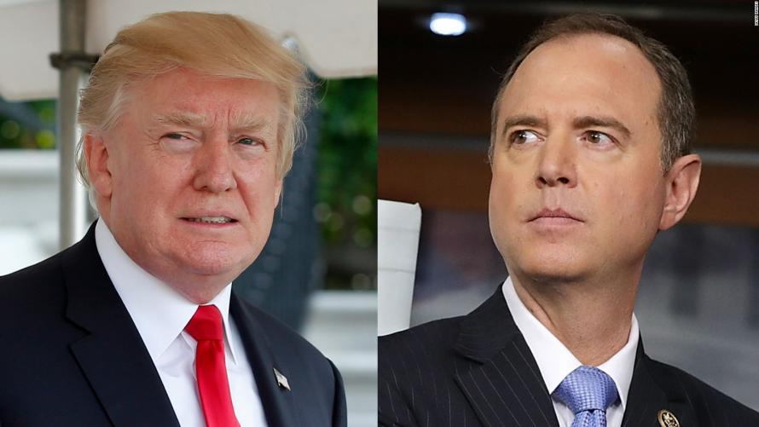
President Trump is "inclined to declassify" the Democratic memo, however there are several sections which would create "especially significant concerns" for "national security and law enforcement interests," wrote White House counsel Don McGahn in a letter to House Intelligence Committee chairman Devin Nunes (D-CA).
While the White House ignored FBI requests to redact the names in the GOP-authored memo, the Democratic response is said to reveal sources and methods which must be concealed.
In a separate letter to FBI Director Christopher Wray and Deputy Attorney General Rod Rosenstein, McGahn highlighted the problematic information. The White House says it will work with the House Intelligence Committee if it wants to revise the Democratic memo and resubmit it for White House review.
“The president encourages the Committee to undertake these efforts,” the letter states. “The Executive Branch stands ready to review any subsequent draft of the Feb. 5th memorandum for declassification at the earliest opportunity.”
Democrats on the House Intel Committee can now make the requested changes, or submit their memo to the full house to seek a vote to override the President's decision.
The House Intelligence Committee voted earlier this week to release the 10-page Democratic memo authored by ranking minority Committee member Rep. Adam Schiff (D-CA) following the declassification and public release of a four-page "FISA memo" authored by staffers for Chairman Devin Nunes.
In response to Trump blocking the Democratic rebuttal, Nunes said on Friday that he was not surprised that the DOJ and FBI advised against its release.

"Ranking Member Schiff pledged to seek the input of the Department of Justice and FBI regarding the memo’s public release, and it’s no surprise that these agencies recommended against publishing the memo without redactions," said Nunes.
Nunes suggested that the Democrats make the "appropriate technical changes and redactions" as recommended by the justice department "so that no sources and methods are disclosed and their memo can be declassified as soon as possible."
Democrats Cry Foul
After the GOP-authored memo was released, Democrats cried foul - calling it "inaccurate" and claiming its sole purpose was to derail and obstruct the ongoing investigations into Russian interference in the 2016 election.
Democrats were outraged at the President's decision. In a Friday night statement, Schiff said that Democrats had provided their memo to the F.B.I. and the Justice Department for review before it was approved for release by the committee, and that the Democrat rebuttal was drawn from the same underlying documents as the Republican one.
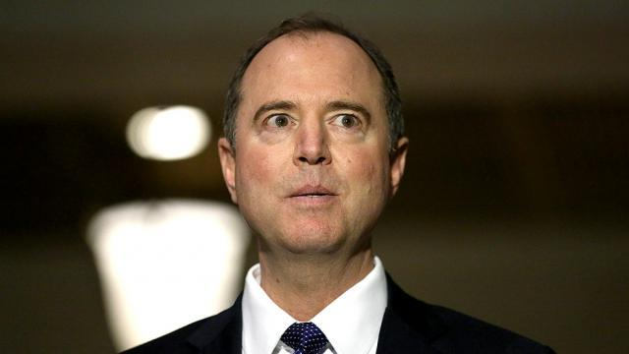
Rep. Adam Schiff (D-CA)
“We will be reviewing the recommended redactions from D.O.J. and F.B.I., which these agencies shared with the White House,” Mr. Schiff said, “and look forward to conferring with the agencies to determine how we can properly inform the American people about the misleading attack on law enforcement by the G.O.P. and address any concerns over sources and methods.”
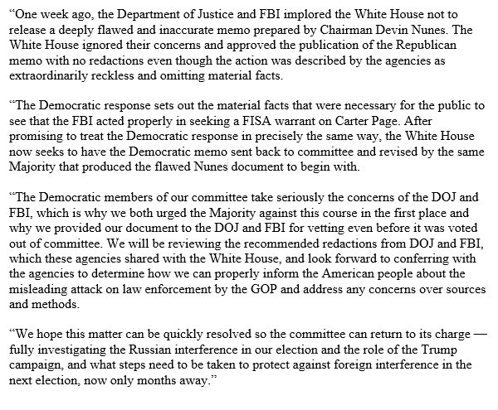

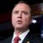Adam Schiff
✔@RepAdamSchiff
After ignoring urging of FBI & DOJ not to release misleading Nunes memo because it omits material facts, @POTUS now expresses concerns over sharing precisely those facts with public and seeks to send it back to the same Majority that produced the flawed Nunes memo to begin with:
Twitter Ads info and privacy
Rep Terri Sewell - a Democratic member of the committee, tweeted: “Republicans and Democrats on the Intelligence Committee voted UNANIMOUSLY to release this memo. @realDonaldTrump is not interested in transparency, he is interested in protecting himself and derailing the Russia investigation."

Rep. Terri A. Sewell
✔@RepTerriSewell
Republicans and Democrats on the Intelligence Committee voted UNANIMOUSLY to release this memo. @realDonaldTrump is not interested in transparency, he is interested in protecting himself and derailing the Russia investigation.
Despite Democrats' anger, McGhan said - in addition to the fact that Trump was "inclined to declassify" the document - that “The executive branch stands ready to review any subsequent draft of the Feb. 5 memorandum for declassification at the earliest opportunity.”
What would you do? Well, I would have released it all as is. Let the Democrats take the heat for the disclosures. Of course, it is pretty hard to put the weasel back into the box, now isn’t it?
What is the Real Smoking Gun?
Grassley/Graham allege, based on intelligence, that the man behind the anti-Trump dossier was known to be unreliable by the FBI (they eventually severed ties with him) because he was caught lying either to US law enforcement or to British courts, telling each entity different stories about a key fact. Either way, FISA judges who approved and renewed the Page warrants weren't told about the proven unreliability of the foreign agent whose work product was (apparently) the central basis for said warrants. The FBI might counter that Steele seemed credible at first, then they dumped him when he burned them, but that doesn't mean their hands are clean, Allahpundit writes: (a) that doesn’t solve the problem that the original FISA application against Page evidently relied “heavily” on information passed from a not-very-credible foreign agent and
(b) that doesn’t explain why the Bureau allegedly failed to tell the FISA Court in later applications to renew their surveillance of Page that Steele’s info maybe hadn’t been so credible...Grassley and Graham make another good point about Steele’s chattering to the press while his investigation was still ongoing: Once bad actors were aware that he was digging for dirt on Trump, they could have sought him out and fed him any amount of BS in hopes of it trickling through to the FBI and deepening the official suspicion surrounding Team Trump. That’s how Clinton cronies — maybe even Sid Blumenthal — got involved in this clusterfark. Because Steele was supposedly willing to accept even unsolicited tips about Trump, the Clinton team may have fed him rumors to help fill a dossier for which their boss was paying.
Two big points there:
Even after the FBI recognized Steele was an established liar, his dishonesty was not disclosed to judges deciding whether to keep the warrants active during renewal applications, which were largely predicated on Steele's credibility.
And the topic about which he apparently lied was whether he blabbed to folks in the media about his work, which could have opened up the floodgates for disinformation from shady characters eager to make the anti-Trump case as juicy and brimming with salaciousness as possible.
That's where Blumenthal and company, whom I wrote about here, may have come in. What a mess. Also, speaking of not revealing pertinent information to the courts, it looks like Nunes was technically incorrect that the judges weren't made aware that the Steele dossier was paid political oppo research.

But he was more broadly correct that the judges didn't have even close to the full picture of who was behind the unverified partisan document upon which they were primarily basing the surveillance of a US citizen -- who happened to be a former aide to a major presidential campaign from the out-of-power party.

"As Nunes himself later admitted, the Bureau apparently did disclose in a footnote that the material was paid political research. It just didn’t mention who, precisely, had paid for it," AP writes. The memo reads, "in footnote 8, the FBI stated that the dossier information was compiled pursuant to the direction of a law firm that had hired an "identified US person" -- now known as Glenn Simpson of Fusion GPS...the application failed to disclose that the identities of Mr. Simpson's ultimate clients were the Clinton campaign and the DNC."

So the disclosure came in a footnote and didn't mention that the parties who paid for the unverified dossier were the Trump campaign's explicit opposition. Maybe there was no misconduct in any of this, but even as someone who believes neither that suspicion of Carter Page was unreasonable, nor that this is all part of a grand anti-Trump conspiracy (remember, the Trump angle of the Russia probe started earlier, for an unrelated reason), there's enough in the Grassley/Graham memo to make me uncomfortable with the standards by which Page was surveilled by the US government.

The Deep State; The Real Enemy of America
Rahm Emmanuel was/is (in)famous for his alleged attribution of the quote “Never allow a good crisis to go to waste.”Nevertheless, in the manner that Chaucer’s “Canterbury Tales” is an “English echo” of “The Decameron” by Giovanni Boccaccio, the quote assigned to Emmanuel is a paraphrase of words emitted by the equally-nefarious Milton Friedman:

“Only a crisis – actual or perceived – produces real change. When that crisis occurs, the actions that are taken depend on the ideas that are lying around. That, I believe, is our basic function: to develop alternatives to existing policies, to keep them alive and available until the politically impossible becomes politically inevitable.” – “Capitalism and Freedom,” by Milton Friedman, Preface, Univ. Chicago Press, 1982.
Although he was an Economist (so-called), Friedman’s Marxist economic endeavors (germinated by the Frankfurt School of Economics “alumni”) were cracked akin to a whip throughout the world and used by the U.S. to further imperialism and fostered dependence by third-world nations. Such “dependence,” it must be added, took the form of loans through the IMF and World Bank…backed by military force. The “dependence” is almost that of the Helsinki Syndrome, in which the kidnapped captive becomes psychologically dependent upon the captor…but the captivity remains. Protection and extortion in the same vein.

These same “entangling alliances” were warned about for the fledgling United States by the Founding Fathers. Such forced alliances are easily seen for what they are: the creation of vassal states through force projection and intimidation.

Even when we’re not directly involved, we “underwrite” the actions. The latest (and largest) prime example was the ousting of Ukraine’s president, Yanukovych, in 2014 and the attempt to force Ukraine to become a part of NATO, as well as another IMF-vassal in the NATO-Euro-hegemony.

Such activities continue: in Syria, in Yemen, and throughout the world... a continued bolstering of U.S. military presence, backed by an ever-smiling line of “Rockettes” willing to “invest in a country’s future” with our almighty, fiat Petrodollar. Friedman’s actions as an economist can be seen enmeshed in virtually all U.S. foreign policy for the past five decades: they form the basis for the actions of “Economic Hit Men” as described by Perkins in his book.

Guess Who's About To Go Bankrupt Next In America
The coerced economic policies within the imperialism of American foreign policy are not the center of this piece. Here is something relayed by Newsweek as reported by the New York Times on 2/2/18, an article entitled White House Pressures Pentagon for North Korea Attack Plan, Report Says, by John Haltiwanger that bears reading:
“The White House is butting heads with the Pentagon on North Korea as senior military officials appear apprehensive about presenting President Donald Trump with military options against the rogue state, The New York Times reported Friday. White House National Security Adviser H.R. McMaster is reportedly concerned with drawing up a specific military plan in order to reinforce Trump’s various threats to the reclusive nation. Unnamed Pentagon officials are seemingly concerned the president is moving toward the use of force too quickly and worry that additional options will increase the probability Trump will move forward with an attack, according to the report.

Dana W. White, press secretary for the Pentagon, told The New York Times the defense secretary “regularly provides the president with a deep arsenal of military options,” and claimed that the reports of reluctance in that regard were “false.”
What can be gathered from this is the media is trying to paint a picture of confusion within the military command structure between the Pentagon and the administration. It is also more “predictive programming,” designed to “show” how the President wants a war: this to make him foot the blame when and if a war commences. Obviously, the United States and North Korea are still in a standoff with neither side backing away from their position. But just picture in your mind: the Emmanuel’s and the Friedman’s…smirking and smiling on the sidelines, knowing all this orchestration of the media is for the public to gulp down…knowing all of these crises have been acted upon by those of their ilk.

We have a President who has ordered the release to the public of some very sensitive information on FISA (more appropriately labeled “DISA,” as the surveillance is directed toward the zeks formerly called “American citizens”). An article came out on Lew Rockwell by former Justice Andrew Napolitano on 2/1/18 entitled Lying, Spying, and Hiding. Here is an excerpt of that article that I recommend reading in its entirety:

“The abuse summarized in the Republican memo apparently spans the last year of the Obama administration and the first year of the Trump administration. If it comes through as advertised, it will show the deep state using the government’s powers for petty or political or ideological reasons.
The use of raw intelligence data by the NSA or the FBI for political purposes or to manipulate those in government is as serious a threat to popular government — to personal liberty in a free society — as has ever occurred in America since Congress passed the Alien and Sedition Acts of 1798, which punished speech critical of the government.”
So, to keep something from coming out of this magnitude, do you see the big picture?
What is the best way to “deflect” attention from something such as this? War, naturally.
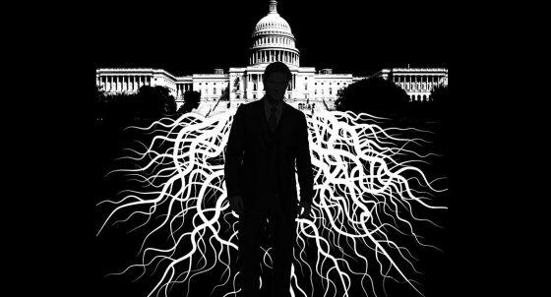
I submit that the powers that be who are within the Deep State will either commence their lackeys to start a war or will create the conditions that will lead to one... not necessarily starting with North Korea, but possibly one of the other theatres where tensions with the U.S. are running high.

I also submit that under such circumstances, it may not be the President who is responsible for the start of such a war: it may be a contrived crisis that the Deep State will not allow to go to waste that propels us into one. Nothing is beyond their capabilities, except to act with compassion and take into consideration the rights and welfare of the average citizen.
The Deep State will allow millions to die in a war before being held accountable, especially to the American people.

The Democrat Base is Escaping

Even though there was a temporary spike in enrollment, mostly concentrated in a few states that caused the national average of food stamp enrollment to spike, nationwide enrollment in the program as a whole is still on a steady decline. Four million people dropped off the food stamp rolls in one month, according to the latest numbers on food stamp enrollment from the U.S. Department of Agriculture (USDA).
The latest USDA data show that the number of participants in the Supplemental Nutrition Assistance Program (SNAP), the government program that administers food stamps, dropped from 45,666,795 in October 2017 to 41,658,868 in November 2017 — a staggering decrease of 4,007,927 over one month
I heard for decades advice from one source or another not to go into debt; especially for stupid stuff. I would not believe that people would borrow money against their home to go to a restaurant or take a cruise. Until I did it. The process is deceptively simple and, it seems, unavoidable for most Americans. You cannot listen to any media that accepts advertisement and not hear ads for home refinancing, or credit card forgiveness programs, or zero percent this or that, or even reverse mortgages.
Can I see a show of hands of anyone out there who has felt that tightness in your chest when you think about the plastic cards in your wallet? The payments are not so bad, not are they? It is the dollar amount that blows you away. A thousand turns into five-thousand pretty fast. Look around. What do you have to show for it? Debt. A virtual iron shackle around your neck that jerks you out of bed in the morning and keeps you at your workstation your entire life.
Don’t you want to be free? Well, be careful what you ask for. Debt freedom is a wasteland of winners. Here are some cautions for you about getting debt free, and why it is so vital to your mortality.
Credit Card Hell
It starts in college, usually. Banks target college students with credit cards. It might be a JC Penny card, Kohl’s, Lowes, or even an oil company. You have good intentions. You always do. I’ll put all my gasoline on this card, and pay it off every month. Only you don’t. You max it out. That’s not the bad part. You could make minimum payments for 50 years and maybe make a dent in it.
But then you take the next step. You get another card at 6% interest, and transfer that 30% interest debt to the new card with the higher limit. Whew. That card is paid off. Except, you charge it right back up to the max. And then the introductory, cash back, double airline miles rate expires and you end up right back at 30% interest on the unpaid balance. Welcome to hell. It gets worse.
You hear an ad that says, “You don’t have to pay that card off.” You make the call. The service is great, and sure enough you negotiate a pay-off of the cards that is 50% of what you owe. Wow. $20,000 in debt gone in three easy payments of $3,300. Where am I going to get the money? A second mortgage. Yeah, that’s the ticket. Hey, at least you don’t have that $115 a month to pay out every month forever. Right?
News flash! The IRS considers that $10,000 discount real income, and you pay 25% tax on it. And it is due all at once in April. That’s another $2,500 you didn’t count on. One problem. Now, your credit is ruined, because the credit card companies have reported a $10,000 charge-off on your record. You have to borrow the money to pay off the IRS, so you take out a loan at, you guessed it, 30% interest. Bingo. Welcome to the bottom below credit card hell.
You play the lottery, work side jobs, and dream of a windfall so you can escape the burden of debt. I have news for you. You are asking for rebirth. You must go through a transfiguration to enter the world of debt freedom. You must say good bye to your debt friends, bankers, and especially the lifestyle of spending tomorrow’s money today. I’m not sure you’re ready for it. The air is rich and the terrain is smooth and the sleep is oh so peaceful. Are you sure you are ready for it?
The Real World
The reality is that you did not get into this overnight, and you will not escape easily. I took a risk and built 20 homes, as a side job. Yeah, try that. Work 40 hours at a day job, in my case third shift away from the family sleeping peacefully in the last house I built while I build another one. It took 10 years, this plan. It nearly killed me. I worked 100 to 120 hours a week for 10 years. We went nowhere. No vacations. No major purchases. Nothing but work. My kids grew up with a dad wearing a plant uniform at night and nail bags during the day. I was strong as granite, and I was determined to pay off student loans, car loans, cards, everything.
Then, the day came. It was a Sunday in July 2005. I woke up, walked up to my loft overlooking the forest beside my magnificent 6,000 square foot house I built just 3 years before. It hit me. Time to sell. I got my digital camera out, snapped 5 pictures of the house inside and out, and posted it on Owners.com. Friday the house sold for asking price.
We closed in a week, and I pocketed enough money to pay everything off. 10 years of hard work, and it was done. I was debt free. Every card, every loan, every single thing was paid off.
A month later, I still had $25,000 in the bank, a kick ass 401k, and 90% of my paycheck was disposable money. I entered the world of debt free. Now, I had a choice. Keep working hard for 15 more years and retire, or do something radical and really dangerous. I chose the latter. I simplified.
I needed so little to just eat and pay rent and transportation, that I chose to cut my work years down to four months. I worked 4 months a year, and the rest of the time was mine. I lost 40 pounds. My asthma went away. I laid my glasses down for good. The lines in my face changed. I started writing and traveling and seeing the world, and I was only 52. Healthy, peaceful, and hungry for knowledge.
Can you do this? Slim chance. You may never escape slavery. You just think you can control it. There are numerous trillion-dollar corporations with the sole purpose of gathering your information and selling it and to keeping you in slavery forever. Here’s the difference. Check your credit. Do you have a slave score? Then you are a slave. Check my credit? I do not exist. Period. Nothing. I have been debt free for so long that they have already overwritten my space with someone else. Am I lucky? Never say that again. I was focused and determined to be free. I came to this world not to be chained to a bank. I came to show people their true potential, the potential the bankers do not want you to see.
Your soul was designed to be free. Why do you so easily choose slavery instead? Do you really believe that you will never have anything if you stay debt free? Wow.
I live in a different world than you. I am rich, because I only need pennies to take care of my basic needs. I escaped. I have no friends, because they don’t want me around except to have fireside chats. They cannot share their stories with me. I cannot share my story with them, because I can see the rage inside of them. I tell people I am debt free, and they look at the ground hopelessly. Oh, they deny it, but I can see it there, burning inside of them. I can walk away, and they cannot. They are inside the yard, and they know they can never leave. I’m just asking you to join me, no matter how hard you have to work. I can tell you this. One 40-hour job is not enough to do it. You’ll need at least two of them. Then, you will need side jobs as well, but you must take 100% of the money, and direct it toward getting rid of your slavers.
When you Believe your Own Propaganda
Something very bad can happen when you start believing the Democrat Globalist Propaganda. Iran is the latest to learn the lesson the hard way. The decision by the Iran-led “Shiite Axis” in the region to send an unmanned aerial vehicle (UAV) into Israeli territory was a dangerous miscalculation by Tehran and its puppets in Syria and Lebanon.
Following strategic victories over the Islamic State and Turkey-backed rebels inside Syria, an overly confident Iran apparently decided to test regional boundaries and its own capabilities by sending the UAV over the border into the Jewish state.
Aviation analysts described the Iranian drone as a new stealthy model similar in design to the American RQ-170 Sentinel spy drone that Iran claimed to have shot down and seized in December 2011. It’s likely the Iranians were testing the model’s ability to penetrate Israeli airspace undetected, making Israel’s discovery of the UAV a remarkable display of regional military superiority.
Iran, Syria and Hezbollah have outrageously been attempting to frame Israel’s massive airstrikes as unprovoked aggression, even fueling conspiracies that no drone was intercepted. In reality, the timeline is self-evident. Following Iran’s ill-conceived provocative UAV move, Israeli jets pounded an Iran-controlled airbase outside the Syrian city of Palmyra that Israel says was utilized to launch the drone. Syrian forces then launched anti-aircraft missiles, reportedly forcing an Israeli F-16 pilot to abandon his jet and sending Israel’s northern communities into bomb shelters. Israel in turn dispatched bombers into Syria to target a series of important Syrian and Iranian military installations, prompting more anti-aircraft fire from Iran-backed Syrian forces.
The Shiite Axis operational to Israel’s north – Iran, Syria and Hezbollah – have been celebrating the incident that resulted in the F-16 abandonment as a victory. “This is the beginning of a new strategic era which puts an end to the violation of Syrian airspace and territory,” Hezbollah claimed in a statement published by Lebanon’s ANI news agency. What the press won’t tell you is that the F-16 jet had 25 missiles fired at it. It finally was hit, but the pilot still managed to fly it all the way back to Israel before he and his navigator ejected over Israeli territory. They are both expected to recover from their injuries.
The Israel Air Force will indeed need to investigate what went wrong and will recalibrate accordingly. However, Hezbollah’s celebrations are more posturing than realistic and seem designed to mask the extent of Israel’s retaliatory airstrikes. One F-16 jet is more powerful that an entire squadron of planes in other air forces.
Israel will undoubtedly continue to act in Syria and Lebanon when necessary to ensure the Jewish state’s security. Meanwhile, Israel’s strikes in Syria have been described in news media reports as not only its most serious engagement in that country since the Syrian civil war began in 2011, but the most devastating blow dealt to the Syrians – and by extension to their Iranian overlords – since perhaps the first Lebanon war in 1982. Make no mistake about this encounter. It is far more significant than anyone will admit right now. The leadership in Iran is drunk with power and desperate to recover from the Persian people rebelling against their oppression. The very lifeblood of Islam is bleeding into the sands of the desert today. This is a war they cannot possibly win, and they would be fools to start it.
Intelligence Minister Israel Katz said it would take Iran and Syria some time to “digest” the extent of the Israeli raids. “They, and we, know what we hit and it will take them some time to digest, understand and ask how Israel knew how to hit those sites,” he said. “These were concealed sites and we have intelligence agencies and the ability to know everything that is going on there and yesterday we proved that.”
Iran’s drone fleet is an important part of its war arsenal against Israel. Don’t forget the American top secret stealth RQ-170 drone they hacked and flew safely to a local airport in Iran. They copied it completely and are now using the model to invade Israeli airspace. If you will remember, this was a gift from Obama to them, as the drone was equipped with Chinese chips with a firmware back door that had been disclosed to Iranian engineers by the Clinton State Department.
Hezbollah has previously threatened to send explosives-laden drones to target Israel’s nuclear plant and civilian infrastructure. Low flying drones could easily enter US airspace from the Gulf of Mexico and devastate the country with a few, strategic targets. Only last week, Iran announced the opening of a drone manufacturing facility meant to mass produce stealth UAVs that can carry smart munitions to attack various targets anywhere in the world. BTW, drones can be launched from specially equipped submarines. Two weeks ago, US Navy P-8 aircraft were flying search routes between Virginia Beach and Nag Head looking for at least one hostile submarine. My feeling is that the Gulf is an easy place to hide and wait amongst the 27 thousand abandoned oil rigs floating in mile-deep water. A half-dozen drones with multiple warheads could turn America off for at least 6 months.
It also must be recalled that Iran’s dispatching of the drone yesterday followed weeks of escalating rhetoric in which Hezbollah repeatedly threatened to attack Israeli offshore gas platforms. IDF troops operating along the northern border were also threatened. They have dispatched fighters to storm the Israeli border.
The F-16 attack from Israel sent Iran, Syria and Hezbollah a clear message that they will suffer enormously following any future provocation. The Shiite Axis would do well to check its inflated hubris and think twice before messing with Israel again. There is no doubt that Iran would lose a war with Israel in a few days, but many innocent Persians would also die. It is time for the women of Persia to ramp up the protests and remove Islam from its government, before it is too late.
The Syndicate Attacks the DOW
They cannot argue with success. $8 trillion in new value, millions of jobs, and nothing but hope on the horizon. Exactly what the Globalists do not want to hear. NAFTA and The Stock Market timing . . . The Bankers and Multi-Nationals are using the US "Deep State" to Handcuff President Trump by intentionally manipulating the stock market. And the connections allowing them to do so are staring all of us in the face! There are trillions at stake. Unfortunately for the Multinationals (corporations and banks), they don't have a seat at the table. Trump, and the U.S. trade team are independent.
Well, it’s pretty much a certainty that a rapid pullout from NAFTA would have a noteworthy negative effect on the Stock Market, at least in the short term. Most good analysts agree around 7% drop immediately, with a +15% rebound after a year as the benefits show up. Still, this would not be much of a problem, with the DOW sitting at record highs over 24,000. But what if the DOW were pushed down – way down – in a violent fashion that put fear in the hearts of many retail investors? Would President Trump be so bold as to make a withdrawal announcement NAFTA then?
The question is, do you think a <3% shift could be caused by this paltry news? I highly doubt it. Profit taking? Not this much, even with automated, nearly real-time trading. Unless, you had algorithmic traders (Market Makers) like VIRTU placing bids and making offers on huge volume, and executed orders on massive ETFs even after hours. What if these Market Makers could promise a client anonymity as well? Well they do, and arguably they just did.
The question now is, WHO is it doing the bidding? .

Mrs. Melissa Hodgman is married to an increasingly well known FBI official: Peter Strzok. It does not get any more clear than this. Multinational, billion-dollar corporations and banks conduct meetings with and donate to DC politicians to write legislation, and sculpt outcomes favorable to their financial interests. This is a fact, and it is completely illegal. But the DOJ, with Strzok working inside the top ranks of the FBI, does absolutely nothing about it.
It's not like these "trillions at stake" would lead to spending billions in Democrat donations to effect changes in the DOW value outcomes, right?

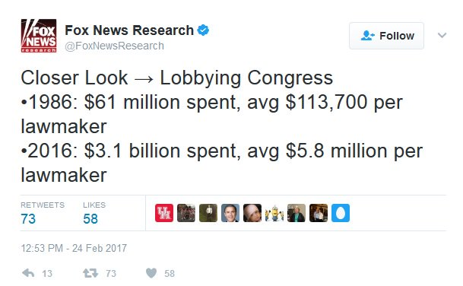
Would the globalist elites really be so duplicitous as to attempt market manipulation to handcuff a President simply because they don't have any campaign donor driven leverage with him? Could they be driven by their hatred of America to attack the one thing that undeniably supports the MAGA agenda? If they succeed and escape exposure and escape prosecution for this assault on the American free market, they will most assuredly defeat Trump in 2020. They have three years. I call on the DOJ to put these guys in jail now, because America is in a dangerous place.
The dogs have been backed into a corner, and they will bite very hard. America is in more danger now than at any time in history. The weapons are real, and they are lethal, and they are here right now in our country. Wake up. I am telling you right now to wake the hell up.
Carter Page on the Clinton Transition Team
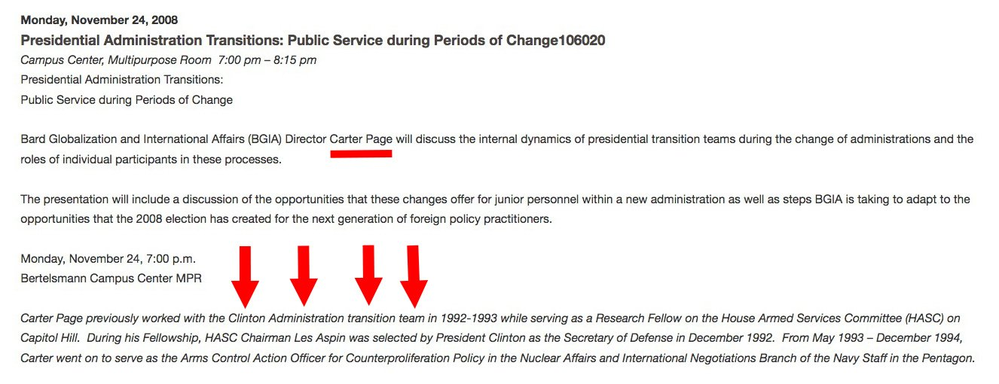
“Carter Page, as we can see in US National News, previously worked with the Clinton Administration transition team in 1992-1993 while serving as a Research Fellow on the House Armed Services Committee (HASC) on Capitol Hill. During his Fellowship, HASC Chairman Les Aspin (D-WI) was selected by President Clinton as the Secretary of Defense in December 1992. From May 1993 – December 1994, Carter Page went on to serve as the Arms Control Action Officer for Counterproliferation Policy in the Nuclear Affairs and International Negotiations Branch of the Navy Staff in the Pentagon.”
So, Carter Page was deliberately pushed toward the Trump Transition Team by DEMOCRATS who wanted to use HIM as a reason to justify FBI spying on Trump via National Security Intelligence apparatus! Put simply, it appears to me that Carter Page was a "Ringer" who got into the Trump Transition Team for the direct purpose of opening that team up to claims of Russia Collusion.
Russian Plane Explodes Shortly After Takeoff
First, let me tell you that planes are not capable of just exploding. They are filled with Kerosene, and they have had center fuel tank problems when they are empty, but this plane blew into a million pieces. That’s what happens when something in the cargo bay explodes. A bomb.
A Russian passenger plane Flight 6W703 bound for Orsk crashed near Moscow soon after take-off on Sunday, killing all 71 people on board, and investigators said they were looking at all possible causes. Temperatures were around minus 5 degrees Celsius with periodic snowfall when the short-haul AN-148 operated by Saratov Airlines took splatted about 900 miles (1,500 km) southeast of the capital.
President Vladimir Putin offered condolences to those who had lost relatives and ordered a special investigative commission to be set up.

“According to preliminary information, nobody survived,” the Kremlin said in a statement. Now some of the shills in the ANON community are saying this was a false flag, no explosion, no crash, and that a couple of people were extracted from the flight. I am calling bull crap on that.
The office of Russia’s transport prosecutor said all 71 people on board had been killed. Transport Minister Maxim Sokolov confirmed there were no survivors and said DNA tests would be needed to identify the dead.
TV images of the crash site showed wreckage of the plane, including at least one engine, lying in fields covered with thick snow.
Helicopters were at the scene as well as rescuers on snowmobiles. An official of the Emergency Situations Ministry said two bodies and a flight recorder had been found. Debris and human remains were spread over a radius of a kilometer from the crash site, investigators said. This means the plane blew up in the air and the large piece of the airframe left a crater.
They said they had opened a criminal case into the incident. Among the possible causes they listed were weather conditions, human error and the plane’s technical condition. No distress signals had been received from the crew, which means it happened suddenly. The plane, manufactured in 2010, had been carrying 65 passengers and six crew. It disappeared from radar screens shortly after taking off from Moscow’s Domodedovo airport.
Interfax news agency said one Swiss national had been among the passengers. Flight manifest shows that Sergei Millian was on the flight. A person of the same name met with groups tied to the Uranium One scandal. That’s all I know about it. Would a spook blow up an entire plane to kill one man? You tell me. The only strange piece of information I was able to find—and I am not sure this would have any bearing on this whatsoever—is that Sergei Millian was reported by the Washington Post as being a key source of information contained in the GPS Fusion dossier that was paid for by the Clinton Crime Syndicate, and that he was in contact with George Papdopoulos during the campaign.
One more name on the flight Vyasheslav Persaqkov, who is the Rosatom’s special representative for international scientific projects. He was #32 on the flight, but listed under Ivanov Vyasheslav. This is absolutely huge. His former title was the deputy director general of Rosatom. He is working on ITER and research for a sodium cooled reactor. The point is, that he was a central technical figure in the valuation of Rosatom and the acquisition tied to Uranium One.
All I know, is that his name was on the manifest for that flight. We know that the destination of this jet. The fact that there have been at least 12 violent or suspicious unsolved murders, including 6 Russian ambassadors, surrounding this dossier is disturbing. Now, there is another Russian dead in a mysterious, freak plane explosion. I guess when there is $1.5 trillion on the table and the prosecution of top generals inside the Clinton Crime Syndicate, no job is too small.
I know you’re wondering why Attorney General Jeff Sessions doesn’t act in a high-profile way to bbing this criminal operation down, but you really have no idea how powerful these people are.
Last week, we witnessed the attempted assassination of more than 250 lawmakers, many of their wives and children by targeting the advanced scheduled high profile Amtrak train heading to the Greenbrier Command and Control Bunker to have secure meetings with the President behind a 25-ton blast door. It was pure divine providence that one more wheel did not come off those tracks. If it had, we would still be burying Republican congressmen.
Perhaps they are not having such a good week, after having to kill an entire planeload of innocent people to get one Russian spy.
Equifax is the Hack: Part Two
Equifax has some serious questions to answer after the Senate Banking Committee analyzing documents from last year's massive data breach discovered that far more private data was stolen than first revealed.
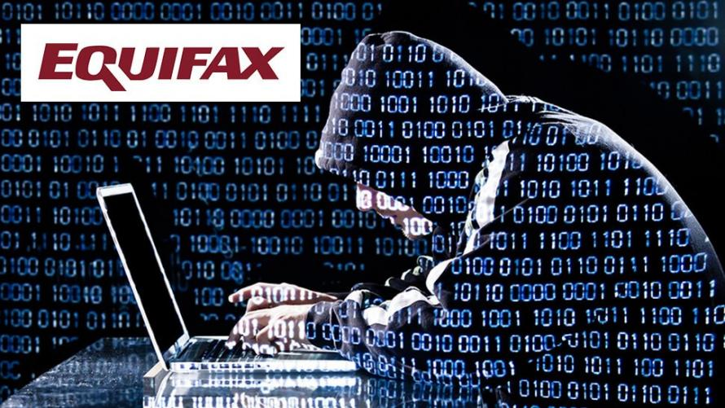
The breach, announced last September, was originally said to have compromised the personal information of approximately 145.5 million U.S. consumers. The information accessed "primarily includes names, Social Security numbers, birth dates, addresses and, in some instances, driver’s license numbers." In other words, pretty much everything that should have been hidden behind a number of firewalls, was made available to the dark net's highest bidder.
The additional information accessed by hackers include tax ID numbers as opposed to just Social Security numbers, email addresses, and more driver's license information than was previously disclosed by the company.
Equifax said, in a document submitted to the Senate Banking Committee and reviewed by The Wall Street Journal, that cyberthieves accessed records across numerous tables in its systems that included such data as tax identification numbers, email addresses and drivers’ license information beyond the license numbers it originally disclosed. -WSJ
It is unknown how many of the 145.5 million people were exposed to the increased level of data theft, however the a company spokeswoman said that an "insignificant number" of email addresses had been compromised.
“We have complied with applicable notification requirements in the disclosure process,” the spokeswoman said, who added that email notices were sent to impacted consumers.
Equifax confirmed to the Wall st. Journal that additional drivers' license information had been accessed, including issue dates and states.
“Additional driver’s license information accessed other than the driver’s license number was extremely minimal” said the spokeswoman, adding that “anyone with a potentially affected driver’s license number” can look up their name on the Equifax website.
Massachussets Senator Elizabeth Warren (D-MA) released a report on the Equifax hack after the Banking Committee she sits on spent the last five months analyzing the breach.
"As your company continues to issue incomplete, confusing, and contradictory statements and hide information from Congress and the public, it is clear that five months after the breach was publicly announced, Equifax has yet to answer this simple question in full: what was the precise extent of the breach?" the letter reads.
Warren's letter then issues four demands to Equifax:
1) A full and complete list of all data elements that Equifax has confirmed were accessed by hackers in the breach,and the number of individuals affected by the breach of these individual data elements. Please include information on when Equifax confirmed that taxpayer identification numbers, email addresses, and driver's license issue dates and states were accessed by the hackers.
2) A full and complete list of all data elements that Equifax has reason to believe may have been accessed by the hackers, the potential number of individuals potentially affected, and the status of Equifax efforts to confirm if they were or were not accessed.
3) A timeline of all Equifax efforts to determine the full extent of the breach, and summaries of any internal reports or information, or reports or information provided to Equifax by Mandiant or any outside entities describing the extent of the breach.
4) The process used by Equifax to inform members of the public that taxpayer identification numbers, email addresses, and drivers' license information has been breached.
Senator Warren and fellow committee member Sen. Mark Warner (D-VA) have concurrently introduced the Data Breach Prevention and Compensation Act, which will hold credit reporting agencies accountable for data breaches - fining them $100 for each customer who had one piece of personal data stolen, and $50 for each additional set of compromised data.
Had this law been in effect during the 2017 breach, it would have cost Equifax billions.
Following the disclosure of the hack, Equifax canned several executives, including CEO Richard Smith - who is set to receive an $18 million bonus. Smith was replaced by interim CEO Paulino do Rego Barros Jr.
In the weeks following, Mr. Smith and Mr. Barros appeared before congressional committees to discuss the breach; Mr. Barros stated that the company quadrupled spending on security and updated its security tools since the breach. -WSJ
Last month, Equifax launched a free service to allow consumers to "lock and unlock" their Equifax credit report in an effort to beef up security.
In a world of flashing headlines and information overload, let the fact that nearly half of America had sensitive information stolen by hackers - a breach which will have serious and lasting effects on both consumers and banks whose fraud prevention departments will be working overtime for years to come

Elena Voronova, a spokeswoman for Saratov Airlines, said there had been no concerns about the technical condition of the plane, which went into service with her company in 2016. It was virtually a brand new aircraft.
The Grand Depression: Globalists are Making Their Move
Throughout 1928, the world banks were moving their cash into hard assets and draining it from the capital markets. It was only a matter of months before the Roaring Twenties came to a screeching halt. Well, they’re doing it again. About a month ago, something very strange began happening across the banking community. Well, that is to say, something stopped happening that has been a regular practice for many years. We know that banks have cut off emerging markets, and now the USA is at the lowest level of business startups in history, by a large amount. Like, since the year 1675. It is a factory space wasteland out there. No. This is bigger than that.
Bankers have almost completely stopped lending . . . . TO EACH OTHER.
The plunge in "InterBank Lending" was so sudden and so substantial that it looks as though it is actually a PLAN, not happenstance or situationally appropriate.
It LOOKS like the Bankers are intentionally choking the US Economy and they're doing so at levels far FAR worse than what took place during the "Fiscal Crisis" of 2007-08.
For more than 45 years, the Federal Reserve has tracked virtually E V E R Y aspect of banking in the United States. They literally look at EVERY financial metric and provide incredible amounts of public reporting to anyone willing to spend time on the Federal Reserve Electronic Data (FRED) web site.
My sources, like Hal Turner, work very hard every day to keep me abreast of what's taking place, so I can give you insight as to how and why certain things happen. This is what he has found in mostly his own words.

INTERBANK LENDING
First, let me explain what INTERBANK lending is. The interbank lending market is a market in which banks extend loans to one another for a specified term. Most interbank loans are for maturities of one week or less, the majority being overnight. Such loans are made at the interbank rate (also called the overnight rate if the term of the loan is overnight).
Banks are required to hold an adequate amount of liquid assets, such as cash, to manage any potential bank runs by clients. If a bank cannot meet these liquidity requirements, it will need to borrow money in the interbank market to cover the shortfall. Some banks, on the other hand, have excess liquid assets above and beyond the liquidity requirements. These banks will lend money in the interbank market, receiving interest on the assets.
The interbank rate is the rate of interest charged on short-term loans between banks. Banks borrow and lend money in the interbank lending market in order to manage liquidity and satisfy regulations such as reserve requirements. The interest rate charged depends on the availability of money in the market, on prevailing rates and on the specific terms of the contract, such as term length. There is a wide range of published interbank rates, including the federal funds rate (USA), the LIBOR (UK) and the Euribor (Eurozone).
Having now explained what INTERBANK LENDING is, and how it is H U G E L Y important for those funds to be available so banks can go about their daily business without running afoul of the law or Depositor needs, take a look at the FRED Data for INTERBANK LENDING for the last twelve months:
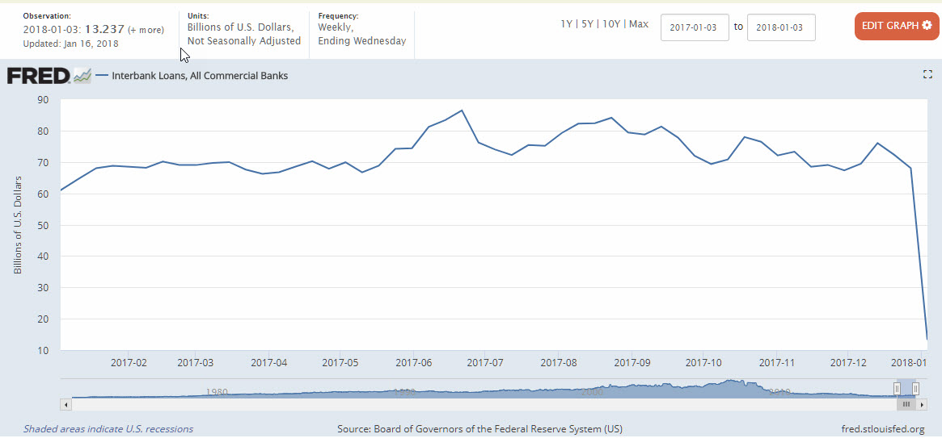

Did you see the problem? Let me point it out:

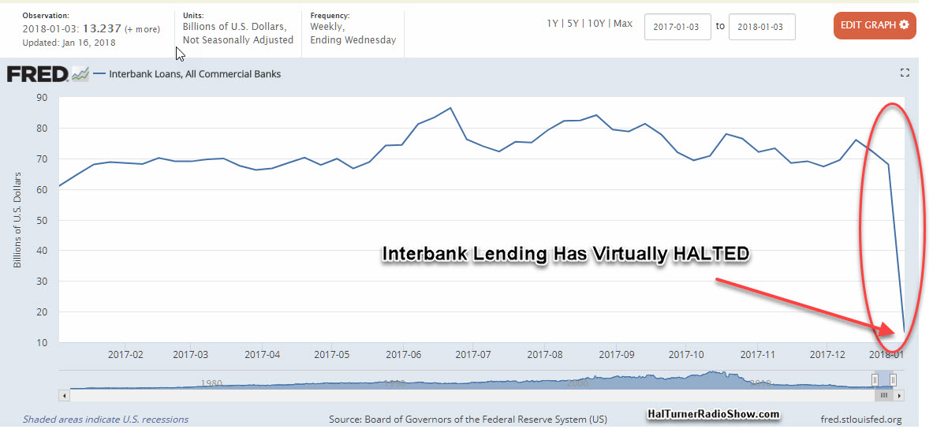

Yes. You see that correctly. INTERBANK LENDING CAME TO A VIRTUAL HALT, plunging from $68.034 BILLION for the week of December 27, to a terrifying level of $13.237 Billion as of January 3, 2018. That's a DROP of EIGHTY-ONE PERCENT (81%) in one week.
Of course, some folks may have a knee-jerk rection to this and say something like "Hey Hal, it was the week between Christmas and New Years. Business was slow. Don't worry about it."
OK. But this has never . . . . and I can prove N E V E R . . . happened before!
To show you how utterly extraordinary this is, take a look at 45 years of INTERBANK LENDING from the FRED reports:

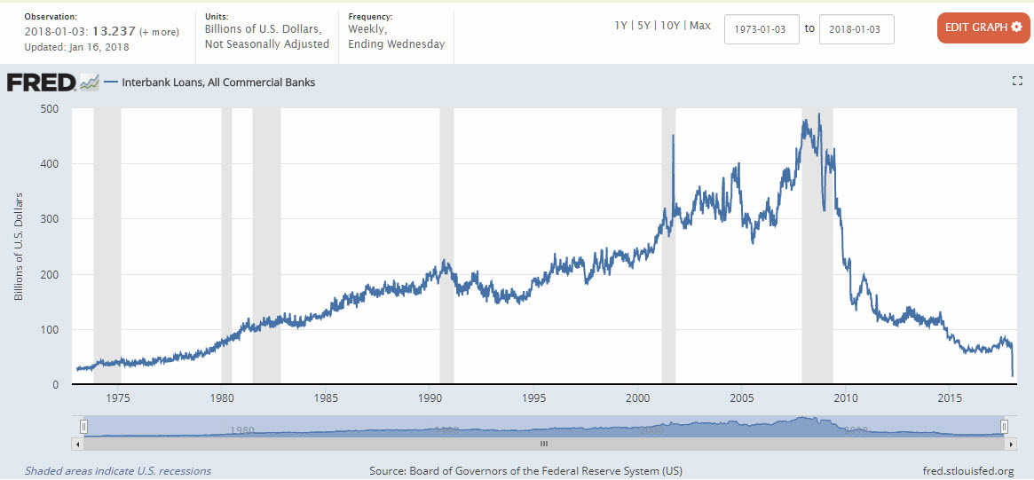
Going all the way back to 1973, INTERBANK LENDING has never ---- N E V E R --- been this low. Not even in the "Recession" of 2008-2009 ! ! ! !
Each of those years had a week between Christmas and New Years. NOT ONCE IN 45 YEARS did the Interbank Lending grind to a halt as it has now.
Let me put this in perspective for you. As of January 3, 2018, the Interbank Lending is about $13 Billion for the week. The FRED Data goes back to January 3, 1973 at which time it was $29 Billion.
Therefore, 45 years later. in an economy that is much, MUCH bigger, the Interbank Lending has collapsed to about 1/2 of what it was in 1973.

WHY?
Why would the banks do this when companies are hiring new people and things are getting better? Good question. And it is a question that NO ONE in the Banking Community seems willing to speak with me about.
For those unfamiliar, I live in New Jersey, about three miles due west of the Empire State Building in midtown Manhattan, New York City. I can pull my car out of my driveway and be in midtown Manhattan in minutes (barring traffic!).
We've got ALL the banks here; ALL of the biggest, most powerful, most influential banks.
We've got back-office Bank Operations occupying entire skyscrapers. Tens-of-thousands of people in the Banking industry . . . . and I know a LOT of those people, socially and professionally. NONE of them will talk about this. Not a peep. Nothing.
Even the Federal Reserve told me "no comment."
THAT is troubling to me. (Story continues below Ad)

Usually, no matter what the story, someone . . . usually quite a few someones . . . . are willing to talk, even if it's off-the-record. Not on this topic. Lips are sealed.
That tells me "trouble." It also tells me that the recent major swings in the Stock Markets are directly related to this.

GOLD? Nope!
If Interbank Lending has suddenly stopped . . . . because Bankers have DECIDED to stop lending to each other (as opposed to not trusting each other), then it stands to reason that Banks which NEED liquidity to meet regulations and cash requirements, would have to get that cash from somewhere else. The easiest place: The Stock Markets . . . . the Banks can sell-off stocks they have acquired and use the cash to bolster themselves.
This makes a lot of sense when you consider that, on Friday, February 2 (one month into the collapse of InterBank Lending) the Stock Market fell 666 points. If this was due to economic worries by the general public, we would expect to see a rise in the price of Gold. It is well established that when Investors are worried about the future, they buy Gold. But that didn't happen.
On Thursday February 1 - the day BEFORE the 666 Drop in Stocks, Gold closed at $1,349.46, which marked the high for the week. Friday opened with the price of gold slightly off at $1,345.35, and then the yellow metal pulled back to end the week at $1,333.39. The price of gold WENT DOWN as STOCKS WENT DOWN.
So the money pouring OUT of the Stock Market was NOT going into Gold! The cash was going somewhere else. But where?
Days later, on Monday, February 5 - the first open market day since the 666 plunge, The Dow Jones industrial average plunged more than 1,100 more points as stocks took their worst loss in six and a half years.
Between Friday and Monday, those two days of steep losses erased the market's gains from the start of this year and ended a period of record-setting calm for stocks.
But again, Gold wasn't phased. Gold closed at $1339.41, up a measly six dollars and two cents ($6.02) from the Friday before!
To me, this is proof that the hundreds-of-billions of dollars coming out of the Stock Market on Friday, February 2 and again on Monday, February 5 is NOT due to Investors seeking safety. The money is going somewhere else.

SPECULATION
Now, I am not a licensed financial planner and cannot offer financial advice. All I am doing here is my job as a Reporter/Journalist/Radio Host, to present the facts and offer my personal views which are clearly evident on their face. DO NOT MAKE ANY FINANCIAL DECISIONS BASED ON WHAT I PUBLISH HERE. Consult with a Licensed Financial Expert before making any financial decisions.
Having said that, I still must ask: Why has the Interbank Lending ground to a virtual halt and where is the money going from all the Stock market sales? What we saw all through the Obama years was that companies could borrow money so cheap, upper shareholders were selling their stock back the company. In other words, companies were taking their shares off the market, and putting them back into treasury. It’s an awesome plan, if the stock were ever to go back up, where you could resell the shares back into a stronger market. The banks, however are up to something else altogether.
It seems to me that either:
1) Banks are selling-off their own Stocks to get cash to sustain themselves (very bad sign) OR . . . . .
2) Someone is pulling HUGE amounts of cash OUT of US Banks, or
3) The Bankers have decided they don't like new found American Nationalism and are deliberately choking our economy to force a Globalist Agenda upon our President and our people by breaking our economy and saying Globalization is our only hope.
I can't help but wonder - and this is pure speculation on my part -- if perhaps Saudi Prince Alwaleed, having recently been released from custody in Saudi Arabia, is somehow trying to punish the US for the "situation" he found himself in, and may be pulling-out his vast wealth? I have NO EVIDENCE to substantiate this, but when a guy THAT wealthy, gets imprisoned (and reportedly tortured) he may have an "ax to grind" and definitely has the wealth to hurt those who may have hurt him. We also know he is no fan of our President.
Or could this be something else? Something far worse?
Could this be a situation that mimics the 1981 movie with Jane Fonda, Chris Christopherson and Hume Cronin entitled" ROLLOVER?" The situation being reported in this post could very well be the start of real-life efforts portrayed in that movie!
You folks had best prepare, right now. Just in case. Have emergency cash (to survive, not to pay bills) emergency food, emergency fuel for cars, trucks, generators. Extra medicines you may need to survive. and such. I’m not saying you should do what I have done. I’m just saying that a little precaution might not be a bad idea.
Orange Barrels
As if there were not enough orange barrels in your neighborhood, President Donald Trump on Monday will unveil his long-awaited infrastructure plan, a $1.5 billion proposal that fulfills a number of campaign goals, but relies heavily on state and local governments to produce much of the funding.
The administration's plan is centered on using $200 billion in federal money to leverage local and state tax dollars to fix America's infrastructure, such as roads, highways, ports and airports. More heavy equipment. More jobs to support that equipment. You get the picture. It is the one things that really makes sense to do with tax dollars.
"Every federal dollar should be leveraged by partnering with state and local governments and — where appropriate — tapping into private sector investment to permanently fix the infrastructure deficit," Trump said at last month's State of the Union address. Better roads and bridges, means better access. Better access means more commerce. More commerce means a stronger America.
Trump has repeatedly blamed the "crumbling" state of the nation's roads and highways for preventing the American economy from reaching its full potential. Have you flown out of San Francisco lately? Chicago? I think Charlotte upgrades every 4 years. It just keeps getting better.
Administration officials previewing the plan said it would feature two key components: an injection of funding for new investments and help speed up repairs of crumbling roads and airports, as well as a streamlined permitting process that would truncate the wait time to get projects underway. Officials said the $200 billion in federal support would come from cuts to existing programs.
Half the money would go to grants for transportation, water, flood control, cleanup at some of the country's most polluted sites and other projects.
States, local governments and other project sponsors could use the grants — which administration officials view as incentives — for no more than 20 percent of the cost. Transit agencies generally count on the federal government for half the cost of major construction projects, and federal dollars can make up as much as 80 percent of some highway projects.
About $50 billion, would go toward rural projects — transportation, broadband, water, waste, power, flood management and ports. That is intended to address criticism from some Republican senators that the administration's initial emphasis on public-private partnerships would do little to help rural, GOP-leaning states
Early reaction to the proposal was divided.
Jay Timmons, president of the National Association of Manufacturers, saluted Trump "for providing the leadership we have desperately needed to reclaim our rightful place as global leader on true 21st-century infrastructure."
"When ports are clogged, trucks are delayed, power is down, water is shut off, or the internet has a lapse, modern manufacturers' ability to compete is threatened and jobs are put at risk," said Timmons. "There is no excuse for inaction, and manufacturers are committed to ensuring that America seizes this opportunity."
Democrats, of course hate the entire plan, because a Democrat is not in the White House. So, we want to make sure they are all voted out of office in 2018, and then their 242 old corporation will go bankrupt. Don’t worry, Earth Explorers. We haven’t been by-partisan for a long time. There are plenty of parties to fill in the hole left when they leave. Imagine how State ballots and conventions will change to meet the new, awakened and informed populace.

