Jihad Report
Feb 10, 2018 -
Feb 16, 2018
Attacks | 42
Killed | 168
Injured | 125
Suicide Blasts | 4
Countries | 14
The Origin of Fake News
In a Tedx Talk at the University of Nevada a couple of weeks ago, investigative journalist Sharyl Attkisson revealed the origins of the "fake news" narrative that was aggressively pushed by the liberal media and Democrat politicians during the 2016 election, and how it was later flipped by President Donald Trump.
Attkisson pointed out that "fake news" in the form of tabloid journalism and false media narratives has always been around under different names.
But she noticed that in 2016, there seemed to be a concerted effort by the MSM to focus America's attention on the idea of "fake news" in conservative media. That looked like a propaganda effort to Attkisson, so she did a little digging and traced the new spin to a little non-profit called "First Draft," which, she said, "appears to be the about the first to use 'fake news' in its modern context."
"On September 13, 2016, First Draft announced a partnership to tackle malicious hoaxes and fake news reports," Attkisson explained. "The goal was supposedly to separate wheat from chaff, to prevent unproven conspiracy talk from figuring prominently in internet searches. To relegate today's version of the alien baby story to a special internet oblivion."
She noted that a month later, then-President Obama chimed in.
Google Issues Ultimatum to Conservative Website: Remove 'Hateful' Article or Lose Ad Revenue
"He insisted in a speech that he too thought somebody needed to step in and curate information of this wild, wild West media environment," she said, pointing out that "nobody in the public had been clamoring for any such thing."
Yet suddenly the subject of fake news was dominating headlines all over America as if the media had received "its marching orders," she recounted. "Fake news, they insisted, was an imminent threat to American democracy."
Attkisson, who has studied the manipulative moneyed interests behind the media industry, said that "few themes arise in our environment organically." She noted that she always found it helpful to "follow the money."
"What if the whole anti-fake news campaign was an effort on somebody's part to keep us from seeing or believing certain websites and stories by controversializing them or labeling them as fake news?" Attkisson posited.
Sponsored
Digging deeper, she discovered that Google was one of the big donors behind First Draft's "fake news" messaging. Google's parent company, she pointed out, is owned by Eric Schmidt, who happened to be a huge Hillary Clinton supporter.
Schmidt "offered himself up as a campaign adviser and became a top multi-million donor to it. His company funded First Draft around the start of the election cycle," Attkisson said. "Not surprisingly, Hillary was soon to jump aboard the anti-fake news train and her surrogate David Brock of Media Matters privately told donors he was the one who convinced Facebook to join the effort."
Attkisson declared that "the whole thing smacked of the roll-out of a propaganda campaign." Attkisson added, "But something happened that nobody expected. The anti-fake news campaign backfired. Each time advocates cried fake news, Donald Trump called them 'fake news' until he'd co-opted the term so completely that even those who [were] originally promoting it started running from it -- including the Washington Post," which she noted later backed away from using the term.
Prager University Lawsuit Unmasks Google's Leftist Bias
Attkisson called Trump's accomplishment a "hostile takeover" of the term and cautioned people to always be aware of "powerful interests might be trying to manipulate" their opinions.
She described two warning signs to look out for.
When the media tries to shape or censor facts and opinions rather than report them.
When so many in the media are reporting the same stories, promulgating the same narratives, relying on the same sources -- even using the same phrases.
Attkisson pointed out that there's an infinite number of ways to report stories, so "when everybody's on the same page, it might the result of an organized campaign."
She warned the audience about the latest effort to quell speech through something called "media literacy," where liberal elites tell everyone else whom they should trust. She said, "Media literacy advocates are busy trying to get state laws passed to require that their version of media literacy be taught in public schools."
What's more, they're developing websites and partnering with universities. She warned that these people have their own agendas and want to tell you what to believe.
Google Bias Against Leading Conservative Websites Is Real
"When interests are working this hard to shape your opinion, their true goal might just be to add another layer between you and the truth," Attkisson concluded.
The Russian Collusion Case
- Special counsel Robert Mueller said a grand jury had indicted 13 Russian nationals and three Russian entities for alleged interference in the 2016 presidential election.
- The defendants allegedly conducted "information warfare" against the United States election process to help Donald Trump win.
- The defendants used fake American personas, social media platforms, and other Internet media to advance their scheme, according to an indictment.
Dan Mangan | Mike Calia
Published 1 Hour Ago Updated 2 Mins Ago CNBC.com

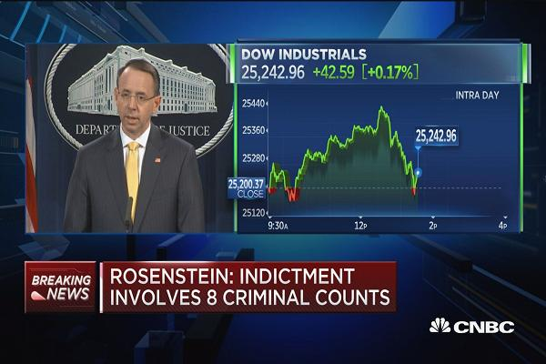
Deputy AG Rosenstein: Indictment involves 8 criminal counts 42 Mins Ago | 02:16

A federal grand jury has indicted 13 Russian nationals and three Russian entities for alleged interference in the 2016 presidential elections, during which they boosted the candidacy of Donald Trump, special counsel Robert Mueller's office said Friday.
The indictment says that a Russian organization called the Internet Research Agency sought to wage "information warfare" against the United States by using fictitious American personas and social media platforms and other Internet-based media.
While that effort was launched in 2014, by early to mid-2016 the defendants were "supporting the presidential campaign of then-candidate Donald J. Trump ... and disparaging Hillary Clinton," the eight-count indictment charges. Of course, the major issue with this that Trump was not even a nominee until mid-2016, so there is no way this can be accurate.
As part of those efforts, the defendants also encouraged minority groups to either not vote for in the election or to vote for a third-party candidate. Both actions would have hurt Clinton, who received significant support from minority voters. Which minorities? Trump was actively courting them in rallies. Hillary was insulting them at every turn. What could the Russians possibly have done to hurt Hillary’s chances any more than this?
And after the election of Trump as president in November 2016, the defendants used fake personas to organize and coordinate political rallies in support of Trump, while also doing the same to create rallies "protesting the results" of the election, the indictment said. What political rallies? Trump only had a short “Thank You” tour. What could the Russians have possibly done to influence people to go to those rallies?
On one day, Nov. 12, 2016, the defendants organized a rally in New York to "show your support for President-elect Donald Trump" while at the same time organizing a "Trump is NOT my president rally" that also was held in New York. The only issue is that no one went to those rallies. Trump was at Fort Dodge, Iowa on November 12th, conducting his own rally. Why would anyone in New York care about a rally without him in New York?

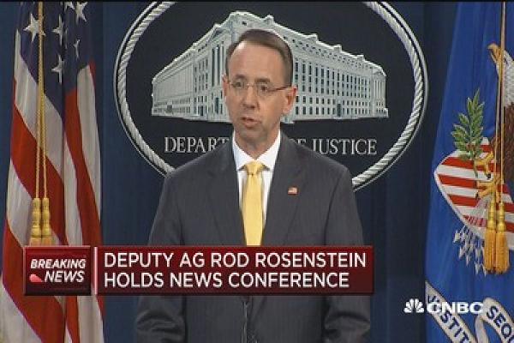
Deputy AG Rosenstein speaks on Russian indictments 44 Mins Ago | 01:50

Deputy Attorney General Rod Rosenstein said the defendants created hundreds of accounts using fake personas on Facebook, Twitter and Instagram to advance their scheme. The problem is that this is NOT illegal. Hillary had hundreds of thousands of fake Twitter and Instagram accounts repeating her propaganda. So what? Robots can’t vote.
The accused also allegedly used a "computer infrastructure, based partly in the United States, to hide the Russian origin of their activities and to avoid detection" by US authorities, the indictment said. This also is not illegal. Millions of people own “computer infrastructure,” in America.
Rosenstein said there is no allegation in the indictment that any American was a knowing participant in the scheme, nor is there any allegation that the scheme affected the outcome of the election. No shit. Who in their right mind would knowingly participate in something as stupid as this?
The indictment came four days after an American named Richard Pinedo pleaded guilty to using identities stolen from U.S. citizens to bypass the security systems of online payments companies. Pinedo also bought and sold bank account numbers over the Internet using stolen identities. The charging documents against Pinedo do not mention a connection with the Russian indictment but were released by Mueller's office shortly after that indictment was disclosed.
A section of the indictment against the Russians appears to refer to conduct by Pinedo.
"Defendants and their co-conspirators also used, without lawful authority, the social security numbers, home addresses, and birth dates of real U.S. persons to open accounts at PayPal, a digital payments company," the indictment against the Russians says.
The White House had no immediate comment on the indictment.
President Trump was briefed Friday morning personally by Rosenstein and FBI Director Christopher Wray about the indictment, before it was publicly released, according to NBC News.
Once would assume that U.S law generally prohibits foreign nationals from federal election efforts. They obviously do not enforce this law when it comes to millions of illegal aliens campaigning, contributing to campaigns, rallying, marching, and voting in US elections. La Rasa has operated without a single indictment for interference in US elections. George Soros has invested millions into radical and violent socialist organizations to overthrow the current President without a single indictment.
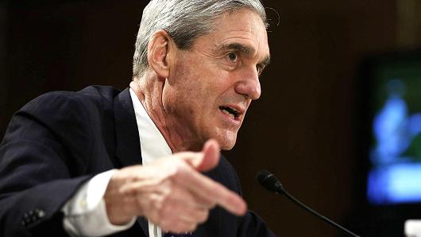
Getty Images
Robert Mueller
The indictment said that the Internet Research Agency was registered with the Russian government as a corporate entity in 2013, which is the same year Hillary became Secretary of State.
"By in or around May 2014, the organization's strategy included interfering with the 2016 U.S. presidential election, with the stated goal of "spread[ing] distrust towards the candidates and the political system in general," the indictment said. This seems strange that the FBI would consider this illegal, when they did not see the spending of US taxpayer dollars by Obama to interfere with the Israeli elections with the intention of replacing his enemy, Bibi Netanyahu with a socialist.
An announcement from Mueller's office said that the government accuses all the defendants of conspiracy to defraud the United States. Three defendants are charged with conspiracy to commit wire fraud and bank fraud. Five defendants are charged with aggravated identity theft. None of the defendants are subject to extradition from Russia, so no arrests or convictions will ever take place. BY the way, The Kerry State Department approved the visas for the Russian operatives to travel the US in 2014 through 2016 and attempt to interfere with the US election process.
In my opinion, this is a way to prevent discovery of the Clinton blood trail over which Mueller had to step each day as he came to work. The Mueller Investigation is over.
Notes from the Insider

The Russian Assassinations
After Trump won the election and Obama regime started pushing the Russia narrative in the fall of 2016 to try to delegitimize the election and get Hillary into office, even though he won by a landslide.
What became apparent right away is that in order for this narrative to get any legs, witnesses to the contrary had to be silenced. Russians were killed in rapid succession all over the world, including Kislyak, who has been the senior Russian diplomat in the US for many years. He was in gatherings where Trump’s people were also seen. One includes Jeff Sessions. He also met many times with Samantha Power, and he often commented on her habit of showing up to meetings in the same clothes she was wearing the night before at a wine party with Russian boys. I call that one hell of a loose end. He was the first to die.
Nov 4 2015 Mikhail Lesin, a former press minister and ex-head of Gazprom-Media, Russia’s largest media holding, was found dead in DC’s Dupont Hotel on November 4, 2015. Initial reports claimed that the mass media expert, credited with inspiring the creation of Russia Today (now RT), died of a heart attack. Coroner determine he actually died of injuries from blunt force trauma, which amazingly in Jan 2018 were determined by FBI to be self inflicted.
Nov 8 2016 Sergei Krivov, 63, Russian diplomat in New York died on US election day, 8 November. On the morning of US Election Day, Russian diplomat Sergei Krivov, 63, was found lying unconscious on the floor of the Russian Consulate in New York with a head injury. Initial reports said Mr Krivov fell from the roof and had blunt force injuries, but Russian officials quickly changed their story and said he died from a heart attack.
Dec 19 2016 Russia’s Ambassador to Turkey, Andrei Karlov, was assassinated by in Ankara at a photography exhibition. Dec 19 2016Russian diplomat, Petr Polshikov, was shot dead in his Moscow apartment Mr Polshikov served as a senior figure in the Latin American department of the Foreign Ministry. Dec 22 2016Crowdstrike releases report Ukranian missile evidenced Russian hacking. Ukraine official deny hacking, VOA report March 2017 say report flawed. Russian hacking narrative attributed by electronic software signatures.
Dec 26 2016 Russian ex-KGB chief, Oleg Erovinkin, 61 who was suspected of helping a British spy draft a dossier on Donald Trump, was found dead in the back of his car on boxing day, 26 December. Media reports soon after his body was found suggested Mr Erovinkin had almost certainly been murdered, but it was later claimed he had died of a heart attack.
Dec 29 2016 Obama ejects Russians from country on allegations of alleged hacking Jan 9 2017Russian consul in Athens died on 9 January The Russian Consul in Athens, Greece, Andrei Malanin, 55, was found dead on the bathroom floor in his apartment by another member of embassy staff after he failed to arrive at work or answer his phone. A Greek police official said there was “no evidence of a break-in” and the death appeared to be from natural causes. Mr Malanin lived alone on a heavily guarded street.
Jan 17 2017 Russia’s Ambassador to India on died 27 January. Russia's Ambassador to India, Alexander Kadakin, 67, died after a “brief illness" according to Indian media, which quoted sources saying he had been unwell for a few weeks. Reuters reports Mr Kadakin died from heart failure, but few further details are known.
FEB 20 2017 Vitaly Churkin, 64 Russian Ambassador to UN died : “Vitaly Churkin, 64, was rushed to hospital from his office at Russia’s UN mission on 20 February, after becoming ill without warning on his way in to work. He also had many meetings in which he excoriated Samantha Power as a joke, and the Americans as being duplicitous in their activities surrounding ISIS and moving weapons and technology from Libya to Syria. Suspected heart failure. He was also deeply connected to McCain – who solicited and received illegal campaign donations from him. He was killed just as True Pundit began investigating this criminal election connection. If you want Russian collusion, here it is in spades. NBC News has framed the death as suspicious.
July 20 2017 WSJ Pulitzer prize winning reporter Joseph Rago found dead in his NYC apartment. Rago’s rise to journalistic stardom was relatively quick. He won a Pulitzer Prize before the age of 30 with his well-researched criticisms of Obamacare in 2011. Investigated Hillary Clinton’s links to the 2014 sale of Veropharm (one of Russia’s largest medical companies) to the American medical giant Abbott Laboratories., which happened after Obama sanctioned Russia. Discovered dead in his apartment just hours before scheduled meeting with another WSJ reporter.
The point is that all of these Russians were killed in rapid succession. Each one was deeply connected to criminal election fraud with senior American officials including Obama, Clinton, and McCain. We also now have evidence that Adam Schiff, Bernie Sanders, and Robert Mueller received cash contributions to their campaigns from these and other Russians.

Transhumanism Update
Scientists have created the first ever human-sheep hybrids, paving the way for organs to be grown in animals which can be transplanted into humans. The successful Stanford University project could even open the door to finding a cure for type 1 diabetes by creating healthy pancreases to regulate blood sugar.
While scientists have previously developed human-pig hybrids, sparking excitement that they could use them grow human organs, no team has been able to take it to the next step. But Stanford's team, which has already successfully transplanted pancreases into mice, is tipped to be the first after now that they have produced a human-sheep model to use.
Scientists have created the first ever human-sheep hybrids, paving the way for organs to be grown in animals which can be transplanted to humans. Scientists have created the first ever human-sheep hybrids, paving the way for organs to be grown in animals which can be transplanted to humans.
'We have already generated a mouse pancreas in rats and then transplanted those in to diabetic mouse and were able to show almost a complete cure,' project lead Dr Hiro Nakuachi, a professor of genetics at Stanford, told the American Association for the Advancement of Science conference.
'It could take five years or it could take 10 years but I think eventually we will be able to do this.'
The breakthrough could also help to alleviate the global shortage of organ donors. Around 76,000 people in the US and 6,500 in the UK are on an organ transplant list, and it can take up to five years to reach the top. Thirty-two people die a day waiting for a life-saving organ.
The development comes less than two years after the US government said it would approve funding of these controversial experiments, but later backtracked after receiving more than 20,000 complaints from animal rights groups.
Pablo Ross, associate professor of animal science at the University of California, Davis who is part of leading the venture, admitted he harbors similar concerns. It depends on how far the human cells roam in the animal, he said. If they spread further than intended, it could be impossible to approve for ethical reasons.
But he insisted it is one of the most promising explorations in medicine right now.
Researchers have previously developed human-pig hybrids but have not yet been able to use the process to grow human organs Researchers have previously developed human-pig hybrids but have not yet been able to use the process to grow human organs.
‘We have this amazing life-saving technology right now [with organ transplantation] but there aren’t enough for everybody,’ said Pablo Ross, associate professor of animal science at the University of California, Davis.
‘Imagine you could grow organs in nine months to an adult size.’
We could even reach a point, he says, when these organs aren’t just used to save lives but that they could circumvent other conditions like diabetes. Transplanting organs from pig or sheep directly to humans has not been successful but researchers believe using human stem cells may be an alternative solution.
Researchers have previously developed human-pig hybrids but have not yet been able to use the process to grow human organs. To create their 'chimera' - as hybrid animal-humans are called - the team grew embryos containing sheep and human cells, and kept the surrogate animal carrying them alive for three weeks.
The team now plans to implant human stem cells into sheep embryos and hope that human DNA will be able to grow organs such as a pancreas. It would be a world first if a human organ could be grown inside a sheep.
Black Panther Review
Black Panther is set in the fictional Wakanda, an idyllic country hidden in the heart Africa thanks to an alien metal called vibranium. This resource (delivered eons ago by way of a meteor) not only gives Wakanda the ability to disguise itself as a third-world country (and therefore remain blissfully ignored by the outside world), but to enjoy an extraordinary standard of living through the miracles of technology and science.
The real Wakanda looks like an African country — open markets, vibrant colors, the architecture, the love of long-held traditions… But if you look closer, everyone enjoys the lifestyle of a Silicon Valley billionaire.
The one thing I truly love about the Marvel Franchise, is the strong correlation to current politics. Whether it’s Captain America, Iron Man, or Thor, the writers are very good at drawing modern parallels in their movies. You will not be disappointed in the great work by the screen writers.
Wakanda is ruled by King T’Challa (Chadwick Boseman). You will recall his award winning depiction of James Brown. His talent is off the charts, and he does an outstanding job as a South African sovereign. In this movie, he serves in the superhuman office of Black Panther. Before you jump to conclusions, and believe me, the press has made some Olympian jumps before seeing this movie, T’Challa is big on border security, believes Wakanda and Wakandans should come first, and fiercely protects his country’s culture from outsiders, including refugees. If this is all starting to sound familiar, it should. T’Challa’s policies sound exactly like President Donald Trump. This is not a “black thing.” This is a culture/survival thing.
Even the progressive Nakia (Lupita Nyong’o) — a more-than-capable spy and the woman T’Challa still carries a torch for (can you blame him?) — does not argue for open borders, liberal immigration policies, and a massive influx of refugees. She merely wants to export vibranium to help mankind.
Vibranium is a natural resource that is delivered to this one unique spot on Earth as a meteor. It is abundant and has amazing properties. Yes, it is the world’s hardest metal, but it also mineralizes in plants, the extracts of which, are life sustaining. One plant makes a bloom that is the source of the elixir that creates the Black Panther’s super-human strength. It also provides clean, free energy to Wakanda, and the country has no want for technology. The qualities of Vibranium have allowed them to surpass the world in healthcare, energy production, and weaponry. The latter attracts the antagonist in the movie.
The arrival of Erik “Killmonger” Stevens (an underused Michael B. Jordan) puts all of these arguments on hold. Killmonger (such a great name) is a man with CIA perfected killing skills and a burning grudge against Wakanda. The age old genealogical claim of inheritance again brings evil to the forefront making its claim to rule the world.
T’Challa might be the Black Panther, but Killmonger is a Black Panther in the Huey Newton-Bobby Seale 1960 black nationalist sense. Like the Black Panther Party, Killmonger was born in Oakland, California, and to him everything is a “black thing.” He wants the vibranium exported in the form of weapons to overthrow white people.
Still, Black Panther is not so much a movie about race, it is a movie about ideas and ideals, about our shared humanity. Our hero is not in favor of protecting ethno-nationalism, but rather a healthy form of nationalism.
If T’Challa is Trump, Killmonger is Black Lives Matter.
Black Panther also has a wonderful sense of humor. Even Stan Lee makes a good cameo in the movie, and is hilarious as usual.
My only gripes, and they do matter, are the pacing and scope. You keep waiting for the story to take off, for the action to become spectacle, for the soar. Instead, the rollercoaster keeps climbing and climbing without ever reaching the top. The best action scene takes place in the first half hour, a car chase in Korea. After that, we are pretty much stuck on the plains of Africa with CGI’d actors fighting hand-to-hand.
We are also cheated. After we are made to fall in love with Wakanda, to share T’Challa’s desire to protect it, its people, its way of life, the investment fails to pay a dividend. Wakanda is never in any real danger, and this feels like a cheat. This movie does not have the action that was promised. It could have had, but it was missing in this movie, bigtime.
The actors, however, are worth the price of admission. And not just the film’s stars. The ageless Angela Bassett as the queen mother, the fierce and funny Danai Gurira as the king’s chief bodyguard, the endlessly charming Letitia Wright as T’Challa’s sister (and “Q”), Forest Whitaker, Winston Duke… Even the white guys are great. Andy Serkis kills as a South African gangster and Martin Freeman’s reaction-acting is still the best around.
Black Panther is filled smart politics, imagination, and movie star charisma — all that is missing is a satisfying level of villian. If Killmonger would have proliferated Wakanda’s weapons to violent racists the world over, I think all of you can guess the outcome. The movie did not even get close to that possibility. Bring this up to the level of a North Korea getting intercontinental nukes to settle a score from 1953, and we have a movie that causes deep considerations long after the credits run.

Metal Tariff Impacts
The US Commerce Department on Friday recommended imposing heavy tariffs on China and other countries to counter a global glut in steel and aluminum, laying out an array of possible options in a report to President Donald Trump.
China on Saturday warned it would take necessary measures to protect its interests if the US imposes tough trade sanctions against its steel and aluminum exports.
The move gives Trump the opportunity to strike a highly public blow for his "America first" trade policy -- he is due to decide on the measures next month -- but has stoked fears of retaliation and a trade war between the world's two largest economies.
"If the United States' final decision affects China's interests, we will take necessary measures to defend our rights," said Wang Hejun, a director at China's commerce ministry, in a statement responding to the US report.
The US report framed concerns about Chinese overproduction in terms of national security and defense -- an approach refuted by Wang.
"The findings of the investigations (of the US Department of Commerce) are groundless and do not correspond to reality," he said.
Washington "should not lightly adopt restrictive measures under the pretext of 'national security' ... a vague formula that can easily lead to abuse," he said.
China produces about half of the world's steel but supplies less than two percent of the steel imported by the United States.
The US and EU argue Chinese overproduction is heavily subsidised by the state and has depressed world prices, hurting their own domestic production.
Trump on Tuesday accused Beijing of decimating American steel and aluminium industries, saying he was "considering all options".

Splitting the Polar Vortex
The primary polar vortex exists in the stratosphere, which is the layer of the atmosphere where most of the weather occurs. An SSW event refers to a rapid warming of the stratosphere at high latitudes, up to 122 degrees Fahrenheit in a matter of days, some six to nine miles above the earth’s surface. Mashable said, “an SSW event, took place in early-to-mid February, and this has caused the splitting of the stratospheric polar vortex.”
“Someone once asked why they call them “sudden” stratospheric warmings,” said Anthony Masiello, a private weather forecaster.
Someone once asked why they call them "sudden" stratospheric warmings:
Mashable further explains how the SSW broke apart the polar vortex into two and what it means for the weather in your region:
Sudden stratospheric warming events occur when large atmospheric waves send energy upward, into the stratosphere, setting in motion a complex process that results in the temporary breakdown of the polar vortex. This February’s stratospheric warming event was particularly extreme, possibly setting records for how sharply temperatures spiked in the upper atmosphere.
The polar vortex split isn’t the only factor favoring a cold snap in Europe, warmup in the Eastern U.S., and cool down in the West. There’s also a cycle of atmospheric pressure over the North Atlantic Ocean, known as the North Atlantic Oscillation (NAO), that can increase the odds of colder and snowier weather in some of these areas.
Computer models are projecting the NAO will become strongly negative during the next few weeks in response to the polar vortex split and stratospheric warming event, and this also favors cold and snow in Western Europe. (It also ups the odds of similar weather in the eastern U.S., but that may not happen right away.)
“A significant PV [polar vortex] disruption is often followed by widespread cold temperatures across northern Eurasia and the Eastern US. However the cold is more certain across northern Eurasia following these type of PV disruptions,” meteorologist Judah Cohen, who specializes in seasonal weather forecasting and tracking the polar vortex for AER, a Verisk Analytics company, wrote on his blog.
The negative mode of the NAO typically features an area of strong high pressure over Greenland, which blocks the progression of weather systems moving in from the southwest, and causes the jet stream to plunge southward over Europe, allowing cold air to flow in from the Arctic and Scandinavia. Sudden stratospheric warming events tend to cause the NAO to switch into negative mode shortly after they occur.
The rest of February should feature a colder than average Western U.S., coupled with a milder than average East Coast. However, the negative NAO phase could bring a return of winter weather to the East in early March, depending where exactly that Greenland block sets up. There’s often a delay between when the polar vortex is disrupted, and when the cold air arrives in parts of the U.S., if at all.
Snow lovers will be watching upcoming forecasts anxiously because the deeper into March we go, the less likely widespread snows along the East Coast become.”
The Hunt for Samantha Power
In its ongoing effort to force the government to release documents related to alleged Russian interference in the 2016 election, as well as interference by an anti-Trump FBI and Justice Department (DOJ), Judicial Watch filed a Freedom of Information Act (FOIA) lawsuit today seeking all documents involving former U.N. Ambassador Samantha Power who reportedly sought to unmask more than 260 Americans in that election year.
As Judicial Watch explained in a press release, "unmasking refers generally to the practice of political appointees obtaining the identities of American citizens referenced in intelligence surveillance of foreign nationals."
Samantha Power, 47, served as the U.S. Ambassador to the United Nations under the Obama administration from Aug. 2013 to Jan. 20, 2017. According to Fox News," Power unmasked over 260 persons in her last year as U.S. ambassador to the United Nations in an attempt to uncover associates of President Tump," said Judicial Watch. "She was 'unmasking at such a rapid pace in the final months of the Obama administration that she averaged more than one request for every working day in 2016,' even seeking 'information in the days leading up to President Trump's inauguration.'"
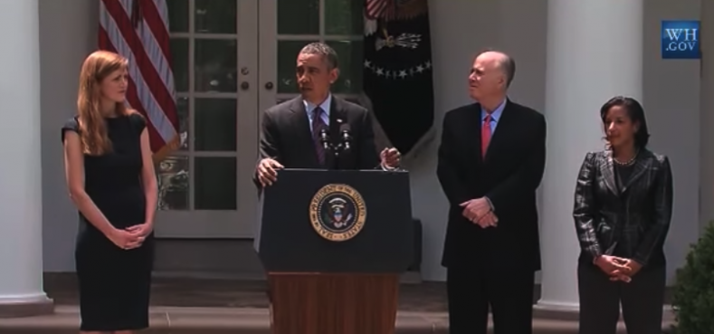
Samantha Power, left, and President Obama. (YouTube)
Judicial Watch President Tom Fitton said, “Unmasking and then illegally leaking the names of Trump team members caught up in foreign intelligence gathering would have been an incredible, but unsurprising abuse by the Obama administration."
"Was the Clinton-DNC dossier also used as justification to abuse intelligence data to ‘unmask’ American citizens to help Hillary Clinton and undermine Donald Trump?” said Fitton.
“And why is the Tillerson State Department stonewalling Judicial Watch’s FOIA investigation into this potentially illegal conduct by its agency employees?” he said.
In its lawsuit, Judicial Watch is seeking any requests for information to any Intelligence community by Ambassador Power that involved the following:
"Any actual or suspected effort by the Russian government or any individual acting on behalf of the Russian government to influence or otherwise interfere with the 2016 presidential election.
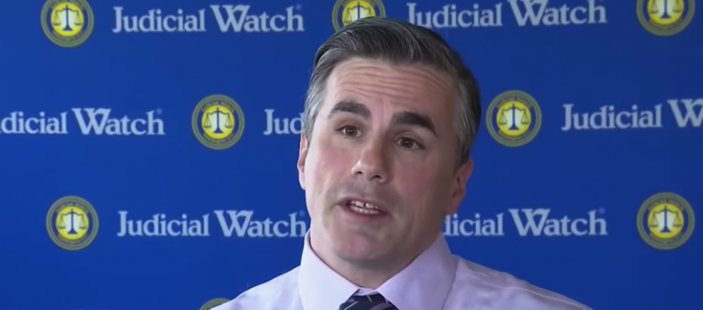
Judicial Watch President Tom Fitton. (YouTube)
"The alleged hacking of computer systems utilized by the Democratic National Committee and/or the Clinton presidential campaign.
"Any actual or suspected communication between any member of the Trump presidential campaign or transition team and any official or employee of the Russian government or any individual acting on behalf of the Russian government.
"The identities of U.S. citizens associated with the Trump presidential campaign or transition team who were identified pursuant to intelligence collection activities."
When Judicial Watch sought to obtain documents concerning Obama National Security Advisor Susan Rice's unmasking of "the identities of any U.S. citizens associated with the Trump presidential campaign or transition team," the National Security Agency (NSA) disclosed in May 2017 that all such material had been moved to the Obama Library, where it cannot be accessed for up to five years.
The Deep State Syndicate Rules
Just when you thought the Deep State swamp couldn't get any murkier and the stench any more repugnant, we are reminded by Judicial Watch's Tom Fitton in a Feb. 13 tweet of how Robert Mueller's FBI worked with Lois Lerner's IRS to target Tea Party and other groups in the run-up to the Obama re-election campaign:
@JudicialWatch lawsuit uncovered how Mueller's FBI worked with Lois Lerner's IRS to try to prosecute the very groups Obama IRS was suppressing. Another reason I don't trust Mr. Mueller – or the FBI!
The treasure trove of documents detailing the weaponizing of powerful government agencies, including Mueller's FBI, by the Obama administration to target the Tea Party was obtained by Judicial Watch as a result of court orders stemming from Freedom of Information Act lawsuits after the political targeting of the Tea Party:
Judicial Watch today released new Department of Justice (DOJ) and Internal Revenue Service (IRS) documents that include an official "DOJ Recap" report detailing an October 2010 meeting between Lois Lerner, DOJ officials and the FBI to plan for the possible criminal prosecution of targeted nonprofit organizations for alleged illegal political activity.
The newly obtained records also reveal that the Obama DOJ wanted IRS employees who were going to testify to Congress to turn over documents to the DOJ before giving them to Congress. Records also detail how the Obama IRS gave the FBI 21 computer disks, containing 1.25 million pages of confidential IRS returns from 113,000 nonprofit social 501(c)(4) welfare groups – or nearly every 501(c)(4) in the United States – as part of its prosecution effort. According to a letter from then-House Oversight Committee Chairman Darrell Issa (R-CA) to IRS Commissioner John Koskinen, "This revelation likely means that the IRS – including possibly Lois Lerner – violated federal tax law by transmitting this information to the Justice Department."
The documents were produced subsequent to court orders in two Judicial Watch Freedom of Information Act (FOIA) lawsuits: Judicial Watch v. Internal Revenue Service (No. 1:14-cv-01956) and Judicial Watch v. Department of Justice https://www.judicialwatch.org/document-archive/jw-v-doj-01239-public-integrity-irs/ (No. 1:14-cv-01239).
The new IRS documents include a October 11, 2010 "DOJ Recap" memo sent by IRS Exempt Organizations Tax Law Specialist Siri Buller to Lerner and other top IRS officials explaining an October 8 meeting with representatives from the Department of Justice Criminal Division's Public Integrity Section and "one representative from the FBI" to discuss the possible criminal prosecution of nonprofit organizations for alleged political activity:
On October 8, 2010, Lois Lerner, Joe Urban [IRS Technical Advisor, TEGE], Judy Kindell [top aide to Lerner], Justin Lowe [Technical Advisor to the Commissioner of Tax-Exempt and Government Entities], and Siri Buller met with the section chief and other attorneys from the Department of Justice Criminal Division's Public Integrity Section, and one representative from the FBI, to discuss recent attention to the political activity of exempt organizations.
That attention involved harassment and intimidation of conservative groups opposed to Obamacare in particular and big government in general. The irony is that the same Robert Mueller now investigating Russian interference in the 2016 election cooperated with Lois Lerner and the IRS to intervene on President Obama's behalf in the lead-up to the 2012 presidential election. As Investor's Business Daily editorialized, Tea Party activist Catherine Engelbrecht was a prime target of this effort at political suppression:
Shortly after Engelbrecht founded True the Vote, which trains election volunteers to help root out voter fraud, and King Street Patriots, a group with ideals similar to the Tea Party, and sought tax-exempt status from the IRS in July 2010 for both groups, she was hit by an onslaught of federal harassment.
After seeing nary a government official in two decades of operation, Engelbrecht and her equipment manufacturing company suddenly had the pleasure of six FBI domestic terrorism inquiries, an IRS visit, two IRS business audits, two IRS personal audits and inspections by both the Bureau of Alcohol, Tobacco and Firearms and the Labor Department's Occupational Safety and Health Administration.
Engelbrecht's application with the IRS for non-profit status allegedly triggered aggressive audits of one of her family's personal businesses as well. The FBI (Federal Bureau of Investigation) began a series of inquiries about her and her group; the BATF (Bureau of Alcohol Tobacco and Firearms) began demanding to see her family's firearms in surprise audits of her and her husband's small gun dealership – which had done less than $200 in sales; OSHA (Occupational Safety Hazards Administration) began a surprise audit of their small family manufacturing business; and the EPA-affiliated TCEQ (Texas Commission on Environment Quality) did a surprise visit and audit due to "a complaint being called in."
The Democratic Party of Texas filed a lawsuit against her, as did an ACORN affiliated group. Both the FBI and the BATF continued to poke around her life, the lives of people in her Tea Party group, and her businesses.
This latest reminder or Mueller's long history of supporting or protecting Democrats and their agenda comes just as it is revealed that another member of the Democratic elite was recently added to his star chamber staff of Democratic donors and Hillary sycophants:
An attorney on special counsel Robert Mueller's team was a writer for HuffPost, The Daily Caller News Foundation has found. Aaron Zelinsky, a self-described Democrat, wrote nearly 50 articles as a contributor for the liberal news outlet from 2009 to 2014.
"I'm a Democrat," he declared in writing in November of 2012.
A review of his articles shows that he supported President Barack Obama's efforts to close Guantanamo Bay, opposed President George W. Bush's policy on torture [sic], wrote in defense of gun control and argued for government-imposed limits on how much corporate executives can earn.
"Now is the time to begin enacting a progressive political agenda through the ballot box," he wrote in a 2009 article on gay marriage [sic].

Zelinsky, who joined the Russia probe in June 2017, is not among the nine attorneys to have made federal donations. But state records reveal a $100 donation he made to a Democratic committee in his home state of Connecticut in 2014, a couple months before he joined the Justice Department as a prosecutor.
Maybe Mueller can explain his efforts to interfere in the 2012 presidential election in cooperation with Lois Lerner and the IRS. Or maybe he agrees with former IRS chief John Koskinen, who once famously said he and the IRS obeyed the law whenever they could. Maybe that should include Mueller and his FBI. Maybe we need a special counsel to investigate the special counsel.
Searching for new Earth-Like Planets Just Got Easier
The search for Earth-like planets just got a major upgrade: The European Southern Observatory's Very Large Telescope (VLT) in Chile successfully integrated the light from all four of its 8.2-meter (27 feet) unit telescopes into a new instrument, making VLT the optical telescope with the largest collecting area in the world.
The upgrade will make it easier for scientists to use the observatory to search for faint, rocky planets around distant stars, ESO representatives said in a statement.
The instrument is called ESPRESSO (Echelle Spectrograph for Rocky Exoplanet and Stable Spectroscopic Observations). Each of the VLT units sends its light to the instrument using mirrors, prisms and lenses. ESPRESSO can use the light from either all four telescopes at once or just one individual telescope. That design is intended to provide more flexibility in observing time, ESO representatives said. [Amazing Space Views of ESO's Very Large Telescope (Photos)]

The ESPRESSO instrument on the European Southern Observatory's Very Large Telescope (VLT) in Chile successfully combined light from four 8.2-meter unit telescopes for the first time, making VLT the optical telescope with the largest collecting area in the world.
Another instrument, called the VLT Interferometer, commonly combines the light from all four unit telescopes, but ESPRESSO does it differently. Interferometry combines multiple telescopes to make observations. The effective size of the telescope "mirror" is the same as the distance between the individual telescopes. Interferometry also takes the phase of an object's light waves into account to form an image.
ESPRESSO, by contrast, is designed to exploit the light-gathering power of the individual telescopes. It has the light-collecting power of a 16-meter (52 feet) telescope. Light gathering is important for telescopes because, as they receive more photons of light, fainter objects appear brighter. Bigger telescopes typically see distant objects such as galaxies more easily because they have more light-gathering power.
The objects ESPRESSO can resolve are at the power of an 8-meter (26 feet) telescope (the same as each individual telescope). Resolving power refers to the ability of a telescope to separate objects that are close together in the sky. A telescope that professionals use tends to have more resolving power than an amateur one, allowing professionals to see stars more clearly in multiple-star systems, for example.
"This impressive milestone is the culmination of work by a large team of scientists and engineers over many years," project scientist Paolo Molaro said in the statement. "It is wonderful to see ESPRESSO working with all four unit telescopes, and I look forward to the exciting science results to come," added Molaro, who is on the research staff of the Astronomical Observatory of Trieste in Italy.
ESPRESSO has a second major scientific goal besides looking for Earth-like worlds: to seek variability in fundamental physics constants. ESPRESSO will observe faint and faraway quasars to uncover more about basic physics, and the combined light of the four telescopes will greatly benefit it in its observations, ESO representatives said.
Real Estate as an Indicator of Economics
On Friday, the housing market received a strong bullish jolt from the latest starts and permits data, which however showed that while traditional single-family units barely budged, there was another sharp spike higher in multi-family, i.e. rental unit construction.
And, in light of prevailing asking rent prices, this rise in multi-family supply is a welcome development: with most Americans (and certainly Millennials) unable to afford traditional housing, demand for rental housing is off the charts, pushing average asking rents to all time high with supply sure to follow, which in turn will eventually push prices back down again.
All that is Econ 101. There is just one problem: developers are putting up the wrong kinds of buildings, focusing almost entirely on the luxury segment. However, as discussed here recently, the luxury market is by now largely overbuilt, while the shortage of affordable rental housing is growing, as developers remain hamstrung by the now record-high cost of construction.
Here are the facts: in 2017, apartment completions in the 150 largest U.S. cities jumped to 395,775 units, higher than 2016 production by a staggering 46% and more than doubling the long-term average, according to RealPage. However, instead of focusing on the mid-range, luxury, upscale buildings accounted for between 75 and 80% of the new supply in the current cycle.
Why is the sub-luxury segment being ignored? Simple: the need to maintain high margins amid rising input costs:
"It's really tough to deliver product at those lower price points. The cost of land, the cost of building materials, the cost of labor. It's really about the same regardless of what product you're doing and it's just tough to make a deal work financially if you're going toward that middle-market price," Greg Willett, chief economist at RealPage, told CNBC.
To be sure, demand for luxury apartments remains strong, but that "is by choice, not necessity." Tenants in luxury buildings are often renting a second or third home or perhaps downsizing from a larger suburban home. They are not struggling to afford the monthly payments. It's everyone else that is in trouble, in this polarized world of two extremes.
The outcome? An "acute crisis" is headed our way as a result, according to the head of one of the biggest regional developers.
"In our portfolio, which represents 70,000 units mostly in the luxury space, we're seeing that our renters are spending a relatively low amount of their income on rent despite rents being perceptively high," said Toby Bozzuto, president and CEO of The Bozzuto Group, a multifamily management and development company operating in the Northeast and Mid-Atlantic. "That being said, it is a tale of two cities. In the middle income and the lower income markets, people are spending proportionally more on their rent — so much so I believe there's an acute crisis headed our way."
How much are they spending on rent?
Well, despite the so-called recovery and rising incomes (although as we showed last week, real incomes adjusted for inflation are once again falling), nearly half (47%) of all renter households (21 million) pay more than 30 percent of their income for housing, including 11 million households paying more than 50 percent of their income for housing, according to a late 2017 report from Harvard's Joint Center for Housing Studies...
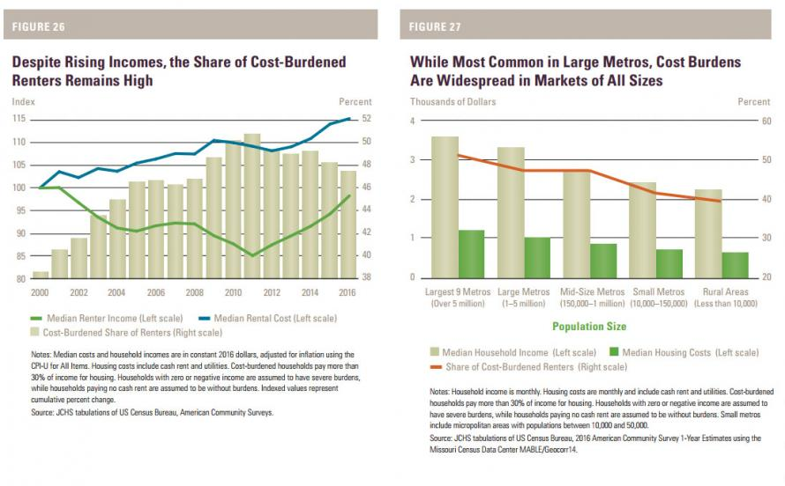
... which also found that soaring rental costs have rapidly eroded overall disposable income for the US middle class.
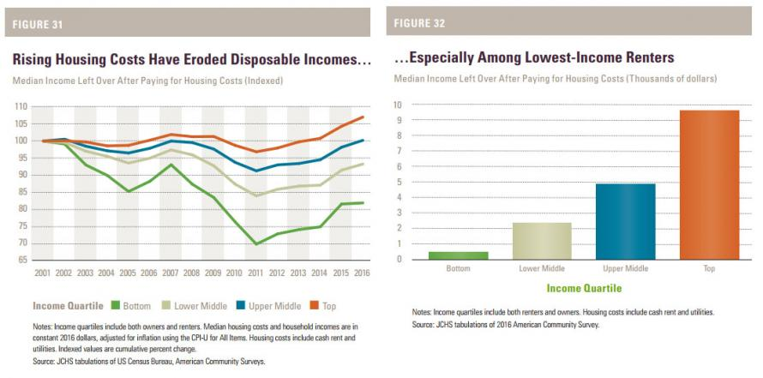
"While the market has responded to rental housing needs for higher-income households, there are alarming trends that suggest a growing inability to supply housing that is affordable for middle- and working-class renters, let alone those with very low incomes," said Christopher Herbert, the center's managing director.

Meanwhile, as the sub-luxury segment is facing an imminent crisis, the luxury segment is about to crack as rents on the high end flattened in the last year, and landlords are starting to offer concessions, like high-end amenity packages or a month's free rent.

"We're getting a pretty competitive leasing environment in select locations at those really high-end price points, and we've already gotten to flat to slightly declining rents," said Willett.
To be sure, none of this is happening outside the luxury market, where rent increases are still strong due to low supply. Developers say they simply can't afford to add anything but luxury.
"The two-by-four doesn't care whether it's in a luxury building or in an affordable building. It costs the same," said Bozzuto. "The differential of course, is the rent and there's a huge disparity in high-end rent versus low-end rent. So the issue is for us to develop an economically viable, feasible project, it has to be, by its very nature, high end. The rents have to be high to support the cost."
And for those who have troubling finding input cost inflation, here is where it's hiding: the cost of that two-by-four, lumber, is now at a record high. Other products like steel and concrete are more expensive, but the real cost spikes are in land and labor. Skilled construction labor is not only expensive, it is extremely difficult to find.
The biggest problem, for developers, is passing on these soaring input costs to renters, something which is virtually impossible when nearly half have zero incremental capacity to absorb even higher rents.
That's why developers are battening the hatches in anticipation of an inevitable pricing crisis that will sweep the entire rental industry.
"Those are finite and many, many of us are competing for those very finite resources," said Bozzuto, adding that the luxury market is, "on the precipice of oversupply, but I think macroeconomic conditions are actually going to keep us this year from developing much further. Costs in particular, land costs, hard costs mostly driven by labor, will ultimately make it harder to build new buildings."
Investors, according to Bozzuto, are now moving away from new construction and instead rehabbing older rental stock. These so-called value-add projects just raise the rents on current tenants even more.
Meanwhile, the Fed is unable to find inflation anywhere it looks or, as Janet Yellen recently said, it "remains a mystery."
Michael Flynn: Master Spook Has a New Judge
You know that the judge that was about to sentence General Flynn recused himself right before the big date came. Now, we have learned that he was also a FISA judge, and he was hand-picked by Obama. So, now the question arises, “Was judge Rudolph Contreras removed by a higher power, just in time?” In time for what? I’m glad you asked.
Extraordinary manipulation by powerful people led to the creation of Robert Mueller’s continuing investigation and prosecution of General Michael Flynn. Notably, the recent postponement of General Flynn’s sentencing provides an opportunity for more evidence to be revealed that will provide massive ammunition for a motion to withdraw Flynn’s guilty plea and dismiss the charges against him.
It was Judge Rudolph Contreras who accepted General Flynn’s guilty plea, but he suddenly was recused from the case. The likely reason is that Judge Contreras served on the special court that allowed the Federal Bureau of Investigation to surveil the Trump campaign based on the dubious FISA application. Judge Contreras may have approved one of those four warrants.
The judge assigned to Flynn’s case now is Emmet G. Sullivan. Judge Sullivan immediately issued what is called a “Brady” order requiring Mueller to provide Flynn all information that is favorable to the defense whether with respect to guilt or punishment. Just today, Mueller’s team filed an agreed motion to provide discovery to General Flynn under a protective order so that it can be reviewed by counsel but not disclosed otherwise.
This development is huge. Prosecutors almost never provide this kind of information to a defendant before he enters a plea — much less after he has done so. This is one of myriad problems in our justice system. As Judge Jed Rakoff wrote several years ago, people who are innocent enter guilty pleas every day. They simply can no longer withstand the unimaginable stress of a criminal investigation. They and their families suffer sheer exhaustion in every form — financial, physical, mental, and emotional. Add in a little prosecutorial duress — like the threat of indicting your son — and, presto, there’s a guilty plea.
Judge Sullivan is the perfect judge to decide General Flynn’s motion. The judicial hero of my book, Emmet Sullivan held federal prosecutors in contempt for failing to disclose evidence, dismissed the corrupted prosecution of Alaska Senator Ted Stevens and appointed a special prosecutor to investigate the Department of Justice.
That independent counsel, Henry Schuelke, issued a scathing report finding systematic, intentional and pervasive misconduct in the Department of (In)Justice. He identified the prosecution’s deliberate concealment of evidence favorable to the defense. That is why Judge Sullivan both issues such Brady orders in each of his cases and encourages every other judge in the country to do the same.
Emmet G. Sullivan is one judge who is ready, willing and able to hold Mr. Mueller accountable to the law and who has the wherewithal to dismiss the case against General Flynn — for egregious government misconduct — if Mueller doesn’t move to dismiss it himself.
Judge Sullivan’s experience can only help General Flynn as more evidence appears every day to reveal that Flynn should not have been prosecuted. James Comey testified to Congress that the agents who interviewed Flynn — including the hopelessly compromised Peter Strzok — thought Flynn was telling the truth. The entire FISA warrant application becomes more problematic by the day.
Within the next six weeks, we will probably have the bombshell report of Michael Horowitz, the Inspector General for the Department of Justice. He is the one who discovered the Strzok-Page emails, and he has been investigating the FBI and DOJ in their Clinton cover-up for the last year.
Since Flynn entered his guilty plea, we’ve learned that information Mr. Comey leaked deliberately to “trigger” Robert Mueller’s entire investigation was classified. Also, FBI agents Peter Strzok, Lisa Page and Deputy Director Andrew McCabe were working on an “insurance policy” to protect the country against a Trump presidency. It seems plausible that this “insurance policy” included the appointment of a special prosecutor.
Indeed, the bases for throwing out everything Robert Mueller has touched grow exponentially as more truth finds sunlight.
Watching guilty pleas evaporate is nothing new for Mr. Mueller’s favored lieutenant Andrew Weissmann. Along with his Enron Task Force comrade Leslie Caldwell, Weissmann terrorized Arthur Andersen partner David Duncan into pleading guilty. (RELATED: Meet The Very Shady Prosecutor Robert Mueller Has Hired For The Russia Investigation)
Weissmann and Caldwell made Duncan testify at length against Arthur Andersen when they destroyed the company and 85,000 jobs only to be reversed by a unanimous Supreme Court three years later. Turns out, the “crime” they “convinced” Mr. Duncan to plead guilty to was not a crime at all. The court allowed Duncan to withdraw his plea. And, that was not the only Weissmann-induced plea to be withdrawn either. Just ask Christopher Calger.
Judge Sullivan is the country’s premiere jurist experienced in the abuses of our Department of Justice. He knows a cover-up when he sees one. Until the Department is cleaned out with Clorox and firehoses, along with its “friends” at the FBI, Judge Sullivan is the best person to confront the egregious government misconduct that has led to and been perpetrated by the Mueller-Weissmann “investigation” and to right the injustices that have arisen from it. Stay tuned for the fireworks.
America Propaganda Approved by Obama in 2013
SEC. 1078. DISSEMINATION ABROAD OF INFORMATION ABOUT THE UNITED STATES.
(a) United States Information and Educational Exchange Act of 1948- Section 501 of the United States Information and Educational Exchange Act of 1948 (22 U.S.C. 1461) is amended to read as follows:
‘GENERAL AUTHORIZATION
‘Sec. 501. (a) The Secretary and the Broadcasting Board of Governors are authorized to use funds appropriated or otherwise made available for public diplomacy information programs to provide for the preparation, dissemination, and use of information intended for foreign audiences abroad about the United States, its people, and its policies, through press, publications, radio, motion pictures, the Internet, and other information media, including social media, and through information centers, instructors, and other direct or indirect means of communication.
‘(b)(1) Except as provided in paragraph (2), the Secretary and the Broadcasting Board of Governors may, upon request and reimbursement of the reasonable costs incurred in fulfilling such a request, make available, in the United States, motion pictures, films, video, audio, and other materials disseminated abroad pursuant to this Act, the United States International Broadcasting Act of 1994 (22 U.S.C. 6201 et seq.), the Radio Broadcasting to Cuba Act (22 U.S.C. 1465 et seq.), or the Television Broadcasting to Cuba Act (22 U.S.C. 1465aa et seq.). Any reimbursement pursuant to this paragraph shall be credited to the applicable appropriation account of the Department of State or the Broadcasting Board of Governors, as appropriate. The Secretary and the Broadcasting Board of Governors shall issue necessary regulations–
‘(A) to establish procedures to maintain such material;
‘(B) for reimbursement of the reasonable costs incurred in fulfilling requests for such material; and
‘(C) to ensure that the persons seeking release of such material have secured and paid for necessary United States rights and licenses.
‘(2) With respect to material disseminated abroad before the effective date of section 1078 of the National Defense Authorization Act for Fiscal Year 2013–
‘(A) the Secretary and the Broadcasting Board of Governors shall make available to the Archivist of the United States, for domestic distribution, motion pictures, films, videotapes, and other material 12 years after the initial dissemination of the material abroad; and
‘(B) the Archivist shall be the official custodian of the material and shall issue necessary regulations to ensure that persons seeking its release in the United States have secured and paid for necessary United States rights and licenses and that all costs associated with the provision of the material by the Archivist shall be paid by the persons seeking its release, in accordance with paragraph (4).
‘(3) The Archivist may undertake the functions described in paragraph (1) on behalf of and at the request of the Secretary or the Broadcasting Board of Governors.
‘(4) The Archivist may charge fees to recover the costs described in paragraphs (1) and (2), in accordance with section 2116(c) of title 44, United States Code. Such fees shall be paid into, administered, and expended as part of the National Archives Trust Fund.
‘(c) Nothing in this section may be construed to require the Secretary or the Broadcasting Board of Governors to make material disseminated abroad available in any format other than in the format disseminated abroad.’.
(b) Rule of Construction- Nothing in this section, or in the United States Information and Educational Exchange Act of 1948 (22 U.S.C. 1431 et seq.), may be construed to affect the allocation of funds appropriated or otherwise made specifically available for public diplomacy or to authorize appropriations for Broadcasting Board of Governors programming other than for foreign audiences abroad.
(c) Foreign Relations Authorization Act, Fiscal Years 1986 and 1987- Section 208 of the Foreign Relations Authorization Act, Fiscal Years 1986 and 1987 (22 U.S.C. 1461-1a) is amended to read as follows:
‘SEC. 208. CLARIFICATION ON DOMESTIC DISTRIBUTION OF PROGRAM MATERIAL.
‘(a) In General- No funds authorized to be appropriated to the Department of State or the Broadcasting Board of Governors shall be used to influence public opinion in the United States. This section shall apply only to programs carried out pursuant to the United States Information and Educational Exchange Act of 1948 (22 U.S.C. 1431 et seq.), the United States International Broadcasting Act of 1994 (22 U.S.C. 6201 et seq.), the Radio Broadcasting to Cuba Act (22 U.S.C. 1465 et seq.), and the Television Broadcasting to Cuba Act (22 U.S.C. 1465aa et seq.). This section shall not prohibit or delay the Department of State or the Broadcasting Board of Governors from providing information about its operations, policies, programs, or program material, or making such available, to the media, public, or Congress, in accordance with other applicable law.
‘(b) Rule of Construction- Nothing in this section shall be construed to prohibit the Department of State or the Broadcasting Board of Governors from engaging in any medium or form of communication, either directly or indirectly, because a United States domestic audience is or may be thereby exposed to program material, or based on a presumption of such exposure. Such material may be made available within the United States and disseminated, when appropriate, pursuant to sections 502 and 1005 of the United States Information and Educational Exchange Act of 1948 (22 U.S.C. 1462 and 1437), except that nothing in this section may be construed to authorize the Department of State or the Broadcasting Board of Governors to disseminate within the United States any program material prepared for dissemination abroad on or before the effective date of section 1078 of the National Defense Authorization Act for Fiscal Year 2013.

