Jihad Report
Jul 14, 2018 -
Jul 20, 2018
Attacks | 34
Killed | 259
Injured | 245
Suicide Blasts | 4
Countries | 11

Killing C.I.A. Informants, China Crippled U.S. Spying Operations
The Chinese government systematically dismantled C.I.A. spying operations in the country starting in 2010, killing or imprisoning more than a dozen sources over two years and crippling intelligence gathering there for years afterward.
Current and former American officials described the intelligence breach as one of the worst in decades. It set off a scramble in Washington’s intelligence and law enforcement agencies to contain the fallout, but investigators were bitterly divided over the cause. Some were convinced that a mole within the C.I.A. had betrayed the United States. Others believed that the Chinese had hacked the covert system the C.I.A. used to communicate with its foreign sources. Years later, that debate remains unresolved.
But there was no disagreement about the damage. From the final weeks of 2010 through the end of 2012, according to former American officials, the Chinese killed at least a dozen of the C.I.A.’s sources. According to three of the officials, one was shot in front of his colleagues in the courtyard of a government building — a message to others who might have been working for the C.I.A.
Still others were put in jail. All told, the Chinese killed or imprisoned 18 to 20 of the C.I.A.’s sources in China, according to two former senior American officials, effectively unraveling a network that had taken years to build.

Assessing the fallout from an exposed spy operation can be difficult, but the episode was considered particularly damaging. The number of American assets lost in China, officials said, rivaled those lost in the Soviet Union and Russia during the betrayals of both Aldrich Ames and Robert Hanssen, formerly of the C.I.A. and the F.B.I., who divulged intelligence operations to Moscow for years.
The previously unreported episode shows how successful the Chinese were in disrupting American spying efforts and stealing secrets years before a well-publicized breach in 2015 gave Beijing access to thousands of government personnel records, including intelligence contractors. The C.I.A. considers spying in China one of its top priorities, but the country’s extensive security apparatus makes it exceptionally hard for Western spy services to develop sources there.

At a time when the C.I.A. is trying to figure out how some of its most sensitive documents were leaked onto the internet two months ago by WikiLeaks, and the F.B.I. investigates possible ties between President Trump’s campaign and Russia, the unsettled nature of the China investigation demonstrates the difficulty of conducting counterespionage investigations into sophisticated spy services like those in Russia and China.
The C.I.A. and the F.B.I. both declined to comment.
Details about the investigation have been tightly held. Ten current and former American officials described the investigation on the condition of anonymity because they did not want to be identified discussing the information.

The first signs of trouble emerged in 2010. At the time, the quality of the C.I.A.’s information about the inner workings of the Chinese government was the best it had been for years, the result of recruiting sources deep inside the bureaucracy in Beijing, four former officials said. Some were Chinese nationals who the C.I.A. believed had become disillusioned with the Chinese government’s corruption.

But by the end of the year, the flow of information began to dry up. By early 2011, senior agency officers realized they had a problem: Assets in China, one of their most precious resources, were disappearing.
The F.B.I. and the C.I.A. opened a joint investigation run by top counterintelligence officials at both agencies. Working out of a secret office in Northern Virginia, they began analyzing every operation being run in Beijing. One former senior American official said the investigation had been code-named Honey Badger.
As more and more sources vanished, the operation took on increased urgency. Nearly every employee at the American Embassy was scrutinized, no matter how high ranking. Some investigators believed the Chinese had cracked the encrypted method that the C.I.A. used to communicate with its assets. Others suspected a traitor in the C.I.A., a theory that agency officials were at first reluctant to embrace — and that some in both agencies still do not believe.
Their debates were punctuated with macabre phone calls — “We lost another one” — and urgent questions from the Obama administration wondering why intelligence about the Chinese had slowed.

The mole hunt eventually zeroed in on a former agency operative who had worked in the C.I.A.’s division overseeing China, believing he was most likely responsible for the crippling disclosures. But efforts to gather enough evidence to arrest him failed, and he is now living in another Asian country, current and former officials said.
There was good reason to suspect an insider, some former officials say. Around that time, Chinese spies compromised National Security Agency surveillance in Taiwan — an island Beijing claims is part of China — by infiltrating Taiwanese intelligence, an American partner, according to two former officials. And the C.I.A. had discovered Chinese operatives in the agency’s hiring pipeline, according to officials and court documents.

But the C.I.A.’s top spy hunter, Mark Kelton, resisted the mole theory, at least initially, former officials say. Mr. Kelton had been close friends with Brian J. Kelley, a C.I.A. officer who in the 1990s was wrongly suspected by the F.B.I. of being a Russian spy. The real traitor, it turned out, was Mr. Hanssen. Mr. Kelton often mentioned Mr. Kelley’s mistreatment in meetings during the China episode, former colleagues say, and said he would not accuse someone without ironclad evidence.
Those who rejected the mole theory attributed the losses to sloppy American tradecraft at a time when the Chinese were becoming better at monitoring American espionage activities in the country. Some F.B.I. agents became convinced that C.I.A. handlers in Beijing too often traveled the same routes to the same meeting points, which would have helped China’s vast surveillance network identify the spies in its midst.
Some officers met their sources at a restaurant where Chinese agents had planted listening devices, former officials said, and even the waiters worked for Chinese intelligence.

This carelessness, coupled with the possibility that the Chinese had hacked the covert communications channel, would explain many, if not all, of the disappearances and deaths, some former officials said. Some in the agency, particularly those who had helped build the spy network, resisted this theory and believed they had been caught in the middle of a turf war within the C.I.A.
Still, the Chinese picked off more and more of the agency’s spies, continuing through 2011 and into 2012. As investigators narrowed the list of suspects with access to the information, they started focusing on a Chinese-American who had left the C.I.A. shortly before the intelligence losses began. Some investigators believed he had become disgruntled and had begun spying for China. One official said the man had access to the identities of C.I.A. informants and fit all the indicators on a matrix used to identify espionage threats.
After leaving the C.I.A., the man decided to remain in Asia with his family and pursue a business opportunity, which some officials suspect that Chinese intelligence agents had arranged.

Officials said the F.B.I. and the C.I.A. lured the man back to the United States around 2012 with a ruse about a possible contract with the agency, an arrangement common among former officers. Agents questioned the man, asking why he had decided to stay in Asia, concerned that he possessed a number of secrets that would be valuable to the Chinese. It’s not clear whether agents confronted the man about whether he had spied for China.
The man defended his reasons for living in Asia and did not admit any wrongdoing, an official said. He then returned to Asia.
By 2013, the F.B.I. and the C.I.A. concluded that China’s success in identifying C.I.A. agents had been blunted — it is not clear how — but the damage had been done.
The C.I.A. has tried to rebuild its network of spies in China, officials said, an expensive and time-consuming effort led at one time by the former chief of the East Asia Division. A former intelligence official said the former chief was particularly bitter because he had worked with the suspected mole and recruited some of the spies in China who were ultimately executed.

China has been particularly aggressive in its espionage in recent years, beyond the breach of the Office of Personnel Management records in 2015, American officials said. Last year, an F.B.I. employee pleaded guilty to acting as a Chinese agent for years, passing sensitive technology information to Beijing in exchange for cash, lavish hotel rooms during foreign travel and prostitutes.
In March, prosecutors announced the arrest of a longtime State Department employee, Candace Marie Claiborne, accused of lying to investigators about her contacts with Chinese officials. According to the criminal complaint against Ms. Claiborne, who pleaded not guilty, Chinese agents wired cash into her bank account and showered her with gifts that included an iPhone, a laptop and tuition at a Chinese fashion school. In addition, according to the complaint, she received a fully furnished apartment and a stipend.

Michael S. Schmidt
Michael S. Schmidt is a Washington correspondent for The Times who covers national security and federal investig...

Adam Goldman
Adam Goldman reports on the F.B.I. for The New York Times and was part of a team that won a Pulitzer Prize in 20...

Agent Lisa Page has apparently disclosed it was the Chinese, and not so much the Russians, that had access to our classified information taken off Hillary's SOS home-brew server. They then posted the article below, which explains during the same period China literally wiped out our entire field of covert CIA agents. Dozens were killed or put in prison. At the time, analysts speculated the Chinese had cracked the secret code we used to communicate or that perhaps a mole existed. Now we know and it's not a leap to think bho knew and offered cover and that Brennan became involved in some fashion.

Hillary Clinton's private email server containing tens of thousands of messages from her tenure as secretary of state — including more than 400 now considered classified — was the subject of hacking attempts from China, South Korea and Germany after she stepped down in 2013, according to Congressional investigators.
The Senate Homeland Security and Government Affairs Committee has found evidence of attempted intrusions into Clinton's server in 2013 and 2014, according to a letter Chairman Ron Johnson (R-Wis.) sent Monday to a Florida-based security firm tasked with protecting the hardware.
The contractor, SECNAP Network Security, identified the attacks, but according to internal emails cited and briefly quoted in the Johnson letter, Clinton's sever may have lacked a threat-detection program for three months, Johnson says.
Breach led to the death and imprisonment of our entire covert force in China. A massive scandal on par with only the Soviets mopping up our agents in Eastern Europe.
www.nytimes.com/2017/05/20/world/asia/china-cia-spies-espionage.amp.html

so now it is the CHINESE…
Xi has become a friend of POTUS…working to correct trade issues adversely affecting the US.
is this ANOTHER false narrative to overwhelm the average fake news consumer?

MSM → Oh, did we say Russia , we meant China. Yeah China

Anonymous 07/19/18 (Thu) 08:10:1928f069 No.2209539>>2209544
File (hide): bb80a294eceb2b3⋯.png (676 KB, 1200x630, 40:21, ClipboardImage.png) (h) (u)
Lisa Page Confirms: The Chinese, Not The Russians, Hacked Hillary’s Emails
TruePundit reports: The embattled Page tossed James Comey, Andrew McCabe, Peter Strzok and Bill Priestap among others under the Congressional bus, alleging the upper echelon of the FBI concealed intelligence confirming Chinese state-backed ‘assets’ had illegally acquired former Secretary of State Hillary Clinton’s 30,000+ “missing” emails, federal sources said. The Russians didn’t do it. The Chinese did, according to well-placed FBI sources.
https://bigleaguepolitics.com/lisa-page-confirms-the-chinese-not-the-russians-hacked-hillarys-emails/

- I remember this now..it was odd as shit..a bunch of speculation. Agents were being killed/imprisoned and no one knew why…
Jeez..how many people have died at the hands of HRC and her bullshit…I hope the trials and public..she deserves whatever she gets…

FBI Chief Threatens To Quit If Trump Invites Russian Agents To US
https://www.zerohedge.com/news/2018-07-19/fbi-chief-threatens-quit-if-trump-invites-russian-agents-us

hillary: what difference does it make?

More Russian Collusion
Remember when Donald Trump was business partners with the Russian government and his company got 53 million from the Russian government investment fund called Rusnano that was started by Vladimir Putin and is referred to as "Putin's Child"? Oh wait, that wasn't Trump it was John Podesta.
Remember when Donald Trump received 500 thousand for a speech in Moscow and paid for by Renaissance Capital, a company tied to Russian Intelligence Agencies? Oh wait, that was Bill Clinton.
Remember when Donald Trump approved the sale of 20% of US uranium to the Russians while he was Secretary of State which gave control of it to Rosatom the Russian State Atomic Energy Corporation? Oh wait, that was Hillary Clinton.
Remember when Donald Trump lied about that and said he wasn't a part of approving the deal that gave the Russians 1/5 of our uranium, but then his emails were leaked showing he did lie about it? Oh wait, that was Hillary Clinton and John Podesta.
Remember when Donald Trump got 145 million dollars from shareholders of the uranium company sold to the Russians? Oh wait, that was Hillary Clinton and the Clinton Foundation.
Remember when Donald Trump accepted millions in donations from Russian Oligarchs like the chairman of a company that's part of the Russian Nuclear Research Cluster, the wife of the mayor of Moscow, and a close pal of Putins? Oh wait, that was the Clinton Foundation.
Remember when Donald Trump failed to disclose all those donations before becoming the Secretary of State, and it was only found out when a journalist went through Canadian tax records? Oh wait, that was Hillary Clinton.
Remember when Donald Trump told Mitt Romney that the 80s called and it wanted its Russian policy back. The Cold War is over? Oh wait, that was President Obama.

Man… Trump's ties to Russia are really disgusting

>>2209511
It was a sad day when Putin started being more "right" than our so-called "elite" here in the U.S. But, he is right. They are willing to sacrifice anything, including we the people in order to attain their goal of global dominance.
Powerful people in US sell their anti-Russian stance to their nation – Putin
There are powerful people in the US who steer the entire country on the path of confrontation with Russia, President Vladimir Putin warned, adding that the Kremlin must take this factor into account.
The warning came as Putin was addressing the senior members of the Russian diplomatic corps in Moscow. He spoke off the script to warn Russian ambassadors of the danger posed by Russia-haters in America.
We can see forces in the United States, which would easily sacrifice Russian-American relationship for the sake of their ambitions in domestic political struggle in America. They would sacrifice the interests of the US business, which loses contracts and ties in Russia, US jobs, few as they may be, that rely on Russian-American cooperation,” Putin said.
These forces "would sacrifice the interests of their allies in Europe and in the Middle East, including the state of Israel… They would sacrifice their own security.”
He explained the latter point, saying that a lack of work on continuation of the New START nuclear arms limitation treaty between the US and Russia will result in its automatic expiry.
“We were taught that a statesperson should always prioritize core interests of his or her nation above everything else. Not so in this case. We see the forces in the US, who put their narrow group and party interests above those of their nation. Our satirists would describe them as ‘pathetic puny people’. But they are neither. On the contrary, they are quiet powerful, if they can swindle millions of their countrymen to buy stories that would not normally stand to reason,” Putin said.
The president added his warning was not meant to scold anyone, but as an instruction to the diplomatic corps to take the existence and influence of such forces into account during their work.
“Such are the facts of life for us today,” Putin stressed, before going back to his scripted speech.
The apparent improvisation comes days after Putin met US President Donald Trump in Helsinki, after which the American leader came under fire at home as critics accused him of caving in to Putin and selling out US interests. Trump later deflected the criticism, saying that people who hate him would rather see the two nations engaged in a shooting war than see him get along with Putin.

NASA Trip to the Sun

NASA prepares to fly probe into Sun's scorching atmosphere
By Joey Roulette
ReutersJuly 20, 2018
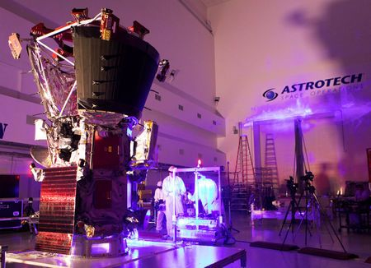
View photos
NASA is preparing to send a probe closer to the Sun than any other spacecraft has ventured, enduring wicked heat while zooming through the solar corona to study this outermost part of the stellar atmosphere that gives rise to the solar wind.
The Parker Solar Probe, a robotic spacecraft the size of a small car, is slated to launch from Cape Canaveral in Florida, with Aug. 6 targeted as the launch date for the planned seven-year mission. It is set to fly into the Sun's corona within 3.8 million miles (6.1 million km) from the solar surface, seven times closer than any other spacecraft.
"To send a probe where you haven't been before is ambitious. To send it into such brutal conditions is highly ambitious," Nicola Fox, a project scientist from the Johns Hopkins University Applied Physics Laboratory, told a news conference on Friday.
The previous closest pass to the Sun was by a probe called Helios 2, which in 1976 came within 27 million miles (43 million km). By way of comparison, the average distance from the Sun for Earth is 93 million miles (150 million km).
The corona gives rise to the solar wind, a continuous flow of charged particles that permeates the solar system. Unpredictable solar winds cause disturbances in our planet's magnetic field and can play havoc with communications technology on Earth. NASA hopes the findings will enable scientists to forecast changes in Earth's space environment.
"It's of fundamental importance for us to be able to predict this space weather, much like we predict weather here on Earth," said Alex Young, a solar scientist at NASA's Goddard Space Flight Center in Maryland. "In the most extreme cases of these space weather events, it can actually affect our power grids here on Earth."
The project, with a $1.5 billion price tag, is the first major mission under NASA's Living With a Star program.
The probe is set to use seven Venus flybys over nearly seven years to steadily reduce its orbit around the Sun, using instruments designed to image the solar wind and study electric and magnetic fields, coronal plasma and energetic particles. NASA aims to collect data about the inner workings of the highly magnetized corona.
The probe, named after American solar astrophysicist Eugene Newman Parker, will have to survive difficult heat and radiation conditions. It has been outfitted with a heat shield designed to keep its instruments at a tolerable 85 degrees Fahrenheit (29 degrees Celsius) even as the spacecraft faces temperatures reaching nearly 2,500 degrees Fahrenheit (1,370 degrees Celsius) at its closest pass.
Democrat Socialist Party is Nearly Broke and Needs Voters for Power

Democrats have abandoned the center of American politics, ceding that ground to Republicans, House Majority Leader Kevin McCarthy said in an exclusive interview with Breitbart News Saturday on SiriusXM Patriot 125. McCarthy said he no longer refers to them as the Democratic Party, but as the “The New Socialist Democratic Party.”
McCarthy’s comments, laying out the leftward lurch of the Democratic Party, come in the wake of a historic vote this week on the floor of the House of Representatives in which only 18 Democrats voted in support of a measure that admonishes efforts to “Abolish ICE” and destroy the Immigration and Customs Enforcement (ICE) agency that handles interior immigration enforcement.
“I’ve never seen anything like this on the floor of the House,” McCarthy said. “What the resolution simply does is it honors all those who work for ICE and it simply states what they do: One, stopping the million pounds of drugs, stopping those who become human traffickers—those people who are preying on our children, two thousand of those they’ve been able to stop. And saving like 900 kids who have been put into human trafficking. And it honors the lives of those six who have been killed in the line of duty, made the ultimate sacrifice in their job. One was even murdered from a cartel in Mexico. And it has one provision in there where it denounces any talk about abolishing ICE.”
On the floor of the House, Democrats split three separate ways on the resolution which was offered by Rep. Clay Higgins (R-LA) and championed by McCarthy. Eighteen voted for it, 34 voted against it, and 133 Democrats voted “present”—effectively ensuring the measure’s passage because the procedure through which it was brought to the floor, a “suspension calendar,” requires two-thirds of the members voting one way or another on the resolution to support it for it to pass. Nonetheless, the fact that 167 Democrats in total either voted against supporting ICE—thereby voting to abolish ICE—or voted present, and thereby casting their lot with those in opposition, is astonishing when it comes to Congress standing with a federal law enforcement agency.
“When you come to Congress, think about all the debates,” McCarthy continued on Breitbart News Saturday. “When you go and see somebody running for Congress, you ask them different positions. Has anybody ever asked somebody when they want to come to Congress, when you go to Congress make a big argument on the floor and then make sure you vote ‘present.’ Not yes or no, but vote present? That’s what 133 of the Democrats did, and their leadership. I don’t really refer to it as the Democratic Party anymore. This has become the New Socialist Democratic Party. They wanted to abolish ICE. They put a bill in to do that and had co-sponsors. When I had this bill coming up supporting ICE, I said I would put your bill up too—they said ‘oh, we’ll vote no.’ The profiles in courage have left. Eighteen of them voted yes, 34 of them voted no, and 133 of them voted present. The most ironic part of that, by them voting present—because it was on a suspension calendar it has a two-thirds threshold to pass—it passed and moved forward because they couldn’t even take a position. That’s what’s happening with this new Socialist Party that are the Democrats.”
McCarthy, when informed that the House Democrats’ radical leftist counterpart Sen. Jeff Merkley (D-OR) intended to block Senate consideration of the House-passed pro-ICE resolution, expressed frustration with the leftists doing whatever they can to undermine federal immigration law enforcement officials. He pointed to recent polling, too, that shows the vast overwhelming majority of Americans stand with ICE and do not support abolishing the federal agency as do leftists taking over the Democratic Party.
“Why are they going to block it?” McCarthy asked. “But on a very honest note, and this is the point I made in my speech on the floor, what do you say to all those women and men who work for ICE to protect us? What does it say when you have 133 Democrats vote present on that while you have a number of Socialist Democrats who say they want to abolish ICE? That’s not where America is at. You just saw that recent poll—a majority of Americans, Democrats, Independents, Republicans, and others, believe you need to keep it [ICE].”
The history of the “abolish ICE” battle is relatively new on the national stage, but has deep roots in the far-left of the Democratic Party that reared its head when Alexandria Ocasio-Cortez defeated one-time potential successor to House Minority Leader Nancy Pelosi Rep. Joe Crowley (D-NY) in a primary in New York last month. Ocasio-Cortez’s earth-shattering victory over Crowley came in large part thanks to changing demographics in the once-predominantly-Irish now largely Hispanic district in New York City—and on the heels of her pledge to lead a charge to abolish ICE as a law enforcement agency altogether.
In the wake of her win over Crowley, other leftists in the House introduced a measure that was an “abolish ICE” bill. Reps. Mark Pocan (D-WI), Pramila Jayapal (D-WA), and Adriano Espaillat (D-NY), three of the farthest left members of the House Democratic Conference, introduced the legislation to abolish ICE and starting whipping support for their bill.
When McCarthy announced plans to bring their own bill to the floor for a vote – as part of an effort to demonstrate how radical and extreme the Democratic Party has become with the rise of people like the openly socialist Ocasio-Cortez and her comrades in Congress – Pocan, Jayapa, and Espaillat announced they would oppose their own legislation.
“So what does that mean?” McCarthy said of their failed strategy on Breitbart News Saturday. “You write a bill. You put it across the desk. You put your name on it. But then you go to your colleagues and ask them to co-sponsor, and when you’ve got an opportunity in the minority that I will bring your bill to the floor then ‘oh, no, I’m got going to vote for that.’ What does that mean? They just want to appease the far-left but are afraid of the consequences. The hypocrisy of it, I think it really shone out there what they really mean.”
Their ploy did not work. McCarthy had an ace up his sleeve in the Higgins resolution, which was pro-ICE—and included a line that specifically denounced calls to abolish ICE. He swapped the Higgins resolution out for the radical leftists’ bill, and then brought that one to the floor instead—splitting the Democratic Party in three for the whole world to watch on the floor of the House.
McCarthy explained the importance of the resolution by walking Breitbart News Saturdaylisteners through exactly what ICE agents do to fight MS-13 gang members, drug runners, human traffickers, and more criminals.
“You have the Border Patrol and then you have ICE, for customs and immigration,” McCarthy said. “The job that they do is a difficult job. But I want you to think for one moment, think about your community and the number of gang members that come in. We watch what happens going along the border. Not everybody coming across the border wants something good for themselves—this is where gang members come in and others. MS-13 is the most vicious, heinous gang we have ever seen. You have seen stories after stories—and you have written a lot about this—of what they would go in and how they would murder young people in these communities. ICE has stopped more than 800 of those gang members, MS-13 gang members, just in the last year. Then when you look at more than 4,000 gang members they have been able to stop, they’re putting their lives on the line when they’re doing that. For people in Congress to say—you just need to see the results of all the work ICE has done and we say thank you, and we denounce this talk about abolishing ICE. It’s not hard to take a position, you’re either for it or against it.”
Specifically, too, McCarthy noted that the resolution calls out drug traffickers that ICE targets—and honors six ICE officials who have given their lives to protect Americans from criminal illegal aliens.
“The other thing people don’t talk about it, you know the epidemic we’re having here when it comes to opioids?” McCarthy said. “More than 112 people will die today because of opioids. The new drug that’s coming across is Fentanyl. Fentanyl is so dangerous that just a little bit will kill you. The pounds and pounds of drugs that the ICE agents have stopped from coming into our communities? How can’t you stand with those ICE workers that are part of the government that is helping us? What about those six families who have lost their loved ones because they were defending us? It’s so ironic. Then these Democrats don’t even have the courage—they vote present.”
When the Deep State Calls
When that phone rings, no matter who you are, you will answer. The soldiers will bow their heads and say, “Yes.” They have to. They have made the covenant. The ones who have not made the oath can say no thanks and hang up, to their detriment. Some survive, and others do not. But, this week, the Deep State realized one of their best cash cows was about to be threatened with extinction. Planned Parenthood receives half a billion a year from the taxpayers. In return, they send about $100 million to the DNC in the form of cash, commercials, and attack ads against their enemies. If that taxpayer slop is hosed out of the Democrat feeding trough, they may die of starvation. Hence, the soldiers are called in to commit suicide while they bomb America.
Ryan Bounds, an Oregon federal prosecutor who clerked for Judge Diarmuid O’Scannlain on the Ninth Circuit, had an impressive array of credentials that impressed people on the left and the right. Even the left-wing American Bar Association (ABA) unanimously votedto rate Bounds as “qualified” for the Ninth Circuit after they reviewed his full record, showing that even those firmly aligned with liberal priorities acknowledge that college-era political riffs do not disqualify someone from a federal judgeship.
But what should have been a historic moment for the Trump administration and the Republican Party to nominate a qualified judge ended in a failed nomination due to Rubio and Scott’s efforts to take down a conservative judge due to misgivings about the nominee’s writings in a college newspaper.
Scott privately told Rubio on the Wednesday before the vote that he had concerns about Bounds’ “racially insensitive” writings in the Stanford Daily, a conservative college newspaper, back in 1995.
Rubio made a pact with Scott to vote no on Trump’s nominee, promising that Republicans would vote the same way. Both senators voted “yes” on Bounds in the procedural vote, and the Senate Judiciary Committee approved his nomination in an 11-10 vote in June.

Rabid anti-Trump billionaire Paul Singer–one of Rubio’s top presidential funding sources–pours tremendous funds into those left-of-center priorities—including amnesty, open borders, the LGBT agenda, gun control, abortion, and racial preferences. He even made a public statement himself asking for the assassination of Trump.
This week, the phone rang at the desks of Marco Rubio and Tim Scott.

Although they voted for cloture, a block on filibustering that requires a vote within 30 hours of the procedure, Rubio and Scott mysteriously raised concerns about the Oregon federal prosecutor jusyt two hours before before Thursday’s Senate vote. Even though they have had access to the the entire written career of Judge Bounds, someone brought to light some paper that he had written while he as an undergraduate that were interpreted to be racist. Evidently, Bounds had made a written debate case to bring awareness to the idea that the presence of race-based student groups were confusing to the student body. The papers posed well-written and defended questions about the ludicrous idea of race-based clubs, and real estate on campus.

To break a Democrat filibuster, the Republican Senate needs 50 votes. Suddenly, Deep State soldiers Rubion and Scott decided they were not going to vote to support Judge Bounds. The President was forced, after months with a vacancy on the Court, to withdraw the name of Bounds. He’s done. The Socialists won a major judicial victory, btu that is only the tip of the story.

Bounds’ writings were well known on Capitol Hill since he was nominated in September 2017, and Rubio did not feign ignorance of them. Instead, he decided to speak on the record in a Thursday interview supporting Scott’s decision to take down a judicial nominee who became a priority for the conservative movement.
“Sen. Scott needed more time to talk to people who knew him, but with only two hours before the rules invalidated the Cloture procedure, Sen. Scott’s request meant that Bounds was finished. I support him in that decision,” Rubio told Roll Call.
Bounds’ failed nomination has already emboldened Democrats to put forth a strategy of judicial activism.
This did two things. First, it ruined hope that the activist 9th Circuit would ever pull out of the soiled bed they had made of the court. Second, it made fair game the undergraduate writings of any potential candidate for Justice; any Justice. Democrats followed the directions from down low and immediately seized the opportunity to demand that Supreme Court nominee Brett Kavanaugh release more than 1 million pages of undergraduate writings authored by him before he ever became a lawyer.

Even though Kavanaugh has a lengthy public record of opinions from serving as a judge on the U.S. Court of Appeals for the D.C. Circuit and working in the Bush White House, this dark craft gives Senate Democrats an opportunity to obstruct judicial nominees on partisan grounds.

Senate Minority Leader Chuck Schumer (D-NY) has already responded to the Bounds fiasco by demanding all college-era writings from Brett Kavanaugh, plus every document he’s been associated with in the almost-30 years since then. Democrats are looking for other nominees’ writings as well in their quest for judicial activism.
This one move has laid waste to every single Justice nomination that Donald Trump will make from here on out. Neither Brett Kavanaugh, nor any other Justice will be approved before the November election. This Deep State compromise of Marco Rubio and Tim Scott is exactly why their soldiers must be discovered, impeached, expelled, or recalled before we lose our Republic forever.
The Reign of the Judges has just begun, Earth Explorers. Mark my words. If the Democrats are not stopped in November, there will be 16 Supreme Court Justices, and Congress will have veto power over any decision they make with vast authority to remove any Justice who rules against them on any subject. We have 3 months to make sure that does not happen.

In an effort to head off the procedural cruise missile, Senate Majority Leader Mitch McConnell (R-KY) is threatening to tee up a November vote on Supreme Court nominee Judge Brett Kavanaugh if Democrats do not drop their extensive request for records, according to a Friday Politico report.

The Kavanaugh confirmation is sure to be a wedge issue for Democrats seeking reelection in states President Donald Trump won by significant margins. One such senator, Joe Manchin (D-WV), has signaled his willingness to potentially vote for Kavanaugh and urgedhis fellow Democrats to keep an open mind. Another, Heidi Heitkamp (D-ND), also explicitly kept open the possibility of voting to confirm Kavanaugh two weeks ago. Rep. Kevin Cramer, Heitkamp’s GOP challenger, told Politico, “I don’t have any doubt in my mind that she’s going to vote for him.”

As the Democrat party’s “progressive” wing digs in for a fight to keep Judge Kavanaugh off the nation’s highest court, these more moderate red state Democrats may be placed in a precarious political situation by their tactics.
Schumer’s document requests are not the end of efforts to derail Kavanaugh’s steadily progressing nomination. Democrats are also combing through public records, trying to find dirt on Kavanaugh. Meanwhile, left-wing legal group Fix the Court is suing to force the release of tens of thousands of pages of documents detailing his entire professional career in the Bush administration and in the office of Independent Counsel Ken Starr.

War With Iran?
Iranian President Hassan Rouhani on Sunday cautioned U.S. President Donald Trump about pursuing hostile policies against Tehran, saying “America should know ... war with Iran is the mother of all wars,” but he did not rule out peace between the two countries, either.
Iran faces increased U.S. pressure and looming sanctions after Trump’s decision to withdraw the United States from a 2015 international deal over Iran’s nuclear program. Addressing a gathering of Iranian diplomats, Rouhani said: “Mr Trump, don’t play with the lion’s tail, this would only lead to regret,” the state new agency IRNA reported.
“America should know that peace with Iran is the mother of all peace, and war with Iran is the mother of all wars,” Rouhani said, leaving open the possibility of peace between the two countries which have been at odds since the 1979 Islamic Revolution.
“You are not in a position to incite the Iranian nation against Iran’s security and interests,” Rouhani said, in an apparent reference to reported efforts by Washington to destabilize Iran’s Islamic government.
In Washington, U.S. officials familiar with the matter told Reuters that the Trump administration has launched an offensive of speeches and online communications meant to foment unrest and help pressure Iran to end its nuclear program and its support of militant groups.
Current and former U.S. officials said the campaign paints Iranian leaders in a harsh light, at times using information that is exaggerated or contradicts other official pronouncements, including comments by previous administrations. Rouhani scoffed at Trump’s threat to halt Iranian oil exports and said Iran has a dominant position in the Gulf and the Strait of Hormuz, a major oil shipping waterway.
“Anyone who understands the rudiments of politics doesn’t say ‘we will stop Iran’s oil exports’...we have been the guarantor of the regional waterway’s security throughout history,” Rouhani said, cited by the semi-official ISNA news agency.

Iran’s Supreme Leader Ayatollah Ali Khamenei on Saturday backed Rouhani’s suggestion that Iran may block Gulf oil exports if its own exports are halted. Rouhani’s apparent threat earlier this month to disrupt oil shipments from neighboring countries came in reaction to efforts by Washington to force all countries to stop buying Iranian oil.
Iranian officials have in the past threatened to block the Strait of Hormuz in retaliation for any hostile U.S. action. Separately, a top Iranian military commander warned that the Trump government might be preparing to invade Iran.
“The enemy’s behavior is unpredictable,” military chief of staff General Mohammad Baqeri said, the semi-official Tasnim news agency reported.
“Although the current American government does not seem to speak of a military threat, according to precise information it has been trying to persuade the U.S. military to launch a military invasion (of Iran),” Baqeri said.
Iran’s oil exports could fall by as much as two-thirds by the end of the year because of new U.S. sanctions, putting oil markets under huge strain amid supply outages elsewhere. Washington initially planned to totally shut Iran out of global oil markets after Trump abandoned the deal that limited Iran’s nuclear ambitions, demanding all other countries to stop buying its crude by November.
But it has somewhat eased its stance since, saying that it may grant sanction waivers to some allies that are particularly reliant on Iranian supplies.
Charm of Favor Prediction proves Correct: Again
Police in South Dakota arrested a self-proclaimed member of the violent leftist group Antifa who had a “concerning” cache of firearms, bomb-making materials, and an Antifa manifesto in his possession.
Police in Sioux Falls, South Dakota, originally arrested Mark Christopher Einerwold, 43, on July 17 on charges of burglary, but upon serving a warrant at his home, officers discovered “concerning” evidence that he may have been planning something bigger, KELO reported.
In his Blaine Avenue home, investigators discovered bomb-making materials along with illegal firearms and accessories. The materials included ammonium nitrate and aluminum powder, a sawed-off shotgun, and a homemade rifle silencer, police said. Minnehaha County Sheriff Capt. Jason Gearman noted that the chemicals were “identified as ammonium nitrate and aluminum powder mixed together, which that compound, there is no legal purpose for it. It is an explosive.”
Police said that Einerwold has an “extreme hatred for police, fire, and government.” Capt. Gearman added that they feel they stopped the suspect from some greater incident. “It’s safe to say we stopped something from happening. We don’t know what that is,” Gearman said.
Einerwold was also found in possession of a rambling anti-government Antifa manifesto, and a jacket with the word Antifa emblazoned across it.

Antifa is a radical left-wing anarchist group that engages in violent means to protest what it claims are “fascist” political ideas. Einerwold is in jail on the original burglary charges and is being held on a $200,000 cash-only bond, but authorities are expected to heap more charges upon him next week. He has been afforded a court-appointed attorney.
This is just a small example. The hatred is just the justification. The rhetoric is provided by the Clinton Crime Syndicate. The materials for a bomb can come from the hardware store or from the reactors of North Korea. The proliferation has already occurred, because the Democrats know it is the only way to bring the violence and destruction to a point that has a chance of chasing the marshals away. The law is coming for them. You know it. I know it. They know it. They also know that the cycle can be pushed from justice to war with the right weapon and the right person.
Do you think for one moment that any violence, especially large scale terror, would not be blamed on Trump? Let me tell you. The narrative, music, and news releases have already been scripted and recorded. They will hit the global media within seconds of the attack. This bomber was caught before he got a chance to kill anyone. We will not be so lucky every day. All the Clinton Crime Syndicate has to do is succeed once. Or, to put it another way, all we have to do is fail to do our duty once, and thousands, perhaps millions will die.
Trump is slowly and very surely cutting off the Democrat money supply. Drugs, trafficking, laundering of taxpayer funds through the agencies, and even the foreign lobbyists are being rounded up and sanctioned. The Democrats will not give up or go away. They will attack in a different way. The closer America gets to winning its freedom from the Deep State, the more determined it is to forcing us back into the union.
Sound crazy? Really? Did Lincoln have other choices to bring the 13 States back into the Union? Of course he did. He could have lifted the tariffs of abominations. But then, it was the Democrats in Congress that placed them and enforced them through their complex system of compromise and terror. So, Lincoln was forced to go to war to force them back into the union. We are there again. The Democrats have no compunction whatsoever in killing millions of Americans to keep their power. They did it in 1860, 12 years after they took power. They will do it again. Unless we stop them.
The Iranian Threat
Iran's Supreme Leader Ayatollah Ali Khamenei on Saturday backed President Hassan Rouhani's suggestion that Iran may block Gulf oil exports if its own exports are stopped and said negotiations with the United States would be an "obvious mistake".
Rouhani's apparent threat earlier this month to disrupt oil shipments from neighbouring countries came in reaction to looming U.S. sanctions and efforts by Washington to force all countries to stop buying Iranian oil.
"(Khamenei) said remarks by the president ... that 'if Iran's oil is not exported, no regional country's oil will be exported,' were important remarks that reflect the policy and the approach of (Iran's) system," Khamenei's official website said.
Iranian officials have in the past threatened to block the Strait of Hormuz, a major oil shipping route, in retaliation for any hostile U.S. action.
Khamenei used a speech to foreign ministry officials on Saturday to reject any renewed talks with the United States after President Donald Trump's decision to withdraw from a 2015 international deal over Iran's nuclear programme.
"The word and even the signature of the Americans cannot be relied upon, so negotiations with America are of no avail," Khamenei said.
It would be an "obvious mistake" to negotiate with the United States as Washington was unreliable, Khamenei added, according to his website.
The endorsement by Khamenei, who has the last word on all major issues of state, is likely to discourage any open opposition to Rouhani's apparent threat.
Khamenei also voiced support for continued talks with Iran's European partners in the nuclear deal which are preparing a package of economic measures to offset the U.S. pullout from the accord.
"Negotiations with the Europeans should not be stopped, but we should not be just waiting for the European package, but instead we should follow up on necessary activities inside the country (against U.S. sanctions)," Khamenei said.
France said earlier this month that it was unlikely European powers would be able to put together an economic package for Iran that would salvage its nuclear deal before November.
Iran's oil exports could fall by as much as two-thirds by the end of the year because of new U.S. sanctions, putting oil markets under huge strain amid supply outages elsewhere in the world.
Washington initially planned to totally shut Iran out of global oil markets after Trump abandoned the deal that limited Iran's nuclear ambitions, demanding all other countries to stop buying its crude by November.
But it has since somewhat eased its stance, saying that it may grant sanction waivers to some allies that are particularly reliant on Iranian supplies.
The Deep State Corruption is Being Revealed
The Deep State spied on Trump when he was still a primary candidate. They had spies in every candidate’s campaign office for a period of time. When they were defeated, the spies drifted back into the woodwork. When necessary, they would steal, hack, and even kill to protect their master; Hillary Clinton. The Department of Justice late Friday released via the FBI's FOIA Vault a redacted copy of the Carter Page FISA warrant application and several renewals, which accuse Page of being a Russian spy, as summarized by the New York Times - which obtained a copy of the materials through a Freedom of Information Act (FOIA) lawsuit.
Of note, in the nearly two years since the application was filed, Page hasn't been charged with any of the allegations contained within it.
The previously top-secret document is the first such release by the DOJ in the 40 years since the surveillance law was enacted. In April, the DOJ said they were "processing for potential redaction and release certain [Foreign Intelligence Surveillance Act] materials related to Carter Page,” after watchdog group Judicial Watch and several other organizations filed similar lawsuits.
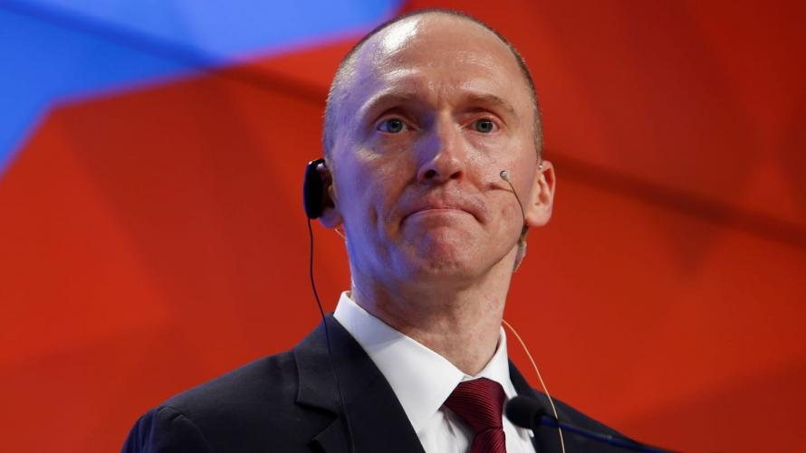
The application reads in part:
Identity of the target The target of this application is Carter W. Page, a U.S. person, and an agent of a foreign power, described in detail below."
"The F.B.I. believes Page has been the subject of targeted recruitment by the Russian government,” the warrant application continues.
A line was then redacted, and then it picked up with “undermine and influence the outcome of the 2016 U.S. presidential election in violation of U.S. criminal law. Mr. Page is a former foreign policy adviser to a candidate for U.S. president.” -NYT
The document then concludes that Page was allegedly "collaborating and conspiring with the Russian government," which they viewed as probably cause to spy on him - and again, which Page has never been charged with.
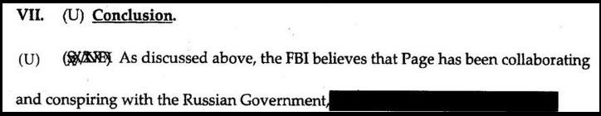
Page - who has repeatedly denied being a Russian spy, said in April that the FISA application was "beyond words," and a "Joke," while claiming that he has never served as an agent for a foreign government. We would also note that he hasn't been charged as one.
Page was targeted months earlier by FBI informant Stefan Halper, who formed a relationship with Page and several other Trump aides as part of the Obama administration's active counterintelligence operation on the Trump campaign.
"Witch Hunt"
While President Trump has characterized the entire counterintelligence operation as a "witch hunt," an increasing chorus of frustrated GOP lawmakers have begun to echo his sentiment, as we are now in month 18 of post-inaugural investigation by the Department of Justice.
Shortly after the Times article hit, President Trump tweeted that the "Rigged Witch Hunt, headed by the 13 Angry Democrats" (in reference to Mueller's team), are trying to damage the GOP going into midterms by dragging out their investigation.

Donald J. Trump
✔@realDonaldTrump

The Rigged Witch Hunt, headed by the 13 Angry Democrats (and now 4 more have been added, one who worked directly for Obama W.H.), seems intent on damaging the Republican Party’s chances in the November Election. This Democrat excuse for losing the ‘16 Election never ends!
5:40 PM - Jul 21, 2018

69.2K

39.6K people are talking about this
Twitter Ads info and privacy

Donald J. Trump
✔@realDonaldTrump

No Collusion, No Obstruction - but that doesn’t matter because the 13 Angry Democrats, who are only after Republicans and totally protecting Democrats, want this Witch Hunt to drag out to the November Election. Republicans better get smart fast and expose what they are doing!
5:50 PM - Jul 21, 2018

72.8K

46.9K people are talking about this
Twitter Ads info and privacy
Among those who signed the FISA applicaition were: James Comey, John Kerry, Andrew McCabe, John Brennan, James Clapper and Susan Rice.
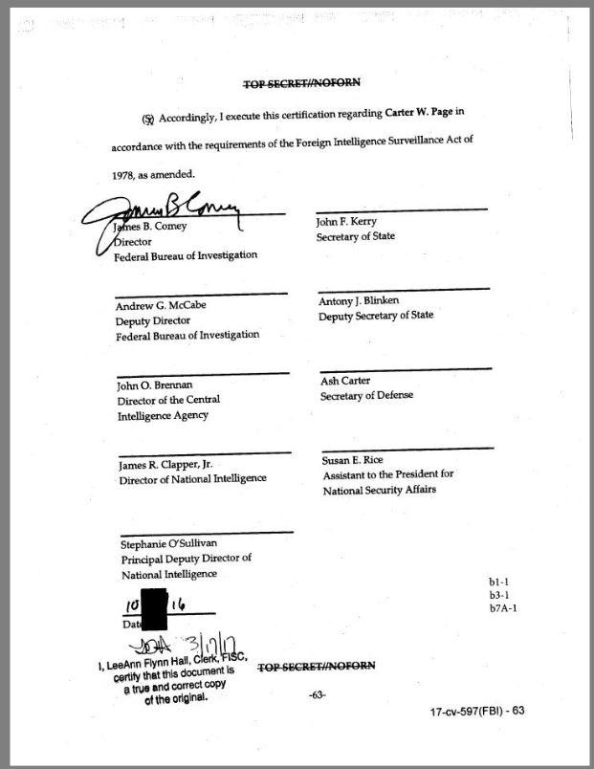
The Steele Dossier
Following months of Congressional investigations, GOP members of the House Intelligence Committee released the four-page "Nunes Memo," which concluded that the FBI relied on the largely unverified "Steele Dossier" as their primary source of evidence. To reinforce the dossier, they included a Yahoo! News article written by Michael Isikoff, which used information fed to him by Steele. (Isikoff was "stunned" to hear of this) The FBI has also been accused of failing to notify the FISA judge that the dossier was political in nature.
To that end, the FISA application draws directly from page 9 of the Steele dossier, claiming that someone "met secretly with Page and that their agenda for the meeting included Divyekin raising a dossier or "kompromat" that the Kremlin possessed on Candidate #2 and the possibility of it being released to Candidate #1's campaign."
View image on Twitter
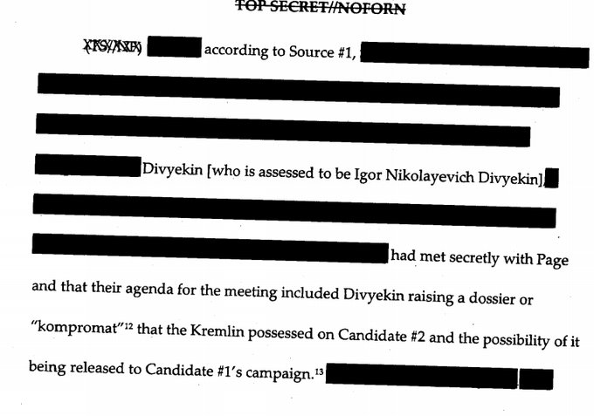

Orin Kerr
✔@OrinKerr

Replying to @OrinKerr
5:14 PM - Jul 21, 2018

110

79 people are talking about this
Twitter Ads info and privacy
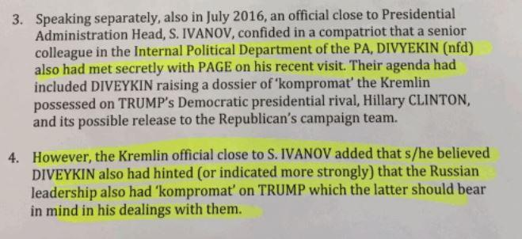
To vouch for Steele himself - a former MI6 agent who the FBI fired after he made inappropriate admissions to the press, the agency wrote the following:
"Not withstanding Source1's reason for conducting the research into Candidate1's ties to Russia, based on Source1's previous reporting history with the FBI, whereby Source1 provided reliable information to the FBI, the FBI believes Source 1s reporting herein to be credible"
The FISA application also says that Steele did not directly provide information to Isikoff, which he in fact did.

Techno Fog@Techno_Fog

· 14h

Replying to @Techno_Fog
The FISA app cites the media's speculation - which was wholly unsubstantiated and based on zero evidence - about why Trump might be friendly to Russia. pic.twitter.com/RD4lJyc07d

Techno Fog@Techno_Fog

FBI/DOJ telling the FISA court that Source 1 (Christopher Steele) did not "directly provide" information to reporter Isikoff.
It turns out that this was 100% false. Steele was the source.
They lied to the FISA court. pic.twitter.com/b0IoOnCNzL
5:53 PM - Jul 21, 2018

The New America Civil War
The U.S. Civil War fought by Lincoln is badly mis-named. Rightly considered it was a war to prevent independence of the South from the united States (not a mistake in capitalization). The South seceded.
Just like the Donbass today fights to fend off a Ukrainian army from eradication of ethnic Russians. Just like the colonists did against King George III.
Argue the legality of secession all you want, ultimately people have the sovereign right to determine the course of their own destiny. Ultimately, they can simply just say, “No.”
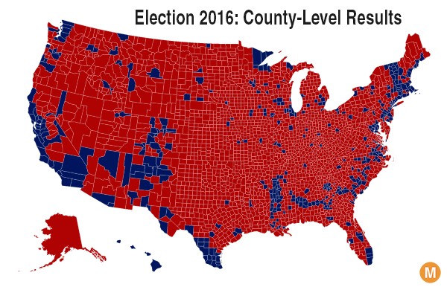
That they choose to abide by some of the legal fictions created around them by their oppressors is irrelevant.
When push comes to that proverbial shove you always have the right to tell some bully to shove it.
A true civil war is one where two factions fight for control of the existing government. It inherently assumes the current geographical arrangement is acceptable.
The two factions disagree about the leadership. And this disagreement in the U.S. is worth trillions to both sides.
Since Donald Trump held his press conference in Helsinki next to Russian President Vladimir Putin the cries of “treason” have been escalating. With each article written and each cable news segment aired, the position of our leaders in government became clear.
“We decide what the function of this government is, not you.”
All Statist arguments boil down to the State saves the savage rabble from themselves. Thus forms the ideological core of this conflict between The People and The Government, but really this is about power.
And The People want theirs back.
The intelligence agencies condemn Trump’s performance at Helsinki because they know this was his moment to strike back. He’d absorbed or deflected most of their outrageous slings and arrows and Helsinki was him pressing his advantage to work for peace with Russia after his initial success with North Korea.
In response the Intelligence Agencies officially declared open war against us and our agent, Donald Trump.
Don’t believe me?
This Reuters piece by CIA mouthpiece Tim Weiner spells it out in the first paragraph.
The foundations of American national security are under assault. The battle lines are drawn. On one side stand the Federal Bureau of Investigation, the Central Intelligence Agency, the National Security Agency. On the other: the commander-in-chief of the United States.
It has that “When in the course of human events…” ring to it, does it not?
Donald Trump’s appalling performance in Helsinki was a subversive act. He rejected the conclusion of American intelligence that his election was aided by a hydra-headed act of political warfare controlled by the Kremlin…
… The display of fealty to Moscow was indelible.
Translation: “Trump is a traitor to the U.S. ”
… But they [the IC] have the power to strike back. For two years now, high-ranking veterans of American intelligence have sounded the alarm about Trump in the starkest language possible.
Translation: “We are the Gatekeepers of Truth. The first line of defense who tried to warn you, the savage rabble.”
Weiner then peddles the pure fiction that the Deep State died with Nixon. And Trump’s “fulminating” about this is proof of both his cowardice and his growing insanity,. He does this while extolling the countless virtues of the thoroughly corrupt and partisan Mueller investigation.
Next step is isolation. Ruth Marcus writing for the CIA-operated WaPo demanded everyone who works for Trump to quit to “save your souls.”
Republicans and Democrats were in full braying mode about how Trump genuflected to a foreign leader. The cable news only stopped long enough to air commercials no one is watching.
Marcus’ piece is pure agitprop to further paralyze Trump’s ability to function as an executive by his staff virtue signaling their fealty to a government a majority of Americans, right, left or libertarian, believe is simply out of control.
When did it become patriotic to genuflect to the CIA?
The ground is being prepared for a 25th Amendment challenge to Trump’s competency or an impeachment hearing after the mid-term elections. And with the stakes this high and the country now in a state of civil war, the ballot boxes will be battlegrounds.
Why?
Because Trump is winning this war against the Deep State. For all of his many faults he is winning more Americans to his side of the ledger. He gathers thousands of troops to rallies across the country while his poll numbers continue to rise, despite the increasingly ineffective barrage of media bombshells thrown his way.
He Tweets rhetorical bombs for the cost of 30 seconds while they spend billions trying to stop him from doing so.
So, the only way to create a “Blue Wave” is to manufacture one. The incentives are there. The radicalized poll workers and Supervisors of Elections are in place. Fully 25% of this country believes these accusations about Trump who believe they are saving themselves from the savage and stupid ‘deplorables’ who elected Trump.
Trump was elected to end the corruption we see around us every day. That corruption infects both the Democrats and their co-conspirators in the GOP. Most of America, in one fashion or another, knows there is something terribly wrong in D.C.
And many are still patriotic enough to see what is happening. Americans love an underdog and Trump is certainly that guy right now.
The response by the unelected gatekeepers of the status quo, the very Deep State that Tim Weiner denies exists, has been to declare open war on them since to the Presser Heard Round the World.
And that is fundamentally un-American.
They are committing the same treason, conspiring with foreign governments to undermine the sitting President, they accuse him of. This is open insurrection that is only tolerated because Trump is still mostly a captured King in his own palace.
D.C. is a lawless land where power for me and not for thee is the rule.
This is a fight to the death between these two factions seeking control over America’s future. The Intelligence Agencies are the vanguard forces of the real power threatened by Trump and Putin colluding to end needless aggravation of U.S./Russian relations.
The media are their shock troops.
Both have been exposed like much of the U.S. military’s weaponry in the past few years to be oriented towards fighting the wrong war.
They perfected the last type of information war but for all of their skill the Overton Window has shifted too far, leaving them exposed.
They fear Trump’s near preternatural understanding of the U.S. media cycle complementing Putin’s logistical and diplomatic superiority forming a bulwark which rebuffs all of their attacks.
But, the real fight begins now. Chuck Schumer warned Trump about going against the CIA. It was obvious then that Schumer outed himself as compromised. His fear of exposure was written all over his face.
Today that warning is real and Trump is surrounded by bears, angry at having disturbed its dreams of global control.

So You Think the Russians Hacked the DNC?
WikiLeaks has published hundreds more files today which it claims show the CIA went to great lengths to disguise its own hacking attacks and point the finger at Russia, China, North Korea and Iran.
The 676 files released today are part of WikiLeaks' Vault 7 tranche of files and they claim to give an insight into the CIA's Marble software, which can forensically disguise viruses, trojans and hacking attacks.
WikiLeaks says the source code suggests Marble has test examples in Chinese, Russian, Korean, Arabic and Farsi (the Iranian language).
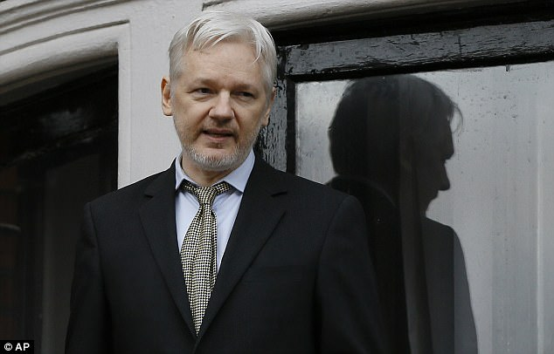
+1

WikiLeaks, founded by Julian Assange (pictured), claims its Vault 7 files come from the CIA's Center for Cyber Intelligence

RELATED ARTICLES
- Previous
- 1
- Next
- 'The president, just for a moment forgot that he was...White House fails to offer ANY evidence of Trump Tower...

SHARE THIS ARTICLE
Share
It says: 'This would permit a forensic attribution double game, for example by pretending that the spoken language of the malware creator was not American English, but Chinese.'
This could lead forensic investigators into wrongly concluding that CIA hacks were carried out by the Kremlin, the Chinese government, Iran, North Korea or Arabic-speaking terror groups such as ISIS.
WikiLeaks, whose founder Julian Assange remains holed up in the Ecuadorean Embassy in London, said Vault 7 was the most comprehensive release of US spying files ever made public.
Earlier this month WikiLeaks published thousands of documents claiming to reveal top CIA hacking secrets, including the agency's ability to infiltrate encrypted apps, break into smart TVs and phones and program self-driving cars.
It also claims the CIA can bypass the encryption of Whatsapp, Signal, Telegram, Wiebo, Confide and Cloakman by hacking the smart phones the applications run on. The CIA was also looking at hacking the vehicle control systems used in modern cars and trucks, WikiLeaks claims.
Wikileaks said the release of confidential documents on the agency already eclipses the total number of pages published over the first three years of the Edward Snowden NSA leaks.
Experts who've started to sift through the material said it appeared legitimate - and that the release was almost certain to shake the CIA.
The truth is that the Clinton Crime Syndicate is doomed. President-elect Donald Trump has promised many times that he will make sure that Hillary Clinton pays for what she’s done and for the harm her crimes have done to this country. However, we’re still waiting for the justice to get to her, and it appears that Trump also waits to get into office and then start taking actions to take criminals down.
However, WikiLeaks aren’t patient anymore. Julian Assange wrote in a letter:
“Hillary Clinton’s crimes will not go unpunished. If she is not formally charged for mishandling sensitive material we will have no choice but to release proof that she is guilty of high treason against the United States for selling patented military secrets to the Saudi Arabian government. We also have proof that she is guilty of crimes against Russia, Uzbekistan, Lithuania, Caledonia and Brazil. The United States would be doing her a favor by putting her in prison and saving her from the severe punishments several of these nations would impose.”
So, this means that Hillary’s imprisonment is imminent, and there will be no way for her to get out of this and escape justice, after all the terrible crimes she’s committed.
WikiLeaks have given Trump a deadline – he has until October 21st to indict traitor Hillary Clinton. If that doesn’t happen till then, they will release undeniable information which will prove her guilt.
We all know that Julian Assange is not someone who is biting off more than he can chew, so there is no doubt that he owns information that will destroy Hillary! So, she is practically doomed, whichever way she turns.
The Human Brain and Sleep
Sleep is not very understood, actually. The idea that the human body spends more energy awake than it can generate is quite evident. We wind down. We get headaches, dizzy, and inattentive. We make mistakes, drift, daydream. We can’t drive, study or even interact with others effectively. Some people need lots of sleep. Some people take more time to sleep than others. It is not so much how much you sleep, but how well you sleep that matters.
The function of sleep has mystified scientists for thousands of years, but modern research is providing new clues about what it does for both the mind and body. Sleep serves to reenergize the body's cells, clear waste from the brain, and support learning and memory. It even plays vital roles in regulating mood, appetite and libido.
Sleeping is an integral part of our life, and as research shows, it is incredibly complex. The brain generates two distinct types of sleep—slow-wave sleep (SWS), known as deep sleep, and rapid eye movement (REM), also called dreaming sleep. Most of the sleeping we do is of the SWS variety, characterized by large, slow brain waves, relaxed muscles and slow, deep breathing, which may help the brain and body to recuperate after a long day.

When we fall asleep, the brain does not merely go offline, as implied by the common phrase “out like a light.” Instead a series of highly orchestrated events puts the brain to sleep in stages. Technically sleep starts in the brain areas that produce SWS. Scientists now have concrete evidence that two groups of cells—the ventrolateral preoptic nucleus in the hypothalamus and the parafacial zone in the brain stem—are involved in prompting SWS. When these cells switch on, it triggers a loss of consciousness.
After SWS, REM sleep begins. This mode is bizarre: a dreamer's brain becomes highly active while the body's muscles are paralyzed, and breathing and heart rate become erratic. The purpose of REM sleep remains a biological mystery, despite our growing understanding of its biochemistry and neurobiology.
We do know that a small group of cells in the brain stem, called the subcoeruleus nucleus, controls REM sleep. When these cells become injured or diseased, people do not experience the muscle paralysis associated with REM sleep, which can lead to REM sleep behavior disorder—a serious condition in which the afflicted violently act out their dreams.
We spend a third of our lives sleeping, an activity as crucial to our health and well-being as eating. But exactly why we need sleep hasn’t always been clear. We know that sleep makes us feel more energized and improves our mood, but what’s really happening in the brain and body when we’re at rest?
Research has identified a number of reasons that sleep is critical to our health. When we’re sleeping, the brain is anything but inactive. In fact, during sleep, neurons in the brain fire nearly as much as they do during waking hours — so it should come as no surprise that what happens during our resting hours is extremely important to a number brain and cognitive functions.
Here are five incredible things your brain does while you’re asleep — and good reason to get some shuteye tonight:
Makes decisions.
The brain can process information and prepare for actions during sleep, effectively making decisions while unconscious, new research has found.
A recent study published in the journal Current Biology found that the brain processes complex stimuli during sleep, and uses this information to make decisions while awake. The researchers asked participants to categorize spoken words that were separated into different categories — words referring to animals or objects; and real words vs. fake words — and asked to indicate the category of the word they heard by pressing right or left buttons. When the task become automatic, the subjects were asked to continue but also told that they could fall asleep (they were lying in a dark room). When the subjects were asleep, the researchers began introducing new words from the same categories. Brain monitoring devices showed that even when the subjects were sleeping, their brains continued to prepare the motor function to create right and left responses based on the meaning of the words they heard.
When the participants woke up, however, they had no recollection of the words they heard.
“Not only did they process complex information while being completely asleep, but they did it unconsciously,” researchers Thomas Andrillon and Sid Kouider write in the Washington Post. “Our work sheds new light about the brain’s ability to process information while asleep but also while being unconscious.”
Creates and consolidates memories.
While you’re asleep, the brain is busy forming new memories, consolidating older ones, and linking more recent with earlier memories, during both REM and non-REM sleep. Lack of rest could have a significant affect the hippocampus, an area of the brain involved in memory creation and consolidation. Some people have learned how to catalog and file thought. Relationships between math and music, emotion and creativity, and even the integration of two souls into one whole being can be accomplished. We probably learn how to love in our sleep.
For this reason, sleep plays a very important role in learning — it helps us to cement the new information we’re taking in for better later recall.
“We’ve learned that sleep before learning helps prepare your brain for initial formation of memories,” Dr. Matthew Walker, a University of California, Berkeley sleep researcher, tells the National Institutes of Health. “And then, sleep after learning is essential to help save and cement that new information into the architecture of the brain, meaning that you’re less likely to forget it.”
Think twice before pulling an all-nighter to study for your next exam: If you don’t sleep, your ability to learn new information could drop by up to 40 percent, Walker estimates.
Makes creative connections.
Sleep can be a powerful creativity-booster, as the mind in an unconscious resting state can make surprising new connections that it perhaps wouldn’t have made in a waking state.
A 2007 University of California at Berkeley study found that sleep can foster “remote associates,” or unusual connections, in the brain — which could lead to a major “a-ha” moment upon waking. Upon waking from sleep, people are 33 percent more likely to make connections between seemingly distantly related ideas.
Clears out toxins.
A series of 2013 studies found that an important function of sleep may be to give the brain a chance to do a little housekeeping.
Researchers at the University of Rochester found that during sleep, the brains of mice clear out damaging molecules associated with neurodegeneration. The space between brain cells actually increased while the mice were unconscious, allowing the brain to flush out the toxic molecules that built up during waking hours.
“We need sleep,” Dr. Nedergaard, the study’s lead researcher, told the National Institutes of Health. “It cleans up the brain.”
If we’re not getting enough sleep, our brains don’t have adequate time to clear out toxins, which could potentially have the effect of accelerating neurodegenerative diseases like Parkinson’s and Alzheimer’s.
Learns and remembers how to perform physical tasks.
The brain stores information into long-term memory through something known as sleep spindles, short bursts of brain waves at strong frequencies that occur during REM sleep.
This process can be particularly helpful for storing information related to motor tasks, like driving, swinging a tennis racquet or practicing a new dance move, so that these tasks become automatic. What happens during REM sleep is that the brain transfers short-term memories stored in the motor cortex to the temporal lobe, where they become long-term memories.
Reading before you sleep could relax you significantly. A study highlighted in the Telegraph by the University of Sussex raised a number of participants stress levels and then attempted to reduce them. Cognitive Neuropsychologist Dr David Lewis found that ‘reading worked best, reducing stress levels by 68 percent’. It was better than listening to music (61%), drinking tea or coffee (54%) and taking a walk (42%). It only took 6 minutes for participants’ stress levels to be reduced.

This is because, when reading a good book, your mind is distracted from daily stresses and worries that causes tension. Stories give your mind the option to be somewhere else for a little while. This means you can leave your own troubles behind. Reading also allows your muscles to relax and slows down your breathing, leaving you feeling calmer.

reading in bed

So how does this affect your sleep? The Sleep Council say ‘39% of people who are in the habit of reading before they go to sleep, sleep very well’. It makes perfect sense that an activity that reduces stress is beneficial before bed. Reading is also a better alternative to watching TV or scrolling through your phone. These emit blue light which tricks your brain into thinking it’s daytime. This is why 49% of Brits prefer to read a book than watch TV before bed and couldn’t go to sleep without a chapter of their current book.

Related: Sleep Relaxation Techniques to Beat the Monday Blues

Brain power
As well as opening your eyes to a million other worlds, reading can boost your brain power. Your brain is a muscle too, and just like the rest of the body, it needs a work out to keep it healthy. Reading is more neurologically challenging than speaking or processing images. Ken Hugh, PhD, president and director of research at Haskins Laboratories says ‘parts of the brain that have evolved for other functions—such as vision, language, and associative learning—connect in a specific neural circuit for reading, which is very challenging’. This means that reading is a great way to work out your brain while doing something enjoyable simultaneously.

Another amazing benefit of reading is that it can reduce the risk of developing the degenerative disease, Alzheimer’s. A study found that people who engage their brains in activity such as reading, solving puzzles or playing chess are 2.5 times less likely to develop the illness. This is likely due to the fact that Alzheimer’s disease is often linked to patients who have a limited brain activity. Reading could not only improve your well-being now but could also have a lasting effect on your health in years to come.

woman reading on bed

Improves creativity
It’s no surprise that reading from a creative stimulus increases your own creativity. By reading books you are able to see things from different perspectives which broadens your mind. Emeritus Professor at the University of Toronto, Keith E. Stanovich is a leading researcher in the psychology of reading. He told MSN, ‘Certainly, our data demonstrate time and again that print exposure is associated with vocabulary, general knowledge, and verbal skills even after controlling for abstract reasoning abilities’. We can see an improvement in all of these things ourselves just by reading books. Reading to children is extremely important also, so the benefits of bedtime stories can impact them hugely. Children are exposed to 50% more words from books than they would be from TV. Reading to your child is the perfect way to enhance their vocabulary without it feeling like a lesson.
Reading can also make you a more empathetic person. Empathy is the ability to understand and share the feelings of another. What better way to improve that skill than by reading from someone else’s point of view? In books, we see the world through someone else’s eyes and feel their feelings with them. Applying this skill in real life is a lot easier when we’ve had the practice. Reading not only boosts our intelligence but also makes us more understanding of other people. So, what are you waiting for? Get reading

One of the most valuable things you can do for your children is to read to them before they go to bed. The more you do this, the brighter and more creative your children will become.
Whether a story is funny, sad, scary or strange, they give children food for thought. When we do it at bedtime, we also give our children the strong message that we care for them. At the moment of ‘detachment’ (saying ‘goodnight’) we are saying that we are ‘attached’ (we’re there for them).
Of course, another way of thinking about all this is that it’s all darned good fun. Some of the best times you’ll ever have – whether that’s as a parent, grandparent, older sibling or parent – is sharing a story at bedtime. And, from the child’s point of view, as that child grows up, it’ll be one of the most beautiful memories you’ll ever have of those people who took the time to share stories with you. To this day, I have friends read to me while I am on the phone with them. Now, I have often fallen asleep, so I don’t do it too much while driving anymore. I can travel to distant places and times within minutes of when the reading starts. The more storylike the reading, the quicker I go out there.
It can be very effective at relieving stress, healing, and forming a lasting bond between two people. I have read all my books for you. All you have to do is listen, and I promise you will love the ride.

