PHA Headlines
On August 01, the director of the Nuclear Information Project for the Federation of American Scientists, Hans Kristensen, tweeted: “Meteor explodes with 2.1 kilotons force 43 km (26 miles) above missile early warning radar at Thule Air Base.”
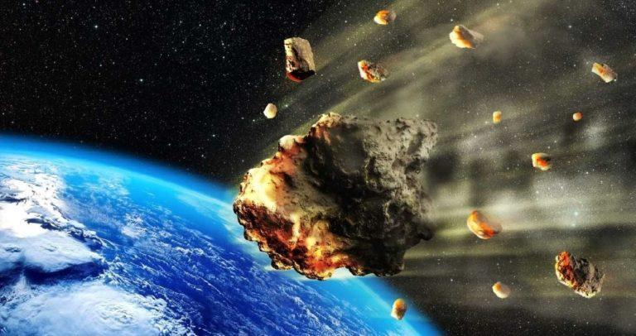
Kristensen quoted a tweet that originated from “Rocket Ron” (@RonBaalke), whose profile allegedly indicates he is a scientist at the Jet Propulsion Laboratory, a federally funded research and development center and NASA field center in La Cañada Flintridge, California. The original tweet on July 31 said: ” A fireball was detected over Greenland on July 25, 2018 by US Government sensors at an altitude of 43.3 km (43 miles). The energy from the explosion is estimated to be 2.1 kilotons.”
View image on Twitter
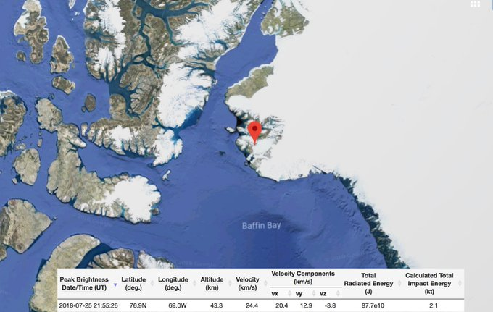

Hans Kristensen
✔@nukestrat

Meteor explodes with 2.1 kilotons force 43 km above missile early warning radar at Thule Air Base. https://twitter.com/RonBaalke/status/1024371681106620416 …
HT @Casillic
We’re still here, so they correctly concluded it was not a Russian first strike. There are nearly 2,000 nukes on alert, ready to launch.

Rocket Ron @RonBaalke
A fireball was detected over Greenland on July 25, 2018 by US Government sensors at an altitude of 43.3 km. The energy from the explosion is estimated to be 2.1 kilotons.

4:14 PM - Aug 1, 2018

1,329

1,468 people are talking about this
Twitter Ads info and privacy
Data from NASA’s Jet Propulsion Laboratory shows reported fireball events for which geographic locations are provided. Each event’s calculated total impact energy is indicated by its relative size and by color. The record shows a meteor traveling at 24.4 kilometers per second (54,000 mph) at 76.9 degrees north latitude, 69.0 degrees west longitude, on July 25 at 11:55 p.m, slammed into the atmosphere directly over Thule, Greenland.
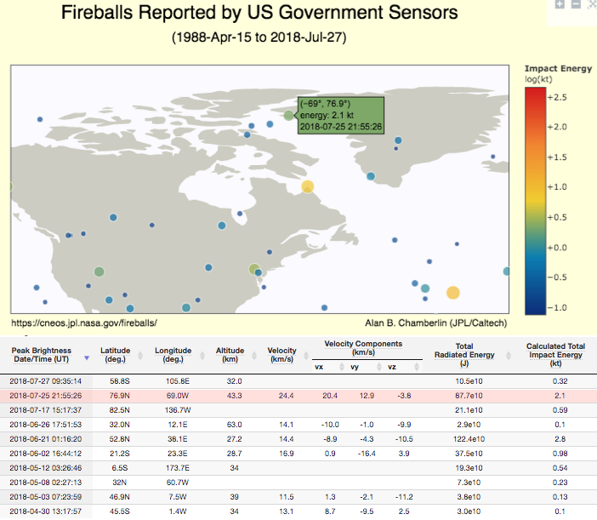
According to the Military Times, the meteor “struck…miles from a key U.S. early warning air base,” which is home to the 12th Space Warning Squadron based at Thule, that operates and maintains the Air Base in support of missile warning, space surveillance, and satellite command-and-control operations missions. Thule is located 1,207 km (750 miles) north of the Arctic Circle and 1,524 km (947 miles) from the North Pole on the northwest side of the island of Greenland.
UHF Phased Array Radar at Thule Air Base (Source/ Air Force)
The story was first reported by Australian media, then blasted across America via Fox News on Friday. The article’s title read “Air Force remains silent after huge meteor hits near US military base,” which generated tremendous buzz on social media and triggered a swarm of journalist contacting the Air Base about the matter.
“No, we don’t have any reports of damage, why are we getting calls on this now?” said Steve Brady, a spokesman at Peterson Air Force Base in Colorado, which handles Thule’s media queries, even though Thule is located in Greenland.
The Aviationist’s Tom Demerly, who reported on the mystery meteor, wrote in an analysis that it is disturbing because there was no public warning from the U.S. government about the meteor impact. “Had it entered at a more perpendicular angle, it would have struck the earth with significantly greater force,” he wrote.
As to “significantly greater force,” well, Demerly does not specifically define what that means as far as kilotons. However, the 2013 Chelyabinsk meteor incident (below) provides the very real understanding of the destructive nature of these space objects. We ask just one question: Why did the US government initially fail to alert citizens of Greenland and the US of an incoming meteor that could have potentially been very dangerous?
* * *
The Chelyabinsk meteor entered Earth’s atmosphere over Russia on February 2013, with a speed of 19 kilometers per second (42,500 mph). It quickly became a dazzling superbolide meteor over the southern Ural region. The bulk of the meteor’s energy was absorbed by the atmosphere, with total kinetic energy before atmospheric impact estimated from infrasound and seismic measurements to be equivalent to the blast yield of 400–500 kilotons or roughly 26 to 33 times as much energy as that released from the atomic bomb detonated at Hiroshima.

The War Against Black People

Induced abortion is the leading cause of death in the United States and accounts for a disturbing 61 percent of deaths of African Americans, according to researchers from the University of North Carolina at Charlotte.
A report Thursday analyzed research using data from the latest year for which all the pertinent information is available (2009) and found that induced abortion was responsible for 1.152 million deaths, making it the number one cause of death in the U.S. at nearly twice the number of deaths from heart disease (599,413) and cancer (567,628).
While abortion accounted for nearly a third of all U.S. deaths in 2009 (32.1 percent), more troubling still, it made up 61.1 percent of African American deaths, according to the study published in the Open Journal of Preventive Medicine (June 2016).
The ongoing disparity of black deaths through abortion has led one leading black pastor to recently decry the “black genocide” taking place in the United States at the hands of the abortion industry.
In his July essay, the Rev. Clenard Childress, Jr. noted that 52 percent of all African American pregnancies end in abortion and that whereas abortion is the most common operation performed on women, it is also “the least regulated medical procedure” and is often “completely ignored by health regulation enforcement.”
Statistics reveal that nearly 1,800 unborn black babies are aborted every day, proportionately more than any other race, Rev. Childress observed.
According to the Centers for Disease Control (CDC), between 2007 and 2010, more than 35 percent of the deaths by abortion in the United States happened to black babies, despite the fact that blacks represent only 12.8 percent of the population. Conversely, non-Hispanic whites, who make up 63.7% of America’s population, account for only 37.7% of all U.S. abortions.
Whatever the intent of abortion practitioners, by functional standards, abortion is a racist institution in the United States, with black children aborted at nearly four times the rate of white children.
Among white women, there are 138 abortions for every 1000 live births; among blacks, there are 501 abortions for every 1000 births. This means that blacks are aborted at 3.6 times the rate of whites.
Carried over to a global context, the figures are equally worrisome, with abortion accounting for more deaths than any other cause.
As of August 4, 2018, there have been nearly 25 million abortions performed worldwide so far this year, while less than a million people have died from road accident fatalities, 4.8 million from cancer, and 990,000 from HIV/AIDS, according to the best available data.
In their study, the UNC-Charlotte researchers, James Studnicki, Sharon J. MacKinnon, and John W. Fisher, lamented the fact that despite the overwhelming weight of data and the universal acknowledgement that the act of abortion results in a human death, abortion is often not reported as a cause of death in the vital statistics system in the United States, an omission stemming from ideology rather than science.
“The exclusion of a major cause of death,” they noted, “especially one with large racial and ethnic disparities, should be a major concern to the scientific community and society as a whole.”
“As a cause of death, the major one for Hispanics and African Americans,” said Dr. Studnicki, the lead researcher, “abortion would be at the top of the scientific agenda in the U.S., and with a funding priority consistent with its importance.”
Democrats Plan to Sacrifice ANTIFA to start a War
Along the trolley tracks behind the U.S. Immigration and Customs Enforcement field office, a biohazard cleanup crew works under police protection. It finds used needles and buckets of human waste simmering in nearly 100-degree heat. The smell of urine and feces fills the block. For more than five weeks, as many as 200 people had occupied the site to demand ICE’s immediate abolition. They’re gone now, but a community is left reeling. Thirty-eight days of government-sanctioned anarchy will do that.
A mob surrounded ICE’s office in Southwest Portland June 19. They barricaded the exits and blocked the driveway. They sent “guards” to patrol the doors, trapping workers inside. At night they laid on the street, stopping traffic at a critical junction near a hospital. Police stayed away. “At this time I am denying your request for additional resources,” the Portland Police Bureau’s deputy chief, Robert Day, wrote to federal officers pleading for help. Hours later, the remaining ICE workers were finally evacuated by a small federal police team. The facility shut down for more than a week.
Signs called ICE employees “Nazis” and “white supremacists.” Others accused them of running a “concentration camp,” and demanded open borders and prosecution of ICE agents. Along a wall, vandals wrote the names of ICE staff, encouraging others to publish their private information online.
Federal workers were defenseless. An ICE officer, who asked that his name not be published, told me one of his colleagues was trailed in a car and confronted when he went to pick up his daughter from summer camp. Later people showed up at his house. Another had his name and photo plastered on flyers outside his home accusing him of being part of the “Gestapo.”
Where were the police? Ordered away by Democratic Mayor Ted Wheeler, who doubles as police commissioner. “I do not want the @PortlandPolice to be engaged or sucked into a conflict, particularly from a federal agency that I believe is on the wrong track,” he tweeted. “If [ICE is] looking for a bailout from this mayor, they are looking in the wrong place.”
The mob set up camp behind the building, where they harassed journalists and banned photography. The open-borders advocates also erected an 8-foot wall around their site. I walked through and saw young children, including infants, in squalid conditions and 90-degree heat. Every American flag was defaced. Anarchist and communist flags were unsoiled.
Stuart Lindquist, the ICE facility’s 79-year-old landlord, visited his property on June 21. “The political powers in the city of Portland have stopped the police from doing what they normally would do,” he told me. When he attempted to drive into the parking lot, occupiers swarmed and pounded his windows. In the commotion, Mr. Lindquist’s car struck someone in the mob, who wasn’t injured. His home address later appeared online, and he says the harassment hasn’t stopped.
On June 28 federal police mobilized from out of state finally moved to reopen the office. They arrested a handful of people for refusing to leave the ICE office’s front, but the rest retreated to the camp and focused their vitriol on the officers. They repeatedly called a black officer “traitor” and “house n—.” They shouted that they knew where the officers lived, and published more addresses online.
The same day Mayor Wheeler again pledged not to intervene. In a statement, he whitewashed the lawless behavior: “I join those outraged by ICE actions separating parents from their children, and support peaceful protest to give voice to our collective moral conscience.”
The Hakes family, which owns the Happy Camper food cart across the street from ICE’s office, responded to the statement with incredulity. The mob “terrorized our family” and forced the business to close, Julie Hakes told me. Ms. Hakes showed me text messages from her 21-year-old daughter, Brianna, who ran the cart. “Just saw a drug deal,” Brianna reported early on. After members of the anti-ICE mob spotted her selling breakfast burritos to federal officers, the situation deteriorated. “Call me immediately!” Brianna wrote after being accused of “supporting the pigs” and “child deportation.” She said people wearing masks threatened to hurt her and burn down the cart, and the police never responded to their frantic calls.
Randy Glary, a 52-year-old artist and longtime resident, was photographing the camp when he said a group of occupiers knocked his camera into his face. Charles Williams, a 62-year-old man who lives across the street, said someone threatened to stab him with an “AIDS-infected needle.” From his balcony, he saw the “thugs” begin masked street patrols. Others brandished sticks. Lisa Leonard, a 53-year-old disabled resident, said occupiers hit her on her head, disabled her electric wheelchair, and lifted her in the air when she complained about loud drumming. She called police, who took a statement but made no arrests.
The locals who spoke to me all wondered why the city allowed this and ignored their calls for intervention. Peter Simpson, a public-information officer with the Portland Police Bureau, explained that “at the mayor’s direction, PPB involvement was very limited” until July 25.
Back at the trolley tracks, the occupiers have been evicted but taxpayers will have to foot the costly cleanup bill. The Hakes family is still trying to recover. Brianna has decided to move out of the neighborhood. “They know my face and car,” she said. Like other residents I spoke to, she expects the mob to return
Along the trolley tracks behind the U.S. Immigration and Customs Enforcement field office, a biohazard cleanup crew works under police protection. It finds used needles and buckets of human waste simmering in nearly 100-degree heat. The smell of urine and feces fills the block. For more than five weeks, as many as 200 people had occupied the site to demand ICE’s immediate abolition. They’re gone now, but a community is left reeling. Thirty-eight days of government-sanctioned anarchy will do that.
A mob surrounded ICE’s office in Southwest Portland June 19. They barricaded the exits and blocked the driveway. They sent “guards” to patrol the doors, trapping workers inside. At night they laid on the street, stopping traffic at a critical junction near a hospital. Police stayed away. “At this time I am denying your request for additional resources,” the Portland Police Bureau’s deputy chief, Robert Day, wrote to federal officers pleading for help. Hours later, the remaining ICE workers were finally evacuated by a small federal police team. The facility shut down for more than a week.
Signs called ICE employees “Nazis” and “white supremacists.” Others accused them of running a “concentration camp,” and demanded open borders and prosecution of ICE agents. Along a wall, vandals wrote the names of ICE staff, encouraging others to publish their private information online.
Federal workers were defenseless. An ICE officer, who asked that his name not be published, told me one of his colleagues was trailed in a car and confronted when he went to pick up his daughter from summer camp. Later people showed up at his house. Another had his name and photo plastered on flyers outside his home accusing him of being part of the “Gestapo.”
Where were the police? Ordered away by Democratic Mayor Ted Wheeler, who doubles as police commissioner. “I do not want the @PortlandPolice to be engaged or sucked into a conflict, particularly from a federal agency that I believe is on the wrong track,” he tweeted. “If [ICE is] looking for a bailout from this mayor, they are looking in the wrong place.”
The mob set up camp behind the building, where they harassed journalists and banned photography. The open-borders advocates also erected an 8-foot wall around their site. I walked through and saw young children, including infants, in squalid conditions and 90-degree heat. Every American flag was defaced. Anarchist and communist flags were unsoiled.
Stuart Lindquist, the ICE facility’s 79-year-old landlord, visited his property on June 21. “The political powers in the city of Portland have stopped the police from doing what they normally would do,” he told me. When he attempted to drive into the parking lot, occupiers swarmed and pounded his windows. In the commotion, Mr. Lindquist’s car struck someone in the mob, who wasn’t injured. His home address later appeared online, and he says the harassment hasn’t stopped.
On June 28 federal police mobilized from out of state finally moved to reopen the office. They arrested a handful of people for refusing to leave the ICE office’s front, but the rest retreated to the camp and focused their vitriol on the officers. They repeatedly called a black officer “traitor” and “house n—.” They shouted that they knew where the officers lived, and published more addresses online.
The same day Mayor Wheeler again pledged not to intervene. In a statement, he whitewashed the lawless behavior: “I join those outraged by ICE actions separating parents from their children, and support peaceful protest to give voice to our collective moral conscience.”
The Hakes family, which owns the Happy Camper food cart across the street from ICE’s office, responded to the statement with incredulity. The mob “terrorized our family” and forced the business to close, Julie Hakes told me. Ms. Hakes showed me text messages from her 21-year-old daughter, Brianna, who ran the cart. “Just saw a drug deal,” Brianna reported early on. After members of the anti-ICE mob spotted her selling breakfast burritos to federal officers, the situation deteriorated. “Call me immediately!” Brianna wrote after being accused of “supporting the pigs” and “child deportation.” She said people wearing masks threatened to hurt her and burn down the cart, and the police never responded to their frantic calls.
Randy Glary, a 52-year-old artist and longtime resident, was photographing the camp when he said a group of occupiers knocked his camera into his face. Charles Williams, a 62-year-old man who lives across the street, said someone threatened to stab him with an “AIDS-infected needle.” From his balcony, he saw the “thugs” begin masked street patrols. Others brandished sticks. Lisa Leonard, a 53-year-old disabled resident, said occupiers hit her on her head, disabled her electric wheelchair, and lifted her in the air when she complained about loud drumming. She called police, who took a statement but made no arrests.
The locals who spoke to me all wondered why the city allowed this and ignored their calls for intervention. Peter Simpson, a public-information officer with the Portland Police Bureau, explained that “at the mayor’s direction, PPB involvement was very limited” until July 25.
Back at the trolley tracks, the occupiers have been evicted but taxpayers will have to foot the costly cleanup bill. The Hakes family is still trying to recover. Brianna has decided to move out of the neighborhood. “They know my face and car,” she said. Like other residents I spoke to, she expects the mob to return
ISIS Calls for BioWarfare in San Francisco
This too will be ignored by the complicit, sharia-compliant Western press. A biological attack is the intentional release of a pathogen (disease causing agent) or biotoxin (poisonous substance produced by a living organism) against humans, plants, or animals. An attack against people could be used to cause illness, death, fear, societal disruption, and economic damage.
EXCLUSIVE: Pro-ISIS Media Outlet Publishes Posters Calling For Biological Attacks In The West, One Of Which Depicts San Francisco
Over the past week, a pro-Islamic State (ISIS) media group has published a series of posters encouraging biological attacks on Western targets.
Excerpt from the transcript (MEMRI):

PRO-ISIS MEDIA OUTLET CIRCULATES VIDEO CALLING FOR BIOLOGICAL ATTACKS IN THE WEST
This transcript was prepared from the original English subtitles of the video
Narrator: “While the world is watching silently! The European governments are developing satanic chemical attack systems to be brutally tested on the cities and peoples, which refused humiliation and humiliation so the Muslim countries in Africa and Khorsan turned into testing fields of phosphorus bombs and toxic gas. The crusader alliance continues bombing Mosul, Raqqa, Al-Anbar and others… with various types of chemical bombs and incendiary gases. And similar to the enemies of God! We invite you, oh Muwahid [monotheist] who lives between the Mushrikeen[idolaters] that you clean the dust of humiliation and to renew the fatal nightmare in the land of the devil worshipers with a silent destructive weapon. It can not be detected or tracked it can not be escaped or avoided with simple equipment, extract the most harmful viruses and infection bacteria then release them safely by following these simple steps: First, try to find the most severe epidemics to treat.”
On Screen: “Hantavirus, derived from the feces and droppings of rats that carry the plague of the most serious plague at the moment. The Cholera virus is extracted from the patient’s waste. Typhoid bacteria, found in human and animal wastes in general and frequent in the dirty areas.”
Narrator: “Second, spread the bacteria extracted by type as follows.”
On Screen: “Sprinkle the liquid substances or the basics of bacteria with drinking water to take effect automatically. Sprinkle the crushed material on exposed fruit and public foods or scatter them in the air in crowded places – with caution.”
Narrator: “Third, try to be safe and avoid any danger that may affect you during the preparation of harmful substances.”
On Screen: “Work in a room with natural and industrial ventilation. Wear gloves and blouses during work. Put the goggles and goggles – according to chemical process requirements. Do not touch or inhale the materials. Isolating the workplace from the rest of the house. Wash your hands with sterile soap and water after each test.”
Off-Screen Voice: “To our brothers in Aqidah [creed] and Iman [faith] in Europe, America, Russia, Australia, and elsewhere, your brothers in your lands have absolved themselves of blame so leap onto their tracks and take an example from their actions and know that Jannah [paradise] is beneath the shadows of swords.”

Trump Prophet Banned by Facebook
“The Trump Prophecy,” a film based on the real-life story of a fireman who says he received supernatural messages in 2011 that Donald Trump would become president, is set to be released in 1,200 theaters beginning Oct. 2, but the project has already run afoul of Facebook algorithms that have blocked ads from the production company based on the “political” content.
The film is the latest movie project by students at Liberty University’s film department, which has created five independent, full-length feature films in the past six years – all of which received wide distribution and national recognition as faith-based projects.
But the latest effort is already drawing greater attention – and controversy – than its predecessors.
The producer of “The Trump Prophecy,” says Facebook has “almost been abusive” in seeking information from the production company, which was just trying to place an ad on the site. Rick Eldridge, the producer and financier from ReelWorks Studios, says Facebook is blocking ads from the production, which is a partnership between ReelWorks Studios and private Christian school Liberty University’s cinema department, alleging it is too “political.”
“The name ‘Trump’ requires a reaction,” Eldridge said. “Unfortunately, people try to come up with a conclusion before they know what the story is about. We’re not doing political ads, but that’s what we’re being accused [of].”
Error loading playlist: Playlist load error: Error loading file
Eldridge said the movie does include reflections from several different world leaders answering questions about what it means to “make America great again” and what the current administration means for Israel and world peace. When producers tried to appeal the ban of their ads, Facebook responded by saying “the text and/or imagery you’re using qualifies as political, based on the definition we’re using for enforcement.”
“I know issues with Trump are often charged, but if you watch the movie, it’s not really about Trump as much as the events that occurred leading up to the election,” said Stephan Schultze, the film’s director and head of the cinematic arts department at Liberty, the nation’s largest university.
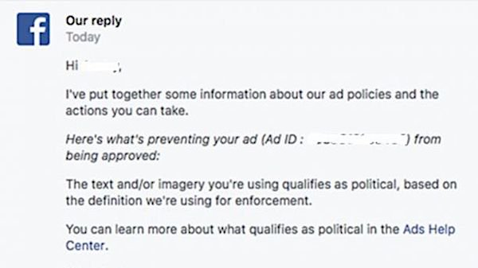
Unlike the book it is based on, “The Trump Prophecies,” which gathers the accounts of retired firefighter Mark Taylor and Mary Colbert talking about messages they received, Eldridge said the movie only focuses on one prophecy from Taylor – that Trump would become president and impact the relationship between America and Israel.
Some of the more controversial claims Taylor has made, not included in the movie, are that former President Barack Obama will be charged with treason and that Trump will release cures for cancer and Alzheimer’s disease kept secret by the pharmaceutical industry.
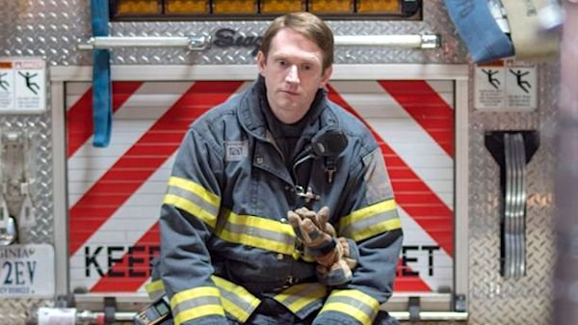
“The Trump Prophecy” centers on the story of firefighter Mark Taylor (courtesy Reelworks)
The film’s producers see it as an uplifting faith movie rather than political.
“We think it’s going to help unite this world, but that’s a message Facebook doesn’t want us to tell,” said Eldridge, who has also produced “Four Blood Moons” and “The Ultimate Gift.”
According to Schultze, 63 students, in addition to some faculty members at Liberty gained “real life, real hands on experience” working on the film. The class runs like a real production, he said. Each student has two roles, as they help with every aspect of the film.
Liberty’s state-of-the-art facilities were part of the reason Eldridge was excited to partner with the Christian school.
“We didn’t debate religion,” said Eldridge. “We didn’t debate politics. We just told a story, and everybody had a good time with it.”
Eldridge said he hopes the film gives people a better understanding of what to pray for based on the Bible verse 2 Chronicles 7:14: “If my people, which are called by my name, shall humble themselves, and pray, and seek my face, and turn from their wicked ways; then will I hear from heaven, and will forgive their sin, and will heal their land.”
“I think the story is really at its core about prayer and it’s about calling our nation to prayer,” he said. “We are a divided nation in a lot of ways, but when you look at leadership … when you look at it from a biblical perspective, we are called to pray for our leaders … whoever is in authority over us.”
The university’s cinema program pits eager amateurs against seasoned professionals in a growing niche market that was long underserved and occasionally mocked by Hollywood. Over the past decade, faith-based films such as “Heaven Is for Real” and “God’s Not Dead” have made an impact at the box office, reaping millions of dollars in ticket sales from their modest budgets.
Founded in 1971 by the Rev. Jerry Falwell, Liberty University was set up as an alternative education facility on the front lines of a moral revival, which some faith-based films reflect.
Schultze said the university’s hometown of Lynchburg – sandwiched between Appomattox and the Blue Ridge Mountains – has joined filmmaking locations such as Atlanta, Louisiana, Kentucky and the Carolinas to challenge the industry dominance of Hollywood, which is taking note of the religious genre.
“Every one of the studios now has a faith-based division in it,” he said. “If the culture shifts, they’ll make movies that adapt to the culture.”
A film crew on the set of “The Trump Prophecy” (courtesy Reelworks)
Schultze proudly noted that his program’s most recent project, “Extraordinary,” was the first student-driven film to be released nationally in the U.S.
“If they were still making ‘Lord of the Rings,’ our students could walk onto that set and go to work,” he said, adding that his students operate professional-grade cinema equipment while honoring God. “There’s going to be a lot more students that feel comfortable having a voice and their worldview expressed publicly,” the cinema teacher said. “It’s full immersion. They get here in the morning, and they work till night.”
The cinema-arts program is 6 years old and graduates about 60 students a year. Each student creates a short film and earns at least one credit on the Internet Movie Database. Alumni have worked on projects such as “Indivisible,” a film about an Army chaplain experiencing a crisis in faith. It stars Justin Bruening of ABC’s “Grey’s Anatomy” and opens Oct. 26.
With “The Trump Prophecy” debuting the same month, the cinema program is testing the waters to produce a television series on campus, said Schultze.
Good Guy with a Gun Report
An armed bystander licensed to carry a firearm shot a gunman who opened fire at a back-to-school event at a Titusville park, reports local ABC affiliate WFTV9.
The shooting occurred at Isaac Campbell Park on South Street shortly after 5:20 p.m. when the shooter, whom police have not identified, returned to the park after a fistfight and began firing.
A bystander licensed to a carry a firearm then shot the shooter, who was flown to a nearby hospital with life-threatening injuries, police said. -WFTV9
(full video here, shooting at 7:50)
The bystander who shot the gunman has been fully cooperative with the investigation, according to local police. “We are extremely grateful that nobody else was injured in this incident,” said Deputy Chief Todd Hutchinson. “This suspect opened fire at a crowded public park, this could have been so much worse."
View image on Twitter

Titusville Police FL@TitusvillePD

Isaac Campbell Park shooting scene secure. One male victim airlifted to local hospital with life-threatening injuries. Titusville Police Detectives on scene conducting ongoing active investigation.
5:33 PM - Aug 4, 2018

5

See Titusville Police FL's other Tweets
Twitter Ads info and privacy
A flyer posted on Facebook and Instagram said a back to school event called "Peace in the City" was going on at the park when the shooting happened. -WFTV9
While we expect 2nd Amendment advocates will point to this incident as a "good guy with a gun" taking down a "bad guy with a gun," gun control activists are likely to pretend it never happened - or that local police would have intervened.
After all, when seconds count, the police are just minutes away!
Maduro Assassination Attempts, or Show and Tell
Speaking on state TV a day after the alleged assassination attempt on Maduro, Interior Minister Nestor Reverol said that six people have been taken into custody and more arrests are possible in the coming hours. He also said that two drones carrying 1 kg each of C-4 explosive were "disoriented" by govt. signal blockers.
He added that the government has raided several Caracas hotels in search for evidence, and noted that one suspect linked to a 2017 attack on Carabobo military base, another to last year’s anti-government protests.
Meanwhile speculation that this was just another false flag attack to build popular support for Maduro's crumbling regime, continues to grow.
* * *
Was it a gas cylinder explosion? An assassination plot of US-allied groups? Or possibly the unheard of “National Movement of Soldiers in T-shirts” that are now claiming responsibility?
And where are the remnants or debris parts to any drones that may have been exploded, or possibly even live iPhone footage (though iPhones have been hard to come by in socialist Venezuela over the years) of drones overhead shot by any one of what appears to have been tens of thousands attending the event?
It seems the more details that come out surrounding the apparent drone assassination attempt of Venezuelan President Nicolas Maduro on Saturday afternoon, the stranger and more ambiguous it gets in terms of exactly what happened and who is responsible.
For starters on Sunday morning US National Security Adviser John Bolton addressed charges of potential American involvement head on, telling Fox News Sunday host Chris Wallace, "I can say unequivocally there was no U.S. government involvement in this at all".

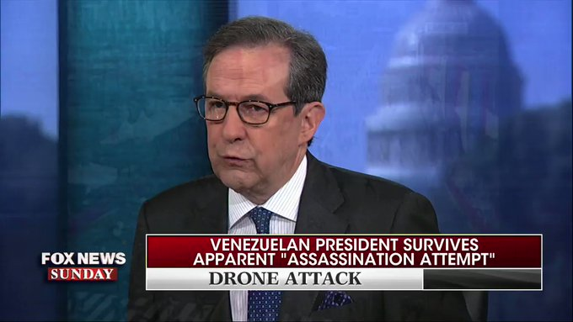

FoxNewsSunday
✔@FoxNewsSunday

.@AmbJohnBolton on the apparent "assassination attempt" on Venezuelan President Nicolás Maduro: “There was no U.S. government involvement in this at all."
8:24 AM - Aug 5, 2018

59

74 people are talking about this
Twitter Ads info and privacy
This followed a speech by Maduro in what was his first formal statement since the incident wherein the controversial left-wing Venezuelan president described, “They tried to assassinate me today," while blaming the attack on right-wing factions specifically connected to Columbia and Florida.
He claimed that "several of those intellectually responsible and the financiers of this attack live in the United States, in the state of Florida," and called on U.S. President Donald Trump to "fight these terrorist groups".
Maduro further related that one drone exploded in front him, with seconds later another blast detonating to his right. “That drone was coming for me but there was a shield of love,”Maduro said.
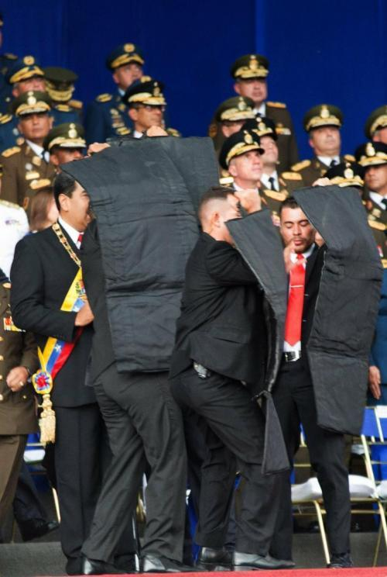
Indeed a live feed showing Maduro speaking at a large army commemoration event in the capital of Caracas was cut off mid-speech as explosions were heard, and body guards immediately shielded the president with bullet proof coverings, after which soldiers can be seen running in disarray before the transmission ends.
Neither President Maduro nor his wife or government ministers sharing the stage with them were reported injured, and they express what appears to be genuine shock and fear when the blasts went off.
Photographs depicted at least one possibly seriously wounded soldier with blood running down his face, and Venezuelan state sources reported that a total of seven National Guard soldiers were injured.

Alberto Rodríguez
✔@AlbertoRodNews

ÚLTIMA HORA | VIDEO - Situación irregular en la avenida Bolívar de Caracas durante Cadena Nacional de Maduro en acto con la GNB.
VTV cortó de emergencia la transmisión oficial.
5:00 PM - Aug 4, 2018

7,053

11.5K people are talking about this
Twitter Ads info and privacy
John Bolton's denial of US involvement came in response to Maduro's prior accusation, and unverifiable claims of suspects in Venezuelan state custody according to Reuters:
Maduro said “everything points” to a right-wing plot that initial investigation suggested was linked to Colombia and the U.S. state of Florida, where many Venezuelan exiles live. Several perpetrators were caught, he said, without elaborating.
In response to these accusations, Bolton elaborated during his Fox interview, saying, "If the government of Venezuela has hard information that they want to present to us that would show a potential violation of U.S. criminal law, we’ll take a serious look at it, but in the meantime I think what we really should focus on is the corruption and oppression in the Maduro regime in Venezuela."
President Trump was promptly briefed on the incident Saturday evening prior to a rally in Ohio, according to White House statements.
And in what could constitute among the more bizarre twists in an already incredibly strange story, an obscure and relatively recently established "resistance" group calling itself the "National Movement of Soldiers in T-shirts" (Soldados de Franela) claimed responsibilityfor the targeted assassination attempt in a series of social media posts. The group claimed it flew two drones toward the president, which it says were shot down by snipers.
“We demonstrated that they are vulnerable. We didn’t have success today, but it’s just a question of time,” wrote the group.
Among the alternate narratives that quickly emerged moments after the attack was that a gas explosion occurred in a nearby residential building. Video footage and photographs showed a nearby apartment building on fire, which Venezuelan and other sources said was caused by one of the drones crashing into it.

Guy Elster
✔@guyelster

· 22h

Replying to @guyelster
#Venezuela Unconfirmed reports say it was an assassination attempt of Maduro by a drone, unclear if there is any casualties in this incident

Guy Elster
✔@guyelster

#Venezuela Fire in a building in #Caracas, possibly after the drone that aimed to kill Maduro crashed pic.twitter.com/nDzNVnwJ78
5:51 PM - Aug 4, 2018
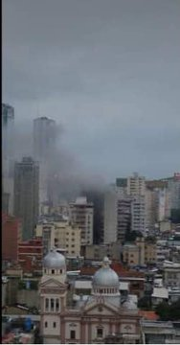

169

284 people are talking about this
Twitter Ads info and privacy
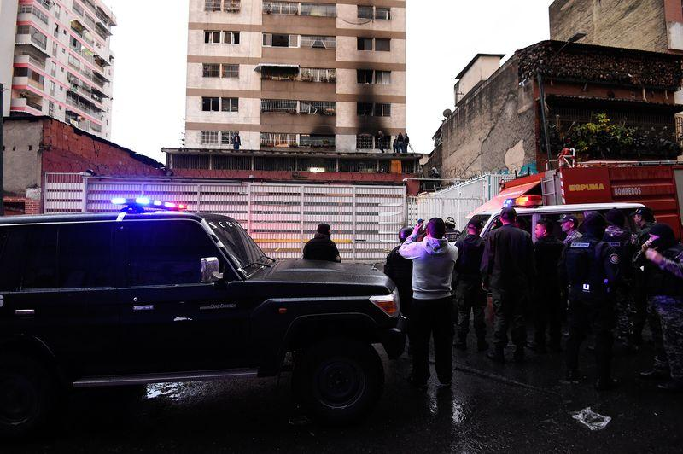
Location of one of the drone crash sites, according to Venezuelan authorities. Image source: Getty
According to a local citizen interviewed by Reuters, there were two distinct blasts. Yet thus far there hasn't been any cell phone video or photographic evidence to emerge depicting what the Venezuelan information ministry described as "drones loaded with explosives" that targeted the downtown area.
During a Saturday emergency briefing on state television, Information Minister Jorge Rodriguez said “We have proof that this was an assassination attempt,” and underscored of the plotters, “They’ve failed.”
Meanwhile, responding official Venezuelan statements suggesting Columbian involvement, the Colombian Foreign Relations Ministry said the charge is “absurd” and without basis: “We’re used to the Venezuelan leader constantly accusing Colombia for any sort of situation,” the ministry said in a late Saturday night statement.
Addressing doubts and contrary claims about the assassination attempt that are currently rampant, a director at the polling firm Delphos, Felix Seijas, told Bloomberg: “It’s a shame that at this hour, public opinion is doubting the official version, be it true or not.” And he concluded, “It’s the outcome of years of control over the free media, censorship and multiple false government alerts on assassination attempts.”

Mars Colony a Bad Idea
This article was originally published at The Conversation. The publication contributed the article to Space.com's Expert Voices: Op-Ed & Insights.

Space X and Tesla founder Elon Musk has a vision for colonising Mars, based on a big rocket, nuclear explosions and an infrastructure to transport millions of people there. This was seen as highly ambitious but technically challenging in several ways. Planetary protection rules and the difficulties of terraforming (making the planet hospitable by, for example, warming it up) and dealing with the harsh radiation were quoted as severe obstacles.
Undeterred, Musk took a first step towards his aim in February this year with the launch of a Tesla roadster car into an orbit travelling beyond Mars on the first Falcon Heavy rocket. This dramatically illustrated the increasing launch capability for future missions made available by partnerships between commercial and government agencies.
But six months later, the plans have started to look more like fantasy. We have since learned that there could be life beneath Mars’ surface and that it may be impossible to terraform its surface.
The possibility that there currently could be life on the red planet was raised last week as scientists reported the discovery of a salt water lake beneath Mars’ surface. The lake would be 1.5km below the south polar cap and at least 20km in diameter. This was found from analysis of subsurface radar data from the Mars Express spacecraft. The water is thought to be briny, with the likely magnesium, calcium, and sodium perchlorate salts acting as an antifreeze down to temperatures of perhaps 200K (-73.15°C).

Mars' south polar cap, hiding the lake.
Credit: NASA/JPL-Caltech/MSSS
This is exciting as it is the first definitive detection of liquid water on Mars, and it is possible that there may be further deep lakes elsewhere on the planet. This means there is a real possibility of current life on Mars.
We already knew life could have existed on Mars in the past. There are several pieces of evidence indicating that Mars was habitable 3.8-4 billion years ago. Data from recent missions – including Mars Global Surveyor, Odyssey, Opportunity, Curiosity and Mars Express – have provided mounting evidence that water was present on the surface in streams and lakes with reasonable acidity and that the right chemistry for life to evolve existed there around the time that life was evolving on Earth.
But Mars lost its magnetic field, which would have protected life from harsh radiation from space, 3.8 billion years ago. This also meant its atmosphere started leaking into space, making it increasingly inhospitable. So living organisms may not have survived.
But while the new discovery may fuel aspiring colonisers’ dreams that the water in the subsurface lake might be usable to sustain a human presence, the reality is very different.
The risk of contamination means we shouldn’t send humans there until we know for sure whether there is naturally evolved life – something that could take years to decades. We will need to drill under the surface and to analyse samples, either in-situ or from material returned to Earth, and find suitable biomarkers to be sure.

Terraforming plans crushed?
Perhaps even more damning, the long-suggested idea of terraforming Mars is now firmly locked in the realm of science fiction. Musk has previously indicated that he wants to terraform the planet to make it more Earth-like, so you can “eventually walk around outside without anything on.” This would most easily be done by producing an atmosphere made of heat-trapping greenhouse gases locked in the planet’s ice in order to raise its temperature and pressure. Musk has suggested that we could drop thermonuclear bombs on the ice at its poles in order to heat it up to release the carbon dioxide.
But according to a new study, published in Nature Astronomy, Mars has lost so much of its potential greenhouse gases to space over billions of years that there is now no possibility of transforming the remaining atmosphere into a breathable one with available technology.

The study is based on measurements of the recent escape rate of gases to space measured over the last 15 years by Mars Express and the last four years by MAVEN. This can tell us how much effective greenhouse gases, carbon dioxide and water are available at Mars. The measurements, combined with knowledge of the inventories of carbon dioxide and water on Mars from recent space missions, show that greenhouses gases locked in the ice caps are not enough to provide the necessary heating.
More may be available deep within the planet but extracting that is well beyond today’s technology. Also, the atmosphere is still being lost due to the lack of a magnetic field, so that would need to be somehow slowed to maintain any changes achieved by terraforming. This means that potential explorers would need to use heavy, airtight walls, roofs or buildings to provide the right atmosphere and the required screening from cosmic radiation.
While Musk may be disappointed by these new results, most Mars scientists are breathing a sigh of relief. There may be present or past life on Mars, and we can now focus on finding it.
We will be searching for signs of life with the ESA-Russian ExoMars 2020 rover, and the NASA Mars 2020 mission will gather samples for eventual return to Earthbound laboratories by around 2030. The results of all this may tell us if there was, is or could be life elsewhere. In our solar system, the best targets are Mars, Saturn’s moon Enceladus and Jupiter’s moons Europa and Titan. And these just hint of the potential for life on the many planets beyond our own solar system.
Mars is bright in our skies this week, the brightest since 2003. The red planet is never far from our thoughts, whether as a potential cradle for life beyond Earth or as a target for humans in the future. We live in exciting times when it comes to space exploration. So let’s not spoil one of the largest and most fundamental experiments for humankind by letting dreams of colonisation go too far – at least until we know whether there is life.
Andrew Coates, Professor of Physics, Deputy Director (Solar System) at the Mullard Space Science Laboratory, UCL

Russian Collusion: Not a New thing

How close America came to being officially pro-Moscow.
How many ways have progressives worked with the Kremlin over the years? The examples are legion. When I was researching my book Dupes, the biggest challenge was sifting through all the self-described “progressive” individuals or organizations to figure out which were closet communists cloaked as liberals, and whether they collaborated with Moscow. When Congress in 1961 published its major investigation of communist front-groups, titled, “Guide to Subversive Organizations and Publications,” one of the most popular title listings in the massive index was “Progressive.”
Progressive here, progressive there, progressive everywhere.
In fact, if you want a case of collusion between an American political party and Moscow in a presidential election, forget sniffing around 2016. Go back to 1948, where progressives created the smelly blueprint.
That year, the Progressive Party ran for president one Henry A. Wallace.
Wallace had been FDR’s vice president and was America’s preeminent dupe to Marxist-Leninists. He was horribly pro-Soviet. One of the stupidest things FDR did (and that’s saying something) was to make Wallace his vice president. Wallace’s public remarks defending Stalin’s USSR were so bad that Democrats demanded he be expelled as FDR’s running mate in 1944, even as FDR’s ideologically unhinged wife, Eleanor, protected him.
FDR merely moved Wallace, retaining him as secretary of commerce in another of FDR’s departments penetrated by communists and Soviet agents of influence. (Long before that, in 1933, FDR had made Wallace secretary of agriculture, which was so infiltrated that the worst of all Depression-era government communist cells — the Ware Cell — operated out of it.)
Harry Truman mercifully replaced Wallace. It would have been devastating for America and the world if Wallace, rather than Truman, had been the sitting vice president ready to replace FDR upon the New Dealer’s death in April 1945. That is one huge bullet that history dodged.
Nonetheless, Wallace still managed to work directly with Moscow. The great Cold War historian John Lewis Gaddis notes that “there is Soviet documentation that Wallace was regularly reporting to the Kremlin in 1945 and 1946 while he was in the Truman administration.”
Many good historians have shown that connection, particularly Allen Weinstein and Alexander Vassiliev in their 1999 work, The Haunted Wood, though more material has since emerged from archives. One of the best historians who has followed Wallace is Ron Radosh, himself an ex-communist, who in a January 2017 piece for the Daily Beast tried to remind modern progressives of what their earlier namesakes had done in 1948. Radosh wrote this devastating assessment of Wallace:
In October of 1945, while he was still secretary of Commerce, Wallace secretly met in Washington, D.C. with Anatoly Gorsky, the station chief of the NKGB (forerunner of the KGB). KGB files show that Wallace told Gorsky that he wanted to share the secrets of the a-bomb with the Soviets, complained that Truman was being influenced by an “anti-Soviet group” in government that wanted the Anglo-Saxon bloc to have dominance in the world, and that he hoped that the Soviet Union could help Wallace’s “smaller group significantly.”
For a member of the President’s Cabinet asking the Soviets to intervene to help his side win an internal battle within the administration was more than indiscreet. It was the action of a willing tool of Moscow.
Radosh’s point is crucial. Here, Wallace was acting not as an unwitting, clueless dupe, but as a willing, fully aware accomplice.
Radosh notes that if Wallace had received the Democratic Party nomination for vice president in 1944 (instead of Truman), he would have made the infamous Harry Dexter White his secretary of the treasury and given a major White House position to another Soviet spy, Laurence Duggan. The decoded Venona papers revealed that Moscow hoped that Duggan would aid the USSR “by using his friendship [with Wallace for] extracting … interesting information.”
Thankfully, President Truman fired Wallace. The final straw for Truman was an awful speech Wallace delivered at Madison Square Garden favoring the recognition of Soviet areas of influence. American communists loved the speech. “He did this while Secretary of State James F. Byrnes was in Europe, negotiating with the Soviets,” writes Radosh. “Byrnes immediately told Truman that if not repudiated immediately, Wallace’s words would be taken as policy and would undermine Byrnes’ attempts to modify Soviet behavior.”
Truman canned Wallace. This made Wallace a martyr and even greater hero to the American far left.
Moscow’s Man in Washington
As the Cold War erupted, Henry Wallace erupted — for the side of Moscow. In October 1947, as members of the Hollywood Ten — every single one of which was a Communist Party member — were called to Washington to testify to their infatuation with Stalin’s state, Wallace joined forces with the communist front-group, the Progressive Citizens of America, in jointly calling for the abolition of House Committee on Un-American Activities. This thrilled American communists; they further realized they had a dutiful pal.
Wallace became a poster boy for the Daily Worker. “Has America gone crazy?” the Daily Worker approvingly quoted Wallace denouncing the House committee hearings. “Is the Un-American Activities Committee evidence that America is travelling the road to fascism?” The former vice president urged his fellow Americans that they “must destroy” the committee. If they did not, the evil “HUAC” would “destroy many of the foundations of democracy and Christianity.”
Yes, “HUAC” would do that, not communism or the USSR. The admirer of the Soviet experiment was worried about threats to democracy and Christianity — in America, that is, by our Congress, not the Politburo.
Wallace adhered to the Soviet-CPUSA line on all the major foreign-policy issues of the day, blasting the Marshall Plan, the creation of NATO, and defending Moscow’s stance everywhere from Berlin to Prague. It was easy to predict where Wallace would stand on an issue. One simply had to see where Stalin stood.
And so, America’s reds and pinkos and fellow travelers knew that they had their boy for the presidential election of 1948. They swarmed to Wallace. Wallace attracted a dedicated mix of closet communists and progressive dupes, with the latter including a glistening parade of oblivious Hollywood celebrities ranging from Katharine Hepburn to Gene Kelly, who were rolled again and again by communist Hollywood screenwriters Dalton Trumbo and John Howard Lawson.
To be clear, Henry Wallace himself was not a member of the Communist Party, but communists throughout America rallied to him as someone they could count on more than any other candidate. The comrades placed their hopes in Wallace in 1948. In the groundbreaking book, The Secret World of American Communism, Harvey Klehr, John Earl Haynes, and Fridrikh Igorevich Firsov described it well: “In 1948 Communists threw all of their strength into Henry Wallace’s presidential campaign and supported the Progressive Party as a Popular Front alternative to the Democrats.”
The extent to which that is true is overwhelming. The list of hardcore communists who flocked to Wallace and sought to control him was thousands upon thousands, and could not begin to be summarized here.
Among the direct Soviet agents working for Wallace was Lee Pressman, who, we now know, had the KGB codename “Vig.” He covertly assisted Soviet intelligence (both the KGB and GRU) for a decade-and-a-half. Publicly, Pressman put on another face. He masqueraded as a proud “progressive,” joining Wallace’s presidential campaign and becoming the principal author of Wallace’s pro-Soviet platform.
Another was Victor Perlo, namesake of the infamous Perlo Group that penetrated the Roosevelt administration, especially the Department of Commerce. Perlo served the Motherland with dedicated Soviet hands such as Frank Coe, Harold Glasser, Charles Kramer, and Harry Dexter White. Perlo was hired as an economist for the Progressive Party and was instrumental in developing the party’s 1948 platform.
There were so many of the Pressman-Perlo mold in the Wallace fold. Anyone with any knowledge of the Wallace campaign knows of the extraordinary level of communist penetration and control.
My friend Mike Shotwell, author of the wonderful memoir, Immersed in Red, had a Stalinist stepfather (who, naturally, publicly proclaimed himself not a Stalinist but a “progressive”) who was Wallace’s chief campaign organizer in Minnesota. Mike writes at length about how Orville’s attraction to Wallace was entirely because of the hope that Wallace would be Stalin’s man in the White House. Orville worked together with the likes of Victor Perlo.
Here again, Ron Radosh puts it well:
In 1948, Wallace announced that he would be an independent candidate for President on a new third party, named the Progressive Party after the ticket Theodore Roosevelt ran on in 1916. Wallace’s new party was created by American Communists acting on behalf of instructions from Moscow, which told CP leaders that war with the U.S. was imminent, and that Western Communists should no longer work within Popular Front governments, and had to break and create a movement against the new anti-Soviet policies being adopted. As the independent left-wing journalist I.F. Stone wrote at the time, “If it had not been for the Communists, there would be no Progressive party.” John Gates, editor of the CP paper The Daily Worker, wrote in his memoir that the Communist Party was “most instrumental in influencing Wallace to make [the]…decision” to run.
Among the sources cited by Radosh is I.F. Stone, who, according to historians John Earl Haynes, Harvey Klehr, and Alexander Vassiliev, from 1936 to 1939 had been a Soviet spy. Stone’s testimony is especially damning: If not for the communists, there would have been no Progressive Party.
The Progressive Party and Henry Wallace and their 1948 presidential campaign were (to borrow from John Brennan’s phrase for President Trump) “wholly in the pocket” of the Kremlin.
Harry Hay and Frank Marshall Davis
So much could be said of this and its broader implications for the evolution of the American left in the decades to follow. Here are merely two telltale examples of Communist Party USA members who supported the Progressive Party’s Wallace campaign in 1948. Both have key relevance to today’s political and cultural battles.
One was Harry Hay, the pioneering “gay” communist and defender of NAMBLA, the North American Man-Boy Love Association. Hay practiced the homosexual lifestyle before he practiced communist organizing. He was brought into the communist orbit by his lover, Will Geer, an actor later famous for his role as “Grandpa Walton” in the hit 1970s TV series, The Waltons.
Harry Hay’s homosexual lifestyle was a blackmail problem for Communist Party USA. He thus left CPUSA in the early 1950s, after roughly 17 years as a member. In 1951, he collaborated with a group of homosexual-Marxist friends and associates in the Los Angeles area in forming the Mattachine Society. Here’s the key point as related to this article: Hay and friends came together through the Progressive Party presidential bid of Henry Wallace. They originally conceived their group as something called “Bachelors for Wallace.” They described themselves as “progressives” — “us progressives,” said Harry referring to his gang.
Today, their cohorts in the LGBTQ movement and wider liberal/progressive left aggressively redefine everything from marriage to gender to sexuality, and demonize and dehumanize and destroy anyone who disagrees or stands in the way of their fundamental transformation of human nature.
The other key figure is Frank Marshall Davis, who throughout the 1970s was mentor to a young man in Honolulu named Barack Hussein Obama. I wrote one of the few biographies of Davis, and I encountered Wallace’s name a bunch of times in that research.
Davis joined Communist Party USA during World War II (CPUSA no. 47544). He was a total apologist for Stalin’s Soviet Union, always toeing the Moscow line in his columns. He was so transparent in his ideological sympathies that he was called to testify before the Senate in December 1956 for his “Soviet activities.” He pled the Fifth. He was placed on the federal government’s Security Index — meaning that he could be arrested if a war broke out between the United States and USSR — and was under regular FBI surveillance.
Yes, that was Obama’s mentor, who’s mentioned repeatedly throughout Dreams From My Father.
A good comrade who, like all CPUSA members, swore a loyalty oath to “pledge myself to rally the masses to defend the Soviet Union [and] to remain at all times a vigilant and firm defender of the Leninist line of the party, the only line that insures the triumph of Soviet Power in the United States,” Davis during the 1948 campaign was all for Wallace.
In fact, Davis had been stumping for Wallace — and torching Wallace’s opponents — well before ’48. In September-October 1943, Davis penned a three-part series contrasting Winston Churchill with Henry Wallace. “Two influential leaders of the United States and Great Britain, Vice President Henry Wallace and Prime Minister Winston Churchill, are moving in opposite directions toward a postwar world,” wrote Davis. “Wallace wants peace and security for all the people in a universal brotherhood of nations; the only people Churchill gives a rap about are the white people of the British Empire… and America, he thinks, ought to use strong-arm tactics to bludgeon all other countries into submission.”
Davis finished his series by posing the choice between Churchill and Wallace in stark terms: “How about it? Are you willing to outtalk the imperialists, the isolationists, and the fascists: Or would you prefer World War III?”
Remember that bust of Churchill that Obama removed from the White House as soon as he got there? Well, Frank Marshall Davis detested Churchill.
Davis continued carrying the red flag for Wallace. Way back in July 1944, four years before the 1948 presidential race, Davis was writing columns with titles like (July 19, 1944) “We Need Wallace.”
Davis was the founding editor of the communist publication, the Chicago Star. His Star was on fire for Henry Wallace throughout its existence, essentially serving as Chicago’s flagship publication for the ’48 campaign. It was telling that at one point the Star ran “A Statement from Stalin” supposedly supporting Wallace’s presidential bid. This, in the Star’s mind, was the ultimate endorsement for its man, as was the backing of Paul Robeson, who Frank Marshall Davis idolized. Robeson, a gushing, fawning admirer of Joe Stalin, became co-chair of Wallace’s Progressive Party presidential campaign.
Yes, co-chair. Comrade Paul, who adored Stalin, was Henry Wallace’s campaign co-chair.
There’s much more I could write about Frank Marshall Davis’s support of Wallace, but I’ll finish with this lesson going forward.
After the Wallace campaign, Davis left Chicago for Party work in Hawaii. In Hawaii, once the Hawaiian Communist Party went underground, with Wallace’s Progressive Party having collapsed after the 1948 loss, Hawaii’s Reds changed their tactics, concentrating instead on infiltrating the Democratic Party, even running their members in local elections to seize delegate positions. One of those who not only urged this tactic but was himself elected to a Democratic precinct was Frank Marshall Davis. For America’s Reds, it was the start of a long march to operate within the Democratic Party, transforming it from the party of Harry Truman and John F. Kennedy to the party of Barack Obama and Bernie Sanders.
For many American communists, a third-party bid was a losing proposition. They would instead pursue a path of working from within one of the two dominant parties: the Democratic Party.
And as for America’s progressives today, in July 2018, who squawk and scream about the Kremlin’s influence in the 2016 presidential election, here’s what I say: you long ago forfeited your credibility.
For progressives to sanctimoniously complain of Russian involvement in a presidential election is the height of arrogance and hypocrisy. For literally over a century, these folks never gave a rip about what the Russians were doing to manipulate Americans. Quite the contrary, 70 years ago the Progressive Party hooked up with the Kremlin in a presidential election, replete with its own candidate. And all along, as Republicans and conservatives sensed and pointed out these outrages, the left shrugged and called them red-baiting paranoiacs. And now the left wants everyone to care about Kremlin meddling merely because Hillary Clinton was the target?
Don’t expect me to join your crusade, progressives. You’re too late — a hundred years too late.
Dems Make-Work with Cost You

Their goal is to kill the booming economy.
Friday morning, 26-year-old software developer David Casarez put on a shirt and tie, grabbed his homemade cardboard sign saying “Homeless – Hungry 4 Success – Take a Resume” and positioned himself at an intersection in Mountain View, California. A passerby posted his photo on Twitter. Within a day, Casarez had over 200 job offers.
No surprise. If you’re looking for a job, your odds are better now than any time in the last half century. There are more job openings than people out looking. Employers who used to demand a college degree or experience are dropping those requirements. Unemployment is near a fifty-year low, and unemployment among blacks and Hispanics is at a nearly all-time low.
Yet Democratic presidential wannabes Senators Kirsten Gillibrand (D-NY), Cory Booker (D-NJ), and Bernie Sanders (I-VT), are campaigning for a “guaranteed jobs” program, as if we’re in a depression instead of a boom.
So too is the new darling of the left, New York Democrat Alexandria Ocasio-Cortez, running for Congress this fall. House Democrats introduced guaranteed job legislation last week.
These Democrats say the federal government should guarantee a job and a paycheck — paid for by taxpayers — for anyone who isn’t working.
To foot the bill for these make-work jobs and many other programs, Democrats like Nancy Pelosi and Elizabeth Warren want to undo the Trump tax cuts. In short, sabotaging the policy that’s producing the economic boom.
Voters need to connect the dots. The hiring surge is the direct result of a huge increase in business investment — up 9.4% during the first half of 2018. Investors are pouring money into private sector companies to buy more vehicles and equipment and increase commercial construction. Companies that buy more trucks and computers and build more office space can hire more drivers and office workers.
What’s causing this jump in job-producing investments? Trump’s tax cuts, especially the drastic cut in the corporate tax rate, previously the highest in the developed world. When investors can earn a higher after-tax return on their money, they’re willing to put more on the line.
That’s also when employers will go out on a limb to hire job seekers like David Casarez.
Of course, even in today’s hot job market, there are people stuck on the sidelines, jobless, lacking skills, and no longer looking. But another public jobs program is not the answer to boost the nation’s low labor participation rate. The U.S. already has 41 federal jobs programs costing a whopping $17 billion a year to push the long-term unemployed into the workforce. With little success to show for it.
Make-work programs like the ones Booker, Gillibrand, and other Dems are proposing have an abysmal record of getting people into lasting private sector jobs, according to a National Bureau of Economic Research survey by David Card of University of California Berkeley and co-authors.
But never mind facts. The Democrats pushing federal job guarantees are not actually interested in making sure people work. After all, this is the party that vehemently opposes any work or work-readiness requirements for Medicaid and other public benefits. The Dems’ job-guarantee campaign is a thinly disguised effort at radical income redistribution. Gillibrand told the Nation magazine a guaranteed jobs program is needed to “stamp out inequality.”
Former president Barack Obama hailed the idea of a universal government-guaranteed income in a July 17th speech. Obama says the goal is to close the “yawning disparities” between rich and poor. Think: everyone gets a check from Uncle Sam whether you work or not. In Chicago, the Democratically controlled municipal legislature is backing a plan to give 1,000 families a $500 monthly stipend, no questions asked. No work required.
If you’re like David Casarez, determined to earn your own living, beware of what the Democrats are planning. Their tax hikes will kill the jobs boom, and their redistributionist schemes will make your paycheck fair game to support those who won’t work at all

Walk Away
By Saritha Prabhu
AUGUST 3, 2018
I don’t much like Donald Trump and didn’t vote for him (or Hillary) in 2016, but I’ve been feeling sorry for him for about 18 months now. It feels strange feeling sorry for someone who’s a boor, a narcissist, an egomaniac, and a serial philanderer, plus the 37 other negative traits usually used to describe him. But it has something to do with the fact that he has been treated in a grossly unfair manner by the mainstream media and the political and cultural left, on a scale we’ve never seen before.
One story of the last two years is how this most alpha of alpha males has become an underdog of sorts in American politics today. Of course, you won’t find this narrative in any of the mainstream media outlets. This narrative merely exists in the minds of millions of voters who are outside the core Democratic base: those of us who are Republicans, moderates, independents, former Democrats like myself. We’ve been silently watching, listening, observing the opposition to Trump in the last eighteen months, and it’s been the most sickening thing to see, more appalling than what the right did to President Obama.
As one voter put it in an article I read a while ago, the hatred shown toward Trump has been “un-American.” I agree with that sentiment, even as I simultaneously hold the thought that Trump is not someone whose character needs defending.
Memo to the left: Know why Trump’s poll numbers have been steady or rising slightly in spite of the invective you’ve been pouring on him every minute of every day? It’s because the economy is booming, and also because most Americans are fair-minded and think that even a flawed sinner like Trump doesn’t deserve to be figuratively kicked every day in a manner that’s often dishonest, exaggerated or out-of-context.
Trump ran as the most anti- of anti-establishment candidates in 2016, and almost everything the political and media establishments have done since then have confirmed what millions of voters have realized: these establishments are out-of-control, they want presidential candidates and presidents they can control, and they won’t abide a true outsider.
In effect, their post-election behavior has confirmed that a President Trump was necessary for this time in American politics. The reality is, there was no peaceful transition of power on Jan. 20, 2017. From the time Trump won the Republican nomination, there has been a concerted effort from different quarters – the press, Hollywood, academia, the Democratic Party – to smear and undermine him.
Some of this was legitimate and what naturally happens in an election. But a lot of the opposition to him was breathtaking and unprecedented, and we’ve been learning more as time passes by. The highest levels of the FBI secretly spied on his campaign, and they did it by misleading the FISA court and using an unverified dossier paid for by the Hillary Clinton campaign.
And the unprecedented opposition continued with a fake Russia collusion narrative and a dubious special counsel investigation to undermine and possibly remove a duly elected president elected by the masses whom the establishment happens not to like. If they are successful, we don’t have a constitutional republic anymore, folks. It’s that simple.
I was a long-time Democrat who “walked away” from the party because I couldn’t stomach the Democrats’ anti-democratic antics. Post-2017, it is like the mask has been ripped off. It has become apparent that the Democratic Party and its media supporters seem to have a problem with representative democracy and how it works. They lost an election they thought they’d handily win, and their reaction to it has been to have a long, screeching public tantrum.
Bill Maher and other liberal commentators have openly talked about the urgent necessity to “remove” Trump. Remove Trump? Are they serious? I thought the way it works if you lose an election is you try to present a better argument before the electorate the next time and win the next election, and not simply try to get rid of the election-winner.
In the last eighteen months, the left, the so-called deep state and their media enablers have tried their damnedest to get rid of Trump even if it meant trampling over the rule of law and the Constitution. That is why those who used to care deeply about civil liberties have been mum when the civil liberties of Trump, Carter Page and others have been violated.
That is why one of the only principled liberal, Prof. Alan Dershowitz, who has been arguing about and defending the civil liberties of the Trump team, has been getting grief and facing ostracism from the left. That is why the mainstream media has not only derelicted its investigative duties, but has been shamelessly spinning one of the biggest stories of our time — how the FBI abused its power to spy on an American political campaign.
The striking thing is, the side that has been accusing Trump of subverting democracy has been guilty of it themselves. In America, even a serial killer has rights and deserves due process. But in the eyes of the left, Trump deserves neither.
But the public isn’t dumb. Those of us who aren’t hardcore Democrats recognize what’s going on and have come to see something that seems counter-intuitive: This loud, brash president is actually a victim and an underdog in American politics today, and he hasn’t been getting a fair shake since he won the election, or been given a proper chance to lead the country.

