Jihad Report
Sep 15, 2018 -
Sep 21, 2018
Attacks | 31
Killed | 126
Injured | 55
Suicide Blasts | 1
Countries | 10

The Q Phenomenon
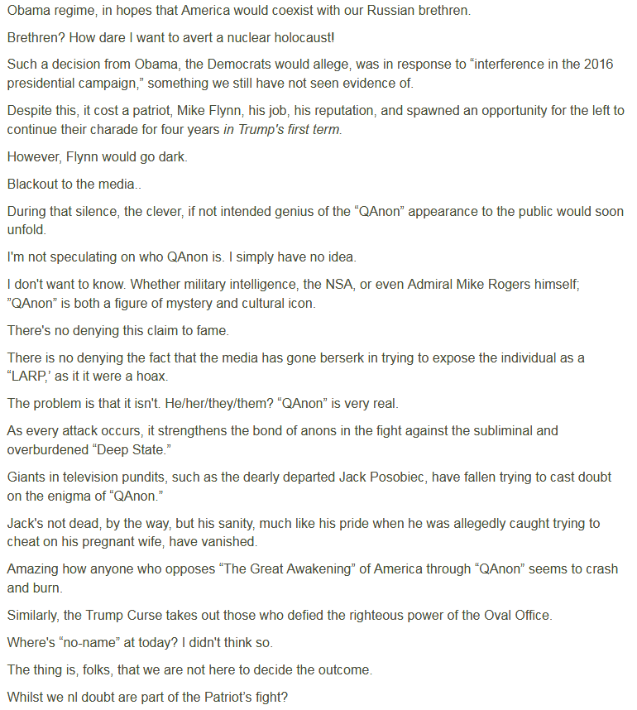
Curiosity Went Black
It's still unclear exactly what's ailing NASA's Curiosity Mars rover, but mission team members are optimistic they can get the six-wheeled robot up and running again.
Since last Saturday night (Sept. 15), Curiosity has had trouble beaming home to Earth certain science and engineering data stored in its memory. Curiosity has stood down from all science operations while the mission team investigates the problem.
The issue is related to the rover's internal file system. Something is preventing the rover from accessing the locations where the affected data are stored, said Curiosity deputy project manager Steve Lee, of NASA's Jet Propulsion Laboratory in Pasadena, California. [Photos: Spectacular Mars Vistas by NASA's Curiosity Rover]
"The team is methodically narrowing down potential causes but hasn't yet determined if it's hardware- or software-related," Lee told Space.com via email.
The good news is that Curiosity remains otherwise stable, healthy and responsive. For example, it's still sending home real-time engineering data (which is very helpful to the folks trying to diagnose the problem). So this is not a time-critical situation, like the computer problem that cropped up about 200 Martian days (or "sols") after Curiosity's August 2012 touchdown on the Red Planet, Lee said.
"During the Sol 200 anomaly, the rover was not responding to commands, nor was it sleeping to recharge its battery," he said.
That previous problem, he added, was traced to a combination of two issues: a partial memory hardware failure in Curiosity's main computer, known as the A-side, and a software bug.
The mission team ended up swapping the rover over to its identical backup (B-side) computer, which still runs Curiosity to this day. Engineers later fixed the software bug, and the team has restricted use of A-side memory to the amount that's still available, Lee said.
So, while the current problem is "quite technically complex," the team is far from discouraged. Curiosity has recovered from seemingly more serious setbacks, after all, and engineers have several options at their disposal to deal with the current one.
"The team is confident that they'll find a workaround to allow Curiosity to return to normal science operations," Lee said.
"If the problem is related to memory hardware, it may be possible [to] work around any portions of the memory banks that are no longer operating," he said. "If it’s a software bug, a fix can be devised to upgrade Curiosity’s onboard flight software. And, ultimately, there is a backup computer available, albeit with less available memory due to the Sol 200 anomaly."
A 'Curiosity' Quiz: How Well Do You Know NASA's Newest Mars Rover?
NASA's Curiosity rover — the centerpiece of NASA's $2.5 billion Mars Science Laboratory (MSL) mission — landed on Mars Aug. 5. How much do you know about Curiosity and its mission?
Start the Quiz
0 of 10 questions complete
During its six-plus years on Mars, Curiosity has found lots of evidence that the Red Planet could have supported microbial life in the ancient past. For example, the rover's observations have helped scientists determine that Curiosity's landing site, the floor of the 96-mile-wide (154 kilometers) Gale Crater, hosted a long-lived lake-and-stream system billions of years ago.
Since September 2014, Curiosity has been exploring the foothills of Mount Sharp, which rises 3.4 miles (5.5 km) into the sky from Gale's Center. The rover is reading the rock layers as it goes, searching for clues about Mars' long-ago transition from a relatively warm and wet world to the cold, dry planet it is today.
The Invasion is Complete

The population of illegal migrants is roughly 22 million, or twice the establishment estimate of 11 million, say three professors from Yale University and the Massachusetts Institute of Technology.
The shocking estimate will force establishment politicians and pro-migration advocates to recalculate the estimated impact of the huge illegal population on wages and salaries, on crime rates, welfare consumption, rental and real-estate prices, productivity rates, and the distribution of job-creating investment funds to coastal vs. heartland states.
The higher illegal population estimate helps explain why Americans’ wages and salaries have risen so little amid apparently record-low unemployment rates, and it also undercuts companies’ loud demands for yet more immigration of foreign workers, consumers, and renters.
The population estimate also raises the political and economic stakes of any amnesty legislation. In 2014, public opposition blocked the bipartisan, establishment, media-boosted Gang of Eight bill, which claimed to offer an amnesty to just 11 million migrants. Currently, advocates for a ‘Dream Act’ amnesty claim it will provide green cards to roughly 3 million sons and daughters of illegal immigrants.
The new estimate also bolsters President Donald Trump’s demand that reluctant GOP and hostile Democratic legislators fund a border wall.
“Our purpose is to provide better information,” said Jonathan Feinstein, an economics professor at Yale. In a video statement, he defended the estimate from likely critics, saying it is an expert analysis, not a political project:
This paper is not oriented towards politics or policy. I want to be very clear. This paper is about coming up with a better estimate of an important number, and we are really trying in this paper to keep away from making any statements about how that could or should be used. It is just a paper to help the debate be organized around some better information, which in my opinion is a good thing to do. I think the debate should always be centered around the best information we can develop.
The academics expected their techniques to show the population is smaller than the consensus estimate of 11.3 million. “Our original idea was just to do a sanity check on the existing number,” said Edward Kaplan, operations research professor at Yale. “Instead of a number which was smaller, we got a number that was 50 percent higher. That caused us to scratch our heads.”
Operations research is a skill that extracts accurate estimates from scraps of data. It began in World War II when academics were enlisted to help track Nazi U-boats and weapons-production. For example, the academics used scraps of information to conclude that the Nazis produced 270 Panther tanks in February 1944. After the war, captured factory data showed the production of 276 Panthers in that month.
“We have a conservative estimate that the number is at least 16.7 million,” said Edward Kaplan, an operations research professor at Yale. The study used “over 1 million scenarios accounting for all of the variability in the various parameters that we need for this model [and] on average, we’re estimating something like 22 million undocumented immigrants in the United States.”
The study says:
The figure [below] also shows our conservative estimate of 16.7 million in Red, and the most widely accepted estimate heretofore of 11.3 million in Blue on the far left. We note that this last estimate is for 2015, but should be comparable since both the estimates based on the survey approach and our modeling approach indicate that the number of undocumented immigrants has remained relatively constant in recent years. Finally, the mean estimate of 22.1 million is shown in black in the center of the distribution.
The new estimate uses new sources of data, such as the fingerprints of migrants caught at the Mexican border, said Mohammad Fazel‐Zarandi, a senior lecturer at the MIT Sloan School of Management. In contrast, the current estimate of 11.3 million is based on the Census Bureau’s annual American Community Survey. “It’s been the only method used for the last three decades,” says Fazel‐Zarandi.
The illegal population is higher than expected because more migrants crowded into the United States during the cheap-labor policies of Presidents’ George H.W. Bush, Bill Clinton, and George W. Bush, the researchers said.
The inflow leveled off in 2008 once the economy crashed when millions of new migrants and poor Americans were unable to pay their rising mortgage costs.
The existing population of illegals tends to decline as many die of natural causes, or return home, or get “Adjustment of Status” to become legal residents. But the population is being kept level because new migrants — especially foreigners who overstay their visas or who migrate from Central America — offset the natural decline.
The Yale study goes up to 2016, and so does not offer 2017 and 2018 numbers. Many new migrants are overstaying their visas and sneaking across the borders, but President Donald Trump has tightened border defenses against overstays and border-crossers.
The Yale study complements the Census Bureau’s new estimate of the nation’s population and workforce. The bureau concluded the nation has been enlarged by 44.5 million legal or illegal immigrants, plus 17 million children of legal immigrants. Together, the new estimates conclude that the nation’s has a record-breaking foreign-born population of 55 million migrants.
That number is roughly 16.9 percent of the population, or roughly one person six living in the United States.
Protestors wave American, Mexican and Guatemalan flags as thousands march at an immigration rally in Homestead, Fla. May 1, 2006. (AP Photo/Lynne Sladky)
The study does not examine the number of illegal white-collar workers. That calculation is difficult because academics have not even counted the number of resident white-collar visa-workers, such as L-1 and H-1B visa holders. Breitbart News estimates that U.S. companies employ roughly 1.5 million white-collar visa workers in jobs that are sought by U.S. college graduates.
Four million young Americans will join the workforce this year, but the federal government will also import 1.1 million legal immigrants, and allows an army of at least 2 million blue-collar and white-collar visa-workers to work U.S. jobs, alongside asylum-claiming migrants and illegal aliens.
Overall, the Washington-imposed economic policy of economic growth via immigration shifts wealth from young people towards older people by flooding the market with cheap white-collar and blue-collar foreign labor.
That flood of outside labor spikes profits and Wall Street values by cutting salaries for manual and skilled labor offered by blue-collar and white-collar employees. The policy also drives up real estate prices, widens wealth-gaps, reduces high-tech investment, increases state and local tax burdens, hurts kids’ schools and college education, pushes Americans away from high-tech careers, and sidelines at least 5 million marginalized Americans and their families, including many who are now struggling with opioid addictions. Immigration also pulls investment and wealth away from heartland states because investment flows towards the large immigrant populations living in the coastal states.

Russia Romance over Moon May Be Over
Moscow may abandon a project to build a space station in lunar orbit in partnership with U.S. space agency NASA because it does not want a "second fiddle role," a Russian official said on Saturday.
Russia agreed last year to work with the U.S. National Aeronautics and Space Administration (NASA) on plans for the moon-orbiting Deep Space Gateway, which will serve as a staging post for future missions.
But the head of Russian space agency Roscosmos, Dmitry Rogozin, said Russia might exit the joint programme and instead propose its own lunar orbit space station project.
"The Russian Federation cannot afford to play the second fiddle role in it," he was quoted as saying by the RIA news agency, without much further elaboration.
A spokesman for Roscosmos said later that Russia had no immediate plans to leave the project.
"Russia has not refused to take part in the project of the lunar orbit station with the USA," Vladimir Ustimenko was quoted as saying by the TASS news agency.
Relations between Moscow and Washington have soured since 2014 after Russia annexed Crimea from Ukraine and was accused of meddling in the U.S. 2016 presidential election
World War Three
I know we have had visions of what world war three would look like. You and I practiced this when we were kids in school as the teachers drilled us in rolling on the floor under our desks and covering our eyes. We watched countless movies about Red Dawns and White Houses down and other such scenarios. What I am about to share with you may surprise you. You go to work or school every day. You sit and complain about traffic or the lack of capital to start your business, or the difficulty in selling your products to make your house payments. You haven’t seen jets flying overhead. You haven’t seen tanks rolling down your streets. You have not heard air raid sirens or had to lock your doors and pull your shades down at night to keep from being seen by assassins.
But, make no mistake. We are at war. Every war has a motto. For America, it was E Pluribus Unum. For the globalist Syndicate, it is E Pluribus Pluribus. They know that if they can divide us, and break apart the unity, they can catch up with the stragglers and kill them. The rest of the people don’t care about the herd. They don’t care about the country. They only care about outrunning the person behind them. Do you think the people of Venezuela care about Venezuela? Hell no. They care about them. How do I eat? Where do I live? Will I survive? This is the weapon of the modern war. All the hatred, the division, the partisan positions throughout our nation are in place. The sights of our guns, and our neighbor’s guns are not far from our eyes. And our enemies? Who are they? That’s the beauty of this war. They are like ghosts. Here and there a murder, a rape, a beating. This town, that town, over here and over there. The terrible strategy of this war is that there is no battle front. The oppression is everywhere. The warriors are in the darkest shadows of our cities, killing thousands every year. Already 5 times as many Americans have been killed on our own streets as in 45 years of wars around the world.
How? You ask how could this be? The war took a giant leap forward when our printed, televised, and broadcast media were taken over by the global Syndicate. The matrix of everyday life is draped over us in a full-immersion strategy to create a life for you. The voice of reason and freedom is crushed by the tech giants as surely as they wore a bloodstained uniform. The laws of our land are used against us by Pharisees and manipulated by Sadducees in dark suits in secret rooms. The rule of law has become the rule by law, and they know that violence will never happen. The threat the founding fathers made against them was a bluff. The armed American is no longer a threat for them or their designs to once again own the treasury of the United States.
Your childhood is ruled by Syndicate instructors, indoctrinating you with their philosophy and their training to make sure you grow up to be a good worker for the State. Your adolescence is shut out of sovereignty by importing low-wage illegal immigrants to take all the jobs that normally would be waiting for your summers and evenings. Your career opportunities are tied to the piece of paper you buy from the university.
I have made an effective case in my books and on this program that for more than 5 thousand years, the world was ruled by a single sovereign. One king with his army oppressed the rest of the world so his bloodline could live off the labors of the rest of the world. But, human beings have a drive to be free.
Having driven the entire known world into hopelessness for dozens of centuries, the sovereign family pushed their desire to own the world to an ancient land. They sent armies with their cannons and germ warfare to drive the indigenous peoples further and further west, until finally they were forced onto prison lands and soaked in alcohol and poverty. The conquered peoples’ own chiefs served the sovereign exactly like the old Scottish lords who sold their people and their lands to the crown a millennia before.
After about 150 years since the first sovereign compact, the new world was returning a very nice profit on the investment by the crown. The colonists began to see the business opportunity, but the leadership had something else in mind. They were used to the freedom from oppression. They could see the fruits of their labors as they pushed the wilderness back and discovered the wealth in the ground seemingly stored for billions of years just for times such as these. After all, the crown could not have known what was here.
The leadership decided to declare independence and form a new government, but this time it would be a people’s government. There would be no king and no king’s armies ensuring his ownership of everything and everyone. In 1776, they made their move. By 1787, the Convention was completed, and the Bill of Rights was assembled and ratified by the 13 colonies. 25 years later the British tried to refight the war and take America back, but there were more States and a national identity backed up by the armed American. All of the founding fathers were executed or driven into bankruptcy, but America still survived. If you read Charm of Favor, you know all this already.
What I want to focus on is what happened 61 years later. In the formative years of America, the Anti-Federalists were made mostly of globalists who still wanted to look like and act like the crown. They wanted control over the government through weakening or strengthening one branch of government over the others. They preferred the Executive to dominate everything, so they fashioned a system whereby only candidates properly groomed would be elected. It mattered not which party they belonged to, as long as they were groomed through the system.
In the year 1848, they changed their name and established the Democratic National Committee. Within just a few years, they began the process of splitting the country apart by using their rule by law tactics to levy heavy tariffs against the 13 Southern States. They knew the States would only suffer these for so long, and then they would fight. They chose not to fight. They chose to secede. They evicted the Union’s troops from Sumter, changed the gage of their railroads to prevent mechanized invasion, and formed their own government based upon the original Constitution.
A million Americans died in that war, but America survived. The President who led the nation through that ordeal was shot in the head shortly thereafter, and the Democrats took control of the country for the next 55 years. But then, something amazing happened.
The industrial revolution facilitated a new class of American; the middle class. Ordinary people invested in America and were being rewarded for that investment. People started businesses, and those businesses sold, grew, merged, and expanded like never before in history. For nearly 8 years the economy exploded with uncontrolled growth. That growth took away the Democrat’s control over the nation. When Hoover was elected in 1928, the economy was set to go even higher. He was an engineer, and a conservative committed to getting government out of the way of the people.
The globalist Syndicate, for which the Democrats were just the political arm in America, executed their plan flawlessly. Their generals moved their capital into gold and hard assets, and the banks collapsed the money supply. Overnight, the stock market collapsed, and the middle class evaporated like spent fireworks in the summer night.
In 1932, the Syndicate placed the man they had groomed for the job into the White House. Within weeks, Communist agents infiltrated the entire Roosevelt administration. They took over dozens of agencies, expanding and forcing their way into nearly every facet of American government. Two terms went by with all of the world’s major industrialists increasing in size by a hundred-fold while nearly every nation was plunged into war that demanded their products. Then, in a blatant act of subterfuge in 1940 in the brokered Chicago Convention, they seized a third term. The liberal Harry Truman took Cactus Jack’s place as VP, and the stage was set for the next Earth changing event.
Roosevelt died shortly after his fourth term, and Harry was in place to press the mighty red button that would take the world into the atomic age of fear of Armageddon. The Soviet spies in the Roosevelt Administration ensured that all the relevant technology was shared with them. Because that is what the globalists do. They want all sides to be equally tooled for war. Their goal is to keep the hatred flowing forever.
For the next 83 years, the Deep State flourished. They added 655 Agencies. They hired millions of employees to fill hundreds of buildings, each with multi-billion dollar budgets. Then, the plan faltered in 2016. Hillary Clinton, the ultimate groomed candidate, lost the election.
Now, you know the Democrats have controlled this country for 170 years. They controlled the White House, or Congress, or the Senate, or the Supreme Court, and sometimes all four of those, but they did not lose control until 5 months ago with the appointment of Neil Gorsuch to the Supreme Court. That was the last branch of government for them, since they lost the Congress, the Senate, and the White House already. The globalists now see that the power of America is being transferred back to the American people.
The crimes committed by the globalist cabal inside our government are now being found out, because they most assuredly would have been swept under a very bloody Clinton rug. America is leading the way. Other nations see what we are doing, and they are doing the same thing. Britain, Italy and Hungary are also rebelling against the globalists. Something that would be unheard of under a Clinton presidency.
They are panicked. They are afraid of being caught, arrested, sentenced and executed for their crimes. They have killed millions to get what they have. Do you think for a second they would not kill millions to keep it? Make no mistake. We are at war. This war will very soon transition from using spies, lawyers, propaganda to bullets, clubs, and armored vehicles.
There is a plot to commit something on the order of 9/11 to stop Trump from nationalizing this election. Claire McCaskell just got wiped out in Missouri with Trump’s appearance. The Democrats will lose 6 seats in the Senate and 25 seats in Congress, but only if you go out and vote. I already voted last Friday with my absentee ballot. Now, it is up to you. Act quickly, no matter what. And, watch your eyes out there.

The European Invasion (continued)
Hungarian Prime Minister Viktor Orban provoked a seething response from his fellow European Union members when he decided to close Hungary's borders and passed legislation to ban foreign influence peddling funded by billionaire financier George Soros. And earlier this month, the European Parliament voted to trigger Article 7 proceedings against Hungary for "undermining democratic values and the rule of law." Indeed, because he's steadfastly refused to accept migrants in according with the policies of unelected bureaucrats in Brussels, Orban has been labeled a tyrant, despite Orban's Fidesz Party securing a majority in the country's most recent Parliamentary elections.
Despite the "extreme bullying" to which Orban has been subjected by his European colleagues, he traveled to Brussels earlier this month to face his accusers ahead of the European Parliament vote. After Orban delivered his address to the room, MEP Nigel Farage, who famously helped orchestrate the UK's vote to leave the EU back in 2016, stepped up to say a few words in Orban's defense.
"Thank God there's at least one European leader who is willing to stand up for his principles, his nation, his culture and his people in the face of such extreme bullying."
Farage argued that the vote conjured memories of Soviet-era show trials, and likened the EU Parliament to a bunch of unelected bureaucrats hypocritically lecturing Orban - whose party holds an outright majority - about democratic principles. Specifically, Farage targeted Frans Timmermans, the unelected Dutch diplomat serving as first Vice President of the European Commission.

Timmermans and the rest of the Commission backed the EU Parliament in condemning Hungary for allegedly mistreating migrants and Roma communities, arguing that "democracy and the rule of law cannot exist without the protection of fundamental human rights."
"All I can say, and I'm sure for Hungarians of a certain age, today will have brought back many dark memories. You're here at a show trial where a bunch of political nonentities get up and point the finger and scream enjoying themselves with their afternoon hate, and the chief prosecutor, the commissar that comes from the unelected government, he has the audacity he has the audacity to lecture you on democracy. You don't know what you're talking about."

Farage then compared Article 7 to an updated version of the Brezhnev Doctrine - the Cold War-era policy of overweening Soviet influence that led to the USSR's brutal repression of the Hungarian Spring uprising.
"What is really happening here, Mr. Orban, is they're just updating the Brezhnev Doctrine of limited sovereignty there's no point pretending in this union you're independent there's no point pretending you've run your own country. An Article 7 is the new method of adopting that. They want to strip you of your voting rights. They want to stop giving you European funding and all of it because you have the audacity to stand up to George Soros, the man who was poured $15 billion all over the world in trying to break down the nation-states to get rid of our traditional forms of democracy."
The authorization of Article 7 proceedings isn't just an insult to Hungary - it is a direct insult to Orban personally, Farage said. He then suggested that Hungary follow in the UK's footsteps and abandon the Union entirely.
"Mr. Orban you keep saying you want to stay a member of this European Union but it's not just your country that's been insulted today - you've been insulted. Come and join the Brexit club - you'll love it."

Hamdi vs Rumsfeld: The Graham Event
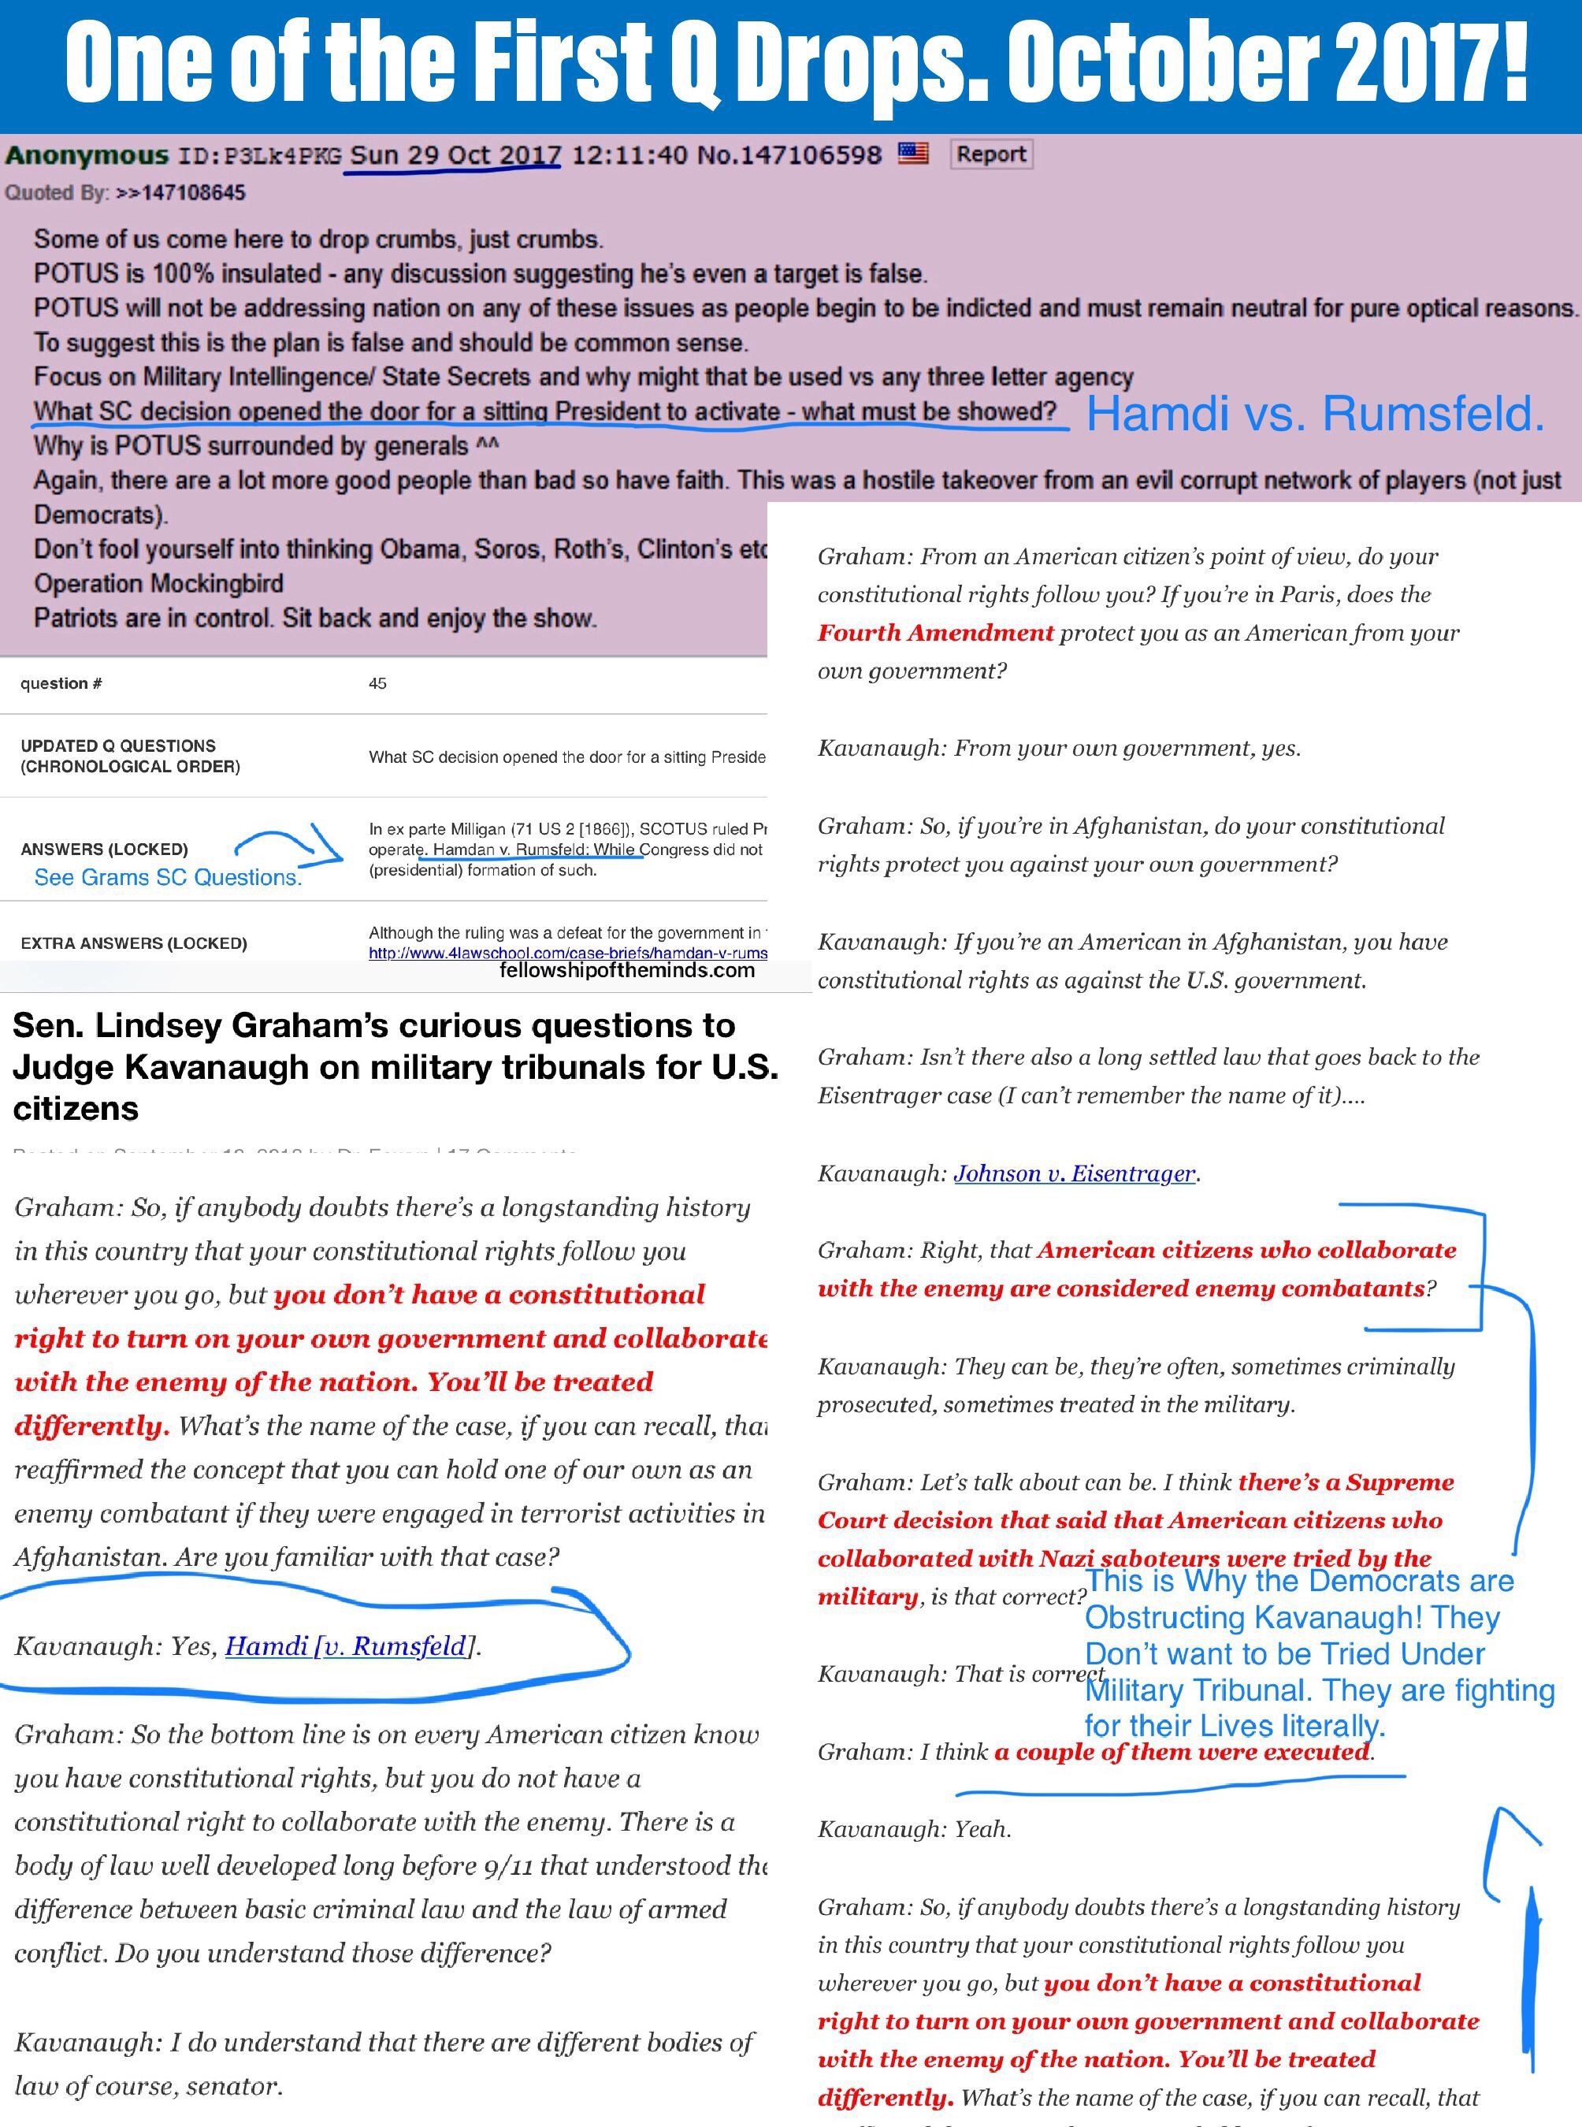
Something Deep is Brewing in the UK
The British government "expressed grave concerns" to the US government over the declassification and release of material related to the Trump-Russia investigation, according to the New York Times. President Trump ordered a wide swath of materials "immediately" declassified "without redaction" on Monday, only to change his mind later in the week by allowing the DOJ Inspector General to review the materials first.
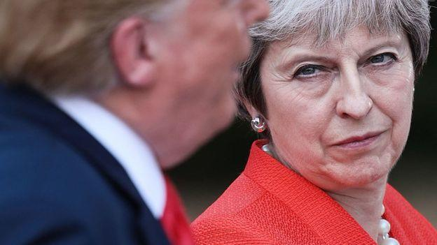
The Times reports that the UK's concern was over material which "includes direct references to conversations between American law enforcement officials and Christopher Steele," the former MI6 agent who compiled the infamous "Steele Dossier." The UK's objection, according to former US and British officials, was over revealing Steele's identity in an official document, "regardless of whether he had been named in press reports."
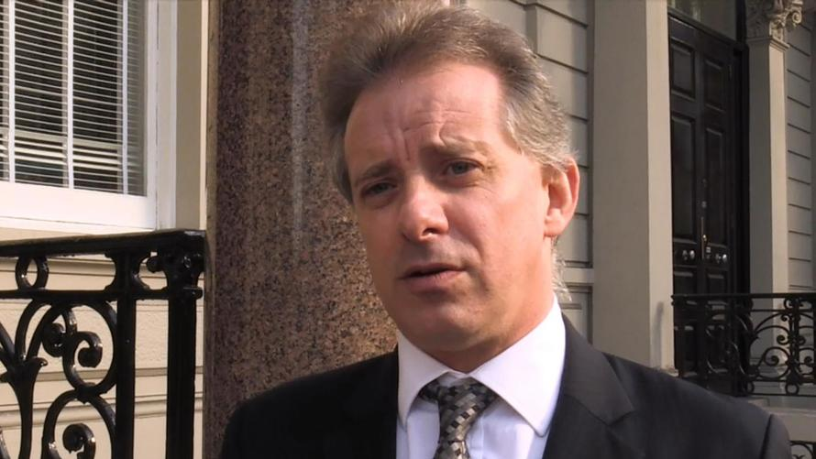
We would note, however, that Steele's name was contained within the Nunes Memo - the House Intelligence Committee's majority opinion in the Trump-Russia case.
Steele also had extensive contacts with DOJ official Bruce Ohr and his wife Nellie, who - along with Steele - was paid by opposition research firm Fusion GPS in the anti-Trump campaign. Trump called for the declassification of FBI notes of interviews with Ohr, which would ostensibly reveal more about his relationship with Steele. Ohr was demoted twice within the Department of Justice for lying about his contacts with Fusion GPS.
Perhaps the Brits are also concerned since much of the espionage performed on the Trump campaign was conducted on UK soil throughout 2016. Recall that Trump aid George Papadopoulos was lured to Londonin March, 2016, where Maltese professor Joseph Mifsud fed him the rumor that Russia had dirt on Hillary Clinton. It was later at a London bar that Papadopoulos would drunkenly pass the rumor to Australian diplomat Alexander Downer (who Strzok flew to London to meet with).
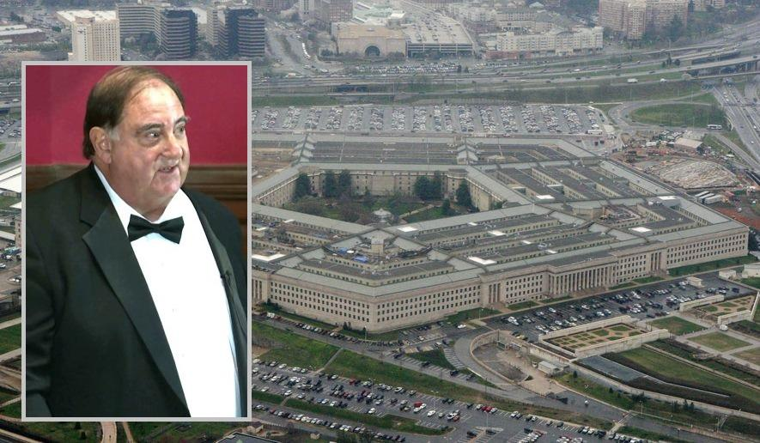
Also recall that CIA/FBI "informant" (spy) Stefan Halper met with both Carter Page and Papadopoulos in London.
Halper, a veteran of four Republican administrations, reached out to Trump aide George Papadopoulos in September 2016 with an offer to fly to London to write an academic paper on energy exploration in the Mediterranean Sea.
Papadopoulos accepted a flight to London and a $3,000 honorarium. He claims that during a meeting in London, Halper asked him whether he knew anything about Russian hacking of Democrats’ emails.
Papadopoulos had other contacts on British soil that he now believes were part of a government-sanctioned surveillance operation. -Daily Caller
In total, Halper received over $1 million from the Obama Pentagon for "research," over $400,000 of which was granted before and during the 2016 election season.
In short, it's understandable that the UK would prefer to hide their involvement in the "witch hunt" of Donald Trump since much of the counterintelligence investigation was conducted on UK soil. And if the Brits had knowledge of the operation, it will bolster claims that they meddled in the 2016 US election by assisting what appears to have been a set-up from the start.
Steele's ham-handed dossier is a mere embarrassment, as virtually none of the claims asserted by the former MI6 agent have been proven true.
Steele, a former MI6 agent, is the author of the infamous and unverified anti-Trump dossier. He worked as a confidential human source for the FBI for years before the relationship was severed just before the election because of Steele’s unauthorized contacts with the press.
He shared results of his investigation into Trump’s links to Russia with the FBI beginning in early July 2016.
The FBI relied heavily on the unverified Steele dossier to fill out applications for four FISA warrants against Page. Page has denied the dossier’s claims, which include that he was the Trump campaign’s back channel to the Kremlin. -Daily Caller
That said, Steele hasn't worked for the British government since 2009, so for their excuse focusing on the former MI6 agent while ignoring the multitude of events which occurred on UK soil, is curious.
Iran: The Civil Unrest Steps Up
Iran's top cleric and leader Ayatollah Khamenei has pointed the finger at the West for a terror attack on a military parade that took place early Saturday in the Southwest city of Ahvaz, which left 25 people dead and over 60 wounded.
Khamenei's condemnation of "plots hatched by US stooges in the region" came simultaneous to Iran summoning the diplomatic envoys of Western countries including the Netherlands, Denmark and Great Britain, for harboring Iranian opposition groups in their countries.
“It is not acceptable that these groups are not listed as terrorist organizations by the European Union as long as they have not carried out a terrorist attack in Europe,” foreign ministry spokesman Bahram Qasemi was quoted as saying by IRNA, per Reuters.

Government officials also indicated the gunmen which unleashed a hail of bullets on men women and children were disguised as Iranian soldiers: “The terrorists disguised as the Islamic Revolution Guards Corps (IRGC) and Basiji (volunteer) forces opened fire at the authorities and people from behind the stand during the parade," the regional Governor of Khuzestan Gholam-Reza Shariati told state media.
Iranian state IRNA news identified that the self-proclaimed "Saudi-affiliated" Al-Ahwaz terrorist group claimed the responsibility for the attack.
Indeed it appears that a group identifying itself as the "Ahwazi Democratic Popular Front" had announced on Twitter some 13 hours before the attack that "Al-Ahvaz will create a challenge for the Iranian occupiers with an attack," according to a translation of the tweet.
Iran's Foreign Minister Mohammad Javad Zarif said in the aftermath that “US masters” and regional terrorist forces should be held accountable for the bloodshed.
Twitter Ads info and privacy
Meanwhile Iran's Supreme Leader ranted against Western and US plotting in his Saturday message, according to a translation and paraphrase by PressTV:
The Leader said the "tragic and sorrowful" incident in Ahvaz and the killing of peopleby mercenary terrorists once again exposed the cruelty of the enemies of the Iranian nation.
These savage mercenaries who open fire on innocent civilians, including women and children, are linked with the same liars who claim to advocate human rights, Ayatollah Khamenei added.
Khamenei then specifically identified US plotting as motivating the attack: "Their crime is the continuation of plots [hatched] by the US-led governments in the region who aim to create insecurity in our dear country."
But on Saturday night the US State Department issued a rare statement of solidarity with Iranians in the wake of the terror attack: “We stand with the Iranian people against the scourge of radical Islamic terrorism and express our sympathy to them at this terrible time. The United States condemns all acts of terrorism and the loss of any innocent lives,” according to the official statement.
Many prominent Western and Gulf-based media outlets refused to use the word "terrorism" in relation to the attack, which reportedly included children among the casualties.

Twitter Ads info and privacy
Iran has in the past accused the United States, Saudi Arabia, and European countries for giving support to the MEK and using the opposition group as a proxy force for attacks withing Iran. The controversial Iranian opposition in exile Mujahideen e Khalq (MEK) is considered by Iran and many other countries as a terror organization (and not long ago by the US State Deptartment, though delisted as a terror group under Obama ), but is now given close support by US Congresspersons and Trump admin officials alike.
Essentially a paramilitary cult, the MEK is suspected of conducting assassinations of high level Iranian figures, especially nuclear scientists and engineers for years, likely at the bidding of foreign intelligence services.
Currently, it is unclear exactly how much external support the Al-Ahwaz separatist group, which has claimed responsibility for the terror attack, receives, if any at all — though Tehran is pointing the finger at Saudi Arabia and its allies.

The Sex Hammer
The Wall Street Journal editorial board has penned a scathing Op-Ed, claiming that "the Democratic standard for sexual assault allegations is that they should be accepted as true merely for having been made."
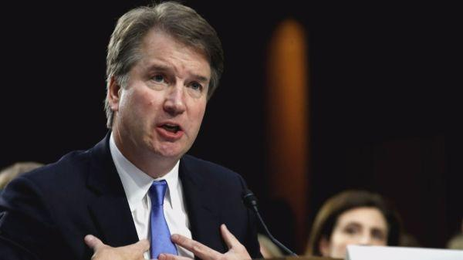
The Journal says that while the last-minute accusation against Supreme Court nominee Brett Kavanaugh is an "ugly spectacle" by itself - liberals have abandoned the entire notion of due process and the burden of proof in order to fit a political agenda.
Via the Wall Street Journal:
The Presumption of Guilt
The new liberal standard turns American due process upside down.
“As Judge Kavanaugh stands to gain the lifetime privilege of serving on the country’s highest court, he has the burden of persuasion. And that is only fair.”
—Anita Hill, Sept. 18, 2018
“Not only do women like Dr. Ford, who bravely comes forward, need to be heard, but they need to be believed.”
—Sen. Maize Hirono (D., Hawaii)
The last-minute accusation of sexual assault against Supreme Court nominee Brett Kavanaugh is an ugly spectacle by any measure. But if there is a silver lining, it is that the episode is providing an education for Americans on the new liberal standard of legal and political due process.
As Ms. Hill and Sen. Hirono aver, the Democratic standard for sexual-assault allegations is that they should be accepted as true merely for having been made. The accuser is assumed to be telling the truth because the accuser is a woman. The burden is on Mr. Kavanaugh to prove his innocence. If he cannot do so, then he is unfit to serve on the Court.

***
This turns American justice and due process upside down. The core tenet of Anglo-American law is that the burden of proof always rests with the person making the accusation. An accuser can’t doom someone’s freedom or career merely by making a charge.
The accuser has to prove the allegation in a court of law or in some other venue where the accused can challenge the facts. Otherwise we have a Jacobin system of justice in which “J’accuse” becomes the standard and anyone can be ruined on a whim or a vendetta.
Another core tenet of due process is that an accusation isn’t any more or less credible because of the gender, race, religion or ethnicity of who makes it. A woman can lie, as the Duke lacrosse players will tell you. Ms. Hirono’s standard of credibility by gender would have appalled the civil-rights campaigners of a half century ago who marched in part against Southern courts that treated the testimony of black Americans as inherently less credible than that of whites. Yet now the liberal heirs of those marchers want to impose a double standard of credibility by gender.
A third tenet of due process is the right to cross-examine an accuser. The point is to test an accuser’s facts and credibility, which is why we have an adversarial system. The denial of cross-examination is a major reason that campus panels adjudicating sexual-assault claims have become kangaroo courts.
It’s worth quoting from the Sixth Circuit Court of Appeals ruling this month in Doe v. Baum on a sexual-assault case at the University of Michigan.
“Due process requires cross-examination in circumstances like these because it is ‘the greatest legal engine ever invented’ for uncovering the truth,” wrote Judge Amul Thapar. “Not only does cross-examination allow the accused to identify inconsistencies in the other side’s story, but it also gives the fact-finder an opportunity to assess a witness’s demeanor and determine who can be trusted. So if a university is faced with competing narratives about potential misconduct, the administration must facilitate some form of cross-examination in order to satisfy due process.”

***
Consider the limited facts of Christine Blasey Ford’s accusation against Judge Kavanaugh. It concerns an event some 36 years ago that she recalls in only partial detail. She remembers the alleged assault and rooms she entered with some specificity, but not the home where it occurred. She doesn’t know how she traveled to or from the home that evening.
She told no one about the incident for 30 years until a couples therapy session with her husband. Her therapist’s notes say there were four assailants but she says there were only two. Two of the three other people she says were at the drinking party that night say they know nothing about the party or the assault, and Mr. Kavanaugh denies it categorically.
Democrats claim that even asking questions about these facts is somehow an unfair attack on her as a woman. Her lawyer is demanding that Ms. Ford testify after Mr. Kavanaugh, and that only Senators ask questions—no doubt to bar Republicans from having a female special counsel ask those questions.
We’re told Ms. Ford even wants to bar any questions about why she waited so long to recall the alleged assault and who she consulted in finally going public this year. Such a process is designed to obscure the truth, not to discover it. None of these demands should be tolerable to Senators who care about finding the truth about a serious accusation.
We don’t doubt that Ms. Ford believes what she claims. But the set of facts she currently provides wouldn’t pass even the “preponderance of evidence”—or 50.01% evidence of guilt—test that prevails today on college campuses. If this is the extent of her evidence and it is allowed to defeat a Supreme Court nominee, a charge of sexual assault will become a killer political weapon regardless of facts. And the new American standard of due process will be the presumption of guilt
Space X Weapons Commitment
SpaceX President and Chief Operating Officer Gwynne Shotwell speaks to audiences around the world and gets lots of questions. During an appearance on Monday at the Air Force Association's annual symposium, Shotwell was thrown a question she said she had never heard before: "Would SpaceX launch military weapons?"
"I've never been asked that question," Shotwell said somewhat surprised. Her response: "If it's for the defense of this country, yes, I think we would." [See the Evolution of SpaceX's Rockets in Pictures]
The room packed with Air Force service members and military contractors burst into applause. They seemed impressed that SpaceX is one of the world's coolest companies and also a staunch patriot. Before the Q&A session, Shotwell delivered a 20-minute presentation that mostly featured promotional videos of SpaceX's spectacular Falcon Heavy mission in February. The videos also drew cheers from the crowd.
Shotwell didn't have much to say about the military launch business other than that SpaceX spent "a lot of time building our relationship with the Air Force. And we're now in a good position. We're competing. We're wining some, and losing some."
When asked how bad is the Air Force acquisition system, Shotwell said the Air Force has not cornered the market on red tape. The "most challenging" government customer for SpaceX has been NASA, she said. The company is preparing to launch its Crew Dragon capsule with astronauts onboard, a mission where failure is not an option, she said. The Air Force has asked SpaceX to make its rockets more reliable for national security satellites, but that still does not compare to the pressure of taking humans to space safely.
Shotwell defended SpaceX's culture of risk taking and aggressive innovation. "Failure is bad. But failure while you're trying and you're testing is not terrible. You're learning from it."

The next big challenge for SpaceX is the Big Falcon Rocket, with a second stage called Big Falcon Spaceship that the company believes can reach Mars. Shotwell noted that both stages are fully reusable.
"I hope to be doing hot tests next year with the second stage, the spaceship, and make an orbital flight in 2020," she said. "We would like to put large cargo on the surface of the moon by 2022. And we have our eyes on the prize to send people to Mars in 2024."
Shotwell admitted that those pronouncements might "sound crazy, but everything we've ever done has sounded crazy to people."
The huge second stage spaceship will travel half way around the world in under 30 minutes, she said. "Imagine what we could do for the defense of the United States."
Asked if she worries about national security space threats from China or Russia, Shotwell replied: "As the president of SpaceX, I am concerned about the competition coming from China and Russia because they're backed heavily by their governments. As an American citizen I worry more about China than Russia."
SpaceX last year flew 18 missions, beating any other company or country besides the United States. This year, SpaceX has completed 16 missions and is on track to complete 22 to 24 launches, while China attempts to carry out 40 (as of Sept. 9, it had already completed 24, surpassing its previous national record of 22 set in 2016).
"I was hoping to beat the Chinese this year," she said. "It does concern me that China is flying 40 times this year. And it's not for commercial customers. They have very few commercial customers. So what in the world are they doing?" she added. "The fact that I'm not beating them is a shame. The fact that they're launching 40 times is something we should all be worried about."
Shotwell echoed concerns voiced by Pentagon officials about China's pursuit of space capabilities. "They innovate in a different way, they go after ideas, they stick to a plan, and their pace is much faster."
Bye Bye Rod Rosenstein
View image on Twitter
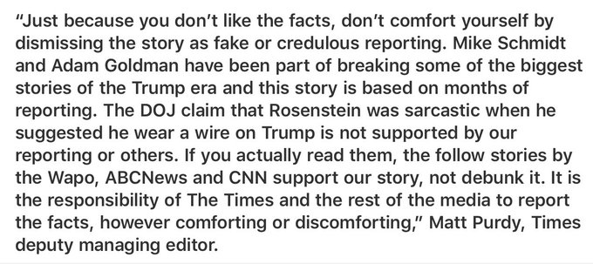

Matt Purdy@mattbpurdy

To the critics of The New York Times Rosenstein story...
9:22 AM - Sep 22, 2018
Twitter Ads info and privacy

Short Story Insert
I'm from Alabama, family still lives there. I'm relaying this story from my dad, who doesn't keep up with Q or anything like that.
My dad works with a guy, let's call him Joe, that worked on a local political campaign. Well the man Joe worked for on the campaign was impressed and was invited to a dinner for Senator Shelby in DC and took Joe with him. It wasn't a huge dinner, Joe said 20ish people there. Well Sessions comes and speaks to the room and Joe said he told the whole room that the feud between he and Trump was bull and not to listen to it and that it was just for the media.
Disclaimer: I do subscribe to the theory that Trump and Sessions aren't feuding. I had told my dad I thought it could be bullshit months ago. But this phone call was last week. He brought it up unprompted too.
The New York Times on Saturday defended its bombshell report on Friday that Deputy Attorney General Rod Rosenstein discussed secretly recording conversations with President Trump last year and proposed the possibility of administration officials invoking the 25th Amendment to remove the president from office.
The Times’s deputy managing editor Matt Purdy wrote in a statement Saturday that the newspaper stands by the reporting of its journalists, Mike Schmidt and Adam Goldman, who broke the story.

Citing unnamed sources, the Times reported on Friday that Rosenstein made the remarks just weeks into his job last year following the sudden firing of FBI Director James Comey.
“The DOJ claim that Rosenstein was sarcastic when he suggested he wear a wire on Trump is not supported by our reporting or others.”
“It is the responsibility of the media to report the facts, however comforting or discomforting.”
Rosenstein on Friday fiercely denied the Times’s reporting in two separate statements, refusing to address the specifics but stating that he saw no reason to invoke the 25th Amendment to remove Trump from office. The amendment proscribes a process by which a majority of Cabinet members can vote to remove a president deemed unfit to serve.
“The New York Times’s story is inaccurate and factually incorrect,” He said in a statement issued by the Justice Department. “I will not further comment on a story based on anonymous sources who are obviously biased against the department and are advancing their own personal agenda.
“But let me be clear about this: Based on my personal dealings with the president, there is no basis to invoke the 25th Amendment,” the deputy attorney general added.
The Art of War: The Treason Tribunals Begin
Last night President Trump made a brief but very important disclosure during a live interview with Sean Hannity while at a rally in Las Vegas. Hannity asked the president about the pending release of declassified documents. Here is how the president responded:
Well, we’re moving along, we’re working along. We’re also dealing with foreign countries that do have a problem. I must tell you. I got called today from two very good allies saying, “please, can we talk.” So, it’s not as simple as all that. And we do have to respect their wishes. But it will all come out.
This morning President Trump sent out a series of tweets on the subject, providing further information:
I met with the DOJ concerning the declassification of various UNREDACTED documents. They agreed to release them but stated that so doing may have a perceived negative impact on the Russia probe. Also, key Allies’ called to ask not to release. Therefore, the Inspector General…..
….has been asked to review these documents on an expedited basis. I believe he will move quickly on this (and hopefully other things which he is looking at). In the end I can always declassify if it proves necessary. Speed is very important to me – and everyone!
An order for declassification, particularly one as potentially broad as this, touches on many different aspects.
In a previous article, I noted that the declassification process was more complex than commonly thought. Politics aside, there are four different elements at play. And they all relate directly to President Trump’s Declassification Order.
First, there is the ongoing process of the declassification order itself.
Second, there is the ongoing preparation of the DOJ Inspector General’s report on FISA abuse, which was announced on March 28, 2018.
A third element is the involvement of certain U.S. allies—almost certainly Britain and Australia—with the FBI and CIA in the events leading to the establishment of the FBI’s Counterintelligence Investigation.
Finally, we have the ongoing investigation by Special Counsel Robert Mueller.
Besides the ongoing investigation by the Inspector General into potential FISA abuse, he has also at least two subset investigations stemming from his June 2018 report: “A Review of Various Actions by the Federal Bureau of Investigation and Department of Justice in Advance of the 2016 Election.”
As part of these ongoing investigations, classified information the Inspector General is using or pursuing must be protected until the conclusion of his investigations. This has almost certainly caused an inherent conflict with the declassification order issued by President Trump.
The Inspector General’s focus in his most recent, and ongoing, investigation is very specific:
A review that will examine the Justice Department’s and the Federal Bureau of Investigation’s (FBI) compliance with legal requirements, and with applicable DOJ and FBI policies and procedures, in applications filed with the U.S. Foreign Intelligence Surveillance Court (FISC) relating to a certain U.S. person.
As part of this examination, the Office of Inspector General (OIG) will also review information that was known to the DOJ and the FBI, at the time the applications were filed, about an alleged FBI confidential source. In addition, the OIG will also review communications the agencies had with the alleged source as it relates to the FISA applications.
The “certain U.S. person” mentioned is former Trump campaign adviser Carter Page. The “alleged FBI confidential source” is Christopher Steele, the former MI6 spy who was hired to produce the controversial dossier on then-candidate Donald Trump. Another related source is FBI informant Stefan Halper, who will probably come up as part of the IG Investigation.
The Inspector General himself needs to pursue a path of declassification prior to releasing any detailed report. The fact that his finalized reports are primarily public require declassification of information being released (classified appendices are sometimes attached).
The presidential order to initiate the declassification process directly interacts with the Inspector General’s investigation into FISA abuse. That is, at least in part, why President Trump is referencing the Inspector General in his tweets. It’s possible this may indicate, or lead to, a tandem release of the Inspector General’s Report along with declassified documents stemming from President Trump’s order.
It appears more likely that the Inspector General will now be responsible for releasing many—if not all—of the items President Trump specified in his declassification order. As President Trump noted in his tweet, if he is not happy with the results, he can always revert course and declassify the documents himself.

Foreign Allies
In relation to our allies, any information subject to declassification that pertains to foreign intelligence or to the allies themselves would almost certainly result in high-level discussions. In this particular case, it would appear these discussions were of such concern that they resulted in phone calls from two of our allies at levels high enough to reach President Trump directly.
These phone calls are telling and likely confirm that British and Australian Intelligence were both involved in the events leading to the establishment of the FBI’s counterintelligence investigation.
Luke Harding of the Guardian, has previously reported on the involvement of UK Intelligence, noting that Britain’s Government Communications Headquarters (GCHQ) was involved in collecting information and transmitting it to the United States:
In late 2015 the British eavesdropping agency, GCHQ, was carrying out standard “collection” against Moscow targets. These were known Kremlin operatives already on the grid. Nothing unusual here – except that the Russians were talking to people associated with Trump. The precise nature of these exchanges has not been made public, but according to sources in the US and the UK, they formed a suspicious pattern. They continued through the first half of 2016. The intelligence was handed to the US as part of a routine sharing of information.
In the summer of 2016, Robert Hannigan, then-head of Britain’s GCHQ traveled to Washington D.C. to personally meet with then-CIA Director John Brennan:
That summer, GCHQ’s then head, Robert Hannigan, flew to the US to personally brief CIA chief John Brennan. The matter was deemed so important that it was handled at “director level,” face-to-face between the two agency chiefs.
Interestingly, Hannigan’s U.S. counterpart was not CIA Director Brennan. Hannigan’s U.S. counterpart was NSA Director Mike Rogers.
Brennan reportedly used the foreign intelligence to launch an inter-agency investigation.
Then-Director of National Intelligence James Clapper personally confirmed foreign intelligence involvement during Congressional testimony:
Feinstein: Over the spring of 2016, multiple European allies passed on additional information to the United States about contacts between the Trump campaign and Russians. Is this accurate?
Clapper: Yes, it is, and it’s also quite sensitive. The specifics are quite sensitive.
The BBC reported that Brennan’s involvement may have gone back to April 2016:
Last April [2016], the CIA director was shown intelligence that worried him. It was – allegedly – a tape recording of a conversation about money from the Kremlin going into the US presidential campaign.
It was passed to the US by an intelligence agency of one of the Baltic States. The CIA cannot act domestically against American citizens so a joint counter-intelligence taskforce was created.
The taskforce included six agencies or departments of government.
Brennan would later refer to this task force during an interview with MSNBC’s Rachel Maddow.
GCHQ’s Hannigan abruptly announced his retirement on Jan. 23, 2017–following President Trump’s Jan. 20, 2017 inauguration.
The Guardian reported on speculation that Hannigan’s resignation was directly related to UK Intelligence sharing:
His sudden resignation – he informed staff just hours before making this decision public – prompted speculation that it might be related to British concerns over shared intelligence with the US in the wake of Donald Trump becoming president.
The Australian involvement comes courtesy of diplomat Alexander Downer through his meeting with Trump campaign foreign policy adviser George Papadopoulos. It was this meeting, supposedly relayed by Australian intelligence to the FBI in late July 2016 that has been reported as the reason leading to the FBI’s Counterintelligence Investigation on July 31, 2016.
Downer, who has long-standing ties to UK intelligence, served on the Advisory Board of private UK intelligence firm Hakluyt from 2008-2014. He reportedly still maintains contact with Hakluyt officials.
Stefan Halper, the outed FBI spy, also has connections to Hakluyt through Jonathan Clarke, with whom he has co-authored two books. Clarke is the U.S. Representative–Director U.S. Operations for Hakluyt.
There are many other interlaced ties. Sir Richard Dearlove, the former Head of MI6, is associated with nearly every foreign intelligence member mentioned.
It was Dearlove who advised Christopher Steele and his partner Chris Burrows to work with a top British government official to pass along information to the FBI. Dearlove knows Stefan Halper through their mutual association at the Cambridge Intelligence Seminar. Dearlove also knows Sir Iain Lobban, a former head of GCHQ, who is an Advisory Board Member at Hakluyt.
These ties appear nearly endless and illustrate why there should be reason for real concern on the part of current British and Australian foreign intelligence officials.
George Papadopoulos on Thursday sent out an attention-grabbing tweet:
The British and Australian governments’ attempt to sabotage the Trump campaign is about to backfire in a spectacular fashion.
Today, he followed up with this:
After reports are finally out that the British and Australian governments were actively spying and trying to sabotage the Trump campaign, those two governments called the president to ask for him not to declassify any I documents. Strange.
Underlying all of the noise appears to be an effort on the part of the DOJ to control the manner in which information becomes public. After President Trump issued his order for declassification, both the DOJ and two of our allies made their case to limit or delay the release of that information.
In exchange for backing away from his immediate declassification request, President Trump has pushed the Inspector General’s Report to the forefront with an accelerated time-frame for its release.
Should the IG report prove less revealing, or more drawn out than is required, President Trump can revert to his prior declassification order.
This apparent behind-the-scenes negotiating appears to be in regards to managing the damage done to our institutions—and our allies—as a result of the actions under the previous administration.
Personally, I’m in favor of full disclosure now—and let the chips fall where they may.
But I also understand the power of leverage. Despite the disappointment sure to be expressed by many, President Trump is currently holding a position of significant leverage over all of those involved—including Britain and Australia.
Ask yourself a simple question. Which avenue proves more powerful in manners of public persuasion. A forced declassification of a specified set of documents by President Trump. Or an honest and damning report issued by an independent Inspector General. One who was nominated by Obama. President Trump has made the decision that a better course is to allow IG Horowitz to manage the information disclosure. If this is not done to President Trump’s satisfaction, well, my guess is all bets are off.
In the meantime, my expectation is that the release of the Inspector General’s report just got significantly accelerated.
Raising Your Vibration
Every thought or feeling has a vibration that can be measured. The reason you want to raise these vibrations is to become high enough to connect to the power of intention. That place is the sweet spot where you feel joy and happiness, and your dream life will become your reality.
Where we may become deceived is that we are told that we can make ourselves happy. Just saying the word will drive a person into depression. A depressed person is not happy, resents people who are happy, and have no more skill at happiness than they do brain surgery. So, where does happiness come from? The truth is that it is a gift. Some say it is given by God. Others say, it rides on the Universe like a song, and we have to resonate with it to impart of it.
Are we always happy? No. If we were, we would have nothing with which to compare it with. Sort of like walking out of a movie theater into the afternoon sun. Dark inside, and light outside. When we’re happy, we would like to know why we are happy or how we got happy, so we can do it on demand. If possible, we would like to have it every day.
What we do know is that happiness is a threshold of frequency. We can be happy when it’s quiet, loud, night, or day. The frequency I am talking about is one that resonates with the soul. There are some ways to attract it into our lives. By way of disclaimer, it won’t always work. Sometimes, you need to eat, meditate, sleep, or cuddle. But, here are some things that you can do for yourself—that is a key phrase—for yourself, that can help to align you with the bounty energy of the universe.
Oh, let me address prayer. Because, sometimes people say that since happiness is a gift from God that you have to pray, and He will give it to you. There are three levels of prayer. I’m sure you have done all three, but knowing what they are, and the value of them will be helpful.
Level One – The lowest level of prayer is the ritual. Regular and sometimes repetitious, they cover blessings over food, opening and closing meetings, or sometimes going to sleep. They are useful for what they do, and keep doing them, but they are of no value for making people happy.
Level Two – The mid-level prayer is when we pray for ourselves. These can be for a job, to find a spouse, or for a job or money. Oh, we can pray our guts out and weep and wail, and these prayers don’t get much further than the ceiling. These prayers form a cacophony of selfish chaos in the universe, and nearly all the time, the line is busy. You won’t get an answer, no matter what you do or what you promise to stop doing. Mostly, you should forget about praying this way, because it will do nothing but depress you and convince you that God is pretty much dead.
Level Three – The highest level of prayer is when we pray for other people. This is the only type of prayer that can move the heavens. When we put the comfort, blessing, wealth, protection, or healing of another person into our prayers two things happen. First, the petition is much more able to develop resonant power in the universe. It can be the catalyst or the attractive vibration that crystalizes the very thing that person needs. Whether you know it or not, all prayers of this type are heard. You can pray for someone’s blessing and you can of course pray for someone’s destruction by calling the vengeance of God upon them. Oh it works. Believe me.
But if you do that you will miss out on the second thing that can happen. When we pray for someone else, we can be given happiness and joy. When you pray for someone to be healed, it has a good effect on you too. When you touch the person with your physical body and pray for that specific thing in that person, the effect is quite miraculous. The bond is eternal. The gift can be highly developed. A much higher form of happiness called joy can quite often be the result. Joy can be remembered. Joy can be shared. Joy can be saved up and invested in other things.
In addition to this, here are some things that can help you master yourself and master happiness.
1. Become conscious of your thoughts.
This is very hard to do. A wise teacher told me half a century ago that when we control the eye, we control the mind. A child who does not see the candy bars in the checkout isle will not think so much about candy bars. You get the point. Watch what you watch.
The more you do this, the more positive thinking will become natural. Come up with some affirmations and place them in spaces where you’ll notice them and read them throughout the day. This means little slogans or works of art or icons that represent a joyful moment. Before you go to work, or go to bed, take a look at these and reflect on their meaning for a moment. If you don’t have anything like this lying around, write something. Print it. Buy a book of positive things like a scripture for the day. Read a few words at beginnings or endings of things. Post them on your bathroom mirror, on the refrigerator, or on the dashboard of your car. Every time you see one, read it in your head or out loud at least three times. Don’t let anyone ever tell this is goofy. It is not. Millionaires may not do this. Billionaires do.
2. Make meditation a regular practice in your life.
Even if you only have a minute, take time to reflect. Meditating is a time when you connect with a higher power and your intuition. I highly recommend learning to breathe properly. I use the FOL meditation, and it works. 17 breaths and then the 18th breath. This will allow you to master your body with the spirit. Show me a person who’s body is in charge of the mortal experience, and I will show you someone in jail, or 60 pounds overweight.
3. Become conscious of the foods you eat.
Some foods vibrate low and some vibrate high. If the food you consume is covered in pesticides, it will leave you feeling weaker. So will artificial, chemicalized processed foods. The good, high-vibrational foods are organic fruits, veggies, nuts, soy, and virgin olive oil. On the low vibrational list are flour-based cereals, dairy, and sugars.
This is not always true for everyone. Really paying attention to how you feel immediately after eating something and how you feel two hours after eating something is the true test. Start paying attention.
4. Reduce your drug and alcohol use or cut it out of your life completely, if it drives you into depression.
Now, here is something amazing to see. There is a maelstrom of information out there in the cosmos. Creative people—that could be any of us some of the time—reach out into this chaos and grab an image, melody, or a string of concepts and bring it back through the veil to this dimension. They create a poem, a song, a painting, or a new technology of some kind.
Sometimes, certain drugs and alcohol can open that portal for us. Greatness is there, make no mistake. Greater than you. Greater than many. It can be overwhelming. It can be intoxicating. It can tempt you to destroy yourself. If you are sober, or more on the sober side of a state of mind, you are less likely to trade your soul for fame and fortune.
If you make this trade, you can be made wealthy beyond a thousand lifetimes, for a while. Then, the pain sets in. Your soul will hurt. You will be tempted to dull this pain with more drugs or alcohol, and it will not help. Every day, you see people who made this deal die of drug overdoses or self inflicted injuries.
I recommend not doing drugs or alcohol. If you do, decide in advance when you are going to start, stop, and most importantly WHY you are doing it. Not because it is Friday. Because you are writing a song. Not because your friends said hey let’s go get hammered. Because you are painting or loving or beholding something amazing with even greater enhancement. When that experience is done, so is the drinking or the drugs.
If you are incapable of driving a vehicle more than once a month, you may have a problem that needs correcting. ‘nuff said.
5. Become conscious of what your music is telling you.
Lyrics that inspire, touch your heart, reach tender place in you that ‘s fine. Lyrics that hate, conjure devils or violence need to be avoided. The vibration of music is very important as well. There is a reason why all church hymns are written in certain keys, utilize minor chords in certain places and have four part harmonies. There is a reason why you feel so good after church. It recharges us.
Now, why doesn’t that work when you play those hymns at home on the CD? Because the vibrations come from within, not from without. If you really want to feel the rejuvenating power of song, learn the hymn by heart and sing it with your might. Then you will feel your heart singing.
The same thing goes for songs you listen to. Learn a song. Sing it yourself without the music. Musical keys and vibrations are everywhere. I used to walk through the noisy power plant on night watch. The motors were turning at 1,750 RPM. That is the 73rd key on the piano. A₆ has several harmonics and octaves below it. I used to transpose songs with my voice, match the harmony, and sing the song as loud as I could in the concrete building that was 7 stories tall. No one could hear me, because we all wore ear plugs as it was deafening loud in there. But, the vibrations in my chest would match the frequency of the key of A, and the resonation was very elating. I was very happy those years working in that plant.
6. Be aware of your home environment.
You're in your home a lot, which will affect your vibration. Prayers, paintings, photographs, crystals, statues, rocks, mantras, books, magazine, flowers, plants, the colors on the wall, and even the way your furniture is arranged all create energy. Get your home high by getting your feng shui on! Oh, remember this. Clutter causes stress. Flowers are so much more beautiful without the weeds. It’s as simple as that. We call this 5-S. In Japanese we say this:
- Seiri
- Seiton
- Seiso
- Seiketsu
- Shitsuke
In English, these words are often translated to:
- Straighten (unclutter)
- Set in Order
- Shine
- Standardize
- Sustain
When these principles were mastered in Japan, they struck fear in the competitors. Any company that mastered this practice was less likely to make mistakes, have fires, accidents, pests, and lose inventory. How many times have you gotten mad because you couldn’t find what you were looking for? My grandmother used to say her three favorite words were, “I found it.”

7. Reduce the amount of low-vibrational television you watch.
Useless humor. Game shows. The news. Sports. All crap. Watch movies. Critique them. Watch how they are filmed. The music. The sets. The plots. It doesn’t matter if its violent or a chick flick. Make sure the good guys win. It will go a long way to opening your mind to the great things of life.
8. Become aware of the vibrational levels of your acquaintances, friends, and extended family.
You can raise your own energy levels by hanging out with people who vibrate highly. Choose to surround yourself with people who are empowering, have the same morals as you, and see how much you rock. Your friends are a reflection of you, and since you are obviously awesome, your friends must be just as awesome.
9. Practice random acts of kindness and expect nothing in return.
Give some money to someone less fortunate than you. Donate to a cause you believe in. Pay for the toll of the person behind you on the parkway. Send a thoughtful gift to someone you haven’t spoken to in years. Donate clothing to a shelter. Pick up a piece of garbage and throw it away. Don’t do it for the thank you and don’t expect one. Do it out of the kindness of your heart.
10. Practice compassion and forgiveness.
Forgiving and having compassion for someone who hurt you may be the hardest thing for you to do on this list, but it’s one of the most important. You are no longer the victim and your abuser holds none of your power. Thoughts of revenge are low vibrational while thoughts of forgiveness are high. Just by thinking thoughts of forgiveness about someone in your past without taking any action will raise your vibration.
2000 Apprehended in 3 Days in Texas

Border Patrol agents in the Rio Grande Valley Sector apprehended more than 2,000 migrants during a three-day period at a tiny area known for illegal border crossing. The groups consisted mainly of migrant families and unaccompanied children from Central America.
McAllen Station agents are being inundated with migrant families and unaccompanied minors illegally crossing the border from Mexico. Once across the border, the migrants turn themselves in to the first Border Patrol agents they can find, according to information provided to Breitbart Texas from Rio Grande Valley Sector Border Patrol officials.
“The continued flow of migrants turning themselves in to Border Patrol agents is creating an unsustainable situation,” Rio Grande Valley Sector Chief Patrol Agent Manuel Padilla, Jr. said in a written statement. “The transnational criminal organizations exploit family units and unaccompanied children populations and create diversions for agents, leaving areas along the Rio Grande vulnerable.”
During a three-day period, McAllen Station agents apprehended more than 2,000 migrants in an area along the border known as Rincon Village. The area has long been known as a staging area where Mexican cartels cross the migrants who will then surrender to Border Patrol agents.
“A majority of apprehensions are occurring near Granjeno, just south of Mission, in what’s become a staging area dubbed ‘Rincon Village,’ where illegal immigrants of all ages turn themselves in to agents. The area is well known and has become a gateway for human smuggling,” Chief Padilla explained.
Sector officials previously told Breitbart Texas that cartels exploit these families and the unaccompanied children in order to tie up Border Patrol agents. While the agents are occupied with processing the migrants, cartels will move other migrant groups who seek to avoid apprehension or drug shipments across other border regions.
There is no physical barrier in this segment of the U.S.-Mexico border.
The New York Times Judge and Jury
We’ve seen it before: a newspaper and individual reporters get a story horribly wrong but instead of correcting it they double down to protect their reputations and credibility - which is all journalists have to go on - and the public suffers.
Sometimes this maneuver can contribute to a massive loss of life. The most egregious example was the reporting in the lead-up to the invasion of Iraq. Like nearly all Establishment media, The New York Times got the story of Iraq’s weapons of mass destruction—the major casus belli for the invasion—dead wrong. But the Times, like the others, continued publishing stories without challenging their sources in authority, mostly unnamed, who were pushing for war.
The result was a disastrous intervention that led to hundreds of thousands of civilian deaths and continued instability in Iraq, including the formation of the Islamic State.
In a massive Times‘ article published on Thursday, entitled, “A Plot to Subvert an Election: Unravelling the Russia Story So Far,” it seems that reporters Scott Shane and Mark Mazzetti have succumbed to the same thinking that doubled down on Iraq.
They claim to have a “mountain of evidence” but what they offer would be invisible on the Great Plains.
With the mid-terms looming and Special Counsel Robert Mueller unable to so far come up with any proof of collusion between Russia and the Trump campaign to steal the 2016 election—the central Russia-gate charge—the Times does it for him, regurgitating a Russia-gate Round-Up of every unsubstantiated allegation that has been made—deceptively presented as though it’s all been proven.
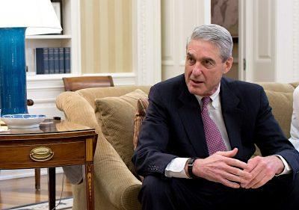
Mueller: No collusion so far.
This is a reaffirmation of the faith, a recitation of what the Russia-gate faithful want to believe is true. But mere repetition will not make it so.
The Times’ unsteady conviction is summed up in this paragraph, which the paper itself then contradicts only a few paragraphs later:
“What we now know with certainty: The Russians carried out a landmark intervention that will be examined for decades to come. Acting on the personal animus of Mr. Putin, public and private instruments of Russian power moved with daring and skill to harness the currents of American politics. Well-connected Russians worked aggressively to recruit or influence people inside the Trump campaign.”
But this schizoid approach leads to the admission that “no public evidence has emerged showing that [Trump’s] campaign conspired with Russia.”
The Times also adds: “There is a plausible case that Mr. Putin succeeded in delivering the presidency to his admirer, Mr. Trump, though it cannot be proved or disproved.”
This is an extraordinary statement. If it cannot be “proved or disproved” what is the point of this entire exercise: of the Mueller probe, the House and Senate investigations and even of this very New York Times article?
Attempting to prove this constructed story without proof is the very point of this piece.

A Banner Day
The 10,000-word article opens with a story of a pro-Russian banner that was hung from the Manhattan Bridge on Putin’s birthday, and an anti-Obama banner hung a month later from the Memorial Bridge in Washington just after the 2016 election.
On public property these are constitutionally-protected acts of free speech. But for the Times, “The Kremlin, it appeared, had reached onto United States soil in New York and Washington. The banners may well have been intended as visual victory laps for the most effective foreign interference in an American election in history.”
Kremlin: Guilty, says NYT. (Robert Parry, 2016)
Why? Because the Times tells us that the “earliest promoters” of images of the banners were from social media accounts linked to a St. Petersburg-based click-bait farm, a company called the Internet Research Agency. The company is not legally connected to the Kremlin and any political coordination is pure speculation. IRA has been explained convincingly as a commercial and not political operation. Its aim is get and sell “eyeballs.”
For instance the company conducted pro and anti-Trump rallies and social media messages, as well as pro and anti-Clinton. But the Times, in classic omission mode, only reports on “the anti-Clinton, pro-Trump messages shared with millions of voters by Russia.” Sharing with “millions” of people on social media does not mean that millions of people have actually seen those messages. And if they had there is little way to determine whether it affected how they voted, especially as the messages attacked and praised both candidates.
The Times reporters take much at face value, which they then themselves undermine. Most prominently, they willfully mistake an indictment for a conviction, as if they do not know the difference.
This is in the category of Journalism 101. An indictment need not include evidence and under U.S. law an indictment is not evidence. Juries are instructed that an indictment is merely an accusation. That the Times commits this cardinal sin of journalism to purposely confuse allegations with a conviction is not only inexcusable but strikes a fatal blow to the credibility of the entire article.
It actually reports that “Today there is no doubt who hacked the D.N.C. and the Clinton campaign. A detailed indictment of 12 officers of Russia’s military intelligence agency, filed in July by Mr. Mueller, documents their every move, including their break-in techniques, their tricks to hide inside the Democrats’ networks and even their Google searches.”
Who needs courts when suspects can be tried and convicted in the press?
What the Times is not taking into account is that Mueller knows his indictment will never be tested in court because the GRU agents will never be arrested, there is no extradition treaty between the U.S. and Russia and even if it were miraculously to see the inside of a courtroom Mueller can invoke states secrets privilege to show the “evidence” to a judge with clearance in his chambers who can then emerge to pronounce “Guilty!” without a jury having seen that evidence.
This is what makes Mueller’s indictment more a political than a legal document, giving him wide leeway to put whatever he wants into it. He knew it would never be tested and that once it was released, a supine press would do the rest to cement it in the public consciousness as a conviction, just as this Times piece tries to do.

Errors of Commission and Omission
There are a series of erroneous assertions and omissions in the Times piece, omitted because they would disturb the narrative:
- Not mentioning that the FBI was never given access to the DNC server but instead gullibly believing the assertion of the anti-Russian private company CrowdStrike, paid for by the DNC, that the name of the first Soviet intelligence chief found in metadata proves Russia was behind the hack. Only someone wanting to be caught would leave such a clue.
- Incredibly believing that Trump would have launched a covert intelligence operation on live national television by asking Russia to get 30,000 missing emails.
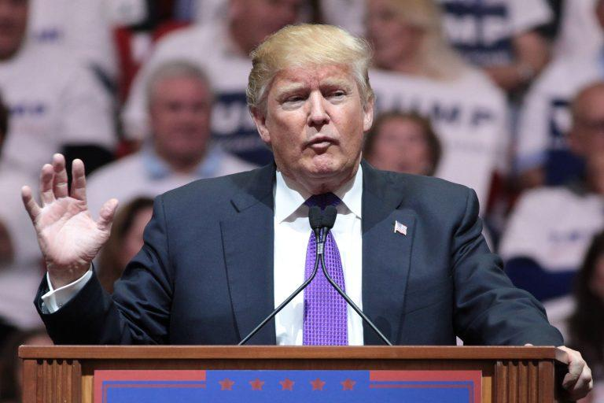
Trump: Sarcastically calls on Russia to get Clinton emails.
- Ignoring the possible role of the MI6, the CIA and the FBI setting up Trump campaign members George Papadopoulos and Carter Page as “colluders” with Russia.
- Repeating misleading statements about the infamous Trump Tower meeting, in which Trump’s son did not seek dirt on Clinton but was offered it by a music promoter, not the Russian government. None was apparently produced. It’s never been established that a campaign receiving opposition research from foreigners is illegal (though the Times has decided that it is) and only the Clinton campaign was known to have obtained any.
- Making no mention at all of the now discredited opposition research dossier paid for by the Clinton campaign and the DNC from foreign sources and used by the FBI to get a warrant to spy on Carter Page and potentially other campaign members.
- Dismissing the importance of politicized text messages between FBI agents Peter Strzok and Lisa Page because the pair were “skewered regularly on Mr. (Sean) Hannity’s show as the ‘Trump-hating F.B.I. lovebirds.’”
- Putting down to “hyped news stories” the legitimate fear of a new McCarthyism against anyone who questions the “official” story being peddled here by the Times.
- Seeking to get inside Putin’s head to portray him as a petulant child seeking personal revenge against Hillary Clinton, a tale long peddled by Clinton and accepted without reservation by the Times.
- Pretending to get into Julian Assange’s head as well, saying he “shared Mr. Putin’s hatred of Mrs. Clinton and had a soft spot for Russia.” And that Assange “also obscured the Russian role by fueling a right-wing conspiracy theory he knew to be false.”
- Ignoring findings backed by the Veteran Intelligence Professionals for Sanity that the DNC emails were leaked and not hacked.
- Erroneously linking the timing of WikiLeaks’ Podesta emails to deflect attention from the “Access Hollywood” tape, asdebunked in Consortium News by Italian journalist Stefania Maurizi, who worked with WikiLeaks on those emails.

Distorts Geo-Politics
The piece swallows whole the Establishment’s geo-strategic Russia narrative, as all corporate media do. It buys without hesitation the story that the U.S. seeks to spread democracy around the world, and not pursue its economic and geo-strategic interests as do all imperial powers.
The Times reports that, “The United States had backed democratic, anti-Russian forces in the so-called color revolutions on Russia’s borders, in Georgia in 2003 and Ukraine in 2004.” The Times has also spread the erroneous story of a democratic revolution in Ukraine in 2014, omitting crucial evidence of a U.S.-backed coup.
The Times disapprovingly dismisses Trump having said on the campaign trail that “Russia was not an existential threat, but a potential ally in beating back terrorist groups,” when an objective view of the world would come to this veryconclusion.
The story also shoves aside American voters’ real concerns that led to Trump’s election. For the Times, economic grievances and rejection of perpetual war played no role in the election of Trump. Instead it was Russian influence that led Americans to vote for him, an absurd proposition defied by a Gallup poll in July that showed Americans’ greatest concerns being economic. Their concerns about Russia were statistically insignificant at less than one percent.
Ignoring Americans’ real concerns exposes the class interests of Times staffers and editors who are evidently above Americans’ economic and social suffering. The Times piece blames Russia for social “divisions” and undermining American democracy, classic projection onto Moscow away from the real culprits for these problems: bi-partisan American plutocrats. That also insults average Americans by suggesting they cannot think for themselves and pursue their own interests without Russia telling them what to do.
Establishment reporters insulate themselves from criticism by retreating into the exclusive Establishment club they think they inhabit. It is from there that they vicariously draw their strength from powerful people they cover, which they should instead be scrutinizing. Validated by being close to power, Establishment reporters don’t take seriously anyone outside of the club, such as a website like Consortium News.
But on rare occasions they are forced to take note of what outsiders are saying. Because of the role The New York Timesplayed in the catastrophe of Iraq its editors took the highly unusual move of apologizing to its readers. Will we one day read a similar apology about the paper’s coverage of Russia-gate?

