Jihad Report
Nov 02, 2019 -
Nov 08, 2019
Attacks | 26
Killed | 150
Injured | 164
Suicide Blasts | 0
Countries | 13
At least four propaganda posters have appeared on Quraysh, a pro-ISIS media outlet, urging followers to “ignite fires” in forests, The Washington Free Beacon says, citing The Middle East Media Research Institute.
“Ignite fires in the forests of America, France, Britain, and Germany, for they are painful to them,” one poster reads, according to the site. Keep your eyes open and make sure you call 911 if you see anything suspicious. Remember, we are at war with the Global Syndicate and they have unlimited funding.
A Warning from the Past
Nathaniel Grigsby was a Union officer during the Civil War, a patriot, and a close friend of President Abraham Lincoln. He was also very much on to the treasonous and evil antics of the Democratic Party, which, after the Civil War, established an enforcement arm to keep former slaves from voting and prospering. You might better know that enforcement arm as the Ku Klux Klan.
The Democratic Party was the party of corruption and evil then, and it remains the party of corruption and evil today. Nate Grigsby tried to warn us 129 years ago. Some things never change.
By Dean James
Trending: McConnell tells President Trump that to survive impeachment, he must become a swamp rat. The chance of that happening is exactly zero!
In Kansas, one man carried out his dying wish and gave us a “grave” warning about the Democratic Party. 129 years ago, his last request was fulfilled and etched on his tombstone.

Top of Form
Bottom of Form
Nathaniel Grigsby was born on October 11, 1811. He was a Civil War veteran, a 2nd Lieut., of Company G, 10th Indiana Cavalry. He was a farmer.
Nathaniel was a dear friend of Abraham Lincoln.
After Lincoln moved to Illinois in 1830, Nathaniel moved with his father to Carroll Co., MO in 1855.
In 1860, he was living in Norborne. He wrote to Lincoln and received an appointment as Republican Precinct Committee Man. He placed Lincoln’s name on the 1860 ballot. All of Natty’s neighbors were Southern sympathizers. He had been talking about electing Lincoln for president in town. One morning at about 2 or 3 a.m. a neighbor rode up and told Natty not to light any lights. The neighbor wanted to warn him that his neighbors were planning to murder him and if he wanted to live he should be on his way.
After the warning, Natty moved back to Spencer Co., IN where he and four of his five sons enlisted in Company C 10th IN Cavalry (Richmond Davis did not enlist). Natty was named 2nd Lieutenant. ~Authentic Campaigner
In 1890, Mr. Grigsby passed away in Kansas. However, he left a brilliant warning to future generations inscribed on his tombstone.
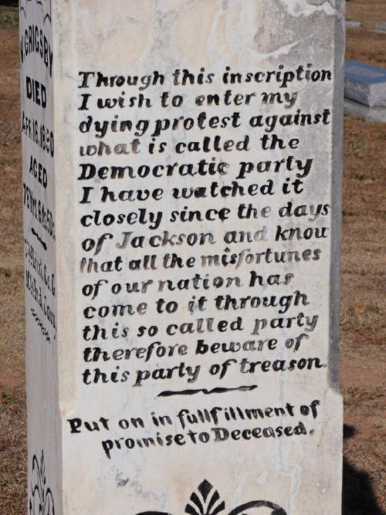
It reads:
“Through this inscription I wish to enter my dying protest against what is called the Democratic party. I have watched it closely since the days of Jackson and know that all the misfortunes of our nation has come to it through this so called party therefore beware of this party of treason.”
Brandon Walker at Mad World News reports:
Set in that stone is a warning to all about the Democrat party. Even Snopes states that the inscription is in fact true.
While you can blame it on his involvement in one of the bloodiest battles in history, loosing a son in the war, or the fact that his childhood friend was assassinated, it still rings true. You can even choose to believe the old Dixicrat lie that even Sodahead admits is a myth back in 2002. You can even blame his 30 years of bitterness or the KKK (founded by Democrats).
It seems these days that everywhere I turn race, old politics, reparations, and reverse racism (even going as far as challenging a NFL team name) is everywhere. Calls to destroy the Constitution, wanting Amendments to destroy the Bill of Rights, calls to turn our beloved country into the USSR type structure, and racist organizations have all one thing in common. Since the DNC likes to “drag up” the nations past while inciting the public into another Civil War, well, two can play that game.
It seems Nathaniel Grigsby’s dying wish to warn us was right all along. 129 years ago…

The Impeachment Battle Begins
“Because President Trump should be afforded an opportunity to confront his accusers, the anonymous whistleblower should testify,” he wrote.
Moreover, given the multiple discrepancies between the whistleblower’s complaint and the closed-door testimony of the witnesses, it is imperative that the American people hear definitively how the whistleblower developed his or her information, and who else the whistleblower may have fed the information he or she gathered and how that treatment of classified information may have led to the false narrative being perpetrated by the Democrats during this process.
As the American public is now aware, in August 2019, you and/or your staff met with or talked to the whistleblower who raised an issue with President Trump’s phone call with Ukrainian President Zelensky. Although you claim that nothing inappropriate was discussed, the three committees deserve to hear directly from you the substance and circumstances surrounding any discussions conducted with the whistleblower, and any instructions you issued regarding those discussions. Given that you have reneged on your public commitment to let the committees interview the whistleblower directly, you are the only individual who can provide clarity as to these conversations.
The requested witnesses also includes Hunter Biden, who sat on the board of Ukrainian gas company Burisma earning up to $83,000 a month while his father was vice president and in charge of the Ukraine portfolio. Former Vice President Joe Biden has famously talked about forcing Ukraine to fire its chief prosecutor — who was investigating Burisma — by threatening to withhold $1 billion in aid for Ukraine.
It also includes Alexandra Chalupa, the Ukrainian-American Democratic National Committee operative who worked with Ukrainian officials to obtain dirt on then-candidate Donald Trump’s campaign, according to Politico.
Also requested is Nellie Ohr, the wife of Justice Department official Bruce Ohr, who worked for Fusion GPS on their dossier of Trump. Ohr gathered information from sources in Ukraine, including from former Ukrainian parliamentarian Sehiy Leshchenko.
Republicans also requested for Devin Archer, Biden’s long-term business partner who also served as a fellow board member of Burisma, Under Secretary of State for Political Affairs David Hale, former NSC official Tim Morrison, Trump’s former special envoy to Ukraine Kurt Volker, and anyone the “whistleblower” relied on in writing his second-hand complaint.
The list is in the format of an official letter to House Intelligence Committee Chairman Adam Schiff (D-CA), who is conducting the inquiry.
“We expect that you will call each of the witnesses listed above to ensure that the Democrats’ ‘impeachment inquiry’ treats the President with fairness, as promised by Speaker Pelosi,” said the letter, signed by Nunes.
“Your failure to fulfill Minority requests shall constitute evidence of your denial of fundamental fairness and due process,” he added
Schiff, House Intelligence Committee chairman, responded to the committee’s Ranking Member Devin Nunes‘s (R-Calif.) request to subpoena witnesses including Hunter Biden and the whistleblower, saying that the committee was evaluating the list and “will give due consideration to witnesses within the scope of the impeachment inquiry.”
“As we move into the open hearing phase of the inquiry, the Committee is mindful that we are engaged in a sober endeavor rooted in the Constitution to determine whether the President of the United States engaged in misconduct that warrants impeachment by the House,” he continued in the statement.
He then warned that the impeachment inquiry will not be used to investigate former Vice President Joe Biden and his son, Hunter Biden, or allegations of Ukrainian meddling in the 2016 U.S. presidential elections.
“This inquiry is not, and will not serve, however, as a vehicle to undertake the same sham investigations into the Bidens or 2016 that the President pressed Ukraine to conduct for his personal political benefit, or to facilitate the President’s effort to threaten, intimidate, and retaliate against the whistleblower who courageously raised the initial alarm,” Schiff said.
Nunes unveiled a list of witnesses House Republicans would like to hear from in a letter (pdf) to Schiff on Nov. 9. The list includes include Hunter Biden’s longtime business partner Devon Archer, the person who filed a complaint against President Donald Trump over Trump’s July phone call with Ukraine’s president, and the “more than half a dozen sources” the whistleblower cited in the complaint, which relied on secondhand information and media reports.
“President Trump should be afforded an opportunity to confront his accusers, the anonymous whistleblower should testify,” Nunes wrote.
“Moreover, given the multiple discrepancies between the whistleblower’s complaint and the closed-door testimony of the witnesses, it is imperative that the American people hear definitively how the whistleblower developed his or her information, and who else the whistleblower may have fed the information he or she gathered and how that treatment of classified information may have led to the false narrative being perpetrated by the Democrats during this process,” he added.
Moreover, Alexandra Chalupa, a former Democratic National Committee (DNC) consultant, and Nellie Ohr, a researcher at Fusion GPS, are also on the list.
Nunes said Chalupa worked with the Ukrainian embassy in Washington to obtain information during the 2016 election about then-candidate Trump’s campaign.
“Given President Trump’s documented belief that the Ukrainian government meddled in the 2016 election to oppose his candidacy, which forms the basis for a reasonable desire for Ukraine to investigate the circumstances surrounding the election and any potential Ukrainian involvement, Ms. Chalupa is a prime fact witness who can assist Congress and the American public in better understanding the facts and circumstances surrounding Ukrainian involvement in the 2016 election,” he wrote.
Similarly, Nunes said Ohr is a “prime fact witness” because she helped produce an unreliable dossier that made salacious claims, without evidence, about Trump and his campaign in 2016.
“In a 2018 interview with the House Judiciary and Oversight Committees, Ms. Ohr stated that, during her work with Fusion GPS that ultimately assisted in the production of the Steele Dossier—comprising false allegations against then-candidate Trump—Fusion GPS used information from sources in Ukraine, including Serhiy Leshchenko who recently lost his post from the Ukrainian parliament,” Nunes wrote.
Meanwhile, Republicans want several former or current White House officials including former National Security Council official Tim Morrison, former Ukraine envoy Kurt Volker, and State Department official David Hale testify as well.
Along with the list submitted on Nov. 9, Nunes has also formally requested Schiff to testify in the probe as the committee chairman had misled the public about his and his staff’s interactions with the anonymous whistleblower prior to the complaint being filed.
“As the American public is now aware, in August 2019, you and/or your staff met with or talked to the whistleblower,” Nunes wrote.
“Although you publicly claim nothing inappropriate was discussed, the three committees deserve to hear directly from you, the substance and circumstances surrounding any discussions conducted with the whistleblower, and any instructions you issued regarding those discussions. Given that you have reneged on your public commitment to let the committees interview the whistleblower directly, you are the only individual who can provide clarity as to these conversations.”
Saturday Update

House Intelligence Committee Chairman Adam Schiff described a request by the Republicans for public testimony this week by the whistle-blower who sparked an impeachment inquiry of President Donald Trump as “redundant and unnecessary.”
On Saturday, House intelligence committee ranking member Rep. Devin Nunes, R-Calif., sent a list of witnesses they would like to interview to Schiff, including Hunter Biden, the son of former vice President Joe Biden. The letter was five pages.
Schiff, a Democrat from California, responded to the letter later Saturday with his own two-page letter.
He wrote the impeachment inquiry “has gathered an ever-growing body of evidence — from witnesses and documents, including the President’s own words in his July 25 call record — that not only confirms, but far exceeds, the initial information in the whistle-blower’s complaint. The whistle-blower’s testimony is therefore redundant and unnecessary. In light of the President’s threats, the individual’s appearance before us would only place their personal safety at grave risk.”
In September, Schiff said the whistle-blower would appear before Congress “very soon,” but later has said the testimony is unnecessary.
In the phone call Trump pressed Ukrainian President Volodymyr Zelensky to conduct an investigation of the Bidens. Without confirmation, Joe Biden pressured former Ukrainian President Petro Poroshenko to fire a top prosecutor, Viktor Shokin, who was investigating Ukrainian natural gas firm Burisma Holdings, where Hunter served on the board, bringing in a reported $50,000 per month.
The whistle-blower in a complaint alleges that Trump abused his official powers “to solicit interference” from Ukraine in the 2020 election. That led to the impeachment inquiry.
Nunes has described it as a “sham impeachment process” and the Republicans’ desired witnesses will “provide transparency to your otherwise opaque and unfair process.”
In the letter, Schiff said “this inquiry is not and will not serve, however, as a vehicle to undertake the same sham investigations into the Bidens or 2016 that the President pressed Ukraine to conduct for his personal political benefit, or facilitate the President’s effort to threaten, intimidate, and retaliate against the whistle-blower who courageously raised the initial alarm.”
Also Saturday, the whistle-blower’s attorney Andrew Bakaj reiterated that his client is only willing to answer questions in writing, a suggestion Republicans reject.
“My client’s complaint has been largely corroborated. Nonetheless, I have offered to have my client respond in writing, under oath, and under penalty of perjury to Republican questions,” Bakaj said in a statement to CNN.
Schiff said the committee is “carefully evaluating the witness list you provided, along with the written justifications you included.” He added the consideration will be given “within the scope of the impeachment inquiry.”
Nunes, who served as chairman of the committee until the Democrats regained control of the House in the 2018 midterm, election, had written: “The minority members must identify all potential witnesses we wish to call before knowing the number, topics or scope of hearings you intend to convene. “e Democrats’ impeachment process against President Trump is a drastic departure from bipartisan precedent for presidential impeachment proceedings.”
The GOP’s witness list also named another former Burisma board member, Devon Archer; former Democratic National Committee staffer Alexandra Chalupa; Undersecretary of State for Political Affairs David Hale; former National Security Council official Tim Morrison; former contractor for Fusion GPS Nellie Ohr; former U.S. Special Representative for Ukraine Kurt Volker; and the individuals from which the whistle-blower obtained information about the phone call.

Batteries Not Included
Looking beyond the dramatic headlines - the cliff-hanger nature of Tesla’s financial statements and the Trump administration’s efforts to re-engineer the auto industry - we need to focus on one number that determines when electric vehicles (EVs) will make economic sense. So says a report out of Argonne Laboratories sponsored by the Department of Energy.
That number, according to researcher George Crabtree, is the price of the battery (as measured in $ per kwh), which he says has to halve in order to make EVs competitive with conventional cars. Not promising one might think. Well, researchers now believe that battery prices could reach the magic level somewhere between 2022 and 2026.
But, there is more to come. Researchers are working on lithium ion-solid state batteries. These would not only eliminate the unfortunate flammability issue that dogs lithium batteries but also possibly double the mileage per charge. Toyota hopes to have such a battery ready in the early 2020s.
Still, what about the potential shortage of minerals required to build the batteries? Crabtree points out that the key to making sure we do not have a lithium shortage is to recycle the batteries. At present we recycle almost 100% of lead acid automotive batteries and less than 5% of lithium batteries. However, figuring out how to recycle the latter economically will require research.
What all this says is that the electric vehicle could emerge from its present position in the United States as a well subsidized status symbol to a commercially competitive vehicle within five years. It looks as if the automobile manufacturers will be ready.
But how about the electricity producers? This requires new modes of power distribution for charging stations as well as an ongoing commitment to fossil-free energy sources. This is not a trifling issue for electricity producers. Electric vehicles could eventually account for 30-40% of US electricity sales. This is huge. But these sales will not be made unless the industry has in place an infrastructure to deliver the power to the right places at the right time.
That brings up the perennial chicken-or-the-egg question.
- Should we incur the expense and build EV infrastructure hoping demand will eventually follow?
- Or should we first allow car manufacturers to first build and sell their cars while hoping electric utilities move fast enough to satisfy the demand for EV charging infrastructure?
In real estate for example, developers build roads and lay water pipes rather than tell prospective home buyers to do the job after they have taken possession. Electric utilities have in the past put in necessary infrastructure or made commitments to customers ahead of demand. But this has typically occurred only after receiving the blessing of state utility commission regulators who would permit these new assets to be added to rate base and earn incremental monies for the utility. In that way, the utility recovers its initial, considerable investment. Without the regulator’s blessing, we believe risk adverse utilities will be loath to invest in a seemingly speculative venture, especially when the Federal administration seems so averse to the new technology.
But aside from limitations of batteries, energy density and mineral shortages, the electrification of transportation has the potential to eliminate roughly one quarter of US carbon emissions. This also assumes electric utilities install EV charging infrastructure while continuing to decarbonize base load power generations (which would knock another quarter off carbon emissions). And it now looks as if electricity producers and distributors have little more than five years to get their acts in order. This means that near term utility capital allocation decisions should be reflecting these changes. If not then perhaps another entity will assume responsibility for this aspect of the energy transition.

The Real China Syndrome
China has high ambitions for its state-controlled digital currency.
I wrote two months ago that its central bank digital currency could be imminent. And since foreign adoption of the yuan has been tepid so far, the technology also represents a massive bid to accelerate the internationalization of yuan.

In hindsight, that timing was too aggressive. Beijing likely will introduce its digital currency within 12 to 18 months. China has also doubled down on its conviction. Recently, Chinese Communist Party (CCP) leader Xi Jinping further fanned the flames by extolling blockchain technology—which underpins cryptocurrencies such as Bitcoin—as a “breakthrough that can facilitate China’s progress.”
That endorsement prompted a rally in cryptocurrency prices, which was perhaps undeserved. But its effect on cryptocurrencies, the yuan’s global adoption, Facebook’s Libra project, and Western banking hegemony can’t be understated.

What It Means for Central Banks
China’s strong endorsement of a blockchain-based central bank currency and the West’s relative aversion to the technology opens an interesting new front in the growing U.S.–China technology rivalry.
And it’s a new front on which the United States may not be prepared to fight.
Developments in fintech, payments, and blockchain digital currencies are receiving support from the highest levels of the Chinese central government. The U.S. government—which seeded development of the internet in the 1960s via the ARPANET project—has so far shunned the technology.
Whether blockchain can be a successful technology underpinning global payments is still an open question. Current blockchain technologies still have speed and volume limitations. But what it allows China to do is bypass the dollar-based global banking system and intermediary banks.
There’s another application China is potentially working on. Max Keiser, the host of the Keiser Report, a financial news show on the Russian state network channel RT, recently suggested that China’s digital currency has even greater ambitions.
“I can tell you that the cryptocurrency that China’s rolling out will be backed by gold,” Keiser told Kitco News, a gold-focused website.
“It’s a two-pronged announcement. Number one, China’s got 20,000 (metric tons) of gold, and number two, they’re rolling out a crypto coin backed by gold, and the dollar is toast.”
If true, that could be a game-changer, as currently, no government currency is backed by gold. The United States abandoned the last remnants of pegging the dollar to its gold reserves in 1971. The ramifications of this are beyond the scope for this article, but it’s a development that Western central banks need to pay attention to.

What It Means for Crypto Market
Bitcoin prices jumped almost 16 percent on Oct. 25, the day after Xi made his pro-blockchain comments at a Politburo meeting on that technology. The Politburo is a body of 25 of the Party’s most elite officials.
But Beijing was quick to tamp down the correlation.
“Rise of blockchain technology was accompanied by that of cryptocurrencies, but innovation in blockchain technology does not mean we should speculate in virtual currencies,” according to an Oct. 28 commentary published on the CCP mouthpiece People’s Daily.
As of Nov. 3, bitcoin prices have declined slightly since that initial rally, and for good reason. Beijing’s affirmation of blockchain isn’t an affirmation of cryptocurrencies. Chinese authorities banned initial coin offerings and domestic cryptocurrency exchanges in 2017, and there’s speculation about a crackdown on cryptocurrency miners.
Any cryptocurrency market reaction to recent developments should be neutral to negative, as China’s state-controlled digital currency could become a legitimate competitor to existing cryptocurrencies.

What It Means for State Control
China has long argued that cryptocurrencies create chaos and disorder. Cryptocurrencies’ key benefits are hugely negative for the CCP: They can’t be centrally controlled and users must sell fiat currency (e.g., the yuan) to purchase digital currencies.
China’s state digital currency affords several benefits for the CCP regime. It’s a digital currency that it can control, the government can track where it’s going, and it’s a domestically developed technology that doesn’t rely on foreign entities.
Beijing undoubtedly has plans to use its digital currency to exert more control and surveillance on users. Unlike paper money, state-controlled digital currency can be used to track consumer spending extremely accurately and also to enforce strict capital controls. Its potential for surveillance is far greater than existing mobile payment apps such as WeChat or Alipay, which are owned by private Chinese companies.
Such tactics can easily be exported abroad, once foreign countries begin to adopt China’s digital currency.
The West doesn’t seem to have many viable alternatives. Cryptocurrencies inherently bypass central banks and therefore, are unlikely to be legitimized by authorities. Absent advancements in blockchain by Western central banks, Libra is perhaps the most logical challenger to China’s proposed currency.
Facebook founder and CEO Mark Zuckerberg argued in his remarks in front of the U.S. House Financial Services Committee on Oct. 23:
“China is moving quickly to launch a similar idea in the coming months. We can’t sit here and assume that because America is today the leader, that it will always get to be the leader if we don’t innovate.”
But the Libra project is having trouble getting off the ground as some initial corporate backers such as eBay, Mastercard, PayPal, and Visa have withdrawn their participation. And lawmakers have so far criticized the project as an effort by Facebook to gain more influence and improve financial returns.
During Zuckerberg’s testimony, he appeared to hedge his bet, conceding that Facebook and himself are perhaps “not the ideal messenger” given the circumstances. He described Libra as one “potential approach” to digitizing payments.
U.S. lawmakers are right to fear Facebook’s growing ambitions, and there must be other alternative solutions. One thing is clear: Beijing isn’t slowing down.

The Mercury Transit
On Monday (Nov.11), observers and scientists in North America will have their last opportunity to view a rare celestial event for three decades.
Mercury will cross in front of the sun, as seen from Earth, a process known as a transit. Although the last transit of Mercury occurred only three years ago, the next won't happen until 2032 and won't be visible from North America. These rare events provide the opportunity for scientists to gather both new scientific observations and re-creations of historical ones.
Because it is closer to the sun than Earth, Mercury constantly passes between our planet and our star. But its orbital plane doesn't quite line up with Earth's, so most of the time it appears to dip either above or below the sun when seen from our planet. Only when Mercury's orbit crosses the plane of the Earth as it appears in line with the sun is a transit visible. Such transits are rare; this will be the fourth of 14 to happen this century. (Venus also transits the sun, but even more rarely, occurring in pairs separated by a century from the last set.)

Mercury's transits happen either in May or November, with most occurring in the fall. These dates change over extremely long timescales with the evolving orbits of the planets.
"During May transits, Mercury's closer to us, so it appears larger than in November," David Rothery, a planetary geoscientist at Open University in the United Kingdom, previously told Space.com. "You can make more precise measurements in May."
The tiny planet will transit next in 2032 and 2039, but the sun will be on the horizon for North American observers, making this year's the last one visible for the continent until May 2049.

A historical observation
One of the most common transit observations is to measure when each side of Mercury comes in contact with the solar limb. These events are usually referred to as contacts, with the planet being fully in front of the solar disk during the second and third contact. (The first contact occurs at the moment when Mercury's silhouette touches the sun's disk for the first time, marking the beginning of the transit, and the fourth contact is when Mercury has completely moved off of the sun's disk.)
According to Sky & Telescope, the Citizen Transit of Mercury (ToM) project will attempt to measure the distance between Earth and the sun during Monday's transit. Students will use equipment from a similar project conducted during the 2017 total solar eclipse, called Citizen CATE, to measure when the planet crosses each point of contact.
For centuries, astronomers struggled to put the solar system in proper perspective, stymied by their inability to measure the distance between Earth and the sun. It wasn't until Sir Edmund Halley, of cometary fame, realized that Venus could play a role that the problem became solvable.
After observing a transit of Mercury, Halley realized that a planet would appear in different positions at the same time to observers at different locations on the Earth. By comparing how the planet shifted with the distance between the two observation points, observers could calculate the distance to the sun. In 1769, more than 25 years after Halley's death, astronomers were finally able to use a Venus transit to make the first calculations about the Earth-sun distance and the resulting size of the solar system.
On Monday, Citizen ToM will replicate Halley's experiment, using Mercury instead of Venus. Volunteers, mostly students spread across more than a dozen sites in the U.S., will equipment identical to each other to take simultaneous images of the transit, allowing them to replicate the historical experiment.
PLAY SOUND

A tenuous atmosphere
Mercury's transit also provides an opportunity to probe the thin atmosphere of the planet. Scientists once thought that objects like Mercury and the moon were too small to hold onto an atmosphere. However, NASA's Mariner 10 probe discovered a thin exosphere at Mercury in 1974. In 2008, NASA's MESSENGER spacecraft made improved observations of the tenuous atmosphere.
"When Mercury is in front of the sun, we can study the exosphere close to the planet," NASA scientist Rosemary Killen said in a statement. "Sodium in the exosphere absorbs and re-emits a yellow-orange color from sunlight, and by measuring that absorption, we can learn about the density of gas there."
The Hubble Space Telescope relies on a similar method to study the upper layers of atmospheres of planets in solar systems beyond Earth's as they pass in front of their stars. As they cross, the light of the star shines through the atmosphere to Earth, allowing the telescope to probe the components of the atmosphere.
In fact, the transit itself echoes how many of today’s exoplanets are found. Instruments like NASA’s Kepler Space Telescope, which discovered thousands of exoplanets, are based on the technique of transits. Kepler detected a dip the star’s brightness as an exoplanet transits, much as Mercury slightly dims the sun as it passes between it and the Earth. So transits of Mercury and Venus provided a foothold into the widespread hunt for other worlds.
Solar system transits also provided insight into the limits of the future telescopes. According to Jay Pasachoff, a professor at Williams College in Massachusetts, the dimming of light from the 2003 and 2006 transits of Mercury were too faint to be detected. The lack of observations opened a door to understanding the limits of exoplanet spacecraft like Kepler and the Transiting Exoplanet Survey Satellite (TESS). While Monday’s transit shouldn’t provide the same problems and subsequent insights, it remains a link to the hunt for worlds beyond the solar system.

The Imperial Debt
The country is accused of leveraging massive loans it holds over small states worldwide to snatch assets and increase its military footprint. Countries around the world owe huge sums to President Xi Jinping's China. Countries around the world owe huge sums to President Xi Jinping's China
Developing countries from Pakistan to Djibouti, the Maldives to Fiji, all owe huge amounts to China. Already there are examples of defaulters being pressured into surrendering control of assets or allowing military bases on their land. Some are calling it "debt-trap diplomacy" or "debt colonialism" - offering enticing loans to countries unable to repay, and then demanding concessions when they default.
Sri Lanka provided a prime example last year. China has the world's largest military by personnel. Owing more than $1billion (£786million) in debts to China, Sri Lanka handed over a port to companies owned by the Chinese government on a 99-year lease. And Djibouti, home to the US military’s main base in Africa, also looks likely to cede control of a port terminal to a Beijing-linked firm.
America is eager to stop the Doraleh Container Terminal falling into Chinese hands, particularly because it sits next to China's only overseas military base. Last March ex-Secretary of State Rex Tillerson said Beijing encouraged "dependency using opaque contracts, predatory loan practices, and corrupt deals that mire nations in debt and undercut their sovereignty".
It is estimated the Chinese military sits at over two million personnel. A report from The Center for Global Development offers some insight into the spreading China debt. It shows how infrastructure project loans to the likes of Mongolia, Montenegro and Laos have resulted in millions or even billions in debts, which often account for huge percentages of the countries' GDPs.
Many of these projects are linked to the "Belt and Road" initiative - a bold project to create trade routes through huge swathes of Eurasia, with China at the centre. Debt-ridden Sri Lanka's Hambantota port, which China recently seized control of. Participating countries often undertake work on roads and ports with part-funding from China.
More recently, China's debt empire has been rearing its head in the Pacific, prompting fears the country intends to leverage the debt to expand its military footprint into the South Pacific. Beijing's creation of man-made islands in the disputed South China Sea for use as military bases suggests the concern may be warranted. Some of the disputed South China Sea islands have had airstrips built on them. Some of the disputed South China Sea islands have had airstrips built on them.
Military batteries have been spotted on the disputed islands, all built by China. They don’t appear to be of an offensive design, but rather a defensive one, preventing any sort of forward command being established by a foreign country. In April China made these intentions more obvious - approaching Vanuatu about setting up a military base.
Australia expressed alarm at this move, which would effectively increase Chinese military presence on a key gateway to Australia’s east coast, The Times reports. Vanuatu owes £191million to China, according to one think tank. Among the projects this money funded was the largest wharf in the South Pacific - considered capable of accommodating aircraft carriers. China’s futuristic new ‘laser AK-47’ assault rifle that can incinerate targets from 1,000yds away. It is unknown how much power they consume, or how often they can fire, but having designed a coil gun myself for a military contractor, I can tell you that the power supply to make these rifles portable does not exist yet.
There is a port in Vanuatu that has received a massive military upgrade - funded by China. Islands such as Tonga also carry some big debts and have already admitted to struggling with repayments. Tongan PM Akilisi Pohiva said on Wednesday that he was concerned Beijing was preparing to seize assets from his country. He urged other Pacific islands to join voices in calling for loan write-offs. This is something the Chinese banks are not going to allow, as it appears the strategy was to encumber entire countries, so that they can effectively be repossessed. This is precisely the tactics being facilitated by Obama during the seizure of more than 700 million acres by the BLM for mortgaging to the Chinese to cover the massive doubling of the US debt. America is so far into debt now, that trying to recover from this last decade of borrowing may prove impossible, unless the creditor can be pressured into bankruptcy itself.
Two loans from China's Export Import Bank totalling more than £91million equal a quarter of the country's GDP. He recently stated “It has become a serious issue. We have debt distress.”
Pohiva said with China debt becoming so prolific, it was no longer a problem to be dealt with individually. He added: “I think these small countries will eventually come together to find a way out.”
China defended its lending practices, saying they were "sincere and unselfish", and insisting it only lent to countries that could repay. Sydney’s Lowy Institute think tank, which has closely monitored China’s activities in the Pacific, estimates Beijing has poured nearly £1.4billion into Pacific countries since 2006.
Other big debtors include Papua New Guinea, which owes roughly £498million in development and aid debt, Fiji, which owes £496million, and Samoa, with debt of £181million.

Voters Beware of Harvesting
America’s electoral obsession isn’t Russian meddling anymore. It’s ballot-harvesting, a long-disputed practice implicated in fraud that’s come to the fore with the nationwide embrace of absentee voting in recent years — and especially in last month’s midterms.
With ballot-harvesting, paper votes are collected by intermediaries who deliver them to polling officials, presumably increasing voter turnout but also creating opportunities for mischief.
The latter is suspected in North Carolina, where uncharacteristic Democratic charges of vote fraud prompted an investigation into whether Republican-paid political operatives illegally collected and possibly stole absentee ballots in a still-undecided congressional race. A national spotlight was shone by The New York Times, which, like Democrats, often minimizes vote fraud; it flooded the zone in this case, assigning five reporters to a single story.
In California, by contrast, Democrats exulted as they credited a quietly passed 2016 law legalizing ballot-harvesting with their recent sweep of House seats in the former Republican stronghold of Orange County, thereby helping them win control of the House. In that case, it was Republican eyebrows that were arched. House Speaker Paul Ryan said what happened in California “defies logic.”
In Orange County, an estimated 250,000 harvested ballots were reportedly dropped off on Election Day alone. County Republican Chairman Fred Whitaker claimed the 2016 law “directly caused the switch from being ahead on election night to losing two weeks later.”
One interaction caught by a Santa Clarita family’s doorbell camera suggested how harvesting can work in practice.

A harvester, identifying herself as Lulu, asks for Brandi, and says she is there to collect her ballot, explaining that there is “this new service, but only to, like, people who are supporting the Democratic Party.”
However, there is no evidence that ballots were marked or discarded by those harvesting the ballots, as is alleged in North Carolina.
Election officials there have refused to certify Republican Mark Harris’s victory over Democrat Dan McReady in the state’s 9th Congressional District, and Rep. Gerry Connolly of Virginia, a Democratic member of the House Oversight and Government Reform Committee, is seeking an emergency hearing into possible voter fraud in that race.
“Votes have been stolen by preying on senior and minority voters, and now a cloud of doubt and suspicion hangs over this election result,” Connolly said.
North Carolina absentee ballots require a “witness,” or second signature, to verify the voter’s identity. In Republican-heavy Bladen County, the same people were signing as witnesses for numerous absentee ballots, a telltale sign that they were being “harvested.”
In fact, one TV station interviewed a harvester who claimed she was paid by Leslie McCrae Dowless Jr., a local political operative, between $75 and $100 a week to pick up completed absentee ballots. Dowless has worked for numerous North Carolina politicians of both political parties.
Dowless’s connection to Harris’s campaign, which paid Harris’s employer $428,000 for administrative, staff and grassroots services, is prompting a national look at ballot harvesting, which is considered election fraud because North Carolina law specifically prohibits anyone from collecting ballots.
But evidence is emerging that Dowless wasn’t the only one harvesting in the Tar Heel State. WBTV, a Charlotte station, reviewed 796 official ballot envelopes of votes cast in Bladen County. The review identified 110 that were signed by two women who are listed as having been paid by a PAC connected to the North Carolina Democratic Party.
North Carolina is but one example of dubious ballot-harvesting nationwide. The practice is so common, harvesters even have their own region-specific names. In Florida, they’re known as “boleteros.” In Texas, they’re called “politiqueras.”
In Missouri, Democratic state Rep. Penny Hubbard, a member of a St. Louis political dynasty known for ballot harvesting, was challenged and ultimately ousted in 2016 by progressive Bruce Franks, a protester in the Ferguson unrest. Absentee-ballot handling irregularities had handed her a delayed 90-vote win, even though Franks won 53 percent of the vote on Election Day.
In Florida, a Palm Beach Post investigation into numerous 2016 primary races uncovered significant evidence of voter fraud by Democratic candidates, who pushed back on any criticism by claiming racial discrimination.
Three Democratic candidates, County Commissioner Mack Bernard, state Rep. Al Jacquet, and a candidate for state Senate, Bobby Powell, all ordered mail ballots on behalf of constituents, in many cases without those constituents’ knowledge. Then, they either filed out the ballots for them or had them fill out the ballots while the candidates were present in their homes. All three candidates won on the strength of massive margins in absentee votes.
One Boynton Beach couple told the Post that Bernard just showed up at their door one day in August. Joseph Cerfius, a blind Haitian man, said he didn’t even know who Bernard was, or that he was a candidate for office. But Bernard produced a ballot, filled it out on Cerfius’s behalf, then actually signed Cerfius’s name.
“I couldn’t sign because I can’t see,” Cerfius said. “I gave him my voting card number. That’s all I did. He wrote my name.”
With a presidential election looming in less than two years, and with the example of California fresh in mind, expect the fight over expanded voting rights to include pushes for legalized ballot harvesting.
States like Florida and Georgia, which both endured contested elections and lawsuits over absentee ballots last month, can anticipate the push to be tinged with racial undertones. The two states’ respective Democratic gubernatorial candidates, Andrew Gillum and Stacey Abrams, were both also their state’s first African-American nominees, and regularly alleged racial discrimination in any arguments advocating the counting of contested ballots.
(Florida currently allows volunteers to collect ballots, except in Miami-Dade County, which has a localized prohibition against anyone having more than two ballots on their person at once. Georgia prohibits the practice except if the voter is disabled.)
Only 16 states regulate ballot-harvesting at all, and their rules vary. In Colorado, one of three states to conduct all elections entirely by mail-in ballots, third-party volunteers are allowed to collect up to 10 ballots, though critics have long alleged that the practice is ripe for exploitation.
In November, Montana voters passed a state referendum banning the collection of ballots by third parties. Arizona’s 2016 ban against the practice, which had previously been linked to voter fraud in the state, was recently upheld by a federal appeals court, despite claims that it would disproportionately impact Latino voters who relied on third parties to help navigate the voting process.

CNN Poll Demands Obama Investigation
A new poll from CNN is bad news for Obama and the Democratic Party. With the Mueller report complete and the Russian collusion narrative collapsed, Americans seem ready to move on.
“The American public increasingly feels that Democrats in Congress are going too far in investigating the President,” CNN reports. “44% say Democrats are doing too much on that score, up from 38% saying so in March. That shift stems largely from independents, 46% of whom now say congressional Democrats are going too far.” And that was before Democrats wasted a whole day moaning and groaning about Attorney General William Barr’s memo about the Mueller report, which Robert Mueller told Barr was accurate.
But the most interesting part of the is that “69% think Congress ought to investigate the origins of the Justice Department's inquiry into Russian interference in the 2016 election, including 76% of Democrats, 69% of independents and 62% of Republicans.” In other words, an overwhelming majority of Americans believe that the Obama Justice Department’s actions in 2016 should be investigated. The American people want answers about the Steele dossier, the FISA court approval of the wiretap, everything. What did Obama know, and when did he know it? Why did the Obama administration not do more to prevent or stop Russian cyber attacks?
As John Nolte at Breitbart explains, this was a poll of random adults and such polls tend to skew left, but they are “useful in looking at trends, and this poll shows that the trends are almost all moving in Trump’s direction.” He continues:
That 69 percent number, though, that is the real news here. What we have, even during these polarized times, is the unified belief the Department of Justice needs to be investigated, which is exactly what Attorney general Bill Barr and Senate Judiciary Chairman Lindsey Graham (R-SC) have promised to do, which is why the media are already working overtime to smear Bill Barr.
We saw how Bill Clinton’s impeachment actually improved his poll numbers, so it is easy to infer from the polling trends we’re seeing now that even if Democrats don’t pursue impeachment, endless investigations are likely to work in President’s Trump favor. If Senate Republicans do their jobs and thoroughly investigate Obama-era abuses of power that led to the illegal spying on Donald Trump’s presidential campaign, we could see the tide turn even more in Trump’s favor in 2020.

Landslide 2020; Maybe
Last week, Democrats took control of Virginia’s House of Delegates and the State Senate. Now, the Democrats hold power over the state’s legislature, the governor’s seat and the lieutenant governor’s seat — the first time since 1993 that this has occurred.
The New York Times now admits that four to five decades of mass immigration — where about 1.2 million legal immigrants are admitted to the United States every year — has shifted Virginia into a blue state:
Not long ago, this rolling green stretch of Northern Virginia was farmland. Most people who could vote had grown up here. And when they did, they usually chose Republicans. [Emphasis added]
The fields of Loudoun County are disappearing. In their place is row upon row of cookie-cutter townhouses, clipped lawns and cul-de-sacs — a suburban landscape for as far as the eye can see. Unlike three decades ago, the residents are often from other places, like India and Korea. And when they vote, it is often for Democrats. [Emphasis added]
…
“It’s a totally different world,” said Charles Poland, 85, a retired history professor whose family has lived in Loudoun County for four generations. His family farm is now dotted with subdivisions filled with four and five-bedroom homes that sell for $750,000. The family legacy is a road named Poland. “If my parents came back today, they wouldn’t recognize the place. The changes came like a tidal wave.” [Emphasis added]
As Breitbart News analyzed, Virginia’s foreign-born population has boomed over the last few decades. In 1990, Virginia was home to less than 312,000 foreign-born residents. Today, there are close to 1.1 million, almost four times what the population was three decades before.
In 2019, 1-in-10 Virginia residents are foreign-born. In 1990, only about 1-in-28 residents were born outside the U.S.
(Screenshot via the New York Times)
A 38-year-old immigrant from India interviewed by the New York Times explained that he voted for Democrats in the recent Virginia election because he supports gun control measures, calling it the “most pressing issue” for him.
Under current legal immigration levels, the U.S. is on track to import about 15 million new foreign-born voters in the next two decades. Those 15 million new foreign-born voters include about eight million who will arrive in the country through chain migration, whereby newly naturalized citizens can bring an unlimited number of foreign relatives to the country.
Republicans’ electoral prospects are only expected to get worse because of historically high legal immigration levels, according to research by Axios and the Atlantic.
Ronald Brownstein, senior editor for the Atlantic, noted this year that nearly 90 percent of House congressional districts with a foreign-born population above the national average were won by Democrats. This means that every congressional district with a foreign-born population exceeding roughly 14 percent had a 90 percent chance of being controlled by Democrats and only a ten percent chance of electing a Republican.
The impact of legal immigration levels was evident in the 2016 election despite President Trump’s victory over Hillary Clinton. Among native-born Americans, Trump won 49 percent to Clinton’s 45 percent, according to exit polling data. Among foreign-born residents, Clinton dominated against Trump, garnering 64 percent of the immigrant population’s vote compared to Trump’s mere 31 percent.

Coup: A Type and a Shadow
Bolivia’s political crisis deepened Sunday as the country’s military chief called on President Evo Morales to resign after his reelection victory touched off weeks of fraud allegations and deadly violence.
The appeal from Gen. Williams Kaliman came after Morales, under mounting pressure, agreed earlier in the day to hold a new presidential election.
“After analyzing the situation of internal conflict, we ask the president to resign, allowing peace to be restored and stability to be maintained for the good of our Bolivia,” Kaliman said on national television.
He also appealed to Bolivians to desist from violence.
Morales’ claim to have won a fourth term last month has plunged the country into the biggest crisis of the socialist leader’s nearly 14 years in power. The unrest has left three people dead and over 100 injured in clashes between his supporters and opponents.
Morale agreed to a new election after a preliminary report by the Organization of American States found a “heap of observed irregularities” in the Oct. 20 election and said a new vote should be held.
“We all have to pacify Bolivia,” Morales said in announcing plans to replace the nation’s electoral tribunal and urging the country’s political parties to help bring peace.
Bolivians honked car horns and broke into cheers and applause in the streets as the OAS findings came out.
“The battle has been won,” said Waldo Albarracín, a public defender and activist. “Now, the duty is to guarantee an ideal electoral tribunal.”
Adding to the leadership crisis, however, the two government ministers in charge of mines and hydrocarbons, as well as the Chamber of Deputies president and three other pro-government legislators announced their resignations. Some said opposition supporters had threatened their families.
Also Sunday, the attorney general’s office said it will investigate judges on the Supreme Electoral Tribunal for alleged fraud following the OAS report.
The man Morales claimed to have defeated, opposition leader and former President Carlos Mesa, said the OAS report showed “monstrous fraud,” and he added that Morales “can’t be a candidate in new elections.”
Morales did not say whether he will run again.
“The priority is to choose a new electoral tribunal and figure out when we’ll have the new elections,” he told local radio Panamericana.
Morales, 60, became the first president from Bolivia’s indigenous population in 2006 and presided over a commodities-fed economic boom in South America’s poorest country. The former leader of a coca growers union, he paved roads, sent Bolivia’s first satellite into space and curbed inflation.
But many who were once excited by his fairy-tale rise have grown wary of his reluctance to leave power.
He ran for a fourth term after refusing to abide by the results of a referendum that upheld term limits for the president. He was able to run because Bolivia’s constitutional court disallowed such limits.
After the Oct. 20 vote, Morales declared himself the outright winner even before official results indicated he obtained just enough support to avoid a runoff with Mesa. A 24-hour lapse in releasing results fueled suspicions of vote-rigging.
The OAS sent a team to conduct what it called a binding audit of the election. Its preliminary recommendations included holding new elections with a new electoral body.
“Mindful of the heap of observed irregularities, it’s not possible to guarantee the integrity of the numbers and give certainty of the results,” the OAS said in a statement.
Pressure on Morales increased ominously on Saturday when police on guard outside Bolivia’s presidential palace abandoned their posts and police retreated to their barracks in at least three cities.
On Sunday, the police commander, Gen. Yuri Calderón, instructed protesting officers to get back on the street and prevent attacks by thugs loyal to the president. And Bolivia’s military said it ordered operations to counter armed groups that have attacked opposition supporters.
During the unrest since the election, protesters have torched the headquarters of local electoral tribunal offices and set up roadblocks that paralyzed parts of Bolivia.
“The question now is if the opposition will accept new elections called by Evo after he had already attempted to steal the election,” said Christopher Sabatini, a lecturer at the School of International and Public Affairs at Columbia University in New York and a senior research fellow at the Chatham House think tank.
“They have good reason to be wary that this time will be cleaner. In fact, given what’s at stake and Morales’ actions up until now, there’s even more reason to believe that he’s going to pull out all the stops to ensure reelection.”

Of the Banks, by the Banks, and For the Banks
Edward Griffin, author of the wildly popular book about the Federal Reserve “The Creature from Jekyll Island,” is holding a conference this weekend called “Red Pill Expo.”
It is all about waking people up from the illusions they are being told. Griffin explains, “The illusions are in health, in politics and in education. The illusions are in the media, in money and in banking, which is my specialty. So, people are coming, some of whom are informed, but most respond to the slogan we are using for the “Red Pill Expo,” and the slogan is ‘Because you know something is wrong.’ That sort of spells it out for most people, not just in America, but for people all over the world. People everywhere are being fed propaganda, lies and false stimuli of all kinds, but deep in their hearts, deep in their instincts, they know something is wrong.”
What’s wrong in the financial world with the longest expansion in history and the Fed starting QE (money printing) again? Griffin says:
“We are living in a system of the banks, by the banks and for the banks, and that is the reality...
They see that the wheels are coming off... The system of inflation in which we live cannot go on forever...
All systems of exponential growth always collapse. They come to an end at some point, and it’s hard to tell exactly at what point, but you do know there is a breaking point where it just moves beyond reality. The banks know this better than anybody. So, I am assuming that they feel they are at the end. You can smell it. You can see it. You can touch it almost. So, what do you do? ...
I think their thinking is, hey, we are at the end and let’s just grab all we can so when the system collapses, we will be okay. That is kind of a crude way of putting it, but I think they are going for broke because they know it is broke, and there is not much they can do about it.”
So, what’s the plan by the bankers? Griffin says, “I think I know..."
"They are waiting for the big collapse to come. They will personally be okay because they will have amassed hard assets. They are trying to hold all the gold, all the silver, all the real estate and all the stuff that has value. They want all the tools, factories and food supplies, but everything else, based on numbers, paper and debt, that will collapse. So, they will be able to pick up everything for pennies on the dollar.”
What does the little guy do? G. Edward Griffin says simply, “Hold hard assets.” Griffin also says,
“This question usually comes in the form of what does the average guy do? ...The answer is if you want to do something, stop being average. You’ve got to climb up out of that level. You have to become un-average. You have to start asking questions, and stand up and take it on the chin now and again. You’ve got to get into the fray. Join the battle. Speak up and join with others with like minds, and start becoming active in the political arena.”

QE by Any Other Name
“On October 9, 2019, the Federal Reserve announced a resumption of quantitative easing (QE). Fed Chairman Jerome Powell went to great lengths to make sure he characterized the new operation as something different than QE. Like QE 1, 2, and 3, this new action involves a series of large asset purchases of Treasury securities conducted by the Fed. The action is designed to pump liquidity and reserves into the banking system.
Regardless of the nomenclature, what matters to investors is whether this new action will have an effect on asset prices similar to prior rounds of QE. For the remainder of this article, we refer to the latest action as QE 4.
To quantify what a similar effect may mean, we start by examining the performance of various equity indexes, equity sectors, commodities, and yields during the three prior QE operations. We then normalize the data for the duration and amount of QE to project what QE 4 might hold in store for the assets.”
The following is one of the tables from article.
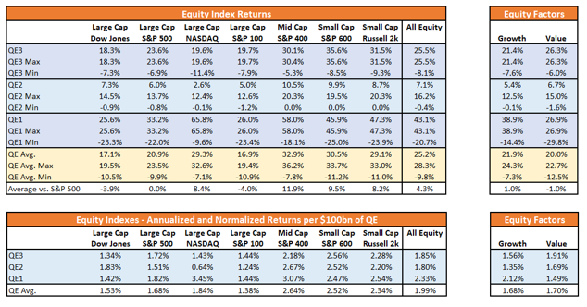
As you will notice, all major markets increased in value during QE-1, 2, and 3.
Since the market increased each time the Fed engaged in monetary programs, it should not be surprising investors now have a “Pavlovian” response to the Fed “ringing the bell.”
Over the last month, we have been discussing the end of the year rally which would be supported by both the Fed, and a “trade deal.”
This past week, as expected, headlines were floated which suggested that tariffs would be reduced in exchange for essentially nothing, This is precisely the case we laid out in September:
“Trump can set aside the last 20%, drop tariffs, and keep market access open, in exchange for China signing off on the 80% of the deal they already agreed to.
For Trump, he can spin a limited deal as a ‘win’ saying ‘China is caving to his tariffs’ and that he ‘will continue working to get the rest of the deal done.’ He will then quietly move on to another fight, which is the upcoming election, and never mention China again. His base will quickly forget the ‘trade war’ ever existed.
Kind of like that ‘Denuclearization deal’ with North Korea.”
We followed that in early October by laying out the case for the “trade deal” to push the markets to 3300:
“Assuming we are correct, and Trump does indeed ‘cave’ into China in mid-October to get a ‘small deal’ done, what does this mean for the market.
The most obvious impact, assuming all ‘tariffs’ are removed, would be a psychological ‘pop’ to the markets which, given that markets are already hovering near all-time highs, would suggest a rally into the end of the year.”
Then, just two week’s ago, as the Fed went into action:
“Clearly, the Fed is concerned about something other than the impact of ‘Trump’s Trade War’ on the economy. In the meantime, the injection of liquidity continues to support asset prices as the litany of ‘algo’s’ which drive -80% of the trading on Wall Street, respond to more liquidity.”
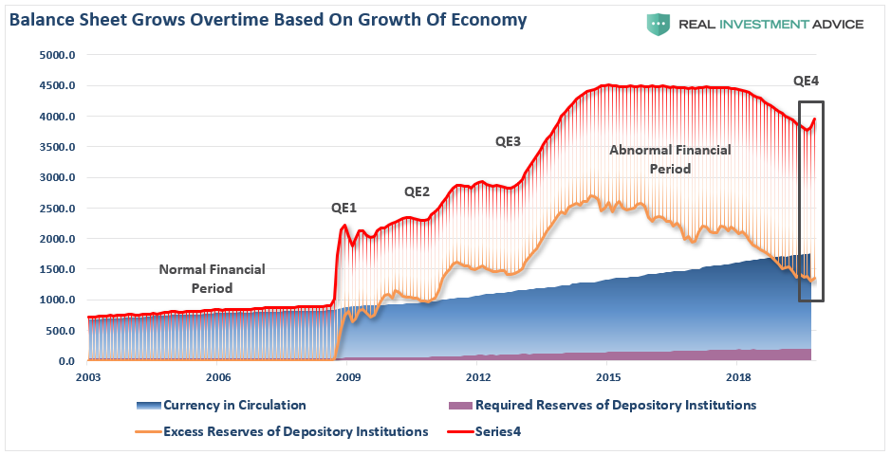
That is where we are today.
The questions now are:
- How do you play it; and,
- What happens next?

How To Play It
As we have been noting over the last month, with the Fed’s more accommodative positioning, we continue to maintain a long-equity bias in our portfolios currently. We have reduced our hedges, along with some of our more defensive positioning. We are also adding opportunistically, to our equity allocations, even as we carry a slightly higher than normal level of cash along with our fixed income positioning.
Currently, it will likely pay to remain patient as we head into the end of the year. With a big chunk of earnings season now behind us, and economic data looking weak heading into Q4, the market has gotten a bit ahead of itself over the last two weeks.
On a short-term basis, the market is now more than 6% above its 200-dma. These more extreme price extensions tend to denote short-term tops to the market, and waiting for a pull-back to add exposures has been prudent.
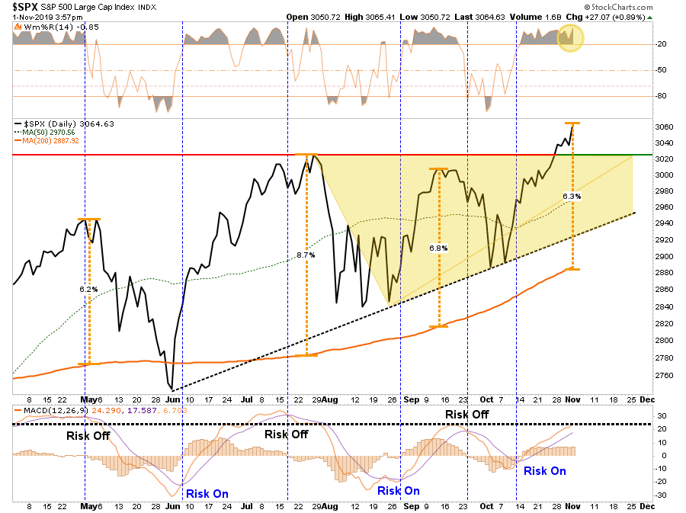
Also, the majority of our indicators are back to more extreme overbought readings, which have typically denoted short-term tops at a minimum.
As I noted last week:
“Given the markets tend to pullback just before Thanksgiving, and during the second week of December, we will have a better opportunity increase allocations if we are patient.“
Once we see that pullback, or even a slight consolidation of the recent advance, we can increase allocations in portfolios towards more equity related exposure.
This begs the question of “what to buy,” which brings us back to our recent RIAPRO.NET article:
“If we assume that assets will perform similarly under QE 4, we can easily forecast returns using the normalized data from above. The following three tables show these forecasts. Below the tables are rankings by asset class as well as in aggregate. For purposes of this exercise, we assume, based on the Fed’s guidance, that they will purchase $60 billion a month for six months ($360 billion) of U.S. Treasury Bills.
The expected top five performers during QE4 on a normalized basis from highest to lowest are: Silver, S&P 400, Discretionary stocks, S&P 600, and Crude Oil.
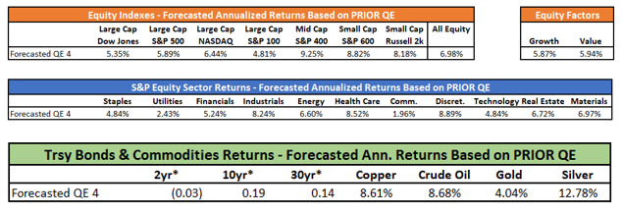
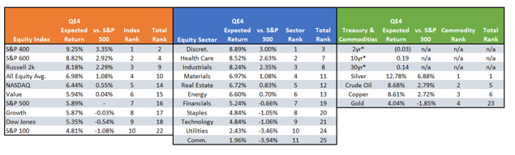
I would highly suggest reading the whole article.

What Happens Next?
Michael Lebowitz, CFA recently penned:
“A Honus Wagner baseball card from 1909 was recently auctioned for over $3 million. While that may seem like a lot of money, it is not necessarily expensive. A baseball card is nothing more than paper and ink with no real value. Its street value, or price, is based on the whims of collectors. “Whim” is impossible to value.
Stocks are not baseball cards. Stocks represent ownership in a corporation, and therefore, their share prices are based on a future series of expected earnings and cash flows. Further, there are many other types of investments that serve not only as alternatives, but provide a means to assess relative value.
Today, investors are trading stocks on a “whim,” with scant attention to their value. Unlike a baseball card, when a stock’s street value rises much more than its real value, an inevitable correction will occur. The only question is not if but when will investors realize what they are truly buying.”
There is an important distinction to be made here between “investing” vs. “speculating.”
Benjamin Graham, in his seminal work Security Analysis (1934) defined investing as:
“An operation in which, upon thorough analysis, promises safety of principal and a satisfactory return. Operations not meeting these requirements are speculative.”
The problem is that today, the term “investor” is now being applied ubiquitously to anyone who participates in the stock market. As Graham noted later in “The Intelligent Investor:”
“The newspaper employed the word ‘investor’ in these instances because, in the easy language of Wall Street, everyone who buys or sells a security has become an investor, regardless of what he buys, or for what purpose, or at what price, or whether for cash or on margin.”
To understand “what happens next,” one must understand the difference between “investment” and “speculation.”
While QE-4 may be driving stocks higher today based on a “whim,” there are two very important difference between QE-4 and QE-1 or 2; 1) stocks are no longer undervalued or 2) under-owned.
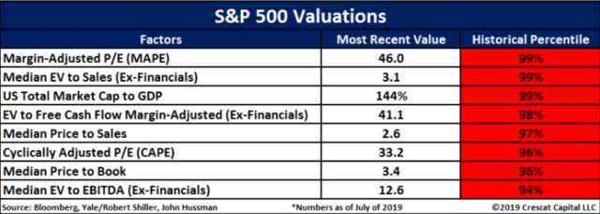
“With cash levels at the lowest level since 1997, and equity allocations near the highest levels since 1999 and 2007, it suggests investors are now functionally ‘all in.’”
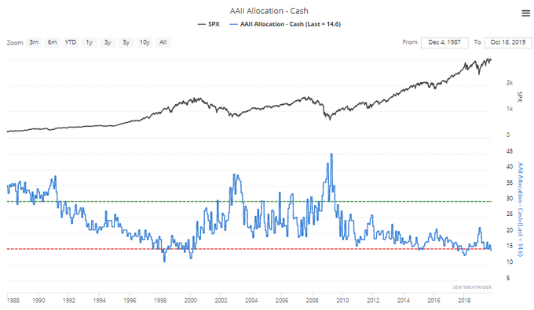
With investors paying exceptionally high prices for equity ownership, expected forward returns becomes much more problematic. As we addressed on Thursday:
“The detachment of the stock market from underlying profitability guarantees poor future outcomes for investors. But, as has always been the case, the markets can certainly seem to ‘remain irrational longer than logic would predict,’ but it never lasts indefinitely.
‘Profit margins are probably the most mean-reverting series in finance, and if profit margins do not mean-revert, then something has gone badly wrong with capitalism. If high profits do not attract competition, there is something wrong with the system, and it is not functioning properly.’” – Jeremy Grantham
Another way to look at the issue of profits as it relates to the market is shown below. When we measure the cumulative change in the S&P 500 index as compared to the level of profits, we find again that when investors pay more than $1 for a $1 worth of profits there is an eventual mean reversion.
With investors paying more today than at any point in history for each $1 of profit, the next mean reversion will be a humbling event.
That is just math.
However, in the meantime, individuals are “speculating” within the markets based solely on the premise that a “greater fool” will be there when the time comes to sell.
Unfortunately, that is rarely the case.
There are virtually no measures of valuation which suggest making investments today, and holding them for the next 20-30 years, will work to any great degree.
This is the difference between “investing” and “speculation.”
When you think about QE-4, as it relates to your portfolio, you have to consider the premise of valuations, margin of safety, and risk. Yes, the markets are indeed bullish by all measures, and holding risk will likely pay off in the short-term. (speculation) However, over the long-term, the “house will always win.” (investing)

ABC Covered up the Epstein Story
They had the Epstein Story weeks before the 2016 Election. ABC killed the story. Ashley Bianco was fired by CBS News this week after her former employer, ABC News, determined she had accessed footage of “20/20” host Amy Robach that was later leaked. On Friday, Bianco said she “never” leaked the clip to the right-wing advocacy group Project Veritas or anyone else — but even if she did, why should CBS News fire her over what might have happened at her previous job? The episode raises the question of whether Bianco, a young producer who had only worked at CBS for four days before she was let go, could sue for wrongful termination.
But two veteran employment attorneys told TheWrap that since New York, where CBS News employed her, is an “at will” state Bianco likely has no legal grounds to challenge her abrupt dismissal.
If she was working at-will, as most TV news producers do in the industry, that “means they can terminate her for any reason of no reason at all, like any other employee and in New York,” employment lawyer Emre Polat said, adding that termed contracts requiring justifiable grounds for termination tend to be reserved for executives or correspondents.
For comparison, Polat described a situation in another industry. “An employee that got fired at a bank for theft or fraud can apply for another bank and if that bank found out that the employee was accused of fraud or theft, they can still terminate that employee. They don’t have to be right,” he said.
He pointed out that it would be another matter if Bianco were a member of a protected class and it could be proven she was discriminated against.
“Even if a person doesn’t have a contract and is an at-will employee, they may still have recourse under anti-discrimination statutes,” employment discrimination attorney Michael Pospis said. “Here in New York, there really is no such thing as a free-standing claim of wrongful termination.”
Polat said he has a feeling CBS News just doesn’t want to “deal with it, whether they’re right or wrong.”
CBS News has not responded to repeated requests for comment.
In her interview with Kelly on the former Fox News host’s new YouTube channel, Bianco said she was blindsided by her firing. “I begged. I pleaded. I didn’t know what I had done wrong and I just, you know, I didn’t — I wasn’t even given the professional courtesy to defend myself,” she said. “You know, I didn’t even know what I was accused of.”
Veterans Day Parade
President Donald Trump will be opening New York City Veterans Day Parade on Nov. 11 with a speech, making history as the first time a sitting president has accepted an invitation to attend the annual event.
Trump will open the 100th edition of the parade with a speech addressing veterans and military officials at Madison Square Park in Manhattan on Monday, the White House confirmed on Nov. 6.
After his tribute, Trump will then lay a wreath at the Eternal Light Memorial in the park.
Doug McGowan, chairman of the United War Veterans Council, which hosts the annual parade, made an appearance on “Fox & Friends” Wednesday to announce the news.
“I am proud to announce—honored to announce—that the commander-in-chief has accepted our invitation and will be leading the New York City Veterans Day Parade, the centennial, this year,” McGowan said.
“This is the first time [a sitting president has appeared]… Citizen Donald Trump in the ’80s, the ’90s, and again in the early 2000s has been here for the veteran’s community of New York.”
Veterans have invited the sitting president to attend the event every year for 25 years, and Trump is the first to accept the invitation.
The parade, which begins at noon, is expected to see more than 25,000 parade participants march along Fifth Avenue. Veterans, military groups, and their supporters will be among the participants.
Veterans march on the street during the 152nd Memorial Day Parade in the New York City borough of Brooklyn on May 27, 2019. (Johannes Eisele/AFP/Getty Images)
The parade is described by the United Veterans War Council as “a non-partisan, non-political event, and may not be used as a platform for any other purpose or political agenda.”
Trump’s support for the parade goes back decades, as in the 1990s he personally offered financial support to save it from financial insolvency.
Constellations Group founder Bill White told “Fox & Friends” Wednesday: “In 1993, almost 25 years ago, the parade was in difficult financial straits, and the president of the United States—then [known as] ‘The Donald’—no questions asked, just said, ‘Yes, I will do it.’”
“He wrote a ginormous check, saved the Veterans Day Parade. He was honored at the Pentagon way back then,” White added.
“He has been a friend to our veterans for many, many, many years… We are so grateful to our president. We have a great commander-in-chief. There’s going to be 30,000 veterans, 400 military units… and it’s our 100th anniversary.”
McGowan told The Associated Press: “This is a day when we put politics aside to focus on honoring our veterans, and to re-commit ourselves as a community to providing them with the services they have earned, the services they deserve and, for many, the services they were denied.
“We thank and commend President Trump for leading that effort on this Centennial, and we acknowledge his historic support for our activities here in New York City.”

The Galactic Bridge: Bifrost?
For the first time, scientists have detected evidence of a magnetic field that's associated with the vast intergalactic 'bridge' that links our two nearest galactic neighbours.
Known as the Magellanic Bridge, the bridge is a huge stream of neutral gas that stretches some 75,000 light-years between our two neighbouring galaxies, the Large and Small Magellanic Clouds (LMC and SMC). Although researchers had predicted it was there, this is the first observation of its magnetic field, and it could help us understand how these vast bridges come to be.
"There were hints that this magnetic field might exist, but no one had observed it until now," said lead researcher, Jane Kaczmarek from the University of Sydney.
Our closest galactic neighbours, the LMC and SMC (photographed below) are 160,000 and 200,000 light-years from Earth respectively, and are visible in the southern night sky.
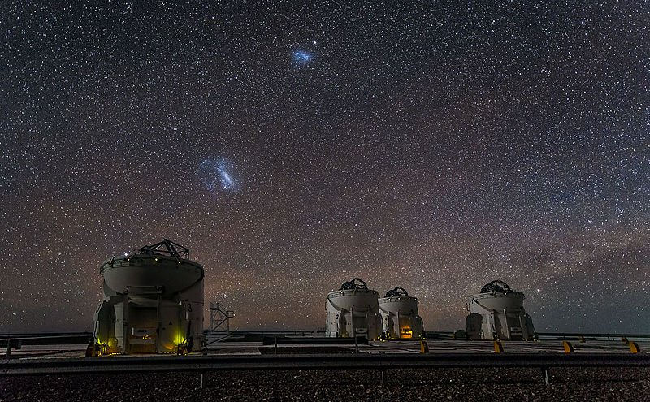ESO/J. Colosimo
Researchers have long known about the Magellanic Bridge that exists between these neighbours, a path with a few known stars inside it. But until now, very little was known about the magnetic field associated with the bridge.
The team has now shown that this newly detected magnetic field is one millionth the strength of Earth's own protective magnetic shield - and it could provide some insight into how it formed.
Two of the leading options are that the magnetic field was generated from within the bridge after the structure formed, or it may have been 'ripped' from the dwarf galaxies thought to have merged and formed the bridge in the first place.
If a bridge between the stars sounds a little sci-fi to you, keep in mind that most of space is made up of different magnetic fields.
"Not only are entire galaxies magnetic, but the faint delicate threads joining galaxies are magnetic, too," said one of the researchers, Bryan Gaensler from the University of Toronto.
"Everywhere we look in the sky, we find magnetism."
The reason we've struggled to study this structure in the past is the fact that these types of cosmic magnetic fields can only be observed indirectly through their effect on other structures in space.
In this case, radio signals from hundreds of very distant galaxies was used to pick up the magnetic field associated with the Magellanic Bridge.
Radio signals can be thought of like waves on the surface of a pond, in that they vibrate along a particular plane in space.
When these radio signals pass through a magnetic field, that plane is rotated, and it allows astronomers to the measure the strength and polarity (direction) of the field.
"The radio emission from the distant galaxies served as background 'flashlights' that shine through the Bridge," said Kaczmarek.
"Its magnetic field then changes the polarisation of the radio signal. How the polarised light is changed tells us about the intervening magnetic field."
Now that we've been able to detect the field, scientists now have a chance to figure out not only how it formed, but the impact it's had on the LMC and SMC.
"In general, we don't know how such vast magnetic fields are generated, nor how these large-scale magnetic fields affect galaxy formation and evolution," said Kaczmarek.
"The LMC and SMC are our nearest neighbours, so understanding how they evolve may help us understand how our Milky Way Galaxy will evolve. Understanding the role that magnetic fields play in the evolution of galaxies and their environment is a fundamental question in astronomy that remains to be answered."
Even cooler is the fact that this is just one study that's part of a bigger project to map the entire Universe's magnetism.
The research has been published in the Monthly Notices of the Royal Astronomical Society, and you can read the full paper for free over at arXiv.org.

