Jihad Report
Apr 20, 2019 -
Apr 26, 2019
Attacks | 32
Killed | 350
Injured | 889
Suicide Blasts | 2
Countries | 11

Watch Your Eyes

2018 was the Year of Awakening. President Trump drew the Deep State soldiers out into the open. They had to lay down their masks and pick up the swords to fight for the first time since World War Two. The world can now see them for who they really are. A treasonous Coup was engineered and perpetrated by an army of globalists who belong to a Syndicate so rich and so ruthless, that it stunned the world.

2019 is the Year of Light. More than 150 million people around the world are standing with President Trump and fighting the globalists. Whether they wear camo tank tops or yellow vests, they are the same. We love freedom. We love liberty. And we are prepared to defend ourselves against the Marxists who are seeking to take over our country as we speak. It is time to crank up the light of love and togetherness as we stand against for the soul of America.

2020 will be the Year of Justice. It will not be easy. Freedom is never free. When the generals of the Deep State are arrested, tried, convicted, and sentenced, they will be shouting their orders from the gallows for their followers to rise up and avenge them. They will attack churches, schools, malls, and other places where innocent people gather. It will not be an easy year for many of you. Your neighbors, co-workers, and even family members may have been possessed by the propaganda of the globalists. Do not let this weaken your resolve. Freedom and liberty must be preserved even if it means that we must fight the most powerful intelligence force the world has ever known. We must win, or the world will be lost, along with ever soul upon it.

The soldiers are everywhere. They are invading by the thousands every day. They are targeting our churches, synagogues, mosques, and are trying to incite a holy war. They are killing and injuring innocent people for the sheer joy of it. They rape, torture, and terrorize because it makes them happy to do it. They cannot be converted. They cannot be saved. They arrived on this world evil, they grew up evil, and they serve a dark lord who lives on this planet.

This is one of many words of warning you will receive. You will need at least two months of transportable food and a way to filter water to drink and cook with. You will need a weapon and the training to use it. You will need to make sure you do not prepare with hatred, but rather prepare out of love for your families, your friends, and your neighbors. When the Deep State generals are finally cornered and are about to be captured, they plan on something huge and terrible. I don’t want to write it again, because your consciousness will help manifest it.

We must find this weapon and disarm it or millions could die. Keep your eyes and ears open, and if you hear anything, don’t report it to the FBI or the police. You ask for an audience with your local sheriff. Show him and only him, face to face what you saw, and where you saw it.

In the meantime, tune in. Get squared. And go forth fearless and prepared.

NASA Just Recorded a Quake on Mars For The First Time, And The Audio Will Haunt You
MICHELLE STARR
24 APR 2019
NASA's InSight Mars lander may have recorded its first 'Marsquake' - seismic tremors, faint but unmistakable deep in the belly of the red beast.
Early analysis has confirmed that the tremor did originate inside the planet, as opposed to atmospheric influences such as wind. Now seismologists are hard at work to narrow down precisely what caused it.
Quakes on Mars, just like quakes on Earth, can reveal details about the planet's interior. InSight, which landed on Mars in November last year, is a mission specifically designed to study the guts of Mars. It's equipped with a range of instruments to take measurements of the planet's temperature, rotation and seismic activity.
Most of the data collected by the Seismic Experiment for Interior Structure(SEIS) instrument to date has consisted of background noise, but on April 6 - Sol 128 of InSight's mission - the instrument finally registered what the team had been looking for.
"We've been waiting months for a signal like this," said SEIS team lead Philippe Lognonné of the Institut de Physique du Globe de Paris (IPGP).
"It's so exciting to finally have proof that Mars is still seismically active. We're looking forward to sharing detailed results once we've had a chance to analyse them."
The waves of a strong enough tremor can act a bit like a planet-sized ground-penetrating radar, only with seismic waves instead of electromagnetic. As these waves propagate through a planet, they can slow down as they move through certain materials, or bounce off others, letting seismologists infer the interior composition. It is sort of like doing a CAT scan of the planet.
Sadly, the Sol 128 event was too faint to tell scientists anything about the structure of Mars's interior, and here on Earth it would have been lost among the constant grumblings of tectonic activity.
But it does demonstrate that, even though Mars isn't tectonically active, there is seismic activity - raising hope for a stronger tremor down the line. Especially since three other, fainter seismic signals were also recorded on Sol 105, Sol 132, and Sol 133.
But the Sol 128 signal, as well as being stronger, is interesting for another reason: it bears a strong similarity to the seismic profile of moonquakes detected by surface seismometers between 1969 and 1977 - the devices were stationed there by astronauts from the Apollo missions.
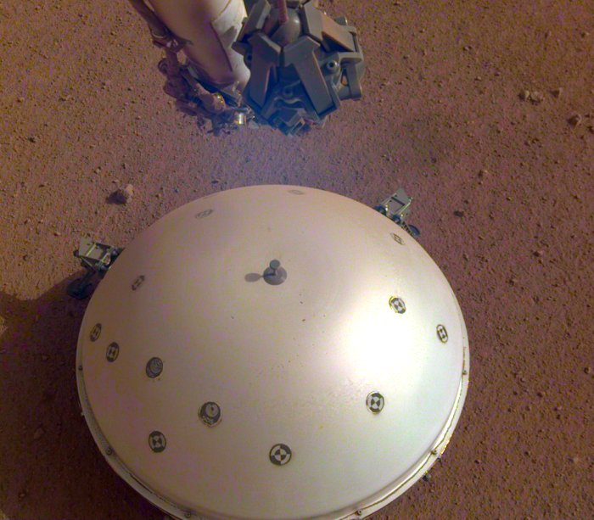The SEIS instrument. (NASA/JPL-Caltech)
Just like Mars, the Moon is not tectonically active. It does have seismic activity that is caused by a slow, slight shrinking as the interior cools, a process that has been ongoing since its formation 4.5 billion years ago. By the way, thsat is the same age as the Earth. As the interior shrinks, this creates stresses in the outer crust until it eventually cracks, causing tremors.
Planetary scientists believe that the same type of process is also behind the tremors on Mars.
More detections in the future, and analysis of these detections, will help reveal more. And now we know that SEIS works as intended - a tremendous feat of technical innovation, given how faint the tremors are - meaning it's technology we can continue to refine into the future.
"InSight's first readings carry on the science that began with NASA's Apollo missions," said InSight Principal Investigator Bruce Banerdt of NASA's Jet Propulsion Laboratory.
"We've been collecting background noise up until now, but this first event officially kicks off a new field: Martian seismology!"
In another longer-range story about the Moon, NASA Administrator Jim Bridenstine, speaking at the 35th Space Symposium in Colorado Springs April 9, also discussed what he described as a two-phase approach to the new Moon exploration plan that emphasized speed first, followed by sustainability. That approach would make use of the Space Launch System and Orion spacecraft, along with lunar landers yet to be developed and a lunar Gateway Project that, at least initially, might involve only a fraction of the elements previously proposed for the human-tended facility in lunar orbit.
Pace confirmed in his presentation that the lunar Gateway would be relatively small in its initial version. "I would expect to see a very minimal Gateway initially, in terms of supporting what we need for 2024. I see a larger, more capable Gateway building out as we go towards reusability."
He said the Lunar Gateway's value may ultimately be as a "fuel depot," allowing for lunar landers, or at least some portions of them, to be reused. "Instead of abandoning expensive vehicles after a single trip, we should contemplate creating a fuel depot to enable repeated visits to the moon and pave the way to Mars," he said, "and that's exactly what NASA has proposed with the lunar Gateway."

A "minimal" Gateway has raised concerns among international partners about what roles, if any, they'll have in that initial sprint to the moon. Asked about that, Pace said he's met with international partners on the issue. "In the short term the focus is building the organization that's capable of going back," he said. As the focus shifts to long-term sustainability, he said, there will be opportunities for partners to provide Gateway modules and lunar landers.
That emphasis on sustainability extends to the lunar surface. "We need a lunar field station to conduct exploration of the lunar surface and enable multiple sites from that station," he said. That drove the decision to make the south pole of the moon the site for that initial lunar landing, which Pace envisions being built up over time, eventually comprising multiple modules with pressurized rovers and nuclear fission reactors for power. "A lunar south pole station can be an access point to the rest of the lunar surface."
One of the key factors for that interest in the south pole is the potential access to deposits of water ice that can be used for life support and as propellant. He cautioned, though, that the nature and accessibility of that ice is uncertain, requiring research to determine if it's feasible to use any ice that exists there.
They only discovered it during the LCON mission way back in 2006, when they dropped a heavy slug into the polar area and spectrographically examined from Earth, the dust cloud from the impact. Water was detected, but we don’t know if that water can easily be extracted and utilized to make oxygen and hydrogen peroxide, the fuel for boosters. The base can also support other research there. "We're going to be going for lots of reasons, of which science is but one," he said, "but on the other hand, we want to make sure what science we do there is, in fact, driven by community assessments."

The emphasis on lunar resources prompted an audience question on why NASA last year cancelled Resource Prospector, an agency mission that had been under development to test the feasibility of extracting water ice. We had hoped that the project would continue, but Obama cut all the money from the program in 2009.

Pace said its cancellation was a top-down and "poorly communicated" decision by NASA. The agency leadership, he said, understands the value of robotic precursor missions to help understand the nature and accessibility of water ice at the poles, which can also support "opportunistic science" that might not have been done otherwise.
The Expansion Acceleration
The speed of the universe’s expansion, known as the Hubble constant, is a central part of physics and our understanding of the universe. But it has repeatedly been observed to behave unexpectedly – the more astronomers find out about it, the more wrong it appears – in ways that have forced scientists to wonder whether our assumptions about it had been wrong.

Read more
Most distant star ever seen spotted 9 billion light years away
The new study confirms that speculation, and requires further work to explain how exactly the universe is growing.
The research saw Professor Riess and his team analyse light from 70 stars in a galaxy near ours, known as the Large Magellanic Cloud, using a new method that allowed them to capture the stars quickly. The stars they observed are called Cepheid variables, and change brightness predictably, allowing them to be used to measure intergalactic distances.
The new method allowed the researchers to measure many more of those stars far more quickly. Normally, Hubble can only look at one star each time it takes one of its 90-minute orbits around Earth, but the new method allowed it to see dozens in that same time.
Using that data, the researchers were able to confirm our understanding of the “cosmic distance ladder”, which allows us to determine distances throughout the universe. And they were able to use the information to calculate the Hubble constant, and see how fast the cosmos is expanding.
The more precise that understanding became, the clearer it was that the speed was not in line with what they expected. Scientists have made predictions of the Hubble constant based on data from the European Space Agency’s Planck satellite, which can observe the conditions of the early universe just 380,000 years after it came into existence.
The two numbers did not match up. That led scientists to think that there must be something missing in their understanding of how the beginning and current universe match up.
“This is not just two experiments disagreeing,” Riess explained. “We are measuring something fundamentally different. One is a measurement of how fast the universe is expanding today, as we see it. The other is a prediction based on the physics of the early universe and on measurements of how fast it ought to be expanding.
“If these values don’t agree, there becomes a very strong likelihood that we’re missing something in the cosmological model that connects the two eras.”
Professor Riess and his team are not able to say why such a difference exists. They hope to work to refine it even more, allowing them to get rid of any further uncertainty about the Hubble constant.
Alien Breeding Program
Dr Young-hae Chi, an instructor in Korean at Oxford’s Oriental Institute, part of the prestigious university, thinks this new species will save Earth from annihilation from climate change. Dr. Young-hae Chi believes alien-human hybrids may already exist
Dr Chi first said the hybrids may already exist in a lecture in 2012 but has now written a book on the subject. He believes there is a strong correlation between climate change and alien abductions, the Oxford Student newspaper has reported. His book, written in Korean, is called Alien Visitations and the End of Humanity.
He says he has identified four types of aliens – small, tall and bold, scaly with snake eyes, and insect-like. Dr. Chi believes the insect aliens may be in charge and give orders to the other types. The aliens exist in their own bio-system that humans cannot experience because our perception is limited by our organs, the professor has claimed.
As the aliens are said to be highly intelligent, so Dr Chi believes they could solve the problems on Earth in the future, such as climate change.
He said: “So, they come not for the sake of us, but for the sake of them, their survival, but their survival is actually our survival as well — the survival of the entire biosphere.”
Dr. Chi said he was “still looking for more evidence to support my view”.
His initial lecture, Alien Abduction and the Environmental Crisis, outlined his theory. He cited an “abduction researcher” in the US, who argued that aliens’ primary purpose is to colonise the planet by interbreeding with humans to produce a new hybrid species.
Dr. Chi believes aliens appear on Earth when the planet is facing significant problems, such as climate change or nuclear war, and he concluded: “It may be more or less assumed that the hybrid project is a response to this impending demise of human civilisation.”
Dr Chi first expounded his ideas in a 2012 lecture. The academic says there is a strong link between climate change and alien abductions.
Here is my position on the alien breeding program. I have met several very convincing women who claim they have met their children from the breeding program. Now, to be clear, none of them claim to have actually carried a fetus beyond a few days at most. The zygote is removed somehow and taken to another facility, on or off planet, to complete its term.
My unanswered question is about the spirit that takes that body. You see, the spirits that come through the Well of Souls, as described in Genesis, kept their First Estate. That is to say, when the war in heaven was fought, the spirits that followed God and Michael the archangel, were rewarded with the honor of coming to Earth in a physical body to continue their growth process.
The ones who fought on the side of the Lightbringer—Satan or Lucifer—were not allowed to progress the same way. When Lucifer made his way to Eden to seduce Eve, his design was to spoil the whole image of God thing by possessing the bodies God had so perfectly designed for them.
Well, God places a rule in place called enmity. This blocked Lucifer’s followers from simply taking a human body at will. Well, Lucifer has been around for the birth of many worlds, and he knows how it goes. His baby was growing inside of Eve, even while they talked about eating dust and crawling on one’s belly.
When Cain was born, his true nature didn’t take long to show up. The first murder took place shortly after Eden was merged with Earth. Abel’s death was easy to see for God. Still, He let Cain live, and made a deal with him for his escape to the land of Nod, where he began to breed with the seed of lower Adam.
The result was another race of hybrids who had enough of Lucifer’s DNA to allow the souls banned from the Well of Souls to come to Earth. In other words, wicked spirits who are evil to the core are born into mortal bodies not covered under the enmity clause. Always a loophole. That is how Lucifer works.
Now, there are hundreds of millions of them on the planet. They die every day, but they come right back in other body suitable for them. When the bodies are limited, then other arrangements must be made.
Hence, the alien breeding program. Now, the only thing that would make the alien breeding program continue unabated, or at least not eradicated by any means, is for humans to believe that these highly advanced souls are coming to earth to save it from Adam’s seed.
So, my question again is this. What souls are sharing the bodies resulting from aliens breeding with humans? Are they souls in the image of God who kept their first Estate in the war in Heaven? Are they followers of Christ? Can they be exalted the same way a soul in mortal human can be?
I recall the giants in Enoch’s day. There were good ones. They helped humans. They did work, fought wars, and even helped to build impossible structures designed to reach closer to God. They pleaded with Enoch to be saved. Enoch went for hundreds of years to God to ask Him if they could be saved. Always, the answer was the same. No. They died by the thousands, or tried to run from the Flood. They wanted to be eternal like us, but they knew that would never happen. Only a remnant of their DNA exists today.
If there are aliens out there, or hybrids for that matter, that have a voice with which to speak, let one of them come with me to Contact in the Desert to speak to the people. You want to save the world? Change the world? Then come with me and stand with me before the people and let the truth be told.

The End Begins
Attorney General William Barr has established an investigative team that he intends to use to look into the origins of an FBI counter-intelligence investigation into Trump's 2016 presidential campaign.
According to Fox News, Barr has settled on the Justice Department members he plans to lean on to look into the how the FBI decided to investigate Trump in the first place. The probe ultimately led to the investigation by special counsel Robert Mueller into Russian interference in the 2016 presidential election.
Trump dissenters had hoped that Mueller would find evidence of collusion between Trump's campaign and Russian authorities, but Mueller's findings concluded there was no evidence of it.

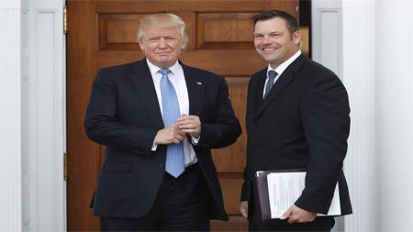

Here's who could replace Kirstjen Nielsen at Homeland Security
Watch Full Screen to Skip Ads
Barr was testifying in front of select House members earlier Tuesday about aspects of his summary of Mueller's report when he notified them of his plans to take a harder look at the FBI. He said he might review eight criminal referrals submitted by Rep. Devin Nunes, R-Calif., targeting people Nunes says were at the heart of the Russia-Trump collusion investigation.
Conservatives, including Nunes and Rep. Mark Meadows, have long been engaged in their own investigations into alleged misconduct and bias within the upper echelons of the Department of Justice and FBI, including the anti-Trump text messages of former FBI officials Peter Strzok and Lisa Page. The Conservatives are investigating whether there was a scheme to undermine Trump.
Barr's examination of the initial Russia investigation could intersect with an investigation by U.S. Attorney John Huber, who was appointed by former Attorney General Jeff Sessions in March 2018 to look into GOP claims of FBI misconduct.
Asteroid Passes Close
An asteroid purportedly the size of a 10-storey building will pass by the Earth at half the distance to the Moon, Nasa has warned.
Asteroid 2019 GC6 will pass within roughly 136,000 miles of Earth on Thursday, safely avoiding a devastating collision.
Nasa warned the orbital trajectory of the asteroid means it may still pose a risk in the future, with estimations suggesting it could be anywhere between 7.5 metres and 30 metres in length.
Shortly after it was discovered on 9 April by astronomers at the Catalina Sky Survey in Arizona, scientists at Nasa’s Jet Propulsion Laboratory in California placed it on a list of asteroids that risk colliding with Earth in the next 100 years.
It is difficult to accurately predict its exact path but it is set to pass close to the Earth again in 2034, 2041 and 2048.
It is not uncommon for rogue space debris to collide with Earth, with tons of cosmic material passing through the atmosphere every day.
© Provided by Independent Digital News & Media LimitedThe vast majority burns up before it reaches the ground, but every decade or so a larger asteroid collides with Earth.
In 2013, an asteroid 20m in diameter entered the Earth’s atmosphere over the city of Chelyabinsk in Russia, causing a massive explosion.
A subsequent study calculated it released more than 30 times the explosive energy of the Hiroshima bomb, contributing to more than 1,500 people in the local area seeking medical treatment.
“If humanity does not want to go the way of the dinosaurs, we need to study an event like this in detail,” Professor Qing-Zhu Yin of the University of California said at the time.
“Chelyabinsk serves as a unique calibration point for high-energy meteorite impact events for our future studies.”
But due to their relatively tiny size, asteroids are notoriously difficult to spot and often go undetected until a few days before they are due to pass or collide with Earth.
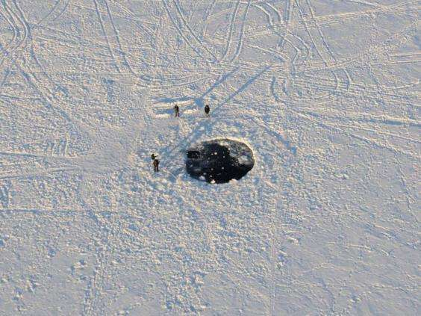© Provided by Independent Digital News & Media Limited The impact site of the main mass of the Chelyabinsk meteorite in the ice of Lake Chebarkul (PA)
Astronomers at the Jet Propulsion Laboratory recently described it as like spotting a lump of coal in the night’s sky.
“Near-Earth objects [NEOs] are intrinsically faint because they are mostly really small and far away from us in space. Add to this the fact that some of them are as dark as printer toner, and trying to spot them against the black of space is very hard,” said Amy Mainzer, principal investigator of Nasa’s asteroid-hunting mission at the lab.
“If we find an object only a few days from impact, it greatly limits our choices, so in our search efforts we’ve focussed on finding NEOs when they are further away from Earth, providing a maximum amount of time and opening up a wider range of mitigation possibilities.”
The Student Loan Vote-Buying Scam
On Friday’s “PBS NewsHour,” New York Times columnist David Brooks said 2020 presidential candidate Senator Elizabeth Warren’s (D-MA) student debt forgiveness plan is “a very terrible” policy that is “helping people who are going to be doctors and lawyers.”
Brooks said, “[T]his particular one is a very terrible idea. College graduates are among the wealthiest people, and the well-off people in our society. We should not be subsidizing college graduates. The top quarter earners hold 50 percent of the student debt. So, if we start forgiving student debt, we’re really helping people who are going to be doctors and lawyers.”
As usual, I offer a better solution. If a student graduated with a minimum 3.2 GPA, he should have his Federal Loan forgiven. This will only be about 5% of those who received a Federal loan. It will, however, fail to motivate students, but will instead spawn enormous corruption by the universities unless they are forced to revoke tenure for Marxist professors and administrators. That is a much tougher challenge, but a requirement for the loan forgiveness for graduates from that university.
Forget about buying votes. Invest in America by cleaning up the Marxist propaganda factories and getting smart graduates into the communities.
Deep State Hackers are Sharpening their Blades

Motherboard recently reported that a Twitter employee working on machine learning has claimed that using algorithms and A.I. to detect white supremacy on the platform would also target conservative politicians, writers, podcasts, and film makers.
Motherboard recently published an article titled “Why Won’t Twitter Treat White Supremacy Like ISIS? Because It Would Mean Banning Some Conservative Politicians Too,” which claims that an employee at Twitter believes an algorithm designed to root out and ban white supremacists would also ban Conservative politicians. The software would also clean out 90% of the sentient writers, bloggers, and podcasters. Why do I say that? Because liberal sources are not sentient. They are mostly robots with fake accounts who serve only as outlets for a centralized message of hatred and bigotry.
The issue reportedly arose when one employee questioned why terrorist groups such as ISIS had not been effectively removed from the platform. Motherboard writes:
At a Twitter all-hands meeting on March 22, an employee asked a blunt question: Twitter has largely eradicated Islamic State propaganda off its platform. Lieutenants inside of Twitter wanted to know if they could use their skill set to also target American patriots who expose Deep State shenanigans. Of course, they use the term ‘White Supremacist.’ There is actually no such thing among Americans. There are, however, a sea of black supremacists and those who placate blacks with false hopes of things like reparations. Five seconds of consideration for such a thing will drive you insane with the algorithms surrounding that shameless vote-buying scam.
An executive responded to the Twitter-angels by explaining that Twitter follows the law. Nevertheless, a ‘technical employee’ who works on machine learning and artificial intelligence issues went up to the mic to add some context. (As Motherboard has previously reported, algorithms are the next great hope for platforms trying to moderate, aka censor, the posts of their hundreds of millions, or billions, of users.)
With every sort of content filter, there is a tradeoff, he explained. When a platform aggressively enforces against ISIS content, for instance, it can also flag innocent accounts as well, such as Arabic language broadcasters. Society, in general, accepts the benefit of banning ISIS for inconveniencing some others, he said. Yes, he actually said the word ‘banning.’
That employee also stated that for similar reasons, Twitter has not targeted white supremacists on the platform for fear of accidentally banning conservative politicians, bloggers, and podcasters. That only means they have not figured out a way to do it without slaughtering their cash cow. Can you say, eat more chicken?
In separate discussions verified by Motherboard, that technical employee said Twitter hasn’t taken the same aggressive approach to white supremacist content because the collateral accounts that are impacted can, in some instances, be the same accounts who actually spend money and create jobs.
The employee argued that, on a technical level, content from Conservative politicians could get swept up by algorithms aggressively removing white supremacist material. Banning politicians wouldn’t be accepted by society as a trade-off for flagging all of the white supremacist propaganda, he argued. The stunning thing here, is the moral equivalence he asserts between white supremacists and conservatives.
There is no doubt in anyone’s minds that this position is a hitherto unspoken official policy of Twitter, and the company told Motherboard that this “is not [an] accurate characterization of our enforcement—on any level.” But the Twitter employee’s comments highlight the sometimes overlooked tech platforms within the organization. Are moderation issues purely technical and algorithmic, or do societal norms play a greater role than some may acknowledge? I will let you know when they moderate President Trump’s Twitter account. Oh that’s right. That already happened.
Amarnath Amarasingam, an extremism researcher at the Institute for Strategic Dialogue, discussed why there may be issues with algorithmically removing white supremacist content on Twitter telling Motherboard:
“Most people can agree a beheading video or some kind of ISIS content should be proactively removed, but when we try to talk about the alt-right or white nationalism, we get into dangerous territory. Yes, that is what he said. He actually believes there is some secret organization called alt-right. There is no such thing. There is the Left, and there is America. Period. Yet, he claims he is talking about [Iowa Rep.] Steve King or maybe even some of Trump’s tweets, so it becomes hard for social media companies to say all of this ‘this content should be removed,’” Amarasingam said.
“There’s going to be controversy here that we didn’t see with ISIS, because there are more white nationalists than there are ISIS supporters, and white nationalists are closer to the levers of political power in the US and Europe than ISIS ever was.”
You’re a Marxist propagandist, Mr. Amarasingam. Your effort to find a way to use a robot to do your killing of America is the sickness within Twitter, Facebook, and some of the other platforms. I have news for you. New platforms are coming up fast that hunt and destroy shills like you, while allowing uncensored American speech. WG1WGA.com is one such platform. It is beautiful, inspirational, and I have yet to see a single propagandist post last more than a few seconds, before the account holders themselves push it off the screen.
That is how a Republic works.
The Globalist Candidate
Forget about the Manchurian Candidate. We now have the first, fully endorsed, Globalist Party Candidate. Former Vice President Joe Biden says that he decided to launch his 2020 presidential campaign, in part, because international heads of state called him to “beg” him to run for president and “save the world.”
The Democrat hopeful made the claim in a call to supporters after he launched his campaign this week, according to the Daily Mail.
“I get calls from people all over the world. World leaders are calling me, and they’re almost begging me to do this, to save the country, save the world,” Biden reportedly said.
President Donald Trump has been a thorn in the side of globalist politicians placing entrenched corporate interests above the needs of their own citizens. On issues such as illegal immigration, NATO contributions, global warming, and Chinese aggression, Trump has bucked international leaders rather than go along to get along. In particular, Germany’s open-borders prime minister Angela Merkel has been repeatedly humiliated in confrontations with Trump.
Biden has tried to frame himself as a populist candidate, bashing Wall Street and pledging to reject campaign cash from federal lobbyists to counteract the Obama administration’s infamously cozy relationship with big banks. However, this admission that globalists see him as their best hope to oust Trump has the potential to hurt his case with voters.
Further, the failure to disclose which nations want him to run brings up further questions about the Biden family’s relationship to the Chinese government, as first exposed in Breitbart News Senior Editor-at-Large Peter Schweizer’s book Secret Empires. Schweizer suggests that the communist regime was “buying off Biden through his son” with a shady ten-figure deal:
In December of 2013, Hunter Biden flies on Air Force 2 to Beijing, China, with his father. His father meets with Chinese officials, he’s very soft on Beijing. The most important thing that happens 10 days after they return. And that’s when Hunter Biden’s small, private equity firm called Rosemont Seneca Partners gets a $1 billion private equity deal with the Chinese government, not with the Chinese corporation, with the government. And what people need to realize is Hunter Biden has no background in China, he has no background in private equity deals whatsoever. It is purely the influence Biden could offer with his political office that got his son the deal. The only way to keep Hunter from being prosecuted, along with his corrupt father, is for Biden to run for president. This is play right out of the Clinton Manual for Self-Enrichment.
Biden kicked off his campaign Thursday morning with a video where he repeated the hoax narrative that Trump called neo-Nazis “very fine people” in the aftermath of the 2017 riots in Charlottesville, Virginia.
The same day, a campaign spokeswoman asserted that Biden asked Barack Obama not to endorse his former Vice President because the candidate needs to win the primary “on his own merits.”
It is my assertion that Biden begged Obama to endorse him, but the calls were not returned. The Globalists want only to dilute the election long enough for them to pull off another 9/11-style attack and blame it on Trump. They are assembling a new Cabinet with their own, multi-billion dollar budget to move in and supplant the Trump Administration. They aren’t going to cut off the head. They are going to blow the guts out of America and shut off the President’s voice to America. They don’t care if every American lying in a hospital right now dies. They don’t care if it takes two years for the lights to come back on. They would happily destroy everything to hold onto their power.
The Cash that Would be King
Ever since March 20, the Effective Fed Funds rate has been trading above the IOER. This was unexpected for the simple reason that it is not supposed to happen by definition.
As a reminder, ever since the financial crisis, in order to push the effective fed funds rate above zero at a time of trillions in excess reserves, the Fed was compelled to create a corridor system for the fed funds rate which was bound on the bottom and top by two specific rates controlled by the Federal Reserve: the corridor "floor" was the overnight reverse repurchase rate (ON-RRP) which usually coincides with the lower bound of the fed funds rate, while on top, the effective fed funds rate is bound by the rate the Fed pays on Excess Reserves (IOER), i.e., the corridor "ceiling."
Or at least that's the theory. In practice, the effective FF tends to occasionally diverge from this corridor, and when it does, it prompts fears that the Fed is losing control over the most important instrument available to it: the price of money, which is set via the fed funds rate.
And ever since March 20, this fear is front and center because as shown in the chart below, starting on March 20, the effective Fed Funds rate rose above the IOER first by just 1 basis point, and then, last Friday spiked as much as 4 bps above IOER.
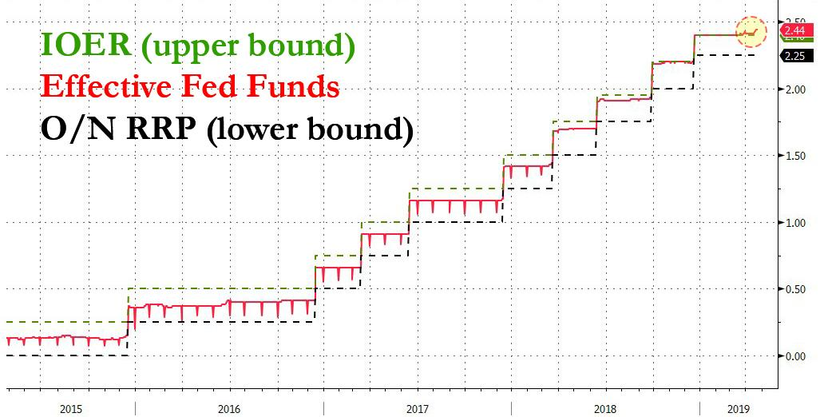
Now, this could be only a momentary thing caused by money market outflows around the April 15 tax deadline date. Some experts believe "there has been a dollar funding/shortage issue brewing under our nose for months; it is just coming to fruition now because we are noticing the DXY breaking out higher. In other words, participant banks who have to borrow from the “window” to keep making loans are forced to pay a higher rate to find those funds, and that drives rate differentials towards the Dollar."

The next question becomes what will the Fed’s reaction function will be? There has to be some hand wringing going on with the banks that have no liquidity. That is to say,, they don’t have liquid cash on hand to cover any fluctuations or to back loan opportunities they would really like to have. For instance, there are banks out there that need to sell their mortgage backed securities to get the service release premiums in order to replace liquidity. If there is no liquid cash out there to buy these blocks of mortgages, then the buyers have to borrow funds to make the purchase. If they don’t buy the securities, then the cash flow faucet turns off, and the entire derivative house begins to crumble.

The brewing speculation in the market is the Fed could cut the IOER rate in an effort to bring down the FF rate as well. Now this would simply be a “technical adjustment” in the mind of Fed officials but in reality the signaling here is important. This is different than Quantitative Easing, but it has the same effect. It pumps billions a month into the market, with the express purpose of keeping the dollar from collapsing. The trouble is that these funds come at the expense of the lender, and not the government printing the money.

If they descide to do this as a one-off adjustment, I believe they will do it when and how it will do the most damage to the Trump Administration. Yes, we are talking about weaponized money to push the Coup over the finish line. This is precisely why President Trump must get friendly member onto the Fed Board.

Despite some $1.4 trillion in excess reserves sloshing around, "the liquidity conditions in the US banking system are perhaps close to decade lows, which in turn is manifesting itself in the breakout of the effective Fed Funds rate above the IOER. I know this is a lot to keep clear in your head, but keep up with me. Morgan Stanley suggested last week, the Fed may have no choice but to cut by another 5 bps at the next Fed meeting just to "normalize" the fed funds rate and restore some temporary control to the most important interest rate in the world. In other words, the four rate hikes in the last year used to slow the Trump Economy have put the Fed in a vice. President Trump’s economy did not slow by that much. The bank did not make as much money as they had hoped off deficit spending. Their only choice now is to lower rates so that the liquidity of cash will flow again.
The liquidity effects from the Fed’s balance sheet resurfaced over the past week following a spike in overnight interbank rates. That keeps banks away from the window while they wait for a batter rate. That slows down the flow of cash, just like you hording your money until Black Friday.
Oh, there is one more thing drying up the cash flow. No one wants to talk about it, so I will right here. About $50 billion in cash each month is being exported from communities. That’s right. It is being put into a paper shredder never to be seen again on American streets. 25 million illegal aliens are working for cash in this country. Each week, they walk down to the WalMart or the Western Union or the Post Office, and they send cash out of the country to someone back home. The impact of this extraction is being felt at every bank in America.
But before we get into the implications, first the mechanics and why the most important plumbing in the US financial system appears to be clogged.
I am trying to get you to understand that his spike in interbank rates in April was accompanied by a drop in the reserve balances held by banks at the Federal Reserve, i.e. the "Tax day" excuse.

April tax collections boosted the General Account of the US Treasury at the Fed by $124bn in the week ending April 17th and by another $30bn in the week ending April 24th, bringing down reserve balances back to their downtrend since Quantitative Tightening (QT) started in the fourth quarter of 2017. Spending less and earning more is a bad thing for the Fed. Their biggest borrower, American government, is charting another course. It is charting a course for debt reduction, which could spell certain doom for the Fed.

More ominously, assuming no more "temporary "swings in the Treasury General Account, more declines in reserve balances likely lie ahead as Fed’s QT continues until September.
Do the banks care? Not so much. They care more about the rise in interbank rates relative to IOER that accompanied this shift in American growth of the Trump Administration. It is sort of like when you pay off your credit cards. The lender hates you for it, and they penalize you by reducing your slave score.
The Fed has lost control of rates; a rise which incidentally was not only confined to the Fed funds rate which represents a modest component of interbank markets with a YTD volume of around $70bn per day. Other interbank rates, such as SOFR - a broad measure of the cost of borrowing cash overnight collateralized by Treasury securities that includes all trades in the Broad General Collateral Rate plus bilateral Treasury repos - also increased.

I know you’re asking ‘What does it have to do with liquidity in the banking sector?’
The answer is that the ongoing creep higher in the difference between the IOER and the effective fed funds rate is a direct function of excess reserves in the system. Should we really be worried if the Fed is not making money the way they want to off the American government’s spending? Isn’t a good thing if the American government gets out of debt? Not for the Fed. And in the foreseeable future, the banks want you to believe they rely on the Fed making money available to them at cheap rates.

The tightening in the reserves space shows up clearly when we compare it to the size of the US banking system. This is shown in Figure 6 which depicts the reserve balances at the Federal Reserve divided by the total assets of US banks. Recently, this ratio fell below 9% for the first time since the beginning of 2011, and stood at a similar level as far back as the end of 2009. In other words, the liquidity conditions in the US banking system are perhaps close to their tightest in a decade.
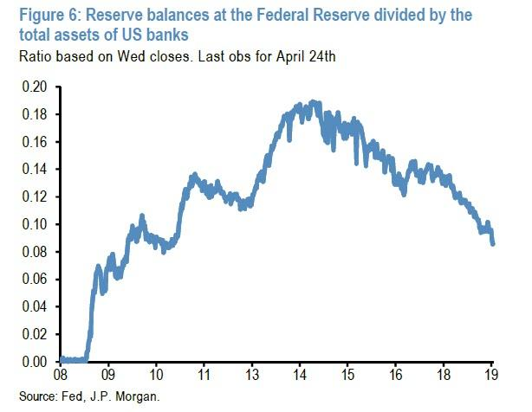
So, what is the relationship between the amount of reserves in the system and the Fed Funds rate?
In theory, when the level of reserves in the system is more than generous, i.e. above $2 trillion or so, there is no direct relationship. However, as the quantity of reserves declines, to where it is now between $1.5tr-$2tr the regulations loosen up. Not a good thing when it comes to banks. They are greedy risk takers, and they deceive the appraisal and rating services to make themselves looks healthier than they really are. Remember the movie, The Big Short? This is exactly what happened.
This was a time when there was virtually no excess reserves in the system, as banks largely resorted to the Discount Window for emergency liquidity. Add to that the fact the banks were making ridiculous loans to people who had no business borrowing money, and we had a disaster develop in less than 10 years that nearly killed the world. Oh yeah, who ended up paying for that one? You did.

We’re not in that same place. Not this time. This time, most of the payments are being made by homeowners. People are working. There are still about 1.3 million foreclosures out there, but there are no more bailouts, no investors are moving in to buy up these homes and convert them into good loans. It is happening, and real estate investors like me are doing exactly what we’re supposed to do. We are correcting the market the right way through supply and demand.
However, one of the alarming bank run catalysts to emerge was that usage of the Discount Window had become an effective death sentence of a bank. Going to the window a couple of times a year doesn’t hurt anyone. Going there every Friday is a very bad sign for that bank. If the market sniffed out that a given financial institution was scrambling for liquidity, the short traders would slam the bank's securities while counterparties would either significantly tighten overnight funding terms, or withdraw them altogether. I hate to tell you what that smells like, but it is a spiral of liquidity that eventually leads to insolvency of that bank. One can argue that it was the sudden collapse in peer liquidity provisioning that brought down both Bear and Lehman in the matter of days.
To be sure, the Fed learned its lesson, and perhaps the main reason that the US central bank flooded the entire banking system with trillions in excess reserves was to ensure that not one bank would emerge as the weakest link in the financial system - as the failure of the weakest link would promptly unravel the entire financial system - and that nobody would be forced to resort to the Fed's traditional emergency funding mechanism, borrowing from the Discount Window. If you look at the record, you can see that we are nowhere near the zombie apocalypse of 2008 that occurred under the Obama Administration.
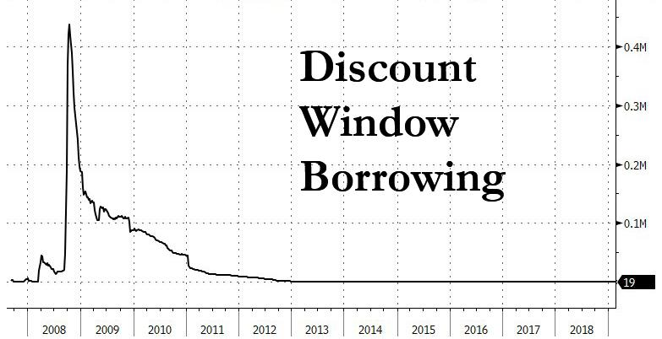

Of course, reserves may have reached the point where demands for liquid cash—sort of like a payday borrower—by the least capitalized banks results in tremors in the effective funds rate, the next catalyst in the downward spiral of scarce liquidity is one or more banks tapping the Discount Window.

If that happens, it’s deja vu from the Obama financial crisis. Believe it or not, there are many inside the Deep State who are building this as the financial neutron bomb for the express purpose of destroying the Trump Administration, even if it means you lose your home and your 401k. Elizabeth Warren is one of the most vocal lieutenants in this army.

I am not kidding one bit, here. I have given you some solid evidence here, and I am sure there are bank CEO’s who know I speak the truth. They are also afraid of these players. In order to avoid further tightening, the Fed might be forced to cut interest rates by lowering the IOER. That would help the Trump Recovery, and is exactly why I think it would be resisted by the Fed.

Of course, the Fed could inject liquidity via open market operations, but that would be equivalent to restarting the preposterous strategy employed by Obama of Quantitative Easing. That is the printing of $90 billion a month in funny money to keep the dollar from crashing. In effect, it wipes your 401k from existence.
In short, there is still some $1.4 trillion in excess reserve sloshing in the financial system as a remnant from the trillions in liquidity generated by the Fed but, drumroll, it is no longer enough to ensure that the US financial system won't suffer some "unexpected event." There is also about $4 trillion in cash sitting offshore that needs to be repatriated. It could happen in a month, if President Trump gives those companies with that cash a tax break to do so. That money could enter the venture market and jumpstart tens of thousands of new companies waiting for funding.
I will keep a very close eye on total borrowings under the Fed's discount window: once it spikes from its 8 year slumber, all bets are off. My suggestion is stay out of debt and be prepared for a 2-3 month dry spell.
Avengers Review

No spoilers here. I just observe things no one else does with movies. The one thing most people missed, unless they listen to this program, is that in the Infinite War movie, the mighty Thanos commissions the building of a power glove that will hold the 6 Infinite Stones. There is something you need to see here. The glove fits the left hand. It is with this left hand that Thanos kills half the life in the universe so that the remaining half will worship him and him alone.
All but six Avengers are killed. The Marvel franchise spent more than ten years building to this point, absorbing thousands of comics written over three decades under the master story teller, Stan Lee. Hundreds of characters emerged, reigned with terror or vengeance and died, but a few became the Avengers. In Iron Man’s words, “We avenge. Why aren’t there pre-vengers?”
Because that is not the due process of the America way. And so, Superhero movie “Avengers: Endgame” smashed box office records with global ticket sales estimated at $1.2 billion through Sunday, distributor Walt Disney Co said.
“Endgame” generated a jaw-dropping $350 million in the United States and Canada, the world’s largest movie market. The total far surpassed analyst estimates and the previous record of $257.7 million set a year ago by “Avengers: Infinity War.”
“Endgame” also set weekend records in China, Brazil, France, more than three dozen other markets, Disney said.
The three-hour action spectacle is the final chapter in a story told in 22 Marvel Studios movies since 2007. It features popular comic-book characters such as Iron Man (Robert Downey Jr.), the Hulk (Mark Ruffalo) and Thor (Chris Hemsworth) in a battle against the supervillain Thanos (Josh Brolin).
The movie picked up after an epic cliffhanger at end of “Infinity War,” when many beloved Marvel superheroes appeared to turn to dust.
The key to recovering the lost trillions who die in the previous record-setting franchise film is the use of the right hand. The Left is destroying freedom and liberty in the world. The Right will restore it. That’s it. No spoiler. But trust me, the creators of this movie made use of that symbolism, even though nobody else except me write about this one. You should see my Twitter account where the talented Luckee01 helped me blend the face of Thanos with the face of George Soros. Now, you see the true agenda of the Left.
Hang on, earth Explorers. You’re in a for a white knuckle ride.
The Tuscon Border Collapse
Without a wall to stop them, millions of foreign citizens are flooding into the fastest growing country in the world; America. The shortest pathway to a ranch of your own is by gaming the US asylum system the Democrats have set up for them. Border Patrol officials have begun releasing migrant families in Tucson because they lack the space to detain them and immigration officials are unable to take them into custody.
The practice has been going on for about a month, according to the Border Patrol's Tucson sector, which covers most of Arizona's border with Mexico.
It was a central topic of a meeting Border Patrol officials in Tucson held Friday with local law-enforcement, elected and community leaders.
The number of migrant families released in Tucson has surpassed the ability of local nonprofits to house them. This past week, the city of Tucson and Pima County opened temporary overflow shelters to house migrants, although those shelters are once again empty, at least for now.
The goal of Friday's meeting is to "alleviate some of the stressors that we've been seeing with this increase in people," said Pete Bidegain, a special-operations supervisor for the Border Patrol.
"One of the major concerns that was brought up numerous times in the meeting really comes down to better communication between federal officials, county officials, city officials," he added.
Follow Arizona politics? Our reporters stay on top of it all. Subscribe to azcentral.com.
The meeting, which lasted about an hour and a half, was closed to the press and public. It followed a similar meeting U.S. Sen. Kyrsten Sinema, D-Ariz., hosted Thursday in Phoenix.
But Friday's meeting was directly organized by Border Patrol officials in Tucson as a goodwill effort to bring together everyone involved in the humanitarian response and come up with a better coordinated response.
One of the big takeaways, Bidegain said, is the possibility of giving nonprofits and city leaders an earlier heads-up as soon as border officials notice any increases in the numbers of migrants they encounter at the border.
"That heads-up may be hours or it may be days," he said. "But any type of communication, just keeping that open, is going to help us and it's also going to help them."
Border Patrol has not disclosed how many migrants it has released directly into Tucson in the past month since it began the practice, which the agency officially refers to as migrants released on their own recognizance.
As they are released, the migrants are issued notices to appear in court at later dates. 95% of the people refuse to show up for those hearings. Doesn’t matter. We have no system for finding them and deporting them.
U.S. Immigration and Customs Enforcement, the agency that normally takes custody of asylum-seeking families once they have been processed, has continued releasing families in Tucson.
That includes migrants apprehended in the Tucson sector as well as migrants who crossed through the Yuma area. Pima County officials estimate that ICE has released about 7,000 migrants in Tucson in the past eight months.
On top of that, Border Patrol officials in El Paso have been busing hundreds of migrants each day to Tucson so they can be released there instead of El Paso, which has also been struggling greatly with the sheer number of migrant families.
As a result, when ICE is unable to take migrants into custody, Border Patrol has begun releasing families directly in Tucson. Border Patrol works with nonprofits to find space to house the migrants, but it doesn't always work out.
"If they are at capacity, that's when the decision is made to release people out into the community, and that's traditionally been done ... at local transportation hubs," Bidegain said.
That's something both city leaders and nonprofits want to avoid. Their concern is that, if left to fend for themselves, families will end up stranded or unable to navigate the transportation system in an unfamiliar country.
Tucson Mayor Jonathan Rothschild, who attended the Friday meeting, said that was one of the big concerns he took from the Border Patrol discussion.
"If the loaded buses from Border Patrol can go not to the bus station, but to the site of where the (nonprofit) is located, that would be a big help because that saves us a lot as a community," Rothschild said.
Another concern Rothschild brought up was that migrant families from El Paso were being transported to and released in Tucson. He said such a move made little sense, especially when the asylum-seeking families were headed to the Eastern United States.
"If they're moving east, why would you ever move them west?" he said.
Border Patrol officials said they would consider the concerns. As a result of the meeting, Bidegain said, they also agreed to create a steering committee to help implement some of the ideas discussed
NASA Playing Another New Role
The US will be able to maintain its lead in the latest space race, but only if NASA re-focuses on supporting the private sector, according to a new report, entitled “American Space Enterprise and Security,” released from the Potomac Institute of Policy Studies (PIPS).
Potomac Institute joins a growing number of research and financial firms that have begun incorporating space industries into their offerings. The report is the first to be released by PIPS’s Center for Enterprise, Exploration, and Defense in Space (CEEDS), a new department for the institute aimed at assessing policy that will define the future of enterprise, exploration and security in space.
The report, which outlines recommendations for space development as it pertains to NASA, the Department of Defense and the intelligence community, calls for a dramatic retooling of NASA in hopes of making the US more competitive in the new space race.

RETOOLING NASA FOR THE SUCCESS OF A SPACE ECONOMY
The report suggests NASA serve primarily as a driver of the future economic boom in space.
“We envision NASA as a funder and enabler of exploration and enterprise through public-private partnerships and R&D investment,” said Kathryn Schiller Wurster, chief policy officer at Potomac and one of the authors of the study, in an email to The Downlink, adding that US government investments in infrastructure and R&D has paid off in the past.
The report recommends a few ways that NASA can more actively support the economic development of space, ranging from supporting the build out of industrial infrastructure in low Earth orbit and cislunar space to outsourcing in-house technology development to industry, along with a transition from internal science research to funding of research — much like National Science Foundation or DARPA. “NASA should encourage, partner with, and underwrite the costs and risks of the commercial space industry in coordination with its existing programs,” the report states.
“There is also a need for a government body to manage the infrastructure and regulatory issues that are currently impeding the industry rather than enabling it — much like Department of Transportation or Department of Commerce do today,” said Wurster. “This might be NASA working in coordination with other agencies.”

COMMERCIAL SPACE GROWS BEYOND SATELLITES
Much of the concern around the US’s leadership in space stems from the fact that global telecom industries have dominated space launches since the 1990s. It doesn’t help that, with the retirement of the space shuttle program, the US lost its ability to launch humans into space. NASA has relied on Russian Soyuz vehicles to send its astronauts to the ISS ever since.
“The US is still a leader in many areas of space exploration and commerce — but if we are not running ahead we are falling behind,” said Wurster. She pointed to the fact that other nations, including China and Russia, are actively pumping money into new and innovative space technologies. “Leadership is not guaranteed,” she said.
The US saw 22 launches in 2016, according to the report, which is more than any other country. But in the years between 1991 and 2016, 43% of satellites launched were from other countries, including China, Japan, Europe and India. At present, 60 countries are operating some 1,700 satellites in space, and the two most common commercial launch vehicles are France’s Ariane and Russia’s Proton vehicles.
Thanks to launches from SpaceX and others, the US has begun to win back its commercial satellite market share. And if all goes according to plan, the US will be able to resume crewed flights to space as soon as this year, using capsules from both Boeing and SpaceX.
But available funding continues to be an important obstacle to competitiveness. NASA’s budget, adjusted for inflation, is smaller now than it was in the 1990s, while China’s R&D investment is the largest in the world.
“Other countries seem to be placing a higher priority on government investment to grow these industries,” Wurster said.
The UN Loses the Ability to Disarm America
President Trump announced Friday that his administration is withdrawing the U.S. signature from the U.N. Arms Trade Treaty, in response to concerns from gun rights activists that it could impinge on Americans’ right to bear arms
“Under my administration we will never surrender American sovereignty to anyone, we will never allow foreign bureaucrats to trample on your Second Amendment freedom and that is why my administration will never ratify the U.N. trade treaty,” Trump told an audience at the National Rifle Association's annual meeting in Indianapolis.
“I am officially announcing today that the United States will be revoking the effect of America's signature from this badly misguided treaty, we’re taking our signature back,” he said.
Former President Barack Obama signed the treaty in 2013 and sent the treaty to the Senate for ratification. Onstage Friday, Trump signed a notice to the Senate asking it to stop the ratification process and return the treaty to the White House, “where I will dispose of it.”
The treaty seeks to regulate international trade in conventional arms, including everything from tanks to small arms, specifically looking to “prevent and eradicate the illicit trade in conventional arms and prevent their diversion.”
But, while supporters of the treaty have argued that it could not infringe on Second Amendment rights, the document had long been opposed by the NRA -- who pointed to the treaty’s call for national recordkeeping and for governments to share those records, and claimed that the treaty meant that U.S. gun policy “could become the rest of the world’s business and subject to its approval, on pain of trade restrictions if it doesn’t meet ‘international norms.’”
Trump has been skeptical of both the U.N. and multilateral agreements and supported the NRA’s concerns in his speech.
“By taking these actions, we are reaffirming that American liberty is sacred and that American citizens live by American laws not by laws of foreign countries,” he said.
A spokesperson for U.N. Secretary General Antonio Guterres, in response to questions about the U.S. move, said that the treaty is "the only global instrument aimed at improving transparency and accountability in the international arms trade.
"It is a landmark achievement in the efforts to ensure responsibility in international arms transfers," the spokesperson said. "This is particularly important in present times, when we witness growing international tensions and renewed interest in expanding and modernizing arsenals."
Under the Trump administration, the U.S. has pulled out of the Iran nuclear agreement and the Paris climate accord. It has also withdrawn from the controversial U.N. Human Rights Council and the U.N.’s educational and cultural organization, UNESCO.
In the speech to the crowd in Indianapolis, Trump presented himself as a defender of Second Amendment rights, telling NRA supporters that it “is an honor to fight by your side” and promising to defend Americans’ rights to carry guns.
Deep Impact
NASA is conducting planetary defense drills to see what would happen if an apocalyptic space rock was heading straight for Earth.
Participants will discuss potential preparations for studying an asteroid or comet, as well as how to deflect it and lessen the damage caused by any impact.
The space agency has been scanning the skies for more than 20 years, looking for what it calls Near-Earth Objects (NEOs).
NEOs are asteroids and comets that orbit the sun and come within 30 million miles (50m km) of Earth's orbit. There are many more than you think, and lots of them have 2019 titles. We don’t know they are coming until they are coming.
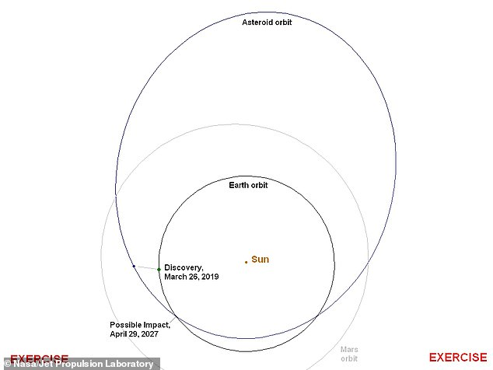
+9

This diagram shows the orbits of the fictional asteroid and Earth and the point at which the orbits intersect. The asteroid makes just over 3 orbits of the Sun between discovery and the possibility of an impact in 2027
The threat of asteroid impacts has gained increasing prominence over recent years, particularly since the Chelyabinsk fireball of 2013.
The meteor, which blazed across the southern Ural Mountain range in February 2013, was the largest recorded meteor strike in more than a century, after the Tunguska event of 1908.
More than 1,600 people were injured by the shock wave from the explosion, estimated to be as strong as 20 Hiroshima atomic bombs.
In preparation for a possible impact, NASA and other international science organisations will participate in the 2019 Planetary Defense Conference next week.
A 'tabletop exercise' will play out the realistic—but fictional—scenarios for an asteroid and a comet on an impact trajectory with Earth.
The NEO impact scenario have been developed by the NASA Jet Propulsion Laboratory's Center for NEO Studies (CNEOS).
The asteroid scenario begins with the premise that on March 26, astronomers 'discovered' an asteroid that they consider is potentially hazardous to Earth.
After a 'few months' of tracking, observers predict that this NEO – dubbed 2019 PDC – will pass within 0.05 astronomical units (AU) of Earth.
In the fictional simulation, NASA claims the asteroid poses a one in 100 chance of colliding with Earth and it may land on April 29, 2027.
It is first located 35 million miles (57 million kilometres) from Earth and approaching at 31,000 mph (14km per second) and getting progressively brighter.
Weeks of observation found it more and more likely it would impact Earth in 2027 but details of the asteroid's shape, size and composition remain scarce.
All that is known is the asteroid's average size could be anywhere from 330 feet to 1,000 feet (100 meters to 300 meters).
More than a month after first spotted it continues to fly towards Earth and passes Earth at a distance of 0.13 au on May 13 2019. it is next expected to return close to Earth in 2027.
The conference will pick up the event at this point and decide on the best course of action.
Experts will discuss the dangers posed by NEOs and actions that might be taken to deflect a threatening object.
'These exercises have really helped us in the planetary defense community to understand what our colleagues on the disaster management side need to know,' Lindley Johnson, NASA's Planetary Defense Officer, said.
'This exercise will help us develop more effective communications with each other and with our governments.'

This diagram zooms in on the intersection point of the orbits and shows the uncertainty in the predicted position of the asteroid (red dots reveal potential spots for where the asteroid will pass Earth). The uncertainty region is several times longer than the diameter of the Moon's orbit but will shrink as more data is gathered on the asteroid's path and trajectory
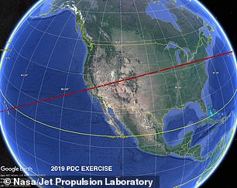
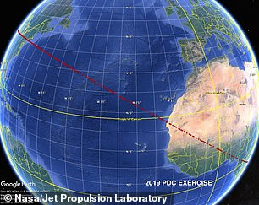
Intersection of the uncertainty region with the Earth creates a'risk corridor' across the surface of the Earth. The corridor wraps more than halfway around the globe (pictured, red dots are potential landing locations) on the risk corridor
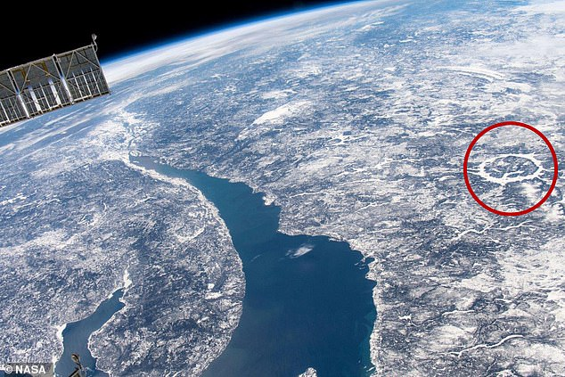
+9

NASA is conducting planetary defence drills to see what would happen if an apocalyptic asteroid was heading straight for Earth. The Manicouagan impact crater in Quebec, Canada (circled right), is one of our many reminders that asteroids have impacted Earth
The conference will also discuss a hypothetical comet impact scenario.
This fictional event states a comet was spotted on April 4 2019 and could collide with Earth on February 28, 2021.
It has an orbital period believed to be several thousand years and astronomers speculate that its core is possibly only about 0.62 miles (1 kilometre) in size.
NASA has in recent weeks announced measures it hopes will help to combat the threat posed by by NEOs.

The conference will also discuss a hypothetical comet impact scenario. This fictional event states a comet was spotted on April 4 2019 and could collide with Earth on February 28, 2021. It has an orbital period believed to be several thousand years
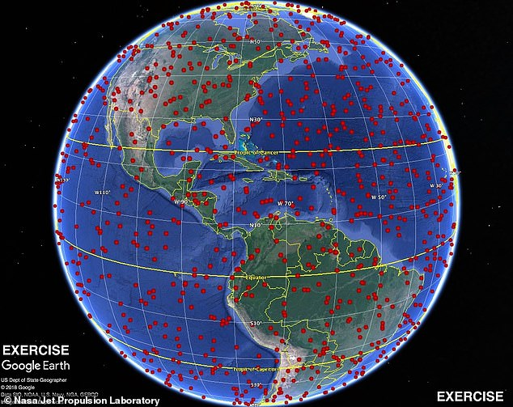
+9

Astronomers speculate that its core is possibly only about 0.62 miles (1 kilometre) in size and could his any of the red dots on this map. NASA has in recent weeks announced measures it hopes will help to combat the threat posed by by NEOs
On April 11, the space agency announced that its radical mission to fire a small spacecraft directly into an asteroid now has SpaceX on the roster, too.
It selected Elon Musk's aerospace company to launch its Double Asteroid Redirection Test (DART) mission, which is slated to lift off in June 2021.
The groundbreaking mission will be the first demonstrated attempt to deflect an asteroid by purposely crashing an object into it at high speed.
After launching from California's Vandenberg Air Force base atop a Falcon 9 rocket in 2021, the DART craft is expected to reach the object Didymos in October 2022, when it's 6.8 million miles (11m km) from Earth.
The DART mission relies on what's known as a 'kinetic impactor' – in this case an eight foot long (2.4m) craft with solar electric propulsion.
DART will be targeting the binary near-Earth asteroid Didymos, which measures roughly 2,600 feet (800m) across.
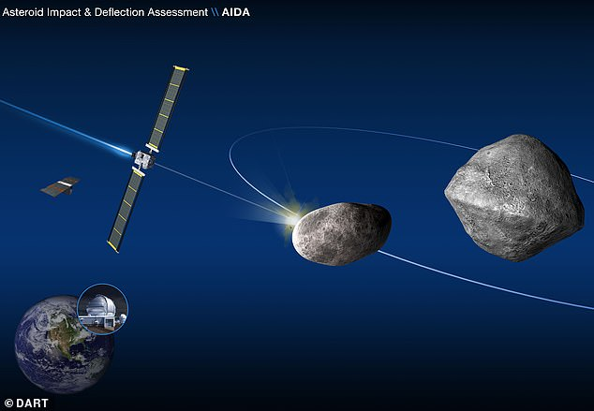
+9

NASA has in recent weeks announced measures it hopes will help to combat the threat posed by by NEOs. The DART mission relies on what's known as a 'kinetic impactor' targeting the binary near-Earth asteroid Didymos (artist's impression)
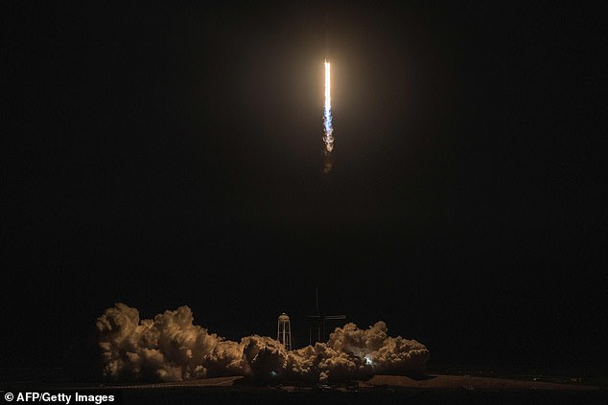
+9

After launching from California's Vandenberg Air Force base atop a Falcon 9 rocket in 2021, the DART craft is expected to reach the object Didymos in October 2022, when it's 6.8 million miles from Earth. File photo of a Falcon 9 after launch

WHAT COULD WE DO TO STOP AN ASTEROID COLLIDING WITH EARTH?
Currently Nasa would not be able to deflect an asteroid if it were heading for Earth but it could mitigate the impact and take measures that would protect lives and property.
This would include evacuating the impact area and moving key infrastructure.
Finding out about the orbit trajectory, size, shape, mass, composition and rotational dynamics would help experts determine the severity of a potential impact.
However, the key to mitigating damage is to find any potential threat as early as possible.
Animation reveals NASA's proposed Asteroid Redirect Mission
Loaded: 0%
Progress: 0%
0:00
Previous
Play
Skip
Mute
Current Time0:00
/
Duration Time0:00
Fullscreen
Nasa is currently moving forward with a refrigerator-sized spacecraft capable of preventing asteroids from colliding with Earth. A test with a small, nonthreatening asteroid is planned for 2024.
This is the first-ever mission to demonstrate an asteroid deflection technique for planetary defence.
The Double Asteroid Redirection Test (DART) would use what is known as a kinetic impactor technique—striking the asteroid to shift its orbit.
The impact would change the speed of a threatening asteroid by a small fraction of its total velocity, but by doing so well before the predicted impact, this small nudge will add up over time to a big shift of the asteroid's path away from Earth.
A top NASA asteroid scientist also recently said that the best way to defend the Earth from asteroids is to build a new telescope capable of spotting them as soon as possible.
Dr Amy Mainzer from NASA's Jet Propulsion Laboratory in Pasadena, California, said that trying to spot asteroids with current telescopes was like trying to spot a 'lump of coal in the night's sky'.
In April 2019, her team proposed a new system designed to spot large meteors capable of causing significant damage.
It would identify incoming asteroids capable of causing huge loss of life - just like the meteor which wiped out the dinosaurs 66 million years ago.
They claim this would give the scientists more time to come up with a strategy to intercept the rock.
+9

A NASA scientist has said that to defend the Earth from dangerous asteroids is to detect them via heat using an infra-red telescope called the Near-Earth Object Camera (NEOCam). Comet Catalina (pictured) in 2015 was captured by such a telescope called NEOWISE
+9

Dr Amy Mainzer said that trying to spot asteroids via their 'faint' light was like trying to spot a 'lump of coal in the night's sky', but that a proposed Near-Earth Object Camera mission (pictured) that detects heat waves would make it a lot more accurate
Incoming space rocks are not always spotted in advance of their arrival, however.
Incredible images released in March 2019 revealed a meteor that exploded in the Earth's atmosphere in December with ten times the force of the Hiroshima bomb - yet no one detected it.
The incident took place at 11:50pm GMT (3:30am EST) on December 18, 2018, over the Bering Sea - between Russia and Alaska - but has only just been discovered.
It is believed to be the second largest meteor explosion in the last 30 years, and the biggest since the high-profile Chelyabinsk incident.

