Jihad Report
May 18, 2019 -
May 24, 2019
Attacks | 37
Killed | 191
Injured | 187
Suicide Blasts | 2
Countries | 16
Flowers: The New Wave in Pesticides
A farm is its own ecosystem, but many conventional practices strip away the life cycle of all the creatures living in it by using pesticides. This makes sense, since crops can be decimated by the wrong kind of insect or other invader. But pesticides have created a number of problems; not only do pests become gradually resistant to the poison, the use of the chemicals can be unhealthy for workers and potentially for the people who come in contact with the produce in their food cycle.
Fast Company reports that many organic farmers are going back to older practices by cultivating an environment where natural pest predators can live. They're growing flowers amongst their other crops, creating a home for creatures like parasitic wasps, who eat aphids in their larval state. It's been a common practice to grow flowers around the perimeter of farmland acres, because it encourages biodiversity. But agriculturalists are experimenting with strips of flowers within their crops, creating a highway for bugs to travel farther and cover more ground for pest control.

It's an especially popular experiment in the U.K., where researchers Ben Woodcock and Richard Pywell are studying the new tactic at the Center for Ecology and Hydrology. They say that planting flowers to encourage bugs may seem obvious, but a certain amount of precision is needed to encourage the right kind in the right amounts, which requires more modern monitoring techniques.
“The wide-scale adoption of precision agricultural systems, particularly GPS mapping and precision application technologies, means that it should now possible to implement and protect these in-field habitats,” they wrote to Fast Company in an email. “This would have been very challenging a few years ago. While this is unlikely to eliminate the need to apply pesticide, it may mean that pests populations are maintained below levels at which they cause damage to crops for longer periods, thus reducing the number of pesticide sprays applied.”
The flowers are particularly important as scientists struggle with the widespread and terrifying phenomenon of beehive death. There are various explanations for why bee colonies have been dying in huge swathes across the world, but many think that overuse of pesticides is a contributing factor.
Other countries have been experimenting, too; in Switzerland, researchers planted a mix of poppies, cilantro, dill, and other flowers in combination with fields of wheat. They found that bugs who eat pests that eat wheat were encouraged by the flower growth, particularly ladybugs. Leaf damage declined by 61 percent. The goal is to find a mix of plants that help increase yield, which would justify the care required to cultivate them.
Even if flower production became simply another tool in the toolbox for farmers, it could dramatically reduce the use of pesticides—and they're also very pretty to look at.

China Joe Involved in Spying on Obama Opponents

Former Vice President Joe Biden was reportedly one of the few Obama administration officials who participated in secretive meetings during the early stages of the Obama-era intelligence community’s initial operations regarding suspected Russian interference in the 2016 presidential campaign.
That tidbit was contained deep inside a 7,700-plus word Washington Post article published June 23, 2017 in which the newspaper also detailed the highly compartmentalized nature of the original Russia interference investigation and the manner in which other U.S. intelligence agencies were deliberately kept in the dark. Part of the efforts eventually involved unsubstantiated and ultimately discredited charges made by the Christopher Steele dossier that Trump campaign officials were colluding with Russia.
Biden’s largely unreported role in the initial Obama administration meetings on the matter of Russian interference could spark further questions now that Attorney General William Barr has appointed a U.S. attorney to investigate the origins of the Russia collusion claims.
Only last week, Barr commented that the intelligence community’s early handling of the Russia investigation may itself raise questions. He noted that it was first handled at a “very senior level” and then by a “small group.”
In an interview on Fox News, Barr stated:
The thing that’s interesting about this is that this was handled at a very senior level of these departments. It wasn’t handled in the ordinary way that investigations or counterintelligence activities are conducted. It was sort of an ad hoc, small group — and most of these people are no longer with the FBI or the CIA or the other agencies involved. I think there’s a misconception out there that we know a lot about what happened. The fact of the matter is, Bob Mueller did not look at the government’s activities.
The lengthy Washington Post article from 2017 detailed the closed circle of Obama administration officials who were involved in overseeing the initial efforts related to the Russia investigation — a circle than was narrowly widened to include Biden, according to the newspaper report.
According to the newspaper, in the summer of 2016, CIA Director John Brennan convened a “secret task force at CIA headquarters composed of several dozen analysts and officers from the CIA, the NSA and the FBI.”
The Post described the unit as so secretive it functioned as a “sealed compartment” hidden even from the rest of the U.S. intelligence community; a unit whose workers were all made to sign additional non-disclosure forms.
The unit reported to top officials, the newspaper documented:
They worked exclusively for two groups of “customers,” officials said. The first was Obama and fewer than 14 senior officials in government. The second was a team of operations specialists at the CIA, NSA and FBI who took direction from the task force on where to aim their subsequent efforts to collect more intelligence on Russia.
The number of Obama administration officials who were allowed access to the Russia intelligence was also highly limited, The Post reported. At first only four senior officials were involved, and not Biden. Those officials were CIA Directir John Brennan, Director of National Intelligence James Clapper, Attorney General Loretta Lynch and then-FBI Director James Comey. Their aides were all barred from attending the initial meetings, The Post stated.
The circle of those who attended the secretive meetings on the matter soon widened to include Biden, The Post reported (emphasis added):
The secrecy extended into the White House.
Rice and White House homeland-security adviser Lisa Monaco convened meetings in the Situation Room to weigh the mounting evidence of Russian interference and generate options for how to respond. At first, only four senior security officials were allowed to attend: Brennan, Clapper, Attorney General Loretta E. Lynch and FBI Director James B. Comey. Aides ordinarily allowed entry as “plus-ones” were barred.
Gradually, the circle widened to include Vice President Biden and others. Agendas sent to Cabinet secretaries — including John F. Kerry at the State Department and Ashton B. Carter at the Pentagon — arrived in envelopes that subordinates were not supposed to open. Sometimes the agendas were withheld until participants had taken their seats in the Situation Room.
Adding another layer of secrecy, the newspaper reported that when the closed Cabinet sessions on Russia began in the White House Situation Room in August, the video feed from the main room was cut off during the meetings.
The feed, which allows only for video and not audio, is usually kept on so that senior aides can see when a meeting takes place.
The paper reported:
The blacked-out screens were seen as an ominous sign among lower-level White House officials who were largely kept in the dark about the Russia deliberations even as they were tasked with generating options for retaliation against Moscow.
It was not clear what went on inside those meetings and how many included Biden’s participation. The meetings progressed during the period that the Steele dossier was reported to the FBI.
The dossier was cited as evidence in three successful FISA applications signed by Comey to obtain warrants to spy on Trump campaign adviser Carter Page. The second and third were renewal applications since a FISA warrant must be renewed every 90 days.
Comey, Brennan and Clapper have been the subjects of a dispute in recent weeks over which top Obama administration officials advocated for the infamous dossier to be utilized as evidence in the Russia collusion investigation, as Breitbart News reported.
The dossier was produced by the controversial Fusion GPS firm which was paid for its anti-Trump work by Hillary Clinton’s 2016 campaign and the Democratic National Committee via the Perkins Coie law firm.
Last year, meanwhile, Biden publically defended the Obama administration’s handling of the Russia probe amid accusations that the Obama White House didn’t do enough and waited until after the election to make the Russia interference charges public.
“I’m sure I’m leaving stuff out,” Biden said last January at a speech to the Council on Foreign Relations. “The bottom line was it was tricky as hell. It’s easy to say now, well maybe we should have said more. But I’ll ask you a rhetorical question — can you imagine if the President of the United States called a press conference in October … and said, ‘Tell you what, the Russians are trying to interfere with our elections and we have to do something about it.’ What do you think would have happened?”

The Deep State Dumpster Fire
Is Trump perfect? No. We knew that years before he ever decided to run for president. How did we know he was the right man for the job? Because he had the right enemies. The plot they concocted to get rid of him failed. And, yes, it was a plot, even a coup. And they were so drunk with their own confidence they could shoot Trump fish (that would be us) in the barrel, that they passed out in the wee hours of election night after a four-month binge of dope and self flagellation. They woke up in a post-party stupor, leaving a paper trail as wide as Interstate-95. Now that dumpster fire called a Hillary campaign is covering the District of Columbia with radioactive ash, turning many current and former denizens of rogue agencies into the walking dead as they embark on the dismal journey between the grand juries and the federal prisons.

Hence, the desperate rage of the impeachment faction, in direct proportion to their secret shameful knowledge that the entire RussiaGate melodrama was, in fact, a seditious subterfuge between the Hillary Clinton campaign and a great many key figures in government up-to-and-including former president Barack Obama, who could not have failed to be clued-in on all the action. Even before the declassification order, the true narrative of events has been plainly understood: that the US Intel “community” trafficked in fictitious malarkey supplied by Mrs. Clinton to illegally “meddle” in the 2016 election.
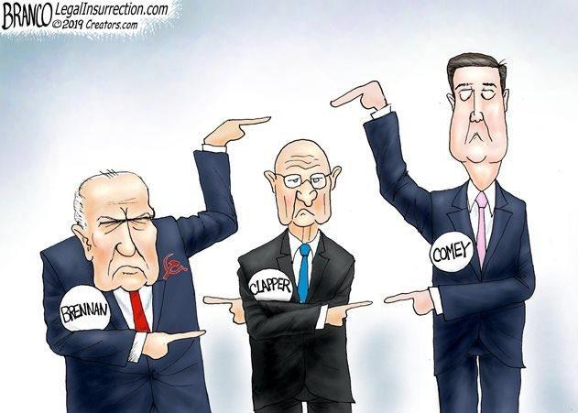
Most of the facts are already documented. The documents are about to be made public, for all to see, in an absolutely unprecedented act of transparency. Only a few details remain to be confirmed: for instance, whether international man-of-mystery and entrapment artist Josef Mifsud was in the employ of the CIA, and/or Britain’s MI6, and/or Mrs. Clinton’s Fusion GPS contractor (or Christopher Steele’s Orbis Business Intelligence company, a subcontractor to both Fusion GPS and the FBI). Questions will now be asked — though not by The New York Times.

The evidence already public indicates that Robert Mueller must have known as early as the date of his appointment (and likely before) that the predicating evidence for his inquiry was false. After all, his soon-to-be lead prosecutor, Andrew Weissmann, was informed of that in no uncertain terms by his DOJ colleague, Deputy Attorney General Bruce Ohr, in 2016.

Justice may seek to know why Mr. Mueller did not inform the target of his inquiry that this was so, when he knew about it one month after being appointed to run the coup operations. The answer to that may be that Mr. Mueller’s true mission was to disable Mr. Trump as long as possible while setting an obstruction of justice trap — which also failed tactically.

Notice that Mr. Mueller declined to testify before the House Judiciary Committee last week. Chairman Jerrold Nadler (D-NY) was a fool to invite him. Did he not know that minority members of his committee get to ask questions too? How about, “Mr. Mueller, when were you aware that the three dossiers you had in your possession were in fact paid for by Hillary Clinton?”
In an interesting turn of the screw last week, polling showed that a majority of those asked were in favor of investigations into the origin of the RussiaGate story. The FBI, being an agency under the direct supervision of the Attorney General, will be hosed out for sure. The CIA, on the other hand, has a sordid history of acting as a sovereign state within the state — hence the derivation of the Deep State. They are renowned for protecting their own.

Remember, the Senate Minority Leader, Mr. Schumer, snidely told the incoming President Trump at the get-go that the Intel community “has six ways from Sunday at getting back at you.” And he had the nads to tell America that Trump was the one weaponising law enforcement to go after political enemies. I guess we’ll finally get to see about that because the CIA’s former director, the wicked Mr. Brennan, is grand jury bound. I suspect he will not be protected by his former colleagues. His downfall may presage a more thorough cleanup, and perhaps a major reorganization, of this monstrous agency. I think it is about time for the end and erasure of the FBI, the CIA, and half a dozen other intelligence agencies. The DNC might as well be dissolved as well. And, don’t worry. There are least two new American parties that would take their place tomorrow.

The indictment of Julian Assange adds a big wrinkle to these upcoming proceedings. Apart for what it means to First Amendment protection for a free press (no small matter), Mr. Assange is the one person who actually knows who handed over the “hacked” DNC emails to Wikileaks. Perhaps getting the answer to that question is the real reason that the DOJ is throwing the book at him. The trial of Mr. Assange is sure to be a humdinger. How many of you believe he will ever be allowed to live long enough to take the stand?

This unique, world-shaping nation – our “sweet land of liberty”– faces an existential threat in the Marxist Uniparty campaign to destroy our president. This flawed but fearless bare-knuckle fighter, Donald J. Trump, was chosen by we the people to rescue America from the Clinton/Obama/Bush/Soros/Deep State takedown in 2016 and to grant its people a short reprieve: a limited window of opportunity to rally behind the Constitution as understood by our Founding Fathers.
Most clear-thinking Americans recognized in 2016 how close we came to national collapse at the hands of the Clinton Crime Syndicate. Two and a half years of relentless carpet-bombing of the Trump administration by the treasonous mass media and continuous, profoundly devious multi-faceted and multi-layered regime-change tactics by the Deep State and the elites of both parties has placed the entire world in a state of fear and trepidation. The question on everyone’s minds is, “How is Trump’s base?”
So far, the softening of support appears limited to those most susceptible to small-picture politics grounded in their own pet issues. But if ever there were a time to keep a firm hold on the big picture, this is it.
Never in the history of this nation has anything come close to the legal, political and psychological blitzkrieg being waged against Americans who support their President. It is the sum of the attacks on Robert Bork plus Clarence Thomas plus Roy Moore plus Brett Kavanagh times 100. And, importantly, it is the same axis of evil driving it: Atheists, pro-aborts, LGBT radicals, totalitarian socialists and predatory corporatists. It is the same coalition of hard lefties who have systematically and successfully waged their demoralizing culture war – across the entire spectrum of social and fiscal conservatism – against Christians and constitutional originalists – since the formation of the DNC in 1848. They have finally taken us to the very brink of collapse. Americans have no idea how hot the water was. They were nearly boiled alive, and they didn’t even know it.
Why do they hate Trump so zealously? Because he is trying to save America – the real America handed down to us by the founders. He is the only LEADERSHIP that stands in the way of these diabolical, God-hating fanatics and their world-conquering agenda. And President Donald Trump is the man chosen – by God and American voters – for this desperate season, to lead real America’s last stand against them. It’s just like God. He always chooses flawed men to set his people free.
In a very real sense, at this critical moment America is Trump and Trump is America. If Trump goes down, America goes down. The window of reprieve will have closed, and this once exceptional nation will be cannibalized and assimilated into the new globalist order along with every other country that has followed Trump’s lead.
Because if this tireless, thick-skinned, counter-punching, PC-rejecting, Christianity-defending warrior, who can’t be steered or intimidated by the leftist media, who knows all the left’s dirty tricks as only a former insider can know them, and who isn’t restrained by the Marquis of Queensberry rules that only Republicans are ever held to … if he can’t defeat the swamp creatures, then who among the very limited universe of possible alternative leaders can?
No one. These are times and circumstances of biblical proportions, and for His own reasons God has raised up Donald Trump as our warrior-champion. Our duty as patriotic Americans is to keep a crystal clear focus on the enormity of the stakes we all face in this war against Trump and to do all that we can to prevent our common enemies from taking him down.
Dirty Cops in Chicago
As a Chicago police officer, Shannon Spalding worked undercover in some of the toughest parts of the city -- only to discover some of the most dangerous criminals were fellow police officers. She risked her life to stop them.
Soon after joining the Chicago Police Department in 1996, Spalding drew an assignment in one of the most violent neighborhoods in the city. "It was a full-blown war every single day," she said.
"It was like a movie set. I was shocked. It was shock and awe for me. It was just a completely different world.”
To survive, Spalding leaned on veteran cops like Ronald Watts.
"I thought he was battling crime and he was doing it with finesse and grace," she said.
In 2006, a decade after Spalding was trained by Watts, she had a new assignment in the narcotics division.
"I was the undercover. I would go out, I would make the controlled narcotics purchases," Spalding explained.
Her partner, Danny Echeverria, would swoop in and make arrests. But during police interviews, something strange started happening.
"People would say … 'I can't believe you're going to arrest me when one of your own is actually running the narcotics trade,'" said Spalding.
Spalding learned Watts and his crew would plant drugs on residents of the Ida B. Wells projects and extort cash.
"Even the good citizens that live there, that are law-abiding citizens, they're subjected to this," she said. "We heard … he would put anything from a couple bags to enough to put you away for 10, 15, 20 years."
In 2006, Ida B. Wells resident Delores Allen witnessed this practice firsthand when her son Zarice was pushed up against Watts' police car.
"He goes in his pocket, brings out the drugs. 'If you guys -- I catch y'all again, I'm going to put these drugs on your ass.' That's his exact words," said Delores Allen.
Allen says Watts kept his word.
Later that year, Zarice was arrested and charged with felony possession of heroin and crack cocaine; he was 17 years old. Allen says the drugs were planted by Watts.
"I just seen all his hopes and dreams and stuff just go," an emotional Allen said. "It just went down the drain from there."
Spalding and her partner would eventually learn Watts' bad deeds had been going on for years.
"If we don't report this criminal conduct we're absolutely no better than Watts or any of these other corrupt officers. And if we do we may just be ending our careers and putting our self in real danger," said Spalding.
"So, what did you and your partner decide to do?" asked Ferrer.
"I convinced him that we needed to go to the FBI," Spalding replied. "My greatest fear was that because this was such a long-running … criminal enterprise … I felt that we would be set up for dead."
Spalding and her partner would spend years undercover investigating Ronald Watts and his team.
In February 2012, Sgt. Ronald Watts and one of his officers, Kallat Mohammed, were arrested after being caught robbing a drug courier of $5,200. That courier was Spalding's informant and was wearing an FBI wire. Both Watts and Mohammed were convicted. Watts was sentenced to 22 months and Mohammed received an 18-month sentence.
Aided by that investigation, more than 60 people wrongfully arrested by Watts and his team have now been exonerated -- including Zarice Johnson.

The Space Force Takes Command
In a stunning move of Fascism, the new Space Command—a Deep State arm of the Air Force—asserted its all-powerful solicitation power and stepped on Space-X in an effort to stop them cold, without ever reaching their goal of space exploration.
A lawsuit filed May 17 by SpaceX against the U.S. government was made public on Wednesday. In the 79-page redacted bid protest, SpaceX challenges the U.S. Air Force's Oct. 10 decision to award development contracts to its competitors and exclude SpaceX.
SpaceX's bid protest with the Court of Federal Claims challenges the Air Force Space and Missile Systems Center's decision to deny SpaceX a Launch Service Agreement contract as "arbitrary and capricious and contrary to law."
The Air Force awarded LSA cost-sharing contracts to Blue Origin ($500 million), United Launch Alliance ($967 million) and Northrop Grumman ($762 million) to help the companies defray the costs of meeting the government's unique launch requirements for the upcoming launch procurement competition known as National Security Space Launch Phase 2 Launch Service Procurement. Without LSA funds, SpaceX is required to bear the brunt of those costs on its own. In the redacted portions of the complaint, SpaceX includes what it estimates those cost would be, such as the construction of a payload integration facility at the Eastern Range launch complex. The figures were redacted.
Related: In Photos: SpaceX's Amazing Triple Rocket Landing of Falcon Heavy
CLOSE
Blastoff! SpaceX Launches 60 Internet-Beaming Satellites
Volume 0%
A company spokesperson in a statement to SpaceNews says SpaceX "respectfully disagrees with the Air Force's LSA award decision. While we support the Air Force moving forward with its Phase 2 acquisition strategy for national security space launches as currently planned, we are formally challenging the Air Force's LSA decision to ensure a level playing field for competition."
The bid protest lays out in detail the reasons why SpaceX believes the court should declare that the LSA award decision "violates the requirement competitive procedures." It also asks the court to suspend further LSA investments by the government and reevaluate SpaceX's proposal.
The entire complaint is a harshly worded condemnation of the Air Force's criteria for selecting launch providers and is especially critical of what SpaceX contends is an institutional bias toward longtime launch provider ULA. Since it emerged as a contender in the launch market a decade ago, SpaceX has sought to challenge ULA's dominance. In 2013, SpaceX sued the Air Force over its decision to award ULA a bulk purchase of launches instead of allowing competitive bids for the work.
In the current complaint, SpaceX argues that with its LSA decision, the Air Force "chose the portfolio that best served the needs of ULA, the long-standing incumbent, by awarding an LSA to ULA and an LSA to each of the two offers that are currently developing major components for ULA's system."
Blue Origin is developing the BE-4 engine for its own New Glenn rocket and for ULA's Vulcan Centaur. Northrop Grumman makes solid rocket boosters that will be used to power its own OmegA launch vehicle and to augment the Vulcan rocket.
The lawsuit says ULA, Northrop Grumman and Blue Origin proposed only conceptual rockets whereas SpaceX has proven commercially viable vehicles. For the first time, SpaceX discloses that its LSA proposal included a portfolio of vehicles, the Falcon 9 and Falcon Heavy, in addition to the still-in-development Starship deep space exploration vehicle.
SpaceX offered Falcon 9 and Falcon Heavy "for the vast majority (if not all) the manifested Phase 2 RFP missions and the developmental Starship for missions scheduled to launch in 2025 or after," says the complaint. SpaceX argues that it proposed the "least risky" approach for assured access to space and to end reliance on Russian rocket engines currently used by ULA's Atlas 5. Nevertheless, the Air Force gave SpaceX's bid a "high risk" rating for its ability to launch the larger category C payloads.
See SpaceX Falcon Heavy Launch 23 DOD Satellites in New Animation
Volume 0%
The protest points out that Falcon 9 and Falcon Heavy to date have launched more than 70 national security, civil and commercial missions.
SpaceX calls that the three LSA winner vehicles "paper rockets," none of which has a meaningful chance of being ready in time for the Phase 2 performance period." In Phase 2 the Air Force will select two suppliers in 2020 to start launching payloads in 2022.
Over the past two days, all three LSA winners have filed "motions to intervene" in the SpaceX lawsuit. This allows the three companies to be parties in the lawsuit and protect any interests that might be put at risk by any court decision. ULA and Blue Origin filed their motions May 21 and Northrop Grumman on May 22. The Department of Justice, which represents the U.S. government in the suit, can turn to these three companies for documentation or data that could help win the case.
SpaceX noted in the complaint that soon after the Oct. 10 LSA awards were announced, the company voiced its concerns to the Air Force. It filed an objection Dec 10 but SMC did not agree, and officially denied SpaceX's objection on April 18, 2019, leading SpaceX to seek relief in court.
The protest does not mention that SpaceX CEO Elon Musk reportedly admitted that its LSA proposal was flawed during a conversation with then Deputy Defense Secretary Patrick Shanahan on Dec. 6, 2018. The comments by Musk were reported by the Pentagon Inspector General April 25 in a report of its investigation of Shanahan for unethical conduct. The IG cleared Shanahan of any improper actions. A member of Shanahan's staff attended and summarized the meeting in a memo that was given to the IG. Musk noted that SpaceX was not successful in the Air Force LSA competition and that SpaceX had written a poor proposal that "missed the mark."
Industry sources who spoke with SpaceNews on Wednesday said Musk's comments could come back to haunt SpaceX in its challenge of the LSA awards. According to these sources, the Air Force gave SpaceX an opportunity to revise its proposal but the company chose not to.
SpaceX offered a different story, with a company source saying on background that the Air Force declined to engage in any discussion about the company's objection to the Launch Services Agreement award decision.
The company insists that it is not seeking to delay or stop the National Security Space Launch Phase 2 Launch Service Procurement. The complaint filed with the Court of Federal Claims, it says, is only intended to give an independent third party an opportunity to review a decision it considers flawed.
Absent any court actions to reverse the LSA decision, says the complaint, "SpaceX will suffer the irreparable harm of being deprived of the opportunity to compete fairly." Because of the flawed and biased treatment of SpaceX, the company will suffer "substantial competitive harm" in the final phase of this procurement, the Phase 2 competition.
NASA Head Quits
A top NASA executive hired in April to guide strategy for returning astronauts to the moon by 2024 has resigned, the space agency said on Thursday, the culmination of internal strife and dwindling congressional support for the lunar initiative.
Mark Sirangelo, named six weeks ago as special assistant to NASA Administrator Jim Bridenstine, left the agency as NASA abandoned a reorganization plan due to a chilly reception on Capitol Hill, Bridenstine said in a statement.
Two individuals close to the space program and familiar with the situation said Sirangelo was escorted out of NASA’s headquarters in Washington on Wednesday after his resignation.
His departure came after lawmakers rejected NASA’s proposal to create a separate directorate within the space agency to oversee future lunar missions and ultimately develop human exploration of Mars.
Enlarge ImageMark SirangeloReuters
“The proposal was not accepted at this time, so we will move forward under our current organizational structure,” Bridenstine said. “Given NASA is no longer pursuing the new mission directorate, Mark has opted to pursue other opportunities.”
Last week, the Trump administration asked Congress to increase NASA’s spending next year by $1.6 billion as a “down payment” on the accelerated goal of landing Americans back on the moon by 2024, more than half a century after the end of the US Apollo lunar program.
The latest initiative was dubbed Artemis, after the goddess of the hunt and the moon in Greek mythology and the twin sister of Apollo.
NASA had aimed to return crewed spacecraft to the lunar surface by 2028, after putting a “Gateway” station into lunar orbit by 2024. However, the prospect of additional funding drew little enthusiasm from congressional appropriators.
The two people with knowledge of the matter said Sirangelo’s ouster was sealed by increasing skepticism that 2024 was a realistic deadline for moon landings.
In his statement, Bridenstine said the agency was still exploring what organizational changes were “necessary to maximize efficiencies and achieve the end state of landing the first woman and the next man on the moon by 2024.”
“If the $1.6 billion does not materialize, we will fall back on the previous plan, which was to land in 2028,” the NASA chief told reporters at a news conference earlier in the day.
NASA announced earlier Thursday it had selected the space technology company Maxar Technologies Inc. as the first contractor to help build the “Gateway” outpost.

The Pelosi Show Gets a Major Edit

Fireworks exploded Wednesday on Capitol Hill after President Donald Trump abruptly walked out of an infrastructure meeting at the White House with the two most powerful Democrats in Congress: House Speaker Nancy Pelosi of California and Senate Minority Leader Chuck Schumer of New York.
Trump reportedly took great offense to the fact that, just prior to the start of the meeting, Pelosi had publicly accused the president of engaging in a “cover-up.”
Those remarks came following a morning meeting with House Democrats to where Pelosi reportedly said Trump “wants to be impeached,” according to The Washington Post. Right on cue as per the script, Pelosi and Schumer — dutifully echoed by their comrades in the establishment media — painted a picture of an enraged and mentally disturbed president throwing a “temper tantrum.”
In a stunning act of transparency, several of his top aides who were present at the abruptly canceled meeting — White House counselor Kellyanne Conway, strategic communications director Mercedes Schlapp, chief economic adviser Larry Kudlow and press secretary Sarah Sanders, went to the public and set the record straight.
What began as an announcement in the Roosevelt Room of the White House about a $16 billion aid package for farmers soon turned into a free-wheeling impromptu news conference, after Nut job Pelosi decided to preempt the event with her own presser, openly accusing the President of conducting the biggest coverup in history. Not a smart move, if you’re going for a meeting to talk about spending money.
She instantly hosed any chance of getting anything done with the President. Someone didn’t get the memo. You don’t slap the President before a dance, because he will calmly and coolly walk away from the table. They all affirmed Trump was "calm," refuting Schumer and Pelosi's claim he had a "temper tantrum"
“Very calm. No tamper tantrum,” Conway said of Trump’s demeanor during the meeting.
She proceeded to excoriate the supposedly “facts-first” media for the blatant “lie” they helped perpetuate that the president had raged at the Democrat leaders. Trump then turned to Schlapp and asked for her take on the meeting.
“You were very calm and you were very direct,” Schlapp said. She also noted how “discouraging” she found it that Pelosi had made her incendiary comments moments before the meeting but still thought a constructive discussion could happen. It was almost like she forgot what day it was and just read the script she was handed.
Trump later turned to Kudlow and asked a similar question.
“You were very calm and you laid out your case,” Kudlow replied.
Kudlow pointed out that neither of the Democrats had said anything and added, to great laughter, that Trump had been “much calmer than [at] some of our trade meetings.”

The president then called upon Sanders and asked if he had been “screaming and ranting and raving” as the media had reported. Sanders chuckled and responded that his tone had been “very calm.”
“I’ve seen both, and this was definitely not angry or ranting,” she said.
“Very calm and straightforward and clear that we have to actually get to work and do good things for the American people,” she continued. “And it’s going to be impossible to do that if we’re spending all of our time fighting.”
Following her response, Trump recalled a prior incident in which the same thing had allegedly occurred — a White House meeting on border security that was purportedly cut short after an angry outburst by the president.
Trump called upon deputy press secretary Hogan Gidley, who was at the second meeting Trump had referred to. Much like his colleagues, Gidley shared an account of that earlier meeting that disputed the narrative set by Pelosi, Schumer and the media. There is no disputing that Trump is unconventional and has a tendency to buck tradition, which isn’t always a bad thing.
In this case, he used the opportunity provided by the farm aid media conference to forcefully push back against the false media reports and narrative of the day before, something no other president in recent history is likely to have done.
This is actually what transparency looks like, and once again, Trump has outsmarted and outmaneuvered his chief congressional rivals — Pelosi and Schumer — by publicly undermining their evidence-free accusations against him, even using the biased media covering the event to serve his own purposes in doing so.
Just like Trump always says. “I don’t do coverup.”
Samantha Power
Many people do not remember Samantha Power. I want to share with you what I know. She became Ambassador to the UN because her husband was Cass Sunstein. He was Communist who headed the Office of Information and Regulatory Affairs for Obama. She testified last fall behind closed doors to the House Intelligence Committee as part of its Russia probe, and one of the big unanswered questions will be why, during her final year as chief U.S. envoy to the U.N., she apparently made nearly three hundred of requests for the unmasking in U.S. intelligence intercepts of the identities of American citizens.
Those identities are closely guarded under Fourth Amendment constitutional protection, and one of lawmakers’ chief concerns, according to Jason Chaffetz, former chairman of the House Committee on Oversight and Government Reform “is the overall perceived ramp-up in the number of unmasking requests” during a sensitive election year. She later was heard warning Trump that is was not wise to piss off John Brennan.
She loved her Russian boys and that red wine at the parties. She posed in a negligee on the cover of a national magazine in heels with the caption, “Wait until they get a load of me.”
All six of the Russians with whom she consorted during her tenure under Obama were assassinated in her last weeks at the UN. None of them were able to testify during the investigation of Russian collusion, because they were all dead.
A red flag waved when we got a sense of how many Americans are “incidentally” surveilled — so many, that near-daily unmasking requests were said to be made in 2016 under the name of a single official: United Nations Ambassador Samantha Power.
Who else was involved? Then-acting Attorney General Sally Yates, national security adviser Susan Rice, and Director of National Intelligence Clapper. Clapper said he requested unmasking of American names “every couple of weeks.” Apparently, it became so common that Clapper told Congress he probably made some requests on his way out the door before Trump’s inauguration, but couldn’t recall the specifics.
Rice initially claimed she knew nothing about the unmasking of surveilled Trump associates. Later, she admitted on MSNBC that she had asked for names of U.S. citizens previously masked in intelligence reports.
Add to all this the report that, during 2016, the Obama administration vastly expanded its searches for information about Americans in the National Security Agency (NSA) database. In 2013, there were 9,500 searches involving 198 Americans. In 2016, that escalated to 30,355 searches of 5,288 Americans.
Sure, it’s possible all that spying on U.S. citizens, all those unmaskings, were on the up and up.
But what if they are not? I am saying that this entire operation was a Deep State effort to overthrow the American government. America’s own intel agencies have gotten caught in significant abuses, despite FBI Director Christopher Wray incorrectly testifiying to the contrary.
In 2016, an inspector general found “widespread” abuse of key provisions designed to protect Americans. A FISC judge found so many violations that he described them as an institutional “lack of candor” and “a very serious Fourth Amendment issue.”
Does any of this have something to do with the NSA reportedly listening in on Congresswoman Jane Harmon (D-Calif.) as she spoke to pro-Israel lobbyists? Somebody leaked her unmasked name in 2009. Or the recordings of Congressman Dennis Kucinich (D-Ohio) in 2011 as he spoke to a Libyan official? Those were later leaked to the press.
What about reports of our intel officials listening in on U.S. members of Congress in 2015 as they communicated with Israel’s prime minister about the Obama administration’s Iran deal?

Is it why Sens. Lindsey Graham (R-S.C.) and Rand Paul (R-Ky.) asked whether they’d been surveilled? Or why, at a hearing in 2017, Yates and Clapper admitted having reviewed and possibly shared “classified documents in which Mr. Trump, his associates or members of Congress had been unmasked”?
Hypothetically, if bad actors abused their authority, might they be so anti-Trump partly because a wildcard Trump administration could be expected to unearth what they’d been doing all these years?
One final note: In October of 2017, Samantha Power reportedly told congressional investigators that many of the hundreds of “unmasking” requests in her name in 2016 were not made by her. The fact is that each and every unmasking had to be done in person at the office set aside for that purpose. Samantha Power physically went to that office every single day to unmask names of Americans, KNOWING that she would be recorded doing so. Why? Because she did not have a choice. She was ordered to do it by John Brennan. Samantha Power was a CIA asset known to the Russians as a spook. To imply that someone else used her name to unmask names is absolutely ridiculous. It is a face-to-face process.
The good news would seem to be that there’s documentary evidence of all this ... if anyone wants to discover it. There are names of who requested what and when, information as to where unmasked intel was sent, names of those who searched the NSA database and under what auspices. Unlike a lot of facets of the Trump-Russia-intel controversy, this trail should be easily traceable. My question is, “How could Mueller step over all those dead Russians and Seth Rich’s body every day when coming to work, and not at least ask who killed them?”
I guarantee you that Putin knows who killed those ambassadors. I think he knows exactly who killed them. And, this is why he does not trust America. It is why no one trusts America. But we just might be too busy chasing the pretty colors flashing before us every day. They might be keeping us from taking a good hard look at a very serious matter.
Officials involved in unmaskings insist they did nothing improper, that their motivations were to protect the nation. Against what? They say they did not act for political reasons, or to spy. Seriously? America prays every single day that these people go to prison.
2nd Amendment Report

A Forney, Texas, woman hid inside a closet, called 911 to report an alleged intruder, then shot that suspect dead.
CBSDFW reports the woman awoke Thursday to the sounds of the suspect repeatedly knocking on her front door. She did not open the door because she had never seen the individual before. Soon after she heard him allegedly trying to make entry through the back door.
The woman hid in a closet and called 911 to report the suspect. The suspect allegedly discovered her while she was still on the 911 call and she shot him.
Deputies arrived to find the suspect nearly at room temperature at the scene.
FOX4 News reports that the woman was not injured in the incident. The deceased invasion suspect has not been identified.
Neighbor Amanda Baber was interviewed about the incident. She said, “Praise God that she had the means to protect herself and that she had the strength to do it because in situations like that, you can get pretty fearful and tend to clam up and not know what to do.”
I love gun control. I never miss.
NGO Caught on Film in Documentary: YouTube Deletes

YouTube censored ‘Borderless,’ a new documentary about mass immigration from independent filmmaker Lauren Southern, on the day of its release.
The feature-length documentary was taken down from YouTube less than 24 hours after it was uploaded, and is currently unavailable. YouTube has yet to give Southern an explanation for its removal.
Southern has since uploaded a backup version to YouTube, although the loss of the original is likely to skew the documentary’s view count. Southern’s previous documentary, about the racially-motivated murder of white farmers in South Africa, accumulated over 2.3 million views on the platform.
Southern says she received a message from YouTube saying the video had “stopped processing.” But Southern points out that processing errors take place before a video has been uploaded, not after.
The Google-owned video platform initially appeared to “soft-censor” Southern’s documentary. YouTube users attempting to access the video found it marked as “deleted” in their favorites feed, and disappeared from their subscription feed, which is meant to show videos from subscribed channels.
“It can’t be a coincidence that it’s not in notifications, shows as deleted, not on my videos list, doesn’t show in recent history…” wrote Southern before the video was fully taken down.

There have been documented cases of Silicon Valley giants using deliberately triggered “errors” to interfere with politically disfavored content creators. A leak from Facebook earlier this year revealed that the company uses “forced glitches” against right-wing users.
Before the documentary was released, Southern’s team successfully exposed an NGO, catching its executive director admitting on camera that it encourages migrants to lie to EU border officials about their reasons for entering Europe. Southern reported that the UN High Commission for Refugees responded to her report, calling it “alarming.”
UFO Not of This World
A former Navy pilot has opened up about an otherworldly experience he says he experienced in 2004. His testimony comes just days after the Pentagon officially revealed the existence of a secret office investigating the existence of UFOs.
Cmdr. David Fravor, a former squadron leader who worked as a Navy pilot for 18 years, said on Monday he was on a routine training mission off the coast of California in 2004 when his unit was directed to go and examine strange unidentified objects that were descending from 80,000 to 20,000 feet, and then disappearing.
Upon flying 60 miles to the location, Fravor says he saw a tic-tac shaped object, “40 feet long with no wings, just hanging close to the water,” in an interview with the Washington Post on Monday. He said it created a disturbance on the water uncharacteristic of a helicopter or a plane, and moved rapidly.
“As I get closer, as my nose is starting to pull back up, it accelerates and it’s gone,” he told the Post. “Faster than I’d ever seen anything in my life. We turn around, say let’s go see what’s in the water and there’s nothing. Just blue water.”
“I can tell you, I think it was not from this world,” Fravor told ABC News, also on Monday. “I’m not crazy, haven’t been drinking. It was — after 18 years of flying, I’ve seen pretty much about everything that I can see in that realm, and this was nothing close.”
Interest in Fravor’s story has surged now that the Pentagon’s information is in the public realm. A video of the encounter Fravor describes is included in a cache of three videos cleared on Saturday for public viewing, which appear to show encounters between military pilots and what the Pentagon calls “anomalous aerial vehicles.”
The Pentagon said funding for its Advanced Aviation Threat Identification Program lasted from 2007 to 2012, and took up just $22 million of the Department of Defense’s $600 billion budget, the New York Times reported.
More than a year after its existence became public, the details surrounding the U.S. military’s Advanced Aviation Threat Identification Program, or AATIP, continue to be as fascinating as they are bizarre. We now know the titles of all of the nearly 40 studies the project funded in roughly four years of operation, as well as their authors and who they worked for. These reports cover a far wider breadth of topics than previously known, ranging from invisibility cloaks and warps drives, to fusion power and laser weapons, to more general advanced physics and materials science work. Some of the work appears to have been legitimate, but there’s at least one instance where the U.S. government almost certainly paid for junk science.
Steven Aftergood, who leads the Federation of American Scientists’ (FAS) Project on Government Secrecy obtained a copy of the list on Jan. 16, 2019, along with a cover letter, in response to a Freedom of Information Act (FOIA) request, which you can see below. The original five-page document is available here. The Defense Intelligence Agency had originally put together the list at the request of the offices of the late Republican Senator John McCain of Arizona and his ranking Democrat colleague on the Senate Armed Services Committee, Rhode Island’s Jack Reed.
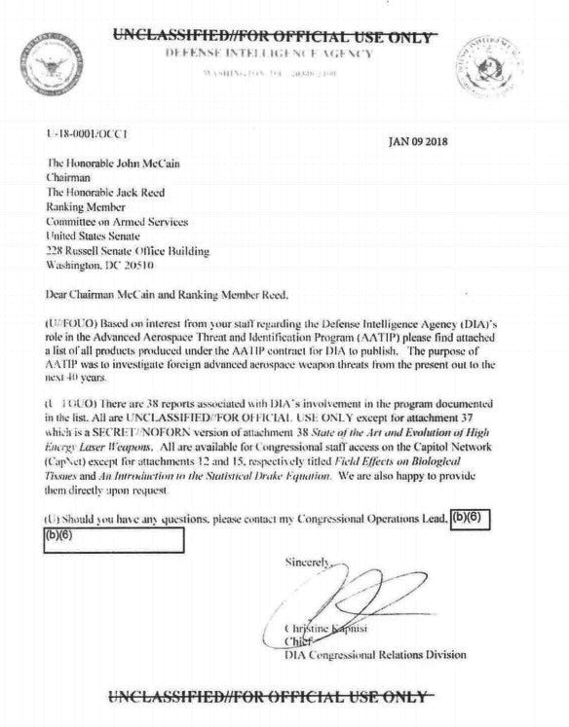
DIA VIA FAS
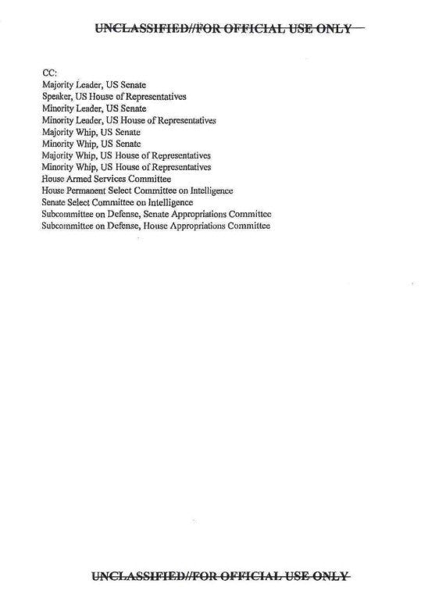
DIA VIS FAS
DIA VIA FAS
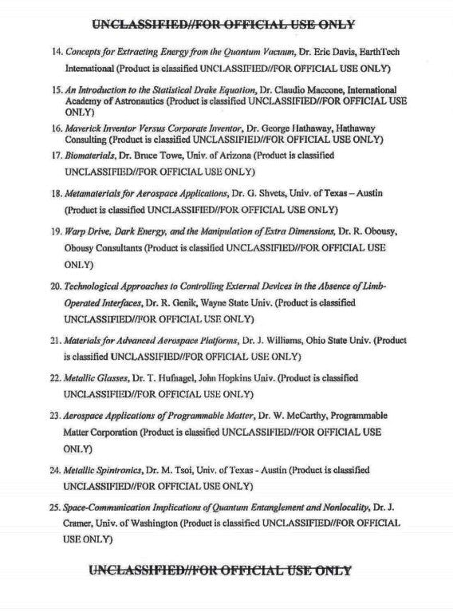
DIA VIA FAS
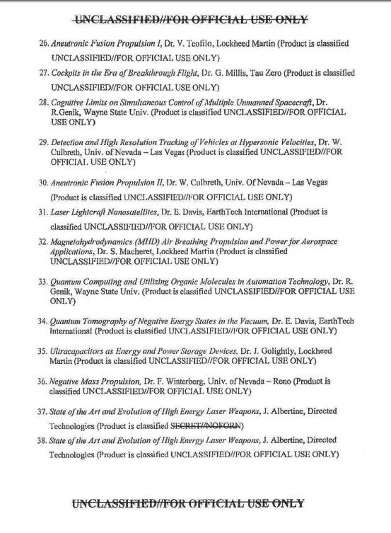
DIA VIA FAS
“Based on interest from your staff regarding the Defense Intelligence Agency (DIA)’s role in the Advanced Aviation Threat Identification Program (AATIP) please find attached a list of all products produced under the AATIP contract for DIA to publish,” the cover letter reads. “The purpose of AATIP was to investigate foreign advanced aerospace weapons threats from the present out to the next 40 years.”
That second statement is interesting in of itself given what is otherwise known about the program, which officially began in 2007 as the Advanced Aerospace Weapon System Applications (AAWSA) program. Between 2008 and 2012, DIA spent approximately $22 million on the program, which eventually became known as AATIP, and produced a total of 38 reports.
Robert Bigelow’s Bigelow Aerospace had won the AATIP contract and managed its research. Bigelow, who made his money in the hotel and real estate industries, is well known for his interest in unidentified flying objects (UFO), fringe science, and the paranormal. Individuals who worked for the program, including Luis Elizondo, who was head of the project for DIA, have since said publicly that investigating reported UFO sightings was a particular focus of the efforts.
As we at The War Zone have noted before, this actually makes good sense in many ways, since UFO sightings can turn out to be very real advanced and top-secret aviation programs. At least outwardly, DIA appeared to be taking the work of AATIP seriously, placing it under its Defense Warning Office, which has been monitoring for “threats to U.S. interests in critical regions” since its creation in 2002.
We know that AATIP definitely did do some investigating of UFO sightings. The disclosure of the program's existence has led to the emergence of a detailed report on a 2004 sighting of an object commonly known as the "Tic-Tac," as well as video footage that F/A-18 Hornets shot using their Advanced Targeting Forward-Looking Infrared (ATFLIR) targeting pods during that incident. You can view those clips below.
But it has also already been clear that AATIP sponsored research into a much wider array of topics beyond UFOs. Based on the list that FAS obtained, much of the research does appear to have come from reputable sources, even if the topics sound highly theoretical or outlandish in some cases. Of the 38 studies, more than half were the work of individuals working at academic institutions, such as the University of Nevada-Las Vegas, University of Nevada-Reno, The Ohio State University, and the University of St. Andrews in Scotland. You can find a good rundown of different authors and their known work at The Black Vault, which collects previously classified government documents and makes them available online.
One report from the University of St. Andrews may sound particularly fanciful with its title “Invisibility Cloaking,” but came by way of German scientist Dr. Ulf Leonhardt, who has been publishing papers on that topic since 2006 and is a noted expert on the topic. Though widely thought to be still far away from being practical, his research is grounded in real science to do with quantum physics and the behavior of light.
There are two more reports from Lockheed Martin, one of which is explicitly about fusion power and another that appears to be related to that topic. That firm’s legendary advanced projects division, the Skunk Works, has been publicly working to make fusion a reality since 2014. A third report from the company is simply titled “Air Breathing Propulsion and Power for Aerospace Applications” and sounds well in line with its known work on advanced propulsion technologies, including hypersonic aircraft and missiles.
Virginia-headquartered Directed Technologies, Inc., which has been receiving government contracts since 1985, appears to have provided a report so legitimate on high energy laser weapon development that AATIP published two versions, one of which was classified Secret with instructions not to release it to foreign nationals. This is the only one of the 38 studies that is classified in any way. All of the others are simply labeled “For Official Use Only.”

But the full list also exposes more dubious projects based on more questionable science from a network of individuals with close ties to Bigelow. The largest single source of these reports is EarthTech International of Austin, Texas. EarthTech's CEO Harold ‘Hal’ Puthoff, Ph.D. and another one of the company’s employees, Eric Davis, Ph.D. both have ties to the Nevada business mogul's now-defunct National Institute for Discovery Science, or NIDSci. An archived copy of that organization's website is available here and features information UFO sightings, extraterrestrials, and other fringe topics.

Puthoff and Davis were the primary authors on six of the 38 reports in total between them. Davis is also the co-author on another report from independent consultant Richard Obousy. Since the list FAS received only notes the primary author, it’s impossible to know how many of the studies EarthTech may have actually had a hand in.
Three of these reports are available online and we at The War Zone have examined their contents previously. In late 2017, after news of the program first broke, Corey Goode posted copies of two of the reports online, one covering “Advanced Space Propulsion” and another delving into “Warp Drive, Dark Energy, and the Manipulation of Extra Dimensions.” A third report, dealing with “Traversable Wormholes, Stargates, And Negative Energy,” is available separately.

All three of these works rely on what is, at best, borderline fringe science. All three individuals have direct links to Bigelow himself. The list contains additional reports from Dr. George Hathaway of Hathaway Consulting, another person with clear ties to Bigelow and his more fringe and paranormal interests, including Paul Czysz, a retired Air Force officer and McDonnell Douglas engineer, another known name in the UFO watcher community, was also among the contributors to AATIP’s research.
Marc Millis, a former NASA propulsion engineer who founded the non-profit The Tau Zero Foundation, which works on various efforts related to novel spaceflight concepts, including faster-than-light travel, is also among the authors. Millis left NASA following an apparent scandal for attending a venture capital event that Joe Firmage hosted in 1999.

Firmage is a Silicon Valley tech millionaire who says he had an unexplained visionary experience with a being who he says produced a ball of energy, which then entered his body.
In addition, there is at least one instance where the work that DIA, or Bigelow acting on their behalf, agreed to fund is especially suspect. Robert Baker’s GravWave company supplied AATIP with a report on high-frequency gravitational waves (HFGW). However, a 2008 report from the JASON group, a collective of expert scientists who advises the U.S. government, questioned the very scientific grounding of separate work Baker had done for the Office of the Director of National Intelligence on this topic.
“The proposed applications of the science of HFGW are fundamentally wrong,” the JASON review said of Baker’s work. “No foreign threat in HFGW is credible.”
With all of this in mind, the newly released list of reports that AATIP funded paints a newly complex picture of the organization and its research efforts. It also further calls into question what its exact objectives were and how focused its work was in meeting those goals – or not.
Hal Puthoff and Luis Elizondo both have gone on to work for the To The Stars Academy, which former Blink 182 front man-turned-UFO enthusiast Tom DeLonge founded in 2015. This private enterprise is continuing to pursue similar work as what had occurred under AATIP, albeit in the unclassified realm, as well as entertainment-related projects and extremely exotic aeronautics programs of questionable merit.
There’s still nothing official to confirm the more outlandish claims of work that AATIP may have been doing on the side, including accounts of having mysterious material from downed objects in storage lockers. But what is clear is that there is still much about the program that we don’t know.
Some would say that this information remains squirreled away out of concern that it would reveal an actual threat to national security, or alternatively, it would be overly embarrassing to disclose. The nature of a number of the reports the program generated would seem to lend evidence to the latter.
Correction: An earlier version of this story incorrectly stated that Joe Firmage claimed he had been abducted by aliens. He claims that he had a visionary experience with an unexplained being. He has also said that he believes in extraterrestrial life and that those beings have visited earth, but not that they have abducted him.
Quantum Entanglement for FTL Communications
The pioneers of quantum mechanics — Werner Heisenberg, Albert Einstein, Wolfgang Pauli, Niels Bohr, Erwin Schrödinger — argued endlessly about the implications of their equations: particles that were somehow waves of probability, that hovered in superposition between two states, that made quantum jumps without traversing the space in between. These thinkers were often as engaged with the philosophy as they were with the mathematics.
Ultimately the interpretations were only words: futile attempts to grasp something beyond language and maybe beyond mind. By the time the hippies were in school, physics textbooks had all but abandoned the messiness of meaning. Quantum physics worked. The message was “Shut up and calculate.” I remember the letdown. I thought for a while that I wanted to be a physicist. I was glad to read here that philosophizing about physics has made a comeback in university classrooms. Without the enthusiasms of the Fundamental Fysiks Group, Kaiser speculates, the inquisitive spirit might never have been revived.
The basic scenario for entanglement-based communication looks like this: two people, traditionally named "Alice" and "Bob" share a pair of particles that can each be measured in one of two quantum states, which we'll call "0" and "1." These particles are prepared in an entangled state in which a measurement of the state of Alice's particle is correlated with the measured state of Bob's particle, no matter how far apart they are. That is, if Alice measures her particle in state 1 at precisely noon in Schenectady, she knows that Bob in Portland will also measure his particle to be in state 1, whether he's in Portland, Maine, Portland, Oregon, or Portland Station on one of the moons of Yavin.
This seems like a perfect mechanism for sending information over vast distances, as Ethan notes:
So now to Olivier’s question: could we use this property — quantum entanglement — to communicate from a distant star system to our own? The answer to that is yes, if you consider making a measurement at a distant location a form of communication. But when you say communicate, typically you want to know something about your destination. You could, for example, keep an entangled particle in an indeterminate state, send it aboard a spacecraft bound for the nearest star, and tell it to look for signs of a rocky planet in that star’s habitable zone. If you see one, make a measurement that forces the particle you have to be in the +1 state, and if you don’t see one, make a measurement that forces the particle you have to be in the -1 state.
This seems like a really obvious application, and in fact a bunch of people seized on this as a justification for ESP and various other schemes-- I recommend David Kaiser's How the Hippies Saved Physics for the fascinating history of this whole business. And, in fact, if the situation described above were possible-- if you could measure a particle's state in a way that forced a particular outcome-- you could absolutely send information this way. But you can't do that.
And this is the point where I don't quite agree with the way Ethan explains the situation. He writes:
It’s a brilliant plan, but there’s a problem: entanglement only works if you ask a particle, “what state are you in?” If you force an entangled particle into a particular state, you break the entanglement, and the measurement you make on Earth is completely independent of the measurement at the distant star. If you had simply measured the distant particle to be +1 or -1, then your measurement, here on Earth, of either -1 or +1 (respectively) would give you information about the particle located light years away. But by forcing that distant particle to be +1 or -1, that means, no matter the outcome, your particle here on Earth has a 50/50 shot of being +1 or -1, with no bearing on the particle so many light years distant.
There's a subtle shift here from the impossible operation that would allow FTL communication to a different sort of operation, and it deserves to be spelled out. That is, in the original statement, you "make a measurement that forces the particle" to be in a particular state, while in the second you "force an entangled particle into a particular state" which breaks the entanglement. Those are not the same thing, though-- one is a measurement, the other is a change of state followed by a measurement.

It helps to think about a concrete implementation of this to make the distinction clear. So, imagine Alice's particle is one of the trapped ions that people regularly use to do quantum information experiments, which can be in one of two internal states. If her particle starts in a superposition of equal parts "0" and "1," how would she go about forcing a definite measurement outcome, let's say "1"?
The answer is to do an operation that we would describe in words as "If you're in state 0, flip the state, otherwise leave it alone." For a trapped-ion system, this is done using lasers to drive a transition from state 0 to state 1 by way of a third state (the jargon term for this is a "Raman transition"). If you choose your states carefully, you can arrange it so that an atom in state 0 will absorb the laser and flip its state, but an atom in state 1 won't interact with the laser at all. This sort of selective absorption is how they distinguish between states 0 and 1 in real trapped-ion experiments (state 0 absorbs a laser photon then re-emits the light, and repeating this a few million times a second gives you a bright spot on a camera pointed at the trap holding the ion), and a two-particle variant of it is how you entangle ions in the first place (the operation is "If Ion A is in state 1, flip the state of Ion B," and you give it an input state where B is definitely in state 0 and A is in a superposition of 0 and 1).
If Alice does this on her particle, it does not, in fact, affect the state of Bob's particle in any way-- it's still in an indeterminate state that's a mix of 0 and 1. It breaks the correlation between the measurement results, though-- Alice's particle is no longer in a superposition, but only in state 1, so when Bob eventually makes a measurement that randomly picks 0 or 1, it doesn't necessarily match Alice's measurement, which is guaranteed to be 1.
It should be noted that the "breaking of entanglement" Ethan describes is actually a slightly tricky thing to do, requiring a fairly specific operation to make it work. You will sometimes hear people assert that entanglement is fragile, and that any disturbance of one of the particles will mess things up, but that's not true. In fact, there are a huge number of things you can do to change the state of one of the two particles without destroying the entangled nature of the system, provided you keep track of what you did to it and adjust your final measurements accordingly. The impossibility of keeping track of all the ways entangled states get shifted is crucial to (the way I think about) the process of "decoherence" that plays a key role in (the way I think about) the "Many-Worlds" interpretation of quantum physics, which is what I was hinting at when I said this gets into some deep stuff, though this post is already running long, so I won't try to explain here.
Crucially, though, this is not the sort of thing that people talk about doing when they talk about using entanglement for faster-than-light communication. What they want is a measurement procedure that forces a particular outcome. That is, they want Alice to use some woo-woo mystical process to ask her particle "What is your state?" and make it come out to be 1, thus instantaneously forcing Bob's particle into state 1 as well. If such a procedure existed, you could, in fact, exploit it to send messages (with disastrous consequences for causality); fortunately, God plays dice with the universe, and the results of a quantum measurement are unavoidably random. Which means that while Alice and Bob end up with measurements that are perfectly correlated, no information passes between them. They can only see the correlation when they get back together and comparelists, and they have to do that at or below the speed of light.

It should also be noted that the version of entanglement-based communication Ethan describes is a particularly naive sort that even fringe physicists mostly reject. A more plausible scheme for actually doing this would be to use different measurement bases to send information. That is, rather than "force the state to be 1 to send Bob a 1," Alice would ask two different questions of her particle. If she wants to send Bob a 1, she would make a measurement asking "Are you in 0 or 1?," but if she wants to send a 0 she makes a measurement asking "Are you in '0+1' or '0-1'?" The latter operation puts Bob's particle into the corresponding state, which has a 50% chance of returning either 0 or 1 for his measurement. So all Bob has to do is measure that probability distribution for each particle-- if it's either 0 or 1 with 100% probability, he knows Alice is sending a 1, and if it's 50% of each, she's sending a 0.
That scheme doesn't work either, for a more subtle reason. The problem is that you can't determine a probability distribution from a single measurement of "0" or "1," so Bob would need to make a lot of copies of the state of his particle in order to distinguish Alice's message. But there's a very deep result (that Kaiser's book claims was directly inspired by these FTL communication schemes) known as the "no-cloning theorem" showing that this is impossible-- you can't make faithful copies of a quantum state unless you already know what it is. There's no way for Bob to unambiguously determine which measurement Alice made, so you're back in the scenario where Alice and Bob each have random strings of 1's and 0's that only turn out to be perfectly correlated later on, when they get back together and compare. Quantum randomness saves the day.
So, as I said, the whole business is subtle and complicated. The end result is always the same, though: While it's one of the weirdest and coolest phenomena in physics, there is no way to use quantum entanglement to send messages faster than the speed of light.

