Jihad Report
Jun 27, 2020 -
Jul 03, 2020
Attacks | 33
Killed | 146
Injured | 65
Suicide Blasts | 1
Countries | 9
Independence Day Trump
President Donald Trump described ongoing drives to destroy historical statues and monuments as part of a broader campaign to “far-left fascism” that seeks to “overthrow the American Revolution,” making his comments during his Salute America address on Friday evening at Mount Rushmore in South Dakota.
Trump said, “There is a new far-left fascism that demands absolute allegiance. If you do not speak its language, perform its rituals, recite its mantras, and follow its commandments, then you will be censored, banished, blacklisted, persecuted, and punished. Not going to happen to us.”

Trump continued, “Make no mistake. This left-wing cultural revolution is designed to overthrow the American Revolution. In so doing, they would destroy the very civilization that rescued billions from poverty, disease, violence, and hunger and that lifted humanity to new heights of achievement, discovery, and progress. To make this possible, they are determined to tear down every statue, symbol, and memory of our national heritage.”
Left-wing orthodoxy is common across institutions, news media, and large corporations, added Trump.
Breitbart News Senior Editor-at-Large Joel Pollak similarly assessed Democrats and their political supporters as advancing a socialist revolution to “correct” the original American Revolution.
Pollak said, “The Democrats want a second American Revolution, and on current trends, they’re going to get it unless there’s a silent majority out there that stands up. … Essentially, we’re in a situation where the country is going to sink if Democrats win.”
Historian Victor Davis Hanson speculated that Trump would be reelected in November — and that only Trump’s reelection could stop an ongoing left-wing and partisan Democrat “Cultural Revolution” in the country.

The New Declaration of Independence

The sun never set on the British Empire. There were no borders to it. British ships ruled the waves. British industry ruled all commerce to every country plus the colonies of America. The king enforced a uniform set of rules controlling the flow of people, goods and money throughout the realm. He had the army, the money, and the skills at his command.
In this borderless "global economy" ruled from London. A small group of brave leaders, people whose names are now legend – George Washington, Thomas Jefferson, Alexander Hamilton, Benjamin Franklin, Tom Paine, among others – decided America should be its own independent country. They chose a new future. They walked away from Armageddon and established a world superpower based upon unalienable rights. These rights allowed something that had never existed on Earth before. A person owns what he makes or grows. It is theirs to do with what they want in their own pursuit of happiness.
The American Revolution was a rebellion against globalism. Better we should govern ourselves, make our own rules that serve our own interest, not the interests of others somewhere else. They can make their rules, we'll make ours. The rest, as they say, is history.
And so, 12 score and four years ago the people of 13 British colonies on the east coast of North America declared their independence from the British Empire. The American Revolution was a trade war. The colonists were prohibited from enjoying the fruits of their labors. What they grew, dug and made with their own hands belonged to someone else. We could not use the bounty of our plentiful farms, forests and mines to make the clothing, furnishings and plows our people used.
Americans were compelled to send their fiber, timber and ore on ships across the ocean to "the workshop of the world" where they were fashioned into finished goods, then sent back and sold at prices set by another. We were forced to buy our essential goods from foreign shores.
Today, the "workshop of the world" is not Britain, but China. And just as the king of England wrote the rules that crippled American industries, the Communist Party of China has waged economic warfare against the United States. China's industries, many of them owned outright by the government, dump their products on our shores at prices far below the cost of production in order to drive American industry into extinction.
Swarms of Beijing's spies and cyber-espionage agents steal our technology and trade secrets – the property of our citizens and the fruit of our intellectual and physical labor. Beijing's rulers invited American companies to do business in China then forced them to hand over their property and earnings. They waged war against our values and our God-given rights, threatening reprisal on Americans who speak freely about the true nature of the Chinese Communist Party. They threatened and withheld the life-saving medical supplies American companies have both made in China or purchased from China.
They waged chemical warfare against our people, producing and exporting deadly drugs that kill tens of thousands of Americans year after year, ravaging our families and laying waste to entire communities. They waged biological warfare on America. Deliberately, through incompetence and corruption, the CCP unleashed a deadly virus on the world that took a toll in lives and treasure and brought our country to a standstill.
That all started to come to an end when Donald Trump was elected. He and he alone had the will and the skills to dismantle the workshop of the world in China and return those jobs to America. He was well on his way to getting it done, when the first trade treaty between China and America was signed. The CCP dominance of the world was collapsing under the weight of their consumption. They either had to change, or die. They made another choice.
They chose to kill 330 million Americans with a bioweapon. The coronavirus pandemic made clear something the CCP designed a long time ago. We had grown dangerously dependent on China for our health, our well-being and our very way of life. That was also by design. A long game of the Global Syndicate that once ruled the world for more than 5 thousand years. America took that rule away in 1776, and the Syndicate has been trying to get it back ever since.
Two hundred forty-four years ago, Americans recognized the cost of being dependent on a foreign power. Fifty years ago, we learned the cost of being dependent on foreign energy when the oil sheiks cut us off. Lines stretched for miles at gas stations, and often there was no gasoline to be had at any price.
Now, we learned the cost of being dependent on foreign manufacturing. Americans could not get the medical supplies we needed to protect ourselves. We were at the mercy of China, the place where our factories had moved. And the problem is not limited to just medical supplies. So many other products we use every day, from smartphones to automobile parts, disappeared from America as factories in China shut down.
Our dependence on Communist China didn't happen overnight. It took many decades, and was the result of decisions, deception, complacency and delusion. It was the result of spies and traitors who gave the CCP missile technology, trade secrets, and access to our universities in exchange for individual wealth, power, and opulence. These few Americans, beginning in 1992, sold America to the CCP for their own greed, yes, but because they were oath members of the Global Syndicate.
The Chinese Communist Party took control of America at the highest levels by financing hundreds of Democrat campaigns. The Democrat party became the political arm of the Global Syndicate, while the CCP was allowed to be the military arm. The banks were addicted to the drug cartel’s cash, just like the British had used opium in the 19th century to addict the Chinese and drain billions out of their economy, the Syndicate began using fentanyl, opiates, and heroin to addict America. They inserted anti-American lessons into our schools and then made it impossible to remove teachers who were indoctrinating our children. In two generations, our own children became their allies in the war to destroy America.
Some of our leaders had a naïve belief that doing business with the People's Republic of China, raising the standard of living of the Chinese people with Western investment, would magically transform a Communist dictatorship into a peace-loving democracy. Our leaders wanted to believe what happened in Japan and Germany after World War II would happen in China after the Cold War. And the Chinese Communist Party wanted us to believe that, too.
The CCP lied to our political and business leaders, promising a rich market for American products – if we gave China the factories and know-how to make those products. Those factories ended up making goods to sell to the American people. American factories were forbidden from selling anything to the Chinese. Just like you are blocked from selling on Facebook or Twitter or YouTube, the Global Syndicate stepped on every American business trying to make money off the great and wealthy Chinese. The Chinese people were forbidden under penalty of death from moving their money from China to America to build factories here.
Our political leaders had also come to believe that the world would be better without nations or borders, that we would all be better off. They allowed, even encouraged, our factories to move to China. And the Chinese Communist Party wanted us to believe that, too.
They said they believed in "free trade" and "globalization" even as they built tariff walls to keep American made products out and sought global supremacy for the Chinese nation under communist rule.
Corporate stockholders were focused on immediate profits. That led them to outsource our jobs and industries and blinded them to the devastating consequences for our people and our nation. They didn’t care that Americans without jobs would not be able to afford to buy their products. They only cared about the price of their stock. But the American people understood what those at the top refused to see.
Now everyone sees the true cost of the China price. Now no one can deny Communist China has ill intentions toward us.
The CCP is a Marxist-Leninist party that believes in a communist "dictatorship of the proletariat." If they have to kill 300 million Chinese people to kill 300 million Americans, that is of no consequence. They can make more Chinese. They cannot make another CCP. Freedom of speech, of the press, of religion, of assembly and the right to own property do not exist.
The CCP is the military arm of the Global Syndicate. They don’t not want to control the world. They want every soul in the world to make the oath and covenant to serve them. It has always been that way. If you choose to give up, they win. If you choose to drink the blood, your soul will be lost forever.
Americans understand it is necessary to loosen the bonds that have tied us to the Communist regime in China. Americans understand we must do as we did over two centuries ago: cut our ties to a foreign tyranny and establish our independence. It is time to burn the mask and breathe free air. It is time to turn off the news media that seeks to place you in solitary confinement. Stand up. And remember that your vote in November is the force that will save the world.
Happy Independence Day!
The Globalist Syndicate
According to a recent poll, 88% of Americans feel that our county is in crisis. Some fear a health crisis from COVID-19. Some fear a crisis of racial tension, crime and police misconduct. And some fear an economic crisis that could destroy the financial security for millions of Americans.
Americans are scared – and the media are feeding that fear. They are skewing the news to scare Americans into voting against President Trump. So much is being covered about the virus and race that Americans are ignoring the real dragon on the horizon: a poor economy.
Prior to Trump, everyone in the world was ripping off us Americans. China took our manufacturing and stole our intellectual property. Illegal immigrants drove down the wages of average working Americans. OPEC, Venezuela and Russia ripped us off over oil. Iran, the World Trade Organization, NATO, the U.N. – they all ripped us off. And the prior administrations let them. It all evolved from the Bretton Woods Agreement after World War II and the power of deep state bureaucrats.
In the 1950s, U.S. bureaucrats convinced our elected leaders that an interdependent world would lead to a more peaceful world. From that theory, the Bretton Woods policy of allowing foreign countries to take advantage of the American market, innovations and partnerships became the policy of choice. The United States allowed it willingly as the "Christian" way to bring peace to the world.
But it all failed. Germany, Japan, China, Russia, OPEC – all took advantage of that policy without any additional security for Americans. The Obama Iran deal was in keeping with that policy – billions of dollars to Iran with no return.
We sacrificed our ability to be self-sufficient and independent. We sacrificed Americans' jobs for the false security of an interdependent world. Is Russia any less hostile? How about China? Iran? Germany? No. They all exploit the "Christianity" of Americans. We are the suckers.
This is not dissimilar to how liberals, Black Lives Matter and Antifa are exploiting Christians for their selfish political ambitions. Guilt. Unwarranted guilt to get what they want.
And who profited from American kind hearts? Globalists, George Soros, the Rothschilds, world bankers. U.S. globalists sold out our Arsenal of Democracy for their personal profits: business globalists like GE, Microsoft, Apple and Starbucks; military globalists like Gen. Mattis and his buddies (the military industrial complex); intellectual globalists like the liberal media cartel (NBC, New York Times, Washington Post, MSNBC, CNN, CBS, ABC); deep state bureaucrat globalists like Brennan, Comey and Clapper. These entities' desire to penetrate foreign markets and make deals with our enemies, to be interdependent, was more important to them than the welfare of average working Americans.
Trump ended that … which infuriates those globalists.
If we outsource manufacturing, employment and oil to our enemies, then who provides those items if we need them to defend the U.S.? With Trump, ripping off America is done. It is over.
USMCA. NATO nations paying fair shares. The Wall. Less immigration. Tax reform. Tariffs on China. Oil production. Trump was making America self-sufficient again. Trump put America first. The stock market, GDP, employment and wages all hit new records – and that angered globalists so much that they declared war on Trump, an all-out war joined by the media, who spin everything about Trump negatively, thereby deliberately scaring Americans.
When the China virus hit, we artificially shut down the economy. The stock market dropped 40% in just a couple of weeks. Retirement accounts suffered. Pension plans suffered. Investments stopped. American industry stopped. Unemployment increased, especially for black and Hispanic Americans. All because of the virus. Is there any wonder why many Americans feel the United States is in an economic crisis?
Worse, unemployment made our largest cities a hotbed for crime again. Idle Americans became criminals again. All those cities are run by Democrats. By shutting down the economy, Democrats fostered an increase of violent crime, demonstrations, looting and destruction of our wonderful American history. Violent crime increased more than 300% in some of those Democrat-controlled cities.
We should not have shut down the economy. The elderly and people with poor health should have sheltered in place, but not all Americans. Shutting down the economy was a mistake. The consequences from the shutdown were more dire than those from the virus. So why do Democrats and media want it to shut down again now?
Our economy is our strength. It is the cornerstone fo our security, safety and peace. Crime drops as jobs increase. Trump got that. He fixed those problems caused by bureaucrats and Bretton Woods. He put American workers first. Black and Hispanic unemployment hit record lows, and so did violent crime.
Our economy is our arsenal of democracy. Jobs, jobs, jobs will make America great again, just as we were doing prior to the virus. Now that we are on the road to that recovery in every measurement, globalists are trying to sabotage it. Trump will again fix the economy – unless liberals, globalists and Democrats stop him in this next election.
Americans may feel the nation is in crisis for various reasons. They may be scared over crime or the China virus – but the economy is the key. We should all rest assured that Trump is on it despite how Democrats and the media try to scare us.

This election is about either going forward again with the Trump policies, or going back to the Bretton Woods approach. Will we allow globalists to scare us about Trump when they are to blame for much of our current problems from decades of appeasement to our enemies and appeasement to radical groups like Black Lives Mater and Antifa?
Trump gets it. Appeasement never works. Fixing the economy helps all Americans, black, white, young, old, men, women. "America first" helps all Americans.
CDC Fraud is Widespread
The Centers for Disease Control and Prevention is conflating the results of two different types of coronavirus tests, distorting several important metrics and providing the country with an inaccurate picture of the state of the pandemic. We’ve learned that the CDC is making, at best, a debilitating mistake: combining test results that diagnose current coronavirus infections with test results that measure whether someone has ever had the virus. The upshot is that the government’s disease-fighting agency is overstating the country’s ability to test people who are sick with COVID-19. The agency confirmed to The Atlantic on Wednesday that it is mixing the results of viral and antibody tests, even though the two tests reveal different information and are used for different reasons.

This is not merely a technical error. States have set quantitative guidelines for reopening their economies based on these flawed data points.
Several states—including Pennsylvania, the site of one
of the country’s largest outbreaks, as well as Texas, Georgia, and Vermont—are blending the data in the same way. Virginia likewise mixed viral and antibody test results until last week, but it reversed course and the governor apologized for the practice after it was covered by the Richmond Times-Dispatch and The Atlantic. Maine similarly separated its data on Wednesday; Vermont authorities claimed they didn’t even know they were doing this.

BY INCLUDING BOTH ACTIVE CASES WITH CASES OF INDIVIDUALS WHO HAD THE CHINA CORONAVIRUS IN THE PAST, THE CDC IS GROSSLY OVERSTATING THE NUMBER OF ACTIVE CASES IN THE US. UNFORTUNATELY, STATES LIKE TEXAS AND FLORIDA HAVE RESET THEIR ECONOMIC REOPENING TIME TABLES BASED ON THIS BOGUS DATA.

A report released Thursday from the Government Accountability Office levied criticism at the CDC for combining active cases of the coronavirus and positive antibody tests, which may give a misleading view of nationwide testing and spread.

The report also criticized the C.D.C.’s counting of coronavirus tests, which combines tests for an active infection and those that detect antibodies. This practice inflates the percentage of Americans that appear to have been tested and gives an unreliable picture of the way the virus is spreading around the country, according to the new report. After the C.D.C. was criticized last month for combining the two types of tests in its reports, the agency promised to separate them. But as of June 9, it had still not resolved the issue, the office reported.

The CDC’s method of reporting the number of active cases is totally flawed. It is fraudulent. The CDC counts individuals who show that they had the China coronavirus in their counts of individuals who are identified currently with the virus. This data is then used by states to determine whether to open our shut down their economies.

Is there anything about this China coronavirus that is valid and accurate?

Americans are being played by their own politicians, ignorant medical ‘experts’ and government agencies. Who needs enemies when your own government is this corrupt?

What Time is It?
Time, as we know it to be, is measured across the globe by the Gregorian calendar.
You may not know it by that name, but the Gregorian calendar (also known as the Western calendar or Christian calendar) is likely the calendar you use every day of your life to tell you what day in time it is. It gets its name from Pope Gregory XIII, who introduced it in October 1582 as a replacement for the Julian Calendar, which was introduced roughly 1600 years prior and named for the Roman Emperor Julius Caesar.

The Gregorian calendar is today’s internationally accepted civil calendar and is the standard “time-keeper” across the planet. It is the calendar that begins on January 1st and ends on December 31st, filled in between by 12 irregular months — 5 with 30 days, 6 with 31, and 1 that is either 28 or 29. It moves in a linear direction, is celebrated as equaling money, and we’re always complaining that there’s not enough of it or afraid that it is going to run out.

I’m quite sure none of this is surprising to you, and probably not even that interesting, because you likely see these as simply facts to describe Time, which in and of itself is an unquestionable aspect of reality.

We don’t question if the letter A is A, or if the color red is red, so why would we question if Time is Time? After all, Time as we know it is exactly what we think it is. Right? Here’s where it starts to get interesting.

We’ve been conditioned to believe so deeply in Time that it may seem ridiculous to even question it, yet, when we allow ourselves to step back and look at it from a pragmatic and critical lens, not only do we begin to question it, we find that it is actually impossible to be the way we think it is.

I told you it was going to get interesting.

3D Coming at You in 3D
To better understand the true nature of Time, let’s begin by looking at the dimension of Space. Science tells us that Space is the third dimension and Time is the fourth dimension, but what does that even mean? Here’s a very simple way to understand it.

Length, width, and height are all dimensions. There are 3 of them. When you have an object that has length, width, and height, it has 3 dimensions and it takes up Space. Therefore, we now have a 3 dimensional object. This is precisely why Space is the third dimension — 3D — and why the first 3 dimensions are all referred to as the dimensions of Space.

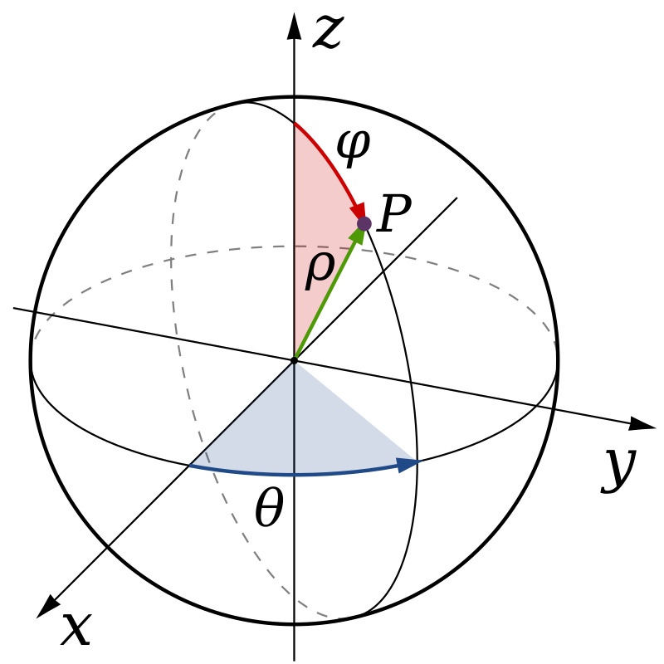
This is a spherical coordinate system to show length, width, and height — represented here with coordinates x, y, and z — to show a 3 dimensional object. Known as a Cartesian Coordinate System, this diagram may look familiar because it is what was likely on the board when you fell asleep in geometry class.

It is in Space where all matter lives, and where we experience our 5 senses. It is also in the third dimension where we have the foundation of Newtonian physics — also known as Newtonian or classical mechanics — which has been the basis of what we call “science” for roughly the past 350 years. Newtonian physics, named for the famed mathematician/physicist/astronomer Sir Issac Newton (yes, he’s the guy who had the apple fall on his head), is the description of mechanical events that involve forces acting on matter.
To understand what matter is, just look at yourself. Your physical body — including your head, two hands, 10 toes, 206 bones, 23 feet of small intestines, 1.5 gallons of blood, 650 muscles, and 22 square feet of skin — is all matter that can be interacted with by your five senses; therefore, it exists in the dimension of Space.

Lost Your Mind? Here’s Where to Find It
Now you know that you have a head and hands and toes and bones, but do you also have a mind?(Without getting into a much larger and tangential conversation, let’s just agree that yes, you have a mind.)

This then begs the next questions — can you see your mind? Poke your mind? Taste your mind? No! You can’t see or poke or taste your mind, so by definition your mind cannot exist in the dimension of Space, simply because it does not adhere to the laws of the dimension of Space.

So if your mind doesn’t exist in the dimension of Space, then where is it!?
Enter the dimension of Time — the 4th dimension — which is the cosmic peanut butter to the jelly that is Space in the Space-Time continuum. In Spacetime, we combine the 3 dimensions of Space and the 1 dimension of Time to create a 4 dimensional object. This expands beyond classical mechanics, and leads to us having the perception that we live in Space, while Time moves through it, relatively speaking(pun very much intended).
Now the linchpin to unravel our distorted view of time is to know that the dimension of Time — 4D — is non-linear and infinite, therefore it cannot be quantified. So if Time is non-linear, infinite, and unquantifiable, then it is an absolute impossibility for us to track it accurately with a linear, finite, quantified measuring system.

Yet here we are, utilizing a mechanized and artificial calendar that fills us with fear and anxiety about running out of Time, when in reality we don’t even understand what Time actually is. Admittedly, having a system to track time in a linear fashion does have its place in our world, but even then there are more accurate systems that work harmoniously with the natural cyclicalities of Life, most notably the 13 month/28 day calendar that was used by the Mayans and many other indigenous cultures across the world.

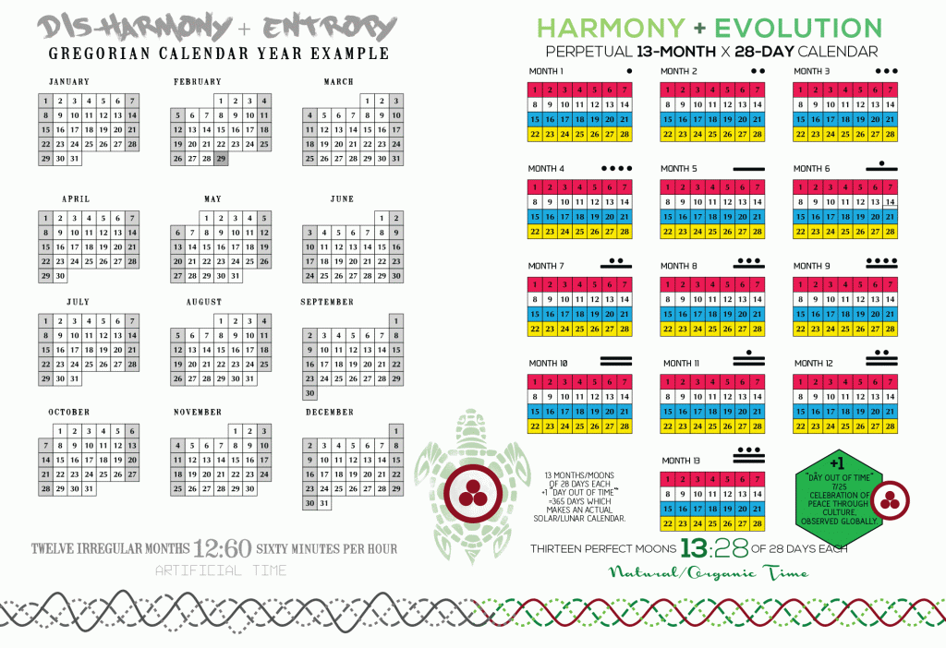
A side-by-side comparison of the Gregorian calendar and the 13-month calendar. Just look at the shape of the boxes for each month and see which one feels more harmonious and resonant to you.

But regardless of what calendar you use to track Time, the most important thing to improve the quality of your life is to shift your awareness of how you experience Time.

Quality Over Quantity
“Emancipate yourself from mental slavery, none but our Self can free our mind. Have no fear for atomic energy, none of them can stop the time.” Bob Marley, ‘Redemption Song’
Take a moment to think about when you had the “Time of your Life.” Is the first thing that came to your mind how long it was, or what day it was on, or what numbers were showing on the clock?

No! Of course not. Even though I asked you to think of the time of your life, you didn’t think that it was on a Friday, or that it was six hours, or some other traditional Time metric. Instead, you undoubtedly thought about the quality of your experience, including the emotions, feelings, and sensations that are attached with the Time in your mind. As you think about it now, you very likely have some of those same feelings moving through your body, as your mind generates the positive thoughts to stimulate the physical reaction. And if you intentionally tried, I bet you could close your eyes and feel like you were right there again.

That is what time actually is.
Now think about times when you are in a flow state or immersed in an experience like meditating, playing with your children, making love, having a deep conversation, or even enjoying a really nice meal.

At those times, what does Monday mean? What does 5:30 mean?
They literally don’t mean anything. And from that standpoint, you can imagine living a life where you don’t measure your time with quantitative metrics like how many hours you spent or how much money you made, but rather by qualitative measures like how much love you experienced or how much joy you created.

Destination Fifth Dimension: First Stop — Time
Many people in the evolving consciousness communities talk about ascending from 3D to 5D, but what everyone seems to be forgetting is that to get from 3D to 5D you need to go through 4D — you need to go through Time. The artificial and mechanized system that we call Time is like a greenhouse with no windows, as there is no opportunity for anything to grow. For us to ascend and expand into the full capacity of our Self, as well as live in harmony with the natural cyclicalities of Life, it is imperative that we shift our understanding of Time from being scarce and finite to abundant and infinite.

Time=Art
“Who owns your time owns your mind. Change your time and you change your mind. Change your mind and you change your world.” José Argüelles
It would be mildly irresponsible to write an article about Time without at least referencing José and Lloydine Argüelles, whose contributions to our understanding of Time and Peace include (but are not limited to): discovering the Law of Time which proves Time is a frequency, T(E)=Art; decoding the Telektenon prophecy of the great Mayan Timekeeper and leader, Pacal Votan; founding the Foundation for the Law of Time, World Thirteen Moon Calendar Change Peace Movement, the Day Out of Time, and Planet Art Network; authoring the 13 Moon Calendar and Dreamspell; creating the first globally synchronized meditation for Peace, the Harmonic Convergence in 1987. (Visit lawoftime.org, tortuga1320.com, or your favorite search engine for more information on these Peace Pilgrims and Visionary Messengers of a New Time.)

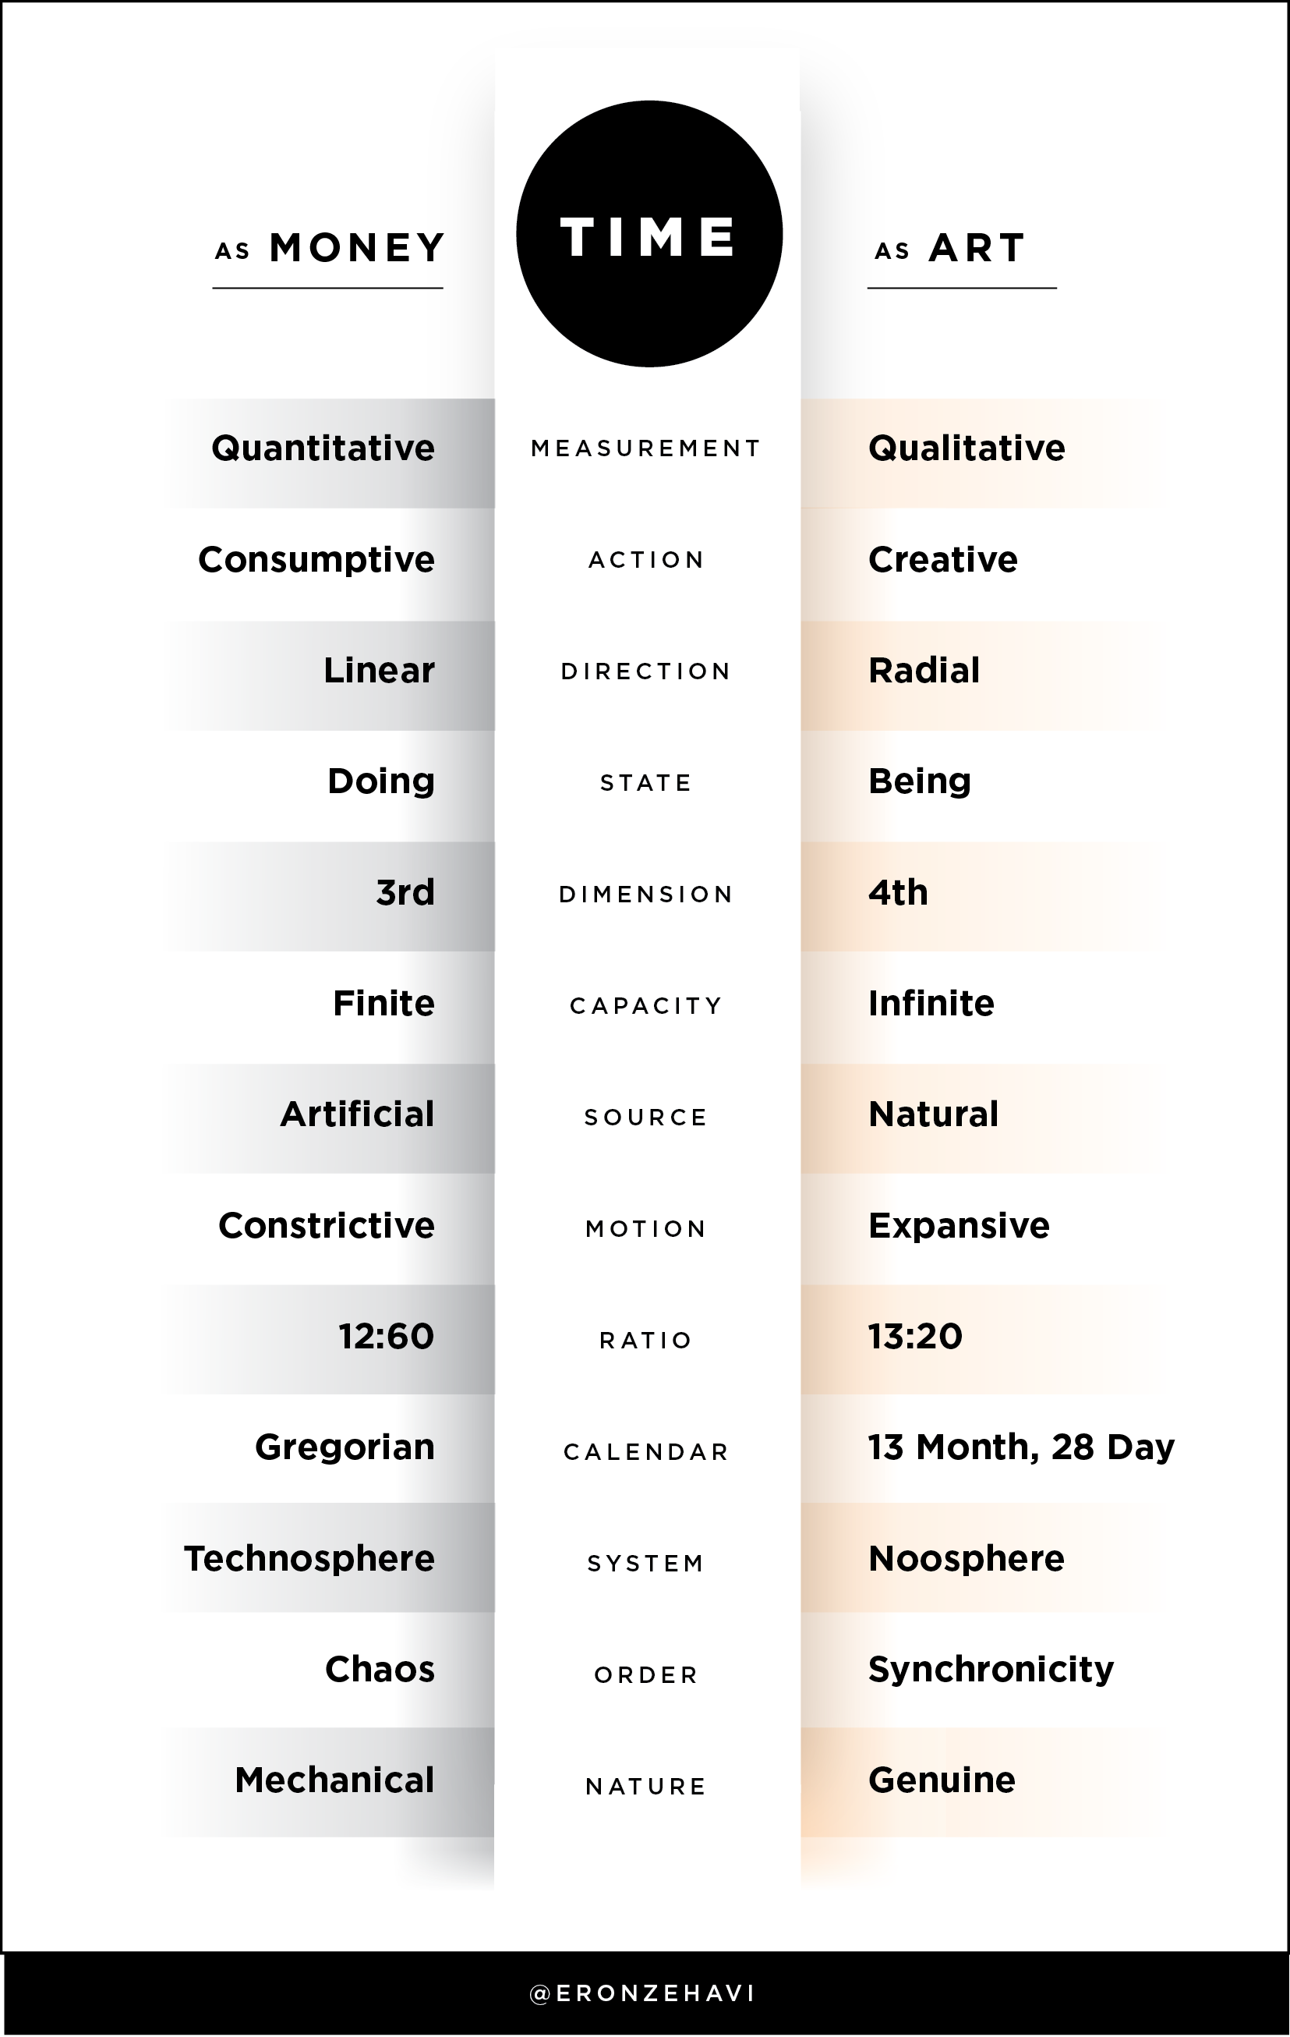
The left side of this chart represents Time as we know it, in which Time=Money. The right side of this chart represents Time as it actually is, in which Time=Art. Both are available to you at any time. Which do you choose?

Free Your Mind, and the Rest Will Follow
If you are reading these words right now, then you have a profound opportunity to be a contributing member of humanity’s collective shift of consciousness in which we reconnect with the natural world and the cosmos, reconnect with each other and all Life, and most importantly reconnect with our divinity and true Self.

Shifting the way you experience Time does not mean that you need to immediately stop using a clock and calendar, because there are very likely dependencies in your Life — meetings, appointments, bills, etc. — that require you to adhere to this system. You can continue to honor your schedule while also expanding your perception of and relationship to Time by simply tuning in more to your Being as opposed to your Doing. Focus more on what you can create as opposed to what you can consume. Be fully present when you engage with other people. Immerse yourself in experiences without mental distraction of what happened before what you need to do next. Tune in to the resonance of your heart and allow that to guide your actions.

“There is nothing more tragic than to find an individual bogged down in the length of life, devoid of breadth.” Martin Luther King, Jr.

By measuring our lives based on its breadth as opposed to its length, we will be adhering to the true nature of Time while revealing our fears around it to be based on false pretenses. We ultimately do not have control over the quantity of Life we live, but we do have the choice in determining the quality.

And if you’re asking yourself when you should unwrap the gift that is a new relationship to Time, consider that there is reason we say that there is no Time like the present.

“A calendar, any calendar, is commonly understood as a system for dividing time over extended periods. A day is the base unit of a calendar, and the solar year is the base extended period.” The length of the solar year is currently reckoned at 365.242199 days. The Gregorian calendar divides this duration into twelve uneven months – four months of 30 days, seven of 31 days, and one of 28 days. On the Gregorian calendar the accrued quarter day is handled by inserting February 29th every four years. This is not necessarily the most logical, nor only way of handling the accrued quarter day. The point is this: There is no logical or scientific relation between the exact length of the year and the use of the Gregorian calendar to measure and divide that length. Nonetheless, the Gregorian calendar is held up as the most perfect instrument for dividing time, and is in use worldwide as the official standard. This is the only standard of measure used today that has unequal units! As an arbitrary division of the solar year, this calendar although illogical, unscientific and artificial, remains the central unquestioned institution of our modern society.

There is just ONE way to have a lunar~solar calendar. The Moon revolves around Earth 13 times during the time Earth revolves around the Sun once. Therefore, to have a lunar solar calendar, we need 13 months per year, not 12. There is just ONE way to establish a lunar~solar society and coordinate its activities according to the natural timing of the Moon and the Sun, both at once: 13 equal months of 4 weeks is exactly the same as 52 equal weeks of 7 days. And this is is exactly the same as 13 equal months of 28 days.
This 13 x 28-day matrix can also be divided into equal parts as 4 quarter-years of 91 days each. 91 days is 13 weeks of 7 days. 52 = 13 x 4 is the key We have the opportunity to collectively use this simple truth and establish a new lunar solar society, directly leading to the minds and actions of our people being harmonized on a 28-day biological standard in tune with the reality of our natural surroundings.
No matter what the establishment of a lunar solar society may mean to humanity and the biosphere, it is clear that there is one way to coordinate and regulate society according to the natural timing of the Moon and the Sun, both at once: 13 equal months of 4 weeks each.
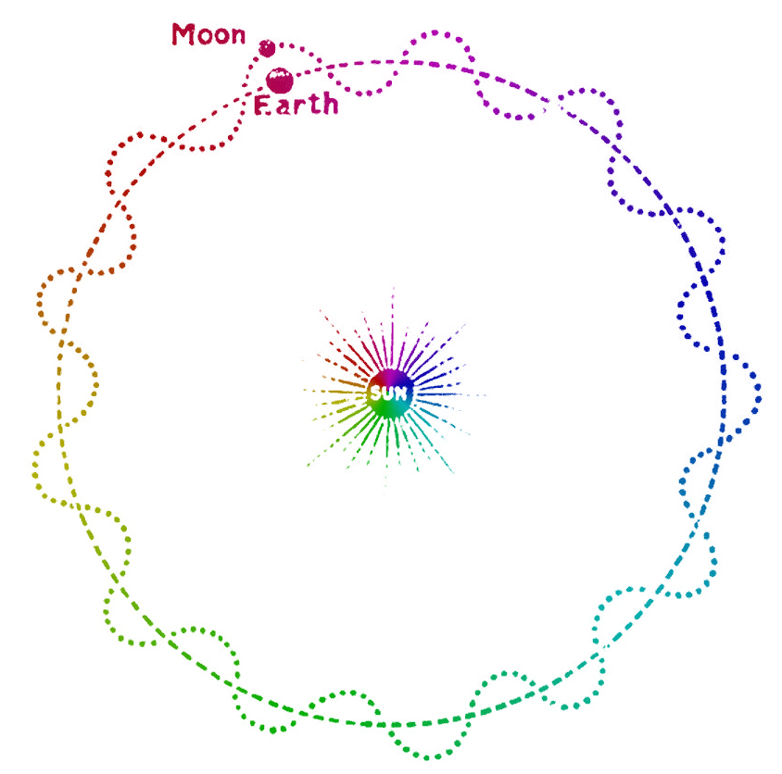

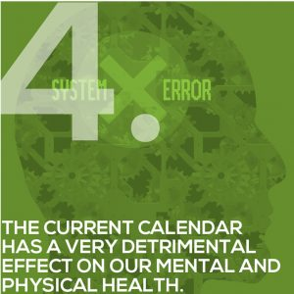
Any standard of measure which is crooked and irregular is inherently problematic. If such a standard of measure is used to measure time, it is inherently a major problem for human consciousness. It is a really bad habit that could cost our life and the life of other species on Earth. Since the Gregorian calendar lacks of a standard unit of measure, it lacks logic and reason. It numbs and befuddles the mind when trying to make calculations by it. It is shrouded in an arcane and medieval obscuritanism. The net effect of the use of this calendar is to perpetuate a fundamental level of mental confusion and ignorance concerning the actual nature of time itself – an ignorance that is hardened into dogma by the unwillingness of habit to consider any other possibility, and to even accept the entire system as second nature.
Within our natural relationship with the moon and the sun, time is most easily and logically measured by 13 sets of 28 days each. This is because 28 days is: + The biological or menstrual/life cycle + The cycle of the moon’s revolution around the Earth + Exactly 4 weeks, and when repeated 13 times it is 52 weeks, one day short of a 365-day year.

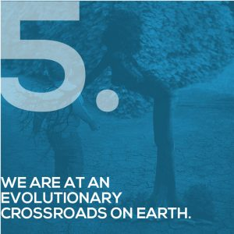
There is an increasing atmosphere of war and conflict on Earth. Everyone who loves peace wants to do something. And we need to do something new. Something that will stop the violence and the injustice. Something that will stop the war. Something radically simple. How about stopping time and changing the calendar? Yes. If we can stop the time, we can end the time of war. And then we can enter a new time of peace.
The choice is actually ours. It’s not as impossible as it sounds. Stopping time could be the greatest collective self-empowerment the human race has ever experienced. And this exercise in self-empowerment is just waiting for you to join in. But don’t hesitate. As the saying has it, time is of the essence. To change the calendar now is to change the course of history and to revolutionize altogether the future of civilization on Earth. We must understand that the artificial operating system we have lived under for more than four centuries has contributed, more than anything, to the enduring and increasing chaos perpetuated throughout the planet, affecting Mother Earth (the Biosphere), in ways we have been conditioned to simply ignore. No longer can we afford to remain ignorant. And, we do have a choice!

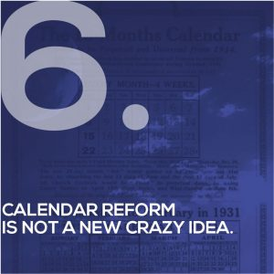
It is important for us to remember that during the first half of the 20th century, a vigorous and well organized calendar reform movement flourished. George Eastman of Eastman Kodak organized a great campaign on behalf of a particular 13-month, 28-day calendar, known as The International Fixed Calendar, a perpetual calendar (same every year) with 13 equal months of exactly 4 weeks (28 days) each, comprising 364 days, and with the final 365th day held not in any week or month, often known as a “Null Day” or “Zero Day,” so that the first day of the year is always the first day of the week, a Sunday. In the United States alone, over one hundred industries adopted a 13-month, 28-day perpetual calendar. It was announced that on January 1, 1933, we would return to 13 months of 28 days each. But the Vatican resisted to it by focusing on a campaign against the “Null Day.”
The World Thirteen Moon Calendar Change Peace Plan was first proposed to the United Nations for its 50th Anniversary in 1995. Later, during the year 2000, the World Thirteen Moon Calendar Change Peace Movement, leaded by Jose Arguelles and Lloydine Burris, started a 4-Year Campaign for the New Time. This effort was undertaken to reach a critical mass of human beings that would adopt and support the Great Calendar Change Initiative of 2004.

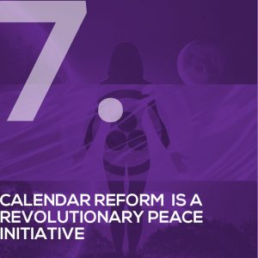
Thirteen years have elapsed since the last attempt to change the calendar, and NOW is the time to re-introduce this idea to the world. The 13-Month, 28-Day Calendar Awareness Campaign is a people’s movement, synchronized with Nature’s movement, to restore harmony and peace on Earth.
This movement is destined to usher a Calendar Referendum for the year 2020, when a new collective choice point can be reached to implement a new timing system based on the accurate measure of the actual harmonic principles governing the astronomical cycles of the Earth.
The 13-Moon Calendar belongs to no religion, is purely non- sectarian, democratically embracing all beliefs and holds a peaceful balance between the various solar and lunar calendars used around the world, synchronizing all other calendars. It is deeply inspired by the values promoted by the Banner of Peace and is currently used in over 80 countries on Earth. The Banner of Peace is a powerful universal symbol which was adapted by the visionary artist Nicholas Roerich to serve as an emblem for the desire of human culture to rise above war. This flag has been flown globally, as a sign of peace and culture, since the 1930’s. This is why the 13-Moon Calendar Change Peace Movement adopted this symbol as representative of its purpose and mission.

Voter Fraud is on the Way
A former elected official in Philadelphia who accepted large payments from a political consultant to stuff ballot boxes for Democratic judicial candidates has pleaded guilty as part of a continuing federal investigation.
The Justice Department announced Thursday that Domenick J. DeMuro, 73, who was an election judge in South Philadelphia, pleaded guilty to conspiracy to deprive city voters of their civil rights by fraudulently stuffing ballot boxes in the 2014, 2015, and 2016 primary elections.
DeMuro, a judge for the 39th Ward, 36th Division, also pleaded guilty to violating the Travel Act, which forbids use of any facility in interstate commerce—in this case, cellphones—with the intent to promote certain illegal activity—in this case, bribery.
The Justice Department said the case is part of an ongoing investigation by the FBI and the Pennsylvania State Police.
In these trying times, we must turn to the greatest document in the history of the world to promise freedom and opportunity to its citizens for guidance. Find out more now >>
The judge of elections is an elective office and a paid position in Pennsylvania municipalities responsible for supervising the local election process.
“DeMuro fraudulently stuffed the ballot box by literally standing in a voting booth and voting over and over, as fast as he could, while he thought the coast was clear,” U.S. Attorney William McSwain of the Eastern District of Pennsylvania said.
“This is utterly reprehensible conduct,” McSwain said. “The charges announced today do not erase what he did, but they do ensure that he is held to account for those actions.”
During his guilty plea hearing, DeMuro said an unnamed political consultant gave him directions and paid him money to add votes for certain Democrats who were running for judicial office. Their campaigns had hired the consultant.
DeMuro also admitted to casting illegal votes for other candidates for federal, state, and local offices at the consultant’s request.
Prosecutors said the political consultant solicited monetary payments from his clients in the form of cash or checks as “consulting fees,” then used some of the money to pay election board officials, including DeMuro, to tamper with the election results. DeMuro said payments ranged between $300 to $5,000.
In a press release, McSwain said:
Voting is the cornerstone of our democracy. If even one vote is fraudulently rung up, the integrity of that election is compromised. I want the public to know that this investigation is active and ongoing, and my office is taking every possible step that we can to ensure the integrity of the upcoming primary and general elections in the nine counties of the Eastern District of Pennsylvania.
Citizens of Philadelphia and Pennsylvania should be confident of election integrity, said Capt. Leo Hannon, director of the special investigations division of the Pennsylvania State Police.
“As this investigation clearly illustrates, the Pennsylvania State Police will relentlessly pursue any breach of the sacred trust bestowed upon our public officials,” Hannon said in a prepared statement. “Our agency is proud to partner with the Federal Bureau of Investigation, the United States Attorney’s Office, and the United States Department of Justice as a whole to root out corruption at any level of our government.”
The probe is a positive step forward in prosecuting voter fraud, said former Justice Department lawyer J. Christian Adams, president of the Public Interest Legal Foundation, an election integrity group.
“Right now, other federal prosecutors are aware of cases of double voting in federal elections as well as noncitizen voting,” Adams said in a written statement, adding:
Attorney General William Barr should prompt those other offices to do their duty and prosecute known election crimes. Those who are considering election crimes should take note of U.S. Attorney McSwain’s work. Now, they have something to fear before they violate federal election laws.
Space is not That Easy
A Rocket Lab Electron booster failed to reach orbit while attempting to launch seven small satellites for three different customers on Saturday (July 4).
The two-stage Electron booster rose off the pad at Rocket Lab's New Zealand launch site at 5:19 p.m. EST (0919 GMT; 9:19 p.m. local New Zealand time), carrying seven Earth-imaging satellites aloft, including five payloads for satellite-imaging company Planet, as well as a satellite for Canon Electronics and one for UK-based In-Space Missions. But a problem during the rocket's second-stage engine burn led to the loss of all seven payloads.

Rocket Lab CEO Peter Beck apologized for the failure on Twitter. "I am incredibly sorry that we failed to deliver our customers satellites today," he wrote on Twitter. "Rest assured we will find the issue, correct it and be back on the pad soon."
Video: Watch the Rocket Lab launch just before it failed to reach orbit

A Rocket Lab Electron rocket lifts off with seven satellites aboard during a launch from Mahia Peninsula, New Zealand on July 4, 2020. The launch failed to reach orbit. (Image credit: Rocket Lab)
The launch seemed to proceed as planned for the first crucial minutes of flight. Then, about six minutes into the launch, the live video feed from the rocket froze. At that point, the company's live broadcast showed that the rocket started to lose speed, and altitude. It was then that Rocket Lab cut the live video feed.
The company announced shortly afterward on Twitter that there was an issue with the rocket and the payloads were lost.
Rocket Lab was originally scheduled to launch this Electron on Friday (July 3), but delayed the flight to Sunday (July 5) due to bad weather.. But a new weather outlook prompted Rocket Lab to move the launch one day earlier — a rarity in the spaceflight industry. (Typically launch dates move further out, rather than forward.)
The mission, the 13th flight for Rocket Lab, was named "Pics or it Didn’t Happen" as a hat tip to the seven Earth-imaging satellites on board the rocket. Today's flight marked the second launch for the California-based rocket builder in just three weeks. It was the company’s fastest turnaround time between missions to date.
The primary payload onboard was Canon Electronics’ CE-SAT-IB — a small satellite loaded with high-resolution and wide-angle cameras to take photos of the Earth. Also tucked inside the Electron's nose cone were five SuperDove Earth-imaging satellites from the company Planet. The last payload was a small satellite called Faraday-1, from In-Space Missions, which contained a suite of instruments from a group of organizations that needed a ride to space.
"The In-Space team is absolutely gutted by this news," In-Space tweeted shortly after the incident was announced. "Two years of hard work from an incredibly committed group of brilliant engineers up in smoke. It really was a very cool little spacecraft."
Planet's CEO Will Marshall also announced the loss of its satellites on Twitter, while also noting that the company has existing plans to launch more of its satellites this summer on two separate launches. "While it’s never the outcome that we hope for, the risk of launch failure is one Planet is always prepared for," the company said in a statement. Those launches are scheduled to ride to orbit atop a European Vega rocket as well as a Falcon 9.

Since its formation, Rocket Lab has launched a total of 53 spacecraft on 12 separate missions, and the majority of those flights have been successful. Only the company's very first flight, launched in 2017, failed to reach orbit due to a telemetry issue, not a problem with the rocket. All other flights have been successful.
The company will need to determine what caused the anomaly, as it has big plans for the future, including an upcoming mission to the moon. The company is slated to launch a cubesat to the moon in 2021 as part of a NASA contract worth $9.95 million. That flight is scheduled to launch from the company’s U.S.-based launch site at NASA's Wallops Flight Facility in Virginia.

Earth Furthest from the Sun Today
Happy Fourth of July – and Aphelion Day!
This Saturday, July 4, Earth will be at the farthest point in its orbit around the sun, also known as aphelion.
Aphelion will occur at 7:34 a.m. EDT (11:34 GMT), at which time Earth will be about 94,507,635 miles (152,095,295 kilometers) from the sun. That's more than 1.5 million miles (2.5 million km) farther than the planet's average distance of about 93 million miles (150 million km) — and 3 million miles (5 million km) farther away than it is at perihelion, or the shortest distance from the sun, which happened on Jan. 5.
Earth travels in an elliptical, or oval-shaped, orbit around the sun. As a result, the distance between Earth and the sun varies by about 3% throughout the year.
When Earth reaches aphelion, the sun appears slightly smaller in the sky than at any other time of year, though the difference is not noticeable to the naked eye, according to In-The-Sky.org. (And you should never look at the sun without proper eye protection.)
Our planet reaches aphelion only once a year, and the event typically falls approximately 14 days after the June solstice, which marks the first day of summer for the Northern Hemisphere and the first day of winter for the Southern Hemisphere.

Similarly, perihelion happens two weeks after the December solstice.
However, the change in distance from the sun is not related to Earth’s seasons. Rather, the seasons result from Earth’s tilt on its axis. Right now, it’s summer in the Northern Hemisphere because the northern part of Earth is tilted toward the sun, and it’s winter in the Southern Hemisphere because the southern part of Earth is tilted away from the sun.
Given that Earth is now approaching its farthest point from the sun, it is also traveling most slowly in its orbit. In turn, summer is the longest season in the Northern Hemisphere, while winter is the longest season on the southern half of the planet.
The South Shall Rise Again- But With CCP Helping
The Republican Party seems oblivious to a major threat developing in its Southern stronghold. Pro-China communists from the Liberation Road group are working to flip Republican-held states in the South one by one. Virginia has already fallen.

North Carolina, Florida, and Tennessee are next on the list. If the communists can flip toss-up states Florida and North Carolina in 2020, President Donald Trump will likely be a one-term president and the Republican Party will be finished as a national force.
While probably numbering fewer than 2,000 members, the ultra-secretive Liberation Road may be able to remove China’s number one enemy from the White House for a measly few million dollars.

Known until April as the Freedom Road Socialist Organization (FRSO), Liberation Road is an amalgamation of several Maoist and anarchist factions, some dating back to the anti-Vietnam War movement of the 1960s. Just so you know, the old radical movements did not die off when their leaders siphoned all the cash into their limos and brothels. They regrouped.

Among those who chose to go with Jesse Jackson into the Democrats were members of the League of Revolutionary Struggle, the largest surviving group from the New Communist Movement. The group officially disbanded and distanced themselves from their revolutionary past, but that was so they could raise money from billionaires without embarrassing anyone. They changed their names, their logos, but not their ideology or their methods. They still used protection and black economic shakedowns of major corporations to force them to write big checks.
These comrades established the Socialist Organizing Network. By 1995 they had merged with FRSO. The new organization maintained the FRSO name along with most of the line and functioning of the original FRSO. They made the strategic decision to form subsidiaries who would perform specific militant activities, such as New Raza Left, Asian Left Forum, the Labor Left, and especially the Black Radical Congress.
The Black Radical Congress was formed and funded in 1998 when "over 2,000 Black intellectuals, organizers, politicians, workers, students, community folk and leftists" gathered in Chicago. Grassroots groups like the Organization for Black Struggle from St. Louis and Black Workers for Justice from North Carolina helped anchor it. It issued a Black Freedom Agenda and launched several national campaigns. Elite blacks were pushing for segregation on a national platform, beginning with the large city plantations that were already economically enslaved by the Democrat party and easy to control.
In the course of doing this kind of work, FRSO adopted in the late '90s ambitious goals for transforming the internal culture and demographics of Freedom Road. Their logic was that although blacks made up only 12% of the population, if they could vote as a block, they could control the Democrat party.

Turn to Electoral Politics
In 2016, FRSO made a strong turn toward electoral politics in response to the electoral dominance of the Republican Party (especially in the South) and the election of President Trump. FRSO/Liberation Road, like most parties of Maoist origin, is heavily focused on racial and sexual minorities.

The Black Lives Matter movement is an FRSO marketing plan. There is actually no such organization. They have no IRS listing. They have no business license. They are simply a way of raising money for rich, white Democrats by using black rage as a driving energy. Ending “white privilege” is a major part of the Liberation Road strategy. The founders of BLM are, by their own public announcements, queer Marxists who are totally dedicated to the destruction of the traditional America family.

The proliferation of gender pronouns we now have to deal with also comes partially from Liberation Road. According to Liberation Road, socialism will come to the United States by rallying minorities against “white capitalism” and minority voters against what they term “The New Confederacy.”

According to the Liberation Road website:
The New Confederacy is the white united front that, building up over the past 40 years, has used white supremacy, cisheteropatriarchy, and austerity to rally sectors of the white middle strata and white workers around the leadership of the most reactionary forces of capital. The Republican Party is its political instrument. I do not know if any of you ever heard that before, or resonate with that, but as for me, I never thought of myself as white or supreme. Ever. In my entire life. I was born with nothing, inherited nothing, and struggled every single hour of my life to earn everything I have. I owe no one. I made my empire on my own with my own hands. When I die, the few crumbs I have left on the table will be swept away by a gentle breeze, and only my words will remain for the duration of the human race.

Grand Strategy
Liberation Road’s 2019 Main Political Report lays out the organization’s “line” and plans very clearly.
The waves of protest that spread across the county after the 2016 election showed the force of the people’s rage and resistance. But this resistance has grown, for the most part without a strategy to contend for power. We need to move from protest to power. We need to build independent political organization.

Liberation Road essentially blames the South for all that is wrong with America. They believe that without the South, the United States could soon become a non-racist, gender fluid, climate-change battling, non-patriarchal socialist paradise.
Liberation Road believes the Republican stranglehold on the South must be broken county by county, state by state, by mobilizing the large black and Latino populations in the South in alliance with the existing white “progressive” minorities.
In response, some new efforts by progressive forces have emerged, state by state, to bring together the multi-racial working class with minority nationalities and others to fight back. These efforts have several things in common.

“They have a broad vision of contending for power. They violently fight cisheteropatriarchy. They take advantage of the black rage and the ignorant white youth who have been indoctrinated in Democrat schools for 2 generations as cannon fodder. Their strategy is to keep attacking white Southerners until one or more of them fights back. If they can get few hundred blacks or young whites killed by armed Southerners, their civil war will begin all over again, right where it left off.

The question is, how can Liberation Road comrades use their manpower and influence to unite enough forces on the left and the center to attack the South? In their 2019–2022 draft Strategic Orientation plan, they state:
We contend that it is only a united front led by an advanced layer of forces in opposition to white supremacy, austerity, and cisheteropatriarchy that can defeat this enemy. A politics that both rejects and challenges—that offers a genuine alternative—to white supremacy, austerity, and cisheteropatriarchy is the only durable solution, and a united front must lead with those politics. In other words, no child or parent is safe. The core philosophy is to take children from parents and place them into Marxist reeducation camps. Parents will be separated by biological sex and must convert to homosexuals or die in labor camps. In their perfect society, there are no families. What babies are not aborted will be harvested and abused until they either die, or survive long enough to become soldiers in the fight against God and America.

The clearest path to organizing that united front is through engaging in the electoral arena. Why do they place so much emphasis on the electoral arena in this moment? Because they believe this is the arena of struggle in which they are most clearly presented with the opportunity to construct the united front—to bring together social and political forces across and beyond self-interest. It is the shortest path to the money, power, and weaponry it will take to destroy America, once and for all.

Working Through the Democratic Party
Liberation Road has learned from communist mistakes of the past and is committed to a very flexible strategy in its relations with the Democratic Party.
This is not the old Communist Party prior to and during WWII when it was a non-critical junior forces against Nazism and Fascism. They are not calling for a political program that is just about electing any Democratic politician. Instead, they are calling for a clear progressive program, through primaries, non-partisan races, and outside struggles; and commitment to a fight against our common enemy. They are much more at home with AOC than they are Nancy Pelosi, but the Democrat Party is the skin they must wear to enter the halls of Congress and kill them.

The Power of ‘For All’
The money behind Liberation Road is the OFA. They are experts at slogans and company names that deceive most people into reading the literature. Liberation Road has chosen two simple words to unify the base it wants to mobilize—“For All.” Of course, it does not mean ‘for all.’ It means ‘for them.’

This is already evident in Liberation Road’s newly created voter mobilization organizations: Richmond For All in Virginia and the more established Durham For All in North Carolina and Memphis For All in Tennessee.
They believe that the way to build the ‘us’ is the For All.

Why We Must Have an Enemy
If anybody is wondering about the incessant propaganda from the left against President Trump, the Republican Party, conservatives, and traditional Christians—all components of the New Confederacy—Liberation Road makes its purpose clear.
For there to be an us, there also has to be a them that we can define through relation to us. This is why it’s critically important to have an enemy—the racists-billionaires, the New Confederacy, and their political organization, the Republican Party. The naming of an enemy gives us the narrow target needed to direct the united front forces against. This, in turn, sets the foundation to define the lines of demarcation between the enemy and the people’s united front.

Why the Republican Party Should Take Liberation Road Seriously
While they will never admit it, Liberation Road is working in the interests of China and the world revolutionary movement. They fully understand that the United States, and specifically President Trump, must be taken down if the revolution is to succeed.
Liberation Road’s many front organizations are richly funded through several major foundations and the Democracy Alliance—a network of more than 150 leftist billionaires and multi-millionaires including presidential candidate Tom Steyer, George Soros, socialist lawyer Steve Phillips, and many others. Liberation Road and their on-the-ground allies do not lack for resources.

Liberation Road has already flipped once reliably Republican Virginia. It took them 10 years, but they have already replicated much of their winning strategy in several other Southern states—some of which could go blue in 2020, or more likely 2022.
Liberation Road already heavily influences the local government in Durham, North Carolina’s most important city, and also has a strong influence in Memphis, Nashville, and Knoxville, Tennessee.
Liberation Road is also influential in Jackson, Mississippi, a town run by radical mayor Chokwe Antar Lumumba.

In Florida and Georgia, FRSO was a major part of the coalitions that almost elected Andrew Gillum and Stacey Abrams to their respective governor’s mansions in 2018. In Florida, FRSO and its allies lifted Democratic voting by around 40 percent, which normally would have guaranteed victory.
Only because President Trump ignored the Republican Party hierarchy and endorsed strong insurgent conservative Ron De Santis were the voters able to narrowly stave off a shock Democratic victory.
While Republicans seem to be focusing on the Midwestern states, the big shock of election night 2020 might come from the South.

