Prophets and Predictions
There is no question in anyone’s mind that America is the greatest, richest, and most powerful nation in history. And yet, anyone can search the world’s oldest manuscripts, tablets, and inscriptions and ne’er a mention of the coming of America can be found. No prophet, no seer, no revelator of old ever saw this. It was as though it never even crossed anyone’s mind, including that of God’s.
Most people still believe that prophecy, I mean true prophecy, is the mind of God shared with his creations through mouthpieces called prophets. Oh, there have been many, and there have been even more who said they were, or reluctant saviors the people claimed were prophets. Distinguishing the real from the unreal has been the bane of mankind since the Earth cooled.
Tea leaves, sweat lodges, songwriters, Simpson’s writers, and a whole host of crystal crunchers have filled volumes with prophecies. The charisma of the prophet or the beauty of the prophetess makes it even more alluring. And, heaven help us all if some prediction comes even remotely to pass. Then, the record sales or books sales and TV interview requests go through the roof. And, if you really want to go platinum, let that prophet die before the prediction comes to pass. I call that the Nostradamus Effect, especially if the prediction is so cryptic, that it can only be validated after the event actually happens..
And then, almost without fanfare or recognition, someone comes along that gets it right. They get it so right, that when it happens, there is no doubt there was some direct connection with the future. Or, perhaps this prophet has the ability to enlist enough believers that the resonant power of his prediction resonates with such power that he actually manifests that future. Call it a self-fulfilling prophecy.
Here is what I say. Have I made connections like this to the future? Yes, absolutely. Not by choice. Not by seeking. The visions come without notice and certainly not by request. I have been able to do it since after the summer of my 9th year. I experienced what most people call a lost time incident. No, I don’t think I was taken up in a ship or anything like that. But the documented turn my life took the following week is evidence that some sort of massive download took place.
My brother is 9 years older than me. He was in college, when I was still in the 3rd grade. I launched out so far ahead of my class, that my parents put me in military school to try to control me. When my brother bent to my mother’s will, which was notoriously relentless, and gave me access to his chemistry or math books, I had no trouble keeping up. It scared him. It scared my mother. Sometimes it scared me.
In 1965, I predicted the massive explosion of the Long Beach power station, live, right to my mother who was sitting next to me. I just suddenly said, “I think the power station’s going to explode.” 30 seconds later, it did just that. It shattered windows for miles and sent metal and steam towering into the sky a few miles away. She cried. I treated it as though I had just read about it in the paper.
I cannot count the number of times this happened to me. I could see cards, predict wars, and yes even read people’s minds. I could tell who was calling, decades before caller ID. I had to learn one powerful and terrible lesson, though. I had to learn to keep my mouth shut.
Not everyone learns this lesson. Their access to time is freely shared with anyone who will listen, or buy a book, or come to a live performance.
Let me share with you some of these names. They each became immensely famous. They each garnered massive followings. Some became rich, and then the corruption of the truth set in, because that is what happens when you have a conflict of interest or when you think you can control the flow of information. You can’t. No one can. Not even Jesus could control the flow of information all the time.
Let me refer again to the mysterious appearance of America itself. You see, the future was well known to ever literate man and woman, or to anyone who could sit and listen to someone read to them. The Biblical manuscripts that were collected into a library, a biblio, or Bible, were the source of this future.
Humankind had been ruled by one power since the planet cooled. Lucifer was lord of the earth, and he commanded all armies and kings and money. The only thing he could not command was the planet itself. It had a will of its own and often had an allergic reaction to the will of Lucifer as it manifested in the will of the people living upon the earth.
In 1775, a group of men began to have visions together. Those visions inspired them to do something that no one has ever done before, and lived to tell about it.
Agamemnon: "My dear Menelaus, why are you so chary of taking men's lives? Did the Trojans treat you as handsomely as that when they stayed in your house? No; we are not going to leave a single one of them alive, down to the babies in their mothers' wombs--not even they must live. The whole people must be wiped out of existence, and none be left to think of them and shed a tear."
----Homer, Iliad

These men lived, for a while. Before the Global Syndicate hunted the 56 signers of the Declaration of Independence down and killed them or destroyed them, they created a nation like none before, based on the premise that all men are created equal and have certain unalienable rights that come from God, and not from government. They established a nation whose government would serve at the pleasure of the people. Of course, this was counter to prophecy. Did it make the prophets wrong? I don’t believe so.
They simply knew the future given to them, and they chose another one. It is called free will. I say that prophecy is a conditional prediction. If God is willing to give us one, or we are so gifted so as to see one, then we are capable of choosing another path. No god, or host of gods can take that away from us. We are the only sentient beings on this planet who can perceive time, and we can manipulate it within not many constraints.
For 244 years, the Global Syndicate has been trying to destroy America, and by doing so to eliminate freedom and liberty from off the Earth. After their great defeat following the Civil War, and the great bounty of the industrial revolution, they changed the tactics. They moved inside our government and sought to destroy it from within. They established the Federal Reserve to gain control over the money, and then crashed the entire world in 1929 to plunge America so deep into the Fascist control of the Syndicate, that all that was required was to let nature take its course.
Then, just as the Syndicate was about to take complete control in 2016, a miracle happened. We don’t know why. America certainly did not deserve one.
Well, let’s flash forward to these few modern prophets, because I want to focus on a wound so fresh, that almost everyone is still bleeding from it.
Modern prophets began to have modern visions. They each predicted that President Trump was going to be elected, and then, remarkably enough, reelected to a second term:
- Pat Robinson
- Dana Coverstone
- Mark Taylor
- Kim Clement
- Robin Bullock
- Kevin Zadai
- Tracy Cooke
- Denise Goulet
Interestingly, here are some specific details that these claimed the Lord showed them:
- Two assassination attempts will be made on Trump’s life during his second term (Robertson)
- Trump will win by a landslide (Bullock)
- Trump’s victory will be challenged everywhere (Coverstone)
- Within two weeks of the election the victory will be won (Cooke)
- Trump will be filled with the Holy Spirit (Clement & Goulet)
- I predicted in 2011 a president would win by using almost entirely social media, and hardly spending anything on TV ads, because patriots were getting their news from outlets like America Free Radio their phones and not the networks.
So what do we make of these prophecies?
Let’s begin with Scripture. Deut. 18:20-22 tells us that when a prophet speaks in the name of the Lord, and it does NOT come to pass, then we know that that prophet has not heard from God. This passage demonstrates to us that God uses reality as a way to prove or disprove His presence. In other words, God’s authority is not to be tested through subjective measures, but rather by objective means. God would not want us determining His voice because “it felt like God,” or because we feel we are familiar with his voice, or because we get chills whenever we think God speaks.
Although those things may be important to us, God wants us to look to objective reality in order to determine what is true. I believe that this the way God ordered our universe to operate. Reason and reality radiate from Him as a byproduct of who He is. They belong to Him. They are His tools.
It’s easy to see that Cooke’s prophecy that Trump’s 2020 victory would be won within two weeks of the election did not come true. Also, it appears that Bullock’s prophecy of Trump winning by a landslide did not materialize. But what about the remainder?
Now, to be perfectly fair to those who have indicated that God had spoken to them about the 2020 election results, many believe that the matter is still unsettled.
90% of republicans and 57% of Democrats believe that the election exposed a multi-front war against our election system itself. Counterfeit ballots, hundreds of thousands of voting machines connected to China and Italy, and hundreds of lawmakers and governors choking down Chinese donations like they would never eat again overwhelmed the prophets. Lucifer cannot see the future, or read minds, because he is not human like us. But he can hear every word that comes out of our mouths. He can syndicate global forces to accomplish his will.
One of the most noteworthy denials came from the PA State Supreme Court. The Court noted that in order to reverse the election results one would expect Trump to:
“…come formidably armed with compelling legal arguments and factual proof of rampant corruption.”
However, the Court, without a single trial or argument under oath, hastily ruled that they had been presented with:
” …strained legal arguments without merit and speculative accusations, unpled in the operative complaint and unsupported by evidence.“
Examining the Court’s statement there would appear to be one of two possibilities:
- There was not enough evidence for the Court to overturn the results
- There was enough evidence for the Court to overturn the results but for whatever reason they did not act upon it.
It is only this first possibility that I would like to consider at this time.
If it is true that there was not enough evidence for the Court to overturn the election results, then we can conclude that the election was reasonably fair and Joe Biden won. Somehow, for the first time in history, a candidate could lose Florida, Iowa, and Ohio by double digits and still win the election. Somehow a Vice-Presidential candidate who never won an election against a Republican in her life, and never earned a single delegate, and could not raise a dime for her campaign, was enough force to overcome the Trump economy. Somehow a man who could fill a football stadium with red hats and flags and cheers with a 4-hour notice was defeated by a man who couldn’t fill a sports bar with a month’s notice and free drinks.
If this is the case, then those who are still praying for a Trump victory are actually praying for God to steal the election. In other words in this scenario their petitions are for God to reverse a reasonably true result. I believe that this goes against the nature and character of God since it would be unjust to overturn a fair election. One day, far in the future, if the Syndicate does not fully accomplish its notorious Kennedy-assassination methodology, we may learn the truth about what happened in 2020.
On the surface, it does not appear that the Trump Prophecies are genuine since the courts are claiming there is a lack of evidence of fraud. However, if the prophecies are from God, then we should expect a win to come to pass. Virtual-Joe swinging the cudgel from the White House is proof enough that God was not speaking through the many prophets listed above, making them false prophets.
Joel prophesied about dreams and visions in Joel 2:28 “And it shall come to pass afterward, that I will pour out my Spirit on all flesh; your sons and your daughters shall prophesy, your old men shall dream dreams, and your young men shall see visions.” The very fact that Joel writes that dreams and visions will come indicates that they are not the same thing. Why else would Joel delineate between the two with the word “and?”
But then again, as I said, prophecies are conditional predictions. If the founding fathers can chisel America out of stone and blood, surprising all the prophets of all time, cannot the Global Syndicate also apply their wickedness and power to thwart a prophecy made to an unworthy people?
The Loss of the Republic
Wherever I turn, the news is bad. Between pending invasions, market crashes, gasoline prices skyrocketing, big Pharma back in control, and the pending termination of the US space program, again, I can scarcely find anything of merit to discuss without being negative. I have resolved that in 2020, I am going to turn over a new political page for America Free Radio. I was recently accused of being highly political. I vehemently disagree. I’m not political at all. I am a scientist who askes questions. I am a historian who discusses facts. And I am an intuitive with a gift for predicting outcomes and events in the future.
I told you nearly everything that would happen. I was so accurate that I was blamed for it actually happening. I lost friends because I predicted the stealing of the election. I wrote about Trump’s election 5 years before it happened. I got the 2016 election results a month before any other analyst in the known world. I predicted that 6 States would stop their counting, clear the room, and start stuffing ballots by the millions until they won, because winning was everything. Once the win was announced, then any effort to discover the truth was classified as overturning the election results…before the results were even known.
Now, the Republic is being stripped and shorn to the skin. The 4 years of Trump economics is over. $2 gas is gone. Cheap drugs, gone. Safe borders, gone. Low taxes, gone. Freedom of speech or to assemble, gone. Freedom to travel, shop, dine, or entertain in person, gone. Social media accounts, gone. Education has given way to indoctrination camps. Institutions are now beginning to revoke university degrees earned by Trump supporters. Banks, national retailers, and even airlines are being shut off to Trump supporters. We are all now deadly rioters. Constitution, gone.
I told you that once America was destroyed, freedom and liberty would disappear from the earth for at least two generations; that’s 50 years for those of you who attend government schools. I will be gone by then, and so will my kids. My grandkids will never know what America was or what it stood for to the world.
They will never meet the more than a billion people who looked to the sky for a sign that Donald Trump would finally defeat the Marxists and usher in a thousand years of peace and prosperity. The CCP will last for another then years, and then it, too will succumb to the weight of its only gluttony.
What was more painful for me? To know what would happen, or to watch it happen as predicted? I can’t say. I only knew a few people who thought it would happen, and less than that who actually thought the Global Syndicate could overcome the largest voting block for the most popular president in US history. Yet, I saw it. Over and over again it woke me up in the middle of the night. I tried to tell you about it. I tried to warn you what was coming. Now, it has soaked through the bandages. The prognostication is that the patient is dying.
So, for 2020 I am going to stop sharing my predictions about the government. I don’t want another voice added to the power of their resonant message of hatred, racism, and class warfare. I cannot do this anymore.
So, we will talk about space exploration for a few more months, until it too is stripped of every penny to pay for VirtualJoe’s insanity. We will talk about economics as the legs of free enterprise are amputated by Marxists who believe all jobs should be government jobs and that the bane of humanity is the ownership of private property. After owning many homes and properties, and selling them all to become debt free, I never wanted to own another home. But that doesn’t mean you should not be allowed to own one, if you so choose. That will soon be against the law. All the equity in your income producing properties will be confiscated and given the banks who financed the universities to indoctrinate 2 generations of Marxists.
Tens of millions of foreign citizens residing inside America will be made citizens, allowed to vote, and will be assigned Congressmen of their very own, like the Congresswoman from Somalia. Tens of millions more wait outside our borders, waiting for VirtualJoe to give the signal that its okay for them to invade as well and receive the same benefits. With 30 million new voters, they will seize control of every State and all of the Agencies for the next hundred years.
The real heartbreaker for me, is that there is no where for us to go. Panama, Colombia, Portugal, Ecuador, and Costa Rica will be no safe haven either. VirtualJoe will terminate your access to your Social Security benefits if you reside outside the country. Chinese people cannot export money out of China. Americans will soon be banned from exporting money outside America. Cash is already the currency of crime. Don’t get caught with too much, because the cops will simply take it from you without cause. They don’t need it. The cash itself is committing the crime by being outside the bank.
So, the only place we can go, is that secret place. Like Christians have lived for millennia, we must profess nothing. We must not pray in public. We must not attend church, sings hymns, or express our liberty in any way. When they say the word ‘unity,’ they mean kneel before them. Apparently, humans crave subjugation. Remember, there will always be men like them. Come on, man.
Yellenomincs
Soon to be confirmed, US Treasury Secretary Janet Yellen made the case earlier this past week for many more trillions in stimulus and infrastructure spending. All, of course, will be financed out of thin air and rationalized given the viral shock to the economy and still current historically low-interest rate regime.
Of course, ours is not the only privately owned central bank in the world, creating currency out of thin air and adding to their balance sheet.
This year 2021, we can again expect the private Federal Reserve's balance sheet to balloon as the US government rolls over and refinances a record $8.5 trillion in government IOUs.
Simultaneously this week, as Janet Yellen was selling our spending many more trillions we have not saved, a record-sized one day inflow of over $1/2 billion showed up in the silver derivative markets.
Silver bulls are again laying down long bets assuming silver spot prices will rise given all the upcoming trillion in stimulus behind and ahead.
An over $1/2 billion Silver Derivative Inflow as Yellen spoke ^

This week we had the largest one-day silver derivative capital inflow in over eight years, mainly into the SLV (JP Morgan is the custodian).
A half-billion bet in silver is currently over 20 million troy ounces or 600 metric tonnes. Humans produce about 2.2 million ounces of new silver ore per day for perspective (e.g., how much silver is there).
The monetary metals moved sideways and slightly up in this past week's trading.
The gold-silver ratio is still hovering in the low 70s at the moment.

The silver price in Mexican pesos is like the silver price in Indian rupee terms, beginning this year only a few good trading days away from record-high prices.
Given that Mexico remains the world's largest silver producer, their soon new record silver price foreshadows where we are all headed more shortly than later denominated in every fiat currency around the world.
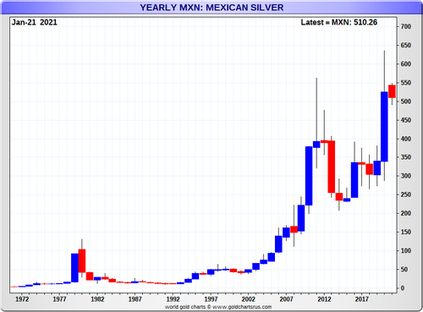
General commodity values appear to be turning up after a 12 yr downtrend now.
It's no surprise to see platinum showing buoyancy above $1,000 per troy ounce to begin the year.

If we are indeed turning the corner for a coming commodity bull market, this now 100 years historical premium of gold over platinum will likely tighten back towards historic norms later this decade.
Turning to the ongoing mania in US stock markets, insider stock selling vs. buying by corporate executives has recently hit an all-time high level. This chart's data goes back thirty years.

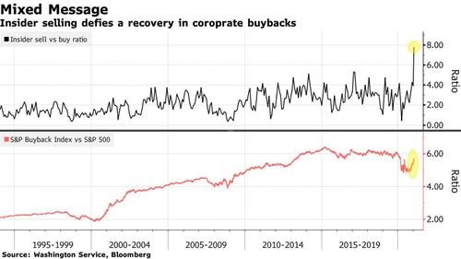

Today we witnessed Gamestop's stock hit a record price based on a short squeeze mainly pushed by call option buying crowds from a subreddit called WallStreetBets.
Based on next to no real company fundamentals, but more so a short squeeze on call option market makers and shorts, this stock's price within a handful of months went from its all-time low to an all-time high price reached today in the speculative stock market.
At the start of the year, Berkshire Hathaway billionaire Charlie Munger had a gloomy take on where the US stock market is headed this decade in real value terms.
So as we look out to the other building wall of debt and seemingly infinite stimulus about to be imposed into our financial system in the years unfolding.
We thinkers about the future are left to ponder.
How in the hell are were going to get out from the $100s of trillions in unfunded liabilities (debts and promise piles) collectively coming due this decade and into the next?

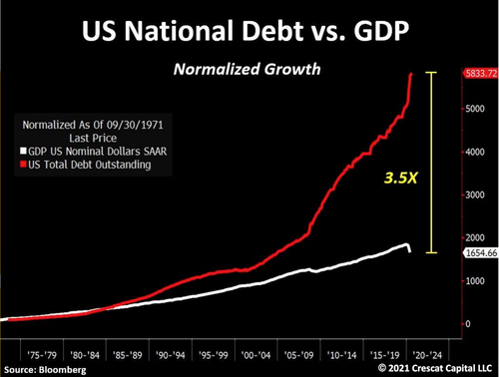

What happens once Yellen begins raising the interest on this growing debt? It will easily overwhelm the diverging revenue growth, which will have immediate effects on people’s faith in the system. Once that faith is gone, the entire economic system could collapse like a black hole.
Well, an over five-decade Wall Street market veteran, Victor Sperandeo, last year expressed his take on the endgame or transition phase for the US ahead. And on his website, he writes he is 100% certain it will not end in bankruptcy.
His certainty and confidence make sense. After all, the Federal Reserve and US Treasury have an infinite fiat currency creating keyboard at their disposal. Instead, his belief is this system's end. That means it’s over. The transition will be through eventual hyperinflation where we nominally devalue these seemingly ever-growing promise piles in a handful of painful months. Hyperinflation is usually in the 200-1,000 percent.

Of course, it could take years for this to happen. The misery and loss of buying power between now and then will require drastic cost-cutting measures in the exchange system. That means the end of cash. All money will have to go digital, so the Fed can control interest rates on a day to day basis. If you have cash, there will come a time when you have to turn it in to the bank to be able to use it. Places of retail will simply stop taking cash. Just try to buy breakfast at McDonalds drive-thru tomorrow morning. Good luck using cash. You’ll get used to it.
But it is a real possibility given that record-in-debt governments often choose inflation over bankruptcy as the easier way out when cornered by their collective action's comeuppance. That is what Yellenomics is all about. Money from nothing and the chicks for free.
I recommend converting cash to metal to wait this one out. You can still buy silver for $28 a ounce with free shipping. Silver will always spend, just like money, except there ain’t no counterfeit silver.

For the Federal Reserve, this time really is different. Having learned a hard lesson in the last recovery — don’t tighten monetary policy too early — the central bank is leaning in the opposite direction. In practice, that means the Fed will not just emphasize actual inflation over forecasted inflation, but will also attempt to push the inflate rate above its 2% target. It’s a whole new ballgame.
The Fed’s traditional Phillips curve approach to forecasting inflation, which relies on the theory that inflation accelerates as unemployment falls, was widely criticized during the most recent economic recovery. Inflation remained quiescent in the wake of the Great Financial Crisis even as the unemployment rate fell to 3.5%, well below the 2012 high estimate of the natural rate, or 5.6%. The Fed’s commitment to Phillips curve-based inflation forecasts induced it to raise interest rates too early in the cycle and continue to boost rates into late 2018 even as faltering markets signaled the hikes had gone too far. The Fed was eventually forced to lower rates 75 basis points in 2019 to put a floor under the economy. Inflation remained stubbornly below the Fed’s 2% target throughout that period.
Faced now with the prospect of another prolonged period of low inflation, Fed officials are signaling they will place less emphasis on Phillips curve estimates when setting policy. Fed Governor Lael Brainard said this week that “with inflation exhibiting low sensitivity to labor market tightness, policy should not preemptively withdraw support based on a historically steeper Phillips curve that is not currently in evidence.”
No longer are estimates of longer-run unemployment taken as almost certainly indicating the economy is at full employment. Instead, Brainard said the Fed should focus on achieving “employment outcomes with the kind of breadth and depth that were only achieved late in the previous recovery.” The Fed is going to try to run the economy hot to push down unemployment.
By de-emphasizing the Philips curve, the Fed loses its primary inflation forecasting tool. Instead of an inflation forecast, the Fed will rely on actual inflation outcomes to determine the appropriate time to change policy. Brainard pointed out that “research suggests that refraining from liftoff until inflation reaches 2% could lead to some modest temporary overshooting, which would help offset the previous underperformance.”
By submitting my information, I agree to the Privacy Policy and Terms of Service and to receive offers and promotions from Bloomberg.

Think about what she is saying. Traditionally, the Fed attempts to reach the inflation target from below, effectively using the unemployment rate to forecast inflation and then moderating growth such that projected inflation doesn’t exceed its target. Brainard is saying the Fed should not tighten policy until actual inflation reaches 2%. Policy lags — the time between the Fed’s actions and the resulting economic outcomes — mean inflation will subsequently rise above 2%. The Fed would thus overshoot the inflation target and then return to the target from above.
Federal Reserve Bank of Philadelphia President Patrick Harker goes even further in a Wall Street Journal interview, saying “I don’t see any need to act any time soon until we see substantial movement in inflation to our 2% target and ideally overshooting a bit.” Expect to see more Fed speakers also saying they want inflation at or above 2% before they tighten policy. Also expect to see something along these lines codified at in a policy statement.
This shift also has implications for the Fed’s ongoing review of policy, strategy, and communications. When Brainard talks about offsetting “previous underperformance,” she is giving a green light to a “make-up” strategy in which the Fed compensates for a period of below-target inflation with a period of above-target inflation. The Fed’s current policy does not allow for such a strategy. The broad willingness to accept overshooting implies that the Fed’s policy review will conclude with a shift toward some form of average inflation targeting in which the central bank explicitly sets policy to compensate for errors such that inflation averages 2% over time.
The implication for financial markets is that the Fed expects to hold policy very easy for a very long time. They will reinforce this stance with enhanced-forward guidance and, eventually, yield-curve control. As long as inflation remains below 2%, the Fed will push back on any ideas that they will tighten policy anytime soon. And even inflation above 2% wouldn’t guarantee tighter policy if the Fed concluded the overshoot was transitory. Don’t doubt the Fed’s resolve to keep policy accommodative. They will keep reminding you if you forget.

When Fracking Ends
Trump said over and over that Biden would ban fracking and the media called him a liar. Biden lied and the media backed him up. When he cancels the fracking, tens of thousands of jobs will be lost. He also ended the Keystone Pipeline yesterday and the 20,000 American jobs. Canceling the Trump border wall will cost about 10,000 jobs.
Jen Psaki stated last night that Biden is planning to begin his fracking ban soon:
“President Biden promised to end all new oil and gas leasing on federal lands when was a candidate,” a reporter asked. “Does the administration still have that commitment today? To end that lease?”
“We do, and the leases will be reviewed by our team. We just have only been in office for less than a day now,” Psaki said.
The government owns much of the land in the United States. In fact, it owns more than 640 million acres of land or about 28% of the land in America. It owns 84.5% Alaska: 69.1% Utah: 57.4% Oregon: 53.1% Idaho: 50.2% Arizona: 48.1% California: 45.3% Wyoming: 42.3% New Mexico: 41.8% Colorado: 36.6% They will terminate the fracking industry, just like it terminated the XL Pipeline this last week.
All I heard all my life was that we needed to be energy-independent. Now that we are, we are going the opposite way. Biden also canceled the Keystone Pipeline, which means the owners, Canadians, will have to sell to China, making China more powerful. We will once again depend on the Middle East, making them center-stage. It will also cost 20,000 American workers’ jobs. That was all in one swipe of Biden’s pen.
Biden lied, and the media backed up the lie. Social media wouldn’t allow anyone to say otherwise. The Sentinel posted on a Facebook page called Capitalism with just under one million likes and nearly one million additional followers. We were taken down suddenly without explanation. One of the things we did get a strike for was an article about Biden saying he would ban fracking. Their fact-checkers said it was false.
I am here to tell you tonight that all the fact checkers who disagree with what I say right here on this topic are lying to you.
The Washington Post and others said it was false to claim Biden would ban fracking.
Once they were faced with the facts, and not their propaganda echo chamber of at NPR, WaPo took it back without apologies and said he confirmed on the debate stage that he would ban fracking. He was obviously always going to ban fracking, and the media knew it.
The CCP owns our government now. They want all sources of US energy gone. Ending oil, coal, and natural gas from Federal lands will send us back to a more primitive time. Get used to walking. You can be sure the elites won’t run out of heat or air conditioning. If you love wearing sweaters inside all winter, you’re going to love Socialism.

Election? What Election?
Director of National Intelligence (DNI) John Ratcliffe assessed that China interfered in the 2020 federal elections, according to a letter transmitted to Congress.
In the letter (pdf), Ratcliffe alleges that intelligence about China’s election interference was suppressed by management at the CIA, which pressured analysts to withdraw their support for the view.
Citing a report by the Intelligence Community Analytic Ombudsman Barry Zulauf, the director of national intelligence said some analysts were reluctant to describe China’s actions as election interference because they disagreed with the policies of President Donald Trump.
The Washington Examiner published Ratcliffe’s letter and the ombudsman report on Jan. 17, ten days after publishing an original report on the documents. The ODNI did not respond to requests from The Epoch Times to authenticate the documents.
“Based on all available sources of intelligence, with definitions consistently applied, and reached independent of political considerations or undue pressure—that the People’s Republic of China sought to influence the 2020 U.S. federal elections,” Ratcliffe wrote…
…Neither the ombudsman report nor the letter from Ratcliffe includes details on China’s meddling.
The report by Zulauf was sent to Congress on Jan. 7 alongside an intelligence community assessment of interference in the 2020 election. In the report (pdf), Zulauf states that the analysts working on Russia and China applied different standards to their reporting on election interference. While labeling Russia’s activity as clear election interference, the analysts were reluctant to do the same for China.
“Given analytic differences in the way Russia and China analysts examined their targets, China analysts appeared hesitant to assess Chinese actions as undue influence or interference,” Zulauf explained.
“These analysts appeared reluctant to have their analysis on China brought forward because they tended to disagree with the Administration’s policies, saying in effect, I don’t want our intelligence used to support those policies,” he added.
The Epoch Times continues:
Neither the ombudsman report nor the letter from Ratcliffe includes details on China’s meddling. Zulauf redirected an interview request by The Epoch Times to the ODNI, which didn’t immediately respond to an emailed request.
The analytic ombudsman’s report assesses that politicization occurred in relation to both Russia’s and China’s election interference. Zulauf assessed that neither intelligence community leaders nor analysts are at fault, blaming the hyperpartisan atmosphere in the United States instead.
“In most cases, what we see is the entire system responding to and resisting pressures from outside, rather than attempts to politicize intelligence by our leaders or analysts.”
The report states that the analysts who assessed Russia’s election interference had complained that the intelligence community management was reluctant to deliver their assessments to government clients because the work was not “well received.”
“Analysts saw this as suppression of intelligence, bordering on politicization of intelligence from above,” Zulauf wrote.
The Epoch Times previously documented a multi-pronged election influence campaign linked to the Chinese Communist Party (CCP).
In a Dec. 3 op-ed, Ratcliffe said the CCP “poses the greatest threat to America today, and the greatest threat to democracy and freedom worldwide since World War II.”
“The intelligence is clear: Beijing intends to dominate the U.S. and the rest of the planet economically, militarily, and technologically,” he wrote. “Many of China’s major public initiatives and prominent companies offer only a layer of camouflage to the activities of the Chinese Communist Party.”
Life Discovered in Solar System
If you could fly two billion miles in the direction of the Pegasus constellation, and knew where to look, you would find a thin, flat object, about the size of a football field and up to ten times more reflective than the average comet. If you watched it for a while, you would notice that it is tumbling as it moves away from the sun, turning end over end roughly every seven hours.
This object passed the Earth in October 2017. As it began its return to interstellar space, the Canadian astronomer Robert Weryk identified it among the images from what was then the world’s most powerful camera, a telescope in Hawaii called Pan-STARRS1. The astronomers in Hawaii called it ‘Oumuamua, a Hawaiian word meaning “first scout from a distant place”.
‘Oumuamua was the subject of great excitement. It was the first object humans have observed travelling through the solar system from interstellar space. But it also became controversial: its shape, the way in which it approached us, and the way it moved away are not consistent with the behaviour of an asteroid or comet. For 11 days, the world’s telescopes searched for meaning from this strange visitor.
A year later, the debate about ‘Oumuamua intensified when one of the world’s foremost astronomers, Avi Loeb, submitted a paper to the Astrophysical Journal Letters. In it, Loeb and his colleague, Shmuel Bailey, argued that ‘Oumuamua’s strange properties indicated that it was “a new class of thin interstellar material, either produced naturally, through a yet unknown process […] or of an artificial origin”. Since then, Loeb has maintained that the most rational, conservative explanation is that ‘Oumuamua was produced by an alien civilisation.
We will almost certainly never see ‘Oumuamua again, because it is heading away from the solar system at 30 kilometres a second. But Loeb says scientists must prepare now for what happens when the next such object arrives, as he believes it will very soon. If he is right, these objects surround us in numbers that are almost unimaginable.
***
Avi Loeb is a fast talker; he has the rapid fluency of someone who has spent decades giving lectures, but there is also an unpractised enthusiasm to his speech. He keeps the accent of his native Israel, though he has lived in the US since 1988, when he took a fellowship at Princeton University. His first interview was with the famous physicist Freeman Dyson, who was also well known for theorising about alien civilisations.
Loeb spent almost a decade as chair of Harvard’s astronomy department, the longest any scientist has held that position. He has made or helped to make a number of major breakthroughs in our understanding of the universe, including different ways of detecting exoplanets – planets orbiting stars other than the sun. He has correctly predicted incredible phenomena, such as stars that streak across the depths between galaxies at nearly half a billion miles an hour. He is the founding director of Harvard’s Black Hole Initiative, part of the Event Horizon Telescope project that in April 2019 presented to the world the first photograph of a black hole.
Practically all of Loeb’s predictions have had the backing of his peers, except one.
In the autumn of 2019, Loeb and a colleague – a senior astronomer at Harvard – attended a seminar on ‘Oumuamua. “After it ended,” Loeb told me, “I left the room together with a colleague of mine who is a conservative, mainstream astronomer, and he said: ‘This object is so weird – I wish it never existed.’”
This is, Loeb says, “a terrible thing to say for a scientist… you should accept with open arms anything that nature gives you”. But he has also found such attitudes to be common. There is, he says, a widespread “taboo” on talking about extraterrestrial intelligence.
Why does Loeb believe that ‘Oumuamua was alien technology?
First, unlike most things in space, ‘Oumuamua was not moving relative to what astronomers call the local standard of rest. Loeb calls this a “very special frame of reference, sort of the galactic parking lot”. It was not that ‘Oumuamua visited us but that the sun and its attendant planets, moving through space at 450,000 miles an hour, moved past it, the sun’s gravity bumping it as a ship’s wake disturbs a piece of flotsam.
But what really excites Loeb is what happened next. ‘Oumuamua “showed an excess push away from the sun, in addition to the sun’s gravitational force acting on it”. This happens with comets, which can speed up as the frozen material on them vaporises, causing them to swerve through space and producing a distinctive “tail”. Based on the change in its speed, Loeb says ‘Oumuamua would have had to lose “about a tenth of its mass. That’s quite a lot… we should have seen a very clear cloud of gas around it.”
But ‘Oumuamua had no tail. Close observation by the Spitzer Space Telescope saw nothing around it; it did not even radiate any heat. And it did not move erratically, as comets do, but accelerated smoothly away from the sun. The most rational explanation for this, Loeb says, is that it was pushed by sunlight itself.
‘Oumuamua’s shape is also distinct from almost everything else we have observed in space. Its brightness varied by a factor of ten every eight hours, suggesting “a very extreme geometry”. The most popular depiction of ‘Oumuamua is of a long, cigar-shaped rock, but research by Sergey Mashchenko, a computational astrophysicist at McMaster University in Canada, suggests a 91 per cent chance that it is disc-shaped.
Each of these factors is highly unlikely for any astronomical object. Taken together, Loeb says, they make ‘Oumuamua “a very rare object, if it’s coming from the same reservoir of objects [asteroids and comets] that we are familiar with”.
For Loeb, the rational answer is to find something that fits the data and is familiar to us.
Astronomers were able to do this in September, when another object, called 2020 SO, was discovered in orbit around the Earth. Just like ‘Oumuamua, 2020 SO appeared to have been pushed from its gravitational course by sunlight. And this time, Nasa confirmed that 2020 SO was artificial. It was a piece of a Centaur rocket, launched from Florida in 1966, that had been recaptured by the Earth’s gravity.
For Loeb, 2020 SO “illustrates the fact that we can identify an object that behaves in a peculiar fashion, that has no cometary tail, and yet it exhibits an extra push. And if ‘Oumuamua, indeed, was that kind of an object, the question is: who produced it?”
***
Loeb’s biggest concern about ‘Oumuamua is not that it has disappeared from sight, but that the response to it “betrays the culture of science”. The Copernican principle, the change in thinking that allowed humanity to begin modern astronomy, states that we are not at the centre of the universe. To pretend, in the face of confounding data, that ‘Oumuamua is just another asteroid is to act as if we are.
Loeb’s sense of scale and probability is informed by a long study of the early universe. In a 2014 paper, he described the likelihood that rocky planets with liquid water provided the chemistry to support life when the universe was as little as ten million years old. In the 13.8 billion years since that time, billions of galaxies – each home to billions of Earth-like planets – have formed. To say that life, intelligence and civilisation have emerged only once in such an expanse of time and space is, he argues, a radical view.
[see also: How Chinese novelists are reimagining science fiction]
“There is nothing more conservative than saying that if you arrange for the same circumstances, you get the same outcome,” he says. For Loeb, the conservative assumption about humanity is “that we are a middle-of-the-road kind of life that exists everywhere. I don’t think that we are special or unique.”
But if we are not unique, it follows that ‘Oumuamua is not unique, either.
Pan-STARRS began searching for near-Earth objects in early 2014, and discovered ‘Oumuamua in under four years. Applying the Copernican principle, we should assume that we will see another object once every three or four years. But this frequency may change, because our ability to see them is about to increase.
This year, the telescope at the Vera C Rubin Observatory in Chile will take its first test pictures – astronomers call this “first light” – of the night sky. Even more powerful than Pan-STARRS, this will repeatedly photograph everything visible in the sky using a mirror more than eight metres across and the biggest digital camera in the world.
“We could then find one such object every month,” says Loeb, “because, you know, there should be many more out there.”
The question of how many ‘Oumuamuas are out there is the point at which the inferences become dizzying. If we see one every few years, Loeb infers that “there should be one in every volume roughly the size of the orbit of the Earth around the sun”. This is a vast area in human terms, but in the immensity of space, “it’s pretty small. So it means that there are plenty of them, a quadrillion of them, inside the Oort cloud. Inside the solar system. There are lots of them.”
It is difficult to reconcile the idea that we are surrounded by trillions of pieces of alien technology with scientific conservatism. Humanity’s understanding of itself would be radically changed if we knew that other life had once built such things.
But Loeb believes, as he explains in his compelling and personal new book on ‘Oumuamua, Extraterrestrial: The First Sign of Intelligent Life Beyond Earth, that humanity’s understanding of itself should change now. The book is not so much a claim for one object as an argument for a more open-minded approach to science – a combination of humility and wonder that he worries has been supplanted by elitism and “intellectual gymnastics”.
“The crime here,” he tells me, is that a whole branch of astronomy, “a subject that is so appealing to the public, that the scientific community can address with its instruments and methodology, is not being addressed at all.”
But if Loeb is right, we may soon have no choice but to wonder. Next month, on 18 February, the Perseverance rover will land on Mars to search for signs of life. Any evidence, even of ancient microbes, on our celestial neighbour would suggest that life is far more abundant than is generally accepted.
“We might learn much more in the coming year,” says Loeb. “So, let’s wait and see.”
CERN Update
Thank your lucky stars you’re alive. It’s truly a miracle of nature. This has nothing to do with spirituality or religion and everything to do with science. Life itself may not be the miracle. Although we haven’t found it elsewhere yet, our galaxy alone is so replete with Earth-like planets that, mathematically speaking, one of them must hold life, even if it’s just the microbial variety. Intelligent life may be another matter.
What CERN scientists say as a result of their latest experiment is: the universe itself is a miracle, as it shouldn’t exist at all. This is of course taken in reference to the Big Bang theory. Though the prevailing one, it’s not the only theory to explain how all and everything came into being. Still, in this view, it all starts with the singularity.
According to the Big Bang, the universe began as a point the size of a grain of sand that was unimaginably hot, unfathomably dense, and packed tight with matter and energy. Then of course it exploded, sending its contents sailing out and eventually, forming the universe as we know it. There’s a few problems with this theory. For one, there’s the increasing rate of universal expansion, known as the Hubble Constant. According to the Big Bang, things should be slowing down, or even contracting. Dark energy is the conventional explanation, even though we can't prove it exists.
There’s another problem and here’s where the CERN scientists come in. The environment that produced the particles that make up the universe, as we know them now, should have created equal parts matter and antimatter. Yet, the latter is surprisingly rare. Not only that, a 50-50 split would’ve seen each particle uniting with its polar opposite, creating a burst of unimaginable energy and leaving nothing behind, save a vast howling void of a cosmos. And yet, here we are.
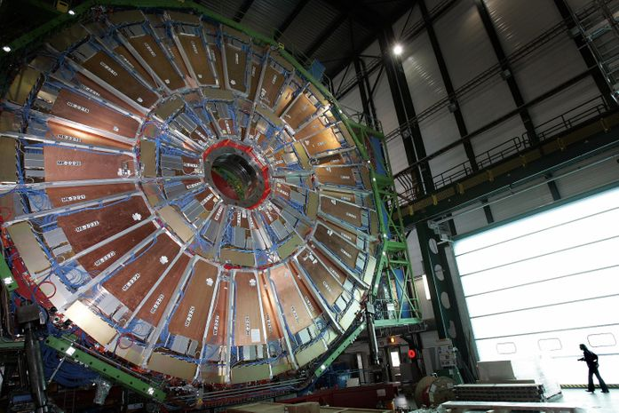
Particle physicists in the BASE collaboration at CERN have been investigating the matter-antimatter imbalance. Credit: Getty Images.
One theory is that matter and antimatter must in some way be radically different. But the latest CERN experiment does not find this is the case. According to the Standard Model of physics, a manual for every known particle in the universe and how it operates, each type of atom has its polar opposite, its antiparticle, with the same mass, but with an opposite electrical charge.
In this study, CERN scientists tried to discern what fundamental difference such particles should have, to validate the existence of the cosmos. They came up empty. Physicists in the BASE collaboration at CERN, studied the magnetic properties of protons and antiprotons with uncanny precision. Some good news: the findings did support the Standard Model, as the particles behaved just as it predicts.
The matter-antimatter imbalance, as it’s called, is a popular topic among particle physicists these days, with many teams around the world looking into it. CERN researcher Christian Smorra was on the team who conducted the most recent experiment. He told Science Alert, "All of our observations find a complete symmetry between matter and antimatter, which is why the Universe should not actually exist."
He added, "An asymmetry must exist here somewhere but we simply do not understand where the difference is. What is the source of the symmetry break?" He and his colleagues' findings were published in the journal Nature.
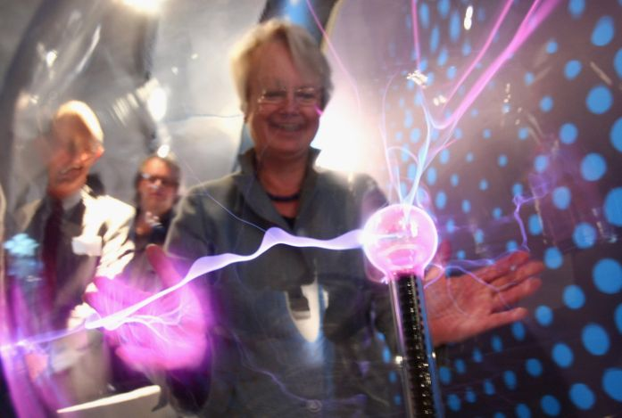
When matter and antimatter particles collide, a burst of pure energy is the result. If these were perfectly balanced in the early days of the universe, how could the cosmos exist at all? Credit: Getty Images.
Protons and antiprotons were the last holdout when it came to particles which could explain the matter-antimatter imbalance. Scientists from Mainz University in Germany devised a manner to assess the magnetism of a particle of antimatter that is 350 times more precise than the previously method. The readout was incredible, to nine places!
-2.7928473441 nuclear magnetons. A proton has the same level of magnetism, only it's positive. Although the study failed to explain our universe’s extreme prejudice towards matter, it did give us a far better understanding of an antiproton’s magnetism.
Antimatter doesn’t last long. As such, it needs to be contained. Researchers used two Penning traps, which are devices that retain antimatter particles using an electrical and a magnetic field. Stefan Ulmer, spokesperson for the BASE collaboration at CERN, said in the press release:
“The measurement of antiprotons was extremely difficult, and we had been working on it for ten years. The final breakthrough came with the revolutionary idea of performing the measurement with two particles. This result is the culmination of many years of continuous research and development, and the successful completion of one of the most difficult measurements ever performed in a Penning trap instrument.”
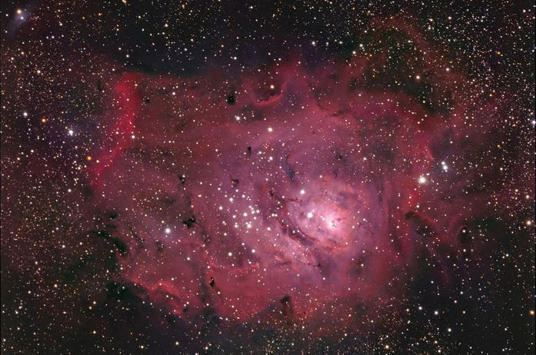
New plans in the works may unveil the secrets of the matter-antimatter imbalance. Pictured here: The Lagoon Nebula in Sagittarius. Credit: Hewholooks, Wikimedia Commons.
Up until now, scientists have probed the differences between particles and their opposites by comparing their electrical charge, magnetism, and mass. Next, this team plans to investigate them in terms of gravity, to see if a discrepancy exists there. Another international collaboration based at CERN, called ALPHA, will be studying what asymmetry, if any, exists between hydrogen and antihydrogen atoms. The BASE team meanwhile, also plans on further examining antiparticles magnetically.
Another important development at CERN, a new linear accelerator introduced at the facility in May, will allow the Large Hadron Collider (LHC) to reach greater luminosity by 2021. CERN Director General, Fabiola Gianotti, said at its unveiling, “This high-luminosity phase will considerably increase the potential of the LHC experiments for discovering new physics and measuring the properties of the Higgs particle in more detail.” Perhaps discoveries made here will help unravel the secret behind the matter-antimatter imbalance.
Artemis Delayed Amid Misfire
Since December of 2017, NASA has been working towards the goal of sending “the next man and first woman” to the Moon by 2024, which will be the first crewed lunar mission since the Apollo Program. As part of this mission, known as Project Artemis, NASA has been developing both the Space Launch System (SLS) and the Orion spacecraft, which will allow the astronauts to make the journey.
Originally, it was hoped that the first uncrewed flight of the SLS and Orion (Artemis I) would take place later this year. But according to recent statements by Associate Administrator Steve Jurczyk, this inaugural launch will most likely take place “mid to late” in 2021. This is the latest in a series of delays for the high-profile project, which has been making impressive progress nevertheless.
The announcement was made on Saturday, Feb. 28th, during the kickoff meeting at the Lunar Surface Innovation Consortium (LSIC) at NASA’s Applied Physics Laboratory in Laurel, Maryland. As part of NASA’s Lunar Surface Innovation Initiative, this consortium brings academic and industry experiments together with government officials to discuss and design the necessary technologies and systems that will enable lunar exploration.
In the course of the keynote address, Jurczyk shared how all the elements that will be needed for the first crewed mission (Artemis 3) in 2024 are currently in development or soon will be. This includes the Orion spacecraft – which is in its final phase of vacuum chamber testing at NASA’s Plum Brook Station – and the SLS core stage, which is awaiting a static-fire test at Stennis Space Center (scheduled for later this year).
Once the tests are complete, the SLS core stage will be shipped to the Kennedy Space Center in Florida where crews will begin the process of integrating it with the Orion spacecraft and an upper stage booster. As for when the rocket and spacecraft will be ready to fly, Jurczyk indicated that it would not be in 2020 (as previously intended) but “hopefully in the mid ’21 timeframe, mid to late ’21 timeframe for Artemis 1.”
Jurczyk also claimed that the administration was making progress on other pieces of the mission architecture, like the development of modules and systems that will go into the creation of the Lunar Gateway. This includes awarding contracts to Northrop Grumman Innovation Systems (NGIS) and Maxaar Technologies to build the HAbitation and Logistics Outpost (HALO) and the Power and Propulsion Element (PPE), respectively.
Then there’s the Lunar Lander element, for which NASA issued an open call for concepts back in September of 2019. To date, NASA has awarded to Lockheed Martin, Boeing, Northrop Grumman, Blue Origin, and Draper Laboratory, and others to produce their own concepts (which include a reusable lander deployed from the Gateway or an expendable one deployed from the Orion spacecraft).
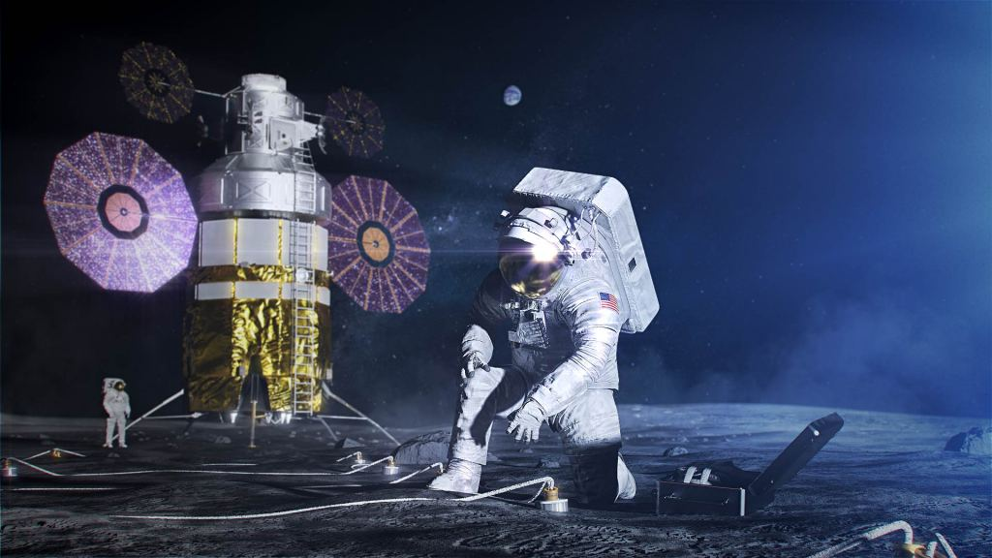Artist’s illustration of the new spacesuit NASA is designing for Artemis astronauts. It’s called the xEMU, or Exploration Extravehicular Mobility Unit. Image Credit: NASA
It’s not clear if this latest delay will jeopardize Project Artemis’ goal of landing a crew on the Moon by 2024. However, it is merely the latest in a program that has been plagued by delays from the beginning. At present, the SLS program is already years behind in its development goals and billions of dollars over budget.
What’s more, NASA is also dealing with the problem of conflicting statements and inconsistency. On the one hand, they are contending with stringent deadlines and the possible cancellation of the Lunar Gateway – a key element in the “Moon to Mars” plan. On the other, there are the statements issued by President Trump during the past nine months that suggest that the focus of his administration could be shifting.
On June 7th, 2019, Trump tweeted “NASA should NOT be talking about going to the Moon – We did that 50 years ago. They should be focused on the much bigger things we are doing, including Mars…” This was followed by similar statements made back in September during the visit of Australian PM Scott Morrison, where he told reporters:
“We’re going to Mars. We’re stopping at the moon. The moon is actually a launching pad. That’s why we’re stopping at the moon. I said, ‘Hey, we’ve done the moon. That’s not so exciting.’ So we’ll be doing the moon. But we’ll really be doing Mars.”
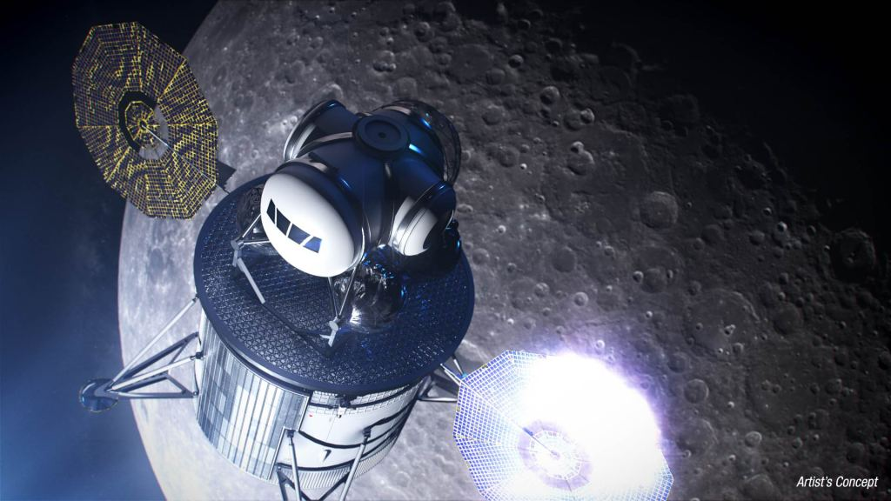Artist’s illustration of Project Artemis lunar lander. Credit: NASA
This stands in contrast to Project Artemis’ priorities, as set by VP Pence Administrator Jim Bridenstine (who was appointed by the Trump administration in 2017). Put simply, Artemis is all about getting to the Moon faster, even if it meant serious shake-ups at the agency. This much was demonstrated with the demotions of longtime heads William Gerstenmaier and William Hill in July of 2019.
In the wake of Pence’s announcement in March of 2019, there have also been changes in terms of the design for mission architecture – for example, the Lunar Lander. Whereas this element was originally intended to be a reusable spacecraft that would ferry astronauts between the Lunar Gateway and the lunar surface, more recent designs are for an expendable vehicle that would travel take astronauts from the Orion spacecraft to the lunar surface and back again.
NASA awarded billions of dollars in development and production contracts to support flights beyond Artemis I, but the flight schedule has changed frequently due to a lack of clear requirements and time frames for planned capability upgrades. Limited NASA oversight also places efforts to plan and execute future flights at risk of adverse outcomes, such as increased costs or delays. For example, NASA is committed to establishing cost and schedule performance baselines for these efforts, but it plans to do so too late in the acquisition process to be useful as an oversight tool. In addition, senior leaders do not receive consistent and comprehensive information at quarterly briefings on future efforts, such as a program to begin developing a more powerful upper stage for SLS. This is because current updates provided to NASA management focus primarily on the more short-term Artemis I and II flights. This approach places billions of dollars at risk of insufficient NASA oversight."
Originally, the long-awaited return to the Moon was slated it to happen no sooner than 2028, giving the SLS and the Gateway plenty of time to be completed. This would not ensure that lunar missions would be sustainable and keep going after the next crewed missions to the surface, but that NASA would be well-positioned to set its sights on Mars next.
South Africa Travel Ban
President Joe Biden will impose a ban on most non-U.S. citizens entering the country who have recently been in South Africa starting Saturday in a bid to contain the spread of a new variant of COVID-19, a senior U.S. public health official told Reuters.
FILE PHOTO: A traveler walks past a Christmas tree as he makes his way through the Ronald Reagan Washington National Airport, in Arlington, Virginia, U.S., December 22, 2020. REUTERS/Kevin Lamarque/File Photo
Biden on Monday is also reimposing an entry ban on nearly all non-U.S. travelers who have been in Brazil, the United Kingdom, Ireland and 26 countries in Europe that allow travel across open borders.
“We are adding South Africa to the restricted list because of the concerning variant present that has already spread beyond South Africa,” said Dr. Anne Schuchat, the CDC’s principal deputy director, in an interview Sunday.
She added the agency was “putting in place this suite of measures to protect Americans and also to reduce the risk of these variants spreading and worsening the current pandemic.”
Then-President Donald Trump directed on Jan. 18 those restrictions on Brazil and Europe be lifted effective Tuesday but Biden’s proclamation will rescind that decision.
Biden, who took office on Wednesday, is taking an aggressive approach to combating the spread of the virus after Trump rejected mandates sought by U.S. health agencies.
Some health officials are concerned that current vaccines may not be effective against the South Africa variant, which also raises the prospect of re-infection.
The South African variant, also known as the 501Y.V2 variant, is 50% more infectious and has been detected in at least 20 countries. CDC officials told Reuters they would be open to adding additional countries to the list if needed.
The South African variant has not yet been found in the United States but at least 20 U.S. states have detected a UK variant known as B.1.1.7. Current vaccines appear effective against the UK mutations.
The South African embassy in Washington did not immediately respond to a request for comment.
CDC ORDERS COMING
Centers for Disease Control and Prevention director (CDC) head Rochelle Walensky will sign a separate order Monday requiring masks on all airplanes, ferries, trains, subways, buses, taxis, and ride-share vehicles for all travelers two and older, officials said. The new requirements are set to take effect in the coming days, they said, and masks can be removed for brief periods while eating or drinking.
On Tuesday, new CDC rules take effect requiring all international air travelers 2 and older to present a negative coronavirus test taken within three calendar days of travel or proof of recovery from COVID-19 to enter the United States.
The CDC will not, as it said on Jan. 12, consider granting temporary waivers to airlines to exempt some travelers from countries with limited testing capacity. Numerous U.S. airlines last week had asked CDC for waivers, airline officials said.
But CDC officials said they would consider case-by-case humanitarian exemptions for some travelers if needed.
CDC officials noted 120 countries currently have mandatory COVID-19 testing requirements for international travel.
The CDC order says travelers should self-quarantine for seven days upon return to the United States and consider getting a new COVID-19 test within three to five days of returning to the United States.
“With the pandemic worsening and these more contagious variants emerging it’s not the time to lift restrictions on international travel,” Schuchat said.
CDC officials have for weeks discussed the possibility of adding these testing requirements before U.S. domestic flights or requiring testing upon return from international travel but have made no decisions.
The U.S. restrictions barring most visitors from Europe have been in place since mid-March when Trump signed proclamations imposing them, while the Brazilian entry ban was imposed in May. The restriction, along with the new South Africa ones, mean most non-U.S. citizens who have been in one of those countries within the last 14 days are not eligible to travel to the United States.
Permanent U.S. residents and family members and some other non-U.S. citizens are permitted to return to the United States under the order.

