Journey to the Center of the Moon

As though right out of my latest book, Asteroid Mining: The Future of Energy, the ESA is now proposing a mission to the Moon to explore the volcanic vents. Infrastructure is going to be one of the biggest components of any permanent human settlement in the moon. NASA Artemis missions are focused directly on building up the facilities and processes necessary to support a moon base. ESA is also contributing both material and knowledge. Most recently, they made another step in their path to explore lava tubes and caves in the subterranean lunar world.
ESA recently started the third round of a series of studies that focus on exploring lunar caves. The current round, called a concurrent design facility (CDF) study, builds on the work done in two previous rounds of Sysnova studies. Originally encompassing five studies ranging from how to lower a probe into a cave to how to communicate with and power any probes that make that descent, ideas were elicited from the public as part of the CAVES and PANGAEA programs.
From the five original concepts in the first Sysnova studies, ESA winnowed it down two three "mission scenarios"—one to find cave entrances, one to thoroughly study a cave entrance, and one explore a lava tube using autonomous rovers. ESA then decided to further evaluate two mission concepts that focus exclusively on exploring a cave entrance, but combining aspects of all three original mission concepts.
Understanding even the entrances of lunar caves can prove invaluable to understanding the resources that might be available in the subterranean world of the moon. It is also key to understanding the radiation protection afforded by the lunar regolith. That protection, depending on its efficacy, can prove to be a game changer in where any potential permanent lunar base would be located.
Images of open lava tubes on the moon. Credit: NASA/LRO
The first selected mission plan is on led by the University of Würzburg. They developed a spherical probe that can be lowered into a cave mouth by a crane attached to a rover. The probe itself is encased in a clear plastic shell and will contain 3-D lidar, an optical camera, and a dosimeter that will allow the probe to read radiation levels at the cave entrance.
Wireless power and communication is the focus of the second mission plan, developed by the University of Oviedo. In its scenario, a "charging head" is attached to the end of a rover-based crane, which is then used to power and directly communicate with autonomous rovers that do not have their own internal power source. Power for the rover and charging head will come directly from solar panels connected to the rover.
Image of the spherical camera system developed by the University of Würzburg. Credit: University of Würzburg
Mission duration for these experiments would be planned for one lunar day, or approximately 14 Earth days. ESA plans to link the mission outcomes of these two project directly to two of their concerted lunar exploration efforts, known as the European Large Logistics Lander (EL3), which will help build up the infrastructure needed for a permanent presence, as well as the Moonlight initiative, which focuses on wireless communication and navigation for lunar exploration vehicles.
Graphic depicting the concept of the University of Oviedo wireless power and control system. Credit: University of Oviedo
Both of these proposed missions are still conceptual at this stage, and neither has received full funding for anything close to planning a fully fledged mission. However, it is clear that ESA's stepwise process is providing value even before any mission is launched—the concepts that have resulted from it are novel and potentially executable with enough willpower and funding. Missions that have made it this far in the process stand a good chance at eventually becoming reality and contributing to the effort to permanently colonize the moon.
The idea is fully discussed in my new book Asteroid Mining: The future of energy. Seal up the opening, pump it full of air, and go to work. Simple as that.

The War on the Middle Class
For thousands of years, the Global Syndicate has had only one, true enemy; the middle class. The prospect of inflation in the United States has moved quickly from a fringe idea to weapon of choice to destroy the middle class and send them back to the ranks of the working poor. With the newly passed $1.9 trillion stimulus package, the Federal Reserve is forcing the excess liquidity built up by the Trump economy into markets where it has no place to go other than fueling financial asset bubbles. Dozens of them. If you’re not out of debt, you will soon feel the absence of disposal income.
Inflation is now running much hotter than anyone would have expected. It is being driven right now by artificial process for oil, but it has been sneaking into areas such as food and housing for quite some time. As the Made-4-TV virus is exposed as the fraud it really is, demand is breaking free with the reopening of our economies, and these inflationary pressures will only accelerate. It was all by design. Like holding an inflatable ball under water and then releasing it, the pressure to get to the surface is unstoppable. The debate is now focused on when and how severely, rather than if, inflation will emerge, and whether it will be transitory or long-lasting.
What is being passed over in the discussion is a simple but terrible truth: a prolonged inflation will destroy the already weakened middle class and worsen the widening wealth gap in America. Simply put, the Syndicate knows we will trample one another trying to get to the bounty before our neighbors.
By pushing this additional stimulus package, which once again has very little going into the hands of those who need it most, the Biden administration may be walking into a policy trap that will favor the elites at the expense of ordinary Americans. Not that we should be surprised at this, but it’s frightening nonetheless.
The middle class will bear the brunt of inflation through rising food, energy, and other prices. Then, later, when government tries to tamp down on rising inflation through higher taxes, the middle class will see its income squeezed even more. Inflation will further increase the income and wealth inequality between those who rely on their labor (i.e., the middle class) and those who, at least for the time being, benefit from the financial market’s inflation-fueled euphoria.
A prolonged inflation will destroy the already weakened middle class and worsen the widening wealth gap in America.
The last time we saw income and wealth inequality in the United States as bad as it is today was the 1930s. This led to substantial social and labor unrest, some of it violent. The Second World War had a leveling effect, and the economic resurgence that followed gave rise to the power and cultural predominance of the middle class in America. But the U.S. is now growing substantially less equal. Indeed, inequality has been rising for the last 45 years.
During this time, wealth has been shifting towards capital and away from labor, and national income has become more concentrated at the top with the rise of an elite managerial class. An analysis published in September 2020 by the RAND Corporation showed that the top 1 percent of income earners took home 22 percent of taxable national income in 2018, compared with 9 percent in 1975. Over the same time frame, the bottom 90 percent of income earners saw their share of national income fall from 67 percent to 50 percent. There are no signs that this trend will reverse itself anytime soon. Inflation will only make it worse.
The top 3 percent of income and wealth will be the biggest winners in an inflationary environment. Investor living on income from property or investments, traders (of goods), speculators (in financial assets), and others who are already wealthy will quickly learn how to navigate in and profit from inflation. The Great Depression hurt everyone, except those investors who had liquid cash. They bought entire city blocks for pennies on the dollar.
Globalist jet-setters can shift between currencies, making money from every single trade as the values fluctuate by the minute. The 2 percent of accounts that hold 98 percent of Bitcoin can use cryptocurrencies as a hedge against inflation and manipulate prices along the way. Fixed-rate debtors (e.g., homeowners with fixed-rate mortgages) will have some protection, as housing stock values tend to rise with inflation.
The middle class will, on the other hand, be the biggest loser in a sustained inflation. Government workers, administrators, entry-level and middle-management employees, and other salaried workers will see their purchasing power steadily erode. Food and energy commodities will begin to consume the majority of disposable income. The moderately wealthy — doctors, lawyers, engineers, anyone from the professional class, which relies on cash income — will fare no better.
People who are in debt at variable rates of interest (i.e., credit card debtors and those with floating-rate mortgages) will see rates skyrocket. Most of the middle class do not have opportunity to reset income annually, let alone monthly, weekly, or daily, as is required in severe inflations. In Mexico, when this occurred, thousands of people just took their car keys to the banks and handed them over. Inflation hit 1,500%, changing the car payments accordingly. There are almost no fixed-rate loans in Mexico for just this reason.
While teachers and other union workers may be able to reset periodically through labor actions and unrest, these moves will still lag behind the cost of living. Those worst off will be elderly retirees and others relying on bonds and fixed incomes. For those unable to rejoin the workforce, an entire life’s savings may dwindle to be worth less than the cost of a trip to Starbucks. Most will lose their homes and become renters for the rest of their lives, ruined by the brutal credit bureaus who imprison financial slaves for 7 years after a financial misstep.
The middle class exists only because it has been successful in transforming disposable income from hard work into investments (mostly housing), savings, and other stores of value. When that disposable income disappears, people fall back down into the working poor.
Government sponsored Inflation eviscerates the stored value that the middle class holds in cash, savings, retirement accounts, bonds, etc., while greatly reducing the purchasing power of income from wages and salaries. In a prolonged inflation, the middle class will, like the working class, be forced to use all of its income as daily bread, primarily consisting of shelter, food, and energy. Because, at least for most, income will not be able to rise as quickly as food, energy, and other costs, the middle class will begin a divestment process in which it disgorges stores of value.
Financial investments along with hard assets such as jewelry, metals, and coins, and even furniture, firearms, and even vehicles, will be turned back into cash to maintain consumption of basic goods and to pay ever-increasing taxes. This selling of an acre of ground a year to pay taxes and buy food eventually eats up the entire farm, and there is nothing left to inherit. This is exactly what the Global Syndicate has been doing for thousands of years.
Not only is this process unjust; it’s also dangerous. Even a cursory reading of history demonstrates that when they are done destroying the middle class, social and political unrest inevitably follows. Leadership to stop them from subjugating the entire world to their will is killed off, sued into oblivion, or banned from social media so they cannot communicate with the very people they are supposed to be leading.
The priority should be on job creation and reopening our schools and local economies through initiatives for small and medium-sized businesses. However, anyone who proposes this solution is called a Neanderthal. Throwing more stimulus money at pork-barrel projects and failed mayors keeps pouring money into the Syndicate’s businesses, robbing the common man of everything he has worked so hard to accomplish.
When does it stop? Well, it used to stop when we the people had had enough, and we vote them all out of office. That doesn’t matter anymore. No matter how many people vote, it will make absolutely no difference, because the Global Syndicate now controls all the tallying systems remotely. Now what? Well, you’ll just have to stay tuned. Because we can’t tell you here. It has to be done in secret code, and you know what that does. It creates another anonymous conspiracy. Let me know when your ready, and I will tell you what can be done to win back our country.

Voter Fraud Judgement
The more that states and counties investigate their own elections the way that they're supposed to, the more they're finding out that it's all been a sham that liberals have been stealing elections right out from under the people.
In Mississippi, they found that in one city, the results were proven to be a lie because 78% of the mail-in votes were determined to be fraudulent.
In the sixty-four-page order, Judge Jeff Weill not only calls for a new election but also finds evidence of fraud and criminal activity, in how absentee ballots were handled, how votes were counted, and the actions by some at the polling place.
In his ruling, the judge said that sixty-six of eighty-four absentee ballots cast in the June runoff were not valid and should never have been counted. Nicholas Holliday was declared the winner by a 37 vote margin. Robert Devaull challenged the results in court.
Judge Weill found many irregularities with absentee ballots. He issued a bench warrant for notary Dallas Jones, who notarized absentee ballots. During a hearing, Jones admitted violating notary duties.
“When you have an absentee ballot, there’s an envelope, you vote, fold the ballot, put it in an envelope, lick the flap, sign across the flap, then notary signs your election certificate, she testified that she didn’t sign in front of anybody, didn’t see anybody sign it, she just notarized it, just stamped them,” said Lydia Quarles, attorney for Robert Devaull.
Now, if other cities would continue this due diligence and investigate the elections and the ballots in their own cities, I'm sure that people would learn that they've been hoodwinked as well.
Just when you thought you'd heard nearly all there is to hear regarding the election fraud, there's more.
Now, it's being reported that China was actually involved in the fraud going as far as printing out fake ballots.
The original report that comes directly from Taiwan reported the following:

As the US election was affected by the epidemic, more than 120 million blank ballots were mailed in advance. According to a source, an underground factory in Guangdong, China, which usually specializes in "forging invoices and falsifying accounts," has forged a large number of blank U.S. ballots since July with a monthly output of 500,000.
Judging from the screenshot of the conversation, the boss not only said, " We have the original model of this version, "We have ordered it before. " There is still a lot of this in inventory. And because the ballots are different in each state in the United States, the underground factory can provide the original model files of "Mississippi, Florida, North Carolina", and emphasize that this is provided by the "previous customer", and there are other states that can also be used for voting. , Not only these 3 states.
It is worth noting that the boss of the underground factory actually stated that the metal patterns and anti-counterfeiting of the real ballots cannot be forged yet, but previously unknown people have ordered a large number of them, and the boss also said, "The amount is not a problem, the main thing is your money. In place, that amount is not a problem."
I know that this is quite a claim, but what evidence do we actually have that something like this may have taken place? Well, how about video and photos?
If all of this is true and accurate, do you understand how massive of a bombshell this would be? This is war worthy. China literally will have interfered in our election on a massive scale.
And there is supposed to be more to come!
An attorney in Michigan, Matthew Depronon, has been conducting an investigation in regards to the voting machines that were located in Antrim County.
He was able to quickly form a team of seven highly trained individuals who have experience in the IT sector.
The team arrived on Sunday morning and quickly got to work upon Mr. Depronon being granted access to the county building and immediately started collecting the blatant evidence.

The collection process was complete after roughly 8 hours. The evidence found included 16 thumb drives, 16 CF cards, and a multitude of forensic images of the voting machines. The investigators were promptly escorted to the local airport in Antrim county by the county's sheriffs.
They were then given permission to board a plane with the evidence in hand. Mr. Depronon has reported that he should have the results of this investigation by sometime on the following Tuesday. However, he did not receive them until the end of last week.
Then, Depronon told Newsmax some bombshell information:
"Well the Secretary of State Jocelyn Benson said it happened by human error. We discovered that’s not true, that’s a lie. It didn’t happen by human error. It happened by a computer program called Dominion Voting System. And through our lawsuit we were able to get access to the Dominion Voting System program and my team went on last Sunday and we took forensic images on that computer system, 16 CF data cards, 16 thumb drives, and we got the forensic image of the actual tabulation machine in the Antrim County clerk office."
It seems as though the voting errors did not occur by human error, but rather by a computer program called the Dominion Voting system. So, basically what this all means is that votes were changed, and it wasn't done through human error, but it was written into the code of the Dominion software.
Georgia
In Georgia, a state Joe Biden won by fewer than 12,000 votes, county election officials still have not complied with a law requiring them to provide documents certifying the chain of custody of more than 400,000 mail-in ballots.
The request for the drop-box transfer forms was made by The Georgia Star News under the Georgia Open Records Law. Last July, the Georgia State Election Board passed an emergency rule requiring election officials to maintain the transfer forms.
But officials for the state's largest county, Fulton, and another major county, DeKalb, said they didn't know if they had the documents and promised to reply later, Georgia Star News reported.
But four months after the Nov. 3 election, those counties and 33 others have failed to comply with the law.
Overall, no chain of custody has been provided for an estimated 404,691 of the estimated 600,000 votes by mail-in ballot deposited in drop boxes, delivered to county registrars and counted in Georgia’s 2020 presidential election, Star News said.
The report pointed out the emergency rule passed by the election board last year "required that every county election office maintain a ballot transfer form that documented the movement of every absentee by mail ballot placed in a drop box and delivered to the county registrar prior to the election, with the number of absentee ballots picked up from each drop box, the signature of the two person team who picked up the ballots, the time of the pickup, and the time of the delivery of those ballot to the registrar, and the name of registrar who received those ballots."
In Congress, a bill sponsored by Democrats would nationalize election procedures, eliminating many of the security measures established by states, such as chain-of-custody and signature standards.
The Star News report noted Georgia's estimated 300 drop boxes, which were used by Stacy Abrams ballot harvesters, were funded by the Center for Tech and Civic Life, which was sponsored by a $350 million payment from Facebook's Mark Zuckerberg.
Occupied DC
Chris Bedford is a senior editor at the Federalist. Here is his report.
My city has been occupied for more than eight weeks. Major thoroughfares blocked, thousands of armed soldiers, armored vehicles, seven-foot fencing, concertina wire.
What’s it all for? An invading army across the Potomac? Rising far-right militias, ready to strike at any moment?
Nope. It’s because when angry rioters and protesters attacked the Capitol on Jan. 6, a Capitol Police force hobbled by its leadership’s poor training regimens, nearly non-existent fitness standards, and fecklessness in the face of crisis were incapable of protecting the building or even shutting the big doors on time.
It’s because those idiot rioters had finally — after months and years of left-wing riots here and across the country — finally given Democratic lawmakers and the corporate media the right-wing riot they always claimed was around the corner.
It’s because panic porn and agitprop are useful tools when you’re working as hard as you can to spread fear and distrust against the half of the country that disagrees with your policies.
And it’s because acting Capitol Police Chief Yogananda Pittman is perfectly content to use her own men and women as political pawns and scapegoats to please her new Democratic bosses.
Just as with “two weeks to slow the spread,” on Capitol Hill we were told one month to stop the “insurrection.” Then three weeks in, the acting Capitol Police chief requested that fencing remain permanently, a sort of replacement for providing the training and enforcing the standards that are expected of police departments across America.
In the following weeks, reporters at outlets like Politico thirstily spread rumors from unnamed “Guard members” that March 4 was the day the militias would finally come back. Except this time, instead of tens of thousands of people flying and driving to the capital for a widely advertised protest with nearly zero preparation for crowd control, there was internet “chatter” about something maybe happening to a building people can’t walk within 100 yards of because it’s surrounded with razor wire and thousands of National Guardsmen.
While headlines like “Capitol Police Say Intelligence Shows Militia Group May Be Plotting To Breach The Capitol” ran in The Washington Post, readers who got seven paragraphs down learn the FBI actually didn’t “have any indication of violence or a specific, credible plot at this time” — the kind of fact that might cause more intelligent or honest journalists to wonder what “intelligence sources” the Capitol Police were citing. None of that got in the way, of course.
And none of it got in the way of acting Chief Pittman, who requested Thursday that the occupation be extended a further two months after the men and women of the National Guard are slated to finally return to their homes, families, and lives.
None of it is enough. While the men and women of the Armed Forces — men and women who could be helping at the border, distributing vaccines, home with their children, or literally anywhere but Washington — lined the halls and stood guard outside against an imaginary army that couldn’t get within 100 yards in any direction, Speaker of the House Nancy Pelosi warned lawmakers to scurry among the tunnels beneath the Capitol instead of walking the halls like adults.
Because “chatter.” If terror attack “chatter” sounds familiar, it’s because you remember 9/11. Same thing, right?
“I plan on going in,” one senior Republican staffer told The Federalist Thursday morning. “Given the Army trucks, soldiers with guns, and barbed wire fences I can’t bring myself to take the left seriously when they tell me that a guy from Indiana is going to show up and be real mad about something he read on Reddit.”
But it doesn’t matter to the leadership in Congress or Pittman. What matters is the narrative. It’s all a great big theater, and all of us here in D.C. — the Capitol Police officers, the Guardsmen, the staff, the neighbors — are living in it.

The Made-4-TV Virus Report
The evidence around the world indicates a significant divergence in what the elites clearly wanted to happen vs. what has actually happened. If the Event 201 pandemic war game on a coronavirus outbreak, held two months before the actual outbreak occurred in China, is any indication, then the globalists greatly overestimated the fear effect of Covid. You remember this video, right? Where the experts on the panel responded to statements read by the moderator about a pandemic outbreak, the rate of spread, and the mortality rates?
They predicted at least 65 million deaths from a coronavirus outbreak, but over a year has passed since the pandemic went international and the official death count stands at 2.5 million, with over 40% of deaths in the US attributed to nursing home patients that were ALREADY dying from preexisting conditions. Removing suspect nursing home deaths from the equation, the death count is probably closer to 1.5 million, again, if we adhere to official estimates.
To put this number in perspective, the CDC states that actual global deaths from the regular annual flu virus peak at around 649,000 depending on the year. Deaths from the flu and pneumonia reach as high as 1.4 million globally per year. Studies funded by the Bill and Melinda Gates foundation find annual pneumonia death stats that are comparable to the CDC’s.
Yet, we never saw Bill Gates calling for economic lockdowns, mask mandates and medical passports because of the flu or pneumonia. Why is that? I can tell you it is because there was never a need to smash the Trump economy before. That was the mission. That was the only mission, no matter how many people died.
Today, the death rate of covid is 0.26%, FAR below initial predictions by globalist institutions and governments. In fact, this does not even begin to justify masks, lockdowns, or social distancing. Not even close. It is now widely proven that the lockdowns did absolutely NOTHING to slow the infection spread of the virus, and now many areas of the US are starting to experience what the lab coat “professionals” affectionately call “herd immunity”. Infections and deaths are plunging, and the lockdowns and mask mandates were useless, except of course to accomplish the primary mission; to smash the Trump economy.
Like the vast majority of all viral illnesses, humans simply get sick, endure, build immunity and get healthy. Some of us die, as we always have, and government intervention is not needed nor is it welcome. This is why large portions of US and European populations are refusing to accept the lockdowns and the vaccines. Why destroy the economy and submit to a potentially dangerous—most certainly unknown—genetic cocktail over a disease that 99.7% of the population is sure to survive?
The establishment elites really blew it this time.
The Global Syndicate announced their reset agenda under the assumption that the death rate for covid would be MUCH higher than it is. They were expecting something biblical, and instead they got something not much more dangerous than mortality rates from electric toothbrushes or drunk driving.
There is now mass public resistance to the vaccinations and medical passports. This is probably why they rushed out the vaccines in the span of 6 months instead of a year to 18 months as they hinted at in early 2020. They are trying to get as many people as possible to take the experimental vaccines before the citizenry realizes that covid is a nothing-burger.
The majority of people never wore the masks and the majority of local businesses never tried to enforce them. I have never been forced to wear a mask except at Walmart, which I don’t shop at anymore. And though people initially went along with the first economic shutdown, they will not be complying with another. In my state of Montana, there are 1,300 deaths attributed to covid. In my county, the estimated infection rate is over 25% (which means almost everyone has probably already been infected), and there are only 13 deaths total.
No one is scared of this thing. Almost no conservative is going to wear a mask, and many people in Red states (and some in Blue states) are going to refuse to take the vaccines or accept medical passports.
This means that the globalists have a big problem. They obviously invested a lot into this pandemic. It is the key to their entire Reset agenda. Without a frightening pandemic killing tens of millions, the globalists will not be able to lock down the public and prevent them from traveling or organizing. They will not be able to institute the medical passports and contact tracing apps that would allow them to watch the public 24/7. They certainly won’t get most Americans to go along with the cashless society and the centralized global governance the elites are so obsessed with.
The fear of coronavirus is waning. The globalists have indeed failed in epic fashion. But, this doesn’t mean that they are going to give up. If my experience studying psychopathic people tells me anything, it is that when these lunatics are cornered they tend to double and triple down on their failures.
The question is, what will happen next? The establishment will need maximum instability and chaos in the near term if they hope to salvage their Reset project. If they wait too long awareness will spread and they might not get another chance for many decades to come, if ever. Here are the events I expect to see over the course of the next year…
Covid Mutation Hype
The globalists are doomed unless they can keep the pandemic panic rolling forward. For now, puppets like Biden and Fauci are going to pretend as if a full reopening of the economy is going to happen. This is a lie. Already we are seeing Biden waffling on when a reopening will take place. He has indicated that it will be at least a YEAR before the shutdowns will completely end, and this is predicated on the majority of Americans submitting to vaccinations and medical passports.
In other words, the establishment is telling us that they intend to hold the economy hostage until we take the jab and give up our freedoms.
Now, are these inbred totalitarians just out of their minds? Well, probably, but that doesn’t mean they don’t have a Plan B. Just look at all the hype surrounding “covid mutations” in places like South Africa and Brazil; the narrative will be that a “new covid variant” that is more dangerous and deadly than the first virus is spreading, and that the lockdowns must return for the greater good of the public.
As a recent article from ‘The New Scientist’ states:
“Existing vaccines should stop people getting severely ill and dying if they do get infected by the P.1 variant. However, because many people remain unvaccinated, plans to ease lockdown restrictions would have to be rethought if this variant causes a resurgence in case numbers. Plus, any variant that circulates widely will have more opportunities to evolve into a more dangerous form.”
The New Scientist does not seem to understand basic science. The overwhelming majority of viruses circulating in the world usually evolve into less deadly forms of their original iteration. Viruses need to survive too, and they don’t do this by mutating into more and more deadly monstrosities that kill their favorite hosts. There is still no evidence that the new covid mutations are any threat whatsoever, but the establishment is already staging the narrative that new lockdowns are coming.
Federal Lockdowns
If the mutation narrative continues on the path it seems to be following, then I expect the Biden Administration to attempt a national federalized lockdown similar to the Level 4 lockdowns used in Europe and Australia, and it will be announced sometime this year.
This program will trigger several reactions; most importantly, most conservative states and counties will refuse to follow federal mandates. I know that my county and probably most of Montana will defy any new shutdown.
There will be several economic consequences that will erupt from this conflict; some positive and some negative.
Domestic Economic Warfare
This phase of the crisis will happen within a month to two months of any national shutdown. Red states will refuse to comply. State politicians, even if they are part of the agenda, will be too scared to try to enforce federal mandates. They will be compelled by the conservative citizenry to keep their states open. Most people in these areas will ignore mandates.
This will lead to a red state fiscal boom, at least in the beginning, as business continues to thrive in conservative areas while blue states suffer under medical tyranny. Companies will flee leftist states by the thousands and move to any states that remain open and accommodating. This will be short lived, though.
Biden and the federal government will try to retaliate, first by cutting off federal funds to any state that does not bow to their power and refusing to give stimulus to any businesses that relocate. Blue states will be flush with stimulus cash while red states will be forced to reduce or eliminate welfare programs and some pension funds.
Of course, the government has no real money to give, they only have our tax dollars and the fiat that the central bank creates from thin air. The likely response will be that conservative states and citizens will simply stop paying federal taxes. Another reaction will be red states taking over federal lands and utilizing the resources on those lands to rejuvenate their industry and make up for the federal dollars lost.
What this amounts to is a soft secession of conservative regions, which will eventually lead to federal attempts at physical intervention (the economic war will turn into a shooting war). The argument from the establishment will be that conservatives are putting the rest of the country “at risk”, that we are “selfish” and “literally killing grandma”.
Complete Erasure Of Conservatives From The Internet
I expect Biden and Big Tech to further pursue their current witch hunt against conservative voices, far beyond what we have already seen. In order to win a fight with conservatives they will first have to silence us so that our side of the argument is never seen or considered by the rest of the population. If they allow us to be heard, we will undoubtedly win because facts and moral reason are on our side.
It is hard to demonize people that simply want to be free.
But, if you can silence conservatives and moderates, then the narrative can be rigged. The establishment spin doctors can tell people that we don’t actually want freedom; we want something else, something evil and nefarious. They can tell people we are “fascists”, and that we are “racists” and that we actually want tyranny. Who is going to tell the public otherwise when we are removed from all available platforms and our websites are booted off service providers due to “dangerous ideas”?
Gun Control Madness
I know that some people think that leftists under Biden will not try to carry out a widespread gun crackdown and that much of the current talk is merely hollow rhetoric. I disagree. I think the globalists are going for broke, and they need to get as many combat capable firearms as they can from Americans soon. Democrats will push hard for legislation like HR 127.
They will then offer a “compromise” with Republicans and the NRA, cutting out portions of the bill. This will be a trick to make the public think that the new restrictions are a “reasonable compromise”. They think we will breath a sigh of relief and say “Well, at least they didn’t take everything…”
The gun grabbers are delusional.
What will really happen is millions of gun owners will pass local and state laws negating federal restrictions. No conservatives are going to give up their gun rights, allow red flag laws to be implemented or allow high capacity firearms to be limited; not at this stage in the game.
International Intervention
Eventually, leftists and the establishment will realize that conservatives will be harder to subjugate than they expected. They will discover that a large part of the US military and law enforcement is on our side. They will start to see mutiny among the people that they rely on as cannon fodder to carry out their dictates.
Even now, there are sheriff’s departments across the country refusing to enforce lockdown orders. And, 30% to 50% of medical professional say they will not be taking the covid vaccine depending on the state. When the rebellion goes live, this is when the globalists will have to pursue extreme options. They will not be able to win using domestic forces. Instead, they will seek out an international response, probably through the United Nations.
The rationale will be that the US has an enormous nuclear arsenal and that the international community cannot allow these weapons to fall into the hands of “white supremacists”. This is when the real fight will begin. If international intervention fails in the US, the globalists will find their heads on the chopping block. If the globalists win the fight in the US then there will be very few people left to resist them in the years going forward.
I have had numerous readers from all over the world write to me, saying that they believe in the face of the pandemic lockdowns it is now all up to Americans to turn the tide. I agree. A successful rebellion against globalism in America will lead to rebellions elsewhere, but the fact remains that if we lose, no one else will dare lift a finger. The future is in our hands.

The Real Devil in Georgia
The story of Democrats’ recent wins in Georgia is the story of Stacey Abrams. According to this narrative, after Abrams lost the 2018 gubernatorial race, she launched Fair Fight to stop Republicans from allegedly engaging in voter suppression and to register thousands of new voters.
When Georgia turned blue in 2020, Abrams received much of the credit. The story goes Democrats are now winning because they are making democracy better.
The career of another Democrat, Lyndon B. Johnson, illustrates a starkly different response to political defeat. Like Abrams, Johnson suffered a tough loss. In the 1941 Democratic Senate primary, Johnson initially thought he’d won. But his wily opponent, Governor W. Lee “Pappy” O’Daniel, had instructed key precincts to hold off reporting their tallies until he saw how many votes he’d need. When O’Daniel’s districts finally came in, Johnson’s lead vanished. Three days after the election, Johnson found he’d lost by just under 2,000 votes.
The true story of Democrats’ recent victories in Georgia may be quite different from the authorized version and may involve characters conspicuously absent from it.
Johnson never lost another election. In 1948, he again ran in the Democratic Senate primary and made it to a runoff vote. This time, Johnson’s opponent appeared to win by a small margin, but within days, officials found 200 more votes for Johnson in the now-infamous Box 13 from the tiny town of Alice, Texas. Never mind that the last 200 names on the rolls in Box 13 were written in different ink, all in the same handwriting, and in alphabetical order. Johnson was declared the winner by 87 votes out of about a million cast. That win boosted a political career that ultimately led Johnson to the White House.
AD
Despite the media’s mythologizing account of Abrams and her work in Georgia, there is reason to suspect the realpolitik spirit of Lyndon B. Johnson is alive and well in Democratic campaigning. The true story of Democrats’ recent victories in Georgia may be quite different from the authorized version and may involve characters conspicuously absent from it.
An Unsettling Letter
In the weeks before Georgia’s momentous election on January 5, 2021, some voters received an unusual letter supposedly from an institution called the Center for Civic Information (CCI). The outside of the envelope enticingly declared, “INSIDE: YOUR NEIGHBORHOOD’S VOTING GRADE.”
The enclosed CCI letter listed seven neighborhoods by individual residents’ names, as in “John Doe’s Neighborhood.” Each recipient’s neighborhood, designated with that recipient’s name, topped the list.
Next to this list were two columns. The first was headed “Current Grade” and contained letter grades for each neighborhood. The second column was headed “2021 Runoff Election Grade” and contained blanks for grades that supposedly would be awarded after January 5.
What did this mean? The letter explained, “Dear [recipient’s name]: ARE YOU AND YOUR NEIGHBORS PARTY VOTERS?”
The CCI’s letter claimed its records show “most Americans vote for candidates from both parties.” But, the letter continued, “some people keep blindly voting based on party alone.” The CCI explained it was “sending this mailing to you and your neighbors to publicize which nearby neighborhoods actually vote for candidates from both parties” (emphasis added). It said:
This chart shows your neighborhood in comparison with other nearby neighborhoods, giving a grade (A = always votes across party lines, and F = never votes across party lines) based on how often the neighborhoods have voted for candidates from both parties. These reflect the real voting records in nearby neighborhoods.
The letter ominously closed:
After the January 5th Runoff Election, we intend to mail an updated chart. You and your neighbors will all know which neighborhoods vote the candidate, and which just vote for the party. So don’t be a party voter, and vote for candidates from both parties this Election Day.
The letter was signed by “Paul and Aaron” but omitted their last names. It concluded with a P.S., “On Tuesday, January 5th, please do your civic duty and vote the candidate, not the party.”
Here is the entire letter:
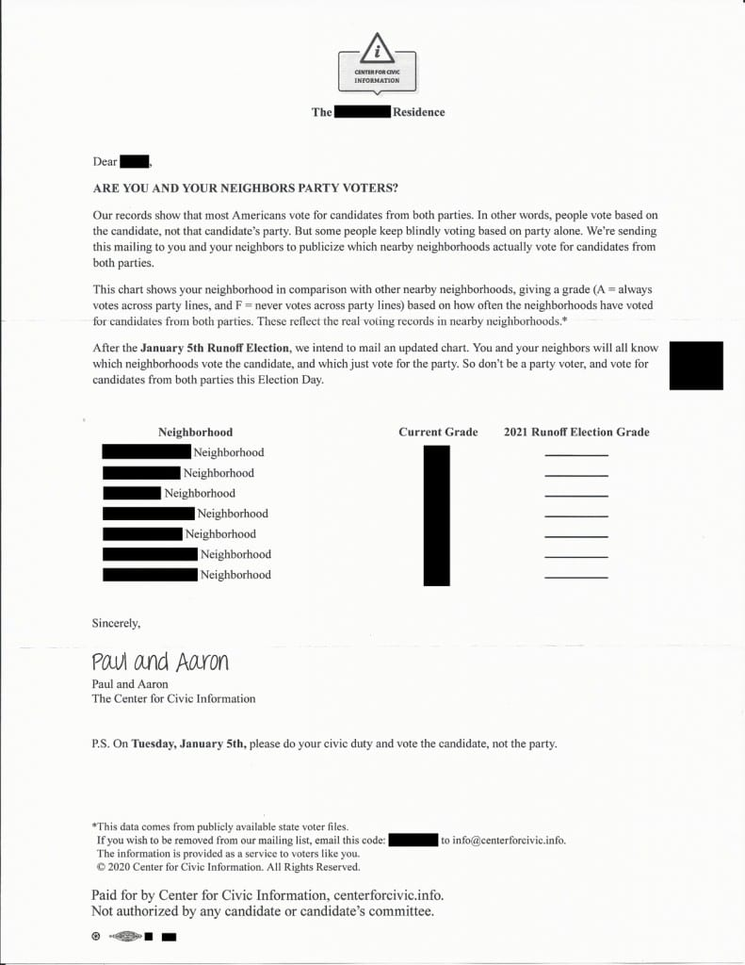
Voters across Georgia described receiving similar letters, as reported here, here, and here. Recipients were disturbed by the idea someone was tracking their voting choices and by the threat to disclose those choices publicly, contrary to the American system’s cherished tradition of a secret ballot. An institution with a similar name, the Center for Civic Innovation, evidently received so many complaints about the CCI letter that it issued a statement denying it had anything to do with it.
An Uninformative Website
Who sent this unsettling letter and why? The CCI’s website is a nearly blank billboard containing links to two Georgia state websites with information about polling places and early voting. The CCI website does not contain any information about the organization itself. Nothing about what the CCI is or does. Nothing about founders, directors, members, employees, or supporters. No statement of purpose. Not even an address.
The website also notably does not repeat the CCI letter’s admonition voters should vote for candidates from both parties.
A Virginia Corporation
Virginia’s business entity database shows CCI was formed on December 2, 2020, just 34 days before Georgia’s runoff election.
The Virginia records give CCI’s office address as 4701 Cox Road Suite 285, Glen Allen, Virginia. But that is not an office, merely the address for a registered agent for service.
The Virginia records identify two people involved with CCI. First, the Articles of Incorporation show CCI was incorporated by Graham Wilson.
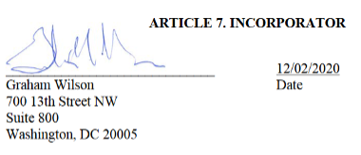
And the Virginia records reveal CCI has one director, Aaron Strauss.
A Democratic Lawyer
Graham Wilson is a partner at the law firm Perkins Coie in Washington, D.C. His “clients include the Democratic National Committee as well as other party and candidate committees.”
Perkins Coie generally has strong ties with the Democratic party. National Review reported Perkins Coie has “been paid at least $41 million for its political work by Democratic-affiliated organizations” and additional sums for “legal work for many left-wing nonprofits.”
CCI was presumably incorporated by this Democrat-affiliated law firm to aid the Democratic candidates in Georgia’s runoff election. But how?
A Progressive Data Analyst
According to netrootsnation.org, Strauss, CCI’s lone identified director, holds a Ph.D. from Princeton University in “political methodology and microtargeting.” He is “a leading proponent of using scientific experimentation and data analysis in politics” and has worked as “the Targeting & Data Director” for the Democratic Congressional Campaign Committee. Strauss’s bio also notes he has “developed state-of-the-art voter file databases”:
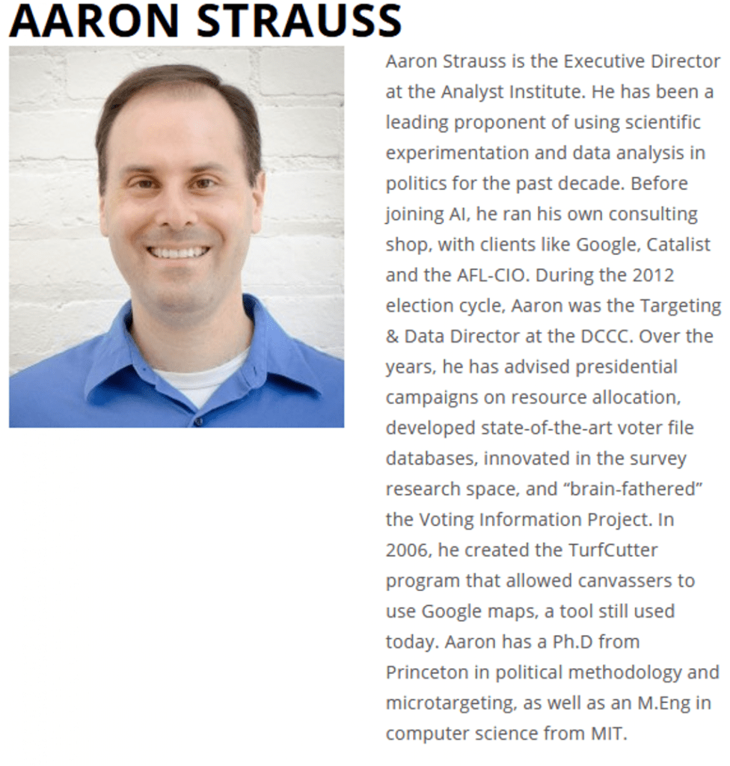
Strauss brags on his Twitter page that he “used science to help defeat Trump,” although he does not explain how:
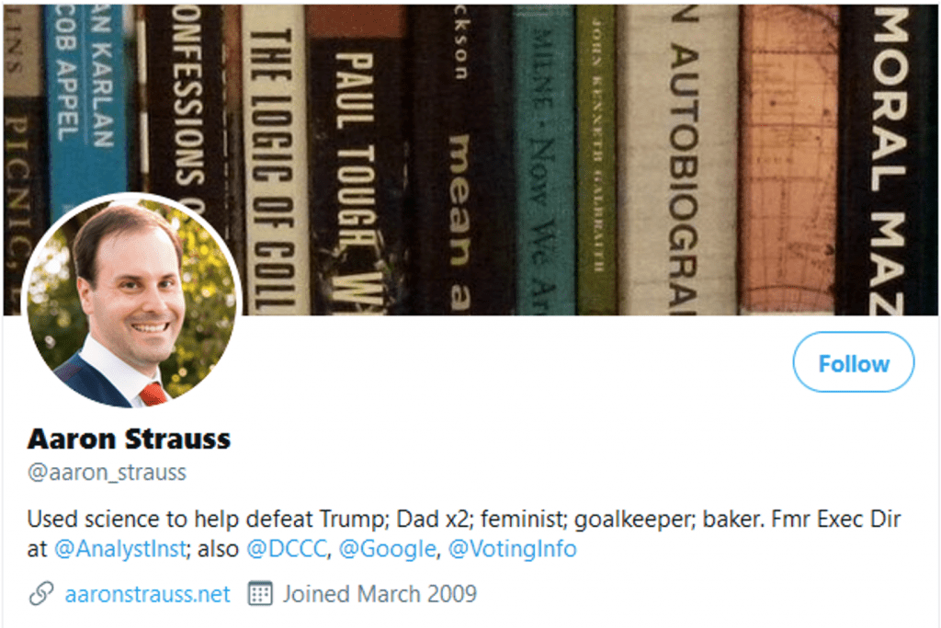
And Strauss’s personal website elaborates on his work for Democrats and the “progressive community” and his desire to “innovate faster than the other side”:
Continued Mysteries
Why would Strauss sign the CCI letter pressuring voters to split their votes in the Georgia runoff election?
Strauss’s bios do not evidence a bipartisan or nonpartisan spirit generally. His resume strongly suggests he thinks voters should vote for progressive Democrats like Jon Ossoff and Raphael Warnock whenever possible. And his tweets following the January 5 election show he was pleased with Democrats following their victory in the Georgia runoff elections and uninterested in bipartisanship:
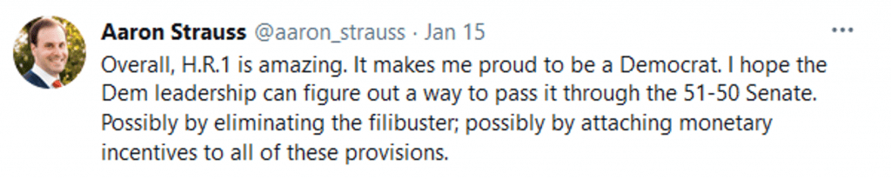
Although Strauss is obviously a committed Democrat, the CCI letter was not partisan on its face. How could a letter urging people to vote for candidates from both parties help Democrats?
Of Microtargeting and Voter Files
The answer appears to be Strauss’s expertise in “microtargeting” and “voter file databases.”
Microtargeting is “a form of targeting that uses recent technological developments to gather large amounts of online data” to “create and convey messages that reflect an individual’s preferences and personality.”
A Pew Research Center article explains voter files “give a nationwide picture of voter registration and election turnout” and usually include “information from outside data sources (such as consumer data vendors, credit bureaus and political organizations).” Data analysts use voter files for predictive modeling, forecasting each potential voter’s “partisanship and expected turnout for future elections.”
According to a CBS News article, voter data analysis is now “so precise that many tools allow campaign managers to target individual voters with powerful and highly customized messages.”
In short, data analysts like Strauss can reasonably predict which individuals are likely to vote in a particular election and for whom they are likely to vote.
Fake Nonpartisanship
Using microtargeting analysis, the CCI almost certainly sent its letter only to likely Republican voters and not to likely Democratic voters. There is no reason an organization incorporated and run by Democrats would urge likely Democratic supporters to vote for the other side in such an important race. And, as noted earlier, the CCI website does not tell everyone to “vote for candidates from both parties this Election Day.” That message was reserved only for the presumed recipients of CCI’s letters: likely Republican voters.
Despite invoking a facially nonpartisan principle (i.e., you should vote for candidates of both parties in the runoff election to show you are not a party voter), the CCI letter was evidently intended to have a partisan purpose and effect. By trying to shame only Republican voters into voting for candidates from both parties, the letter apparently aimed to shift some Republican votes to Democratic candidates. Likely Democratic voters, on the other hand, would not receive the letter and feel no similar pressure to shift any of their votes to Republican candidates. The net effect of the letter would be to decrease Republican and increase Democratic tallies in the runoff election.
The Neighbors Letter
The CCI letter appears to be based on a political science experiment conducted in 2006. Researchers tested the effects of social pressure on voter turnout.
As part of the experiment, voters received a letter informing them their voting records are public information. That letter, now known in academic circles as the Neighbors Letter, revealed both the recipients’ and their neighbors’ voting turnout history. The Neighbors Letter also informed recipients that a follow-up mailing after the upcoming election would report to the neighborhood each recipient’s turnout in the election.
Researchers found the Neighbors Letter was remarkably effective. It increased turnout by an astounding 8.1 percent.
The researchers concluded “the influence of a single piece of direct mail turns out to be formidable when (and only when) social pressure is exerted” and “[e]xposing a person’s voting record to his or her neighbors turns out to be an order of magnitude more effective than conventional pieces of partisan or nonpartisan direct mail.”
Strauss is well acquainted with the Neighbors Letter experiment. Long before becoming CCI’s director, he wrote about the striking effectiveness of the Neighbors Letter in an article on optimizing voter turnout. Examining the 2006 experiment, Strauss concluded the “social pressure of seeing your or your neighbors’ vote records” was “extremely successful” at motivating voters.
The CCI’s Twist on the Neighbors Letter
The researchers’ 2006 Neighbors Letter differed importantly from the CCI letter. Whereas the Neighbors Letters was a nonpartisan effort to pressure people to vote, the CCI letter tried to pressure certain people to change for whom they voted. The CCI letter also falsely implied to recipients that their vote is publicly known and that neighborhoods are “graded” based on how often they vote for candidates from both parties.
Despite these substantive differences, the CCI letter used the same “social pressure” technique that researchers found was so effective in 2006. The CCI letter threatened to disclose recipients’ voting habits publicly to pressure them to change their voting behavior.
The Myth of Democrats’ Fair Fight
Did the CCI letter bully enough Republican voters to shift one of their votes to a Democratic candidate so that Democrats won? The 2006 Neighbors Letter experiment shows it’s possible.
Wasn’t the CCI’s letter a sophisticated form of voter suppression? And so isn’t it a myth Democrats won in Georgia through a “fair fight”?
In the November general election, Republican Perdue received 2,462,617 votes. Suppose each of those Republican voters received the CCI letter in December. The 2006 experiment found the Neighbors Letter affected the behavior of about 8 percent of recipients. So what if 8 percent of those who voted for Perdue in November shifted one of their two votes in the January runoff election to a Democrat? That would be 197,009 votes transferred from Republican to Democratic candidates.
When the two Democrats won on January 5, Warnock beat Loeffler by 93,272 votes, and Ossoff beat Perdue by 54,944 votes. The Democrats’ combined margin of victory was 148,216 votes, equal to a shift of 74,108 votes. That’s well below the 197,009 votes that would have been transferred from Republicans to Democrats in this hypothetical, which would produce a significant margin of 394,018 votes.
Maybe the CCI letter was sent to fewer voters or was less effective than in this hypothetical. But even then given Democrats’ very small margin, it’s not outside the realm of possibility the CCI letter led to Democrats’ victory on January 5.
Irrespective of the letter’s effect, there’s no doubt the CCI letter was disingenuous. It invoked a fake civic duty, provided misinformation, and pressured recipients to vote a certain way by threatening to embarrass them publicly.
And aside from how many votes the CCI letter changed, it likely sowed distrust among a portion of the electorate, including doubt about the legitimacy of the election’s outcome. Of the recipients who resisted the pressure to change their votes, how many still worried their neighbors would fall for the CCI letter? How many felt a pang of paranoia that the election was apparently being manipulated by shadowy figures in the background? The events on January 6 at the Capitol show how dangerous such doubt and paranoia can be.
Nothing about the CCI letter makes our democracy better. Someone should ask Abrams about the Center for Civic Information. What exactly is CCI’s connection to her party and its supporters? Wasn’t CCI’s letter a sophisticated form of voter suppression? And so isn’t it a myth Democrats won in Georgia through a “fair fight”?
What Happened to all My Last Lives?
Why can´t I remember my past lives?
A lot of people refuse to believe in past lives because they say: if I have lived before, why can´t I remember? Let me address this question.
Children that remember past lives
First of all it should be mentioned that a lot of children DO remember their past lives. Professor Ian Stevenson from the University of Virginia, Charlottesville, researched cases of children who remembered past lives as identifiable persons, and during the 50 years of his research he found around 3000 cases of such children. He published his work in the book: “Twenty cases suggestive of reincarnation” in 1966, and after his death in 2007 his work has been continued by Jim Tucker also working at the University of Virginia, Charlottesville.
A common trait in these cases is that the child had died under violent circumstances in its past life. It seems that the memories of those dramatic or traumatizing events surrounding the death of the child in its previous life spill over into its next incarnation and the child wants to share them. At the age of about three (or when s/he has learned to speak) the child begins to talk about its last life and make claims about events that took place in that life. These claims will, of course, be viewed with astonishment and wonder by its present parents, but due to the exact knowledge the child can present about its previous life the parents will usually end up accepting that their child was somebody else´s child in a past life.
The case of Ashok Kumar / Ravi Shankar
I would like to present such a case from my book: Death is an Illusion: “One of the best examples of this is probably the case of Ashok Kumar / Ravi Shankar. Ashok Kumar was the son of Sri Jageshwar Prasad and at the age of six he was brutally murdered by two men who slit his throat with a knife or a razor. A few years after the murder, a boy was born to parents not far away from the town where Ashok Kumar lived. The boy was named Ravi Shankar and when he learned to speak he claimed to be the son of Sri Jageshwar Prasad, although he did not know this man. He could give details of the murder of Ashok Kumar and could even identify the murderers. I quote: “Ravi Shankar’s mother testified that the boy had a linear mark resembling closely the scar of a long knife wound across the neck. She said she first noticed this mark when he was three to four months old. The mark was apparently congenital”.
Not only did Ravi Shankar remember his past life as Ashok Kumar and could identify his murderers, but his body exhibited a scar that fit the way Ashok was murdered. These scars from injuries from one´s last life are not uncommon and Ian Stevenson wrote a book in which he presents such cases. The title is: “Where reincarnation and Biology Intersect.” The cases presented in the book are a very interesting read and they are solid proof of reincarnation.
Who were you when you were big?
Only a few days ago I saw a post on Facebook in which a mother from New York, much to her great consternation, recounted how her son claimed to have been a firefighter and had died in one of the Twin Towers during the 9/11 attack of 2001. The child could recount details of his death that he had no way of knowing had he not experienced them. He told how he had been unable to escape from the building and how he died in the fire.
The memories that the children have will normally begin to fade around the age of six. The child then gets a better ´foothold´ of its new incarnation and begins to concentrate on what its current life has to offer. Most children will have completely forgotten their past life memories when they enter adolescence.
It is my experience that you can ask any three-year-old: “Who were you when you were big?” and you will get an interesting answer. The child will stop, listen and think and will say things like: I was a hunter, I was drowned in the sea, I fought in the war, I was a housewife etc. Most children are happy to be recognized as mature beings with experiences behind them, and not `just´ as children with a ´tabula rasa ´and no past.
Our memories from past lives are stored in our supra-consciousness
However, adults can also access their memories from past lives via hypnosis or trance. It is not as if the memories from past lives have been deleted in each new incarnation, it is just that they are not active, day-conscious memories. Our past-life memories are stored in our supra-consciousness and it is possible to access them. This can be done via hypnosis or trance and this has been proved in thousands of cases of regression therapy.
Regression therapy is a very powerful and efficient therapeutic tool that has helped thousands of patients get rid of life-impeding traumas, both mental and physical, inflicted on them in former lives. An example could be a man who all his life had suffered from a strong pain in this right side. The pain was there every day and prevented the man from living a normal life. He sought help from a regression therapist, who put him ´under´ and asked him to go back to the time when the pain originated. He then saw himself during WW1 being stabbed by a bayonet at the hands of a French soldier. During the regression session, the man relived the pain and suffering of his death from the wound. When he came out of hypnosis, he already felt that the pain in his side had eased and after a few days, the pain had completely gone, never to return again.
Regression therapy is a very powerful way to get rid of past-life traumas and it clearly shows that our memories from past lives can be accessed via hypnosis. The memories are there, only not as active, day-conscious ones.
The majority does not remember
Most of us have no active, day-conscious memories of our past lives, so let us look at why that is: Martinus says that when we reincarnate we are not supposed to remember our past lives because such memories would be confusing and detrimental to our project in our current incarnation.
When we reincarnate we do so with a specific purpose. There are aspects from our past lives that we need to correct and improve, and there are things that we have to learn, or maybe we are on a mission of some kind to teach or empower others. If we are burdened with active memories of past lives, of past mistakes or past sufferings, then we will be confused and we may lose our bearings. Also, because we have a huge number of past lives behind us, which life should we remember? A lot of memories from past lives would not be to our advantage for our present life projects.
All our past lives are with us in the shape of the person we have become
However, Martinus says that it is not the question of active memories that we should be concerned with, because all our past lives are with us in each new incarnation in the shape of the person we have become.
As explained in several of my books, we are all on a journey of evolution from primitive to advanced beings. We have come a long way on this journey whose goal is for us to become real, finished human beings that cannot hurt, harm, maim, or kill, and that can only emanate universal love. However, we are not there yet. We still have some distance to cover as long as we can lie, steal, cheat, hurt, injure, denigrate others, or show intolerance towards them and participate in killing, which we do when we still eat meat.
But life itself will correct these unfinished sides to our personality via our karma and we will all, without exception, reach the goal one day. Everybody will reach that goal, no matter where they stand today on the ladder of evolution.
It is our consciousness / soul / spirit that survives the death of our physical body and for each life we live, we learn a lot of lessons and add to our experience ´bank´. This ´bank´ is stored in our supraconsciousness and it accompanies us from life to life. We can access the contents of this ´bank´ every time we have to make a decision, because we can draw on the lesson learned from our former experiences. If we already have an experience from a similar situation in our ´bank´, then we will immediately know what to do. For each life we live, our ´bank account´ gets fatter and fatter. It does so because we add lessons and learnings and in that way we become wiser and more insightful for each life we live.
The person we are today has been shaped via our experiences and sufferings in former lives. I can also put it like this: we ARE our past lives.
There is no need to remember our past lives, because the person we are today is the essence of all those lives. This is easy to see when we look at the people around us. Some are wise, mature, and ethical. They are always ready to help others, because in their superconsciousness they retain an echo of what it is like to suffer. It is our own sufferings in former lives that make us into compassionate, all-loving humans beings. Such a being has come a long way on its evolutionary journey and the goal of becoming a real, finished human being is within sight.
On the other hand, we also meet people who do not care one jot about other beings. They manifest intolerance and even hatred towards others, they think they have a right to shoot and kill others, if they feel like it, and they will carry guns and threaten others. They think they have a right to kill animals, and they are often racist, prejudiced, and malevolent. They have not come all that far on their evolutionary journey and the goal is still not in sight. But they will also reach the goal one day.
So, whether we remember our past lives or not, those lives are always with us in each new incarnation, and our level of humanitarianism and love for others is the ‘barometer’ on which we can gauge how far we have come.

