Jenny Rae Le Roux
California needs a business person as governor. They need someone who knows where the State is bleeding. They need someone who knows how to get the people breathing and living and working again. They need Jenny Rae Le Roux.
https://JennyRae.CA.com
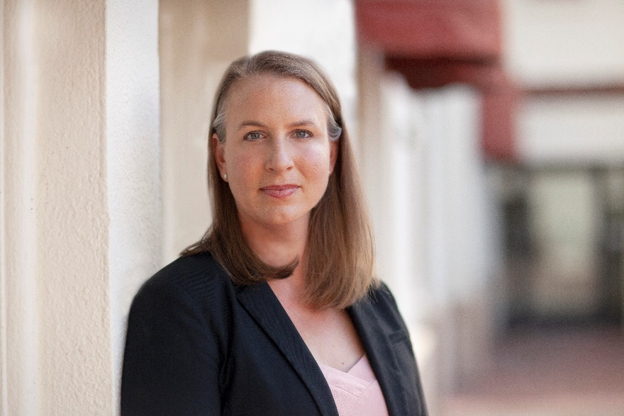
Newsom and the California Legislature failed to pass vital COVID liability protection for businesses, schools, and churches, and as a result many insurance companies have withdrawn related protection. One COVID lawsuit for an uninsured organization poses such risk that groups are resorting to vaccine passports.
If supplemental unemployment benefits are still active when I take office, I will join at least 26 other states and end them immediately. Our small businesses depend on this vital support.
- Liability protection for small businesses m for COVID.

- California’s annual filing fee for an LLC is $300 more than any other state and 16 times the national median. Even New York only charges $9 every other year. For this exorbitant fee, California businesses receive nothing more than other states provide. I will reduce the filing fee to the national median of $50. What about the California Air Resources Board? Required application is charging $75,000 to start a new business in California?

- Newsom signed AB 5 into law in September 2019, forcing many California companies to convert independent contractors into employees even when the contractors preferred their independent status. Any law with this many exceptions doesn’t deserve to be a law. I will undo this burdensome regulation to free businesses and millions of gig economy workers. This destroyed thousands of small businesses in California.

- Private Attorneys General Act is the fatted calf for the establishment. Notices to employers of forthcoming legal action have increased from 11 in 2006 to 4,317 in 2018. An independent review of over 1,000 of these notices between 2016 and 2018 found that at least 75% did not protect the interests of workers.

- PAGA reform is essential and I will work to make it happen. I will protect our businesses from frivolous lawsuits that only aim to line the pockets of private attorneys.
6 According to the California Chamber of Commerce, the Legislature has proposed 319 anti-business bills in the last 10 years. Should the Legislature continue to send anti-business bills to my desk, I will veto them.
It’s time to free California to work again.

15% Absenteeism is About to Get Worse
Nearly three-quarters of unvaccinated Americans would quit their jobs if they were required to take a COVID-19 vaccine, according to a poll by the Washington Post and ABC News.

Only 16% of unvaccinated workers would get a COVID shot if required, 35% would ask for a medical or religious exemption and 42% would quit their job, according to the results reported by the Daily Caller.
But if a medical or religious exemption were not available -- which essentially is the case for Washington state employees, for example -- 72% said they would quit their job.
Just 18%, the poll found, would get the shot.
Meanwhile, a survey of 961 American employers found that 52% will have some sort of vaccine requirement by the end of this year.
In a Fox News poll in August, 44% of Americans said they are more likely to shop at a business that requires employees and customers to be vaccinated or have a recent negative COVID-19 test. Only 24% were less likely.
The Seattle Police Department, which has lost about 300 officers since last year's defund effort, could lose more than 200 more officers over Democratic Mayor Jenny Durkan's COVID vaccine mandate for city employees, reported KTTH talk-host Jason Rantz.
State employees, under Democratic Gov. Jay Inslee's mandate, also face the loss of their job if they don't get vaccinated.

Rantz previously reported there is strong resistance to the governor's mandate, including from State Patrol troopers and teachers.
Rantz obtained an internal poll of the State Patrol Troopers Association conducted Aug. 9-17 that found 295 troopers said they would refuse vaccination at the risk of being fired.
In a more general question, 449 troopers said they disagree with mandatory vaccinations. Only 19 said they supported it.
The association said in an email to members: "Important questions need to be addressed, including what the agency will look like with a 20-35 percent loss of employees? How will the agency deploy resources to the areas that are most impacted?"
In Los Angeles, hundreds of first responders have formed groups to oppose a new city law requiring all public employees to be vaccinated against COVID-19, the Los Angeles Times reported.
A group called Firefighters 4 Freedom said in a statement that its objective "is to stop the mandated vaccinations for all City employees as well as the citizens of this great country. "
"We want to bring education and truth to the people without being censored," the group said.
On its website, the group states it's "not a vaccine versus non-vaccine issue, this is not a left verse right political issued"
This is a human rights issue," the group states. "We hope you stand with us, for we believe all members and citizens have the freedom of choice and natural rights. Your body, your choice. My body, my choice."
Doctors are also challenging the mandates, including with lawsuits.
University of California Irvine School of Medicine psychiatrist and medical ethicist Aaron Kheriaty is suing the university system to recognize his natural immunity from COVID-19 recovery, Just the News reported.
He has the help of six UC medical professors who wrote that the UC system's 90-day medical exemption for recovered faculty is "not supported by scientific data and underestimates the durability of natural immunity," which is far better established than for COVID-19 vaccine-induced immunity.
They cited the many studies worldwide that establish "prior infection with SARS-CoV-2 appears to provide greater than 99% efficacy from reinfection" due to "antibodies to the nucleocapsid and to the spike protein, T-helper cells, B-cells, natural killer cells, and innate immunity."
Faucists Hate Ivermectin. Why?
It's been quite a week. I've been in the media business for decades and I've never before witnessed such lies, exaggeration and outright fraud. All with the intent to force everyone to be vaccinated. The question is why?
Let's start with the vaccine itself. The results in Israel prove what a sham, charade and fraud this all is. The U.S. government and Centers for Disease Control and Prevention argue that the vaccine is our only chance to survive. And that people are hospitalized and dying with COVID-19 because they are unvaccinated.
Both arguments are pure fraud.
First, are you aware that anyone who dies within 14 days of getting vaccinated is considered "unvaccinated"? No wonder they claim everyone who is dying is unvaccinated. If you die from COVID-19, whether you're vaccinated or unvaccinated, they just call you unvaccinated.
If a businessperson in the private sector tried that scam, they'd spend the next 20 years in prison for fraud.
The CDC has also been using stats of COVID-19 deaths going back to January to make the claim that the deaths are almost exclusively among the unvaccinated. That's because earlier in the year almost everyone was unvaccinated. That's called rigging the numbers. The CDC must be using the same Democrats who rigged and stole the 2020 election.
Worst of all, the media have blacked out the developing disaster in Israel. Israel is the most vaccinated country in the world. They all got the Pfizer vaccine. At first, deaths and hospitalizations went to almost zero. Israel declared victory over COVID-19.
But everything changed. Today a massive COVID-19 outbreak has engulfed vaccinated Israel. Hospitals are full. People are dying. At this moment, Israel, the most vaccinated nation in the world, has more COVID-19 infections per capita than any country in the world.
At this moment, 0.2% of the entire population of Israel is catching COVID-19 each day.

This past week was the worst week for COVID-19 in Israel EVER. Israel is setting records for vaccinated people in the hospital. Deaths are skyrocketing.
It's so bad, no-mask, no-lockdown Sweden has just banned travelers from Israel. Many EU countries are following suit.
The vaccine isn't just failing, it's a spectacular fail. It wore off. It no longer works. And just as my holistic doctor friends predicted, it makes the next wave far worse. These doctors say vaccinated people are far more contagious; they carry heavier viral loads and are far more susceptible to getting severe illness than someone with "natural immunity."
This experiment with an "experimental, emergency-use-only" vaccine is a great big failure. A dangerous and deadly failure.
But at this very moment, Biden, the CDC and the U.S. media are pushing the vaccine, vaccine mandates and vaccine passports harder than ever. The question is why?
Why is forcing every American to get vaccinated so important at the exact moment Israel proves the vaccine they're pushing is a dramatic, dangerous and deadly failure?
And it's not just Israel. In the U.K., a majority of the COVID-19 deaths last month were among vaccinated people. And the U.K. death rate from COVID-19 today is dramatically higher than a year ago – when there was no vaccine.
Separate from all that, the VAERS vaccine reporting system reports the vaccine itself is causing tremendous rates of death and crippling injuries. So, vaccinated Americans are dying and becoming severely sick from the vaccine, in addition to dying and becoming severely sick from COVID-19 after getting the vaccine.
And none of this is featured in the news. It's a total media blackout.
Worse yet, the same government, CDC and media are trying desperately to denigrate and slander the drug that is most successful in treating COVID-19. It's called ivermectin. In my next column, I'll show you conclusive proof from around the world that ivermectin is miraculously effective versus COVID-19.
Something is very wrong. It sure seems like someone is scared you might actually recover from COVID-19, doesn't it?
The question is WHY?
The Compromised Virtual Joe
Our political pundits are focusing on Biden's disastrous withdrawal from Afghanistan as a political blunder by the president and our military leaders, but what if the root cause for Biden's withdrawal is much more ominous and sinister than mere stupidity? The following questions demand an answer.
Why would our military commanders willingly give up Bagram, a strategic airport built by the Russians, and why would they willingly leave $85 billion in military hardware behind?
Why would they leave thousands of Americans stranded behind enemy lines while providing the Taliban a "kill list" of those Americans left behind? Unlike previous withdrawals, where it is customary upon withdrawal to first evacuate our citizens, and then destroy the equipment and blow up the bases, we did the opposite. We did not evacuate our citizens. We did not destroy the equipment. And we did not blow up the bases.
We have learned that the Biden administration cut off all communication with the anti-Taliban resistance group, the National Front. Although Ali Nazar, head of foreign relations for the group, has said he "tried to reach out," there has been no response from the Biden administration. Glenn Beck recently reported that his mission to rescue Afghan Christians has been blocked by our State Department and the White House, and he fears that they may be burned alive or crucified by the Taliban.
Are we to believe that our military leadership, led by four-star generals, is so naïve and incompetent? Highly unlikely!
A more likely scenario is that Afghanistan was surrendered at the urging of the Red Chinese, who saw an opportunity to blackmail old Joe for the many kickbacks he and his son, Hunter, had been taking throughout his years in Washington, D.C. It is no secret that the Red Chinese have had their eye on Afghanistan's mineral deposits. Just two weeks before the American surrender, a Chinese delegation met in Kabul with the Taliban. Although the mainstream media have protected and covered for Joe Biden, reports of information contained on Hunter Biden's laptop and emails exchanged between his partner, Tony Bobulinski, and Hunter, are damning proof of illicit wheeling and dealing by the Bidens to provide access to the White House while Joe was vice president.
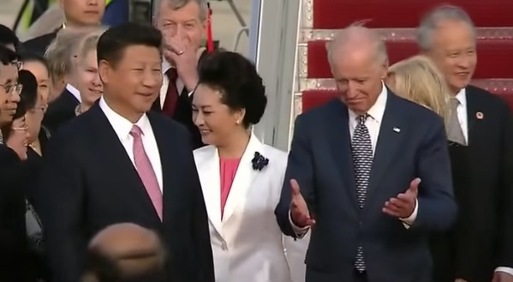
YouTube screen grab (cropped).
In a May 2017 email exchange between Hunter Biden and his former business partner, Tony Bobulinski, the two discussed how to cut Joe Biden in on a multi-million-dollar deal with a Communist Party billionaire. In the email, Joe Biden was referred to as "The Big Guy." That email exchange was one of thousands of messages found on Hunter Biden's laptop that he left behind in a repair shop in Wilmington, Delaware in April of 2019. The repair shop–owner turned over the laptop to the FBI, but in a telling sign of the FBI's lack of fidelity to our country, it failed to investigate what was clearly a sign of selling access.
As far back as 2013, Hunter Biden's equity firm scored a $1.5-billion deal with the Bank of China only days after his father paid an official visit to the country. The deal was made at a time when the Red Chinese declared their sovereignty over the South China Sea. Our allies in the region were rightfully upset and voiced their disapproval; thus, it was in that context that Vice President Joe Biden was sent to China to confront the Chinese about their controversial move. He flew to China on Air Force Two along with his son, Hunter, and his granddaughter. However, Joe Biden failed to challenge the Chinese. Instead, he went soft, and, not surprisingly, his son returned to the United States with a $1.5-billion deal.
Surrendering to a terrorist organization, leaving Americans behind enemy lines, providing the terrorists with $85 billion in military aid which they will in return use against us, and blocking the evacuation of Americans are indicative of an administration acting as a proxy for those who seek our demise. Already, there has been a transfer of our left-behind arms to Iran and Pakistan, while secretary of state Antony Blinken has announced our intention to recognize the Taliban as a legitimate government should they renounce terror. Blinken should not need to be reminded that the Taliban is a terror organization, and to drive that point home, they wasted no time in releasing the ISIS and al-Qaeda terrorists held as prisoners while we were there.
Investigative journalist Lara Logan recently stated that instead of holding the terrorists accountable, we are deferring to them on the 20th anniversary of 9/11, the deadliest terrorist attack upon our country. Negotiating with a terrorist organization is forbidden under U.S. law, but with a corrupt DOJ and a spineless Congress, it appears there is no one we can rely upon but ourselves to conduct a proper investigation into the treasonous acts committed by Joe Biden and his band of cohorts.
Is China, by way of a domestic proxy, now dictating American foreign policy? If so, where do we go from here?
Indian Bar Association Sues the WHO
It is bad enough when a lawyer sues you. It is epic when a national bar association sues you. The Indian Bar Association (IBA) sued WHO Chief Scientist Dr. Soumya Swaminathan on May 25, accusing her in a 71-point brief of causing the deaths of Indian citizens by misleading them about Ivermectin.
Point 56 of the lawsuit states, “That your misleading tweet on May 10, 2021, against the use of Ivermectin had the effect of the State of Tamil Nadu withdrawing Ivermectin from the protocol on May 11, 2021, just a day after the Tamil Nadu government had indicated the same for the treatment of COVID-19 patients.”
Advocate Dipali Ojha, lead attorney for the Indian Bar Association, threatened criminal prosecution against Dr. Swaminathan “for each death” caused by her acts of commission and omission. The brief accused Swaminathan of misconduct by using her position as a health authority to further the agenda of special interests to maintain an EUA for the lucrative vaccine industry.
Specific charges included the running of a disinformation campaign against Ivermectin and issuing statements in social and mainstream media to wrongfully influence the public against the use of Ivermectin despite the existence of large amounts of clinical data showing its profound effectiveness in both prevention and treatment of COVID-19.
In particular, the Indian Bar brief referenced the peer-reviewed publications and evidence compiled by the ten-member Front Line COVID-19 Critical Care Alliance (FLCCC) group and the 65-member British Ivermectin Recommendation Development (BIRD) panel headed by WHO consultant and meta-analysis expert Dr. Tess Lawrie.
The brief cited US Attorney Ralph C. Lorigo’s hospital cases in New York where court orders were required for dying COVID patients to receive the Ivermectin. In multiple instances of such comatose patients, following the court-ordered Ivermectin, every single patient recovered.
Advocate Ojha accused the WHO and Dr. Swaminathan in Points 60 and 61 as having misled and misguided the Indian people throughout the pandemic from mask wear to exonerating China as to the virus's origins.
“The world is gradually waking up to your absurd, arbitrary and fallacious approach in presenting concocted facts as ‘scientific approach.’ While the WHO flaunts itself like a ‘know it all,’ it is akin to the vain Emperor in new clothes while the entire world has realized by now, the Emperor has no clothes at all.”
The brief accused the WHO of being complicit in a vast disinformation campaign. Point 61 states, “The FLCCC and the BIRD have shown exemplary courage in building a formidable force to tackle the challenge of disinformation, resistance, and rebuke from pharma lobbies and powerful health interests like WHO, NIH, CDC, and regulators like the US FDA.”
Dr. Swaminathan was called out for her malfeasance in discrediting Ivermectin to preserve the EUA for the vaccine and pharmaceutical industry. Point 52 reads, “It seems you have deliberately opted for deaths of people to achieve your ulterior goals, and this is sufficient grounds for criminal prosecution against you.”
The Indian Bar Association posted an update on their website June 5, 2021, noting that Dr. Swaminathan had deleted her now-infamous tweet. They wrote, "However, deleting the tweet will not save Dr. Soumya Swaminathan and her associates from the criminal prosecution which is to be launched by the citizens with active support from the Indian Bar Association."
When You Lose Wars
One of the first signs is losing wars together with excessive debts, deficits, devaluations and decadence The US being defeated and hurriedly fleeing from Afghanistan in a few days clearly signifies the end of the US empire.
The mighty US military has in the last few decades conducted disastrous wars against very small countries with no big armies or weaponry. Vietnam, Iraq, Libya and Afghanistan come to mind but there are many more as we show below.
Brown’s University has just made a study of the US cost of wars since 9/11. They arrive at a staggering $8 trillion and the loss of 900,000 lives .
So in the last 20 years, the US has spent $8 trillion or 40% of annual GDP on fighting battles. Nothing they have done has been with the intention of winning a war. By the way, winning is when the enemy surrenders or is completely vanquished. The report also states that even after the exodus from Afghanistan the US is still fighting battles in over 80 countries.

US CURRENT WAR ACTIVITY
The cost of being involved in some kind of war activity in 85 countries will continue to cost the dying US empire dearly for decades to come. Unless there is victory, there is no return on this investment, except for the manufacturers of weapons, and their lobbyists, and of course the politicians who are paid to continue the fighting to use up the weapons that are being manufactured. Human life is absolutely meaningless to these people. It is all about the power and the money.

1984 IS HERE AGAIN
The 2020s have fulfilled Orwell’s 1984 with Big Brother watching us everywhere. Oh, sure Snowden informed us about Prism and the NSA spying on everyone, but did that really help or hurt the bad guys? Has it gotten any better or worse since then? Do you even care? Since you have nothing to hide, you probably think it’s okay. You think it’s fine that computers now score your threat level to the Global Syndicate. You are not doing anything now, but would you do something if Trump told you to? Would you fight back with weapons against a Communist effort to seize all the guns in America? Would you stop paying your taxes, if the movement called for it? Would you resist accepting endless DNA-altering booster shots specially designed for your demographic?
Oh, you didn’t know that? You think there is just one version of the jab? Do you think the experimentation is with only one formula or in one geographic location? Do you actually think you’re getting the same jab as Trump, or Biden, or Klaus Schwab? Why do you think only 3% of the American black community is jabbed?
Do you think the viral weapons maker are working overtime right now to find a cure, or to find a better weapon that will take out Americans so they can walk in and start living in your home with you in the ground, without firing a shot or shedding a tear?
The Made-4-TV virus has been a superb excuse for controlling the people in more than 184 countries. Free speech has been banned in the media and unacceptable censorship is now the rule on social media whether it relates to vaccines, climate or race. Don’t you wonder why France had over a million people in the streets yesterday, telling government they refuse to get the vaccine passport? Americans are different. We go quiet. Like when a woman gets slapped. They go quiet. And then you go to sleep.
“Don’t you see that the whole aim of Newspeak is to narrow the range of thought? In the end we shall make thoughtcrime literally impossible, because there will be no words in which to express it.”
― George Orwell, 1984
That’s the whole purpose of the algorithms. They aren’t waiting for the words to be spoken. They will be able to predicts the words by your previous actions. They will suppose, just from what they believe are your thoughts. But it gets worse as we are seeing severe clampdowns on free movement. There are lockdowns, quarantines, restrictions or bans on travel both domestically and internationally, ban on shopping, restaurants, theatres, cinemas, stadiums with offices and schools closed. And then we are not allowed to see friends, parents, or even go to work. I have plane tickets bought, and I check every day to see if there are any more restrictions on my movement. You know what I have noticed? People don’t say a damned word in the security lines. They strip down and let strangers unreasonably search their luggage and their clothing without their consent, and they never say a word about it. The list of restrictions is endless and they seem to be deliberately and regularly turned on and off in order to keep the people off balance. Like a moody manager, we keep our mouths closed until we know it’s okay to speak, or to smile.
“Doublethink means the power of holding two contradictory beliefs in one’s mind simultaneously, and accepting both of them.”
― George Orwell, 1984
There have been great variations of these restrictions. Countries like Australia and New Zealand have locked people in. Then we have, for example, Sweden or South Dakota on the other hand which has had virtually no restrictions, and no closure of schools, shops or offices. No masks have ever been mandated.
The Chief Epidemiologist Tegnell in Sweden has conducted a non-intervention policy, telling the people to take their own precautions. He doesn’t consider that masks fulfil any purpose either but rather that they have a negative effect. Quite a contrast to Australia. When it comes to infections and deaths, Sweden has fared better than many countries. People in Australia are reaching out to me for Ivermectin. I may be their only source. If you’re on the run, let me know down there. I may be able to help.
One of the most tragic things I have ever heard in my long and varied life is the suppression of this one proven cure. History will convict these leaders who follow the Global Syndicate. What leader wants their own people to die? How can they sleep at night, knowing that $10 worth of drugs could save a life, and they held it back? This despite major parts of India and Central Africa having used Ivermectin with almost 100% success and virtually eliminated Covid. Hundreds of hospital doctors in the US have also used Ivermectin with great results. Some talk about it. Most are in fear for their licenses as Syndicate officials can end their careers with a red stamp in one second, if they misbehave.
I show a map with the blue area of Africa where Ivermectin has been successfully used. The blue line at the bottom shows deaths per 100,000 in that region. A massive difference to the deaths (yellow line) in the yellow areas.
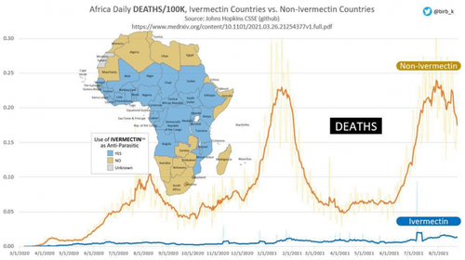
We are talking hundreds of millions of lives that have already been saved. Ivermectin was invented 50 years ago against parasite infestations. Over 4.5 billion doses have been given and the creator received the Nobel prize. Still the Global Syndicate’s agencies like the FDA, WHO, Big Pharma and Western governments refuse to acknowledge the success of Ivermectin against Covid. It is too cheap to produce and compete with the vaccines. It saves lives, which is not the intention of the strange recipe of chemicals they are calling a vaccine.

HISTORY REWRITTEN
In the US and the UK history is now being rewritten especially at university campuses. Statues, paintings and books related to slavery are being taken down even if the historical person was a major benefactor to the university in question.
“Every record has been destroyed or falsified, every book rewritten, every picture has been repainted, every statue and street building has been renamed, every date has been altered. And the process is continuing day by day and minute by minute. History has stopped. Nothing exists except an endless present in which the Party is always right.”
― George Orwell, 1984
The problem with rewriting history is where do you stop? Throughout history there have been wars and invasions which were all unjust. But we can’t reverse history. Just take America as an example. Both North and South America have been invaded and taken over by European countries in the last few hundred years, whether they were English, French, Spanish or Portuguese.
In North America a major part of the previous population was killed and the rest moved to reservations. Even that history was rewritten, because you don’t even know what happened to the people who were here before the Indians wiped them out and began wandering the land for hundreds of years as warring tribes. If we rewrite history the Europeans must obviously pull out and give the land back to the Indians. Of course, the Indians killed everyone before them, so they cannot give back the land they took by genocide.
Hardly practical! Elections have consequences. So does victory.
“The Ministry of Peace concerns itself with war, the Ministry of Truth with lies, the Ministry of Love with torture and the Ministry of Plenty with starvation. These contradictions are not accidental, nor do they result from ordinary hypocrisy: they are deliberate exercises in doublethink”
― George Orwell, 1984

RICH LAND POOR LAND AND DESTITUTE LAND
Rich Land – Poor Land – Destitute Land is the natural cycle of most countries and empires.
As a country goes from rich to poor, it finds it hard to accept that it is in a permanent decline.
For some countries like Venezuela that can’t borrow money externally, the process from abundance to destitution was very quick and for others like the Roman Empire it took centuries.
For more powerful countries, running out of money is no problem. Since deficits are only believed to be temporary, they can easily be financed by debt. And this is exactly what happened to the US empire in the early 1960s. There was gradually less money in the till than the country spent, so it started borrowing.
For 60 years the US has increased the Federal debt every year with the exception of 4 years. So the US is now living on not just borrowed money but also borrowed time.
Excessive debt has throughout history killed empires and the already-dying US empire will be no exception.
It took 200 years for the US to reach just under $1 trillion. Reagan managed to treble that debt in just 8 years. Obama inherited a $10t debt from Bush and doubled it to $20t in 8 years.
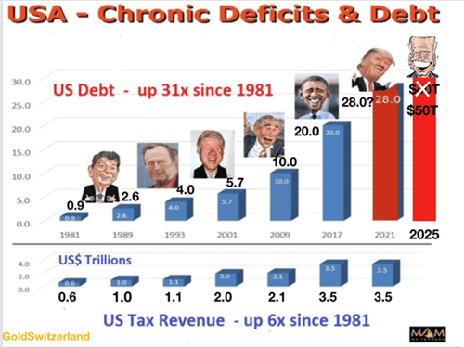
The national debt was pretty stable until Obama became president. That was the first time the Global Syndicate had won everything in Washington. Trump was an anomaly. By 2018, the Syndicate had a business model that was unstoppable, no matter how many Americans voted. Virtual Joe and his gang of criminals are just a fuller, less charismatic version of Obama. Same speech writers. Same agenda. Same ruthless disregard for human life.
In 2025 US debt will be 50x higher than when Reagan took over and 100x higher since the gold window was closed in Aug 1971. 100 times.
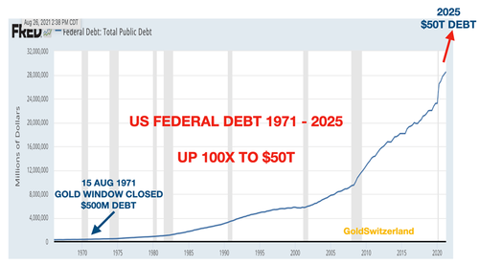
So we are now in the exponential phase of the debt explosion. Exponential moves are almost without exception terminal. Exponential. If you square something every five years, the number expands and increases its rate of expansion. 5 times 5 is 25. What is 25 times 25? 625. You don’t even want to know what 625 squared is.
There is a more scientific illustration how these exponential moves occur and also how they end.
Imagine a football stadium which is filled with water. Every minute one drop is added. The number of drops doubles every minute. Thus it goes from 1 to 2, 4, 8 16 etc. So how long would it take to fill the entire stadium? One day, one month or a year? No it would be a lot quicker and only take 50 minutes! That in itself is hard to understand but even more interestingly, how full is the stadium after 45 minutes? Most people would guess 75-90%. Totally wrong. After 45 minutes the stadium is only 7% full! In the final 5 minutes the stadium goes from 7% full to 100% full.
It is of course impossible to predict where we are in this debt explosion. If we are in the final 5 minutes then debt can still increase almost 15x. And if we get hyperinflation which is very likely, the increase could be substantially higher.
As debt will have grown 50x since 1981 by 2025, tax revenues will probably stay at a measly $3.5t as the economy slows down or even collapses. The consequences are obvious. When the interest rates rise, which is guaranteed as the Fed loses control, the US empire can’t even afford to pay the interest and will default.
This is how all empires end, they lose not only wars but also total control of money.
What a bloody mess!
The only problem is that once fortunes have turned, there is a very, very long way back to prosperity. This is what history and the laws of nature teach us although most political leaders are too arrogant to learn from history.

THE RICH GETTING RICHER
As empires reach the end game, money printing and debt accelerates as I show above. This leads to a total debasement of the currency. For example the Roman silver coin, the Denarius, lost almost 100% of its silver content between 180 and 280 AD.
The US dollar of the dying US empire has not fared much better and has lost 98% in real terms since 1971. As the currency collapses more and more fake money must be produced to keep the illusion going. By definition, money which is created without any service or goods offered in return is always fake and has zero real value.
During times of rapid credit expansion with fake money, the ones standing nearest the printing press always benefit greatly since they have access to the money before it totally loses its value. This happened for example during the hyperinflation in Zimbabwe or in Venezuela and it is now happening in the US.
Wealthy Americans are getting the money first and rapidly increasing their wealth in relation to GDP. How does this happen? Simple. What the Global Syndicate has done is sterilized the economy of business startups. Existing businesses, which are the life blood of millionaires, can access capital, and startups cannot. Wage earners have no hope of ever becoming millionaires. If you think your 401k will make you a millionaire, you are in for a rude awakening.
The rich get richer? Yeah. During the shutdown, millionaires increased by 30%. Did you? No. You were blocked, while the rest of the runners got to lap you a few times. From salon owners to restaurants to theaters to arenas to non-essential businesses, they were all forced to close by SWAT.

CONSEQUENCES – PRECIOUS METALS & STOCKS
As debts, deficits and currency debasement accelerate, the consequences are crystal clear and inevitable.
The epic bubble in stocks is coming to an end and could implode at any time. Don’t believe me? How many of you have crypto currencies in secret wallet somewhere? What’s it worth right now? Dog dirt, that’s what. My stock portfolio is down at least 43% across the board. Whether it expands further due to the massive expansion in money supply is irrelevant. Neither a company nor a country can show real growth based on fake money. When the bubble bursts, the world will learn that it consisted mainly of air that will just evaporate. Your money is so far up the horse’s ass you will never see it again.
As the markets implode, so will all the debt and the bubble assets such as stocks, bonds and property. These asset values were all illusory, based on hope and fake money. Once the markets start breaking down, we will see the same process as the stadium above filling up with water. But this time it will be in reverse and values will decline by unthinkable percentages in the “first 5 minutes”. Remember that in the last 5 minutes, the stadium went from 7% full to 100% full.
For our investors and ourselves, we have owned physical gold and some physical silver in Switzerland (obviously outside the financial system) since 2002 when gold was $300 and silver $4.
We were convinced then that the risks we saw necessitated a high percentage of one’s financial assets in gold for wealth preservation purposes. What has happened since completely confirms our position.
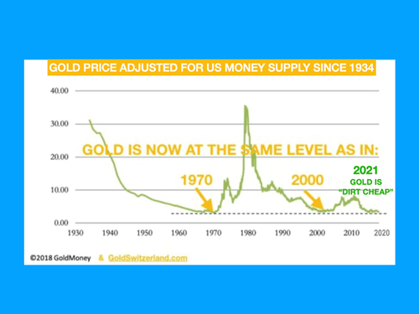
But the world has still not understood how undervalued gold is in relation to the massive expansion of money supply. Therefore I will continue to show the graph below which tells us that gold is as cheap to buy today as it was in 1971 when gold was $35 or in 2000 when gold
was $288. In the face of the dying US empire, there is no better asset to own.
The CCP’s Worst Enemy
For U.S. imperial strategists, the notorious Afghan graveyard of empires is not an entirely deadbeat loss. As President Biden noted gleefully and cryptically this week, “China has real problems… it will be interesting to see what happens.”
The United States may have suffered a shameful, historic defeat in Afghanistan, but there is still a silver lining in this cloud for the imperial planners in Washington.
The destruction, anarchy and trillions of dollars wasted in prosecuting a 20-year war can deliver a consolation prize for the United States. Namely, by making Afghanistan a cauldron of destabilization for China, as well as Russia, Iran and the Central Asia region.
When President Joe Biden was asked this week by reporters about the future relations between Afghanistan’s Taliban rulers and China, he sounded remarkably relishing.
“China has a real problem with the Taliban,” said Biden. And not only China, he added, but also Russia, Iran and Pakistan.
“They’re all trying to figure out what do they do now. So it will be interesting to see what happens.”
The American gloating here is sickening. Washington dumped trillions into Afghanistan, largely to wipe out the Taliban’s enemies and to build massive poppy farms to feed the heroin industry. The Taliban is the largest drug cartel in global history. But all that money has made them powerful and lazy and ruthless.
What should be done, to tell you the truth, is an international tribunal for war crimes should be established to investigate and prosecute U.S. political and military leaders who see Americans as mules to pull their golden wagons up the hill. They should pay the price for ransacking Central Asia.
Yet in spite of this hideous, glaring legacy, here we have Virtual Joe and his gang or criminals enjoying the prospect that the smoldering remains of Afghanistan bequeathed by the Americans to the Taliban, along with $85 billion in modern weaponry, will cause future problems for perceived geopolitical rivals – in particular China. Afghanistan is like a pregnant Trojan horse, that was just trotted into Bejing.
Beijing, Moscow and Tehran have been cautiously reaching out to the Taliban since they took back control of Afghanistan on August 15 after the U.S.-backed regime in Kabul collapsed. Actually, they have been speaking for many years, even though Moscow for one still officially designates the Taliban as a terrorist organization. Putin hates what heroin does to his country. The Establishment Party in the US loves it. They make bets how many people will die in Chicago or New Orleans every weekend over it. They close their eyes and masturbated over the opioid deaths every day. Every lowlife, do nothing, extra American that died made it that much easier for them to breathe.
The interim government unveiled this week by the Taliban has raised concerns that the new administration in Kabul is dominated by the old guard of the militant group which ruled prior to the U.S. invasion in 2001. That, in turn, raises questions about the Taliban leadership’s avowed commitments to prevent Afghanistan from becoming a hub for terrorism and narcotics which of course would present major security challenges for regional neighbors. That is the biggest joke in history. On you.
China has urged the Taliban to cut ties with terror networks belonging to Al Qaeda and the Turkestan Islamic Movement. The latter is an umbrella for Uighur jihadists who have been waging a years-long terror campaign in China’s Xinjiang western province which shares a border with Afghanistan. Uighur separatists have found safe haven in Afghanistan with the Taliban’s consent. Potentially, therefore, Afghanistan could pose increased security headaches for Beijing. Oh, you ain’t seen thing yet. They’re pissed, and now they have stealth drones.
To this end, China has been diplomatically engaging with the Taliban and promising massive capital investment in Afghanistan for postwar reconstruction. From Beijing’s point of view, this is not just about buying security guarantees. Afghanistan stands to become a key link in China’s Belt and Road Initiative coupling Eurasian economic development. Be careful what you hook to your belt, China. It could explode.
For the Taliban, partnering with China and other regional powers makes sense too. They get the vital international recognition they require for underpinning governance. And they get badly needed funds for reconstruction. This is made all the more urgent because Washington and its Western allies have been reluctant to engage with the new rulers of Afghanistan. The U.S. has frozen foreign assets of the country since the Taliban swept to power.
So, it would seem to be very much in the interests of the Taliban to comply with the concerns of China and other regional states to stabilize the country and prevent it from descending into a conduit for terrorism.
Moreover, Beijing is also confronted with other terrorist dangers lurking in Afghanistan which threaten to harass China’s ambitious economic plans. Welcome to terrorist hell.
Chinese diplomats and workers in Pakistan’s southwest Baluchistan province are already being killed one by one. The attacks have been reportedly carried out by the Baluchistan Liberation Army and another outfit called the Tehrik-e-Taliban Pakistan. How many more do you think there are? These groups are motivated to disrupt the China-Pakistan Economic Corridor that stretches to the port of Gwadar in southern Pakistan that links to the oil-rich Persian Gulf, as well as the wider Arabian Sea and the Indian Ocean. That corridor is another key link in China’s transcontinental economic expansion. And they have an endless supply of money, thanks to the American drug trade.
The Baluchi militants are based in Afghanistan’s Kandahar city – a Taliban stronghold – and have, at least in the past, been supported by the Taliban. There are no suggestions that recent attacks on Chinese personnel and business interests have been abetted by the Taliban. But it is no doubt an acute concern for Beijing that the Taliban will be able to rein in militants that operate from their territory.
Hence, China and the Taliban rulers have a precarious balancing act ahead of them. China, like Russia, Iran and other regional stakeholders, needs a stable political environment for realizing economic ambitions. The Taliban need that stability too if their nation is to rise from the ashes of America’s “longest war”. And they don’t want to antagonize internal strife by combating militant groups. What was Russia’s bane, and then America’s twenty year 9/11, will now become China’s festering boil.
But if Washington and its dutiful European allies decide to make Taliban governance troublesome by engendering adversarial international relations and obstacles then Afghanistan could, in consequence, pose serious security disruption for China as well as Russia, Iran and others. The Taliban may not be able to guarantee security, even if they wanted.
Arguably, a motive for Washington going into Afghanistan two decades ago was not the supposed revenge for the dubious 9/11 terror incidents, but rather to assert geopolitical control over China and Russia’s backyard. Militarily, the U.S. occupation of Afghanistan turned out to be a disastrous failure and at a ruinous cost for future American generations.
But for U.S. imperial strategists, the notorious Afghan graveyard of empires is not an entirely deadbeat loss. As President Biden noted gleefully and cryptically this week, “China has real problems… it will be interesting to see what happens.”
Plan A didn’t work out so well for Washington. Time for Plan B.
Mars Habitat May Have Been Located
Mars is bombarded with radiation. Without a protective magnetic shield and a thick atmosphere like Earth's, radiation from space has a nearly unimpeded path to the Martian surface. Our machines can roam around on the surface and face all that radiation with impunity.
But not humans. For humans, all that radiation is a deadly hazard.
How can any potential human explorers cope with that? Well, they'll need shelter. And they'll either have to bring it along with them or build it there somehow.
Or maybe not. Maybe they could use natural features as part of their protection.
A new study using data from Mars Science Laboratory (MSL) Curiosity has uncovered how Mars' natural landscape features can provide some shelter from radiation. Specifically, it shows how Martian buttes provide protection from high-energy particles from space.
The study is titled "Directionality of the Martian Surface Radiation and Derivation of the Upward Albedo Radiation" and it's published in Geophysical Research Letters. The lead author is Guo Jingnan from the University of Science and Technology of China.
When MSL Curiosity landed on the surface of Mars in 2012, it carried in its payload an instrument called the Radiation Assessment Detector (RAD).
RAD is about preparing for future human visits to Mars. It detects and measures harmful radiation on Mars that comes from the Sun and other sources. It can also assess the hazard that radiation poses to any microbial life that may be extant on Mars. RAD is about the size of a toaster and sits unobtrusively on Curiosity's top surface.
One of the areas MSL studied with RAD is the Murray Buttes region. The Murray Buttes region is on lower Mt. Sharp in Gale Crater. Curiosity was there primarily to study geology, especially the sandstone features and a type of layering called "cross-bedding".
But while there, RAD kept gathering data. And that data showed a drop in surface radiation.
MSL Curiosity spent 13 sols parked near a butte in the Murray Buttes area. It primarily conducted surface science and drilling operations while there. But RAD was also active, giving scientists a 13-day reading of radiation data in one location.
The RAD data showed that while near the butte, there was a reduction in radiation dose of about 5 percent. The research team also constructed a sky visibility map, showing that 19 percent of the sky was obscured when the rover was next to the butte.
This isn't a scientific slam-dunk when it comes to protecting future human explorers from radiation, but it's important data.
There's more nuance to the data. While driving through the Murray Buttes area, Curiosity didn't have an unobstructed view of the sky due to terrain features. So the team constructed the panoramic view of the sky from averages taken over several previous months to compare with the data gathered during the 13-sol parking.
There's some approximations in those averages, but they'll have to do.
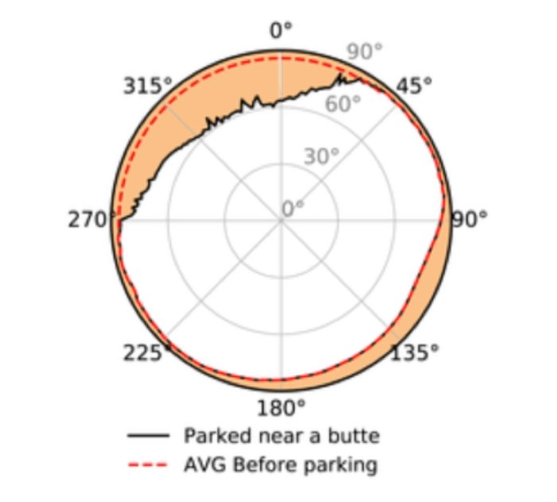A sky map to illustrate the effect of the butte on radiation exposure. (Jingnan et al., GRL, 2021)
The dotted red line in the image above represents those approximations and averages.
RAD found something else, too. Radiation striking things, or people, on the surface of Mars originates from space. And most of the radiation striking a person or a piece of equipment comes directly from the sky.
But some of the radiation is albedo radiation, meaning it's reflected off of the surface, striking objects from below. What did RAD find out about that?
It turns out that the same surface features that can offer protection from direct radiation can also increase reflected radiation. RAD showed that buttes can create an increase in this secondary, reflected radiation. That's one of the complexities in understanding radiation on Mars.
The radiation dose on the surface of Mars isn't consistent, but fluctuates. Heliospheric changes can affect it, as can the angle of sky that any explorers may be exposed to. A steeper angle means that radiation has to travel through more atmosphere, which changes the surface exposure.
Mars' orbit changes its distance to the Sun, which also affects surface radiation. Lower altitudes will be exposed to less radiation than higher altitudes. And radiation isn't a homogenous phenomenon: there are protons, alpha particles, ions of various elements, neutrons, and gamma rays.
Overall the study helps paint a more complete picture of the Martian radiation environment. There's been lots of thought put into in-situ resource utilization on Mars. Shelter is a primary need for explorers on Mars, and if an advantage can be gained by using existing terrain features for protection, then those features will fit in a mission profile somewhere.
There's already lots of talk about placing bases in lava tubes, where people would be protected by meters of Martian regolith. But astronauts can't spend all their time there. They'll have to venture out into the radiation.
Any mission to Mars involving humans will need layers and layers of contingencies. In the event of an emergency of some sort, it'll be vital to keep astronauts' radiation doses as low as possible.
In fact, the entire mission will be planned to keep annual exposure within limits. It's not too difficult to imagine planetary explorers making use of whatever radiation shelter they can as they try to contend with an equipment breakdown or other mishap.
Detailed radiation maps that take into account sky exposure and terrain and anything else could save lives.
Time for the Biden Administration to End
“If these governors will not help us beat the pandemic, I will use my power as President to get them out of the way.”
When I heard that I rolled down my window on the Interstate and screamed out the window. I was not the only American who was mad as hell.
The reaction from state Governors made clear, a major line in the sand had been crossed, and Civil War was now, officially, brewing.
Governor Henry McMaster of South Carolina responded to Biden's threat with these exact words:
“The American Dream has turned into a nightmare under President Biden and the radical Democrats. They have declared war against capitalism, thumbed their noses at the Constitution, and empowered our enemies abroad. Rest assured, we will fight them to the gates of hell to protect the liberty and livelihood of every South Carolinian."
Governor Greg Abbott of Texas responded:
"Biden’s vaccine mandate is an assault on private businesses. I issued an Executive Order protecting Texans’ right to choose whether they get the COVID vaccine & added it to the special session agenda. Texas is already working to halt this power grab.”
Governor Parsons of Missouri responded:
"The Biden Administration’s recent announcement seeking to dictate personal freedom and private business decisions is an insult to our American principles of individual liberty and free enterprise. This heavy-handed action by the federal government is unwelcome in our state and has potentially dangerous consequences for working families. Vaccination protects us from serious illness, but the decision to get vaccinated is a private health care decision that should remain as such. My administration will always fight back against federal power grabs and government overreach that threatens to limit our freedoms."
The utterly shocking remark by Biden caused many Americans to recoil in horror and ask themselves how he intended to do that, since it was States which created the federal Government, and not the other way around.
Americans need to remember what the Founding Fathers wrote about this very thing happening. They know it would happen. It always happens when government is no longer afraid if the people.
Let’s read The fourteenth Amendment, Sections 3 and 4.
Amendment 14, Section 3:
No person shall be a Senator or Representative in Congress, or elector of President and Vice President, or hold any office, civil or military, under the United States, or under any State, who, having previously taken an oath, as a member of Congress, or as an officer of the United States, or as a member of any State legislature, or as an executive or judicial officer of any State, to support the Constitution of the United States, shall have engaged in insurrection or rebellion against the same, or given aid or comfort to the enemies thereof. But Congress may by a vote of two-thirds of each House, remove such disability.
Amendment 14, Section 4:
The validity of the public debt of the United States, authorized by law, including debts incurred for payment of pensions and bounties for services in suppressing insurrection or rebellion, shall not be questioned. But neither the United States nor any State shall assume or pay any debt or obligation incurred in aid of insurrection or rebellion against the United States, or any claim for the loss or emancipation of any slave; but all such debts, obligations and claims shall be held illegal and void.
It seems as though Biden intends to declare Governors who oppose him to be "in insurrection" and send either federal agents or federal troops to remove that Governor from office pursuant the Section 3, and/or to withhold all federal money to such states under Section 4 above, claiming the state itself is "in insurrection" by failing to obey Biden's vax and mask mandates!
Get that? Does anyone think that 27 States can be held in insurrection and thus held hostage financially or invaded by Federal forces like in 1862, just be cause they won’t force vaccinate their people? Do you see how serious this is? Forget about the war. Think about the chemical enslavement of 90 million American adults—don’t get me started on the kids—who are immune from the Made-4-TV virus. How important is it that these people get the jab before the long-term side effects are known? Who is really trying to conquer this land by waiting for its people to die?
Don’t think for one moment that USSS, FBI, and DHS task forces are set up at this very moment to monitor “violent revolt speech” online! This broadcast is meant for you, but they are listening. They were briefed on the speech ahead of time. They knew Biden was going full-tilt-tyranny, and they began monitoring online speech looking for "violent revolt speech" because that is what they now expect.
Do they care even one bit that 17 governors have already announced their attorneys are standing by? No. Do they even flinch at the threats by governors to come and take it? Nope. It is not governors they are afraid of. It’s you.
You know, in our founding documents, the Declaration of Independence in particular, the Founding Fathers laid out the following truism:
“But when a long train of abuses and usurpations, pursuing invariably the same Object evinces a design to reduce them under absolute Despotism, it is their right, it is their duty, to throw off such Government, and to provide new Guards for their future security.”
Are we not precisely at that point right now? Are we not finding ourselves forbidden to go out to certain public places unless we take the experimental, deadly, and damaging "jab?" Are we not finding ourselves under threat of losing our jobs unless we submit to the poison death dart they masquerade as a "vaccine?" Are we not being told we may be forbidden to travel by plane, bus, train, or perhaps even across state lines unless we do as THEY say? Is this all not "absolute Despotism?"
Doesn't our own Declaration of Independence tell us what is to be done under such circumstances? Doesn't it say ". . . it is their right, it is their duty, to throw off such Government, and to provide new Guards for their future security?”
So, what will we do? Stop complying? Get fired than take the jab? Fly out of here? Leave the military?
That is precisely what the CCP wants you to do. They want America to die. They want Americans to die. They can’t shoot down our planes, so they shot down our pilots. They cannot beat the armed American, so they make us fight one another.
Now is not the time to abandon our government or our country. Now is the time for us to fix our government and to unite as one people tomorrow morning and service justice. War is justice denied. Do not deny justice. Do not delay justice. Serve justice. Don’t quit. Don’t protest. Don’t vote. Don’t’ post.
Work harder. Take control of your space and make it sovereign. Don’t miss a minute of work, but do not follow illegal orders. Remove the military from the control of Virtual Joe and his gang of criminals. Fly those F-22’s better and faster than they have ever been flown. Don’t take the jab and don’t bomb Americans. Make that plane your own and fight for freedom and liberty against all enemies.

