The True Source of Water
70% of Earth is Water. At least 70% of every human being is water. Nothing on Earth can live without water. The origin of water on Earth, therefore, is the origin of life in the Solar System (and the Universe) as we know it.
Figuring out where and how our world obtained its water might be key to finding life on other worlds, but the truth is we don't know for sure where it came from.
Nonetheless, it's commonly accepted that one potential mechanism for water delivery was bombardment from water-bearing asteroids and comets when Earth as we know it today was much younger.
But a new analysis of rocks collected from the Moon and brought to Earth during the Apollo era suggests that this might not actually be the case.
Rather, according to a team of researchers at Lawrence Livermore National Laboratory, the likeliest explanation is that Earth formed with its water. In other words, it was here all along.
"Earth was either born with the water we have, or we were hit by something that was basically pure H₂O, with not much else in it," explains cosmochemist Greg Brennecka of LLNL.
"This work eliminates meteorites or asteroids as possible sources of water on Earth and points strongly toward the 'born with it' option."
The Moon might seem a strange sort of place to look for Earth's water. It's dusty, dry, and extremely not wet at all.
As it turns out, though, the Moon is a great place to study Earth's history. The Moon formed when two massive objects – one roughly the size of Mars, the other a little smaller than our own world – smacked together and reformed into blobs that would become Earth and its Moon.
Earth's memory of this event has weathered over time, but because the Moon has no plate tectonics or weather, geological evidence doesn't erode the same way.
That's not to say that there are no processes at all up there. Impacts from other objects and previous volcanic activity can alter the lunar surface. There are, however, some samples in the Apollo collection that are relatively unchanged.
Now, according to the giant-impact hypothesis, that giant smash-up 4.5 billion years ago actually depleted Earth and the Moon of their volatiles.
That's why, under that model, the Moon is so dry; and, compared to other objects in the Solar System that have water, the bulk of Earth is pretty dry too, especially once you take its size into account.
To understand the history of the Earth-Moon system prior to the giant impact, the team looked at three lunar samples that crystallized 4.3 to 4.35 billion years ago, examining two isotopes: volatile and radioactive isotope rubidium-87 (⁸⁷Rb), and the isotope it decays into, strontium-87 (⁸⁷Sr).
The latter especially is thought to be a good proxy for understanding the long-term volatile budget of the Moon, and relative abundances of moderately volatile elements, such as rubidium, reflect the behavior of more volatile species, like water.
Interestingly, the team's analysis revealed that there was very little ⁸⁷Sr in the Earth-Moon system, even prior to the giant impact. This suggests that both proto-Earth and the impactor, Theia, were strongly depleted in volatile elements, suggesting that volatile depletion was not a result of the giant impact after all.
This means that the different volatile distributions on Earth and the Moon were inherited from Earth and Theia, which could explain why Earth is wetter. It also suggests that both bodies probably formed in the same general region of the Solar System, rather than Theia forming farther out and migrating in, and that the impact couldn't have happened earlier than 4.45 billion years ago.
Although this challenges some accepted views of the formation of Earth and the Moon, it neatly explains the origins of volatiles in the Earth-Moon system, the researchers say. It accounts for differences in their volatile proportions, and explains the similarities in isotope ratios.
"There were only a few types of materials that could have combined to make the Earth and Moon, and they were not exotic," explains cosmochemist Lars Borg of LLNL.
"They were likely both just large bodies that formed in approximately the same area that happened to run into one another a little more than 100 million years after the Solar System formed…but lucky for us, they did just that."

Message from Bishop Carlo Maria Vigano
Moving forward to the Capitol Ottawa.
Dear truck drivers:
You are facing great difficulties, not only because you give up your work to demonstrate, but also because of these adverse weather conditions, long nights in the cold, and attempts to be cleared away you face. But along with these difficulties, you have also experienced the closeness of many of your fellow citizens who, like you, have understood the looming threat and want to support you in protesting against the regime.
Allow me also to express to you my support and my spiritual closeness to which I join the prayer that your event may be crowned with success and may also extend to other countries. In these days, we see the masks of tyrants from all over the world fall. And, unfortunately, we also see so much conformism, so much fearfulness, so much cowardice in people, who up until yesterday, were regarded as friends; even among our family members.
Yet, precisely because of this extreme situation, we discover with amazement gestures of humanity made by strangers, signs of solidarity and brotherhood on part of those who feel close to us in the common battle. We discovered so much generosity, so much desire to shake us from this stupor. We discover that we are no longer willing to passively suffer the destruction of our world imposed by a cabal of unscrupulous criminals thirsting for power and money.
In this relentless attack on the traditional world, not only your way of life and your identity have been affected, but also your possessions, your activities, and your work. This is the great reset. This is the future promised by slogans like ‘Build Back Better.’
This is the future of billions of people being controlled in their every move, in all their transactions, in every purchase, every bureaucratic practice, every activity. Automatons without souls or wills, deprived of their identity, reduced to having a universal income that allows them to survive, to buy only what others have already decided to put up for sale.
Today, more than ever, it is essential that you realize that it is no longer possible to passively resist. It is necessary to take a position to fight for freedom, to demand respect for natural freedoms. But even more, dear Canadian brothers, it is necessary to understand that this dystopia serves to establish the dictatorship of the new world order and totally erase every trace of our Lord Jesus Christ from society, from history, and from the tradition of people.
Demonstrate for your right, Canadian friends, but may these rights not be limited to a simple claim to the freedom to enter supermarkets or not to be vaccinated. May it also be a proud and courageous claim to your sacrosanct right to be free men. The truth will make you free.
And, may God bless you
Treason by Any Other Name
The weaponization of the Obama agencies, including the White House, explains the things that otherwise appear hard to account for in the Durham allegations, such as why the Joffe team would perform the function it allegedly did when the only money in sight seems to have been a billing arrangement with Michael Sussmann. That money came directly from the Clinton Crime Syndicate.
Joffe was a lot more plugged in to the Obama White House than he ever was with Hillary Clinton. Joffe doesn’t need a motive. He was a soldier for the Global Syndicate following orders. The focus of his billion-dollar company was to facilitate a Coup against President Trump simply because Hillary did not win the election. It became vital, because without Hillary’s administration being employed to clean up the blood trail, they all would be caught, prosecuted, and executed.
John Durham is filing on the crimes he can prove, which at the moment have everyone focused on Hillary’s responsibility for Fusion GPS and its influence ops. He cannot make unproven allegations. The track record is that not one single person he ever prosecuted, ever escaped justice. No one has that record without solid, irrefutable evidence. I see an effort, in some of the known Spygate arrangements, to keep the Obama executive’s fingerprints off of the enterprise – but in terms of structure and institutional function, it had to be involved.
Original text:
Do not discredit Internet sleuths, who have been understandably concerned, perhaps a bit impatient, at the abridgment and consequent misunderstanding with which Fox and some new media outlets have been conveying the import of the latest filing by John Durham in the case against Michael Sussmann. By abridgement, I mean they left out key aspects of the allegations. Maybe it was overlooked, or perhaps too complicated to explain to their audience. I doubt it. Their counsel was to take the dumb road. They were told by the Syndicate to just cover the highlights and to stick with the talking points. For those details, you will have to listening to America Free Radio.
Even some of the sleuths missed some things. One of the most important errors is seeking to interpret the revelations about DNS lookup monitoring as the all-purpose explanation of how spying on Trump was done.
It’s not. We haven’t been pursuing the companion avenues of spying for nothing all these years. Monitoring DNS transactions is a really big puzzle piece, but it’s just one of the pieces. What has made it so big with the latest update from Durham is that that update gets the monitoring into the Executive Office of the President. Not only were they spying on the top secret communications of the President and his staff, but they were leaking things from those communications to the press almost real time.
The Trump White House was plagued with leaks of classified information. It was so prevalent, that the entire staff all the way to Kelly Ann Conway and Steve Bannon were getting gunshy. They didn’t know who the spies were, but they knew they had to be monitoring phone calls and emails.
Many of these news outlets are speaking as if data about Trump and his campaign and associates was “stolen,” in an operation ordered and paid for by Hillary Clinton. That’s not an accurate rendering.
Hillary paid for exploitation of that data in an effort to tar Trump with a false narrative. It means they were not only listening and reading, they were editing and inserting false information as well.
But the (frankly diabolical) reality about how the data was obtained is that it was being processed, up to the point of being fed into the Fusion GPS operation, by people with legitimate access to it. They didn’t have to steal it, or otherwise break the law in obtaining it. Joffe and others had access to it through the assigned functions of their jobs. That’s not spying. That is treason. And, Hillary was paying for it.
It means the Obama administration – the supervisor and arbiter at the time of legitimate access – had to be in on it. All of it.
The nuclear bomb that is latest Durham filing is that it’s the first court filing we’ve seen, at any point since 2017, in which a conduit for some of the spying went through the Obama EOP. That’s the DNS resolution service performed by Neustar, employer of Rodney Joffe (“Tech Executive-1”), for the EOP. That is proof that everyone on the Obama team, which includes Susan Rice, John Brennan, James Clapper, James Comey, Joe Biden, John Rhodes, Samantha Power—who was going down to the FISA every day for a year ummasking names—and Obama himself.
Neustar’s service for the EOP provided DNS data actually used for the Hillary-instigated operation. It may have been very little, but that level of access provided them the ability to fabricate traffic and to cover up traffic. And, they could easily and professionally make it look like it was Russian in origin. But it’s significant that Durham mentions it, which he would not do if it weren’t relevant to the subsequent interactions of the Clinton operatives, Sussmann, and the federal agencies Sussmann approached. In other words, he has the proof or he would not mention it at all. John Durham does not bluff.
And this billion-dollar contractor for DARPA called Neustar’s service to the EOP gives us a known opportunity with a wide-open spigot. Add to that the motive and the means, and you have the makings of a crime. Durham isn’t going to spill his guts right now on what he’s found out about the extent and use of the data involved. But it matters, and quite seriously.
The other note is that Neustar performing DNS services for the EOP doesn’t necessarily mean the bulk of the work was done inside the White House complex (which includes the executive office buildings). Neustar could well have maintained the operation at a separate site with a secure connection to the EOP users. In such a case there was probably a small contingent of Neustar employees in the White House complex, but most of the workers would have been in a secure facility elsewhere (e.g., a location in northern Virginia, near where Neustar’s corporate headquarters is located).
The fact that Rodney Joffe sold the company and bailed as soon as Durham was assigned to the case by Jeff Sessions, and recently deeded his own home into a trust, tells me he knows he’s caught.
Durham is limiting his court statements to what is legally useful and relevant to his Sussmann case, but Joffe is clearly running for his life. Durham is tying Hillary Clinton, Perkins Coie, and Marc Elias to the Joffe-to-Sussmann-to FBI chain, with billing and some telling communications among the parties. Durham’s case is that Sussmann lied to the FBI about whom he represented in coming forward in September 2016.
As of now, the information Durham discloses isn’t going beyond illuminating that predicate for his case. The details about the Georgia Tech-DARPA project are key, because they link the Alfa Bank-Trump allegations – the content Sussmann offered the FBI when he made the false statement – to Hillary and Fusion GPS at one end, and the FBI at the other.
But Georgia Tech-DARPA applies to Alfa Bank. It’s not the comprehensive explanation or means of all the spying on Trump.
We don’t know yet how much else GT-DARPA may apply to. We don’t have enough details for that. My guess is that it is implicated in more of the hydra-headed spying-on-Trump monster. But Sussmann’s false statement to the FBI when he shopped the GT-DARPA work framing Trump is the case Durham can make right now. His prosecutorial obligation in court documents is to focus there.
Pay close attention to the evidence. The Alfa Bank connection was not with a “Trump server” or even a Trump Hotels server, but with the server of a small business (Listrak) that was contracted for server operations by a sub-contractor to Trump Hotels, Cendyn. (The sub-contractor provided hospitality advertising and management services to Trump Hotels.)
Why were the Neustar researchers keyed on Listrak – the sub-sub-contractor – and Alfa Bank? The only answer they could give is that Listrak was a sub-contractor to a sub-contractor of Trump Hotels. How would they know this? Why would they even care? Not a speck of activity of interest cued them to Listrak. Nothing highlighted them in any way. Listrak’s sole interest was that it performed a service for a short while for a sub-contractor of Trump Hotels.
It was a fishing expedition.
Listrak was never seen to “do” anything interesting in connection with Trump. The researchers chose to pluck it from obscurity simply because they were trying to fabricate a Trump-Russia connection, and Listrak, with its DNS lookups with Alfa Bank, was the only thing they could find.
That’s not spying in the sense of government agencies spying. It’s really important to “get” that. The Hillary side of the enterprise wasn’t spying so much as making stuff up. The spying part of the larger plan was done by assets that were under the control of the Obama administration.
Once the “Russia” angle was concocted as a means of legitimizing the spying on Trump, they could spy, as long as it can be tied to “Russia.” In fact, it was a perpetual license to spy.
Durham’s latest filing indicates that Joffe exploited access to the EOP data as well as the GT-DARPA data stream to orchestrate the fiction about Trump. That’s quite curious.
How much EOP-specific data could there possibly be? That’s only one question here.
a Clinton supporting contractor (Joffe) obtained sensitive information (perhaps unlawfully) about the Office of the President of the United States (Trump), manipulated the information, passed it to a DNC/Clinton lawyer (Sussmann), who then delivered it to the CIA.
All on American soil.
This is important because the CIA is generally prohibited from conducting domestic operations. The FBI explains:
“The CIA collects information only regarding foreign countries and their citizens. Unlike the FBI, it is prohibited from collecting information regarding ‘U.S. Persons,’ a term that includes U.S. citizens, resident aliens, legal immigrants, and U.S. corporations, regardless of where they are located.”
In the CIA’s own words:
“The FBI is responsible for coordination of clandestine collection of foreign intelligence through human sources or human-enabled means and counterintelligence activities inside the United States.”
Yet when it came to Trump, here was the CIA doing what it is prohibited: “collecting information regarding U.S. persons” inside the United States.² (See also the CIA’s bulk surveillance program.)
A top CIA official answered the call of a DNC lawyer who alleged that these suspicious internet “lookups” proved “that Trump and/or his associates were using supposedly rare, Russian-made wireless phones in the vicinity of the White House and other locations.” Accusations that were baseless, according to Durham.
In other words, the secret police was more than willing to accept politically damaging information against the President. I’m curious what they did with it. It seems naive to think the information stayed at the CIA. I bet it was passed onto the FBI or DOJ, who may have used it to further the Trump/Russia investigation.
The scandal we are seeing come to light just isn’t about Hillary and Joffe and Sussmann. It’s not limited to Fusion GPS, FISA abuse, or Igor Danchenko.
It’s also about the willingness of U.S. intelligence to target the President. And on that topic, the CIA has some serious questions to answer.

Operation Neustar
Neustar's access to government networks was worse than we thought!
And I thought they had everything!
It appears Neustar was subcontracted for EOP by Verisign, Inc. who had the federal contract to provide DNS services for ALL .gov websites!
#ButNothingsHappening
Verisign Inc. was providing DNS services for the entire .gov system under a contract with GSA.
The earliest contract that makes clear that they are managing the .gov domain for the federal government is in 2010 or 2011, but there are contracts earlier.
usaspending.gov/award/CONT_AWD…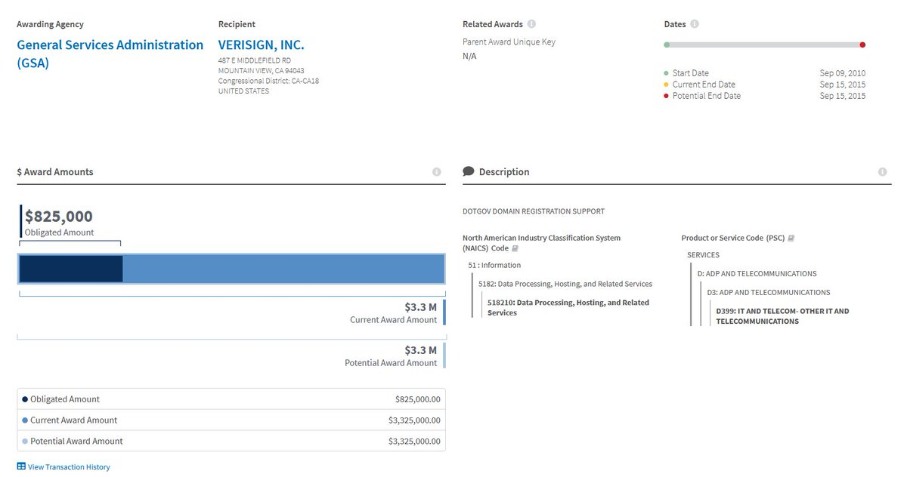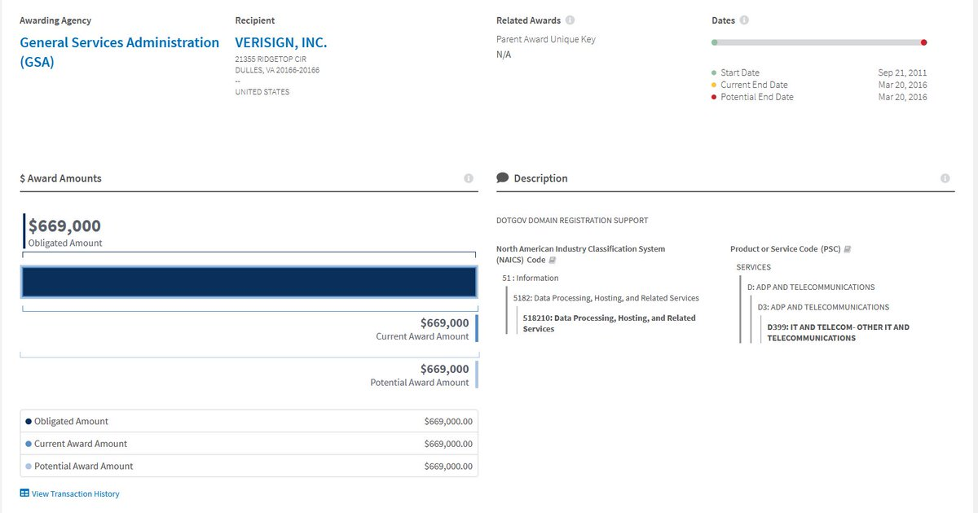
https://www.usaspending.gov/award/CONT_AWD_GST0309DS6049_4735_GS35F0286T_4730
Here is the contract from 2016 that was recently extended until June of 2022.
In 2014 when Neustar got access to do DNS services at the Executive Office of the President, Verisign was the contractor for all .gov domains. If Neustar was a subcontractor, it was for Verisign.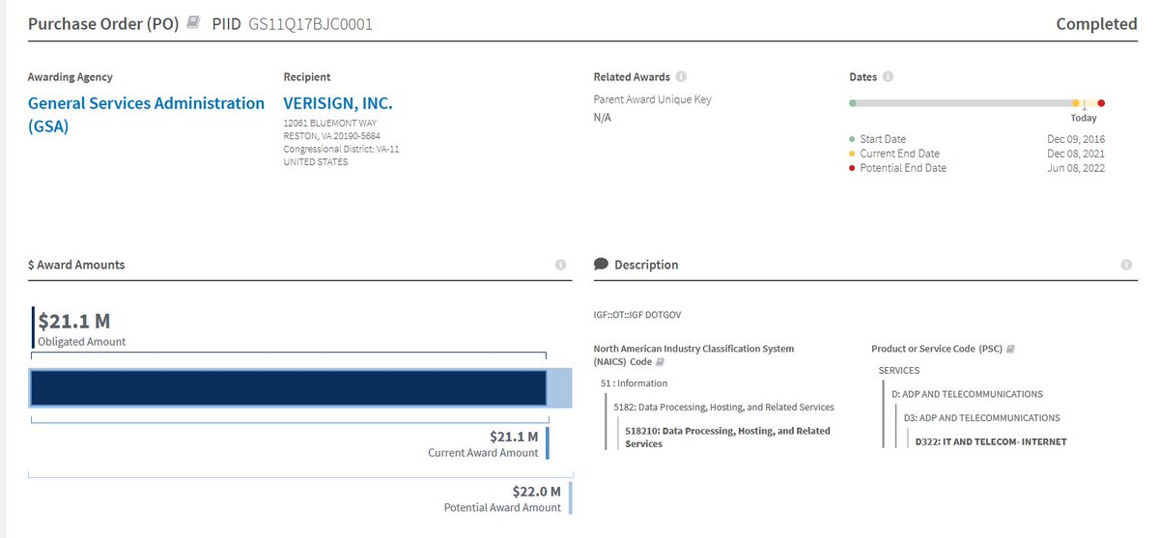
Neustar was brought in to offer DNS resolution which is a security solution that gives their servers all the DNS data for that domain. This 2014 assignment might have been specific to the EOP, but that is uncertain.
.gov domains include federal, state, local & tribal governments.
If you saw my previous thread, Neustar was providing law enforcement secure VPNs for the FBI, DEA, ATF, & USMS starting in 2010.
Potentially giving them access to secure FBI communications.
Unroll available on Thread Reader
From 2010-2014 Neustar acquired all of these agencies as clients. Until 9/2/17 all of these were sole provider contracts claiming no one but Neustar could provide the service.
Unroll available on Thread Reader
Following a still classified OIG investigation into Insider Threats in FBI Classified Networks, delivered on 9/22/17, all of these contracts are allowed to expire & DOJ's law enforcement agencies no longer need Neustar in their networks.
Unroll available on Thread Reader
But we don't know how widely Verisign was using Neustar to provide DNS security solutions, that also allowed them to data mine information from the Executive Office of the President.
But I now know what Neustar did next.
See this contract with Verisign?
It's really Neustar!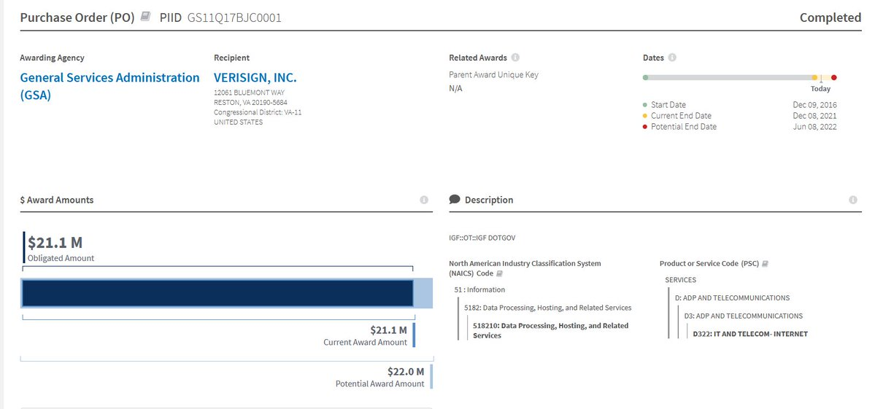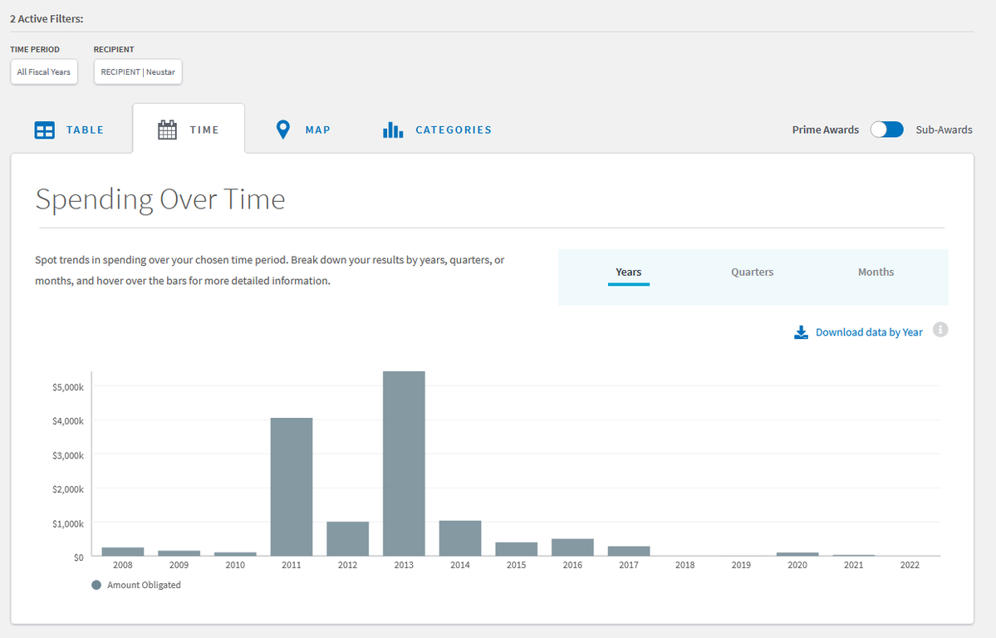
After Neustar lost it's DOJ network contracts, it most certainly remained a subcontractor for Verisign.
Then on 10/25/18 it was announced that Neustar was buying Verisigns security solutions DNS contracts & would take over the service.
Neustar was providing subcontracted security services to Verisign, took over the entire contract from Verisign, but the bills still say Verisign.
Which is why they have escaped us for so long. itsecurityguru.org/2018/10/26/neu…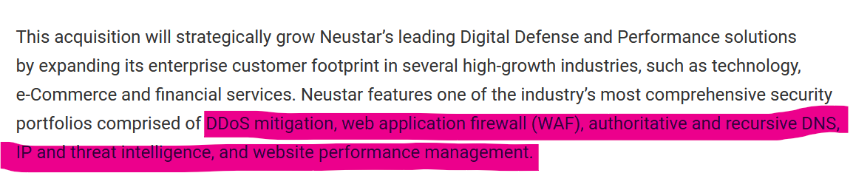
Neustar Acquires Verisign’s Security Services Customer Contracts.Neustar®, Inc., a trusted, neutral provider of real-time information services, today announced that it has entered into a definitive agreement with VeriSign, Ihttps://www.itsecurityguru.org/2018/10/26/neustar-acquires-verisigns-security-services-customer-contracts/
How does Neustar provide that solution?
By taking it's customers' internet and placing it all inside Neustar's custom network.
Not just DNS queries, websites, emails, & other systems of all US government computer networks were placed inside Neustar's private network of servers!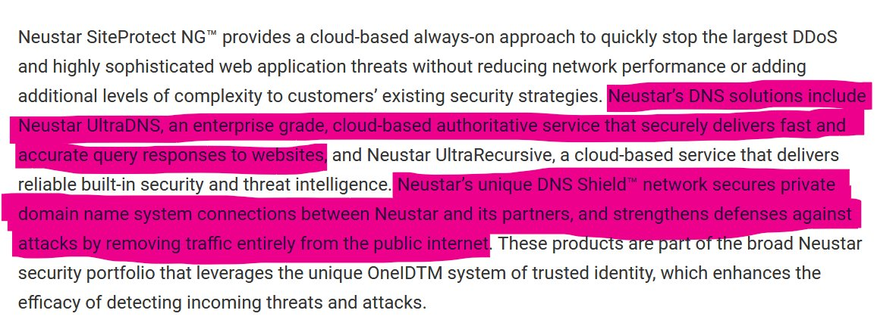
And the contracts still said Verisign if you went digging to do investigative research on them...
Let's go to an incident revealed in one of Durham's filings. Sussmann approached OIG in Spring of 2017 claiming he had data from Joffe showing an OIG employee connecting to a foreign VPN.
Did this data come from providing DNS security for Verisign?
Unroll available on Thread Reader
Indicates that Joffe had the ability to spy upon DOJ Office of the Inspector General employees!
What dates did OIG investigate FBI networks?
April 2014 until March 2017!
Neustar got the DNS security contract in 2014, Sussmann approached OIG in March 2017
Unroll available on Thread Reader
Then one week after Durham revealed evidence that Joffe was spying on OIG employees. OIG's .gov website went offline because of an expired SSL security certificate.
The feds by these certificates from Verisign, the only company authorized to provide them.
What power to datamine do you have if you have every DNS click, email, & document sent by every federal government employee in unclassified networks, inside your network?
You have all the power to blame & frame federal agencies with real & false allegations.
Then in 2020, Neustar took over all of Verisign's public DNS business too! Making them even more powerful & possibly replacing data they lost when Obama's FCC took their contract for running the US phone system.
Neustar Announces Acquisition of Verisign’s Public DNS ServiceNeustar announces acquisition of Verisign’s recursive Public DNS Service, providing Verisign users with continued performance and more security optionshttps://www.home.neustar/about-us/news-room/press-releases/2020/neustar-announces-acquisition-of-verisigns-public-dns-service
@mentionspointed out an interesting coincidence.
Verisign's Board of Directors includes Clintonista Jamie Gorelick, Deputy Attorney General to Janet Reno from 1994-97, the predecessor of DAG Eric Holder in that office.
investor.verisign.com/board-director…
Jamie Gorelick | Board of Directors | VeriSign, Inc.The Investor Relations website contains information about VeriSign, Inc.'s business for stockholders, potential investors, and financial analysts.https://investor.verisign.com/board-directors/jamie-gorelick
I think we now know why Joffe wanted to become the top cybersecurity official in the federal government.
A job promised to him by Democrats & members of Hillary Clinton’s campaign! They never thought she would lose!
Unroll available on Thread Reader
• • •
When Sanctions Backfire
Russia is the country to blame right now. Trump is out of the White House, so now it must be Putin that the Global Syndicate wants to target. Well, Putin is a great chess player and a remarkable long-range strategist. Underground gas storage facilities (UGS) in Europe were 95.3% empty as of February 17, Russia’s state energy giant and major gas exporter Gazprom said on Saturday, citing data from Gas Infrastructure Europe.
This means that Europe now has only 4.7% of its gas reserves left for the remainder of the winter season.
The volume of active gas in storage facilities is 21% or 8.3 billion cubic meters less compared to the same time last year. In total, 44.8 billion cubic meters have already been withdrawn from Europe’s UGS this winter.
According to Gazprom, gas reserves in underground storage facilities in Ukraine are also at a minimum, having dropped to 10.6 billion cubic meters, which is 45% less than last year.
Also, earlier this week, authorities in Germany, which has one of the largest underground storage capacities in Europe, reported a plunge in storage volumes to historically low levels compared to previous years.
The European Union, however, this week claimed that its supplies were sufficient to last several more weeks in the event that Russia stops its gas flow to the bloc amid tensions over Ukraine.
Russian gas supplies to European countries had already started to fall in mid-2021, and the decline accelerated at the beginning of 2022. Gazprom, however, repeatedly insisted that it is still supplying Europe with gas in strict accordance with existing contracts.
Despite this, the president of the European Commission, Ursula von der Leyen, on Saturday called Gazprom’s supply policy intentionally harmful.
“Gazprom is consciously trying to store and deliver as little as possible while prices and demand are skyrocketing,” she said in a speech at the Munich Security Conference, as quoted by Anadolu news agency.
According to the Commission, until recently, the EU satisfied almost a quarter (24%) of its energy needs with gas, 90% of which was imported. Some 40% of its imports came from Gazprom. The question remains, is Putin more dangerous when he controls your energy, or when he stacks his soldiers on your border?
Pedos Going Down
What would you rather have, the Global Syndicate’s pedos going to jail or taking a dirt nap? A French fashion agent linked to Jeffrey Epstein was found dead in his prison cell on Friday night, the Paris prosecutor’s office said.
Jean-Luc Brunel, 76, was in detention awaiting a trial on charges of rape of a minor and sexual harassment.
He was suspected of being involved in a global paedophile ring organised by the late disgraced financier Epstein, who took his own life in prison while awaiting trial for sex crimes, in 2019.
US prosecutors accused Brunel of finding young girls for his longtime associate and financier.
Lawyers for the fashion agent suggested he had killed himself, according to reports in the French press.

- Who is Jean-Luc Brunel? Disgraced fashion agent and Jeffrey Epstein friend found dead after ‘suicide’ in jail
Le Monde reported his legal team as saying: “His decision was not driven by guilt, but by a deep sense of injustice.”
Brunel was arrested in December 2020 at Paris’s Charles de Gaulle airport while trying to board a plane to Senegal.
He co-founded modelling agency MC2 Model Management in the US with funding from Epstein.
Several women accused Brunel of sexual assault, and at least a dozen people were known to have given evidence for the French investigation into allegations against Epstein and his circle.
Virginia Giuffre, who claims she was trafficked by Epstein as a teenager, alleged that Brunel procured women, some of them minors, for sex with Epstein and others. He lured them with promises of modelling work, she said.
Epstein’s illicit activities have resurfaced in recent months due to a number of high-profile cases involving his associates.
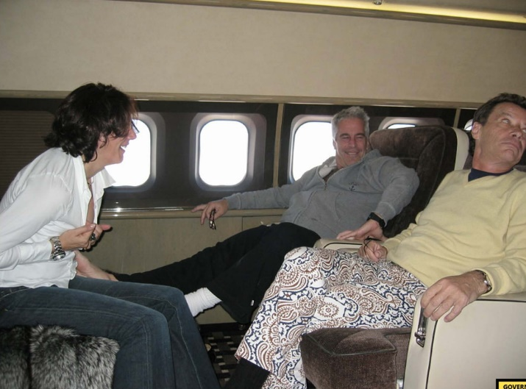
Brunel with Jeffrey Epstein and Ghislaine Maxwell on the billionaire’s private jet
(US District Attorney’s Office )
Ghislaine Maxwell, the socialite daughter of late press baron Robert Maxwell and a former girlfriend of Epstein, was found guilty in December of recruiting and grooming girls for the financier.
Prosecutors described Maxwell as a “sophisticated predator” who targeted vulnerable young girls. She is set to be sentenced on 28 June and faces up to 65 years in prison – meaning the 60-year-old could spend the rest of her life behind bars.
Ms. Giuffre, the most prominent of Epstein’s accusers, said she hoped Maxwell’s guilty verdict was “another step in justice being served” but that “Maxwell did not act alone. Others must be held accountable. I have faith that they will be”.
Prince Andrew settled a civil sexual assault case brought against him by Ms Giuffre this week. She sued the Duke of York claiming she was forced to have sex with him when she was 17 years old after being trafficked by Epstein. Prince Andrew denied her allegations.
Who’s next?
The Canadian Court Jesters
The Ontario Superior Court of Justice asked self-custody wallet provider
@nunchuk_io
to disclose user information and freeze user’s bitcoin.
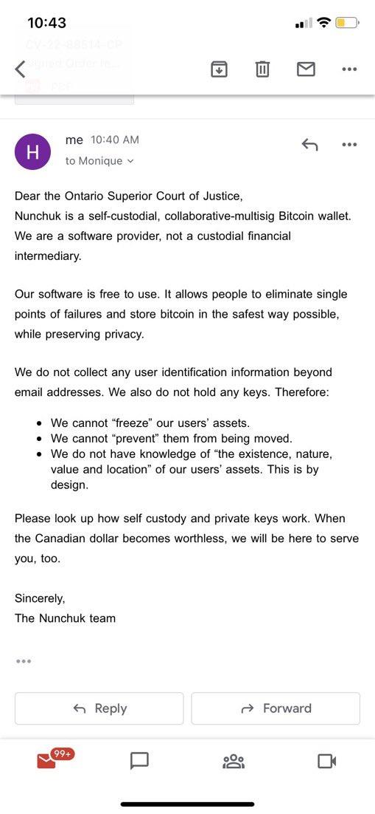
The 2020 Election Coup
An election audit in Colorado between a citizen and Colorado’s Secretary of State Jena Griswold was filed in November. The case requests as relief a full, independent forensic audit of the voting systems in Colorado.
Colorado Secretary of State Jena Griswold was sued over the destruction of election records, failure to properly test voting equipment, and obstruction of independent election audits. The relief sought in this case is a full, independent forensic audit of Colorado voting systems and the 2020 election in Colorado.
In the filing to the case, Hanks asserts the following:
WHEREFORE, on their First Claim for Relief, Plaintiffs pray that this Honorable Court enter judgment declaring that Defendant violated C.R.S. § 1-5-608.5 by failing to have Colorado voting systems tested by a federally accredited laboratory before the 2020 election. Plaintiffs pray that the Court enter judgment that an independent forensic audit is necessary to determine whether the voting systems meet legal standards, and whether the systems accurately recorded the votes of the people of Colorado in the 2020 election. Plaintiffs pray that the Court order the Defendant to pay the costs of such audit. Because of the importance of this case to the voters of Colorado, Plaintiffs pray for advancement on the docket and accelerated discovery pursuant to C.R.C.P. 57 (m). Plaintiffs pray for an award of costs, expert witness fees, reasonable attorney fees, and all other appropriate relief.
TRENDING: "Everyone is at Risk for Blood Clots!" - CDC and Pfizer Issue Urgent Warnings on Blood Clots Even in "The Healthiest Athletes"
In this portion of the case, Hanks argues that the voting machines in Colorado weren’t properly certified by certified auditors per state law. The same situation occurred in Arizona. The TGP reported that the auditors in Arizona hadn’t been properly certified prior to the 2020 Election, therefore, nullifying any certifications they made before the 2020 Election.
The second point that Hanks makes is that the Secretary of State destroyed election records. Hanks states:
“Forensic examination found that election records, including data described in the Federal Election Commission’s 2002 Voting System Standards (VSS) mandated by Colorado law as certification requirements for Colorado voting systems, have been destroyed on Mesa County’s voting system, by the system vendor and the Colorado Secretary of State’s office. Because similar system modifications were reportedly performed upon county election servers across the state, it is possible, if not likely, that such data destruction in violation of state and federal law has occurred in numerous other counties.”
The third point from Hanks is that a recent law that Griswold put into place, despite unanimous pushback prevents independent election audits. [If this is allowed to stay there will never be independent, adequate, and honest election audits in Colorado]. An example of recent issues in the state where the machines should be audited is given in the case.
In the most recent election, November 2, 2021, the El Paso County clerk’s office transmitted election data to Defendant’s website using an internet connection. As batches of votes were transmitted, the total votes counted increased on Defendant’s website by approximately 20 per cent. This happened twice. The El Paso County Clerk telephoned Defendant’s office. Defendant’s office was unaware that its website was showing inflated vote totals from El Paso County. Defendant’s office and the El Paso County Clerk agreed to manually decrease the vote totals that had been transmitted by the voting system.
Mercy, Peace, Justice War
It was all fun and games making Trudeau/Hitler memes until this week when Trudeau’s enforcers on horseback trampled an old woman.
Because a man with any sense of decency does not send men on horseback into a crowd.
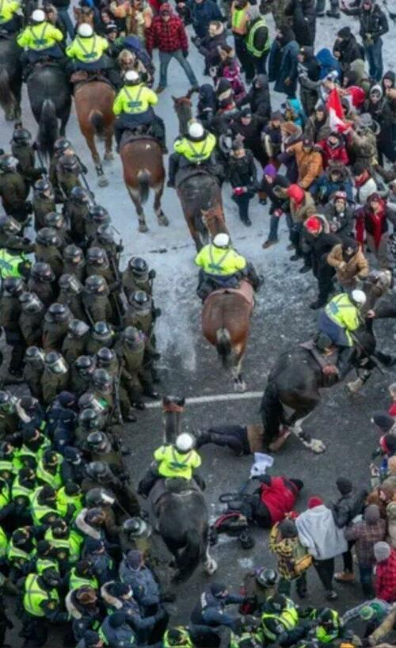
The only thing worse than this are the people commenting on this saying some variation of ‘well, she deserved it.’
Yes, she could have gone home.
Yes, she could have gotten the clot-shot.
Yes, she could have just complied with whatever Justin Trudeau told her what her morality was.
But Trudeau could have chosen differently as well. As opposed to acting like a scared little boy worried about facing public ridicule, he could have sacked up and met with the protestors.
Instead, he did what all boy-emperors have ever done, he chose violence and intimidation.
Those who blame the victims are worse than Justin Trudeau. They will never admit it, even to themselves, but their belief in the state as moral arbiter is shaken to its foundation when things like this happen.
So they bluster about playing stupid games, win stupid prizes. Empathy? Who needs that in Davos’ Brave New World.
Those against the protests have their reasons, none of them, however, are morally justified. Because if you allow the state, an immoral construction at its core, to define your morality, you will forever have to justify tyranny to remain on the side of the angels.
Blaming the victim is the easiest thing to do. How many rapists have claimed “she had it coming?” How many abusers every day blame the people they abuse because they are too ashamed to admit they are in the wrong?

We Are All Unclean Now
The part of the Great Reset pertaining to COVID-19 was always about amplifying the divisions between people. To create a new religion around it. Its sacrament is the vaccine. Its Lord’s prayer is demonizing ivermectin and trusting the science. Its vestment is the mask.
Its “amen,” is “in the name of public health.”
It has led to such dehumanizing that those who do not comply with the high priests now deserve their fate.
Mario Draghi in Italy declared the unvaccinated to no longer be a part of Italian society.
And, in a way, sadly, Trudeau’s supporters are correct. One always has the choice to accept the abuse if the alternative is death. That woman didn’t go to Parliament Square with that choice in mind because, she, sadly, still believed in the religion of the State as a subordinate partner with the people in shaping society.
Those final illusions were trampled fully in the eyes of millions around the world.
Politically, there is no going back for Justin Trudeau. He, along with his supporters, will hide behind their ‘cope’ and refuse to accept the responsibility for their actions.
The Ottawa police are doing the same thing, putting out disinformation about trying to trip the horses and harm the policemen.
At this point those still on the job in Ottawa made a choice as well, to side with tyrants and embrace their own inner one.
Many of them will enjoy finally getting to mete out the violence that festers in their souls, after all, it’s why many of them became cops in the first place.
Those who still have their humanity are now deciding whether to go along or walk away. If they go along they will lose what’s left of their humanity just like men did during World War II.
And their true face has been revealed.

No Zeal for More Tyranny
Now, as bad as things are in Canada, In New Zealand, Prime Minister Jacinda Arden, tried to follow Trudeau’s script to quell protests in Wellington.
And from all reports there, her efforts have failed completely. She convened a meeting of essentially the national security council on Thursday.
We have no solid reports of what went down.
Therefore, the silence about the outcome of that meeting speaks volumes. The military weren’t willing to get involved, just like what happened to Trudeau in Canada.
Moreover, New Zealand’s police commissioner Andrew Coster came out with a public statement saying negotiation was the path forward, something Arden has rejected out of hand, just like Trudeau, both reading from Davos’ script.
Coster said negotiations and de-escalation were the only safe ways to resolve the protest and he would continue to talk to the protesters. Police say there are about 800 protesters but numbers could rise over the weekend.
Coster said any forceful police action would risk injuries to the public and could turn a largely peaceful protest violent, and could increase the number of protesters.
Ottawa Police Chief Peter Sloly tried to hold the line against Trudeau’s megalomania earlier this week. That resulted in him resigning, presumably because he wouldn’t give the order to roust up the protestors and beat heads, and a more pliant enforcer put in his place.
The result is what we’re witnessing now in Ottawa.
The casual obscenity in this clip is the newscasters’ commentary about police restoring order.
The reality is that Arden and Trudeau are both hanging on by a thread because public opinion already turned against them. The only thing propping Trudeau up at this point is the shock at the speed he has escalated events. That shock will wear off very soon.
If parliament doesn’t act to limit/censure or simply get rid of this guy, Canadians will have a much bigger problem on their hands.
Too many Canadians are still asking, “Is this Canada?” When they should be stating, “This is not Canada.”
Stop asking for permission to feel outraged and feel the outrage.
In New Zealand, the veil of authority for Arden is thinner thanks to Trudeau’s mistakes in Ottawa. No doubt they are seeing the same things we are and want no part of it. The knives will come out for Arden quickly if she doesn’t back down.
I say all the time, spooks start civil wars, militaries end them. In Canada, the civil war there is just beginning. What we’ve not seen in New Zealand means it’s likely over before anyone even realized they were in one.
The Global Syndicate’s Great Reset rests on tyrants like Justin Trudeau to win through fear, intimidation and the banal corruption of weak people to support them. With each image of peaceful people being trampled under the bootheel of Canadian stormtroopers, more people awaken from the slumber of the comfortable lie the government protects us from chaos.
That’s what the State is folks, violence. The State is always violence. This is why Klaus Schwab and his minions raised and groomed Trudeau, Arden and the other beautiful leaders. There is no law these people recognize. The law does not apply to them. This is why your school boards own your children. This is why your elections are stolen. This is why the blood of saints cries from the dirt. There is no restraint on the State’s behavior they feel is justified for their holy cause.
Canadian Pastor Locked up for Talking
In an unjust society the only place for a just man is in prison,” said the writer Henry David Thoreau. That is increasingly true in Canada, where critics of its COVID restrictions can be thrown in jail for peaceful protests. Fidel Trudeau is unleashing powers meant for terrorists on the truckers. His mandates already damaged their livelihoods, but now his treatment of the truckers as a group akin to ISIS threatens to wipe them out completely. Meanwhile, a Calgary pastor who merely preached to the truckers finds himself in solitary confinement on a phony charge of incitement, according to his lawyer.
The condition of religious freedom in America is pretty dismal, but it appears to be even worse in Canada. This imprisoned pastor, Artur Pawlowski, didn’t urge the truckers to violence. On the contrary, he explicitly disavowed violence. “May God help us all, because we don’t fight with guns and swords,” he said to truckers gathered for a freedom convoy rally. “We don’t fight with Tasers and the police vehicles. We don’t. We just want to go back and work hard and achieve something and provide for our families. We just want to be left alone.”
He encouraged the truckers to continue their protests. “Hold the line,” he said. “Stand your ground.” He likened their protest to the Solidarity movement in Poland during the Cold War and exhorted the truckers to remain united against overweening politicians.
At his bail hearing this week, the Canadian government argued that his speech roused the truckers to continue their protests, as if the effectiveness of the speech made it particularly prosecutable. (One wonders: Would the state have not prosecuted him if the speech had fallen flat?) The court denied Pawlowski bail on these absurd grounds.
This isn’t the first time Canadian government officials have trampled on his free speech and religious freedom.
“Provincial court Judge Erin Olsen said Crown prosecutor Steven Johnston had established sufficient grounds to order Pawlowski held without bail pending trial on charges related to allegations he incited protesters to continue an ongoing blockade of the Coutts border crossing,” reported the Calgary Herald. Like a verdict from a Soviet show trial, the judge asserted out of thin air that Pawlowski’s blameless exercise of free speech “contributed to enormous economic harm to the local, provincial and national economy and substantial community harm to ordinary Canadians.”
In other words, he is a threat to the tyranny of Trudeau and his minions. Good for him. It is too bad other pastors don’t join him. The COVID commissars are making an example out of him in order to keep others quiet.
This isn’t the first time Canadian government officials have trampled on his free speech and religious freedom. Last year, he and two other “anti-mask activists” were fined and put on probation for simply preaching against pandemic decrees. An actual condition of their probation was that they preach the “science” behind the decrees.
“They are on the wrong side of science,” said the judge in the case. He even dictated to Pawlowski a line that he should include in his future sermons: “I am aware that the views I am expressing to you may not be held by medical experts … the majority of medical experts favour social distancing … vaccine programs.”
In 2021, police disrupted Easter services at his parish to see if his congregation was conforming to COVID regulations. Born in Soviet-occupied Poland, Pawlowski has said that the experience reminded him of those dark days: “I grew up seeing police and authorities destroying my country, not upholding the law. They were the truly brown shirts of the government, beating, torturing and showing total disregard towards law. Even though we had the constitution, they didn’t care.”
Another similarity to those days is that Canada’s government is in effect forcing pastors to serve as stooges of the state. The Soviets famously turned orthodox clergy into propagandists for state fiats. Their religious freedom shriveled down to “freedom of worship,” which basically meant that they had no freedom outside of the four walls of their churches and even there they had to toe the party line.
How is Canada’s fining and prosecuting of pastors for not upholding government orthodoxy about all things LGBTQ and COVID-related much different than that? Sen. Josh Hawley, among others, thinks Canada deserves a place on the State Department list of countries hostile to religious freedom. He is right. Biden’s administration, for that matter, belongs on the list too. But even Biden would probably think twice before throwing a pastor into jail for just talking to truckers.
The docility of the clergy during the COVID hysteria has been particularly dismaying, especially since it is so obviously a byproduct of an anti-Christian medical culture. The vaccine mandates come from the same secularist busybodies who hatched the contraceptive mandate and demand that religious hospitals perform transgender surgeries. Giving Fauci and company total control over health care makes about as much sense as entrusting senior centers to euthanists.
Pawlowski is a welcome exception to the cowering pastors who seconded the state’s decrees. And that’s precisely why he finds himself in jail — the honorable place under a tyrannical government for anyone who dares talk back.

The Durham Offensive (Update)
One week ago today, we discussed Special Counsel John Durham’s motion in the government’s criminal case against former Hillary Clinton campaign attorney Michael Sussmann. We discussed the stunning revelation of Tech Executive 1, which turned out to be Rodney Joffe. It’s been a week, and guess what the fake stream news did.
They did exactly what I told you they would do. 90% of the alternative media got it wrong too. Joffe’s Neustar was the tech company that used DARPA access to the EOP’s server to manipulate DNS data. That’s just like the cops dropping a baggie of cocaine under your car seat when they search your car. Joffe sketched Russian footprints in the sand, where the FBI could find them. Beginning in July of 2016, just 2 months after Trump became the candidate, he also started to erase Hillary and Biden’s blood trail from Ukraine and Russia. Obama gave him direct access to the EOP. The rest was DARPA and Clinton wetwork.
Durham’s filing confirmed revealed that “enemies of Donald Trump actually surveilled the internet traffic at Trump Tower, at his New York City apartment building, and later at the executive office of the president of the United States, then fed disinformation about that traffic to intelligence agencies hoping to frame Trump as a Russia-connected stooge.”
While earlier filings by Durham had revealed equally explosive facts, this time the special counsel’s motion generated enough attention that #Durham began to trend on Twitter. Not since the special counsel’s office indicted Sussmann in September 2021 for lying to the FBI’s former general counsel, James Baker, has the Durham investigation forced itself into the legacy press’ purview. We only guessed who Tech Executive 1 was. We thought it was Jack Dorsey or Mark Zuckerberg. We had no idea who Rodney Joffe was.
So, what did the Global Media Empire do Monday morning? Rather than report on the latest developments, they spun Friday’s filing as a big nothingburger, while parading several false narratives—just as it did when news of the indictment of the Clinton campaign’s lawyer broke.
Charlie Savage at the New York Times led the way in a Monday article headlined, “Court Filing Started a Furor in Right-Wing Outlets, but Their Narrative Is Off Track.” Amazingly, several of Savage’s talking points coincided with arguments presented by Sussmann’s attorneys in a document filed with the court that same day.
By Tuesday, Vanity Fair had joined in, quoting Savage’s “analysis.” That evening, Jimmy Kimmel turned the talking points into one-liners. Wednesday saw Brian Stelter at CNN further cribbing from the Savage’s initial take at the Times.
Even Sean Hannity got it wrong, saying that Joffe was simply spying on Trump’s communications with Russia. There were no communications like that. Joffe was fabricating those DNS connections. The close-knit spy ring, commissioned by Obama and funded by Hillary, was using the most powerful intelligence tools in the world to conduct a coup against a sitting president. That is treason.
While the leftist press continues to fall in line to echo the Tanker’s defense of the Clinton campaign’s former attorney with talking points that are nothing but gibberish. Here they are and why they are wrong.

1. It’s Just Those Crazy Right-Wingers
In his opening salvo in the Sussmann counter-offensive, Savage began his New York Times column by noting that Durham’s Friday night filing “set off a furor among right-wing outlets about purported spying on former President Donald J. Trump.”
Framing the “furor” as right-wing proves a ready go-to for a corrupt media seeking to discount the substance of the reporting. Stelter likewise hit this talking point repeatedly over at CNN, in his article “Right-wing media said it was exposing a scandal. What it really revealed is how bad information spreads in MAGA world.”
Hillary Clinton likewise pushed the right-wingers angle, tweeting that “Trump & Fox are desperately spinning up a fake scandal to distract from his real ones.”
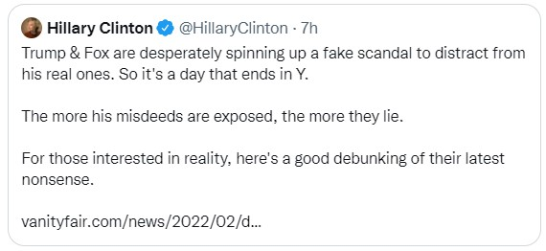
Of course, while casting coverage of Special Counsel Durham’s investigation as the cries of cray-cray conservatives might resonate with their readers, as a substantive counter to the most recent revelations in the Sussmann case it falls flat.

2. Pay No Attention to the Facts Behind the Filing
The second narrative pushed by Savage and then quickly parroted by his ilk is that the facts behind Durham’s most recent court filing are too dense for readers to bother using their brainpower to decipher. Yes, I am serious.
The facts “also tend to involve dense and obscure issues, so dissecting them requires asking readers to expend significant mental energy and time—raising the question of whether news outlets should even cover such claims,” Savage wrote in his Monday pro bono P.R. piece for Sussmann.
Amazingly, CNN quoted this passage in its coverage of the issue, demonstrating the utter lack of regard in which the leftist press holds its readers.

3. There Was No ‘Infiltration,’ So There Is No Story
A third counter pushed in response to Durham’s Friday court filing focused on Fox News’ coverage and its opener that read, “Lawyers for the Clinton campaign paid a technology company to ‘infiltrate’ servers belonging to Trump Tower. They claim there is a huge difference between infiltrate and exploit their secret connection to the White House servers.
Durham said the data Sussmann provided to the CIA came from data tech executive Rodney Joffe obtained when he “exploited” his access to sensitive data from the Executive Office of the President (EOP). The CIA? The most effective assassination forcer in world history was used against a sitting president? Now, we know what Senate minority leader Chuck Schumer meant when he warned Trump not to piss off CIA director John Brennan, saying, “He’ll get you six ways from Sunday.”
Hillary didn’t pay Joffe to do it. Joffe voluntarily exploited his access to the data and received no compensation from Clinton for his forays into the EOP and other databases. That is actually a criticism by the Times, CNN, and others are using right now. They hocked the Russia collusion hoax for five years. But, in any event, correcting those two points does nothing to counter the serious allegations revealed in Durham’s latest filing revealed.
In fact, he exposed so many significant details that it required two separate articles to adequately cover the developments. Notwithstanding the concerted pushback against the Fox News article, The Federalist’s in-depth coverage remains unblemished.

4. But Trump Wasn’t Even President Yet
The next narrative launched to minimize the significance of the revelations contained in Durham’s motion focused on the data Sussmann presented to the CIA purporting to show “that Russian-made smartphones, called YotaPhones, had been connecting to networks at Trump Tower and the White House, among other places.”
The data relating to the White House “came from Barack Obama’s presidency,” the Times reported, quoting two lawyers representing one of the researchers who aided Joffe. Rather, “to our knowledge,” the lawyers claimed, “all of the data they used was nonprivate DNS data from before Trump took office.”
This counter is nothing but lawyerly wordsmithing, however, and anyone who read the actual court filing—that dense document Savage believed beyond the grey matter of his readers—would know that fact. As the motion explained, in providing the DNS data to the CIA, Sussmann told the government agents “these lookups demonstrated that Trump and/or his associates were using supposedly rare, Russian-made wireless phones in the vicinity of the White House and other locations.”
As a matter of pure logic, the data Sussmann presented to the CIA related to the White House must have somehow related to Trump or it would not “demonstrate” that “Trump and/or his associates were using” the Russian cell phones “in the vicinity of the White House.” Most likely, then, the data presented concerned the transition period. Further, there is nothing to say that after Trump took office Joffe stopped “exploiting” the data.

5. It’s Old News
The fifth response, which Savage again initiated, ran that the “news” was “old news.”
“But the entire narrative appeared to be mostly wrong or old news,” Savage wrote early in his Times coverage. He reiterated that point later: “for one, much of this was not new: The New York Times had reported in October what Mr. Sussmann had told the C.I.A. about data suggesting that Russian-made smartphones, called YotaPhones, had been connecting to networks at Trump Tower and the White House, among other places.”
Surprise, surprise: It was Savage himself who made passing reference to the YotaPhones in his October 1, 2021, Times article that focused primarily on the Alfa Bank aspect of the indictment. In retrospect, we should have foreseen Durham’s latest revelations because they were handed to the Sussmann-friendly reporters who penned the October article, in what is now an obvious attempt to get ahead of the bad news Sussmann’s legal team knew was coming.
What the Times did not report on October 1, 2021, however, was that Joffe’s internet company “had come to access and maintain dedicated servers for the [Executive Office of the Presidency] as part of a sensitive arrangement whereby it provided DNS resolution services to the EOP.”
Nor did the Times report, as Durham alleged, that Joffe and his associates, “exploited this arrangement by mining the EOP’s DNS traffic and other data for the purpose of gathering derogatory information about Donald Trump.” Also missing from the October 2021 coverage was the fact that DNS data compiled, but withheld, from the CIA showed the DNS lookups involving the EOP and the Russian cellphone provider “began at least as early as 2014 i.e., during the Obama administration and years before Trump took office.”
In other words, this was new news, and those claiming otherwise serve, not as journalists, but as pushers of propaganda.

