The Making of the Christ
Jesus left Bethlehem with his parents before his 2nd year and went to Egypt. I traveled many cities in Egypt, but the one that contained the story of the resurrection was in Abydos. The temple of Seti I is situated in Abydos, one of the most important archaeological sites of Ancient Egypt. Abydos is located in Upper Egypt, about 10 km from the Nile River.
Seti sent his engineers to look for the site upon which to build his temple to the passion or Isis and Osiris. Seti wanted his temple to be built upon the even more ancient site known as the Osiron, believed to have been founded around -3470 AR.
In that ancient time, most of the Inner Sea region was living in barbarism, as civilization had yet to recover from the devastation caused by Earthfall in -5293 AR. According to legend, a prophet of Nethys called Azghaad unified the tribes living alongside the Sphinx River and established his capital at Sothis. He became the first pharaoh of Osirion, and he and his successors were revered by the populace as God-Kings.
Osiris ruled ancient Egypt in the 25th century BC, having inherited the kingship from his ancestors in a lineage stretching back to the creator of the world, Ra or Atum. His queen is Isis, Although he was the first Pharoah, Set craved this power and ended up murdering him and cutting his body into several parts and scattering them across the known world. Set is one of the children of the earth god Geb and the sky goddess Nut.
Osiris's death is followed by a period in which Set assumes the kingship. But the murderer does not hold onto that reign, because Isis searches for her husband's body with the aid of Nephthys. When searching for or mourning Osiris, the two goddesses are often likened to falcons or kites, possibly because kites travel far in search of carrion, because the Egyptians associated their plaintive calls with cries of grief, or because of the goddesses' connection with Horus, who is often represented as a falcon.
Osiris represented the life-giving divine power that was present in the Nile’s water and in the plants that grew after the flood. There was no dam in those days, so the replenishing of the farmlands of Egypt was a result of the flooding of the banks, which occurred every year right after the rising of the Star Sirius in the South. The Nile flows north, so the life energy of the river was associated with the star’s rising.
The goddesses do find the scattered body parts of Osiris and restore body, often with the help of other deities, including Thoth, a deity credited with great magical and healing powers, and Anubis, the god of embalming and funerary rites. Osiris becomes the first mummy, and the gods' efforts to restore his body are the mythological basis for Egyptian embalming practices, which sought to prevent and reverse the decay that follows death.
This part of the story is often extended with episodes in which Set or his followers try to damage the corpse, and Isis and her allies must protect it. Once Osiris is made whole, Isis conceives his son and rightful heir, Horus. One ambiguous spell in the Coffin Texts may indicate that Isis is impregnated by a flash of lightning, while in other sources, Isis, still in bird form, fans breath and life into Osiris's body with her wings and copulates with him.
This raising of Osiris was depicted for centuries until Abydos was buried by the desert and not uncovered until Dorothy Edy, also known as Om Seti located it from dreams she had. She believed she was a priestess at the Temple and was slain in those days. She believe she was reincarnated in England and traveled to Egypt in her old age to help find the ancient city. Hanni Al Zenni was commission by Egypt to find it and uncover it, but would not have known where it was except for her memory of having lived there as a young girl. These two building formed one center of power that was only a small town at the time of Jesus’ youth.
It was a once a necropolis for Egypt's earliest kings and later became a pilgrimage center for the worship of the god Osiris. It is also where the cults of the deified kings of ancient Egypt were celebrated.
The temple of Seti I has an unusual L-shaped ground plan and was built primarily of limestone, with the occasional use of sandstone in different areas throughout the structure. The temple was completed after Seti I's death, by his son, Ramesses II, whose cartouches are found in certain parts of the temple, along with his characteristic sunk relief style, that is different from the very fine raised relief of his father.
Each year, the passion of Osiris was celebrated with various parades and reenactments that the locals participated in. As a young child, Jesus would have seen this play many times. He knew the story. All the priests of Herod knew this story.
Jesus was born in Bethlehem in Judea. This happened while Herod was king of Judea. After Jesus’ birth, Wise Men from the east came to Jerusalem. ² They asked, “Where is the child who has been born to be king of the Jews? We saw his star when it rose. Now we have come to worship him.”
³ When King Herod heard about it, he was very upset. Everyone in Jerusalem was troubled too. ⁴ So Herod called together all the chief priests of the people. He also called the teachers of the law. He asked them where the Messiah was going to be born. ⁵ “In Bethlehem in Judea,” they replied. “This is what the prophet has written. He said,
⁶ “ ‘But you, Bethlehem, in the land of Judah,
are certainly not the least important among the towns of Judah.
A ruler will come out of you.
He will rule my people Israel like a shepherd.’ ” (Micah 5:2)
⁷ Then Herod secretly called for the Wise Men. He found out from them exactly when the star had appeared. ⁸ He sent them to Bethlehem. He said, “Go and search carefully for the child. As soon as you find him, report it to me. Then I can go and worship him too.”
⁹ After the Wise Men had listened to the king, they went on their way. The star they had seen when it rose went ahead of them. It finally stopped over the place where the child was. ¹⁰ When they saw the star, they were filled with joy. ¹¹ The Wise Men went to the house. There they saw the child with his mother Mary. They bowed down and worshiped him. Then they opened their treasures. They gave him gold, frankincense and myrrh. ¹² But God warned them in a dream not to go back to Herod. So they returned to their country on a different road.
Jesus’ Family Escapes to Egypt
¹³ When the Wise Men had left, Joseph had a dream. In the dream an angel of the Lord appeared to Joseph. “Get up!” the angel said. “Take the child and his mother and escape to Egypt. Stay there until I tell you to come back. Herod is going to search for the child. He wants to kill him.”
¹⁴ So Joseph got up. During the night, he left for Egypt with the child and his mother Mary. ¹⁵ They stayed there until King Herod died. So the words the Lord had spoken through the prophet came true. He had said, “I brought my son out of Egypt.” (Hosea 11:1)
¹⁶ Herod realized that the Wise Men had tricked him. So he became very angry. He gave orders about Bethlehem and the area around it. He ordered all the boys two years old and under to be killed. This agreed with the time when the Wise Men had seen the star. ¹⁷ In this way, the words Jeremiah the prophet spoke came true. He had said,
¹⁸ “A voice is heard in Ramah.
It’s the sound of crying and deep sadness.
Rachel is crying over her children.
She refuses to be comforted,
because they are gone.” (Jeremiah 31:15)
Jesus’ Family Returns to Nazareth
¹⁹ After Herod died a horrible and painful death from a strange illness, Joseph had a dream while he was still in Egypt. When Jesus was about ten years old, Joseph had another dream wherein an angel of the Lord appeared to him. ²⁰ The angel said, “Get up! Take the child and his mother. Go to the land of Israel. The people who were trying to kill the child are dead.”
²¹ So Joseph got up. He took the child and his mother Mary back to the land of Israel. ²² But then he heard that Archelaus was king of Judea. Archelaus was ruling in place of his father Herod. This made Joseph afraid to go there. Joseph had after all already been warned in a dream. So he went back to the land of Galilee instead. ²³ There he lived in a town called Nazareth. So what the prophets had said about Jesus came true. They had said that he would be called a Nazarene. Nazareth was a very small town near the sea. Joseph was a carpenter and with his tools and skills could always be a valuable asset to any town where he lived.
By the time Jesus was 12, Joseph and Mary had made several trips back to Jerusalem on caravans. This was the only way to travel in the desert. Robbers and nomads preyed upon stragglers along this way, so caravans were the only way to carry security, food, and enough people to ward off any such attacks.
You will recall the time when the caravan had left Jerusalem, and before long Mary discovered that Jesus was not with them. It had been nearly a decade since they fled Bethlehem, and perhaps the role her Son would play in the world was far from her mind.
Luke 2:41-52 KJV
Now his parents went to Jerusalem every year at the feast of the passover. And when he was twelve years old, they went up to Jerusalem after the custom of the feast. And when they had fulfilled the days, as they returned, the child Jesus tarried behind in Jerusalem; and Joseph and his mother knew not of it.
But they, supposing him to have been in the company, went a day's journey; and they sought him among their kinsfolk and acquaintance. And when they found him not, they turned back again to Jerusalem, seeking him.
And it came to pass, that after three days they found him in the temple, sitting in the midst of the doctors, both hearing them, and asking them questions. And all that heard him were astonished at his understanding and answers.
And when they saw him, they were amazed: and his mother said unto him, Son, why hast thou thus dealt with us? behold, thy father and I have sought thee sorrowing. And he said unto them, How is it that ye sought me? wist ye not that I must be about my Father's business?
This must have brought eternity slamming back into her heart. The complacency was over. She remembered what was said about the sorrow piercing her heart. This was only the beginning.
Some scholars believe that Jesus’ father Joseph died when he was about 12 and that this traumatic event could have been the catalyst for him, still as a young boy, to begin a personal quest to attain spiritual enlightenment. Some researchers believe that he spent these undocumented years visiting Britain with one ‘Joseph of Arimathea’, while others believe he travelled to India and Persia. In the late 19th century a Russian traveler claimed to have discovered genuine texts in a monastery in India that proved that Jesus travelled and taught there and elsewhere in the East
Jesus may have travelled to Britain with ‘Joseph of Arimathea’, a tin trader who some believe was his uncle, although other ‘canonical gospel’ texts describe him mainly as a rich man and disciple of Jesus. A great degree of literature had been written about this particular tale, taking it into the realms of tradition, so that by the 15th century, Glastonbury in Somerset was touted as the birthplace of British Christianity.
Joseph was believed to have erected the first church there to house the Holy Grail. My ancestors were guardians of the Grail and possibly the Ark in Rosslyn as the hereditary sheriffs of Galloway. There is a spring in Stranraer, Scotland that bears Joseph’s name. My family name is all over that town.
There was also an account that Joseph of Arimathea had earlier visited Glastonbury with Jesus as a child, which inspired artist and poet William Blake to compose a poem that became the words to the English hymn Jerusalem.
‘And did those feet in ancient time/walk upon England’s mountains green? And was the Lamb of God/On England’s pleasant pastures seen?’
Upon returning at age 30, the first place Jesus is noticed was the River Jordan visiting his cousin, John the Baptist.
Matt 3:13
Then cometh Jesus from Galilee to Jordan unto John, to be baptized of him. 14But John forbad him, saying, I have need to be baptized of thee, and comest thou to me? 15And Jesus answering said unto him, Suffer it to be so now: for thus it becometh us to fulfil all righteousness. Then he suffered him. 16And Jesus, when he was baptized, went up straightway out of the water: and, lo, the heavens were opened unto him, and he saw the Spirit of God descending like a dove, and lighting upon him: 17And lo a voice from heaven, saying, This is my beloved Son, in whom I am well pleased.
Mark 1: 1-8
1Then was Jesus led up of the Spirit into the wilderness to be tempted of the devil. 2And when he had fasted forty days and forty nights, he was afterward an hungred. 3And when the tempter came to him, he said, If thou be the Son of God, command that these stones be made bread. 4But he answered and said, It is written, Man shall not live by bread alone, but by every word that proceedeth out of the mouth of God.
5Then the devil taketh him up into the holy city, and setteth him on a pinnacle of the temple,
6And saith unto him, If thou be the Son of God, cast thyself down: for it is written, He shall give his angels charge concerning thee: and in their hands they shall bear thee up, lest at any time thou dash thy foot against a stone.
7Jesus said unto him, It is written again, Thou shalt not tempt the Lord thy God.
8Again, the devil taketh him up into an exceeding high mountain, and sheweth him all the kingdoms of the world, and the glory of them; 9And saith unto him, All these things will I give thee, if thou wilt fall down and worship me. 10Then saith Jesus unto him, Get thee hence, Satan: for it is written, Thou shalt worship the Lord thy God, and him only shalt thou serve. 11Then the devil leaveth him, and, behold, angels came and ministered unto him.

Hebrew Chapter 5

For every high priest taken from among men is ordained for men in things pertaining to God, that he may offer both gifts and sacrifices for sins:
2Who can have compassion on the ignorant, and on them that are out of the way; for that he himself also is compassed with infirmity.
3And by reason hereof he ought, as for the people, so also for himself, to offer for sins.
4And no man taketh this honour unto himself, but he that is called of God, as was Aaron.
5So also Christ glorified not himself to be made an high priest; but he that said unto him, Thou art my Son, to day have I begotten thee.
6As he saith also in another place, Thou art a priest for ever after the order of Melchisedec.
7Who in the days of his flesh, when he had offered up prayers and supplications with strong crying and tears unto him that was able to save him from death, and was heard in that he feared;
8Though he were a Son, yet learned he obedience by the things which he suffered;
9And being made perfect, he became the author of eternal salvation unto all them that obey him;
10Called of God an high priest after the order of Melchizedec.
11Of whom we have many things to say, and hard to be uttered, seeing ye are dull of hearing.
12For when for the time ye ought to be teachers, ye have need that one teach you again which be the first principles of the oracles of God; and are become such as have need of milk, and not of strong meat.
13For every one that useth milk is unskilful in the word of righteousness: for he is a babe.
14But strong meat belongeth to them that are of full age, even those who by reason of use have their senses exercised to discern both good and evil.
For this Melchisedec, king of Salem, priest of the most high God, who met Abraham returning from the slaughter of the kings, and blessed him;
2To whom also Abraham gave a tenth part of all; first being by interpretation King of righteousness, and after that also King of Salem, which is, King of peace;
3Without father, without mother, without descent, having neither beginning of days, nor end of life; but made like unto the Son of God; abideth a priest continually.
4Now consider how great this man was, unto whom even the patriarch Abraham gave the tenth of the spoils.
5And verily they that are of the sons of Levi, who receive the office of the priesthood, have a commandment to take tithes of the people according to the law, that is, of their brethren, though they come out of the loins of Abraham:
6But he whose descent is not counted from them received tithes of Abraham, and blessed him that had the promises.
7And without all contradiction the less is blessed of the better.
8And here men that die receive tithes; but there he receiveth them, of whom it is witnessed that he liveth.
9And as I may so say, Levi also, who receiveth tithes, payed tithes in Abraham.
10For he was yet in the loins of his father, when Melchisedec met him.
11If therefore perfection were by the Levitical priesthood, (for under it the people received the law,) what further need was there that another priest should rise after the order of Melchisedec, and not be called after the order of Aaron?
12For the priesthood being changed, there is made of necessity a change also of the law.
13For he of whom these things are spoken pertaineth to another tribe, of which no man gave attendance at the altar.
14For it is evident that our Lord sprang out of Juda; of which tribe Moses spake nothing concerning priesthood.
15And it is yet far more evident: for that after the similitude of Melchisedec there ariseth another priest,
16Who is made, not after the law of a carnal commandment, but after the power of an endless life.
17For he testifieth, Thou art a priest for ever after the order of Melchisedec.
There were far too many pilgrims for the temple priests to feed the lamb on one evening, so they divided the feast over two nights. The elite partook on the second night. The sacramental feast may have been a Seder, or a more relaxed Passover supper where hymns are sung and unleavened bread eaten along with the lamb. This holiday is linked to Passover not just in its position on the calendar but also in much of its symbolism. The bible tells of the Passover meal during which Jesus Christ prepared his disciples for his death.
Before the actual sacrament, Judas leaves to betray Him.
Matt 26: 26
Now as they were eating, Jesus took bread, and _{w} after blessing it broke it and gave it to the disciples, and said, "Take, eat; _{x} this is my body." ²⁷ And he took a cup, and when he _{y} had given thanks he gave it to them, saying, "Drink of it, all of you, ²⁸ for _{x} this is my _{z} blood of the ₃ covenant, which is poured out for _{a} many _{b} for the forgiveness of sins. ²⁹ I tell you I will not drink again of this fruit of the vine until that day when I drink it new with you _{c} in my Father's kingdom."
³⁰ _{d} And when they had sung a hymn, _{e} they went out to _{f} the Mount of Olives.

Matt 26: 36-45
³⁶ Then Jesus went with his disciples to a place called Gethsemane, and he said to them, “Sit here while I go over there and pray.” ³⁷ He took Peter and the two sons of Zebedee along with him, and he began to be sorrowful and troubled. ³⁸ Then he said to them, “My soul is overwhelmed with sorrow to the point of death. Stay here and keep watch with me.”
³⁹ Going a little farther, he fell with his face to the ground and prayed, “My Father, if it is possible, may this cup be taken from me. Yet not as I will, but as you will.”
⁴⁰ Then he returned to his disciples and found them sleeping. “Couldn’t you men keep watch with me for one hour?” he asked Peter. ⁴¹ “Watch and pray so that you will not fall into temptation. The spirit is willing, but the flesh is weak.”
⁴² He went away a second time and prayed, “My Father, if it is not possible for this cup to be taken away unless I drink it, may your will be done.”
⁴³ When he came back, he again found them sleeping, because their eyes were heavy. ⁴⁴ So he left them and went away once more and prayed the third time, saying the same thing.
⁴⁵ Then he returned to the disciples and said to them, “Are you still sleeping and resting? Look, the hour has come, and the Son of Man is delivered into the hands of sinners. ⁴⁶ Rise! Let us go! Here comes my betrayer!”
John 18: 12
Then the band and the captain and officers of the Jews took Jesus, and bound him, 13 And led him away to Annas first; for he was father in law to Caiaphas, which was the high priest that same year. 14 Now Caiaphas was he, which gave counsel to the Jews, that it was expedient that one man should die for the people.
John 19: 28
Then led they Jesus from Caiaphas unto the hall of judgment: and it was early; and they themselves went not into the judgment hall, lest they should be defiled; but that they might eat the passover.
Friday was the second night of the Passover.
Remember, the sins of the world are being settled upon Jesus. He is brought before Pilate to be judged. Pilate’s wife had a dream where she became convinced Jesus was a good man and that Pilate should not harm him. Wives sometimes prevail upon rulers, but Pilate’s course was set by very dark powers he could not control.
He tried to avoid the path by calling upon a custom to pardon a prisoner before Passover. So, he called for Barabbas to be released or Jesus. He figured that this violent murderer was a good contrast to Jesus, and that he would please his wife by sparing Jesus. But, the Pharisees were dressed in formal attire and scattered through the crowd. They shouted for Barabbas to be freed, and the weak sheep of a people joined in.
We see that behavior every day, don’t we?
Matt 27: 21
The governor answered and said unto them, Whether of the twain will ye that I release unto you? They said, Barabbas. 22Pilate saith unto them, What shall I do then with Jesus which is called Christ? They all say unto him, Let him be crucified. 23And the governor said, Why, what evil hath he done? But they cried out the more, saying, Let him be crucified.
Pilate Washes his Hands
(Mark 15:12-15)
24When Pilate saw that he could prevail nothing, but that rather a tumult was made, he took water, and washed his hands before the multitude, saying, I am innocent of the blood of this just person: see ye to it. 25Then answered all the people, and said, His blood be on us, and on our children. 26Then released he Barabbas unto them: and when he had scourged Jesus, he delivered him to be crucified.
Jesus had been kept up all night in an illegal trial. We see illegal political trials to this very day in our own capitol. He was carrying some of the sins of the world. He had been scourged, which a mortal man could not have survived. He collapsed carrying the cross they settled on Him to carry, so Simon—a pilgrim who did not know the laws that no men could line the streets leading to Golgotha—was given the task of carrying the cross for Him.
When they arrived at the top of the hill, he laid the cross down on the ground, already stained by so many who had been crucified on that very place. They laid Jesus on that cross and drove a nail through his feet to hold him in place. Then the Roman crucifiers stretched his arms on that cross and drive nails through the palms of his hands.
Then, fearing that his large stature might allow His weight to pull the heads of the nails through His palms, they put the nail in the sure place.
Isa 22
21And I will clothe him with thy robe, and strengthen him with thy girdle, and I will commit thy government into his hand: and he shall be a father to the inhabitants of Jerusalem, and to the house of Judah.
22And the key of the house of David will I lay upon his shoulder; so he shall open, and none shall shut; and he shall shut, and none shall open.
23And I will fasten him as a nail in a sure place; and he shall be for a glorious throne to his father's house.
Still the sins of the world were being settled on Him. The pain that you and I placed upon Him was there now. The pain that generations from now were placed upon Him.
But His thoughts were for the innocents who were following orders.

“Father, forgive them, for they know not what they do.” Luke 23:34
“Amen, I say to you, today you will be with me in paradise.” Luke 23:43
“Woman, behold your son. Son, behold your mother.” John 19:26–27
“My God, My God, why have you forsaken me?” Matthew 27:46 & Mark 15:34
“I thirst.” John 19:28
“It is finished.” Matthew 27:46 & Mark 15:34
“Father, into thy hands I commit my spirit.” Luke 23:46
24And they shall hang upon him all the glory of his father's house, the offspring and the issue, all vessels of small quantity, from the vessels of cups, even to all the vessels of flagons.
25In that day, saith the LORD of hosts, shall the nail that is fastened in the sure place be removed, and be cut down, and fall; and the burden that was upon it shall be cut off: for the LORD hath spoken it.
Betrayal in the Coup
John Durham’s Friday motion exceeded expectations, discussing CIA conclusions that Sussmann was providing implausible data to federal authorities, providing CIA notes regarding their meeting with Sussman, and confirmation that they essentially spied on President-Elect Trump.
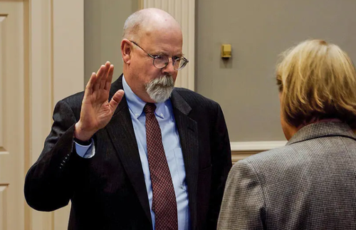
The motion can be found here. It was filed as part of the government’s efforts to convince the court that the evidence it seeks to admit in Sussman’s trial is relevant and admissible. Let’s go through the most important parts.

The CIA Notes Part 1: January 31, 2017.
Durham provided to the Court two sets of notes related to Sussman’s representations to the CIA. The first was from Sussman’s January 31, 2017 contacts with a CIA employee where Sussman discussed wanting to provide to the CIA data on “the presence and activity of a unique Russian made phone around President Trump.” It was said that this secret activity started in April 2016 and continued after Trump’s “move to the White House.”
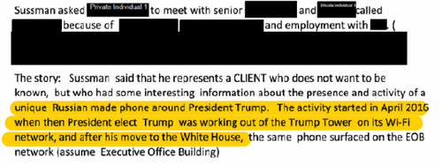
Sussman alleged the Russian phone (YotaPhone) was always close to Trump (“only around the President’s Movements”), surfacing at his Trump Tower Network in April 2016 and being used through Wi-Fi at Trump’s Grand Central West apartment. The phone even “appeared with Trump in Michigan” when he was interviewing a Cabinet Secretary.
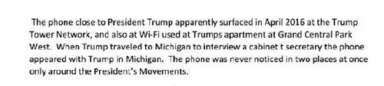
At a minimum, this confirms what we reported nearly two months ago: that the Trump transition data was passed to the CIA. Yet it’s also more than that. The CIA was provided with data all the way back from April 2016.
Why does April 2016 matter? Because Russia was alleged to have hacked “the Democratic Congressional Campaign Committee and DNC networks in April 2016.” Recall that “Crowdstrike was contacted on April 30, 2016 to respond to a suspected breach” of the DNC.

The CIA Notes Part 2: Sussmann’s February 9, 2017 meeting with the CIA
That January 31, 2017 conference was used to schedule the February 9, 2017 meeting with the CIA. At that meeting, Sussman repeated his allegations that a “Russian-made Yota-phone” had been seen at Trump properties and had traveled with Trump to Michigan. He further alleged that “In December 2016, the Yota-phone was seen connecting to WIFI from the Executive Office of the President (the White House).”
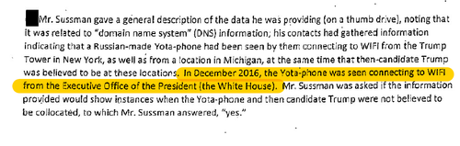
A brief but necessary aside: The Washington Post alleged us to have fanned “the flames” on the Sussman/Joffe spying operation, taking us to task for stating (correctly): “They spied on Trump.” I hope the Washington Post is reading this, because the CIA notes confirm what we reported and what we told them via e-mail. Techno 1, WaPo 0.
Back to the Durham Filing – and the CIA’s analysis of the Sussman/Joffe data.
The CIA reviewed the Trump/YotaPhone data (and the Alfa Bank data) in early 2017. The fact that the CIA accepted this data on President Trump is its own scandal. In any event, the CIA’s findings are significant, as they concluded that the data was not “technically plausible” and was “user created and not machine/tool generated.”
(I’ve been asked about the last part of that paragraph, which says the “Special Counsel’s Office has not reached a definitive conclusion in this regard.” The term “definitive conclusion” stands out, making me suspect he has “initial” conclusions on the data. Durham’s filings in this case suggest he agrees with the CIA.)
Anyway, what a finding by the CIA. Of course, this only leads to more questions:
- Which “user” created the data?
- Does it go back to the Joffe conspiracy?
- And who else is part of that conspiracy?
For that last question, consider this revelation from a previous Durham filing:
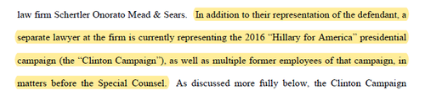
As to those questions of a conspiracy, Durham’s granting of immunity provides some insight. As we suspected back on April 5, “Researcher-2” (identified as David Dagon) has been given immunity. The reason? So that Durham can “uncover otherwise-unavailable facts” relating to the Alfa Bank project.
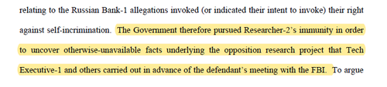
Dagon being granted immunity is certainly important, as Durham states that Rodney Joffe – who led the Alfa Bank hoax effort – remains a “subject” of the investigation. While Sussman and others argue that it’s impossible to prosecute Joffe because of the 5-year statute of limitations, Durham disagrees, stating: “defense counsel is not – and could not be – aware of all the evidence that the Government has collected and continues to collect, or the possible violations of law it is investigating.”
Durham will also be granting immunity at trial “for an individual who was employed at” Fusion GPS. I initially suspected this was Christopher Steele but was steered in the right direction after some smart folks noted the person was “employed” at Fusion GPS (as opposed to Steele, who was “retained” by Fusion GPS). This person might be Laura Seago.
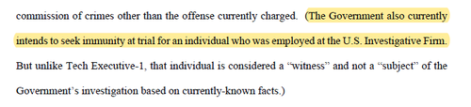
This former Fusion GPS employee will likely testify to “limited information pertaining to” Christopher Steele. As Durham puts it: this will include whether Sussman was acting on behalf of the Clinton Campaign when he relayed the Alfa Bank allegations.
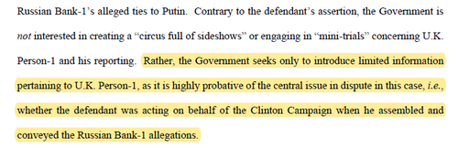
Finally, I leave you with some questions to consider. Start asking why Sussman and Joffe were so desperate to provide the FBI and CIA with dirt purportedly linking Trump and Russia. Sussman himself provided false statements to federal officials, and it’s becoming more and more likely that someone potentially fabricated this evidence. Sussman and Joffe risked charges - and thus jeopardized their lucrative careers - to tie Trump to Russia.
Considering the personal costs to both men, are we to believe that this was only about politics?
Or maybe this all leads back to the DNC hack…
The Ultimate Currency War
The Chinese digital currency, variously known as the digital yuan, digital renminbi, e-CYN, and e-yuan—is currently being developed by the Chinese regime through its central bank. Since the e-yuan is backed by the People’s Bank of China (PBOC), it is a central bank digital currency (CBDC) or simply the digital version of China’s fiat currency.
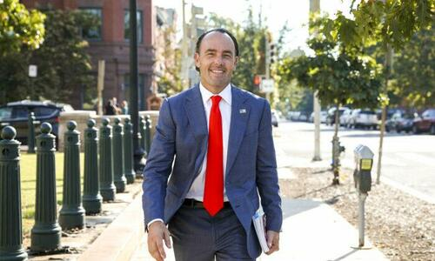
So far, pilot tests of the e-yuan are being carried out in more than 20 different Chinese cities and the money was made available to visiting foreigners through a mobile app for the first time during the 2022 Beijing Winter Olympics.
“This isn’t a simple digital payment app. This is an app that tracks where you are, what your name is, what your social security number is, [and] what all of your identifiers are. It has the geo-locating ability,” he explained.
Bass explained once the Chinese digital money is fully-developed and is made available to everyone outside of China, the Chinese regime could seek out certain e-yuan users, such as those in financial trouble, and corrupt them.
“Image if the Chinese government had access to every Tom, Dick, and Harry in America, and in Europe, and in Canada,” he said. “Imagine if they could cross-run an algorithm that says, let’s look for U.S. government employees that have Tinder that are short on cash—and maybe they’re married—and we can corrupt them immediately.”
“It gives them the ramp to corrupt anyone and everyone around the world that’s corruptible, which is a real national security problem,” he added. “So it’s a way they can export digital authoritarianism.”
China’s global rollout of its e-yuan has a very specific agenda, Bass said, which is to reduce its dependence on the U.S. dollar. It is a term we have been throwing around called ‘Dedollarize.’
“About 87 percent of global transactions that China settles are settled in dollars,” he said. “They’re desperately short energy, they’re desperately short food, they’re desperately short basic materials, they have to go buy these things every day around the world, and no one trusts their currency, and they still have a closed capital account.”
“And so what do they have to do? They have to use their [U.S.] dollars to do so,” he said.
More than 80 countries in the world, including the United States, are exploring the issuance of CBDC, according to tracking by the Washington-based think tank Atlantic Council. So far Nigeria is among nine countries that have launched digital forms of their currencies.
In March, the White House issued an outline of President Joe Biden’s executive order on digital assets. The president was “placing urgency” on research and development of a U.S. CBDC, and issuing one was “deemed in the national interest.”
Several U.S. lawmakers have been keen to see the threat posed by the e-yuan properly addressed. In May last year, Reps. French Hill (R-Ark.) and Jim Himes (D-Conns.) introduced the 21st Century Dollar Act (H.R.3506), which would require the U.S. Treasury Department to include in a report for Congress any risks to the U.S. dollar posed by the digital yuan.
In March, Sen. Marsha Blackburn (R-Tenn.) and eight of her Republican colleagues introduced the Say No To the Silk Road Act (S.3784). If enacted, the legislation would require the U.S. Commerce Department and U.S. Trade Representative’s office to file reports on the e-yuan.
Additionally, the U.S. State Department would be required to put a warning on its website, warning U.S. citizens traveling to China “about the dangers of the digital yuan,” according to the text of the bill.
“There are some senators that you’ll see in the coming weeks are going to launch legislation to outlaw its use. And I believe that, that those that legislation must happen,” Bass said.
“The West needs to convene, and we need to ban it immediately,” he added. “You can’t have a little bit of cancer, you either have cancer, you don’t have cancer.”
Shanghaid
Make no doubt about it, there’s something seriously disturbing about the state of the recent Covid lockdowns taking place in Shanghai. Even for China.
Here is what the outbreak looks like, if we are to believe the numbers coming out of China. You’ll have to excuse me for being frank, but I simply don’t believe them. China has lied about nearly everything since the beginning of the pandemic, and they certainly don’t have the rest of the world’s best interest in mind now that they are allying with Russia economically.

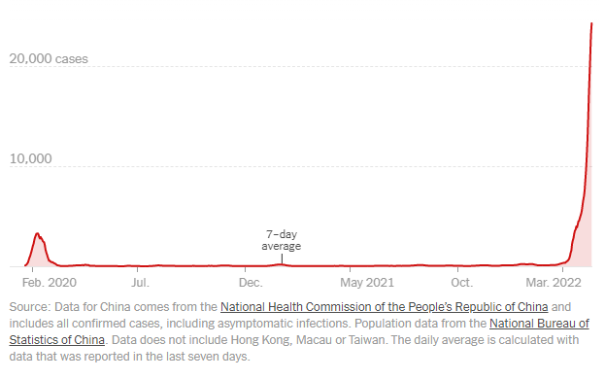
Source: NY Times
Rather, I believe the numbers are likely being exaggerated one way or the other (just as I believe China does with their macroeconomic data), in order to meet the needs of whatever agenda the CCP is trying to push.

Here we are, two years into Covid, with ample time behind us to have studied the virus, developed vaccines, boosters and therapeutics and allowed for natural immunity to spread – and China is locking down the city of 26.3 million people at the first sign of a couple cases of Covid.
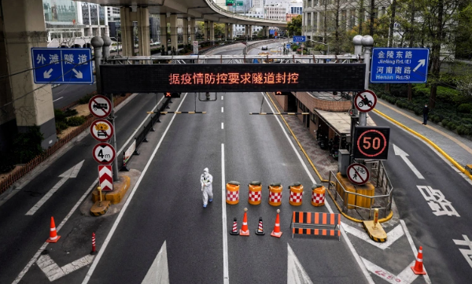
Photo: NBC News
The actions China has taken to implement this round of lockdowns have been dystopian and Orwellian, to say the least.
For example, according to the NY Times:
- all international flights to and from Shanghai have been halted
- many roads to the city’s two airports have also been closed
- the government performed P.C.R. tests on 25.67 million people
- the government has not allowed residents to go to grocery stores
- the government has put together tens of thousands of cots in two convention centers as quarantine centers - but they don’t have showering facilities
China is also, once again, sealing people in their homes. Videos on social media “show trapped residents howling and screaming from inside high-rise buildings at night,” The Independent wrote this week.
According to social media posts, the city is even using drones to try and calm the nerves of angry residents.
“Please comply [with] covid restrictions. Control your soul’s desire for freedom. Do not open the window or sing,” this drone is reported to be saying.
There are a innumerable disturbing things about the dystopian way this alleged outbreak is being handled, but none more pressing is the question of why it is being handled the way it is.

🔥 Only for the holiday weekend // If you would like to support the blog and become a paid subscriber to an annual plan this weekend, I can offer you 50% off discount that will be valid for as long as you stay a subscriber: Get 50% off forever

It felt like, heading into the spring, the world was over the idea of Covid. Mask mandates and vaccine mandates were being lifted, businesses were starting to recover and we were heading into the warmth of summer with the attitude that we now knew the risks of Covid and that it was time for every person to take care of themselves.
So, why such a drastic overreaction by China? Why continue the country’s completely irrational and inane “Covid Zero” policy at this point?
It’s simply doesn’t make any sense – even for China. In fact, the country’s extremely dramatic and overzealous response feels so abnormal that it made me wonder yesterday whether China was simply using it as a tool for a state sponsored power grab that it had long planned.
I also wondered if the drastic measures - similar to the measures we saw at the beginning of Covid from China - were a sign that the country knows something about the virus that the rest of the world still doesn’t.
Certainly, nobody thinking reasonably believes such a drastic reaction to this virus, which has already wreaked its first round of global havoc but has settled down and become a way of life in places like Florida and the Nordic states where they’ve allowed herd immunity to run rampant, is warranted.
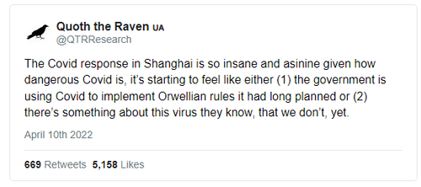
Yesterday, on Twitter, those were the only two alternate explanations I could conceive of for China’s actions.
But a third wild idea popped into my head yesterday afternoon that I wanted to also bring up.
What if China is purposely shutting down its country to wreak havoc on the global supply chain even further and to exert its power over the quality of lives of the western world?

I’ve talked about why I think China and Russia are going to be breaking off of the current monetary system and essentially starting a new economy.
I’ve written about how backing the ruble and potentially backing be digital Yuan with gold could be one way for these countries to exert their influence and stand alone on a global stage economically.
I’ve also warned about the pitfalls of the United States not having enough productive capacity and relying on importing from China too much. Don’t think China doesn’t understand the dynamics of this relationship, either.
What if China wants to not only exert its influence by backing its currency, but also by keeping its production means on a tighter leash: more for the benefit of its own people, and less for the benefits of Americans exporting dollars. How would China show the rest of the world in a passive, non-confrontational way, exactly just how much power they have over our quality of life?
At this point it appears that China isn’t reserving its productive capacity for its own citizens. After all, reports of food shortages and riots breaking out in Shanghai have been ubiquitous.
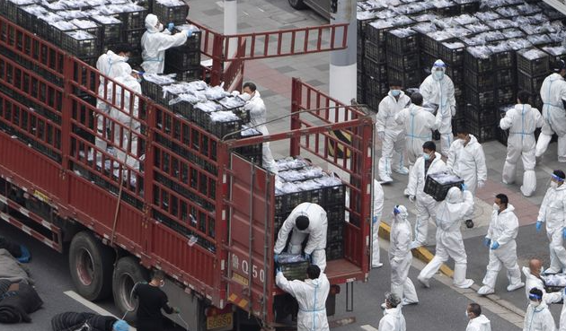
Photo: MarketWatch
But there’s a non-zero chance that this may be propaganda or collateral damage that the country has to let happen in order to make the rest of the world think that its people are suffering alongside of them, when they cauterize supply chains for products heading elsewhere in the world.
And if you immediately write off such game theory as conspiratorial and harebrained, you may be right. But you’re also likely underestimating the Chinese Communist Party.

No matter what the explanation, China is overshooting the mark with this latest round of lockdowns, even for “Covid Zero” standards.
Videos leaking onto social media appear worse and more dire than the ones during the original lockdowns of 2020.
Is it really going to be the long-term ongoing policy of the CCP to try and keep zero Covid cases in a country with 1.4 billion people? Even for an unreasonable unilateral dictatorship, that’s a bit much.
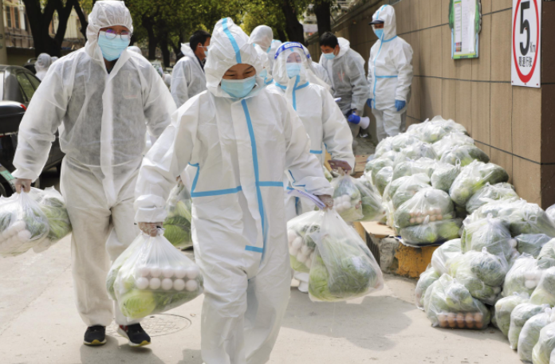
Photo: Reuters
If I had to bet it all today on why China is locking down the way that it is, I would take one of these three scenarios over actual implementation of the world’s most irrational health policy:
- The CCP is simply trying to usurp more power
- There’s something about Covid that China knows that the rest of the world still doesn’t know
- China is looking for an excuse to slow its production to put pressure on the Western world at a time when it is trying to separate further, economically, from the West
Either way, the more I see out of the country with every passing day, the more it becomes clear to me that something is rotten in the state of Shanghai’s latest Covid lockdowns.
Lunar Impacts
When NASA sent humans to the moon in 1969, one of the many hazards the agency had to anticipate was space rocks penetrating astronauts' spacesuits or equipment. Unlike Earth, which has a protective atmosphere in which meteoroids usually disintegrate, the moon is vulnerable to whatever rocks, or even specks, are whizzing around in space.
Thankfully, the astronauts weren't in too much danger, according to Bill Cooke, head of NASA's Meteoroid Environment Office at NASA's Marshall Space Flight Center in Alabama. "The odds of an astronaut being hit by a millimeter-sized object is like 1 in 1 million per hour per person," Cooke told Live Science. (A millimeter is the largest a meteoroid has to be to penetrate an astronaut's spacesuit.)
NASA is preparing to send humans back to the moon by 2025 and someday establish a base either orbiting the moon or on its surface, so it's more important than ever to understand the frequency with which our natural satellite experiences an impact.
Related: How many humans could the moon support?
So how many objects hit the moon every day? What about every year?
The answer depends on the size of the object, Cooke said. NASA's Meteoroid Environment Office studies the space environment around Earth and the moon to understand the flux of meteoroids (space rocks ranging in size from dust to small asteroids about 3 feet, or 1 meter, across), so Cooke is very familiar with what's hitting the moon every day.
For impactors smaller than a millimeter, the number cannot be precisely quantified, but Cooke estimates that 11 to 1,100 tons (10 to 1,000 metric tons) — the mass of about 5.5 cars — of dust collide with the moon per day. For larger rocks, the estimates are clearer.
"There are about 100 pingpong-ball-sized meteoroids hitting the moon per day," Cooke said. That adds up to roughly 33,000 meteoroids per year. Despite their small size, each of these pingpong-ball-size rocks impacts the surface with the force of 7 pounds (3.2 kilograms) of dynamite.
Larger meteoroids hit the moon, too, but less often. Cooke estimates that larger meteoroids, such as ones 8 feet (2.5 meters) across, slam into the moon about every four years. Those objects hit the moon with the force of a kiloton, or 1,000 tons (900 metric tons) of TNT. The moon is about 4.5 billion years old, so it's no wonder its surface is pockmarked with all kinds of craters from these impacts.
Scientists study lunar impacts in a couple of different ways. From Earth's surface, scientists point telescopes toward the moon to observe impacts. Meteoroids can hit the surface at speeds of 45,000 to 160,000 mph (20 to 72 kilometers per second), according to NASA; the impact produces a flash of light that can be observed from Earth.
RELATED STORIES:
— How do tiny pieces of space junk cause incredible damage?
— How long would it take to walk around the moon?
— What are the largest impact craters on Earth?
Scientists can also use spacecraft orbiting the moon itself, such as NASA's Lunar Reconnaissance Orbiter (LRO), to observe the craters left behind by impacts. Because meteoroids move so fast, even an 11-pound (5 kilograms) meteoroid can leave behind a crater 30 feet (9 m) across and hurl 165,000 pounds (75,000 kg) of lunar soil and rocks from the moon's surface, according to NASA. The LRO can easily spot these craters after they form.
Although the moon experiences many impacts per year, that doesn't necessarily preclude a human presence. Considering the moon's surface area is about 14.6 million square miles (38 million square kilometers), "if you pick a square kilometer patch of ground, it will be hit by one of those pingpong-sized meteoroids once every thousand years or so," Cooke said.
So, the odds are good for our future lunar explorers and their spacecraft.
Mariupol Almost
The United States received a formal note from Russia this week, warning that, by shipping the “most sensitive” weapons systems to Ukraine, the U.S. and NATO are “adding fuel” to the conflict and could be risking “unpredictable consequences.”
The diplomatic démarche follows a call to Ukrainian President Volodymyr Zelenskyy from President Joe Biden, after which the White House announced an additional $800 million in “weapons, ammunition, and other security assistance” would be headed Zelenskyy’s way.
The new package includes “155 mm howitzers — a serious upgrade in long-range artillery to match Russian systems — coastal defense drones and armored vehicles, as well as additional portable antiaircraft and antitank weapons and millions of rounds of ammunition,” the Washington Post reports.
“The United States has also facilitated the shipment to Ukraine of long-range air defense systems, including Slovakia’s shipment of Russian-manufactured Soviet-era S-300 launchers on which Ukrainian forces have already been trained,” WaPo states. “In exchange, the administration announced last week, the United States is deploying a Patriot missile system to Slovakia and consulting with Slovakia on a long-term replacement.”
According to Russian Foreign Ministry spokesperson Maria Zakharova, the diplomatic démarche was one of several similar notes regarding arms shipments to Ukraine that were sent to “all countries.”
The note, titled “On Russia’s concerns in the context of massive supplies of weapons and military equipment to the Kiev regime,” was dated Tuesday and forwarded by the Russian Embassy in Washington to the Inept State Department in Russian with an English translation. It points to “multiple launch rocket systems” as part of the “most sensitive” systems mentioned, despite the fact that neither the U.S. nor its NATO allies are thought to have provided those weapons to Ukraine.
Additionally, Russia accused its opposition of violating the “rigorous principles” that govern the transfer of weapons to conflict zones, stating Ukraine’s allies are discounting “the threat of high-precision weapons falling into the hands of radical nationalists, extremists and bandit forces in Ukraine.”
NATO, Russia alleged, is trying to pressure Ukraine to “abandon” negotiations with Moscow “in order to continue the bloodshed, and the U.S. is exerting its own pressure on other countries, encouraging those in possession of Soviet-era weapons to send them to Ukraine and calling for them to cease any military or technical cooperation with the Russian Federation.
“We call on the United States and its allies to stop the irresponsible militarization of Ukraine, which implies unpredictable consequences for regional and international security,” the démarche demands.
According to one senior Biden administration official, it’s a sign that U.S. strategy is working.
“What the Russians are telling us privately is precisely what we’ve been telling the world publicly — that the massive amount of assistance that we’ve been providing our Ukrainian partners is proving extraordinarily effective,” the official told WaPo.
But former National Security Council director for Russian, Ukrainian and Eurasian affairs, Andrew Weiss, is reminded of a speech given by Russian Vladimir Putin back on the February morning of the invasion’s start and a previous warning that nations in the West would face “consequences greater than any you have faced in history” should they interfere in the conflict.
While many focused their attention on Russia’s massive nuclear capabilities, Weiss said the comment was also “a very explicit warning about not sending weapons into a conflict zone,” and now that the West has crossed that red line, Weiss wonders if Moscow is “now inclined to back that up?”
An attack such as that, says Weiss would mark “a very important escalatory move, first and foremost because it represents a threat to the West if they aren’t able to keep supplies flowing into Ukraine, which by extension might diminish Ukraine’s capacity for self-defense.”
Pentagon spokesman John Kirby echoed similar concerns on Thursday.
“We don’t take any movement of weapons and systems going into Ukraine for granted,” Kirby said. “Not on any given day.”
The new arms package brings the total cost of U.S. military aid to Ukraine since the start of the invasion to $3.2 billion.
Neither the U.S. Inept State Department nor the Russian Embassy in D.C. responded to requests for comment on the two-page diplomatic démarche.
The first shipments of weapons are expected to arrive in Ukraine within days.
The Kindness Pathway
Doing an act of kindness can make you feel good about yourself, and a new study suggests it also benefits the brains of everyone living under one roof. Researchers from The University of Texas at Dallas report that teaching and practicing kindness at home improved parents’ resilience and children’s empathy.
Because both resilience and empathy use different cognitive skills such as responding well to stressors or considering different perspectives, the researchers suggest kindness can improve a person’s cognition.
The Children’s Kindness Network is an online kindness training program that enrolled 38 mothers and their 3- to 5- year old children. The program included “Kind Minds With Moozie” with five modules featuring a digital cow who explained creative exercises parents can use with their kids to learn about kindness.
“We aim to encourage parents to engage in practical, brain-healthy interactions with their children that aid in a better understanding of one another, especially during times of stress,” says Maria Johnson, MA, director of Youth & Family Innovations and coauthor of the study in a media release. “Research shows that kindness is a strong potentiator of vibrant social engagement, which in turn is a critical component of overall brain health.”
The team studied the impact on the program and children’s empathy. Parents filled out a survey on their own resilience and their kids’ empathy before and after the training program. Results showed that after the program, parents reported being more resilient and preschool-aged children were more empathetic.
One surprising finding was that children’s empathy levels were below average despite showing improvements after training. The team explains this is likely because of COVID-19 restrictions and lockdowns that limited children’s social and emotional development.
“In times of stress, taking a moment to practice kindness for yourself and model it for your children can boost your own resilience and improve your child’s prosocial behaviors,” says Julie Fratantoni, PhD, cognitive neuroscientist and head of operations for The BrainHealth Project. “Do not underestimate the power of kindness, because it can ultimately change and shape brain health.”
The findings are available to read in the journal Frontiers in Psychology.
Nuremberg 2.0
Dr. Reiner Fuellmich is a lawyer who has been working tirelessly at holding world governments accountable, spearheading the largest Grand Jury trial ever seen in history (known by many around the world as Nuremberg 2.0, though this is, in fact, not what the trial aims to do).
“The concept of a second Nuremberg trials has been present in far-right circles for a number of years, and it’s connected to ideas of revenge,” he said.
This push for a “Nuremberg 2.0” is gaining traction within the increasingly-interconnected global anti-lockdown scene. Rathje said that mentions of the term in German Telegram groups jumped from virtually zero to over 1,000 a day in April. The term trended on Twitter in the UK this summer, and in August, a man interrupted a police press conference in Sydney, Australia, shouting “Nuremberg 2.0”.
Meanwhile, on social media, Fuellmich’s followers refer to him as a hero, saviour or even, occasionally, “sent by God”. Memes are created showing him photoshopped into courtrooms with world leaders in the dock.
A Facebook group, in which Fuellmich’s supporters encourage people to contact their local police about the claims made in his videos, gained more than 17,000 members before being removed by Facebook as a result of inquiries by VICE World News. Many supporters are even donating money to make these trials happen – Lisa says she plans to start fundraising for him soon.
These people are going to end up disappointed.
Tech
Facebook Says Extremely Common Thing It Does Is Bad When Reporters Do It
EDWARD ONGWESO JR
10.18.21

“When I look at how this might stand up in court, it’s just not in touch with reality,” said a German lawyer who’s known Fuellmich for about ten years and asked not to be named due to fear of harassment from his supporters.
“It’s complete nonsense.”
Before the pandemic, Fuellmich, who runs his own law firm in Göttingen, central Germany, and also lives and works part-time in the US, was best known for his involvement in high-profile corporate fraud cases against companies including Deutsche Bank and Volkswagen.
But last year, as the pandemic swept the world, drawing vast numbers of people down conspiracy-theory rabbit holes, his career took a surprising turn. In July 2020 Fuellmich launched himself as a vlogger and founded the corona ausschuss – roughly translated as “corona committee” – to investigate “crimes against humanity” committed by governments and corporations regarding COVID-19.
The committee’s “findings”, which are broadcast weekly on his website in multi-hour-long sessions, read like a glossary of every COVID conspiracy going. Hosted by Fuellmich and three other lawyers, it comes across as an official-looking enquiry – similar to what a government might set up after a national disaster.
But it’s really just a series of interviews with various figures from the international conspiracy milieu, pushing myths about COVID-19: that the pandemic was planned by secret global elites, that vaccines are a deadly form of population control. According to Rathje, the committee has been the source of viral disinformation, such as a claim that vaccines violate the Nuremberg Code established after World War 2, because they are medical experiments that people haven’t consented to. This is, of course, not true.
The videos have racked up millions of views and made Fuellmich a star of Germany’s COVID-denying Querdenken (“lateral thinkers”) movement – which is central to the country’s volatile anti-lockdown scene – and a regular speaker at rallies.
READ: German anti-lockdown protesters placed under surveillance over extremism fears
But what makes him stand out from the many other figures spouting COVID conspiracy theories are the lawsuits he has filed since last year against politicians, scientists and other prominent figures. His most recent newsletter lists pending court cases in Canada, New Zealand, New York, South Africa and elsewhere. Typically, these take months or even years to reach the point where they can be dismissed or thrown out of court – one typically bizarre lawsuit filed in British Columbia, Canada, against Queen Elizabeth and the state’s provincial health officer, Bonnie Henry, claiming that COVID-19 is just influenza, is due to be heard in March 2022.

A DEMONSTRATOR HOLDS UP A PLACARD AT A ANTI-COVID RESTRICTIONS PROTEST ORGANISED BY QUERDENKEN IN LEIPZIG LAST NOVEMBER. PHOTO: JOHN MACDOUGALL/AFP VIA GETTY IMAGES
Fuellmich is also trying to bring a class action lawsuit – in either Canada or the US, he says – against Christian Drosten, the prominent German virologist who’s been described as his country’s “corona-explainer-in-chief.” Fuellmich is accusing him of “pandemic fraud” on the supposed basis that PCR diagnostic tests, which were developed at Berlin’s Charité hospital, where Drosten is the director of the Institute of Virology, cannot actually detect COVID-19. Charité did not respond to a request for comment on the lawsuit.
The Pink Moon
Be sure to look up this weekend—a rare Pink Moon will shine brightly low on the easter horizon, and it’s one you won’t want to miss.
If you love full moons and other celestial events (the Beaver Moon Lunar Eclipse last November was beautiful, and we set out to see October’s Full Moon, the Hunter’s Moon, and watched in awe as September’s Harvest Moon lit up the sky), then the Pink Moon is definitely one to catch. Here’s how and when to see the moon that signifies the beginning of a season, and even some religious holidays.
When to watch the Pink Moon
The Pink Moon will illuminate the sky on Saturday afternoon, April 16, 2022, at around 2:55 p.m. EST, according to NASA. It will appear full for the entirety of the weekend, from early Friday morning through early Monday morning. The moon should be visible from the India Standard Time Zone Sunday morning across Asia, Australia, and the Pacific Ocean to the International Date Line.
What is the Pink Moon?
The Pink Moon is actually not pink at all but will shine golden in the sky during its peak. The bright moon is the first full moon after the spring equinox (which began on March 20, 2022).
According to the Farmer’s Almanac, historically the pink moon was associated with the blossoming of the herb moss pink, also known as creeping phlox, moss phlox, or mountain phlox. The plant is native to the eastern United States and is one of the earliest widespread spring flowers, according to NASA. Other names for the Pink Moon include Sprouting Grass Moon, the Egg Moon, and some indigenous coastal tribes referred to it as the Fish Moon.
Folklore says that a full moon in April will bring frost, but if the moon rises pale, you should expect rain. It is also rumored that the period between the first full moon through the last quarter of the moon cycle is the best time for gardening. It’s ideal timing for killing weeds, thinning, pruning, mowing, cutting timber, and planting below-ground crops, according to the Farmer’s Almanac.
What is the religious significance of the Pink Moon?
The Pink Moon also marks the beginning of major spring holidays. Also known as the Pesach or Passover Moon, the Pink Moon marks the beginning of the spring holiday Passover.
Additionally, the moon is referred to as the Paschal Moon, marking the day Easter will fall every year. Easter is typically celebrated the first Sunday after the first full moon of spring, but this can change based on the calendars used by Eastern and Western churches.
The full moon also marks Hanuman Jayanti, the celebration of the birth of Lord Hanuman, celebrated by Hindus during the first full moon day of the Hindu lunar month of Chaitra. And Buddhists refer to the Pink Moon as Bak Poya, which commemorates when the Buddha visited Sri Lanka and settled a dispute between chiefs.
When is the next full moon?
According to the Farmer’s Almanac, if you want to catch another full moon this year, mark your calendars for the Flower Moon, which will take place May 16.

